ECONOMIC COMMISSION FOR EUROPE
INLAND TRANSPORT COMMITTEE
World Forum for Harmonization of Vehicle Regulations (WP.29)
Working Party on Noise and Tyres (GRBP)
Task Force Measurement Uncertainties (TF MU)

Draft Report of the 6th meeting of the Informal Working Group
Measurement Uncertainties (IWG MU)
WebEx only !

October 06, 2020 starting at 1:00 pm ending at 4:00 pm CET

October 07, 2020 starting at 1:00 pm ending at 4:00 pm CET

Working Documents
* Documents not yet available
 | Welcome and opening remarks
Mr. Truls Berge as the Chair of this TF opened the 6th meeting on the subject Measurement Uncertainties. This time as Informal Working Group (IWG MU).
 | Introduction of participants and organizations | IWGMU-06-09*
The Group welcome the experts from Turkey and India, who joined the meeting for the first time.
All attendees agreed to share the information, which is available on the Attendance List, and to allow uploading the list to the UNECE Website (see IWGMU-06-09)
 | Adoption of the agenda | IWGMU-06-01
The Agenda was adopted with the addition of the documents IWGMU-06-05, 06-05a, 06-05b, 06-06 and 06-07
 | Approval of the Draft Report of the 5th meeting | TFMU-05-05*
Due to COVID-19 the Draft Report of the 5th meeting was not finalized yet.
 | Review of documents, presented at 72nd session of GRBP  - Revised ToR for IWG on Measurement Uncertainties | GRBP-72-10
The Chair presented Informal document GRBP-72-10. The Terms of Reference – “Timeline” were revised due to the COVID-19 situation.
The new Timeline was approved by 72nd session of GRBP
 | Review of documents, presented at 72nd session of GRBP  - Status report  - Strategic approach to handle uncertainties in UN Regulations | GRBP-72-11
The Chair presented the Status report to the Group as presented to 72nd session of GRBP. Some of the experts complained, that the Status report was not sent out for comments to the Group, before it was submitted to GRBP. The Chair explained that this happened due to the current COVID-19 situation.
To avoid, that this could happen again, the Group agreed that the Status report for the coming GRBP session has to be distributed for comments before submitted to GRBP.
The Status report, as given to 72nd session of GRBP, summarized the work done during the 5th meeting of the Task Force based on the three documents TFMU-05-02, TFMU-05-03 and TFMU-05-04.

TFMU-05-02 presented the effect of implementing a correction procedure for track and temperature for ECE Reg.51-03 measurements. The procedure was implemented on a selection of M1 vehicles, measured in be "third party" in different countries, compared to type approval measurements. Both same physical vehicle and same tyres was part of the comparison, as well as same model and PWT, but different tyres were included. The method worked well for 5 out of 6 cars. The method could be difficult to implement for EVs.

TFMU-05-03 presented a table listing all quantities influencing the uncertainty when measuring according to Reg.51.03. They were categorized in 4 situations: Run-to-run, Day-to-day, Sit-to-site and Vehicle-to-vehicle. For each input quantity, the estimated uncertainty on Lwot and Lcrs was listed and its impact on Lurban. For most of these quantities, the impact is known, and the status listed as "done". However, there are still some open issues, like the influence of air temperature on the tyre noise contribution, that need to be investigated and verified.

TFMU-05-04 presented a table, listing 8 uncertainty groups (like equipment, experimental set-up, measurement, test vehicle, test tyres, etc.) where the uncertainty contribution to testing according to Reg.117 needs to be quantified. For each of the groups, the sources of uncertainty, nature and probability distribution were listed.

IWG MU originally planned for the 6th and 7th meeting prior to this 72nd GRBP meeting. However, due to the Covid-19 situation, both these meeting were cancelled. The progress of the group relies heavily on the contribution from both OICA and ETRTO to finalize a procedure how to deal with uncertainty when testing is performed by a third party. The current situation has made it impossible to prioritize the work of IWG MU in the last 6 months. This then makes it impossible to meet the proposed timeline as given in the Terms of Reference, as approved by GRBP at its 71st session (GRBP-71-31e TOR IWG MU). The chair of the IWG MU has therefore proposed a revised timeline as presented in the Informal document (GRBP-72-10). The proposal is to shift all dates with approximately a 6 months delay.

The new dates are presented under agenda item 13.

The Informal Working Group agreed (as the Task force before):
- the measurement uncertainties shall be minimized, e.g. by narrowing ambient and test conditions or by correction
- any residual uncertainty shall be covered by tolerances
Possible measures for minimizing measurement uncertainties are:
- Narrow the application range to minimize external influences
- Introduce compensation models
- Apply tolerances
- Statistical compliance
- Repeat measurements under type approval conditions
 | Review of documents, discussed during the 6th meeting  - Open issues | IWGMU-06-02  IWGMU-06-03  IWGMU-06-04  IWGMU-06-05  IWGMU-06-06  IWGMU-06-07
IWGMU-06-02: OICA presented an updated version of its earlier shown document TFMU-05-03 on Measurement Uncertainties regarding the main impact quantities. Justification were based on the following approaches:
- by measurement (or simulation) results from specific experiments, e.g. investigations on power train noise at indoor test bench
- by classic statistical methods e.g. parameter studies and correlation analysis (ACEA Tyre study)
- by theoretical derivations based on physical relations e.g. distance law (deviation from centered driving)

IWGMU-06-03: The Chair presented a summary of “Temperature correction of M+P data from RRT on ISO tracks, 2005” The observations of this analysis can be summarized as follows:
- The peak-to-peak variation is somewhat larger when correction for air temperature is applied, compared to road temperature.
- In most cases, the road temperature is quite higher than the reference temperature (+ 20 degr.C), which will lead to a higher sound level, than the uncorrected.
- In most cases, the sound level corrected for road temperature is higher than the level corrected for air temperature. The difference is in the range of -0.1 to 1.0 dB.
- Tyre D (winter tyre) seems to be less sensitive to the surface characteristics of the ISO surface, compared to the summer tyre

IWGMU-06-04: The experts from Renault Group presented a summary of ongoing work regarding
- Uncertainty induced by measurement system
- Measuring run to run deviation
The main conclusion of this work are:

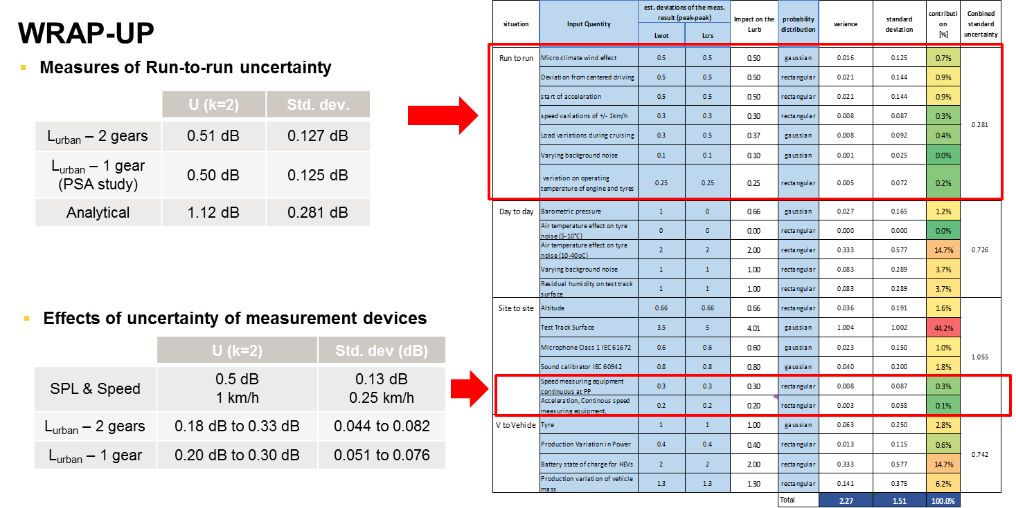

IWGMU-06-05: The experts from ISO presented a summary of a project by Donavan & Lodico “Measuring Tire-Pavement Noise at the Source: Precision and Bias Statement”.
Definitions:
- Precision
  - Repeatability: Single operator testing same pavement under same environmental conditions within a single test session -> +/- 0.2 dB with a limit of 0.6 dB
  - Reproducibility: Multiple test teams measuring under the same environmental conditions or a single test team measuring over multiple days -> +/- 0.4 dB with a limit of 1.1 dB
- Bias: Uncertainty from longer periods of time between tests or from multiple test sites -> +/- 0.5 dB with a limit of 1.4 dB
Findings:
- Tire/pavement noise decreases with increasing temperature and this relationship depends on both the tire and the pavement.
  - 0.039 dB/deg F established as general correction factor
- Test tire differences are a source of variability. However, no correlation could be established based on hardness, tread depth, or tire age, within the limits tested.
  - Hardness:62-66
  - Tread : 1200 miles
  - Age: 2.5 years

Tire/Road Air temperature correction performance:
Table 3 shows an average of ranges and standard deviations of uncorrected and corrected OBSI data
++++++++++++++++++++++++++++++++++++++++++++++++++++++The Report and the Appendix to the Report are uploaded as IWGMU-06-05a and IWGMU-06-05b.

IWGMU-06-06: The HCV experts from OICA presented their first approach to address Measurement Uncertainty quantities, which are different to those shown in IWGmU-06-02. Due to COVID-19 the expert were not able to work on this subject. Hopefully for the next meeting a more comprehensive result can be shown.

IWGMU-06-07: The expert from Scania presented an approach to analysis the “Influence of temperature and atmospheric pressure on sound pressure level”.
The approach is based on the sound pressure from a monopole and the ideal gas law.
The result is shown as:
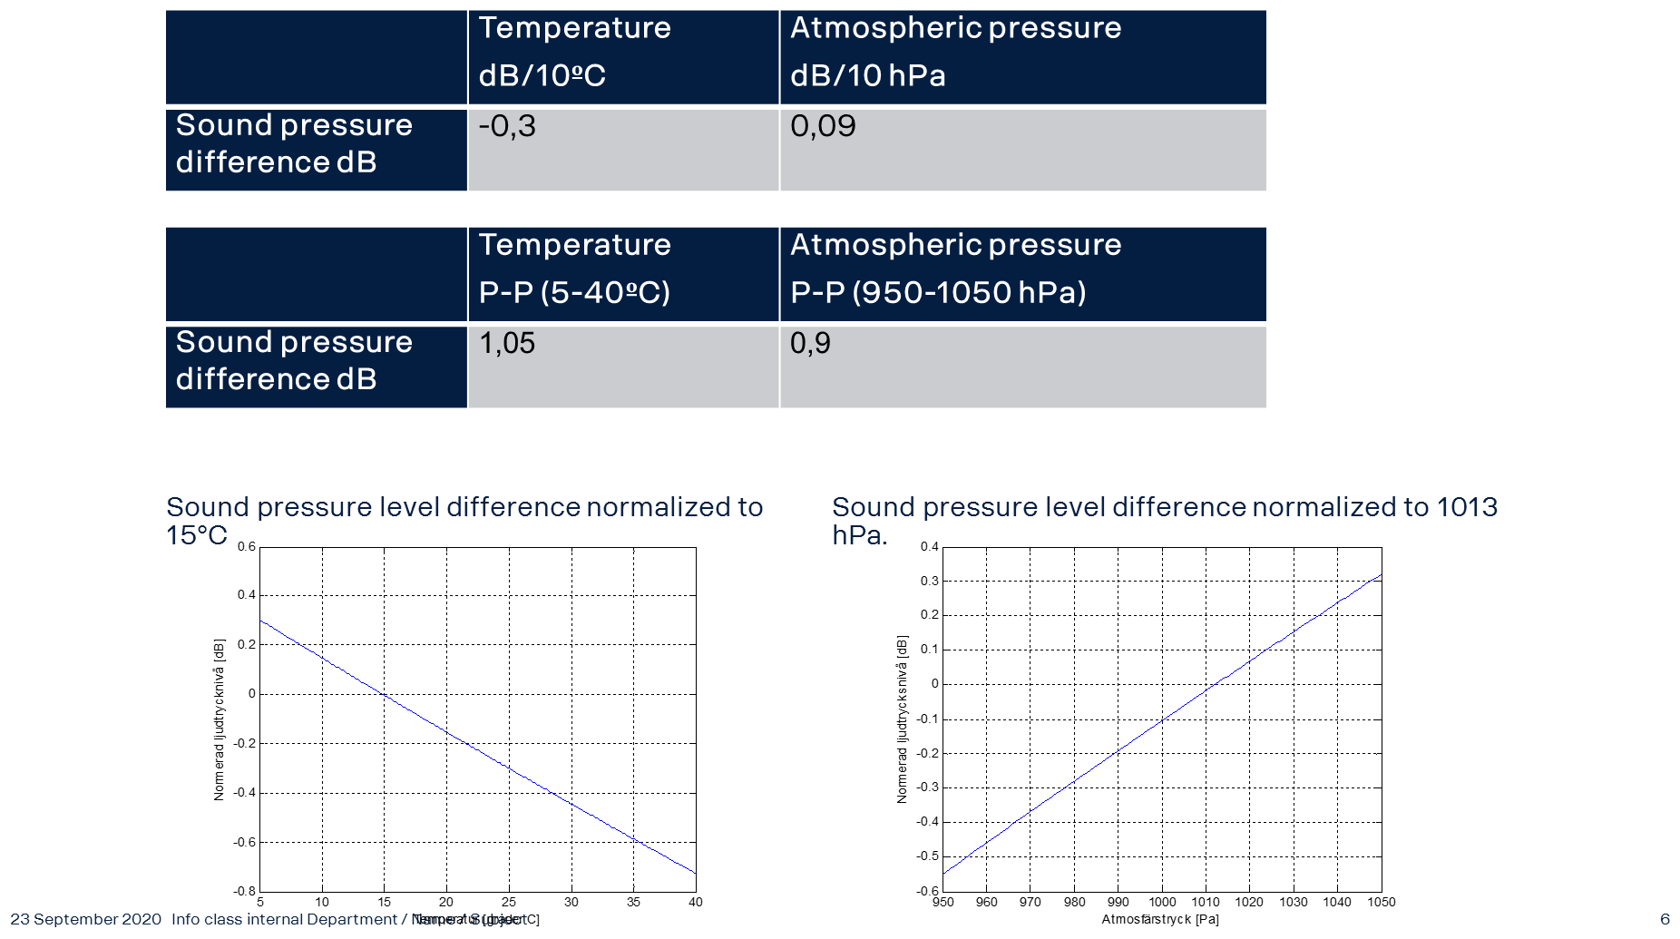

Where the sound pressure level difference in respect to temperature has been normalized to 15⁰C and to atmospheric pressure to 1013 hPa.

The Chair thanked all members for their work, presented in these documents.
An intensive discussion was held about the questions whether the Run-to-Run and the Site-to-Site measurement uncertainties as mentioned in IWGMU-06-02 are in line with the findings of the other presentations.
The Group agreed again to take these findings back home and give answers to the following questions:

- Are the listed uncertainties (see TFMU-06-02) covering the experts’ experience for reasons of the deviations of their measurement results?
- Are the given values (see TFMU-06-02) in line with their own experience?
- Are uncertainties missing?
- Are the mentioned ones valid for both test procedures according to UN Regulation No. 51.03, Annex 3, §3.1.2.1. and §3.1.2.2.?
- Most of the mentioned uncertainties in TFMU-06-02 are based on the measurement procedure for vehicles of category M1, N1 and M2 (M ≤ 3500 kg). Have uncertainties to be added, which are only valid for the test procedure for vehicles of category M2 (M > 3500kg), N2, M3 and N3?
- Experts on HCV are requested to check if HCV specific uncertainties need to be added to TFMU-06-06
- Experts on HCV are requested to check if their findings can be implemented in document IWGMU-06-02.
- When doing this examination, keep in mind that the uncertainties need to be independent. Some uncertainties can be combined others not.
- Check with your experience if the probability distribution is following a rectangular or a gaussian one (see TFMU-02-06, column G). If you are not sure, use the rectangular one in the first place as proposed by the GUM.

 | Exchange of information on national and international requirements  - Uncertainties context:  - For Type approval authorities  - For COP  - For In-use compliance and market surveillance | UN Regulation No 51.03  UN Regulation No 117.04  Regulation (EU) 2018/858
-None-
 | Actions on uncertainties | TFMU-02-06  TFMU-02-07  TFMU-03-04  GRBP-71-21  TFMU-05-05*
See Agenda item 6 and 7
 | Characterization of test tracks variation using PSD of texture  - Report from latest ISO meeting | TFMU-01-03
No further input could be given by ISO. The next ISO WG42 meeting is planned to be held from 19th to 21st of October 2020.
 | Characterization of temperature compensation acc to CPX method | TFMU-03-02
No further results were available
 | Identification of open issues/ problems
See Agenda item 6 and 7
 | Follow up of project and milestones  - Key elements / Planning | GRBP-72-11  GRBP-72-10
GRBP-72-10

D. Timeline
1. The aim of the Informal Working Group is to present
  - during the 73rd GRBP in January 2021 a Draft document for Reference and an Informal document for amendments to UN Regulation No 51 and No 117
  - during 74th GRBP in September 2021 a Working document for amendments to UN Regulation No 51 and No 117 for consideration and adoption
  - during 74th GRBP in September 2021 an Informal Working document containing general Guidelines for how to improve test procedures in other UN Regulations to reduce measurement uncertainties for consideration.
  - during 75th GRBP in January 2022 a Working document containing general Guidelines for how to improve test procedures in other UN Regulations to reduce measurement uncertainties for consideration and adoption.
Any Other Business
- Agenda for 7th meeting
Main issues:
Review IWGMU-06-02
Review IWGMU-06-06
Follow-up of the Timeline
 | Next meeting(s)
- Official sessions of next IWG MU:
- 1 to 2 December 2020 from 1 pm to 4 pm CET
 | Adjourn
Mr. Truls Berge thanked the attendees for fruitful discussions and closed the 6th meeting of IWG MU.
_____________________________

All documents of this Task Force (TF MU) will be available via the UNECE website: Link

_{[!OC([1033])!]}

