SLR-39-19/Rev.1
II. Justification
General
1. The Informal Working Group on Visibility, Glare and Levelling (IWG VGL) was established at the seventy-fourth session of GRE in October 2015. Its first task was to “define technology neutral requirements, as instructed by WP.29, in particular to find a general solution for glare and visibility issues, and to review all levelling requirements” (ECE/TRANS/WP.29/GRE/74, Annex III).
2. This proposal is based on the concepts finally agreed at the tenth meeting of IWG VGL. The main technical changes apply to paragraph 6.2.6. and related sub-paragraphs for the dipped beam headlamps vertical orientation. The corresponding paragraph 6.22.6.1. and related sub-paragraphs for the adaptive front-lighting systems (AFS) dipped beam vertical orientation have been changed accordingly. Due to the basic changes agreed by IWG VGL, also some other paragraphs needed to be changed or added.
3. GRE, at its seventy-ninth session, decided that elements of the objectives of IWG VGL (ECE/TRANS/WP.29/GRE/76, Annex III) would be transferred to IWG SLR, in order to avoid duplication of work and since both groups had converging goals (ECE/TRANS/WP.29/GRE/79, para. 31).
4. As indicated in its adopted Terms of Reference (ECE/TRANS/WP.29/GRE/79, Annex II), IWG SLR shall take over and consider the outcome of IWG VGL (based on the discussion document ECE/TRANS/WP.29/GRE-79-29) as recommended at the seventy-ninth session of GRE (ECE/TRANS/WP.29/GRE/79, para. 31).
5. IWG SLR, at its twenty-seventh session, considered informal document ECE/TRANS/WP.29/GRE-79-29 and decided to submit it without modifications to the eighty-first GRE session for comments (ECE/TRANS/WP.29/GRE/2019/3).
6. Following an in-depth consideration during the eighty-first GRE session, GRE agreed on a modified diagram (ECE/TRANS/WP.29/GRE-81-21 and Annex II) and requested IWG SLR to prepare, on the basis of the new diagram, a revised proposal for consideration at the next session (ECE/TRANS/WP.29/GRE/81, para. 10).
7. IWG SLR, in line with the GRE request, submitted to the eighty-second GRE session a revised proposal (ECE/TRANS/WP.29/GRE-82-25) which has been extensively discussed during the meeting. Eventually GRE requested IWG SLR to prepare a revised document for the next session, taking into account the comments made at the eighty-second GRE session (ECE/TRANS/WP.29/GRE/82, para. 31).
8. The current proposal reflects the text that IWG SLR agreed by majority.

Detailed technical explanations
- In paragraph 6.2.4.2., category of vehicles N₂G (off-road) is added allowing a maximum height of 1,5m for installation of the dipped-beam headlamp in addition to the N₃G category of vehicles. This is done in order to align with proposal for an amendment to the 04, 05 and 06 series of amendments of UN Regulation No. 48 (ECE/TRANS/WP.29/GRE/2020/3), submitted by the experts from the Russian Federation.
- Paragraph 6.2.6.1.1. provides the requirements for initial downward inclination, this paragraph has been rearranged to improve readability. An additional requirement is introduced to limit the initial downward vertical inclination to the value of -0.5 per cent or less. The goal is to take the tolerances which have to be considered during the Periodical Technical Inspection (PTI) of headlamps into account. This topic was addressed during SLR Ad-hoc meeting on “Headlamp levelling”, held in Bonn on 28th of November 2019 (meeting minutes Ad-hoc 04-Rev.1, based on presentation Ad-hoc 03).
- The decision to add this requirement was taken during IWG SLR 35th session (SLR-35-22, report of SLR 35th meeting, 11-13 December 2019)
- For the initial downward inclination, the proposal also gives the possibility to define different values of initial downward inclination for different variants/versions of the same vehicle type. As the new requirements for the vertical inclination according to installation are more stringent, it will allow all variants/versions of a same vehicle type to meet these provisions.
- Titles of sub-paragraphs 6.2.6.1.1. and 6.2.6.1.2. are added for clarification: 6.2.6.1.1. Initial downward inclination and 6.2.6.1.2. Vertical inclination limits of the cut-off.
- Paragraph 6.2.6.1.2. describes the new requirements for the vertical inclination limits of the cut-off, the provisions of which have been reorganised to improve readability. The vertical inclination values according to the installation height are presented in a table. A new diagram has been inserted providing an illustration of the requirements (aiming in percent on the horizontal axis and headlamp mounting height in meters on the vertical axis).
- Explanations of the lines in the diagram:

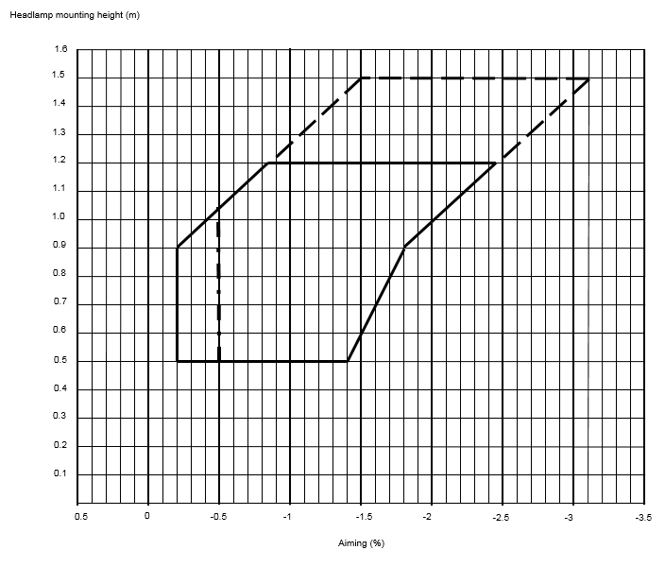
- The vertical line on the left was initially defined at 0 per cent and derived from the GTB study based on the ‘Klettwitz study’ (ECE/TRANS/WP.29/GRE-71-32). However, some Contracting Parties were reluctant to have the horizontal cut-off with no downward inclination. At its seventy-eighth session, GRE experts decided to keep the previous vertical limit of -0.2 per cent.
- The inclined line on the left (starting from 0.9m* in height), results from a mathematical calculation based on the position of the oncoming driver’s eyes (at 0.94m high) for headlamps up to a height of 1.2m, measured at a distance of 25m and with an initial aim of 1 per cent down. Using this calculation, it is possible to increase the inclination proportionally to the installation height and still guarantee that glare remains under control; the cut-off line will always stay under 0.94m at 25m distance (VGL-10-03, sheet 13).
* Note: Initially defined at a height of 0.95m, it was rounded down to 0.9m.
- In addition, the line on the left side of the diagram was extended from a height of 1.2m to 1.5m in spite of the fact that, during the Klettwitz tests, no vehicles of categories M₂/M₃/N₂/N₃ were tested. This is the reason the lines above a height of 1.2m are shown as dotted lines.
- To cover all possible cases of a same type of vehicle (aiming tolerances / chassis deviation / cut-off-line stability / tyre deviation / full or empty tank / levelling device), a range of 1.6 per cent was agreed (see OICA survey, VGL-10-10) and used to define the right hand limit. and the point (-1.8 / 0.9), based on line defined in item 16.
- Starting from 0.9m high, the range of 1.6 per cent is applied to define the line on the right side of the diagram and up to 1.5m.
- On the right side, under 0.9m high, there was a compromise to reduce the range progressively to 1.4 per cent at a height of 0.5m (ECE/TRANS/WP.29/GRE/81, para. 10 and Annex II).
- The vertical dotted line at -0.5 per cent is already explained in item 10 to address PTI concerns.
- The paragraph 6.2.6.2.2. (containing the requirements for manual levelling devices) is proposed to be deleted; however the outcome of 35th IWG SLR meeting was to keep it in square brackets, as it is still subject to discussion (SLR-35-22, report of SLR 35th meeting, Brussels 11-13 December 2019).
- Amendments to paragraph 6.2.6.2.3. and 6.2.6.3 (including its sub-paragraphs) are clarifications of the existing requirements only.
- In this proposal, first sentence in paragraph 6.2.9.3. mandating automatic levelling device in case of objective luminous flux exceeding 2,000lm is deleted. This requirement is recognized as not performance based neither technologically neutral, as suggested by IWG VGL (ECE/TRANS/WP.29/GRE-78-32).
- Furthermore, an editorial correction is done in paragraph 6.2.9.3., by adding ‘passing beam’.
- The paragraph 6.22.6.1.1. dealing with provisions for initial downward inclination for Adaptive Front lighting System (AFS), is also amended. As for the passing beam (dipped-beam) headlamps, this value shall meet the same requirements and different values for different variants/versions of the same vehicle type can be defined.
- Editorial corrections and clarifications are brought in paragraphs 6.22.6.1.2., 6.22.6.1.2.1. and 6.22.6.2.2.
- Some editorial corrections are made to Annex 2 (Arrangements of approval marks)
- In Annex 9 (CoP), Paragraph 1.3.2., containing the requirements for the variation of inclination with load, is amended to align with new provisions of paragraph 6.2.6.1.2. There are no additional tolerances for control of conformity of production (as decided at 35th SLR session, December 2019).
__________________

