|  |  |  |  |
| --- | --- | --- | --- |
|  | United Nations |  | |
| Description: _unlogo | **Economic and Social Council**  **SLR-40-07 rev 01** | |  |

Proposal for corrections to UN Regulations Nos. 113 and 149

Submitted by the Informal Working Group on Simplification of Lighting and Light-Signalling Regulations[[1]](#footnote-2)\*

The text reproduced below was prepared by the Informal Working Group on Simplification of Lighting and Light-Signalling Regulations (IWG SLR) after having identified errors in UN Regulation No. 149, due to the existing mistakes in frozen UN Regulation Nos. 113. The modifications to the existing text of the UN Regulations are marked in bold for new or strikethrough for deleted characters.

I. Proposal

A. Supplement 7 to the 01 series of amendments to UN Regulation No. 113

*Annex 3, Figure C;* amend to read:

“

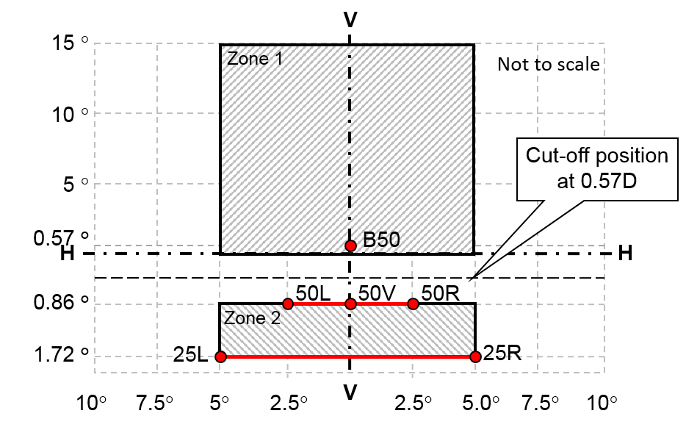

**Figure C**

**Passing Beam Test Points and Zones for Class B Headlamp(s):**

…”

B. Supplement 1 to the 02 series of amendments to UN Regulation No. 113

*Annex 3, Figure C;* amend to read:

“



**Figure C**

**Passing Beam Test Points and Zones for Class B Headlamp(s):**

…”

C. Supplement 2 to the 03 series of amendments to UN Regulation No. 113

*Annex 3, Figure C;* amend to read:

“



**Figure C**

**Passing Beam Test Points and Zones for Class B Headlamp(s):**

…”

D. Supplement 2 to the 00 series of amendments to UN Regulation No. 149

*Annex 4, Figure A4-IX;* amend to read:

“



**Figure A4-IX**

**Passing Beam Test Points and Zones for Class BS Headlamp(s)**

…”

II. Justification

1. The proposal to amend UN Regulation No. 113 corrects a mistake introduced by the 01 series of amendments to UN Regulation No. 113 when angular coordinates were introduced instead of dimensions in mm with screen at 25m.

For Annex 3, Figure C, the description of the zone 1 is not in line with the photometric requirements set in paragraph 6.2.5.2 which defines the horizontal angles to 5° to the left and 5° to the right.

2. The same correction applies to UN Regulation No. 113 02 series of amendement

3. The same correction applies to UN Regulation No. 113 03 series of amendement

4. The same correction applies to UN Regulation No. 149:

For Annex 4, Figure A4-IX, the description of the zone 1 is not in line with the photometric requirements set in paragraph 5.4.4.2. Table 34 which defines the horizontal angles to 5° to the left and 5° to the right for the class BS headlamps.

1. \* In accordance with the programme of work of the Inland Transport Committee for 2020 as outlined in proposed programme budget for 2020 (A/74/6 (part V sect. 20) para 20.37), the World Forum will develop, harmonize and update UN Regulations in order to enhance the performance of vehicles. The present document is submitted in conformity with that mandate. [↑](#footnote-ref-2)