UN GRSP Informal Working Group
on Deployable Pedestrian Protection Systems
(IWG-DPPS)
Draft minutes IWG-DPPS/7/02
7th Meeting Minutes, 15-17 September 2020 - Web-Meeting

- Chair welcomed all participants and thanked the HBM presenters for the detailed presentations.
- The agenda was approved, with addition of the sensing width item.
- The meeting minutes of the 6th meeting were approved.
- Update of WP.29/GRSP activities: the Informal Group was granted one-year extension.
- Follow-up discussion on open topics
5.1. Defining head test area ( IWG-DPPS-7-04)
Mr. Lee (Korea) presented different testable areas depending on test conditions.
Mr. Lammers(Netherlands) and B. Buenger(Audi) clarified that each variant separately shall be type approved and tested on their specific test areas. H. Lammers confirmed the deployed bonnet to be the real-world situation, and therefore reflected in the marking and testing.
CPs position:
NL: mark in deployed position for static tests, marking in undeployed for dynamic testing.
Germany, Korea, Japan: always marking in undeployed position
Spain: marking in undeployed position was easier, but from a technical perspective they may also accept the deployed position if documented by the OEM.
Other CPs (UK, France) will document their position for next session.

5.2. HIT determination
5.2.1. Simulation (human models, simulation conditions/requirements)
- THUMS presentation (IWG-DPPS-7-06)
Mr. Miyazaki & Hayashi (Toyota) presented a THUMS overview. THUMS model will be available for free by January 2021.
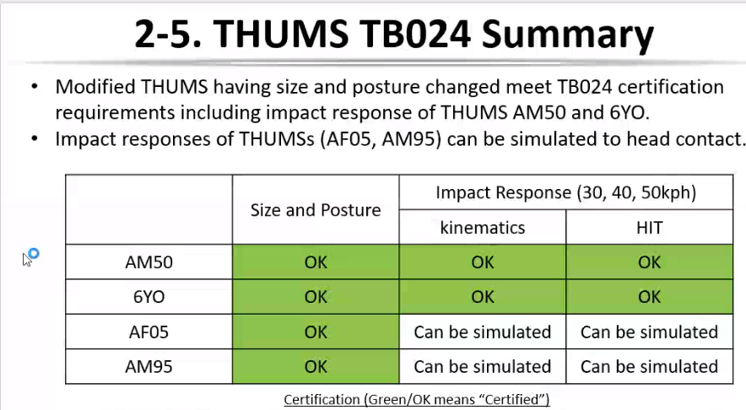
O. Zander (Germany) asked the meaning of “kinematics and HIT can be simulated”for THUMS.
C. Klug (TU Graz): As currently there are no 5th and 95th HBM validation corridors, only kinematic and impact responses correlations between THUMS and PHMS are possible (for head, neck, pelvis and foot locations) on different types of vehicles (Sedan, SUV, minivan).
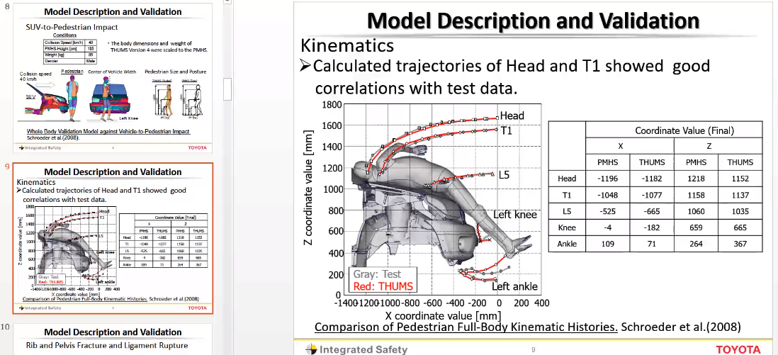
AF05 corridors will be available in 2021. THUMS validation papers are accessible from conferences only - 56th STAPP Car Crash Conference, October 2021.
C. Klug mentioned a publicly available NHTSA paper on the HBM validation (https://www-esv.nhtsa.dot.gov/Proceedings/22/files/22ESV-000043.pdf​​​​​​​) and presented her TU Graz dissertation references as scientific basis for DPPS decisions on HBMs and HIT. CORA scores were suitable to judge the correlation, as well as PHMS and THUMS HITs , which were very close together (1ms).
=> Mr. Tanaka (Japan) agreed with this combined validation basis.
- GHBMC presentation (IWG-DPPS-7-08)
Mr. Chin-Hsu Lin (GM) and Scott Gayzik (Wake Forest) & C. Untaroiu (Virginia Tech) presented the Global Human Body Model Consortium (GHBMC) model overview, founded for automotive crash simulations, also used in aviation and supported by NHTSA. The models have been generated using upright MRI and depicting live people with statures of interest, from live to CAD to CAE. MRI scans and specimen derived CAD were compared and match well. All detailed kinematics validation was elaborated on 50th percentile male PHMS.
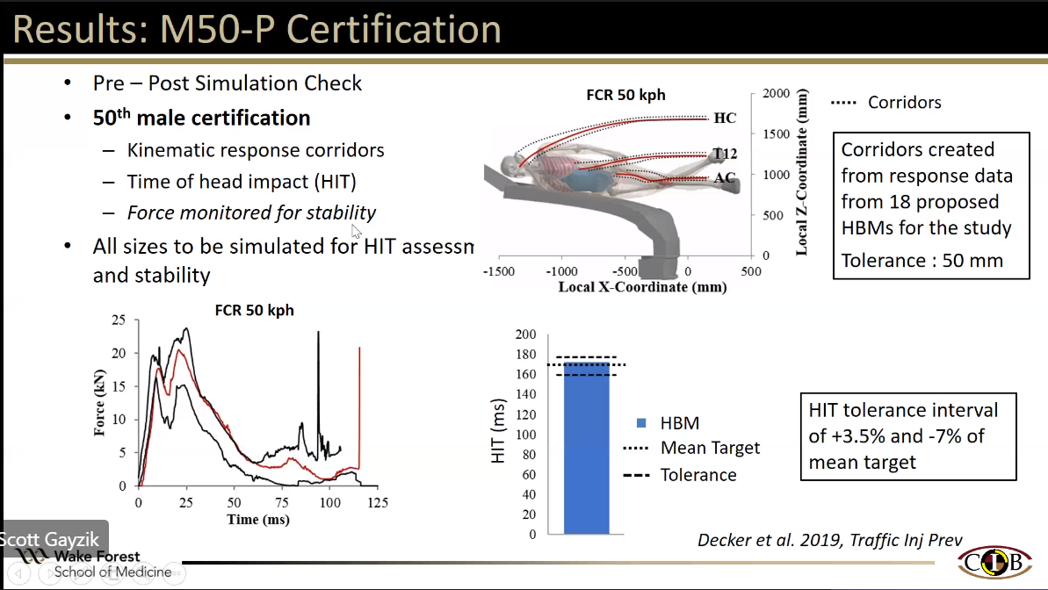
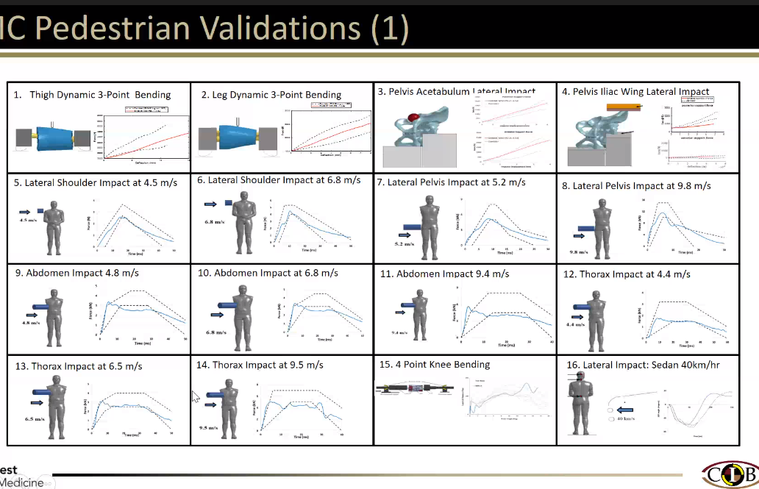
Action (Chair): CPs to check presentations for the next January meeting and use the references in the preamble of the DPPS amendment regarding the use of CAE HBMs.
- Others: EuroNCAP generic vehicle model usage, human model certification, simulation requirement/procedure) (IWG-DPPS-7-08) (IWG-DPPS-7-11)
C. Klug presented a summary of HBM certification for Euro NCAP.
Euro NCAP and TU Graz accept to share the generic vehicle model (GVM) usage. However, CAE model maintenance (versions update) conditions should be clarified. And current generic models are open source, so they can be modified (tbd in regulation).
Another option would be to provide model specifications in the Mutual Resolution 1, but detailed specifications and validation of individually built GVMs would be needed, and Mutual Resolution No.1 amendment requires a revised scope of DPPS by WP.29.
P. Broertjes (EC) mentioned challenges in implementing CAE models for VRU Proxy virtual testing, preferring a basic boundary conditions HIT database (as previously proposed by Dirk Gehring), which would be more suitable for market surveillance and self-certification. B. Buenger mentioned that HIT generation is just a supporting value and not directly related to the regulation thresholds, and A. Besch stated that a certification description would be more neutral. An Annex in the Amendment could enable the use of the HBM.
Action CPs & OEMs: review and confirm that TB024 content and the HBM validation documents are ok until the January meeting.
OICA confirmed that all OEMs use the Euro NCAP TB 024 for HBM positioning.
Action: Chair will arrange the HBM certification and HIT determination procedure by simulation based on the TB024 and communication with experts and propose it this year.
5.2.2. Physical testing (IWG-DPPS-7-03)
Mr. Lee (Korea) presented a comparison of static and dynamic tests, where the HIC from the dynamic test was higher (+58%, but well below the threshold), on a still rising hood.
In comparison, Japan’s simulation study was related to overshooting time, shown to be uncritical.
G. Maurer (BMW) proposed to check the height of the hood on videos, to better understand the differences between the two physical tests.
Action: Mr. Lee (KATRI) will share more specified data about the injury difference between dynamic and static headform tests after more tests to be conducted.

5.2.2. Physical dummy testing: for HIT determination: Ped 50% dummy : advancement status.
Japan’s opinion is to keep physical dummies to determine HIT in the amendment as an alternative.
Chair mentions that 6yo or AF5th are needed to determine HIT: next IG discussion item.
Conclusion: keep the General text of the test procedure with 50th % male in the amendment - until all physical dummies’ statures are available – to keep open this alternative.

5.3. Verification Impactor (IWG-DPPS-7-09)
O. Zander (Germany) presented an advancement status of the Flex-PLi study as Sensing Impactor for DPPS GTR9. Intrusion and energy, due to lower velocities, were investigated through an inverse certification test, where a honeycomb was attached to the moving ram. Acceleration sensors in the leg were impacted and signals recorded. Double acceleration integral calculation was used to generate the resulting intrusion values to assess the vehicle impact. First tests indicate a good contact biofidelity and repeatability of the FlexPLI impactors tested. Action: More impactors will be tested to confirm the study result.
Note: This study assesses if the FlexPLI is repeatable in terms of intrusion, without any unexpected mechanical behavior even for low speed conditions (as the impactor was not designed for). This is a one-time verification study only, to be used as background in the preamble.
5.4. Others
5.4.1 Proposal Korea (IWG-DPPS-7-05):
Korea presented the amendment proposal structure. Members requested the amendment draft proposal. Japan asked Korea to use the draft document that OICA and Japan proposed, when sharing it later.
Action: Korea will present a draft proposal, based on this organization plan.
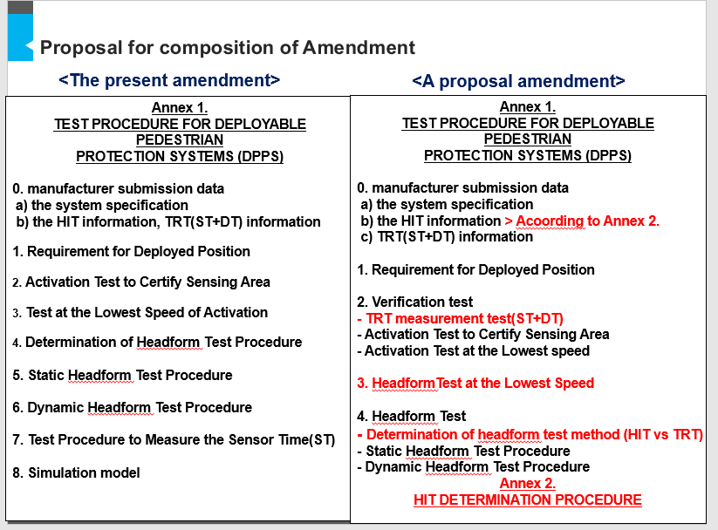
5.4.2 “Sensing Width” ( IWG-DPPS-7-10)
D. Gehring (BGS) presented a proposal on the Detection Area Width:
- independent from the DPPS width or structural parts under the vehicle outer surface. “Detection Area” and “Relevant Vehicle Width” definitions were introduced, related to the pedestrian impact to the vehicle front.
The width of the Detection Area shall be as a minimum of the Relevant Vehicle Width – 12.5% on each side (but not more than -250mm on each side).
Different vehicle examples shown highlight the adequate coverage of the vehicle front by the proposal. The idea was to include everything with the axle just being the reference for the longitudinal measurement.
H. Lammers(Netherlands) proposed to include the maximum in front of a vertical transversal plane located at the front axle point. Cameras in the proposal were meant to address cameras replacing the Outside Rear View Mirrors and should be called “Camera Monitoring Systems”. Mr. Lee (Korea) supported the NL’s proposal.
Mr. Tanaka (Japan) requires until next January to assess this proposal on several vehicles.
Action (Japan): Provide feedback on more vehicles and comment on the proposal: Jan. 2021
- Date and place of the next meeting (web meeting)
- 8th meeting: 18 Nov 2020, 9:00-11:00h (CET): Teams invitation : 1 point :
- detection impactor (Flex-PLI study tb finished)

- IWG-DPPS 9th meeting: 20-21 January (EU morning)

