SLR-HL-28

Submitted by the expert from Poland | )

Proposal for amendments to ECE/TRANS/WP.29/GRE/2020/8/Rev.2

Economic Commission for Europe

Inland Transport Committee

World Forum for Harmonization of Vehicle Regulations

Working Party on Lighting and Light-Signalling

Eighty……… session

Geneva, …………
Item … of the provisional agenda
Revised proposal for a new [0x] series of amendments to UN Regulation No. 48

Submitted by [the expert from Poland]
The text reproduced below was prepared by [Poland]. This revised proposal is based on ECE/TRANS/GRE/2020/8/Rev.2 and aims to introduce new requirements for headlamp levelling, in particular on the vertical inclination in relation to the dipped-beam headlamp mounting height, and to allow manual levelling only for off-road vehicles. The modifications to the existing text of the UN Regulation No. 48 are marked in bold for new or strikethrough for deleted characters.

I. Proposal
Paragraph 6.2.6.1. and related sub-paragraphs, amend to read:
“6.2.6.1. Vertical orientation
6.2.6.1.1. The initial downward inclination of the cut-off of the dipped-beam to be set in the unladen vehicle state with one person in the driver's seat shall be specified within an accuracy of 0.1 per cent by the manufacturer and indicated in a clearly legible and indelible manner on each vehicle close to either headlamp or the manufacturer's plate by the symbol shown in Annex 7.

Initial downward inclination
The initial downward inclination of the cut-off of the passing-beam (dipped-beam) shall be:
- set in the unladen vehicle state with one person in the driver's seat,
- specified within an accuracy of 0.1 per cent according equation:

I = -h/0.75 (dashed line on drawing below)
where:

I – cut-off inclination (in %);
h - mounting height of headlight optical axis (in m)

- indicated in a clearly legible and indelible manner on each vehicle close to either headlamp or the manufacturer's plate by the symbol shown in Annex 7.
Different values of initial downward inclination for different variants/versions of the same vehicle type can be defined, provided that only the pertinent value is indicated on each variant/version.

6.2.6.1.2. Vertical inclination limits of the cut-off

6.2.6.1.2.1. Depending on the mounting height in meters (h) of the lower edge headlamp optical axis of the apparent surface in the direction of the reference axis of the passing-beam (dipped-beam) headlamp, measured on the unladen vehicles, the vertical inclination of the cut-off of the passing-beam (dipped-beam), starting from the initial downward inclination value, shall under all the static conditions of Annex 5, remain between ± 0.2% of value prescribed in paragraph 6.2.6.1.1., specified within an accuracy of 0.1 per cent the following limits and the initial aiming shall have the following values:, under all the static loading conditions of Annex 5:
The above limits and the initial aiming values are summarized in the diagram below.

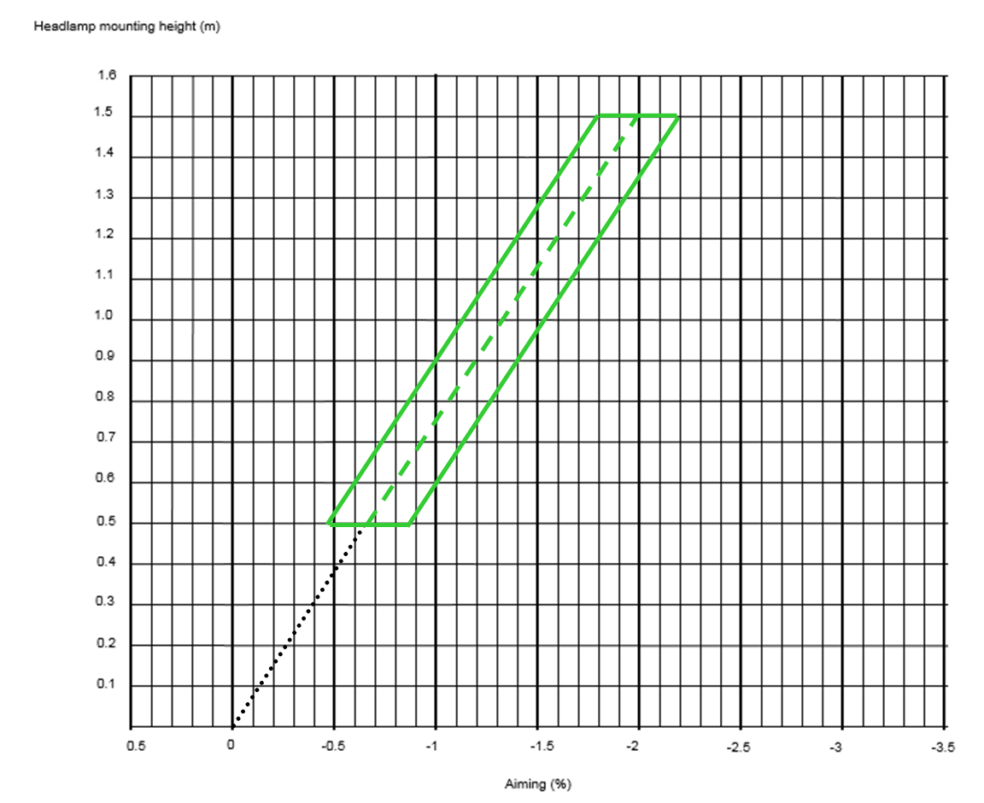
h < 0.8
limits: between -0.5 per cent and -2.5 per cent
initial aiming: between -1.0 per cent and -1.5 per cent
0.8 < h < 1.0
limits: between -0.5 per cent and -2.5 per cent
initial aiming: between -1.0 per cent and -1.5 per cent
or, at the discretion of the manufacturer,
limits: between -1.0 per cent and -3.0 per cent
initial aiming: between -1.5 per cent and -2.0 per cent
The application for the vehicle type-approval shall, in this case, contain information as to which of the two alternatives is to be used.
h > 1.0
limits: between -1.0 per cent and -3.0 per cent
initial aiming: between -1.5 per cent and -2.0 per cent

6.2.6.1.2.2. However while it is impossible to meet requirements specified in paragraph 6.2.6.1.2.1. because of design constraints of vehicle which are impossible to avoid it is satisfactory to meet below prescribed limits but under condition describe below
[
Mounting height h [m] | Upper inclination limit  [per cent] | Lower inclination limit  [per cent]
0.5 ≤ h ≤ 0.9 | -0.20 | -1.40 to -1.80*
0.9 < h ≤ 1.2 | -0.20 to -0.85* | -1.80 to -2.45*
1.2 < h ≤ 1.5** | -0.85 to -1.50* | -2.45 to -3.10*
* increasing linearly, in relation to the dipped-beam headlamp mounting height
** for categories N₂G, N₃G, M₂G, M₃G (off-road) vehicles only

The above limits and the initial aiming values are summarized in the diagram below.

For category N₃G (off-road) vehicles, where the headlamps exceed a height of 1,200 mm the limits for the vertical inclination of the cut-off shall be between: -1.5 per cent and -3.5 per cent
The initial aim shall be set between:-2 per cent and -2.5 per cent.

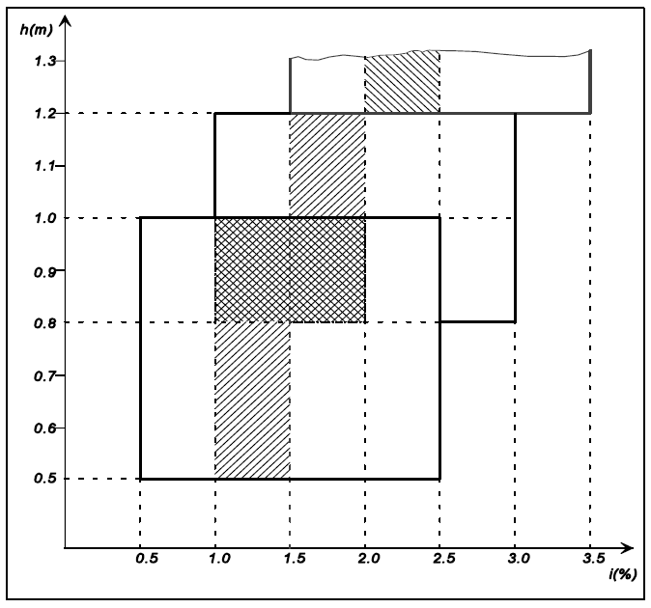

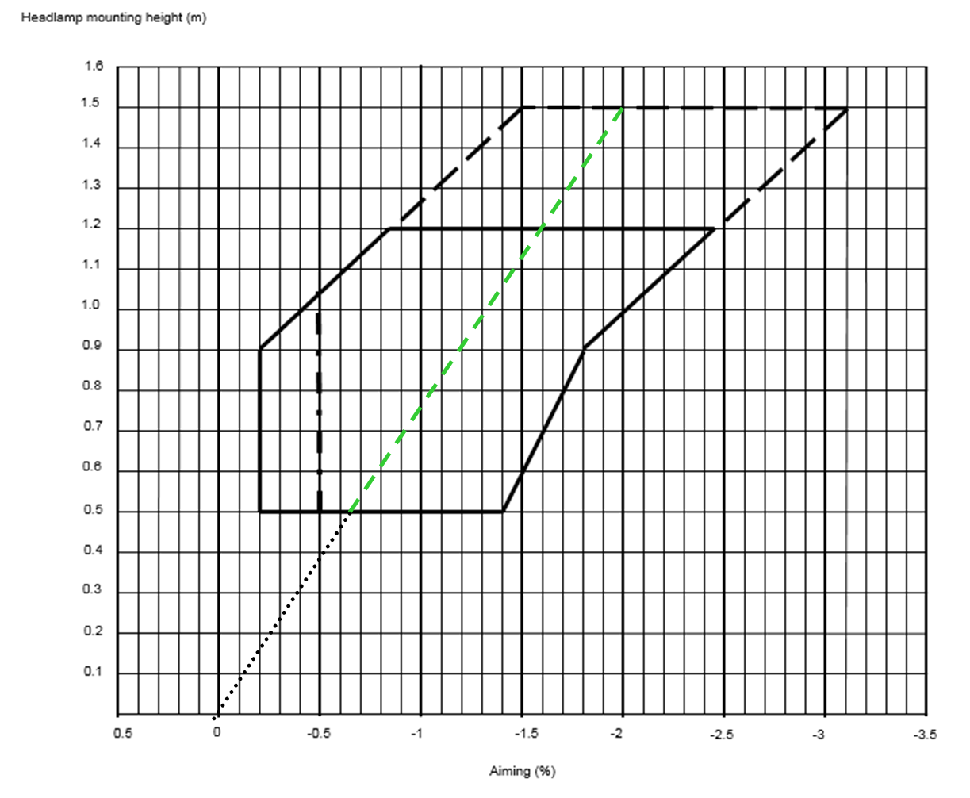
In addition
- Clear justification why it is impossible to meet requirements specified in paragraph 6.2.6.1.2.1. should be submitted to technical service
- A remark in the communication form (item 10. of Annex 1) shall detail inform other Administrations which design restrictions impossible to avoid make impossible to met requirements of paragraph 6.2.6.1.2.1.
- A notice in the vehicle shall inform the user that in certain condition may appear the impaired road illumination and/or excessive glare to other road users.

Paragraph 6.2.6.2. and related sub-paragraphs, amend to read:
“6.2.6.2. Headlamp levelling device
6.2.6.2.1. In the case where a headlamp levelling device is necessary to satisfy the requirements of paragraphs 6.2.6.1.1. and 6.2.6.1.2., the device shall be automatic.
6.2.6.2.2. However, devices which are adjusted manually, either continuously or non-continuously, shall only be permitted for vehicles of categories M₂G, M₃G, N₂G, N₃G, [provided they have a stop position at which the lamps can be returned to the initial inclination defined in paragraph 6.2.6.1.1. by means of the usual adjusting screws or similar means. where these systems also incorporate:
(a) a warning signal or message to the driver requesting that the vertical inclination of the dipped-beam headlamps shall be checked. The characteristics of this warning signal or message are defined in paragraph 6.2.6.2.2.1. below.
(b) in addition, a visual inclination status to the driver indicating the current setting of the vertical inclination of the cut-off of the dipped-beam is shown. The characteristics of this visual inclination status are defined in paragraph 6.2.6.2.2.2. below.
6.2.6.2.2.1. The warning signal or message shall be shown when the device which starts or stops the engine (propulsion system) is in a position which makes it possible to start the propulsion system and when the dipped-beam headlamps are switched ON (manually or automatically relative to the ambient light conditions according to the requirements of Annex 13).
The warning signal or message shall be shown until one of the following conditions is met:
(a) it is manually confirmed or whenever the inclination status is changed by the driver;
(b) it has been shown for at least 10 seconds;
(c) the vehicle speed has reached at least 15 km/h.
6.2.6.2.2.2. The visual inclination status shall be shown every time the engine (propulsion system) is started.

Furthermore, the visual inclination status shall be shown:

(a) at each switching ON of dipped-beam headlamp;
and

(b) whenever the visual inclination status is changed by the driver.

The visual inclination status shall be shown unless:
- it is manually confirmed by the driver or
- it has been shown for at least 10 seconds.
6.2.6.2.2.3. Automatic stop-starts of the propulsion system initiated by a vehicle control system, do not need to show the warning signal and the visual inclination status as specified in paragraphs 6.2.6.2.2.1. and 6.2.6.2.2.2. above.]
6.2.6.2.2.[4.] These manually adjustable devices shall be operable from the driver's seat easily visible, reachable and identifiable by the driver in accordance with the requirements of UN Regulation No. 121.
Continually adjustable devices shall have reference marks indicating the loading conditions that require adjustment of the dipped-beam.
The number of positions on devices which are not continuously adjustable to adjust the dipped-beam headlamps shall be such as to ensure compliance with the range of values prescribed in paragraph 6.2.6.1.2.2. in all the loading conditions defined in Annex 5.
For these devices also, the loading conditions of Annex 5 that require adjustment of the dipped-beam shall be clearly marked near the control of the device (Annex 8).
Requirements of controls for the headlamps leveling devices are specified in Annex 8.
6.2.6.2.2.[5.] The different positions to adjust the dipped-beam headlamps shall be explained in the owner's handbook.
6.2.6.2.3. In the event of a failure of devices described prescribed in paragraphs 6.2.6.2.1. and 6.2.6.2.2., the passing-beam (dipped-beam) shall not assume a position in which the dip vertical orientation is less downward than it was at the time when the failure of the device occurred.”
Paragraph 6.2.6.3. and related sub-paragraphs, amend to read:
“6.2.6.3. Measuring procedure
6.2.6.3.1. After adjustment of the initial downward vertical inclination, the vertical inclination of the passing-beam (dipped-beam), expressed in per cent, shall be measured in static conditions under all the loading conditions defined in Annex 5.
6.2.6.3.2. The measurement of the variation of passing-beam (dipped-beam) downward vertical inclination as a function of load shall be carried out in accordance with the test procedure set out in Annex 6.”
Paragraph 6.2.9.3., amend to read:
“6.2.9.3. With respect to vertical inclination the provisions of paragraph 6.2.6.2.2. above shall not be applied for dipped-beam headlamps with a light source or LED module(s) producing the principal dipped beam and having an objective luminous flux which exceeds 2,000 lumens.
In the case of filament lamps for which more than one test voltage is specified, the objective luminous flux which produces the principal passing-beam (dipped-beam), as indicated in the communication form for the type approval of the device, is applied.
In the case of passing-beam (dipped-beam) headlamps equipped with an approved light source, the applicable objective luminous flux is the value at the relevant test voltage as given in the relevant data sheet in the Regulation, according to which the applied light source was approved, without taking into account the tolerances to the objective luminous flux specified on this datasheet.”
Paragraph 6.22.6.1. and related sub-paragraphs, amend to read:

“6.22.6.1. Vertical orientation:
6.22.6.1.1. The initial downward inclination of the cut-off of the basic passing-beam (dipped-beam) to be set in the unladen vehicle state with one person in the driver's seat shall be specified within an precision accuracy of 0.1 per cent by the manufacturer and indicated in a clearly legible and indelible manner on each vehicle, close to either the front lighting system or the manufacturer's plate, by the symbol shown in Annex 7.
Where differing initial downward inclination are specified by the manufacturer for different lighting units that provide or contribute to the cut-off of the basic passing-beam (dipped-beam), these values of downward inclination shall be specified within an precision accuracy of 0.1 per cent by the manufacturer and indicated in a clearly legible and indelible manner on each vehicle, close to either the relevant lighting units or on the manufacturer's plate, by the symbol shown in Annex 7 in such a way that all the lighting units concerned can be unambiguously identified.
The value(s) of this (these) indicated vertical orientation(s) shall be defined by the vehicle manufacturer in the range prescribed in paragraph 6.2.6.1.2. in relation to the mounting height of the lighting units that provide or contribute to the cut-off of the basic passing-beam (dipped-beam).
Different values of initial downward vertical orientation for different variants/versions of the same vehicle type can be defined, provided that only the pertinent value is indicated on each variant/version.
6.22.6.1.2. The downward inclination of the horizontal part of the "cut-off" of the basic passing-beam (dipped-beam) shall remain between the limits indicated in paragraph 6.2.6.1.2. of this Regulation under all the static loading conditions of the vehicle of Annex 5 of this Regulation; and the initial aiming shall be within the specified values.
6.22.6.1.2.1. In case the passing-beam (dipped-beam) is generated by several beams from different lighting units, the relevant requirements provisions according to paragraph 6.22.6.1.2. as above indicated apply to each said beam's "cut-off" (if any), which is designed to project into the angular zone, as indicated under item 9.3. of the communication form conforming to the model in Annex 1 to UN Regulation No. 123 or item 9.3.3. in Annex 1 to UN Regulation No. 149.
6.22.6.2. Headlamp levelling device
6.22.6.2.1. In the case where a headlamp levelling device is necessary to satisfy the requirements of paragraph 6.22.6.1.2., the device shall be automatic.
6.22.6.2.2. In the event of a failure of this the device prescribed in paragraphs 6.22.6.2.1., the basic passing-beam (dipped-beam) shall not assume a position in which the downward inclination dip vertical orientation is less downward than it was at the time when the failure of the device occurred.”
At the end of paragraph 12., add a new paragraph 12.8. and its subparagraphs to read:

“12.8. Transitional provisions applicable to [0x] series of amendments.
12.8.1. As from the official date of entry into force of the [0x] series of amendments, no Contracting Party applying this UN Regulation shall refuse to grant or refuse to accept UN type approvals under this UN Regulation as amended by the [0x] series of amendments.
12.8.2. For vehicles of categories M₁ and N₁ the following applies:
12.8.2.1. As of 1 September [2024] Contracting Parties applying this UN Regulation shall not be obliged to accept UN type approvals to the preceding series of amendments, first issued after 1 September [2024].
12.8.2.2. Until 1 September [2027], Contracting Parties applying this UN Regulation shall accept UN type-approvals to the preceding series of amendments, first issued before 1 September [2024].
12.8.2.3. As from 1 September [2027], Contracting Parties applying this UN Regulation shall not be obliged to accept type-approvals issued to the preceding series of amendments to this UN Regulation.
12.8.3. For vehicles of categories M₂, M₃, N₂ and N₃ the following applies:
12.8.3.1. As of 1 September [2026] Contracting Parties applying this UN Regulation shall not be obliged to accept UN type approvals to the preceding series of amendments, first issued after 1 September [2026].
12.8.3.2. Until 1 September [2029], Contracting Parties applying this UN Regulation shall accept UN type-approvals to the preceding series of amendments, first issued before 1 September [2026].
12.8.3.3. As from 1 September [2029], Contracting Parties applying this UN Regulation shall not be obliged to accept type-approvals issued to the preceding series of amendments to this UN Regulation.
12.8.4. Notwithstanding the transitional provisions above, Contracting Parties who start to apply this UN Regulation after the date of entry into force of the most recent series of amendments are not obliged to accept UN type-approvals which were granted in accordance with any of the preceding series of amendments to this UN Regulation.
12.8.5. Notwithstanding paragraphs 12.8.2.3. and 12.8.3.3. Contracting Parties applying this UN Regulation shall continue to accept UN type-approvals to the preceding series of amendments to this UN Regulation, for the vehicle types which are not affected by the changes introduced by the [0x] series of amendments.
12.8.6. Contracting Parties applying this UN Regulation may grant UN type-approvals according to any preceding series of amendments to this UN Regulation.
12.8.7. Contracting Parties applying this UN Regulation shall continue to grant extensions of existing approvals to any preceding series of amendments to this UN Regulation.”

Annex 2, amend to read:

“Arrangements of approval marks

Model A
(See paragraph 4.4. of this UN Regulation)

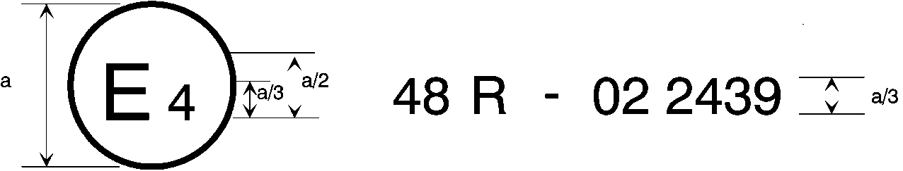
[0x]
a = 8 mm min.
The above approval mark affixed to a vehicle shows that the vehicle type concerned has, with regard to the installation of lighting and light-signalling devices, been approved in the Netherlands (E 4) pursuant to UN Regulation No. 48 as amended by the [0x] series of amendments. The approval number indicates that the approval was granted in accordance with the requirements of UN Regulation No. 48 as amended by the [0x] series of amendments.

Model B
(See paragraph 4.5. of this UN Regulation)

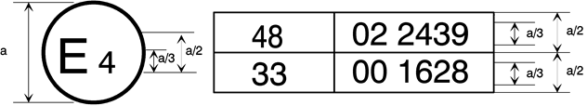
[0x]
a = 8 mm min.
The above approval mark affixed to a vehicle shows that the vehicle type concerned has been approved in the Netherlands (E 4) pursuant to UN Regulation No. 48 as amended by the [0x] series of amendments and UN Regulation No. 33.1 The approval number indicates that, at the dates when the respective approvals were given, UN Regulation No. 48 was amended by the [0x] series of amendments and UN Regulation No. 33 was still in its original form.”

Annex 8, amend to read:
“The controls for the headlamp-levelling devices referred to in paragraph 6.2.6.2.2. of this UN Regulation

1. Specifications
1.1. Downward Inclination of the dipped-beam shall in all cases be produced by a simple control, the operation of which is clearly described in the owner’s handbook. in one of the following ways:
- by moving a control downwards or to the left;
- by rotating a control in a counter clockwise direction;
- by depressing a button (push-pull control).
If several buttons are used to adjust the beam, the button which gives the greatest downward inclination shall be installed to the left or below the button(s) for other dipped-beam positions.
A rotary control that is installed edge-on, or with only the edge visible, should follow the operating principles of control of types (a) or (c).
1.1.1. This control shall carry symbol(s) indicating clearly the movements corresponding to the downward and upward inclination of the dipped-beam.
1.2. The "0" position corresponds to the initial inclination according to paragraph 6.2.6.1.1. of this Regulation.
1.3. The marks used on control shall be explained in the owner's handbook.
1.4. Only the following symbols may be used to identify the controls:
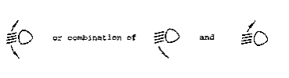

Symbols employing five lines instead of four may also be used

Example 1:
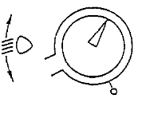

Example 2:
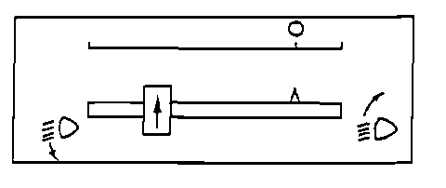

Example 3:
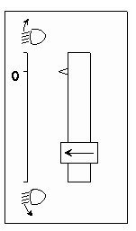
”

Annex 9, paragraph 1.3.2., amend to read:

“1.3.2. Variation of inclination with load
The variation of the passing-beam (dipped-beam) downward inclination as a function of the loading conditions specified within this section shall remain within the range specified in paragraph 6.2.6.1.2. of this Regulation.
0.2 per cent to 2.8 per cent for headlamp mounting height h < 0.8;
0.2 per cent to 2.8 per cent for headlamp mounting height 0.8 ≤ h ≤ 1.0;
or
0.7 per cent to 3.3 per cent (according to the aiming range chosen by the manufacturer at the approval);
0.7 per cent to 3.3 per cent for headlamp mounting height 1.0 < h ≤ 1.2 m;
1.2 per cent to 3.8 per cent for headlamp mounting height h > 1.2 m.

In the case of a class "F3" front fog lamp with (a) light source(s) having a total objective luminous flux which exceeds 2,000 lumens, the variation of the downward inclination as a function of the loading conditions specified within this section shall remain within the range:
0.7 per cent to 3.3 per cent for front fog lamp mounting height h ≤ 0.8 ;
1.2 per cent to 3.8 per cent for front fog lamp mounting height h > 0.8 m.
h < 0.8: 0.7 per cent minimum vertical inclination and 3.3 per cent maximum vertical inclination;
h > 0,8: 1.2 per cent minimum vertical inclination and 3.8 per cent maximum vertical inclination.
The states of loading to be used shall be as follows, as indicated in Annex 5 of this UN Regulation, for every system adjusted accordingly.”

II. Justification
1. The Informal Working Group on Visibility, Glare and Levelling (IWG VGL) was established at the seventy-fourth session of GRE in October 2015. Its first task was to “define technology neutral requirements, as instructed by WP.29, in particular to find a general solution for glare and visibility issues, and to review all levelling requirements” (ECE/TRANS/WP.29/GRE/74, Annex III).
2. Following several meetings the technical safety needs were detail discussed by IWG-VGL. The main of it was the recommendation for automatic levelling only. This was supported by 83-rd and 84-th GRE. There was also agreed exclusion for off-road vehicles (N2G, N3G, M2G, M3G) to be allowed manual levelling device. It is because of special design of such vehicles and negligible statistical significance of presence of such vehicles in real traffic.
3. Decision to allow automatic levelling causes significant changes in the conditions concerning the levelling tolerance values due to the lack of necessity to take into account the influence of manual levelling devices and connected phenomena. For devices controlling the cut-off inclination automatically there is no need to take into account vehicle suspension characteristics and the connection with headlamp mounting height. Therefore also the idea - originally proposed by IWG-VGL - for initial aim to be anywhere inside the box is no longer valid.
4. As the result it is proposed to set the initial aim as value directly related to compromise between minimum road illumination distance (75 m) and the glare avoidance set many years ago in component (headlamp) requirements which is based on h = 0.75 m height and I=1% down cut-off inclination. It is represented by the line described by equation:

I = -h / 0.75
where:
I - cut-off vertical inclination;
h - mounting height of headlight optical axis (in m)
Because of that it is needed to replace the headlamp lower edge by the optical axis height for setting the proper value of inclination in regard to road illumination distance. There is no need to change any other height requirements of Reg. No 48 e.g. minimum and maximum mounting height limits.
5. For the automatic levelling device, the only parameter determining its effectiveness is the inclination difference ΔI between the nominal value of the inclination and the value that differs most from this value for the various possible load distribution on the vehicle. This value is independent of the headlamp mounting height.
6. Tests of changes in inclination ΔI depending on the load for real vehicles equipped with automatic levelling, which were carried out at the Motor Transport Institute in 2012-2014 and repeated recently for passenger cars of different design, showed that the inclination is controlled in the range better than ΔI = ±0.1 - 0.2% for most tested vehicles. It is needed to take into account that tested vehicles were not obligated to fulfil here proposed requirements but only the presently existed which are many times wider than the proposed ones. It is the clear evidence that the possibilities of modern technology easily allow to meet the proposed requirements. Taking above into account there is proposed to restrict “box” to ± 0.2% from initial aim value as the best choice.
7. The obvious advantages of the above proposal in relation to the box proposed in GRE/2020/8/Rev.2 are the reduction of glare and the improvement of road illumination. Moreover it is clearly performance based and technology neutral requirement.
6. Due to the discontinuation of consent to manual levelling device also the earlier justification to the compromised "box" shape have also expired. However for practical reasons it can be used for some rarely situation when there may arise design constraints that make it impossible to comply above requirements (ΔI = ± 0.2%) even with use of contemporary good quality automatic levelling device. It may concern some e.g. complicated suspension of heavy vehicle. To solve this problem without significant deterioration of traffic safety it is proposed to allow the use of “wider” range (“box” size) as proposed in GRE/2020/8/Rev.2 but only under condition that it will be remark in the communication form and a notice in the vehicle which shall inform the user that in certain condition the impaired road illumination is possible and/or excessive glare to other road users may occur. Such kind of exemptions are used many times in Reg. 48.
The obligation to inform regarding impaired visibility and glare risk will prevent abuse of this possibility beyond really justified cases.
7. The rest of proposed changes (off-road vehicles requirements, transitional provisions, conformity of production) it is proposed to be as suggested by expert from OICA.

1 The second number is given merely as an example.

