1. **Applying a Multi-pillar Approach to the NATM**  
   1. The purpose of the NATM is to assess, based on the functional requirements, whether an ADS is able to safely address the various situations it may encounter in the real world.
   2. Validating these capabilities is a highly complex task which cannot be done comprehensively nor effectively through one validation methodology alone. As a result, VMAD has proposed that the NATM adopt a multi-pillar approach for the validation of ADS, composed of a scenarios catalogue and four validation methodologies (pillars) each of which is explored in greater detail in subsequent sections of this document:
      * **A** **scenarios catalogue,** consisting of a series of relevant and critical scenarios that represent real-world traffic situations, will be a tool used by the following three pillars (testing methodologies) to validate the safety of an ADS. The goal of these scenarios is to exercise and challenge an ADS’ capabilities to safely operate. This catalogue will provide a minimum baseline (non-exhaustive inventory) of scenarios that should be considered (and built upon as required) to validate each safety requirement for an ADS;
      * **Simulation/virtual Testing** which uses software-in-the-loop (SIL), hardware-in-the-loop (HIL), and/or vehicle-in-the-loop simulation methods to model virtual scenario elements to test the capabilities of an ADS or its component(s);
      * **Track testing** which uses a closed-access testing ground with various scenario elements to test the capabilities and functioning of an ADS;
      * **Real-world testing** which uses public roads to support testing, evaluation and functioning of ADS in real-world traffic situations; and finally,
      * **Audit/assessment** procedures which establish how manufacturers will be required to demonstrate to safety authorities using documentation, their simulation, test-track, and/or real-world testing of the capabilities of an ADS. The audit will validate that hazards and risks relevant for the system have been identified and that a consistent safety-by-design concept has been put in place. The audit will also verify that robust processes/mechanisms/strategies (i.e., safety management system) that are in place to ensure the ADS meets the relevant functional requirements throughout the vehicle lifecycle. It shall also assess the complementarity between the different pillars of the assessment and the overall scenario coverage.
      * **In-service monitoring and reporting** procedures to confirm the pre-deployment safety audit/assessment through feedback from the operational experience of vehicles in use, to fuel the common scenario database with new scenarios from the field and to allow the whole AD community to learn from major AD accidents/incidents.
2. **In-service monitoring and reporting**
   1. The in-service monitoring and reporting pillar addresses the in-service safety of automated vehicles after market introduction. The pillar consists in the collection of relevant data during AVs operation.
   2. The 3 purposes of in-service monitoring and reporting is to use retrospective analysis of data from manufacturers to:
      * + demonstrate that the initial safety assessment (residual risk) in the audit phase before the market introduction is confirmed in the field overtime (“*safety confirmation*”).
        + to fuel the common scenario database with important new scenarios that may happen with automated vehicles in the field (“*scenario generation*”) and
        + to derive safety recommendations for the whole community by sharing learnings derived from key safety accidents/ incidents to allow the whole community to learn from operational feedback, fostering continuous improvement of both technology and legislation (“*safety recommendations*”).

The obligation to have “real-time monitoring” (self-checks) of the performance of ADs subsystems by the manufacturer is not part of this pillar but is part of the functional requirements. However, some reporting mechanisms on the performance of ADS subsystems overtime could be part of the first bullet above, and contribute to the predictive monitoring of safety performance degradation.

The processes put in place by the manufacturer to manage safety during in use (e.g. to manage changes in the traffic rules and in the infrastructure) are assessed with the audit pillar.

* 1. **Why should this pillar be included in the NATM?**
  2. Whatever safety evaluation is done before market introduction, it will only be confirmed once a sufficient number of vehicles is in the field and once they are subjected to a sufficient range of traffic and environmental conditions. It is therefore essential that a feedback loop (fleet monitoring) is in place to confirm the safety by design concept and the validation carried out by the manufacturer before market introduction. The operational experience feedback from in-use monitoring will allow ex-post evaluation of regulatory requirements and validation methods, providing indications on gaps and needs for review.
  3. New scenarios and new risks might be introduced by AVs on the market. Therefore, the In -Use Monitoringpillar could be used to generate new scenarios in the common scenario database to cover these new safety risks.
  4. Finally, in the early phase of market introduction of ADS, it is essential that the whole community learns from a crash involving a particular AVs in order to quickly react and lead to safety developments and subsequent prevention of that crash scenario for all other ADS.
  5. **Strengths and weaknesses of the pillar:**
  6. Data from the field will be the most realistic way to assess the safety performance of an ADS over a wide range of real driving traffic and environmental conditions.
  7. Data from the field are also instrumental to ensure that the scenario database is updated with the latest scenarios in particular those deriving from the increasing use of ADS.
  8. Regarding safety recommendations, learning from in-service data is a central component to the safety potential of ADSs. Lessons learned from a crash involving a single ADS could lead to safety developments and subsequent prevention of that crash scenario in other ADSs. Feedback from the operational experience is recognized as best practice for safety management also in other transport sectors (e.g. already in place in aviation, railway and maritime sectors). Field operation data can also provide evidence of the positive impact of ADs on road safety.
  9. Limitations might derive from the quantity of data to be handled (too much data is as problematic as too little data), availability of tools for automatic scenario generation, and identification of responsibility handlers. Methods to verify the reliability of collected data should also be developed. The data collected should be comparable amongst manufacturers. It will create challenges on which data and how these data are collected and reported (definition of suitable reporting criteria). Time-wise, another challenge is the development of the in-service safety monitoring framework in a timely manner in order to serve AVs market deployment. Data privacy should also be taken into account.
  10. A standardized format for communication of information will be needed to allow processing by authorities in a standard manner and that any outcomes are easily shareable or open for analysis by other authorities. Different type of data may be needed depending on the purpose of the data collection.
  11. Ad-hoc processes for reporting the operational feedback from AVs should be developed for the automotive sector taking into account the higher number of monitored vehicles and events to be recorded.
  12. **Maturity of the Pillar**
  13. In-service monitoring and reporting is standard practice in the industry to develop and improve driver assistant systems (see ISO 26262 and SOTIF[1]). It was introduced as part of the audit of the new ALKS regulation. Starting from this requirement, additional elements should be developed in order to establish a more comprehensive approach for information sharing. In-service monitoring and reporting has already been implemented for many years as part of EU emissions regulations.
  14. The development of new traffic scenarios on the basis of traffic data has already started from the manufacturers’ side, through post-processing of recorded data elements and images (tools for complete automatic scenario generation are not available yet).
  15. Operational Accident/incident analysis is a well-established practice in some vehicle safety regimes, where conventional vehicles data recorders are collecting relevant information in certain crash or near crash-like situations[2]. Specific reports are also delivered to the relevant authority and publicly available through a centralized repository[3]. No standard data elements are currently defined for ADS crash/near missed-investigation: entities engaging in testing or deployment are encouraged to voluntarily collect data associated with crashes[4]. Because it is first time to introduce the concept of in-service-monitoring into the automotive safety sector which is usually used by normal citizens different from other transport sector, feasibility, such as how to collecting data and how to define near-miss-data, would be important view point and it should be well discussed.
  16. Mechanisms for operational feedback to improve common knowledge are already in place for decades in other transport sectors (see [ECCAIRS portal](http://eccairsportal.jrc.ec.europa.eu/)). A first step would be to investigate the suitability of such tools for the automotive sector too. However, the main effort would still remain in defining common reporting criteria and developing a common repository. According to mechanisms already in place in other sectors (e.g. see figure below), in-service data recorded related to safety-relevant events (i.e. accidents, near-miss events, abnormal functioning etc.) are processed by manufacturers/operators and then an accident report (what happened) by manufacturers/operators is delivered to the National authority. National authorities are then responsible to perform the accident analysis (why did it happened), derive safety recommendations (how could this be avoided), and evaluate the possible impact on existing legislation. National information is then recorded into (1) a Central Repository of Occurrences and (2) a Central Repository of Safety Recommendations. Access to data recorded into the Central Repository is subject to strict rules and mainly limited to competent Authorities. Safety recommendations are shared internationally according to the guiding principle that transport safety is of global concern and its improvement should not be limited by geographical or organizational borders. Privacy is ensured at all levels. Another option could be for the measured data to be directly communicated to the authorities, who will then be in charge of collection, storage and post-processing of the information.

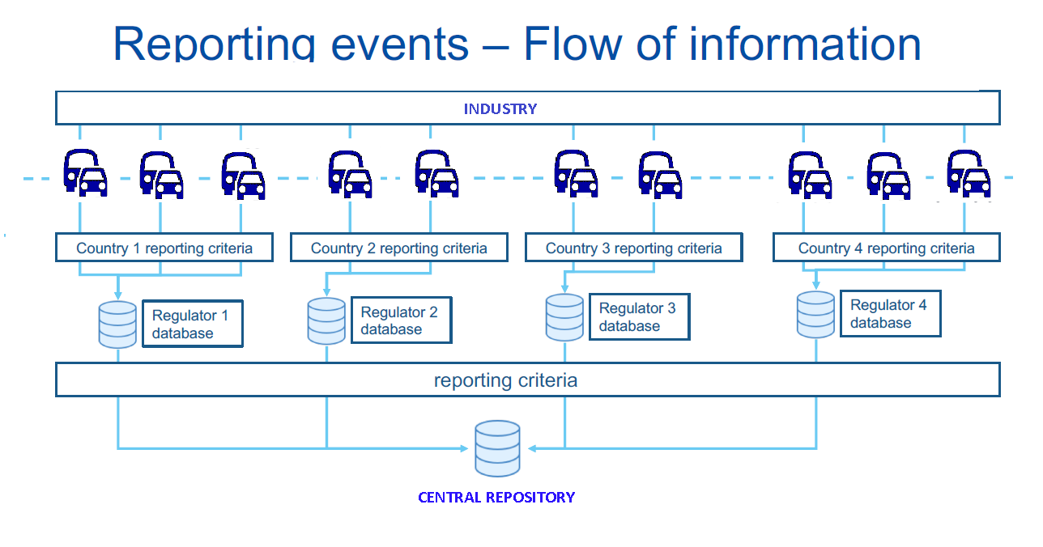

*Figure 7 – Reporting events – flow of information*

* 1. There is some link with the Informal Working Group that is already working on data recording requirements for conventional and automated vehicles (DSSAD/EDR IWG[5]) in particular regarding accident analysis. However in-service monitoring as part of the ADS assessment method has a different purpose (i.e. confirming the safety assessment, fueling the scenario database, detailed analysis of accidents/incidents) than EDR/DSSAD (accident reconstruction and liability in case of road traffic offense).

**Outstanding issues to develop and operationalize the New Assessment/Test Method for Automated Driving (NATM)**

1. **Purpose**
   1. The intent of this document is to facilitate VMAD’s development of the new assessment/test method (NATM) as outlined in the NATM Master Document
   2. This document establishes outlines anticipated activities to further develop the NATM Master Document. This includes addressing outstanding questions pertaining to the NATM pillars’ design, and scope, as well as the development of any technical resources that may be required to implement the NATM in practice.
   3. Workplan items that can be achieved by March 2021 will support the development of the first iteration of the NATM Master Document tabled at WP.29-183 in March 2021. Outstanding items not completed before March 2021 will be considered at WP.29-183.
2. **NATM Pillars/Element Interaction**
   * + 1. The goal of the NATM is to assess the safety of an ADS in a manner that is as repeatable, objective and evidence-based as possible, whilst remaining technology neutral and flexible enough to foster ongoing innovation in the automotive industry.
   1. The overall purpose of the NATM is to assess, based on the functional requirements, whether the ADS is able to cope with the occurrences that may be encountered in the real world, in particular by looking at scenarios linked to road users behaviour/environmental conditions in traffic scenarios but also scenarios linked the driver behaviour (e.g. HMI) and ADS failures.
   2. As previously noted, the multi-pillar approach recognizes that the safety of an ADS cannot be reliably assessed/validated using only one of the pillars. Each of the aforementioned testing methodologies possesses its own strengths and limitations, such as differing levels of environmental control, environmental fidelity, and scalability.
   3. A single assessment or test method may not be enough to assess whether the ADS is able to cope with all occurrences that may be encountered in the real world.
   4. For instance, while real-world testing provides a high degree of environmental fidelity, a scenario-based testing methodology using only real-world testing could be costly, time-consuming, difficult to replicate, and pose safety risks. Consequently, track testing may be more appropriate methods to run higher risk scenarios without exposing other road users to potential harm. Further, test scenarios can also be more easily replicated in a closed track environment compared to the real-world. That said, test track scenarios can be potentially difficult to develop and implement, especially if there are numerous or complex scenarios, involving a variety of scenario elements.
   5. Simulation/virtual testing, by contrast, can be more scalable, cost-effective, safe, and efficient compared to track or real-world testing, allowing a test administrator to safely and easily create a wide range of scenarios including complex scenarios where a diverse range of elements are examined. However, simulations may have lower fidelity than the other methodologies. Simulation software may also vary in quality and tests could be difficult to replicate across different simulation platforms.
   6. In-service monitoring and reporting can confirm the pre-deployment safety assessment and fill the gaps between safety validation through virtual/physical testing and real life conditions. Evaluation of in-service performance will also serve to update the scenario database with new scenarios deriving from increasing deployment of driving automation. Finally, the feedback from operational experience can support ex-post evaluation of regulatory requirements.
   7. Refer to Figures for more information regarding the respective strengths and weaknesses of each testing methodology.
   8. In addition to the respective strengths and weakness of each test pillar, the nature of the functional requirements being assessed will also inform what pillars are used. For instance:
   9. The most appropriate method to assess an ADS’s overall system safety prior to market introduction may be the audit pillar, using a systematic approach to perform a risk analysis. The audit could include information such as safety by design confirmed validation outputs as well as analysis of data collected in the field by the manufacturer.
   10. Virtual testing may be more suitable when there is a need to vary test parameters and a large number of tests need to be carried out to support efficient scenario coverage (e.g., for path planning and control, or assessing perception quality with pre-recorded sensor data).
   11. Track tests may be best suited for when the performance of an ADS can be assessed in a discrete number of physical tests, and the assessment would benefit from higher levels of fidelity (e.g., for HMI or fall back, critical traffic situations).
   12. Real-world testing may be more suitable where the scenario may not be precisely represented virtually or on a test track (e.g., interactions with other road-users and perception quality may be assessed through real world evaluation).
   13. In-service monitoring and reporting of field data represents the best way to confirm the safety performance of an ADS in the field after market introduction over a wide variety of real driving traffic and environmental conditions.
   14. Given these considerations, the sequence and composition of test pillars used to assess each functional requirement may vary. While some testing might follow a logical sequence from simulation to track and then to real world testing, there may be deviations depending on the specific functional requirement being tested.
   15. It is therefore necessary for the NATM pillars to be used together to produce an efficient, comprehensive, and cohesive process, taking into account their strengths and limitations. The methods complement one another, avoiding excessive overlaps or redundancy to ensure an efficient and effective validation strategy.
   16. As previously noted, the NATM pillars not only include the three aforementioned test methods but also an aggregated analysis (e.g., an audit/assessment /in service monitoring/reporting pillar). Whereas the test methods will assess the safety of the ADS, the audit/assessment pillar will serve to assess the safety of the ADS as well as the robustness of organizational processes/strategies. Elements of the audit are:

* Assessment of the robustness of safety management system,
* Assessment of the (identified) hazards and risks for the system,
* Assessment of the Verification strategy (e.g. verification plan and matrix) that describe the validation strategy and the integrated use of the pillars to achieve the adequate coverage
* Assessment of the level of compliance with requirements achieved through an integrated use of all pillars, including consistency between the outcomes of one pillar as input for another pillar (forward and backward) and adequate use of scenarios. This level of compliance concerns both new vehicles as vehicles in use.
* The audit may also incorporate results from the Simulation, Track test and Real-World tests carried out by the manufacturer.
  1. Figure 1 provides a diagram that outlines how the pillars, scenarios, and functional requirements (developed by FRAV) will interact. Further examination of each of these elements follows in the subsequent sections of this document.

*Figure XX. Relationship between VMAD Pillars, Scenarios and FRAV Functional Requirements*

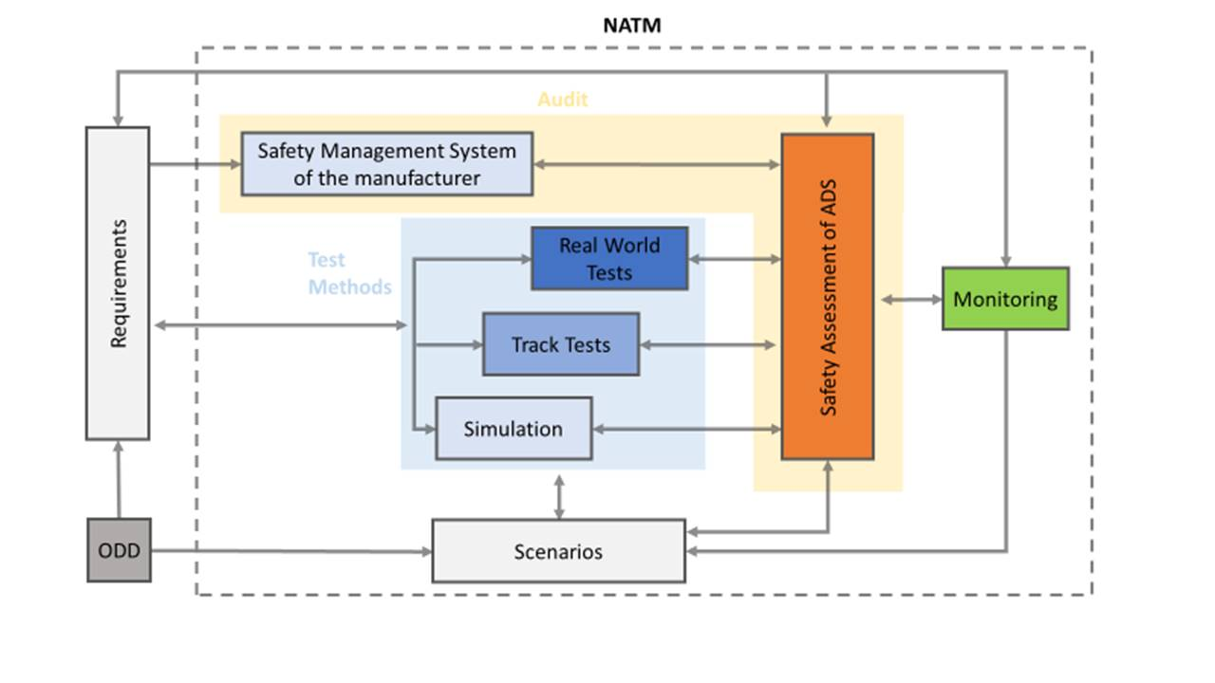

1. Safety of the intended function: ISO/PAS 21448,
2. See 49 CFR Part 563, Event Data Recorders. [www.gpo.gov/fdsys/pkg/CFR-2016-title49-vol6/xml/CFR-2016-title49-vol6-part563.xml](http://www.gpo.gov/fdsys/pkg/CFR-2016-title49-vol6/xml/CFR-2016-title49-vol6-part563.xml)
3. Vehicle Database: Event Data Recorder Reports. https://www-nrd.nhtsa.dot.gov/database/VSR/EventData.aspx
4. NHTSA Voluntary Guidance, https://www.nhtsa.gov/sites/nhtsa.dot.gov/files/documents/13069a-ads2.0_090617_v9a_tag.pdf
5. DSSAD/EDR <https://wiki.unece.org/pages/viewpage.action?pageId=87621709>