- Simulation/Virtual Testing
  - Common Definitions. The following definitions are used throughout this section.
    - ‘Model-In-the-Loop’ (MIL) is an approach which allows quick algorithmic development without involving dedicated hardware. Usually, this level of development involves high-level abstraction software frameworks running on general-purpose computers.
    - ‘Software-In-the-Loop’ (SIL) is where the actual implementation of the developed model will be evaluated on general-purpose hardware. This step requires a complete software implementation very close to the final one. SIL testing is used to describe a test methodology, where executable code such as algorithms (or even an entire controller strategy), is tested within a modelling environment that can help prove or test the software
    - ‘Hardware-In-the-Loop’ (HIL) involves the final hardware running the final software with input and output connected to a simulator. HIL testing provides a way of simulating sensors, actuators and mechanical components in a way that connects all the I/O of the Electronic Control Units (ECU) being tested, long before the final system is integrated.
    - ‘Vehicle -In-the-Loop’ (VIL) is a fusion environment of a real testing vehicle in the real-world and a virtual environment. It can reflect vehicle dynamics at the same level as the real-world and save the cost of constructing an external environment for testing. It can be operated on a vehicle test bed or on a test track.
    - ‘Driver-the-Loop’ (DIL) is typically conducted in a fixed-base driving simulator used for testing the human–automation interaction design. DIL has components for the driver to operate and communicate with the virtual environment.
    - ‘Stimulation’ is a type of simulation whereby artificially generated signals are provided to real equipment in order to trigger it to produce the result required for verification of the real world, training, maintenance, or for research and development.
    - ‘Deterministic’ is a term describing a system whose time evolution can be predicted exactly
    - ‘Probabilistic’ is a term pertaining to non-deterministic events, the outcomes of which are described by a measure of likelihood
    - ‘Stochastic’ means a processes involving or containing a random variable or variables. Pertaining to chance or probability.
    - ‘Parameterization’ is the process of adjusting numerical or modeling parameters in the model to improve agreement with a referent.
    - ‘Abstraction’ is the process of selecting the essential aspects of a source system or referent system to be represented in a model or simulation, while ignoring those aspects not relevant to the purpose of the model or simulation. Any modeling abstraction carries with it the assumption that it does not significantly affect the intended uses of the simulation.
    - ‘Closed Loop Testing’ means a simulation environment does take the actions of the system-in-the loop into account. Simulated objects respond to the actions of the system (e.g. system interacting with a traffic simulatin model)
    - ‘Open Loop Testing’ means a simulation environment that does not take the actions of the system-in-the loop into account (e.g. system interacting with a recorded traffic situation)
    - ‘Validation of Simulation’ is the process of determining the degree to which a model or a simulation is an accurate representation of the real world from the perspective of the intended uses of the simulation.
    - ‘Verification of Simulation’ is the process of determining the extent to which an simulation is compliant with its requirements and specifications as detailed in its conceptual models, mathematical models, or other constructs.
    - ‘Model’ is a description or representation of a system, entity, phenomenon, or process
    - ‘Model Parameter’ are numerical values used that are used to support a Model’s functionality.
    - ‘Simulation Tool’ is an imitation of the behavioral characteristics of a system, entity, phenomenon, or process.
    - ‘Simulation Toolchain’ is a combination of simulation tools that are used to support the validation of an ADS.
  - Introduction. Virtual testing is a powerful tool to support the development and validation of ADSs. Simulation-based testing can be used in different phases of the ADS development and certification. Although not restricted to traffic scenarios, virtual testing can be used to explore in a comprehensive and cost-effective way the performances of an ADS (or of part of it) on a wide range of traffic scenarios. Virtual testing is also particularly indicated to validate the ADS (or part of it) on safety critical scenarios, namely those scenarios for which safety could be difficult to ensure also on test tracks.
  - Virtual/simulation-based testing includes replacing one or more physical elements characterized in a scenario-based test by virtual model. The goal of such virtualization is to resemble, to a sufficient extent, the original physical elements. For automotive applications, simulation can be used to reproduce the driving environment and the objects operating therein that interact with either the entire system (e.g. a full vehicle with tires and ADS functions), a subsystem (e.g. an actuator or a hardware controller), or a component (e.g. a sensor).
  - Through this approach, an assessor can get confidence about the ADS based on the simulation and validation that was performed by the developer in an agile, controllable, predictable, repeatable and efficient manner. Virtual/simulation-based testing can be used at different phases of the ADS’ development and certification.
  - The simulation toolchain may result in the combination of different approaches. Tests can be performed:
      - entirely inside a computer (referred to as Model or Software in the Loop testing, MIL/SIL), with a simulation model of the elements involved (e.g. a simple representation of the control logic of an ADS) interacting in a simulated environment; and/or
      - with a sensor, a subsystem, or the whole vehicle interacting with a simulated environment (Hardware or Vehicle in the Loop testing, HIL/VIL). For VIL simulation, the vehicle can either be in:
        - a laboratory where the vehicle would be standing still or moving on a chassis dynamometer and be connected to the simulated environment by wire or by direct simulation of its sensors; or
        - a proving ground where the vehicle would be remotely connected to a simulation of the test environment and would interact with its virtual objects by physically moving on the test-track.
  - The interaction between the system under the test and the simulated environment can either be an open- or closed-loop.
      - Open-loop simulations (also referred to as software or hardware reprocessing, shadow mode, etc.) could be done through a variety of methods, such as the ADS interacting with virtual situations collected from the real world. In this case, virtual objects’ actions are data-driven only and the information is not self-corrected based on feedback from the output. Because the open-loop controller may vary due to external disturbances without the ADS and/or the assessor knowing, the applicability of open-loop simulation in the ADS validation may be limited.
      - Closed-loop simulations includes a feedback loop that continuously sends information from the closed-loop controller to the ADS. Within these test systems, the behavior of the digital objects could react in different ways depending on the action of the system under test.
  - Selecting an open- or closed-loop test could depend on factors such as the objectives of the virtual testing activity and the status of development of the system under test. For ADS validation it is expected that mainly closed-loops simulations and virtual testing will be considered.
  - Strengths and Weaknesses of the Pillar The flexibility of the approach which can be used for different purposes and at different stages in the vehicle development process, makes it a standard tool in vehicles design and validation in general. For ADSs, given the need to verify the capability of the automated system to deal with an infinite number of possible driving situations, virtual testing becomes an indispensable tool given the impossibility to test the vehicle behaviour in real life in all possible situations and for any change in its driving logic. Furthermore, virtual testing can be extremely beneficial to replace real world and proving ground testing concerning safety-critical traffic scenarios.
  - In contrast to all its potential benefits, a limitation of this approach is in its intrinsic limited fidelity. As models can only represent a coarse representation of the reality, the suitability of a simulation model to satisfactorily replace the real world for validating the safety of ADSs has to be carefully assessed. Therefore, the validation of the simulation tool is essential to determine the transferability and reliability of the results compared to real-world performance.
  - An approach for validating the accuracy of a simulation toolchain is to compare the ADS’ performance within a virtual test with its performance on a test track when executing the same scenario. Given the high number of scenarios that simulation testing can perform compared to test track-testing, the validation will likely need to be performed on a smaller but still sufficiently representative subsection of the relevant scenarios.
  - Figure 4 summarizes the main strengths and weaknesses of the virtual testing as part of the demonstration of the safety level by the manufacturer.
Figure 4. Strengths and Weaknesses of the Simulation Pillar
Strengths | Weaknesses
• Controllability – Simulation affords an unmatched ability to control many aspects of a test.  • Agility – Simulation allows for system changes to be revaluated immediately.  • Efficiency – In MIL and SIL, Simulations can be accelerated faster than real-time so that many tests can be run concurrently in a relatively short amount of time.  • Cost effectiveness at test execution–In spite of the investments required to develop, validate and maintain a complete simulation tool-chain, the running costs connected to its use are considerably lower than those required by physical testing.  • Wide scenario coverage. Compared to other testing methods, virtual testing allows a wider exploration of safety-critical scenarios. By properly combining the experiments parameters it can for example reduce the space of the known unknowns and to the extent possible that of the unknown unknowns (including the effect of system failures). | • Lower environmental fidelity/reliability – It is difficult, and likely impossible for simulation models to completely reproduce the environment, responses, as well as the behaviour of the vehicle, other road users etc. in the real world.  • Risk of over-reliance. Without proper consideration of simulation models’ intrinsic limitations, a risk exists to put too much emphasis on simulation results without sufficient proof of their validity by physical testing.

  - Maturity of the Pillar Virtual testing is a constantly evolving test method. While it is in many ways mature and used commonly for design and development processes, the real-world reliability and validity of each embodiment of the tool still needs to be determined. Although simulation testing can be used both in the ADS development process by the manufacturer and in the ADS certification process by the authority, it can be considered a mature option only as a tool for the vehicle manufacturer. Further research activities will be needed to understand the suitability of the tool also in the potential tests required by the certification process. Topics to be addressed are for instance the validation requirements (when is a model valid for what purpose). The next paragraphs will therefore provide more details on validation principles and techniques.
  - General simulation validation processes. The validation process aims at determining the accuracy degree to which a Model and Simulation (M&S) represents the real world within the target domain of applicability.. Ultimately the validation should demonstrate that the product satisfies the user needs regardless of the specific implementation (specifications shall be dealt with at the verification level).
  - The accuracy is investigated by inspecting whether the model’s output variables of interest are within an acceptable range of accuracy with respect to experimental setup. The acceptability range of the accuracy shall be specified beforehand and should be such that, if a model satisfied the accuracy requirements, it can be used as a substitute for the real system. Validation is however not an absolute, any model is in fact an approximation of the real system’s behavior.
  - Example of existing vehicle regulations leveraging on simulation for validation requirements. Generic guidelines for the simulation toolchain validation have already been given in established type approval directives. For instance, UNECE R140, which regulates the Electronic Stability Control (ESC), allows the ‘Sine with dwell’ manoeuvre to be carried out in a virtual environment upon the provision by the manufacturer of a report showing comparable behavior of selected reference quantities with respect to the physical counterpart. The virtual vehicle model used for the simulation shall also include a minimum list of physical characteristics to be simulated. (EU) 2018/858 extends the virtual validation concept to several vehicle sub-functions. The overall process is shown in Figure 6 and requires the manufacturer to provide a suitable mathematical model which undergoes a validation process against physical test data and a technical review approval. Similarly to (EU) 2018/858, ECE/TRANS/WP.29/2020/81 exploits the methodology presented in Figure 6 for validating the Automated Lane Keeping System for scenarios that are difficult to replicate in the real world

Figure 6. Validation process including computer simulation, (EU) 2018/858.
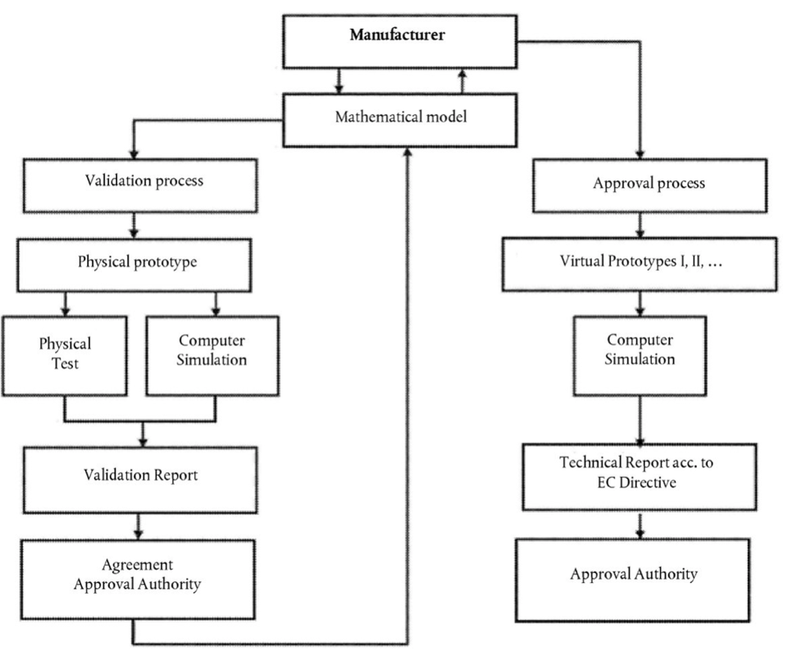
  - Virtual Testing to Support Effective ADS Validation. As already mentioned, virtual testing is a widely used tool in the development and internal validation of ADS. In this case, simulation tools are manufacturer specific and proprietary and their designated usage depends on the virtual validation and verification strategies implemented by the manufacturer. The simulation design and the toolchain should therefore not be regulated or standardized but rather explained and reviewed during the type-approval or certification process.
  - Simulation can consist of a number of different tools used for analysis, design, and testing. Despite the heterogeneity of subsystems and disciplines involved in the development of an ADS, there are many simulation tools that together allow covering of the entire development process. SIL in the laboratory environment offers a safe way to prototype and implement the control and algorithms of vehicles. The incorporation of a vehicle and real sensors in the simulation loop via HIL validates the design and reduces the time required for system verification.
  - As no one simulation tool can be used to test all aspects of the ADS, manufacturers may exploit the attributes of various simulation tools to develop confidence in the safety of the full system. A simulation toolchain may consist of multiple simulation types. By applying the same scenarios across all abstraction levels (MIL, SIL, HIL, VeHIL, proving ground) allows effective validation of the system without requiring an impossible number of physical tests to be carried out.

Figure 7. A possible use of virtual testing during vehicle development and validation
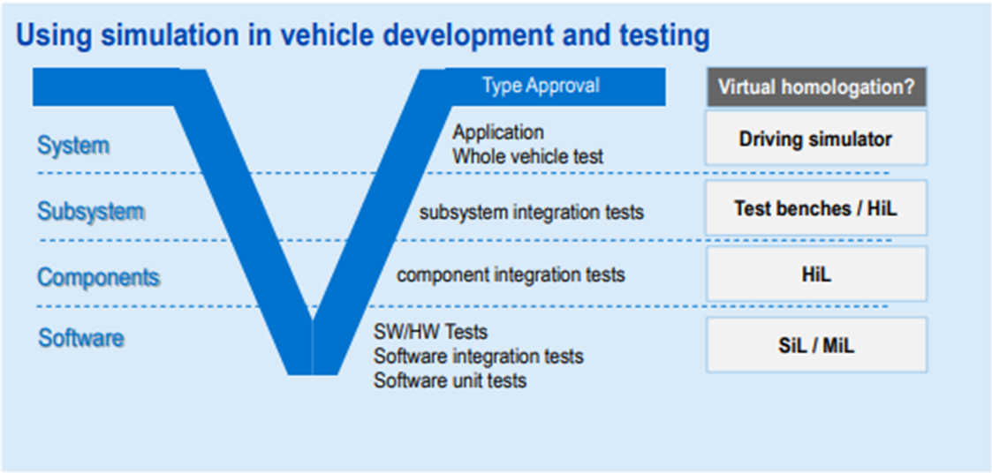
  - Simulation introduces models to represent the behavior of the system of interest. Consequently, simulations can be accurate only to some degree. Understanding the accuracy offered by a simulation tool is key to determining and arguing its use during development and validation activities. The level of accuracy required for a simulation model depends on the test goal and should be established through a separate activity. When model accuracy can be shown to sufficiently match real world behavior, performance data generated by simulation can be used to support the ADS validation.
  - Simulation for validation can achieve different objectives, depending on the overall validation strategy and the accuracy of the simulation tools:
      - Provide qualitative confidence in the safety of the full system
      - Contribute directly to statistical confidence in the safety of the full system (caveats apply)
      - Provide qualitative or statistical confidence in the performance of specific subsystems or components
      - Discover challenging scenarios to test in the real world (e.g. closed course tests)
A schematic representation of how different types of virtual testing can contribute to the ADS validation in combination with other test methods is reported in Figure 8.

Figure 8. A schematic representation of virtual testing use during ADS validation
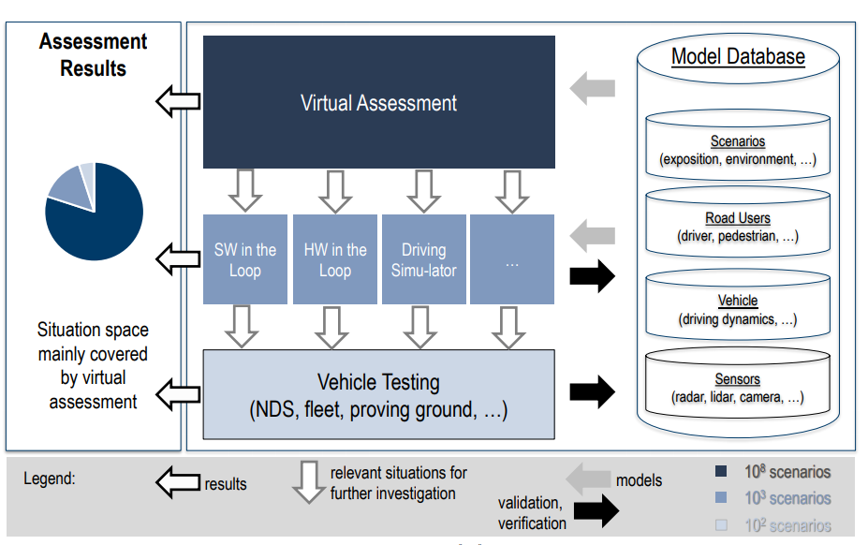
  - Regardless of the type of simulation, any simulation result should be reproducible at a later point for traceability and maintenance purposes. For SiL, this means that the simulator will repeatedly produce the same results for given initial conditions, input data and random seed. For HiL or hardware reprocessing, this means that the hardware configurations, test conditions and any hardware burn-in is comprehensively documented.
  - How Simulation can be used to Support other Test Methods. The strength of virtual testing lies in its capacity to cost-effectively assess performance across ranges of variables and arrays of scenarios. Virtual testing enables results of limited physical tests to be supplemented by verifiable data covering variations on the physical test scenario. As such, virtual testing expands the scope of the assessment to account for the diversity of traffic. Virtual testing enables coverage of safety-critical scenarios at their logical abstraction levels, confirming that an ADS will perform as intended across the parameter ranges. These advantages reduce the burden on physical tests (offsetting their weaknesses) to improve the efficiency of the overall assessment across the pillars.
  - Virtual testing also enables assessment of ADS performance boundaries, enabling precision of limits between collision avoidance and crash mitigation. In this respect, virtual testing can play an important role in the development of performance requirements and traffic scenarios.
  - Real-world tests can also aid in the generation of realistic simulation scenarios and in establishing the accuracy of the simulation models:
      - Real-world data for vehicle and component model validation: Vehicle data and data measured via vehicle sensors are important sources for quantifying and arguing model accuracy (e.g. vehicle dynamics or sensor models).
      - Real-world data for scenario accumulation: Fleet data may help determine which relevant cases to simulate.
      - Real-world data for traffic modeling: The generation of novel scenarios in simulation requires realistic road user behavior for virtual simulations in order to remain meaningful and representative.
  - Virtual testing provides speed and flexibility in analyzing real-world events to verify ADS performance against such events and, if necessary, support modifications to improve performance. In this regard, virtual testing can play an important role in responding to concerns identified through in-use monitoring of ADS performance. Scenario descriptions can be shared and integrated rapidly into virtual testing regimes worldwide. The various types of virtual testing, including hardware-in-the-loop methods that come close to matching physical testing, ensure robust and rapid responses.
  - ADS virtual tool chain validation. Before virtual testing methods can be used to validate or approve an ADS, validity of simulation models/toolchains should be ensured and the manufacturer should demonstrate that outputs of the simulation results are consistent with the results of physical tests carried out on test-track or real world as schematically presented in Figure 9. The physical tests should concern relevant scenarios depending on the system design and the level of automation.
Figure 9. The model calibration/validation cycle
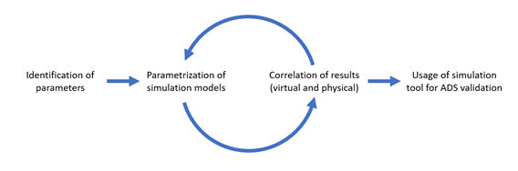
  - In order to understand validation requirements for simulation, we need to first understand what the simulation is being used to validate (e.g. perception systems, planning systems etc.). Depending on the validation target, the requirements on the simulation will be different. The first phase of this process is Preparation and the second phase is Execution.
  - Preparation Phase. The preparation phase consists of the following four steps:
      - Adaptation of the simulation platform to ODD. ODD can incorporate different attributes. ODD attributes will then need to be incorporated within the simulation framework. As an example, if rainfall defined in mm/h (with 1 mm/h resolution) is part of ODD definition, then the simulation platform needs to be able to cater to such requirements.
      - Test scenarios definition. Test scenarios may be defined at varied levels of details. The simulation environment shall be able to properly reproduce the scenarios.
      - Model requirements definition. Define model requirements based on model classes and fidelity levels.
      - Tolerance definition. Defining a reasonable tolerance for the KPIs.
      - Pass/fail criteria definition. Metrics with pass/fail-criteria (including acceptable deviations and tolerances) need to be defined to support the validation process.
  - Execution Phase. The execution phase consists of the following four steps in which the validation considers an increasingly complex systems. Since the validation of the subsystems models does not guarantee the validation of the integrated system model (due to the inherent differences between the model and the reality) and the other way around (due to possible parameters overfitting), all the four steps must be carried out.
      - Validate Subsystem models e.g. environment model (road network, weather conditions, road user interaction), sensor models (RADAR, Camera, LIDAR), vehicle model (steering, braking, powertrain)
        - The subsystem are validated in general standalone and open loop settings against specifications, behaviour, transfer functions (input/output of the subsystem)
        - The behaviour and parameters are determined using component test beds (steering, sensors, etc.) and reference measurement equipment for the environment (e.g. high accurate measurement system to characterize lanes, etc.)
        - If variants (typically the case) needs to be considered also the different variants needs to be modeled (e.g. different types of brakes, steering, etc.)
        - The validated subsystem model is mandatory. Once this is achieved, related documentation can be used for all type-approvals/certifications involving that subsystem. If the manufacturers maintains a catalogue of validated subsystems models to be applied for the virtual validation of the integrated vehicle model, the vehicle certification or type-approval may focus exclusively on the last step.
      - Validate vehicle system (vehicle dynamics model together with the environment model)
        - Vehicle system means integrating the virtual vehicle in an virtual environment to basically validate the vehicle dynamics on a virtual road
        - For this step typically only a 3D road network is sufficient (including friction and other properties). Traffic scenarios, buildings, etc. are not required
        - As we have already in this step an integrated system, we need to consider appropriate quantitative metrics in the validation process.
        - Main focus is lateral and longitudinal behaviour of the vehicle. The procedure is already described in several standards (ISO8726, ISO13674, ISO7401, etc.)
      - Validate sensor system (sensor model together with the environment model)
        - Sensor system means integrating the virtual sensor in a virtual environment
        - Typically starting point are static objects and in a further step dynamic objects
        - The environmental model is much more complex (weather conditions, objects, etc.). It is important to define a structured way for the validation. E.g. for visual systems not only the object itself is relevant but also the foreground and the background
        - Standard test are not defined yet
      - Validate integrated system (sensor model + environment model with influences form vehicle model)
        - In this step the integrated system is considered, focus are especially the interactions between the different models (vehicle, environment, sensor, etc.). As the step is quite complex 3 sub-steps are proposed
          - Open-loop (replay of vehicle movement); evaluation based on sensor raw data. The first sub-step only considers a replay of one or more relevant real world tests
          - In this case the detection and the driving function is not considered/active
          - The input data for the vehicle model are the recorded set values from the driving function on the real road (so e.g. acceleration, braking, steering)
          - The virtual vehicle in the related virtual environment should behave like in the real world (evaluation based on the criteria defined in the preparation which also define the signals which have to be recorded)
          - Beyond, the sensor raw output (without detection/perception) should also correlate to the output on the real road
          - Though the sensor model system is already validated it is important to do this step as here all three models (vehicle, environment and sensor are interacting). E.g. the field of view of the sensor is influenced by the chassis movement which is influenced by the road. Further blind spots especially for trucks and trailers could be investigated
        - Open-loop (replay of vehicle movement); evaluation based on object data as output of AD detection. The second sub-step already includes the detection/perception.
          - The output of the detection is basically the object list. This object list is compared to the object list coming from the detection on the real road
          - The test is still a replay test without the driving function (could be the same test as in sub-step 1). The only difference is that not the raw data is compared but the object lists
        - Closed-loop (AD detection and function in the loop); evaluation based on overall behavior. In this last step also the driving function is integrated. This is the final validation step
          - The validation test is reactive and not a replay. The driving order for the function is the same in virtual and in the real world. Based on the closed loop the AD function is reacting on the perceived objects and driving the vehicle.
          - The behaviour of the overall virtual system is compared to the real system.
        - IMPORTANT: the validation tests which are performed in this process must be different to the final validation tests of the ADAS/AD system…
  - Future of simulation/virtual testing in certification and type-approval process. At present the use of simulation and virtual testing is only possible for vehicle manufacturers with assessors only able to analyse the results during the audit phase. In the future certification entities may be allowed to make a direct use of simulation and virtual testing for 3rd party model and ADS validation. This paragraph outlines the possible use of simulation and virtual testing by independent assessors on the basis of the simulation approach/type.
  - MIL/SIL could be used by 3rd parties and certification bodies but ways needs to be established as new standards for model exchange are required. As this only involves software that can be deployed and archived for traceability it could be used by 3rd parties and certification bodies in general. However, each manufacturer uses a different tool for developing its virtual tool-chain. 3rd parties and certification bodies cannot handle every available tool and it is impossible to integrate any tool in an independent simulated environment that could be used for co-simulation as today chassis-dynos are used for emission testing. Standardization is therefore needed to ensure that each tool will be able to export the model in a specific format that can be processed in co-simulation. In this way both the original model and the co-simulation environment can be developed by different suppliers.
  - HIL could not be used by 3rd parties and certification bodies, will be used by manufactures, part of the assessment process. HiL is a mix of hardware and simulation . On a HIL there are typically a lot of specific arrangements required to get the system running. Control units, sensors etc. have special open interfaces to bring them together with virtual parts but changing the setup of a HIL is extremely complex. Documenting everything which was modified from standard is challenging and therefore it seems unlikely that HIL could be used by 3rd parties and certification bodies.
  - DIL could be used by 3rd parties and certification bodies to assess driver interaction. Driver-in-the-Loop could be possible but depends on the use case. 3rd parties and certification bodies need to check also the realism of the interaction with the driver. It could be useful to assess the appropriateness of transition demand requests and requirements for proper HMI.
  - VIL could be used 3rd parties and certification bodies. It must be differentiated between VIL on test-beds and VIL on proving ground. VIL on vehicle test beds seems the most viable option at present. The biggest challenge is this case is the interaction between the vehicle and the virtual environment. Vehicle Dynamics simulation is only an extension to the longitudinal part already used for emissions. Using over the air sensor stimulation needs no open interfaces of the vehicle. In this light the vehicle can be used as is (which is important for the type-approval). Further research is needed to expand the range of sensors that can be stimulated. VIL on Proving Ground suffers the difficulty to use over the air sensor stimulation as the vehicle is actually moving in a real environment. At the same time the possibility to inject a significant number of virtual dynamic objects may allow the test in real world settings of scenarios that at present are almost impossible to be reproduced due to their complexity and their safety implications. This option at present can be considered for ADS development and testing by vehicle manufacturers, but for 3rd parties and certification bodies it seems a more remote application.
  - Annex. Documentation requirements for vehicle manufacturers. The purpose of this annex is to provide requirements for manufacturers (or other parties) on the documentation package to produce and maintain in order to consider a model & simulation (M&S) and its associated data suitable to use for a specific purpose (Credibility for purpose).
  - Vehicle manufacturers (or other parties) should document all relevant aspects of the M&S activities. The documentation is not only focused on activities performed to assure the verification and validation (V&V) of the model(s), but also on processes and tools necessary to support the overall M&S credibility for purpose. In addition, the documentation should include both OEM and partners or suppliers activities involved in the M&S. The documentation contribute to the overall credibility of the M&S, because they can support:
      - The understanding of the M&S process, including V&V
      - The understanding of the assumptions and limitations
      - The assessment of the validity of the results
      - The traceability of the M&S
      - The reproducibility of the results
  - Thus, a minimum set of documentation requirements must be established to assess the credibility of simulation. These requirements enable to achieve transparency, repeatability, traceability as well as confidence on training and experience for key M&S personnel.
  - This annex suggest to establish and maintain an handbook (“best practices” document) to describe the M&S processes that should be updated with feedbacks from lessons learned. Anyway, there is no specific prescription on the way processes, products and data are documented, but they should normally be in line with the general practices established in the Safety Management System (or Quality Management System).
  - Organizations benefit from these common requirements in the credibility processes by eliminating unnecessary redundancy and facilitating reuse of information.
  - Special considerations
      - The following requirements are generic due to the applicability to all types of M&S.
      - The suitability for one purpose of M&S does not imply that it is suitable for some other type of use within the same organization.
      - Documentation requirements for OEM are applicable in both regimes. In the frame of the type approval they should be assessed in the frame of Audit pillar.
      - The Use history can contribute to the overall credibility of the M&S
  - General description
      - In order to use simulation for ADS validation we must ensure the “credibility” of the results from simulation/virtual testing. Thus, it is important to document different aspect of M&S aspects such as:
        - Verification and Validation: by defining acceptability criteria/validation metrics to assess whether the simulation leads to results with acceptable accuracy or not, methodology for the model calibration. (i.e. the model calibration should be based on specific criteria to avoid of using unrealistic values for parameters), limit of operations and validation domain.
        - Uncertainties: by Identifying and quantifying sources uncertainty and assessing how these uncertainties affects simulation results.
        - Other aspects, such as experience and expertise, configuration management and record keeping
      - In the frame of this annex, the following areas are covered by the documentation requirements for OEM:
        - Supporting activities. This area covers overarching topics that can influence the credibility M&S such as:
          - Management
          - People Qualifications
        - Development & Use. This area covers area both aspects that pertain to the general assessment of the credibility of the M&S for their broad use (permissible use) and aspects relevant to the current application of the M&S to generate the particular M&S results under assessment(proposed use). This area covers the following main aspects:
          - Objectives
          - Verification
          - Validation
          - Uncertainty
          - Results Robustness
          - Reporting
  - Documentation requirements
      - Supporting Activities. Organization shall document (e.g. Organization handbook):
        - Verification and validation process for the M&S
        - Configuration Control and Record Keeping, i.e.
          - Model(s) used, Data sets and any other artifacts
          - M&S software, the operating system and the computer hardware platform used
          - Documentation storage (as general expectation, the information and data should be kept as per other Type approval documentation)
        - Change Management, i.e.
          - Change to the model or to the software that is likely to invalidate the V&V
        - Continuous improvement
        - Supply chain management
        - Auditing method for best practices and processes.
        - Best practices, i.e.
          - Data verification and validation.
          - Uncertainty characterization methods for the M&S.
          - Sensitivity analysis methods for the M&S.
          - Analyzing and interpreting the M&S results, including documentation of inference guidelines and statistical processes used.
        - Training requirement
          - Procedures related to the required knowledge and experience level (e.g., qualifications for personnel)
      - Development & Use. Organization shall document:
        - Accreditation strategy
          - M&S Description
            - Overview, Intended use, Application (i.e. description of the M&S including computational models, description of the permissible use, description of proposed use and its appropriateness in relationship with permissible use, the problem to be addressed by the M&S and how the M&S will be used in the overall ADS validation.)
            - Requirements, Metrics and Acceptance criteria for M&S products (i.e. (fidelity)requirements and acceptability criteria for the permissible/proposed use and the quantitative and qualitative metrics used to measure their success). Documentation should also provide the rationale used to determine metrics and the acceptability criteria
Figure 10. The model calibration/validation cycle
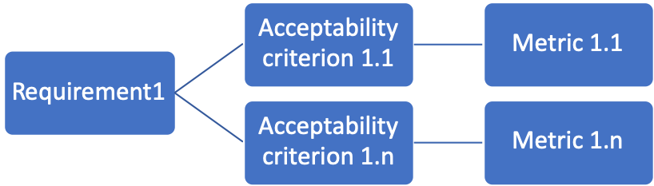
          - Criticality assessment. The purpose of the criticality assessment is to provide a method for evaluating the risk associated with inappropriate decisions being made due to the simulation's results.

          - Use history (i.e. how and when the model and simulation have been used in the past as well as references relevant historical use documents)
          - Assumptions, capabilities, limitations (i.e. the assumptions and abstractions underlying the M&S, the basic structure and mathematics of the model, limits of operation (e.g., boundary conditions) of models)
          - Data (i.e. All data used in the development and use of an M&S, the traceability of data from its source)
          - Set-up and execution (i.e. any parameter calibrations and the domain of calibration, documentation of failures, assurance that simulations and analyses are conducted within the limits of operation)
        - Verification
          - Verification plan and report (i.e. Verification techniques used and the domain of verification, Verification results, Numerical error estimates, any aspects that have not been verified)
        - Validation plan and report (i.e. Validation techniques used and the domain of validation of all models, Validation metrics and data sets used for model validation, results of validation, any aspects that have not been validated)
        - Uncertainty (uncertainty quantification processes and quantified uncertainties). It refers to referent data, input data and results, propagation of uncertainty in the model, any significant physical processes, effects, scenarios, or environments not considered in the uncertainty characterization analysis)
        - Results Robustness (i.e. Results of any sensitivity analyses performed with the M&S)
        - Reporting (i.e. all Results from the previous activities (not already explicitly mentioned), unachieved acceptance criteria, violation of assumption and violation of limits of operations, Unfavorable outcomes related to proposed use and execution of simulation)

K. M. H. Forsberg, "The relationship of system engineering to the project cycle.," in In INCOSE International Symposium, 1991
J. S. Carson, "Model Verification and Validation," in Winter Simulation Conference, 2002
ref.
ref
The verification helps to provide an assurance that a simulation will not exhibit unrealistic or unstable behavior in those areas that are not or cannot be tested, contributing to the overall credibility of the simulation.

