VMAD – SG2b Input for VMAD 08 (v.3)
Compilation Document
Background to the document
This document provides a high level overview of key concepts and issues associated with the track and real-world testing pillars of the new assessment/test method (NATM).
This document is based on, and furthermore compiles, the responses from VMAD’s subgroup 2b members concerning high level descriptions of the track testing and real world testing pillars received prior, during and following the SG2b virtual meeting on 24 June 2020.
Part 1 sets out the high level overview of key concepts and issues, whereas Part 2 sets out an analysis of the common and diverging viewpoints among SG2b members. For ease of reference, the input provided by SG2b members is set out in Annexes I, II, and III. Notes on the SG2b meeting held virtually on 24 June 2020 are set out in Annex VI.
The document’s submission to the Chairs of the VMAD IWG serves as input to the discussions on the VMAD’s NATM master document for the upcoming 1Xth VMAD meeting on 10 September 2020.

Contents
Part 1 – High Level Overview 2
Part 2 – Initial Overview of Common & Diverging Viewpoints 11
Annex I – Responses to Questions Posed to the Sub-Groups by VMAD Co-Chairs 15
1. Provide a definition of the pillar/element. What is the pillar/element? 15
2. Provide a high-level description of the various techniques that can be used by this methodology. 18
3. Identify the strengths and weaknesses of the pillar/element. What are the implications/impacts
of these strengths and weaknesses when applying the pillar/element to the NATM? 22
4. Why should the pillar/element be included within the NATM? 26
5. Discuss the maturity of the pillar/element. Is the pillar/element ready to be used now? Is there existing work? [added at the meeting between co-chairs and SG Leaders] 27
6. Discuss how the pillar/element interacts with each other. 28
7. Any other characteristics of the pillar/element 30
Annex II – JRC Contribution to NATM workplan questions concerning AV Test track testing 31
Annex III – Input from Germany: Presentation 33
Annex IV – Meeting Notes Virtual Meeting 24 June 42

Part 1 – High Level Overview

1. Track Testing

1.1. Track testing Defined
Track Testing uses a closed-access testing ground with relevant physical and/or virtual scenario elements to assess the capabilities and functional safety requirement of an ADS, including the human factors related safety requirements.
The information generated during the track-test can also be used to validate the virtual tests by comparing an ADS’ performance within a virtual test with its performance on a test track when executing the same scenario.
Due to the various strengths and limitations of track testing (e.g., the cost, fidelity) (refer to ‘Question 3’ for more information), entities may choose to use this methodology to assess safety requirements using a limited number of critical test scenarios.

1.2. High Level Description of the Methodology’s Techniques
Track testing includes physical vehicles completing specific scenarios on a closed track to assess the safety requirements of an ADS (e.g., human factors, safety system).
The methodology allows for control over many elements of the ODD, using physical or virtual inputs (e.g., vehicle-in-the-loop, which involves having a real vehicle manoeuvre around a physical space, while test scenarios/inputs are virtually transmitted) that can be controlled/defined or measured during a test.
In order to ensure that the results of the track tests are consistent, elements such as weather should be considered. For instance, rain and/or fog may be difficult to reproduce and assess. Alternatively, track tests could also be conducted under more challenging conditions, such as naturally occurring or artificial rain, in order to assess the vehicle’s performance during critical test scenarios under these more challenging conditions.
The information generated during the track-test could also be used to validate the virtual tests by comparing an ADS’ performance within a virtual test with its performance on a test track when executing the same scenario.

1.3. Strengths and Weaknesses of the Pillar
Approach | Strengths | Weaknesses
Track Testing | • Controllability – Track testing allows for control over many of the test elements, including certain aspects of the ODD.  • Fidelity – Track testing involves functional, physical ADS-equipped vehicles and lifelike obstacles and environmental conditions.  • Reproducibility – Track testing scenarios can be replicated in different locations by different testing entities.  • Repeatability – Track testing allows for multiple iterations of tests to be run in the same fashion, with the same inputs and initial conditions.  • Efficient – Compared to real-world testing, closed-course testing can accelerate exposure to known rare events or safety critical scenarios by setting them up as explicitly designed test scenarios. Road testing could be an inefficient way to observe rare events manifesting by chance.  • Track testing can be used to validate the quality of the simulation toolchain by comparing an ADS’ performance within a simulation test with its performance on a test track when executing the same scenario. | • Significant time – Track testing can take a significant amount of time to set up and execute.  • Costly – Track testing may require a substantial number of personnel and specialized test equipment (e.g., obstacle objects, measurement devices, safety driver).  • Limited variability – Track testing facility infrastructure and conditions may be difficult to modify to account for a wide variety of test elements (e.g., ODD conditions). They are restricted to their geometries, dimensions, size and ODD limitations such as weather conditions, time of day, number and type of other traffic agents.  • Safety risks – Track testing with physical vehicles and real obstacles presents a potentially uncertain and hazardous environment for the test participants (e.g., safety driver and experiment observers).  • Identifying unknown unknowns - It is difficult to envisage never-before-met-of scenarios to run through track testing that could reveal edge cases or other hazard vulnerabilities. This lowers the environmental fidelity of track testing comparing to real world testing.

1.4. Why include this Pillar in the NATM?
As per the strengths and limitation table, there are a number of reasons for including track testing in the NATM. For instance, track testing can provide a higher level of environmental fidelity than simulation. Unlike real-world testing, track testing allows for control over many of the test elements.
It can be used to validate the virtual tests.

1.5. Maturity of the Pillar
Track testing is a mature process which is used to assess safety requirements for some existing technologies; however, testing of ADS vehicles is fairly new and may need to be further refined. For instance, it may be difficult to develop specific ODD elements.

1.6. How the Pillar Interacts with Other Pillars
Track testing can be used to validate the quality/reliability of the simulation toolchain by comparing an ADS’ performance within a simulation test with its performance on a test track when executing the same scenarios. Track testing can accelerate exposure to known rare events or safety critical scenarios identified by SG1a’s work as well as real-world experiences, for example in-service monitoring and real world testing.

1.7. Next Steps – Workplan
Although substantial work has been accomplished by VMAD with regards to track tests, there are still a number of outstanding questions about the scope, concepts, and/or technical elements that need to be addressed prior to developing specific track tests for validating the safety of ADS.
For VMAD to move forward with the development of specific track tests, the following questions (among others) will need to be considered by the working group.
To note, it may be difficult to capture all elements and test procedures that need to be considered when validating the safety of an ADS. To help tackle this problem, in consultation with SG1a and the other VMAD sub-groups, SG2b could consider developing best practices/procedures for developing test procedures in phases, such as organizing its workplan according to specific ODD and micro ODD elements, while also considering critical and nominal scenarios.
- Identify best practices/procedures that currently exist regarding track-testing. Identify technical resources/tools that still need to be developed (or what externally developed resources should be referenced in the NATM). What are supporting components of the methodology (e.g., dictionary of terms, scenarios from SG1a)?
- In consultation with SG1a, identify the scenario elements of an ODD that can be reliably reproduced in a test procedure (e.g., different roadway layouts; interactions with a variety of different types of road users and objects exhibiting static or dynamic behaviours; and, environmental conditions, among many others factors), including how they are measured.
- Determine the various levels of abstraction of scenarios required for track test scenarios.
- Outline/describe the various methods/procedures for track testing that could be used to assess an ADS’ safety requirements.
- Identify the information/data produced using track testing that can provide a clear, objective assessment of the ADS performance.
- Identify how track testing could be used to validate specific functional safety requirements established by FRAV. Which functional requirements can be partially assessed by track testing (e.g., system safety, operational design domain, object and event detection and response (OEDR), human factors)?
- Identify how track testing could be used to validate the results of specific virtual tests.

2. Real-world Testing

2.1. Real-world testing Defined
Real-world testing uses public roads to test the capabilities and compliance with safety requirements (e.g., human factors, safety system) of an automated driving system (ADS) or of a vehicle with an ADS in real-world traffic scenarios. Real-world testing is the ultimate way to demonstrate an ADS can safely operate within its true operating environment.
In addition, real-world testing can be used to collect data (e.g., through vehicles that are fitted with sensors and conventionally driven) to identify and record new traffic scenarios and improve the environmental validity of track and virtual testing methodologies.

2.2. High Level Description of the Methodology’s Techniques
This testing approach uses public roads to test compliance with safety requirements of an ADS.
This testing method can expose the ADS to a wide variety of real-world conditions related to an operational design domain (ODD). There are various approaches to real-world testing. For example, tests can be done within a specific ODD (e.g., highway driving) with a safety driver who is monitoring/ensuring the ADS is functioning safely.
Although it may not be possible to encounter all traffic scenarios during a real-world test, the likelihood of covering specific complex scenarios could be increased by selecting a specific type of ODD (e.g., highway) and examining when and where specific elements (e.g., high- or low-density traffic) typically occur.
Another possible method within the real-world is conducting tests in a ‘shadow mode’. For instance, a vehicle could be operated by a human with the ADS functioning in the background, receiving data from various sensors, interpreting the information, and making decisions but not controlling the vehicle. These decisions are recorded and compared to the decisions/actions of the human driver. If there is a decision by the ADS that is different than how the human operated the vehicle, then the assessor can attempt to decipher what the differences were and how critical the difference in the proposed actions by the ADS are compared to the human’s actions.
Specific infractions identified during real-world testing may be later reviewed/assessed by evaluating the information/data using track and real-world testing. In addition, real-world testing data can be collected (e.g., through vehicles that are fitted with sensors and conventionally driven) to identify and record new traffic scenarios and improve the environmental validity of track and virtual testing methodologies.

2.3. Strengths and Weaknesses of the Pillar
Approach | Strengths | Weaknesses
Real World/ Open Road Testing | • High environmental validity – allows for validation of the vehicle in its intended ODD(s) and the diverse conditions these may present.  • Can be used to test scenario elements, such as weather and infrastructure (e.g., bridges, tunnels), that are unavailable through track testing  • Identifying unknown unknowns – allows for the identification of edge cases and other unknown hazard vulnerabilities that challenge the ADS.  • Data collection – Real world data can be collected and used to identify new traffic scenarios and improve the environmental validity of track and simulation testing methodologies.  • Real-world testing may be used to validate the simulation and track-testing by comparing an ADS’ performance within a simulation and track test with its performance on in a real-world environment when executing the same scenario.  • ‘Shadow/silent mode’ (i.e., the human test driver is operating the vehicle and the ADS operates in the background without executing any controls). This testing can be used to collect data to determine the coverage of the overall assessment. | • Restricted controllability – Public-road scenarios affords a limited amount of control over ODD conditions.  • Restricted reproducibility – Public-road scenarios are difficult to replicate exactly in different locations.  • Restricted repeatability – Public-road scenarios are difficult to repeat exactly over multiple iterations.  • Limited scalability – Public-road scenarios may not scale up sufficiently.  • Costly – Requires a number of resources and is time-consuming  • Potential impact on traffic and safety authorities  • Model, single software, and toolchain validation  • User’s level of expertise impacts results of tests  • New competencies must be developed by authorities  • Safety risks: on-road testing could subject test personnel and the public to significant risks of unsafe behavior.

2.4. Why include this Pillar in the NATM?
Real-world testing may be used to validate if a portion of the simulation and track-testing environment were modelled properly by comparing an ADS’ performance within a simulation and track test with its performance on in a real-world environment when executing the same scenario.
Real-world testing to assess the safe behaviour of the ADS within its true operating environment.

2.5. Maturity of the Pillar
Real-world testing is regularly conducted to assess the performance of human drivers, including such methods as gathering data or shadow driving. However, testing of ADS performance may pose some new challenges for this test methodology. Experiences could be drawn from other motor vehicle-related real-world testing schemes, such as real driving emissions (RDE) testing and market surveillance.

2.6. How the Pillar Interacts with Other Pillars
Real-world testing may be used to validate if portions of a virtual and/or track-testing environment were modelled properly by comparing an ADS’ performance within a simulation and track test with its performance on in a real-world environment when executing the same test scenario.
It can also be used to identify new traffic scenarios for track and virtual testing, allowing for the identification of edge cases and other unknown hazard vulnerabilities that could challenge the ADS. The information gathered from real world testing can also be used in the hazard and risk analysis and design of the ADS systems.
In order to help ensure the safety of road users, real-world tests should be conducted after the ADS has successfully completed various track tests and/or virtual tests.

2.7. Next Steps – Workplan
Although substantial work has been accomplished by VMAD with regards to real-world testing, there are still a number of outstanding questions about the scope, concepts, and/or technical elements that need to be addressed prior to developing specific real-world tests for validating the safety of ADS.
For VMAD to move forward with the development of specific real-world, the following questions (among others) will need to be considering by the working group.
To note, it can be difficult to capture all elements and test procedures that need to be considered when validating the safety of an ADS. To help tackle this problem, in consultation with SG1a and the other VMAD sub-groups, SG2b could consider developing best practices/procedures in phases, such as organizing its workplan according to different ODD and micro ODD elements, while also considering critical and nominal scenarios.
- Further discussion is required on the scope of real-world testing:
  - whether it concerns all real-world testing including testing op public roads during the development of automated driving systems;
  - whether it concerns only the testing on public roads for the purpose of assessing the safety of vehicles with automated driving systems; or
  - whether it concerns both.
- Identify best practices/procedures that currently exist regarding real-world testing? Identify technical resources/tools that still need to be developed (or what externally developed resources should be referenced in the NATM). What are supporting components of the methodology (e.g., dictionary of terms, scenarios from SG1a)?
- In consultation with SG1a, identify the scenario elements of an ODD that can be reliably reproduced in a real-world test procedure (e.g., different roadway layouts; interactions with a variety of different types of road users and objects exhibiting static or dynamic behaviours; and, environmental conditions among many others factors), including how they are measured?
- Determine the various levels of abstraction of scenarios for real-world test scenarios.
- Outline/describe the various methods/procedures for real-world testing that could be used to assess an ADS’ safety requirements.
- Identify the information/data produced using real-world testing that can provide a clear, objective assessment of the ADS performance.
- Identify how real-world testing could be used to assess specific functional safety requirements established by FRAV. Which functional requirements can be partially assessed by real-world testing (e.g., system safety, operational design domain, object and event detection and response (OEDR), human factors)?
- Identify how real-world testing could be used to validate the results of specific virtual and track tests.

Part 2 – Initial Overview of Common & Diverging Viewpoints

This second part aims to provide an overview of common and diverging viewpoints among the submitted responses and the feedback received prior, during, and following the SG2b meeting of 24 June, with the intention of providing a basis for discussions during the upcoming VMAD meeting on 10 July.
The overview of common viewpoints should not be regarded as the official position of SG2b, but instead seen as guidance to the Chairs of VMAD on issues where, at VMAD level, a general agreement may be reached rather easily.
The diverging viewpoints also include those viewpoints which have been expressed by only one or several parties, but not by all parties. This does not necessarily mean that this is a diverging viewpoint, but instead that in such case, further discussion is required in order to identify whether this is indeed a diverging viewpoint – either at VMAD level or during a future meeting of SG2b.

1. On the definition and elements (covering questions 1 & 2)

1.1. Commonalities
1.1.1. On the definition and elements of track testing
- To be used to assess the system’s capabilities and functionalities in meeting the requirements during nominal and critical driving scenarios.
- To be used as validation of simulation assessments.
1.1.2. On the definition and elements of real world testing
- To be used to assess the system’s capabilities and functionalities in meeting requirements when driving in real traffic.
- To be used to assess the validity of the safety demonstration by the manufacturer / validity of the audit assessments.

1.2. Divergences
1.2.1. On the definition and elements of track testing
- Several parties highlighted the use of track testing for the verification/assessment of human factors, however this was not (explicitly) mentioned by all parties.
- One party made reference to evaluating sub-systems, in addition to fully assembled systems. Evaluating of sub-systems was not mentioned by other parties.
- Several parties make reference to the testing of the system, whereas others make reference to the testing of the vehicle.
- Different techniques were mentioned by different parties (data/video recording, driving robot, physical inputs, virtual external inputs).
- Differing opinions on the (weather) conditions with which track tests should be carried out, with one party suggestion to use track test for additional tests under unideal weather conditions.
- One party suggesting to use track test to assess the vehicle’s behaviour when reaching the borders of the respective ODD.
- One party suggested that track testing could also be used to validate the performance of a failed system.
1.2.2. On the definition and elements of real world testing
- Diverging opinion on the assessment of non-nominal traffic scenarios during real world testing, with regards to both their requirement to be encountered during real world tests as well as their inclusion in the assessment if encountered during real world assessments.
- The possibility to collect real-world testing data to be used for the identification of new traffic scenarios and the improvement of the environmental validity of track and virtual testing methodologies was only mentioned by one party.
- Several parties highlighted the use of real world testing for the verification/assessment of human factors, however this was not (explicitly) mentioned by all parties.
- Diverging opinions on the length and quantity of real world testing.
- Further discussion required on the design (parameters) of the real world tests, for example in terms of what [traffic scenarios/situations/conditions] should be covered, how it should be designed to ensure that many of the traffic scenarios may occur, etc.
- The way in which the ‘test matrix’ would be applied, as well as the entity to develop the test matrix.
- Different techniques and concepts were mentioned by different parties (data/video recording, driving robot, data post-processing with big data analyzation, the use of shadow modes, safety envelopes).
- Several parties make reference to the testing of the system, whereas others make reference to the testing of the vehicle.

2. On why the pillar/element should be included (covering question 4)

2.1. Commonalities
2.1.1. On track testing
- Higher fidelity than simulation
- Opportunity to test critical scenarios
2.1.2. On real world testing
- Ultimate way/environment for the assessment.

3. On maturity of the pillar (covering question 5)

3.1. Commonalities
3.1.1. On track testing
- Considered mature
3.1.2. On real world testing
- Experiences can be drawn from other motor vehicle related areas (RDE, market surveillance, human driver assessments)

4. On the interaction between pillars (covering question 6)

4.1. Commonalities
4.1.1. On track testing
- Validation of simulation assessments.
4.1.2. On real world testing
- Validation of previous/other assessments.

4.2. Divergences
4.2.1. On real world testing
- Several parties stated that real world testing should be later in the assessment process, following positive assessments in other pillars. One party stated that it should not be necessary to carry out the test methods in a specific order.

Annex I – Responses to Questions Posed to the Sub-Groups by VMAD Co-Chairs

1. Provide a definition of the pillar/element. What is the pillar/element?

1.1. Track Testing

1.1.1. Input from Canada:
Track Testing uses a closed-access testing ground with relevant physical and or virtual scenario elements to test the capabilities and functioning of an ADS and/or its subsystems. In addition, track testing can be used to validate the quality of the simulation toolchain by comparing an ADS’ performance within a simulation test with its performance on a test track when executing the same scenario.

1.1.2. Input from OICA/CLEPA:
- The purpose is to determine the system's ability to meet functional requirements during nominal and critical driving conditions.
- The data generated during the test can also be used for validation of manufacturers simulation data.
- The outcome of these tests are used to support the audit/assessment

1.1.3. Input from ETSC:
The track test assesses the automated driving system’s compliance with the minimum performance requirements (functional requirements) during normal and notably critical traffic situations. It also serves to confirm the audit assessment of the interaction with the driver/user, notably during the critical traffic situations.

1.1.4. Input from CIECA:
In addition to the input already delivered by members of SG 2b, CIECA wants to insert and pay attention to the role of the human driver in an automated vehicle and especially the interaction between the vehicle and the driver: the HMI (Human Machine Interface) or the “handover” of driving from vehicle to the (human) driver.

1.2. Real World Testing

1.2.1. Input from the JRC:
The real world test puts the verified system to the test in scenarios or situations that the system would likely encounter in everyday driving after its release.
The first purpose is to confirm that the safety demonstration by the manufacturer is valid and is implemented on the vehicle. The second purpose is to check that the vehicle shows minimum performances for standard manoeuvres (e.g. normal lane keeping lane change), key critical scenarios (e.g. emergency braking) and key traffic conditions (e.g. smooth integration in the traffic, weather conditions).

1.2.2. Input from Canada:
Real-world Testing uses public roads to test the capabilities ADS in real-world traffic situations. In addition, real-world testing data can be collected (e.g., through vehicles that are fitted with sensors and conventionally driven) to identify and record new traffic scenarios and improve the environmental validity of track and virtual testing methodologies.

1.2.3. Input from OICA/CLEPA:
- The purpose is to confirm the system's ability to meet functional requirements during nominal driving conditions as well as its natural behavior in real world traffic.
- The outcome of these tests are used to support the audit/assessment

1.2.4. Input from ETSC:
The real world tests assess the vehicle’s compliance with minimum performance requirements as well as its behaviour in real world conditions. It also serves to confirm the audit assessment of the interaction with the driver/user.
Clarification based on the SG2b meeting on 24 June 2020: We call for the vehicle to be assessed based on its performance during the full real world tests. We call for the real world tests to require certain common traffic scenarios to be encountered based on the ODD (e.g. navigate a roundabout safely, navigate a crossing safely, etc), in order to ensure the representativeness of such real world tests. If a vehicle encounters uncommon or even critical situations during the real world tests, we feel that these should be included as part of the assessment of the vehicle’s performance during the specific real world test. However, as it cannot be guaranteed that these uncommon or critical situations will be encountered during real world tests, we suggest that these situations are only assessed ‘if encountered’, rather than as ‘required to be encountered’ during the real world tests.

1.2.5. Input from CIECA:
In addition to the input already delivered by members of SG 2b, CIECA wants to insert and pay attention to the role of the human driver in an automated vehicle and especially the interaction between the vehicle and the driver: the HMI (Human Machine Interface) or the “handover” of driving from vehicle to the (human) driver.

2. Provide a high-level description of the various techniques that can be used by this methodology.

2.1. Track Testing

2.1.1. Input from China:
For the track test, the following techniques would be used:
- data/video recording synchronizely
- driving robot.

2.1.2. Input from Canada:
Track test: This testing approach allows for physical vehicles to be tested through a set of realistic scenarios (based on the test track’s geometries, dimensions, size, and the ODD) to evaluate either target sub-systems and/or the fully assembled system. This testing methodology can use physical or virtual external inputs (i.e., vehicle-in-the-loop, which involves having a real vehicle manoeuvre around a physical space, while test scenarios/inputs are virtually transmitted) that can be controlled or measured during a test.

2.1.3. Input from OICA/CLEPA:
- The track tests will be carried out with high levels of fidelity in a discrete number of scenarios.
- These tests can be precisely defined such that tests can be repeated and reproduced regardless of the entity conducting the assessment.
- Track tests should be carried out in ideal/ good conditions - rain / fog etc should not be considered as difficult to reproduce.

2.1.4. Input from ETSC:
- Assess compliance with minimum performance requirements during normal and critical traffic scenarios.
- Serves as a tool to validate the audit assessments on interaction with the driver/user, notably during critical traffic scenarios.
- Serves as a tool to in addition to ideal weather conditions, also validate the system’s performance during unideal weather conditions, such as for example rain, heavy rain, fog, glare from sunlight, etc.

2.1.5. Input from CIECA:
On a test track the vehicle will be tested on specific scenarios where the circumstances can be varied in order to see how the vehicle will react to specific circumstances (putting the vehicle under pressure). Once entering the borders of its ODD we want to know how the vehicle behaves and whether and how it will hand over control to the driver whenever necessary.

2.2. Real World Testing

2.2.1. Input from China:
For the real-world test, the following techniques would be used:
- data/video recording synchronizely
- data post-processing with big data analyzation.

2.2.2. Input from the JRC:
Evaluation of the entire system under its use environment during real world operation. The safety envelope, ODD related including but not limited to environment, weather, and also vehicle dynamics shall be recorded during the real world test.

2.2.3. Input from Canada:
Real-world testing: uses public roads to support the testing and evaluation of ADS. This testing method exposes the ADS to a wide variety of real-world conditions related to the ODD and OEDR. There are various approaches to real-world testing. For example, tests can be done to assess full system performance in a real-world, unpredictable, and uncontrollable environment, allowing the ADS to operate with a safety driver who is monitoring/ensuring the vehicle is functioning safely.
Another possible method within the real-world is conducting tests in a ‘shadow mode’ (i.e., the human test driver is operating the vehicle and the ADS operates in the background without executing any controls). For instance, a car can be driven by a human and with the ADS operating in the background, receiving data from various sensors but not controlling the car. The ADS makes decisions about how to drive based on the sensor inputs. These decisions are recorded and compared to the decisions/actions of the human driver. If there is a decision by the ADS that is different than how the human operated the vehicle, then the entity can attempt to decipher what the differences were and how critical the difference is so that it can be rectified.
In addition, real-world testing data can be collected (e.g., through vehicles that are fitted with sensors and conventionally driven) to identify and record new traffic scenarios and improve the environmental validity of track and virtual testing methodologies.

2.2.4. Input from OICA/CLEPA:
- The real world assessment can be done objectively. Any possible infractions during the test may be later reviewed by evaluating the world model data with any external testing equipment.
- The real world test route should be chosen with the objective to cover a realistic number of traffic scenarios.
- It may not be possible to encounter all chosen traffic scenarios during the test as it is impossible to control other actors and infrastructure status.
- The previously referenced ‘test matrix’ should only be applicable to nominal driving conditions.
- It is difficult to define a standard test matrix for all possible ADS / ODD combinations. The test matrix should therefore be developed by the OEM/TAA. The framework could include an example of such a test matrix.

2.2.5. Input from ETSC:
- Sufficient real world tests to validate the compliance with minimum requirements as well as the vehicle’s behaviour for the envisaged ODD.
  - Includes for example real world assessments during both night and day, if the vehicle is designed to operate during both times of the day.
- Based on a test matrix developed as part of the regulatory framework.
- To require mandatory elements to be covered and passed during the real world assessments as well as optional elements that need to be passed if encountered during the real world assessment.
- All situations encountered during the real world tests should be assessed.
- Serves as a tool to validate the audit assessments on interaction with the driver/user.

2.2.6. Input from CIECA:
In real world traffic however we want to see how the vehicle behaves in its natural habitat. Instead of testing how the vehicle will react in a specific (artificial) situation to a certain situation we want to know how the vehicle (system) deals with a variety of (traffic) situations that might occur all together. In other words: in real world traffic there are many variables at once the vehicle has to respond to.
For the development of this test specific in traffic courses could be designed. It is impossible to test all the elements as mentioned in the test matrix in one or two in traffic tests (in contrary to testing on a test track). This means in traffic tests should be designed in a way there is a chance that many traffic situations might occur. And as already mentioned, the added value of this test is in the combination of tasks to be performed by the vehicle (system) as they appear in daily traffic; sometimes rather complex and unexpected (edge cases). A very important issue in these cases is the interaction between the human driver and the automated vehicle (hand over).

3. Identify the strengths and weaknesses of the pillar/element. What are the implications/impacts of these strengths and weaknesses when applying the pillar/element to the NATM?

3.1. Track Testing And Real World Testing Combined

3.1.1. Input from China:
 | Strengths | Weakness
Track test | It can be verified for typical and extreme conditions. To make up for the shortage of simulation test and open road test. The consistency and repeatability of the scene can be guaranteed. | The number of test scenarios is limited, and the test scenarios cannot be completely equivalent to the real environment.
Real-world test | High environmental validity—real-world test would be the closest to the actual situation among the multi-pillars. And in comparison to the regular and idealized scenarios in track or simulation test, actual situation would be a strict test.  Abundant traffic conditions—real-world would be used to identify new traffic conditions. And actual conditions | Safety risks—real-world test would be executed on open road with unwitting traffic participants. There is potential risk.  Time costly-- Requires a number of resources and is time-consuming.

3.1.2. Input from Canada:
The following text is a revised version of the ‘Strengths and Weaknesses’ table found in the NATM Master Document:
Approach | Strengths | Weaknesses
Track Testing | • Controllability – Track testing allows for control over many of the test elements, including certain aspects of the ODD.  • Improved fidelity – Track testing involves functional, physical ADS-equipped vehicles and lifelike obstacles and environmental conditions.  •Reproducibility– Track testing scenarios can be replicated in different locations.  • Repeatability – Track testing allows for multiple iterations of tests to be run in the same fashion, with the same inputs and initial conditions.  • Efficient – Compared to real-world testing, closed-course testing can accelerate exposure to known rare events or safety critical scenarios by setting them up as explicitly designed test scenarios. Road testing could be an inefficient way to observe rare events manifesting by chance.  • Track testing can be used to validate the quality of the simulation toolchain by comparing an ADS’ performance within a simulation test with its performance on a test track when executing the same scenario. | • Significant time –Track testing can take a significant amount of time to set up and execute.  • Costly – Track testing may require a substantial number of personnel and specialized test equipment (e.g., obstacle objects, measurement devices, safety driver).  • Limited variability – Track testing facility infrastructure and conditions may be difficult to modify to account for a wide variety of test elements (e.g., ODD conditions). They are restricted to their geometries, dimensions, size and ODD limitations such as weather conditions, time of day, number and type of other traffic agents.  • Safety risks – Track testing with physical vehicles and real obstacles presents a potentially uncertain and hazardous environment for the test participants (e.g., safety driver and experiment observers).  • Identifying unknown unknowns - It is difficult to envisage never-before-met-of scenarios to run through track testing that could reveal edge cases or other hazard vulnerabilities. This lowers the environmental fidelity of track testing comparing to real world testing.
Real World/ Open Road Testing | • High environmental validity – allows for validation of the vehicle in its intended ODD(s) and the diverse conditions these may present.  • Can be used to test scenarios elements, such as weather and infrastructure (e.g., bridges, tunnels), that are unavailable through track testing  • Identifying unknown unknowns – allows for the identification of edge cases and other unknown hazard vulnerabilities that challenge the ADS.  • Data collection – Real world data can be collected and used to identify new traffic scenarios and improve the environmental validity of track and simulation testing methodologies.  • Real-world testing may be used to validate the simulation and track-testing by comparing an ADS’ performance within a simulation and track test with its performance on in a real-world environment when executing the same scenario.  • ‘Shadow/silent mode’ (i.e., the human test driver is operating the vehicle and the ADS operates in the background without executing any controls). This testing can be used to collect data to determine the coverage of the overall assessment. | • Restricted controllability – Public-road scenarios affords a limited amount of control over ODD conditions.  • Restricted reproducibility – Public-road scenarios are difficult to replicate exactly in different locations.  • Restricted repeatability – Public-road scenarios are difficult to repeat exactly over multiple iterations.  • Limited scalability – Public-road scenarios may not scale up sufficiently.  • Costly – Requires a number of resources and is time-consuming  • Potential impact on traffic and safety authorities  • Model, single software, and toolchain validation  • User’s level of expertise impacts results of tests  • New competencies must be developed by authorities  • Safety risks: on-road testing could subject test personnel and the public to significant risks of unsafe behavior.

3.2. Track Testing

3.2.1. Input from OICA/CLEPA:
- The extent to which it can be used is limited due to environmental constraints as a track environment cannot fully replicate the conditions of a given ODD.

3.3. Real World Testing

3.3.1. Input from the JRC:
Strengths:
- Whatever risk analysis, design and validation that was made by the manufacturer, the ability of the AD to cope with real life scenarios will only be fully demonstrated when the vehicle is used on the road.
- Real-world testing provides a high degree of environmental fidelity.
- It allows differing levels of coverage, environmental control, environmental fidelity;
- Furthermore, test track scenarios can be potentially difficult to develop and implement, especially if there are numerous or complex scenarios, involving a variety of scenario elements.
- Real road testing can complement the test track tests for conditions (weather, visibility, asphalt…) and infrastructure (tunnels, bridges, different curves radius, long stretches of road works…) that cannot be reproduced in a test track.
- Data collection – Real world data collected can be used to identify new traffic scenarios and improve the environmental validity of track and simulation testing methodologies.
- Real-world testing may be used to validate the simulation and track-testing by comparing an ADS’ performance within a simulation and track test with its performance on in a real-world environment when executing the same scenario.
Weaknesses:
- Using only real-world testing could be costly, time-consuming and can pose safety risks. Moreover, it presents limited repeatability, reproducibility and scalability.
- Restricted controllability – Public-road scenarios may not allow much, if any, control over ODD conditions.

3.3.2. Input from OICA/CLEPA:
- The time and scope of the real-world test will be small in comparison, so will be limited to confirming the system's ability to either meet specific functional requirements e.g. demonstrating compliance to road traffic laws or interaction with other road users.

4. Why should the pillar/element be included within the NATM?

4.1. Input from China:
There are some differences between the simulation test results and the track test results, and the real-world test cannot cover the limit scenario. So track tests are needed.
For the real-world test, the ultimate usage environment is the open road and real world. So the test in its ultimate environment would be essential.

4.2. Input from the JRC:
Is the only method that allows assessing the vehicle (including all the systems) in scenarios or situations that it would likely encounter in everyday driving once on the public roads.
Whatever risk analysis, design and validation that was made by the manufacturer, the ability of the AD to cope with real life scenarios will only be fully demonstrated when the vehicle is used on the road. Therefore, to minimize “unknown” scenarios and take into account the uncertainties related to real world operation of ADS, a feedback loop should be established by manufacturers to learn from the operational experience and improve the technology. It will also be used to confirm the safety demonstration to authorities and could also be used to draw lessons learnt (safety recommendations) derived from real-life driving experience, allowing for scenarios catalogue continuous update.

4.3. Input from Canada:
Track Test: In addition to this test method providing a higher level of environmental fidelity than simulation, it provides an opportunity to test the vehicle with less danger than what is likely posed within real-world tests.
Real-world testing: Real-world testing may also be used to validate whether portions of simulation and track-testing environment were modelled properly by comparing an ADS’ performance within a simulation and track test with its performance on in a real-world environment when executing the same scenario. Moreover, it is the ultimate way to demonstrate an ADS’ safe behaviour within its true operating environment.

5. Discuss the maturity of the pillar/element. Is the pillar/element ready to be used now? Is there existing work? [added at the meeting between co-chairs and SG Leaders]

5.1. Track Testing

5.1.1. Input from China:
The track test technology is mature, and the site conditions and equipment conditions can meet the test requirements.

5.1.2. Input from Canada:
Track testing is a mature process which is used for validation of many existing technologies, however testing of ADS vehicles and augmented reality testing is fairly new and may need to be further refined.

5.1.3. Input from OICA/CLEPA:
- Track testing has been used for many years and is mature enough to be included as a pillar.

5.2. Real World Testing

5.2.1. Input from China:
I think the real-world test has enough maturity to be used. In traditional field of vehicle development, road test is an existing process. And the open-road test for ADS is popular in many international cities.

5.2.2. Input from the JRC:
Currently there is little progress on this regard. Nonetheless, potentially, there should be a large amount of information and approaches as OEMs use on-road testing to verify and validate their systems.
Using the experience from technical services and OEMs, together with other regulatory frameworks such as the RDE procedure and the safety market surveillance, will allow increasing the pace to develop a robust real world safety procedure.

5.2.3. Input from Canada:
Real-world testing is regularly conducted to assess the performance of human drivers, gathering of data or shadow driving is also conducted regularly; however, testing of ADS performance may pose some new challenges.

5.2.4. Input from OICA/CLEPA:
- Manufacturers and authorities have experience with real world testing from RDE Testing. A similar approach should be applied to ADS testing.

6. Discuss how the pillar/element interacts with each other.

6.1. Track Testing

6.1.1. Input from China:
Simulation test results can be entered into the track test to verify the reliability of the simulation test results. At the same time, the track test focuses on typical scenarios and extreme scenarios to make up for the shortcomings of the real-world test.

6.1.2. Input from Canada:
As per the strengths and weaknesses table above, track testing can be used to validate the quality of the simulation toolchain by comparing an ADS’ performance within a simulation test with its performance on a test track when executing the same scenarios. Track testing can accelerate exposure to known rare events or safety critical scenarios identified by real-world testing.

6.2. Real World Testing

6.2.1. Input from China:
For the real-world test, I think it would be the later process among the validation system. To interact well, the division would be designed in high-level. And safety is the baseline of real-world test.

6.2.2. Input from the JRC:
The AV shall be verified to be safe by virtual test, test track and other methods. The assessment of these methods shall result in a positive result before it is allowed to drive in real-world testing. The real-world testing is one of necessary parts of multi-pillars methods and the last step before vehicle is released for production. Moreover, data obtained during real world testing and assessment feeds all the previous pillar/element.
Data collection – Real world data collected can be used to identify new traffic scenarios and improve the environmental validity of track and simulation testing methodologies.

6.2.3. Input from Canada:
Real-world testing may be used to validate whether portions of simulation and track-testing environment were modelled properly by comparing an ADS’ performance within a simulation and track test with its performance on in a real-world environment when executing the same scenario.
It can also be used to identify new traffic scenarios for track and virtual testing, allowing for the identification of edge cases and other unknown hazard vulnerabilities that challenge the ADS. The information gathered from the real world can also be used in the hazard analysis and design of the ADS systems.

6.3. Track Testing and Real World Testing Combined

6.3.1. Input from OICA/CLEPA:
- Traffic scenarios should be described in a manner which allows application across multiple assessment types (simulation, track test and real-world testing).
- It is not expected that a single assessment type can be used to assess all functional requirements.
- The functional requirement being assessed will have an impact on the assessment method. e.g.
  - Path planning and control via simulation
  - HMI or Fall back response via track test
  - Interaction with other road users via real world test
In general, the Audit consist of methods which are used to assess functional/operational safety. Performance data that is used in the assessment will be generated by virtual tests, track tests and real world tests. These tests can be done in parallel as they will likely be used to test different functional requirements. It should not be necessary to carry out these test methods in a specific order.

6.3.2. Input from ETSC:
- Track tests should only be performed once the audit/simulation assessments have demonstrated desirable levels of safety.
- Real world tests should only be conducted after track tests have been successfully passed, in order to guarantee a certain level of safety for all road users during the real world test drives.

7. Any other characteristics of the pillar/element

7.1. Input from the JRC:
This pillar/element provides the ground for the evaluation of the entire system under its use environment. It allows:
- Assessment of safety during real world operation
- Covers real world scenarios, not only those assed during track-test (Weather, light, road pavement, real world scenarios,)
- Shall be representative of real world road user interactions
- Shall be representative of real world use and driving dynamics (traffic flow)

Annex II – JRC Contribution to NATM workplan questions concerning AV Test track testing
The following the answers to the questions to be considered as part of workplan development. On request of VMAD chairs, we reviewed the suggested questions and proposed some answers.
Q: Which of the scenarios developed by VMAD can be reliably used to partially validate the safety of an AV through track testing and the quality of the simulation model?
A: The scenarios should be the ones that are safety critical and that falls within the ODD of the vehicle. Scenario reproducing the system disengagement when at the ODD threshold should also be tested in the test track. Tests should be done with a random selection of a number of scenarios within the set range (ODD) the day of the test.
Q: What are the safety-critical elements that should be tested on track? What is safety critical element/scenario.
A: The tests should detect whether the manufacturer safety demonstration is valid and is implemented in the vehicle. Tests should also check that the vehicle shows minimum performances for standard manoeuvres (e.g. normal lane keeping, lane change, LDW), key critical scenarios (e.g. emergency braking with different targets, collision avoidance) and key traffic conditions (e.g. smooth integration in the traffic, respect of traffic rules) also disengagement when passing the ODD threshold.
Q: Which scenario elements can be reliably reproduced in a test procedure?
A: This is a very broad question as it depends on the scenario. All vehicle dynamics and braking conditions can be reproduced. Traffic participants can be reproduced with target foam vehicles and VRU dummies also buildings, traffic lights, sidewalks, trees and posts can be reproduced. Multi road users and combined scenarios can also be reproduced. Asphalt conditions can be reproduced, night and day conditions as well. Weather conditions can not all be reproduced, wind for example yes but poor visibility, snow and rain not artificially.
Q. What data would provide a clear, objective assessment of the vehicle performance?
A: Pass or fail on definite test thresholds, no scores.

Q: What best practices/procedures related to track testing should be captured in the NATM? What technical resources/tools still need to be developed (or what externally developed resources should be referenced in the NATM)?
A: From our testing experience, tests should focus on vehicle functions. Test parameters should be chosen randomly from a set of scenarios and related parameters within the set range given by the vehicle ODD. Multiple scenarios should be tested simultaneously e.g vehicle passing through 2 parked vehicles one on each side (no false alarm for AEB) with a stopped vehicle some meters in front (AEB).

Annex III – Input from Germany: Presentation
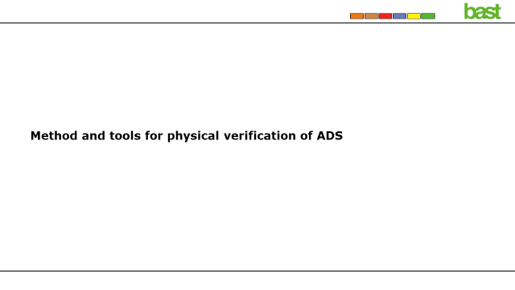

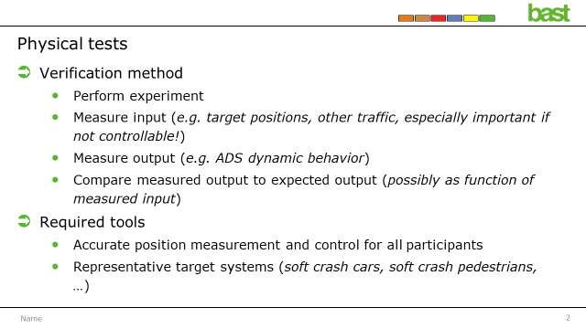

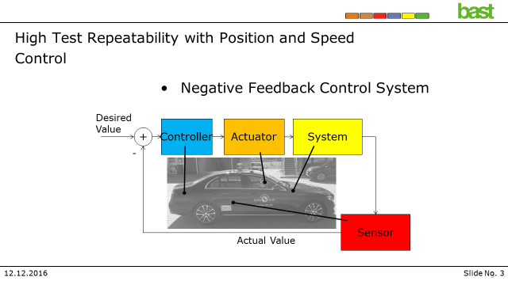

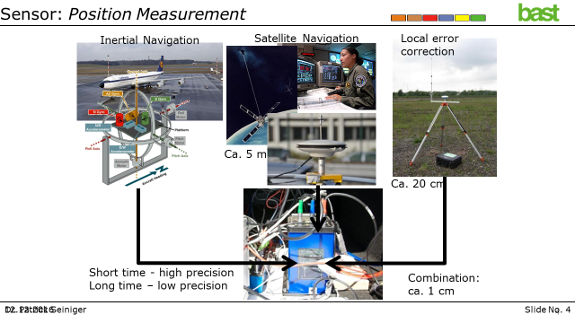

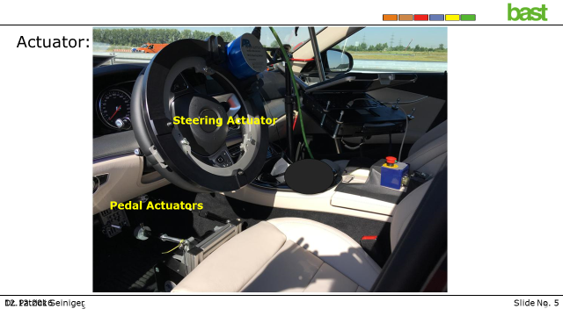

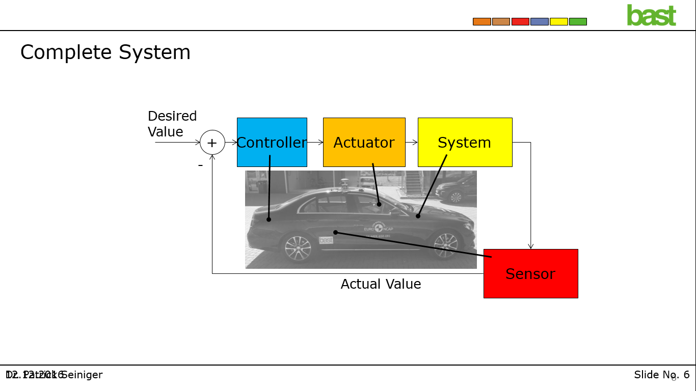

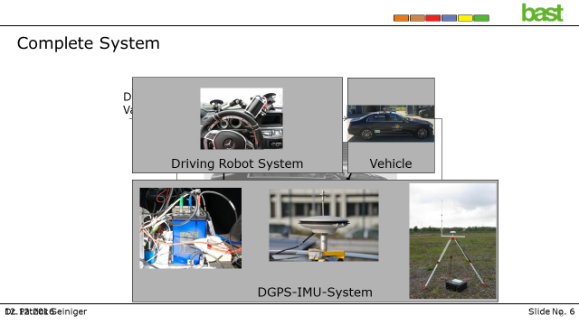

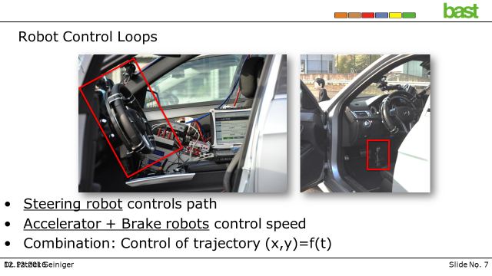

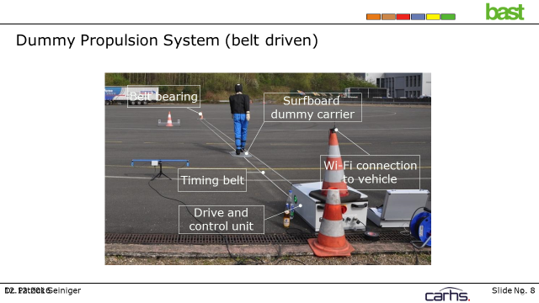

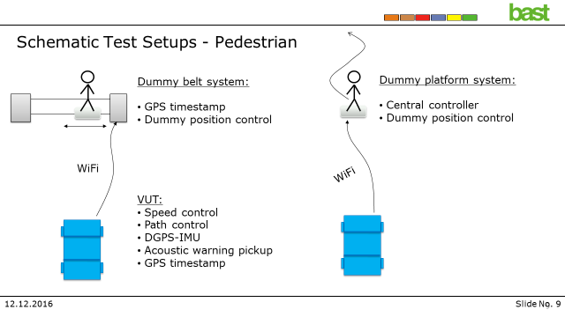

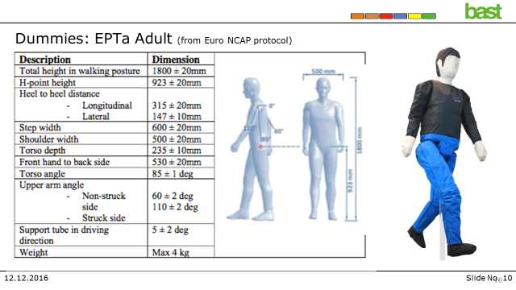

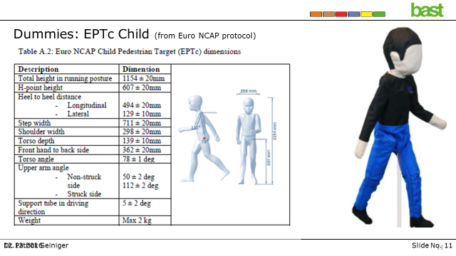

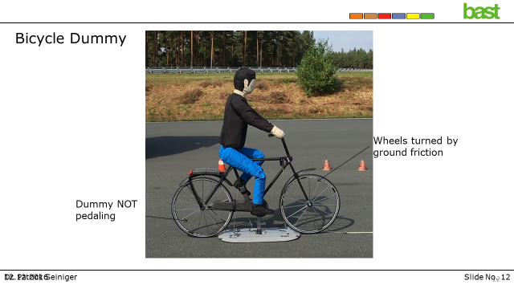

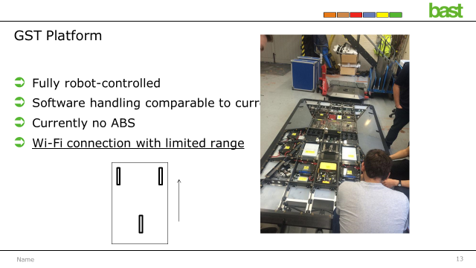

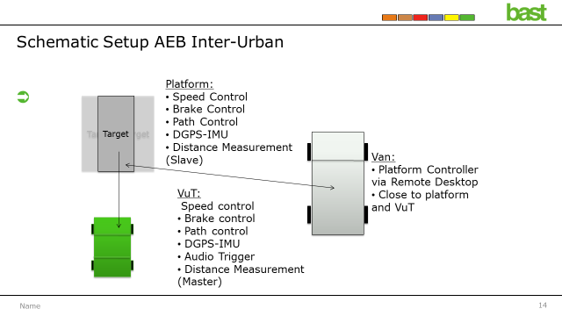

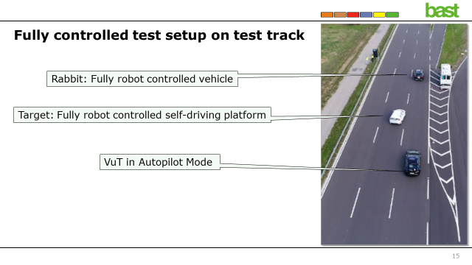

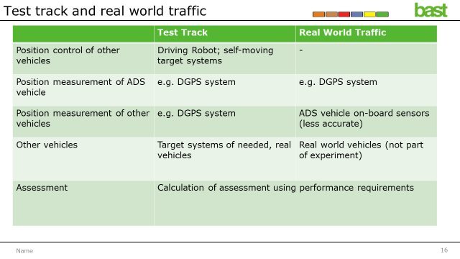

Annex IV – Meeting Notes Virtual Meeting 24 June
SG2b Leader welcomed the participants, informed them about the outline of the meeting, and stated that the goal was to discuss the compilation document that would be submitted to the Chairs of VMAD as input for the discussions during the upcoming VMAD meeting on 10 July.
SG2b Leader introduced the first question included in the compilation document: Provide a definition of the pillar/element. What is the pillar/element?
OICA/CLEPA indicated that their understanding of the purpose of track testing is used to assess nominal and critical scenarios that may not be appropriate during real world testing, but you benefit from high degrees of fidelity compared to virtual testing. Real world testing would purely be to confirm the system’s ability to meet certain functional requirements during nominal driving conditions. These nominal driving conditions could be complex, for example driving through the cross roads with a lot of road users and pedestrian surrounding the vehicle, but the scenarios would be nominal – would not be trying to assess cut-in scenarios or critical scenarios that may need large intervention from the vehicle.
ETSC indicated that all traffic situations encountered [during the real world tests] should be included in the assessment. Although it cannot be guaranteed that all traffic scenarios are encountered, the assessment should focus on the whole trip and not only the nominal driving conditions.
OICA/CLEPA clarified its position that relatively rare scenarios, such as a cut-in vehicle or a sharp deceleration, should not be required to be encountered during real world tests, as it may require driving around for a long time to ensure these conditions are met and could be evaluated. OICA/CLEPA explained that they therefore push for purely nominal driving situations, where the system’s ability to comply with traffic rules and interaction with other road users would be assessed. OICA/CLEPA remarked that other test methods such as simulation would not be able yet to very precisely represent how other road users interact with each other virtually, and further clarified that the functional requirements that would be assessed [in real world tests] would be relatively limited and looking at the compliance with traffic rules and interaction with other road users in nominal scenarios. OICA/CLEPA elaborated that the limited scope of real world testing was due to time available to do this real world testing, which was limited compared to other types of assessment and testing. OICA/CLEPA stated that real world testing may be limited to 1 or 2 hours as similar to tests for human drivers, or around a week as suggested by China during the VMAD meeting in Tokyo.
SG2b Leader noted this was a point of discussion that will be put forward in the report for discussion at either the upcoming VMAD meeting or a future SG2b meeting afterwards.
SAE submitted a comment on question 1 in the meeting’s chat pertaining to track testing that is also used to evaluate, validate performance of failed system. Could be for an ADS failure or a normal system and ADS reaction.
SG2b Leader then introduced the second question: Provide a high-level description of the various techniques that can be used by this methodology.
OICA asked, with regards to the input from the JRC, for a clarification for the meaning of the ‘safety envelope’, as this was not defined in the document, and suggested deleting the wording
The JRC proposed instead of deleting the reference to the safety envelope, to provide the subgroup with a definition on their understanding of the safety envelope, which it remarked was relatively similar to the safety requirements already using the UN regulation on ALKS. The JRC stated that certain safety conditions would have to be fulfilled during the assessment and that this would consider different areas.
As regards the input included as general in the document, the JRC clarified that the input was related to the real world on road tests. The JRC further expressed support for what is included in the master document from VMAD regarding the track test, and stated that a lot of information contained was present in the master document.
SG2b Leader confirmed that JRC’s input on the safety envelope could be added to the compilation document, and indicated that a discussion on the definition of a safety envelope could be held in the subgroup at a later point in time, in order to ensure a common understanding of the concept.
OICA/CLEPA stated that the safety envelope implies there would be some form of matrix to ensure the vehicle is in a safe condition or not, and as that would be a functional requirement, it would be the role of the FRAV IWG instead. OICA/CLEPA therefore suggested that any conversation on the definition of a safety envelope should be differed to the FRAV IWG. OICA/CLEPA indicated their willingness to discuss the topic, including on what matrix could be used – and suggested to discuss it offline, which SG2b Leader acknowledged.
SG2b Leader subsequently introduced question 3: Identify the strengths and weaknesses of the pillar/element. What are the implications/impacts of these strengths and weaknesses when applying the pillar/element to the NATM?
No comments were made by the participants.
SG2b Leader then introduced question 4: Why should the pillar/element be included within the NATM?
No comments were made by the participants.
SG2b Leader then introduced question 5: Discuss the maturity of the pillar/element. Is the pillar/element ready to be used now? Is there existing work? [added at the meeting between co-chairs and SG Leaders]
SG2b Leader highlighted the presentation submitted by Germany, as included in the compilation document as Annex II.
The JRC stated that many test tracks in Europe are equipping themselves to start doing test on autonomous vehicles, and that although to accommodate for product development, it could also be used for type approval. It also noted that apart from the maturity, there is also the level of the infrastructure.
China stated that they have researched standardisation of how to execute the track test and the real world test. China indicated to make summary of some characteristics to test and evaluate, and offered to share the document with the subgroup 2b later.
SG2b Leader welcomed the offer and reiterated that any input would be welcome.
SG2b Leader then introduced question 6 - Discuss how the pillar/element interacts with each other - and noted overlap in the submitted input.
OICA/CLEPA highlighted the new temporary subgroup under VMAD that is developing a document describing how the pillars interact with each other. A first draft of document would be send around to VMAD on Friday 26 June. The ambition would be to review the document first during the VMAD meeting, after which the reports from each subgroups would be discussed, based on agreement reached during last VMAD meeting.
SG2b Leader subsequently introduced question 7: Any other characteristics of the pillar/element.
As a general comment, Canada asked whether it would be possible to structure the compilation document in a way to display the input for each of the pillars separately. Canada furthermore inquired about the possibility to review the compilation document before it is submitted to the VMAD group, in order to allow for the possibility to provide further comments. This request was supported by OICA/CLEPA and the JRC.
SG2b Leader indicated this request would be taken into account.
SG2b Leader subsequently introduced Annex I: JRC Contribution to NATM workplan questions concerning AV Test track testing.
JRC indicated they had worked on this text following VMAD meeting, and had submitted it in anticipation of a future request from the VMAD Chairs to the subgroups to also address the questions in the NATM work plan, and therefore served as input for discussions in a later stage.
SG2b Leader acknowledged the input as useful information for the future and asked subgroup members to already think about the work plan and timelines, in terms of what the subgroup could and should deliver before March 2021, and what could and should be delivered after that.
SG2b Leader informed the members that shortly after the upcoming VMAD meeting on 10 July, another subgroup meeting would be organised to discuss the next steps as well as the outcomes of the VMAD meeting. There was furthermore the intention to have regular teleconference meetings of the subgroup in order to continue the work.
SG2b Leader also asked for the subgroup members’ availability to join meetings during July and August, due to the upcoming summer holidays.
The JRC indicated that team members could join, perhaps in alternating attendance among its team members, however also indicated that attendance in August could be difficult.
SG2b Leader underlined the important for every member of the subgroup to be able to join the meetings over the upcoming two months, and stated that the possibility to attend would be addressed at a later stage.

Human factors includes the human-machine interface (HMI) as discussed by FRAV, however also allows for potential other human factors-related aspects, such as the behaviour of both vehicle and driver. Coordination with FRAV required.
There are diverging viewpoints among the SG2b members on whether the ADS itself or the vehicle with the ADS should be assessed during real world testing. For readability however, the remainder of Part I on real-world testing will use ADS to refer to both.

