**EPPR-44-05 (EPPR Sec.)**

**Proposal for amendments to GTR2 Amd5**

**based on EPPR-44-03 (IMMA­­­)**

Figure A4.App12/5, *amend to read:*

WMTC for vehicles with a maximum design vehicle speed of 45km/h and 25km/h low engine displacement or maximum net or continuous rated power

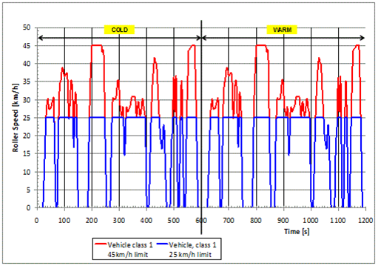

Note:  
**The blue line depicts RST25, i.e.** the truncated ~~desired~~ vehicle speed trace limited to 25 km/h**,** ~~is~~ applicable for vehicles with a limited maximum design vehicle speed of 25 km/h **of class 0-1**.

**The blue line, extended by the red line for speeds over 25 km/h, depicts RST45, i.e.** the truncated ~~desired~~ vehicle speed trace limited to 45 km/h**,** ~~is~~ applicable for vehicles with a limited maximum design vehicle speed of 45 km/h **of class 0-2.**

In case of vehicle**s** with maximum design speed of 50km/h **of class 0-2**, the vehicle shall be driven on WMTC up to maximum speed of 50km/h.

*Continued*

Figure A4.App12/6, *amend to read:*

WMTC for vehicles with a maximum design vehicle speed of 45km/h and 25km/h low engine displacement or maximum net or continuous rated power

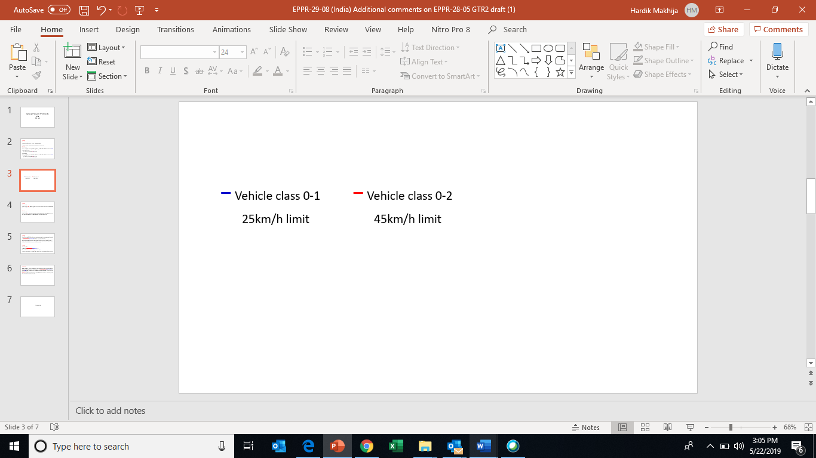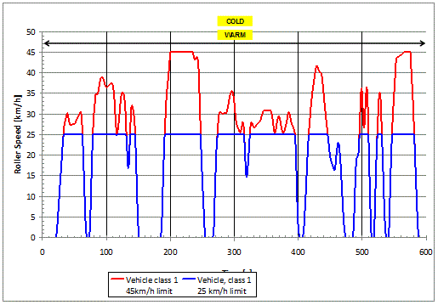

Note:  
**The blue line depicts RST25, i.e.** the truncated ~~desired~~ vehicle speed trace limited to 25 km/h**,** ~~is~~ applicable for vehicles with a limited maximum design vehicle speed of 25 km/h **of class 0-1**.

**The blue line, extended by the red line for speeds over 25 km/h, depicts RST45, i.e.** the truncated ~~desired~~ vehicle speed trace limited to 45 km/h**,** ~~is~~ applicable for vehicles with a limited maximum design vehicle speed of 45 km/h **of class 0-2.**

In case of vehicle**s** with maximum design speed of 50km/h **of class 0-2**, the vehicle shall be driven on WMTC up to maximum speed of 50km/h.

_______