1 | Welcome and organizational matters
2 | Attendance:  ETRTO :  N. de Mahieu, M. Munster M. Calvitti, L. Garro, Marie-Pierre Reinert, S. Miller, Abdul Ghani Soufi,  CATARC :  Xu Tianchu, Mr Zhubin,
3 | Competition law guidelines  Reminded
4 | Approval of the agenda  Approved
5 | Review CATARC questions regarding test blocks  CATARC presented their concern as per annex 1.  ETRTO reviewed it and provided the experience from the other test centers.  The conclusion is that the CATARC proposed test sequence  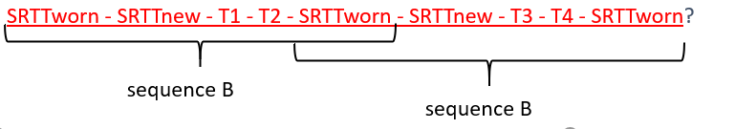  is a solution also used by other test centers.  CATARC received well the ETRTO experience and agreed that the concern is now solved.

