VMAD SG4 on Track and Real World Testing

Overview of Best Practices, Technical Resources, Missing Elements & Considerations

Version: 09 April 2021
1. | Introduction
This document follows-up on VMAD’s “New Assessment/Test Method for Automated Driving (NATM) - Master Document”, as presented during the GRVA session in February 2021. The NATM Master Document’s sections 7 on track testing and 8 on real-world testing are in turn based on SG4’s Concept Paper, which included a list of outstanding issues concerning both track testing and real-world testing.
The first outstanding issue for both track testing and real-world testing consisted of the following points:
- Identify best practices/procedures that currently exist regarding track-testing/real-world testing.
- Identify technical resources/tools that still need to be developed (or what externally developed resources should be referenced in the NATM).
- What are supporting components of the methodology (e.g., dictionary of terms, scenarios from SG1)?
This document addresses this outstanding issue for track-testing in part 2 and real-world driving in part 3. Each part first provides an overview of best practices and procedures regarding the testing of motor vehicles respectively on test tracks and in real driving conditions. It subsequently sets out the technical resources and tools available, after which it will list the available supporting components of the methodology. The final section of each part subsequently sets out an overview of elements that are still missing and considerations for the development of requirements for respectively track testing and real-world testing.
 | Note: the order in which the regulations, standards, best practices, guidance, technical resources and tools are included in the relevant sections of this document is random.

2. | Track Testing
 | This part sets out an overview of available best practices, technical resources as well as tools, supporting components, and missing elements and considerations related to the assessment of automated vehicles on test tracks.
2.1. | Overview of Available Best Practices and Procedures
 | This sections provides an overview of available best practices and procedures for the testing of motor vehicles on test tracks. A concise description of each entry is listed, rather than an extensive description of all its aspects, in order for the overview to serve as a reference document for the future work of SG4.
2.1.1. | Regulations and Standards for Automated Driving Systems (ADS)
 | There are as of yet few regulations, standards and procedures developed for evaluating the safety of automated driving systems.
2.1.1.1. | UN Regulation 157 on uniform provisions concerning the approval of vehicles with regard to Automated Lane Keeping Systems
Annex 5 of UN Regulation 157 sets out the test specifications for automated lane keeping systems (ALKS). In section 3 of the annex, general principles for the tests are set out, including on test conditions, test targets and test parameter variation.
Section 4 sets out the provisions for the test scenarios required for the assessment of the system’s performance with regards to the dynamic driving task. This includes tests on lane keeping, avoiding a collision with a road user or object blocking the lane, following a lead vehicle, avoiding a collision with a vehicle cutting into the lane of the ALKS vehicle, avoiding a collision with a stationary obstacle after a lane change of the lead vehicle, and the ALKS vehicle’s field of view.
Section 5 sets out provisions for additional verification, which include among others the assessment of compliance with provisions on system activation and deactivation, steering, means to override the system, driver availability, driver support systems, driver attentiveness, system behaviour during a minimal risk manoeuvre, transition demand, driver resuming control, exceeding system parameters, failures, emergency manoeuvres, detection areas and real-world test (see paragraph 3.1.1.1. of this document).
The test specifications set out in Annex 5 are meant to be a minimum set of tests, allowing the responsible authorities to perform any other test within the system boundaries and subsequently compare the measured results against the requirements. The pass and fail criteria for the tests are furthermore derived from the technical requirements in paragraphs 5 to 7 of UN Regulation 157.
2.1.2. | Regulations and Standards for Advanced Driver Assistance Systems (ADAS)
 | There is a large number of international standards, procedures and evaluation methods for advanced driver assistance systems which could be considered in the context of developing the requirements for track testing of automated driving systems.
 | Advanced Emergency Braking Systems (AEBS) | UN R131 | Uniform provisions concerning the approval of motor vehicles with regard to the Advanced Emergency Braking Systems (AEBS)
 |  | UN R152 | Uniform provisions concerning the approval of motor vehicles with regard to the Advanced Emergency Braking System (AEBS) for M1 and N1 vehicles
 | Forward Collision Warning (FCW) | UN R131  UN R152 | Both UN Regulations include requirements for FCW
 |  | ISO 15623 | Intelligent transport systems —  Forward vehicle collision warning systems — Performance requirements and test procedures
 | Lane Keeping Assistance Systems (LKAS) | UN R79 | The requirements on ACSF of Category B1 in the UN Regulation on uniform provisions concerning the approval of vehicles with regard to steering equipment
 |  | ISO 11270 | Intelligent transport systems —  Lane keeping assistance systems (LKAS) — Performance requirements and test procedures
 | Lane Change Assistance Systems | UN R79 | The requirements on ACSF of Category C in the UN Regulation on uniform provisions concerning the approval of vehicles with regard to steering equipment
 | Lane Change Decision Aid Systems | ISO 17387 | Intelligent transport systems —  Lane change decision aid systems (LCDAS) — Performance requirements and test procedures
 | Lane Departure Warning Systems (LDWS) | UN R130 | Uniform provisions concerning the approval of motor vehicles with regard to the Lane Departure Warning System (LDWS)
 |  | ISO 17361 | Intelligent transport systems —  Lane departure warning systems —  Performance requirements and test procedures
 | Assisted Parking Systems (APC) | UN R79 | The requirements on ACSF of Category A in the UN Regulation on uniform provisions concerning the approval of vehicles with regard to steering equipment
 |  | ISO 16787 | Intelligent transport systems —  Assisted Parking System(APS) —  Performance requirements and test procedures
 | Adaptive Cruise Control (ACC) | ISO 15622 | Intelligent transport systems —  Adaptive Cruise Control systems —  Performance requirements and test procedures
 |  | ISO 22178 | Intelligent transport systems —  Low speed following (LSF) systems —  Performance requirements and test procedures
 |  | ISO 22179 | Intelligent transport systems —  Full speed range adaptive cruise control(FSRA) systems — Performance requirements and test procedures
2.1.3. | New Car Assessment Programmes (NCAPs) Protocols
 | Over the last decade, consumer protection organizations like the European New Car Assessment Programme (EuroNCAP), the Chinese New Car Assessment Programme (C-NCAP) and others have introduced requirements for the assessment of various advanced driver assistance systems. This has led to the development of various methods for the replication of critical situations between vehicles and other vehicles, pedestrians, bicyclists and in the future also motorcycles.
2.1.3.1. | EuroNCAP Test & Assessment Protocol for Highway Assist Systems
EuroNCAP has several test protocols on vehicle safety, including on adult and child occupant protection, vulnerable road user protection and safety assistance systems. Of particular interest in the context of this overview is the test protocol “Assisted Driving – Highway Assistance Systems”. The test protocol focuses on the system’s assistance competence and safety backup.
The assistance competence is further subdivided into driver engagement (covering elements on consumer information, system status, driver monitoring as well as driving collaboration) and vehicle assistance (covering elements on speed assistance, adaptive cruise control performance as well as steering assistance). EuroNCAP applies in this regard a balancing principle, where the assistance competence score equals the vehicle assistance score, but only when the driver engagement score (at least) matches the vehicle assistance score. Otherwise, the assistance competence score is limited to the driver engagement score.
The safety backup covers elements on system failure, unresponsive driver intervention and collision avoidance.
2.1.4. | (Academic) Literature on Assessing the Safety of Automated Driving Systems (ADS)
 | Khastgir, S., Birrell, S., Dhadyalla, G., and Jennings, P., "The Science of Testing: An Automotive Perspective," SAE Technical Paper 2018-01-1070, 2018, https://doi.org/10.4271/2018-01-1070
 | [Further input on available best practices and test procedures welcome]
2.2. | Overview of Available Technical Resources & Tools
 | This section provides an overview of available technical resources and tools that could be considered for use during the track testing of automated vehicles.
2.2.1. | Test Equipment Used in New Car Assessment Programmes (NCAPs)
Over the last decade, consumer protection organizations like the European New Car Assessment Programme (EuroNCAP), the Chinese New Car Assessment Programme (C-NCAP) and others have introduced requirements for the assessment of various advanced driver assistance systems. This has led to the development of various methods for the replication of critical situations between vehicles and other vehicles, pedestrians, bicyclists and in the future also motorcycles, all using remote-controlled target dummies that are fully impactable and drive at a high speed.
Appendix I summarizes the necessary test equipment and the test scenarios being tested in the Euro NCAP rating.
In those tests, the vehicle under test is controlled by driving robot systems that achieve a positional accuracy of approximately 5 cm. This is necessary since assistance systems would require a driver as an operator for the basic driving task. For testing automated vehicles that allow a hands-off situation, driving robots (steering and pedal actuators) will only be necessary for specific investigations (e.g. testing of overruling and driver interaction).
 | [Input on further available technical resources and tools welcome]
2.3. | Overview Supporting Components of the Methodology
 | This sections provides an overview of the components supporting track testing, as developed by other VMAD subgroups as well as FRAV.
2.3.1. | FRAV Requirements
FRAV is expected to establish safety requirements for automated driving systems. In particular, FRAV is currently expected to set out safety requirements for automated driving systems related to the following starting points:
- ADS should drive safely.
- ADS should interact safely with the user.
- ADS should manage safety-critical situations.
- ADS should safely manage failure modes.
- ADS should ensure a safe operational state.
Further performance topics are derived from these starting points, and underlying safety goals related to/derived from the performance targets are currently being discussed, as are views on criteria, metrics, and performance indicators that might be used to define requirements that can be measured and/or verified.
 | [Further input welcome]
2.4. | Missing Elements & Considerations
 | This section provides an overview of considerations regarding elements related to respectively the procedure and the technical resources/tools that are currently not yet available as well as general considerations regarding the development of track testing requirements.
2.4.1. | Missing Elements and Considerations regarding the Procedure
 | [To be added once the overview of available procedures has been finalized, input welcome.]
2.4.2. | Missing Elements and Considerations regarding the Technical Resources & Tools
[The performance of the test equipment needs further optimization, and the main optimization points are as follows:
- Accurate measurement of longitudinal distance and TTC inside the curve
- Accurate positioning in the tunnel
- Normal operation of test equipment in special weather, especially in rain and snow
- Measure the transverse distance between the two vehicles, especially the distance deviation within the curve]
 | [It is deemed necessary to prepare the required equipment according to the test purpose for the specific ADS.]
 | [Further input welcome]

3. | Real-World Testing
 | This part sets out an overview of available best practices, technical resources as well as tools, supporting components, and missing elements and considerations related to the assessment of automated vehicles on public roads.
3.1. | Overview of Available Best Practices and Procedures
 | This sections provides an overview of available best practices and procedures for the testing of motor vehicles on public roads. A concise description of each entry is listed, rather than an extensive description of all its aspects, in order for the overview to serve as a reference document for the future work of SG4.
3.1.1. | Regulations and Standards for Automated Driving Systems (ADS)
 | There are only few regulations and standards developed for evaluating the safety of automated driving systems on public roads.
3.1.1.1. | UN Regulation 157 on uniform provisions concerning the approval of vehicles with regard to Automated Lane Keeping Systems
Annex 5 of UN Regulation 157 sets out the test specifications for automated lane keeping systems (ALKS). Section 5.4 of the annex concerns the provisions regarding the real-world tests.
During the real-world assessment, the Technical Service should assess at least:
- Prevention of activation when the system is outside of its technical boundaries/requirements for ALKS
- No violation of traffic rules
- Response to a planned event
- Response to an unplanned event
- Detection of the presence of other road users within the frontal and lateral detection ranges
- Vehicle behaviour in response to other road users (following distance, cut-in scenario, cut-out scenario etc).
- System override
The UN Regulation recommends that the real-world test is undertaken once the system has passed all of the other tests outlined in this Annex and upon completion of a risk assessment by the Technical Service.
3.1.2. | Regulations and Standards for Motor Vehicle Testing on Public Roads
 | There are only few regulations and standards developed for evaluating motor vehicles on public roads.
3.1.2.1. | Real-Driving Emissions (RDE) Test Procedure
 | The European type approval framework with respect to emissions from light passenger and commercial vehicles includes a test procedure to verify their real driving emissions (RDE) performance. The requirements for the RDE test are set out in Annex IIIA of Commission Regulation (EU) 2017/1151, and include - amongst many others - general requirements, trip requirements, operational requirements, and requirements on boundary conditions as well as trip evaluation.
3.1.3. | Guidance for Automated Driving Systems (ADS)
 | There are only few guidance documents on (evaluating) the safety of automated driving systems on public roads.
3.1.3.1. | Safety Assessment for Automated Driving Systems (in Canada)
The Safety Assessment tool should be used by entities that are designing vehicles equipped with ADS features that are intended for use on public roadways in Canada. This includes all vehicles equipped with ADS features that meet the SAE definitions for automation levels 3 through 5 that are to be manufactured, imported, operated and/or sold in Canada.
The Safety Assessment sets out 13 expected outcomes, divided into three sections:
- ADS capabilities, design, and validation: reviews vehicle design considerations linked to the specific level of automation, intended use, operational design domain (ODD), basic vehicle functions, as well as testing, verification and validation that has been conducted.
- User-centered safety: focuses on safety systems; the accessibility of the controls; driver/user knowledge of capabilities, limitations, and maintenance requirements; and ADS operation in the event of collisions or system failures.
- Cyber security and data management: focuses on strategies used to manage cyber security risks, safe functioning of the vehicle as it is deployed, data collection by the ADS, including considerations for the sharing of data with government, and protection of personal information.
3.1.4. | Regulations, Standards and Guidance on Automated Vehicles Trials on Public Roads
 | There are several guidelines, standards and regulations developed for trialing and development testing of automated vehicles on public roads.
3.1.4.1. | L3 Pilot Deliverable D3.4 – Evaluation Plan
 | The L3 Pilot project focuses on conducting large-scale testing and piloting of level 3 automated driving systems on public roads, and deliverable D3.4 defines the methods and data sources for evaluation areas and research questions. The document poses research questions, summarizes the process of setting up experimental procedures, provides evaluation plans, and lessons learned. These evaluation plans cover technical and traffic evaluation, user and acceptance evaluation, mobility impact evaluation, safety impact evaluation, efficiency and environmental impact assessment, and social-economic impact assessment.
3.1.4.2. | PAS 1881:2020 - Assuring the safety of automated vehicle trials and testing: Specification
 | PAS 1881:2020 specifies requirements for safety cases for automated vehicle trials and development testing to demonstrate that the respective activities can be done safely in the UK. The safety cases should cover among others the operational design domain and test objectives, the operational risk assessment, operational guidance, route selection and assessment, safe operation and control, security, assurance of system safety, safety testing and acceptance process, modelling and simulation, change control, insurance, as well as monitoring, reporting and continuous improvement.
3.1.4.3. | UK’s Code of Practice: Automated vehicle trialing
 | The Code is primarily intended to be used by organizations or individuals planning to trial or pilot automated vehicle technologies and services. It aims to support and promote the safe trialing and use of automated vehicle technologies and services on public roads or in other public places in the UK and build public confidence in automated vehicle technologies and services; support cooperation between trialing organizations and those responsible for the management of traffic, infrastructure, law enforcement, and other areas to support maximum road safety; and encourage sharing of information to help uphold and develop the highest standards of safety in the UK and internationally.
3.1.4.4. | Zenzic: Safety Case Framework: The Guidance Edition
 | Zenzic’s Safety Case Framework provides guidance for testing and trialing of connected and automated mobility in the UK. The guidance, among others, sets out detailed safety requirements, and provides a process for developing best-practice risk management.
3.1.4.5. | AVSC Best Practice for In-Vehicle Fallback Test Driver Selection, Training, and Oversight Procedures for Automated Vehicles Under Test
 | This AVSC document provides safety considerations for test drivers of automated vehicles. The document addresses the qualifications and training framework for in-vehicle fallback test drivers, including elements on driver selection, basic driver training, ADS training, initial ADS driving on public roads, and periodic evaluations. The document also covers pre-trip, in-trip and post-trip protocols for testing ADS-operated vehicles on public roads, incident response training and protocols, as well as updating and monitoring training curricula.
3.1.4.6. | FESTA Handbook
 | The FESTA Handbook was produced to provide comprehensive guidance for conducting field operational tests, which are defined as studies undertaken to evaluate a [driver support systems/] function, or functions, under normal operating conditions in road traffic environments typically encountered by the participants using study design so as to identify real-world effects and benefits. The FESTA handbook also addresses naturalistic driving studies, where the purpose is not the testing of functions but the observation of driver (or rider) behavior in everyday traffic situations, using advanced technology for in-vehicle unobtrusive recording.
3.1.4.7. | Testing Highly Automated Vehicles in Canada: Guidelines for Trial Organization
Amongst others, these guidelines establish a set of voluntary minimum safety requirements that trial organizations are expected to follow when operating in Canada. Pre-test considerations include general safety requirements, such as “Prior Testing Requirements for Trials”, which states that trial organizations should ensure that all trial vehicles have undergone sufficient testing (as determined by the trial organization) in a closed course (e.g. closed roads, parking lots, or test tracks), on-road in another jurisdiction, and/ or through other validation mechanisms (i.e. computer simulations) prior to commencing a trial on public roads with other road users.
It also includes ADS requirements, such as requirements for data recording devices, for trails with drivers, for trails with ADS-dedicated vehicles (without a human in the driver’s seat or even present), and for the self-declaration of vehicle safety.
3.1.4.8. | Safety-Relevant Guidance for On-Road Testing of Prototype Automated Driving System (ADS)-Operated Vehicles (SAE: J3018_202012)
 | This document provides preliminary1 safety-relevant guidance for in-vehicle fallback test driver training and for on-road testing of vehicles being operated by prototype conditional, high, and full (Levels 3 to 5) ADS, as defined by SAE J3016. Moreover, this guidance only addresses testing of ADS-operated vehicles as overseen by in-vehicle fallback test drivers (IFTD).
3.1.5. | (Academic) Literature on Assessing Automated Driving Systems (ADS)
 | Khastgir, S., Birrell, S., Dhadyalla, G., and Jennings, P., "The Science of Testing: An Automotive Perspective," SAE Technical Paper 2018-01-1070, 2018, https://doi.org/10.4271/2018-01-1070
 | [Further input on available regulations, standards, guidance, test procedures, guidance on trials, academic literature, etc, welcome]
3.2. | Overview of Available Technical Resources & Tools
 | This section provides an overview of available technical resources and tools that could be used during the testing of automated vehicles on public roads.
 | [To be added, input welcome]
3.3. | Overview Supporting Components of the Methodology
 | This sections provides an overview of the components supporting real-world testing, as developed by other VMAD subgroups as well as FRAV.
3.3.1. | FRAV Requirements
FRAV is expected to establish safety requirements for automated driving systems. In particular, FRAV is currently expected to set out safety requirements for automated driving systems related to the following starting points:
- ADS should drive safely.
- ADS should interact safely with the user.
- ADS should manage safety-critical situations.
- ADS should safely manage failure modes.
- ADS should ensure a safe operational state.
Further performance topics are derived from these starting points, and underlying safety goals related to/derived from the performance targets are currently being discussed, as are views on criteria, metrics, and performance indicators that might be used to define requirements that can be measured and/or verified.
 | [Further input welcome]
3.4. | Missing Elements & Considerations
 | This section provides an overview of considerations regarding elements related to respectively the procedure and the technical resources/tools that are currently not yet available as well as general considerations regarding the development of real-world testing requirements.
3.4.1. | Missing Elements and Considerations regarding the Procedure
[Test procedures should clearly describe how the test should be prepared and performed, including requirements on instrumentation and test participants involved (e.g. safety driver, assessor, etc…).
The set of abstract (functional) scenarios relevant to the considered automated driving application (use-case) should be identified. This set of scenarios will constitute the minimum non-exhaustive common baseline for safety validation testing by the manufacturers and for independent verification by the authority. There will also be the need to identify specific scenarios relevant to local conditions (e.g. categories of other road users allowed, possible presence of wild animals, etc…), but the common baseline mentioned above will ensure a minimum level of interoperability among the different countries.
Safety remains the priority in situations involving vulnerable road users and in critical/emergency conditions, and can be evaluated only with a pass-fail approach. Therefore, there is the need for the definition of test validity criteria, i.e. requirements on the duration and characteristics of the performed test that guarantee a significant representativeness of ADS real world normal operation can be assessed.
Technical resources common to those used during track-testing that can be applied during the real world testing should be identified.
Different ADS levels may require dedicated assessments. For instance, Level 3 would need assessment of certain requirements for the transition demand and a possible Minimum Risk Manoeuvre.
Real World Safety testing should address the behavioural performance of the vehicle within its ODD, including at the ODD boundaries and possibly also outside the ODD.]
3.4.1.1. | European Commission comments on ALKS extension
In the context of the extension of UN Regulation 157 on ALKS to allow for respectively speeds greater than 60 km/h and lane changes, the European Commission suggested a generic multi-step approach for the definition of real-world test drives which could be considered by SG4. The multi-step approach, as set out in greater detail in the summery provided in Annex II to GRVA-08-11, consists of the following steps:
- First step on the identification of the parameters defining the ODD and their ranges;
- Second step on defining of test scenarios and test cases (for both test track and RWS);
- Third step on a "Scoring" or "Pass-Fail" strategy;
- Fourth step on selecting the RWS test scenarios and test cases;
- Fifth step on the execution and ex-post analysis of RWS test data (including test validity).
 | [Further input welcome]
3.4.2. | Missing Elements regarding the Technical Resources & Tools
 | In real-world testing, technical tools shall continuously work for many hours. So the operational stability is necessary. To automatically test and judge, the technical tools shall be more intelligent.
 | [Further input welcome]

A. | Appendix I
A.I | Consumer Protection Tests in Euro NCAP
 | (Patrick Seiniger & Adrian Hellmann, BASt – Federal Highway Research Institute of Germany)
Over the last decade, consumer protection organizations like the European New Car Assessment Programme (EuroNCAP) and others have introduced requirements for the assessment of various advanced driver assistance systems. This has led to the development of various methods for the replication of critical situations between vehicles and other vehicles, pedestrians, bicyclists and in the future also motorcycles, all using remote-controlled target dummies that are fully impactable and drive at a high speed.
In those tests, the vehicle under test is controlled by driving robot systems that achieve a positional accuracy of approximately 5 cm. This is necessary since assistance systems would require a driver as an operator for the basic driving task. For testing automated vehicles that allow a hands-off situation, driving robots (steering and pedal actuators) will only be necessary for specific investigations (e.g. testing of overruling and driver interaction).
The following sections summarize the necessary test equipment and the test scenarios being tested in the Euro NCAP rating.
A.I.1. | Vehicle under Test Equipment
 | The vehicle under test needs to be equipped with a position measurement device with high precision below 2 cm accuracy at all times. An Inertial measurement unit with differential GPS sensor fusion fulfils this requirement. The unit transmits the vehicle’s position either to a central computer or to the other test targets and records the trajectory for the assessment of the test. An example is shown in the picture below. In this picture, the DGPS-IMU (blue) is fixed to a strut that is clamped between vehicle roof and floor.
 | 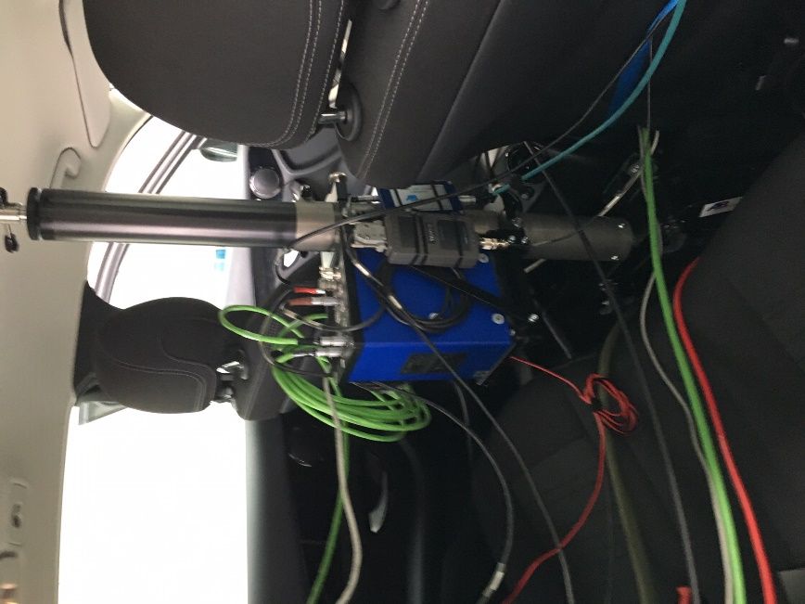
 | If needed, pedal and steering actuators can be used to control the vehicle or simulate driver input. An example for a steering actuator system (showing as well the control computer) is shown in the picture below.
 | 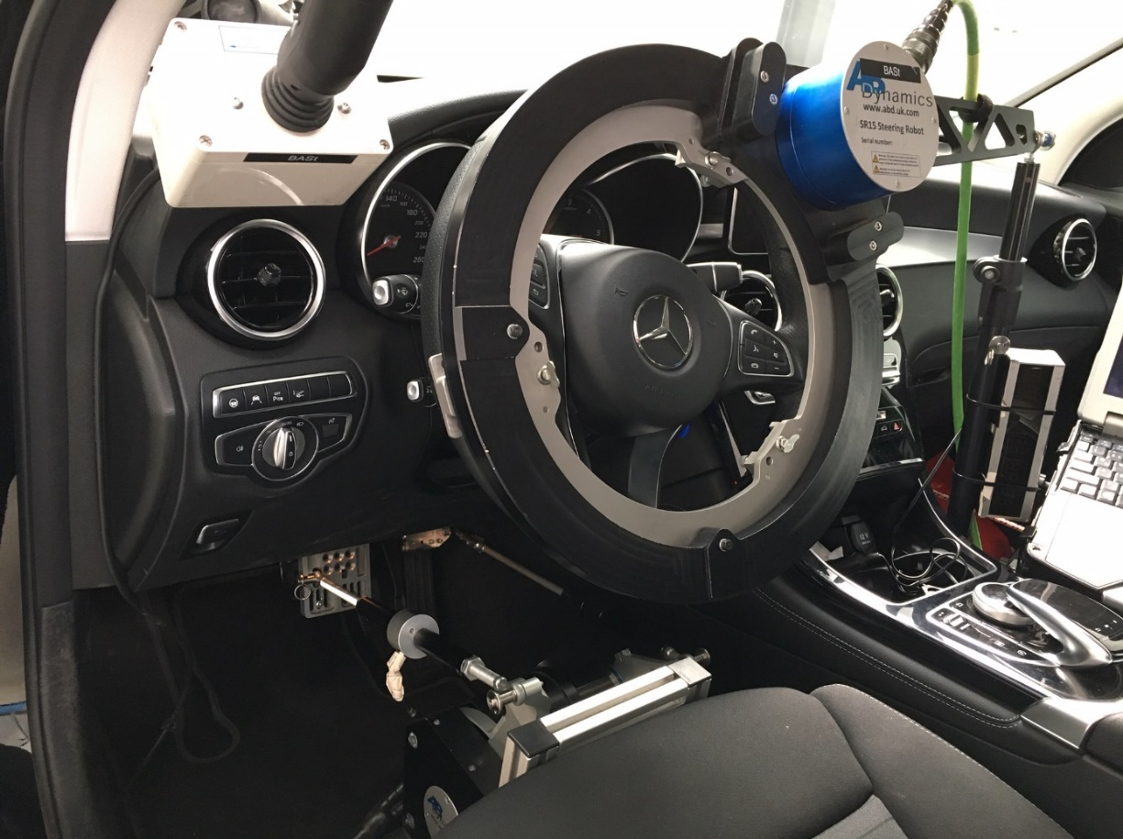
A.I.2. | Test Targets
A.I.2.1. | Vehicle Target  The "Global Vehicle Target", abbreviated GVT, shown in the picture below, is used to represent collision scenarios with a passenger car. It consists of a dummy and a self-propelled drive unit and is defined in ISO standard 19206-3. The mockup imitates a Ford Fiesta (seventh generation, construction period 2009 to 2017) on a scale of 1:1 and is constructed as follows: foam sheets connected with Velcro strips to create a load-bearing structure form a framework. This is covered with a shell consisting of several parts, which is provided with metal fibers and foils to generate a representative radar reflection. The properties are tuned so that the GVT is reliably recognized as a passenger car from all sides.
 | 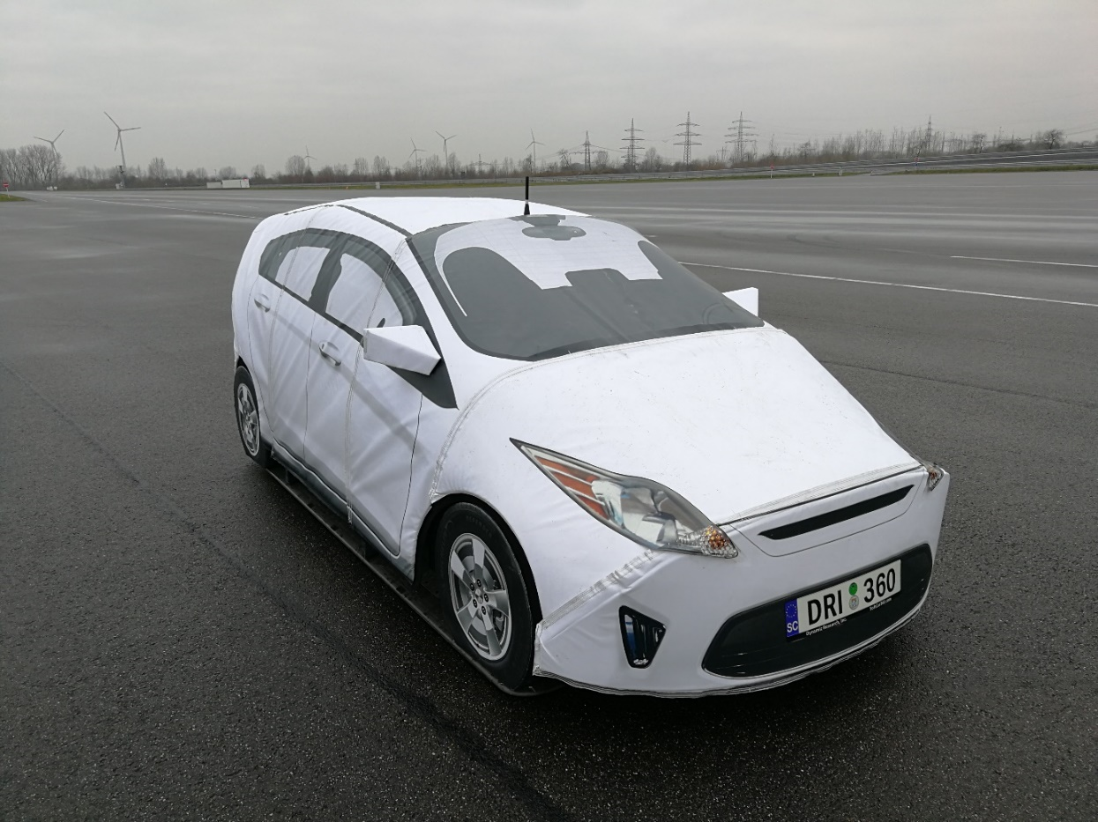

 | At the time of an impact, the target disintegrates to pieces and can be rebuilt within approximately 10 minutes.
 | 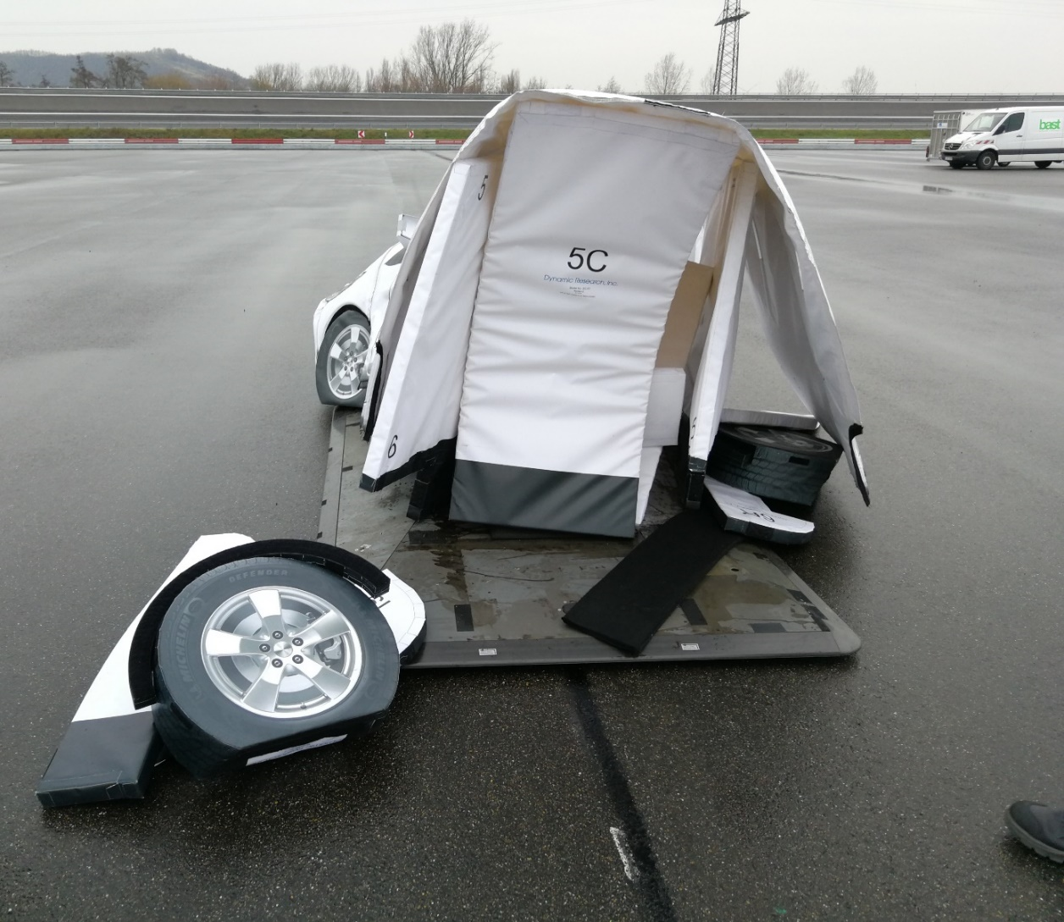
The drive unit, or platform, can be moved manually, from a control station, or automatically traverse complex trajectories with the highest precision. During a collision, the GVT disintegrates into its lightweight individual parts, which are designed to be shock- and abrasion-resistant and can then be quickly reassembled.
The drive unit can not only be driven over, but it is also designed so that it can withstand the test vehicle braking on it without any damage. It is shown in the picture below.
 | 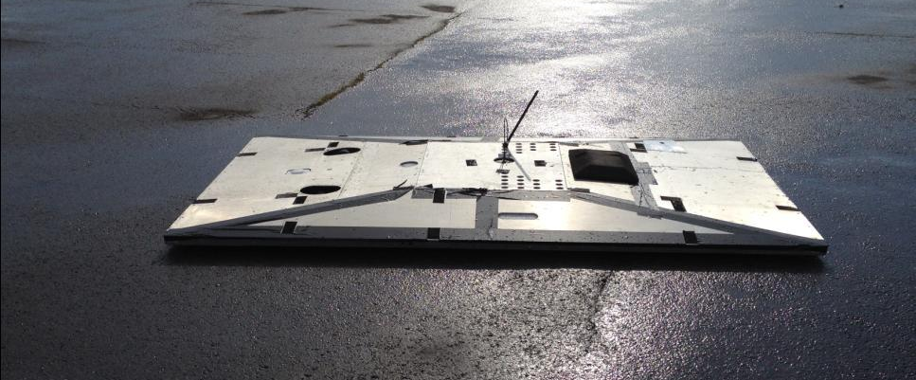
A.I.2.2. | Pedestrian Target  In the case of emergency braking systems designed for accidents with unprotected external road users, it is not to be expected, even in the distant future, that all test cases can be tested in a collision-avoiding manner. For ethical reasons, the question of using humans as target objects does not arise here. A target object (better: dummy) must appear as a human to usual sensor technology and allow to survive a collision. The pedestrian dummies used in Euro NCAP are specified in ISO standard 19206 – 2 and represent a typical adult and a child aged six years.  Platform solutions are now common, where a dummy is attached to a moving platform using magnets, for example. At the time of impact, the dummy is disconnected from the platform and hits vehicle and / or the road surface. For platform concepts, the dimensional stability of the dummy and the abrasion behavior of the clothing are important - but such concepts just get by with comparatively simply constructed, portable platform solutions for movement. The platforms are available in self-propelled or belt-driven and -guided versions. Dummies can also simulate the gait of a human being by moving extremities. An example of a night test setup of pedestrian dummy with belt-driven platform is shown in the picture below.
 | 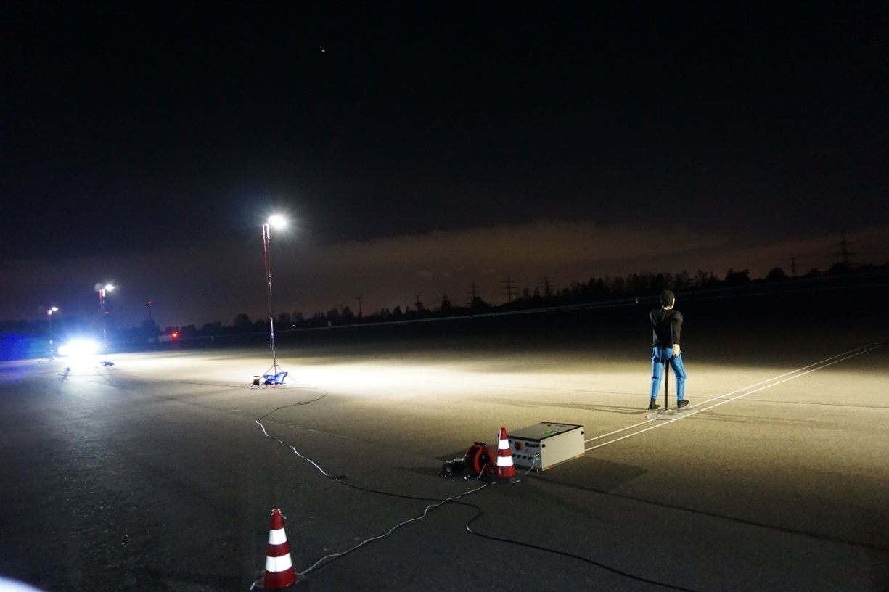
Belt-driven concepts, such as the "4a Surfboard", allow in principle smaller heights and better repeatability, but are not very flexible in the representation of the pedestrian trajectory because of the belt guidance - much more relevant: during tests in longitudinal direction, the abutment of the belt could interfere with the RADAR sensor technology. Removing the abutment means that the carriage is only pulled in one direction and is no longer indirectly stabilized laterally. Compliance with the required tolerances must be ensured by adjusting the carriage very accurately and is very sensitive to crosswind.
A solution for this is a self-movable platform, comparable to the one used for vehicle targets, but smaller in size. A self-movable platform will also be necessary for more complex scenarios and/or higher dummy speeds and therefore becomes now common with the Euro NCAP test labs.

A.I.2.3. | Bicycle and Motorcycle Targets  The same requirements for the combination of bicycle and cyclist as described above apply here as well. The dummy bicycle must survive collisions without unacceptable damage, support the cyclist dummy, have high stability for cyclist-typical speeds, have moving wheels or spokes for the RADAR signature, and possibly emulate pedaling movements of the legs.  Since the metallic spokes of the wheels have a significant contribution to the RADAR signature of the dummy, the platform has a recess so that the wheels of the bicycle touch the ground and are thus rotated. To simulate motorized two-wheelers, however, the connection is rigid and rotating triple mirrors are seated in the wheel hubs.  The targets are defined in the standards ISO-19206-4 (bicycle, see picture below) and ISO-19206-5 (motorcycle).
 | 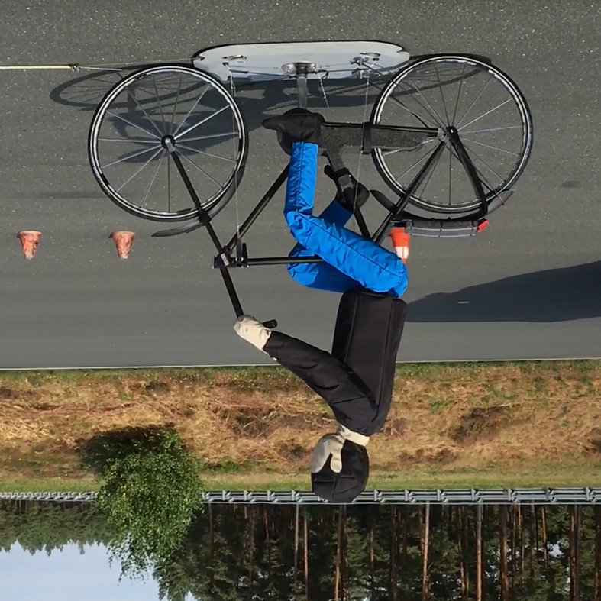
A.I.3. | Test Scenarios
A.I.3.1. | Test scenarios for Car-Pedestrian (Euro NCAP 2020-2023)  In the test procedure for pedestrian assistance systems, the ego vehicle driving straight ahead is guided on a collision course with crossing pedestrian dummies or dummies moving longitudinally in the direction of travel, except for the test configuration with turning vehicle. The essential parameters for pedestrian emergency brake assistants are given in the table on the next page.

Test ID | CPFA-50 | CPNA-25 | CPNA-75 | CPNC | CPLA-50 | CPLA-25 | CPTA | CPRA
Vehicle Speed | 10 – 60 km/h, 5 km/h steps | 10 – 60 km/h, 5 km/h steps | 10 – 60 km/h, 5 km/h steps | 10 – 60 km/h, 5 km/h steps | 20 – 60 km/h, 5 km/h steps | 50 – 80 km/h, 5 km/h steps | In left turns 10, 15, 20 km/h; in right turn: 10 km/h | Up to 4 km/h | Up to 8 km/h
Dummy Speed | 8 km/h | 5 km/h | 5 km/h | 5 km/h (child) | 5 km/h | 5 km/h | 5 km/h | 5 km/h | 5 km/h
Dummy obscured? |  |  |  | Yes, by 2 vehicles
Impact point (for no brake intervention) | 50% (center of vehicle under test) | 25% | 75% | 50% | 50% | 25% | 50% | 25, 50,  75% | 50%
Expected intervention | Braking | Braking | Braking | Braking | Braking | Warning | Braking | Braking | Braking
Pedestrian direction | Crossing, from the left (for right-hand traffic) | Crossing, from the right | Crossing, from the right | Crossing, from the right | Longitudinal | Longitudinal | Longitudinal, oncoming | Crossing, from the right (behind the vehicle) | Stationary (behind vehicle)
Day/Night | Day | Both | Both | Day | Both | Both | Day | Day | Day

 | An example for a CPNC test is shown in the following picture.
 | 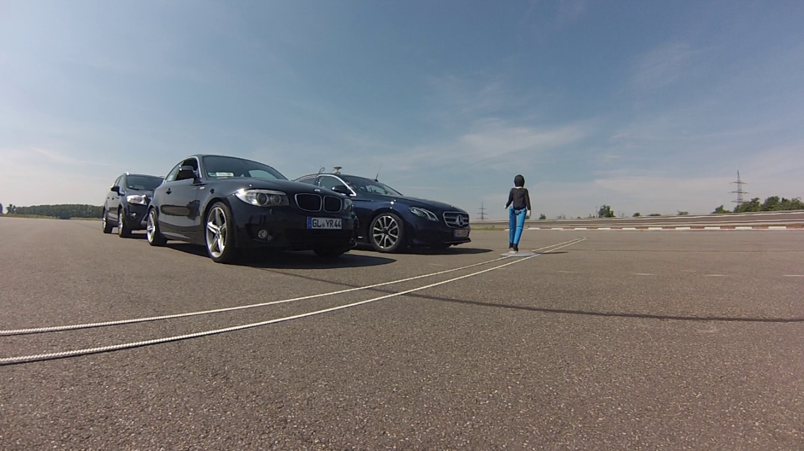
A.I.3.2. | Test scenarios for Car-Bicycle  In the test procedure for emergency braking assistance systems for the protection of bicyclists, the ego vehicle driving straight ahead is guided toward crossing or longitudinally moving bicycle dummies. The parameters similar to the tests with pedestrians are given in the table below.
Test ID | CBNA | CBNAO | CBFA | CBLA-50 | CBLA-25
Vehicle Speed | 10 – 60 km/h, 5 km/h steps | 10 – 60 km/h, 5 km/h steps | 10 – 60 km/h, 5 km/h steps | 25 – 60 km/h, 5 km/h steps | 50 – 80 km/h, 5 km/h steps
Dummy Speed | 15 km/h | 10 km/h | 20 km/h | 15 km/h | 20 km/h
Dummy obstructed |  | Yes
Impact location | 50% | 50% | 50% | 50% | 25%
Expected intervention | Braking | Braking | Braking | Braking | Warning
Dummy direction | Crossing, from the right | Crossing, from the right | Crossing, from the left | Longitudinal | Longitudinal
Day/Night | Day | Day | Day | Day | Day
 | An example for a CBLA test is shown in the following picture.
 | 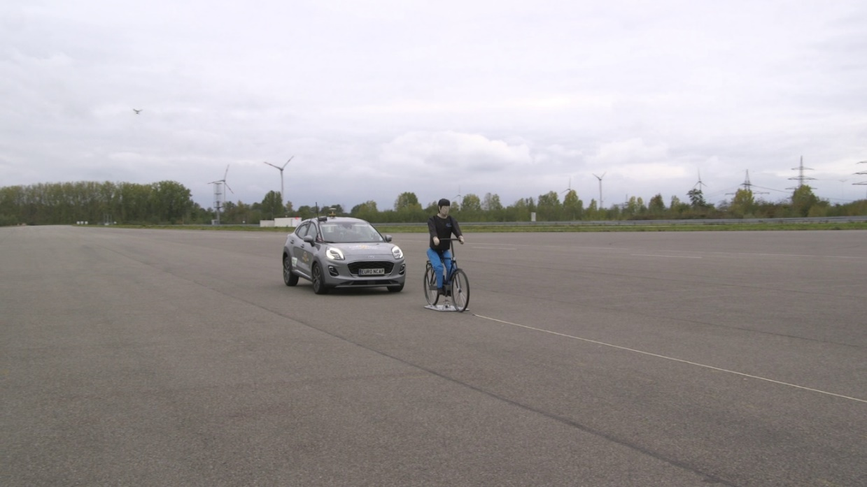
A.I.3.3. | Test scenarios Car-Car (Euro NCAP 2020-2023)  In the test procedure for rear collision and intersection emergency brake assistants, the ego vehicle is subjected to situations that mimic inner-city, turning situations or the end of a traffic jam. The essential parameters are given in the table below. The ego-vehicle moves mainly in a straight line; in individual cases, it turns.
Test ID | CCRs AEB | CCRs FCW | CCRm AEB | CCRm FCW | CCRb | CCFtap
Vehicle Speed | 10 – 50 km/h, 5 km/h steps | 30 – 80 km/h, 5km/h steps | 30 – 80 km/h, 5 km/h steps | 50 – 80 km/h, 5 km/h steps | 50 km/h, initial distances 12 and 40 m | 10, 15, 20 km/h
Dummy Speed | stationary | stationary | 20 km/h | 20 km/h | 50 km/h | 30, 45, 55 km/h
GVT deceleration |  |  |  |  | -2 m/s^2 and  -6 m/s^2
Overlap | 50%,75%, center, -75%, -50% | 50%,75%, center, -75%, -50% | 50%, 75%, center, -75%, -50% | 50%, 75%, center, -75%, -50% | center, | 50%
Expected intervention | Braking | Warning | Braking | Warning | Braking and Warning | Braking
An example for a CCRs test is shown in the following picture.
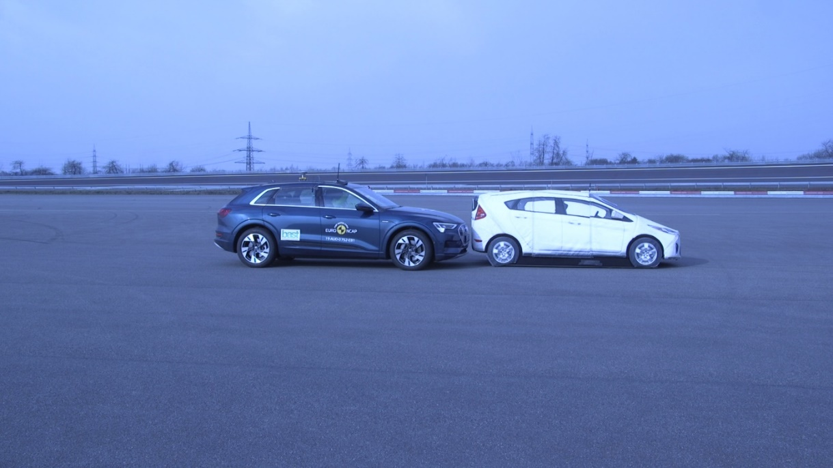

GRVA-09-07
VMAD-12-05
See FRAV-08-09 as well as other FRAV documents containing comments on it.
See FRAV-09-08 as well as other FRAV documents containing comments on it. See also FRAV-09-05 and related document containing comments on it.
For the other testing provisions of UN Regulation 157, see paragraph 2.1.1.1. of this document.
See FRAV-08-09 as well as other FRAV documents containing comments on it.
See FRAV-09-08 as well as other FRAV documents containing comments on it. See also FRAV-09-05 and related document containing comments on it.

