- Correction of Figure 1.

Proposal for a Supplement [x] to 04, 05 and 06 series of amendments to UN Regulation No. 10
Annex 4 - Paragraph 1, amend to read:

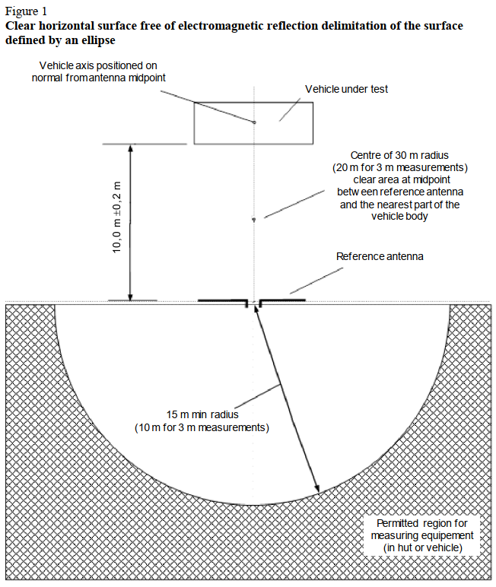
(3,00 m ± 0,05 m)

Justification:
- CISPR 12 includes note (The 10,0 m ± 0,2 m dimension may be changed to 3,00 m ± 0,05 m in accordance with 5.2.3.2 and 5.2.3.4.)
UN Regulation No. 10 includes conditions for alternative 3 m measurement directly in the figure.
Formal correction only, forgotten alternative shall be included into the figure.

- Just open question to paragraph 6.10.2.

6.10.2. Vehicles which do not have electrical/electronic systems with "immunity related functions" need not be tested for immunity to radiated disturbances and shall be deemed to comply with paragraph 6.4. and with Annex 6 to this Regulation.

Question:
- Is the paragraph still needed?

- Testing conditions for categories L5, L6 vehicles

Proposal for a Supplement [x] to 04, 05 and 06 series of amendments to UN Regulation No. 10
Annex 6, Paragraph 3.3.4., amend to read:
"3.3.4. Either at 1.0 ± 0.2 m behind the vertical centreline of the vehicle's front wheel(s) (point C in Figure 1 of Appendix 1 to this annex) in the case of three-wheeled or four-wheeled vehicles.
Or at 0.2 ± 0.2 m behind the vertical centreline of the vehicle's front wheel (point D in Figure 2 of Appendix 1 to this annex) in the case of two-wheeled vehicles."

[or alternatively Annex 6, Paragraph 3.2., amend to read:
3.2. For categories M, N, O, T, R, and S, L6 and L7 vehicles according to ISO 11451-2.]

Justification:
- Paragraph 3.3. of annex 6 prescribes reference point for category L vehicles for immunity of vehicles to electromagnetic radiation, but paragraph 3.3.4. specifies reference point for two and three-wheeled vehicles only.
Reference point for category L6 and L7 defined in R.E.3 is not covered, and test setup is not clear.
- L2, L5 can have two front wheels, by analogy the same test setup is preferred for L6, L7.
- References to R.E.3:
2.1.6. "Category L6": A vehicle with four wheels whose unladen mass is not more .....
2.1.7. "Category L7": A vehicle with four wheels, other than that classified for the category L6....
- Technical background:
Regulation No. 10, 3.3.4. (current text)
two-wheeled vehicles  0.2 ± 0.2 m behind ...front wheel | three-wheeled vehicles  1.0 ± 0.2 m behind... front wheel
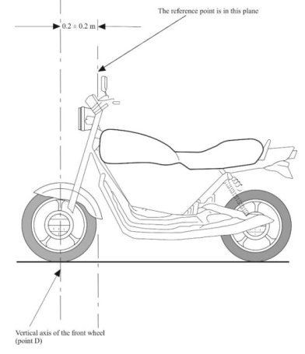 | 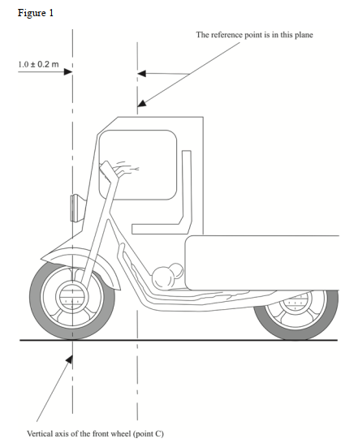

ISO11451-2
(0,2 ± 0,2) m behind the front  axle | or (1 ± 0,2) m inside the vehicle, measured from the point of intersection of the vehicle windscreen and hood
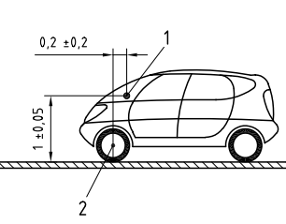 | 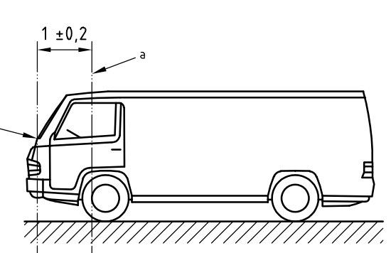
whichever results in a reference point closer to the antenna

- Measurement of narrowband electromagnetic emissions at the vehicle broadcast radio antenna

Proposal for a Supplement [x] to 04, 05 and 06 series of amendments to UN Regulation No. 10
[Proposal for [x] series of amendments to UN Regulation No. 10]
Annex 5, Paragraph 1.3., amend to read:
1.3. As an initial step Optionally the levels of emissions in the Frequency Modulation (FM band (76 to 108 MHz) shall may be measured at the vehicle broadcast radio antenna with an average detector. If the level specified in paragraph 6.3.2.4. of this Regulation is not exceeded, then the vehicle shall be deemed to comply with the requirements of this annex in respect of that frequency band and the full test shall not be carried out.

Justification:
- Old and partly redundant as an initial step there is prescribed to measure narrowband electromagnetic emissions from vehicles at the broadcast radio antenna. This shortened test procedure does not cover whole frequency range.
- The method shall not be required as an initial step in case of providing full tests procedure.
Measurement of narrowband electromagnetic emissions at the vehicle broadcast radio antenna method could be used as an option only.
- [Alternatively, there could be open discussion if the procedure is still valid and suitable. Only NOK results launches complete measurement in whole frequency range.]

- Requirements for trolleybuses

Proposal for a Supplement [x] to 04, 05 and 06 series of amendments to UN Regulation No. 10
[Proposal for [x] series of amendments to UN Regulation No. 10]
Annex 4, Paragraph 1.2., amend to read:
1.2 Test method
This test is intended to measure the broadband emissions generated by electrical or electronic systems fitted to the vehicle (e.g. ignition system or electric motors).
If not otherwise stated in this annex the test shall be performed according to CISPR 12, notwithstanding to Annex G of the CISPR 12.

Annex 5, Paragraph 1.2., amend to read:
1.2. Test method
This test is intended to measure the narrowband electromagnetic emissions that may emanate from microprocessor-based systems or other narrowband source.
If not otherwise stated in this annex the test shall be performed according to CISPR 12 or CISPR 25, notwithstanding to Annex G of the CISPR 12 and to Annex A of the CISPR 25.

Insert a new paragraph 6.10.7.4.,
6.10. Exceptions
6.10.7.4. "Trolleybuses": AC / DC mains portion of the vehicle propulsion system shall be excluded from this Regulation.

Justification:
- Trolleybuses are excluded from the test method of the current CISPR 12 and 25 and covered by EN 50121-3-1 even if contains combustion engine.
- Note: New CISPR 12:2006 resp. CISPR 25:2008 and newer exclude mains portion of the vehicle propulsion system form the application of the test method, see note (1) below.
- Some contracting parties require to apply UN Regulation No. 10 for trolleybuses even without mains independent propulsion system.
- There shall be clearly stated or declined if UN Regulation No. 10 shall be applicable for trolleybuses and for main propulsion system.
- Technical background (CISPR 12, annex G, resp. CISPR 25, annex A):
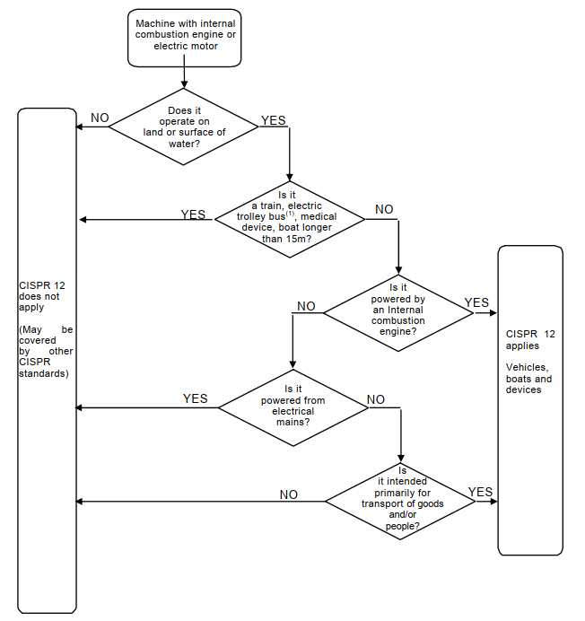
- Following note is only in new CISPR 12:2006 resp. CISPR 25:2008 and newer:
(1) In the case of a dual-mode trolley bus (e.g. propelled by power from either a.c./d.c. mains or an internal combustion engine), the internal combustion propulsion system shall be included, but the a.c./d.c. mains portion of the vehicle propulsion system shall be excluded from this standard.

