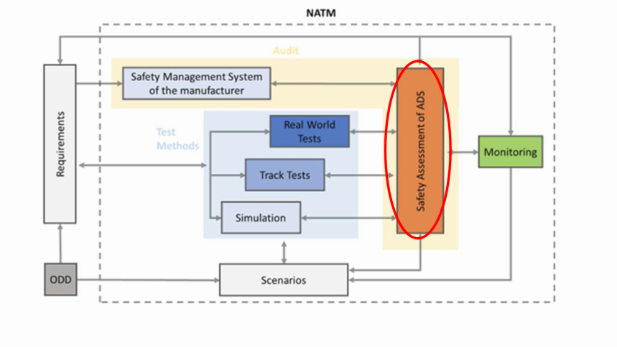**Building blocks – Safety Assessment of ADS**

VMAD-SG3-09-06-Rev1

**SAFETY REPORT BY MANUFACTURER**

****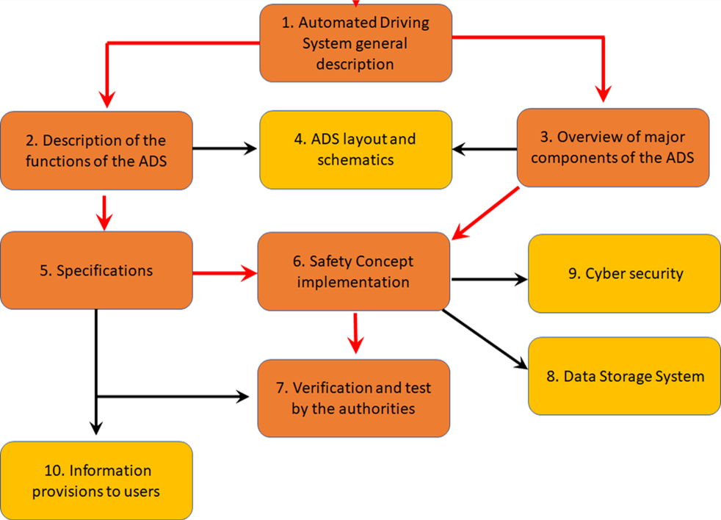

7. Validation & Verification

**ASSESSMENT REPORT BY AUTHORITY**

|  |  |
| --- | --- |
| **A) A Safety report by manufacturers (based on January 2020 discussion)** | **UN R157 - Annex4, Information Document (rev)** |
| **General purpose of the documentation** | Section 1 – General purpose of the documentation of document  The manufacturer shall provide a documentation package which gives access to the basic design of "ADS" and the means by which it is linked to other vehicle systems or by which it directly controls output variables.  The function(s) of "ADS", including the control strategies, and the safety concept, as laid down by the manufacturer, shall be explained.  Documentation shall be brief, yet provide evidence that the design and development has had the benefit of expertise from all the system fields which are involved.  For periodic technical inspections, the documentation shall describe how the current operational status of "The System" can be checked.  Information about how the software version(s) and the failure warning signal status can be readable in a standardized way via the use of an electronic communication interface, at least be the standard interface (OBD port).  The documentation package should show that the "ADS":  (a) Is designed and was developed to operate in such a way that it is free from unreasonable risks for the driver, passengers and other road users within the declared ODD and boundaries;  (b) Respects, under the performance requirements specified elsewhere by FRAV;  (c) Was developed according to the development process/method declared by the manufacturer. |
| **Type of documentation to be provided** | 3.1.1. Documentation shall be made available in three parts:  (a) An information document which is submitted to the authority shall contain brief information on the items listed in Appendix X (layout for information document).  (b) The formal documentation package annexed to the information document, containing the material listed in this paragraph 3. (with the exception of that of paragraph 3.4.4.) which shall be supplied to the certification Authority for the purpose of conducting the safety assessment. This documentation package shall be used by the certification Authority as the basic reference for the verification process set out in paragraph 4. of this annex. The certification Authority shall ensure that this documentation package remains available for a period determined of at least 10 years counted from the time when production of the ADS is definitely discontinued.  (c) Additional confidential material and analysis data (intellectual property) of paragraph 3.4.4. which shall be retained by the manufacturer, but made open for inspection (e.g. on-site in the engineering facilities of the manufacturer) at the time of the product assessment / process audit. The manufacturer shall ensure that this material and analysis data remains available for a period of 10 years counted from the time when production of the ADS is definitely discontinued. |
| 1. **Description of the system (ODD, function, type)** | 3.2. Description of the functions of "The ADS"  A description shall be provided which gives a simple explanation of all the functions including control strategies of "The ADS" and the methods employed to perform the dynamic driving tasks within the ODD and the boundaries under which the ADS is designed to operate, including a statement of the mechanism(s) by which control is exercised.  The manufacturer shall describe the interactions expected between the system and the driver, vehicle occupants and other road users as well as Human-Machine-Interface (HMI).  Any enabled or disabled automated driving functions for which the hardware and software are present in the vehicle at the time of production, shall be declared and are subject to the requirements of this annex, prior to their use in the vehicle. The manufacturer shall also document the data processing in case of continuous learning algorithms are implemented.  3.2.1. A list of all input and sensed variables shall be provided and the working range of these defined, along with a description of how each variable affects system behaviour.  3.2.2. A list of all output variables which are controlled by "The System" shall be provided and an explanation given, in each case, of whether the control is direct or via another vehicle system. The range of control (paragraph 2.7.) exercised on each such variable shall be defined.  3.2.3. Limits defining the boundaries of functional operation including ODD-limits shall be stated where appropriate to automated lane keeping system performance.  3.2.4. Interaction concept with the driver when ODD limits are reached shall be explained including the list of types of situations in which the system will generate a transition demand to the driver.  3.2.5. Information shall be provided about the means to activate, override or deactivate the system including the strategy how the system is protected against unintentional deactivation. This shall also include information about how the system detects that the driver is available to take over driving control along with specification and documented evidence of the used parameter to identify driver attentiveness as well as the influence on the steering thresholds. |
| The manufacturer shall declare the operational design domain(s) (ODD): Road conditions, Geographical area, Speed range, Other conditions that must be fulfilled for the safe operation in the automated driving mode or will otherwise trigger a transition demand/minimum risk maneuver. |
| The manufacturer shall declare the main functionality of the system (functional architecture), its dependencies on, and interaction with, other vehicle systems, the driver, the environment and other road users (see section 1 of the Annex 1- See also main sections of the framework document). |
| The manufacturer shall declare the overall system architecture (see generic architecture “sense, plan, act” in the safety first white paper from industry) as well as the safety concept put in place to meet the safety requirements.  Follow the principle of RXSWIN vs Software number.  It shall provide an identification of safety critical components and software in particular for the following subsystems:  -Perception and objects detection including mapping and positioning  - Characterization of the decision-making safety  - Documented data processing in case of continuous learning implemented.  - Human-machine interactions including the driver but also other road users  - Supervision and remote monitoring (if applicable). | 3.3. System layout and schematics  3.3.1. Inventory of components.  A list shall be provided, collating all the units of "The ADS" and mentioning the other vehicle systems which are needed to achieve the control function in question.  An outline schematic showing these units in combination, shall be provided with both the equipment distribution and the interconnections made clear.  This outline shall include:  (a) Perception and objects detection including mapping and positioning  (b) Characterization of Decision-making  (c) Remote supervision and remote monitoring by a remote supervision centre (if applicable).  (d) The data storage system (DSSAD).  3.3.2. Functions of the units  The function of each unit of "The System" shall be outlined and the signals linking it with other units or with other vehicle systems shall be shown. This may be provided by a labelled block diagram or other schematic, or by a description aided by such a diagram.  3.3.3. Interconnections within "The System" shall be shown by a circuit diagram for the electric transmission links, by a piping diagram for pneumatic or hydraulic transmission equipment and by a simplified diagrammatic layout for mechanical linkages. The transmission links both to and from other systems shall also be shown.  3.3.4. There shall be a clear correspondence between transmission links and the signals carried between Units. Priorities of signals on multiplexed data paths shall be stated wherever priority may be an issue affecting performance or safety.  3.3.5. Identification of units  Each unit shall be clearly and unambiguously identifiable (e.g. by marking for hardware, and by marking or software output for software content) to provide corresponding hardware and documentation association. Where software version can be changed without requiring replacement of the marking or component, the software identification must be by software output only.  Where functions are combined within a single unit or indeed within a single computer, but shown in multiple blocks in the block diagram for clarity and ease of explanation, only a single hardware identification marking shall be used. The manufacturer shall, by the use of this identification, affirm that the equipment supplied conforms to the corresponding document.  3.3.5.1. The identification defines the hardware and software version and, where the latter changes such as to alter the function of the unit as far as this Regulation is concerned, this identification shall also be changed.  3.3.6. Installation of sensing system components  The manufacturer shall provide information regarding the installation options that will be employed for the individual components that comprise the sensing system. These options shall include, but are not limited to, the location of the component in/on the vehicle, the material(s) surrounding the component, the dimensioning and geometry of the material surrounding the component, and the surface finish of the materials surrounding the component, once installed in the vehicle. The information shall also include installation specifications that are critical to the system’s performance, e.g. tolerances on installation angle.  Changes to the individual components of the sensing system, or the installation options, shall be notified to the certification Authority.. |
|  | **Section 5 – Specifications**  Description of ADS specifications in Normal (§5.1) and Emergency Conditions (§5.1), the acceptability criteria (§5.3) and the demonstration of compliance with those criteria (§5.4). |
|  |  |
| **2) Hazard and Risk analysis (functional and operational safety, link with cyber risk as well), Safety concept and safety by design by manufacturers**  NOTE: Avoid duplication (cross reference to cyber regulation?): Important is the link between cyber analysis and the safety of the function. CSMS in application. | **Section 6 – Safety Concept implementation**  Description of the implementation of the safety concept, i.e. the approaches adopted to assure the safety of passengers and other road users, as well as compliance with road rules, starting from the definition of safety objectives. The Section includes the manufacturer statement (§6.1), the description of software architecture (§6.2) and hardware solutions (§6.3) adopted to achieve the safety objectives, system self-diagnostics and main design provisions adopted to obtain safe operation (§6.4 = ex 5.1+ex 6.4 + ex 6.5), transition demand (§6.5), human-machine interface (§6.6), protection against simple unauthorized interventions (§6.7 = ex 5.2), ~~validation and verification by the manufacturer (§6.8)~~, simulation tools and tool-chains description and validation ((§6.7, input from VMAD-SG2).  3.4. Safety concept of the manufacturer  3.4.1. The manufacturer shall provide a statement which affirms that the "The ADS" is free from unreasonable risks for the driver, passengers and other road users.  3.4.2. In respect of software employed in "The ADS", the outline architecture shall be explained and the design methods and tools used shall be identified (see 3.5.1). The manufacturer shall show evidence of the means by which they determined the realization of the system logic, during the design and development process.  3.4.3. The manufacturer shall provide an explanation of the design provisions built into "The System" so as to ensure functional and operational safety. Possible design provisions in "The System" are for example:  (a) Fall-back to operation using a partial system.  (b) Redundancy with a separate system.  (c) Removal of the automated driving function(s).  3.4.3.1. If the chosen provision selects a partial performance mode of operation under certain fault conditions (e.g. in case of severe failures), then these conditions shall be stated (e.g. type of severe failure) and the resulting limits of effectiveness defined (e.g. initiation of a minimum risk manoeuvre immediately) as well as the warning strategy to the driver.  3.4.3.2. If the chosen provision selects a second (back-up) means to realise the performance of the dynamic driving task, the principles of the change-over mechanism, the logic and level of redundancy and any built in back-up checking features shall be explained and the resulting limits of back-up effectiveness defined.  3.4.3.3. If the chosen provision selects the removal of the automated driving function, this shall be done in compliance with the relevant provisions of this regulation. All the corresponding output control signals associated with this function shall be inhibited.  3.4.4. The documentation shall be supported, by an analysis which shows, in overall terms, how the system will behave to mitigate or avoid hazards which can have a bearing on the safety of the driver, passengers and other road users.  The chosen analytical approach(es) shall be established and maintained by the manufacturer and shall be made open for inspection by the certification Authority before market introduction.  The certification Authority shall perform an assessment of the application of the analytical approach(es):  (a) Inspection of the safety approach at the concept (vehicle) level.  This approach shall be based on a Hazard / Risk analysis appropriate to system safety.  (b) Inspection of the safety approach at the system level including a top down (from possible hazard to design) and bottom up approach (from design to possible hazards). The safety approach may be based on a Failure Mode and Effect Analysis (FMEA), a Fault Tree Analysis (FTA) and a System-Theoretic Process Analysis (STPA) or any similar process appropriate to system functional and operational safety. |
| General safety requirements are at this stage set by the framework document and future more detailed requirements development in FRVA (prevent accident, traffic rules, duty of care, failsafe response, HMI, OEDR, cyber/software updates, etc.) . |
| The manufacturer shall declare the high-level safety rules and the safety concept used for the design and described how this concept is implemented in the vehicle design. |
| The manufacturer shall in particular demonstrate that it has conducted a hazard and risk analysis for the automated system, its integration in the overall vehicle design and the broader transportation ecosystem and put in place adequate design and redundancy to address these risk and hazards (safety concept) and that the design leads to an acceptable residual risk for the ODD concerns). |
| Systems shall in particular be designed to address risks that could impact critical functions of the system (for the driver and other road users) due to cyber-attacks and failure (functional safety) but also potential inadequate control, undesirable control actions, reasonably foreseeable misuse by the driver or other road users(to be further defined), tampering and inadequate interaction with other road users (operational safety) during the lifetime of the vehicle. Relevant demonstration methods include ISO 26262 for functional safety and a system-theoretic process analysis (STPA) for operational safety or an equivalent method such as draft ISO PAS 21448. |
| The manufacturer shall describe how the current responses of the ADS to non-critical driving situations, expressing carefulness/duty of care of the ADS. |
| The manufacturer should identify critical scenarios in the ODD and responses to these critical scenarios. This includes traffic challenging scenarios for the ODD with other road users, emergency situation, severe failures). |
| Traffic rules/lifetime:  The manufacturer shall describe how the ODD will be managed during the lifetime of the vehicle and how the function will be prevented from being activated in case the conditions required for the ODD cannot be guaranteed anymore by the manufacturer.  The manufacturer shall describe how the compliance with traffic rules will be managed through the lifetime of the vehicle. | Part of the SMS? |
| **3) Verification and Validation by manufacturer** | The documentation shall demonstrate the validation/verification plans and results including appropriate acceptance criteria. This shall include validation testing appropriate for validation, for example, Hardware in the Loop (HIL) testing, vehicle on-road operational testing, testing with real end users, or any other testing appropriate for validation/verification.  Results of validation and verification may be assessed by analysing coverage of the different tests and setting coverage minimal thresholds for various metrics.  The documentation shall confirm that at least each of the following items is covered where applicable under (a)-(c):  (i) Issues linked to interactions with other vehicle systems (e.g. braking, steering);  (ii) Failures of the automated lane keeping system and system risk mitigation reactions;  (iii) Situations within the ODD when a system may create unreasonable safety risks for the driver, passengers and other road users due to operational disturbances (e.g. lack of or wrong comprehension of the vehicle environment, lack of understanding of the reaction from the driver, passenger or other road users, inadequate control, challenging scenarios)  (iv) Identification of the relevant scenarios within the boundary conditions and management method used to select scenarios and validation tool chosen.  (v) Decision making process resulting in the performance of the dynamic driving tasks (e.g. emergency manoeuvres), for the interaction with other road users and in compliance with traffic rules  (vi) Reasonably foreseeable misuse by the driver (e.g. driver availability recognition system and an explanation on how the availability criteria were established), mistakes or misunderstanding by the driver (e.g. unintentional override) and intentional tampering of the system.  (viii) Cyber-attacks having an impact on the safety of the vehicle .  The documentation shall establish that argumentation supporting the safety concept is understandable and logical and implemented in the different functions of the systems.  The documentation shall also demonstrate that validation plans are robust enough to demonstrate safety (e.g. reasonable coverage of chosen scenarios testing by the validation tool chosen) and have been completed.  The documentation shall demonstrate that the vehicle is free from unreasonable risks for the driver; vehicle occupants and other road users in the operational design domain, i.e. through:  (a) an overall validation target (i.e., validation acceptance criteria) supported by validation results, demonstrating that the entry into service of the automated lane keeping system will overall not increase the level of risk for the driver, vehicle occupants, and other road users compared to a manually driven vehicles; and  (b) A scenario specific approach showing that the system will overall not increase the level of risk for the driver, passengers and other road users compared to a manually driven vehicles for each of the safety relevant scenarios;  The documentation should allow the certification Authority to tests to verify the safety concept.  3.4.4.1. The documentation shall itemize the parameters being monitored and shall set out, for each failure condition of the type defined in paragraph 3.4.4. of this annex, the warning signal to be given to the driver/vehicle occupants/other road users and/or to service/technical inspection personnel.  3.4.4.2. This documentation shall also describe the measures in place to ensure the "The System" is free from unreasonable risks for the driver, vehicle occupants, and other road users when the performance of "The System" is affected by environmental conditions e.g. climatic, temperature, dust ingress, water ingress, ice packing. |
| The manufacturer shall demonstrate that all design solutions have been verified and validated (through simulation and physical testing including real world testing) by the manufacturer as individual subsystem and as part of the entire vehicle architecture and that the residual risk is acceptable for the driver and other road users.  In case the manufacturer rely on sub-contractors for subsystem, for the demonstration, the manufacturer may use documentation on the verification, validation carried out by its suppliers but remains responsible of the overall safety of the ADS. |
| The manufacturer shall declare the scenarios taken into account for the ADS design, and declare the scenario management method used to select scenarios and choose a validation tool.  NOTE: After market retrofitting |
| The safety demonstration shall combine  - a quantitative pre-validation target (e.g., using validation acceptance criteria), documented by the manufacturer, demonstrating that the introduction of the ADS will not increase the overall level of risk for the driver and other road users.  - a scenario-based approach, taking into account that the most relevant critical scenario have been addressed and that the residual risk is acceptable for the driver and other road users.  Acceptable risk level for AD function are not defined for now. OEM shall explain why the risk is acceptable. |
|  | *Relevant to Section 6* |
|  | **Section 8 of Annex I, Appendix 1 of R157 - Data Storage System**  Description of DSSAD in terms of type of data stored (§8.1), storage location and crash survivability (§8.2), data recorded during vehicle operation and occurrences (§8.3), data security and protection against unauthorized access or use (§8.4), means and tools to carry out authorized access to data (§8.5). |
|  | **Section 8 of Annex I, Appendix 1 of R157 +regulation 155 and 156-**  **Cybersecurity aspects**  Summary of compliance with Cybersecurity & OTA Regulations, namely: cyber security and software update management (§9.1), identification of risks, mitigation measures, secondary risks and assessment of residual risk (§9.2), software update procedure and management put in place to comply with legislative requirements (§9.3). |
|  | **Section 10 of Annex I, Appendix 1 of R157-**  **Information provided to the users**  Description of information provided to the users to properly inform them about the ADS characteristics and their responsibilities; it includes models of the information provided (§10.1), as well as excerpts from owner’s manual (§10.2). |
|  | **Annex I -**  List of applied regulations, codes and standards |
|  | |
| **B) Evaluation by authorities (to be covered under phase 3?)** | **Assessment report by Authorities** |
| **1) Evaluation of the design and its verification/validation by the manufacturer** |  |
| Before assessing the manufacturer’s safety concept” the certification authority shall check that a valid safety management scheme is implemented within the manufacturer (See paper on the audit of the safety management scheme). | Assessment of verification and validation performed by the manufacturer, including both the vehicle safety functions (§7.1) and the vehicle behavior when facing failures, operational disturbance, boundary and emergency conditions (§7.2). |
| The certification authority shall make a finding of at least safety equivalence compared to (at least) to (error free )manual driving including driver assistant systems within the ODD (i.e. quantitative and qualitative target above)) based on the manufacturer’s safety evaluation report documenting scenarios taken into account, testing, validation methods listed above). | See section A3 above. Overall safety target to be discussed by FRAV or in this group? |
| They shall verify that the hazard and risk analysis (i.e. hazards, occurrence and criticality) covers the scenarios of the system that are relevant to the ODD concerned.(link with subgroup 1). |
| They shall assess that the logical chart of responses to risk (e.g. redundancy, manoeuvers) covers the range of identified scenarios. They shall check that the safety concept is implemented consistently in the design of the different functions of the AD system |
| They shall check that the verification/validation process is robust enough (simulation, track test, in use data) and manufacturer has mitigated risks as reasonably possible and meet the minimum performance requirements. . The validation shall in particular show that the human – machine interactions (including misuses by the driver and other road users) have been properly assessed, based on a relevant set of tests and users. |
| They shall ensure that there is a transparent method of measuring the operational/run-time performance of the system. |
| The assessments is to be concluded in several steps: audit of the processes in place in the manufacturer organization, assessment once the safety concept is established and assessment of the validation of the manufacturer, monitoring of the manufacturer once the product is on the market. |
|  |
| **2) Evaluation tests by authorities (to be covered under phase 3?)** | *Relevant to the Testing Pillar as well. Difference between functional safety and operational safety?* |
| The authorities might carry out a minimum number of track tests to verify that the vehicle operates safely from the functional and operational safety point of view.  Check that the safety concept is implemented by the manufacturer. Confirm that the safety concept is valid to the vehicle type variant version to be covered by the assessment | Taking into account the results of the analysis of the manufacturer’s documentation package referred to in paragraph 3, the certification authority may perform or may request the tests to be performed to check specific points arisen from the documentation provided by te manufacturer.  4.1. The functional operation of "The System", as laid out in the documents required in paragraph 3., shall be tested as follows:  4.1.1. Verification of the function of "The System"  The certification authorities may verify "The System" under non-failure conditions by testing on a track a number of selected functions from those described by the manufacturer in paragraph 3.2. above, and by checking the overall behaviour of the system in real driving conditions including the compliance with traffic rules.  These tests shall include scenarios whereby the system is overridden by the driver.  Tests according to this verification shall take into account tests already conducted under the testing Pillar .  These tests can be based on scenarios listed in xxxx and/or on additional scenarios not covered by xxxx (Scenario pillar).  4.1.1.1. The verification test results shall correspond with the description, including the control strategies, provided by the manufacturer in paragraph 3.2. and shall comply with the performance requirements developed by FRAV.  4.1.2. Verification of the safety concept of paragraph 3.4.  The reaction of "The System" shall be checked under the influence of a faults in any individual unit by applying corresponding output signals to electrical units or mechanical elements in order to simulate the effects of internal failure within the unit. The certification authority may conduct this check for at least one individual unit, but shall not check the reaction of "The System" to multiple simultaneous failures of individual units.  The certification Authority shall verify that these tests include aspects that may have an impact on vehicle controllability and user information (HMI aspects e.g. transition scenarios).  4.1.2.1. The certification Authorities may also check a number of scenarios that are critical for the Object and Event Detection and Response (OEDR) and characterization of the decision-making and HMI functions of the system (e.g. object difficult to detect, when the system reaches the ODD boundaries, traffic disturbance scenarios) as defined in the regulation.  4.1.2.2. The verification results shall correspond with the documented summary of the hazard analysis, to a level of overall effect such that the safety concept and execution are confirmed as being adequate and in compliance with the requirements of FRAV.  Simulation shall not be a substitute for physical tests in Annex 5 to this UN Regulation. |
| Check the basic functionality as well as critical failure and driving scenarios through (track) testing. However, simulation can be used in case some critical scenarios/failure may prove to be difficult to be tested on track. |
| The authorities might carry out test drives in real-world traffic to verify the carefulness and understandability of operation by other road users in non-critical scenarios and the respect of basic traffic rules. |
| The minimum number of tests should include false negative and false positive test scenarios.  NOTE: Goal : Inject perception problem.  Question: What does this technically mean? A perfect system would not have FNs and FPs…  How to test false positive and especially false negative on the road??  Even for a track test, how can one induce a system to fail by influencing its objects detection capabilities? The assessment of false or true is due to the system reaction. |
| The authority carrying out the tests shall have access to the system that is necessary to carry out the test under this section.  OICA comments: What is meant by “shall have access to the system”?  Manufacturers will make all the relevant documents and test results open for inspection (accessible). However, it must be clear that neither a source code review nor a direct copy of the verification toolchain (databases, simulation toolchains, sensor models, reprocessing data) will be practicable due to Intellectual Property, time constraint and intrinsic complexity. |
|  |  |
| **3) Simulation evaluation by authorities (to be covered under phase 3?)** | *Relevant to Section 6 of the Information Document/Safety Report* |
| Simulation method may be used by manufacturers to demonstrate safety, subject to their validation by the approval authorities/technical services in accordance with the procedure for virtual testing in (VMAD/SG2 on the simulation pillar).  Manufacturer shall demonstrate the validation of the simulation tool and its scope (e.g. vehicle model, sensor model, recognition model or environmental model).  Authorities shall be able to verify the validation done by the manufacturer to demonstrate the correlation of the expected results with track tests/on road tests (tool give representative results), scope, traceability, etc. as well as the validity of the simulation tool for the system concerned(applicability to the ODD concerned). | 4.2. Simulation tool and mathematical models for verification of the safety concept may be used in accordance with (conditions being developpped by VMAD/SG2 on the simulation pillar), in particular for scenarios that are difficult on a test track or in real driving conditions. Manufacturers shall demonstrate the scope of the simulation tool, its validity for the scenario concerned as well as the validation performed for the simulation tool chain (correlation of the outcome with physical tests). |
| **5) Pass/Failed criteria/Follow up:** |  |
| Clear Failed evaluation: the hazard/risk analysis does not cover the hazard risks of the use case, the safety concept does not address the hazard/risk analysis identified, the verification/validation does not guarantee an acceptable level of risk or the scenarios taken into account are not transparent ,test failed. | ***See section A.3 above (risk assessment/design)+ section B2 (testing).***  *Looking at experience in other fields, the dialogue with the authority starts at very early stages of the design & development process, so that minor/major non-conformities are identified and easily corrected. As a result, there are no cases of final failed evaluation.* |
| More elaborated common rating scheme needed? (e.g. observations, recommendations for the different level of criticality). |  |
| What about follow up in case of failed evaluation? |  |
| What about monitoring after a successful evaluation? On road monitoring. | *Covered by the pillar on in-service monitoring* |
|  |  |
| **6) Transparency/information sharing amongst authorities on the assessment carried out.** |  |
| As the future new assessment, method will rely more on the assessment by authorities than standardized technical requirements, to continue to ensure mutual recognition more transparency will be needed on what was done by the authorities while at the same time guaranteeing the protection of intellectual property for vehicle manufacturers.  Where do we put the limit between the two objectives?  Minimum set of information required to understand the system (functionality, operation) can be shared.  Description of the function (ODD) focusing on the functions available to the driver and other road users + test report done by the TAA |  |
| Systematic transmission or on request? |  |
| **Additional requirements** | **UN R 157 - Annex4: Outstanding issues NATM after September 2021)** |
| Consider safety audit for sub-systems/components of the ADS and the responsibility of the different actors within the supply chain | Not covered by R157 |
| Which information shall be made available?  Is some information to be available to some stakeholders beyond certification authorities (e.g. consumer, registration authorities, insurers, police)?  **Consumer:** Educated and trained as requested by the provisions of the UNECE Framework Document on AVs.  **Registration authorities**: They need to be aware of the vehicle being “capable of automation” and “system being enabled in the vehicle”.  **Insurers:** No rational behind sharing technical information with insurers.  **Police:** DSSAD / EDR provisions will be applied.  Entitled bodies will have access to required information based on national law | Not covered |
| Competence of the auditor: The authority shall have the necessary competences, certifications and training to carry out the vehicle safety assessment and tests listed above. Reference to ISO standards? |  |
| Which differences between type approval and self certification systems? |  |
|  |  |
|  | |
| **References :** |  |
| UN Framework document on automated vehicles  FRVA functional requirements  VMAD subgroup work on scenarios.  ISO 26262/SOTIF 21448  UL 4600  EU guidelines: https://ec.europa.eu/growth/content/guidelines-exemption-procedure-eu-approval-automated-vehicles_en  Annex 6 o UN Regulation 79.  EU Regulation 858/2018  UN R157  OICA comments: UL4600 is not a reference in this document; it is not a standard rather a compendium. Should be deleted here. |  |

*From OICA CLEPA Presentation GRVA-09-10e

