SLR-49-01/Rev.1

GTB proposal to clarify and improve the text of
UN Regulation No. 148.00
I. Proposal
Paragraph 5.4.4.2., amend to read:
“5.4.4.2. In case of failure of any one light source in a single lamp containing more than one light source, one of the following provisions shall apply:
(a) The light intensity at the points of standard light distribution defined in paragraph 2.2. of Annex 3 shall be at least 80 per cent of the minimum intensity required; or
(b) The light intensity in the axis of reference shall be at least 50 per cent of the minimum intensity required, provided that a note in the communication form states that the lamp is only for use on a vehicle fitted with an operating tell-tale indicating failure.”

Paragraph 5.11.3., amend to read:

“5.11.3. Photometric characteristics
For the approval of this device, the illumination of the space to be occupied by the plate is determined. The illuminated areas are grouped in the following categories:
- Category 1a: illuminated area of at least 340 x 240 mm (Figure A3-IX).
- Category 1b: illuminated area of at least 520 x 120 mm (Figure A3-X).
- Category 1c: illuminated area of at least 255 x 165 mm, for use on agricultural or forestry tractors, (Figure A3-XI).
- Category 2a: illuminated area of at least 330 x 165 mm (Figure A3-XII).
- Category 2b: illuminated area of at least 440 x 220 mm (Figure A3-XIII).
- Category 1: illuminated area of at least 130 x 240 mm for use on a vehicle of category L (Figure A3-XIV).
- Category 2: illuminated area of at least 200 x 280 mm for use on a vehicle of category L (Figure A3-XV).
At each of the points of measurement shown in paragraph 3. of Annex 3, the luminance B shall be at least
…”

Correct the following figures

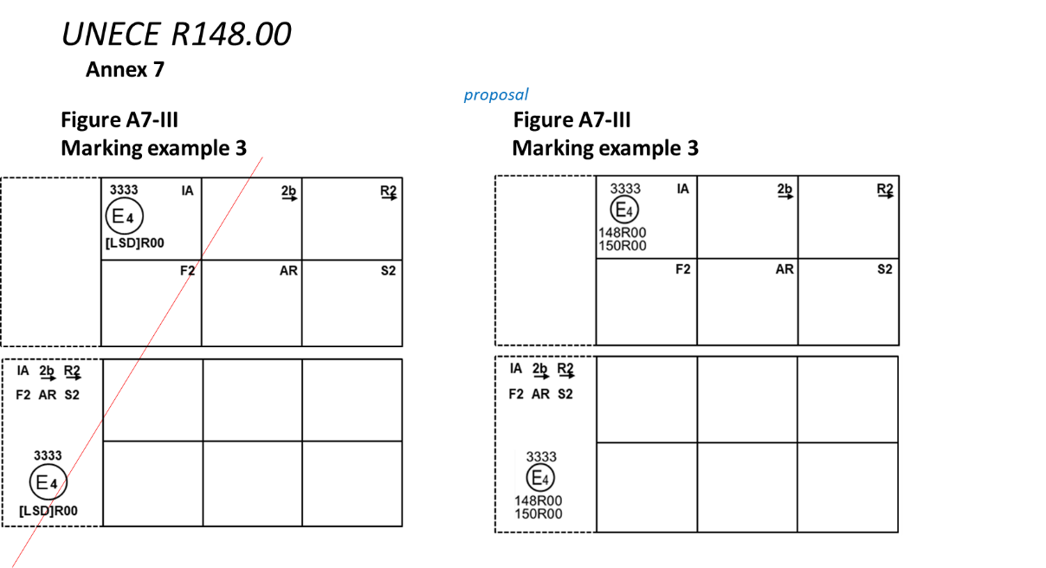

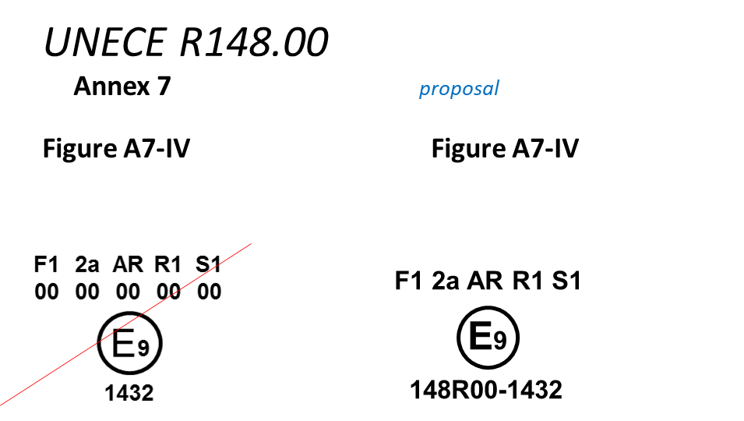
II. Justification:
1. For DRL, the requirement for “operating tell-tale” has been modified to a “tell-tale indicating failure”. This modification was introduced with Supplement 18 to the original series of amendments to UN Regulation No.87, but not in UN Regulation No.148. (UN Regulation No. 87 Revision 3 - Amendment 2 Supplement 18 to the original version of the Regulation – Date of entry into force: 22 June 2017)
2. The explanation for the categories of the illuminated area, existing in the frozen UN Regulations Nos. 4 (definitions) and 50 (Par. 1 of Annex 5), were unintentionally omitted in the original text of UN Regulation No.148. This proposal is intended to re-introduce such an explanation under paragraph 5.11.3. The missing information for the category of the illuminated area was given with reference to the relevant rear registration plate.
3. Some errors have been identified in Figures A7-III and A7-IV. This proposal also corrects such Figures.

