|  |  |  |  |
| --- | --- | --- | --- |
|  | United Nations | ECE/TRANS/WP.29/GRBP/2021/12 | |
|  | **Economic and Social Council** | | Distr.: General  30 June 2021  Original: English |

**Economic Commission for Europe**

Inland Transport Committee

**World Forum for Harmonization of Vehicle Regulations**

**Working Party on Noise and Tyres**

**Seventy-fourth session**

Geneva, 15-17 September 2021

Item 7 (e) of the provisional agenda

**Tyres: UN Regulation No. 117 (Tyre rolling resistance, rolling noise and wet grip)**

**Proposal for amendments to UN Regulation No. 117**

**Submitted by the Informal Working Group on Wet Grip Performance for Tyres in a Worn State[1]\***

The text reproduced below was prepared by the expert from the Informal Working Group on Wet Grip Performance for Tyres in a Worn State (IWG WGWT). This document aims to introduce a procedure and thresholds on wet grip performance for C1 tyres in worn state, in accordance with the IWG WGWT mandate (Annex III to ECE/TRANS/WP.29/GRBP/71). The modifications to the current text of the Regulation are marked in bold for new or strikethrough for deleted characters.

**I. Proposal**

*Paragraph 1.1.,* amend to read:

“1.1. This Regulation applies to new pneumatic tyres * of ~~Classes~~ **classes** C1, C2 and C3 **in new state** with regard to their sound emissions, rolling resistance and to adhesion performance on wet surfaces (wet adhesion) **and for class C1 tyres in worn state with regard to adhesion performance on wet surfaces (wet adhesion)**. It does not, however, apply to:”

*Paragraph 1.2.,* amend to read:

“1.2. Contracting Parties shall issue or accept approvals to rolling sound and/or ~~wet~~ adhesion **of tyres in new state on wet surfaces and/or adhesion of tyres in worn state on wet surfaces** and/or rolling resistance.”

*Paragraph 2.13.1.,* amend to read:

“2.13.1. "*Snow tyre for use in severe snow conditions*": means a snow tyre whose tread pattern, tread compound or structure is specifically designed to be used in severe snow conditions and that fulfils the requirements of paragraph **6.5.**~~6.4.~~ of this Regulation.”

*Insert new paragraphs 2.19.9. and 2.19.10.*, to read:

“**2.19.9. "*Tyre in worn state*" or "*worn tyre*"means the tyre in a state as defined in Annex 9 to this Regulation.**

**2.19.10. "*Tyre in new state*" means the tyre in a state as defined in Annex 9 to this Regulation.**”

*Paragraph 3.1.1.,* amend to read:

“3.1.1. The performance characteristics to be assessed for the ~~tyre~~ type **of tyre**; "rolling sound emissions level" and/or "adhesion performance level on wet surfaces **of tyre in new state**" **and/or "adhesion performance level on wet surfaces of tyre in worn state”** and/or "rolling resistance level"~~.~~ ~~Tyre "snow performance level" in cases of "snow tyre for use in severe snow conditions"~~; **and/or "snow performance level" in case of "snow tyre for use in severe snow conditions"**;”

*Paragraph 4.3.1.,* amend to read:

“4.3.1. In case the approval of a tyre pursuant to this Regulation has been granted by the same Type Approval Authority than that granting the approval pursuant to UN Regulation No. 30 or UN Regulation No. 54, the approval mark pursuant to UN Regulation No. 30 or UN Regulation No. 54 can be combined with an indication of the applicable series of amendments to which the tyre was approved pursuant to UN Regulation No. 117 on the form of 2 digits (example "~~02~~**03**" indicating that the UN Regulation No.117 approval was granted following the ~~02~~**03** series of amendments) and the suffixes according to paragraph 5.2.2. using the addition sign "+", as described in Annex 2, Appendix 3 of this Regulation, for example "0236378 + ~~02S1WR2~~ **03SWRB**".”

*Paragraph 5.2.2.,* amend to read:

“5.2.2. The communication form mentioned in paragraph 5.3. below shall identify specific performance parameters of UN Regulation No. 117 by the following suffixes:

S To identify additional conformity to the requirements on tyre rolling sound emissions;

W To identify additional conformity to the requirements on ~~tyre~~ adhesion ~~of~~ on wet surfaces **of tyres in new state**;

R To identify additional conformity to the requirements on tyre rolling resistance.

**B To identify additional conformity to the requirements on adhesion on wet surfaces of tyres in worn state;**

~~Taking into account that two stages are defined for rolling sound and rolling resistance specifications in paragraphs 6.1. and 6.3. below, S and R will be followed either by the suffix "1" for compliance to stage 1 or by the suffix "2" for compliance to stage 2.~~”

*Paragraph 5.3.1.2.,* amend to read:

“5.3.1.2. The suffix(es) mentioned in paragraph 5.2.2. above shall be preceded by the two digits identifying the series of amendments of the prescription on tyre performances for UN Regulation No. 117, e.g. ~~02S2~~ **03S** to identify the ~~second~~ **third** series of amendments on tyre road rolling sound emissions ~~at stage 2~~ or ~~02S1WR1~~ **03SWR** to identify the ~~second~~ **third** series of amendments on tyre road rolling sound emissions ~~at stage 1~~, tyre adhesion on wet surfaces and rolling resistance ~~at stage 1 (see paragraph 6.1. below for stage 1 and stage 2 definitions)~~."

*Paragraph 5.4.3.,* amend to read:

“5.4.3. The suffix(es), and the identification to the relevant series of amendments, if any, as specified in the communication form.

One of the suffixes listed below or any combination of them can be used.

|  |  |
| --- | --- |
| ~~S1~~ | ~~Sound level at stage 1~~ |
| S~~2~~ | ~~Sound~~ **Rolling sound** **emission** level ~~at stage 2~~ |
| W | Wet adhesion level **of tyres** **in new state** |
| ~~R1~~ | ~~Rolling resistance level at stage 1~~ |
| R~~2~~ | Rolling resistance ~~at stage 2~~ |
| **B** | **Wet adhesion level of tyres** **in worn state** |

These suffixes shall be placed to the right or below the approval number, if part of the original approval.

If the approval is extended subsequent to UN Regulation Nos. 30 or 54 approvals, the addition sign "+" and the series of amendment to UN Regulation No. 117 shall be placed in front of the suffix or any combination of suffixes to denote an extension to the approval.

If the approval is extended subsequent to the original approval under UN Regulation No. 117, the addition sign "+" shall be placed between the suffix or any combination of suffixes of the original approval and the suffix or any combination of suffixes added to denote an extension to the approval.”

*Paragraph 6.1.1.,* amend to read:

“6.1.1. For ~~Class~~ **class** C1 tyres, the rolling sound emission value shall not exceed the values given below. These values refer to the nominal section width as ~~given in paragraph 2.17.1.1. of~~ **defined in** UN Regulation No. 30:

| *~~Stage 1~~* | |
| --- | --- |
| *~~Nominal section width~~* | *~~Limit dB(A)~~* |
| ~~145 and lower~~ | ~~72~~ |
| ~~Over 145 up to 165~~ | ~~73~~ |
| ~~Over 165 up to 185~~ | ~~74~~ |
| ~~Over 185 up to 215~~ | ~~75~~ |
| ~~Over 215~~ | ~~76~~ |
| ~~The above limits shall be increased by 1 dB(A) for extra load tyres or reinforced tyres and by 2 dB(A) for "special use tyres".~~ | |

| *~~Stage 2~~* | |
| --- | --- |
| *Nominal section width* | *Limit dB(A)* |
| 185 and lower | 70 |
| Over 185 up to 245 | 71 |
| Over 245 up to 275 | 72 |
| Over 275 | 74 |
| The above limits shall be increased by 1 dB(A) for "snow tyre for use in severe snow conditions", extra load tyres or reinforced tyres, or any combination of these classifications. | |

”

*Paragraph 6.1.2.,* amend to read:

“6.1.2. For ~~Class~~ **class** C2 tyres, the rolling sound emission value with reference to its category of use (see paragraph 2.1., subparagraph (d) above) shall not exceed the values ~~pertinent to the applicable stage~~ given below:

| *~~Stage 1~~* | |
| --- | --- |
| *~~Category of use~~* | *~~Limit dB(A)~~* |
| ~~Normal tyre~~ | ~~75~~ |
| ~~Snow tyre~~ | ~~77~~ |
| ~~Special use tyre~~ | ~~78~~ |

| *~~Stage 2~~* | | | |
| --- | --- | --- | --- |
| *Category of use* |  | *Limit dB(A)* | |
| *Other* | *Traction tyres* |
| Normal tyre |  | 72 | 73 |
| Snow tyre |  | 72 | 73 |
| Snow tyre for use in severe snow conditions | 73 | 75 |
| Special use tyre |  | 74 | 75 |

*”*

*Paragraph 6.1.3.,* amend to read:

“6.1.3. For ~~Class~~ **class** C3 tyres, the rolling sound emission value with reference to its category of use (see paragraph 2.1., subparagraph (d) above) shall not exceed the values ~~pertinent to the applicable stage~~ given below:

| *~~Stage 1~~* | |
| --- | --- |
| *~~Category of use~~* | *~~Limit dB(A)~~* |
| ~~Normal tyre~~ | ~~76~~ |
| ~~Snow tyre~~ | ~~78~~ |
| ~~Special use tyre~~ | ~~79~~ |

| *~~Stage 2~~* | | | |
| --- | --- | --- | --- |
| *Category of use* |  | *Limit dB(A)* | |
| *Other* | *Traction tyres* |
| Normal tyre |  | 73 | 75 |
| Snow tyre |  | 73 | 75 |
| Snow tyre for use in severe snow conditions | 74 | 76 |
| Special use tyre |  | 75 | 77 |

*”*

*Paragraph 6.2.,* amend to read:

“6.2. The wet ~~grip performance~~ **adhesion** **of tyres in new state** will be based on a procedure that compares either peak brake force coefficient ("pbfc") or mean fully developed deceleration ("mfdd") against values achieved by a Standard Reference Test Tyre (SRTT). The relative performance shall be indicated by a wet grip index (G).”

*Paragraph 6.3.,* amend to read:

“6.3. Rolling resistance coefficient limits, as measured by the method described in Annex 6 to this Regulation.

~~6.3.1. The maximum values for stage 1 for the rolling resistance coefficient shall not exceed the following (value in N/kN is equivalent to value in kg/tonne):~~

| *~~Tyre class~~* | *~~Max value (N/kN)~~* |
| --- | --- |
| ~~C1~~ | ~~12.0~~ |
| ~~C2~~ | ~~10.5~~ |
| ~~C3~~ | ~~8.0~~ |
| ~~For "snow tyre for use in severe snow conditions", the limits shall be increased by 1 N/kN.~~ | |

~~6.3.1.2.~~ The maximum values ~~for stage 2~~ for the rolling resistance coefficient shall not exceed the following (value in N/kN is equivalent to value in kg/tonne):

| *Tyre class* | *Max value (N/kN)* |
| --- | --- |
| C1 | 10.5 |
| C2 | 9.0 |
| C3 | 6.5 |
| For "snow tyre for use in severe snow conditions”, the limits shall be increased by 1 N/kN. | |

”

*Insert a new paragraph 6.4.*, to read:

“**6.4. The wet adhesion of tyres in worn state shall be based on a procedure defined in Annex 9 to this Regulation.**

**6.4.1. For class C1 tyres, tested in accordance with either procedure given in Annex 9 to this Regulation, the tyre shall meet the following requirements:**

**[**

| ***Category of use*** |  | ***Wet grip index (GB)*** |
| --- | --- | --- |
| **Normal tyre** |  |  |
| **Snow tyre** |  |  |
| **Snow tyre for use in severe snow conditions** |  |
|  |  |
| **Special use tyre** |  |  |

]”

*Paragraph 6.4. (former),* renumber as 6.5.

*Paragraph 6.5., (former),* renumber as 6.6. andamend to read:

“6.**6.**~~5.~~ In order to be classified as a "traction tyre", a tyre is required to meet ~~at least one of~~ the condition~~s~~ of paragraph 6.~~5.~~**6.**1. below."

*Paragraphs 6.5.1, 6.6. (former) and 6.7.,* renumber as 6.6.1., 6.7. and 6.8., respectively.

*Insert a new paragraph 8.2.2.*, to read:

“**[8.2.2. In the case of verifications with regard to approvals in accordance with paragraph 6.4. of this Regulation, these shall be carried out using the same procedure (see Annex 9 to this Regulation) as that adopted for original approval, and the Type Approval Authority shall satisfy itself that all tyres falling within an approved type comply with the approval requirements. The assessment shall be based upon the production volume of the tyre type at each manufacturing facility, taking into account the quality management system(s) operated by the manufacturer. Where the test procedure involves testing a number of tyres at the same time, for example a set of four tyres for the purpose of testing wet adhesion in accordance with the standard vehicle procedure given in Annex 9 to this Regulation, then the set shall be considered as being one unit for the purposes of calculating the number of tyres to be tested.]**”

*Paragraph 12.,* amend to read:

“12. Transitional provisions

~~12.1. As from the date of entry into force of the 02 series of amendments to this Regulation, Contracting Parties applying this Regulation shall not refuse to grant approval under this Regulation for a type of tyre if the tyre complies with the requirements of the 02 series of amendments, including the stage 1 or stage 2 rolling sound requirements set out in paragraphs 6.1.1. to 6.1.3. of this Regulation, the requirements for wet grip performance set out in paragraph 6.2.1. of this Regulation, and the stage 1 or stage 2 rolling resistance requirements set out in paragraph 6.3.1. or 6.3.2. of this Regulation.~~

~~12.2. As from 1 November 2012, Contracting Parties applying this Regulation shall refuse to grant approval if the tyre type to be approved does not meet the requirements of this Regulation as amended by the 02 series of amendments, and shall, in addition, refuse to grant approval if the stage 2 rolling sound requirements set out in paragraphs 6.1.1. to 6.1.3. of this Regulation, the requirements for wet grip performance set out in paragraph 6.2.1. of this Regulation, and the stage 1 rolling resistance requirements set out in paragraph 6.3.1. of this Regulation are not complied with.~~

~~12.3. As from 1 November 2014, Contracting Parties applying this Regulation may refuse to allow the sale or entry into service of a tyre which does not meet the requirements of this Regulation as amended by the 02 series, and which does not meet the requirements of this Regulation as amended by the 02 series of amendments including the wet grip performance requirements set out in paragraph 6.2.1. of this Regulation.~~

~~12.4. As from 1 November 2016, Contracting Parties applying this Regulation shall refuse to grant approvals if the tyre type to be approved does not meet the requirements of this Regulation as amended by the 02 series of amendments including the stage 2 rolling resistance requirements set out in paragraph 6.3.2. of this Regulation and the wet grip requirements set out in paragraphs 6.2.2. and 6.2.3. of this Regulation.~~

~~12.5. As from 1 November 2016, any Contracting Party applying this Regulation may refuse to allow the sale or entry into service of a tyre which does not meet the requirements of this Regulation as amended by the 02 series, and which does not meet the stage 2 rolling sound requirements set out in paragraphs 6.1.1. to 6.1.3. of this Regulation.~~

~~12.6. As from the dates given below, any Contracting Party applying this Regulation may refuse to allow the sale or entry into service of a tyre which does not meet the requirements of this Regulation as amended by the 02 series, and which does not meet the stage 1 rolling resistance requirements set out in paragraph 6.3.1. of this Regulation:~~

| *~~Tyre class~~* | *~~Date~~* |
| --- | --- |
| ~~C1, C2~~ | ~~1 November 2014~~ |
| ~~C3~~ | ~~1 November 2016~~ |

~~12.7. As from the dates given below, any Contracting Party applying this Regulation may refuse to allow the sale or entry into service of a tyre which does not meet the requirements of this Regulation as amended by the 02 series, and which does not meet the stage 2 rolling resistance requirements set out in paragraph 6.3.2. of this Regulation and the wet grip requirements set out in paragraphs 6.2.2. and 6.2.3. of this Regulation:~~

| *~~Tyre class~~* | *~~Date~~* |
| --- | --- |
| ~~C1 and C2~~ | ~~1 November 2018~~ |
| ~~C3~~ | ~~1 November 2020~~ |

~~12.8. Until 13 February 2019 (60 months after the entry into force of Supplement 4 to the 02 series of amendments of this Regulation) Contracting Parties applying this Regulation may continue to grant type approvals according to the 02 series of amendments to this Regulation, based on the provisions of Annex 4 to this Regulation.~~

~~12.9. Until 3 months after the date of entry into force of Supplement 11 to the 02 series of amendments to this Regulation, Contracting Parties applying this Regulation can continue to grant type approvals according to the 02 series of amendments to this Regulation, without taking into account the provisions of Supplement 11.~~

~~12.10. Until 3 months after the date of entry into force of Supplement 13 to the 02 series of amendments to this Regulation, Contracting Parties applying this Regulation can continue to grant type approvals according to the 02 series of amendments to this Regulation, without taking into account the provisions of Supplement 13.~~

**12.1. As from the official date of entry into force of the 03 series of amendments, no Contracting Party applying this Regulation shall refuse to grant or refuse to accept type approvals under this Regulation as amended by the 03 series of amendments.**

**12.2. Contracting Parties applying this Regulation shall continue to accept type approvals of , to grant approvals to and to grant extensions of approvals to, the classes C2 and C3 tyres, which are not affected by the changes introduced by the 03 series of amendments, to the 02 series of amendments to this Regulation.**

**12.3. As from 7 July 2024, Contracting Parties applying this Regulation shall not be obliged to accept type approvals of class C1 tyres to the 02 series of amendments, first issued after 7 July 2024.**

**12.4. Until 7 July 2026, Contracting Parties applying this Regulation shall accept type approvals of class C1 tyres to the 02 series of amendments, first issued before 7 July 2024.**

**12.4.1. Until 7 July 2026, Contracting Parties applying this Regulation shall continue to grant extensions of existing approvals of class C1 tyres to the 02 series of amendments first issued before 7 July 2024.**

**12.5. As from 7 July 2026, Contracting Parties applying this Regulation shall not be obliged to accept type approvals of class C1 tyres issued to the 02 series of amendments to this Regulation.**

**12.6. Contracting Parties applying this Regulation may grant type approvals according to any preceding series of amendments to this Regulation.**

**12.6.1. Contracting Parties applying this Regulation shall continue to grant extensions of existing approvals to any preceding series of amendments to this Regulation.**

12.**7**~~11~~. Until 1 September 2024, Contracting Parties applying this Regulation may continue to grant type approvals according to the ~~02~~**03** series of amendments to this Regulation, based on snow performance test described in Annex 7 to this Regulation using SRTT14 as reference tyre. (a)

12.**8**~~12~~. Until 1 September 2024, Contracting Parties applying this Regulation may continue to grant type approvals according to the ~~02~~**03** series of amendments to this Regulation, based on the test procedures for measuring **the** wet ~~grip~~ **adhesion of tyres in new state as** described in Annex 5 of this Regulation, without taking into account the provisions **introduced after** ~~of~~ Supplement ~~13~~ **12 to the 02 series of amendments**.

(a) SRTT14 will be available from the supplier until end of October 2021.”

*Annex 1*

*Paragraph 8.,* amend to read:

“8. Performance(s) approved: sound level ~~at (stage 1/stage 2),~~~~2~~ wet adhesion level **of tyres in new state**, rolling resistance level ~~(stage 1/stage 2)~~~~2~~**, wet** **adhesion level of tyres in worn state**”

*Paragraph 8.2.,* amend to read:

“8.2. Wet adhesion level **of tyres in new state** of ~~the~~ representative ~~tyre~~ size, see paragraph 2.7. of this Regulation, as per item 7. of the test report in the appendix to Annex 5: ……………………… (G) using the vehicle or trailer method2”

*Insert a new paragraph 8.3.*, to read:

“**8.3. Wet adhesion level of tyres in worn state of representative size, see paragraph 2.7. of this Regulation, as per item Y. of the test report in the appendix to Annex 9: ……………………… (GB) using the vehicle or trailer method2**”

*Paragraphs 8.3. (former) to 8.4.,* renumber as 8.4. to 8.5., respectively.

*Annex 2, Appendix 1,* amend to read:

“Annex 2 ‑ Appendix 1

~~Example of~~ Examples of separate UN Regulation No. 117 approval marks

~~Arrangements of approval marks~~

~~(See paragraph 5.4. of this Regulation)~~

~~Approval according to Regulation No. 117~~

# Example 1

~~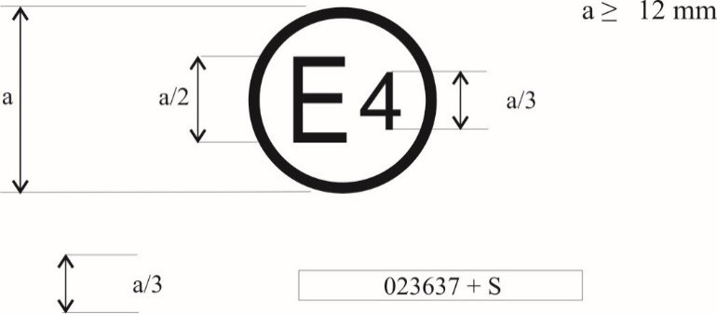~~

**~~0212345 S2~~**

~~The above approval mark, affixed to a tyre shows that a tyre concerned has been approved in the Netherlands (E 4) pursuant to Regulation No. 117 (marked by S2 (rolling sound at stage 2) only), under approval number 0212345. The first two digits of the approval number (02) indicate that the approval was granted according to the requirements 02 series of amendments to this Regulation.~~



**0312345 S**

**The above approval mark, affixed to a tyre shows that a tyre concerned has been approved in the Netherlands (E4) pursuant to UN Regulation No. 117 (marked by S (rolling sound)), under approval number 0312345. The first two digits of the approval number (03) indicate that the approval was granted according to the requirements of the 03 series of amendments to this Regulation.**

# Example 2

~~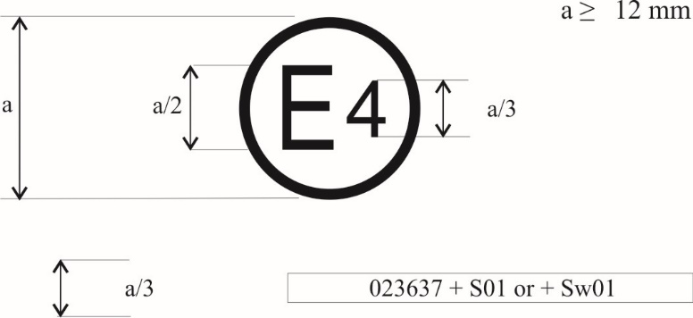~~

**~~0212345 S1WR1~~**

~~The above approval mark shows that the tyre concerned has been approved in the Netherlands (E 4) pursuant to Regulation No. 117 (marked by S1 (rolling sound at stage 1) W (wet adhesion), and R1 ( Rolling resistance at stage 1 ) under approval number 0212345. This indicates that the approval is for S1WR1. The first two digits of the approval number (02) indicate that the approval was granted according to the requirements of the 02 series of amendments to this Regulation.~~



**0312345 SWRB**

**The above approval mark shows that the tyre concerned has been approved in the Netherlands (E4) pursuant to UN Regulation No. 117 (marked by S (rolling sound), W (wet adhesion of tyres in new state), R (rolling resistance) and B (wet adhesion of tyres in worn state)) under approval number 0312345. The first two digits of the approval number (03) indicate that the approval was granted according to the requirements of the 03 series of amendments to this Regulation.**”

*Annex 2, Appendix 2,* amend to read:

“Annex 2 ‑ Appendix 2

Approval according to UN Regulation No. 117 coincident with approval of UN Regulations Nos. 30 or 54[2]

# Example 1

~~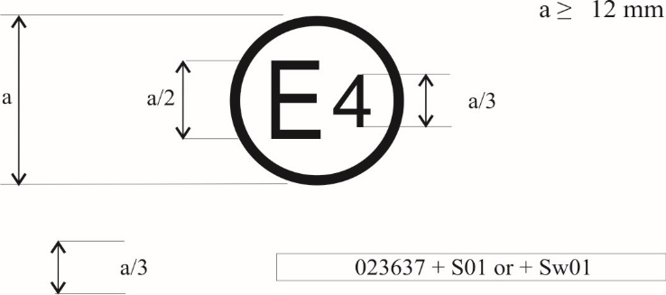~~

**~~a/3~~****~~0212345 S2 0236378~~**

~~The above approval mark shows that the tyre concerned has been approved in the Netherlands (E 4) pursuant to Regulation No. 117 (marked by S2 (rolling sound at stage 2)), under approval number 0212345 and Regulation No. 30, under approval number 0236378. The first two digits of the approval number (02) indicate that the approval was granted according to the 02 series of amendments and Regulation No. 30 included the 02 series of amendments.~~



**a/3** **0312345 S 0236378**

**The above approval mark shows that the tyre concerned has been approved in the Netherlands (E4) pursuant to UN Regulation No. 117 (marked by "S" (rolling sound)), under approval number 0312345 and UN Regulation No. 30, under approval number 0236378. The first two digits of the approval numbers ("03" and "02") indicate that the approval pursuant to UN Regulation No. 117 was granted according to the 03 series of amendments and the approval pursuant to UN Regulation No. 30 according to the 02 series of amendments.**

# Example 2

~~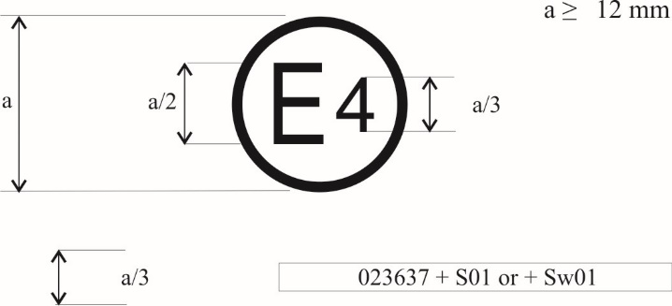~~

|  |  |  |
| --- | --- | --- |
|  | **~~0212345 S2 0236378~~** |  |

|  |  |  |
| --- | --- | --- |
|  | **~~Or~~** |  |
|  | **~~0212345 S2WR2~~**  **~~0236378~~** |  |

# ~~The above approval mark shows that the tyre concerned has been approved in the Netherlands (E 4) pursuant to Regulation No. 117 (marked by S2WR2 (rolling sound at stage 2 wet adhesion and rolling resistance at stage 2)), under approval number 0212345 and Regulation No. 30 under approval number 0236378. The first two digits of the approval number (02) indicate that the approval was granted according to the 02 series of amendments and Regulation No. 30 included the 02 series of amendments.~~



**0312345 SWRB 0236378**

**or**

**0312345 SWRB**

**0236378**

**The above approval mark shows that the tyre concerned has been approved in the Netherlands (E4) pursuant to UN Regulation No. 117 (marked by "SWRB" (rolling sound, wet adhesion of tyres in new state, rolling resistance and wet adhesion of tyres in worn state)), under approval number 0312345 and UN Regulation No. 30 under approval number 0236378. The first two digits of the approval numbers ("03" and "02") indicate that the approval pursuant to UN Regulation No. 117 was granted according to the 03 series of amendments and the approval pursuant to UN Regulation No. 30 according to the 02 series of amendments.**

# Example 3

~~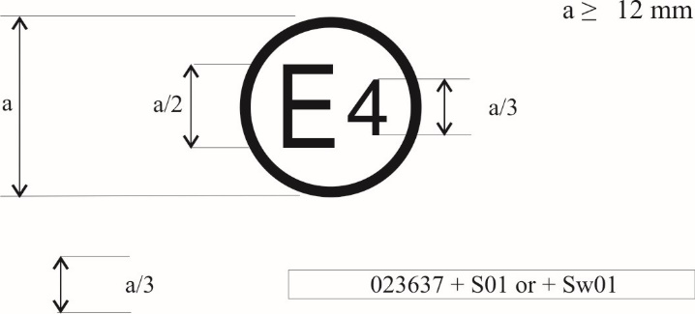~~

**~~a/3~~****~~0212345 S2 0054321~~**

~~The above approval mark shows that the tyre concerned has been approved in the Netherlands (E 4) pursuant to Regulation No. 117 and the 02 series of amendments under approval number 0212345 (marked by S2), and Regulation No. 54. This indicates that the approval is for rolling sound stage 2 (S2). The first two digits of the Regulation No. 117 approval number (02) in conjunction with "S2" indicate that the first approval was granted in accordance with Regulation No. 117 which included the 02 series of amendments. The first two digits of Regulation No. 54 (00) indicate that this Regulation was in its original form.~~



**a/3** **0312345 SWR 0065432**

**The above approval mark shows that the tyre concerned has been approved in the Netherlands (E4) pursuant to UN Regulation No. 117 (marked by "SWR" (rolling sound, wet adhesion of tyres in new state and rolling resistance)), under approval number 0312345 and UN Regulation No. 54 under approval number 0065432. The first two digits of the approval numbers ("03" and "00") indicate that the approval pursuant to UN Regulation No. 117 was granted according to the 03 series of amendments and the approval pursuant to UN Regulation No. 54 according to its original form.**

# ~~Example 4~~

~~~~

**~~a/3~~****~~0212345 S2 0054321~~**

~~The above approval mark shows that the tyre concerned has been approved in the Netherlands (E 4) pursuant to Regulation No. 117 and the 02 series of amendments under approval number 0212345 (marked by S2 R2), and Regulation No. 54. This indicates that the approval is for rolling sound stage 2 (S2) and rolling resistance stage 2. The first two digits of the Regulation No. 117 approval number (02) in conjunction with "S2R2" indicate that the first approval was granted in accordance with Regulation No. 117 which included the 02 series of amendments. The first two digits of Regulation No. 54 (00) indicate that this Regulation was in its original form.~~ ”

*Annex 2, Appendix 3,* amend to read:

“Annex 2 ‑ Appendix 3

Combinations of markings of approvals issued in accordance with Regulations Nos. 117, 30 or 54 [3]

# Example 1

~~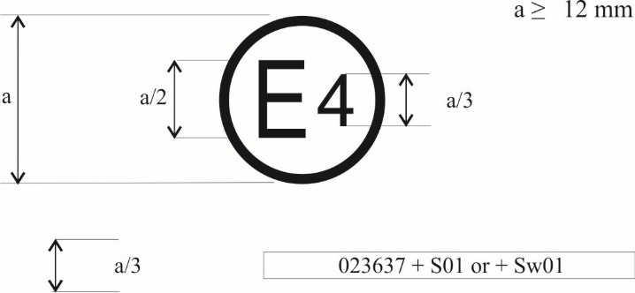~~

**~~a/3~~****~~0236378 + 02S1~~**

~~The above approval mark shows that the tyre concerned has been approved in the Netherlands (E 4) pursuant to UN Regulation No. 30 according to its 02 series of amendments (indicated by the first two digits of the approval number, "02") under approval number 0236378. It is also marked by "+ 02S1" which indicates that the tyre was also approved pursuant to UN Regulation No. 117 (02 series of amendments) for rolling sound at stage 1.~~

~~~~

**a/3** **0236378 + 03S**

**The above approval mark shows that the tyre concerned has been approved in the Netherlands (E4) pursuant to UN Regulation No. 30 according to its 02 series of amendments (indicated by the first two digits of the approval number, "02") under approval number 0236378. It is also marked by "+ 03S" which indicates that the tyre was also approved pursuant to UN Regulation No. 117 (03 series of amendments) for S (rolling sound).**

# Example 2

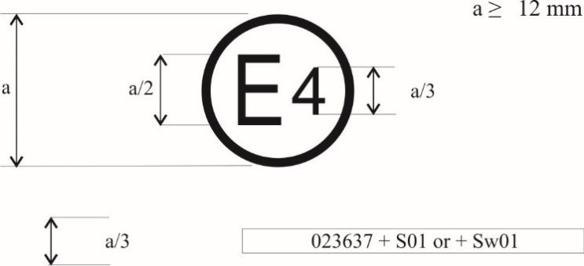

|  |  |  |
| --- | --- | --- |
|  | **~~0236378 + 02S1WR2~~** |  |

~~The above approval mark shows that the tyre concerned has been approved in the Netherlands (E 4) pursuant to Regulation No. 30 according to its 02 series of amendments under approval number 0236378. It is also marked by "+ 02S1WR2" which indicates that the tyre was also approved pursuant to UN Regulation No. 117 (02 series of amendments) for S1 (rolling sound) W (wet adhesion) and R2 (rolling resistance).~~



**a/3** **0236378 + 03SWRB**

**The above approval mark shows that the tyre concerned has been approved in the Netherlands (E4) pursuant to UN Regulation No. 30 according to its 02 series of amendments (indicated by the first two digits of the approval number, "02") under approval number 0236378. It is also marked by "+ 03SWRB" which indicates that the tyre was also approved pursuant to UN Regulation No. 117 (03 series of amendments) for S (rolling sound) W (wet adhesion of tyres in new state), R (rolling resistance) and B (wet adhesion of tyres in worn state).”**

*Annex 2, Appendix 4,* amend to read:

“Annex 2 ‑ Appendix 4

Extensions to combine approvals issued in accordance with Regulation No. 117~~[4]~~

# Example 1

~~~~

|  |  |  |  |
| --- | --- | --- | --- |
|  | |  | |
|  | **~~0212345 W + S2R2~~** | |  |

~~The above approval mark shows that the tyre concerned has been initially approved in the Netherlands (E 4) pursuant to Regulation No. 117 and the 02 series of amendments under approval number 0212345. This indicates that the approval is for W (wet grip). The S2R2 preceded by + indicates that it has had its approval extended under Regulation No. 117 to rolling sound at stage 2 and rolling resistance at stage 2 based on separate certificate(s).~~



**a/3** **0212345 S2WR2 + 03B**

**The above approval mark shows that the tyre concerned has been initially approved in the Netherlands (E4) pursuant to UN Regulation No. 117 and the 02 series of amendments under approval number 0212345. The marking is complemented by S2WR2 (rolling sound** **at stage 2) W (wet adhesion of tyres in new state) and R (rolling resistance** **at stage 2)** **The "03B" preceded by "+" indicates that it has had its approval extended under UN Regulation No. 117 and 03 series of amendments to wet adhesion of tyres in worn state based on separate certificate.**

# ~~Example 2~~

|  |  |  |  |
| --- | --- | --- | --- |
|  | | ~~a ≥ 12 mm~~ | |
|  | **~~0212345 S1W + R1~~** | |  |

~~The above approval mark shows that the tyre concerned has been initially approved in the Netherlands (E 4) pursuant to Regulation No. 117 and the 02 series of amendments under approval number 0212345. This indicates that the approval is for S1 (rolling sound at stage 1) and W (wet grip). The R1 preceded by + indicates that it has had its approval extended under Regulation No. 117 to rolling resistance at stage 1 based on separate certificate(s).~~

# ~~Example 3~~

~~~~

|  |  |  |
| --- | --- | --- |
|  | |  |
|  | **~~0167890 SW + 02R1~~** |  |

~~The above approval mark shows that the tyre concerned has been initially approved in the Netherlands (E 4) pursuant to Regulation No. 117 and the 01 series of amendments under approval number 0167890. This indicates that the approval is for S (rolling sound at stage 1) and W (wet grip). The 02R1 preceded by + indicates that it has had its approval extended under Regulation No. 117 and the 02 series of amendments to rolling resistance at stage 1 based on separate certificate(s).~~”

*Annex 5, title,* amend to read*:*

“Test procedure~~s~~ for measuring the adhesion on wet surfaces of tyres in new state ~~wet grip index of new tyres~~”

*Annex 5 – Appendix,* amend to read*:*

“Test reports examples of wet grip index for tyres in new state

*Example 1:* Test report of wet grip index **for tyres in new state** using trailer or tyre test vehicle method

…

*Example 2:* Test report of wet grip index **for tyres in new state** using vehicle method

…”

*Annex 7, Appendix 3, Part I, paragraph 7.*, amend to read:

“7. Snow grip index relative to SRTT according to paragraph **6.5.1.1.**~~6.4.1.1.~~”

*Insert a new Annex 8,* to read*:*

“Annex 8 (reserved)”

*Insert a new Annex 9,* to read*:*

“Annex 9

Test procedure for measuring the adhesion on wet surfaces of tyres in worn state

**1. General part (reserved)**

**2. Tyres of class C1**

**Principle**

**Two steps:**

**1) Preparation of the tyre in worn state**

**2) Wet grip index evaluation of the tyre in worn state**

**2.1. Definitions**

**For the purpose of this Annex, the "*Candidate tyre*" or "*Candidate tyre set*" [and the "*Reference tyre*"or "*Reference tyre set*”] mentioned in Part (A) of Annex 5 shall be read respectively as "*Candidate tyre in worn state*" or "*Candidate tyre set in worn state*"[ and the "*Reference tyre in worn state*"or "*Reference tyre set in worn state*"].**

**2.1.1. "*Tyre in worn state*" or "*worn tyre*"means, for the purpose of this Regulation, a new tyre artificially worn by reducing the tread depth at the height of the tread-wear indicator as defined in the UN Regulation No. 30 (1.6 +0.6 / −0.0 mm).**

**2.1.2. "*Tyre in new state*" means a new tyre before starting to be artificially worn.**

**2.1.3. "*Groove*" means the space between two adjacent ribs or blocks in the tread pattern.**

**2.1.4. "*Groove depth*" meansthe perpendicular distance from a real or calculated reference plane defined by edges of two adjacent ribs to the lowest point in the groove.**

**2.1.5. "*Groove average depth*" meansthe average of 4 tyre groove depth measurements in a single groove (figure 3).**

**2.1.6. "*Reference tread width*" (*C*) is calculated as follows*:***

**Where:**

***Ra* is the nominal aspect ratio as defined as part of tyre size designation in UN Regulation No. 30 except for the sizes listed in Annex 5 of UN Regulation No. 30 where it is taken as 90 and**

***S*1 is the nominal section width according to UN Regulation No. 30 except for the sizes listed in Annex 5 of UN Regulation No. 30 where it is the tyre section width listed therein.**

**2.1.7. "*Tread-wear indicators*": see definition in UN Regulation No.30.**

**2.1.8. "*Centerline*" means the line dividing the overall width of the tyre in two equal parts.**

**2.1.9. "*Central zone*" means the area on the tread width defined by the ¾ (75%) of the reference tread width (*C*) symmetrically measured from the centerline.**

**2.1.10. "*Shoulder zone*" means the area on both sides of the tread outside of the central zone.**

**2.1.11. "*Mould parting line*" means the border circumference in which mould tread pattern segments connects with mould sidewall plates. If no mould parting line is visible on the tyre, a virtual mould parting line shall be considered as the circumferential line in the equivalent position at the end of the shoulder grooves.**

**2.1.12. "*Tread pattern* *limit points Li and Le*" *means the* points located on the tyre profile between mould parting line and hypothetical point up to 15 mm on the tyre profile towards centerline (see Figure 1).**

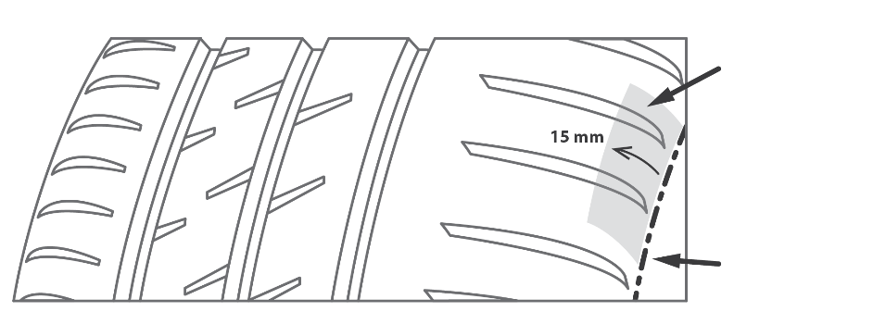

**Li (Le) zone**

**Mould parting line**

**Figure 1**

**2.1.13. "*Buffing*" is all the processes of removing material from the tread to prepare the tyre in worn state for following the procedure in paragraph 2.2.1.**

**2.2.Theoretical target profile of a tyre at worn state**

**The theoretical target profile is the profile curve of the tyre in worn state, as described in paragraph 2.2.1.2.2.**

**2.2.1.** **Preparation of class C1 tyres in worn state**

**The following paragraphs outline the preparation of worn tyres of class C1 by removal of a predetermined amount of tread rubber (for example cutting, grinding, surface finish) for subsequent wet grip index testing.**

**2.2.1.1. Apparatus**

**2.2.1.1.1. *Tread Depth Gauge.***

**Any mechanical, optical, or electronic device capable of measuring groove (void) depth can be used. The resolution of the gauge shall be at least 0.02 mm. The accuracy of the gauge shall be to within ±0.04 mm.**

**2.2.1.1.2. *Tyre Tread Removal Machine,* with equipment to remove tread rubber in a predetermined manner. Specifically, the equipment shall ensure a buffing accuracy and precision on the "average final depth" as required in the paragraph 2.2.1.2.4.1.**

**2.2.1.2. Procedure**

**Choose 4 positions approximately equally spaced around the circumference.**



**Figure 2**

**At each of the four positions, choose measurement points in the lateral direction:**

* **In the central zone pursuant to the procedure described in paragraph 2.2.1.2.1. and**
* **In each shoulder zone at least one measurement point.**

**2.2.1.2.1. *Choice of the control measurement points of the central zone***

**To control the conformity of the preparation process (see paragraph 2.2.1.2.3., choose *n* measurement points in the central zone, in the lateral direction (see Figure 2)**

* **The number of measurement points *n* shall be greater than or equal to 4 */;**
* **1 measurement point in each principal groove;**
* **The other measurement points shall be located in non-principal grooves:**
  + - * **At the maximum tread depth in the corresponding groove/zone;**
      * **In order to have the most regular distribution of the *n* points.**

**\*/ In case a tyre tread profile does not allow the measurement at 4 points in the central zone, the tread depth may be measured at 3 measurement points.**

**Measurement locations in the principal grooves shall be positioned at locations with full tread depth, for example, avoiding rubber ridges, tie bars, treadwear indicators and other elevated elements.**

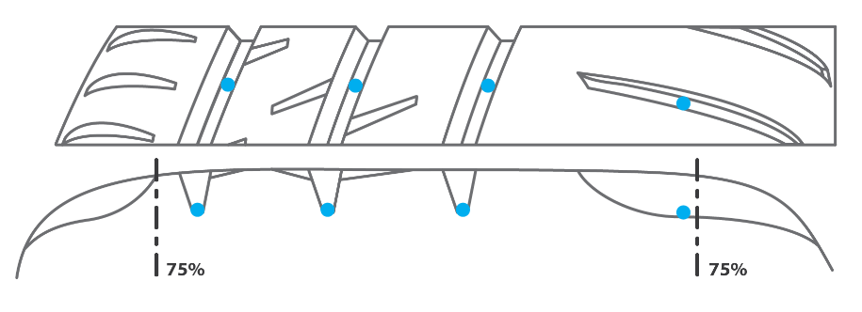

**Figure 3**

**2.2.1.2.2. Description of theoretical worn target profile**

**Central zone: curve built on a circle with its center located on the radial axle passing through the centerline and its radius built on a fit on all the points located at 2 mm height on all the control points as described in 2.2.1.2.1.. Alternatively, depending of the specificity of the tread pattern geometry, the fitting curve can be the offset of the original tyre profile.**

**Shoulder zone: edges of the artificial worn profile in the central part of the tread are connected with Le and Li points. Regularity of the whole artificial worn tyre profile (on the of the central zone to the shoulders) shall be assured (for example by an arc of circumference or another curve).**

**Center of**

**the circle**

**Centerline**

**Li**

**Le**

**Shoulder zone**

**Central zone**

**Shoulder zone**

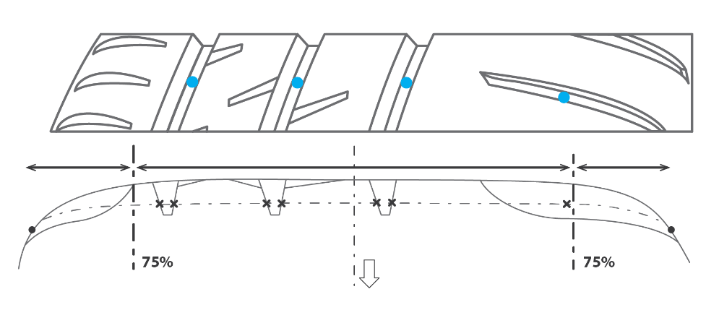

**Figure 4**

**2.2.1.2.3. Preparation of the worn tyre.**

**Inspect the tyre to determine that there are no tread defects that would affect the finished tyre. If such conditions are noted, do not use the tyre for this procedure.**

**Depending on the worn tyre preparation processing technique, the removing of the rubber can be managed by targeting directly the worn tyre target profile, or by a manual regular controlling of the rubber removal, or other means.**

**2.2.1.2.4. Validation of the prepared tyre**

**2.2.1.2.4.1. Validation of tread depths**

**At the end of the preparation process, measure the depths in the measurement locations defined in 2.2.1.2.1.**

**For all the measurement points defined in the central zone:**

* **The individual final tread depths have to be 2 mm ± 0.4 mm**
* **The average tread depth has to be 2 mm ± 0.2 mm**

**For all the measurement points defined in the shoulder zone:**

* **The final tread depth in the shoulder zone shall not be higher than 2 mm.**

**≤ 2 mm**

**2 mm ± 0.4 mm**

**2 mm ± 0.2 in average (4x4)**

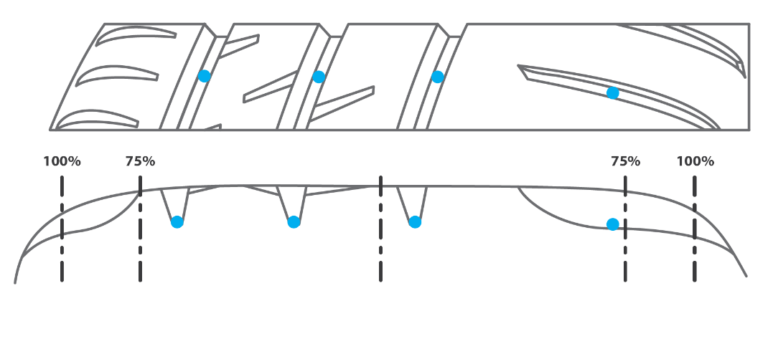

**Figure 5**

**If one of the above conditions is not met, another candidate tyre shall be prepared.**

**2.2.1.2.4.2. Validation of the surface of the worn tyre**

**The arithmetic mean deviation of the roughness profile, as defined in [ISO 4287:1997], of the final surface shall be determined at 3 measurement~~s~~ positions in the lateral direction approximately equally spaced on the prepared surface, at 4 circumferential positions equally spaced.[ The sampling length shall not be less than [8mm] and the evaluation length shall not be less than [40 mm]. The limit wavelengths for the profile filter shall be λs = [25 µm] and λc = [0.8 mm].]**

**The average of the 3 arithmetic mean deviation values of the roughness profile of the final surface shall not exceed ~~[~~20 µm~~]~~.**

**If the above condition is not met, another candidate tyre shall be prepared.**

**2.3.**  **General test conditions**

**All the provisions specified in Annex 5, Part (A), paragraph 3. "General test conditions" and its subparagraphs apply except for paragraph 3.4. "Replacement of reference tyres". The paragraph 2.3.1. of this Annex applies instead.**

**2.3.1. Replacement of reference tyres**

**When irregular wear or damage results from tests, or when wear or aging influences the test results, the use of the reference tyre shall be discontinued.**

**2.4. Testing methods for measuring the adhesion on wet surfaces**

**For the calculation of the wet grip index (GB) of a candidate tyre in worn state, the wet grip braking performance of the candidate tyre is compared to the wet grip braking performance of the reference tyre on a vehicle travelling straight ahead on a wet, paved surface. It is measured with one of the following methods:**

**(a) Vehicle method consisting of testing a set of tyres mounted on an instrumented passenger car;**

**(b) Testing method using a trailer towed by a vehicle or a tyre test vehicle, equipped with the test tyre(s).**

**2.4.1. Testing method (a) using an instrumented passenger car**

**All the provisions specified in Annex 5, Part (A), paragraph 4.1. "Testing method (a) using an instrumented passenger car" and its subparagraphs apply with the exception of paragraph 4.1.6. "Processing of measurement results". The paragraph 2.4.1.1. of this Annex applies instead.**

**2.4.1.1.** **Processing of measurement results**

**2.4.1.1.1. Calculation of the average braking force coefficient**

**All the provisions specified in Annex 5, Part (A), paragraph 4.1.6.1. apply.**

**2.4.1.1.2. Validation of results**

**The coefficient of variation *CVBFC* is calculated as follows:**

**where**

**denotes the corrected sample standard deviation and**

**the arithmetic mean of the average braking force coefficients *BFCave,j* of *N* test runs.**

**For the reference tyre:**

**(a) The coefficient of variation *CVBFC* of the initial and the final braking test of the reference tyre within one test cycle shall be less than or equal to [4] per cent.**

**(b) The arithmetic means of the average braking force coefficients of the initial and the final braking test shall not differ by more than [5] per cent of the average of the two values:**

**where**

**/ is the arithmetic mean of the average braking force coefficients in the initial/final braking test of the reference tyre within a test cycle.**

**(c) The temperature-corrected average braking force coefficients (BFCave,corr, see paragraph 3.2.1. of this Annex) as calculated from the initial and from the final braking tests of the reference tyre within a test cycle shall be not less than [0.57] and not greater than [0.79].**

**If one or more of the above conditions is not met, the complete test cycle shall be performed again.**

**For the candidate tyres (T):**

**The coefficient of variation *CVBFC* is calculated for each candidate tyre set. If one coefficient of variation is higher than [4] per cent, the data shall be discarded and the braking test repeated for that candidate tyre set.**

**2.4.1.1.3. Calculation of adjusted average braking force coefficient**

**All the provisions specified in Annex 5, Part (A), paragraph 4.1.6.3. apply.**

**2.4.1.1.4. Calculation of the wet grip index of the candidate tyre**

**[The wet grip index *GB*(T*n*) of the candidate tyre T*n* (*n* = 1, 2 or 3) is calculated as follows:**

**where:**

**is the arithmetic mean of the average braking force coefficients of the candidate tyre T*n*within a braking test;**

***BFC*adj(R) is the adjusted average braking force coefficient in accordance with Table 1;**

***BFC*(R0) = 0.68 is fixed as the braking force coefficient for the reference tyre in the reference conditions;**

***ϑ* is the measured wet surface temperature in degrees Celsius when the candidate tyre Tn is tested;**

***ϑ*0 is the wetted surface reference temperature for the candidate tyre according to its category of use as listed in Table 2;**

***MTD* is the measured macro texture depth in mm of the track (see paragraph 3.1.4. of this Annex);**

***MTD*0 = 0.8 mm is the macro texture depth of the reference track;**

***K*vehicle = 1.87 is a factor to grant consistency between previous calculation of the wet grip index and this one, and to ensure convergence between vehicle and trailer method and**

**coefficients *a*, *b*, *c* and *d* are given in Table 2.**

**Table 2**

| ***Category of use*** | | ***ϑ0***  ***(°C)*** | ***a*** | ***b***  ***(°C−1)*** | ***c***  ***(°C−2)*** | ***d***  ***(mm−1)*** |
| --- | --- | --- | --- | --- | --- | --- |
| **Normal tyre** | | **20** | **+0.99382** | **+0.00269** | **−0.00028** | **−0.02472** |
| **Snow tyre** | | **15** | **+0.92654** | **−0.00121** | **−0.00007** | **−0.04279** |
|  | **Snow tyre for use in severe snow conditions** | **10** | **+0.72029** | **−0.00539** | **+0.00022** | **−0.03037** |
| **Special use tyre** | | **not defined** | | | | |

**]**

**2.4.2.** **Testing method (b) using a trailer towed by a vehicle or a tyre test vehicle**

**All the provisions specified in Annex 5, Part (A), paragraph 4.2. "Testing method (b) using a trailer towed by a vehicle or a tyre test vehicle" and its subparagraphs apply with the exception of paragraph 4.2.8. "Processing of measurement results". The paragraph 2.4.2.1. of this Annex applies instead.**

**2.4.2.1. Processing of measurement results**

**2.4.2.1.1. Calculation of the peak braking force coefficient**

**All the provisions specified in Annex 5, Part (A), paragraph 4.2.8.1. apply.**

**2.4.2.1.2. Validation of results**

**The *µ*peak coefficient of variation *CV*µ is calculated as follows:**

**where**

**denotes the corrected sample standard deviation and**

**the arithmetic mean of the peak braking force coefficients () of *N* test runs.**

**For the reference tyre (R):**

**(a) The coefficients of variation *CVμ* of the initial and the final braking tests of the reference tyre within one test cycle shall be less than or equal to [4] per cent;**

**(b) The arithmetic mean of the peak braking force coefficients of initial and the final braking test of the reference tyre within one test cycle shall not differ by more than [5] per cent of the average of the two values:**

**where**

**/ is the arithmetic mean of the peak braking force coefficients in the initial/final braking test of the reference tyre within a test cycle;**

**(c) The temperature-corrected average peak braking force coefficients (*µ*peak,corr, see paragraph 3.2.2. of this Annex) as calculated from the initial and from the final braking test of the reference tyre within a test cycle shall be not less than [0.65] and not greater than [0.90].**

**If one or more of the above conditions is not met, the complete test cycle shall be performed again.**

**For the candidate tyre(s) (T*n*):**

**The coefficient of variation of the peak braking force coefficient *CVµ* is calculated for each candidate tyre. If one coefficient of variation is greater than [5] per cent, the data shall be discarded and the braking test repeated for this candidate tyre.**

**2.4.2.1.3. Calculation of the adjusted average peak braking force coefficient of the reference tyre**

**All the provisions specified in Annex 5, Part (A), paragraph 4.2.8.3. apply.**

**2.4.2.1.4. Calculation of the wet grip index of the candidate tyre**

**[The wet grip index *GB(*T*n)* of the candidate tyre T*n* (*n* = 1, 2, 3) is calculated as follows:**

**where:**

**is the arithmetic mean of the peak braking force coefficients of the candidate tyre T*n* within a braking test;**

***µ*peak,adj(R) is the adjusted peak braking force coefficient in accordance with Table 3;**

***µ*peak(R0) = 0.85 is fixed as the peak braking force coefficient for the reference tyre in the reference conditions;**

***ϑ* is the measured wet surface temperature in degrees Celsius when the candidate tyre Tn is tested;**

***ϑ*0 is the wetted surface reference temperature for the candidate tyre according to its sidewall marking as listed in Table 4;**

***MTD* is the measured macro texture depth of the track**

***MTD*0 = 0.8 mm is fixed as the macro texture depth of the reference track;**

***K*trailer = 1.50 is a factor to grant consistency between previous calculation of the wet grip index and this one, and to ensure convergence between vehicle and trailer method and**

**coefficient *a*, *b*, *c* and *d* are given in Table 4.**

**Table 4**

| ***Category of use*** | | ***ϑ0***  ***(°C)*** | ***a*** | ***b***  ***(°C−1)*** | ***c***  ***(°C−2)*** | ***d***  ***(mm−1)*** |
| --- | --- | --- | --- | --- | --- | --- |
| **Normal tyre** | | **20** | **+0.99757** | **+0.00251** | **−0.00028** | **+0.07759** |
| **Snow tyre** | | **15** | **+0.87084** | **−0.00025** | **+0.00004** | **−0.01635** |
|  | **Snow tyre for use in severe snow conditions** | **10** | **+0.67929** | **+0.00115** | **−0.00005** | **+0.03963** |
| **Special use tyre** | | **not defined** | | | | |

**]**”

*Insert a new Annex 9 – Appendix 1,* to read*:*

“Annex 9 – Appendix 1

**Worn tyre preparation report example**

|  |  |
| --- | --- |
| **Date of buffing** |  |
| **Manufacturer** |  |
| **Brand** |  |
| **Trade description/commercial name** |  |
| **Size** |  |
| **Service description** |  |
| **Rim width** |  |
| **Inflation pressure (kPa)** |  |
| **Week of manufacture** |  |
| **Tyre identification code** |  |

**Tread depth measurement**

|  |  |  |  |  |  |  |  |
| --- | --- | --- | --- | --- | --- | --- | --- |
| ***Tread depth***  ***Central zone: (2.0 ± 0.4) mm***  ***Shoulder zone: ≤ 2 mm*** | | ***in central zone (yes/no)*** | ***Circumferential locations*** | | | | ***Average*** |
| ***1*** | ***2*** | ***3*** | ***4*** |  |
| **Transversal locations** | **1** |  |  |  |  |  |  |
| **2** |  |  |  |  |  |  |
| **3** |  |  |  |  |  |  |
| **4** |  |  |  |  |  |  |
| **5** |  |  |  |  |  |  |
| **6** |  |  |  |  |  |  |
| **7** |  |  |  |  |  |  |
| **8** |  |  |  |  |  |  |
| **Average** | | |  |  |  |  |  |

|  |  |  |  |  |  |
| --- | --- | --- | --- | --- | --- |
|  |  |  |  |  | ***Values*** |
| **Average tread depth in central zone (mm)**  **Central zone: (2.0 ± 0.2) mm** | | | | |  |
| **Average tread depth in shoulder zone (mm)**  **Shoulder zone: ≤ 2 mm** | | | | |  |

**Roughness measurement**

|  |  |  |  |  |  |
| --- | --- | --- | --- | --- | --- |
| ***Arithmetic mean deviation of the roughness profile (µm)*** | | ***Sections*** | | | |
| ***1*** | ***2*** | ***3*** | ***4*** |
| **Trans. Loc.** | **1 (right)** |  |  |  |  |
| **2 (center)** |  |  |  |  |
| **3 (left)** |  |  |  |  |
| **Average** | |  |  |  |  |

|  |  |
| --- | --- |
| **Average of the arithmetic mean deviation of the roughness profiles (µm)** |  |

”

*Insert a new Annex 9 – Appendix 2,* to read*:*

“Annex 9 – Appendix 2

Test reports examples of wet grip index for tyres in worn state

***Example 1:* Test report of wet grip index for tyres in worn state using trailer or tyre test vehicle method**

|  |  |  |  |  |  |
| --- | --- | --- | --- | --- | --- |
| **Test report number:** |  |  | **Test date:** |  | |
|  |  |  |  |  |  |
| **Track:** |  |  |  | **Minimum:** | **Maximum:** |
| **Texture depth (mm):** |  |  | **Wetted surface temp. (°C):** |  |  |
| **µpeak,corr:** |  |  | **Ambient temp (°C):** |  |  |
| **Water depth (mm):** |  |  |  |  |  |
|  |  |  |  |  |  |
| **Speed (km/h):** |  |  |  |  |  |

|  |  |  |  |  |  |  |
| --- | --- | --- | --- | --- | --- | --- |
| ***No.*** | | ***1*** | ***2*** | ***3*** | ***4*** | ***5*** |
| **Brand** | |  |  |  |  |  |
| **Pattern/trade description** | | **SRTT…** |  |  |  | **SRTT…** |
| **Size** | |  |  |  |  |  |
| **Service description** | |  |  |  |  |  |
| **Reference (test) inflation pressure (kPa)** | |  |  |  |  |  |
| **Tyre identification** | |  |  |  |  |  |
| **M+S marking (Y/N)** | |  |  |  |  |  |
| **3PMSF marking (Y/N)** | |  |  |  |  |  |
| **Rim** | |  |  |  |  |  |
| **Load (kg)** | |  |  |  |  |  |
| **Pressure (kPa)** | |  |  |  |  |  |
| **µpeak** | **1** |  |  |  |  |  |
| **2** |  |  |  |  |  |
| **3** |  |  |  |  |  |
| **4** |  |  |  |  |  |
| **5** |  |  |  |  |  |
| **6** |  |  |  |  |  |
| **7** |  |  |  |  |  |
| **8** |  |  |  |  |  |
|  | |  |  |  |  |  |
| **Standard deviation, *σµ*** | |  |  |  |  |  |
| ***CVµ* ≤ [4] %** | |  |  |  |  |  |
| ***CVal*(*µ*peak) ≤ [5] %** | |  |  |  |  |  |
| ***µ*peak,corr(R)** | |  |  |  |  |  |
| **µpeak,adj(R)** | |  |  |  |  |  |
| **Wet grip index** | |  |  |  |  |  |
| **Wetted surface temp. (°C)** | |  |  |  |  |  |
| **Ambient temp. (°C)** | |  |  |  |  |  |
| **Remarks** | |  |  |  |  |  |

***Example 2: Test report of wet grip index for tyres in worn state using vehicle method***

|  |  |  |  |  |  |  |  |  |  |
| --- | --- | --- | --- | --- | --- | --- | --- | --- | --- |
| **Test report number:** |  |  | **Test date:** |  | |  | **Driver:** |  | |
|  |  |  |  |  |  |  |  |  | |
| **Track:** |  |  |  | **Minimum:** | **Maximum:** |  | **Vehicle** |  | |
| **Texture depth (mm):** |  |  | **Wetted surface temp. (°C):** |  |  |  | **Brand:** |  | |
| ***BFC*ave,corr,1:** |  |  | **Ambient temp (°C):** |  |  |  | **Model:** |  | |
| ***BFC*ave,corr,2:** |  |  |  |  |  |  | **Type:** |  | |
| ***CVal*(*BFC*ave,corr):** |  |  |  |  |  |  | **Year of registration:** |  | |
| **Water depth (mm):** |  |  |  |  |  |  | **Maximum axle load:** | **Front** | **Rear** |
|  |  |  |  |  |  |  |  |  | |
| **Initial speed (km/h):** |  |  | **Final speed (km/h):** |  | |  |  |  | |

|  |  |  |  |  |  |  |  |  |  |  |  |  |  |  |  |  |  |
| --- | --- | --- | --- | --- | --- | --- | --- | --- | --- | --- | --- | --- | --- | --- | --- | --- | --- |
| ***No.*** | | ***1*** | | | ***2*** | | | ***3*** | | | ***4*** | | | ***5*** | | | |
| **Brand** | |  | | |  | | |  | | |  | | |  | | |
| **Pattern/trade description** | | **SRTT…** | | |  | | |  | | |  | | | **SRTT…** | | |
| **Size** | |  | | |  | | |  | | |  | | |  | | |
| **Service description** | |  | | |  | | |  | | |  | | |  | | |
| **Reference (test) inflation pressure (kPa)** | |  | | |  | | |  | | |  | | |  | | |
| **Tyre identification** | |  | | |  | | |  | | |  | | |  | | |
| **M+S marking (Y/N)** | |  | | |  | | |  | | |  | | |  | | |
| **3PMSF marking (Y/N)** | |  | | |  | | |  | | |  | | |  | | |
| **Rim** | |  | | |  | | |  | | |  | | |  | | |
| **Front axle pressure (kPa)** | | **left:** | | **right:** | **left:** | | **right:** | **left:** | | **right:** | **left:** | | **right:** | **left:** | | **right:** |
| **Rear axle pressure (kPa)** | | **left:** | | **right:** | **left:** | | **right:** | **left:** | | **right:** | **left:** | | **right:** | **left:** | | **right:** |
| **Front axle load (kg)** | | **left:** | | **right:** | **left:** | | **right:** | **left:** | | **right:** | **left:** | | **right:** | **left:** | | **right:** |
| **Rear axle load (kg)** | | **left:** | | **right:** | **left:** | | **right:** | **left:** | | **right:** | **left:** | | **right:** | **left:** | | **right:** |
|  | | ***Braking distance (m)*** | ***BFCi*** | | ***Braking distance (m)*** | ***BFCi*** | | ***Braking distance (m)*** | ***BFCi*** | | ***Braking distance (m)*** | ***BFCi*** | | ***Braking distance (m)*** | ***BFCi*** | |
| **Measurement** | **1** |  |  | |  |  | |  |  | |  |  | |  |  | |
|  | **2** |  |  | |  |  | |  |  | |  |  | |  |  | |
|  | **3** |  |  | |  |  | |  |  | |  |  | |  |  | |
|  | **4** |  |  | |  |  | |  |  | |  |  | |  |  | |
|  | **5** |  |  | |  |  | |  |  | |  |  | |  |  | |
|  | **6** |  |  | |  |  | |  |  | |  |  | |  |  | |
|  | **7** |  |  | |  |  | |  |  | |  |  | |  |  | |
|  | **8** |  |  | |  |  | |  |  | |  |  | |  |  | |
|  | **9** |  |  | |  |  | |  |  | |  |  | |  |  | |
|  | **10** |  |  | |  |  | |  |  | |  |  | |  |  | |
|  | |  | | |  | | |  | | |  | | |  | | |
| **Standard deviation, σBFC** | |  | | |  | | |  | | |  | | |  | | |
| ***CVBFC* ≤ [4] %** | |  | | |  | | |  | | |  | | |  | | |
| ***CVal*(*BFC*ave) ≤ [5] %** | |  | | |  | | |  | | |  | | |  | | |
| ***BFC*ave,corr(R)** | |  | | |  | | |  | | |  | | |  | | |
| ***BFC*adj(R)** | |  | | |  | | |  | | |  | | |  | | |
| **Wet grip index** | |  | | |  | | |  | | |  | | |  | | |
| **Wetted surface temp. (°C)** | |  | | |  | | |  | | |  | | |  | | |
| **Ambient temp. (°C)** | |  | | |  | | |  | | |  | | |  | | |
| **Remarks** | |  | | |  | | |  | | |  | | |  | | |

”

**II. Justification**

1. As stated in the Terms of Reference of the Informal Working Group on Wet Grip Performance for Tyres in a Worn State (IWG WGWT), the experts of IWG WGWT prepared a proposal of a new series (03) of amendments to UN Regulation No. 117 for tyres of class C1 containing:

* the method for preparing a tyre to be tested in worn state at its type approval;
* the test conditions;
* the test methods;
* the type-approval thresholds of tyre wet grip performance in worn state.

Some information […] is missing in the document due to the post processing of the work program launched within the group to assess the methodology of preparation, testing and the thresholds. This document will then be completed by an informal document.

2. The scope of UN Regulation No. 117 is extended to reflect the wet grip on new tyres in worn state for C1 tyres (paragraphs 1.1. and 1.2.).

3. The definitions of tyres in worn state, in opposition with tyres in new state, is introduced to consider the new wet grip performance on worn tyres (paragraphs 2.19.9. and 2.19.10.).

1. A new suffix “B” is introduced to identify the new performance (paragraphs 4.3.1., 5.2.2., 5.4.3. and Annex 2 for approval markings).
2. Stage 1 of tyre rolling sound emissions and of tyre rolling resistance is not considered in the 03 series of amendment to UN Regulation No. 117. Stage 2 becomes then the only stage for rolling sound emissions and rolling resistance (paragraphs 5.4.3., paragraphs 6.1.1., 6.1.2. and 6.1.3. for rolling sound emissions for C1, C2, and C3 tyres, paragraphs 6.3. for rolling resistance for C1, C2, and C3 tyres).
3. New thresholds are introduced (paragraph 6.4.).
4. New requirements on conformity of production are introduced to address the wet grip performance of worn tyres (paragraph 8.2.2.).
5. Transitional provisions reflect the regional requirements for the introduction of requirement on wet grip performance of worn tyres as mentioned in European Union (EU) Regulation No. 2019/2144. This new series of amendment (03) applies exclusively to class C1 tyres, as a consequence it is still possible to grant and accept type approval under 02 series of amendments for classes C2 and C3 tyres.
6. Marking are updated to reflect the new requirement of wet grip performance for worn tyres (Annex 2).
7. Annex 5 is retitled as wet grip test procedure for tyres in new state, Annex 9 is introduced to specify new wet grip requirement for tyres in worn state.
8. Annex 8 is reserved for ice tyres.
9. Annex 9 describes the provision for the wet adhesion performances of tyres in worn state. The process of preparation of the tyre in worn state is detailed in paragraph 2.2.1., The methodology of testing is similar to Annex 5 for tyres in new state, with the exceptions related to tyres in worn state (paragraphs 2.3. and 2.4.). Test reports for buffing and wet adhesion are proposed in the appendices to Annex 9 accordingly.

1. * In accordance with the programme of work of the Inland Transport Committee for 2021 as outlined in proposed programme budget for 2021 (A/75/6 (Sect.20), para 20.51), the World Forum will develop, harmonize and update UN Regulations in order to enhance the performance of vehicles. The present document is submitted in conformity with that mandate.
2. Approvals in accordance with UN Regulation No. 117 for tyres within the scope of UN Regulation No. 54 currently do not include **the requirement on** ~~wet~~ adhesion ~~requirements~~ **of tyres in worn state on wet surfaces**.
3. **Approvals in accordance with UN Regulation No. 117 for tyres within the scope of UN Regulation No. 54 currently do not include the requirement on adhesion of tyres in worn state on wet surfaces.**
4. ~~Approvals in accordance with Regulation No. 117 for tyres within the scope of Regulation No. 54 currently do not include wet adhesion requirements.~~