Virtual Testing – Proposed Annexes
Annex I - Virtual Testing Toolchain Example

Virtual Testing is introduced to reduce the burden of physical tests and effectively provide evidence on the ADS performance across the operational domain. However, no one simulation tool can be used to test all aspects of the ADS software, this is why manufacturers will exploit the attributes of various simulation tools to develop confidence in the safety of the full system.
Each virtual testing tool will have their own strengths and weakness based on the speed and cost of execution and the level of fidelity achieved. Typically, lower fidelity tools are used to cover a vast number of scenarios to obtain a general understanding of the systems performance. Then it is possible to increase the level of fidelity within a subset of scenarios to validate the performance of the ADS in a statistically relevant number of realistic scenarios. A manufacturer’s virtual testing toolchain may consist of the following tools:

Perception simulation

Perception simulation can be used to train and validate the perception algorithms of the ADS software with physical accurate sensor models in combination with ground-truth data. This can be done in open-loop since the planning and control algorithms are bypassed.

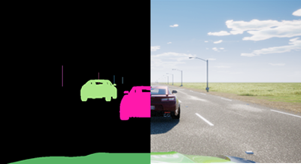

Planning & Control (P&C) simulation

P&C simulation can be used to validate the control algorithms of the ADS software with basic sensor models. This can be done faster than real time so is an effective way to test the control system over a vast number of scenarios.

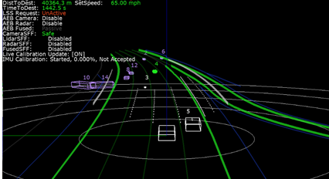

Full AV Stack simulation (SIL or HIL)

Full AV Stack simulation can accurately render sensor data streams that represent a wide range of environments and scenarios. The ADS software processes the simulated data as if it were coming from the sensors of a vehicle actually driving on the road and sends actuation commands back to the simulator. This allows engineers to test rare conditions, such as rainstorms, snowstorms, or sharp glare at different times of the day and night. Each scenario can be tested repeatedly, adjusting multiple variables such as road surfaces and surroundings, weather conditions, other traffic, and time of day.

HIL can be used to test the entire hardware component or ECU before the real vehicle is available and to test the interactions/ networks of the components within the virtual prototype e.g. conduct E/E failure test of hardware components.

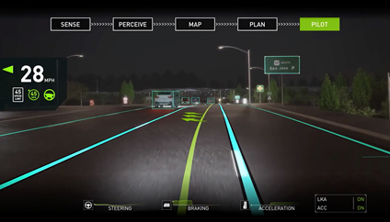

Vehicle in the Loop (VIL)
VIL provides a validation environment for ready-to-drive vehicles in combination with a virtual environment simulation. It allows to execute complex and safety critical scenarios on vehicle level.

VIL on Test Beds:

VIL on test beds combines this with the advantages of a lab and focuses on flexibility in scenario generation and reproducibility of scenario execution. It allows additionally to test the real sensors and perception in the loop.

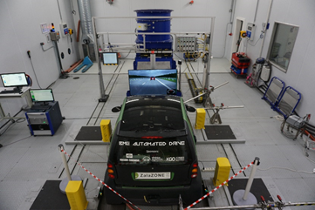

VIL on Test bed may consist of the following elements:

- Longitudinal dynamics: The longitudinal dynamics are emulated by the test bed. This can either be a chassis dynamometer or a wheel hub / powertrain test bed. High dynamic dynamometers in combination with a vehicle dynamics simulation allow the execution of various maneuvers and scenarios including high dynamic maneuvers at the limits (realistic wheel slip, etc.)
- Lateral dynamics: In case of lateral dynamics, including the steering is required, test beds can be extended by additional devices to allow steering. Ideally steering is not only allowed but also the resulting reaction forces are emulated properly to avoid error states and to ensure a proper operation together with the AV function
- Interface virtual environment simulation: Depending on the use case and the requirements, there are different possibilities: Object list injection (no sensor, no perception in the loop), raw data injection (no sensor but perception in the loop), over-the-air stimulation of the sensor (sensor and perception in the loop). Using the over-the-air stimulation, there are no modification on the vehicle required. Also, a mixed operation is possible.

VIL on proving grounds:

VIL on proving grounds focuses more on the interaction between the driver/passenger and the vehicle. In this configuration the real acceleration (longitudinal and lateral) of the vehicle can be experienced by the driver/passenger (difference to Vehicle-in-the-Loop at test beds). A judgment and rating by the real driver are possible.

VIL Test bed may consist of the following elements:
- Longitudinal dynamics: The real longitudinal dynamics are available
- Lateral dynamics: The real lateral dynamics are available
- Interface virtual environment simulation: Typically, the interface between the vehicle and the virtual environment is done via object list injection. Also, raw data injection is possible. Real sensors cannot be considered (with a few exceptions for very simple sensors like ultrasonic).

Driver in the Loop (DIL)

DIL virtual testing can be helpful to support the assessment of this category of functional requirement by analysing the interaction between the driver and the ADS in a safe and controlled environment.

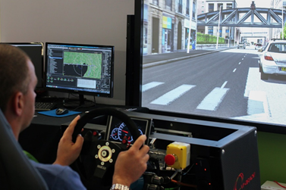

Software Reprocessing (SwR)

SwR involves playing back previously recorded sensor data, rather than synthetic data, to the ADS software to accurately assess the perception performance in an open loop system.
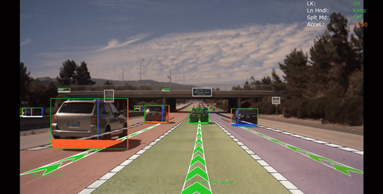

Considering the categories of functional requirements currently being considered, virtual testing seems particularly relevant for assessing requirements related to:
- ADS should drive safely and ADS should manage safety critical situations. These are the requirements where virtual testing can play the most prominent role. MIL/SIL, HIL and VIL virtual testing can all be used to assess these requirements at different stages of vehicle verification and validation.
- ADS should interact safely with the user. DIL virtual testing can be helpful to support the assessment of this category of functional requirement by analysing the interaction between the driver and the ADS in a safe and controlled environment.
- ADS should safely manage failure modes and ADS should ensure a safe operational state. The use of virtual testing in these two categories is also very promising but would probably require further research work. SIL virtual testing could include simulated failures and maintenance requests. HIL and VIL virtual testing could be used to assess how the system would react to the occurrence of a real malfunctioning induced to the real system.

Functional Requirement | SIL | HIL | VIL | DIL | SwR
ADS should drive safely | Y | Y | Y | - | Y
ADS should interact safely with the user | - | - | - | Y | -
ADS should manage safety-critical situations | Y | Y | Y | - | Y
ADS should safely manage failure modes | Y | Y | Y | -- | -

The table below describes all available test environments. The main difference in these test environments is in the application of virtual and real stimuli and in the items being tested.

Virtual Testing Tool | Software | Hardware | Vehicle | Driver | Environment
Perception | Real | Virtual | Virtual | Virtual | Virtual
Planning & Control | Real | Virtual | Virtual | Virtual | Virtual
Full AV Stack (SIL) | Real | Virtual | Virtual | Virtual | Virtual
Full AV Stack (HIL) | Real | Real | Virtual | Virtual | Virtual
Vehicle in the Loop | Real | Real | Real | Virtual | Virtual
Driver in the Loop | Virtual | Virtual | Virtual | Real | Virtual
Software Reprocessing | Real | Virtual | None | None | Real
Proving Ground | Real | Real | Real | Real | None
Real World Test | Real | Real | Real | Real | Real

Annex II - Lane Model Validation
Lane model validation is considered to provide a practical example on how the validation is performed as a part of the credibility assessment. Accurate representation of lane models are required for perception algorithm used for most lateral support systems e.g. lane keep assist, lane centering, lane change assist etc. In order to demonstrate that the lane models are fit for purpose we have used the processes defined in the credibility assessment. Vehicle dynamics is not considered during this process because the chassis dynamic will have negligible impact on the ability to detect the lane markings. The process consist of the following elements:
- Subsystem – camera model
- Sensor System – camera model with virtual lane markings.
- Integrated System – Lane detection algorithms
Camera Model Validation

Simulation needs to provide accurate image (intrinsic property) from the correct position (extrinsic property) for all cameras for a given scene. Specific camera-related phenomena that should be considered during the validation include:
- Lens distortion: optical aberration due to projection
- Vignette: darkening of the screen border.
- Grain jitter: white noise injection.
- Bloom: presence of fringes around bright areas
- Auto exposure: image gamma adaption to darker or brighter areas.
- Lens flares: reflection of bright objects on the lens.
- Depth of field: blurring of objects near or very far away of the camera.
- Exposure time: shutter opening duration

Below is a non-exhaustive list of tools that can be used to support the camera model validation.
Tool | Image | Purpose
Macbeth Color chart Test | 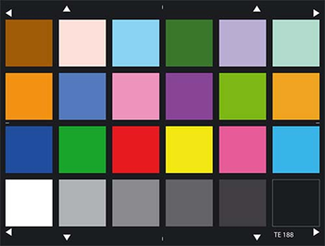 | - To determine the camera color space of the camera  - To determine the parameters for camera noise modelling  - To learn about the exposure characteristics
OECF chart Tests | 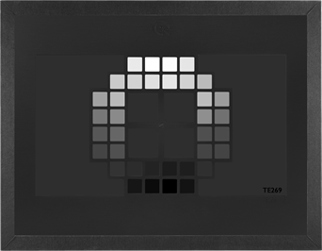 | - Is designed for evaluating the opto-electronic-conversion-function of a camera.
SFR Chart | 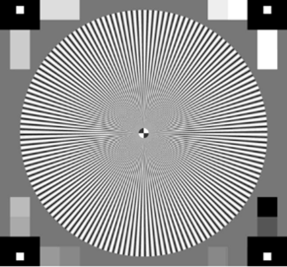 | - To measure sharpness, contrast and lens effects
Lens Flare Characterization |  | - To differentiate the static and the dynamic components (dark shot noise) a video has to be recoded  - To determine the lens characteristic for lens flares and ghosting artifacts
FTheta Calibration | 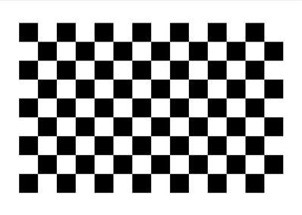 | - At every position, tilt the checkerboard target both horizontally and vertically up to 45 degrees  - To determine the ftheta polynomial and to compare it with a more precise lens measurement
Multi Camera Calibration | 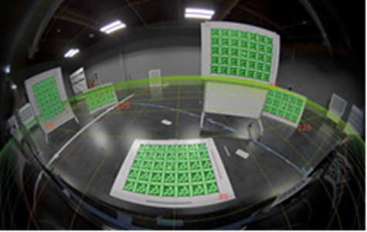 | - Creating the multi camera calibration scene to check out lens distortion and camera positions

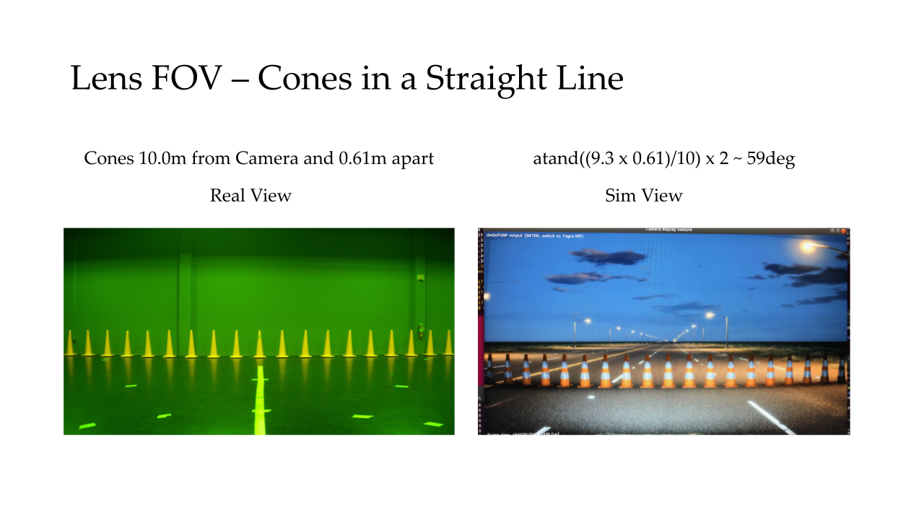
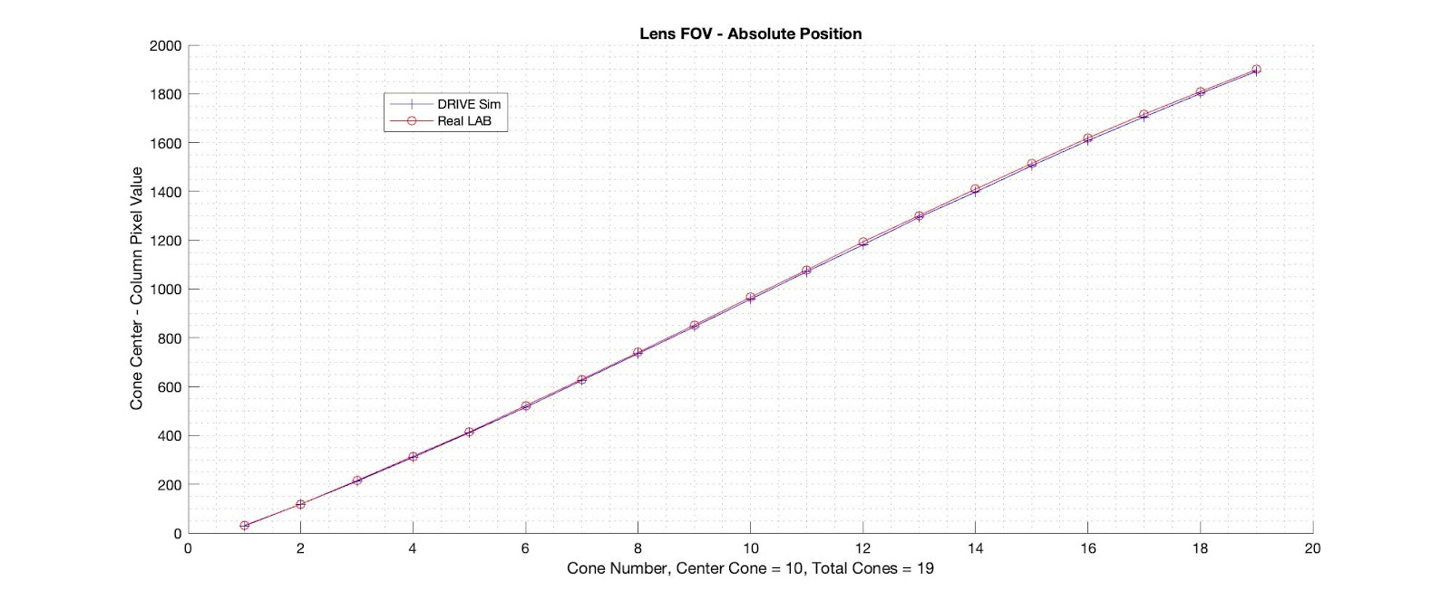
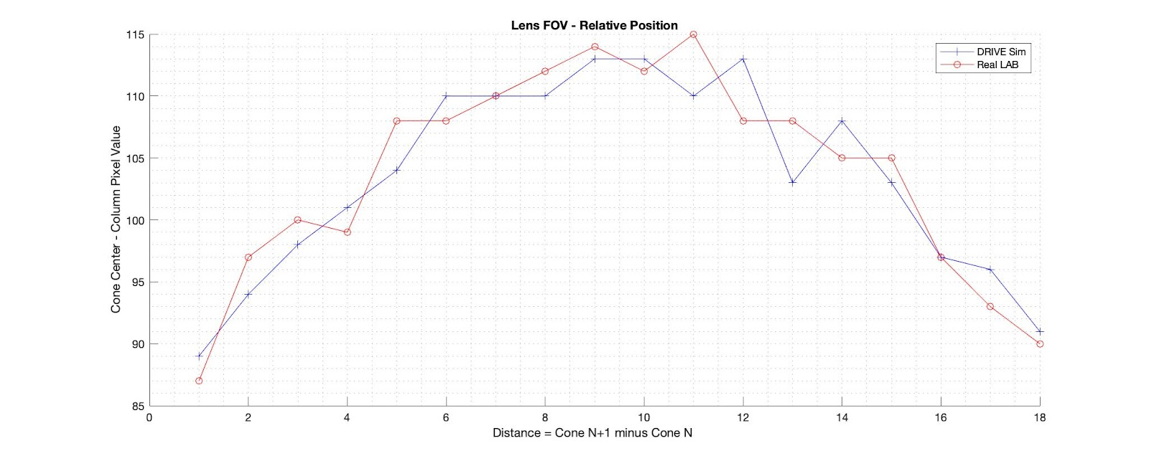

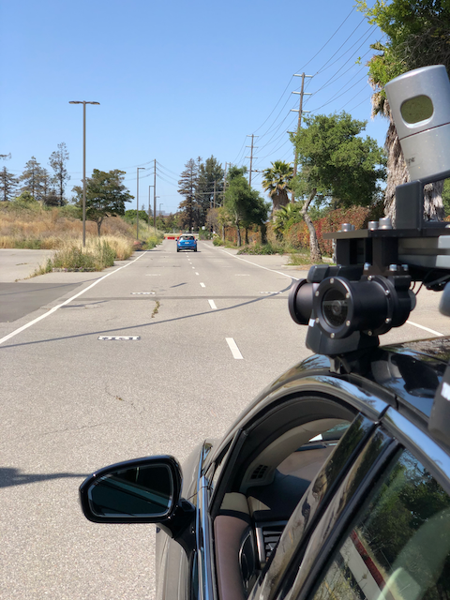
- 2 lanes wide with 200+ meter Range

- Single Capture at distances:
[5, 10, 15, 20, 30, 40, 50, 100, 150]

- Measured Rear Axle to Rear Axle

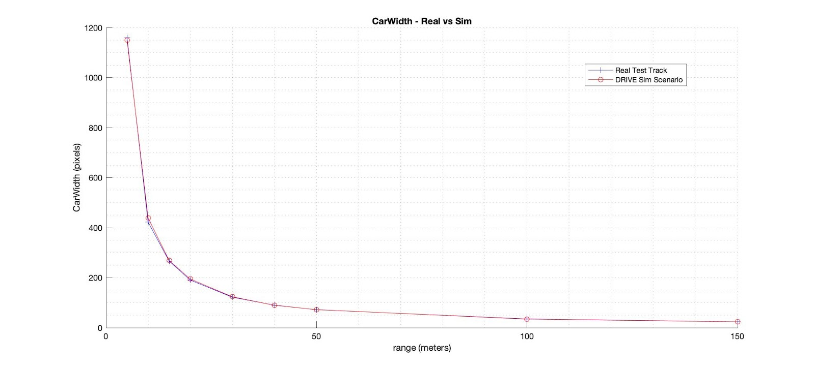

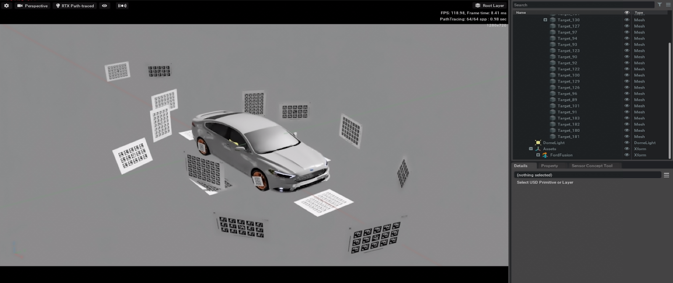

AprilTags is a visual fiducial system, useful for a wide variety of tasks including augmented reality, robotics, and camera calibration. The tags provide a means of identification and 3D positioning, even in low visibility conditions. The tags act like barcodes, storing a small amount of information (tag ID), while also enabling simple and accurate 6D (x, y, z, roll, pitch, yaw) pose estimation of the tag.

The April tag chart positions and orientations are well constrained in the scene as they are visible from multiple camera’s. Hence, we can use them as a general gauge that the process is working. If the calibration tool does not like the sim data, then these values will not line up.

Camera_front_wide_120fov
Sim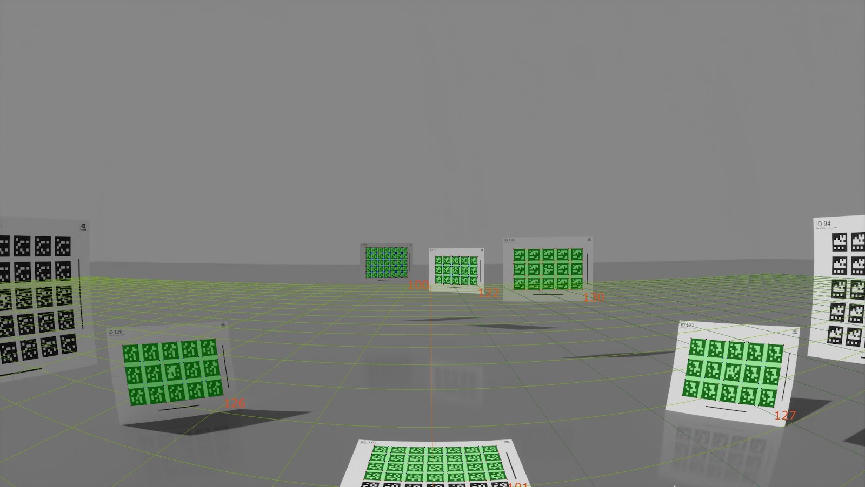
Real
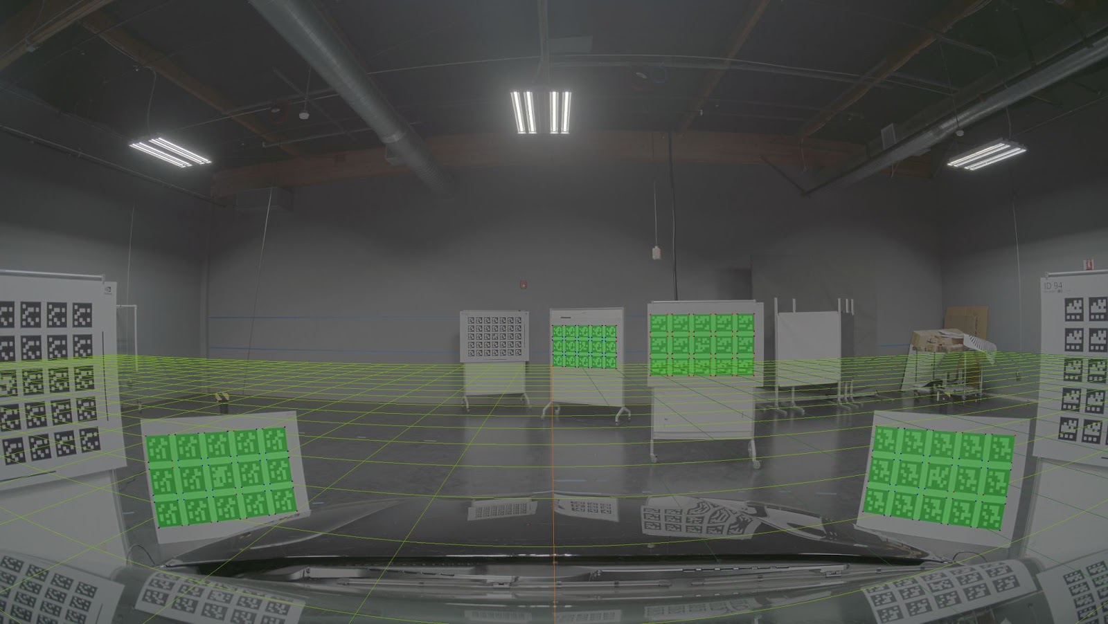

Camera_left_fisheye_200fov
Sim
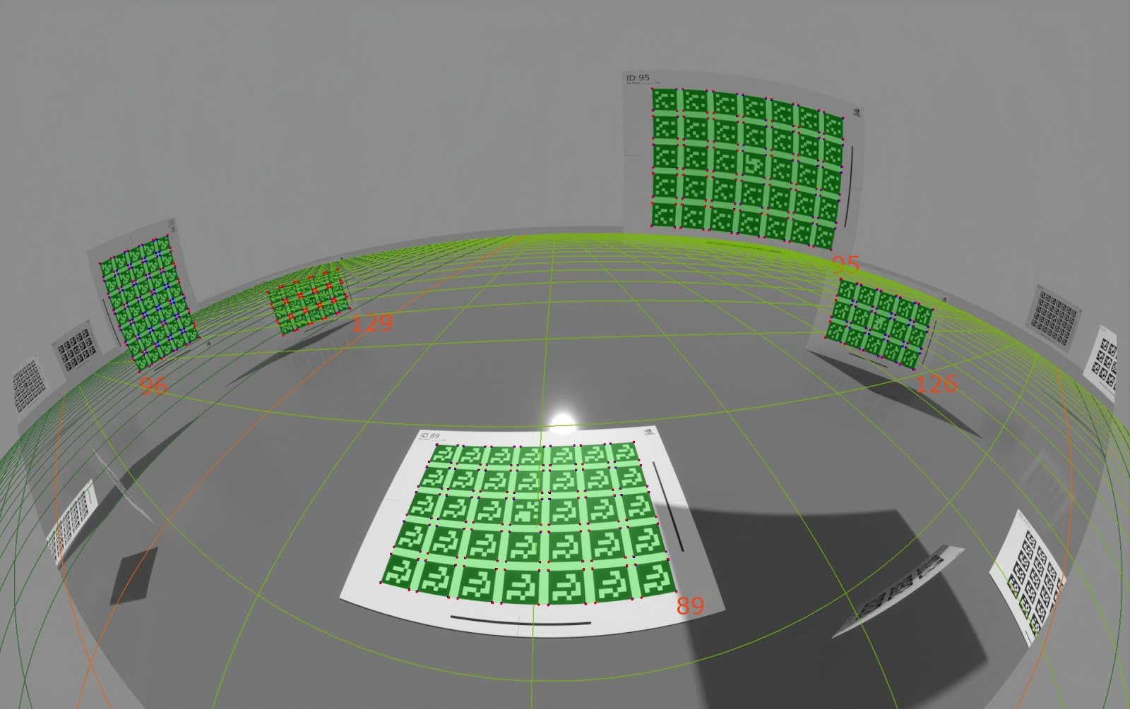
Real
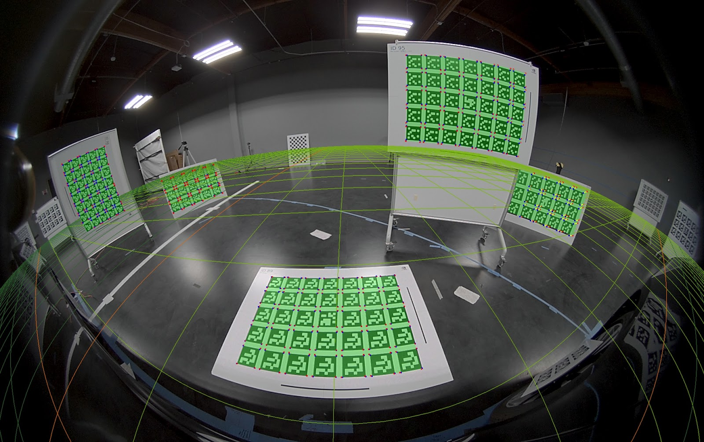

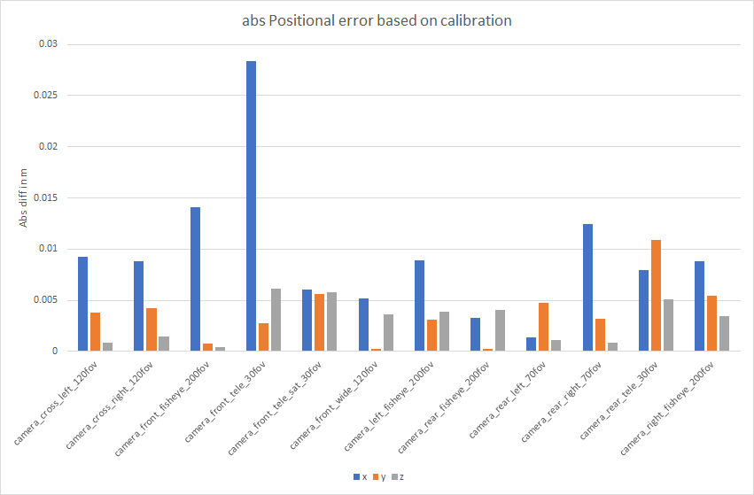
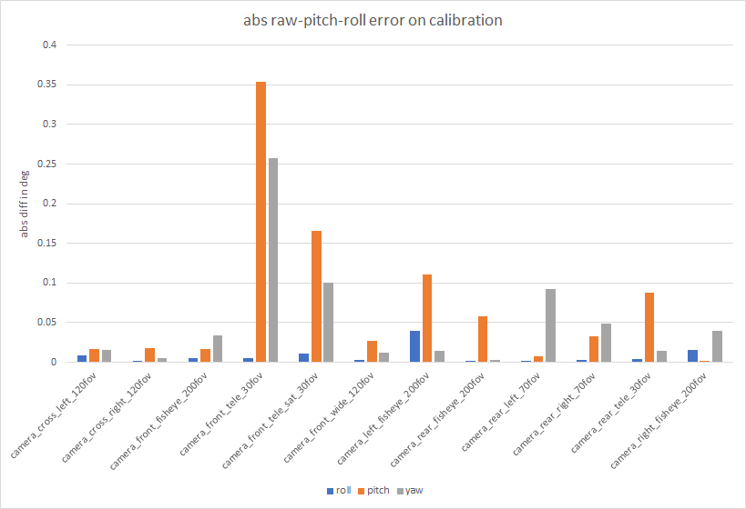

Camera Intrinsics (ftheta model parameters)
In general the ftheta models are the same, except the estimated principal centers are off for the fov30.

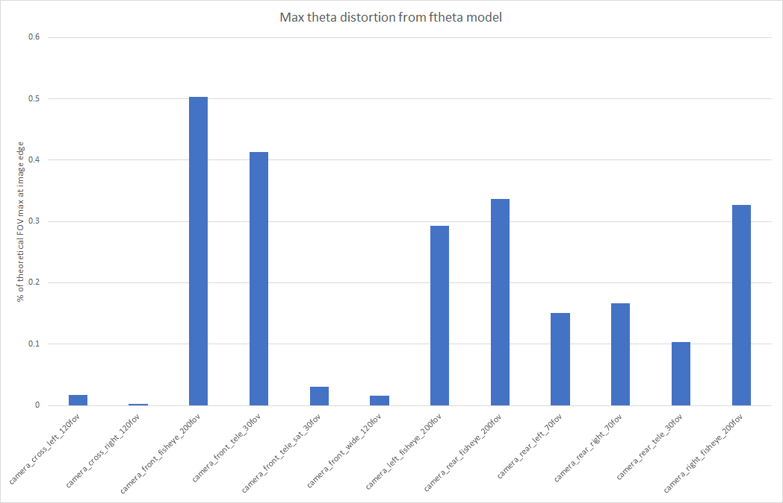

Sensor System Validation
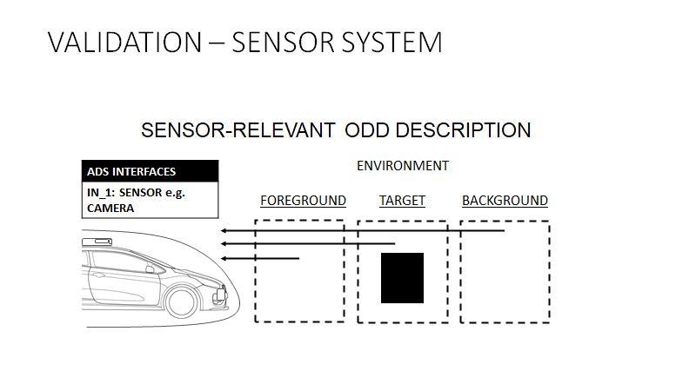

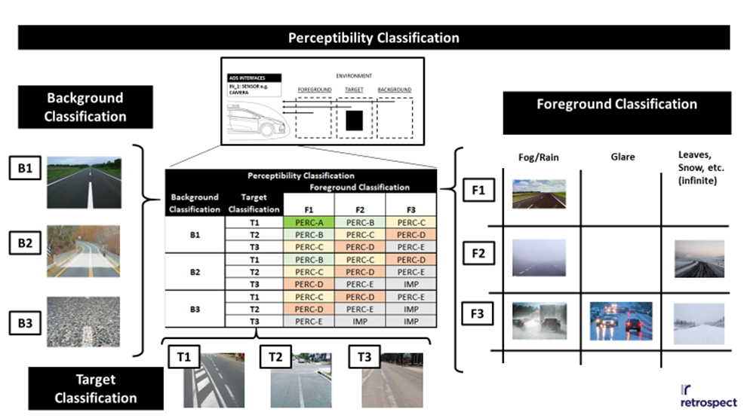

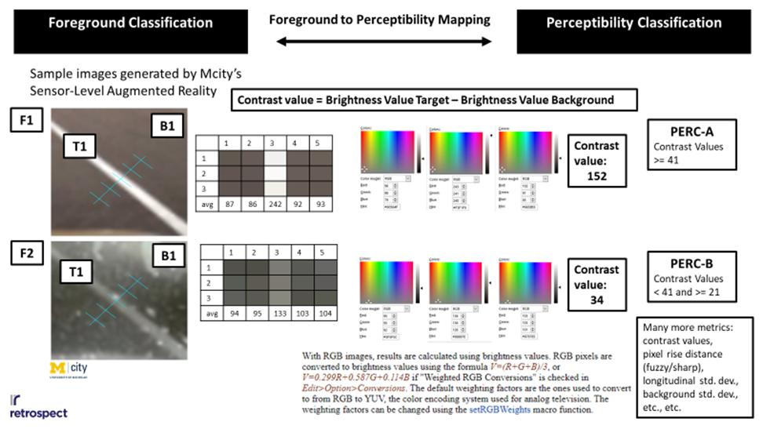

Integrated System Validation

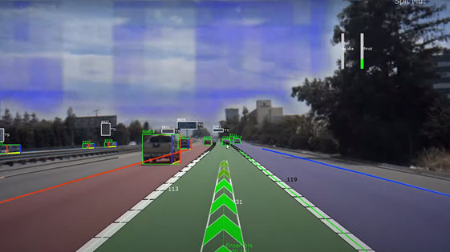
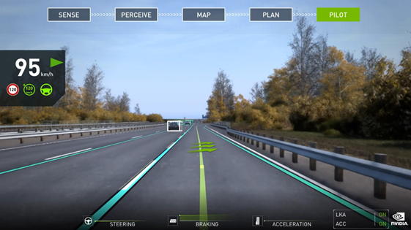

Correlation threshold tbd
•Correlation of lane detection performance on synchronized data.
•Exact threshold would determine if lane detection algos are used to support: LDW, LKAS or ADS.
• Widely recognized modelling standards • Virtual road network: ASAM OpenDrive® + ASAM OpenCRG® • Virtual traffic agents: ASAM OpenScenario® • No requirements on traffic agent modelling, e.g. how to reproduce traffic dynamics? • Virtual 3D reconstruction of the driving environment: • Obstruction of view, weather conditions… • Move beyond visual realism, need to provide sensors grade realism

Proving Ground Model Confirmation
A set of specific scenarios can be used to validate the output of SIL and HIL testing by assessing the complete system in a controlled environment. The physical tests used to validate the virtual testing toolchain results may be conducted by 3rd party.
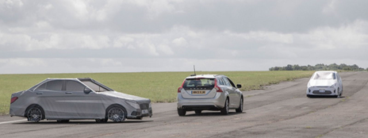

6.18.8. Real World Model Confirmation
On-road testing is always performed with a highly trained safety driver continuously monitoring the vehicle’s behavior and ready to immediately intervene when necessary. A co-pilot may monitor’s the ADS software and that the vehicle’s path is valid for current road conditions. RWTs are ideal for validating the simulation models used in the virtual testing toolchain and may be conducted by 3rd party.

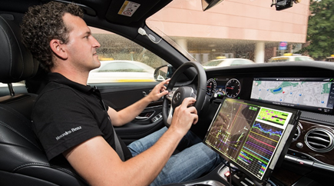

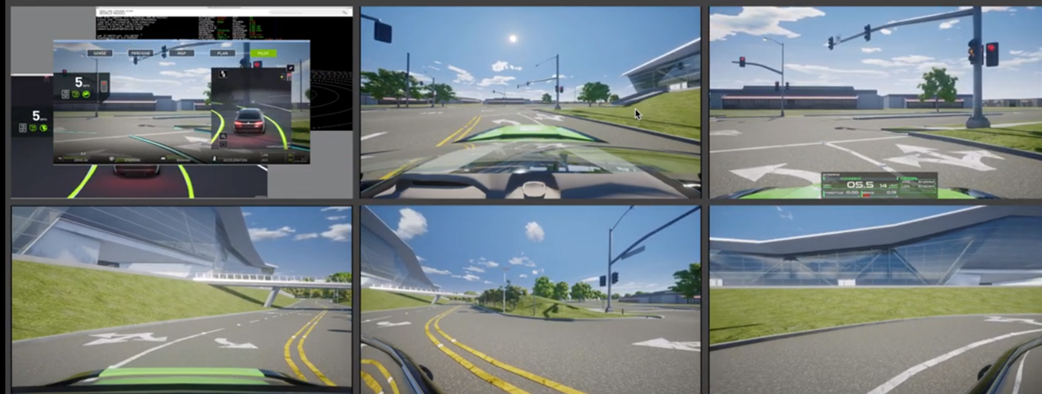

For the sensor system validation I was thinking about separating it into 2 components: in lab and in real world. Starting off in lab with static scenes and known light sources etc then moving to dynamic and more variable environments in the real world.

·By looking at the example of the lane model validation: it should be pointed out that validation of a model should be done using redundant methods of calibration for instance.
·For the sensor system part: the sensor system should be qualified using known KPIs such as very deterministic static scenarios at first. This will allow the system to be validated and you can get a measurable KPI. After that it can be extended to weather conditions etc..
·The methods we use are almost the same apart from the calibration and validation. We calibrate the camera using two types of calibration and compare them together. For the system sensor, we use a sensor model qualification

