The following paragraphs define the stability of the DPPS after deployment and therefore the timeframe during which static/dynamic tests can be performed.

9.1.0 Definitions

Testing time: Time frame in which the physical test has to be performed

Dynamic tests: This is regarded as default test configuration to represent the impact of the pedestrian’s head onto the DPPS.
The triggering time depends on the HIT vs. WAD information.

Under contracting party option all requirements shall be demonstrated using a dynamic test.
If a contracting party chooses to use the static test, the following requirements must be fulfilled.

Static time constraint tests: When there is a constraint on time for the stability of the system and HIT>TRT. The triggering time depends on the stability information provided by the manufacturer.

Static tests: When HIT>TRT, stability information of the system has been proven and there is no constraint of time to perform the test, the tests can be done in stable settled deployed position.
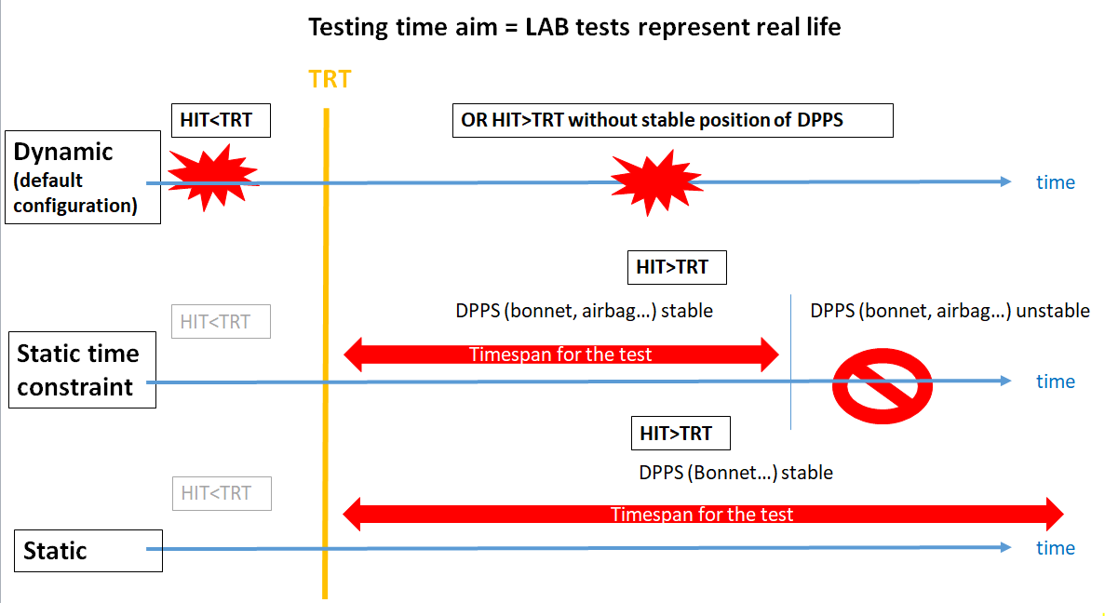
[Fig. 9.1.2 – scheme of different test configurations]

9.1.2 System specification
As an contracting party option, a technical description of the DPPS components shall be submitted by the manufacturer. This shall be accompanied by the following information:

For Sensing system:
* Type (pressure, optical, vision…)
* Sensor locations
* Operation process
Deployment information:
*Type of system (airbag, active hood, …)
*Mechanism explanation
*Component description (lifting system (e.g. actuator), hinge, latch, ...)
*Intended deployment height information
*TRT (ST+DT) information
*Evolution of system stability (e.g. pressure or force vs. time diagram)

With this information the test can be conducted statically (static or static time constraint) or dynamically.
During the static tests it has to be ensured that the resisting force of the DPPS is equivalent to the actual situation at the real head impact time.

