- GRVA-10-22 proposal
5.6.4.6.4.1. Automatic initiation of the lane change manoeuvre
In case of an automatic initiation the lane change manoeuvre shall commence between 3.0 seconds and 7.0 5.0 seconds after the manual activation of the procedure as described in paragraph 5.6.4.6.2. and shown in the Figure below. The manoeuvre shall commence at the earliest opportunity when the situation is not deemed critical as defined in 5.6.4.7.
- Compromise proposal
Existing Provisions
5.6.4.6. Lane Change Procedure
5.6.4.6.1. The initiation of a lane change procedure of an ACSF of Category C shall only be possible if an ACSF of Category B1 is already active.
5.6.4.6.2. The lane change procedure requires, and shall start immediately after, a manual activation by the driver of the direction indicator to the intended side for the lane change.
5.6.4.6.3. When the lane change procedure starts, the ACSF of Category B1 shall be suspended and the ACSF of Category C shall carry on the lane keeping function of ACSF of category B1, until the lane change manoeuvre starts.
5.6.4.6.4. The lateral movement of the vehicle towards the intended lane shall not start earlier than 1.0 second after the start of the lane change procedure. Additionally, the lateral movement to approach the lane marking and the lateral movement necessary to complete the lane change manoeuvre shall be completed as one continuous movement.
The lane change manoeuvre shall be initiated either automatically or by a second deliberate action of the driver. A vehicle shall not be equipped with both these means of initiation.
5.6.4.6.4.1. Automatic initiation of the lane change manoeuvre
In case of an automatic initiation the lane change manoeuvre shall commence between 3.0 seconds and 5.0 seconds after the manual activation of the procedure as described in paragraph 5.6.4.6.2. and shown in the Figure below.

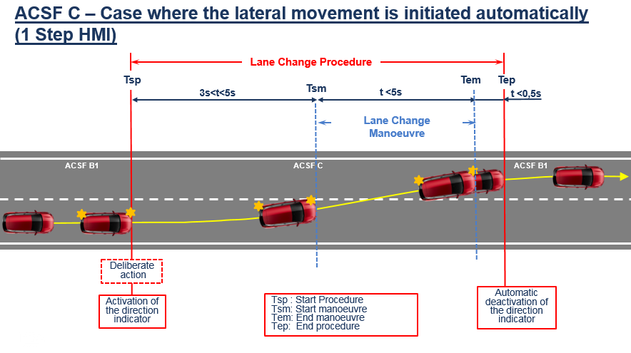

Amendment Option 1 for 5.6.4.6.4.1
5.6.4.6.4.1. Automatic initiation of the lane change manoeuvre
In case of an automatic initiation the lane change manoeuvre shall commence between at least 3.0 seconds and 5.0 seconds after the manual activation of the procedure as described in paragraph 5.6.4.6.2. [and shown in the Figure below]. The manoeuvre shall commence at the earliest opportunity as long as the situation is not deemed critical as defined in 5.6.4.7. In addition, if the target lane has available space when the lane change procedure is requested by the driver, however loses this space before the start of the lane change manoeuvre, the system shall refrain from persisting the lane change manoeuvre.
The manufacturer shall demonstrate to the satisfaction of the Technical Service the system control strategy [which should include consideration for appropriate behaviour in various traffic situations (e.g. heavy traffic) [in order to avoid unintentional aborts]].

Amendment Option 2 for 5.6.4.6.4.1
5.6.4.6.4.1. Automatic initiation of the lane change manoeuvre
In case of an automatic initiation the lane change manoeuvre shall commence between at least 3.0 seconds and 5.0 seconds after the manual activation of the procedure as described in paragraph 5.6.4.6.2. [and shown in the Figure below]. The manoeuvre shall commence at the earliest opportunity as long as the situation is not deemed critical as defined in 5.6.4.7. The manufacturer shall ensure and demonstrate to the Technical Service at the time of type approval that the system does not tend to claim non-available space in the adjacent lane (e.g. procedure is suppressed in case a vehicle is present in the target lane).

Existing provisions continued (adapted to proposal, changes to two-step TBD)
5.6.4.6.4.2. Initiation of the lane change manoeuvre by a second deliberate action
In case of an initiation by a second deliberate action the lane change manoeuvre shall commence between 3.0 and 7.0 seconds after the manual activation of the procedure as described in paragraph 5.6.4.6.2.
Additionally, the lane change manoeuvre shall commence at the latest 3.0 seconds after the second deliberate action as shown in the Figure below.
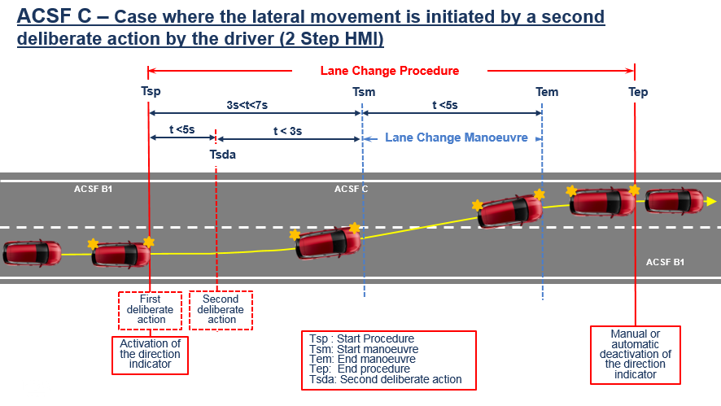
The control to operate the second deliberate action shall be located in the steering control area.

5.6.4.6.5. The lane change manoeuvre shall be completed in less than:
(a) 5 seconds for M₁, N₁ vehicle categories;
(b) 10 seconds for M₂, M₃, N₂, N₃ vehicle categories.
5.6.4.6.6. Once the lane change manoeuvre has completed, ACSF of Category B1 lane keeping function shall resume automatically.
5.6.4.6.7. The direction indicator shall remain active throughout the whole period of the lane change manoeuvre and shall be automatically deactivated by the system no later than 0.5 seconds after the resumption of ACSF of Category B1 lane keeping function as described in paragraph 5.6.4.6.6. above. Automatic deactivation by the system of the direction indicator is required only if the lane change manoeuvre is initiated automatically.
5.6.4.6.8. Suppression of the Lane Change Procedure
5.6.4.6.8.1. The lane change procedure shall be suppressed automatically by the system when at least one of the following situations occurs before the lane change manoeuvre has started:
(a) The system detects a critical situation (as defined in paragraph 5.6.4.7.),
(b) The system is overridden or switched off by the driver,
(c) The system reaches its boundaries (e.g., lane markings are no longer detected),
(d) The system has detected that the driver is not holding the steering control at the start of the lane change manoeuvre,
(e) The direction indicator lamps are manually deactivated by the driver,
(f) Following the deliberate action of the driver to start the procedure described in paragraph 5.6.4.6.2., the lane change manoeuvre has not commenced:
[(i) At the latest after 5.0 seconds, in the case of an automatic initiation, ]
(ii) At the latest after 7.0 seconds, in the case of an initiation by a second deliberate action,
(iii) At the latest after 3.0 seconds after the second deliberate action, in the case of an initiation by a second deliberate action,
whatever is appropriate
(g) The system, with an initiation of the lane change manoeuvre by a second deliberate action, has not detected the second deliberate action at the latest 5.0 seconds after the start of the lane change procedure.
(h) The lateral movement described in paragraph 5.6.4.6.4. is not continuous.
5.6.4.6.8.2. Manual deactivation of the lane change procedure, using the manual control of the direction indicator, shall be possible for the driver at any time.
5.6.4.7. Critical situation
A situation is deemed to be critical when, at the time a lane change manoeuvre starts, an approaching vehicle in the target lane would have to decelerate at a higher level than 3m/s², 0.4 seconds after the lane change manoeuvre has started, to ensure the distance between the two vehicles is never less than that which the lane change vehicle travels in 1 second.
The resulting critical distance at the start of the lane change manoeuvre shall be calculated using the following formula:
S_{critical} = (v_{rear} - v_{ACSF}) * t_{B} + (v_{rear} - v_{ACSF})² / (2 * a) + v_{ACSF} * t_{G}
Where:
v_{rear} is The actual speed of the approaching vehicle or 130 km/h whatever value is lower
v_{ACSF} is The actual speed of the ACSF vehicle
a = 3 m/s² (Deceleration of the approaching vehicle)
t_{B} = 0.4 s (Time after the start of the lane change manoeuvre at which the deceleration of the approaching vehicle starts)
t_{G} = 1 s (Remaining gap of the vehicles after the deceleration of the approaching vehicle).

