Motorway Scenario: Lane Keeping at Bend
Title – Lane keeping at bend and with ORU presence
Scenario Description – This scenario assesses the capability of the ADS to maintain its lane of travel on a road with bend, and other road user presence in close proximity.
The ego vehicle drives in its lane of travel at a constant speed, and the ORU drives in a lane adjacent to the ego vehicle’s lane of travel. During the test, the ORU drives along the road bend while remaining ahead of the ego vehicle.

Picture/Graphic:
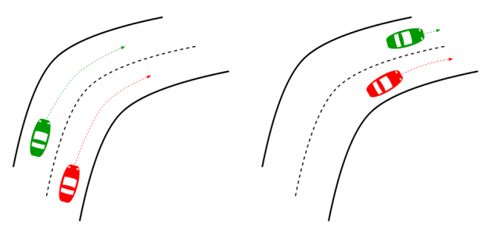
Road Topology and road objects requirements (Pegasus Layers 1,2,3): This scenario takes place at a road with a minimum of two lanes per direction of travel. The specific road curvature should be derived from ODD analysis.
[Optional Section] Initial Conditions: The ego and ORU vehicles start the test with ORU vehicle position being in front of the ego. Both vehicles reach target speed and maintain it throughout the bend of the road. Target relative speed between ego and ORU is 0 km/h.
DUT behavior (Pegasus Layer 4): Both the ego and ORU drive in the same direction and in their lanes of travel. Before entering the bend, both vehicles should have reached their target speed.
Other actors’ behavior (Pegasus Layer 4): No other actors are involved.
Environment (Pegasus Level 5): Should be derived from ODD analysis
Communication (Pegasus Layer 6): No communication is required.
ODD specification/restriction: Road topology must be included in the ODD.
TAGS and Categories: Road types: Motorway Vehicle categories: TBC

Motorway Scenario: Static Passable Object
Title – ADS encounter of static passable object in its lane of travel
Scenario Description – In this scenario, the ADS is assessed by encountering a static passable object in its lane of travel.
During the test, the ego vehicle drives at a constant speed on a multi lane road. On the road ahead, there is a passable object in the ego’s lane of travel. The object is blocking a part of the lane, but leaving sufficient space to pass it without leaving the ego’s lane of travel.
Picture/Graphic:
Road Topology and road objects requirements (Pegasus Layers 1,2,3): This scenario takes place at a road with a minimum of two lanes per direction of travel. The specific road parameters should be derived from ODD analysis.
[Optional Section] Initial Conditions: The ego vehicle starts the test by having a sufficient distance from the static passable object allowing it to reach the target speed.
DUT behavior (Pegasus Layer 4): The ego vehicle drives as in normal driving conditions leading it to encounter the static passable object.
Other actors’ behavior (Pegasus Layer 4): No other actors are involved.
Environment (Pegasus Level 5): Should be derived from ODD analysis
Communication (Pegasus Layer 6): No communication is required.
ODD specification/restriction: Road topology must be included in the ODD.
TAGS and Categories: Road types: Motorway Vehicle categories: TBC

Motorway Scenario: Static Impassable Object
Title – ADS encounter of static impassable object in its lane of travel
Scenario Description – In this scenario, the ADS is assessed by encountering a static impassable object in its lane of travel.
During the test, the ego vehicle drives at a constant speed on a multi lane road. On the road ahead, there is an impassable object in the ego’s lane of travel. The object is blocking the lane sufficiently to prevent the ego from being able to pass it without leaving the lane of travel.
Picture/Graphic:
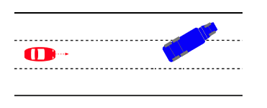
Road Topology and road objects requirements (Pegasus Layers 1,2,3): This scenario takes place at a road with a minimum of two lanes per direction of travel. The specific road parameters should be derived from ODD analysis.
[Optional Section] Initial Conditions: the ego vehicle starts the test by having a sufficient distance from the static impassable object allowing it to reach the target speed.
DUT behavior (Pegasus Layer 4): the ego vehicle drives as in normal driving conditions, leading it to encounter the static impassable object.
Other actors’ behavior (Pegasus Layer 4): No other actors are involved.
Environment (Pegasus Level 5): Should be derived from ODD analysis
Communication (Pegasus Layer 6): No communication is required.
ODD specification/restriction: Road topology must be included in the ODD.
TAGS and Categories: Road types: Motorway Vehicle categories: TBC

