Proposal for amendments to
Based on document version sent by JRC on Nov. 29th 2021

Submitted by the experts of Germany
UNR157-11-10
ECE/TRANS/WP.29/2020/81

The text reproduced below was prepared by the experts from the ‘task force on testing’ lead by JRC/EC. The proposal is aimed at modifying the text of document ECE/TRANS/WP.29/2020/81 (Regulation 157 on ALKS). All modifications to ECE/TRANS/WP.29/2020/81 are given in blue text. Deletions are indicated by red strikethrough text.
General comments:
- It was suggested to discuss on reference to Technical service vs Type Approval Authority; ADDRESSED (same as Annex 4)
- It was suggested to discuss the opportunity to use other terms than ALKS (e.g. ALKS+(LC), highway chauffeur etc.) to refer to the new system with lane change capabilities;
- The requirement on change in control strategy needs clarification.
Pending items:
- General definition of “difficult” scenarios (proposal: The "difficult" parameter range identifies the set of concrete scenarios requiring an emergency manoeuvre to the ALKS); ADDRESSED
- Add new text for 4.2.2 (proposal being prepared by industry) for high-speed testing of pedestrian crossing without mandating collision avoidance; ADDRESSED (see 5.3)
- Scope of Track Testing in 3.1: JP proposed to include verification of simulation tools: discuss if implement JP proposal here or in Annex 4; ADDRESSED (in Annex 4, see proposed text below)
- Paragraph 4.7 (lane change) has been restored but will undergo further revision once the discussion on lane change will be finalized; ADDRESSED
- Japan will elaborate difficulty classification according to the CC driver model that will be incorporated in Appendix 1.
- Paragraph 4.6 (Field of view test) will undergo further revision once the discussion on requirements is finalized.
I. Proposal – Annex 5
Paragraph 1., amend to read:
Test Specifications for track testing of ALKS vehicles
1. Introduction
This annex defines track tests with the purpose to verify the technical requirements on ALKS.
Until such time that specific test provisions have been agreed, the type-approval authority or the technical service acting on its behalf (hereafter referred as type-approval authority) shall ensure that the ALKS is subject to at least the tests outlined in Annexes 5 and 6. The specific test parameters for each test shall be selected by the Technical Servicetype-approval authority and shall be recorded in the test report in such a manner that allows traceability and repeatability of the test setup.
Pass- and Fail-Criteria for tests are derived solely from the technical requirements in paragraphs 5 to 7 of the Regulation. These requirements are worded in a way that they allow the derivation of pass-fail-criteria not only for a given set of test parameters, but for any combination of parameters in which the system is designed to work (e.g. operating speed range, operating lateral acceleration range, curvature range as contained in the system boundaries).
The test specifications specified in this document are meant to be shall be intended as a minimum set of tests,. tThe technical service type-approval authorities may perform any other additional tests within the system ODD boundaries and may then compare the measured results against the requirements.
Under Paragraph 2., insert to read:
2.6. "Difficult" parameter range identifies the set of concrete scenarios causing imminent collision risk.
Under Paragraph 3., insert to read:
3.1. Track testing
The system shall be verified on a closed-access area with various scenario elements to test the capabilities and functioning of an ALKS.
3.12. Test conditions
3.12.1. The tests shall be performed under conditions (e.g. environmental, road geometry) that allow the activation of the ALKS. For conditions not tested that may occur within the defined operating range of the vehicle, the vehicle manufacturer shall demonstrate as part of the audit described in Annex 4 to the satisfaction of the relevant authorities that the vehicle is safely controlled.
3.12.2. If system modifications are required in order to allow testing, e.g. road type assessment criteria or road type information (map data), it shall be ensured that these modifications don’t have an effect on the test results. These modifications shall in principle be documented and annexed to the test report. The description and the evidence of influence (if any) of these modifications shall be documented and annexed to the test report.
3.2.3. In order to test the requirements for failure of functions, self-testing and initialization of the system, and implementation of a minimal risk manoeuvre, errors may be artificially induced and the vehicle may be artificially brought into situations where it reaches the limits of the defined operating range (e.g., environmental conditions).
It shall be verified, that the condition of the system is according to the intended testing purpose (e.g. in a fault-free condition or with the specific faults to be tested).
3.12.34. The test surface shall afford at least the adhesion required by the scenario in order to achieve the expected test result.
3.2.5. Vehicle conditions
3.2.5.1. Test mass
The subject vehicle shall be tested in a load condition agreed between the manufacturer and the approval authority. No load alteration shall be made once the test procedure has begun. The vehicle manufacturer shall demonstrate, through the use of documentation, that the system works at all load conditions.
3.2.5.2. The subject vehicle shall be tested at the tyre pressure recommended by the vehicle manufacturer.
3.12.46. Test Targets Tools
3.12.46.1. The target used for the vehicle detection tests shall be a regular high-volume series production vehicle of Category M or N or alternatively a "soft target" representative of a vehicle in terms of its identification characteristics applicable to the sensor system of the ALKS under test according to ISO 19206-3:2018. The reference point for the location of the vehicle shall be the most rearward point on the centreline of the vehicle.
3.12.46.2. The target used for the Powered-Two-wheeler tests shall be a test device according to ISO CD 19206-5 or a type approved high volume series production motorcycle of Category L3 with an engine capacity not exceeding 600 cm3. The reference point for the location of the motorcycle shall be the most backward point on the centreline of the motorcycle.
3.12.46.3. The target used for the pedestrian detection tests shall be an "articulated soft target" and be representative of the human attributes applicable to the sensor system of the AEBS under test according to ISO 19206-2:2018.
3.2.6.4. In addition to reference targets, state-of-the-art test tools may be used to carry out the tests, replacing real vehicles and other road users (e.g., soft targets, mobile platforms, etc.), or making real vehicles driverless. It shall be ensured that the test tools replacing the reference targets have comparable characteristics to those. Tests must not be carried out in such a way as to endanger the personnel involved and significant damage of the vehicle under test must be avoided where other means of validation are available.
3.12.46.45. Details that enable the target(s) to be specifically identified and reproduced shall be recorded in the vehicle type approval documentation.
3.3. Test parameter variation
The manufacturer shall declare the system boundaries to the Technical Servicetype-approval authority. The Technical Servicetype-approval authority shall define different combinations of test parameters (e.g. present speed of the ALKS vehicle, type and offset of target, curvature of lane) in order to cover scenarios in accordance with paragraph 3.3.1 of the present annex.
If this is deemed justified, the Technical Service may test additionally any other combination of parameters may be tested.
If a collision cannot be avoided for some test parameters, the manufacturer shall demonstrate either by documentation or, if possible, by verification/testing that the system doesn’t unreasonably switch its control strategy.
3.3.1. The approval authority shall define the approach to classify the difficulty level of the testing scenarios. Parameters of the traffic critical scenarios shall be chosen in order to ensure a certain difficulty level. In particular, for systems operating at speeds above 60km/h the approval authority shall include tests of traffic critical scenarios:
- in the “difficult” parameter range and;
- in the “unavoidable collision” parameter range for the given scenario.
Authorities may use the method(s) presented for guidance in Appendix 1 to determine the difficulty of the tests.
For scenarios in the “unavoidable collision” class, the manufacturer may demonstrate either by documentation or, if possible, by verification/testing that the system doesn’t unreasonably switch its control strategy.

Under Paragraph 4., insert to read:
4. Test scenarios to assess the performance of the system with regard to the dynamic driving task
Test scenarios shall be selected depending on the Operational Design Domain (ODD)).
4.1. Lane Keeping
4.1.1. The test shall demonstrate that the ALKS does not leave its lane and maintains a stable positionmotion inside its ego lane across the speed range and different curvatures within its system boundaries.
4.1.2. The test shall be executed at least:
(a) With a minimum test duration of 5 minutes;
(b) With a passenger car target as well as a PTW target as the lead vehicle / other vehicle;
(c) With a lead vehicle swerving in the lane; and
(d) With another vehicle driving close beside in the adjacent lane.
4.2. Avoid a collision with a road user or object blocking the lane
4.2.1. The test shall demonstrate that the ALKS avoids a collision with a stationary vehicle, road user or fully or partially blocked lane up to the maximum specified speed of the system.
4.2.2. This test shall be executed at least:
(a) With a stationary passenger car target;
(b) With a stationary powered two-wheeler target;
(c) With a stationary pedestrian target;
(d) With a pedestrian target crossing the lane with a speed of 5 km/h for speeds of the ALKS vehicle up to 60km/h;
(e) With a target representing a blocked lane;
(f) With a target partially within the lane;
(g) With multiple consecutive obstacles blocking the lane (e.g. in the following order: ego ALKS-vehicle -motorcyclePTW - car);
(h) On a curved section of road.

4.3. Following a lead vehicle
4.3.1. The test shall demonstrate that the ALKS is able to maintain and restore the required safety distance to a vehicle in front and is able to avoid a collision with a lead vehicle which decelerates up to its maximum deceleration.
4.3.2. This test shall be executed at least:
(a) Across the entire speed range of the ALKS
(b) UsingFor a passenger car target as well as a PTW target as lead vehicle, provided standardized PTW targets suitable to safely perform the test are available;
(c) For constant and varying lead vehicle velocities (e.g. following a realistic speed profile from existing driving database);
(d) For straight and curved sections of road;
(e) For different lateral positions of lead vehicle in the lane;
(f) With a deceleration of the lead vehicle of at least 6 m/s² mean fully developed deceleration until standstill.
4.4. Lane change of another vehicle into lane
4.4.1. The test shall demonstrate that the ALKS is capable of avoiding a collision with a vehicle cutting into the lane of the ALKS vehicle up to a certain criticality of the cut-in manoeuvre in accordance with paragraph 4.4.2. of the present annex.
4.4.2. The criticality of the cut-in manoeuvre shall be determined according to TTC, longitudinal distance between rear-most point of the cutting in vehicle and front-most point of the ALKS vehicle, the lateral velocity of the cutting-in vehicle and the longitudinal movement of the cutting-in vehicle, as defined in paragraph 5.2.5.
4.4.3. This test shall be executed taking into consideration at least the following conditions:
(a) ForWith different TTC, distance and relative velocity values of the cut-in manoeuvre, covering types of cut-in scenarios in which a collision can be avoided and those in which a collision cannot be avoided;
(b) ForWith cutting-in vehicles travelling at constant longitudinal speed, accelerating and decelerating;
(c) ForWith different lateral velocities, lateral accelerations of the cut-in vehicle;
(d) ForWith passenger car as well as PTW targets as the cutting-in vehicle, provided standardized PTW targets suitable to safely perform the test are available.
4.5. Stationary obstacle after lane change of the lead vehicle
4.5.1. The test shall demonstrate that the ALKS is capable of avoiding a collision with a stationary vehicle, road user or blocked lane that becomes visible after a preceding vehicle avoided a collision by an evasive manoeuvre.
4.5.2. The test shall be executed at least:
(a) With a stationary passenger car target centred in lane
(b) With a powered two-wheeler target centred in lane
(c) With a stationary pedestrian target centred in lane
(d) With a target representing a blocked lane centred in lane
(e) With multiple consecutive obstacles blocking the lane (e.g. in the following order: egoALKS-vehicle – lane change vehicle – motorcyclePTW – car)
4.6. Field of View test
4.6.1. The test shall demonstrate that the ALKS vehicle is capable of detecting another road user within the forward detection area up to the declared forward detection range and a vehicle beside within the lateral detection area up to at least the full width of the adjacent lane. If the ALKS vehicle is capable of performing lane changes, it shall additionally demonstrate that the system is capable of detecting another vehicle within the rear detection range.
4.6.2. The test for the forward detection range shall be executed at least:
(a) When approaching a motorcyclePTW target positioned at the outer edge of each adjacent lane;
(b) When approaching a stationary pedestrian target positioned at the outer edge of each adjacent lane;
(c) When approaching a stationary motorcyclePTW target positioned within the ego lane;
(d) When approaching a stationary pedestrian target positioned within the ego lane.
4.6.3. The test for the lateral detection range shall be executed at least:
(a) With a motorcyclePTW target approaching the ALKS vehicle from the left adjacent lane;
(b) With a motorcyclePTW target approaching the ALKS vehicle from the right adjacent lane.
4.6.4. The test for the rear detection range shall be executed at least:
(a) With a PTW approaching the ALKS from the rear outer edge of each adjacent lane;
4.7. Lane changing
4.7.1. Lane Change tests are only required if the ALKS is capable of performing lane changes either during an MRM, emergency situations or during regular operation.
The test shall demonstrate that the ALKS vehicle does not cause an unreasonable risk to safety of the vehicle occupants and other road users during a LCP, that the system is capable of correctly performing lane changes, and is able to assess the criticality of the surrounding situation before starting the LCM.
4.7.3. The tests shall be executed at least:
(a) With different vehicles, including a PTW approaching from the rear;
(b) In a scenario where a LCM in regular operation is possible and executed;
(c) In a scenario where a LCM in regular operation is not possible due to a vehicle approaching from the rear;
(d) With an equally fast vehicle following behind in the adjacent lane, preventing a lane change;
(e) With a vehicle driving beside in the adjacent lane preventing a lane change;
(f) In a scenario where a LCM during a MRM is possible and executed.
(g) In a scenario where the ALKS vehicle reacts to another vehicle that starts changing into the same space within the target lane, to avoid a potential risk of collision.
4.8. Avoid emergency braking before a passable object in the lane
4.8.1. The test shall demonstrate that the ALKS vehicle is not initiating an Emergency Braking with a deceleration demand greater than [5] m/s² due to a passable object in the lane (e.g., a manhole lid or a small branch).
4.8.2. The test shall be executed at least:
(a) Without a lead vehicle;
(b) With a passenger car target as well as a PTW target as the lead vehicle, provided standardized PTW target suitable to safely perform the test is available.

Under Paragraph 5., delete to read:
5.3 Additional other scenarios that may or may not be part of the ODD shall be assessed (e.g. by physical or virtual testing or appropriate documentation) if deemed justified by the Technical Servicetype-approval authority. Some of the cases may include:

(a) Y-split of highway lanes
(b) Vehicles entering or exiting the highway
(c) Partially blocked ego lane, tunnel
(db) Traffic lights
(ec) Emergency vehicles
(f) Construction zones
(gd) Faded/erased/hidden lane markings
(he) Emergency/Service personnel directing traffic
(if) Change in road characteristics (no longer divided, pedestrians permitted, roundabout, intersection)
(j) Normal traffic flow resumed (i.e. all vehicles moving > 60km/h)
(g) Oncoming traffic / wrong way driver
(h) A pedestrian target crossing the lane with a speed of 5 km/h for speeds of the ALKS vehicle above 60km/h.

5.4 Real-world test
The Technical Service shall conduct, or shall witness, an assessment of the system, in a fault-free condition, in the presence of traffic (a ‘real-world’ test). The purpose of this test is to support the Technical Service in understanding the functionality of the system in its operating environment and to complement the assessment of the documentation provided under Annex 4.
Together, the assessment of Annex 4 and the real-world test shall enable the Technical Service to identify areas of system performance that may require further assessment, either through testing or further review of Annex 4.
During the real-world assessment, the Technical Service shall assess at least:
(a) Prevention of activation when the system is outside of its technical boundaries/requirements for ALKS
(b) No violation of traffic rules
(c) Response to a planned event
(d) Response to an unplanned event
(e) Detection of the presence of other road users within the frontal and lateral detection ranges
(f) Vehicle behaviour in response to other road users (following distance, cut-in scenario, cut-out scenario etc).
(g) System override
The location and selection of the test route, time-of-day and environmental conditions shall be determined by the Technical Service.
The test drive shall be recorded and the test vehicle instrumented with non-perturbing equipment. The Technical Service may log, or request logs of any data channels used or generated by the system as deemed necessary for post-test evaluation.
It is recommended that the real-world test is undertaken once the system has passed all of the other tests outlined in this Annex and upon completion of a risk assessment by the Technical Service.

Appendix 1
A suggested approach for traffic critical scenario difficulty classification

Following data sheets are pictorial examples of simulations which determines conditions under which ALKS shall avoid a collision, taking into account the combination of every parameter, at and below the maximum permitted ALKS vehicle speed.
Where collision is deemed to be avoidable, three subsets are defined, to differentiate between the parameter sets based on their difficulty in accordance to the performance model laid down in paragraph 3 of Annex 4 Appendix 3:
- “Easy” conditions are highlighted by green colour,
- “Medium” conditions are highlighted by yellow colour,
- “Difficult” conditions are highlighted by red colour, while
- “Unavoidable collision” is highlighted by red colour with black “X”.
1. Cut in
Classification of difficulty of the scenarios based on the initial parameters is done the following way in accordance to the performance model laid down in paragraph 3 of Annex 4 Appendix 3:
- Easy: PFS <= 0.85;
- Medium: PFS > 0.85 and CFS < 0.9;
- Difficult: CFS => 0.9.
Based on these equations the classification may be done for any parameter set; to show some examples, a number of figures are presented below with different ego vehicle speeds.
Alternatively the authority may also find the appropriate way to use the performance model laid down in paragraph 2 of Annex 4 Appendix 3 for the classification of the scenario difficulty.

Figure 1
For Ve0 = 130 kph
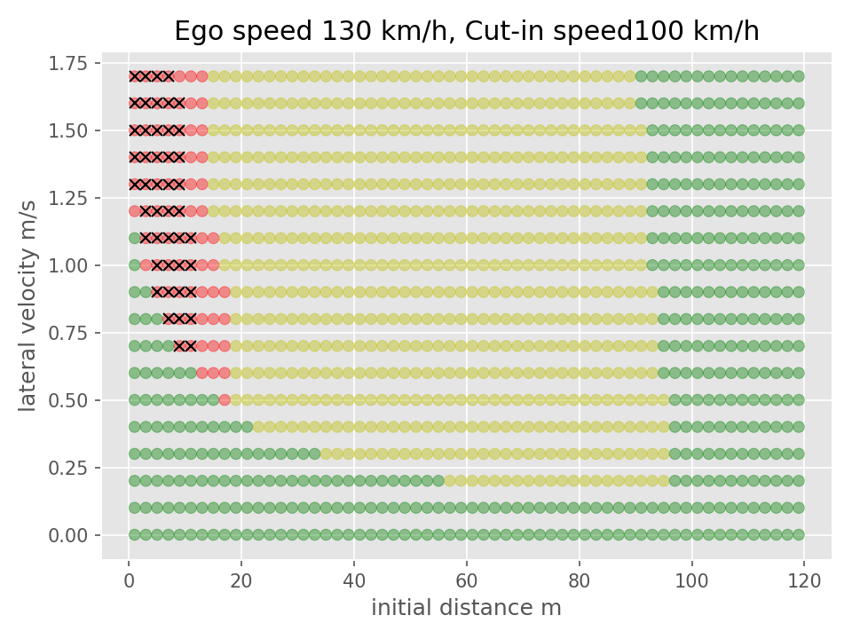

Figure 2
For Ve0 = 110 kph
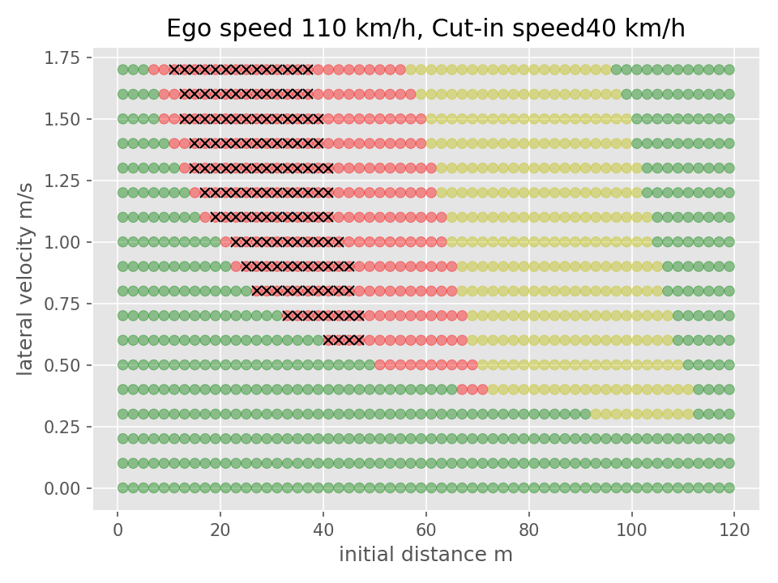

Figure 3
For Ve0 = 90 kph
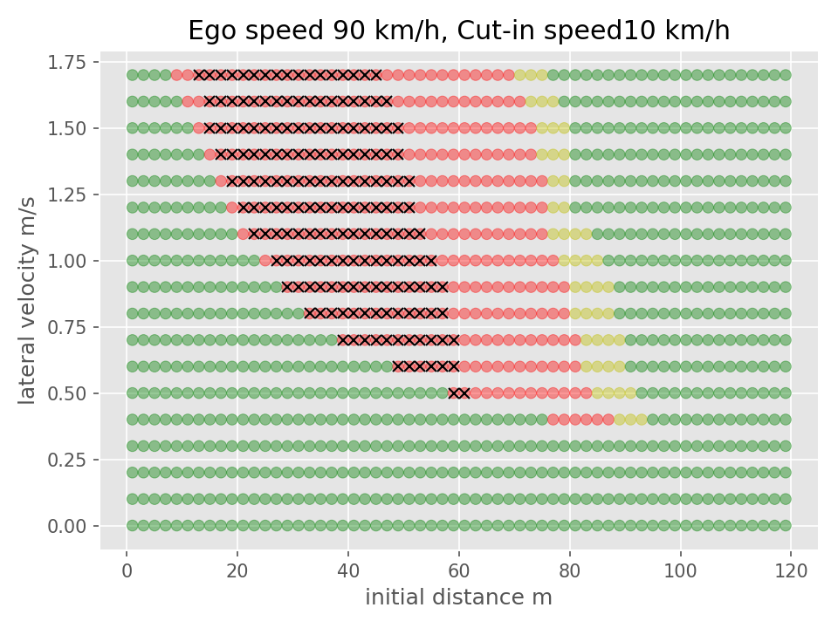

Figure 4
For Ve0 = 60 kph
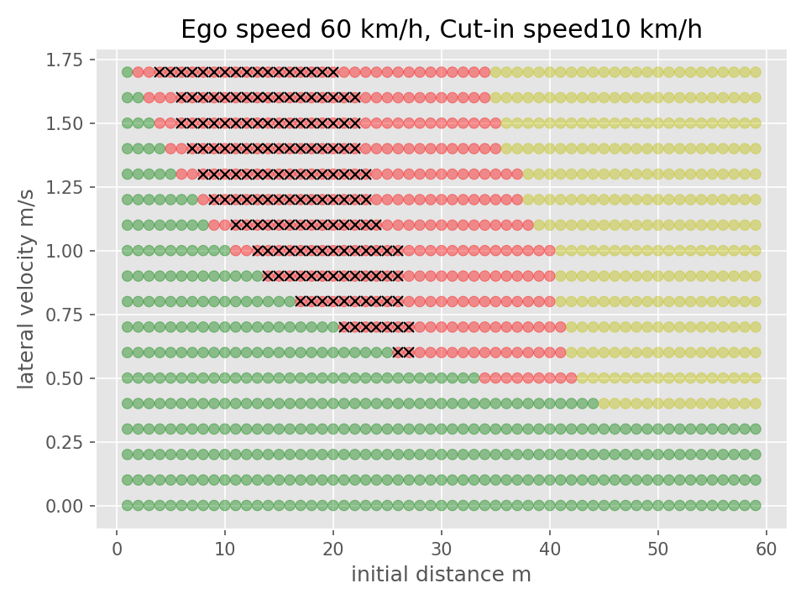

2. Cut out
Classification of difficulty of the scenarios based on the initial parameters is done the following way in accordance to the performance model laid down in paragraph 3 of Annex 4 Appendix 3:
- Easy: PFS = 0;
- Medium: PFS > 0 and CFS < 0.5;
- Difficult: CFS => 0.5.
Based on these equations the classification may be done for any parameter set; to show some examples, a number of figures are presented below with different ego vehicle speeds.
Alternatively the authority may also find the appropriate way to use the performance model laid down in paragraph 2 of Annex 4 Appendix 3 for the classification of the scenario difficulty.

Figure 5
For Ve0 = 130 kph
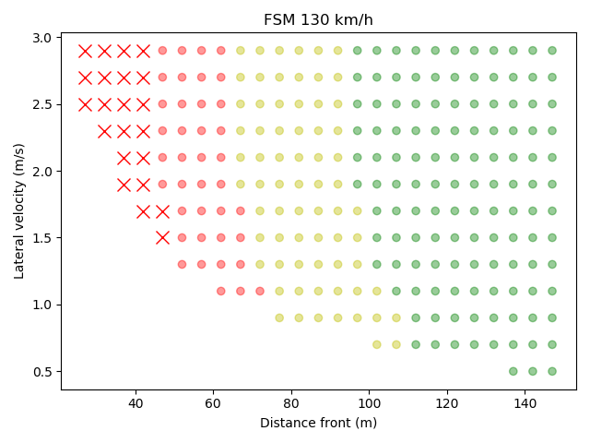

Figure 6
For Ve0 = 120 kph
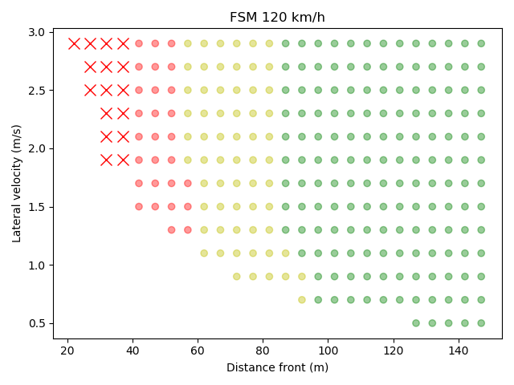

Figure 7
For Ve0 = 110 kph
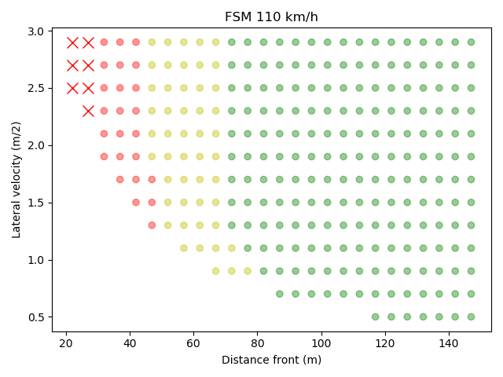

Figure 8
For Ve0 = 100 kph
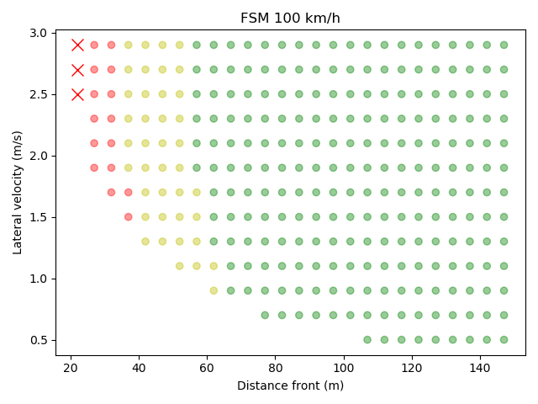

Figure 9
For Ve0 = 90 kph
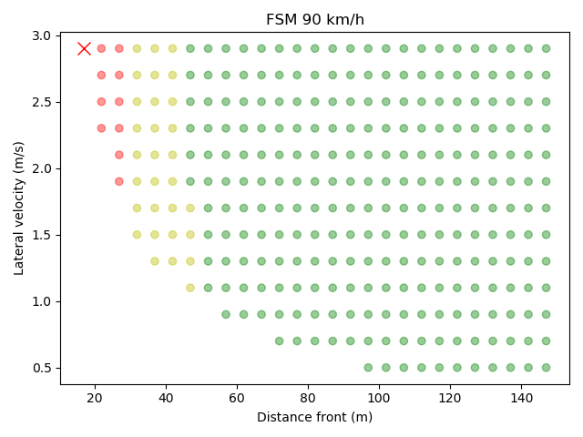

Figure 10
For Ve0 = 80 kph
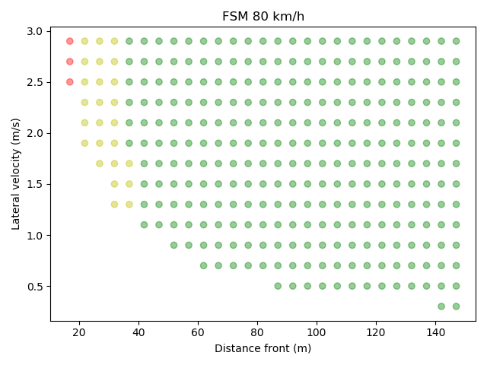

Figure 11
For Ve0 = 70 kph
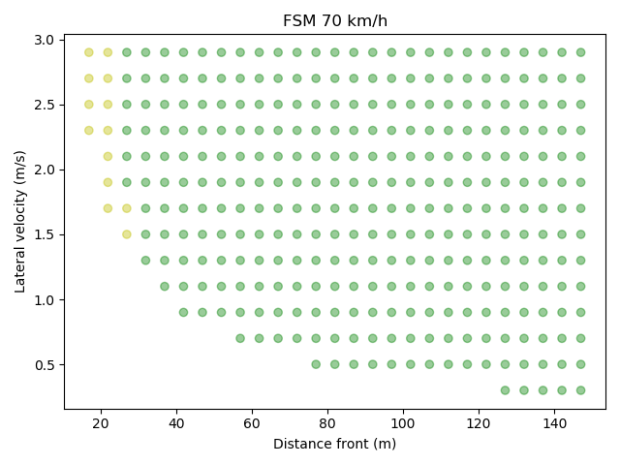

Figure 12
For Ve0 = 60 kph
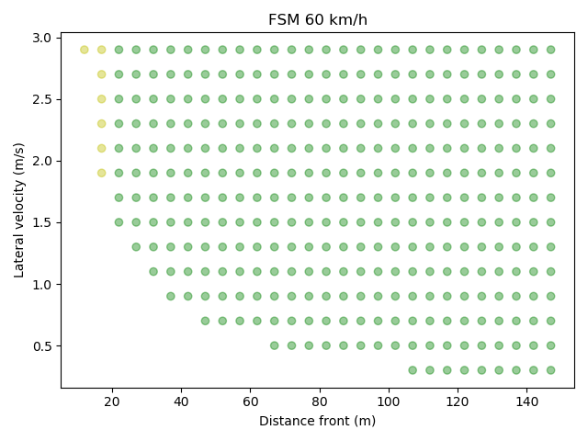

3. Deceleration
Classification of difficulty of the scenarios based on the initial parameters is done the following way in accordance to the performance model laid down in paragraph 3 of Annex 4 Appendix 3:
- Easy: PFS = 0;
- Medium: PFS > 0 and CFS < 0.5;
- Difficult: CFS => 0.5.
Based on these equations the classification may be done for any parameter set. The classification matrix for the different cases is presented below in Fig. 13.
Alternatively the authority may also find the appropriate way to use the performance model laid down in paragraph 2 of Annex 4 Appendix 3 for the classification of the scenario difficulty.

Figure 13
Deceleration
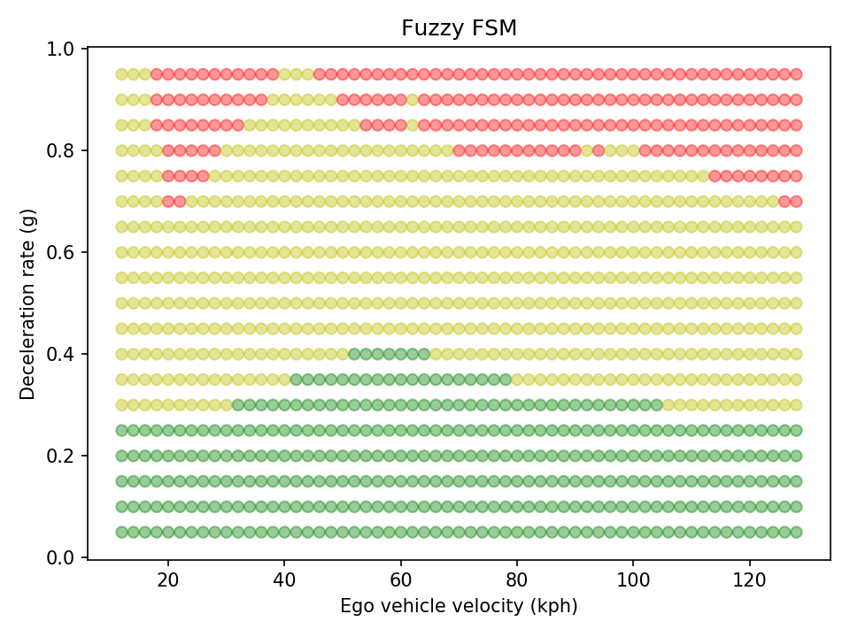

II. Proposal – Annex 4
Paragraph 4., insert to read:

4.2.1 The Type Approval Authorities may verify the accuracy of simulation tools used by means of results from track and/or public road test performed under Annex 5 and/or Annex 6, and/or by performing additional tests where needed.

