Submitted by the leadership of SIG UNR157 | UNR157-12-04
UNR157-12-05
Submitted by the experts of OICA and CLEPA
The text reproduced reflects the state of play of the discussion in the SIG UNR157 up to its 11^{h} meeting for adding the lane change capability of ALKS.
Modifications to the existing text of UN-Regulation No. 157 (incl. suppl. 02 to 00 series) are marked in black bold for new or strikethrough for deleted characters.
Comments:
- Agreements and group conclusions highlighted in grey with changes by the Chair from UNR157-11-04 highlighted in blue.
- Open points of discussions highlighted in yellow. In particular: Homework
-Proposed text by OICA/CLEPA
-Proposed text by the UK
-Proposed text by JP
-Proposed text by the JRC task force on testing

- Proposed text by OICA/CLEPA for the 12th session
I. Proposal
Point of discussion for para. 2.8: Homework: New text expected from industry to address comments from the 6th meeting (clear distinction between regular Lane Changes and Lane Changes during EM).
Paragraph 2.8., amend to read
2.8. "Emergency Manoeuvre (EM)" is a manoeuvre performed by the system in case of an event in which the vehicle is at imminent collision risk and has the purpose of avoiding or mitigating a collision. [This includes manoeuvres when a collision is already imminent as well as [those where evasive steering needs to be performed by the system in order to keep the risk of a collision at a low level / evasive steering manoeuvres that aim to avoid a collision to become imminent.]
Group conclusion on para. 2.21 .to 2.27. agreed (reminder: may need renumbering if merged with speed increase proposal). Point of discussion in 2.25: to be confirmed if “combination” should be included as a follow-up of the recent adoption of commercial vehicles requirements. New definition proposed by JP in blue to be confirmed.
Paragraphs 2.21. to 2.27., insert to read:
2.21. “Starting lane” is the lane out of which the ALKS vehicle intends to manoeuvre.
2.22. “Target lane” is the lane into which the ALKS vehicle intends to manoeuvre. The target lane can be a regular lane of travel, an enter lane, an exit lane or a hard shoulder, emergency refuge area or beside the road.

2.24. A "Lane Change Procedure (LCP)" starts when the direction indicator lamps are activated and ends when the direction indicator lamps are deactivated by the system. It comprises the following operations in the given order:
(a) Activation of the direction indicator lamps;
(b) Temporary suspension of the mandatory lane keeping functionality of the ALKS;
(c) Lateral movement of the vehicle towards the lane boundary;
(d) Lane Change Manoeuvre;
(e) Resumption of the mandatory lane keeping function of the ALKS;
(f) Deactivation of direction indicator lamps.
2.25. A "Lane Change Manoeuvre (LCM)" is part of the LCP and
(a) Starts when the outside edge of the tyre tread of the vehicle’s front wheel closest to the lane markings crosses the outside edge of the lane marking to which the vehicle is being manoeuvred and
(b) Ends when the rear wheels of the vehicle [or combination] have fully crossed the lane marking [or combination].
2.26. "Target stop area" means a potential stopping area (e.g. emergency lane, hard shoulder, beside the road, slowest lane of traffic, own lane of travel).
2.27. “Beside the road” means the area of road surface beyond the boundaries of the carriageway which is not a hard shoulder or emergency refuge area.
2.28. “Possibly Potential vehicle-existing presence area (PVPA)” is the area in which another vehicle could be relevant to the ALKS when performing a lane change and that is enclosed by the following lines.
- A front Forward line is a line perpendicular to the traveling direction at the minimum following distance specified in paragraph 5.2.3.3.
- Lateral lines are a lines parallel to the traveling direction at the outer edges of the ALKS vehicle and the outer edges of the lanes next to the target lanes.
- A Rearward line is a line at the back perpendicular to the traveling direction at the distance specified in paragraphs 5.2.6.7.2.1.and 5.2.6.7.2.3.
The lines (a) ~ (c) above are measured from the most forward / sideward / rearward point of the vehicle, the area changes according to the travel speed of the ALKS vehicle.
Point of discussion on 2.28 and 2.29: Proposal from industry for definitions of MRM and Regular lane changes to be confirmed
[2.28. “MRM lane change” is a lane change performed by the ALKS during a minimum risk manoeuvre.]
[2.29. “Regular lane change” is any lane change performed by the ALKS that is not an MRM lane change.]
Point of discussion on 2.30: JP proposal (UNR157-06-05) for definition of evasive lane change to be confirmed (Reminder: may need renumbering if merged with speed increase proposal.)
[2.30. An "Evasive Lane Change” is steering manoeuvre when the ALKS vehicle cannot avoid collision by its full braking performance.”]
Point of discussion on 2.31: JP proposal (UNR157-07-12) for definitions of MRM lane change procedure to be confirmed (Reminder: may need renumbering if merged with speed increase proposal.)
[2.31. A "Minimum Risk Manoeuvre Lane Change Procedure (MRMLCP)" starts when the direction indicator lamps are activated and ends when the hazard warning lamps are activated by the system. It comprises the following operations in the given order:
(a) Activation of the direction indicator lamps;
(b) Temporary suspension of the mandatory lane keeping functionality of the ALKS;
(c) Lateral movement of the vehicle towards the lane boundary;
(d) Lane Change Manoeuvre towards the target stop area in target lane;
(e) Stop the vehicle when arrive target stop area.
(f) Deactivation of direction indicator lamps and activation of hazard lamps.]
Group conclusion on 5.1.6.: Proposal agreed.
Paragraph 5.1.6., amend to read:
5.1.6. The system shall perform self-checks to detect the occurrence of failures and to confirm system performance at all times (e.g. after vehicle start the system has at least once detected an object at the same or a higher distance than that what is declared as detection ranges according to paragraph 7.1. and its subparagraphs).
Point of discussion on 5.2.1.: Industry see need for such provision since these manoeuvres don’t fit with LCP. Concerns raised by JP and SE that they lack detail and if they are necessary. Consider moving proposed new text to new, separate paragraph or whether needed at all.
Homework: Industry proposed new text in red at 11th meeting (SIG-157-11-07). Industry to come with new proposal addressing the raised concerns in particular to distinguish emergency and non-emergency lane crossing
Paragraph 5.2.1., amend to read:
5.2.1. The activated system shall keep the vehicle inside its lane of travel and ensure that the vehicle does not unintentionally cross any lane marking (outer edge of the front tyre to outer edge of the lane marking). The system shall aim to keep the vehicle in a stable lateral position inside the lane of travel to avoid confusing other road users.
[When intentionally crossing lane markings other than during an LCP (e.g. when forming an access corridor for emergency vehicles or slightly crossing lane markings in order to pass an obstacle partly blocking the current lane of travel), this manoeuvre shall not endanger the safety of the vehicle or any other road user and shall ensure sufficient lateral distance to road boundaries and other road users.]
[When necessary to follow applicable traffic rules (e.g. forming an access corridor for emergency vehicles) or to avoid disruptions in the traffic flow (e.g. passing an obstacle partly blocking the lane of travel), the ALKS vehicle is permitted to intentionally cross lane markings.
A vehicle with ALKS enabled is permitted to intentionally cross lane markings when it is necessary to follow applicable traffic rules or when responding to an obstacle with a preventative risk minimizing strategy (e.g. to form an access corridor for emergency vehicles or for driving around an obstacle partly blocking the lane of travel in order not to disrupt the traffic flow or not to cause a risk to following traffic).

Such lane crossings are not considered to be a lane change as defined in Par 5.2.6 or 5.3 [as long as the vehicle remains partly in its original lane of travel].
The vehicle shall aim at returning [completely] to its original lane of travel once the situation that required this manoeuvre has passed.
The manufacturer shall demonstrate to the Technical Service the strategies implemented in the system to ensure that these manoeuvres do not endanger the safety of the vehicle or any other road user.]
Group conclusion on para. 5.2.6 to 5.2.6.3.: Proposal agreed.
Paragraph 5.2.6. and subparagraphs, insert to read:
5.2.6. Lane Change Procedure (LCP)
The requirements of this paragraph and its subparagraphs apply to the system capable of performing a LCP.
The fulfilment of the provisions of this paragraph and its subparagraphs shall be demonstrated by the manufacturer to the satisfaction of the technical services during the assessment of Annex 4 and according to the relevant tests in Annex 5.
5.2.6.1. A LCP shall not cause an unreasonable risk to safety of the vehicle occupants and other road users. LCPs shall only be performed in an uncritical way as described in paragraphs 5.2.6.1.1. and 5.2.6.1.2.
5.2.6.1.1. The intervention shall not cause a collision with another vehicle or road user in the predicted path of the vehicle during a lane change.
5.2.6.1.2. A lane change procedure shall be predictable and manageable for other road users.
5.2.6.2. A LCP shall be completed without undue delay.
5.2.6.3. The system may perform a single or multiple lane change(s) across regular lanes of traffic and/or to the hard shoulder in accordance with national traffic rules in the country of operation.
Group conclusion on (new) para. 5.2.6.4: agreed.
Paragraph 5.2.6., amend to read:
5.2.6.4. The system shall generate the signal to activate and deactivate the direction indicator signal. The direction indicator shall remain active throughout the whole period of the LCP and shall be deactivated by the system in a timely manner once the lane keeping functionality is resumed.
Points of discussion: Come back to a) and decide if [] can be removed, and whether d) should be deleted, when JP provides further data on their scenario validation study. b) is not removed but now linked to systems capability to perform a LCP to address SE concerns; Group conclusion on e)-g): to be placed under regular LC requirements (see para. 5.2.6.5.1.).
5.2.6.5. The activated system may shall only undertake a LCP in compliance with Paragraph 5.1.2, and only if all of the following requirements conditions are fulfilled:
(a) The vehicle is equipped with a sensing system capable of fulfilling the front, side and rearward detection range requirements as defined in paragraph 7.1., [7.1.1.1. and 7.1.2.1.] and subparagraph 7.1.3.
[(b) All system self-checks, as defined in paragraph 5.1.6. is positively confirmed.]There is no failure present affecting limiting the system's capability to perform a LCP safely.
(c) A gap Sufficient free space in the adjacent lane allowing a LCM is already present available or expected to become available open up shortly.
[(d) There is no other vehicle which is activating direction indicator to come to the target lane (except following vehicles at and near merging and departing lanes).]
(e) The RLCP is anticipated to be completed before the ALKS vehicle comes to standstill (i.e. in order to avoid coming to standstill while in the middle of two regular lanes due to stopped traffic ahead). In case the ALKS vehicle becomes stationary between two regular lanes during the LCM (e.g. due to the surrounding traffic), it should shall at the next available opportunity either complete the RLCP or return to its original lane.
(f) The target lane is a regular lane of travel, or hard shoulder temporarily opened up as a regular lane of travel.
(g) There is a reason for a lane change (e.g. when operation cannot be continued in the current lane, to overtake a slower moving vehicle, or to prevent violation of the obligation to drive in the slowest lane when possible, [or a LCP is being undertaken as part of a MRM as a follow up of a severe failure].
Group conclusion on paras 5.2.6.5.1: agreed. New text in blue by JP (SIG-157-11-13) to include direction indicator detection capability to be confirmed.
5.2.6.5.1. Lane Change Procedure: Additional specific requirements for regular lane changes
The activated system shall only initiate a regular LCP if the following conditions are fulfilled:
[(x) There is no other vehicle in the possibly vehicle-existing area except for following vehicles at and near merging and departing lanes. This is not the case with the ALKS which has a capability of detecting the activation of direction indicator of another vehicle.
(x) There is no other vehicle which is activating direction indicator to come to the target lane in the possibly vehicle-existing area if the ALKS has a capability of detecting the activation of direction indicator of another vehicle.]
There is no other vehicle in the PVPA, whose priority resulting from its active direction indicators, would prevent a LCP of the ALKS according to national traffic rules.
(a) The LCP is anticipated to be completed before the ALKS vehicle comes to standstill (i.e. in order to avoid coming to standstill while in the middle of two regular lanes due to stopped traffic ahead). In case the ALKS vehicle becomes stationary between two regular lanes during the LCM (e.g. due to the surrounding traffic), it should at the next available opportunity either complete the LCP or return to its original lane.
(b) The target lane is a regular lane of travel, or hard shoulder temporarily opened up as a regular lane of travel.
(c) There is a reason for a lane change (e.g. Operation cannot be continued in the current lane, for the purpose of overtaking a slower moving vehicle, to prevent violation of the obligation to drive in the slowest lane when possible where a lane change is required by national traffic rules).
Group conclusion on paras 5.2.6.5.2 to 5.2.6.5.2.2: agreed.
5.2.6.5.2. Lane Change Procedure: Additional specific requirements during an MRM
5.2.6.5.2.1. Lane changes during a MRM shall be made only if under the traffic situation these lane changes can be considered to minimize the risk to safety of the vehicle occupants and other road users.
5.2.6.5.2.2. Before initiating a lane change procedure, the system shall, if deemed appropriate, reduce the vehicle speed to minimize the risk related to that lane change (e.g. by adapting the speed of the vehicle to that of other vehicles in the target lane).
Point of discussion on 5.2.6.5.2.3.: Requirement coming from RMF (UNR79) as proposed by JP needed? A lane change may be needed immediately in case the MRM is triggered by a severe failure
[5.2.6.5.2.3. A lane change procedure manoeuvre shall not start within the first 5s following the start of the MRM intervention, unless a sooner initiation is required either in order to reach a minimal risk target stop area (e.g. when the hard shoulder is ending ahead or in case of failure) or if the lane change manoeuver can be performed with a criticality equal to that of a regular lane change.
.]
Point of discussion on 5.2.6.5.2.4.: Is this a duplication of what is covered by 5.5.1. and so not needed?
[5.2.6.5.2.4. In case the target stop area cannot be reached in an uncritical way the system shall aim to keep the vehicle within its current lane of travel while the vehicle is stopping.]
Group conclusion on para. 5.2.6.6.: Agreed.
5.2.6.6. Lane change manoeuvre (LCM)
5.2.6.6.1. The lateral movement to approach the lane marking in the starting lane and the lateral movement necessary to complete the LCM shall aim to be one continuous movement. During the lane change manoeuvre, the system shall aim to avoid a lateral acceleration of more than 1 m/s² in addition to the lateral acceleration generated by the lane curvature.
The duration between initiation of the LCP and start of the LCM shall be in compliance with traffic rules in the country of operation.
Points of discussion: Proposal by industry (UNR157-10-06) is in principle agreed to but need to consider the best location (now proposed under LCM requirements). JP presented their results of internal study on detection range at the 11th meeting. Wording suggested to account for their concerns arising from that.
[5.2.6.6.x. A LCM shall only be initiated when the relevant area of the target lane is expected to remain unoccupied throughout the manoeuvre (e.g. there is no other vehicle in the second to next lane expected to change lanes on a conflicting trajectory). Priority shall be given to other road users in accordance with traffic rules].
Group conclusion on para. 5.2.6.6.2. and 5.2.6.6.3.: Agreed.
5.2.6.6.2. The LCM may be abandoned before being completed if the situation requires it. In this case the LCM shall be completed by steering the ALKS vehicle back into the starting lane if traffic conditions allow it.
The ALKS vehicle shall be in a single lane of travel at the end of the LCM.
5.2.6.6.3. When several consecutive lane changes are performed, the direction indicator may remain active throughout these lane changes while the lateral behaviour shall ensure that each lane change manoeuvre can be perceived as an individual manoeuvre by following traffic.
5.2.6.6.4*. Lane change manoeuvre: Additional specific requirements for regular lane changes
5.2.6.6.4*.1. The system shall not cause a collision with another vehicle changing into the target lane on a conflicting trajectory.
5.2.6.6.4.1.1. Another vehicle’s [potential/probability] for changing into the target lane on a conflicting trajectory shall be assessed based on e.g. its direction indicator status, vehicle dynamics and surrounding traffic.
5.2.6.6.4.1.2. If the system is not able to assess the status of the direction indicator on another vehicle in the PVPA, a LCM shall not be be initiated if there is another vehicle in that part of the PVPA whose lane change into the target lane would lead to a risk of collision with the ALKS vehicle except for following vehicles at and near merging and departing lanes.
Group conclusion on 5.2.6.6.4.: Agreed.
5.2.6.6.4 Lane change manoeuvre: Additional specific requirements in MRM
5.2.6.6.4.1. A lane change manoeuvre during MRM shall be indicated in advance to other road users by activating the appropriate direction indicator lamps instead of the hazard warning lights.
5.2.6.6.4.2. Once the lane change manoeuvre is completed the direction indicator lamps shall be deactivated in a timely manner, and the hazard warning lights shall become active again.
Group conclusion on 5.2.6.6.4.3. and 5.2.6.6.4.4.: Agreed
5.2.6.6.4.3. Upon termination of the LCM the ALKS shall aim to bring the vehicle in a position that reduces the risk to the vehicle occupants and other road users.
5.2.6.6.4.4 The following additional requirements are to be fulfilled When bringing the vehicle to a safe stop beside the road or on a hard shoulder not wide enough to fit the entire vehicle, the vehicle may come to a standstill on the lane mark beside the road.
Group conclusion on 5.2.6.7.1.: Agreed.
5.2.6.7. Assessment of the target lane
5.2.6.7.1. A LCP shall only be initiated if [the ALKS vehicle would be able to keep a safe distance from a lead vehicle or any other obstacle in the target lane according with the provisions of paragraph 5.2.3.3. and if] the lane change of the ALKS vehicle does not disturb surrounding traffic flow an approaching vehicle in the target lane is not forced to unreasonably decelerate due to the lane change of the ALKS vehicle.
Point of discussion on para 5.2.6.7.2. and subparagraphs: Revised wording (strikethrough and new text underlined) to be agreed as well as values. JP presented the outcome of their national study on scenario validation in the 11th meeting and proposed new text (SIG-11-13) in blue to include the requirements that the vehicle can detect direction indicator of other vehicles or not. New wording by the UK (SIG157-11-16) in green.
5.2.6.7.2. Assessment of the target lane for a regular lane change
A regular LCP shall only be initiated if the ALKS vehicle is able to fulfil the requirements of par. 5.2.4. and 5.2.5. also with respect to the target lane.
5.2.6.7.2.1. When there is an approaching vehicle
An approaching vehicle in the target lane should not have to The ALKS vehicle shall not make an approaching vehicle in target lane decelerate. But where this is reasonable necessary [due to the traffic situation], in the absence of more specific traffic rules, the approaching vehicle shall not have to decelerate at a higher level than A m/s², B seconds after the ALKS vehicle starts crossing a lane marking the lane change manoeuvre, to ensure the distance between the two vehicles is never less than that which the lane change ALKS vehicle travels in C seconds. [If the ALKS does not have a capability of detecting activation is not able to assess the status of the direction indicator of another vehicles in parts of the PVPA, an approaching vehicle in the lane next to the target lane shall be treated as the like an approaching vehicle is in the target lane.]
With:
(a) A equal to [3.0] [1.5] m/s²
(b) B equal to:
(i) [0.4] seconds after the outside edge of the tyre tread of the vehicle’s front wheel closest to the lane marking crosses the outside edge of the lane marking start of the lane change manoeuvre, provided that the full width of the approaching vehicle was detected by the ALKS vehicle during its lateral movement for at least 1.0s there was at least 1.0 s lateral movement of the ALKS vehicle within the starting lane that was in principle visible to an the approaching vehicle from the rear without an obstruction before the LCM starts; ; or
(ii) [1.4] seconds after the outside edge of the tyre tread of the vehicle’s front wheel closest to the lane marking crosses the outside edge of the lane marking start of the lane change manoeuvre, provided there was not at least 1.0 s lateral movement of the ALKS vehicle within the starting lane in principle visible to an approaching vehicle from the rear before the LCM starts.
Or Japan alternative for b):
[2.0 seconds after starting lateral movement of the vehicle toward the lane boundary]
(c) C equal to [1.0] second.
5.2.6.7.2.2. Determination of whether a situation is critical shall consider any deceleration or acceleration of the ALKS vehicle.
Group conclusion on para. 5.2.6.7.2.3.: Agreed.
5.2.6.7.2.3. When there is no vehicle detected
If no approaching vehicle is detected by the system in the target lane, the minimum gap to the rear rearward detection range shall be calculated sufficient to assess the presence of vehicles under the assumption that:
a) the approaching vehicle in the target lane is at a distance from the ALKS vehicle equal to rearward detection range and
b) the approaching vehicle in the target lane is travelling with the allowed maximum speed + 30km/h or 160km/h, whichever is lower.
Group conclusion on para. 5.2.6.7.2.4.: Agreed
5.2.6.7.2.4. When there is an equally fast or slower moving vehicle
At the beginning of the LCM, the distance between the rear of the ALKS vehicle and the front of a vehicle following behind in the target lane at equal or lower longitudinal speed shall never be less than the speed which the following vehicle in target lane travels in 1.0s.
Point of discussion for para. 5.2.6.7.3 and subparagraphs: Confirm tentative agreement with revised wording (strikethrough and new text underlined) to align with para. 5.2.6.7.2.1 .
5.2.6.7.3. Assessment of the target lane for an MRM lane change
5.2.6.7.3.1. When there is an approaching vehicle
In the absence of more specific traffic rules, the An approaching vehicle in the target lane should not have to decelerate at a higher level than A m/s², B seconds after the ALKS vehicle starts crossing a lane marking the lane change manoeuvre, to ensure the distance between the two vehicles is never less than that which the lane change ALKS vehicle travels in C seconds.
With:
(a) A equal to 3.7 m/s² in case of emergency and 3.0 m/s2 in case of nominal lane change
(b) B equal to:
(i) 0.0 second, if during a minimal risk manoeuvre the lateral movement of the ALKS vehicle continued for at least 1 second while the vehicle had not yet crossed the lane marking and the direction indicator had been active for at least 3.0 seconds prior to crossing of the lane markings while the full width of the vehicle approaching from the rear was detected by the sensing system;
(ii) 0.4 seconds after the ALKS vehicle has crossed the lane marking start of the lane change manoeuvre, provided that the full width of the approaching vehicle was detected by the ALKS vehicle during its lateral movement for at least 1.0s there was at least 1.0 s lateral movement of the ALKS vehicle within the starting lane that was in principle visible to an the approaching vehicle from the rear without an obstruction before the LCM starts; or
(iii) 1.4 seconds after the ALKS vehicle has crossed the lane marking start of the lane change manoeuvre, provided there was not at least 1.0 s lateral movement of the ALKS vehicle within the starting lane in principle visible to an approaching vehicle from the rear before the LCM starts.
(c) C equal to:
(i) 0.5 second, if the lane change is performed towards a lane intended for slower traffic or towards the hard shoulder during a minimal risk manoeuvre;
(ii) 1.0 second for all other conditions.

Para. 5.2.6.7.3.2.: Agreed in principle but SE had concerns over reward detection distance and industry thought that b) would constrain the system in cases of urgency.
Homework: Industry to come with revised wording to address the concerns.

5.2.6.7.3.2. When there is no vehicle detected
If no approaching vehicle is detected by the system in the target lane, the minimum gap to the rear rearward detection range shall be calculated sufficient to assess the presence of vehicles under the assumption that:
a) the approaching vehicle in the target lane is at a distance from the ALKS vehicle equal to rearward detection distance and
b) the approaching vehicle in the target lane is travelling with the allowed maximum speed +30 km/h or 160km/h, whichever is lower and
(c) the approaching vehicle on a hard shoulder is travelling at a maximum speed of 80 km/h and a maximum speed difference to the ALKS vehicle at the start of the LCM of 40 km/h.
5.2.6.7.3.3. When there is an equally fast or slower moving vehicle
At the beginning of the LCM , the distance between the rear of the ALKS vehicle and the front of a vehicle following behind in the target lane at equal or lower longitudinal speed shall never be less than the speed which the following vehicle in target lane travels in 0.7s.
Group conclusion on para 5.2.6.7.4 and 5.2.6.7.6.: Agreed. (Consider renumbering of following paragraphs at later stage.)
5.2.6.7.4. Determination of whether a situation is critical shall consider any deceleration or acceleration of the ALKS vehicle.
[5.2.6.7.6. In the case that, in the target lane, no obstacle or road user is present within the forward detection range, the speed of the ALKS vehicle, prior to beginning the lane change manoeuvre, shall be such that the lane change manoeuvre can complete and the vehicle can be brought to a complete stop within a distance equal to the forward detection range less 2m.]
Group conclusion on para 5.2.6.7.7.: Agreed.
5.2.6.7.7. In case the ALKS decelerates the vehicle during a lane change procedure into a regular lane of traffic, this deceleration shall be factored in when assessing the distance to a vehicle approaching from the rear, and the deceleration shall not exceed 2m/s², except for the purpose of avoiding or mitigating the risk of an imminent collision or when required to ensure reaching the target stop area during an MRM.
How the provisions of this paragraph are implemented in the system design shall be demonstrated to the Technical Service during type approval.
Group conclusion on para 5.2.6.7.8.: Agreed.
5.2.6.7.8. Where there is not sufficient headway time for the vehicle behind at the end of the lane change procedure, the ALKS shall not increase the rate of deceleration for at least 2 seconds after the completion of the lane change procedure except for the purpose of avoiding or mitigating the risk of an imminent collision or when required to fulfil other requirements of this regulation (e.g. to adapt to changing speed limits, maintain sufficient following distance) or to ensure reaching the target stop area during an MRM.
How the provisions of this paragraph are implemented in the system design shall be demonstrated to the Technical Service during type approval.
Group conclusion on para 5.3.1 and subparagraphs: Agreed.
Point of discussion for para. 5.3.2 and 5.3.3. (with subparagraphs).: Can [] be deleted? Is para.5.3.3. for emergency situation only?
Paragraph 5.3., amend to read
“5.3. Emergency Manoeuvre (EM)
5.3.1. An Emergency Manoeuvre shall be carried out in case of an imminent collision risk [or when the vehicle needs to cross lane markings to mitigate the risk of a collision].
5.3.1.1. Any longitudinal deceleration demand of more than 5.0 m/s² of the system shall be considered to be an emergency manoeuvre.
[5.3.1.2. Any lateral manoeuvre that leads the ALKS vehicle to cross lane markings in response to a risk of collision and that is not considered a lane change according to paragraph 5.2.6. shall be considered to be an emergency manoeuvre.]
5.3.2. This manoeuvre shall decelerate the vehicle up to its full braking performance if necessary and/or may perform an automatic evasive manoeuvre, when appropriate.
If failures are affecting the braking or steering performance of the system, the manoeuvre shall be carried out with consideration for the remaining performance.
During the evasive manoeuvre the ALKS vehicle shall not cross the lane marking (outer edge of the front tyre to outer edge of the lane marking) [unless the system is capable of fulfilling the provisions of paragraph 5.3.5.]
After the evasive manoeuvre the vehicle shall aim at resuming a stable position.
[5.3.3. Lateral Evasive manoeuvre crossing lane crossing markings to minimize the risk of a collision.]
[5.3.3.1. The vehicle shall only cross lane markings in response to a risk of imminent collision if the system has sufficient information about its surrounding to the front and side (as defined in paragraph 7.1.) and to the rear (according to the following paragraphs) in order to assess the criticality of crossing the lane markings.]
[5.3.3.2. The activated system shall not cause a collision with another vehicle or road user in the predicted path of the vehicle when crossing lane markings in response to a risk of imminent collision.]
[5.3.3.3. The vehicle shall only cross lane markings in response to a risk of imminent collision if another vehicle in the evasive lane is not forced to unmanageably decelerate due to that manoeuvre.]
[5.3.3.3.1. When crossing the lane markings by not more than [30] cm, it shall be ensured that
- the distance to a vehicle following behind in the evasive lane at equal or lower speed is greater than that which the following vehicle travels in 0.5s. [and/or]
- a minimum lateral distance of 1m to vehicles travelling in the evasive lane is ensured.]
[5.3.3.3.2. When crossing the lane markings by more than [30] cm up to [half the vehicle’s width], it shall be ensured that
- an approaching vehicle in the evasive lane shall not have to decelerate at a higher level than 4 m/s², 0,4 seconds after the ALKS vehicle starts crossing the lane markings, to ensure collision avoidance between the two vehicles, and
- the distance to a vehicle following behind in the evasive lane at equal or lower speed is greater than that which the following vehicle travels in 0.5s. and
- the evasive lane is unoccupied across the length of the ALKS vehicle.]
[5.3.3.3.3. When crossing the lane markings by more than [half the vehicle’s width], the criticality of the situation shall be assessed according to the corresponding provisions for a LCP provisions in paragraphs 5.2.6.]
[5.3.3.4. The vehicle shall aim at returning to its original lane of travel once the situation that required the lateral manoeuvre has passed.]
Point of discussion for para. 5.3.3.5.: Alternative wording from industry (UNR157-11-07) in 11th SIG reflecting that minor crossing could go without indication in order avoid confusing other road users. Need to come back in next SIG meeting.
[5.3.3.5 . The system shall generate the signal to activate and deactivate the direction indicator signal. The direction indicator shall remain active throughout the whole period of crossing the lane markings and shall be deactivated by the system in a timely manner once the lane keeping functionality is resumed.]
5.3.3.5 . The system shall generate the signal to activate and deactivate the direction indicator signal. The direction indicator shall remain active throughout the whole period of crossing the lane markings and shall be deactivated by the system in a timely manner once the lane keeping functionality is resumed.]
An evasive manoeuvre intended to cross lane markings shall be indicated to other road users in accordance with national traffic rules.
When initiating an evasive manoeuvre that intends to cross into the adjacent lane by more than [30cm], the system shall indicate its intention to change into the adjacent lane by generating the signal to activate the direction indicator.]
Point of discussion 5.4.2.4.: Can proposed text be agreed and [] removed? Alternative wording proposed by Industry in UNR157-11-07.
Paragraph 5.4.2.4., insert to read:
[5.4.2.4. In case the ALKS is capable to perform [a regular] LCP, it shall be aimed that [a regular] LCP is not part of the transition phase, meaning that a LCP shall not be started when a transition demand is known to occur during the procedure.]
[5.4.2.4. In case the ALKS is capable to perform [a regular] LCP, it shall be aimed that [a regular] LCP is not part of the transition phase, meaning that a LCP shall not be started when a transition demand is known to occur during the procedure.]
When a LCP is required to be performed during the transition phase (e.g. when the lane is ending ahead), the system shall implement appropriate strategies to ensure the driver can resume control safely even during this manoeuvre (e.g. appropriate HMI, adapted overriding thresholds, limiting the max. lateral acceleration).
Point of discussion for para.5.5.1.: New alternative text from UK (UNR157-11-16), based on proposal from Japan (UNR157-11-05) and swapping para 5.5.1. and 5.1.2., to be confirmed.
Paragraphs 5.5.1. and 5.5.2., amended and reorder to read:
5.5.2.1. The minimum risk manoeuvre shall bring the vehicle to standstill unless the system is deactivated by the driver during the manoeuvre.
This shall be in a target stop area according to paragraph 5.2.6., if:
(i) the ALKS is capable of performing a lane change during an MRM; and
(ii) the target stop area can be considered minimising the risk under the given circumstances (e.g. traffic situation, environmental conditions, system failures).
Otherwise, within its current lane, or in the case the lane markings are not visible, following an appropriate trajectory taking into account surrounding traffic and road infrastructure.
5.5.1.2. During the minimum risk manoeuvre the vehicle shall be slowed down inside the lane or, in case the lane markings are not visible, remain on an appropriate trajectory taking into account surrounding traffic and road infrastructure, with an aim of achieving a deceleration demand not greater than 4.0 m/s².
Higher deceleration demand values are permissible for very short durations, e.g. as haptic warning to stimulate the driver’s attention, or in case of a severe ALKS or severe vehicle failure.
Additionally, the signal to activate the hazard warning lights shall be generated with the start of the minimum risk manoeuvre but suspended during a LCP.
Group conclusion on para 6.4.1: Proposal agreed.
6.4.1. The following information shall be indicated to the driver:
(a) The system status as defined in paragraph 6.4.2.
(b) Any failure affecting the operation of the system with at least an optical signal unless the system is deactivated (off mode),
(c) Transition demand by at least an optical and in addition an acoustic and/or haptic warning signal.
At the latest 4 s after the initiation of the transition demand, the transition demand shall:
(i) Contain a constant or intermittent haptic warning unless the vehicle is at standstill; and
(ii) Be escalated and remain escalated until the transition demand ends.
(d) Minimum risk manoeuvre by at least an optical signal and in addition an acoustic and/or a haptic warning signal and
(e) Emergency manoeuvre by an optical signal
(f) A LCP, if the ALKS is capable of performing a LCP, by at least an optical signal.
The optical signals above shall be adequate in size and contrast. The acoustic signals above shall be loud and clear.”
Point of discussion for para. 7.1: At the 11th meeting JP proposed the alternative text in blue (UNR157-11-13) and Industry proposed to specify range in terms of distance rather than lanes (UNR157-11-07). Proposals have been combined, can that be agreed to?
Paragraph 7.1. amend to read:
7.1. Sensing requirements
The fulfilment of the provisions of this paragraph shall be demonstrated by the manufacturer to the technical service during the inspection of the safety approach as part of the assessment to Annex 4 and according to the relevant tests in Annex 5.
The ALKS vehicle shall be equipped with a sensing system such that, it can at least determine the driving environment (e.g. road geometry ahead, lane markings) and the traffic dynamics [including the activation of direction indicator in other vehicle]:
(a) Across the full width of its own traffic lane, the full width of the traffic lanes immediately to its left and to its right, up to the limit of the forward detection range;
(b) Along the full length of the vehicle and up to the limit of the lateral detection range;
[(c) Across the full width of its own traffic lane, the full width of the traffic lanes immediately to its left and to its right, the full width of the lane next to the target lane, up to the limit of the forward side and rearward detection range, if fitted to perform a LCP.]
[If the ALKS is capable of performing a LCP, in addition to above, a sensing system shall be able to determine the traffic dynamics at least up to [9]m to each side, measured from the centre of the ALKS vehicle in [(c) Across the full width of its own traffic lane, the full width of the traffic lanes immediately to its left and to its right, the full width of the lane next to the target lane, up to the limit of the forward, side lateral and rearward detection range , if fitted to perform a LCP.]
The requirements of this paragraph are without prejudice to other requirements in this Regulation, most notably paragraph 5.1.1.
Paragraph 7.1.X. insert to read:
[7.1.X. Direction indicator [status] Detection range area of activation of direction indicator of other vehicle
If the manufacturer declares that the ALKS has a capability of detecting activation of direction indicator of other vehicle, this declared range shall be sufficient to cover area and height of the direction indicator of the vehicles which normally in the market in possibly vehicle-existing area.
The manufacturer shall declare the area within the PVPA in which the system is able to assess the status of other vehicle’s direction indicators. This shall account for the different direction indicator positions of vehicles which are normally operated in the PVPA in the system’s countries of operation.
The Technical Service shall verify that the distance and the height of at which the vehicle sensing system detects a direction indicator this area during the relevant test in Annex 5 is equal or greater than the declared value.]
Point of discussion for new para. 7.1.1.1., 7.1.2.1 and 7.1.3.: New text in red by Industry (UNR157-11-07) that specifies detection range in terms of distance rather than lanes to be confirmed and distance to be agreed.
Paragraph 7.1.1.1., insert to read:
[7.1.1.1. The requirements of this paragraph additionally apply to the system, if the ALKS is capable to perform a LCP.
The manufacturer shall declare the forward detection range measured from the most forward point of the vehicle. This declared range shall be sufficient to cover at least the target lane and the lane next to the target lane an area [9]m to the side(s) to which the ALKS performs a LCP measured from the centre of the ALKS vehicle.
The Technical Service shall verify that the distance at which the vehicle sensing system detects a road user vehicle during the relevant test in Annex 5 is equal or greater than the declared value.]

Paragraph 7.1.2.1., insert to read:
[7.1.2.1. The requirements of this paragraph additionally apply to the system, if the ALKS is capable to perform a LCP.
The manufacturer shall declare the lateral detection range. This declared range shall be sufficient to cover at least the target lane and the lane next to the target lane an area [9]m to the side(s) to which the ALKS performs a LCP measured from the centre of the ALKS vehicle.
The Technical Service shall verify that the distance at which the vehicle sensing system detects a road user vehicle during the relevant test in Annex 5 is equal or greater than the declared value.]
Renumber paragraphs 7.1.3. to 7.1.6. into 7.1.4. to 7.1.7.
Paragraph 7.1.3., insert to read:
[7.1.3. Rearward detection range
The requirements of this paragraph apply to the system, if the ALKS is capable to perform a LCP.
The manufacturer shall declare the rear detection range measured from the most rearward point of the vehicle. This declared range shall be sufficient to cover at least the target lane and the lane next to the target lane an area [9]m to the side(s) to which the ALKS performs a LCP measured from the centre of the ALKS vehicle.
The Technical Service shall verify that the distance at which the vehicle sensing system detects a road user vehicle during the relevant test in Annex 5 is equal or greater than the declared value.]
Group conclusion on para 7.1.5.: Agreed. (“Vehicle” deleted to be line with latest UNR 157 version (=suppl.1 to 00 series))
Paragraph 7.1.5., amend to read:
7.1.5. The vehicle manufacturer shall provide evidence that the effects of wear and ageing do not reduce the performance of the sensing system below the minimum required values specified in paragraph 7.1. over the lifetime of the system/vehicle.
Point of discussion for 8.2.1.: Can proposed amendments by the UK (UNR157-11-16) be confirmed?
Paragraph 8.2.1., amend to read:
8.2.1. …
(e) Start of Emergency Manoeuvre;
(i) Remaining in lane
(ii) Crossing lane
(f) End of Emergency Manoeuvre;
(i) Remaining in lane
(ii) Crossing lane
…
(k) Severe vehicle failure.;
(l) Start of Lane Change Procedure;
(m) End of Lane Change Procedure.

Point of discussion for Annex 4, paragraph 4.2.1.: Can proposed amendments by the JRC be confirmed?
Annex 4, Paragraph 4.2.1., insert to read:

4.2.1 The Type Approval Authority may verify the accuracy of simulation tools used by means of results from track and/or public road test performed under Annex 5 and/or Annex 6, and/or by performing additional tests where needed.

Note: Following paragraphs for Annex 5 not discussed in 11th SIG.
Point of discussion for Annex 5: Can proposed amendment proposed by the JRC task force be confirmed?
Paragraph 1., amend to read:
Test Specifications for track testing of ALKS vehicles
1. Introduction
This annex defines track tests with the purpose to verify the technical requirements on ALKS.
Until such time that specific test provisions have been agreed, the type-approval authority or the Technical Service acting on its behalf (hereafter referred as type-approval authority) shall ensure that the ALKS is subject to at least the tests outlined in Annexes 5 and 6. The specific test parameters for each test shall be selected by the Technical Servicetype-approval authority and shall be recorded in the test report in such a manner that allows traceability and repeatability of the test setup.
Pass- and Fail-Criteria for tests are derived solely from the technical requirements in paragraphs 5 to 7 of the Regulation. These requirements are worded in a way that they allow the derivation of pass-fail-criteria not only for a given set of test parameters, but for any combination of parameters in which the system is designed to work (e.g. operating speed range, operating lateral acceleration range, curvature range as contained in the system boundaries).
The test specifications specified in this document are meant to be shall be intended as a minimum set of tests,. tThe technical service type-approval authorities may perform any other additional tests within the system ODD boundaries and may then compare the measured results against the requirements (concrete: expected test outcome).
Under Paragraph 2., insert to read:
2.6. "Difficult" parameter range identifies the set of concrete scenarios causing imminent collision risk.
Under Paragraph 3., insert to read:
3.1. Track testing
The system shall be verified on a closed-access area with various scenario elements to test the capabilities and functioning of an ALKS.
3.12. Test conditions
3.12.1. The tests shall be performed under conditions (e.g. environmental, road geometry) that allow the activation of the ALKS. For conditions not tested that may occur within the defined operating range of the vehicle, the vehicle manufacturer shall demonstrate as part of the audit described in Annex 4 to the satisfaction of the type-approval authority that the vehicle is safely controlled.
3.12.2. If system modifications are required in order to allow testing, e.g. road type assessment criteria or road type information (map data), it shall be ensured that these modifications don’t have an effect on the test results. These modifications shall in principle be documented and annexed to the test report. The description and the evidence of influence (if any) of these modifications shall be documented and annexed to the test report.
3.2.3. In order to test the requirements for failure of functions, self-testing and initialization of the system, and implementation of a minimal risk manoeuvre, errors may be artificially induced and the vehicle may be artificially brought into situations where it reaches the limits of the defined operating range (e.g., environmental conditions).
It shall be verified, that the condition of the system is according to the intended testing purpose (e.g. in a fault-free condition or with the specific faults to be tested).
3.12.34. The test surface shall afford at least the adhesion required by the scenario in order to achieve the expected test result.
3.2.5. Vehicle conditions
3.2.5.1. Test mass
The subject vehicle shall be tested in a load condition agreed between the manufacturer and the type-approval authority. No load alteration shall be made once the test procedure has begun. The vehicle manufacturer shall demonstrate, through the use of documentation, that the system works at all load conditions.
3.2.5.2. The subject vehicle shall be tested at the tyre pressure recommended by the vehicle manufacturer.
3.12.46. Test Targets Tools
3.12.46.1. The target used for the vehicle detection tests shall be a regular high-volume series production vehicle of Category M or N or alternatively a "soft target" representative of a vehicle in terms of its identification characteristics applicable to the sensor system of the ALKS under test according to ISO 19206-3:2018. The reference point for the location of the vehicle shall be the most rearward point on the centreline of the vehicle.
3.12.46.2. The target used for the Powered-Two-wheeler tests shall be a test device according to ISO CD 19206-5 or a type approved high volume series production motorcycle of Category L3 with an engine capacity not exceeding 600 cm3. The reference point for the location of the motorcycle shall be the most backward point on the centreline of the motorcycle.
3.12.46.3. The target used for the pedestrian detection tests shall be an "articulated soft target" and be representative of the human attributes applicable to the sensor system of the AEBS under test according to ISO 19206-2:2018.
3.2.6.4. In addition to reference targets, driverless robotised vehicles or state-of-the-art test tools may be used to carry out the tests, replacing real vehicles and other road users (e.g., soft targets, mobile platforms, etc.) that could reasonably be encountered within the ODD, including those with poor radar signatures (e.g., plastic or carbon fibre bodywork, very small vehicles, etc.). It shall be ensured that the test tools replacing the reference targets have comparable characteristics to those. Tests must not be carried out in such a way as to endanger the personnel involved and significant damage of the vehicle under test must be avoided where other means of validation are available.
3.12.46.45. Details that enable the target(s) to be specifically identified and reproduced shall be recorded in the vehicle type approval documentation.
3.3. Test parameter variation
The manufacturer shall declare the system boundaries to the Technical Servicetype-approval authority. The Technical Servicetype-approval authority shall define different combinations of test parameters (e.g. present speed of the ALKS vehicle, type and offset of target, curvature of lane) in order to cover scenarios in accordance with paragraph 3.3.1 of the present annexwhich a collision shall be avoided by the system as well as those in which a collision is not expected to be avoided, where applicable.
If this is deemed justified, the Technical Service may test additionally any other combination of parameters may be tested.
If a collision cannot be avoided for some test parameters, the manufacturer shall demonstrate either by documentation or, if possible, by verification/testing that the system doesn’t unreasonably switch its control strategy.
3.3.1. The type-approval authority shall define the approach to classify the difficulty level of the testing scenarios. Parameters of the traffic critical scenarios shall be chosen in order to ensure a certain difficulty level. In particular, for systems operating at speeds above 60km/h the type-approval authority shall include tests of traffic critical scenarios if any:
- in the “difficult” parameter range and;
- in the “unavoidable collision” parameter range for the given scenario.
Type-approval authorities may use the method(s) presented for guidance in Appendix 1 to determine the difficulty of the tests.
For scenarios in the “unavoidable collision” class, in agreement with the type approval authority the manufacturer may demonstrate either by documentation or, if possible, by verification/testing that the system doesn’t unreasonably switch its control strategy.

Under Paragraph 4., insert to read:
4. Test scenarios to assess the performance of the system with regard to the dynamic driving task
Test scenarios shall be selected depending on the Operational Design Domain (ODD)).
At the time of type approval, the Technical Service shall conduct or shall witness at least the following tests to assess the behaviour of the ALKS:
4.1. Lane Keeping
4.1.1. The test shall demonstrate that the ALKS does not leave its lane and maintains a stable positionmotion inside its ego lane across the speed range and different curvatures within its system boundaries.
4.1.2. The test shall be executed at least:
(a) With a minimum test duration of 5 minutes;
(b) With a passenger car target as well as a PTW target as the lead vehicle / other vehicle;
(c) With a lead vehicle swerving in the lane; and
(d) With another vehicle driving close beside in the adjacent lane.
4.2. Avoid a collision with a road user or object blocking the lane
4.2.1. The test shall demonstrate that the ALKS avoids a collision with a stationary vehicle, road user or fully or partially blocked lane up to the maximum specified speed of the system.
4.2.2. This test shall be executed at least:
(a) With a stationary passenger car target;
(b) With a stationary powered two-wheeler target;
(c) With a stationary pedestrian target;
(d) With a pedestrian target crossing the lane with a speed of 5 km/h for speeds of the ALKS vehicle up to 60km/h;
(e) With a target representing a blocked lane;
(f) With a target partially within the lane;
(g) With multiple consecutive obstacles blocking the lane (e.g. in the following order: ego ALKS-vehicle -motorcyclePTW - car);
(h) On a curved section of road.
4.3. Following a lead vehicle
4.3.1. The test shall demonstrate that the ALKS is able to maintain and restore the required safety distance to a vehicle in front and is able to avoid a collision with a lead vehicle which decelerates up to its maximum deceleration.
4.3.2. This test shall be executed at least:
(a) Across the entire speed range of the ALKS
(b) UsingFor a passenger car target as well as a PTW target as lead vehicle, provided standardized PTW targets suitable to safely perform the test are available;
(c) For constant and varying lead vehicle velocities (e.g. following a realistic speed profile from existing driving database);
(d) For straight and curved sections of road;
(e) For different lateral positions of lead vehicle in the lane;
(f) With a deceleration of the lead vehicle of at least 6 m/s² mean fully developed deceleration until standstill.
4.4. Lane change of another vehicle into lane
4.4.1. The test shall demonstrate that the ALKS is capable of avoiding a collision with a vehicle cutting into the lane of the ALKS vehicle up to a certain criticality of the cut-in manoeuvre in accordance with paragraph 4.4.2. of the present annex.
4.4.2. The criticality of the cut-in manoeuvre shall be determined according to TTC, longitudinal distance between rear-most point of the cutting in vehicle and front-most point of the ALKS vehicle, the lateral velocity of the cutting-in vehicle and the longitudinal movement of the cutting-in vehicle, as defined in paragraph 5.2.5 of this Regulation.
4.4.3. This test shall be executed taking into consideration at least the following conditions:
(a) ForWith different TTC, distance and relative velocity values of the cut-in manoeuvre, covering types of cut-in scenarios in which a collision can be avoided and those in which a collision cannot be avoided;
(b) ForWith cutting-in vehicles travelling at constant longitudinal speed, accelerating and decelerating;
(c) ForWith different lateral velocities, lateral accelerations of the cut-in vehicle;
(d) ForWith passenger car as well as PTW targets as the cutting-in vehicle, provided standardized PTW targets suitable to safely perform the test are available.
4.5. Stationary obstacle after lane change of the lead vehicle
4.5.1. The test shall demonstrate that the ALKS is capable of avoiding a collision with a stationary vehicle, road user or blocked lane that becomes visible after a preceding vehicle avoided a collision by an evasive manoeuvre.
4.5.2. The test shall be executed at least:
(a) With a stationary passenger car target centred in lane
(b) With a powered two-wheeler target centred in lane
(c) With a stationary pedestrian target centred in lane
(d) With a target representing a blocked lane centred in lane
(e) With multiple consecutive obstacles blocking the lane (e.g. in the following order: egoALKS-vehicle – lane change vehicle – motorcyclePTW – car)
4.6. Field of View test
4.6.1. The test shall demonstrate that the ALKS vehicle is capable of detecting another road user within the forward detection area up to the declared forward detection range and a vehicle beside within the lateral detection area up to at least the full width of the adjacent lane. If the ALKS vehicle is capable of performing lane changes, it shall additionally demonstrate that the system is capable of detecting another vehicle within the rear detection range.
4.6.2. The test for the forward detection range shall be executed at least:
(a) When approaching a motorcyclePTW target positioned at the outer edge of each adjacent lane;
(b) When approaching a stationary pedestrian target positioned at the outer edge of each adjacent lane;
(c) When approaching a stationary motorcyclePTW target positioned within the ego lane;
(d) When approaching a stationary pedestrian target positioned within the ego lane.
4.6.3. The test for the lateral detection range shall be executed at least:
(a) With a motorcyclePTW target approaching the ALKS vehicle from the left adjacent lane;
(b) With a motorcyclePTW target approaching the ALKS vehicle from the right adjacent lane.
4.6.4. The test for the rear detection range shall be executed at least:
(a) With a PTW approaching the ALKS from the rear outer edge of each adjacent lane;

4.6. Field of View test
4.6.1. The test shall demonstrate that the ALKS is capable of detecting another road user within the forward detection area up to the declared forward detection range and a vehicle beside within the lateral detection area up to at least the full width of the adjacent lane. [If the ALKS is capable of performing lane changes, it shall additionally demonstrate that the ALKS is capable of detecting another vehicle within the front, side and rearward detection range at least the target lane and the lane next to the target lane within an area 9m to the side(s) to which the ALKS performs a LCP measured from the center of the ALKS vehicle.]
4.6.2. The test for the forward detection
[4.6.2.1 The requirements of this paragraph apply to the system, if the ALKS is capable to perform a LCP.
The test for the forward detection range shall be executed at least:
(a) When approaching a PTW target positioned at the outer edge of each target lane and the lane next to the target lane 9m to the side(s) to which the ALKS performs a LCP from the center of the ALKS vehicle;
(b) When approaching a stationary pedestrian target positioned at the outer edge of each target lane and the lane next to the target lane;]
4.6.3. The test for the lateral detection range
[4.6.3.1 The requirements of this paragraph apply to the system, if the ALKS is capable to perform a LCP.
The test for the lateral detection range shall be executed at least:
(a) With a PTW target approaching the ALKS vehicle from the left target lane and the lane next to the target lane left side;
(b) With a PTW target approaching the ALKS vehicle from the left target lane and the lane next to the target lane right side.
4.6.4. The test for the rear detection range shall be executed at least:
(a) With a PTW approaching the ALKS from the rear in the left adjacent lane target lane and the lane next to the target lane within an area 9m to the left measured from the center of the ALKS vehicle;
(b) With a PTW approaching the ALKS from the rear in the right adjacent lane target lane and the lane next to the target lane within an area 9m to the right measured from the center of the ALKS vehicle.]
4.6.5. The test for the direction indicator detection range
The requirements provisions of this paragraph apply to the ALKS that has a capability of detecting a the direction indicator status of another vehicle.
The test for the detection range area of direction indicator shall be executed at least:
- With an activation of direction indicator of a PTW vehicle target positioned at the outer edge of each target lane and the lane next to the target lane9m to the side(s) to which the ALKS performs a LCP from the center of the ALKS vehicle.
- With an activation of direction indicator of a PTW vehicle target positioned at random of each target lane and the lane next to the target lane within an area 9m to the side(s) to which the ALKS performs a LCP from the center of the ALKS vehicle.
- With different types of vehicles, including passenger car and PTW

4.7. Lane changing
4.7.1. Lane Change tests are only required if the ALKS is capable of performing lane changes
The test shall demonstrate that the ALKS vehicle does not cause an unreasonable risk to safety of the vehicle occupants and other road users during a LCP, that the system is capable of correctly performing lane changes, and is able to assess the criticality of the surrounding situation before starting the LCM.
4.7.3. The tests shall be executed at least:
(a) With different vehicles, including a PTW approaching from the rear;
(b) In a scenario where a LCM in regular operation is possible and executed;
(c) In a scenario where a LCM in regular operation is not possible due to a vehicle approaching from the rear;
(d) With an equally fast vehicle following behind in the adjacent lane, preventing a lane change;
(e) With a vehicle driving beside in the adjacent lane preventing a lane change;
(f) In a scenario where a LCM during a MRM is possible and executed.
(g) In a scenario where the ALKS vehicle reacts to another vehicle that starts changing into the same space within the target lane, to avoid a potential risk of collision.
Points of discussion for para. 4.8.: 1.) How is “passable object” defined? JRC: No definition yet; initial suggestion for a definition: “A “passable object” is such an object, that may be rolled over without causing damage in the ALKS vehicle.” 2.) Should a further new test-scenario for avoiding “phantom breaks” be considered in the this test annex?
4.8. Avoid emergency braking before a passable object in the lane
4.8.1. The test shall demonstrate that the ALKS vehicle is not initiating an Emergency Braking with a deceleration demand greater than [5] m/s² due to a passable object in the lane (e.g., a manhole lid or a small branch).
4.8.2. The test shall be executed at least:
(a) Without a lead vehicle;
(b) With a passenger car target as the lead vehicle,
(c) With a PTW target as the lead vehicle

Under Paragraph 5., delete to read:
5.3 Additional other scenarios that may or may not be part of the ODD shall be assessed (e.g. by physical or virtual testing or appropriate documentation) if deemed justified by the Technical Servicetype-approval authority. Some of the cases may include:

(a) Y-split of highway lanes
(b) Vehicles entering or exiting the highway
(c) Partially blocked ego lane, tunnel
(db) Traffic lights
(ec) Emergency vehicles
(f) Construction zones
(gd) Faded/erased/hidden lane markings
(he) Emergency/Service personnel directing traffic
(if) Change in road characteristics (no longer divided, pedestrians permitted, roundabout, intersection)
(j) Normal traffic flow resumed (i.e. all vehicles moving > 60km/h)
(g) Oncoming traffic / wrong way driver
(h) A pedestrian target crossing the lane with a speed of 5 km/h for speeds of the ALKS vehicle above 60km/h.

5.4 Real-world test
The Technical Service shall conduct, or shall witness, an assessment of the system, in a fault-free condition, in the presence of traffic (a ‘real-world’ test). The purpose of this test is to support the Technical Service in understanding the functionality of the system in its operating environment and to complement the assessment of the documentation provided under Annex 4.
Together, the assessment of Annex 4 and the real-world test shall enable the Technical Service to identify areas of system performance that may require further assessment, either through testing or further review of Annex 4.
During the real-world assessment, the Technical Service shall assess at least:
(a) Prevention of activation when the system is outside of its technical boundaries/requirements for ALKS
(b) No violation of traffic rules
(c) Response to a planned event
(d) Response to an unplanned event
(e) Detection of the presence of other road users within the frontal and lateral detection ranges
(f) Vehicle behaviour in response to other road users (following distance, cut-in scenario, cut-out scenario etc).
(g) System override
The location and selection of the test route, time-of-day and environmental conditions shall be determined by the Technical Service.
The test drive shall be recorded and the test vehicle instrumented with non-perturbing equipment. The Technical Service may log, or request logs of any data channels used or generated by the system as deemed necessary for post-test evaluation.
It is recommended that the real-world test is undertaken once the system has passed all of the other tests outlined in this Annex and upon completion of a risk assessment by the Technical Service.

Appendix 1
Guidance to determine the difficulty of the test

Following data sheets are pictorial examples of simulations, which determines conditions under which ALKS shall avoid a collision, taking into account the combination of every parameter in accordance to the Performance models of Annex 4 Appendix 3, at and below the maximum permitted ALKS vehicle speed.
- In case of perfomance model 1 in annex 4
Where collision is deemed to be avoidable, three subsets are defined, to differentiate between the parameter sets based on their difficulty in accordance to the Performance model 1 laid down in paragraph 3.3 of Annex 4 Appendix 3:
- “Avoidable” conditions are highlighted by green colour,
- “Difficult” conditions are highlighted by blue colour, while
- “Unavoidable” is highlighted by red colour.
1.1. Cut in
Classification of difficulty of the scenarios based on the initial parameters is done the following way in accordance to Performance model 1:
- “Avoidable” can be avoided by a braking demand with lower than 5 m/s².
- "Difficult" cannot be avoided by a braking demand with lower than 5 m/s².
- “Unavoidable” cannot be avoided by a braking demand with 7.6 m/s².
Based on these equations the classification may be done for any parameter set; to show some examples, a number of figures are presented below with different ego vehicle speeds.
Figure 1
For Ve0 = 130 kph
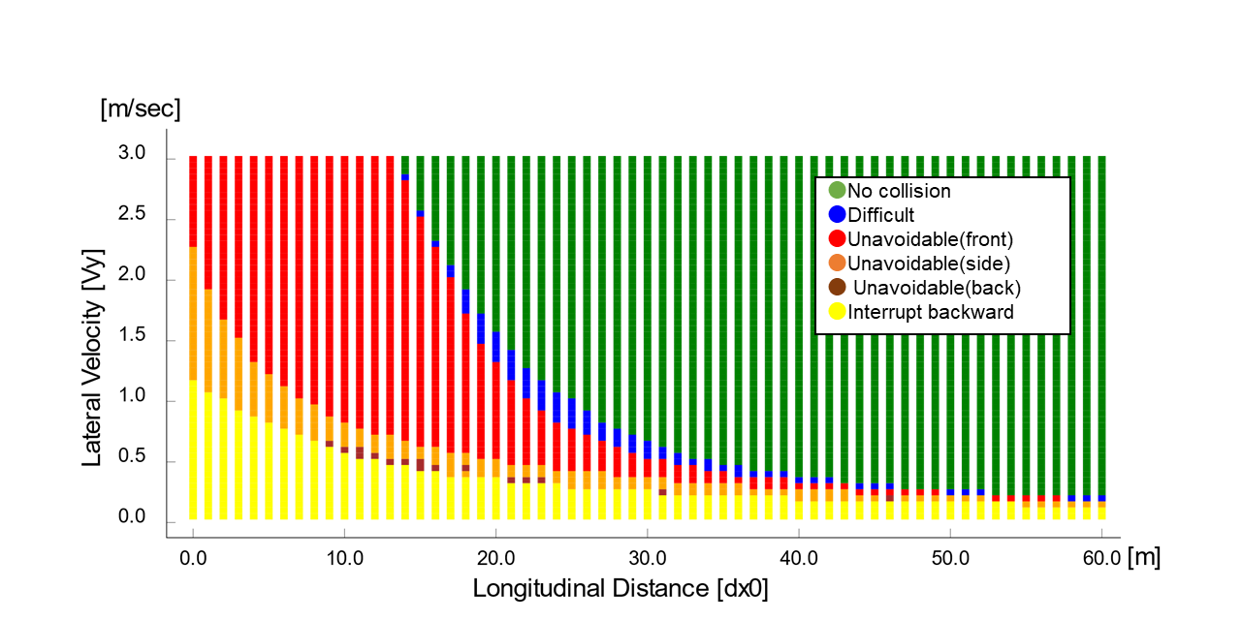
Figure 2
For Ve0 = 60 kph
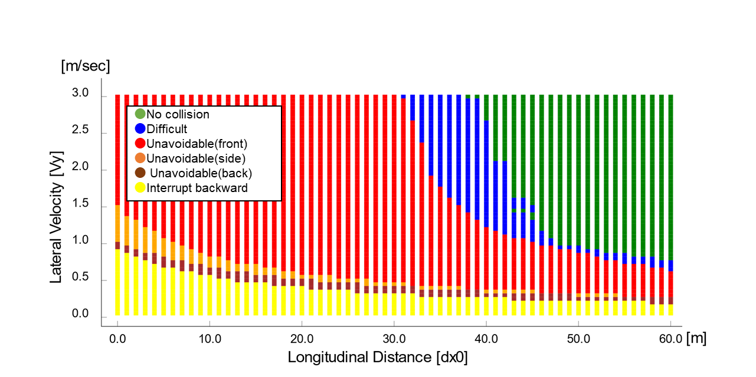
1.2. Cut out
Classification of difficulty of the scenarios based on the initial parameters is done the following way in accordance to the Performance model 1:
- “Avoidable” can be avoided by a braking demand with lower than 5 m/s².
- "Difficult" cannot be avoided by a braking demand with lower than 5 m/s².
- “Unavoidable” cannot be avoided by a braking demand with 7.6 m/s².
Based on these equations the classification may be done for any parameter set; to show some examples, a number of figures are presented below with different ego vehicle speeds.
Figure 3
For Ve0 = 130 kph
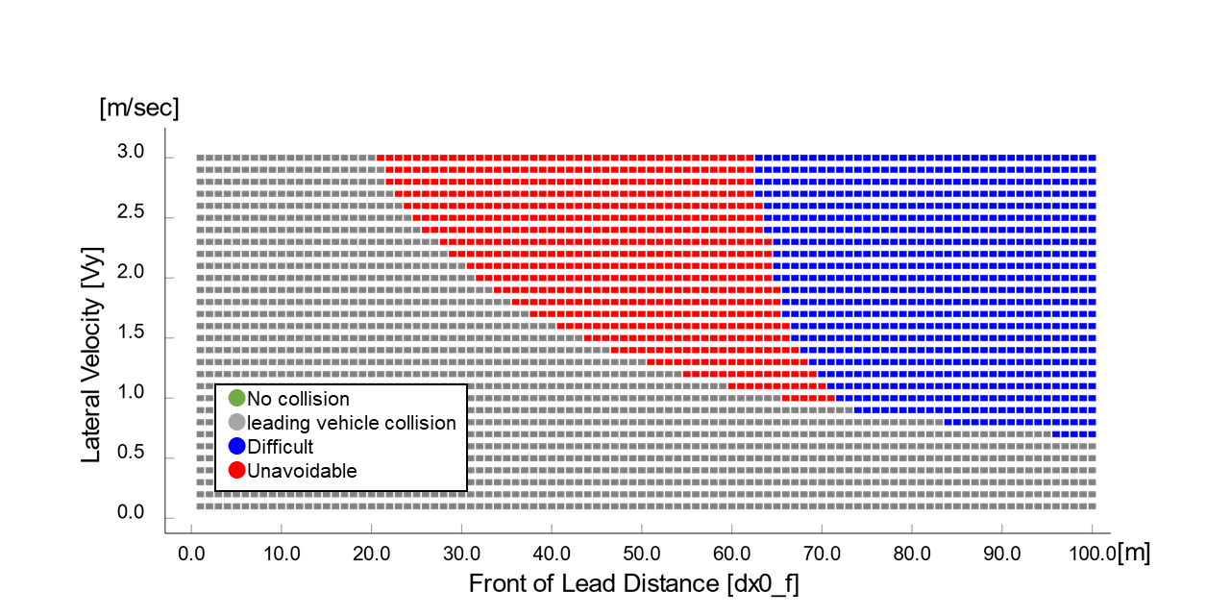
Figure 4
For Ve0 = 120 kph
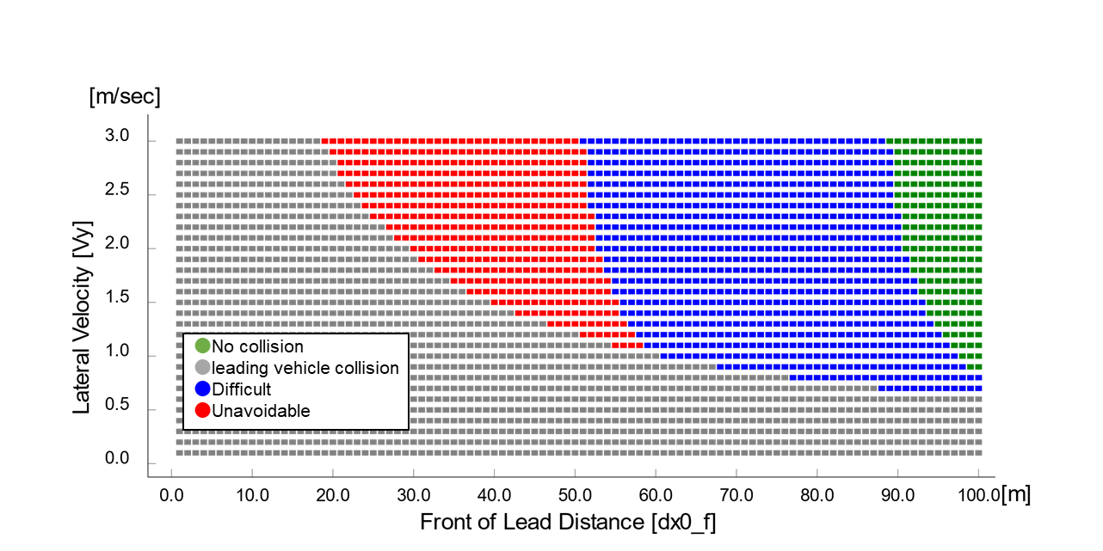
Figure 5
For Ve0 = 110 kph
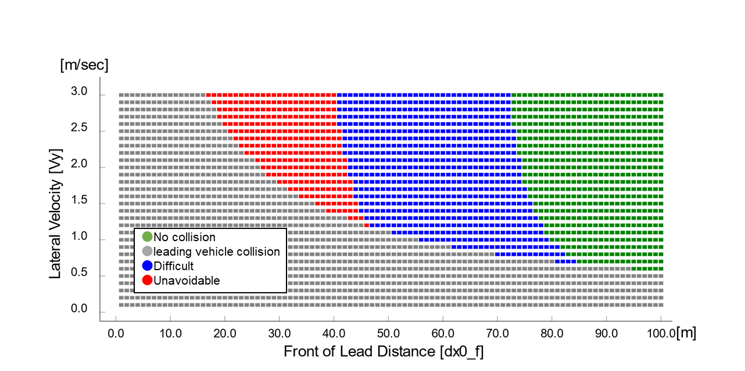
Figure 6
For Ve0 = 100 kph
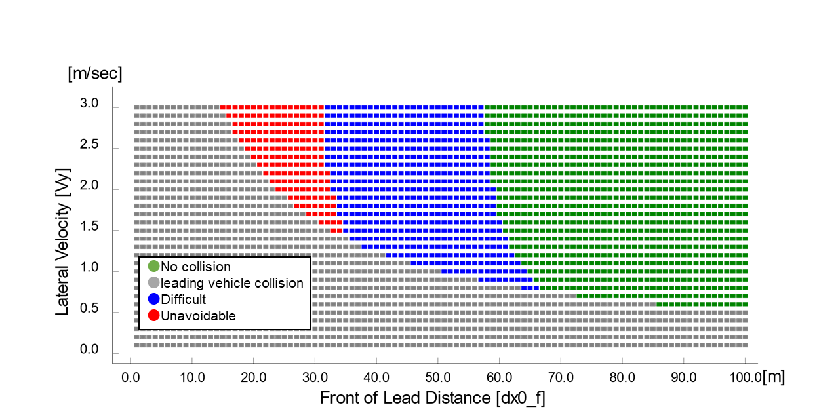
Figure 7
For Ve0 = 90 kph
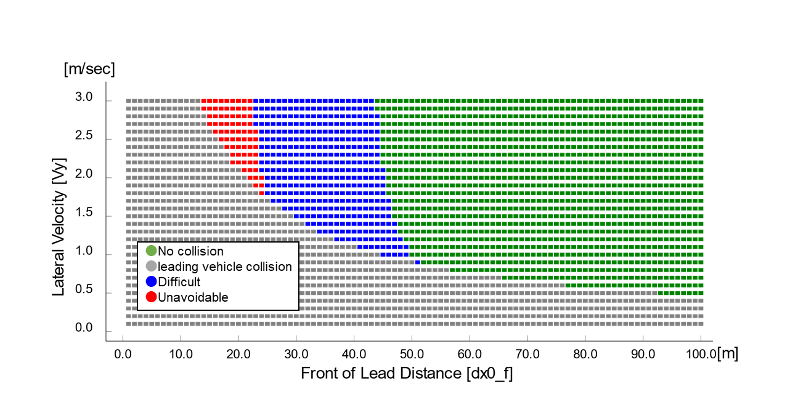
Figure 8
For Ve0 = 80 kph
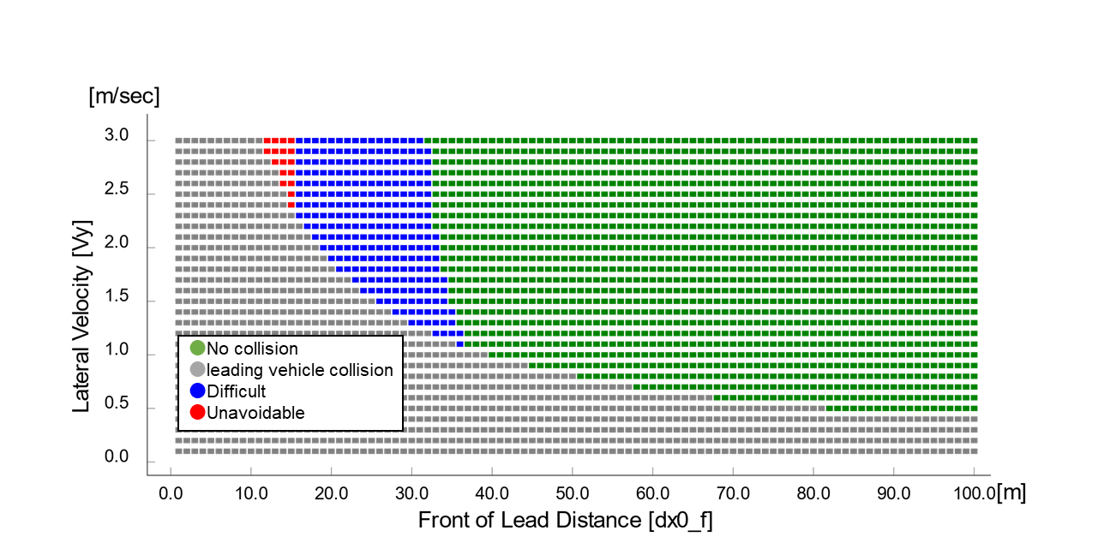
1.3. Deceleration
Classification of difficulty of the scenarios based on the initial parameters is done the following way in accordance to the Performance model 1 :
- “Avoidable” can be avoided by a braking demand with lower than 5 m/s².
- "Difficult" cannot be avoided by a braking demand with lower than 5 m/s².
- “Unavoidable” cannot be avoided by a braking demand with 7.6 m/s².
Based on these equations the classification may be done for any parameter set; to show some examples, a number of figures are presented below with different ego vehicle speeds.
Figure 9
Deceleration

Difficult area and Unavoidable area are not found.
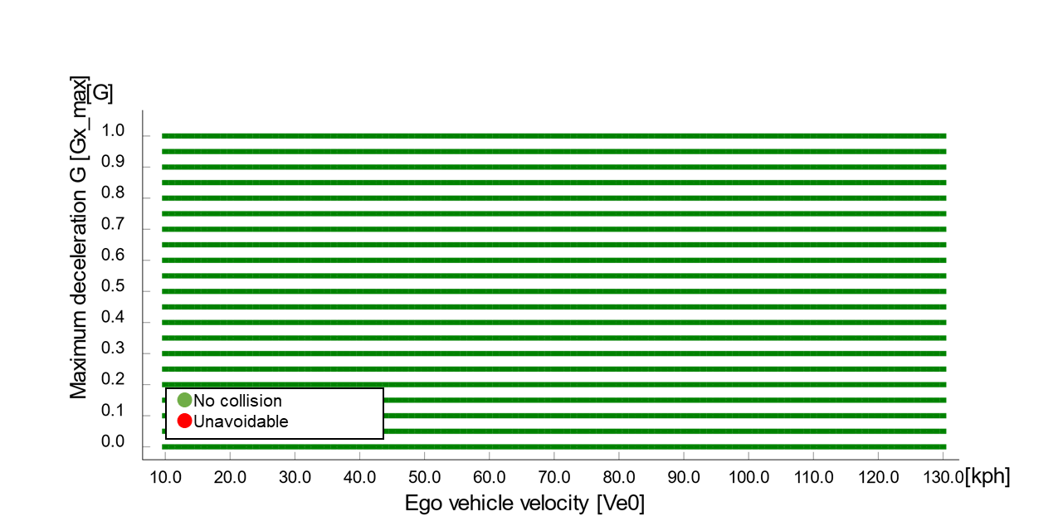

2. In case of performance model 2 of annex 4
Following data sheets are pictorial examples of simulations which determines conditions under which ALKS shall avoid a collision, taking into account the combination of every parameter, at and below the maximum permitted ALKS vehicle speed.
Where collision is deemed to be avoidable, three subsets are defined, to differentiate between the parameter sets based on their difficulty in accordance to the performance model 2 laid down in paragraph 3.4 of Annex 4 Appendix 3:
- “Easy” conditions are highlighted by green colour,
- “Medium” conditions are highlighted by yellow colour,
- “Difficult” conditions are highlighted by red colour, while
- “Unavoidable collision” is highlighted by red colour with black “X”.
2.1. Cut in
Classification of difficulty of the scenarios based on the initial parameters is done the following way in accordance to the performance model laid down in paragraph 3.4 of Annex 4 Appendix 3:
- Easy: PFS <= 0.85;
- Medium: PFS > 0.85 and CFS < 0.9;
- Difficult: CFS => 0.9.
Based on these equations the classification may be done for any parameter set; to show some examples, a number of figures are presented below with different ego vehicle speeds.

Figure 10
For Ve0 = 130 kph
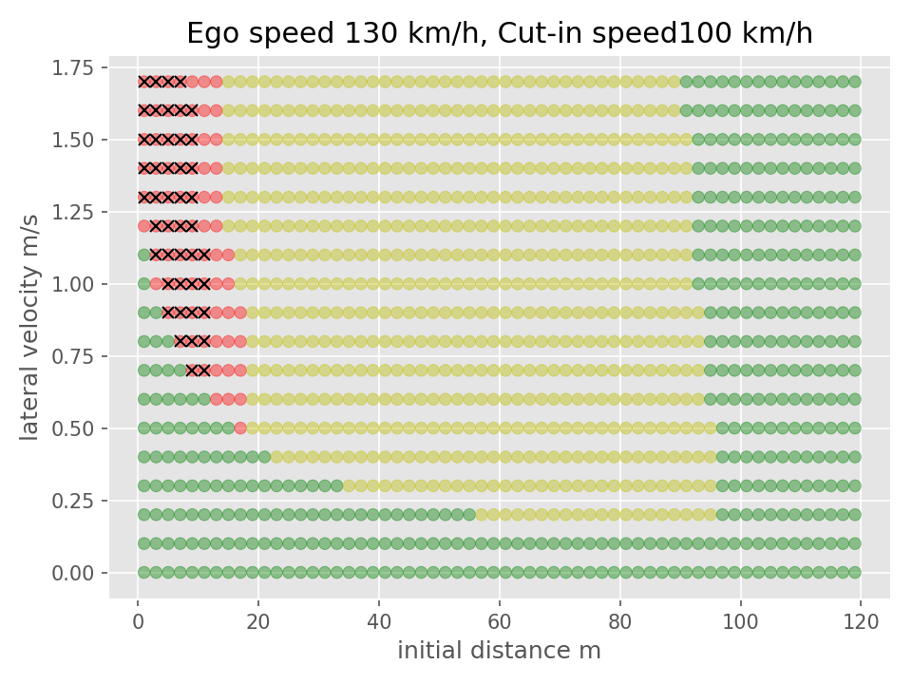

Figure 11
For Ve0 = 110 kph
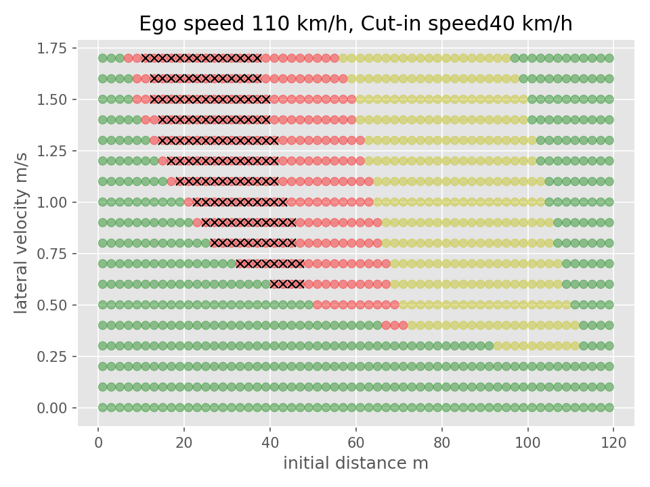

Figure 12
For Ve0 = 90 kph
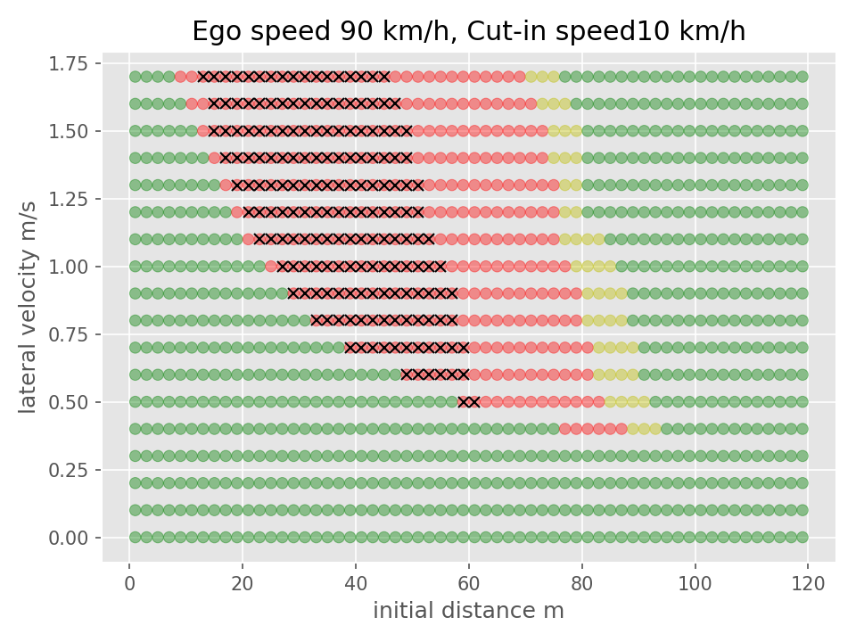

Figure 13
For Ve0 = 60 kph
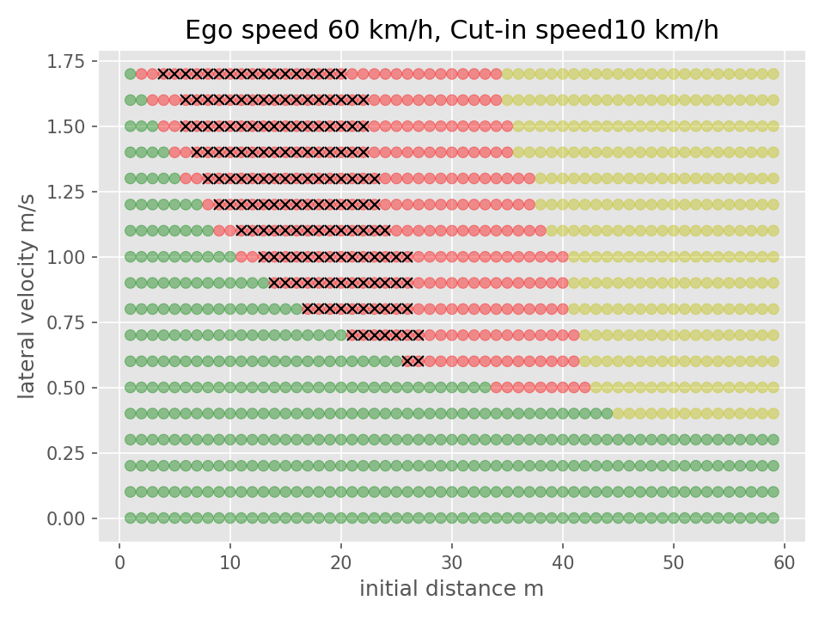

2.2. Cut out
Classification of difficulty of the scenarios based on the initial parameters is done the following way in accordance to the performance model 2 laid down in paragraph 3.4 of Annex 4 Appendix 3:
- Easy: PFS = 0;
- Medium: PFS > 0 and CFS < 0.5;
- Difficult: CFS => 0.5.
Based on these equations the classification may be done for any parameter set; to show some examples, a number of figures are presented below with different ego vehicle speeds.

Figure 14
For Ve0 = 130 kph
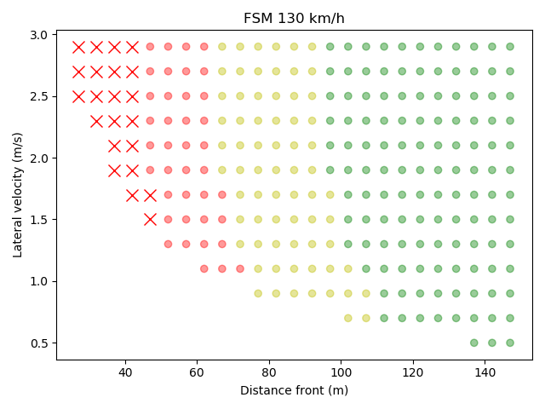

Figure 15
For Ve0 = 120 kph
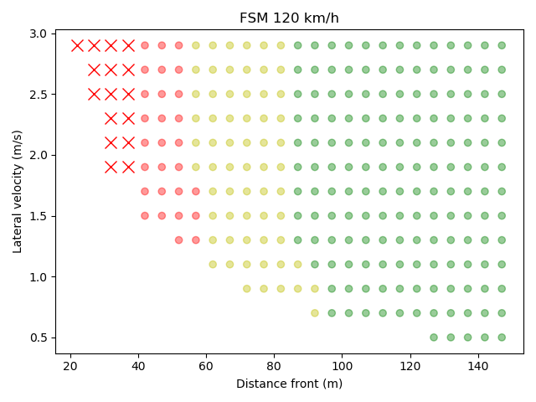

Figure 16
For Ve0 = 110 kph
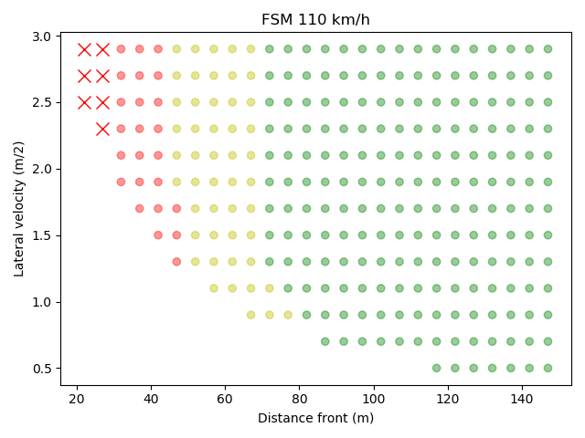

Figure 17
For Ve0 = 100 kph
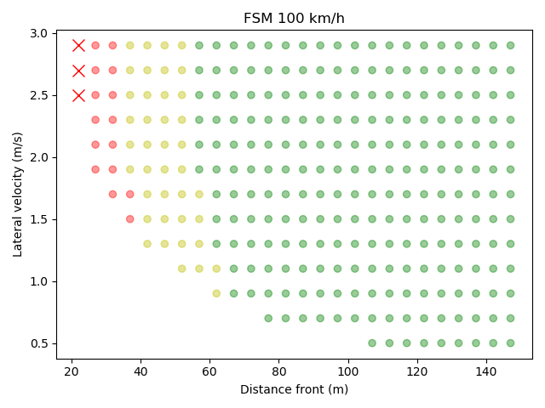

Figure 18
For Ve0 = 90 kph
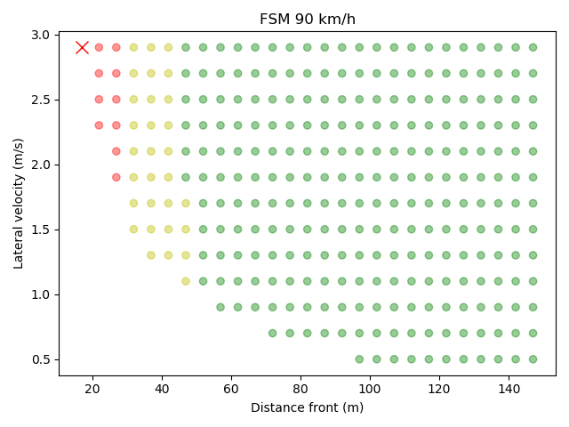

Figure 19
For Ve0 = 80 kph
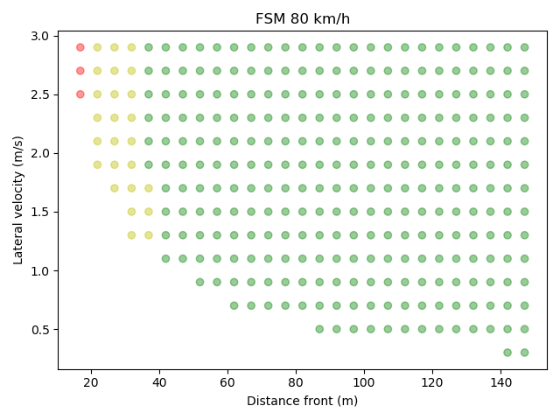

Figure 20
For Ve0 = 70 kph
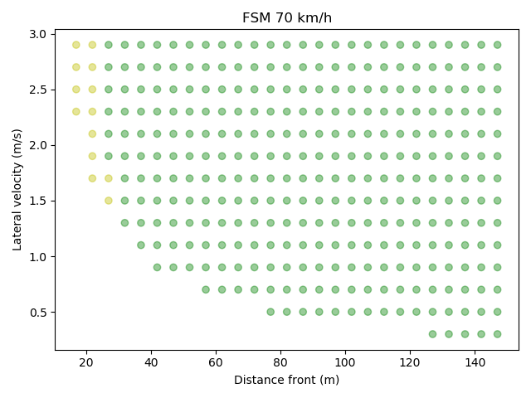

Figure 21
For Ve0 = 60 kph
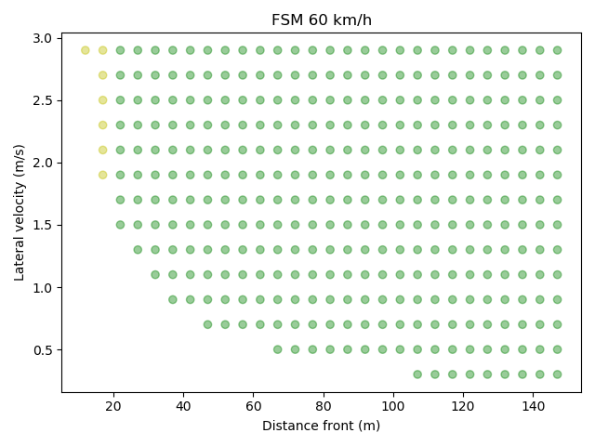

3. Deceleration
Classification of difficulty of the scenarios based on the initial parameters is done the following way in accordance to the performance model laid down in paragraph 3.4 of Annex 4 Appendix 3:
- Easy: PFS = 0;
- Medium: PFS > 0 and CFS < 0.5;
- Difficult: CFS => 0.5.
Based on these equations the classification may be done for any parameter set. The classification matrix for the different cases is presented below in Fig. 22.

Figure 22
Deceleration
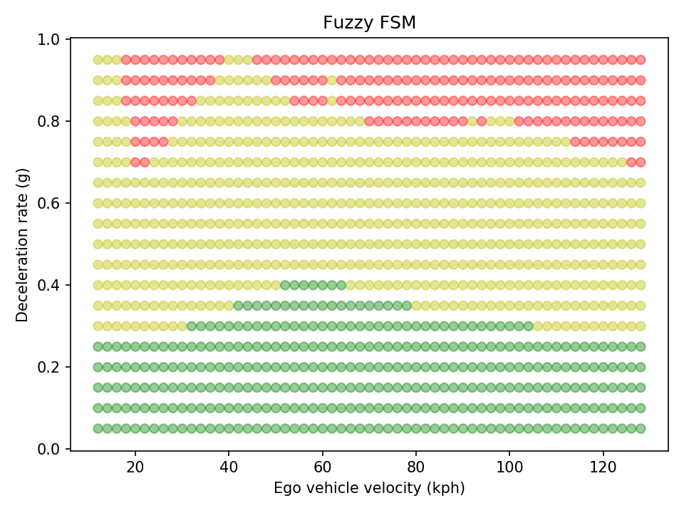

II. Proposal – Annex 4

II. Justification

