Proposal immunity testing up to 6GHz – Antenna positions

The ISO11451-2 Par 8.1 already states:

“Additional vehicle positions, antenna locations or both could be needed to ensure complete illumination of the vehicle owing to the narrow beam widths of high- frequency antennas.”

An emphasis can be added to R10 like:

Definition: *Immunity related areas*: Areas where electronic control units with immunity related functions and the associated wiring harness are situated.

Add following at end of par 5.1.3 of Annex 6:

The number of antenna positions and the position of the antenna with respect to the vehicle shall be documented in the test report.

- If the length of the *Immunity related area* is smaller than the 3 dB beamwidth of the antenna, only one antenna position is necessary at that point. The antenna shall be aligned with the middle of that area (see Figure 4);

- If the length of the *Immunity related area* is greater than the 3 dB beamwidth of the antenna, multiple antenna positions are necessary in order to cover that area (see Figure 5). The number of antenna positions shall allow to meet the following condition:

 (1)

With:

N: Number of antenna positions;

D: Antenna distance;

2β: 3 dB antenna beamwidth angle in the plane parallel to ground (i.e. the H-plane beamwidth angle when the antenna is used in vertical polarization);

L: Total length of the Immunity related area;

Depending of the chosen values of N (number of antenna positions) different set-up shall be used:

if N=1 (only one antenna position is necessary) and the antenna shall be aligned with the middle of the immunity related area (see Figure 1).

if N>1 (more than one antenna position is necessary) and multiple antenna positions are necessary in order to cover the total length of the immunity related area (see Figure 2).

# **Antenna position**

# Figure 1

# **Antenna position for N = 1 (one antenna position to be used) – Vertical polarization shown**

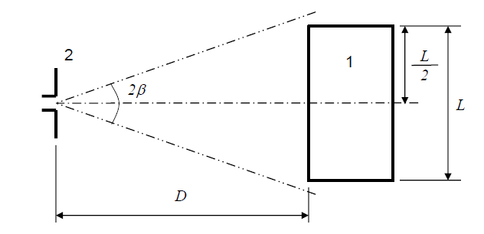

Legend:

1: Immunity related area

2: Antenna

# Figure 2

Antenna positions for N = 2 (multiple antenna positions to be used) –   
Vertical polarization shown



Legend

1 Immunity related area

2 Antenna (two positions)

As requested by Aurelie, we from the NL EMC experts panel have provided examples how to tackle the following two topics:

- Alternative methods for immunity testing above 2GHz for large vehicles

- Clarification how the R10 and the supporting radiated immunity standard addresses beamwidth in regard to the chosen antenna position. We also included an addendum for extra clarification if needed.