UNECE GRSP Informal Working Group   
on Deployable Pedestrian Protection Systems   
(IWG-DPPS)

**16th meeting**, 5-6 of April 2022,

**Draft Minutes**

1. Chair introduced the meeting and welcomed all attendants, with a new participant: Ezanna Wondimneh (NHTSA) , replacing Mary Versailles.
2. The agenda was approved with one modification, and the official one was published.
3. The minutes of the 15th meeting were approved with one modification, and revised.
4. UN/WP.29/GRSP News

Mr. Park (Chair of IWG-DPPS) commented the March 2022 WP29 report on GTR9, (modifications in blue):

“149. On amendment 4 on DPPS, he explained that the IWG Phase 1 would include numerical simulation for head impact time (HIT) against the vehicle in case of deployable systems and a marker in the preamble for generic approach to be developed in the next phase. He also informed that the expert from Japan had proposed a sentence about an equivalent method (physical or alternative numerical simulation) to the numerical simulation to be agreed by Contracting Parties. He clarified that the request by Japan to allow optional alternatives could be temporarily resolved by including the statement in the preamble (Part A) in brackets. He concluded that not yet completely listed remaining issues would be eventually discussed in a Phase 2 of the work on DPPS. The WP29 representative from Korea, on behalf of Chair of DPPS-IWG, complemented the above-mentioned information, clarifying that a draft proposal of Amendment 4 would be discussed at the May 2022 session of GRSP.”

1. **May 2022 GRSP report:**

* no informal additional doc.
* IWG will request 6 months mandate extension (May GRSP: tbd).

1. **Follow-up discussion on open topics and drafting.** 
   * 1. **HIT determination: Alexander Besch (pilot of the Subgroup on Numerical Simulation)**

The IWG understood that:

the DPPS can only be considered if the detection pre-requisites are met (as in Figure 3 Flowchart DPPS Assessment). Otherwise, the hood must be tested as a passive one (undeployed hood). If the active hood detects and opens as planned, then the dynamic test (at least, as CP option) can be run.

This flowchart will be inserted in the introduction of Annexes 2 and 3, and in preamble, to explain the principle of the numerical simulation. The Static test on the already deployed hood is chosen as a worst case for HIT (shortest time).

* **Action: All: please check both Annexes 2, 3 & send comments & questions until 23rd of May to Alexander (and ID in cc).** (the subgroup will meet on 31 May to fine tune the wording).
* The consolidated informal doc will be for internal use only, with Annexes 2 and 3. (note: no preamble modification needed).

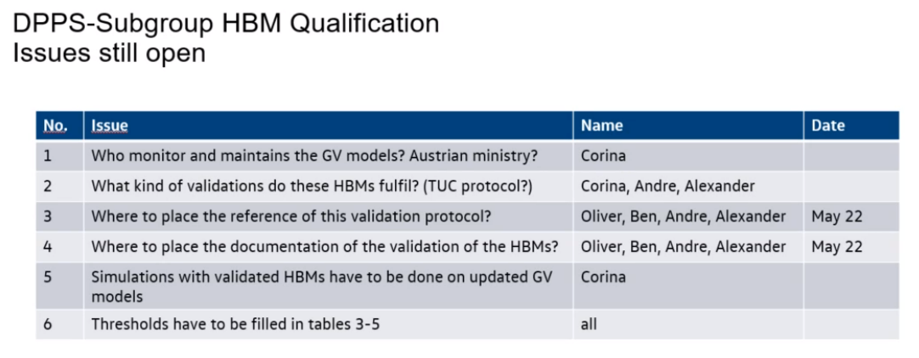

Corina reports that the Austrian Ministry will shortly answer Q1. Chair clarifies that the GVs will be stored on the UN website. When the GVs must be updated, the Austrian Ministry is thinking about volunteering for this role.

A.B. explains that the thresholds tables for HBM qualifications (Annex 2) should be filled during this year (more simulations needed with updated GVs). Corina answers that updated GVs should be released this month, then all developers and COHERENT participants will run simulations and submit data for integration in the tables 3-5, in Autumn 2022. (For vote in Dec 2022 GRSP).

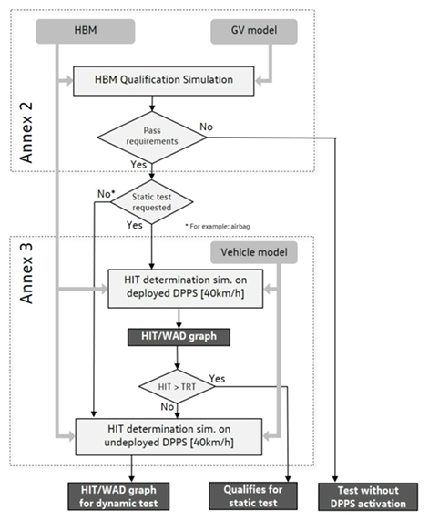

* + 1. **Deployed position: O. Zander (IWG-DPPS-16-07, and -08)**

Oliver Zander explained that a decision is needed for the “C” part of the magenta curve: the test should either be performed dynamically (C1) or optionally, dynamic or static, (C2); depending on whether the oncoming hood velocity has a significant HIC impact or not.

Hans Lammers proposes that, due to limited available data (OICA: not significant, Korea: significant), and maybe depending on where it really happens on the curve (closer to B or A areas => if speed is already going down or not), to only test it dynamically (as the test time point on the curve is unknown).

Ben Buenger presented OEMs comparative data, where no significant HIC increase is shown on oncoming bonnet velocity.

Tanaka-san mentions that Japan needs more time to discuss before reaching a decision on C1 or C2 proposals.

Dirk Gehring clarifies that it is a very small duration (5ms) where this situation/ area might need to be tested dynamically. As at least there are other test points which need to be tested dynamically, the effort to do it dynamically is not very high (we talk about max. 1 or 2 points).

|  |  |
| --- | --- |
| **Oliver’s proposal:**  Machine generated alternative text: Deplo ment velocity  c  To summarize the idea:  ln case the HIT is on the right side of the magenta part of the curve (A), the test may be performed  statically.  ln case the HIT is on the left side of the magenta part of the curve (B), the test is to be performed  dynamically. | **Ben’s new data (hardware results*):***  ***+ : oncoming*** |
| **CP DECISION : C1 or C2 solution - IWG in April22 ?**  Machine generated alternative text: ln case the HIT is on the magenta part of the curve (C), we give two options in square brackets which  are:  [(C-I): The test is to be performed dynamically]  [(C-2): The test may be performed either dynamically or statically.] |  |

* **CP’s decision on C1 or C2:**

**(C-1):** The test is to be performed dynamically: USA (as they plan to do all tests dynamically); G, NL (based on current data- 5th April), Sp; Fr., K.

(C-2): The test may be performed either dynamically or statically: J, as there is no big change according to research.

Ben Bünger presents some new Industry data, in order to further discuss the C-2 option:

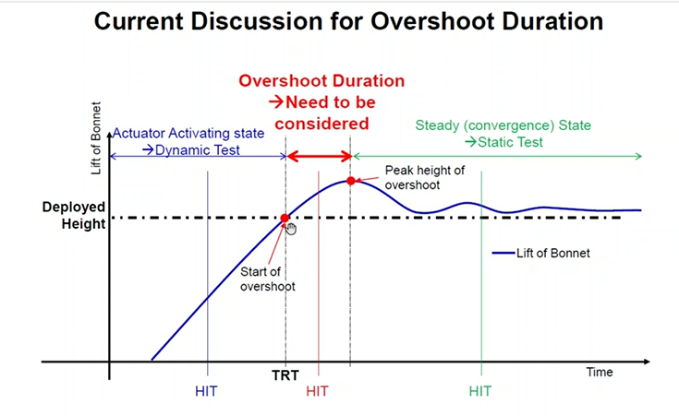 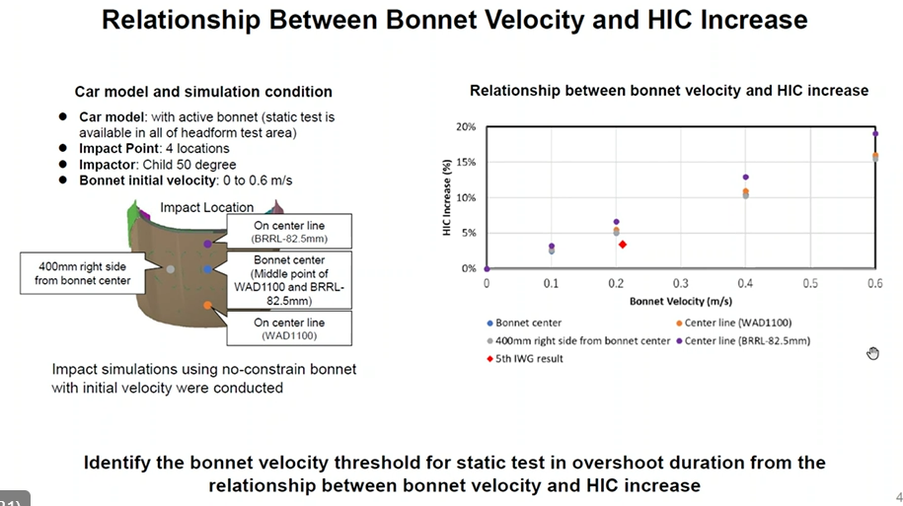

**OZ**: many cars would need to perform dynamic testing anyway, as USA would request dynamic testing anyway, so why not deciding it dynamically. But following conditions may need some amendments : tbd in next meeting.

In case of HIT ≥ MDT (max. deployment time), the test may be performed either statically at a height no more than the RDH or dynamically at the timing of the head impact.

[In case of HIT < MDT, the test shall be performed dynamically at the timing of the head impact.]

[In case of HIT < RDT, the test shall be performed dynamically at the timing of the head impact. In case of RDT ≤ HIT < MDT, the test may be performed either statically at a height no more than the RDH or dynamically at the time of the head impact.]

Tanaka-san refer to §5 of GTR9, where the CP can choose dynamic or static tests in any case. An OEM may only ask the CP if the static test is possible - when all prerequisites are met.

**5. Headform Test Procedure at nominal velocity (9.7m/s)**

**Based on a determination by each Contracting Party or regional economic integration organization, either all requirements shall be demonstrated using the dynamic test in paragraph 5.2., or, when the following conditions are fulfilled, all requirements may be demonstrated using the static test in paragraph 5.1., if this technical alternative is offered by the vehicle manufacturer.**

**Action:** Industry to gather more data to give evidence for C-2, in order to avoid for each car test to “double-check”.

* + 1. **Mark-up in deployed or undeployed position of the DPPS:**

Definitions

When performing measurements as described in this Part, the vehicle should be positioned in its normal ride attitude.

**In case of the vehicle equipped with a deployable pedestrian protection system as defined in paragraph 3.17., that area shall be defined with the system deactivated. [Where a deployable pedestrian protection system is fitted, the manufacturer shall state which area is marked up, either the deployed or un-deployed position.]**

**OZ: markup: see IWG-DPPS-7-02**

* + 1. **Detection area – geometrically described by 75% or corner bumpers -42mm:**

[IWG-DPPS-13-03.rev1_Decision_List.docx (live.com)](https://view.officeapps.live.com/op/view.aspx?src=https%3A%2F%2Fwiki.unece.org%2Fdownload%2Fattachments%2F136446311%2FIWG-DPPS-13-03.rev1_Decision_List.docx%3Fapi%3Dv2&wdOrigin=BROWSELINK)

NHTSA could accept the definition, with a **well described rationale**. (separate section or complementary one, detailing the different conditions discussed and leading to the current conclusion). Also answer Mary’s questions (about length % of sensing tubes or other systems).

* Drafting subgroup: PM, EB, TG, ID (please send me an email if you wish to participate), OZ, DG, BB. (until next IWG). Proposal to be circulated, then meeting together if needed.

1. **Next meetings:**

IWG-DPPS-17 **2-3 June** (Thursday, Friday): **hybrid** meeting in **Paris- meeting room booked**;

(nr simulation meeting: 31 May);

IWG-DPPS-18: **13-14 September** (Tuesday, Wednesday)

IWG-DPPS-19: **21-22 November** (Monday, Tuesday)