Transmitted by the experts of the  Informal Working Group on  Measurement Uncertainties (IWG MU) | Informal document GRBP-76-ZZe  (76th GRBP, 5-7 September 2022,  agenda item 3)

Proposal to Introduce a new Appendix on Measurement Uncertainties to UN Regulation No. 51.03 Annex 3, Supplement 8

The text below has been prepared by the experts of the Informal Working group on Measurement Uncertainties (IWG MU) in order to introduce a new Appendix to Annex 3 to the regulation to implement a table showing the measurement uncertainties when performing type-approval, COP or field testing (e.g. market surveillance).
- Proposal
Annex 3, add new Appendix 4
“Annex 3 – Appendix 4
Estimation of the calculation of the expanded measurement uncertainties for sound measurements of Annex 3 for vehicles of category M and N.

- General

  - The method for M1, N1 and M2 < 3500 kg classes of vehicles (Annex 3) is based on two driving conditions; a constant speed test, L_{crs}, and a wide-open throttle acceleration test, L_{wot}, to determine the final type-approval level, L_{urban}. The uncertainty table in paragraph 2.1 is valid for these categories of vehicles. The uncertainty table in paragraph 2.2 is valid for vehicle classes N2, N3, M2 >3500 kg and M3. Vehicles in these classes are only measured according to the wide-open throttle acceleration test.

  - Based on the probability distribution, the variance and the standard deviation, the combined standard uncertainty is calculated. For each of the quantities, their contribution to the overall uncertainty (in %) has been calculated and makes it easy to understand the influence of the quantity to the total uncertainty. The percentage is based on the total expanded uncertainty for all for test situations. Some of these quantities can be compensated for, like the influence of temperature and test track variations, while others are of random types, like instrumentation accuracy and cannot be compensated.

  - The uncertainty is grouped into 4 different categories; Run-to-run, day-to-day, site-to-site and vehicle-to-vehicle. For each of these categories, the uncertainty budget is calculated separately for type-approval, CoP and field testing. For type-approval, the relevant uncertainty is only related to run-to-run variations, while CoP includes vehicle-to-vehicle variations as well.

  - Reg.51.03 is only regulating type-approval and CoP testing. However, due to the introduction of market surveillance and other types of in-use testing, based on this regulation, it is important to include the uncertainty contribution relating to vehicle-to-vehicle variations.

- Uncertainty estimation

2.1 Estimation of uncertainty per situation for M1, N1 and M2 < 3500 kg

Situation | Input Quantity | Estimated deviations of the meas. result (peak-peak) |  | Impact on Lurb | Probability  Distribution | Variance | Standard uncertainty | Share | Comb. stand. un-  certainty | Uncertainty Budgets |  |  | 95% uncertainty
 |  | Lwot | Lcrs |  |  |  |  |  |  | Type  Appro-val | CoP | Field  Tests
Run to Run | Microclimate wind effect | 1,60 | 1,50 | 1,57 | gaussian | 015 | 0,392 | 5,6% | 0,53 | 0,53 | 0,53 | 0,53 | 1,1
 | Driver #1:  Deviation from centred driving | 0,50 | 0,50 | 0,50 | rectangular | 0,02 | 0,144 | 0,8%
 | Driver #2: Start of acceleration | 0,60 | 0,00 | 0,40 | rectangular | 0,01 | 0,144 | 0,5%
 | Driver #3:  Speed variations of +/- 1km/h | 0,30 | 0,50 | 0,50 | rectangular | 0,02 | 0,144 | 0,8%
 | Driver #4:  Load variations during cruising | 0,00 | 1,00 | 0,34 | gaussian | 0,01 | 0,085 | 0,3%
 | Varying background noise | 0,40 | 0,40 | 0,40 | rectangular | 0,01 | 0,115 | 0,5%
 | Variation on operating temperature of engine (WOT) and tyres (WOT&CRS) => See ISO 362-1 note | 0,80 | 0,80 | 0,80 | rectangular | 0,05 | 0,231 | 2,0%
Day to Day | Barometric pressure  (Weather +/- 30 hPa) | 0,40 | 0,40 | 0,40 | gaussian | 0,01 | 0,100 | 0,4% | 1,06 | 0,53 | 1,06 | 1,06 | 2,1
 | Air temperature effect on tyre noise  (5-10°C) | 0,00 | 0,00 | 0,00 | rectangular | 0,00 | 0,000 | 0,02%
 | Air temperature effect on tyre noise (10-40°C) | 2,20 | 3,60 | 2,67 | rectangular | 0,60 | 0,772 | 21,9%
 | Varying background noise during measurement | 0,00 | 0,00 | 0,00 | rectangular | 0,00 | 0,000 | 0,0%
 | Air intake temperature variation | 1,60 | 0,00 | 1,06 | rectangular | 0,09 | 0,305 | 3,4%
 | Residual humidity on test track surface | 0,90 | 2,10 | 1,31 | rectangular | 0,14 | 0,377 | 5,2%
Site to Site | Altitude (Location of Track)  -100 hPa/1000m (fr.1015 to 915 hPa) | 0,70 | 0,70 | 0,70 | rectangular | 0,04 | 0,202 | 1,5% | 1,63 |  | 0,82 | 1,63 | 3,3
 | Test Track Surface | 3,40 | 5,50 | 4,11 | rectangular | 1,41 | 1,187 | 51,8%
 | Microphone Class 1 IEC 61672 | 1,00 | 1,00 | 1,00 | gaussian | 0,06 | 0,250 | 2,3%
 | Sound calibrator IEC 60942 | 0,50 | 0,50 | 0,50 | gaussian | 0,02 | 0,125 | 0,6%
 | Speed measuring equipment continuous at PP | 0,10 | 0,10 | 0,10 | rectangular | 0,00 | 0,029 | 0,0%
 | Acceleration calculation from vehicle speed measurement | 0,50 | 0,50 | 0,50 | rectangular | 0,02 | 0,144 | 0,8%
Vehicle to Vehicle | Production Variation on Tyres; Aging of Tyres until delivery to customer (1dB after one year) | 0,80 | 1,50 | 1,04 | gaussian | 0,07 | 0,259 | 2,5% | 1,73 |  | 1,73 | 1,73 | 3,5
 | Tyres at minimum tread depth | 0,40 | 0,40 | 0,40 | gaussian | 0,04 | 0,209 | 1,8%
 | Variation on Tyre Size and Brand  (non-OEM) | 0,00 | 0,00 | 0,00 | gaussian | 0,00 | 0,000 | 0,0%
 | Production Variation in Power, incl. proper break-in of a brand-new engine | 0,40 | 0,40 | 0,40 | rectangular | 0,01 | 0,115 | 0,5%
 | Battery state of charge for HEVs  (3 dB(A)) | 0,00 | 0,00 | 0,00 | rectangular | 0,00 | 0,000 | 0,0%
 | Production Variability of Sound Reduction Components | 1,10 | 0,00 | 0,73 | gaussian | 0,03 | 0,182 | 1,2%
 | Impact of variation of vehicle mass | 1,60 | 1,60 | 1,60 | rectangular | 0,21 | 0,462 | 7,8%
 |  |  |  |  |  |  | 1,552 | 100 %
 |  | Overall Combined Uncertainty +/- | Expanded uncertainty (95%)  +/- |  | Type Approval | CoP | Field Test
Coverage Factor
k=2 (95%) |  | 1,73 | 3,46 |  | 1,5 | 4,5 | 5,3

2.2 Estimation of uncertainty per situation for N2, N3, M2 >3500 kg and M3

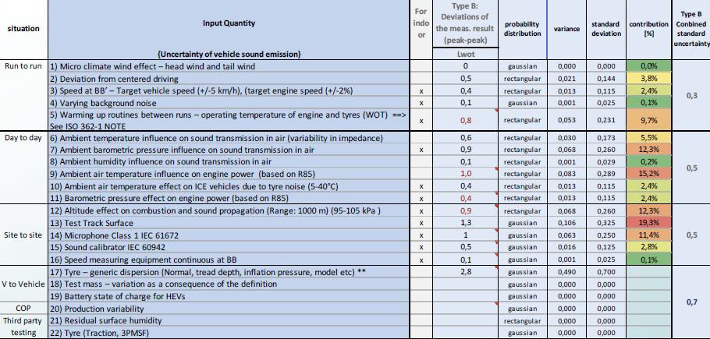

- Update of tables
  - The tables in 2.1 and 2.2 are based on the Supplement 7 of Regulation 51.03. If the regulation is amended, any implication for the measurement uncertainties shall be evaluated and if necessary, the tables in Appendix 4 shall be updated.

Justification:
The measurement uncertainties developed in this Appendix are based on the work of the GRBP Informal Working Group on Measurement Uncertainties. This working group has developed a Document for Reference, which describes a general approach to estimate measurement uncertainties (ECE-TRANS-WP.29-GRBP-2022-09).

The impact of the quantities on the expanded uncertainty has been evaluated separately for run-to-run, day-to-day, vehicle-to-vehicle and site-to-site variations. Some of the different impacts are based on calculations from tolerances in Annex 3, while others are based on experiences.

