Minutes of the Meeting

10th meeting of the
WP.15 IWG-EV for the
Introduction of Electrified Vehicles in the ADR

Venue: Held via MS Team call
Chairman: Kees de Putter (RDW)
Secretariat: Karine Pelletier (OICA/Volvo AB)
Date: Monday, 24th of October 2022 from 14:00 to 16:30

0. Welcome

The chair opened the meeting and welcomed the participants.

      - Competition guidelines and law compliance policy

Participants were reminded of the competition guidelines and law compliance policy.

This policy consists of not discussing the market conduct of individual companies and of not exchanging any business sensitive information. See, for the principle the EU competition law details here.

      - Attendance list

As a full participants list could not be extracted from teams a list has been drafted based on notes. Participants should check the list for completeness, see file IWG-EV 10th session _ Meeting Participant Attendance .docx.

      - Approval of the agenda

Agenda was presented to the group. The optional presentation mentioned in 7.2 did not materialize and is taken off the agenda. Agenda was approved with this modification.

      - Approval of the minutes of last meeting

With some editorial corrections in 7.3 (imitate+initiate / treat+thread) the MoM of the 9th session were approved IWG-EV 9th session _ Minutes of Meeting .docx.

      - IWG-EV way of working

Nothing to review.

      - About the introduction of electrified vehicles in the ADR

6.1. Reporting from the sub-groups

6.1.1. Users sub-group

Because Dario could not be present at the meeting the following report of the users' subgroup was presented by Kees.

The users met together with the vehicle manufacturers in Brussels on September 28 for an entire day workshop
During the workshop the risk analysis approach, developed by the users was presented to the manufacturers.
The engagement was very fruitful: the following result have been reached:
- Understanding of basis for development/reading of the bow ties, as well as their limit and scope,
- Detailed discussion on the risk related to release of high voltage electricity, the barriers relative to vehicle design, as well as ATEX classification of the loading/unloading areas,
- More work is still to be done to finalize the bow ties. Therefore, a second F2F workshop has been planned for October 31. It is expected that during this workshop the electricity risk and the battery runaway risk will be finalized.

6.1.2. Truck manufacturers sub-group

As Karine was not available in the meeting the following update was presented by Kees on her behalf.

As presented at the 9th IWG-EV meeting, multiple subjects are in discussion in the manufacturers sub-group, see following red block specifically:

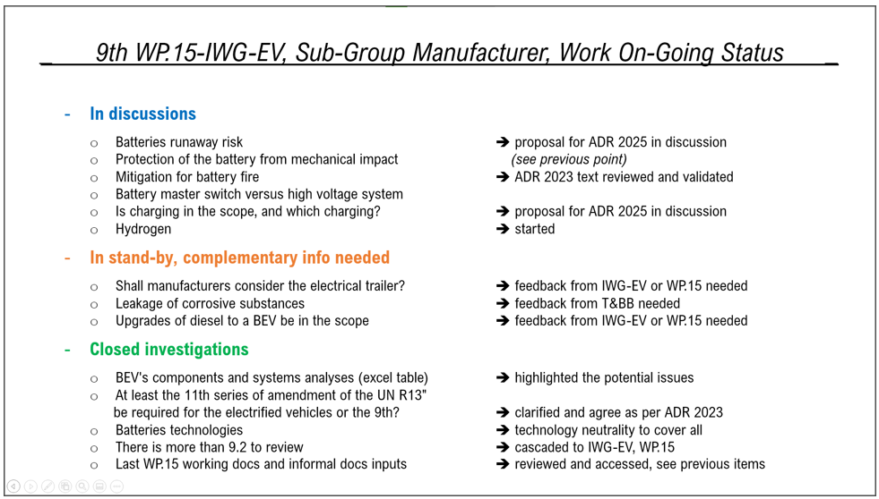

The group is drafting proposals of modification of the chapter 9.2's subsections of the ADR agreement and is working to fine tune the proposals.

Below (6.1.2.1 to 6.1.2.4) are some subjects the sub-group is working on. However, these are examples as discussion and risk assessments are still in progress. It should also be noted that no consensus exists at this moment in the sub-group on the draft text presented below and guidance document.

6.1.2.1 For battery runaway risks and, for example but not limited to, impact, shock, internal/external fires

A potential new sub-chapter or new added paragraph in the ADR agreement chapter 9.2.4.6. for FL, EX/II, EX/III and MEMU (transport types to be decided) could be added.

"The electric power drive shall be so constructed that, under normal conditions of use and under reasonably foreseeable misuse and incidents, excess heat shall not constitute a hazard to the load by raising the temperature on the inner surface of the load compartment above 80 °C. "

The sub-group is also working on a guideline to secure the right interpretation of this demand.

6.1.2.2 On the battery master switch

The group is analyzing the relevance or not of a battery master switch, specifically if it is safe to switch on and off (or not) high voltage circuits/components. Depending on the conclusion, the group may support or modify the following proposal.

"To make the vehicle safe in an area where an explosive atmosphere may occur [while handling the load], a device shall be placed in the driver's cab, within easy reach of the driver in his seat, that will de-energize the low and high voltage systems outside the protective housing of the REESS and low voltage battery box."

6.1.2.3 About charging

The sub-group may recommend restricting any kind of pantographs charging at this stage.

On charging scenarios, the sub-group is reviewing the following proposal:

When vehicle is unloaded, similar to any other vehicles: OK to charge.
When vehicle is loaded: OK to charge.
When vehicle's container is discharged or being unloading: To restrict the charging.
When vehicle's container is being filled or loading: To restrict the charging.
Overnight, no monitoring: OK for AT to charge.

6.1.2.4 About hydrogen

The sub-group is reviewing a list of components/circuits and assessing the potential risk to the load.

More to come.

6.1.3. Hydrogen vehicles sub-group

Nothing new to review.

6.1.4. Trailers and bodybuilders sub-group

Michaël to present the status of this sub-group.

Sascha Pfeifer (CLCCR) gave a presentation on trailer electrification and the work undertaken at WP.29 level to make this possible. Find the presentation here Presentation_CLCCR_Trailer_axles_2022_Oct KdP.pdf. A significant number of UN Vehicle regulations require modification to make this possible.

6.1.5. Explosives sub-group

The explosives group has not yet started. This delayed to await the measures against or against the effects battery runaway.

6.2. ADR’s agreement modifications

6.2.1. News from WP.29 and its GRs, as well as other UN Working Groups

The OICA is presenting to the coming GRSG the following working document to update of the UN R105 accordingly to the ADR 2023, see ECE/TRANS/WP.29/GRSG/2022/29 - (OICA) Proposal for Supplement 2 to the 06 series of amendments to Regulation No. 105 (Vehicles for the carriage of dangerous goods).

The GRVA continues its discussions on autonomous vehicles, it will more information current 2023 on time plan updates of regulation.
It may be relevant to consider how to do dangerous good transport with an autonomous vehicle.

The CLCCR continues the discussions on e-trailers and vehicle categories/definitions at the GRSG for modification of the RE.3, at the GRVA for the UN R13 and the GRSP for the UN R100.
It may be relevant to consider how to approach e-trailer for transport of dangerous goods, and new high voltage components installed on the trailers.

The OICA is looking to complete the UN R122 to cover adequately the H2 combustion parking heater.
There are also discussion to introduce "Radiation Warmer". These electrical heaters would be installed in the cab, picture for example only:

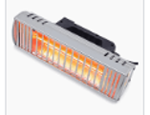

And new flameless hydrogen heater configurations for the driver cab may be added to the UN R122. Please find more info on the function principle here https://www.researchgate.net/publication/348002640_Embracing_Hydrogen_Flameless_Oxyfuel_for_CO2-free_Heating and https://tenova.com/newsroom/press-releases/tenovas-flameless-smartburner-enabling-hydrogen-based-decarbonization.

      - Others

7.1. 112th session of the WP.15

The 112th session of WP.15 will be from the 8th to the 11th of November.
The limit for the working documents was the 16th of August.

The following working document (ECE/TRANS/WP.15/2022/8) has been published to add the applicable cable's ISO standard's year of publication.

During the 9th session of the IWG-EV, it was decided to forward a report of the IWG to reflect progress to WP.15, and that this report could be done by a late Informal Document before the meeting reactions were received on the draft report. Based on these reactions and those received, the draft was simplified and shortened. A new draft was circulated and resulted in Informal document No 6 that would be presented at the 112th WP.15 session. The final document has been published here Report of the informal working group on Electrified Vehicles (Netherlands).

      - Conclusion

  - Action’s list (What/When/Who)

Presented in the following table are the open actions only, for the closed actions please see previous MoMs.

Who | When | What | Comment
Karine | Moved to beginning 2022 (was end 2021) | - GTR 13/20 & R100/R134 overview of the text,  - what about thermal runaway and crash, and  - next steps, what are the modifications coming | Karine/Kees are looking for a speaker

  - Date and place of next meeting

Karine will to send a poll:
- for the 11th IWG-EV meeting end of January 2023 and
- for the 12th IWG-EV meeting beginning April 2023.

