Reception Party for FRAV/VMAD Informal Working Group
- Date: 16th December 2022 (6:00 pm – 7:30 pm)

- Venues: Square Kojimachi (スクワール麹町)
Room: 『Kinka』(錦華) 3rd floor (3階)
http://www.square.or.jp/

III. Access to the Square Kojimachi
6-6 Koujimachi, Chiyodaku, Tokyo, Japan

- 2 min by walk from COMORE Yotsuya (Meeting room)
- 30 sec by walk from Kojimachi exit (麹町口) at Yotsuya-station (JR)
- 3 min by walk from Yotsuya exit (四ツ谷口) at Yotsuya-station (Tokyo metro Marunouchi-line)
- 1 min by walk from No. 3 exit at Yotsuya-station (Tokyo metro Nanboku-line)

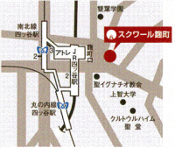
COMORE Yotsuya
Square Kojimachi

