Transmitted by expert from Republic of Korea | Draft consolidated DPPS-21-xx- preamble & technical requirements

Proposal for Amendment 3
Submitted by the Chair (Republic of Korea) of the Informal Working Group on the Deployable Pedestrian Protection Systems of UN Global Technical Regulation No. 9.
The text reproduced below was prepared by the experts of the Informal Working Group (IWG) of the Deployable Pedestrian Protection Systems (IWG-DPPS) on UN Global Technical Regulation No. 9. The modifications are marked in bold for new or strikethrough for deleted characters. The proposal below consequently aims at revising GTR9-02 and submitting a consolidated text for the draft 03 series of amendments to GTR9, including part I (the preamble) and part II (technical requirements).

I. Proposal
In Section I: Statement of Technical Rationale and Justification:

- Renumber Paragraph 0 as Paragraph 0 bis, and add a new Paragraph 0 to read as follows:

0. FOREWORD: UN Global Technical Regulation (GTR) No. 9, Pedestrian Safety, was established in the Global Registry on 12 November 2008. Development of the original GTR is discussed as “Phase 1” beginning with paragraph 0 bis. The GTR was amended by Corrigendum 1 on 12 November 2009, and by Corrigendum 2 and Amendment 1, affecting only the scope of the GTR, on 10 November 2010. Amendment 2 was established on 14 November 2018 and replaced the European Enhanced Vehicle-safety Committee (EEVC) lower legform impactor used for the bumper test with the flexible pedestrian legform impactor (FlexPLI). Development of Amendment 2 is discussed as “Phase 2” beginning with paragraph 133. Amendment 3 was established on [insert date when established] and added new requirements for vehicles equipped with a Deployable Pedestrian Protection System (DPPS). Amendment 3 is discussed as “Phase 3” beginning with paragraph 228. The informal working group that developed Amendment 3/Phase 3 notes that paragraph 122 in the discussion of Phase 1 has been superseded for vehicles equipped with a DPPS.

- After paragraph 227, add a new subsection C to read as follows:

- Phase 3

228. Sections 1. to [x]. reflect the development of Phase 3 of UN GTR No. 9 and are related to the development of test provisions for vehicles equipped with deployable pedestrian protection systems (DPPS), including prerequisites, without changing the headform impactors and their corresponding parameters for tests to the bonnet top.

1. INTRODUCTION AND GENERAL BACKGROUND

229. During the fifty-sixth session of GRSP (9-12 December 2014) the expert from Korea proposed the development of test provisions for active devices to further improve vehicle safety performance. It was noted that guidelines already existed for testing active bonnets (INF GR/PS/141 Rev. 1), however these were considered to be insufficient, and consent was sought from WP.29 and AC.3 to extend the mandate of the IWG on the development of phase 2 to GTR No. 9.

230. The proposal from Korea to develop an amendment to GTR9 with regards to test provisions for deployable systems of the outer surface to ensure an adequate protection of pedestrians was endorsed by AC.3 at its forty-eighth session (17 November 2016) and the mandate of the IWG on the development of Phase 2 was extended until December 2017.

231. The development of the test provisions for deployable systems was initiated by a Task Force under the umbrella of the IWG on phase 2 (TF-DPPS). After four meetings of TF-DPPS, the mandate of the IWG expired. Subsequently, AC.3 endorsed at its fifty-second session (14 March 2018) the transformation of TF-DPPS into a new Informal Working Group (IWG-DPPS).

232. The TF-DPPS had held the following meetings:
(a) 27-28 February 2017; Paris, France
(b) 28-29 March 2017; Paris France
(c) 7 September 2017; virtual
(d) 21-23 November 2017; Berlin, Germany

233. The IWG-DPPS had held the following meetings:
(a) 18-20 April 2018; Frankfurt/Main, Germany
(b) 5-7 September 2018; Brussels, Belgium
(c) 10 December 2018; Geneva, Switzerland
(d) 12-14 March 2019; Paris, France
(e) 3-4 September 2019; London, United Kingdom
(f) 28 November 2019; virtual
(g) 4-5 March 2020; virtual
(h) 15-17 September 2020; virtual
(i) 18 November 2020; virtual
(j) 20-21 January 2021; virtual
(k) 9-10 March 2021; virtual
(l) 27-28 April 2021; virtual
(m) 29-30 June 2021; virtual
(n) 14-15 September 2021; virtual
(o) 16-17 November 2021; virtual
(p) 9-10 February 2022; virtual
(q) 5-6 April 2022; virtual
(r) 2-3 June 2022; hybrid
(s) 18-19-20 October; 2022; hybrid, OICA-Paris
(t) 8-9 Nov2022; virtual
(u) 15-16 Nov2022; virtual

234. The meetings were attended by representatives of: EC, France, Germany, Italy, Japan, Korea, the Netherlands, Spain, UK, USA, CLEPA and OICA.

235. The meetings were chaired by Mr. Park (Korea), while the secretariat was provided by Mr. Kinsky (OICA) from February 2017 (TF-DPPS1) until September 2018 (IWG-DPPS 2nd session), and by Ms. Dausse (OICA) for the IWG meetings since November 2018.

236. TRANS/WP.29/GRSP/2022/02 was proposed at the seventy-first session of GRSP and was a revised draft GTR not including the preamble. An informal document will be proposed to update the working document. [TRANS/ WP.29/GRSP/2023/xx is proposed at the seventy-third session of GRSP as a complete draft GTR9-03 document, including part 1 and part 2 and supersedes the other drafts. ]

2. PRINCIPLE of DPPS

237. DPPS should be activated as intended for pedestrian protection when the pedestrian is hit by a vehicle. To achieve this goal, the IWG agreed that requirements were needed to ensure that:
• The pedestrian’s collision is detected, and
• The existing headform requirements in the GTR are met for a 35km/h head impact velocity as well as for vehicle speeds below the deployment threshold of the DPPS.

Only contact sensors are taken into consideration for detection on current DPPS.

238. This Regulation is to improve protection from injury caused by the vehicle front during a collision with a pedestrian. To assure that a DPPS operates properly and offers at least the same level of pedestrian protection as a conventional passive system, the IWG agreed that the system provisions listed in 237 are needed at a minimum. Additionally, the IWG discussed the need for two other system requirements:
- Higher speeds - Assurance that a DPPS system will deploy safely at pedestrian impact speeds above 40 km/h

- Body loading - Assurance that pedestrian body loading of a DPPS will not compromise its effectiveness prior to head impact

These needs may exist for DPPS systems in particular, as opposed to conventional passive systems. Members of the IWG expressed their concerns that at higher speeds, actuator limitations may prevent the timely deployment of a DPPS, while the negative effects of body loading may be exacerbated by a deployed system without sufficient support. Some members of the IWG found that a reasonable bonnet clearance at the location and prior to the head impact is needed to prevent a hard head contact due to a collapsing bonnet.

239. At this time, the IWG agreed that a regulatory need is not known with enough certainty to warrant the development of test procedures and requirements related to higher impact speeds and body loading. In other words, current DPPS systems that meet the requirements listed in paragraph 237 may also account for higher impact speeds and body loading. However, further research or the development of future DPPS may result in insights for which the effect of pedestrian body loading and protection at higher speeds may require special attention. Additionally, future accidentology may reveal a prominent safety need exists in current DPPS systems due to body loading and impacts at higher speeds. In either case, the GTR will be reviewed and adapted if and where necessary.

240. At the request of the United States, the IWG decided that, based on a determination by each Contracting Party or regional economic integration organization, either all requirements shall be demonstrated using the dynamic test in (insert cite), or, when the following conditions are fulfilled, all requirements may be demonstrated using the static test in (insert cite): [• Detection Test Area, Detection Verification, Determination of Head Impact Time, Protection at Speed below Lower Threshold].

3. DETECTION TEST AREA, LATERAL OFFSET LEG VERSUS HEAD

241. As one of the fundamental prerequisites to account for the potential safety benefits of DPPS, the pedestrian needs to be detected during an accident prior to head impact on the vehicle. The IWG discussed the required width of the area on the vehicle front where a pedestrian needs to be detected in order to purposefully initiate the system.

242. An earlier Task Force study was recalled by the expert from Germany in which it was shown that pedestrian impacts take place over the entire vehicle width (TF-BTA-6-07). In a later IWG meeting, LAB presented an analysis of fatal French accidents contained within the Etudes Détaillées d’Accidents (EDA) database (IWG-DPPS-18-08) The LAB analysis revealed that for all cases in which a pedestrian was struck outside the longitudinal frame rails of the vehicle, accounting for approx. 15-20% of the vehicle width, there were no subsequent head impacts to the bonnet (though about 1/3 of the cases did result in pelvis impacts to the bonnet). Thus, in principle and ideally, a detection of pedestrians in nowadays DPPS should be required accordingly.

243. Also, it was agreed that in many cases the pedestrian may tend to spin off at the outer widths of typically angled or V-shaped vehicle front end surfaces, without a head-to-bonnet impact. This effect is even more present when using a leg impactor as pedestrian surrogate without attaching any mass of a pedestrian hip, torso, arms, neck, and head, consequently limiting the load on the sensing system and therefore not being representative for a pedestrian.

244. In the light of these observations, the IWG investigated further definitions of a detection area.

245. The expert from Japan proposed the detection area, which would differ from the leg test area, being the area in the lateral direction of the vehicle in which activation of the DPPS is ensured in a vehicle-to-pedestrian impact (Task Force Document DPPS-3-03). Reason given was that only in this area a head impact test would be allowed with activated DPPS, while outside this area the DPPS was supposed to remain deactivated.

246. The expert from Germany suggested to use the bumper test area (BTA) as already defined for the lower extremity injury risk assessment based on the tests with the lower legform impactor. Since the FlexPLI was also chosen as verification impactor (compare Chapter 4) and the BTA is well elaborated and established, the expert from Germany reasoned that existing definitions could be applied.

247. The expert from ACEA also referred to current regulatory definitions and proposed to apply the lower leg test area defined in amendment 2 to GTR no 9 as required confirmation of sensing capabilities for DPPS homologation or self-certification (IWG-DPPS-1-08).

248. The expert from OICA suggested to define the outer boundaries of the detection area by the width between the corner reference points (CRPs, the intersections of the side reference lines and the bonnet leading edge reference line), projected to the upper bumper reference line (IWG-DPPS-4-05). It was noted by IWG participants that when a vehicle has multiple or continuous intersections between the BLERL and the SRL, the most outboard point is used as the CRP. It was also noted that the distance between right and left CRPs can be narrowed easily by a minor, cosmetic redesign of the vehicle front end. Such a redesign would have no effect on the legform test zone but could lead to large differences in CRP locations and thus greatly affect the DPPS detection test area. Therefore, the IWG abstained from further discussions on the use of the CRP in defining the detection test area.

249. The expert from BGS proposed a required percentage of the vehicle width (around the longitudinal vertical centreplane as its centre) as detection test area, with a subtraction of no more than 12.5 percent of the vehicle width but a maximum of 250mm at each side of the vehicle. The BGS proposal also stated that the detection test area should be no less than the BTA (IWG-DPPS-5-09). It was explained that with a percentage all vehicles would be equally treated, regardless their effective width; however, big cars should not be allowed to further reduce the detection area, beyond 250mm on each side.

250. The expert from Germany subsequently provided an update to the BGS proposal wherein the vehicle width was defined as the width at the cross-section of the front axle, without rear view mirrors or rear-view mirror substitute systems, so that the proposed detection test area was not linked to the width of the deployed area of the DPPS. (IWG-DPPS-7-10). Examples of four current vehicle models were displayed to show how the detection test area based on the 12.5 percent stipulation was greater than the BTA.

251. Japan investigated the outer most boundary of the detection area proposed by Germany and confirmed that it covers the headform test area for vehicles equipped with DPPS currently available on the market in Japan. Thus, Japan accepted the detection area proposed by Germany. However, it was suggested that in cases where the sensing width is narrower than the width of the detection area, the DPPS would be allowed to only be activated within the sensing width (IWG-DPPS-9-09). Rationale was the lateral offset between the lower extremity impact and the pedestrian head impact after wrap around would be considered as rather small.

252. The group examined indications regarding the possible lateral offset between lower extremities and head in pedestrian accidents with passenger cars.
253. The expert from Japan presented PMHS tests, HBM finite element simulations and dummy tests where the lateral movement of the pedestrian’s head until the head impact on the vehicle front was small. It was concluded that the impact locations of the head and the leg would not differ a lot (IWG-DPPS-10-04).

254. The expert from Germany examined some cases from the German in-depth accident database (GIDAS) for real world trajectories of pedestrians. The sample showed in several cases a significant lateral offset between the first leg impact and the subsequent pedestrian head impact. They concluded that laboratory test conditions with stationary test specimen do not always reflect real world impact conditions in an appropriate way (IWG-DPPS-10-09).

255. The expert from Japan proposed that the pedestrian accidents scenario assumed under current GTR9 is the case when the vehicle impacts the stationary pedestrian from the side, and the pedestrian accidents scenario assumed in the test for DPPS should be the same as current GTR9. Japan found that, for consistency reasons, a consideration of the pedestrian kinematics with significant lateral offset between the pedestrian’s leg impact and the subsequent head impact would require such a consideration with modified impact angles also during component tests. However, Japan also showed that this would not be in the scope of the IWG and beyond the minimum requirements as specified in the GTR (IWG-DPPS-11-03).

256. The expert from Germany clarified the objective of the IWG, which was not limited to clarification of the current practice, but also to develop new and more detailed requirements, where needed, to ensure a correct activation and design for vulnerable road user protection. Since the detection of pedestrians is one of the indispensable prerequisites and DPPS needs to be correctly activated, real world conditions under consideration of pedestrian trajectories with a considerable offset between leg and head impact need to be taken into account to provide for at least the same level of protection as conventional systems without DPPS (IWG-DPPS-11-05).

257. The expert from Japan presented a literature review of real-world accident data and concluded that a walking pedestrian hit laterally by a vehicle would be a representative accident scenario (IWG-DPPS-12-07) which is reflected by the current GTR9 test procedures. The expert from Germany found that also a large number of oblique impacts were included in the share of given lateral impacts which need to be taken into consideration with respect to the leg vs. head offset. It was added that GTR9 would not only cover lateral but also oblique impacts, since the outer skin of the vehicle front would be in most cases not parallel to the moving trajectory of the crossing pedestrian and thus not perpendicular to the velocity vector of the impactor during the impact. Regarding the pedestrian accidents scenario assumed for DPPS, other contracting parties supported Germany’s proposal, but Japan did not accept it. However, because the detection area proposed by Germany covers the headform test area for vehicles equipped with DPPS currently available on the market in Japan, Japan accepted the detection area proposed by Germany regardless the difference of assumption for the pedestrian accidents’ scenario for the tests.

258. The expert from VDA explained possible shortcomings of the BTA definition when applied to the DPPS detection test area. For the lower leg injury assessment, the BTA is defined by the greatest of the following areas: (a) the area limited by the corners of bumper, moving on either side 42mm inboard; (b) the outermost ends of the bumper beam, moving on either side 42mm inboard. The expert from VDA took exception to the use of the bumper beam in defining the detection test area for DPPS applications (IWG-DPPS-14-04). They presented conditions that exist on two production vehicles, in which structures are appended to the bumper beam, but only for certain markets, in order to fulfil corresponding crash test requirements. These structures have the effect of extending the BTA. Hence, if the structures were used to stipulate the DPPS detection test area, there would exist different detection test areas for different markets.

259. Further discussion on bumper beam structures ensued. The expert from OICA described the structures as "optional" and insufficient to serve as a pressure tube backstop. Additionally, they extend outboard into an area in which the fascia covering is curved (outboard to the corners of bumper as defined by the 30-degree gage). These two factors preclude the ability to install a sensing tube that could generate enough signal to trigger a DPPS actuator as described in a previous VDA analysis (IWG-DPPS-12-08).

260. A working subgroup of the IWG analysed current examples of DPPS on the market to guide a decision on how to proceed with a suitable definition for the detection test area. This survey included twelve production vehicles with different sizes and body styles. For each vehicle, following widths were noted: the OEM-reported, width of sensing, a possible detection test area determined by the 12.5 percent/250mm stipulation, and a possible detection test area determined via the lower leg BTA's criteria: the 30-degree gauge and the bumper beam (IWG-DPPS-18-07).

261. The survey revealed that the width of sensing can also extend outboard of the detection test area when defined by the relevant 30-degree corner gauge contact points and into an area where a glancing blow will occur. In the vehicle survey, the 12.5 percent-based width of the detection test area was wider than the corner gauge-based "geometry" in most of the vehicles surveyed. This shows that – at least to a certain extent – it is feasible to overcome the "spin off/low signal" issue brought up in IWG-DPPS-12-08.

262. The vehicle survey showed one instance where the corner gauge-based detection test area was greater than the 12.5 percent-based detection test area. In this case, the reported width of sensing was even greater. This shows that it is feasible to enforce the corner gauge-based detection test area when it is wider than the 12.5 percent-based width.

263. The vehicle survey also showed that some of the vehicles had reported widths of sensing that would not have met the width requirement of the detection test area as determined by the 12.5 percent stipulation or the corner gauge. This means that with phase 3 of global technical regulation no 9, new vehicles will have a greater width of sensing relative to many vehicles not fulfilling this requirement.

264. Based on the aforementioned discussions, the bumper beam has been excluded from the stipulation for the DPPS detection test area. Furthermore, the exclusion is consistent with a performance-based standard. If it was included, it would partly act to prescribe the sensing tube technology and the form of the bumper beam itself. Originally, the bumper beam was considered because sensing technology that uses a pressure tube typically operates by using the beam as a hard surface to "back up" the tube. It was reasoned that if the beam is of a certain length, it is feasible to require the tube (and the sensing area) to be the same length: in three vehicles of the survey, the width of the bumper beam underlying the fascia exceeded the 75% stipulation. However, this misleadingly assumes that the beam will always be made of a rigid, tubular structure and that pressure tube technology is used. In fact, the survey showed that accelerometers were used in four of the vehicles. A regulation should not prescribe a particular technology or stand in the way of new technologies, such as different sensing technologies or bumper beams that take on different materials, shapes, and functions.

265. The IWG finally agreed upon the minimum width of the detection test area being the vehicle width minus 12.5% (but not more than 250mm) on each side but extending at least up to the points 42 mm inboard of each corner of bumper.

4. TEST PROCEDURES FOR THE SENSING SYSTEMS OF DPPS AND SELECTION OF THE VERIFICATION IMPACTOR

266. For verification of the functionality of the DPPS sensing system, component tests will be performed with the flexible pedestrian legform impactor (FlexPLI), representing the lower extremities of a 50th percentile male for injury assessment of knee and tibia injuries. The use of the FlexPLI as sensing impactor was agreed following extensive investigations.

267. Contact biofidelity was considered to be an indispensable property of such a sensing impactor. The IWG-DPPS found that, when verifying the ability of a contact sensor to detect a pedestrian, the relevant properties of an impactor are the total mass, mass distribution, moments of inertia, centre of gravity, impactor width, bending stiffness and the local stiffness / compression behaviour in impact direction were highly relevant properties of an impactor for the signals in use with contact sensors. While most properties of the FlexPLI were accepted to be very reliable due to its design specifications, two complementary studies were carried out to ensure its biofidelic and repeatable local stiffness.

268. The first study, carried out by Concept Tech, investigated time histories of different pedestrian surrogates and human body models for identical load cases. It concluded the FlexPLI had, in principle, an appropriate contact biofidelity to work as a representative pedestrian surrogate for sensing issues (IWG-DPPS-3-03).

269. The second study, carried out by BASt and Boehme & Gehring GmbH (BGS) in cooperation with ACEA members, focused on the intrusion during inverse tests at impact speeds typical for the lower deployment threshold of DPPS within the typical time interval for detection of pedestrians. Here, two different setups were used, covering the height dimensions as required by RCAR and UN-R 42 which need to be fulfilled by a high number of vehicles. It could be shown that the double integral of the filtered impactor acceleration signal, representing the intrusion, was within a small range with satisfactory coefficients of variation (IWG-DPPS-6-04, IWG-DPPS-7-09 and IWG-DPPS-9-11).

270. The IWG-DPPS concluded that the FlexPLI was currently the best available pedestrian surrogate which could be used as an impactor for the sensing verification of the system for the time being.

271. The IWG emphasized that, due to the complexity of testing the DPPS, the test provisions laid down represent a limited range of typical load cases. It is therefore seen as due care of the vehicle manufacturer that any DPPS would ensure the necessary protection (e.g., for a variation of speeds and pedestrian statures) in order to act as intended in the event of a collision with a pedestrian for a variety of pedestrian statures.

5. DETERMINATION OF HEAD IMPACT TIME (HIT) AND WRAP AROUND DISTANCE (WAD)

272. The pedestrian Head Impact Time (HIT) is defined as the elapsed time subsequent to the time of first contact of the Pedestrian surrogate (neglecting forearms and hands) with the vehicle outer surface and the time of first contact of its head with the vehicle outer surface.”

273. The IWG discussed three methods of determining HIT:

- Use of human body model (HBM) simulations.
- Use test dummies and physical testing.
- Use of a “generic” approach.

274. The IWG ultimately agreed to propose a procedure using HBM simulations based upon a procedure on Euro NCAP TB024, as an initial DPPS amendment.

275. For deployable pedestrian protection systems to work as intended, it is necessary that the system in question is activated in due time.

276. The HIT of pedestrians of the relevant statures needs to be compared with the total response time (TRT) of the DPPS.

277. This comparison provides the basis for whether headform tests to the vehicle front are performed with the DPPS either statically in undeployed or in deployed position, or dynamically onto a deploying system.

278. The IWG DPPS understood human body model (HBM) simulations being the common method for determination of the HIT. In order to ensure comparability and applicability of HBM for that purpose, a qualification procedure for HBMs was developed within a subgroup of the IWG DPPS.

279. Given its limitations, the IWG recognized the qualification procedure being applicable for the determination of HIT and wrap around distance (WAD) only.
The simulation procedure described is limited to HBM qualification for the determination of HIT and related WAD and not suited to qualify for injury assessment in any pedestrian or other crashworthiness regulations.

280. In order to create an independent baseline, reference simulations have been used to determine requirements and tolerances described in the Annex 2 ”Qualification Process of HBMs for Pedestrian HIT-Determination”. The HBMs that were used for these reference simulations have been validated by comparing their simulation responses (HIT, kinematics) with PMHS tests.

281. However, the injury assessment abilities of the HBMs are not validated. Therefore, and as of now, the HBMs may not be used for injury assessment in any pedestrian or other crashworthiness regulation.

282. The simulation procedures with the qualified HBMs and the actual vehicle model for HIT determination are described in Annex 3 “HIT determination simulation”.

[283. Linear regression explanation -JSP
After each HIT value for each stature has been determined through the simulation procedure, how to calculate HIT values corresponding to WAD for dynamic testing and the decision of the test mode was discussed. IWG considered two methods, “linear regression method” and “dot-to-dot method” and recognized each method has pros and cons. Majority agreed on “linear regression method” because the method is practical to figure out the corresponding HIT values to WADs and also applicable in case where WAD positions in question are lower than 6 years old stature’s WAD or higher than 95th percentile male adult stature’s WAD(IWG-XX-XX(OICA)). Meanwhile, both Japan and Korea preferred “dot-to-dot method” because the method is mathematically more accurate by using the simulated HIT values by the agreed procedure in annexes and the linear regression method may have low correlation(IWG-XX-XX(Japan), IWG-XX-XX(Korea)). IWG finally agreed on “linear regression method” to figure out HIT values after the long discussion on both methods. ]

[284. At the 14th meeting of IWG, an expert from Japan proposed to add the HIT calculation method currently used by the contracting parties applying UN regulation No.127 and requested to include the following text in GTR as Contracting Party’s option (IWG-DPPS-14-03).
“A Contracting Party may choose to alternatively accept to use the (physical or numerical) simulation tools and method for HIT calculation different from the tool and method defined in *.** and *.** of this Annex, respectively, in case the equivalency is shown by the manufacturer and is agreed by such Contracting Party.”

However, the Chair and an expert from Germany opposed Japan’s proposal in which the calculation method is not specified, and mentioned that objective of the IWG is to clarify the test procedure in GTR. On the other hand, the European Commission and the Netherland expressed no objection to Japan’s proposal as it is currently practiced by the contracting parties applying UN Regulation No. 127. At the end of the meeting, the Chair decided to request guidance for the 70th session of GRSP.
285. At the 70th session of GRSP, the Chair of DPPS IWG requested the guidance for Japan’s proposal, and GRSP agreed, that the request by Japan to allow optional alternatives could be resolved by including the statement in the preamble (Part A).]

[GRSP, agreed, that the request by Japan to allow optional alternatives could be temporarily resolved by including the statement in the preamble (Part A) in brackets. This to give to Contracting Parties further time to consider and a final decision on removing those brackets could be made when the draft is reviewed by GRSP in May 2022.]

[
[6. PROTECTION AT SPEEDS BELOW LOWER DEPLOYMENT VELOCITY THRESHOLD -OZ

282. In order to protect the head of a pedestrian in the event of a collision, DPPS usually provide additional clearance between the bonnet and underlying hard structure. However, since DPPS are only activated at and above a lower deployment velocity threshold, head protection at head impact velocities equivalent to the vehicle speed below this threshold must be demonstrated in order to ensure at least the same level of protection as conventional passive systems. For that purpose, headform tests are performed at these impact velocities on the undeployed DPPS and their results compared to the biomechanical limits which also apply for the compliance tests.

283. Members of IWG found wide variations of the ratio between head impact velocity and vehicle impact speed (between .68 and 1,5 for a car impact speed of 40km/h) in former studies. When taking into account the ratio for the legal requirements (head impact velocity 35km/h corresponding to a vehicle speed of 40km/h), the IWG finally decided to use a rounded ratio of 0.9 for the verification tests at lower deployment velocity threshold.

284. Thus, for the DPPS to demonstrate a fulfillment of this prerequisite, head impact tests are to be performed at an impact velocity which is 0.9 times the vehicle lower deployment velocity threshold.

7. TRT MEASUREMENT - JSP

8. HEADFORM TEST OPTIONS -OZ

285. Depending on the degree of fulfillment of the prerequisites, the compliance tests with adult and child headform impactor are performed on the static DPPS in either the undeployed or the deployed state, or on the deploying DPPS.

286. A protection at speeds below the lower deployment velocity threshold is an indispensable requirement for vehicle approval or compliance.

287. Furthermore, only those tests qualify for being performed on the deployed DPPS, where the pedestrian is detected appropriately and during simulations with qualified HBM on the deployed DPPS, the HIT is proven to be greater than the TRT.

288. Where a pedestrian is not detected or any relevant HBM fails the qualification procedure, all tests are to be performed on the undeployed, static DPPS.

289. In the remaining cases, where the HIT is smaller than or equals the TRT, or where wished by the CP, dynamic tests are to be performed on the deploying DPPS. Synchronization of the headform impactor and the DPPS during dynamic tests are to be derived from the generated regression line out of HIT as a function of WAD during simulations on the undeployed bonnet.

9. DEPLOYED POSITION – OZ?

10. HEAD TEST AREA - JSP

]

Part II, Text of the Regulation,
Paragraph 3, amend to read:
"3. Definitions
When performing measurements as described in this Part, the vehicle should be positioned in its normal ride attitude.
In case of the vehicle equipped with a deployable pedestrian protection system as defined in paragraph 3.17., that area shall be defined with the system deactivated.
If the vehicle is fitted with a badge…
…"
Paragraph 3.24. ("Assessment Interval" (AI)), renumber as paragraph 3.3.
Paragraphs 3.3 to 3.14.(former), renumber as paragraphs 3.4 to 3.15.
Insert new paragraphs 3.16. to 3.19., to read:
3.16. "Deployable Pedestrian Protection System (DPPS)" means a technical system, which is activated for head protection of a pedestrian in the event of a collision with a pedestrian. It comprises a deployment module, together with other related components required for its function, such as e.g. bonnet, sensors, or wiring, etc.
3.17. "Deployment module" means a unit, comprising components, such as airbags, springs, or pyrotechnic actuators etc., that are used to change the vehicle outer surface from a position of normal use in the vehicle to a deployed position.
3.17.1. "Initiation of the deployment module" means, at the option of the manufacturer, either the moment when visible movement of the actuator is initially detected, or the moment when the triggering signal is sent from the electronic control unit to the deployment module.
3.18. "Deployment time (DT)" means the duration from the initiation of the deployment module, as defined in paragraph 3.18.1 until the DPPS reaches for the first time [initially arrives at] its deployed position, as defined in paragraph 3.19.1.
“Deployment time (DT)” means the duration from the initiation of the deployment module until the DPPS reaches its maximum deployment height for the first time. Measurement shall be done on the outer surface of the DPPS, in the area above the lifting actuator.
3.18.1. "Deployed position" means the static position of the vehicle outer surface equipped with a DPPS that can be maintained by the system after its activation.
3.18.2. "Un-deployed position" means the position of the vehicle outer surface equipped with a DPPS when the DPPS is not activated.
3.19. "Detection test area" is the area designated to detect a pedestrian in order to initiate the activation of the deployable system. The width of the detection test area shall be the relevant vehicle width, minus a distance from each side of 12.5 percent of the relevant vehicle width, but not more than 250mm from each side. The detection test area must not be smaller than the area inboard of the corners of bumper (CoB) minus 42mm on each side, as measured horizontally and perpendicular to the longitudinal median plane of the vehicle. At the choice of the manufacturer, a wider detection test area may be declared.

Figure XX Detection Test Area
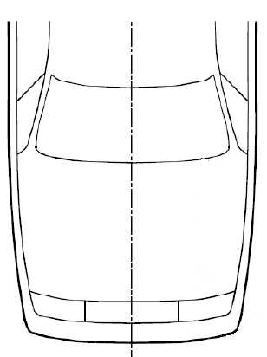
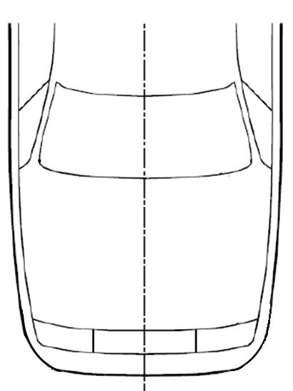
CoB -42mm (l+r)
Detection Test Area
Detection Test Area
CoB -42mm (l+r)
CoB (l)
CoB (l)
CoB (r)
CoB (r)
Relevant Vehicle Width (RVW)
75% of RVW
Relevant Vehicle Width (RVW)
75% of RVW
CoB -42mm (l+r) > 75% of RVW
CoB -42mm (l+r) < 75% of RVW

Paragraphs 3.15. to 3.18.(former), renumber as paragraphs 3.20 to 3.23.
Insert new paragraph 3.24., to read as follows:
3.24. “The pedestrian Head Impact Time (HIT)” is defined as the elapsed time subsequent to the time of first contact of the Pedestrian surrogate (neglecting forearms and hands) with the vehicle outer surface and the time of first contact of its head with the vehicle outer surface.”

Paragraphs 3.19 to 3.23.(former), renumber as paragraphs 3.25. to 3.29.
Insert new paragraphs 3.30 to 3.31., to read as follows:
"3.30. "Outer surface" means those components of the vehicle within the headform test areas, which may be contacted by the pedestrian in case of an accident. The outer surface may include the bonnet, the fenders, but also external airbags or other components within the headform test areas.
Paragraphs 3.25. and 3.26.(former), renumber as paragraphs 3.32 and 3.33.
Insert new paragraphs 3.34 and 3.35., to read:
"3.34. "Relevant vehicle width (RVW)" is the maximum width of the vehicle without rear view mirrors or rear-view mirror substitute systems, measured on or in front of a vertical transverse plane passing through the front axle of the vehicle.
3.35. "Sensing time (ST)" means the duration from the time of the first contact of the Flex-PLI with the vehicle outer surface to the initiation of the deployment module."
3.31. "Sensors" are pedestrian contact sensors that detect a pedestrian contact with the front of the vehicle. These sensors include, but are not limited to, accelerometers, fibre optic sensors, pressure sensors, etc."

Paragraphs 3.27. to 3.29. (former), renumber as paragraphs 3.36 to 3.38.
Insert new paragraphs 3.39. to 3.41., to read:
"3.39. "Testing of the DPPS":
The headform impact tests on the DPPS can be performed in three ways: statically, dynamically or combined.
3.39.1. "Static testing" means the launch of the headform on a DPPS being in the deployed position.
3.39.2. "Dynamic testing" means the synchronized launch of the headform onto the deploying DPPS at the appropriate HIT.
3.39.3. "Combined testing" means the set of tests on a DPPS in which a given test is run in either the static mode or the dynamic mode.
3.40. "Testing time" means the timeframe after the DPPS reaches its deployed position in which the headform test to the DPPS is to be performed.
3.41. “Total Response Time (TRT)” means the duration from the time of first contact of the Flex-PLI with the vehicle outer surface to the time the DPPS reaches its Maximum Deployment Height first. It is the sum of the Sensing Time and the Deployment Time.

Figure XX
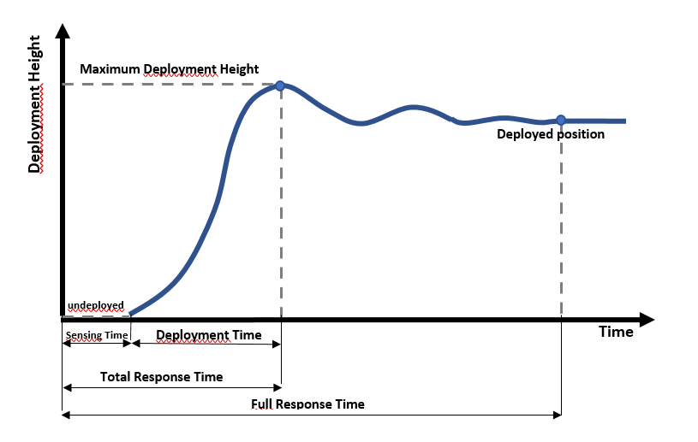

Paragraphs 3.30 to 3.32 (former), renumber as paragraph 3.42 to 3.44.
Paragraphs 5.2., 5.2.1. and 5.2.2., amend to read:
“5.2. Headform tests
If the manufacturer stipulates that the vehicle shall be tested as a DPPS, the test conditions and requirements in Annex 1 shall apply.
"5.2.1. Child headform to the front structure:
When tested in accordance with paragraphs 7.2., 7.3. and, if applicable, Annex 1, the HIC shall comply with paragraph 5.2.3.
5.2.2. Adult headform to the front structure:
When tested in accordance with paragraph 7.2., 7.4. and, if applicable, Annex 1, the HIC shall comply with paragraph 5.2.3."
Insert new paragraph 6.2.4., to read:
"6. TEST SPECIFICATIONS
6.2. Preparation of the vehicle
…
6.2.4. If the manufacturer stipulates that the vehicle shall be tested as a DPPS, the vehicle shall be adjusted as specified in the test procedure defined in Annex 1.”

Annex 1
Test procedure for deployable pedestrian protection systems (DPPS)

Preliminaries and pre-requisites

Based on a determination by each Contracting Party, a Contracting Party may either allow static tests, dynamic tests, and a combination thereof, or stipulate dynamic tests only.

For DPPS to be assessed statically, dynamically or combined, it will be necessary for the vehicle manufacturer to identify detailed information highlighted in this Annex before any testing begins. The vehicle manufacturer shall identify all necessary information regarding detection of pedestrians and the deployment of the system. Based on the evidence identified, activation of the system in the headform test will be determined.
1.1. If the pre-requisites from 1.2 to 1.6. are not met, the vehicle will be tested in the un-deployed position.
1.2. System specification:
As a Contracting Party option, a technical description of the DPPS components shall be identified by the manufacturer. This shall be accompanied by the following information:
1.2.1. For Sensing system:
(a) Sensor type (e.g., pressure, optical, acceleration, etc.)
(b) Sensor locations
(c) Operation process (including the lower deployment threshold speed of the DPPS)
1.2.2. Deployment information:
(a) Technology of the DPPS (airbag, active bonnet, etc.)
(b) Mechanism explanation
(c) Component description (lifting system (e.g., actuator), hinge, latch, etc.)
(d) Deployed position information (not required for dynamic testing)
(e) TRT (ST and DT separately) information (not required for dynamic testing, where only ST is requested)
(f) Evolution of system stability (e.g., pressure or force versus time diagram) (not required for dynamic testing).

1.3. The marking of the head test areas of the DPPS shall always be done in undeployed position, for static, dynamic or combined testing.
1.4. HIT information shall be provided according to Annexes 2 (HBM qualification) and 3 (HIT determination simulation).
1.5. Verification of the pre-requisites for deployed static tests: Deployed Position (d) and DT (e) in the deployment time history curve.
1.5.1. Deployed Position
The vehicle outer surface with the DPPS capable of maintaining the deployed position shall reach a position equal to or above the deployed position [required height] during the time between the TRT and the HIT that corresponds to the rear end of the respective headform test area. The position shall not go below the [required height] deployed position after the first overshoot phase [exceeding 10 percent / 10mm tbc below the [required height] deployed position]. If the position does not meet this requirement, then dynamic tests shall be performed.
The values specified by the manufacturer shall be verified by using appropriate tracking means, such as high-speed videos, accelerometer, or laser at the reference points (at the lifting devices). The tolerances are of [±10]% for the specified values. If the measured values are within the defined tolerances, the value specified by the manufacturer shall be used. Otherwise, the measured value shall be used for the test.

1.6. Sensing System Verification
1.6.1. The detection test area, as defined in paragraph 3.20. of this regulation, will be subdivided into three thirds of identical width, whereas one third is the geometrical trace between the left and right end of the detection test area, measured with a flexible tape following the outer contour of the bumper at the upper bumper reference line, equally divided by three. See Figure 2 below.
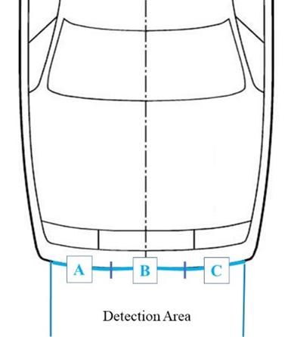
Figure 2
Scheme of the detection test area subdivision
Detection Test Area
A
B
C

1.6.2. The vehicle manufacturer shall specify the lowest speed of activation (lower deployment velocity threshold) of the DPPS.
1.6.3. For the system deployment verification, sensor activation tests with the flexible lower legform impactor, as specified in paragraph 6.3.1.1 of this regulation, shall be performed at the DPPS lower deployment velocity threshold.
1.6.4. A minimum of one test per third (A, B and C) shall be performed, maintaining a minimum distance of 50 mm to adjacent tests. Upon request of the manufacturer, additional tests outboard either side of the detection test area may be performed to provide for possible future extensions (e.g. aerodynamic attachments) enlarging the RVW.
1.6.5. Where a test is performed within the tolerances as specified in paragraph 3 of this Annex, but below the nominal lower deployment velocity threshold or outside the detection test area and the system does not deploy, the test must be repeated.
Test Assessment
1.6.6. If the system is not activated during any of the verification tests, all headform tests shall be conducted in un-deployed position according to paragraphs 7.2. to 7.4. of this regulation.
1.6.7 For tests with stationary vehicle: the vehicle should be set to the normal running condition as specified by the manufacturer for a vehicle speed corresponding to the particular use case.

- Verification of TRT and /or ST at nominal velocity

2.1. The TRT shall be confirmed by using the Flex-PLI at the vehicle speed at 11.1 m/s and at the centre line of the vehicle.
2.2. The ST is measured either independently, or during a TRT measurement test, at the vehicle speed as specified in this regulation and at the centre of the bonnet.
2.2.1 For dynamic testing, only ST shall be verified. If the measured ST is within a tolerance of -5ms/+3ms, the value specified by the manufacturer shall be used. Otherwise, the measured value shall be used for the test.
2.2.2 For tests with stationary vehicle: the vehicle should be set to the normal running condition as specified by the manufacturer.

3. For verification tests of paragraphs 1 and 2 of Annex 1 with the flexible lower legform impactor the following tolerances shall apply:
3.1. For tests with a moving vehicle impacting the stationary impactor:
Target speed: ± 0.6 m/s; impact accuracy: ± 50 mm.
3.2. For tests with a propulsion system propelling the impactor against the stationary vehicle:
Target speed, impact accuracy, angle tolerances are those of the performance tests, as in paragraph 7.1. of the regulation.

4. Headform test for protection below the lower deployment threshold speed of the DPPS

4.1. The vehicle outer surface shall remain in un-deployed position.
4.2. The test procedures specified in paragraphs 7.2. to 7.4. of this regulation shall apply with the impact speed specified at 0.9 times the lower deployment threshold speed. The allocation of the HIC 1700 and HIC 1000 zones may differ from those at nominal velocity (9.7 m/s) head impact tests according to paragraph 5.2.4 of this regulation.

5. Headform Test Procedure at nominal velocity (9.7m/s)
The impact points and the allocation of the HIC 1700 and HIC 1000 zones shall always be based on and related to the test area where the DPPS is deactivated.

5.1. Static test option:
If the vehicle manufacturer supports the static test [alternative], provided the following conditions are fulfilled, the requirements for an impact test [shall] be demonstrated using the static test.
If any of the following conditions are not met, then the dynamic test option shall be performed.

5.1.1. The HIT determined on the deployed DPPS, as described in Annex 3,
at the impact point WAD shall be greater than or equal to the TRT (HIT≥TRT).

Where the vehicle manufacturer has demonstrated by numerical simulations on the deployed DPPS, as described in Annex 3, that HIT ≥ TRT for the smallest selected stature pedestrian, then all tests may be performed statically.

5.1.2. The vehicle outer surface shall represent the deployed position and the resisting force. [The outer surface of the vehicle shall be set to that position and its resisting force by appropriate means.]
5.1.2.1. Static time constraint condition, linked to the resisting force:
When there is a constraint on time for the stability of the system and HIT≥TRT, the launching time of the headform test shall ensure that the system remains stable (tolerance ±10 per cent of corresponding resisting force), as identified by the manufacturer (pre-requisite in paragraph 1.2. of Annex 1).
Based on the evolution of system stability (see Fig. 1), a decision can be made on how to perform the test. During the static tests it shall be ensured that the resisting force of the DPPS is equivalent to the actual situation at the real HIT.
HIT<TRT
TRT
OR HIT ≥ TRT without stable position of DPPS
DPPS (Bonnet…) stable
Dynamic
Static time constraint
DPPS (bonnet, airbag…) unstable
Figure 1: Testing time aim = LAB tests represent real life
DPPS (bonnet, airbag…) stable
time
time
time
Timespan for the test
Timespan for the test
HIT<TRT
Static
HIT<TRT
HIT ≥ TRT
HIT ≥ TRT

5.1.2.2. Appropriate means (e.g., actuator surrogates) shall ensure the corresponding resisting force of the DPPS can be used.
5.1.3. The test procedures specified in paragraphs 7.2. to 7.4. of this regulation shall apply.
5.1.4 Test accuracy at impact location
5.1.4.1. Prior to conducting the static tests at 9.7 m/s, one headform test at the discretion of the test laboratory may be conducted on the undeployed DPPS to confirm that impact velocity and impact location are within tolerances.
5.1.4.2. If the tolerances for impact speed and location are met during the test on the undeployed DPPS, there is no requirement to prove that these tolerances are still met during the static tests, provided that test inputs remain the same.
5.1.4.3 Alternative methods to demonstrate the test accuracy may also be accepted.

5.2. Dynamic test option:

5.2.1. The dynamic verification of a DPPS is based on a headform test performed on the DPPS, where the headform launch device and DPPS deployment are synchronized to achieve the correct HIT.
The following steps are conducted:
5.2.1.1. Test accuracy at impact location
Prior to conducting the dynamic tests at 9.7m/s, one headform test at the discretion of the test laboratory shall be conducted on the undeployed bonnet to confirm that impact velocity and impact location are within tolerances.
If the tolerances for impact speed and location are met during the undeployed test, there is no requirement to meet these tolerances during dynamic tests, provided test inputs remain the same.
5.2.1.2. To enable dynamic testing to be conducted, HIT and sensing time (ST) are required inputs, which shall be established by the following:
(a) HIT is obtained from Annex 3, Figure 2.
Figure 2
Wrap Around Distance [mm]
AM95
AM50
AF05
6YO

Head Impact Time [ms]

(b) ST is determined from manufacturer pre-requisite or sensor verification test., carried out at the center of the bonnet (Y0).
5.2.1.3. The test facility shall ensure that the head impact occurs at the correct time relative to the deployment of the DPPS, taking into account the HIT and ST, as shown in Figure 2 below.
Figure 2: Example of test rig synchronisation
“DPPS opening time” is calculated by deducting the sensing time (ST) from the HIT at that particular test point.
“DPPS Fire Delay” = Launching Duration Head Impactor – HIT + Sensing Time
Launching duration head impactor is rig-specific and is the time period between launching of the head impactor and the time of head impact to the undeployed bonnet.

Leg Impact
Initiation of Deployment Module
Head Impact
Sensing Time (ST)
DPPS Fire Delay
Launching Duration Head Impactor
Lab Test:
Pedestrian to Vehicle Event:
Head Impactor launch
Head Impact Time (HIT)
DPPS Opening time (OT)
DPPS Opening time (OT)

5.3. "Combined" test option:
Combined static and dynamic tests may apply, at manufacturer’s choice.

If the bonnet top test area consists of sections where the HIT of the HBM at the corresponding impact point is less than TRT (HIT<TRT) and sections where the HIT of the HBM at the corresponding impact point is greater than or equal to TRT (HIT≥TRT, then all test points forwards of the corresponding wrap around distance WAD (HIT < TRT) shall be tested dynamically. The remaining section of the bonnet top test area may be tested statically. The undeployed marking procedure shall be used for this combined option. (see Figure 4 below).

Figure 4
Scheme of HIT vs WAD for combined testing
Wrap Around Distance [mm]
Head Impact Time [ms]
AM95
AM50
AF05
6YO
TRT
DYNAMIC TESTS
QUALIFIES FOR STATIC TESTS

Annex 1 Appendix 1: Flowchart DPPS Assessment guideline
¹: Minimum number of tests specified for Contracting Parties of the 1958 Agreement, only
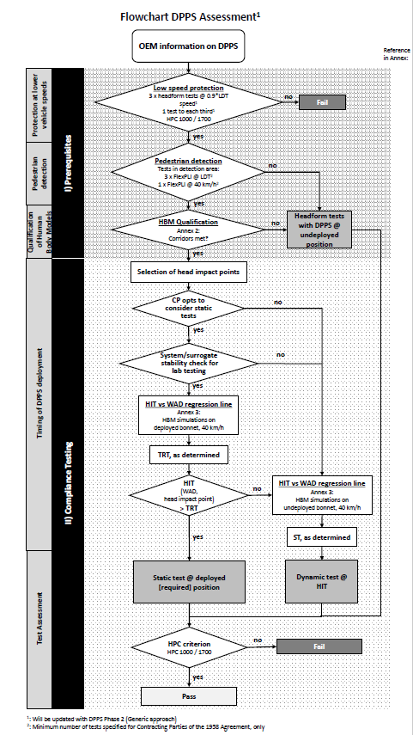

Annex 2

Qualification Process of Human Body Models for Pedestrian HIT-Determination

INTRODUCTION

[Annex 1 describes the test procedure for the Deployable Pedestrian Protection System. Based on the evidence provided by the vehicle manufacturer, the authority may decide whether subsystem testing for head impact assessment is conducted in either the deployed or undeployed position of the Deployable Pedestrian Protection System or if dynamic tests are required.]

HBM compliance must be demonstrated by the vehicle manufacturer in accordance with the procedure in this document. All requirements which are specified within this document have to be fulfilled to qualify a HBM to be used in Annex 3.

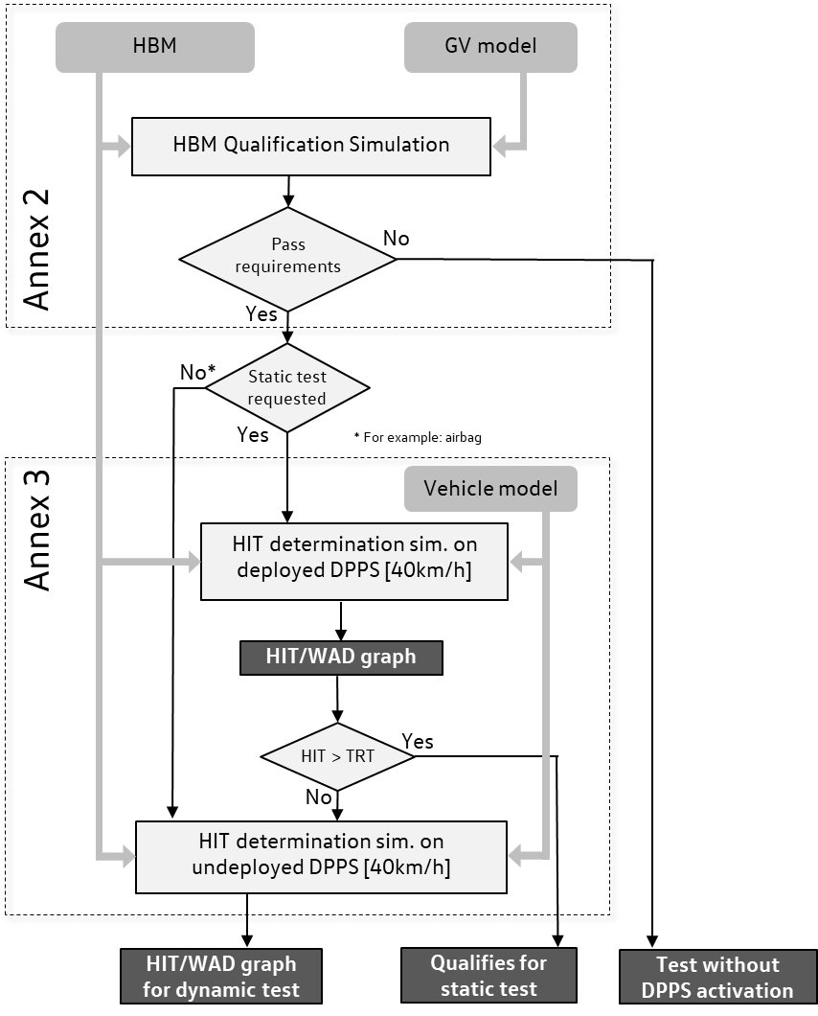

Limitations

As mentioned in the preamble of UN-GTR No.9, the qualification procedure described in this text is simplified and therefore limited to the purpose of pedestrian Head Impact Time (HIT) and Wrap Around Distance (WAD) calculation and is not suited to qualify for injury assessment in this or any other crashworthiness regulation. Only measures relevant for these outputs are included in the qualification procedure (Klug et al. 2021) and have been determined within sensitivity studies and round robin simulations (Klug et al. 2017, Klug et al. 2019).

Definitions

Throughout this document, the following definitions are used:

- A Human Body Model (HBM) is understood as a virtual geometric and mechanical representation of the human body, which takes the human anatomy into consideration. The procedure described in this document refers to HBMs used for the simulation of pedestrian impacts. Pedestrian models which are required for Annex 3 shall be selected from the following statures, a six year old (6YO), 5th percentile female (AF05), 50th percentile male (AM50) and 95th percentile male (AM95).
- Generic Vehicle (GV) Models are generic replications of car fronts representing three vehicle categories: Family Cars (FCR), Roadsters (RDS), Sports Utility Vehicles (SUV). (The shape of the generic Multi Purpose Vehicle (MPVs) was found to lay in between the generic FCR and generic SUV and is therefore covered already.) The GVs are available on the UNECE website [tbd]. The vehicle models provide representative shapes for the selected vehicle categories as well as median structural response upon pedestrian impact in terms of force- deflection characteristics and are modelled to be robust and transferable to all considered explicit Finite Element (FE) codes.
- HBM vs. GV simulation: A computer simulation providing evidence that the specific Human Body Model simulation is comparable with reference simulations and shows consistent results – in particular referring to HIT and WAD. The reference simulations are based on models which have been validated by comparing their simulation response with PMHS tests (see Appendix B). Another purpose is to make sure that models give comparable results with varying hardware or software environments when applied for a specific purpose.
- HIT-Determination simulation: A computer simulation for determination of HIT as a function of WAD in the DPPS vehicle model for deriving the test conditions for the assessment of deployable systems as specified in the Annex 1.

General Requirements

Only those HBM statures have to be qualified which are required for the HIT determination simulations described in Annex 3, paragraph 2.2.

The pedestrian Human Body Model that is qualified is the very same model as used for HIT-Determination simulations. This applies to:

  - Version of the Human Body Model;
  - Node-Position of every single node of the Human Body Model;
  - If available:
    - identical initial element stresses/strains;
    - identical initial contact penetrations/contact forces;
  - Identical material cards (including fracture mode), contact cards, control cards and constraints.

Furthermore, it is important that all simulations (qualification and HIT-Determination) are performed with consistent settings. This applies to:

  - Solver-Version;
  - Solver-Platform (SMP, MPP);
  - Solver-Precision (Single, Double Precision);
  - The time-step used for simulations;
  - Time-step settings (relating to initial and dynamic mass scaling);
  - Contact settings (between Human Body Model and Vehicle);
  - Control settings which are affecting the pedestrian model.

Procedure

HBM Pre-processing

Shoes

The HBM may be fitted with a pair of shoes, featuring a sole thickness (at the heels) of 20 to 30 mm.

Positioning

The car manufacturer has the freedom to choose a positioning tool. Positioning can be achieved through pre-simulation (pulling/pushing the limbs of the HBM to the desired position) or by re- meshing/morphing. The target posture of the AM 50 model is specified in Table 1.

All other model sizes have to meet the required initial posture defined in Table 2.

For all abbreviations and reference point description (HC, AC etc.) see Appendix A.

Table 1
Initial Posture AM 50.
Abbrev. | Measure | Ref. Value | Tolerance (+/-) | Angle Definition
Px | Heel to heel distance Longitudinal | 310 mm | 5.0% | 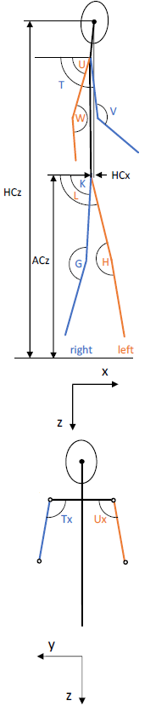
Py | Heel to heel distance lateral | 185 mm | 15.0%
ACz | Height of AC relative to the ground level | 949 mm | 2.0%
K | Right Upper Leg Angle (around Y w.r.t. horizontal) | 89° | 5°
L | Left Upper Leg Angle (around Y w.r.t. the horizontal) | 106° | 5°
G | Right Knee flexion Angle (Y) | 164° | 5°
H | Left Knee flexion Angle (Y) | 175° | 5°
Ty | Right Upper Arm Angle (Y  w.r.t. horizontal) | 98° | 5°
Uy | Left Upper Arm Angle (Y  w.r.t. horizontal) | 70° | 5°
Tx | Right Upper Arm Angle (X  w.r.t. horizontal) | 100° | 10°
Ux | Left Upper Arm Angle (X  w.r.t. horizontal) | 100° | 10°
V | Right Elbow flexion Angle | 140° | 5°
W | Left Elbow flexion Angle Left | 160° | 10°
HCx | x-Position of HC relative to AC | 44 mm | 15 mm
HCz | Height of HC relative to the ground level | 1686 mm | 1.5%
M | Total mass | 76.7kg | 5%

The angles should be measured using the reference axis as defined in Appendix A. The reference measures for the other sizes of models are listed in Table 2.

Table 2
Reference Posture of other pedestrian sizes.
Abbrev. | Unit | Reference | Reference | Reference | Tolerance
 |  | 6YO | AF05 | AM95
Px | mm | 199 | 243 | 340 | 5.0%
Py | mm | 152 | 164 | 265 | 15.0%
ACz | mm | 613 | 831 | 1043 | 2.0%
K | ° | 89° | 89° | 89° | 5°
L | ° | 106° | 106° | 106° | 5°
G | ° | 164° | 164° | 164° | 5°
H | ° | 175° | 175° | 175° | 5°
Ty | ° | 98° | 98° | 98° | 5°
Uy | ° | 70° | 70° | 70° | 5°
Tx | ° | 100° | 100° | 100° | 10°
Ux | ° | 100° | 100° | 100° | 10°
V | ° | 140° | 140° | 140° | 5°
W | ° | 160° | 160° | 160° | 10°
HCx | mm | 6.5 | 27 | 16 | 15 mm
HCz | mm | 1100 | 1468 | 1836 | 1.5%
M | kg | 22.8 | 46.9 | 102.6 | 5%

The right side in viewing/walking direction of the HBM is defined as the struck side. The z-direction is defined as the vertical axis, positive in inferior direction. The local HBM x-axis is the frontal axis, facing anterior. (Both shoe soles should ideally contact the ground – if ACz cannot be achieved with ground contact, a z-offset of the HBM is permitted).

None of the limbs, i.e. arms/legs shall be artificially connected, tied or constrained to each other (e.g. wrists tied) The HBM should be exposed to a vertical acceleration field constituting the gravitational loading for HBM qualification and HIT determination simulation.

Output Parameters

The HBM must be equipped with “sensors” and other output definitions, which allow tracking the trajectories of selected body parts. The centre specifies the centre of all nodes; i.e. the node with averaged coordinates.
Node histories must be output at the HC and AC. Outputs must be in the global coordinate system, with the x-direction parallel to the vehicle longitudinal axis in driving direction and the z- direction parallel to the vehicle height axis facing upwards. The sensor shall be constrained to the structure, which was used for the definition of the geometric centre (at least 10 nodes of the cortical bone for HBMs with skeleton and all related bodies for HBMs without skeleton).

Impact Simulations

According to tables 3-5 the HBM must be impacted by the provided generic vehicle models at three different impact velocities (30 km/h, 40 km/h and 50 km/h). The simulation time must be higher than the expected Head Impact Time.

The static and dynamic coefficient of friction between the car and the HBM should be set to 0.3.

The Head Centre of Gravity (CoG) of the HBM must be positioned in line with the vehicle centreline (y=0 in the global coordinate system).

Output Requirements

It should be confirmed that the following outputs have been generated from each simulation:
Time history curves of:

- x and z coordinate of HC and AC in the global coordinate system
- x displacement of vehicle COG in the global coordinate system
- Resultant acceleration of HC
- Contact forces (between vehicle and HBM without upper extremities, vehicle and HBM head and total contact force)
- Total hourglass and internal energies of the total setup
- Mass increase,
all plotted every 0.1ms.

Furthermore, animations of the simulations should be generated with an output interval of 1ms.

Quality Checks

The following Quality Checks shall be performed:

  - Contact force (between HBM and vehicle) is zero at simulation start.
  - Total energy remains constant within a 15% tolerance.
  - Hourglass energy ≤ 10% of the total energy.
  - Artificial mass increase is less than 3%.

Reference Results for Qualification Simulations

From the qualification simulations with the generic vehicle models, HIT values and the location of AC and HC at the time of head impact should be compared with the references in Table 3-5.
These tables have been created using simulations with validated HBMs (see Appendix B).
The trajectories are measured relative to the generic vehicle model, which means that the x-displacement of the generic vehicle has to be subtracted from the measured x coordinates HCx and ACx in the global coordinate system. For HCz and ACz the global z-coordinates are used.

[Table 3
AM50
GV Type | Velocity [km/h] | HIT [ms] |  | ACx [mm] |  | ACz [mm] |  | HCx [mm] |  | HCz [mm]
 |  | Min | Max | Min | Max | Min | Max | Min | Max | Min | Max
FCR | 30
 | 40
 | 50
RDS | 30
 | 40
 | 50
SUV | 30
 | 40
 | 50

Table 4
6YO
GV Type | Velocity [km/h] | HIT [ms] |  | ACx [mm] |  | ACz [mm] |  | HCx [mm] |  | HCz [mm]
 |  | Min | Max | Min | Max | Min | Max | Min | Max | Min | Max
FCR | 30
 | 40
 | 50
RDS | 30
 | 40
 | 50
SUV | 30
 | 40
 | 50

Table 5
AF05
GV Type | Velocity [km/h] | HIT [ms] |  | ACx [mm] |  | ACz [mm] |  | HCx [mm] |  | HCz [mm]
 |  | Min | Max | Min | Max | Min | Max | Min | Max | Min | Max
SUV | 30
 | 40
 | 50

]

AM95

The AM95 does not need to be specifically qualified. AM95 models which can be used are all derived from AM50 models and therefore the AM95 only has to meet the positioning requirements and no specific qualification simulations need to be performed.

Documentation

General

The following information should be provided:

  - Date of report
  - Name of car manufacturer
  - Type and release version of software (FE-software package name, revision and version)
  - Name and version of Human Body Model
  - Version of Generic Vehicle models applied

Images showing the front view and side view of the pedestrian, at t0 and at the time of head impact should be added to the report.

Quality Checks

For all simulations Table 6 should be filled in

Table 6
Quality Checks
Verification evaluation criteria | Allowed | Observed | Pass?
Coefficient of friction between GV and Human Body Model | 0.3 |  | Y/N
Head centre of gravity is positioned at vehicle centreline | Y=0 mm |  | Y/N
Contact force between HBM and vehicle at simulation start | 0 |  | Y/N
Change in total energy throughout simulation | ≤15% |  | Y/N
Amount of hourglass energy relative to total energy | ≤10% |  | Y/N
Artificial mass increase relative to total mass of the setup | ≤3% |  | Y/N

Calculation of Head Impact Time

Time of first contact is defined as the first time at which the contact force is no longer 0 anymore.
The Head Impact Time (HIT) is defined as the elapsed time subsequent to the time of first contact of the HBM (neglecting forearms and hands) with the vehicle outer surface and the time of first contact of its head with the vehicle outer surface.

If this method is for any reason not applicable, an appropriate alternative method should be applied and documented.

Initial Posture of Pedestrian Model

The following table has to be filled in for all statures using the references from Table 1 and 2.

Table 7
Initial Posture Check
Abbrev. | Unit | Measured Value (for Stature …) | Deviation to Reference | Tolerance | Pass?
Px | mm |  |  | 5.0% | Y/N
Py | mm |  |  | 15.0%
ACz | mm |  |  | 2.0%
K | ° |  |  | 5°
L | ° |  |  | 5°
G | ° |  |  | 5°
H | ° |  |  | 5°
Ty | ° |  |  | 5°
Uy | ° |  |  | 5°
Tx | ° |  |  | 10°
Ux | ° |  |  | 10°
V | ° |  |  | 5°
W | ° |  |  | 10°
HCx | mm |  |  | 15 mm
HCz | mm |  |  | 1.5%
Total weight | kg |  |  | 5%

Results of Qualification Simulations

To qualify one HBM stature the following table has to be filled in including all GV shapes and collisions speeds where reference values are provided in the corresponding tables 3, 4 or 5. To pass the requirements the values of the respective HBM have to be within the min/max values of table 3-5.

Table 8
Results of Qualification Simulation
GV Type | Velocity [km/h] | HIT [ms] |  | ACx [mm] |  | ACz [mm] |  | HCx [mm] |  | HCz [mm]
 |  | Measured | Pass? | Measured | Pass? | Measured | Pass? | Measured | Pass? | Measured | Pass?
FCR | 30
 | 40
 | 50
RDS | 30
 | 40
 | 50
SUV | 30
 | 40
 | 50

For each simulation, the following diagrams should be provided:

  - ACx and HCx as a function of time
  - ACz and HCz as a function of time
  - HCz as a function of HCx and ACz as a function of ACx
  - Total Contact Force between HBM and GV as a function of time
  - Total, kinetic, internal and hourglass energy as a function of time

APPENDIX A: REFERENCE SYSTEMS

Global Coordinate System

The global coordinate system is defined as shown in Figure A.1:

  - X direction is the driving direction of the vehicle (longitudinal axis) and X=0 at the foremost point of the vehicle at t=0.
  - Y direction is the vehicle lateral axis with Y=0 at the vehicle centreline.
  - Z direction is parallel to the vehicle height axis facing upwards, Z=0 at the ground level.

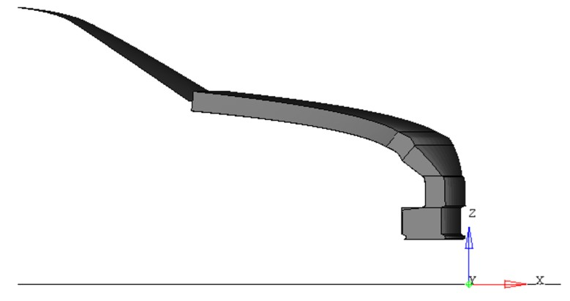
Figure A.1: Global Coordinate System

Note: All Generic Vehicle models are already positioned correctly – no transformation of the vehicle is required

HBM Reference Axis

The HBM reference coordinate system is defined as: The x-axis of the local HBM is defined in the sagittal plane, oriented in the anterior direction. The y-axis is the one defined in the coronal plane, pointing to the right of the HBM and the z-direction is defined as the cross product of the aforementioned axis, this being the vertical axis oriented in the inferior direction.

The local axes describing the initial posture with the corresponding landmarks are shown in Figure A.2 (small capital r stands for right and l for left side of the body)

HBM with skeleton

HC
SCl SCr
HMl
HMr
USl
AC
x
z
Fr
Fl
Mr
Ml

USr

right left

Figure A.2: Local HBM axes for angle definitions

  - Centre of gravity of the head (hereafter called HC) is defined as the mass centre of all parts of skull, scalp, face, brain, intracranial space, scalp. It should be connected to all nodes of inner cranium for the dynamic output.
  - AC is defined as the geometric centre of the right and left acetabulum centres. The geometric centre of all nodes within the concave surface of each acetabulum has to be determined as averaged coordinate of all nodes on the pelvic bone surface within the boundaries defined as sharp edge where the bone changes its curvature shown in Figure A.3. This has to be done at the left and the right Acetabulum. The midpoint of the left and right acetabulum centred is AC and should be connected to all nodes of the right and left acetabulum.

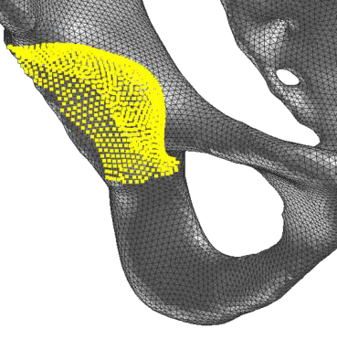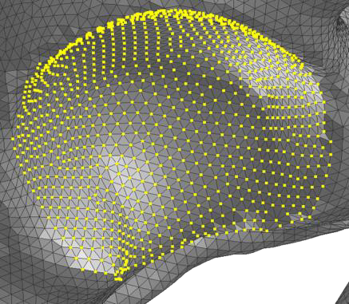

Figure A.3: Definition of Acetabulum Centre (all nodes up to sharp edge where the bone changes curvature)

  - The Upper Leg Angle is defined as the angle about Y between the femur reference axis and the horizontal.
  - The femur reference axis is defined as the connection between the centre of the nodes of the acetabulum and the midpoint (F) between Epicondylus femoralis medialis (FEM) and Epicondylus femoralis lateralis (FEL). If FEM and FEL are not clearly identifiable from the bony structure, the approach shown in Figure A.3 can be used. For this approach the femur model has to be positioned such that the lateral and medial epicondyle are overlaying as much as possible, as seen in the left image in Figure A.4. Then a cylinder is created from the contour of femoral condyle. The points of intersection of the axis of a longitudinal cylinder along the femoral condyle and the outer surface of the bone should be used as FEM and FEL. This point has to be determined on the left (Fl) and the right femur (Fr) of the HBM.

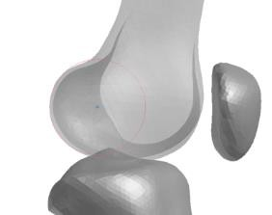
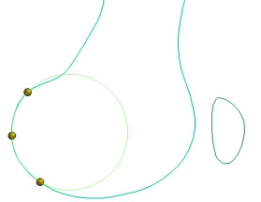
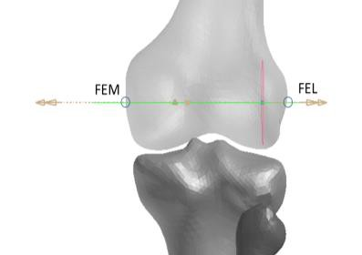
F

Figure A.4: Construction of FEL and FEM

  - The Knee Flexion Angle is defined between the femur reference axis and the connection between the midpoint of the femoral epicondyles and the inter-malleolar point (M) located midway between the tip of the medial malleolus (MM) on the tibia bone and tip of the lateral malleolus (LM) on the fibula as shown in Figure A.5. These points have to be defined on the left (Ml) and right side (Mr) of the HBM.

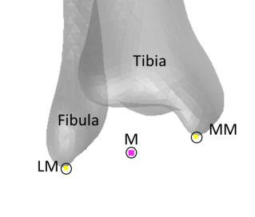
Figure A.5: The right inter-malleolar point (MR) located midway between MM and LM

  - The Upper Arm Angle is defined as angle around the Y axis between the horizontal plane and the humerus reference axis. The humerus reference axis is defined as the connection between the shoulder reference point (SC) and the Humerus reference point (HM). SC is determined as the midpoint of the most laterodorsal point of the Angulus Acromialis (AA) and the most ventral point of processus coracoideus on the scapula (PC), both on the scapula. HM is defined as the midpoint of the most caudal-lateral point on lateral epicondyle (EL) and the most caudal-medial point on medial epicondyle (EM). These points have to be defined on the left (SCl, HMl) and right side (SCr, HMr) of the HBM.

  - The Elbow Flexion Angle is defined as angle between the humerus reference axis and the connection between HM and the most caudal-medial point on the ulnar styloid (US). This axis has to be defined on the left (HMl, USl) and right side (HMr, USr) of the HBM.

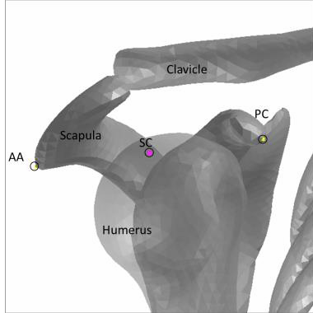 | 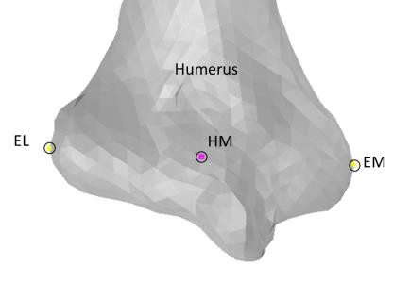 | 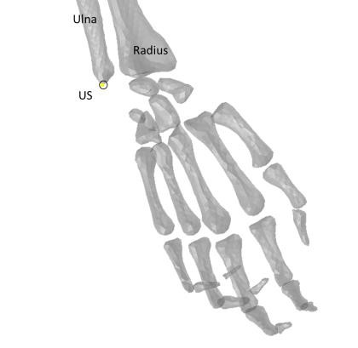

Figure A.5: Anatomic Landmarks of upper extremities

  - The Heel to Heel distance is defined as the distance between the centre of all nodes of the right and the left calcaneus. If this cannot be determined, the distance between the most posterior node of the left heel to the most posterior node of the right heel of the shoe sole has to be used.

HBM without skeleton

Wherever the landmarks described in the previous section cannot be identified in an HBM, points according to the definition in Table 10 should be used.

Table 10
Reference nodes used for determination of the initial posture for HBMs where anatomic landmarks cannot be defined

HBM with full skeleton | HBM without skeleton
HC | Centre of gravity of the body/bodies representing the full head moving with the head
Scl/SCr | Geometric centre of shoulder joint connecting the Thorax with the body representing the upper arm
HMl/HMr | Geometric centre of elbow joint connecting the body representing the upper arm with the body representing the lower arm
USl/USr | Geometric centre of wrist joint connecting the body representing the hand with the body representing the lower arm (on the posterior side / side of the pinkie)
AC | Geometric centre of hip joint connecting the body representing the pelvis with the body representing the upper leg
Fr/Fl | Geometric centre of knee joint connecting the body representing the upper leg with the body representing the lower leg
Mr / Ml | Geometric centre of ankle joint connecting the body representing the foot with the body representing the lower leg bones

[APPENDIX B: Documentation of validation of reference Human Body Models

This Section contains a description of the validation of the reference AM50 human body models that were used for the definition of the qualification corridors, as depicted in Chapter 2.5 of Annex 2.
The validation procedure, in contrast to the previously described qualification simulations, describes the process towards a determination of the degree to which the reference models represent the pedestrian kinematics during real world crashes.

For their individual validations the different models had to undergo a harmonized procedure. This procedure consisted of simulations of the HBM against a model representing a generic vehicle frontend (SAE buck) used in post mortem human subject (PMHS) experiments. The SAE buck is part of the THUMS User Community validation repository. The HBM responses were compared to scaled corridors⁵ derived from three tests with PMHS.

The procedure used for the validation of those models that were used for the qualification corridors is kept simple and therefore limited to the purpose of pedestrian Head Impact Time (HIT) and Wrap Around Distance (WAD) calculation. It is not suited to qualify for injury assessment in this or any other crashworthiness regulation. If HBMs are intended for extended usage, more enhanced validations are needed.

The impact of the simplicity of this procedure compared to a more detailed validation procedure on the established qualification corridors related to HIT and WAD is expected to be neglectable. [However, the potential influence on WAD and HIT results for human body models subjected to a more stringent validation procedure should be further evaluated during phase 2 of the IWG on DPPS.]

To validate exactly the same model, which is used for the qualification simulations, the HBM posture is not aligned with the PMHS tests, but corresponds to Table 1 of this document instead. The main difference between the posture from the PMHS tests and Table 1 is the arm posture (the PMHS leg position and the proposed HBM position both target the SAE J2782 measures and are therefore comparable). Previous studies have shown that the arm posture effects HIT by roughly ±3 ms which is smaller than the range of results observed in the PMHS study.

The HBM is positioned vertically relative to the SAE buck such that AC (as defined in Fig. A.3) is positioned at a height of 932 mm. (Based on the offset between H-Point and pelvis reference point used for tracking defined in SAE J2782, the provided location of the pelvis reference point⁵ was offset by 73 mm to convert it to the H-Point location. The minimum value of the pelvis reference point from the corridor was taken to ensure that HC requirements from Table 1 are not contradicted.)
For the lateral position, AC is aligned with the vehicle centerline.

The unchanged SAE buck model⁵ has an initial velocity of 40 km/h. The same contact settings as defined in 2.2 are used (i.e. the static and dynamic coefficient of friction between the car and the HBM is set to 0.3.). No ground floor is modelled. Gravity is applied and the HBM is positioned as close as possible to the vehicle model.
All outputs as described in 2.3. are generated. From the simulations, the HIT is calculated according to 3.3. The model fulfills the validation, if the criteria defined in Table 11, based on the scaled corridors defined in Forman et al. (2015), are met and all quality checks defined in 2.4. are fulfilled. For the HIT, the mean from the PMHS test was taken as reference value, allowing a deviation of +/- 15%, which corresponds to the average deviation between HIT and TRT in DPPS cars observed in previous studies.

Table 11
Validation of AM50 HBMs

 | HIT [ms] |  | HCx [mm] |  | HCz [mm]
 | Min | Max | Min | Max | Min | Max
Reference from PMHS Tests | 117 | 159 | 1402 | 1653 | 1020 | 1271
HBM 1
HBM 2
HBM 3

]

Annex 3

HIT-Determination Simulation

INTRODUCTION

A HIT-Determination simulation is a computer simulation for determination of HIT over WAD in the DPPS vehicle model for deriving the test conditions for the assessment of deployable systems as specified in the Annex 1.

General Requirements

The Human Body Models (HBMs) that are used for HIT-Determination simulations have to be qualified according to Annex 2. The HBMs have to be the very same unchanged HBMs that are qualified in Annex 2. All simulations (qualification and HIT-Determination) have to be performed with consistent settings as described in paragraph 1.3 of Annex 2.

Procedure

Impact Simulations

There are two kinds of numerical simulations:

HIT Simulations on deployed DPPS
Simulations on the deployed DPPS to decide whether the physical head test on the deployable system can be done dynamically or statically.

HIT Simulations on undeployed DPPS
Simulations on the undeployed DPPS to determine HIT (needed for dynamic test time triggering) and WAD values.

Pedestrian models shall be selected from the following statures, a six year old (6YO), 5th percentile female (AF05), 50th percentile male (AM50) and 95th percentile male (AM95). The pedestrian position and stance to be used in the model is defined in Annex 2. The pedestrian model has to be positioned, such that the head CoG is aligned with the vehicle centreline.

The vehicle model has to be positioned in the setup such that the vehicle ground level is aligned with the ground level used in the qualification simulations.
As described in Annex 2 the HBM should be exposed to a vertical acceleration field constituting the gravitational loading.
A local vehicle coordinate system has to be initially aligned with the global coordinate system defined in Annex 2, Appendix A and should be connected to the vehicle model CoG.

The initial speed of the vehicle model has to be prescribed and is 40 km/h for all simulations. The y and z motion of the car has to be constrained and the motion in x-direction must not be constrained.

Selection of HBMs

The selected HBMs (needed to draw the WAD/HIT-line in the evaluation) are those HBMs where the head hits the DPPS properly, which is when:
- There is a contact between head and the DPPS
- At time of this contact the x-coordinate of the CoG of the head is smaller than the largest x-coordinate of the DPPS at y=0.

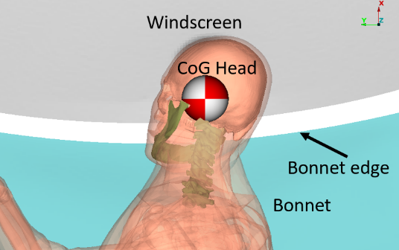
See picture with an example, where the CoG of the head lies behind the DPPS at time of contact. This HBM does not hit the DPPS properly (only contact with chin of HBM).

Simulations with the next tallest HBM should also be performed, but only to prove that this HBM does not hit the DPPS properly.

If only one HBM should hit the DPPS properly, the next tallest HBM should also belong to the selected HBMs.

Output Requirements

It should be confirmed that the following outputs have been generated from each simulation:
Time history curves of:

- x and z coordinate of HC and AC in the global coordinate system
- x displacement of vehicle CoG in the global coordinate system
- Resultant acceleration of HC
- Contact forces (between vehicle and HBM without upper extremities, vehicle and HBM head and total contact force)
- Total hourglass and internal energies of the total setup
- Mass increase,
all plotted every 0.1ms or less.

Furthermore, animations of the simulations should be generated with an output interval of 1ms.

Quality Checks

The following Quality Checks shall be performed:

  - Contact force (between HBM and vehicle) is zero at simulation start.
  - Total energy remains constant within a 15% tolerance.
  - Hourglass energy ≤ 10% of the total energy.
  - Artificial mass increase is less than 3%.

Documentation

General

The following information should be provided:

  - Date of report
  - Name of car manufacturer
  - Type and release version of software (FE-software package name, revision and version)
  - Name and version of Human Body Model
  - Specification of car

Images showing the front view and side view of the pedestrian, at t0 and at the time of head impact should be added to the report.

Consistency with Qualification Simulations

For all simulations Table 1 should be filled in

Table 1
Checklist for simulation settings | Consistent between Qualification and HIT determination Simulation?
Identical Human Body Model | Y/N
Solver Version | Y/N
Timestep | Y/N
All other control settings | Y/N

Quality Checks

For all simulations Table 2 should be filled in

Table 2
Verification evaluation criteria | Allowed | Observed | Pass?
Coefficient of friction between Vehicle and Human Body Model | 0.3 |  | Y/N
Head centre of gravity is positioned at vehicle centreline | Y=0 mm |  | Y/N
Contact force between HBM and vehicle at simulation start | 0 |  | Y/N
Change in total energy throughout simulation | ≤15% |  | Y/N
Amount of hourglass energy relative to total energy | ≤10% |  | Y/N
Artificial mass increase relative to total mass of the setup | ≤3% |  | Y/N

Calculation of Head Impact Time

Time of first contact is defined as the first time where the contact force is not 0 anymore.
The Head Impact Time (HIT) is defined as the elapsed time subsequent to the time of first contact of the HBM (neglecting forearms and hands) with the vehicle outer surface and the time of first contact of its head with the vehicle outer surface.

If this method is for any reason not applicable, an appropriate alternative method should be applied and documented.

Determination of WAD corresponding to HIT

For the determination of the wrap around distance (WAD) a point on the surface of the vehicle is necessary. This point is defined as follows (all coordinates relative to the local vehicle coordinate system):

At time of head contact with the DPPS the point

($x_{head}$, 0, $z_{head}$)
where
$x_{head}$ is the x-coordinate and
$z_{head}$ is the z-coordinate of the CoG of the head

will be projected orthogonally onto the surface of the undeployed vehicle. (If there are multiple projection points take the one with the highest x value.)

Compute the WAD for this point rounded the nearest full millimetre.

Results of HIT-Determination

For those HBMs that are selected according to 2.2 the computed HIT-Values and corresponding WADs have to be filled into the following tables
If HIT>TRT for all HBMs, simulations on the undeployed DPPS are not required.

Table 3 HIT Simulations on deployed DPPS

HBM | WAD [mm] | HIT [ms]
6YO
AF05
AM50
AM95

Table 4 HIT Simulations on undeployed DPPS

HBM | WAD [mm] | HIT [ms]
6YO
AF05
AM50
AM95

For each simulation, the following diagrams should be provided:

  - ACx and HCx as a function of time
  - ACz and HCz as a function of time
  - HCz as a function of HCx and ACz as a function of ACx
  - Total Contact Force between HBM and vehicle as a function of time
  - Total, kinetic, internal and hourglass energy as a function of time

Evaluation

HIT Simulations on deployed DPPS

Based on the results of table 3 a graph shall be plotted using a linear regression line for comparison with TRT in the diagram as shown in Figure 1.

Wrap Around Distance [mm]
Head Impact Time [ms]
AM95
AM50
AF05
6YO
TRT
DYNAMIC TESTS
QUALIFIES FOR STATIC TESTS

Figure 1: WAD vs HIT

HIT Simulations on undeployed DPPS

Based on the results of table 4 a graph shall be plotted using a linear regression line as shown in Figure 2. The lines have to be extrapolated in both directions.
Head Impact Time [ms]
Wrap Around Distance [mm]
AM95
AM50
AF05
6YO

Figure 2: WAD vs HIT
________________

The choice applies to Contracting Parties of 1958 Agreement, only.
Will be updated with DPPS Phase 2 (HIT determination by a generic approach option).
Minimum number of tests is specified for Contracting Parties of 1958 Agreement, only.
Minimum number of tests is specified for Contracting Parties of 1958 Agreement, only.
The choice applies to Contracting Parties of 1958 Agreement, only.
The flowchart in Figure 3 illustrates the decision process for Contracting Parties (1958 Agreement) that allow both static and dynamic options. For Contracting Parties that allow only dynamic option, this flow chart is also useful, but not all steps will be considered.
Klug, Corina; Ellway, James (2021): Euro NCAP TB 024 - Pedestrian Human Model Certification v3.0.1.
Klug, Corina; Feist, Florian; Raffler, Marco; Sinz, Wolfgang; Petit, Philippe; Ellway, James; van Ratingen, Michiel (2017): Development of a Procedure to Compare Kinematics of Human Body Models for Pedestrian Simulations. In: 2017 IRCOBI Conference Proceedings. Klug, Corina; Feist, Florian; Schneider, Bernd; Sinz, Wolfgang; Ellway, James; van Ratingen, Michiel (2019): Development of a Certification Procedure for Numerical Pedestrian Models. In: The 26th ESV Conference Proceedings. International Technical Conference on the Enhanced Safety of Vehicles.
Schneider, Lawrence W.; Robbins, D. H.; Pflueg, M. A.; Snyder, R. G.; Corporate Author: University of Michigan, Ann Arbor, Transportation Research Institute: ”Development of anthropometrically based design specifications for an advanced adult anthropomorphic dummy family, volume 1. Final report”
Pipkorn, Bengt; Forsberg, Christian; Takahashi, Yukou; Ikeda, Miwako; Fredriksson, Rikard; Svensson, Christian; Thesleff, Alexander (2014): Development and component validation of a generic vehicle front buck for pedestrian impact evaluation. In: International Research Council on the Biomechanics of Injury (Hg.): 2014 IRCOBI Conference Proceedings. IRCOBI Conference. Berlin, Germany, 10.-12.9.2014: IRCOBI (IRCOBI Conference Proceedings), S. 718–729.
Forman, J. L.; Hamed Joodaki; Ali Forghani; Patrick Riley; Varun Bollapragada; David Lessley et al. (Hg.) (2015): Biofidelity Corridors for Whole‐Body Pedestrian Impact with a Generic Buck. International Research Council on the Biomechanics of Injury. Lyon, France. Online verfügbar unter http://www.ircobi.org/wordpress/downloads/irc15/pdf_files/49.pdf.
https://tuc-project.org/whole-body-pedestrian-impact/
Wu, Taotao; Kim, Taewung; Bollapragada, Varun; Poulard, David; Chen, Huipeng; Panzer, Matthew B. et al. (2017): Evaluation of biofidelity of THUMS pedestrian model under a whole-body impact conditions with a generic sedan buck. In: Traffic Inj Prev 18 (1), 148-154. DOI: 10.1080/15389588.2017.1318435.
Klug, Corina; Feist, Florian; Raffler, Marco; Sinz, Wolfgang; Petit, Philippe; Ellway, James; van Ratingen, Michiel (2017): Development of a Procedure to Compare Kinematics of Human Body Models for Pedestrian Simulations. In: 2017 IRCOBI Conference Proceedings, IRC-17-64. IRCOBI. Antwerp, Belgium, 13.-15.9.2017. http://www.ircobi.org/wordpress/downloads/irc17/pdf-files/64.pdf.
Klug, Corina; Feist, Florian; Schneider, Bernd; Sinz, Wolfgang; Ellway, James; van Ratingen, Michiel (2019): Development of a Certification Procedure for Numerical Pedestrian Models. In The 26th ESV Conference Proceedings. Eindhoven, Netherlands, 10-13 June: NHTSA, Paper No.19-0310-O. https://www-esv.nhtsa.dot.gov/Proceedings/26/26ESV-000310.pdf.

