OICA | 3.3 |  | ge | The text states: “"Background concentration" means the test substance concentrations on the on-road surface layer”. In the test method we measure the background concentration at the vehicle air intake. | “"Background concentration" means the test substance concentration at the vehicle air intake.
OICA | 5.1 |  | ed | The text states: “….. interior air emissions entering into the cabin with outside air.” | … air emission entering into the cabin with outside air.
OICA | 5.1 | The two last lines | ed | The wording seems confusing and not clear in this context : “… regarding the measurement of interior air emissions entering into the cabin with outside air”.  Is it not better to say “pollutants” instead of “emissions” ? | “… regarding the comparison of internal measurement of air pollutants entering into the cabin and measurement of pollutants in outside air.”
OICA | 7.5X |  | ge | The wording is not clear. What would be the meaning of doing a test without the filter if there is one originally by the OEM ?  Or is it if the vehicle has a different filter than the original one from the OEM ? | “If the model of vehicle of the OEM has no filter in its definition, the vehicle shall be tested without an additional filter”  Or TBD ?
OICA | 8.1 | b | te | “Nitrogen monoxide inside and outside the cabin”. What is the motivation for including this substance, its not in the WHO air quality guideline. | Remove the substance from the scope
OICA | 8.2.1 |  | te | CO2-Sensor between headrests may be affected by breath of the driver or passenger | position behind driver headrest recommended
OICA | 8.2.3. | (b) | ge | “line lengths must be identical and not more than 1 m”  the volume of analyzers induces their place inside the vehicle at the 2nd row of seats or the trunk, therefore the line would be more than 1m what is very short  - Is sufficient : as short as possible | Just keep the following :  “line lengths must be identical”
OICA | 8.3.1 |  | te | Is there such an example of such and instrument available? | Add example
OICA | 8.3.1. |  | te | Chemiluminescence analyzers measure alternatively NO and NOx. The calculation of the difference is said to be NO2, it is not a direct measurement.
OICA | 8.3.1. |  | ed | Additionally, be careful, there are 2 lines 8.3.1 | Rename the following other subchapters
OICA | 8.5 |  | te | Change measurement interval | to 5 sec
OICA | 8.8.1 |  | te | Wind speed will influence outside conditions | maximum wind speed limit should be determined (e.g. 5 m/s)
 | 8 |  | ge | Detection limit and accuracy requirements for test instruments is missing. | Add detection limit and accuracy requirements. Add examples of test instruments that fulfils the spec.
OICA | 9.3.2.  (and in the table subclause 12.2) |  | ge | The low limit of 30 µg/m3 for PM2,5 is already quite high in many countries or cities at least in western Europe. | To lower this limit : TBD
OICA | 9.3.6 |  | ge | The occupants shall not have to smoke the same day than the test (understood that the breath and the clothes have not to be polluted). “At least 24 hours” is excessive. | “Further, occupants shall not have smoked the same day to avoid to add pollution to the test”
OICA | 9.3.7  9.3.8  9.3.9, 9.3.12 |  | ed | What is the meaning of the expression “speed bin” used 5 times.  Does that mean “speed range” ? | Replace “speed bin” by “speed range”
OICA | 9.3.7. |  | ge | The values of limits for speed and percentage are too precise and difficult to follow in one test.  For speed, 40% or 45% of 60 km/h is complicated and confusing. | Percentage urban/ expressway 50 ± 25%
OICA | 9.3.8. |  | ge | In many countries, the urban speed limit is 50 km/h. Between 50 and 60 it could be included in expressway speeds (9.3.9.) | Urban speed range is characterised by vehicle speeds lower than or equal to the official limit of the country of test.
OICA | 9.3.8 |  | te | Definition of urban speed should be changed | v < 50 km/h (50 km/h city speed limit)
OICA | 9.4.1 |  | ge | What is the meaning and utility of all this preconditioning before a parking time for 6 to 72 hours ?  Is it a pre-test to check that everything works ? | Just keep the final lines : “exposure to extreme… or smoke should be avoided”.
OICA | 9.6.3 |  | ed | “rote” instead of “route” | “drive to the beginning of the test route …”
OICA | 9.6.4 |  | ed | “rote” instead of “route” | “Drive on the urban and expressway parts of route”
OICA | 11.1.6 |  | ge | The value of the global basic level of CO2 concentration (here 413 ppm) is rising every year and is measured in Hawaii.  It is already at 418 ppm in May 2023...  moreover, it is not evident that this precise level would be the ambient level of the place where the calibration will be made. | “…shall be tested prior to each test and shall be the average value of the year of test (global reference, for instance 418 ppm in 2023) ± 20 ppm”

CLEPA/Europe | IV | 1. | Te | There are also cabin air pollutants to be taken into account, such as CO2. | …with outside and cabin air pollutants.
CLEPA/Europe | IV | 3.3. | te | Normally “background concentration” is not influenced by special contaminant sources. “on-road surface layer” could lead to a misinterpretation, meaning concentration with traffic. | …substance concentration on ground level without unnatural sources such as traffic, etc.
CLEPA/Europe | IV | 6.4. | Ge | As stated by CLEPA and ACEA in 24th session CEN WS103 and after a careful reading of the draft CWA 17934:2022 is not a valid, reproducible and stable test method in the current state. Round Robin tests with an identical car equipped with test equipment lead to inconsistent results at most of the tested parameters. CLEPA and ACEA already stated, that they cannot accept any results from this test method in its current version. It is not acceptable to refer to that special test method in the normative references at the moment. | Delete reference 6.4. to CWA 17934:2022.  In case the test method gets further developed and can prove stability by several test drives, we reintegrate that reference into UN paper again.
CLEPA/Europe | IV | 7.5. | Te | The filter should must be a OEM-approved Hybrid Filter as particle filters cannot remove NOx, which is part of our test procedure. If only a particle filter is available, alternatively NOx should not be measured. | … with OEM-approved hybrid cabin air filter….
CLEPA/Europe | IV | 7.5.X | Te | In our interpretation it is said here that if there is no OEM filter in series, the tests should be performed with no filter? Doing tests without any filter (in series or not) technically does not improve cabin air quality at all. Maybe there are other technologies in future substituting the classic filter for air cleaning-maybe we should expand our definition here. | … is not installed with a filter by the OEM the test should not be performed. In case there is installed alternative technology for air cleaning instead of a filter, the vehicle can be tested in taking presumably special requirements of that alternative technology into account.
CLEPA/Europe | IV | 8.2.3. | te | - Sampling line analyzer requires many strict conditions. Some insights on the specific measuring instruments and setup shall be recommended.  - there is a time variation in NO and NO2 concentration while driving, but can the available type of instruments measure it accurately?  Since this kind of instruments measure the difference by switching the air flow, the error increases in an unsteady environment. | To be discussed
CLEPA/Europe | IV | 8.4.1 Table | Te | 1: Carbon monoxide CO it should read CO2, carbon dioxide here  2: We recommend the following units, as they are more common in this context:µg/m³ for PM2.5 and ppb for the gases. | See comments left side.
CLEPA/Europe | IV | 9.1.1. | Te | Flow direction of some filters is sometimes technically relevant, otherwise the OEM’s intended filter performance might not be achieved. | …take out the cabin air filter, replace it by new original artificially aged one and make sure it is installed in the correct air flow direction – often indicated by an arrow on the filter.
CLEPA/Europe | IV | 9.3.2. | Te | - CO2: recommend to document CO2 level in the outside air as well in the cabin before start.  - Fine particles PM2.5 should be not less than 30 ug/m3.However in many places the air is cleaner than this, and there are few days when this condition of PM2.5 is met. | CO2: See comments left side.  Regarding PM2.5 minimum outside air concentration we should discuss balance between significance of measurement results by a sufficient high outside air concentration and practicability as in some areas such outside air concentrations are not available for a valid measurement.  What could be a compromise or proposal to meet both – validity and practicability?
CLEPA/Europe | IV | 9.3.5. | Te | Fragrances and fresheners are definitely disturbing the measurement. | …fragrancers and freshenders must not be active.
CLEPA/Europe | IV | 9.3.5. | Te | Polyester clothing in our opinion is too strict, as usually fibers from clothing are beyond PM2.5 size. There is significantly more influence by dirt and dust on the clothing and shoes. | All outer clothing and shoes should be clean to minimize particle generation. This also applies to the vehicles interior such as seats or carpets.
CLEPA/Europe | IV | 9.5. | te | This part should be discussed more closely.  For example:  - REC switched off or in Auto mode?  - Partial OSA/REC mode?  With the HVAC settings where indoor set temperature = 22°C and the outdoor temperature >> 22°C, the cabin thermal comfort cannot be guaranteed for the cabin occupants, with the AC off. | To be discussed  Allow the condition of AC ON at least when the filter efficiency measurement is not involved in the testing procedure.  But should be discussed in the group.

Palas, Germany | 8.5 time resolution |  | ge | In which time resolution the final radings will be analyzed?
Palas, Germany | 9.11 |  | ge | An additional check of the contamination of the HVAC system should be done in order to provide the system is in general contaminated with high dust load.
Palas, Germany | 9.2.2 |  | te | In order to avoid a too high rH, we should reduce the allowed rH. In ambient air we normally start to heat or to dry at rH > 55-50%rH because of the hygroscopic growth. | Change 40-80 % rH into 40-60% rH
Palas, Germany | 9.3.2 |  | te | Background of minimum 30µg in central Europe or Scandinavian Area too high since the average is much lower. | >15 µg/m³
Palas, Germany | 9.3.8 |  | te | Speed <60 km/h and <100 km/h in these ranges it has to be checkd if Isokinetic sampling is necessary for PM2.5
Palas, Germany | 9.5 |  | te | It is written that the Aircon should be off, but also remakrs for manual and automatic modes are recommended. Why?
Palas, Germany | 11.1.2 |  | te | Before all campaigns a calibration must be done in order to check the deviation to a reference. Even though some suppliers recommend only an annual calibration of their instrument, it is too important just to rely that no drfit happened. At least a validation to get a correction factor must be done.

MANN+HUMMEL GMBH; Germany |  |  | ge | What is the difference to CEN-Paper? – CEN/WS 103 Real drive test method for collecting vehicle interior air quality data
MANN+HUMMEL GMBH; Germany | 4.2 |  | ge | NO is not necessary from our side, also no WHO target value, just NO2 is specified.  Was VOC discussed? | Delete NO.
MANN+HUMMEL GMBH; Germany | 7.5.1 |  | te | A artificial aging which is similar to 3000 km mileage is difficult. Depends on outside concentrations. IPA aging is worst-case treatment and should not be considered, based on our tests it is similar to approx. 10tkm.  A climate cycle (humidity & temp. change) test should be defined for 3000 km aging. 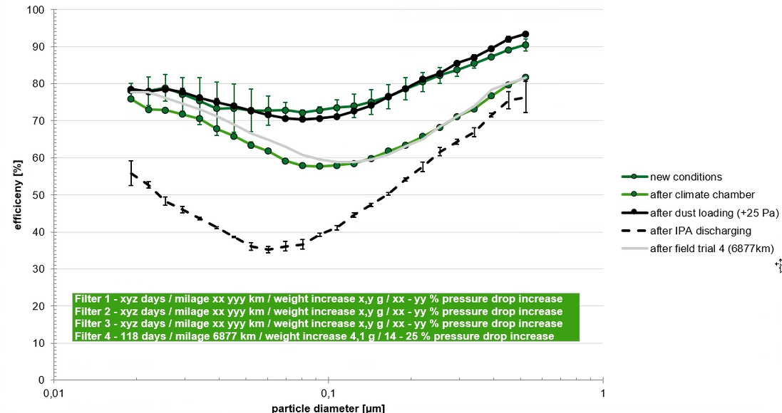
MANN+HUMMEL GMBH; Germany | 8.3.1 |  | te | Different measurement method for mobile NO2 measurement: ICAD - iterative cavity-enhanced differential optical adsorption spectroscopy - method | Add both methods as ICAD is state of the art
MANN+HUMMEL GMBH; Germany | 8.4.1 |  | te | NO2 values can be up to 1 ppm in special cases (e.g. tunnel,…)  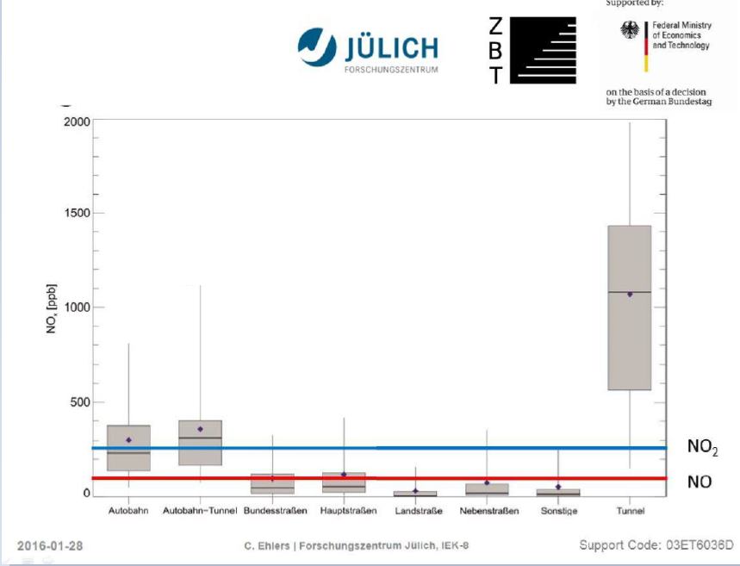 | Increase measurement rang for NO2 up to 1000 ppb
MANN+HUMMEL GMBH; Germany | 8.5 |  | te | Measurement devices like Grimm MiniWRAS or Palas Fidas Frog have higher time resolutions (1 min / 6 s) | 1-2s time resolution is recommended but deviations up to 1 min allowed
MANN+HUMMEL GMBH; Germany | 9.3.2 |  | te | PM2.5 average values in Germany are mainly below the minimum value of 30 µg/m³. Also WHO guideline recommends values from 5 µg/m³ (annual) to 15 µg/m³ (24h) | Decrease PM2.5 limit to 5 µg/m³ similar to CEN/WS 103 paper
MANN+HUMMEL GMBH; Germany | 9.4.1 |  | te | Whats the background of the vehicle condition? Therefor weather must be stable over many day´s in a row. | Vehicle condition directly before the series of measurement.
MANN+HUMMEL GMBH; Germany | 11.1.3 |  | te | What is dynamic calibration?  If deviations (e.g. level of measurement points) occur a correlation factor is probably required.

Donnay Detoxicology LLC (DD) / USA | 3.2 |  | ed, ge | “test substances” should include carbon monoxide (CO), and apparently did in earlier versions as CO is still included in Table 8.4.1. CO emissions per km from petrol vehicles (and per second when idling) are greater than emissions of PM, NO, and NO2 combined. CO also is of much greater toxicological concern, annually poisoning more people in every country than any other toxin.  In vehicle emissions, only the CO--and not the PM, NO, or NO2--is documented to cause acute poisoning of occupants with symptoms that include painful headaches, vomiting, nausea, blurry vision, shortness of breath, and blacking out. Thousands of consumer complaints about CO poisoning have been reported to US NHTSA about many makes and models in the last 10 years, including at least 12 crashes, one of which killed two law enforcement officers.  According to road testing of a 2016 Ford Explorer done by KATRI and presented to the VIAQ on Jan 29, 2019. CO levels in the cabin during a realistic road test climbed steadily to about 80 ppm within 15 minutes and were still climbing when the test was stopped. See slide 13p in  https://wiki.unece.org/download/attachments/75531403/VIAQ-15-11%20Proposal%20for%20the%20test%20mode.pdf?api=v2  This is higher than the 50 ppm and 70 ppm thresholds for home CO alarms required in the EU and USA, respectively.  There is less need to include NO in any cabin testing protocol because NO correlates closely with NO2 in vehicle emissions, is not regulated separately from NO2, is very short-lived, and has never been associated with any acute poisonings or deaths of vehicle occupants.  In contrast, CO does not track closely with either the level of particulates or NO2 in petrol engine exhaust. This is clearly shown in a presentation about emissions from Euro -4,-5 and -6 vehicles given by Daisy Thomas of 3DATX at the 2023 PEMS conference at UC Riverside in USA (see slide 65)  https://3datx.com/wp-content/uploads/3DATX-OPUS_Enhanced-PTI-Pilot_Prelim-Results_221122.pdf  So even if automakers can show NO2 and PM remain below safe limits, they cannot assure anyone that more dangerous CO also is low. | Delete nitrogen monoxide and replace with carbon monoxide.
DD/USA | 3.3 |  | ge | "Background concentration" should not be defined as those measured “on the on-road surface layer.”  Background levels outside and inside the vehicle cabin are needed to make sense of both PM2.5 and gas measurements. Instead of recording only the background outdoor levels at the road surface, the outdoor levels should be measured via the outdoor sampling line located near the fresh air inlet. The background of interior cabin air should be measured separately at the same time for PM, NO2, CO and CO2. | Change definition of "Background concentration" to specify that “interior background” and “exterior background” concentrations are defined as “the 5-minute average of levels measured through the exterior and interior cabin air sampling lines, respectively, when the vehicle engine and climate controls are turned off, all doors and windows closed, the driver and passenger are inside, and other environmental conditions as specified in Section 12.2.
DD/USA | 4.2 |  | ed, ge | As discussed in 3.2, there are more important health to measure CO than NO. I recommend adding abbreviation for CO. | Add CO abbreviation for carbon monoxide, CAS# 630-08-0
DD/USA | 7.1 |  | ed | Draft says “The selection of vehicles should be based on a worst case to minimize testing cost.” But there is no definition of “worst case.” Also not clear why the choice of vehicle should affect testing cost. All relatively new vehicles should have approximately the same cost to evaluate, install equipment, run tests, and remove equipment when finished. | Add definition or explanation of “worse case”
DD/USA | 7.1 vs 7.2 |  | ed | Vehicles with 3000 to 15000 km that have been driven for at least one month should not be described as new. Since consumers typically start driving a new car with under 100 km, I recommend this be the limit. | Delete 7.2 and change 7.1 to specify “new vehicles from serial production with less than 100 km”
DD/USA | 8.1. |  | ge, te | As discussed at 3.2, there is much more need and rationale to test for CO than NO. All gases, including both CO and CO₂, should be sampled both inside and outside the cabin. If CO₂ is sampled only inside, as draft recommends, it will not be possible to know if high CO₂ levels measured in cabin are due more to occupants exhaling or vehicle exhaust entering from outside | Delete nitrogen monoxide;  Add carbon monoxide;  Specify that all pollutants should be measured “both inside and outside the vehicle cabin”.
DD/USA | 8.2.2. |  | te | The external sampling point should NOT be “as close as reasonably possible to the ventilation air intake” because fresh air intakes are usually located in the middle to the rear of the engine compartment, not ahead of the engine. As such these vents may be contaminated by any gases, oils, or particulates leaking from the engine or exhaust manifold. To sample true background air, the external sampling hose should be installed so that the open end is not under the hood/bonnet but protrudes from under the leading edge of the hood/bonnet for a few centimeters. | Replace with “The external sampling line should protrude 2 cm from under the front of the hood, in line with the fresh air intake closer to the cabin. The sampling line should be securely taped so it is open facing forward, not up, down, left or right.”
DD/USA | 8.3.2. |  | te | CO also is best measured with an NDIR analyzer. | Change to “For carbon dioxide (CO₂) and carbon monoxide (CO):”
DD/USA | 8.4.1. | 8.4.1. | ed, te | This table includes a line for Carbon Monoxide among the test substances, which I support keeping. It does not include CO2, however, which I assume the author means to include and which I also support. The 5000 ppm max detection limit proposed for CO is high enough, but the max for a CO2 analyzer should be at least 10 times higher (50000 ppm). When 4 or 5 adults are in a vehicle with windows closed and HVAC in recirculate mode, CO levels quickly exceed 5000 ppm. Since NO is less important to measure than CO or CO2, I suggest deleting it. | Delete line for Nitrogen Dioxide  Add line for Carbon Dioxide, specifying measurement range of no more than 100ppm to no less than 50000 ppm.
DD/USA | 9.2.4. |  | ed, te | Weather conditions need to limit wind speed in order to assess the real-world worst-case scenario, which occurs when wind speed is calm or at least below 10 km/hr. | Add “and wind speed below 10 km/hr”
DD/USA | 9.3.1 |  | te | To test real-world worst-case scenarios, the driving test should be conducted during morning or evening rush hours when outdoor background levels of air pollutants are highest. If background levels exceed the WHO Air Quality Guidelines for indoor and outdoor air, a second test should be done during non-rush hours. | Add “The test should be conducted on weekdays during morning or afternoon rush hours (7am-9am; 4:00 pm to 6pm). If background levels of any of the air pollutants exceed any of the WHO air quality guidelines, the test should be repeated during non-rush hours.”
DD/USA | 9.3.2. |  | ed, te | The maximum allowable background air pollution levels both inside and outside the cabin should be as specified in the WHO 2021 Air Quality Guidelines. There should not be any required minimums for background air pollution, either inside or outside the cabin.  The proposed minimum PM2.5 of 30 ug/m3 is unnecessary and much higher than WHO recommends. It is also higher than the majority of the world experiences. See figure 2 from Pia et al 2022 that is attached below.  https://pubs.acs.org/doi/10.1021/acs.estlett.2c00203#  If CO measurement is added as recommended in place of NO, then NO can be deleted here as well. | Replace entire section with “Background levels of PM and gases measured inside and outside the cabin when the engine and HVAC are off shall not exceed the lowest WHO Air Quality Guidelines for indoor and outdoor air.”
DD/USA | 9.3.4 |  | ed | “should be avoided” instruction is not clear as “should not be used” in 9.3.3 and elsewhere | Change: Fragrances and air fresheners “…should be avoided” to “…should not be used”
DD/USA | 9.3.6 |  | ed | Same comment as 9.3.4. | Change: The occupants “should avoid” applying any fragrances” to “should not”
DD/USA | 9.3.7 |  | ed | To be consistent with prior sections, “shall” should be “should” | Change: “shall” to “should”
DD/USA | 9.5. |  | te | HVAC system settings specify only an automatic mode (when air vents may be open or closed) and a manual mode (in which air vents are open), but no sections specify which mode is to be used at which times during the test. 9.6.2. instructs only to “adjust HVAC operation mode” after starting engine, but not how to adjust it.  Neither of these modes captures the real world worst-case accumulation of air pollutants inside vehicles, however. This occurs when all windows and vents are closed and the HVAC is in recirculate mode with the fan on high. This mode creates negative pressure inside the vehicle during accelerations that cause exhaust gases to be pulled into the cabin through air extractors, drain holes, and any other unsealed holes or seams in the body. | Add: “for recirculation mode: fan speed 100%, AC on max, with all vents closed”  Add “During 1 hour test, each of the 3 ventilation modes should be tested for at least 10 minutes on urban roads and 10 minutes on highways. On each type of roadway, the recirculation mode should be tested from first, followed by the manual mode, and then the automatic mode.”
DD/USA |  |  |  |  | Worst case scenario starts with the driver and 3 adult passengers inside for 5 minutes with engine off, then a 30 second cold start, with fresh air closed, AC on high, backing up first through exhaust, then driving forward,
D/USA | 9.6. |  | te | “Real driving test procedure” should not include driving for at least 10 minutes before the start of the road test as proposed in 9.6.2, or driving for an additional unspecified time and distance to the start of the test route, as proposed in 6.3. The vehicle showed be towed to the starting point so it can be test driven from a cold start with cold tires, after background levels have been measured inside and out, with driver and passenger inside | Add: “Vehicle should be transported to the starting point of the test on a flatbed tow truck, with all windows closed. At the site, driver and adult passenger should enter vehicle and turn all the analyzers on during the background measurements made for 5 minutes before the driver starts the engine.”
DD/USA | 9.6.1 |  | te | Background measurements of environmental variables made before starting the engine need to include the same measures taken outside and inside the cabin. | Add: “With the driver and at least one adult passenger, switch on GPS logger and all instruments. Take background measurements of air pollutants, relative humidity, air temperature and pressure both inside the cabin and outside using the installed sampling lines and analyzers for at least 5 minutes before starting the engine and record max.”
DD/USA | 9.6.2 |  | te | After the background test, the GPS logger, and PM and gas analyzers should all be left on, so they are already on when the engine is started. The HVAC mode setting needs to be specified in 10-minute windows. HVAC should start with worst case manual recirculate mode, then test manual fresh air mode, then test auto mode. | Delete: “switch on PM analyzers and drive for at least 10 minutes”  Add: “Change the HVAC settings every 10 minutes after starting the engine, starting with recirculation mode using 100% fan, then fresh air with 50% fan, and then automatic mode with 50% fan.”
DD/USA | 9.6.3 |  | te | As discussed above at 9.6, the vehicle should be towed, not driven, to start of test route (mis-spelled rote), and the analyzers for both outside and cabin air should be kept on after the initial 5-minute background test. To replicate worst case real-world scenario when pollution emissions are highest, the test drive should begin quickly after a cold start. | Replace with: “Wait 1 minute after starting the engine and then start driving the test route.”
DD/USA | 9.6.4. |  | ed | Route is mis-spelled | Change “rote” to: “route”
DD/USA | 9.6.5 |  | te | All analyzers should be kept on for 5 minutes after the test is completed, the vehicle is parked, and the engine and HVAC are turned off, while the driver and passenger remain inside with the windows closed. This is needed to measure how quickly any still higher than outdoor levels of air pollutants inside the cabin decrease is off. | Replace with: “At the conclusion of the driving test, park the car and turn the engine and HVAC off but leave all windows closed and analyzers on for 5 more minutes.”
DD/USA | 9.6.6. |  | te | As discussed at 9.6.5. analyzers should be not turned off until 5 minutes after the engine. | Replace with: “Turn off all the analyzers 5 minutes after turning off the engine. After analyzers are turned off, driver and passenger may exit the vehicle.
DD/USA | 9.6.7 |  | te | All measurement data from all insturments should be saved, not just the protocols of PM and GPS analyzers | Replace with: “Save all data from the GPS, PM and air pollution analyzers to a computer.”
DD/USA | 9.6.8 |  | te | There is no need to turn all the instruments back on to do another background test after the 5-minute test recommended in 9.6.5 is completed. | Replace with “Review all test results to see what percent of the measurements for each variable were successfully recorded. If over 90% for PM, NO2, CO and CO2, the test is complete and the instruments can be removed from the vehicle. If not, the test is incomplete and should be repeated or abandoned.”
DD/USA | 10.1 |  | te | Calculation of results needs to specify how to present result of NO2, CO and CO2 gas measurements. I recommend reporting the min, max, and mean of each pollutant recorded during the different HVAC modes (recirc, fresh air, and auto). | Add subsection specifying that “Results of gas measurements made before, during and after the test drive should be reported by their mean, minimum and maximum in each period. Within the test drive, results should be given separately for each HVAC mode.”
DD/USA | 11.1.3 to 11.1.7 |  | te,ge | These sections only address PM and CO2 analyzers, not NO2 or CO analyzers. But all the detail they provide is unnecessary, and some may conflict with manufacturer instructions. Sections 11.1.1 and 11.1.2 are sufficient. | Delete Sections 11.1.3 to 11.1.7
DD/USA | 12.2 |  | te | Quality control requirements for road test should include wind speed <10 km/hour and time of day during morning or afternoon rush hours (between 7-9am or 4-6pm) | Add row to table requiring speed <10 km/hr  Add row to table requiring initial testing during rush hours  Change “PM” in row 9.3.2 of table to “all pollutants” and change criterion to “below WHO Air Quality Guidelines”

Regarding 3.2. Data on CO correlations with particulates and NOx inside tailpipes, presented by
Daisy Thomas and of 3DATX at the 2023 PEMS conference at UC Riverside in USA (see slide 65)

https://3datx.com/wp-content/uploads/3DATX-OPUS_Enhanced-PTI-Pilot_Prelim-Results_221122.pdf

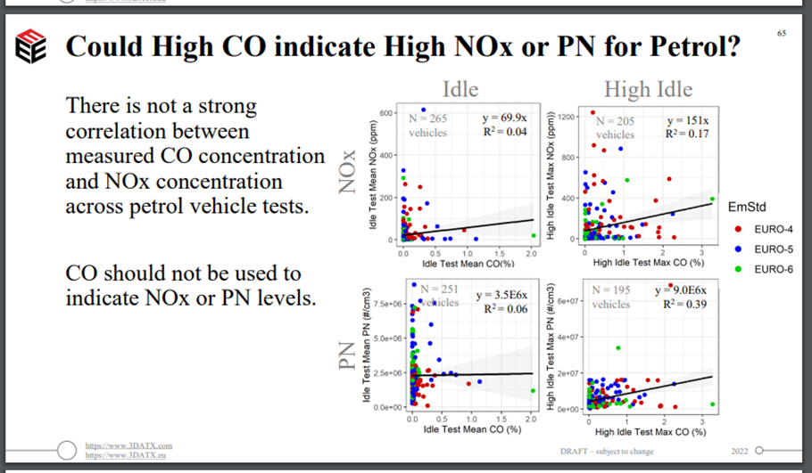

Regarding 9.3.2. Data on average annual exposure to NO2, published by Pia et al 2022,

https://pubs.acs.org/doi/10.1021/acs.estlett.2c00203#
Note that 50% of world population is exposed to annual average PM2.5 below 20 ug/m3,
so it does not make sense to require a higher minimum of 30 ug/m3.
