  - A-LCA Methodology draft

A-LCA Methodology

Green text: Fully agreed
Orange text: Partially agreed
Turquoise text: Discussion ongoing

Accepted text-> Purple

Terms for the definition section

Table of Contents
Table of Content
Preamble 5
1. Statement of technical rational and justification 6
1.1 Introduction 6
1.2 Methodology background 6
1.3 Technical rationale and justification 6
2. Mutual Resolution 7
2.1 Introduction 7
2.1.1 Terminology 7
2.1.2 Future Reviews 7
2.2 General Methodology 7
2.2.1 Level Concept 8
2.2.2 Definition of Product Category 12
2.2.3 Functional Unit 12
2.2.4 System Boundaries 12
2.2.5 Environmental Impact category 13
2.2.6 Data Quality & Data Collection Method 14
2.2.7 Cut-off 15
2.2.8 Energy Modelling 15
2.2.9 Allocation Rules 17
2.2.10 Recycling Modelling 20
2.2.11 Biogenic Carbon & Negative Emissions 21
2.2.12 Logistics 21
2.2.13 Chain of custody 22
2.2.14 Carbon offsets 24
2.3 Definitions 24
2.4 Abbreviations 31
2.5 General Provisions 31
2.6 Normative Reference 31
3. Specific Methodology per Life Cycle Stages 32
3.1 Material Production Stage 32
3.1.1 Declared Unit 32
3.1.2 Automotive Material Classification 32
3.1.3 Data Collection & Type 32
3.1.4 Energy Modelling 32
3.2 Parts Production & Vehicle Assembly 32
3.2.1 LCA Levels in Parts Production and Vehicle Assembly 32
3.2.2 Declared Unit 34
3.2.3 System Boundaries 35
3.2.4 Data collection & type 35
3.2.5 Logistics 40
3.2.6 Energy Modelling 42
3.3 Use Stage 42
3.4 End of Life 42
4. Reporting 43
5. Verification 44
Annex 45
A 1. Additional Guidance on Classifying Waste vs Co-product 45

Table of Figures
Figure 1: Relationship of standards 8
Figure 2: General structure of Life Cycle Assessment according to ISO 14040 9
Figure 3: Evolution of implementation areas for vehicle LCAs and involved stakeholders 10
Figure 4: Examples of high quality LCAs in different levels 12
Figure 5: System boundaries 13
Figure 6: Product, Co-Product or Waste 17
Figure 7: Waste vs. co-product classification hierarchy based on EU Waste Framework Directive 18
Figure 8: Multi-output allocation decision procedure 19
Figure 9: System boundaries for transportation. 21
Figure 10: Overview of chain of custody models 22
Figure 11: System boundaries in production. 35
Figure 12: Definition of PCF_{as} 36
Figure 13: PCF cascade of primary data for an exemplary supply chain 37
Figure 14:Calculation of an aggregated DQR 40
Figure 15: Definition of Scopes. 40
Figure 16: Distribution center on supplier side. 42
Figure 17: Distribution center on customer side. 42

Table of tables
Table 1: General structure of the level concept 11
Table 2: Possible variances of primary and secondary data. 14
Table 3: Explanation chain of custody models 22
Table 4: Primary data share of the example as in Figure 12 37
Table 5: Sample scoring criteria for performing a qualitative data quality assessment. 38
Table 6: Transportation between supplier and customer. 41

Preamble

Statement of technical rational and justification

Introduction

Methodology background

Technical rationale and justification

Mutual Resolution

Introduction
The mutual resolution is based on the attributional LCA approach. This approach seeks to determine the environmental impacts associated with a vehicle’s life cycle. The global warming potential (GWP), expressed in CO₂ equivalents, is attributed to a specific unit of a product by adding up the CO₂ equivalents of all attributable processes along its life cycle.

Terminology
Clarification on ISO expressions used in the rulebook:
The following definitions apply in understanding how to implement an ISO International Standard and other normative ISO deliverables:
- The term “shall” indicate what is required to be compliant with this rulebook.
- The term “should” indicate a recommendation rather than a requirement. Any deviation from a “should” recommendation must be justified by the party conducting the study and made transparent.
- The term “may” indicate an option that is permissible.
- The term “can” is used to indicate that something is possible, for example, that an organization or individual is able to do something.
Additional definitions of frequently used terms throughout the rulebook can be found in the Glossary.

Future Reviews

General Methodology
The methodology of this resolution is based on the product carbon footprint standard ISO 14067 and the ISO 14040 and 14044 life cycle assessment standards (Figure 1).
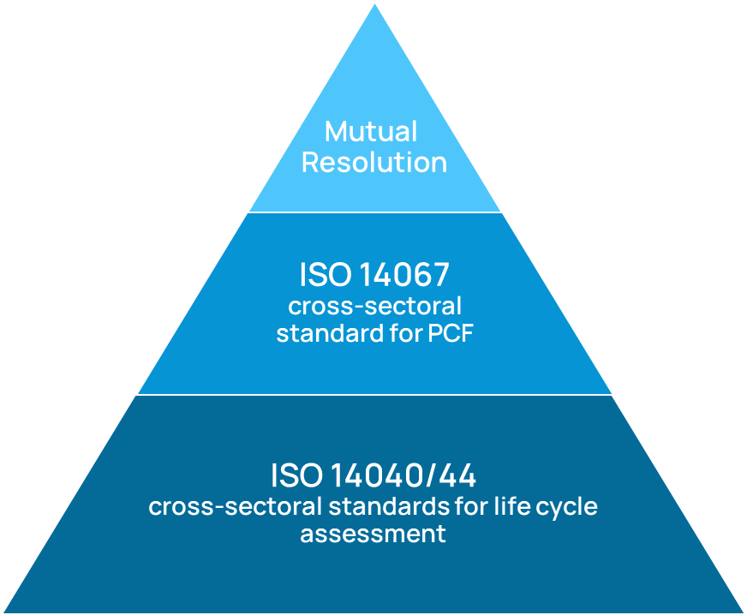
Figure 1: Relationship of standards
Existing rules shall be applied according to the following hierarchy:
- The analysis shall be based on the principles laid down in ISO 14040/44
- The product carbon footprints shall be calculated in accordance with ISO 14067.
- Automotive-specific requirements shall be applied as defined in this document.

Level Concept
Goal & Scope Definition
The level concept was developed in UNECE IWG A-LCA to reflect the different motivations and goals to tackle a vehicle LCA. The importance of LCA has grown considerably in recent years and the number and type of use cases for LCA expanded as a result. The Level Concept also takes into account the increasing demand for LCA results based on primary data. By transparently addressing these new forms of vehicle LCAs and their input data variation, the Level Concept helps to ensure a consistent application of the vehicle LCA method and the appropriate selection of a product system model for an intended application.
Background
According to ISO 14040 standard, a life cycle assessment (LCA) consists of four steps as visualized in Figure 1.
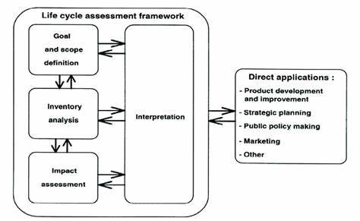
Figure 2: General structure of Life Cycle Assessment according to ISO 14040
Goal and scope definition is the first step of these four. In this step the study is defined in detail and central choices are made regarding its conduct.
“The goal definition shall firstly state the intended application(s) of the LCA results in a precise and unambiguous way. … The decision-context is one key criterion for determining the most appropriate methods for the LCI model.” (ILCD handbook)
In a nutshell, it is crucial to know the intended purpose and application of an LCA to define appropriate requirements for modelling the product system.
At the same time, vehicle LCAs are used by a growing number of stakeholders for an increasing range of different purposes and applications. Traditionally, vehicle LCAs were mainly used in R&D for technology comparisons and support of strategic decision making (e.g. which powertrain / material / production technology / … is environmentally superior?) or by OEM’s to show that their successor models were more environmentally friendly than the previous ones (continuous improvement). This is also reflected in the list of direct applications in ISO 14040 (compare Fig. 1, box on the right). Currently, an extension of applications towards reduction measure implementation and reporting – especially in the context of decarbonization and circular economy (CE) – can be observed (see Figure 2).
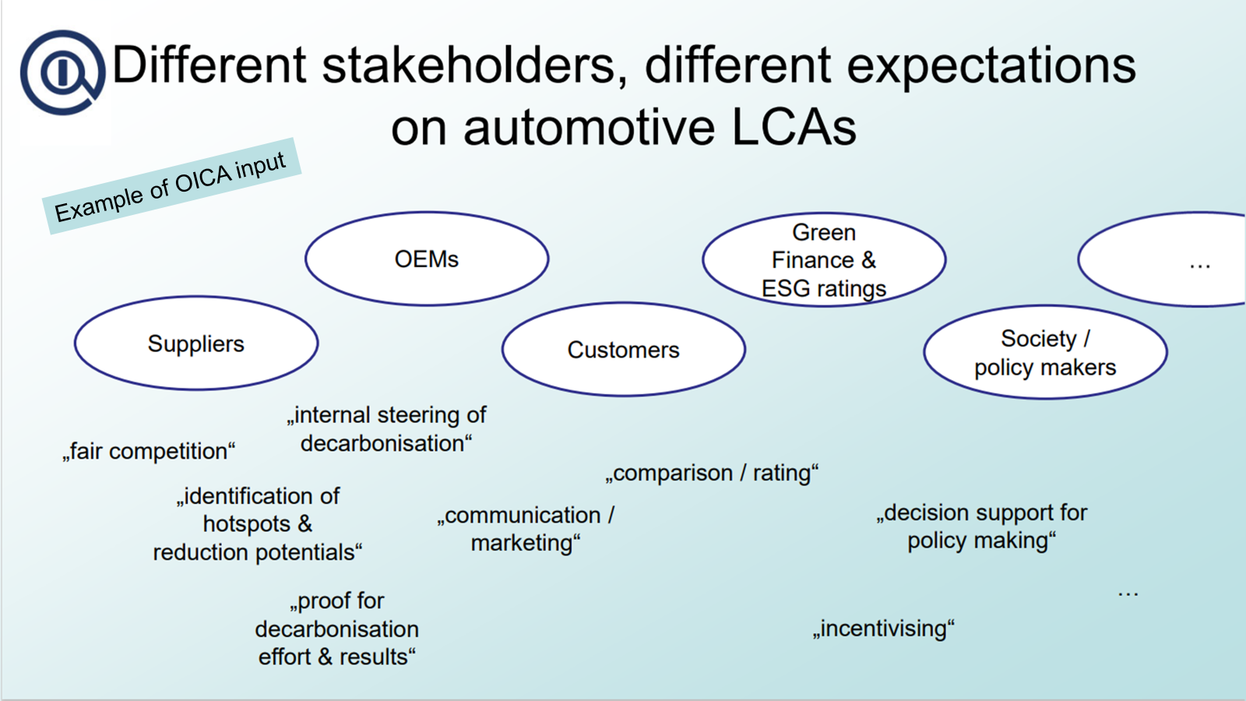
Figure 3: Evolution of implementation areas for vehicle LCAs and involved stakeholders
As a consequence, this resolution on vehicle LCA addresses different types of vehicle LCA use cases and highlights where these require different scope definitions and requirements concerning methodology, quality, reporting, and review.
Use cases and application of Level Concept
The Level Concept distinguishes four different levels based on the underlying questions of the assessment. This could range from “what is the right mobility concept for a city?”
to “what is the carbon footprint of a certain vehicle model?”. This leads to different requirements for the product system model especially with regard to the upstream life cycle phases in the foreground system (supply chain and vehicle production).

- Level 1 (multiple approaches possible)
- Purpose
  - General uses, including research and strategic public policy making
  - Strategic planning: future projection, fleet modeling, etc.
- Vehicle modeling
  - Generic fuel-powertrain model normalized by vehicle mass
  - Generic part and material composition
  - User-defined vehicle model
- Approach for the application of the level concept
  - Flexible in applying “mix&match” of levels from different life cycle stages, depending on the purpose of the study, availability of data, etc.
  - For comparability and transparency, practitioners should specify the discrete levels (“mix&match”) used for their applications

- Level 2 (multiple approaches possible)
- Purpose
  - OEM’s internal assessment and strategic planning
  - Product development and improvement
  - Marketing
- Vehicle modeling
  - Existing vehicle model of choice for assessment
  - Bill of material (BOM) & material information system (IMDS/CMDS) for composition
- Approach for the application of the level concept
  - Flexible in applying “mix&match” of levels from different life cycle stages, other than vehicle modeling, depending on the purpose of the assessment
  - For comparability and transparency, practitioners should specify the discrete levels (“mix&match”) used for their applications

- Level 3 (single fixed approach)
- Purpose
  - OEM’s official reporting
  - Reporting for government programs
- Vehicle modeling
  - Representative vehicle for reporting
  - Bill of material (BOM) & material information system (IMDS/CMDS) for composition,
  - for hotspot parts applying “part-by-part” supply-chain modeling instead
  - Harmonized material classification
- Approach for the application of the level concept
  - Each lifecycle stage should specify one fixed, proper level for one harmonized A-LCA approach.

- Level 4 (single fixed approach)
- Purpose
  - OEM’s and supplier’s official reporting
  - Reporting for government programs
- Vehicle modeling
  - Representative vehicle for reporting
  - Full supply-chain and vehicle production modeling
- Approach for the application of the level concept
  - Full lifecycle modeling (material production, part & vehicle production, usage, and end-of-life)
  - Rules required for chain of custody
According to questions of the assessment granularity, product specificity and scope of foreground and background is chosen. To put it the other way round: Whereas a level 1 study is representative of a broad range of products, e.g. all category 1-1 vehicles, level 4 is more focused on the fine variations of individual vehicle models.
The choice of representativity / specificity also concerns downstream life cycle phases (WTW / use phase, EoL) or background system processes (e.g. energy production). Also, for the use phase or EoL the data for a specific vehicle could be used. This implies however that the LCA is done retrospective. For many use cases the analysis (declaration) point in time is the moment the product is put on the market. Consequently, the following life cycle stages can only be analyzed prospectively. For predictive data it is obvious that average data (e.g. for lifetime milage) are used. It is also obvious that for predictive data there is no way to provide primary data, as you cannot measure something that happens in the future.
Table 1: General structure of the level concept
 | Purpose | Degree of freedom | vehicle model | supply chain model
Level 1 | strategy | multiple approaches possible | generic | generic
Level 2 | strategy | multiple approaches possible | BOM¹ & MDS² | generic
Level 3 | reporting | single fixed approach | BOM¹ & MDS² | partly specific
Level 4 | reporting | single fixed approach | BOM¹ & MDS² | mainly specific
¹BOM bill of material, ²MDS material data system

The vehicle representing a big population of vehicles in Level 1 are very often no real but virtually defined vehicles. Consequently, no primary data exists, and only secondary data can be used to model e.g. supply chain emissions. On the other hand, Level 4 profits from more and more use of primary data representing the real / company specific supply chains.
So far there is the general observation, the more granular/detailed a system model for a LCA is, the higher the identified emissions are. Unless there is an abundance of LCA data to derive highly representative and high-quality secondary data, situation will stay like that. It is crucial to understand that the magnitude of emissions is only comparable between studies on the same level. Vehicle LCAs with different level choice may not be compared on a quantitative basis.
This does not imply any rating on the quality of studies. A Level1LCA is not necessarily of lower quality than a Level 4 study. Both serve different purposes / use cases (strategy focused or reporting focused) and therefore have different underlying “models of reality”.
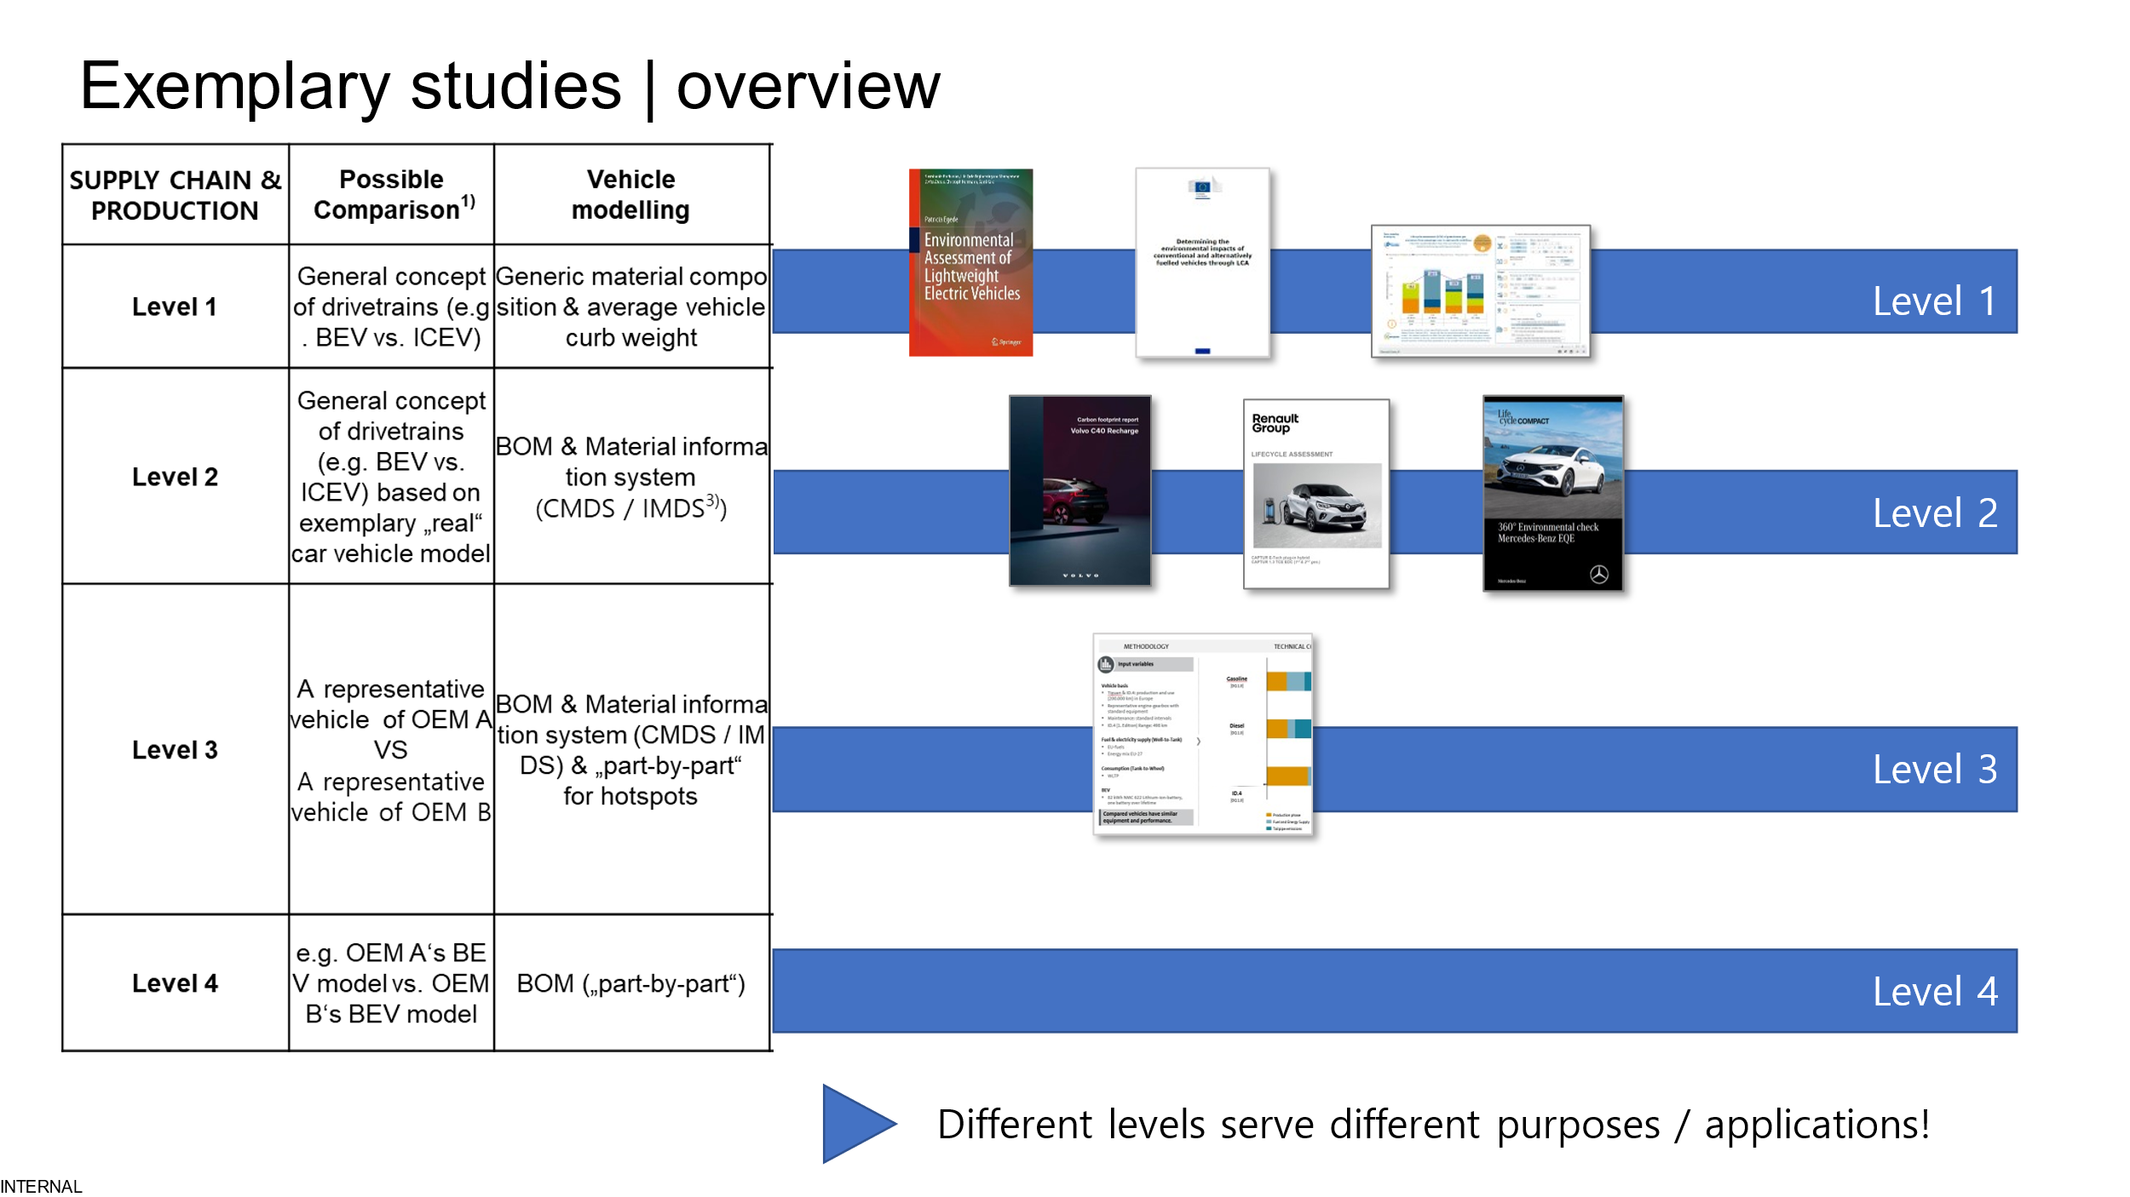
Figure 4: Examples of high quality LCAs in different levels

Definition of Product Category
Category 1-1 vehicles (light duty passenger cars)

Functional Unit
The functional unit of an automotive vehicle life cycle assessment is defined on final vehicle level (product sold with intent use transport).

System Boundaries
In general, the life cycle of a vehicle comprises following life cycle stages: (1) resource extraction, raw material sourcing, (2) production of materials & parts (3) production (bodyshop, paint and general assembly) of complete vehicle (4) logistics and distribution (5) product use (including maintenance) and (6) end-of-life (Figure 2).
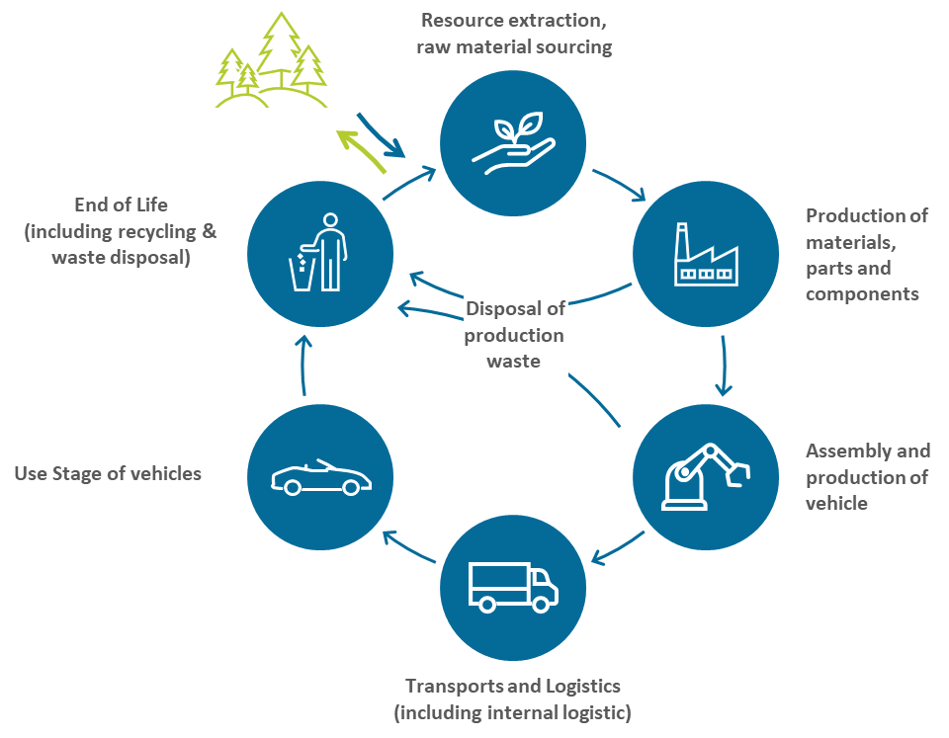
Figure 5: System boundaries

Environmental Impact category
Climate Change is the selected environmental impact category for vehicle life cycle assessment following this method.
The GHGs that shall be accounted for are carbon dioxide (CO₂), methane (CH₄), nitrous oxide (N₂O), hydrofluorocarbons (HFCs), perfluorinated compounds, sulfur hexafluoride (SF₆), nitrogen trifluoride (NF₃), perfluorocarbons (PFCs), hydrofluoroethers (HFEs), perfluoropolyethers (e.g., PFPEs), chlorofluorocarbon (CFCs) and hydrochlorofluorocarbon (HCFCs). To ensure the latest required GHGs, please refer to IPCC AR.
The 100-year GWP characterization factors (GWP100y) according to the Intergovernmental Panel on Climate Change (IPCC) shall be used in the PCF calculations, based on the latest IPCC’s Assessment Report (AR). These factors include the climate carbon response for non-CO₂ gases, i.e., carbon feedbacks and chemical effects. Biogenic CO₂ shall be accounted for.
Once a new AR has been published, its characterization factors shall be used. If the characterization factors cannot be updated immediately, a transition period of two years after the publication of a new IPCC AR is granted after which the characterization factors shall be updated. If secondary data used are based on outdated characterization factors, this must be clearly stated and alternative datasets that use the latest characterization factors should be prioritised.
[Applicable during AR6 being the latest AR: The AR 6 characterization factors for the substances that are not listed in case of AR 6 in Table 7.15 of the IPCC AR6 shall be extracted from Table 7 SM6 in Section 7 Supplementary Materials of the AR6 Climate Change 2021.]
In addition to the total PCF including biogenic CO₂, the separate emission values shall be reported:
- Net fossil GHG emissions and removals
- Net biogenic GHG emissions and removals other than biogenic CO₂ (if applicable)
- Net biogenic GHG emissions and removals including biogenic CO₂ (if applicable)
- GHG emissions resulting from aircraft transportation (if applicable)
If separate emission values do not occur, these emission values may be reported as zero.
Removals in the PCF shall not include any measures not related to the product system usually referred to as carbon offsets (see 2.2.14).
In addition, the biogenic carbon content and total carbon content of products shall be reported separately. If mass-balanced materials are used in the supply, the attributed biogenic carbon content shall additionally be reported to accurately account for emissions from combustion of these materials.

Data Quality & Data Collection Method
Temporal representativeness:
The reference year for the secondary data shall correspond to the assessment period of the activity data. For instance, the electricity consumption mix corresponding to the year of assessment, or the most representative year shall be employed for the calculations.

Geographical representativeness:
The geography of the data shall correspond to the activity data most geographically relevant to the process. For instance, the electricity consumption mix corresponding to the geography of the product (country or state if available) shall be employed for the calculations.

Technological representativeness:
The secondary data source shall correspond to the activity data that is technologically representative of the process. For instance, the electricity or heating generation mix shall be representative of the source of energy used.

Primary data
Primary data is a quantified value of a process, an activity obtained from a direct measurement, or a calculation based on direct measurements.
Efforts shall be taken to increase the share of primary data as well as achieve high data quality for both secondary and primary data, (for data quality rating see 3.1.3).
Primary data shall include primary activity data, i.e., a technical flow, and primary GHG emission factor, i.e., the carbon footprint of the corresponding activity expressed in kgCO₂eq per unit (Table 1). Consequently, the measured materials consumptions and a secondary GHG emission factor is not considered as primary data. Primary data may be obtained through meter readings, purchase records, utility bills, engineering models, direct monitoring, material or product balances, stoichiometry or other methods for obtaining data from specific processes in the value chain of the company. A single calculation might include both primary, secondary data and a mix of both expressed by the primary data share. For example, calculating emissions from the consumption of electricity could involve primary activity data, such as data on consumption in kWh, multiplied by a secondary emission factor provided by national GHG inventories representing GHG emission intensity (CO₂eq per kWh).

Table 2: Possible variances of primary and secondary data.
Approach | Direct emission measurement
Primary data | Source of emission is within company boundaries and is measured
Approach | Activity data source |  | Emission factor source
Approach | Energy | Material | Energy | Material
Primary data | Consumption measured  (primary) |  | For on-site production  Emission measured (primary)  For supplier-specific electricity  - Primary with gua-rantee of origin | Measured and reported as a share by supplier
Secondary data | Consumption/production measured (primary) |  | Secondary databases, data proxy

The data may need to be scaled, aggregated, or otherwise mathematically processed to relate it to the declared unit or the reference flow of the process. Mathematical modelling may be used to fill in the missing data, or data aggregation may be required to attenuate the effect of revisions, turnarounds, or other atypical production conditions.

Secondary Data
In general the goal to use primary data whenever feasible shall be pursued. If the use of primary data is not feasible secondary data may be used. Ideally, the use of secondary data warrants the following crucial requirements:
- When using secondary data, a conservative estimate shall be applied. With this, the motivation to replace secondary by primary data shall be strengthened.
- Even if the use of secondary data is required, any eventual competitive distortion shall be avoided.
- The selection of secondary data shall be guided by the representativeness criteria (see xx) to limit errors introduced into the PCF calculation. The effort to search for data with the fewest errors needs to be balanced with economic feasibility to the extent that misleading results are avoided.
- Secondary data shall be accessible to all stakeholders, regardless of size, economic power or experience in life cycle assessment.
Three principal approaches can be followed to harmonize the use of secondary data with respect to the requirements mentioned above:
- Definition of prescriptive secondary data
- Definition of a whitelist of data sources
- Definition of hierarchy for secondary data sources

Data Quality Rating

Cut-off
In general, all processes and flows that are attributable to the analyzed system shall be included. If, based on the results of a screening analyses, individual material or energy flows are found to be insignificant for the carbon footprint, these may be excluded for practical reasons (see ISO 14067, PEF method). Process modules, inputs and outputs may only be excluded if their sum represents less than 3% of the total product carbon footprint. This 97% coverage shall be achieved and documented in a screening analysis.
An initial screening of the Life Cycle Inventory (LCI) of (a) representative vehicle(s)/product(s) shall be performed and, referred to as the screening step. The screening pursues the goal to point out needs of action in terms of data collection activities or activities to improve data quality. A screening shall include the Life Cycle Impact Assessment (LCIA) for the Impact Category Global Warming Potential and allow further refinement of the PCF system model of the product(s) in scope in an iterative manner as more information becomes available. Within screening, no exemption is allowed, and readily available primary or secondary data may be used, fulfilling the data quality requirements to the extent possible.
To determine the 97% coverage, the PCF data received from upstream reporting entities and emission factors shall be considered as 100%, as direct insights in the actual coverage of the upstream processes are at least very difficult if not impossible.
Once the screening is performed, the initial scope settings may be refined. The representative product approach and a description of the excluded attributable processes shall be documented.
Compliance can be proven on a product category or sectoral level and does not have to be executed on a product level. Product category rules or sectoral guidance can specify simplified rules to be applied.

Energy Modelling
This methodology follows the idea to account GHG of all life cycles. Consequently, the energy modelling follows the same principle and covers all GHG emissions form the cradle or well of energy to the final use.

Accounting for GHG emissions from electricity
For each process that requires electricity, the GHGs emitted by this specific energy use must be determined. All GHG emissions resulting from the use of the required electricity (cradle-to-gate) shall be included in the product carbon footprint.
To calculate the share of electricity consumption in the product carbon footprint, generator-specific emission factors shall be used. Depending on the type of electricity generation, different amounts of greenhouse gases are emitted. The factors used shall take into account upstream emissions (e.g., the mining and transport of fuel to the electricity plant or the growing and processing of biomass for use as an energy source), emissions during the generation of electricity (e.g., combustion of fossil fuels) including losses during transmission and distribution and downstream emissions (e.g., the treatment of waste arising from the electricity plants).

Electricity from a directly and dedicated connected generator
If electricity is produced on site with a direct connection to the power generator (e.g., photovoltaic plant on the roof, wind park beside the production facility, own fossil power plant) or a direct connection to a power generator operated by a power supplier, the amount of electricity consumed by this power generator and the related emission factor shall be used if no contractual instruments have been sold to a third party. Otherwise, the country-specific residual grid mix shall be used.
As verification of using electricity from the company's own facilities, proof of installation of the company's own generation technology as well as a meter reading shall be available. The amount of electricity and the period of the meter reading shall be equal to the amount of electricity required and the respective period. In addition, the meter reading should be confirmed by a third party to prove that the specified generation technology, the respective period and the amount of electricity generated are in fact as stated.

Electricity (from a power supplier or) via contractual instruments
If electricity is accessed via a contractual instrument, the following electricity mix shall be used:
1. Supplier-specific electricity product shall be used if:
- a tracking system is installed in the country.
- the set of minimum criteria to ensure the contractual instruments are reliable is met, i.e., no double counting and no exclusions.
2. Total supplier-specific electricity mix, i.e., the share of electricity supply specific to the supplier, shall be used if the set of minimum criteria is met to ensure the contractual instruments are reliable.
The country-specific residual grid mix (consumption mix) shall be used (such as AIB for Europe). Country-specific means the country in which the activity occurs.
The regional residual grid mix (consumption mix), or region representative residual grid mix, consumption mix, shall be used.
If residual grid mixes are not available, grid-specific fossil production mixes shall be used.
In general, three different reference types can be defined for contractual instruments:
Utility Tariffs
When using an electricity supply contract, electricity is purchased from a supplier via the public grid.

Energy Attribute Certificates (EACs)
EACs should enable renewable energy to be tradable. An EAC is a certificate that proves that one megawatt hour of electricity was generated from renewable energy and transferred into the electricity grid. EACs can be separated from the physical quantity of electricity and therefore traded independently. Depending on the region, different systems are in place for trading Energy Attribute Certificates. For example, International Renewable Energy Certificates (iRECs) are traded through an international registry as a renewable energy instrument. In contrast, Renewable Energy Certificates (RECs) or Guarantees of Origin (GoOs) are examples of verification instruments in specific regions.

Power Purchase Agreements (PPAs)
A PPA is an electricity supply contract concluded directly between an electricity producer (plant operator) and an electricity consumer. The contract specifies the delivery of a certain amount of electricity over a particular period at an agreed price. In general, the types of PPAs can be differentiated. There are physical PPAs, which can be further subdivided into on-site and off-site, and virtual PPAs.
Electricity from PPAs can only be considered an eligible linked with EACs.
The contractual instrument used to calculate the related emission factor shall meet the following minimum criteria:
It shall convey the information associated with the unit of electricity delivered together with the characteristics of the generator.
It shall be assured with a unique claim and therefore be the only instruments that carry the environmental attribute claim associated with that quantity of electricity generated.
It shall be tracked and redeemed, retired or cancelled by or on behalf of the company (e.g., by an audit of contracts, third-party certification, or may be handled automatically through other disclosure registries, systems, or mechanisms).
It shall refer to the same year to which the contractual instrument is applied.
The attribute tracking instrument shall refer to an electricity production asset located in the same regional market (within which an interconnection can be proven).
If the electricity consumed comes from more than one electricity mix, each mix source shall be used in terms of its proportion in the total kWh consumed. If a certificate of origin covers only a part of the consumed electricity, the residual grid mix shall be used for the uncovered amount.
In addition to the emission factors as shown in the contractual instrument of the electricity, the following GHG emissions shall be taken into account:
Upstream emissions (e.g., the mining and transport of fuel to the electricity plant, the growing and processing of biomass for use as an energy source or construction and maintenance)
Downstream emissions (e.g., the treatment of waste arising from the electricity plants)

Allocation Rules
In case a process has more than one output the question how to allocate the CO₂e-burden to the outputs arises. Outputs of a process can be viewed as products, co-products or waste. Products or co-products share the CO2e-burden of the production/generation process, whereas waste eventually increases the CO2e-burden for the product. In a first step the question waste or product must be answered (see Figure 3)

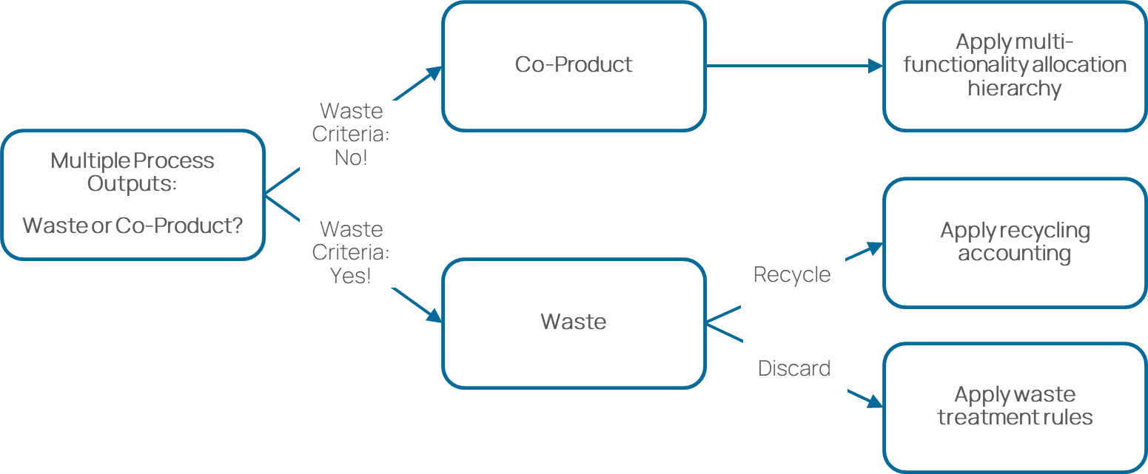
Figure 6: Product, Co-Product or Waste

Waste vs. Co-Product
Waste is any material or process output which is not deliberately produced as an integral part of a multi-output production process. No further use of the material or process output is certain. Additionally, the holder discards or intends to discard or is legally required to discard the residue based on national waste legislation.
Waste materials with certain further use but requiring further treatment other than normal industrial practice before use (i.e., waste recovered by recycling) shall follow the requirements on material recycling.
“Normal industrial practice” can include all steps which a producer would take for a product, such as the material being filtered, washed, or dried; or adding materials necessary for further use; or carrying out quality control. However, treatments usually considered as a recovery operation cannot, in principle, be considered as normal industrial practice in this sense. Some of such processing tasks considered as normal industrial practice can be carried out on the production site of the manufacturer, some on the site of the next user, and some by intermediaries, as long as they also meet the criterion of being ‘produced as an integral part of a production process’ (adopted from the EU’s Guidance on the interpretation of key provisions of Directive 2008/98/EC on waste).
A co-product in contrast is produced as an integral part of a multi-output process where its further use is certain. Typically, co-products directly replace a raw material or fuel without requiring further processing other than normal industry practice. For co-product allocation, multi-output allocation applies (please refer to section Allocation Rules).
The following hierarchy shall be applied (please refer to Annex A1 for definitions of the respective criteria):

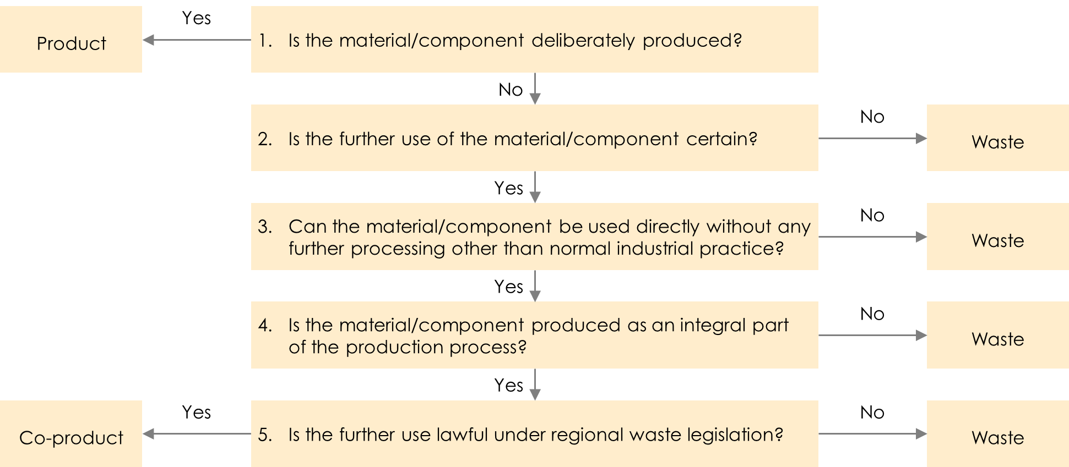
Figure 7: Waste vs. co-product classification hierarchy based on EU Waste Framework Directive
Residues classified as waste following the hierarchy can also be transformed into recycled feedstock. However, this transformation would require further processing other than normal industry practice (see point 3 in Figure 4), such that the residue would be classified as waste in the first instance.
Pre-consumer scrap that is not reintroduced into the same process (i.e., all scrap except run-around scrap) shall be defined as waste unless legal evidence (following legislation of the region where scrap is generated, e.g., legal judgement or legal report from regional waste legislation) exists that classifies the pre-consumer scrap material as co-product.

Waste Treatment
Any GHG emissions arising from the treatment of production waste shall be included in the total PCF. Waste can be generated during different stages of a product’s life cycle (cradle-to-gate), including:
- Resource extraction, raw material sourcing
- Production of materials, semi-finished products
- Production of vehicle parts and components
- Logistics to supplier gate (including internal logistics)
- End of Life of the vehicle
All auxiliaries and energy inputs and waste outputs shall be fully considered in the calculation of the product carbon footprint. Cut-off rules as described in Section 2.2.7 shall be applied.
The party generating waste is responsible for treatment until final disposal (for example, incineration or landfill). This is also referred to as the “polluter pays principle”. If additional processes follow the end-of-waste state, then these are attributed to the company using the recycled or reused material flow as a secondary material.
The impact of preparatory steps and supporting activities such as collection, transportation, sorting, dismantling, or shredding shall be added to the inventory results of the product system generating the waste.
The impact of the process treating waste with energy recovery (e.g., incineration) shall be added to the inventory results of the product system that generated the waste treated in the process.
The energy recovered from the waste-to-energy process shall be treated as free of burdens. Burdens or credits associated with previous or subsequent life cycles are not considered. The general practice in the automotive industry is following the polluter pays principle, i.e., allocating waste treatment emissions to the product system generating the waste.
Production processes may also generate material scrap that is recycled. In this case, please see Section 2.2.10.
GHG emissions shall be calculated using primary data regarding the type of waste, its composition and type of waste treatment activity. Depending on the type of waste treatment (for example landfill or incineration), companies may use waste treatment emission factors based on internal primary data. If no primary emission factors are available, emission factors derived from accepted secondary databases can be employed.
If no primary data for waste treatment are available, waste treatment emissions should be estimated based on primary data on the waste type and composition and specific emission factors according to the quantity and type of waste treatment and final disposal (landfill, incineration).

Multi-output Allocation
Allocation shall be avoided whenever possible. If allocation cannot be avoided, follow the approach in Figure Figure 5.
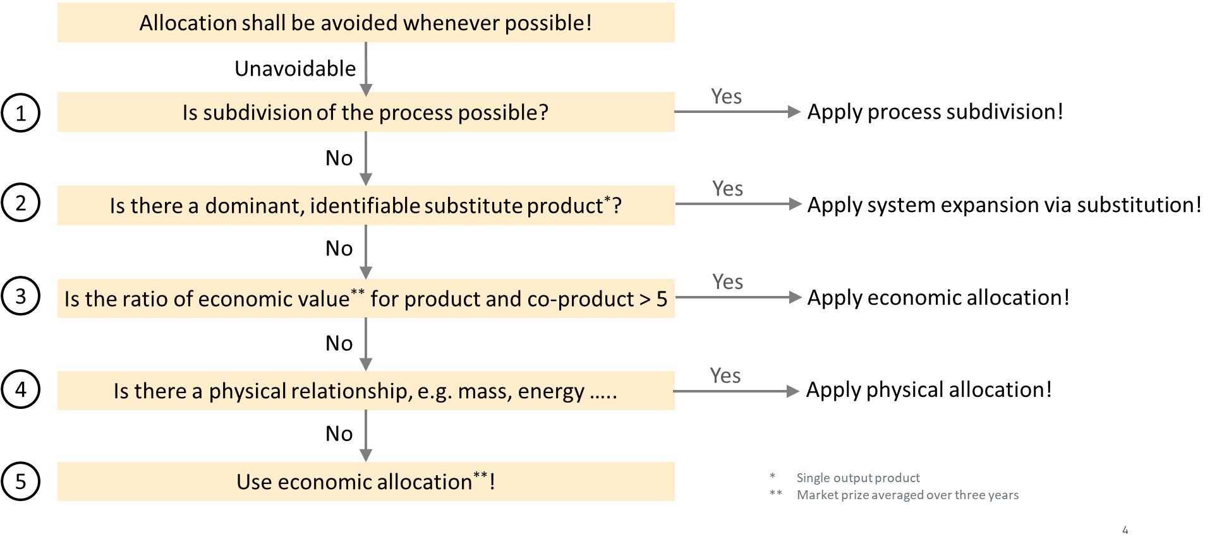

Figure 8: Multi-output allocation decision procedure
If allocation cannot be avoided and subdivision is possible, subdivision shall be applied. Subdivision refers to disaggregation of multifunctional processes or facilities to isolate the input flows directly associated with each process or facility output.

If subdivision cannot be applied, but a dominant substitute product can be identified, expanding the product system to include the additional functions related to the co-products shall be applied. System expansion via substitution shall only be used if no new multi output allocation is introduced.
System expansion via substitution should only be used if there is a dominant, identifiable displaced product and production path for the displaced product based on sector consensus. Dominant means that the production process is the main process on the market. If available, positive lists of co-products and displaced products based on sector consensus shall be used to model the system expansion and the respective substitution credits. For the emissions data, primary data shall be used, and secondary data may only be used if primary data is not available. In case of secondary data, the requirements in section 6.15 shall apply to guarantee that the dataset and source for calculating system expansion credits are compliant. If no sector consensus exists, the following requirements shall always be fulfilled:
  - The production of the co-product is an integral part of the production process.
  - A dedicated, single-output process to produce the co-product exists.
  - The alternative dataset must be representative of the dominant production route.
  - A clear description of the process for selecting the alternative product substituted by the co-product shall be documented.
Double counting shall be avoided. No market-mediated effects shall be applied, as the attributional LCA approach shall be used.

When allocation cannot be avoided, no subdivision is possible and no dominant substitute product can be identified, companies shall calculate the ratio of the economic value of the reference product to each co-product per declared unit. This ratio is employed in the next step of the decision tree to determine the most suitable allocation approach. For the use of economic values, sales prices shall be averaged over the last 3-5 years to smooth out fluctuations. If sales prices are not available or not applicable, other economic factors can be applied (e.g., cost).

If the calculated economic value ratio is equal or lower than five, companies shall apply allocation using a physical relationship to partition inputs and outputs between the studied co-product(s). The physical relationships to choose from are:
- produced masses
- produced pieces
- contained exergy
- contained energy

If the calculated ratio is higher than five, companies shall apply an economic allocation using economic value as criterion to partition inputs and outputs between the studied co-product(s).
For the determination and use of economic allocation factors, the following hierarchy shall be applied. Only one type of economic allocation factor shall be chosen consistently in the order of priority of the hierarchy. Only if the respective prioritized factor is not available, the next factor in the hierarchy may be chosen. The chosen factor shall always be averaged over the last multiple years to smooth out fluctuations. A period of 3-5 years is recommended, and a systematic approach should be internally documented for materials with high fluctuations of the selected factor of price/ cost.
- Global market price (global market prices are usually only available for commodities)
- Regional market price
- Other economic allocation factors (i.e., production costs or sales price)

Recycling Modelling
Recycling plays a crucial role in enabling a circular economy and reaching climate protection goals. In particular, recycling of currently unused or inefficiently used material streams is key to reducing primary material use as well as environmental burdens related to current waste treatment. The environmental burden of the recycling process needs to be distributed between the systems receiving and providing the secondary material.
Shifting the environmental burden of the recycling process may create an increasing demand for recycled material. These steering effects can lead to technology shifts, enabling emission reductions and/or increased material efficiency in the industry.
The allocation hierarchy in ISO 14044 does not account for the steering effects and no specific allocation hierarchy for recycling is provided. In principle, ISO 14044 applies the same allocation hierarchy for multi-output systems. However, specific assessment approaches for recycling are described in ISO 14044: Avoided burden for the primary production route and cut-off. Avoided burden of the primary production route usually incentivizes the provision of material for recycling at the end-of-life and, thus should only be applied if these incentives lead to overall emission reductions. However, if environmental incentives can lead to overall emission reductions, this highly depends on the market situation and requires a detailed analysis. Consequently, the cut-off EOL allocation (i.e. recycling content method) approach shall be applied due to the following reasons:
- Ease of use
- Avoidance of double counting
- Higher comparability of PCFs
The product system generating material for recycling follows a cut-off approach in a cradle-to-gate scope. Preparatory steps for recycling shall generally be allocated to the waste receiving system (i.e., the product system using the (to be) recycled material). This deviation from the polluter pays principle (as required for waste-to-energy, incineration, or disposal emissions) is a pragmatic exemption as following the polluter pays principle in this context would require defining material- and component-specific system boundaries. Other than the emissions from the respective preparatory steps and the recycling treatment emissions, to be recycled, to be re-used, or to be re-manufactured materials enter the product system using recycled material burden-free.
For pre-consumer scrap, preparatory steps owned by the company generating the waste shall be accounted for by the producer of the waste (they might be insignificant; cut-off rules apply).

Biogenic Carbon & Negative Emissions
Uptake of atmospheric CO₂ shall be assigned with a characterization factor of -1 kg CO₂eq per kg CO₂; the emission of CO₂ shall be assigned with a factor of 1 kg CO₂eq per kg CO₂. If plants absorb atmospheric CO₂, the CO₂ uptake shall be considered in the separate emission value 3 (Net biogenic GHG emissions and removals including biogenic CO₂).

Logistics
In addition to emissions from production, manufacturing, use stage and end of life, there are also emissions from the transportation and logistics of vehicles, products, or materials.
Emissions from transportation shall cover emissions from well-to-wheel, i.e., the system boundaries span from energy provision, production and distribution ending at the transportation operation itself. Emissions from the production of the transportation means and infrastructure, e.g., roads, vehicles, ships and railways, shall not be included.
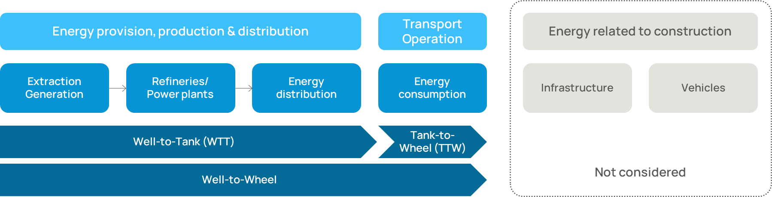
Figure 9: System boundaries for transportation.
In case of transport chains (transport of a product by more than one transport mode) the chain links shall be individually quantified and subsequently summed up.
The ultimate approach of quantifying transportation emissions shall be based on measuring the fuel and energy consumption of a trip and multiplying it by the emission factor of the fuel/energy that covers all upstream emissions of the fuel/energy. Only transport emissions quantified on the basis of measured fuel/energy consumption shall be considered as primary data. In case of collective transport the primary data based transport emissions require allocation to the individual product. Such allocations do not change the classification of emission data as being primary data.
Direct measurement of fuel/energy consumption of a transport operation may however not always be possible and modelling transport emissions is required. Calculation of transport emissions shall follow the recommendation set out in the GLEC Framework V3.0, except for the mandate to include emissions from the construction and dismantling of energy infrastructure. The GLEC framework allows for three approaches to establish transport distances: Shortest feasible distance (SFD), great circle distance (GCD) and actual distance. These approaches shall be used according to the following hierarchy:
- Actual distance
- SFD
- GCD
Emissions reduction from the use of low-carbon fuels may only be claimed if a statement of sustainability (origin and emissions reduction) for the fuel is provided as issued by a bonded warehouse.

Chain of custody
Chain of custody is an administrative process by which information about materials is transferred, monitored, and controlled as those materials move through supply chains [ISO 22095:2020]. There are, in principle, four possible chain of custody models, illustrated in Figure 10. Their common objective is to guarantee correct accounting and corroborate a link between ingoing content, e.g., ‘sustainable’, ‘recycled’ or ‘organic’ by harmonized definitions, and the final outgoing product. They differ whether it is a physical or administrative link. Furthermore, they differ in the set of rules for balancing, and the option to keep materials streams segregated or not.

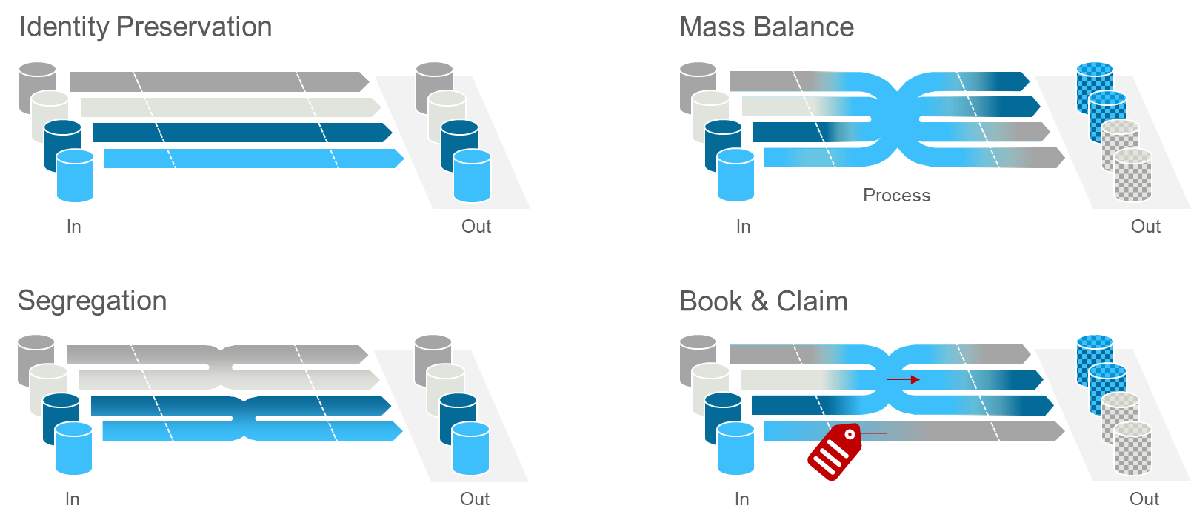
Figure 10: Overview of chain of custody models

The following table was adapted from the above-cited Whitepaper and provides high-level explanations and differentiations for the four chain of custody models:
Table 3: Explanation chain of custody models
[adapted from the above-cited EMF Whitepaper Table 1, page 11]
Model | Explanation | Example
Identity preservation | It is possible to physically track the product to its desired origin, ensuring unique traceability and physical separation of products from other sources along the supply chain. | Buying food from a single certified producer.
Segregation | Consists in the aggregation of volumes of products of identical origin or produced according to the same standards in one stock item. | Buying food from a trader that exclusively handles identically certified supplies
Mass balance | Considering the output, no physical or chemical difference exists between in-scope and out-of-scope. It involves balancing volume reconciliation to ensure the exact volumes of in and out-of-scope source is maintained along the supply chain. Given that the volume or the ratio of sustainable material integrated is reflected in the product produced and sold to customers. This model requires that a reconciliation period is defined (e.g., a month, a year). | Buying a certain percentage of a supply from certified origin. Applies to, e.g., sustainable forestry for wooden materials, recycled, bio-based or renewable materials, organic cotton
Book and claim – restricted certificate trading | The certified product/component is disconnected from the certification data but belongs to the same production system or value chain. The certified product evolves in separate flows from the certified supply. Certificates are issued at the beginning of the supply chain by an independent body reflecting the sustainable content of supplies. The intended outcome is that outputs from one supply chain is associated with total claims corresponding to the certified input. | Buying material with renewable/recycled/ biobased content.  Certificates with guarantee of origin or comparable certifications declaring e.g., recycled, renewable, biobased content.  CO₂ capture certificates from a production system controlled by the company, e.g., carbon capture and storage.

To calculate the PCF according to this mutual resolution, all types of models may be taken into account if the requirements listed below are met and an independent third-party chain of custody verification for the balance of materials is available. The balance between input and output shall be correct.
The mass balance approach helps enable fossil raw materials to be replaced by more sustainable alternative materials (e.g., with recycled content, bio-content). In contrast to a segregated use of alternative raw materials, mass balance enables the use of existing production networks with low or no investments into new process technologies and production facilities. A book and claim model can be applied when there is no direct connection between the final product and the certified supply. An example of a book and claim model is applied in green electricity markets and receives more attention in other sectors as way to support circular transformation of the industry; therefore, it is accepted as a solution.

Guiding principles
In implementing chain-of-custody methods, including mass balancing, the following set of guiding principles shall be fulfilled:
- The use of chain-of-custody approaches shall achieve significant changes and an effective transition towards a more circular, more bio-based and lower GHG emissions production in complex value chains.
- The choice and implementation of chain-of-custody approaches and models shall be transparent, clear, and credible – abiding by relevant standards such as ISO and CEN.
Note: Certification schemes are not yet available in all sectors.
- Labels and claims referring to chain-of-custody controlled specified characteristics and used on products shall fulfill the following requirements:
  - description of the chain-of-custody approaches and models
  - accurate and appropriate implementation of the chain-of-custody model
  - compliant with existing standards and regulations
  - non-misleading
If the “specified characteristic” content in products cannot be measured and verified, labels and claims shall mention this. For example, this often applies to mass balancing (e.g., chemically recycled content in plastics).
- No double counting: A reliable accounting system shall be installed at each operating site to ensure that the claimed volume on the output side exactly matches the actual volume on the input side within the declared time and regional scope.
Additional requirements for a mass balance chain of custody approach:
- The operating sites in the spatial boundaries for mass balancing are under the operational control of the same company/corporate group/joint venture.
- It shall be technically possible according to standard industry practice to produce a mass-balanced product from an alternative feedstock. Share of mass-balanced material can be technically lower than the attributed share.
- Applied emissions factors for the mass-balance system boundaries shall be product and process specific.

Carbon offsets
Any GHG offsets (such as defined in the glossary) shall be excluded from the reported PCF.
If applicable, offsets shall be reported separately from the PCF. This includes both offsets with and without certificates. If carbon offsets have been purchased, they shall transparently mention the origin of reported carbon offsets and refer to the original certificate.
For rules on taking a renewable electricity certificate into account, refer to Section 2.2.8.
Any carbon-neutrality claims based on carbon offsetting for automotive products are out of the scope of the here described methodology.

Definitions
Term | Definition | Source
Allocation | Partitioning the input or output flows of a process or a product system between the product system under study and one or more other product systems | DIN EN ISO 14040, Feb. 2021
Attributable process | Those processes that consist of all service, material and energy flows that become, make and carry a product throughout its life cycle. | WBCSD Pathfinder
Attributionable | Process-based modelling intended to provide a static representation of average conditions, excluding market-mediated effects. | PEF guidelines (EC-JRC, 2021)
Average data | Production-weighted average of specific data | PEF guidelines (EC-JRC, 2021)
Bill of Materials | A bill of materials or product structure (sometimes bill of material, BOM or associated list) is a list of raw materials, sub-assemblies, intermediate assemblies, sub-components, parts and the quantities of each needed to manufacture the product in the scope. In some sectors it is equivalent to the bill of components. | Adapted from PEF guidelines (EC-JRC, 2021)
Biogenic carbon | Carbon derived from biomass | DIN EN ISO 14067, Feb. 2019
Biomass | Material of biological origin, excluding material embedded in geological formations and material  transformed to fossilized material. Biomass includes organic material (both living and dead), e.g. trees, crops, grasses, tree litter, algae, animals, manure and waste of biological origin. Biomass excludes peat. | ISO 14 067 /  ISO 14021
Carbon offsetting | Mechanism for compensating for a full PCF or a partial PCF through the prevention of the release of, reduction in, or removal of an amount of GHG emissions in a process outside the product system under study | DIN EN ISO 14067, Feb. 2019
Characterization factor | Factor derived from a characterization model, which is applied to convert an assigned life cycle inventory analysis (3.4.26) result to the common unit of the category indicator (3.10.8) | ISO 14050:2020, 3.6.23
Climate Change | Environmental Footprint impact category considering all inputs and outputs that result in greenhouse gas (GHG) emissions. The consequences include increased average global temperatures and sudden regional climatic changes. | PEF guidelines (EC-JRC, 2021)
Closed-loop recycling | In a closed loop, the secondary material from one product system is either reused in the same product system (real closed-loop) or used in another product system without changing the inherent technical properties of the material (quasi closed-loop). | ISO 5157:2023(en), 3.2.6.6
CO₂eq (carbon dioxide equivalent) | Unit for comparing the radiative forcing of a greenhouse gas to that of carbon dioxide | ISO 14050:2020(en) Environmental management — Vocabulary, 3.9.3.
Co-product | Any of two or more products coming from the same unit process or product system | DIN EN ISO 14067,  Feb. 2019, p. 22
Cradle-to-gate | System boundary that is applied for a partial PCF assessment that includes a part of the product’s life cycle. Cradle-to-gate represents the GHG emissions and removals arising from all life cycle stages, up to the point where the product leaves the production site (the ”gate”). This explicitly excludes the life cycle stages use and end-of-life. | adapted from TFS PCF Guideline and in reference to ISO 14067 6.3.4.2 System boundary options
Cradle to grave | A product’s life cycle that includes raw material extraction, processing, distribution, storage, use, and disposal or recycling stages. All relevant inputs and outputs are considered for all of the stages of the life cycle. | PEF guidelines (EC-JRC, 2021)
Cut-off criteria | Specification of the amount of material or energy flow or the level of significance of GHG emissions associated with unit process or the product system, to be excluded from a PCF study | DIN EN ISO 14067, Feb. 2019
Declared unit | Quantity of a product for use as a reference unit in the quantification of a partial PCF | DIN EN ISO 14067, Feb. 2019
Direct emissions | GHG emissions from the processes that are owned or controlled by the reporting company | WBCSD Pathfinder
Downstream emissions | Indirect GHG emissions that occur in the value chain following the processes owned or controlled by the reporting company | WBCSD Pathfinder
Elementary flow | Material or energy entering the system being studied that has been drawn from the environment without previous human transformation, or material or energy leaving the system being studied that is released into the environment without subsequent human transformation | DIN EN ISO 14067, Feb. 2019
End-of-life | Point in time during the life cycle at which a product or resource is taken out of use and is disposed. | ISO/DIN 59004
End of Life allocation | Rules that define how to allocate environmental credits and/or burdens derived from reuse, recycling or recovery of materials and products after the vehicles’ first life cycle (after End of Life vehicle disposal) | Adapted from DIN EN ISO 14040/44 and ILCD handbook
End-of-waste | The end-of-waste state for waste in Europe is reached when the material is no longer considered waste under the national implementation of the Waste Framework Directive. | EN 15804
Functional unit | Quantified performance of a product system for use as a reference unit | DIN EN ISO 14067 / ISO 14040 : 2006
GLEC framework | Global Logistics Emissions Council framework, to harmonize the calculation and reporting of logistics GHG emissions across multi-modal supply chains. | Smart Freight Center GLEC
Global warming potential (GWP) | Index, based on radiative properties of GHGs, measuring the radiative forcing following a pulse emission of a unit mass of a given GHG in the present-day atmosphere integrated over a chosen time horizon, relative to that of carbon dioxide (CO₂) | DIN EN ISO 14067,  Feb. 2019
Greenhouse gases (GHGs) | Gaseous constituent of the atmosphere, both natural and anthropogenic, that absorbs and emits radiation at specific wavelengths within the spectrum of infrared radiation emitted by the Earth’s surface, the atmosphere, and clouds | DIN EN ISO 14067,  Feb. 2019
ILCD Format | International Life Cycle Data Format
Indirect emissions scope 2 | GHG emissions from the generation of purchased or aquired electricity, steam, heating, or cooling consumed by the reporting compagny | adapted from GHG Protocol
Indirect emissions scope 3 | All indirect emissions (not included in scope 2) that occur in the value chain of the reporting compagny, including both upstream and downstream emissions | GHG Protocol
Infrastructure emission | Embodied emissions that arise due to the production or dismantling of infrastructure.  Note 1: infrastructure refers to any capital goods e.g. production facilities, energy provision (powerplants, transmission lines) or transport services (roads, railways, vehicles).  Note 2: emissions arising from the operation of infrastructure (operation of a power plant) is not understood as infrastructure emissions.
Input | Product, material, or energy flow that enters a unit process | DIN EN ISO 14040, Feb. 2021
Land use | Human use or management of land within the relevant boundary | DIN EN ISO 14067,  Feb. 2019
Life cycle | Consecutive and interlinked stages related to a product, from raw material acquisition or generation from natural resources to end-of-life treatment | DIN EN ISO 14067,  Feb. 2019
Life cycle assessment (LCA) | Compilation and evaluation of the inputs, outputs and the potential environmental impacts of a product system throughout its life cycle | DIN EN ISO 14067,  Feb. 2019
Life cycle emissions | The sum of GHG emissions resulting from all stages of the life cycle of a product and within the specified boundaries of the product | WBCSD Pathfinder
Life cycle inventory (LCI) | The phase of life cycle assessment involving the compilation and quantification of inputs and outputs for a product throughout its life cycle (such as a product’s GHG emissions and sources) | DIN EN ISO 14067,  Feb. 2019, p. 25
Life Cycle impact Assessment (LCIA) | phase of life cycle assessment aimed at understanding and evaluating the magnitude and significance of the  potential environmental impacts for a product system throughout the life cycle of the product | DIN EN ISO 14040, Feb. 2021
Life cycle inventory results | GHG impact of the studied product per unit of analysis | GHG Protocol
Material | Physical goods that are further processed (and not consumed) in manufacturing processes. | adapted from WBCSD Pathfinder
Multi-input-output unit process | Operation or process with multiple inputs, such as materials and energy, and multiple outputs, such as co-products and waste | WBCSD Pathfinder
Negative emissions | Removal of greenhouse gases (GHGs) from the atmosphere by deliberate human activities, i.e., in addition to the removal that would occur via natural carbon cycle processes | IPCC glossary
Net negative emissions | A situation of net negative emissions is achieved when, as the result of human activities, more greenhouse gases are removed from the atmosphere than are emitted into it. Where multiple greenhouse gases are involved, the quantification of negative emissions depends on the climate metric chosen to compare emissions of different gases (such as global warming potential, global temperature change potential, and others, as well as the chosen time horizon). | IPCC glossary
Open-loop recycling | In open-loop recycling, the material is reused in other product systems and its inherent properties are changed (e.g., recycled material may have a different chemical composition, a different structure or a higher concentration of dissolved impurities compared to primary material). | Catena-X PCF Rulebook V2
Output | Product, material, or energy that leaves a unit process | DIN EN ISO 14040, Feb. 2021
Packaging | Any product to be used for the containment, protection, handling, delivery, storage, transport and presentation of goods, from raw materials to processed goods, from the producer to the user or consumer, including processor, assembler or other intermediary. | ISO 21067:2007(en)]
Partial PCF | Sum of GHG emissions and GHG removals of one or more selected process(es) in a product system, expressed as carbon dioxide equivalents and based on the selected stages or processes within the life cycle. | DIN EN ISO 14067,  Feb. 2019
Primary data | Primary data is a quantified value of a process, or an activity obtained from a direct measurement or a calculation based on direct measurements.  Primary data can include greenhouse gas emission factors and/or greenhouse gas activity data. Average data from industry associations or global averages do not qualify as primary data. | DIN EN ISO 14067,  Feb. 2019
Process | Set of interrelated or interacting activities that transforms inputs into outputs. | DIN EN ISO 14067,  Feb. 2019, p. 23
Product | any good or service  Note 1: The product can be categorized as follows:  ⎯ services (e.g. transport);  ⎯ software (e.g. computer program, dictionary);  ⎯ hardware (e.g. engine mechanical part);  ⎯ processed materials (e.g. lubricant).  Note 2: Services have tangible and intangible elements. Provision of a service can involve, for example, the following:  ⎯ an activity performed on a customer-supplied tangible product (e.g. automobile to be repaired);  ⎯ an activity performed on a customer-supplied intangible product (e.g. the income statement needed to prepare a tax return);  ⎯ the delivery of an intangible product (e.g. the delivery of information in the context of knowledge transmission);  ⎯ the creation of ambience for the customer (e.g. in hotels and restaurants).  Software consists of information and is generally intangible and can be in the form of approaches, transactions or procedures.  Hardware is generally tangible and its amount is a countable characteristic. Processed materials are generally tangible and their amount is a continuous characteristic. | DIN EN ISO 14040, Feb. 2021
Carbon Footprint of a Product  or  Product Carbon Footprint (PCF) | Sum of GHG emissions and GHG removals in a product system, expressed as  CO2 equivalents and based on a life cycle assessment using the single impact category  of climate change | DIN EN ISO 14067, Feb. 2019
Product category | Group of products that can fulfill equivalent functions. | DIN EN ISO 14067, Feb. 2019
Product category rules (PCR) | Set of specific rules, requirements and guidelines for developing Type III environmental declarations  and footprint communications for one or more product categories | DIN EN ISO 14040, Feb. 2021
Product system | Collection of unit processes with elementary and product flows, performing one or more defined functions, and which models the life cycle of a product | Adapted from ISO 14067: 2019
Raw material | Primary or secondary material that is used to produce a semi-finished good, product or service.  Secondary material includes recycled material. | Adapted ISO 14040/44
Reference flow | Measure of the inputs to or outputs from processes in a given product system required to fulfil the function expressed by the functional unit. | DIN EN ISO 14067,  Feb. 2019, p. 24
Reference vehicle | "Reference vehicle" means the version within a type of vehicle, which is identified by the Type Approval Authority, in consultation with the manufacturer and in accordance with the criteria laid down in Annex 1, paragraph 4. to this Regulation, as being the most problematic in terms of reusability, recyclability and recoverability; | UN-R133
Renewable Energy | Energy from renewable sources’ or ‘renewable energy’ means energy from renewable non-fossil sources, namely wind, solar (solar thermal and solar photovoltaic) and geothermal energy, ambient energy, tide, wave and other ocean energy, hydropower, biomass, landfill gas, sewage treatment plant gas, and biogas. | Renewable Energy Directive (2018/2001)
Representative product | The representative product can be a real or an averaged (non-existing) product. The averaged product should be calculated based on sales-weighted characteristics of all technologies/materials used in the company’s production system. | Catena-X PCF Rulebook V3
Risk management | Plans, actions, strategies, or policies to reduce the likelihood and/or consequences of risks or to respond to consequences. | IPCC Glossary
Secondary data | Data which do not fulfil the requirements for primary data.  Note 1: Secondary data can include data from databases and published literature, default emission factors from national inventories, calculated data, estimates or other representative data, validated by competent authorities.  Note 2: Secondary data can include data obtained from proxy processes or estimates. | DIN EN ISO 14067, Feb. 2019
Sectoral guideline | PCF reporting rules issued by industry associations or initiatives as guidance for their members, | Catena-X PCF Rulebook V3
Sensitivity analysis | Systematic procedures for estimating the effects of the choices made regarding methods and data on the outcome of a CFP study | DIN EN ISO 14067, Feb. 2019
Supplier gate | The supplier's factory (out-bound) gate, through which the product leaves the production site and is ready for shipment to the customer. | Catena-X PCF Rulebook V3
Supply chain | Those involved, through upstream and downstream linkages, in process and activities relating to the provision of products to the user. | DIN EN ISO 14067,  Feb. 2019
Sustainability | A dynamic process that guarantees the persistence of natural and human systems in an equitable manner. | IPCC Glossary, p. 49
System boundary | Boundary based on a set of criteria representing which unit processes are a part of the system under study. | DIN EN ISO 14040, Feb. 2021
Type III environmental declarations | Type III environmental declarations present quantified environmental information on the life cycle of a product to enable comparisons between products fulfilling the same function. Such declarations  ⎯ are provided by one or more organizations,  ⎯ are based on independently verifiedlife cycle assessment (LCA) data, life cycle inventory analysis (LCI) data or information modules in accordance with the ISO 14040 series of standards and, where relevant, additional environmental information,  ⎯ are developed using predetermined parameters, and  ⎯ are subject to the administration of a programme operator, such as a company or a group of companies, industrial sector or trade association, public authorities or agencies, or an independent scientific body or other organization. | DIN EN ISO 14025, Oct. 2011
Transport / distribution packaging | Packaging designed to contain one or more articles or packages, or bulk material, for the purposes of transport, handling and/or distribution. | ISO 21067: 2007(en)
Unit process | Smallest element considered in the life cycle inventory analysis for which input, and output data are quantified. | DIN EN ISO 14067,  Feb. 2019
Upstream emissions | Indirect GHG emissions that occur in the value chain prior to the processes owned or controlled by the reporting company. All upstream transportation emissions are also included as part of upstream emissions. | WBCSD Pathfinder
Use stage | That part of the life cycle of a product that occurs between the transfer of the product to the consumer and the end-of-life of the product. | Adapted from WBCSD Pathfinder
Value chain | All the upstream and downstream activities associated with the product system.
Waste | Materials, co-products, products, or emissions without economic value that the holder intends or is required to dispose of. | DIN EN ISO 14067,  Feb. 2019, p. 26;  WBCSD Pathfinder

Abbreviations

General Provisions

Normative Reference

Specific Methodology per Life Cycle Stages

Material Production Stage

Declared Unit

Automotive Material Classification

Data Collection & Type

Energy Modelling

Parts Production & Vehicle Assembly

LCA Levels in Parts Production and Vehicle Assembly
As introduced in section 2.2.1, the analysis of global warming potential can also be carried out for parts production and vehicle assembly in different levels of detail. In case the goal of the analysis is e.g. concerned with mobility concepts rather than individual vehicles or the specific details of the vehicle production are not the main interest, an archetypal vehicle production is included in the analysis. The cradle to gate carbon footprint of parts production or vehicle manufacturing can thus reflect:
- an average for a vehicle fleet (various segments, models on global or national level) -> Level 1
- an average for vehicles of a specific segment (various models on global or national level) or a vehicle chosen as representative for a specific segment both based on BOM-Data -> Level 2
- an average for specific vehicle models (with different equipment variants on global, national or local production site level) –> Level 3
- a specific vehicle model. -> Level 4
In the ideal case, the average values are calculated as weighted averages of a population of individual vehicles. If the analysis of the individual vehicle were based on real emission data (primary data), even the averages would reflect the correct averages of real emissions. As there is no abundance of analysis data on individual vehicles very often the average vehicle is defined by assumptions and modeling and secondary data is used to quantify the environmental impact.
Within this resolution four levels detail are differentiated.

Level 1
As described in 2.2.1 there are multiple approaches possible for Level 1, the following section minimum standard for calculation. GHG-emissions due to the production of vehicle parts and vehicle assembly are quantified with a (lump) carbon emission factor which is a function of net vehicle weight. All specific emission effects due to different materials, gross material input, different production processes or transport of parts or vehicles is included in the carbon emission factor. The calculation of vehicle carbon footprint from production is simply given by:
$$C_{VP}={CEF}_{VP}×M_{NM}$$
Wherein:
C_{VP} carbon emissions due to material production, component and vehicle manufacturing in kilogram of carbon dioxide equivalent (kgCO₂e)
CEF_{VP} Carbon emission factor of material production, component and vehicle manufacturing in kilogram of carbon dioxide equivalent (kgCO₂e/kg_{CW})
M_{NM} Net mass of the vehicle in kilogram (kg), i.e. mass of the vehicle in running order minus the mass of the driver (75kg) minus the mass of any fuels.
The CEF may be determined from literature or OEM publications. The carbon emission factors may reflect geographical differences, if there is evidence that material, component and vehicle production is more CO₂e-intense in some parts of the world than in others.
As no details on the production of the vehicle enter into the calculation, also the end of life emissions of a vehicle shall only be captured by the (lump) carbon emission factor.
For transparency all the factors used in calculation shall be reported.

Level 2
GHG-emissions due to the production of vehicle parts and vehicle manufacturing are quantified by breaking down the vehicle as delivered to the customer by mass of materials. Breaking down by material is obvious for the automotive industry because material and mass declaration systems are mandatory for decades. The calculation of the cradle to gate vehicle carbon footprint is given by:
$$C_{VP}=\sum_{i}{(M_{i}×U_{i}×{CEF}_{i})}+C_{OP}$$
Wherein:
C_{VP} carbon emissions due to material production processes, component production and vehicle manufacturing in kilogram of carbon dioxide equivalent (kgCO₂e)
M_{i} Net mass of the material i in kilogram (kg)
U_{i} use coefficient of material i in percentage of the gross material input relative to the net material input (%). The value is greater than 100% when offcut or loss is assumed.
CEF_{i} Carbon emission factor of material i reflecting material production processes, component production and vehicle manufacturing in kilogram of carbon dioxide equivalent (kgCO₂e/kg)
C_{OP} Carbon emissions reflecting vehicle manufacturing processes (OEM’s operation of bodyshop, paintshop and general assembly) in kilogram of carbon dioxide equivalent (kgCO₂e/vehicle)
Again, all specific emission effects due to different production processes or transport of parts or vehicles is included in the (lump) carbon emission factor. C_{OP} may be determined from literature or OEM publications. It may be justified to differentiate virgin or recycled materials. In that case the calculation is given as follows:
$$C_{VP}=\sum_{i}{(M_{i}(R_{i}×U_{i}×{CEF}_{i,R}+\left(1-R_{i}\right)×U_{i}×{CEF}_{i,V}))}$$
Wherein:
R_{i} share of recycled material i in percentage of the gross material input (%)
CEF_{i,V} Carbon emission factor of virgin material i reflecting material production, component and vehicle manufacturing in kilogram of carbon dioxide equivalent (kgCO₂e/kg)
CEF_{i,R} Carbon emission factor of recycled material i reflecting material production, component and vehicle manufacturing in kilogram of carbon dioxide equivalent (kgCO₂e/kg)
For transparency all the factors used in calculation shall be reported.

Level 3
The contribution of different subsystems of a vehicle to the GHG-emissions of vehicle production is by far not evenly distributed. Accounting these most relevant subsystems in terms of GHG-emissions from vehicle production (so called ‘hotspots’) in a more detailed manner differentiates Level 3 from Level2 in the calculation of the cradle to gate vehicle carbon footprint.
[Definition of Hotspots]
For those hotspot or key subsystems primary data based reporting is the preferred approach and the use of available site-specific primary data is mandated. In case primary data cannot be obtained, secondary data shall be used. Secondary data shall be traceable and based on field survey data and released by government authorities.
The calculation of vehicle carbon footprint from production is given by:
$$C_{VP}= \sum_{i}{{(C}_{HS,i}})+C_{BV}$$
Wherein:
C_{VP} carbon emissions due to material production processes, component production and vehicle manufacturing in kilogram of carbon dioxide equivalent (kgCO₂e)
C_{HS} carbon emissions due to manufacturing of hotspot subsystems (including material production processes and component production) and their assembly to the vehicle in kilogram of carbon dioxide equivalent (kgCO₂e)
C_{BV} carbon emissions due to material production, component and vehicle manufacturing with the exception of hotspot subsystems in kilogram of carbon dioxide equivalent (kgCO₂e)
C_{HS} is calculated according to Level 4 definitions. C_{BV} for the remaining vehicle materials, parts and production processes excluding hotspots follow the calculation defined for Level 2.
[Transport to be covered]

Level 4
GHG-emissions due to the production of vehicle parts and vehicle assembly are quantified by a stepwise attributional reporting of real emissions (site specific, primary data) for the material and components along the supply chain until the final assembly in the vehicle. For each Tier level this requires to add the GHG-emissions for the manufacturing of a product in its own operations to the sum of GHG-emissions of the purchased parts or materials for that product. Transport within the supply chain is accounted according to the definitions in section 3.2.5.
The calculation of vehicle carbon footprint from production is given by:
$$C_{VP}=\sum_{i}{\left(C_{T1,i}\right)+C_{op}}$$
$$C_{T,j}=\sum_{i}{(C_{Tj-1,i})}+ C_{op,j}$$
Wherein:
C_{VP} carbon emissions due to material production, component and vehicle manufacturing in kilogram of carbon dioxide equivalent (kgCO₂e)
C_{op} carbon emissions due to the vehicle manufacturer’s own operations for material production processes, component production and vehicle manufacturing in kilogram of carbon dioxide equivalent (kgCO₂e)
C_{T1} carbon emissions reported from the Tier 1 supplier for the material production processes, component production of supplied parts in kilogram of carbon dioxide equivalent (kgCO₂e)
C_{Tj} carbon emissions reported from the Tier j supplier for the material production processes, component production of supplied parts in kilogram of carbon dioxide equivalent (kgCO₂e)
In case primary data cannot be obtained, secondary data shall be used. Secondary data shall be traceable and based on field survey data and released by government authorities.

[Transport to be covered]

Declared Unit
The product carbon footprint shall be assessed for a declared unit. A functional equivalent is established by the data recipient and is defined from a product use perspective (see 3.2.3).
For countable products, i.e., a component or part, the declared unit shall be 1 piece as described in the part description including a defined weight and a unique identifier (part number).
For materials, i.e., mass products or commodities, the declared unit shall be 1 kg of products, regardless of its state (solid, liquid, gas), as its specific density is considered.
If packaging is included, the declared unit is 1 kg or 1 piece of unpackaged product at the factory gate. The PCF however includes the PCF contribution of packaging.
[Add declared unit for OEM: Vehicle delivered to customer at show room]

System Boundaries
The system boundary of the parts and vehicles production stage is outlined in Figure 11.
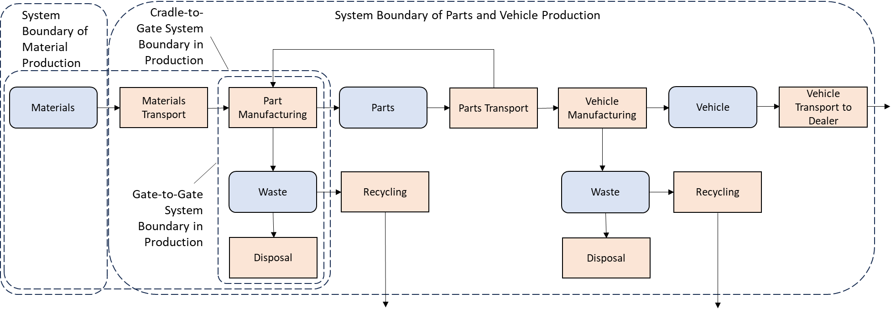
Figure 11: System boundaries in production.
The transport of the final assembled vehicle to the dealer show room is also included in the parts and vehicle production and therefor to be included in the PCF of the vehicle in production.
The cradle-to gate PCF includes all attributable upstream and direct emissions of producing a product, including all upstream transportation activities.
When accounting for emissions, companies shall further define their cradle-to-gate boundary by listing all the attributable processes of their studied product.
The system boundaries are therefore including:
- Resource extraction, raw material sourcing
- Production of materials, semi-finished products
- Production of vehicle parts and components
- Auxiliary production processes (e.g., lighting, air conditioning, storage facilities)
- Disposal of production waste
- Packaging of vehicle parts and components,
including all operations required for performing packaging
- Disposal of production waste (incl. packaging waste)
- Logistics (including internal logistics and transport packaging)
- Quality control in production
- IT for process and manufacturing control
Despite of being included in the system boundaries in principle, insignificant processes may be excluded based on the cut-off rules.
In general, GHG emissions not connected directly to the production system relevant for the product shall be excluded from the system boundaries. These are amongst others:
- Employee commuting and work travel
- Research and development, administration, or sales processes
- Auxiliary inputs not directly related to the production process (such as heating and lighting of associated office rooms, secondary services like maintenance, sanitary facilities, canteen services, facility management e.g., plant security and fire safety and general IT)
- Auxiliary inputs to maintain the manufacturing equipment
- Emissions from construction or dismantling of capital good (such as buildings, manufacturing equipment or any other infrastructure for transport, media or energy distribution and energy generation, within or outside the control of the reporting company)

Data collection & type

Time period
Emissions shall by default be reported averaged over the period of one year (reporting or calendar year) to avoid seasonal fluctuations and reflect typical production conditions.
Shorter periods may be considered if data on a full year are not yet available. Longer averaging periods may be considered but shall not exceed five years. Any averaging period deviating from the default shall be flagged and justified.

Temporal validity
Emissions shall by default be reported for the most recent year (reporting or calendar year). An annual check is recommended to ensure data actuality. To perform the annual check, the initial screening analysis should be updated based on data for the most recent year. An update of data is mandatory if the reported emission increases by 5% or more based on the screening analysis compared to the previous reporting period. Additionally, an update of data is mandatory in the following situations (adapted from GHG protocol):
- Structural changes in operation to the product system under study, including significant process change in operation, change in production technologies or technology advancement, raw material or energy changes.
- Changes in calculation methodology or improvements in the accuracy of emission factors or activity data or inclusion of new types of sources that result in a significant impact on the emissions data.
- Discovery of significant errors, or a number of cumulative errors that are collectively significant.

Geography
Emissions shall by default be reported on the plant level. Averaging over a region or country may be considered but shall be flagged as such.
[Explain about differences if secondary data are used]

Primary data share
To create visibility on the share of primary data in PCF calculations, the primary data share (PDS) indicator in each data set shall be determined and shared. The Primary Data Share (PDS) is defined as the proportion (percentage) of a PCF that is derived from primary data (as defined in Section 2.2.6.1).
The PDS is reported for the total PCF (PCF_{total}) only. To ensure that a consistent PDS can be reported no matter if reporting is done stepwise or collectively for multiple steps, the percentage of the primary data shall relate to the absolute sum of all positive or negative PCF contributions (PCF_{as}). The positive or negative PCF contributions (PCF_{i}) are to be understood as intermediate summands to the total PCF, which might reflect the total PCF contributions from suppliers or contributions from individual process steps under the control of the reporting company. Figure 8 illustrates the definition of PCF_{as}.
$${PCF}_{as}=\sum_{i}{\left|{PCF}_{i}\right|}$$
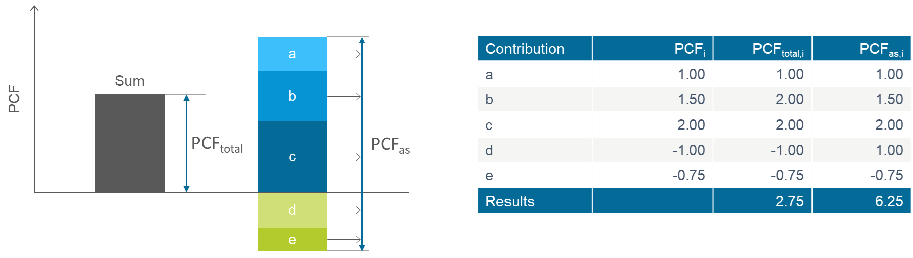
Figure 12: Definition of PCF_{as}
In case there are no negative PCF contributions PCF_{total} is equal PCF_{as}.
In case PCF_{as} is not yet reported PCF_{total} shall be used instead.
Having introduced PCF_{as} the primary data share can now be defined:
$$PDS_{PCF}=\frac{\left|Part of PCF based on primary data [kg CO_{2} eq]\right|}{{PCF}_{as} [kg CO_{2} eq]}$$
The aggregated primary data share for multiple PCF contributions reported with individual PDS (PDS_{i})
$${PDS}_{aggregated}=\frac{\sum_{i}{\left(\left|{PCF}_{total,i}\right|⋅{PDS}_{i}\right)}}{\sum_{i}{{PCF}_{as,i}}}$$
As an example, three suppliers, Company A, Company B and Company C, provide parts to Company D. Each part has a different primary data share and contribution to the absolute value total PCF of the part of Company D (cf. Figure 11). According to formula above, the primary data share of Company D’s part is calculated from the primary data share and contributions to the absolute value total PCF (see Figure 12).
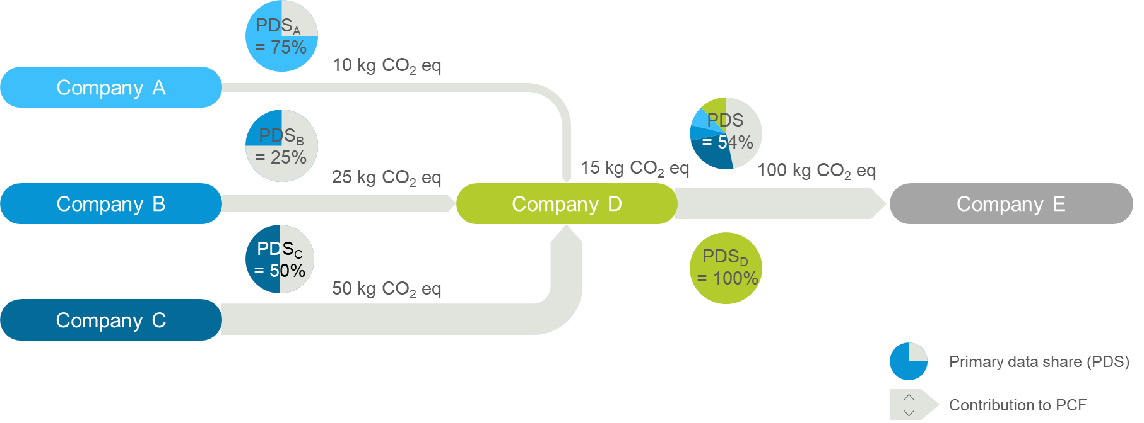
Figure 13: PCF cascade of primary data for an exemplary supply chain

Table 4: Primary data share of the example as in Figure 12
 | PDS_{i} | PCF_{total},_{i} | PDS Aggregation
Company A | 75% | 10 $kg CO_{2} eq$ | 75% * 10 $kg CO_{2} eq$ = 7.5 $kg CO_{2} e$
Company B | 25% | 25 $kg CO_{2} eq$ | 25% * 25 $kg CO_{2} eq$ = 6.3 $kg CO_{2} e$
Company C | 50% | 50 $kg CO_{2} eq$ | 50% * 50 $kg CO_{2} eq$ = 25 $kg CO_{2} e$
Company D | 100% | 15 $kg CO_{2} eq$ | 100% * 15 $kg CO_{2} eq$ = 15 $kg CO_{2} e$
Total |  | 100 $kg CO_{2} eq$ | ≈ 54 $kg CO_{2} e$, (7.5 + 6.3 + 25 + 15)$kg CO_{2} eq$  ≈ 54% PDS_{total}

When calculating the primary data share, a contribution to the primary data share shall only be attributed, if both the activity data (e.g., amount in kWh) and the GHG emission factor (expressed in kgCO₂eq per unit) information is derived from primary data. Supplier data shall only be considered as primary data if declared as such in percentage of primary data share.
Only product or company-specific data may contribute to the primary data share.

Data quality assessment
During the data collection process, companies shall assess the data quality of activity data, emission factors, and/or direct emissions data by using the data quality ratings (DQR).
Today companies can calculate their Product Carbon footprints (PCFs) with the scope cradle-to-gate using several data types. The quality of data can be significantly different. Therefore, data quality assessments of data used to calculate a PCF provide data users with a better understanding of the overall integrity of the data and the resulting PCF.
The standard defines the three data quality indicators to use in assessing data quality. They are:
- Technological representativeness: the degree to which the data reflects the actual technology(ies) used in the process.
- Geographical representativeness: the degree to which the data reflects actual geographic location of the processes within the inventory boundary (e.g., country or site)
- Temporal representativeness: the degree to which the data reflect the actual time (e.g., year) or age of the process.
Assessing data quality during data collection allows companies to make data quality improvements more efficiently than if data quality is assessed after collection is complete.
Data quality shall be assessed for both primary and secondary data in terms of how well they represent the actual production of the product under study. In the case of secondary data, the data quality rating reported for the original data taken from a database may not be directly used.
Instead, the reported data quality rating should serve as the basis to assess the representativeness of the product under study, i.e., how well the secondary data represents actual production in the supply chain.
The data quality of each PCF shall be calculated and reported. The DQR calculation shall be based on three data quality criteria where TeR is the technological representativeness, TiR is the time/temporal representativeness, GeR is the geographical representativeness, Table 4 shall be used to determine a semi-quantitative data quality rating.
The quality levels are expressed in five categories from 1 (best) to 5 (worst). The representativeness (technological, geographical, and time-related) characterizes the degree to which the processes and products selected depict the system analyzed.
Table 5: Sample scoring criteria for performing a qualitative data quality assessment.
 |  | 1 |  | 2 | 3 |  | 4 |  | 5
Technology Representa-tiveness (TeR) |  | The dataset has been created based on data reflecting the exact technology employed (i.e. plant specific process/equipment data for the plant/equipment where the product has been manufactured)  Explanation: this quality score can be achieved only in case of use of primary data |  | The dataset has been created based on data reflecting the company-specific and same technology to the one employed for the actual manufacturing (i.e. same technology, the company/site specific but not necessarily plant specific – it could be an average if several company/site specific data are available)  Explanation: this quality score can be achieved only in case of use of primary data | The dataset has been created based on data reflecting an average for an equivalent technology to the one employed for the actual manufacturing (i.e. same technology, but not company specific)  Explanation: this is the maximum score achievable with secondary data |  | The dataset has been created based on data reflecting a technological proxy (i.e. similar but not same technology, irrespectively if based on averages or supplier specific data) |  | The dataset has been created based on different or unknown technology vs technology actually employed
Temporal/time Representa-tiveness  (TeR) |  | The difference between “Reference Period End” of the dataset and “Date of Issue” of the PCF is ≤1 year (i.e. 366d (to count for leap year)) |  | The difference between “Reference Period End” of the dataset and “Date of Issue” of the PCF is >1 year and ≤2 years (i.e. 731d) | The difference between “Reference Period End” of the dataset and “Date of Issue” of the PCF >2 years and ≤3 years (i.e. 1096d) |  | The difference between “Reference Period End” of the dataset and “Date of Issue” of the PCF is >3 years and ≤4 years (i.e. 1461d) |  | The difference between “Reference Period End” of the dataset and “Date of Issue” of the PCF is >4 years
Geographical Representa-tiveness  (GeR) | The dataset has been created based on data reflecting the country subdivision in which the product has been manufactured  Example for country subdivision: Provinces in China, States in the US, applicable for bigger countries |  | The dataset has been created based on data pertaining the country, in which the product has been manufactured  The area where the dataset is generated is valid for the geographical area where the site is located  Example 1: The site is in California and the dataset is a US average. |  | The dataset has been created based on data pertaining the geographical region (e.g. Europe, Asia, N. America), in which the product has been manufactured  The area where the dataset is generated is valid for the geographical area where the site is located.  Example 1: The site is in Spain and the dataset is a European average | The dataset has been created based on global averages  Example: The site is in Japan and the dataset is a global average |  | The dataset has been created based on data with a geographical scope which is either unknown or pertaining a country, or region not including the site in which the product has been manufactured  Example 1: In absence of a global average, the dataset geographical applicability is unknown.  Example 2: The site is in Mexico, but the dataset is a US average, or a Finnish average or an Asian average or a European average

The data quality shall be propagated through the supply chain in the same manner as the primary data share (PDS). If no DQR is reported, the values representing the lowest data quality as per the sample scoring criteria in Table 5 will be propagated as a default. Therefore, the lowest rating has either the meaning of the lowest data quality or that no data quality rating has been reported.

Aggregated Data Quality Rating
Each data quality indicator of the PCF (technical, temporal, and geographical) shall be calculated as a weighted mean with the absolute total product carbon footprint excl. bio contribution as weight:
Accounting for uptake of biogenic or fossil emissions with a characterization factor of -1 kg CO₂eq per kg CO₂ can lead to negative PCF contributions. Thus, the sum of the PCF can be lower than the positive contributions to the PCF (Figure 14). When calculating an aggregated DQR, negative contributions would lead to erroneous calculation of the data quality rating.
Hence, to calculate the PDS and DQR absolute values of the PCF, the following formula shall be used:
$${DQR}_{aggregated}=\frac{\sum_{i}{\left(\left|{PCF}_{total,i}\right|⋅{DQR}_{i}\right)}}{\sum_{i}{{PCF}_{as,i}}}$$
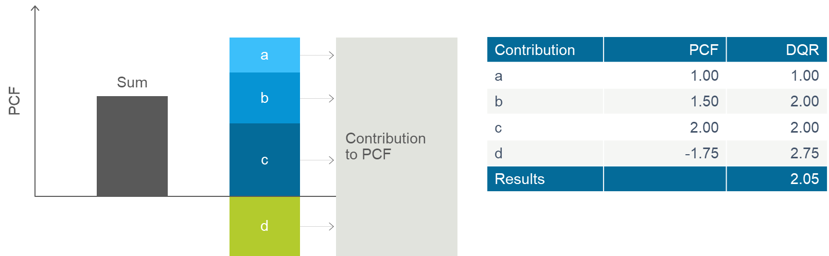

Figure 14:Calculation of an aggregated DQR
A valid survey of field data requires a strictly defined structure of components and production processes for the respective subsystem on which data are submitted to enable a level playing field comparison.

Logistics
This section deals with transportation from a supplier to its customer.
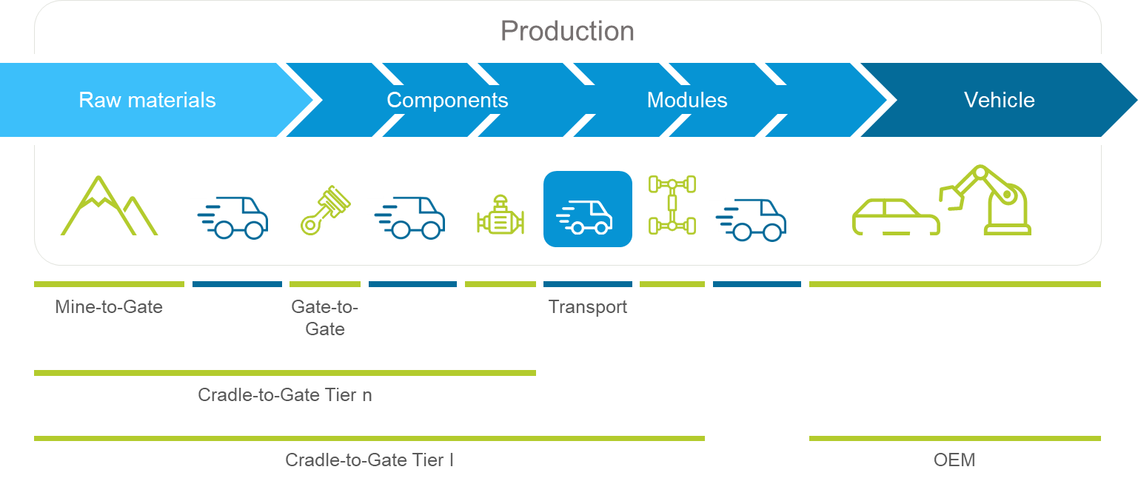
Figure 15: Definition of Scopes.
As for the product carbon footprint, the cradle-to-gate boundaries end at the suppliers' outbound gates (cf. Section 4.2 System Boundaries). This boundary applies independently from the responsibilities in economic or operative terms for transportation processes.
Nonetheless, if a supplier is responsible in economic or operative terms for the outbound logistics (i.e., transportation from the supplier to its customer), the supplier shall report the product carbon footprint from this transportation in addition to and separately from the product carbon footprint (Table 5). Otherwise, the customer shall account for transportation between the supplier’s and its own shipping site (factory gate or distribution center, see Figure 12 and Figure 13).
The table below describes different cases of responsibility and accountability for transportation from supplier to customer:
Table 6: Transportation between supplier and customer.
The responsibility to account for GHG emissions from transport depends on which party is responsible in economic or operative terms.
Case | Description | Economic/operative responsibility for transportation from supplier to customer | Accounting for transportation emissions
1 | Multiple shipping sites, and/or multiple unloading sites  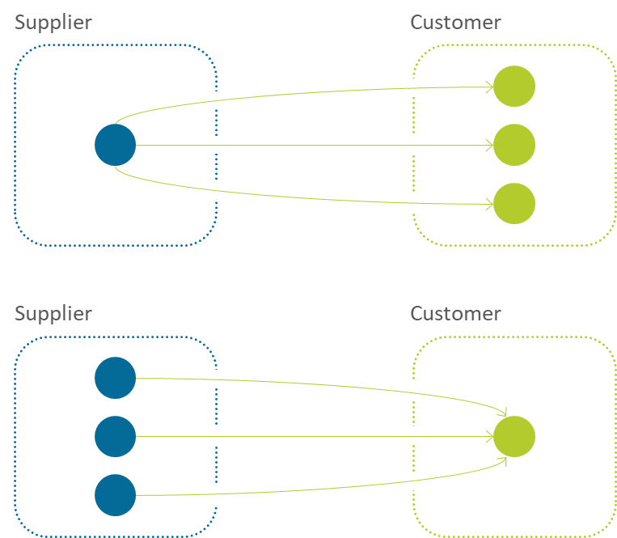 | Inbound transportation contracted or operated by customer | Customer responsible for quantification of transportation emissions.  As for multiple transportation relations, emissions shall be attributed by mass between the respective products
2 | Multiple shipping sites, and/or multiple unloading sites  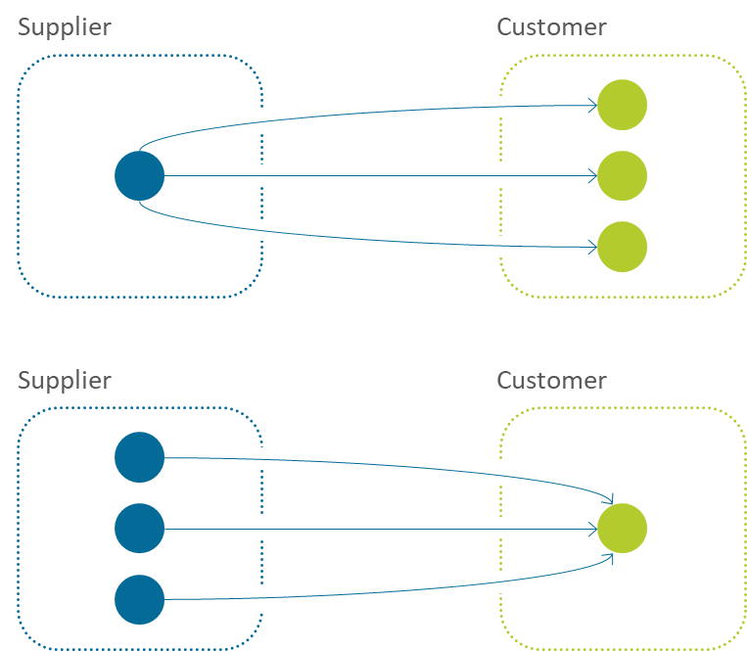 | Outbound transportation contracted or operated by supplier | Transportation emissions to be reported separately by supplier to the customer (additionally to supplier's PCF).  As for multiple transportation relations, emissions shall be attributed by mass between the respective products

Transports from production sites to suppliers' distribution centers are deemed as suppliers' in-house logistics, i.e., the distribution center is regarded as the shipping point (see Figure 12).
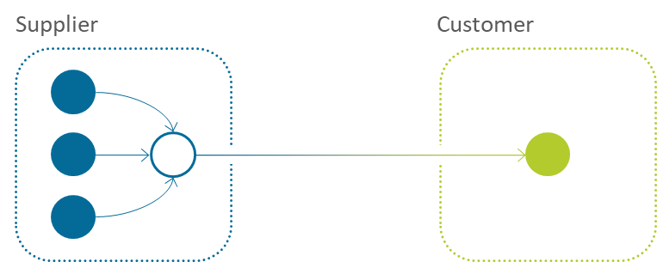

Figure 16: Distribution center on supplier side.
Transports from customers' distribution centers to production sites are deemed as customers' in-house logistics, i.e., the distribution center is regarded as the unloading point (see Figure 13).
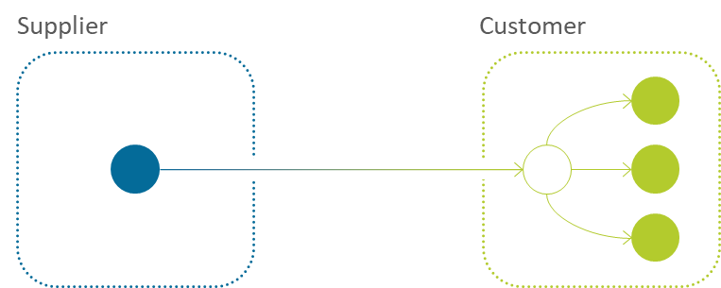
Figure 17: Distribution center on customer side.
Regardless of whether transportation emissions are quantified by a supplier or a customer, they shall be consolidated within the customers' PCFs.

Energy Modelling

Use Stage

End of Life

Reporting

Verification

Annex
- Additional Guidance on Classifying Waste vs Co-product
‘Deliberately produced’ means that the manufacturing process directly seeks to produce the material/component, i.e. is the result of a technical choice.
‘Further use is certain’ means that it is not a mere possibility but a certainty; in other words, it is guaranteed that the material will be used. This criterion may be indicated through, for example:
- Existence of contracts between the material producer and subsequent user
- A financial gain for the material producer
- A solid market (sound supply and demand) existing for this further use
- Evidence that the material fulfils the same specifications as other products on the market
‘Used directly without any further processing other than normal industrial practice’ means that if a production residue has to be treated before it can be used, this may indicate a waste treatment operation. Those treatment techniques that address typical waste-related characteristics of the production residue, such as its contamination with components which are hazardous or not useful, would prevent classification as non-waste. On the other hand, a treatment which is normal industrial practice, e.g. modification of size or shape by mechanical treatment, does not prevent the production residue from being regarded as a by-product.
‘Normal industrial practice’ can include all steps which a producer would take for a product, such as the material being filtered, washed, or dried; or adding materials necessary for further use; or carrying out quality control. However, treatments usually considered as a recovery operation cannot, in principle, be considered as normal industrial practice in this sense. Recovery operations are divided into three sub-categories: preparing for re-use, recycling, and other recovery.
‘Produced as an integral part of a production process’ means that the process where the co-product is generated has to be an integral part of a production process. Therefore, a material, which is made ready for further use through an integral part of a production process, can be regarded as a co-product. If a material leaves the site or factory where it is produced in order to undergo further processing, this may be evidence that such tasks are no longer part of the same production process, thus disqualifying it as a co-product.
‘Further use is lawful‘ means that the further use of the material must be lawful, i.e. the substance or object fulfils all relevant product, environmental and health protection requirements at the national level for the specific use and will not lead to overall adverse environmental or human health impacts.

Source for Annex: European Commission (2012): Guidance on the interpretation of key provisions of Directive 2008/98/EC on waste.

https://www.ipcc.ch/report/ar6/wg1/downloads/report/IPCC_AR6_WGI_Chapter07.pdf
https://www.ipcc.ch/report/ar6/wg1/downloads/report/IPCC_AR6_WGI_Chapter07_SM.pdf
Available at https://www.aib-net.org/facts/european-residual-mix
Source: https//ellenmacarthurfoundation.org/white-papers-and-articles
https://ens.dk/sites/ens.dk/files/Affald/guidance_on_the_interpretation_of_key_provisions_on_waste.pdf

