EPPR-08-xx
13 October 2014 – 8th LEPPR working group
Working paper submitted by the representative of the European Commission

GLOBAL REGISTRY

Created on 18 November 2004, pursuant to Article 6 of the
AGREEMENT CONCERNING THE ESTABLISHING OF GLOBAL TECHNICAL REGULATIONS FOR WHEELED VEHICLES, EQUIPMENT AND PARTS WHICH CAN BE FITTED AND/OR BE USED ON WHEELED VEHICLES
(ECE/TRANS/132 and Corr.1)
Done at Geneva on 25 June 1998

Global technical regulation No. 2
Revision 1

REQUIREMENTS FOR TWO- AND THREE-WHEELED LIGHT MOTOR VEHICLES WITH REGARD TO TAILPIPE EMISSIONS AFTER COLDSTART, TAILPIPE EMISSIONS AT IDLE, AT FREE ACCELERATION AND WITH REGARD TO THE ENERGY EFFICIENCY.

(Established in the Global Registry on dd.mm.yy)


UNITED NATIONS
TABLE OF CONTENTS
Section / Annex Number | Title | Page #
A. | STATEMENT OF TECHNICAL RATIONALE AND JUSTIFICATION | 5
1. | Introduction | 5
2. | Procedural background | 6
3. | Existing regulations, directives and international voluntary standards | 7
4. | Discussion of the issues addressed by the GTR | 10
5. | Regulatory impact and economic effectiveness | 13
B.1. | TEXT OF THE REGULATION, GENERAL REQUIREMENTS | 15
1. | Purpose | 15
2. | Scope | 15
3. | Vehicle sub-classification | 17
4. | Definitions | 19
5. | General requirements | 26
6. | Nomenclature | 27
7. | General requirements applicable for manufacturers requesting whole vehicle type-approval in countries that apply mutual recognition of type-approval | 27
8. | General requirements applicable for manufacturers requesting type-approval of replacement pollution-control devices in countries that apply mutual recognition of type-approval | 28
9. | Performance requirements for the type I test of a two-wheeled motorcycle | 29
B.2. | TEXT OF THE REGULATION, TEST TYPE I, EXHAUST EMISSIONS AFTER COLD START | 30
B.2.1. | Annex: type I test procedure for hybrid vehicles | 78
B.2.2. | Annex: type I test procedure for vehicles fuelled with LPG, NG/biomethane, flex fuel H₂NG or hydrogen | 89
B.2.3. | Annex: type I test procedure for vehicles equipped with a periodically regenerating system | 93
B.3. | TEXT OF THE REGULATION, TEST TYPE II, TAILPIPE EMISSIONS AT (INCREASED) IDLE AND AT FREE ACCELERATION | 101
B.4. | TEXT OF THE REGULATION, TEST TYPE VII, ENERGY EFFICIENCY | 107
 | Annexes to test type VII requirements
B.4.1. | Annex: method of measuring carbon dioxide emissions and fuel consumption of vehicles powered by a combustion engine only | 114
B.4.2. | Annex: method of measuring the electric energy consumption of a vehicle powered by an electric powertrain only | 118
B.4.3. | Annex: method of measuring the carbon dioxide emissions, fuel consumption, electric energy consumption and driving range of vehicles powered by a hybrid electric powertrain | 122
B.4.4. | Annex: electrical energy/power storage device State Of Charge (SOC) profile for an externally chargeable Hybrid Electric Vehicle (OVC HEV) in a type VII test | 144
B.4.5. | Annex: method for measuring the electricity balance of the battery of OVC and NOVC HEV | 146
B.4.6. | Annex: method of measuring the electric range of vehicles powered by an electric powertrain only or by a hybrid electric powertrain and the OVC range of vehicles powered by a hybrid electric powertrain | 148
B.5. | TEXT OF THE REGULATION, COMMON ANNEXES | 153
B.5.1. | Annex: symbols | 154
B.5.2. | Annex: reference fuels | 158
B.5.3. | Annex: test vehicle requirements Test types I, II and VII | 164
B.5.4. | Annex: classification of equivalent inertia mass and running resistance, applicable for two- and three-wheeled vehicles (table method) | 166
B.5.5. | Annex: road tests of two- and three-wheeled vehicles equipped with one wheel on the driven axle for the determination of test bench settings | 169
B.5.6. | Annex: road tests of two- and three-wheeled vehicles equipped with two or more wheels on the powered axles for the determination of test bench settings | 175
B.5.7. | Annex: chassis dynamometer system | 182
B.5.8. | Annex: exhaust dilution system | 188
B.5.9. | Annex: [approval] / [certification] tests of a replacement pollution-control device type as separate technical unit | 201
B.5.10. | Annex: vehicle propulsion unit family with regard to environmental performance demonstration tests | 204
B.5.11. | Annex: information document containing the essential characteristics of the propulsion units and the pollutant control systems | 208
B.5.12. | Annex: test result reporting requirements and information concerning the conduct of tests | 228
B.5.13. | Annex: template form to record coast down times | 237
B.5.14. | Annex: template form to record chassis dynamometer settings | 238
B.5.15. | Annex: driving cycles for the type I test | 239
B.5.16. | Annex: explanatory note on the gearshift procedure | 277

A. | STATEMENT OF TECHNICAL RATIONALE AND JUSTIFICATION
A.1. | Introduction  The industry producing two-, three and four-wheeled light motor vehicles is a global one, with companies selling their products in many different countries. The Contracting Parties to the 1998 Agreement have all determined that work should be undertaken to address emissions from two- and three-wheeled light motor vehicles as a way to help improve air quality internationally.  This GTR covers three main environmental verification test type to verify and validate the environmental performance of a wide range of light motor vehicle types with two-, three- and for some Contracting Parties even four-wheeled light motor vehicles, e.g. powered cycles, two- and three-wheel mopeds, two- and three-wheel motorcycles, motorcycles with side-cars and quadricycles such as on-road quads, all-terrain quads and quadrimobiles. Contracting parties should have the liberty to deal with those four-wheeled light motor vehicles in terms of environmental requirements in the same way than with three-wheeled light motor vehicles.  The aim of this Global Technical Regulation (GTR) is to provide measures to strengthen the world-harmonisation of light motor vehicle approval and certification legislation, in order to improve the cost effectiveness of environmental performance testing, remove trade barriers, reduce the overall complexity of global legislation, remove potential areas of conflict or opposing requirements and improve the air quality.  The first step in this process in 2004 was to establish the certification procedure for motorcycle exhaust emissions in a harmonised UN GTR No 2. The GTR No 2 Revision 1 extends the scope to all two-wheeled vehicles as well as to all three-wheeled vehicles, updates the testing methodology for technical progress and sets out requirements to measure the energy efficiency of different types of propulsion units fitted to two- and three-wheeled light motor vehicles. The test procedures were developed so that they would be:  - representative of world-wide on-road vehicle operation;  - able to provide an internationally harmonised set of environmental tests to ensure efficient and practicable controls of on-road emissions over the normal life of a vehicle;  - corresponding to state-of-the-art testing, sampling and measurement technology in the area of environmental performance testing of light motor vehicles;  - applicable in practice to existing and foreseeable future exhaust emissions abatement technologies;  - applicable in practice to existing and foreseeable future powertrain technologies;  - capable of providing a reliable ranking of exhaust emission levels from different engine types;  - inclusive of adequate test cycle-bypass prevention provisions.  The technical and economic feasibility of the measures contained within this GTR have been considered and are discussed further in Section A.5.
This GTR covers three test types related to tailpipe emissions:
- Test Type I: Tailpipe emissions after cold start
To monitor the gaseous pollutant emissions a vehicle produces when in general use, test type I defines a test procedure to take a vehicle from cold and performing a chassis dynamometer driving cycle which has been designed as far as is practicable, to represent driving of that vehicle type, while taking into consideration the requirements of test repeatability and reproducibility.
- Test Type II: Tailpipe emissions at idle (PI engine) and free acceleration test (CI engine)
To test the idle and high idle emissions referred to in road worthiness testing, test type II defines a test procedure at two idle engine speeds for vehicles equipped with PI engines to measure the emissions of CO and HC and a test procedure at free acceleration for vehicles equipped with CI engines to measure opacity as a simplified verification method to verify particulate matter emissions for CI vehicles.
- Test Type VII: Energy efficiency, i.e. CO₂ emissions, fuel/energy consumption and electric range
To provide information required by consumers to judge the energy efficiency and running costs and practicality of a vehicle, test type VII measures for publication and inclusion in vehicle literature, the energy efficiency with respect to CO₂ emissions, fuel consumption, energy consumption and electric range.
 | The base GTR No 2, entering into force on [30 August 2005] builds on the work of the WMTC Informal Working Group (IWG), its deliberations and conclusions, provided in the group's Technical Report (ECE/TRANS/180/Add.2/Appendix 1) which produced its last amendment on the base GTR in 2011. GTR No 2 Revision 1 is based on the work of the Informal Working Group on Environmental and Propulsion unit Performance Requirements of light motor vehicles (EPPR), from now on referred to as L-EPPR informal working group, which held its first meeting during the 65th GRPE in January 2013 sponsored by the European Commission (EC). Specific issues and options raised and resolved in their development are discussed in a separate options document. "Introduction issues and proposed options for harmonisation" of this document, which will be transferred into the report that accompanies the revised GTR No 2 when the final revision of GTR No 2 is adopted by the informal working group L-EPPR and sent to GRPE for review.
A.2. | Procedural background
The original work on the base GTR No. 2 started in May 2000 with the establishment of the WMTC Informal Working Group. At the UNECE working party on pollution and energy (GRPE) 45th session in January 2003, a formal proposal by Germany for the establishment of a GTR was approved for presentation to the Executive Committee for the 1998 Agreement (AC.3). At its session on 13 November 2003, the proposal from Germany was also approved as a GTR project by AC.3.
The base GTR No. 2 was approved by AC.3 in June 2005. Amendment 1 to the base GTR No. 2 was approved by AC.3 in November 2007. The draft text of Amendment 2 to GTR No. 2 on the introduction of performance requirements (limit values for pollutant emissions for vehicles fitted with gasoline engines) was approved by GRPE in January 2011, subject to final decisions concerning the format of the text by AC.3.
At its April 2006 meeting held in Pune (India), the informal working group WMTC/FEG agreed to prepare new test cycle proposals and a new vehicle classification for draft amendments to the GTR in order to suit low-powered vehicles, such as commonly used in India and China.
A small WMTC Task Force, coordinated by the International Motorcycle Manufacturers Association (IMMA), was set up to prepare a proposal on the test cycle(s) and any new classification that might be necessary to achieve this objective. The Task Force was attended by India, Italy, Japan, Germany, the EC and IMMA. Task Force meetings were held in August and October 2006.
At its November 2006 meeting held in Ann Arbor (United States of America), WMTC/FEG agreed to a modified version of one of the WMTC Task Force proposals and forwarded it to WMTC Informal Group in January 2007 where it was approved for submission to GRPE.
The intention of setting up the group was put forward by the EU and announced during the 63rd and 64th meetings of the GRPE in January and June 2012 and in the 157th session of the WP.29 in June 2012.
With the mandate (informal document: WP.29-158-15) accepted at the 158th session of the WP.29 (13-16th November 2012) to establish the environmental and propulsion unit performance requirements for light motor vehicles (L-EPPR) informal working group under the GRPE. At the GRPE xx session in 201x, a formal proposal drafted by the L-EPPR informal working group for revision 1 of this GTR was tabled for adoption by the Executive Committee for the 1998 Agreement (AC.3).
On-going developments of test types and procedures and global discussion on harmonisation have resulted in the technical requirements contained within this GTR. The final text of the GTR is presented below, in Part B of this document.
A.3. | Existing regulations, directives and international voluntary standards
A.3.1. | Technical references in the original development of this GTR No 2 and related UN GTRs in the area of environmental performance requirements  For the original development of this GTR No 2 and related UN GTRs in the area of environmental performance requirements,, the following regulations contained relevant applications of exhaust emissions requirements for light motor vehicles which were available for technical reference:  - UN Regulation No. 40, 01 series of amendments:  Uniform provisions concerning the approval of motorcycles equipped with a positive-ignition engine with regard to the emission of gaseous pollutants by the engine  - EU:  Directive 97/24/EC amending by Directive 2002/51/EC: The reduction of the level of pollutant emissions from two-and three-wheeled motor vehicles. Note: the EU has not acceded to Regulation Nos 40 and 47, but in EU type-approval legislation for light motor vehicles the ECE R40 and ECE R47 desired vehicle speed test profile vs. test time are used as type I test to verify emissions after cold start. Alternatively the WMTC desired vehicle speed test profile vs. test time may be used to approve a motorcycle in the EU.  In March 2013 Regulation (EU) No 168/2013 was adopted in the course of 2013 as well as the delegated act on environmental and propulsion unit performance requirements Regulation (EU) No 134/2014 (REPPR) in the beginning of 2014 setting out technical provisions and environmental performance test procedures. As of September 2014 this revised legal package is applicable for EU type-approval.  - Indian Regulation:  MoSRT&H/ CMVR/ TAP-115/116 and Central Motor Vehicle Rule No. 115  - Japanese Regulation:  - Road vehicle Act, Article 41 "Systems and Devices of Motor Vehicles";  - Safety Regulations for Road Vehicles, Article 31 "Emission Control Devices";  - United States of America Regulations:  - US-FTP Subpart F, Emission Regulations for 1978 and Later New Motorcycles  - ISO standards:  - ISO 11486 (Motorcycles - Chassis dynamometer setting method);  - ISO 6460 (gas sampling and fuel consumption);  - ISO 4106 (Motorcycles -- Engine test code -- Net power);  Most of these regulations had been in existence for many years and the methods of measurement varied significantly. The technical experts were familiar with these requirements and discussed them in their working sessions. The L-EPPR Informal Working Group therefore considered that to be able to determine a light motor vehicle’s real impact on the environment, in terms of its exhaust pollutant emissions and energy consumption, the test procedure and consequently the GTR No 2 needs to represent modern, real-world vehicle operation as well as representative ageing of the pollution control devices for all two- and three wheeled vehicles.  Consequently, the draft GTR was based on new research into the worldwide pattern of real light motor vehicle use with a wide range of propulsion units.
A.3.2. | Technical references in developing this revision of the GTR  For the development of GTR No 2 Revision 1, the following legislation and technical standards contained relevant applications of requirements for light motor vehicles or transferable provisions for passenger cars:  Test type I:  - UN (1998 agreement, light-duty and heavy-duty vehicles): WLTP, UN S.R.1;  - UN (1958 agreement, light motor vehicles): UN Regulation 40, UN Regulation 47 and UN R.E.3;  - UN (1958 agreement, M/N-category vehicles): UN Regulation 83;  - EU: Regulation (EU) No 168/2013;  - EU draft REPPR (delegated act on Environmental and Propulsion unit Performance supplementing Regulation (EU) No 168/2013), Directive 97/24/EC supplementing Directive 2002/24/EC.  Test type II:  - UN (1958 agreement, light motor vehicles): UN Regulation 40, UN Regulation 47;  - UN (1958 agreement, light-duty vehicles): UN Regulation 83;  - EU: EU REPPR, Directive 2009/40/EC  Test type VII:  - UN (1958 agreement, light-duty vehicles): UN Regulation 101, UN Regulation 83;  - EU: Regulation (EU) No 168/2013 and EU draft REPPR (Delegated Act on Environmental and Propulsion Unit Performance supplementing Regulation (EU) No 168/2013).
A.3.3. | Methodology for deriving harmonised test procedures for this revision of the GTR  The European Commission launched an L-EPPR study in January 2012 with the objective to develop proposals to revise and update GTR No 2 for technical progress and to develop proposals for harmonised EPPR legislation not yet covered at the international level for two-and three-wheeled light motor vehicles, e.g. crankcase and evaporative emission test requirements, energy efficiency, durability of pollution control devices, on-board diagnostic requirements, propulsion unit performance requirements, etc. The output of this comprehensive study was submitted for the assessment and approval of the L-EPPR group.  The methodology used in this study to develop the test procedures contained within the GTR involved an iterative process of review. The process was initially based on an assessment of existing literature and new evidence, which was gathered from a wide range of pertinent stakeholders, to provide more insight with regards to the future requirements of the GTR.  The first phase comprised a stocktake of appropriate literature, international legislation and proposals. The aim was to ensure that all current and proposed test types and the specific requirements of different regions were captured.  The second phase of the evidence gathering consisted of a stakeholder consultation. An important part of this was a questionnaire, which asked stakeholders to provide information and at times their views on current practices in different regions and the way forward.  The third phase, involved the derivation of the test types contained within the GTR, and consisted of a technical evaluation of the information collected in phases one and two. Specifically, each test type was assessed and the following aspects considered:  - common international practices (existing harmonised practices);  - significant differences with respect to testing methods and procedures;  - the global technical feasibility;  - the likely cost and economic impact;  - the likely acceptability for all Contracting Parties;  - the effectiveness of each proposal at improving vehicle emission performance;  - the suitability of the testing procedures with regard to current and future powertrains and technologies.  The order of the aspects presented above does not represent any ranking, the priority was dependent on each of the specific areas analysed during the development of the GTR. Where multiple options were left after the assessment of the factors listed above, further iterative evaluation was undertaken by the Informal Working Group.  The fourth and final stage of the study involved a review of the proposed harmonised test procedures by the EC, and following further discussion this feedback was incorporated and a final set of iterations undertaken, which form the technical content of the EC’s proposals to revise and supplement GTR No 2 and which were made available as working documents to be discussed and agreed by the L-EPPR informal working group.  The outcome of this work was, among others, the development of a new proposal to revise GTR No 2 based on the consolidation of existing global legislation and up-to-date technical provisions, a proposal to supplement GTR No 2 with respect to requirements regarding durability of pollution control device as well other related proposals.  Subsequently the L-EPPR group assessed the study output and decided as follows: [to be inserted by the L-EPPR group before submitting the final proposal for GTR No 2 Revision 1 and the equivalent UN Regulation to GRPE.]
A.4. | Discussion of the issues addressed by the GTR  GTR No 2 Revision 1 brings together the tailpipe pollutant and CO₂ emissions related test types I, II and VII. This latter mentioned test type VII verifies the energy efficiency of the light motor vehicle in terms of setting out a test procedure required to determine the fuel consumption of vehicles equipped with a combustion engine, energy consumption of as well as the electric range for pure electric and hybrid electric light motor vehicles.  The issues addressed by the test procedure development group of the original GTR No 2, covering test types I, II and VII for motorcycles equipped with PI engines, are discussed in detail in the Technical Report ECE/TRANS/180/Add.2/Appendix 1. The process used to develop this GTR was based on four basic steps. First, the basis of the test cycle development was the collection and analysis of driving behaviour data and statistical information about moped and motorcycle use for the different regions of the world. These data had to include all relevant real life vehicle operations and built the basis for the cycle development. In a second step the in-use driving behaviour data were combined with the statistics on vehicle use in order to create a reference database that is representative for worldwide moped and motorcycle driving behaviour. This was achieved using a classification matrix for the most important influencing parameters. In the final classification matrix three different regions (Europe, Japan, United States of America), three different vehicle classes and three different road categories were included.  The next step was to compact this reference cycle into a test cycle of the desired length. A computer search programme then selected a number of modules (vehicle speed/time sequences between two stops) to represent by approximation this length. The statistical characteristics of this number of modules are then compared to those of the database. The comparison is done on the basis of the chi-squared method, an accepted statistical criterion.  Finally, a first draft of the World-wide Motorcycle Test Cycle (WMTC) was produced and validated on 53 mopeds and motorcycles. It was foreseen that this first draft needed to be modified on the basis of an evaluation concerning driveability and practical points such as typical gear shifts concerning the measurement procedure. Since this process is iterative by nature, several adaptation rounds including the driveability tests were carried out.  In the interim period, further developments to the existing test types I, II and VII (fuel consumption only for conventional two-wheeled vehicles equipped with conventional PI and CI engines) and the test cycle were identified by the Contracting Parties as part of previous amendments and this revision, including:  - the development of the alternative cycle for low-powered two-wheeled light motor vehicles to take account of the use of these vehicles outside Europe, Japan and the USA, which were the sources of the original database;  - in order to take into account the performances and the use of low-powered motorcycles, additional data were supplied by India. After further analysis, it was agreed that the previously agreed reduced vehicle speed test cycles should be modified and that the class 1 vehicle subcategories could be merged;  - the comparative database of results from the different test procedures, which act as a major input for the discussion of exhaust emission limit values that are compatible with existing limit values in different regions/countries;  - the definition of pollutant emission limit values for motorcycles equipped with a PI engine;  - the need for updates to the emission sampling requirements to match current practice in emission laboratories and to harmonise those worldwide;  - the need for updates to the dynamometer provisions to match current practice;  - the correction of formulae and standardisation of measuring units;  - the inclusion of a wider range of powertrain types and the ability to cover others in development;  - the re-introduction of other light motor vehicles included in the original test programme within the GTR;  - the introduction of other light motor vehicle categories that use the same or similar powertrain technologies, i.e. three- and four-wheeled light motor vehicles;  - although provisions for test type VII were included in the original GTR for vehicles equipped with a single PI and CI engine, at the time of developing this revision there is a requirement for testing procedures which provide equivalent energy efficiency data for hybrid-electric and pure electric vehicles as well as expanding to alternative gaseous fuels such as LPG, CNG and hydrogen;  At the time of creation of the base GTR No 2, durability requirements (test type V) were outside the scope of the WMTC informal group's mandate. However, Contracting Parties were expressly permitted within this section to specify durability requirements and/or useful life provisions in their national or regional legislation in relation to the emission limits set out in this GTR. A dedicated GTR introduces a harmonised test procedure for the durability of pollution control devices of light motor vehicles (test type V) and refers to GTR No 2 Revision 1 as the WMTC is used to verify the tailpipe emissions during and after completion of distance accumulation.  In the development of the basic GTR No 2, specific technical issues were raised, discussed, and resolved, which are discussed in the Technical Report ECE/TRANS/180/Add.2/Appendix 1.
A.4.1. | Applicability  The Informal Working Group followed the agreed terms of reference and prepared a draft GTR No 2 Revision 1 for all two- and three-wheeled vehicles under the 1998 Agreement as well as an equivalent UN Regulation with two-, three- and four-wheeled light motor vehicles in its scope under the 1958 Agreement.
A.4.2. | Definitions  The definitions used in this GTR are taken from the draft common definitions incorporated in S.R.1 as well as from the work of the UN VPSD group operating under GRPE with the goal to harmonise high level powertrain definitions and from other international and regional legislation, as listed in Section A.3.
A.4.4. | Performance Requirements  The performance requirements from the base GTR No 2 have been carried over into the proposal of GTR No 2 Revision 1. The current principle emission limits adopted in 2012 have been transferred to the alternative performance limits section and the Euro 4 emission limits, which are to date the most stringent ones for two-wheeled motorcycles, have been proposed to become the new principle performance limits (point 9 of section B.1.). For other types two-, three- and four-wheeled light motor vehicles there are no harmonised test limits agreed (yet) but which might be established in the future.
A.4.5. | Reference Fuel  The principal performance requirements introduced in point 9 of section B.1. of this GTR are based on the use of the reference fuel as specified in Annex 5.2. The use of this standardised reference fuel for determining compliance with the principle emission limits set out in point 9 of section B.1. is considered as an ideal condition for ensuring the reproducibility of regulatory emission testing, and Contracting Parties are encouraged to use such fuel in their compliance testing.  Contracting Parties may continue using reference fuels currently in use in their countries for the principal performance requirements in point 9 of section B.1. on condition that their equivalence with the reference fuel in Annex B.5.2. in terms of emissions is demonstrated.  The alternative performance requirements in point 9 of section B.1. are applicable with the corresponding reference fuels.
A.5. | Regulatory impact and economic effectiveness
A.5.1. | Anticipated benefits  Increasingly two- and three-wheeled light motor vehicles are being prepared for the world market. To the extent that manufacturers are preparing substantially different models in order to meet different emission regulations and methods of measuring CO₂ emission and fuel or energy consumption, testing costs and other production values are increased. It would be more economically efficient to have manufacturers using a similar test procedure worldwide wherever possible to prove satisfactory environmental performance before placing a product on the market. It is anticipated that the test procedures in this GTR will provide a common test programme for manufacturers to use in countries worldwide and thus reduce the amount of resources utilised to test light motor vehicles. These savings will accrue not only to the manufacturers, but more importantly, to the consumers and the authorities as well. However, developing a test programme just to address the economic question does not completely address the mandate given when work on this GTR was first started. The test programme also improves the state of testing light motor vehicles, reflects better how light motor vehicles are used today and covers recent and near-future powertrain technologies, fuels and emission abatement technologies.
A.5.2. | Potential cost effectiveness  At the time of writing this revision of the GTR, the data is not available to undertake a full impact assessment of the test types contained. This is in part because not all limit values have been set out and it is undecided to what level the proposed upgrade of test procedures will be accepted by Contracting Parties. Specific cost effectiveness values can be quite different, depending on the national or regional environmental needs and market situation. While there are no calculated values here, the belief of the technical group is that there are clear and significant benefits comparing to justifiable, anticipated cost increases associated with this GTR. Finally allowing not only all two-wheeled light motor vehicles but also three- and for the Contracting Parties applying the test procedures set out in this GTR also for a selection of four-wheeled light motor vehicles, to be tested according to a dynamic, real-world emission laboratory test-cycle will much better reflect the actual environmental performance of light motor vehicles including pollutant emissions and energy efficiency measurement results, allowing the gap between claimed and actual, real-world environmental performance experienced by citizens to be narrowed

B.1. | TEXT OF THE REGULATION, GENERAL REQUIREMENTS
1. | Purpose  This regulation provides a worldwide-harmonized measurement method for the determination of the levels of gaseous pollutant emissions at the tailpipe, the emissions of carbon dioxide and the energy efficiency in terms of fuel/energy consumption and electric range of two-[ and three-] wheeled light motor vehicles that are representative for real world vehicle operation.
2. | Scope
2.1. | Two- [and three-]wheeled light motor vehicles equipped with a propulsion unit in accordance with table B.1.-1

 | Vehicle with PI engines including hybrids |  |  |  |  |  |  |  |  | Vehicles with CI engines including hybrids |  | Pure electric vehicle  or  vehicle propelled with compressed air (CA) | Hydrogen Fuel cell vehicle
 | Mono-fuel |  |  |  | Bi-fuel |  |  | Flex-fuel |  | Flex-fuel | Mono-fuel |  | Hydrogen Fuel cell vehicle
 | Petrol | LPG | NG/Biomethane | H₂ | Petrol | Petrol | Petrol | Petrol | NG/Biomethane | Diesel | Diesel |  | Hydrogen Fuel cell vehicle
 |  |  |  |  | LPG | NG/Biomethane | H₂ | Ethanol (E85) | H₂NG | Biodiesel | Diesel |  | Hydrogen Fuel cell vehicle
Type I test | Yes | [Yes] | [Yes] | [Yes] | [Yes  (both fuels)] | [Yes  (both fuels) | [Yes  (both fuels)] | [Yes  (both fuels)] | [Yes  (both fuels)] | [Yes  (B5 only)] | [Yes] | [No] | [No]
Type I test  Particulate mass | Yes | [No] | [No] | [No] | [Yes  (petrol DI only)] | [Yes  (petrol DI only)] | [Yes  (petrol DI only)] | [Yes  (petrol DI only)] | [No] | [Yes  (B5 only)] | [Yes] | [No/Yes for CA] | [No]
Type II test, | Yes | [Yes] | [Yes] | [Yes] | [Yes  (both fuels)] | [Yes  (both fuels)] | [Yes  (petrol only)] | [Yes  (both fuels)] | [Yes (NG/biomethane only)] | [Yes  (B5 only)] | [Yes] | [No] | [No]
Type VII test | Yes | [Yes] | [Yes] | [Yes] | [Yes  (both fuels)] | [Yes  (both fuels)] | [Yes  (both fuels)] | [Yes  (both fuels)] | [Yes  (both fuels)] | [Yes  (both fuels)] | [Yes] | [Yes  (only energy consumption)] | [Yes  (only fuel consumption)]
Table B.1.-1: Scope with regard to the propulsion unit(s)
3. | Vehicle sub-classification  Figure B.1-1 provides a graphical overview of the vehicle sub-classification in terms of engine capacity and maximum vehicle speed if subject to the environmental test types indicated by the (sub-)class numbers in the graph areas. The numerical values of the engine capacity and maximum vehicle speed shall not be rounded up or down.  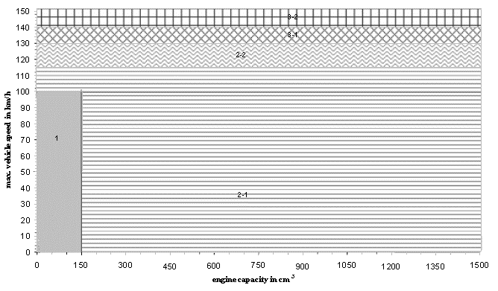  Figure B.1.-1: Vehicle sub-classification for environmental testing, test types I and VII
3.1. | Class 1  Vehicles that fulfil the following specifications belong to class 1:  Table B.1.-2: sub-classification criteria for class 1 light motor vehicles
  engine capacity < 150 cm³ and v_{max}< 100 km/h | class 1
3.2. | Class 2  Vehicles that fulfil the following specifications belong to class 2 and shall be sub-classified in:  Table B.1.-3: sub-classification criteria for class 2 light motor vehicles
  Engine capacity < 150 cm³ and 100 km/h ≤ v_{max}< 115 km/h or engine capacity ≥150 cm³ and v_{max}< 115 km/h | sub-class 2-1
  115 km/h ≤ v_{max}< 130 km/h | sub-class 2-2
3.3. | Class 3  Vehicles that fulfil the following specifications belong to class 3 and shall be sub-classified in:  Table B.1.-4: sub-classification criteria for class 3 light motor vehicles
  130 ≤ v_{max}< 140 km/h | subclass 3-1
  v_{max} ≥ 140 km/h | subclass 3-2

4. | Definitions  The following definitions shall apply in this GTR:
4.1. | ‘actuator’ means a converter of an output signal from a control unit into motion, heat or other physical state in order to control the powertrain, engine(s) or drive train;
4.2. | ‘air intake system’ means a system composed of components allowing the fresh-air charge or air-fuel mixture to enter the engine and includes, if fitted, the air filter, intake pipes, resonator(s), the throttle body and the intake manifold of an engine;
4.3. | ‘alternative fuel vehicle’ means a vehicle designed to run on at least one type of fuel that is either gaseous at atmospheric temperature and pressure, or substantially non-mineral oil derived;
4.4. | ‘bi-fuel vehicle’ means a vehicle with two separate fuel storage systems that can run part-time on two different fuels and is designed to run on only one fuel at a time;
4.5. | ‘biodiesel’ means a vegetable oil- or animal fat-based diesel fuel consisting of long-chain alkyl esters produced in a sustainable way;
4.6. | ‘biomethane’ means a renewable natural gas made from organic sources that starts out as ‘biogas’ but then is cleaned up in a process called ‘biogas to biomethane’ which removes the impurities in biogas such as carbon dioxide, siloxanes and hydrogen sulphides (H 2 S);
4.7. | ‘boost control’ means a device to control the boost level produced in the induction system of a turbocharged or supercharged engine;
4.8. | ‘carburettor’ means a device that blends fuel and air into a mixture that can be combusted in a combustion engine;
4.9. | ‘catalytic converter’ means an emission pollution-control device which converts toxic by-products of combustion in the exhaust of an engine to less toxic substances by means of catalysed chemical reactions;
4.10. | ‘catalytic converter type’ means a category of catalytic converters that do not differ as regards the following:  (a) number of coated substrates, structure and material;  (b) type of catalytic activity (oxidising, three-way, or of another type of catalytic activity);  (c) volume, ratio of frontal area and substrate length;  (d) catalytic converter material content;  (e) catalytic converter material ratio;  (f) cell density;  (g) dimensions and shape;  (h) thermal protection;  (i) an inseparable exhaust manifold, catalytic converter and muffler integrated in the exhaust system of a vehicle or separable exhaust system units that can be replaced;
4.11. | ‘cold-start device’ means a device that temporarily enriches the air/fuel mixture of the engine, thus assisting the engine to start;
4.12. | ‘common rail’ means a fuel supply system to the engine in which a common high pressure is maintained;
4.13. | ‘communication protocol’ means a system of digital message formats and rules for messages exchanged in or between computing systems or units;
4.14. | ‘compression ignition engine’ or ‘CI engine’ means a combustion engine working according to the principles of the ‘Diesel’ cycle;
4.15. | ‘defeat device’ means any element of design which senses temperature, vehicle speed, engine speed and/or load, transmission gear, manifold vacuum or any other parameter for the purpose of activating, modulating, delaying or deactivating the operation of any part of the emission control and exhaust after-treatment system and which reduces the effectiveness of the emission control system under conditions which may reasonably be expected to be encountered in normal vehicle operation and use;
4.16. | ‘drive train control unit’ means the on-board computer that partly or entirely controls the drive train of the vehicle;
4.17. | ‘drive train’ means the part of the powertrain downstream of the output of the propulsion unit(s) that consists if applicable of the torque converter clutches, the transmission and its control, either a drive shaft or belt drive or chain drive, the differentials, the final drive, and the driven wheel tyre (radius);
4.18. | ‘electric powertrain’ means a system consisting of one or more electric energy storage devices such as batteries, electromechanical flywheels, super capacitors or other, one or more electric power conditioning devices and one or more electric machines that convert stored electric energy to mechanical energy delivered at the wheels for propulsion of the vehicle;
4.19. | ‘electric range’, means the distance that vehicles powered by an electric powertrain only or by a hybrid electric powertrain with off-vehicle charging can drive electrically on one fully charged battery or other electric energy storage device as measured in accordance with the procedure set out in Annex B.4.4.;
4.20. | ‘electronic throttle control’ (ETC) means the control system consisting of sensing of driver input via the accelerator pedal or handle, data processing by the control unit(s), resulting actuation of the throttle and throttle position feedback to the control unit in order to control the air charge to the combustion engine;
4.21. | ‘engine capacity’ means:  (a) for reciprocating piston engines, the nominal engine swept volume;  (b) for rotary-piston (Wankel) engines, double the nominal engine swept volume;
4.22. | ‘engine control unit’ means the on-board computer that partly or entirely controls the engine or engines of the vehicle;
4.23. | ‘exhaust emissions’ means tailpipe emissions of gaseous pollutants and particulate matter;
4.24. | ‘exhaust gas recirculation (EGR) system’ means part of the exhaust gas flow led back to or remaining in the combustion chamber of an engine in order to lower the combustion temperature;
4.25. | ‘flex fuel H₂NG vehicle’ means a flex fuel vehicle designed to run on different mixtures of hydrogen and natural gas or biomethane;
4.26. | ‘flex fuel vehicle’ means a vehicle with one fuel storage system that can run on different blends of two or more fuels;
4.27. | ‘fuel cell’ means a converter of chemical energy from hydrogen into electric energy for propulsion of the vehicle;
4.28. | ‘fuel requirement’ by the engine means the type of fuel normally used by the engine:  - petrol;  - liquefied petroleum gas (LPG);  - NG/biomethane (natural gas);  - either petrol or LPG;  - either petrol or NG/biomethane;  - diesel fuel;  - mixture of ethanol and petrol (flex fuel);  - mixture of biodiesel and diesel (flex fuel);  - hydrogen (H₂) or a mixture (H₂NG) of NG/biomethane and hydrogen;  either petrol or hydrogen (bi-fuel);
4.29. | ‘H₂NG’ means a fuel blend of hydrogen and natural gas;
4.30. | ‘hybrid vehicle’ means a powered vehicle equipped with at least two different energy converters and two different energy storage systems (on-vehicle) for the purpose of vehicle propulsion;
4.31. | ‘hybrid electric vehicle’ means a vehicle that, for the purpose of mechanical propulsion, draws energy from both of the following on-vehicle sources of stored energy/power:  (a) a consumable fuel;  (b) a battery, capacitor, flywheel/generator or other electrical energy or power storage device.  This definition also includes vehicles which draw energy from a consumable fuel only for the purpose of recharging the electrical energy/power storage device;
4.32. | ‘hydrogen fuel cell vehicle’ means a vehicle powered by a fuel cell that converts chemical energy from hydrogen into electric energy, for propulsion of the vehicle;
4.33. | ‘intercooler’ means a heat exchanger that removes waste heat from the compressed air by a charger before entering into the engine, thereby improving volumetric efficiency by increasing intake air charge density;
4.34. | ‘LPG’ means liquefied petroleum gas which is composed of propane and butane liquefied by storage under pressure;
4.35. | ‘maximum vehicle speed’ of a vehicle means the maximum achievable vehicle speed measured in accordance with the requirements set out in UN GTR No [x];
4.36. | ‘distance accumulation’ means a representative test vehicle or a fleet of representative test vehicles driving a predefined distance as set out in point 5 of section B.4. in accordance with the test requirements of Annex B.4.1. or B.4.2.;
4.37. | ‘mono-fuel vehicle’ means a vehicle that is designed to run primarily on one type of fuel;
4.38. | ‘NG’ means natural gas containing a methane content of more than 80 volume %;
4.39. | ‘opacity’ means an optical measurement of the density of particulate matter in the exhaust flow of an engine, expressed in m⁻¹
4.40. | ‘original equipment pollution-control devices’ mean pollution-control devices including oxygen sensors, catalytic converter types, assemblies of catalytic converters, particulate filters or carbon canisters for evaporative emission control covered by the [approval] / [certification] and originally delivered for the [approved] / [certified] vehicle;
4.41. | ‘OVC range’ means the total distance covered during complete combined cycles run until the energy imparted by external charging of the battery (or other electric energy storage device) is depleted, as measured in accordance with the procedure set out in section B.4.6.;
4.42. | ‘parent vehicle’ means a vehicle that is representative of a propulsion unit family set out in Annex B.5.10.;
4.43. | ‘particulate filter’ means a filtering device fitted in the exhaust system of a vehicle to reduce particulate matter from the exhaust flow;
4.44. | ‘particulate matter’ means components of the exhaust gas which are removed from the diluted exhaust gas at a maximum temperature of 325.0 K (52.0 °C) by means of the filters described in the test procedure for verifying average tailpipe emissions;
4.45. | ‘periodically regenerating system’ means a pollution control device such as a catalytic converter, particulate filter or any other pollution control device that requires a periodical regeneration process in less than 4,000 km of normal vehicle operation;
4.46. | ‘pollution-control device’ means those components of a vehicle that control or reduce tailpipe and/or evaporative emissions;
4.47. | ‘pollution-control device type’ means a category of pollution-control devices that are used to control pollutant emissions and that do not differ in their essential environmental performance and design characteristics;
4.48. | ‘positive ignition engine’ or ‘PI engine’ means a combustion engine working according to the principles of the ‘Otto’ cycle;
4.49. | ‘powertrain’ means the components and systems of a vehicle that generate power and deliver it to the road surface, including the engine(s), the engine management systems or any other control module, the pollution environmental protection control devices including pollutant emissions and noise abatement systems, the transmission and its control, either a drive shaft or belt drive or chain drive, the differentials, the final drive, and the driven wheel tyre (radius);
4.50. | ‘powertrain calibration’ means the application of a specific set of data maps and parameters used by the control unit’s software to tune the vehicle’s powertrain, propulsion or drive train unit(s)’s control;
4.51. | ‘powertrain control unit’ means a combined control unit of combustion engine(s), electric traction motors or drive train unit systems including the transmission or the clutch;
4.52. | ‘powertrain software’ means a set of algorithms concerned with the operation of data processing in powertrain control units, propulsion control units or drive-train control units, containing an ordered sequence of instructions that change the state of the control units;
4.53. | ‘properly maintained and used’ means that when selecting a test vehicle it satisfies the criteria with regard to a good level of maintenance and normal use according to the recommendations of the vehicle manufacturer for acceptance of such a test vehicle;
4.54. | ‘propulsion unit’ means a combustion engine, an electric engine, any hybrid application or a combination of those engine types or any other engine type;
4.55. | ‘pure electric vehicle’ means a vehicle powered by:  - a system consisting of one or more electric energy storage devices, one or more electric power conditioning devices and one or more electric machines that convert stored electric energy to mechanical energy delivered at the wheels for propulsion of the vehicle;  - an auxiliary electric propulsion unit fitted to a vehicle designed to pedal;
4.56. | ‘reference mass’ means the mass in running order of the vehicle increased with the mass of the driver (75 kg) and if applicable plus the mass of the propulsion battery;
4.57. | ‘replacement pollution-control devices’ means pollution-control devices including oxygen sensors, catalytic converter types, assemblies of catalytic converters, particulate filters or carbon canisters for evaporative emission control intended to replace an original equipment pollution-control device on a vehicle type with regard to environmental and propulsion unit performance [approved] / [certified] in accordance with this GTR and which can be [approved] / [certified] as a separate technical unit;
4.58. | ‘scavenging port’ means a connector between crankcase and combustion chamber of a two-stroke engine through which the fresh charge of air, fuel and lubrication oil mixture enters the combustion chamber;
4.59. | ‘SCR system’ means a system capable of converting gaseous pollutants into harmless or inert gases by injecting a consumable reagent, which is a reactive substance to reduce tailpipe emissions and which is adsorbed onto a catalytic converter;
4.60. | ‘sensor’ means a converter that measures a physical quantity or state and converts it into an electric signal that is used as input to a control unit;
4.61. | ‘starting aid’ means a device which assists engine start up without enrichment of the air/fuel mixture such as glow plugs, injection timing and spark delivery adaptations;
4.62. | ‘stop-start system’ means automatic stop and start of the propulsion unit to reduce the amount of idling, thereby reducing fuel consumption, pollutant and CO2 emissions of the vehicle;
4.63. | ‘super-charger’ means an intake air compressor used for forced induction of a combustion engine, thereby increasing propulsion unit performance;
4.64. | ‘tailpipe emissions’ means the emission of gaseous pollutants and particulate matter at the tailpipe of the vehicle;
4.65. | ‘turbocharger’ means an exhaust gas turbine-powered centrifugal compressor boosting the amount of air charge into the combustion engine, thereby increasing the propulsion unit performance;
4.66. | ‘variable cam phasing or lift’ means allowing the lift, the opening and closing duration or timing of the intake or exhaust valves to be modified while the engine is in operation;

5. | General requirements
5.1. | The manufacturer shall equip two- and three-wheeled vehicles in the scope of this GTR with systems, components and separate technical units affecting the environmental performance of a vehicle that are designed, constructed and assembled so as to enable the vehicle in normal use and maintained according to the prescriptions of the manufacturer to comply with the detailed technical requirements and testing procedures of this GTR.
5.2. | Vehicles with a maximum design vehicle speed ≤ 25 km/h or ≤ 45 km/h or with a maximum net or continuous rated power ≤ 4 kW shall meet all the relevant requirements of this GTR applying to vehicles with a maximum vehicle design speed of > 25 km/h or maximum net or continuous rated power > 4 kW. Annex B.5.15. includes test cycles dedicated for such vehicles with a low maximum vehicle design speed or low maximum power.
5.3. | Any hidden strategy that ‘optimises’ the powertrain of the vehicle running the relevant test cycles in an advantageous way, reducing tailpipe emissions and running significantly differently under real-world conditions differently than under emission test laboratory conditions, is considered a defeat strategy and is prohibited, unless the manufacturer has documented and declared it to the satisfaction of the [certification] / [approval] authority.
5.3.1. | An element of design shall not be considered a defeat device if any of the following conditions is met:
5.3.1.1. | the need for the device is justified in terms of protecting the engine against damage or accident and ensuring safe operation of the vehicle;
5.3.1.2. | the device does not function beyond the requirements of engine starting;
5.3.1.3. | the operating conditions are included to a substantial extent in the test procedures for verifying if the vehicle complies with this GTR and with the delegated and implementing acts adopted pursuant to this GTR.
5.4. | Hybrid applications or applications equipped with a stop-start system shall be tested with the fuel-consuming engine running where specified in the test procedures.
5.5. | For hybrid applications or applications equipped with a stop-start system, the manufacturer shall install on the vehicle a ‘service mode’ that makes it possible, subject to environmental and propulsion unit performance testing or inspection, for the vehicle to continuously run the fuel-consuming engine. Where that inspection or test execution requires a special procedure, this shall be detailed in the service manual (or equivalent media). That special procedure shall not require the use of special equipment other than that provided with the vehicle.
6. | Nomenclature
6.1. | Where rounding is required, values ≥ 5 shall be rounded up and values < 5 rounded down.
6.2. | Throughout this document the decimal sign is a full stop (period) "." and if used the thousands separator a comma ",".
7. | General requirements applicable for manufacturers requesting whole vehicle type-approval in countries that apply mutual recognition of type-approval
7.1. | The manufacturer shall demonstrate by means of physical demonstration testing to the approval authority that the vehicles made available on the market, registered or entering into service in those countries comply with the detailed technical requirements and test procedures concerning the environmental performance of these vehicles laid down in this GTR;
7.2. | Where the manufacturer modifies the characteristics of the emission abatement system or performance of any of the emission-relevant components after the approved vehicle type with regard to environmental performance is placed on the market, the manufacturer shall report this to the approval authority without delay. The manufacturer shall provide evidence to the approval authority that the changed emission abatement system or component characteristics do not result in a worse environmental performance than that demonstrated at type-approval;
7.3. | The manufacturer shall ensure that spare parts and equipment that are made available on the market or are entering into service comply with the detailed technical requirements and test procedures with respect to the environmental performance of the vehicles referred to in this GTR. An approved light motor vehicle equipped with such a spare part or equipment shall meet the same test requirements and performance limit values as a vehicle equipped with an original part or equipment satisfying durability requirements up to and including those set out in point X of section B.4 of the GTR on durability of pollution control devices.
7.4. | The manufacturer shall ensure that type-approval procedures for verifying conformity of production are followed as regards the detailed environmental and propulsion unit performance requirements.
7.5. | The test procedures shall be carried out or witnessed by the approval authority or, if authorised by the approval authority, by the technical service. The manufacturer shall select a representative parent vehicle to demonstrate compliance of the environmental performance of the light motor vehicles to the satisfaction of the approval authority complying with the requirements of Annex B.5.10.
7.6. | The measurement methods and test results shall be reported to the approval authority in the test report format pursuant to Annex B.5.12.
7.7. | The environmental performance type-approval regarding test types I, II and VII shall extend to different vehicle variants, versions and propulsion unit types and families, provided that the vehicle version, propulsion unit or pollution-control system parameters specified in Annex B.5.10 are identical or remain within the prescribed and declared tolerances in that Annex.
7.8. | The manufacturer shall submit to the approval authority a description of the measures taken to prevent tampering with the powertrain management system including the computers controlling the environmental and propulsion unit performance.
8. | General requirements applicable for manufacturers requesting type-approval of replacement pollution-control devices in countries that apply mutual recognition of type-approval
8.1. | National authorities shall prohibit the making available on the market or installation on a vehicle of new replacement pollution-control devices intended to be fitted on vehicles approved under this GTR where they are not of a type in respect of which an environmental and propulsion unit performance type-approval has been granted in compliance with this GTR and with the GTR on propulsion unit performance requirements.
8.2. | A replacement pollution-control device type intended to be fitted to a vehicle type-approved in compliance with this Regulation shall be tested in accordance with section B.2., B.3., B.4 and shall be designed to have an equivalent durability performance than the original pollution control device it replaces.
8.3. | Original equipment replacement pollution-control devices which are of a type covered by this GTR and which are intended to be fitted to a vehicle which the relevant whole vehicle type-approval document refers to, do not need to comply with the test requirements of B.2., B.3.and B.4., provided they fulfil the requirements of point 3 of Annex B.5.9.
9. | Performance requirements for the type I test of a two-wheeled motorcycle.
9.1. | The principal requirements of performance are set out in point 9.2 for two-wheeled motorcycles. Contracting Parties may also accept compliance with one or more of the alternative performance requirements set out in point 9.3 for two-wheeled motorcycles. For low displacement motorcycles (< 50 cm³, < 4 kW) as well as for three-wheeled light motor vehicles no harmonised emission limits apply and remain to be defined separately by each Contracting Party until agreement is reached on harmonised limits in the future.
9.2. | The principal performance requirements for a two-wheeled motorcycle  The gaseous pollutant emissions for each class of two-wheeled motorcycle set out in point 3. of section B.1., obtained when tested in accordance with the applicable test cycle specified in Annex B.5.15., shall not exceed the pollutant tailpipe emission limit values specified in Table B.1.-5.  Table B.1.-5: principal performance requirements
  Vehicle Class | Propulsion Class | CO  (mg/km) | HC  (mg/km) | NOx  (mg/km) | PM  (mg/km)
  Class 1 and Class 2 | PI &  PI Hybrid, | 1140 | 380 | 70 | -
  Class 3 | PI &  PI Hybrid, | 1140 | 170 | 90 | -
  All | CI &  CI Hybrid | 1000 | 100 | 300 | 80
9.3. | Alternative performance requirements  The gaseous emissions for each class of vehicle set out in point 3. of section B.1., obtained when tested in accordance with the applicable test cycle specified in Annex B.5.15., shall not exceed the pollutant emission limit values specified in one of the alternative pollutant emission limit value tables in points 9.3.1., 9.3.2., 9.3.3. or 9.3.4. at the choice of the Contracting Party.
9.3.1. | Table B.1.-6: alternative performance requirements A
   | CO |  | HC |  | NOx
  Vehicle Class | Class 1 and Class 2 | Class 3 | Class 1 and Class 2 | Class 3 | Class 1 and Class 2 | Class 3
  Limit values  L_{X} in mg/km | 2200 | 2620 | 450 | 270 | 160 | 210
9.3.2. | Table B.1.-7: alternative performance requirements B
   | CO |  | HC+ NOx
  Vehicle Class | Class 1 and Class 2.1 | Class 2.2 and Class 3 | Class 1 and Class 2.1 | Class 2.2 | Class 3
  Limit values  L_{X} in mg/km | 1870 | 2620 | 1080 | 920 | 550
9.3.3. | Table B.1.-8: alternative performance requirements C
   | CO |  | HC+ NOx
  Vehicle Class | All |  | Class 1 and Class 2 | Class 3
  Limit values  L_{X} in mg/km | 1870 | 2620 | 1000 | 800
9.3.4. | Table B.1.-9: alternative performance requirements D
   | CO | HC |  | NOx
  Vehicle Class | All | Class 1 and Class 2 | Class 3 | Class 1 and Class 2 | Class 3
  Limit values  L_{X} in mg/km | 2620 | 750 | 330 | 170 | 220

 | B.2. |  | TEXT OF THE REGULATION, TEST TYPE I, EXHAUST EMISSIONS AFTER COLD START
 | 1. |  | Introduction
 | 1.1. |  | This section provides a harmonised method for the determination of the levels of gaseous pollutant emissions and particulate matter collected at the tailpipe, the emissions of carbon dioxide and is referred to in Annex B.4. to determine the energy efficiency in terms of fuel consumption, energy consumption and electric range of the vehicle types within the scope of this GTR that are representative for real world vehicle operation.
 | 1.2. |  | The results may form the basis for limiting gaseous pollutants, to report carbon dioxide and the energy efficiency of the vehicle in terms of fuel consumption, energy consumption and electric range indicated by the manufacturer within the environmental performance [approval] / [certification] procedures in a robust and harmonised way.
 | 2. |  | General requirements
 | 2.1. |  | The components liable to affect the emission of gaseous pollutants, carbon dioxide emissions and affecting the energy efficiency of the vehicle shall be so designed, constructed and assembled as to enable the vehicle in normal use, despite the vibration to which it may be subjected, to comply with the provisions of this GTR.  Note 1: The symbols used in sections B.2., B.3. and B.4. are summarised in Annex B.5.1.
 | 3. |  | Test conditions
 | 3.1. |  | Test room and soak area
 | 3.1.1. |  | Test room  The test room with the chassis dynamometer and the gas sample collection device shall have a temperature of 298.0 ± 5.0 K (25.0 ± 5.0 °C). The room temperature shall be measured in the vicinity of the vehicle cooling blower (fan) before and after the type I test.
 | 3.1.2. |  | Soak area  The soak area shall have a temperature of 298.0 ± 5.0 K (25.0 ± 5.0 °C) and be such that the test vehicle to be preconditioned can be parked in accordance with point 4.2.4. of this Annex.
 | 3.2. |  | WMTC, test cycle parts  The WMTC test cycle (vehicle speed patterns) for type I, VII and VIII environmental tests consist of up to three parts as set out in Annex B.5.15. Depending on the vehicle classification in terms of engine displacement and maximum design vehicle speed in accordance with point 3. of section B.1., the following WMTC test cycle parts in Table B.2.-1 shall be run:  Table B.2.-1: WMTC test cycle parts for class 1.2 and 3 vehicles
  Vehicle (sub-)class | Applicable parts of the WMTC as specified in Annex B.5.15.
  Class 1: | part 1, reduced vehicle speed in cold condition,  followed by part 1, reduced vehicle speed in warm condition.
  Class 2 subdivided in:
  Sub-class 2-1: | part 1, reduced vehicle speed in cold condition,  followed by part 2, reduced vehicle speed in warm condition.
  Sub-class 2-2: | part 1, in cold condition,  followed by part 2, in warm condition.
  Class 3 subdivided in:
  Sub-class 3-1: | part 1, in cold condition,  followed by part 2, in warm condition,  followed by part 3, reduced vehicle speed in warm condition.
  Sub-class 3-2: | part 1, in cold condition,  followed by part 2, in warm condition,  followed by part 3, in warm condition.
 | 3.3. |  | Specification of the reference fuel  The appropriate reference fuels as specified in Annex B.5.2. shall be used for conducting test type I.
 | 3.4. |  | Type I test procedure.
 | 3.4.1. |  | Driver  The test driver shall have a mass of 75 kg ± 5 kg.
 | 3.4.2. |  | Test bench specifications and settings
 | 3.4.2.1. |  | The dynamometer shall have a single roller for two-wheel vehicles with a diameter of at least 400 mm. A chassis dynamometer equipped with dual rollers is permitted when testing tricycles with two front wheels or quadricycles.
 | 3.4.2.2. |  | The dynamometer shall be equipped with a roller revolution counter for measuring actual distance travelled.
 | 3.4.2.3. |  | Dynamometer flywheels or other means shall be used to simulate the inertia specified in point 4.2.2.
 | 3.4.2.4. |  | The dynamometer rollers shall be clean, dry and free from anything which might cause the tyre(s) to slip.
 | 3.4.2.5. |  | Cooling fan specifications as follows:
 | 3.4.2.5.1. |  | Throughout the test, a variable-rotation speed cooling blower (fan) shall be positioned in front of the vehicle so as to direct the cooling air onto it in a manner that simulates actual operating conditions. The blower rotation speed shall be such that, within the operating range of 10 to 50 km/h, the linear velocity of the air at the blower outlet is within ±5 km/h of the corresponding roller speed (from which the actual vehicle speed is calculated). At the range of over 50 km/h, the linear velocity of the air shall be within ±10 percent. At a desired vehicle speed of less than 10 km/h, air velocity may be zero.
 | 3.4.2.5.2. |  | The air velocity referred to in point 3.4.2.5.1. shall be determined as an averaged value of nine measuring points which are located at the centre of each rectangle dividing the whole of the blower outlet into nine areas (dividing both horizontal and vertical sides of the blower outlet into three equal parts). The value at each of the nine points shall be within 10 percent of the average of the nine values.
 | 3.4.2.5.3. |  | The blower outlet shall have a cross-section area of at least 0.4 m² and the bottom of the blower outlet shall be between 5 and 20 cm above floor level. The blower outlet shall be perpendicular to the longitudinal axis of the vehicle, between 30 and 45 cm in front of its front wheel. The device used to measure the linear velocity of the air shall be located at between 0 and 20 cm from the air outlet.
 | 3.4.2.6. |  | The detailed requirements regarding the chassis dynamometer are listed in Annex B.5.7.
 | 3.4.3. |  | Exhaust gas measurement system
 | 3.4.3.1. |  | The gas-collection device shall be a closed-type device that can collect all exhaust gases at the vehicle exhaust outlets on condition that it satisfies the backpressure condition of ± 1.225 Pa (125 mm H₂O). An open system may be used instead if it is confirmed that all the exhaust gases are collected. The gas collection shall be such that there is no condensation which could appreciably modify the nature of exhaust gases at the test temperature. An example of a gas-collection device is illustrated in Figure B.2.-1:  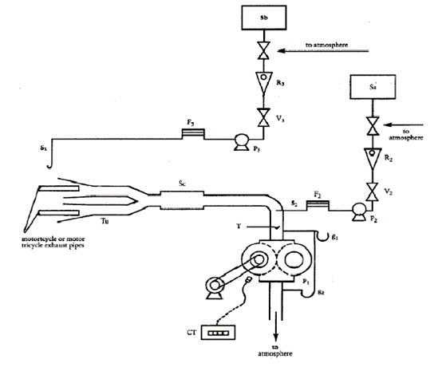  Figure B.2.-1: Equipment for sampling the gases and measuring their volume
 | 3.4.3.2. |  | A connecting tube shall be placed between the device and the exhaust gas sampling system. This tube and the device shall be made of stainless steel, or of some other material which does not affect the composition of the gases collected and which withstands the temperature of these gases.
 | 3.4.3.3. |  | A heat exchanger capable of limiting the temperature variation of the diluted gases in the pump intake to ± 5.0 K (0.0 °C ) (shall be in operation throughout the test. This exchanger shall be equipped with a preheating system capable of bringing the exchanger to its operating temperature (with the tolerance of ± 5.0 K (0.0 °C )) before the test begins.
 | 3.4.3.4. |  | A positive displacement pump shall be used to draw in the diluted exhaust mixture. This pump shall be equipped with a motor with several strictly controlled uniform rotation speeds. The pump capacity shall be large enough to ensure the intake of the exhaust gases. A device using a critical-flow venturi (CFV) may also be used.
 | 3.4.3.5. |  | A device (T) shall be used for the continuous recording of the temperature of the diluted exhaust mixture entering the pump.
 | 3.4.3.6. |  | Two gauges shall be used, the first to ensure the pressure depression of the dilute exhaust mixture entering the pump relative to atmospheric pressure, and the second to measure the dynamic pressure variation of the positive displacement pump.
 | 3.4.3.7. |  | A probe shall be located near to, but outside, the gas-collecting device, to collect samples of the dilution air stream through a pump, a filter and a flow meter at constant flow rates throughout the test.
 | 3.4.3.8. |  | A sample probe pointed upstream into the dilute exhaust mixture flow, upstream of the positive displacement pump, shall be used to collect samples of the dilute exhaust mixture through a pump, a filter and a flow meter at constant flow rates throughout the test. The minimum sample flow rate in the sampling devices shown in Figure B.2.-1 and in point 3.4.3.7. shall be at least 150 litre/hour.
 | 3.4.3.9. |  | Three-way valves shall be used on the sampling system described in points 3.4.3.7. and 3.4.3.8. to direct the samples either to their respective bags or to the outside throughout the test.
 | 3.4.3.10. |  | Gas-tight collection bags
 | 3.4.3.10.1. |  | For dilution air and dilute exhaust mixture the collection bags shall be of sufficient capacity not to impede normal sample flow and shall not change the nature of the pollutants concerned.
 | 3.4.3.10.2. |  | The bags shall have an automatic self-locking device and shall be easily and tightly fastened either to the sampling system or the analysing system at the end of the test.
 | 3.4.3.11. |  | A revolution counter shall be used to count the revolutions of the positive displacement pump throughout the test.  Note 2: Attention shall be paid to the connecting method and the material or configuration of the connecting parts, because each section (e.g. the adapter and the coupler) of the sampling system can become very hot. If the measurement cannot be performed normally due to heat damage to the sampling system, an auxiliary cooling device may be used as long as the exhaust gases are not affected.  Note 3: With open type devices, there is a risk of incomplete gas collection and gas leakage into the test cell. There shall be no leakage throughout the sampling period.  Note 4: If a constant volume sampler (CVS) flow rate is used throughout the test cycle that includes low and high vehicle speeds all in one (i.e. part 1, 2 and 3 cycles), special attention shall be paid to the higher risk of water condensation in the high vehicle speed range.
 | 3.4.3.12. |  | Particulate mass emissions measurement equipment
 | 3.4.3.12.1 |  | Specification
 | 3.4.3.12.1.1. |  | System overview
 | 3.4.3.12.1.1.1. |  | The particulate sampling unit shall consist of a sampling probe located in the dilution tunnel, a particle transfer tube, a filter holder, a partial-flow pump, and flow rate regulators and measuring units.
 | 3.4.3.12.1.1.2. |  | It is recommended that a particle size pre-classifier (e.g. cyclone or impactor) be employed upstream of the filter holder. However, a sampling probe, used as an appropriate size-classification device such as that shown in Figure B.2.-4, is acceptable.
 | 3.4.3.12.1.2. |  | General requirements
 | 3.4.3.12.1.2.1. |  | The sampling probe for the test gas flow for particulates shall be so arranged within the dilution tract that a representative sample gas flow can be taken from the homogeneous air/exhaust mixture.
 | 3.4.3.12.1.2.2. |  | The particulate sample flow rate shall be proportional to the total flow of diluted exhaust gas in the dilution tunnel to within a tolerance of ± 5 percent of the particulate sample flow rate.
 | 3.4.3.12.1.2.3. |  | The sampled dilute exhaust gas shall be maintained at a temperature below 325.0 K (52.0 °C) within 20 cm upstream or downstream of the particulate filter face, except in the case of a regeneration test, where the temperature shall be below 465.0 K (192.0 °C).
 | 3.4.3.12.1.2.4. |  | The particulate sample shall be collected on a single filter mounted in a holder in the sampled diluted exhaust gas flow
 | 3.4.3.12.1.2.5. |  | All parts of the dilution system and the sampling system from the exhaust pipe up to the filter holder which are in contact with raw and diluted exhaust gas shall be designed to minimise deposition or alteration of the particulates. All parts shall be made of electrically conductive materials that do not react with exhaust gas components, and shall be electrically grounded to prevent electrostatic effects.
 | 3.4.3.12.1.2.6. |  | If it is not possible to compensate for variations in the flow rate, provision shall be made for a heat exchanger and a temperature control device as specified in Annex B.5.8. so as to ensure that the flow rate in the system is constant and the sampling rate accordingly proportional.
 | 3.4.3.12.1.3. |  | Specific requirements
 | 3.4.3.12.1.3.1. |  | Particulate matter (PM) sampling probe
 | 3.4.3.12.1.3.1.1. |  | The sample probe shall deliver the particle-size classification performance described in point 3.4.3.12.1.3.1.4. It is recommended that this performance be achieved by the use of a sharp-edged, open-ended probe facing directly in the direction of flow, plus a pre-classifier (cyclone impactor, etc.). An appropriate sampling probe, such as that indicated in Figure 1-1, may alternatively be used provided it achieves the pre-classification performance described in point 3.4.3.12.1.3.1.4.
 | 3.4.3.12.1.3.1.2. |  | The sample probe shall be installed near the tunnel centreline between ten and 20 tunnel diameters downstream of the exhaust gas inlet to the tunnel and have an internal diameter of at least 12 mm.  If more than one simultaneous sample is drawn from a single sample probe, the flow drawn from that probe shall be split into identical sub-flows to avoid sampling artefacts.  If multiple probes are used, each probe shall be sharp-edged, open-ended and facing directly into the direction of flow. Probes shall be equally spaced at least 5 cm apart around the central longitudinal axis of the dilution tunnel.
 | 3.4.3.12.1.3.1.3. |  | The distance from the sampling tip to the filter mount shall be at least five probe diameters, but shall not exceed 1,020 mm.
 | 3.4.3.12.1.3.1.4. |  | The pre-classifier (e.g. cyclone, impactor, etc.) shall be located upstream of the filter holder assembly. The pre-classifier 50 percent cut point particle diameter shall be between 2.5 µm and 10 µm at the volumetric flow rate selected for sampling particulate mass emissions. The pre-classifier shall allow at least 99 percent of the mass concentration of 1 µm particles entering the pre-classifier to pass through the exit of the pre-classifier at the volumetric flow rate selected for sampling particulate mass emissions. However, a sampling probe, used as an appropriate size-classification device, such as that shown in Figure B.2.-4, is acceptable as an alternative to a separate pre-classifier.
 | 3.4.3.12.1.3.2. |  | Sample pump and flow meter
 | 3.4.3.12.1.3.2.1. |  | The sample gas flow measurement unit shall consist of pumps, gas flow regulators and flow measuring units.
 | 3.4.3.12.1.3.2.2. |  | The temperature of the gas flow in the flow meter may not fluctuate by more than ± 3.0 K (3.0 °C ), except during regeneration tests on vehicles equipped with periodically regenerating after-treatment devices. In addition, the sample mass flow rate shall remain proportional to the total flow of diluted exhaust gas to within a tolerance of ± 5 percent of the particulate sample mass flow rate. Should the volume of flow change unacceptably as a result of excessive filter loading, the test shall be stopped. When the test is repeated, the rate of flow shall be decreased.
 | 3.4.3.12.1.3.3. |  | Filter and filter holder
 | 3.4.3.12.1.3.3.1. |  | A valve shall be located downstream of the filter in the direction of flow. The valve shall be responsive enough to open and close within one second of the start and end of the test.
 | 3.4.3.12.1.3.3.2. |  | It is recommended that the mass collected on the 47 mm diameter filter (P_{e)} is ≥ 20 µg and that the filter loading is maximised in line with the requirements of points 3.4.3.12.1.2.3. and 3.4.3.12.1.3.3.
 | 3.4.3.12.1.3.3.3. |  | For a given test, the gas filter face velocity shall be set to a single value within the range 20 cm/s to 80 cm/s, unless the dilution system is being operated with sampling flow proportional to CVS flow rate.
 | 3.4.3.12.1.3.3.4. |  | Fluorocarbon coated glass fibre filters or fluorocarbon membrane filters are required. All filter types shall have a 0.3 µm DOP (di-octylphthalate) or PAO (poly-alpha-olefin) CS 68649-12-7 or CS 68037-01-4 collection efficiency of at least 99 percent at a gas filter face velocity of 5.33 cm/s.
 | 3.4.3.12.1.3.3.5. |  | The filter holder assembly shall be of a design that provides an even flow distribution across the filter stain area. The filter stain area shall be at least 1075 mm².
 | 3.4.3.12.1.3.4. |  | Filter weighing chamber and balance
 | 3.4.3.12.1.3.4.1. |  | The microgram balance used to determine the weight of a filter shall have a precision (standard deviation) of 2 µg and resolution of 1 µg or better.  It is recommended that the microbalance be checked at the start of each weighing session by weighing one reference weight of 50 mg. This weight shall be weighed three times and the average result recorded. The weighing session and balance are considered valid if the average result of the weighing is within ± 5 µg of the result from the previous weighing session.  The weighing chamber (or room) shall meet the following conditions during all filter conditioning and weighing operations:  - Temperature maintained at 295.0 ± 3.0 K (22.0 ± 3.0 °C);  - Relative humidity maintained at 45 ± 8 percent;  - Dew point maintained at 282.5 ± 3.0 K (9.5 ± 3.0 °C).  It is recommended that temperature and humidity conditions be recorded along with sample and reference filter weights.
 | 3.4.3.12.1.3.4.2. |  | Buoyancy correction  All filter weights shall be corrected for filter buoyancy in air.  The buoyancy correction depends on the density of the sample filter medium, the density of air, and the density of the calibration weight used to calibrate the balance. The density of the air is dependent on the pressure, temperature and humidity.  It is recommended that the temperature and dew point of the weighing environment be controlled to 295.0 K ± 1.0 K (22.0 °C ±1.0 °C) and 282.5 ± 1.0 K (9.5 ± 1.0 °C) respectively. However, the minimum requirements stated in point 3.4.3.12.1.3.4.1. will also result in an acceptable correction for buoyancy effects. The correction for buoyancy shall be applied as follows:  Equation B.2.-1:  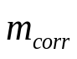=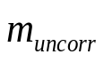  where:  m_{corr} = PM mass corrected for buoyancy (mg)  m_{uncorr} = PM mass uncorrected for buoyancy (mg)  ρ_{air} = density of air in balance environment (mg/cm³)  ρ_{weight} = density of calibration weight used to span balance (mg/cm³)  ρ_{media} = density of PM sample medium (filter) with filter medium Teflon coated glass fibre (e.g. TX40): ρ_{media} = 2.300 kg/m³  ρ_{air} can be calculated as follows:  Equation B.2.-2:  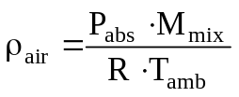  where:  P_{abs} = absolute pressure in balance environment  M_{mix} = molar mass of air in balance environment (28.836 gmol⁻¹)  R = molar gas constant (8.314 Jmol⁻¹K⁻¹)  T_{amb} = absolute ambient temperature of balance environment  The chamber (or room) environment shall be free of any ambient contaminants (such as dust) that would settle on the particulate filters during their stabilisation.  Limited deviations from weighing room temperature and humidity specifications shall be allowed provided their total duration does not exceed 30 minutes in any one filter conditioning period. The weighing room shall meet the required specifications prior to personal entrance into the weighing room. No deviations from the specified conditions are permitted during the weighing operation.
 | 3.4.3.12.1.3.4.3. |  | The effects of static electricity shall be nullified. This may be achieved by grounding the balance through placement on an antistatic mat and neutralisation of the particulate filters prior to weighing using a Polonium neutraliser or a device of similar effect. Alternatively, nullification of static effects may be achieved through equalisation of the static charge.
 | 3.4.3.12.1.3.4.4. |  | A test filter shall be removed from the chamber no earlier than an hour before the test begins.
 | 3.4.3.12.1.4. |  | Recommended system description  Figure B.2.-2 is a schematic drawing of the recommended particulate sampling system. Since various configurations can produce equivalent results, exact conformity with this figure is not required. Additional components such as instruments, valves, solenoids, pumps and switches may be used to provide additional information and coordinate the functions of component systems. Further components that are not needed to maintain accuracy with other system configurations may be excluded if their exclusion is based on good engineering judgment.  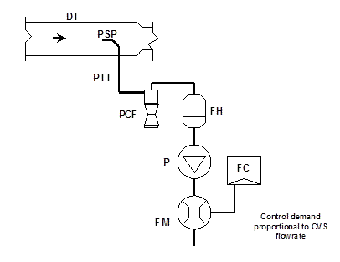  Figure B.2.-2: Particulate sampling system  A sample of the diluted exhaust gas is taken from the full flow dilution tunnel (DT) through the particulate sampling probe (PSP) and the particulate transfer tube (PTT) by means of the pump (P). The sample is passed through the particle size pre-classifier (PCF) and the filter holders (FH) that contain the particulate sampling filters. The flow rate for sampling is set by the flow controller (FC).
 | 3.4.4. |  | Driving schedules
 | 3.4.4.1. |  | Test cycle WMTC  The WMTC test cycles (vehicle speed patterns vs. test time) for the type I test consist of up to three parts, as laid down in Annex B.5.15.
 | 3.4.4.2. |  | Vehicle speed tolerances
 | 3.4.4.2.1. |  | The vehicle speed tolerance at any given time on the test cycles prescribed in Annex B.5.15. is defined by upper and lower limits. The upper limit is 3.2 km/h higher than the highest point on the trace within one second of the given time. The lower limit is 3.2 km/h lower than the lowest point on the trace within one second of the given time. Vehicle speed variations greater than the tolerances (such as may occur during gear changes) are acceptable provided they occur for less than two seconds on any occasion. Vehicle speeds lower than those prescribed are acceptable provided the vehicle is operated at maximum available power during such occurrences. Figure B.2.-3 shows the range of acceptable vehicle speed tolerances for typical points.
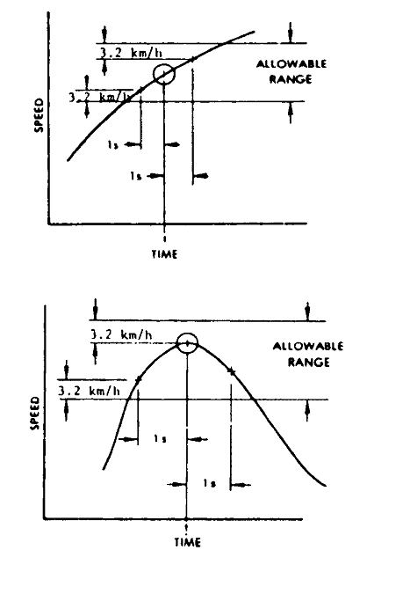
Figure B.2.-3: Drivers trace, allowable range
 | 3.4.4.2.2. |  | If the acceleration capability of the vehicle is not sufficient to carry out the acceleration phases or if the maximum design speed of the vehicle is lower than the prescribed cruising vehicle speed within the prescribed limits of tolerances, the vehicle shall be driven with the throttle fully open until the desired vehicle speed is reached or at the maximum design vehicle speed achievable with fully opened throttle during the time that desired vehicle speed exceeds the maximum design vehicle speed. In both cases, point 3.4.4.2.1. is not applicable. The test cycle shall be carried on normally when desired vehicle speed is again lower than the maximum design speed of the vehicle.
 | 3.4.4.2.3. |  | If the period of deceleration is shorter than that prescribed for the corresponding phase, desired vehicle speed shall be restored by a constant vehicle speed or idling period merging into succeeding constant vehicle speed or idling operation. In such cases, point 3.4.4.2.1. is not applicable.
 | 3.4.4.2.4. |  | Apart from these exceptions, the deviations of the roller speed (from which the actual vehicle speed is calculated) in comparison to the desired vehicle speed of the cycles shall meet the requirements described in point 3.4.4.2.1. If not, the test results shall not be used for further analysis and the test run shall be repeated.
 | 3.4.5. |  | Gearshift prescriptions for the WMTC prescribed for the test cycles set out in Annex B.5.15. and explained in more detail in Annex B.5.16.
 | 3.4.5.1. |  | Test vehicles equipped with an automatic transmission
 | 3.4.5.1.1. |  | Vehicles equipped with transfer cases, multiple sprockets, etc., shall be tested in the configuration recommended by the manufacturer for street or highway use.
 | 3.4.5.1.2. |  | Vehicles equipped with automatic-shift transmissions shall be tested in the predominant drive mode. The accelerator control shall be used in such a way as to accurately follow the desired vehicle speed trace of the test cycle.
 | 3.4.5.1.3. |  | Idle modes shall be run with automatic transmissions in ‘Drive’ and the wheels braked. After initial engagement, the selector shall not be operated at any time during the test. Idle modes shall be run with automatic transmissions in ‘Drive’ and the wheels braked.
 | 3.4.5.1.4. |  | Automatic transmissions shall shift automatically through the normal sequence of gears. The torque converter clutch, if applicable, shall operate as under real-world conditions.
 | 3.4.5.1.5. |  | The deceleration modes shall be run in gear using brakes or throttle as necessary to maintain the desired vehicle speed.
 | 3.4.5.2. |  | Test vehicles equipped with a semi-automatic transmission  Vehicles equipped with semi-automatic transmissions shall be tested using the gears normally employed for driving, and the gear shift used in accordance with the manufacturer's instructions.
 | 3.4.5.3. |  | Test vehicles equipped with manual transmission
 | 3.4.5.3.1 |  | Mandatory requirements
 | 3.4.5.3.1.1. |  | Step 1 — Calculation of desired vehicle speeds to shift gear  Upshift desired vehicle speeds (v_{1→2} and v_{i→i+1}) in km/h during acceleration phases shall be calculated using the following formulae:  Equation B.2.-3:  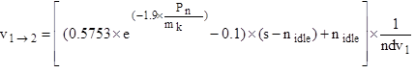  Equation B.2.-4:  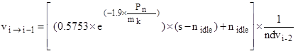, i = 2 to ng -1  where:  ‘i’ is the gear number (≥ 2)  ‘ng’ is the total number of forward gears  ‘P_{n}’ is the rated power in kW  ‘m_{k}’ is the reference mass in kg  ‘n_{idle}’ is the idling engine speed in min⁻¹  ‘s’ is the rated engine speed in min⁻¹  ‘ndv_{i}’ is the ratio between engine speed in min⁻¹ and vehicle speed in km/h in gear ‘i’
 | 3.4.5.3.1.2. |  | Downshift desired vehicle speeds (v_{i→i-1}) in km/h during cruise or deceleration phases in gears 4 (4th gear) to ng shall be calculated using the following formula:  Equation B.2.-5:  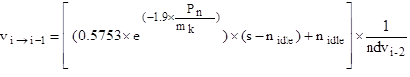, i = 4 to ng  where:  i is the gear number (≥ 4)  ng is the total number of forward gears  P_{n} is the rated power in kW  m_{k} is the reference mass in kg  n_{idle} is the idling engine speed in min⁻¹  s is the rated engine speed in min⁻¹  ndv_{i-2} is the ratio between engine speed in min⁻¹ and vehicle speed in km/h in gear i-2  The downshift desired vehicle speed from gear 3 to gear 2 (v_{3→2}) shall be calculated using the following equation:  Equation B.2.-6:  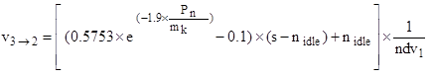  where:  P_{n} is the rated power in kW  m_{k} is the reference mass in kg  n_{idle} is the idling engine speed in min⁻¹  s is the rated engine speed in min⁻¹  nd_{v1} is the ratio between engine speed in min⁻¹ and vehicle speed in km/h in gear 1  The downshift desired vehicle speed from gear 2 to gear 1 (v_{2→1}) shall be calculated using the following equation:  Equation B.2.-7:  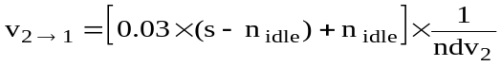  where:  ndv₂ is the ratio between engine speed in min⁻¹ and vehicle speed in km/h in gear 2  Since the cruise phases are defined by the phase indicator, slight vehicle speed increases could occur and it may be appropriate to apply an upshift. The upshift desired vehicle speeds (v_{1→2}, v_{2→3}and v_{i→i+1}) in km/h during cruise phases shall be calculated using the following equations:  Equation B.2.-8:  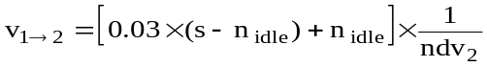  Equation B.2.-9:  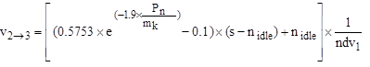  Equation B.2.-10:  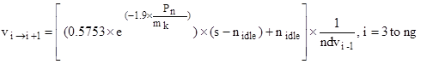
 | 3.4.5.3.1.3. |  | Step 2 — Gear choice for each cycle sample  In order to avoid different interpretations of acceleration, deceleration, cruise and stop phases, corresponding indicators are added to the vehicle speed pattern as integral parts of the cycles (see tables in Annex B.5.15.).  The appropriate gear for each sample shall then be calculated according to the vehicle speed ranges resulting from equations to determine the desired vehicle speeds to shift gears of point 3.4.5.3.1.1. and the phase indicators for the cycle parts appropriate for the test vehicle, as follows:  Gear choice for stop phases:  For the last five seconds of a stop phase, the gear lever shall be set to gear 1 and the clutch shall be disengaged. For the previous part of a stop phase, the gear lever shall be set to neutral or the clutch shall be disengaged.  Gear choice for acceleration phases:  gear 1, if v ≤ v_{1→2}  gear 2, if v_{1→2} < v ≤ v_{2→3}  gear 3, if v_{2→3} < v ≤ v_{3→4}  gear 4, if v_{3→4} < v ≤ v_{4→5}  gear 5, if v_{4→5} < v ≤ v_{5→6}  gear 6, if v > v_{5→6}  Gear choice for deceleration or cruise phases:  gear 1, if v < v_{2→1}  gear 2, if v < v_{3→2}  gear 3, if v_{3→2} ≤ v < v_{4→3}  gear 4, if v_{4→3} ≤ v < v_{5→4}  gear 5, if v_{5→4} ≤ v < v_{6→5}  gear 6, if v ≥ v_{4→5}  The clutch shall be disengaged, if:  (a) the vehicle speed drops below 10 km/h, or  (b) the engine speed drops below n_{idle} + 0.03×(s — n_{idle});  (c) there is a risk of engine stalling during cold-start phase.
 | 3.4.5.3.3. |  | Step 3 — Corrections according to additional requirements
 | 3.4.5.3.3.1. |  | The gear choice shall be modified according to the following requirements:  (a) no gearshift at a transition from an acceleration phase to a deceleration phase. The gear that was used for the last second of the acceleration phase shall be kept for the following deceleration phase unless the vehicle speed drops below a downshift desired vehicle speed;  (b) no upshifts or downshifts by more than one gear, except from gear 2 to neutral during decelerations down to stop;  (c) upshifts or downshifts for up to four seconds are replaced by the gear before, if the gears before and after are identical, e.g. 2 3 3 3 2 shall be replaced by 2 2 2 2 2, and 4 3 3 3 3 4 shall be replaced by 4 4 4 4 4 4.  In the cases of consecutive circumstances, the gear used longer takes over, e.g. 2 2 2 3 3 3 2 2 2 2 3 3 3 will be replaced by 2 2 2 2 2 2 2 2 2 2 3 3 3.  If used for the same time, a series of succeeding gears shall take precedence over a series of preceding gears, e.g. 2 2 2 3 3 3 2 2 2 3 3 3 will be replaced by 2 2 2 2 2 2 2 2 2 3 3 3;  (d) no downshift during an acceleration phase.
 | 3.4.5.3.2. |  | Optional provisions  The gear choice may be modified according to the following provisions:  The use of gears lower than those determined by the requirements described in point 3.4.5.2.1. is permitted in any cycle phase. Manufacturers’ recommendations for gear use shall be followed if they do not result in gears higher than determined by the requirements of point 3.4.5.2.1.
 | 3.4.5.3.3. |  | Optional provisions  Note 5: The calculation programme to be found on the UN website at the following URL may be used as an aid for the gear selection:  http://live.unece.org/trans/main/wp29/wp29wgs/wp29grpe/wmtc.html  Explanations of the approach and the gearshift strategy and a calculation example are given in Annex B.5.16.
 | 3.4.6. |  | Dynamometer settings  A full description of the chassis dynamometer and instruments shall be provided in accordance with Annex B.5.15. Measurements shall be taken to the accuracies specified in point 3.4.7. The running resistance force for the chassis dynamometer settings can be derived either from on-road coast-down measurements or from a running resistance table, with reference to Annexes B.5.4. or B.5.5. for a vehicle equipped with one wheel on the powered axle and to Annexes B.5.4. or B.5.6. for a vehicle with two or more wheels on the powered axles.
 | 3.4.6.1. |  | Chassis dynamometer setting derived from on-road coast-down measurements  To use this alternative, on-road coast-down measurements shall be carried out as specified in Annex B.5.5. for a vehicle equipped with one wheel on the powered axle and Annex B.5.6. for a vehicle equipped with two or more wheels on the powered axles.
 | 3.4.6.1.1. |  | Requirements for the equipment  The instrumentation for the roller speed (actual vehicle speed), desired vehicle speed and time measurement shall have the accuracies specified in point 3.4.7.
 | 3.4.6.1.2. |  | Inertia mass setting
 | 3.4.6.1.2.1. |  | The equivalent inertia mass mi for the chassis dynamometer shall be the flywheel equivalent inertia mass, mfi, closest to the sum of the mass in running order of the vehicle, the mass of the driver (75 kg) and the propulsion batteries if applicable. Alternatively, the equivalent inertia mass mi can be derived from Annex B.5.4.
 | 3.4.6.1.2.2. |  | If the reference mass mref cannot be equalised to the flywheel equivalent inertia mass mi, to make the target running resistance force F* equal to the running resistance force FE (which is to be set to the chassis dynamometer), the corrected coast-down time ΔTE may be adjusted in accordance with the total mass ratio of the target coast-down time ΔTroad in the following sequence:  Equation B.2.-11:  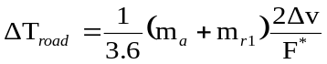  Equation B.2.-12:  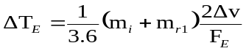  Equation B.2.-13:  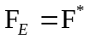  Equation B.2.-14:  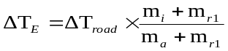  with 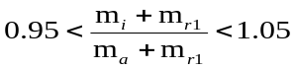  where:  mr1 may be measured or calculated, in kilograms, as appropriate. As an alternative, mr1 may be estimated as f percent of m.
 | 3.4.6.2. |  | Running resistance force derived from a running resistance table
 | 3.4.6.2.1. |  | The chassis dynamometer may be set by the use of the running resistance table instead of the running resistance force obtained by the coast-down method. In this table method, the chassis dynamometer shall be set by the mass in running order regardless of particular vehicle characteristics.  Note 6: Care shall be taken when applying this method to vehicles with extraordinary characteristics.
 | 3.4.6.2.2. |  | The flywheel equivalent inertia mass mfi shall be the equivalent inertia mass m_{i} specified in Annexes B.5.4., B.5.5. or B.5.6. where applicable. The chassis dynamometer shall be set by the rolling resistance of the non-driven wheels (a) and the aero drag coefficient (b) specified in Annex B.5.4., or determined in accordance with the procedures set out in B.5.5. or B.5.6. respectively.
 | 3.4.6.2.3 |  | The running resistance force on the chassis dynamometer F_{E} shall be determined using the following equation:  Equation B.2.-15:
 | 3.4.6.2.4. |  | The target running resistance force F* shall be equal to the running resistance force obtained from the running resistance table FT, because the correction for the standard ambient conditions is not necessary.
 | 3.4.7. |  | Measurement accuracies  Measurements shall be taken using equipment that fulfils the accuracy requirements in Table B.2.-2:  Table B.2.-2: Required accuracy of measurements
  Measurement items | At measured value | Resolution
  a) Running resistance force, F | + 2 percent | -
  b) Vehicle speed (v1, v2) | ± 1 percent | 0.2 km/h
  c) Coast-down vehicle speed interval (2Δv = v1 — v2) | ± 1 percent | 0.1 km/h
  d) Coast-down time (Δt) | ± 0.5 percent | 0.01 s
  e) Total vehicle mass (mk) | ± 0.5 percent | 1.0 kg
  f) Wind speed | ± 10 percent | 0.1 m/s
  g) Wind direction | - | 5 deg.
  h) Temperature | ± 1 K (± 1 °C) | 1 K (1 °C)
  i) Barometric pressure | - | 0.2 kPa
  j) Distance | ± 0.1 percent | 1 m
  k) Time | ± 0.1 s | 0.1 s
 | 4. |  | Test procedures
 | 4.1. |  | Description of the type I test  The test vehicle shall be subjected, according to its category, to test type I requirements as specified in this point 4 and comply with the requirements set out in Annex B.5.3.
 | 4.1.1. |  | Type I test (verifying the average emission of gaseous pollutants, CO₂ emissions and fuel consumption in a characteristic driving cycle)
 | 4.1.1.1. |  | The test shall be carried out by the method described in point 4.2. The gases shall be collected and analysed by the prescribed methods.
 | 4.1.1.2. |  | Number of tests
 | 4.1.1.2.1. |  | The number of tests shall be determined as shown in Figure B.2.-4. R_{i1} to R_{i3} describe the final measurement results for the first (No 1) test to the third (No 3) test and the gaseous pollutant, carbon dioxide emission, fuel / energy consumption or electric range as laid down in Annex B.4. ‘L_{x}’ represents the limit values L₁ to L₅ as defined in the emission limits in point B.1.9.
 | 4.1.1.2.2. |  | In each test, the masses of the carbon monoxide, hydrocarbons, nitrogen oxides, carbon dioxide and the fuel consumed during the test shall be determined. The mass of particulate matter shall be determined only for vehicles equipped with a CI or a direct injected PI combustion engine.
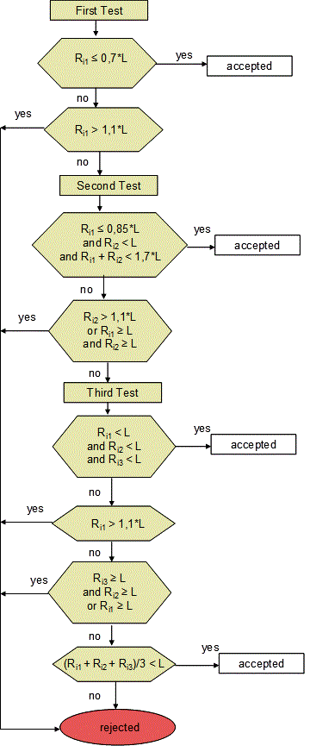
Figure B.2.-4: Flowchart for the number of type I tests
    4.1.1.2.3. | Exhaust emissions may be sampled during preparation tests for type I testing or as verification tests for test types IV, VII or VIII but the results of these tests shall not be used for the purpose of exhaust emission type-approval to satisfty the type I or type V test requirements.
    Exhaust emissions may be sampled during preparation tests for type I testing or during verification tests for test types IV, VII or VIII but the results of these tests shall not be used for the purpose of exhaust emission type-approval to satisfty the requirements set out in point 4.1.1.2.2.
  Exhaust emissions may be sampled during preparation tests for type I testing or during verification tests for test types IV, VII or VIII but the results of these tests shall not be used for the purpose of exhaust emission [approval / certification] to satisfy the requirements set out in point 4.1.1.2.2.
 | 4.2. |  | Type I test
 | 4.2.1. |  | Introduction
 | 4.2.1.1. |  | The type I test consists of prescribed sequences of dynamometer preparation, fuelling, parking, and operating conditions.
 | 4.2.1.2. |  | The test is designed to determine hydrocarbon, carbon monoxide, oxides of nitrogen, carbon dioxide, particulate matter mass emissions if applicable and energy efficiency measurements such as fuel / energy consumption as well as electric range while simulating real-world operation. The test consists of engine start-ups and vehicle operation on a chassis dynamometer, through a specified driving cycle. A proportional part of the diluted exhaust emissions is collected continuously for subsequent analysis, using a constant volume (variable dilution) sampler (CVS).
 | 4.2.1.3. |  | Except in cases of component malfunction or failure, all emission-control systems installed on or incorporated in a tested vehicle shall be functioning during all procedures.
 | 4.2.1.4. |  | Background concentrations are measured for all emission constituents for which emissions measurements are taken. For exhaust testing, this requires sampling and analysis of the dilution air.
 | 4.2.1.5. |  | Background particulate mass measurement  The particulate background level of the dilution air may be determined by passing filtered dilution air through the particulate filter. This shall be drawn from the same point as the particulate matter sample, if a particulate mass measurement is applicable according to point 4.1.1.2.2. One measurement may be performed prior to or after the test. Particulate mass measurements may be corrected by subtracting the background contribution from the dilution system. The permissible background contribution shall be ≤ 1 mg/km (or equivalent mass on the filter). If the background contribution exceeds this level, the default figure of 1 mg/km (or equivalent mass on the filter) shall be used. Where subtraction of the background contribution gives a negative result, the particulate mass result shall be considered to be zero.
 | 4.2.2. |  | Dynamometer settings and verification
 | 4.2.2.1. |  | Test vehicle preparation  The test vehicle shall comply with the requirements set out in Annex B.5.3.
 | 4.2.2.1.1. |  | The manufacturer shall provide additional fittings and adapters, as required to accommodate a fuel drain at the lowest point possible in the tanks as installed on the vehicle, and to provide for exhaust sample collection.
 | 4.2.2.1.2. |  | The tyre pressures shall be adjusted to the manufacturer’s specifications to the satisfaction of the technical service or so that the speed of the vehicle during the road test and the vehicle speed obtained on the chassis dynamometer are equal.
 | 4.2.2.1.3. |  | The test vehicle shall be warmed up on the chassis dynamometer to the same condition as it was during the road test.
 | 4.2.2.2. |  | Chassis dynamometer preparation, if settings are derived from on-road coast-down measurements  Before the test, the chassis dynamometer shall be appropriately warmed up to the stabilised frictional force Ff. The load on the chassis dynamometer FE is, in view of its construction, composed of the total friction loss Ff, which is the sum of the chassis dynamometer rotating frictional resistance, the tyre rolling resistance, the frictional resistance of the rotating parts in the powertrain of the vehicle and the braking force of the power absorbing unit (pau) Fpau, as in the following equation:  Equation B.2.-16:  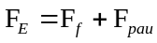  The target running resistance force F* derived from Annex B.5.4. and; for a vehicle equipped with one wheel on the powered axle Annex B.5.5. or for a vehicle with two or more wheels on the powered axles Annex B.5.6., shall be reproduced on the chassis dynamometer in accordance with the vehicle speed, i.e.:  Equation B.2.-17  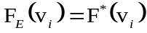  The total friction loss Ff on the chassis dynamometer shall be measured by the method in point 4.2.2.2.1. or 4.2.2.2.2.
 | 4.2.2.2.1. |  | Motoring by chassis dynamometer  This method applies only to chassis dynamometers capable of driving an vehicle. The test vehicle shall be driven steadily by the chassis dynamometer at the reference vehicle speed v₀ with the drive train engaged and the clutch disengaged. The total friction loss Ff (v₀) at the reference vehicle speed v₀ is given by the chassis dynamometer force.
 | 4.2.2.2.2. |  | Coast-down without absorption  The method for measuring the coast-down time is the coast-down method for the measurement of the total friction loss Ff. The vehicle coast-down shall be performed on the chassis dynamometer by the procedure described in Annexes B.5.4. and B.5.5. for a vehicle equipped with one wheel on the powered axle and Annexes B.5.4. and B.5.6. for a vehicle equipped with two or more wheels on the powered axles, with zero chassis dynamometer absorption. The coast-down time Δti corresponding to the reference vehicle speed v0 shall be measured. The measurement shall be carried out at least three times, and the mean coast-down time shall be calculated using the following equation:  Equation B.2.-18:  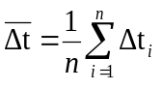
 | 4.2.2.2.3. |  | Total friction loss  The total friction loss Ff_{(v0)} at the reference vehicle speed v₀ is calculated using the following equation:  Equation B.2.-19:  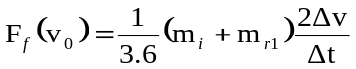
 | 4.2.2.2.4. |  | Calculation of power-absorption unit force  The force Fpau(v₀) to be absorbed by the chassis dynamometer at the reference vehicle speed v₀ is calculated by subtracting Ff_{(v0)} from the target running resistance force F*(v₀) as shown in the following equation:  Equation B.2.-20:  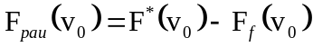
 | 4.2.2.2.5. |  | Chassis dynamometer setting  Depending on its type, the chassis dynamometer shall be set by one of the methods described in points 4.2.2.2.5.1. to 4.2.2.2.5.4. The chosen setting shall be applied to the pollutant and CO₂ emission measurements as well as for the energy efficiency measurements (fuel /energy consumption and electric range) laid down in Annex B.4.
 | 4.2.2.2.5.1. |  | Chassis dynamometer with polygonal function  In the case of a chassis dynamometer with polygonal function, in which the absorption characteristics are determined by load values at several specified vehicle speed points, at least three specified vehicle speeds, including the reference vehicle speed, shall be chosen as the setting points. At each setting point, the chassis dynamometer shall be set to the value Fpau (v_{j}) obtained in point 4.2.2.2.4.
 | 4.2.2.2.5.2. |  | Chassis dynamometer with coefficient control  In the case of a chassis dynamometer with coefficient control, in which the absorption characteristics are determined by given coefficients of a polynomial function, the value of Fpau (v_{j}) at each specified vehicle speed shall be calculated by the procedure in point 4.2.2.2.  Assuming the load characteristics to be:  Equation B.2.-21:  where:  the coefficients a, b and c shall be determined by the polynomial regression method.  The chassis dynamometer shall be set to the coefficients a, b and c obtained by the polynomial regression method.
 | 4.2.2.2.5.3. |  | Chassis dynamometer with F* polygonal digital setter  In the case of a chassis dynamometer with a polygonal digital setter, where a central processor unit is incorporated in the system, F*is input directly, and Δti, Ff and Fpau are automatically measured and calculated to set the chassis dynamometer to the target running resistance force:  Equation B.2.-22:  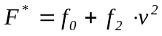  In this case, several points in succession are directly input digitally from the data set of F*j and v_{j}, the coast-down is performed and the coast-down time Δtj is measured. After the coast-down test has been repeated several times, Fpau is automatically calculated and set at vehicle speed intervals of 0.1 km/h, in the following sequence:  Equation B2.-23:  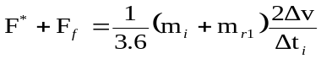  Equation B.2.-24:  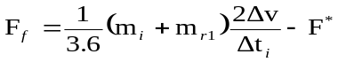  Equation B.2.-25:  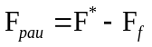
 | 4.2.2.2.5.4. |  | Chassis dynamometer with f*0, f*2 coefficient digital setter  In the case of a chassis dynamometer with a coefficient digital setter, where a central processor unit is incorporated in the system, the target running resistance force is automatically set on the chassis dynamometer.  In this case, the coefficients f*0 and f*2 are directly input digitally; the coast-down is performed and the coast-down time Δti is measured. Fpau is automatically calculated and set at vehicle speed intervals of 0.06 km/h, in the following sequence:  Equation B.2.-26:  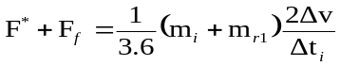  Equation B.2.-27:  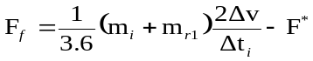  Equation B.2.-28:
 | 4.2.2.2.6. |  | Dynamometer settings verification
 | 4.2.2.2.6.1. |  | Verification test  Immediately after the initial setting, the coast-down time ΔtE on the chassis dynamometer corresponding to the reference vehicle speed (v₀) shall be measured by the procedure set out in Annexes B.5.4. and B.5.5. for a vehicle equipped with one wheel on the powered axle and in Annexes B.5.4. and B.5.6. for a vehicle with two or more wheels on the powered axles. The measurement shall be carried out at least three times, and the mean coast-down time Δt_{E} shall be calculated from the results. The set running resistance force at the reference vehicle speed, FE (v₀) on the chassis dynamometer is calculated by the following equation:  Equation B.2.-29:  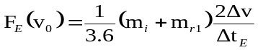
 | 4.2.2.2.6.2. |  | Calculation of setting error  The setting error ε is calculated by the following equation:  Equation B.2.-30:  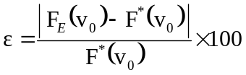  The chassis dynamometer shall be readjusted if the setting error does not satisfy the following criteria:  ε ≤ 2 percent for v₀≥ 50 km/h  ε≤ 3 percent for 30 km/h ≤ v₀< 50 km/h  ε ≤ 10 percent for v₀< 30 km/h  The procedure in points 4.2.2.2.6.1. to 4.2.2.2.6.2. shall be repeated until the setting error satisfies the criteria. The chassis dynamometer setting and the observed errors shall be recorded. Template record forms are provided in the template in accordance with Annex B.5.14.
 | 4.2.2.3. |  | Chassis dynamometer preparation, if settings are derived from a running resistance table
 | 4.2.2.3.1. |  | The specified vehicle speed for the chassis dynamometer  The running resistance on the chassis dynamometer shall be verified at the specified vehicle speed v. At least four specified vehicle speeds shall be verified. The range of specified vehicle speed points (the interval between the maximum and minimum points) shall extend either side of the reference vehicle speed or the reference vehicle speed range, if there is more than one reference vehicle speed, by at least Δv, as defined in Annex B.5.4. and B.5.5. for a vehicle equipped with one wheel on the powered axle and in Annex B.5.4. and B.5.6. for a vehicle with two or more wheels on the powered axles. The specified vehicle speed points, including the reference vehicle speed points, shall be at regular intervals of no more than 20 km/h apart.
 | 4.2.2.3.2. |  | Verification of chassis dynamometer
 | 4.2.2.3.2.1. |  | Immediately after the initial setting, the coast-down time on the chassis dynamometer corresponding to the specified vehicle speed shall be measured. The vehicle shall not be set up on the chassis dynamometer during the coast-down time measurement. The coast-down time measurement shall start when the chassis dynamometer vehicle speed exceeds the maximum vehicle speed of the test cycle.
 | 4.2.2.3.2.2. |  | The measurement shall be carried out at least three times, and the mean coast-down time ΔtE shall be calculated from the results.
 | 4.2.2.3.2.3. |  | The set running resistance force FE(v_{j}) at the specified vehicle speed on the chassis dynamometer is calculated using the following equation:  Equation B.2.-31:  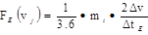
 | 4.2.2.3.2.4. |  | The setting error ε at the specified vehicle speed is calculated using the following equation:  Equation B.2.-32:  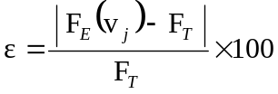
 | 4.2.2.3.2.5. |  | The chassis dynamometer shall be readjusted if the setting error does not satisfy the following criteria:  ε ≤ 2 percent for v ≥ 50 km/h  ε≤ 3 percent for 30 km/h ≤ v < 50 km/h  ε≤ 10 percent for v < 30 km/h
 | 4.2.2.3.2.6. |  | The procedure described in points 4.2.2.3.2.1. to 4.2.2.3.2.5. shall be repeated until the setting error satisfies the criteria. The chassis dynamometer setting and the observed errors shall be recorded.
 | 4.2.2.4. |  | The chassis dynamometer system shall comply with the calibration and verification methods laid down in Annex B.5.7.
 | 4.2.3. |  | Calibration of analysers
 | 4.2.3.1. |  | The quantity of gas at the indicated pressure compatible with the correct functioning of the equipment shall be injected into the analyser with the aid of the flow metre and the pressure-reducing valve mounted on each gas cylinder. The apparatus shall be adjusted to indicate as a stabilised value the value inserted on the standard gas cylinder. Starting from the setting obtained with the gas cylinder of greatest capacity, a curve shall be drawn of the deviations of the apparatus according to the content of the various standard cylinders used. The flame ionisation analyser shall be recalibrated periodically, at intervals of not more than one month, using air/propane or air/hexane mixtures with nominal hydrocarbon concentrations equal to 50 percent and 90 percent of full scale.
 | 4.2.3.2. |  | Non-dispersive infrared absorption analysers shall be checked at the same intervals using nitrogen/ CO and nitrogen/ CO₂ mixtures in nominal concentrations equal to 10, 40, 60, 85 and 90 percent of full scale.
 | 4.2.3.3. |  | To calibrate the NO_{X} chemiluminescence analyser, nitrogen/nitrogen oxide (NO) mixtures with nominal concentrations equal to 50 percent and 90 percent of full scale shall be used. The calibration of all three types of analysers shall be checked before each series of tests, using mixtures of the gases, which are measured in a concentration equal to 80 percent of full scale. A dilution device can be applied for diluting a 100 percent calibration gas to required concentration.
 | 4.2.3.4. |  | Heated flame ionisation detector (FID) (analyser) hydrocarbon response check procedure
 | 4.2.3.4.1. |  | Detector response optimisation  The FID shall be adjusted according to the manufacturer’s specifications. To optimise the response, propane in air shall be used on the most common operating range.
 | 4.2.3.4.2. |  | Calibration of the hydrocarbon analyser  The analyser shall be calibrated using propane in air and purified synthetic air (see point 4.2.3.6.).  A calibration curve shall be established as described in point 4.2.3.1 to 4.2.3.3.
 | 4.2.3.4.3. |  | Response factors of different hydrocarbons and recommended limits  The response factor (R_{f}) for a particular hydrocarbon species is the ratio of the FID C₁ reading to the gas cylinder concentration, expressed as ppm C₁.  The concentration of the test gas shall be at a level to give a response of approximately 80 percent of full-scale deflection for the operating range. The concentration shall be known to an accuracy of 2 percent in reference to a gravimetric standard expressed in volume. In addition, the gas cylinder shall be pre-conditioned for 24 hours at a temperature of between 293.0 K and 303.0 K (20.0 °C and 30.0 °C).  Response factors shall be determined when introducing an analyser into service and thereafter at major service intervals. The test gases to be used and the recommended response factors are:  Methane and purified air: 1.00 < Rf < 1.15  or 1.00 < Rf < 1.05 for NG/biomethane-fuelled vehicles  Propylene and purified air: 0.90 < Rf < 1.00  Toluene and purified air: 0.90 < Rf < 1.00  These are relative to a response factor (Rf) of 1.00 for propane and purified air.
 | 4.2.3.5. |  | Calibration and verification procedures of the particulate mass emissions measurement equipment
 | 4.2.3.5.1. |  | Flow meter calibration  The technical service shall check that a calibration certificate has been issued for the flow meter demonstrating compliance with a traceable standard within a 12-month period prior to the test, or since any repair or change which could influence calibration.
 | 4.2.3.5.2. |  | Microbalance calibration  The technical service shall check that a calibration certificate has been issued for the microbalance demonstrating compliance with a traceable standard within a 12-month period prior to the test.
 | 4.2.3.5.3. |  | Reference filter weighing  To determine the specific reference filter weights, at least two unused reference filters shall be weighed within eight hours of, but preferably at the same time as, the sample filter weighing. Reference filters shall be of the same size and material as the sample filter.  If the specific weight of any reference filter changes by more than ± 5 µg between sample filter weighings, the sample filter and reference filters shall be reconditioned in the weighing room and then reweighed.  This shall be based on a comparison of the specific weight of the reference filter and the rolling average of that filter’s specific weights.  The rolling average shall be calculated from the specific weights collected in the period since the reference filters were placed in the weighing room. The averaging period shall be between one day and 30 days.  Multiple reconditioning and reweighings of the sample and reference filters are permitted up to 80 hours after the measurement of gases from the emissions test.  If, within this period, more than half the reference filters meet the ± 5 µg criterion, the sample filter weighing can be considered valid.  If, at the end of this period, two reference filters are used and one filter fails to meet the ± 5 µg criterion, the sample filter weighing may be considered valid provided that the sum of the absolute differences between specific and rolling averages from the two reference filters is no more than 10 µg.  If fewer than half of the reference filters meet the ± 5 µg criterion, the sample filter shall be discarded and the emissions test repeated. All reference filters shall be discarded and replaced within 48 hours.  In all other cases, reference filters shall be replaced at least every 30 days and in such a manner that no sample filter is weighed without comparison with a reference filter that has been in the weighing room for at least one day.  If the weighing room stability criteria outlined in point 3.4.3.12.1.3.4. are not met but the reference filter weighings meet the criteria listed in point 4.2.3.5.3., the vehicle manufacturer has the option of accepting the sample filter weights or voiding the tests, fixing the weighing room control system and re-running the test.  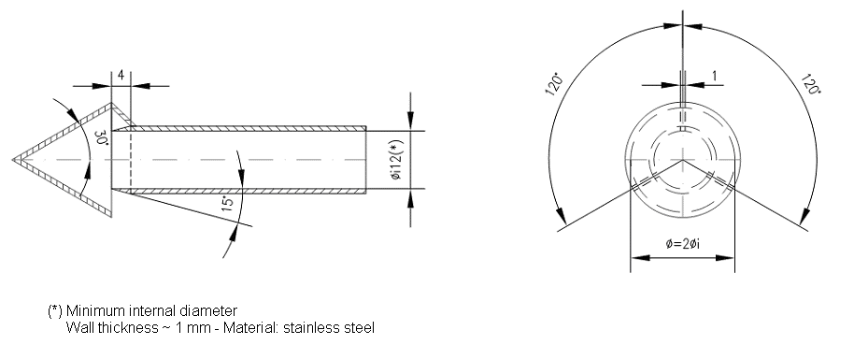  Figure B.2.-4: Particulate sampling probe configuration
 | 4.2.3.6. |  | Reference gases
 | 4.2.3.6.1. |  | Pure gases  The following pure gases shall be available, if necessary, for calibration and operation:  Purified nitrogen: (purity: ≤ 1 ppm C₁, ≤ 1 ppm CO, ≤ 400 ppm CO₂, ≤ 0.1 ppm NO);  Purified synthetic air: (purity: ≤ 1 ppm C₁, ≤ 1 ppm CO, ≤ 400 ppm CO₂, ≤ 0.1 ppm NO); oxygen content between 18 and 21 percent by volume;  Purified oxygen: (purity > 99.5 percent vol. O₂);  Purified hydrogen (and mixture containing helium): (purity ≤ 1 ppm C₁, ≤ 400 ppm CO₂);  Carbon monoxide: (minimum purity 99.5 percent);  Propane: (minimum purity 99.5 percent).
 | 4.2.3.6.2. |  | Calibration and span gases  Mixtures of gases with the following chemical compositions shall be available:  - C₃H₈ and purified synthetic air (see point 4.2.3.6.1.);  - CO and purified nitrogen;  - CO₂ and purified nitrogen;  - NO and purified nitrogen (the amount of NO2 contained in this calibration gas shall not exceed 5 percent of the NO content).  The true concentration of a calibration gas shall be within ± 2 percent of the stated figure.
 | 4.2.3.6. |  | Calibration and verification of the dilution system  The dilution system shall be calibrated and verified and shall comply with the requirements of Annex B.5.7.
 | 4.2.4. |  | Test vehicle preconditioning
 | 4.2.4.1. |  | The test vehicle shall be moved to the test area and the following operations performed:  - The fuel tanks shall be drained through the drains of the fuel tanks provided and charged with the test fuel requirement as specified in Annex B.5.2. to half the capacity of the tanks.  - The test vehicle shall be placed, either by being driven or pushed, on a dynamometer and operated through the applicable test cycle as specified for the vehicle (sub-)category in Annex B.5.15. The vehicle need not be cold, and may be used to set dynamometer power.
 | 4.2.4.2. |  | Practice runs over the prescribed driving schedule may be performed at test points, provided an emission sample is not taken, for the purpose of finding the minimum throttle action to maintain the proper vehicle speed-time relationship, or to permit sampling system adjustments.
 | 4.2.4.3. |  | Within five minutes of completion of preconditioning, the test vehicle shall be removed from the dynamometer and may be driven or pushed to the soak area to be parked. The vehicle shall be stored for between six and 36 hours prior to the cold start type I test or until the engine oil temperature T_{O} or the coolant temperature T_{C} or the sparkplug seat/gasket temperature T_{P} (only for air-cooled engine) equals the air temperature of the soak area within 2.0 K (2.0 °C).
 | 4.2.4.4. |  | For the purpose of measuring particulates, between six and 36 hours before testing, the applicable test cycle set out in Annex B.5.15. shall be conducted. The technical details of the applicable test cycle are laid down in Annex B.5.15. and the applicable test cycle shall also be used for vehicle pre-conditioning. Three consecutive cycles shall be driven. The dynamometer setting shall be indicated as in point 3.4.6.
 | 4.2.4.5. |  | At the request of the manufacturer, vehicles fitted with indirect injection positive-ignition engines may be preconditioned with one Part One, one Part Two and two Part Three driving cycles, if applicable, from the WMTC.  In a test facility where a test on a low particulate emitting vehicle could be contaminated by residue from a previous test on a high particulate emitting vehicle, it is recommended that, in order to pre-condition the sampling equipment, the low particulate emitting vehicle undergo a 20 minute 120 km/h steady state drive cycle or at 70% of the maximum design vehicle speed for vehicles not capable of attaining 120 km/h followed by three consecutive Part Two or Part Three WMTC cycles, if feasible.  After this preconditioning, and before testing, vehicles shall be kept in a room in which the temperature remains relatively constant between 293.0 K and 303.0 K (20.0 °C and 30.0 °C). This conditioning shall be carried out for at least six hours and continue until the engine oil temperature and coolant, if any, are within ±2.0 K (2.0 °C) of the temperature of the room.  If the manufacturer so requests, the test shall be carried out not later than 30 hours after the vehicle has been run at its normal temperature.
 | 4.2.4.6. |  | Vehicles equipped with a positive-ignition engine, fuelled with LPG, NG/biomethane, H₂NG, hydrogen or so equipped that they can be fuelled with either petrol, LPG, NG/biomethane, H₂NG or hydrogen between the tests on the first gaseous reference fuel and the second gaseous reference fuel, shall be preconditioned before the test on the second reference fuel. This preconditioning on the second reference fuel shall involve a preconditioning cycle consisting of one Part One, Part Two and two Part Three WMTC cycles, as described in Annex B.5.15. At the manufacturer’s request and with the agreement of the technical service, this preconditioning may be extended. The dynamometer setting shall be as indicated in point 3.4.6. of this Annex.
 | 4.2.5. |  | Emissions tests
 | 4.2.5.1. |  | Engine starting and restarting
 | 4.2.5.1.1. |  | The engine shall be started according to the manufacturer’s recommended starting procedures. The test cycle run shall begin when the engine starts.
 | 4.2.5.1.2. |  | Test vehicles equipped with automatic chokes shall be operated according to the instructions in the manufacturer’s operating instructions or owner’s manual covering choke-setting and ‘kick-down’ from cold fast idle. In the case of the WMTC set out in Annex B.5.15., the transmission shall be put in gear 15 seconds after the engine is started. If necessary, braking may be employed to keep the drive wheels from turning.
 | 4.2.5.1.3. |  | Test vehicles equipped with manual chokes shall be operated according to the manufacturer’s operating instructions or owner’s manual. Where times are provided in the instructions, the point for operation may be specified, within 15 seconds of the recommended time.
 | 4.2.5.1.4. |  | The operator may use the choke, throttle, etc. where necessary to keep the engine running.
 | 4.2.5.1.5. |  | If the manufacturer’s operating instructions or owner’s manual do not specify a warm engine starting procedure, the engine (automatic and manual choke engines) shall be started by opening the throttle about half way and cranking the engine until it starts.
 | 4.2.5.1.6. |  | If, during the cold start, the test vehicle does not start after ten seconds of cranking or ten cycles of the manual starting mechanism, cranking shall cease and the reason for failure to start determined. The revolution counter on the constant volume sampler shall be turned off and the sample solenoid valves placed in the ‘standby’ position during this diagnostic period. In addition, either the CVS blower shall be turned off or the exhaust tube disconnected from the tailpipe during the diagnostic period.
 | 4.2.5.1.7. |  | If failure to start is an operational error, the test vehicle shall be rescheduled for testing from a cold start. If failure to start is caused by vehicle malfunction, corrective action (following the unscheduled maintenance provisions) lasting less than 30 minutes may be taken and the test continued. The sampling system shall be reactivated at the same time cranking is started. The driving schedule timing sequence shall begin when the engine starts. If failure to start is caused by vehicle malfunction and the vehicle cannot be started, the test shall be voided, the vehicle removed from the dynamometer, corrective action taken (following the unscheduled maintenance provisions) and the vehicle rescheduled for test. The reason for the malfunction (if determined) and the corrective action taken shall be reported.
 | 4.2.5.1.8. |  | If the test vehicle does not start during the warm start after ten seconds of cranking or ten cycles of the manual starting mechanism, cranking shall cease, the test shall be voided, the vehicle removed from the dynamometer, corrective action taken and the vehicle rescheduled for test. The reason for the malfunction (if determined) and the corrective action taken shall be reported.
 | 4.2.5.1.9. |  | If the engine ‘false starts’, the operator shall repeat the recommended starting procedure (such as resetting the choke, etc.)
 | 4.2.5.2. |  | Stalling
 | 4.2.5.2.1. |  | If the engine stalls during an idle period, it shall be restarted immediately and the test continued. If it cannot be started soon enough to allow the vehicle to follow the next acceleration as prescribed, the driving schedule indicator shall be stopped. When the vehicle restarts, the driving schedule indicator shall be reactivated.
 | 4.2.5.2.2. |  | If the engine stalls during some operating mode other than idle, the driving schedule indicator shall be stopped, the test vehicle restarted and accelerated to the vehicle speed required at that point in the driving schedule, and the test continued. During acceleration to this point, gearshifts shall be performed in accordance with point 3.4.5.
 | 4.2.5.2.3. |  | If the test vehicle will not restart within one minute, the test shall be voided, the vehicle removed from the dynamometer, corrective action taken and the vehicle rescheduled for test. The reason for the malfunction (if determined) and the corrective action taken shall be reported.
 | 4.2.6. |  | Drive instructions
 | 4.2.6.1. |  | The test vehicle shall be driven with minimum throttle movement to maintain the desired vehicle speed. No simultaneous use of brake and throttle shall be permitted.
 | 4.2.6.2. |  | If the test vehicle cannot accelerate at the specified rate, it shall be operated with the throttle fully opened until the roller speed (actual vehicle speed) reaches the value prescribed for that time in the driving schedule.
 | 4.2.7. |  | Dynamometer test runs
 | 4.2.7.1. |  | The complete dynamometer test consists of consecutive parts as described in Annex B.5.15.
 | 4.2.7.2. |  | The following steps shall be taken for each test:  (a) place drive wheel of vehicle on dynamometer without starting engine;  (b) activate vehicle cooling fan;  (c) for all test vehicles, with the sample selector valves in the ‘standby’ position, connect evacuated sample collection bags to the dilute exhaust and dilution air sample collection systems;  (d) start the CVS (if not already on), the sample pumps and the temperature recorder. (The heat exchanger of the constant volume sampler, if used, and sample lines shall be preheated to their respective operating temperatures before the test begins);  (e) adjust the sample flow rates to the desired flow rate and set the gas flow measuring devices to zero;  - For gaseous bag (except hydrocarbon) samples, the minimum flow rate is 0.08 litre/second;  - For hydrocarbon samples, the minimum flame ionisation detection (FID) (or heated flame ionisation detection (HFID) in the case of methanol-fuelled vehicles) flow rate is 0.031 litre/second;  (f) attach the flexible exhaust tube to the vehicle tailpipes;  (g) start the gas flow measuring device, position the sample selector valves to direct the sample flow into the ‘transient’ exhaust sample bag, the ‘transient’ dilution air sample bag, turn the key on and start cranking the engine;  (h) put the transmission in gear;  (i) begin the initial vehicle acceleration of the driving schedule;  (j) operate the vehicle according to the driving cycles specified in Annex B.5.15.;  (k) at the end of part 1 or part 1 in cold condition, simultaneously switch the sample flows from the first bags and samples to the second bags and samples, switch off gas flow measuring device No 1 and start gas flow measuring device No 2;  (l) in case of vehicles capable of running Part 3 of the WMTC, at the end of Part 2 simultaneously switch the sample flows from the second bags and samples to the third bags and samples, switch off gas flow measuring device No 2 and, start gas flow measuring device No 3;  (m) before starting a new part, record the measured roll or shaft revolutions and reset the counter or switch to a second counter. As soon as possible, transfer the exhaust and dilution air samples to the analytical system and process the samples according to point 6., obtaining a stabilised reading of the exhaust bag sample on all analysers within 20 minutes of the end of the sample collection phase of the test;  (n) turn the engine off two seconds after the end of the last part of the test;  (o) immediately after the end of the sample period, turn off the cooling fan;  (p) turn off the constant volume sampler (CVS) or critical-flow venturi (CFV) or disconnect the exhaust tube from the tailpipes of the vehicle;  (q) disconnect the exhaust tube from the vehicle tailpipes and remove the vehicle from the dynamometer;  (r) for comparison and analysis reasons, second-by-second emissions (diluted gas) data shall be monitored as well as the bag results.
 | 5. |  | Analysis of results
 | 5.1. |  | Type I tests
 | 5.1.1. |  | Exhaust emission and fuel / energy consumption analysis
 | 5.1.1.1. |  | Analysis of the samples contained in the bags  The analysis shall begin as soon as possible, and in any event not later than 20 minutes after the end of the tests, in order to determine:  - the concentrations of hydrocarbons, carbon monoxide, nitrogen oxides, particulate matter if applicable and carbon dioxide in the sample of dilution air contained in bag(s) B;  - the concentrations of hydrocarbons, carbon monoxide, nitrogen oxides, carbon dioxide and particulate matter if applicable in the sample of diluted exhaust gases contained in bag(s) A.
 | 5.1.1.2. |  | Calibration of analysers and concentration results  The analysis of the results has to be carried out in the following steps:  (a) prior to each sample analysis, the analyser range to be used for each pollutant shall be set to zero with the appropriate zero gas;  (b) the analysers are set to the calibration curves by means of span gases of nominal concentrations of 70 to 100 percent of the range;  (c) the analysers’ zeroes are rechecked. If the reading differs by more than 2 percent of range from that set in (b), the procedure is repeated;  (d) the samples are analysed;  (e) after the analysis, zero and span points are rechecked using the same gases. If the readings are within 2 percent of those in point (c), the analysis is considered acceptable;  (f) at all points in this section the flow-rates and pressures of the various gases shall be the same as those used during calibration of the analysers;  (g) the figure adopted for the concentration of each pollutant measured in the gases is that read off after stabilisation on the measuring device.
 | 5.1.1.3. |  | Measuring the distance covered  The distance (S) actually covered for a test part shall be calculated by multiplying the number of revolutions read from the cumulative counter (see point 3.4.2.2.) by the circumference of the roller. This distance shall be expressed in km to three decimal places.
 | 5.1.1.4. |  | Determination of the quantity of gas emitted  The reported test results shall be computed for each test and each cycle part by use of the following formulae. The results of all emission tests shall be rounded.
 | 5.1.1.4.1. |  | Total volume of diluted gas  The total volume of diluted gas, expressed in m³/cycle part, adjusted to the reference conditions of 273.0 K (0.0 °C ) and 101.3 kPa, is calculated by  Equation B.2.-33:  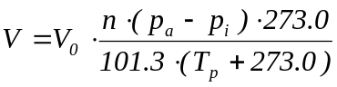  where:  V₀ is the volume of gas displaced by pump P during one revolution, expressed in m³/revolution. This volume is a function of the differences between the intake and output sections of the pump;  N is the number of revolutions made by pump P during each part of the test;  p_{a} is the ambient pressure in kPa;  p_{i} is the average under-pressure during the test part in the intake section of pump P, expressed in kPa;  T_{P} is the temperature (expressed in K) of the diluted gases during the test part, measured in the intake section of pump P.
 | 5.1.1.4.2. |  | Hydrocarbons (HC)  The mass of unburned hydrocarbons emitted by the exhaust of the vehicle during the test shall be calculated using the following formula:  Equation B.2.-34:  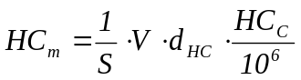  where:  HCm is the mass of hydrocarbons emitted during the test part, in mg/km;  S is the distance defined in point 5.1.1.3.;  V is the total volume, defined in point 5.1.1.4.1.;  d_{HC} is the density of the hydrocarbons at reference temperature and pressure (273.0 K (0.0 °C) and 101.3 kPa);  d_{HC} = 631·10³ mg/m³ for petrol (E5) (C₁H_{1.89}O_{0.016});  = 932·10³ mg/m³ for ethanol (E85) (C₁H_{2.74}O_{0.385});  = 622·10³ mg/m³ for diesel (B5) (C₁H_{l.86}O_{0.005});  = 649·10³ mg/m³ for LPG (C₁H_{2.525});  = 714·10³ mg/m³ for NG/biogas (C₁H₄);  = 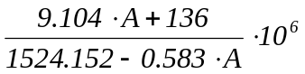 mg/m³ for H₂NG (with A = NG / biomethane quantity within the H₂NG mixture in (volume %)).  HCc is the concentration of diluted gases, expressed in parts per million (ppm) of carbon equivalent (e.g. the concentration in propane multiplied by three), corrected to take account of the dilution air by the following equation:  Equation B.2.-35:  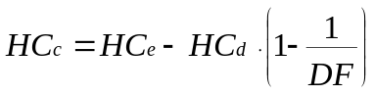  where:  HC_{e} is the concentration of hydrocarbons expressed in parts per million (ppm) of carbon equivalent, in the sample of diluted gases collected in bag(s) A;  HC_{d} is the concentration of hydrocarbons expressed in parts per million (ppm) of carbon equivalent, in the sample of dilution air collected in bag(s) B;  DiF is the coefficient defined in point 5.1.1.4.7.  The non-methane hydrocarbon (NMHC) concentration is calculated as follows:  Equation B.2.-36:  C_{NMHC} = C_{THC} - (Rf CH₄ · C_{CH4})  where:  C_{NMHC} = corrected concentration of NMHC in the diluted exhaust gas, expressed in ppm carbon equivalent;  C_{THC} = concentration of total hydrocarbons (THC) in the diluted exhaust gas, expressed in ppm carbon equivalent and corrected by the amount of THC contained in the dilution air;  C_{CH4} = concentration of methane (CH₄) in the diluted exhaust gas, expressed in ppm carbon equivalent and corrected by the amount of CH₄ contained in the dilution air;  Rf_{CH4} is the FID response factor to methane as defined in point 4.2.3.4.1.
 | 5.1.1.4.3. |  | Carbon monoxide (CO)  The mass of carbon monoxide emitted by the exhaust of the vehicle during the test shall be calculated using the following formula:  Equation B.2.-37:  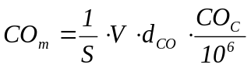  where:  CO_{m} is the mass of carbon monoxide emitted during the test part, in mg/km;  S is the distance defined in point 5.1.1.3.;  V is the total volume defined in point 5.1.1.4.1.;  d_{CO} is the density of the carbon monoxide, d_{CO} = 1.25·10⁶ mg/m³ at reference temperature and pressure (273.0 K (0.0 °C) and 101.3 kPa);  CO_{c} is the concentration of diluted gases, expressed in parts per million (ppm) of carbon monoxide, corrected to take account of the dilution air by the following equation:  Equation B.2.-38:  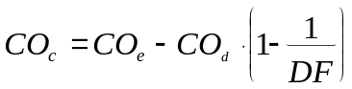  where:  CO_{e} is the concentration of carbon monoxide expressed in parts per million (ppm), in the sample of diluted gases collected in bag(s) A;  CO_{d} is the concentration of carbon monoxide expressed in parts per million (ppm), in the sample of dilution air collected in bag(s) B;  DiF is the coefficient defined in point 5.1.1.4.7.
 | 5.1.1.4.4. |  | Nitrogen oxides (NOx)  The mass of nitrogen oxides emitted by the exhaust of the vehicle during the test shall be calculated using the following formula:  Equation B.2.-39:  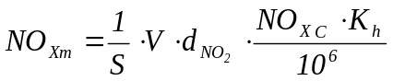  where:  NO_{xm} is the mass of nitrogen oxides emitted during the test part, in mg/km;  S is the distance defined in point 5.1.1.3.;  V is the total volume defined in point 5.1.1.4.1.;  d_{NO2} is the density of the nitrogen oxides in the exhaust gases, assuming that they will be in the form of nitric oxide, d_{NO2} = 2.05·10⁶ mg/m³ at reference temperature and pressure (273.0 K (0.0 °C) and 101.3 kPa);  NO_{xc} is the concentration of diluted gases, expressed in parts per million (ppm), corrected to take account of the dilution air by the following equation:  Equation B.2.-40:  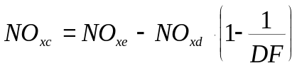  where:  NO_{xe} is the concentration of nitrogen oxides expressed in parts per million (ppm) of nitrogen oxides, in the sample of diluted gases collected in bag(s) A;  NO_{xd} is the concentration of nitrogen oxides expressed in parts per million (ppm) of nitrogen oxides, in the sample of dilution air collected in bag(s) B;  DiF is the coefficient defined in point 5.1.1.4.7.;  K_{h} is the humidity correction factor, calculated using the following formula:  Equation B.2.-41:  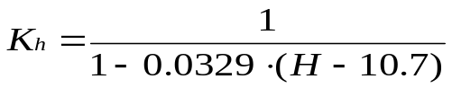  where:  H is the absolute humidity in g of water per kg of dry air:  Equation B.2.-42:  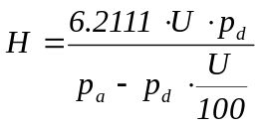  where:  U is the relative humidity as a percentage;  p_{d} is the saturated pressure of water at the test temperature in kPa;  p_{a}is the atmospheric pressure in kPa.
 | 5.1.1.4.5. |  | Particulate matter mass  Particulate emission Mp (mg/km) is calculated by means of the following equation:  Equation 2-43:  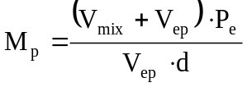  where exhaust gases are vented outside the tunnel;  Equation B.2.-43:  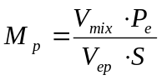  where exhaust gases are returned to the tunnel;  where:  V_{mix} = volume V of diluted exhaust gases under standard conditions;  V_{ep} = volume of exhaust gas flowing through particulate filter under standard conditions;  P_{e} = particulate mass collected by filter(s);  S = is the distance defined in point 5.1.1.3.;  M_{p} = particulate emission in mg/km.  Where correction for the particulate background level from the dilution system has been used, this shall be determined in accordance with point 4.2.1.5. In this case, the particulate mass (mg/km) shall be calculated as follows:  Equation B.2.-44:  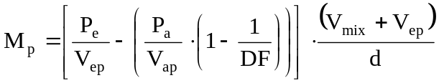  where exhaust gases are vented outside the tunnel;  Equation B.2.-45:  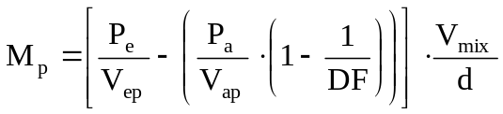  where exhaust gases are returned to the tunnel;  where:  V_{ap} = volume of tunnel air flowing through the background particulate filter under standard conditions;  P_{a} = particulate mass collected by background filter;  DiF = dilution factor as determined in point 5.1.1.4.7.  Where application of a background correction results in a negative particulate mass (in mg/km), the result shall be considered to be zero mg/km particulate mass.
 | 5.1.1.4.6. |  | Carbon dioxide (CO₂)  The mass of carbon dioxide emitted by the exhaust of the vehicle during the test shall be calculated using the following formula:  Equation B.2.-46:  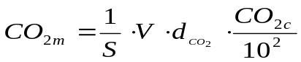  where:  CO_{2m} is the mass of carbon dioxide emitted during the test part, in g/km;  S is the distance defined in point 5.1.1.3.;  V is the total volume defined in point 5.1.1.4.1.;  d_{CO2} is the density of the carbon monoxide, d_{CO2} = 1.964·10³ g/m³ at reference temperature and pressure (273.0 K (0.0 °C) and 101.3 kPa);  CO_{2c} is the concentration of diluted gases, expressed as a percentage of carbon dioxide equivalent, corrected to take account of the dilution air by the following equation:  Equation B.2.-47:    where:  CO_{2e} is the concentration of carbon dioxide expressed as a percentage of the sample of diluted gases collected in bag(s) A;  CO_{2d} is the concentration of carbon dioxide expressed as a percentage of the sample of dilution air collected in bag(s) B;  DiF is the coefficient defined in point 5.1.1.4.7.
 | 5.1.1.4.7. |  | Dilution factor (DiF)  The dilution factor is calculated as follows:  For each reference fuel, except hydrogen:  Equation B.2.-48:  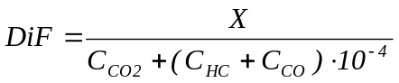  For a fuel of composition C_{x}H_{y}O_{z}, the general formula is:  Equation B.2.-49:  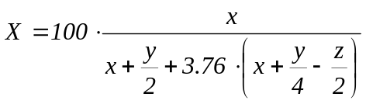  For H₂NG, the formula is:  Equation B.2.-50:  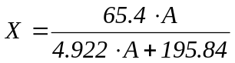  For hydrogen, the dilution factor is calculated as follows:  Equation B.2.-51:  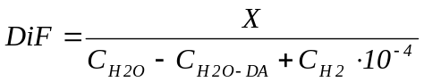  For the reference fuels contained in annex B.5.2., the values of ‘X’ are as follows:  Table B.2.-3: Factor ‘X’ in formulae to calculate DiF  In these equations:  C_{CO2} = concentration of CO₂ in the diluted exhaust gas contained in the sampling bag, expressed in percent by volume,  C_{HC} = concentration of HC in the diluted exhaust gas contained in the sampling bag, expressed in ppm carbon equivalent,  C_{CO} = concentration of CO in the diluted exhaust gas contained in the sampling bag, expressed in ppm,  C_{H20} = concentration of H₂O in the diluted exhaust gas contained in the sampling bag, expressed in percent by volume,  C_{H20-DA} = concentration of H₂O in the air used for dilution, expressed in percent by volume,  C_{H2} = concentration of hydrogen in the diluted exhaust gas contained in the sampling bag, expressed in ppm,  A = quantity of NG/biomethane in the H₂NG mixture, expressed in percent by volume.
  Fuel | X
  Petrol (E5) | 13.4
  Diesel (B5) | 13.5
  LPG | 11.9
  NG/biomethane | 9.5
  Ethanol (E85) | 12.5
  Hydrogen | 35.03
 | 5.1.1.5. |  | Weighting of type I test results
 | 5.1.1.5.1. |  | With repeated measurements (see point 4.1.1.2.), the pollutant (mg/km), and CO₂ (g/km) emission results obtained by the calculation method described in point 5.1.1. and fuel / energy consumption and electric range determined according to Section B.4. are averaged for each cycle part.
 | 5.1.1.5.1.1 |  | Weighting of WMTC results  The (average) result of Part 1 or Part 1 reduced vehicle speed is called R1, the (average) result of Part 2 or Part 2 reduced vehicle speed is called R2 and the (average) result of Part 3 or part 3 reduced vehicle speed is called R3. Using these emission (mg/km) and fuel consumption (litres/100 km) results, the final result R_{F}, depending on the vehicle category as defined in point 5.1.1.6.1., shall be calculated using the following equations:  Equation B.2.-52:  where:  w₁ = weighting factor cold phase  w₂ = weighting factor warm phase  Equation B.2.-53:  where:  w_{n} = weighting factor phase n (n=1, 2 or 3)
 | 5.1.1.6.1. |  | For each pollutant emission constituent and carbon dioxide emission the weightings shown in Tables B.2.-4 shall be used.
 | 5.1.1.6.1.1. |  | Table B.2.-4: Type I test cycles (also applicable for test Types VII and VIII), applicable weighting equations and weighting factors.
  Vehicle Class number | Equation # | Weighting factors
  1 | B.2.-52 | w₁ = 0.50  w₂ = 0.50
  2 | B.2.-52 | w₁ = 0.30  w₂ = 0.70
  3 | B.2.-53 | w₁ = 0.25  w₂ = 0.50  w3 = 0.25  w₃ = 0.25
 | 6. |  | Records required
 | 6.1. |  | The following information shall be recorded with respect to each test:  (a) test number;  (b) vehicle, system or component identification;  (c) date and time of day for each part of the test schedule;  (d) instrument operator;  (e) driver or operator;  (f) test vehicle: make, vehicle identification number, model year, drivetrain / transmission type, odometer reading at initiation of preconditioning, engine displacement, engine family, emission-control system, recommended engine speed at idle, nominal fuel tank capacity, inertial loading, reference mass recorded at 0 kilometre, and drive-wheel tyre pressure;  (g) dynamometer serial number: as an alternative to recording the dynamometer serial number, a reference to a vehicle test cell number may be used, with the advance [approval] / [certification] of the Administration, provided the test cell records show the relevant instrument information;  (h) all relevant instrument information, such as tuning, gain, serial number, detector number, range. As an alternative, a reference to a vehicle test cell number may be used, with the advance [approval] / [certification] of the Administration, provided test cell calibration records show the relevant instrument information;  (i) recorder charts: identify zero point, span check, exhaust gas, and dilution air sample traces;  (j) test cell barometric pressure, ambient temperature and humidity;  Note 7: A central laboratory barometer may be used; provided that individual test cell barometric pressures are shown to be within ± 0.1 percent of the barometric pressure at the central barometer location.  (k) pressure of the mixture of exhaust and dilution air entering the CVS metering device, the pressure increase across the device, and the temperature at the inlet. The temperature shall be recorded continuously or digitally to determine temperature variations;  (l) the number of revolutions of the positive displacement pump accumulated during each test phase while exhaust samples are being collected. The number of standard cubic meters metered by a critical-flow venturi (CFV) during each test phase would be the equivalent record for a CFV-CVS;  (m) the humidity of the dilution air.  Note 8: If conditioning columns are not used, this measurement can be deleted. If the conditioning columns are used and the dilution air is taken from the test cell, the ambient humidity can be used for this measurement;  (n) the driving distance for each part of the test, calculated from the measured roll or shaft revolutions;  (o) the actual roller vehicle speed pattern for the test;  (p) the gear use schedule for the test;  (q) the emissions results of the type I test for each part of the test and the total weighted test results;  (r) the second-by-second emission values of the type I tests, if deemed necessary;  (s) the emissions results of the type II test (see Annex B.3.).

Annexes to test type I requirements
Annex Number | Annex title | Page
B.2.1. | Annex: type I test procedure for hybrid vehicles | 78
B.2.2. | Annex: type I test procedure for vehicles fuelled with LPG, NG/biomethane, flex fuel H₂NG or hydrogen | 89
B.2.3. | Annex: type I test procedure for vehicles equipped with a periodically regenerating system | 93

B.2.1. | Annex: type I test procedure for hybrid vehicles
1. | Introduction
1.1. | This Annex defines the specific provisions regarding [approval] / [certification] of hybrid electric vehicles (HEV).
1.2. | In principle, for the environmental type I, II, VII and VIII tests, hybrid electric vehicles shall be tested in accordance with this Regulation, unless otherwise provided for in this annex.
1.3. | For the type I, type VII and type VIII tests, off-vehicle charging (OVC) vehicles (as categorised in point 2) shall be tested according to Conditions A and B. Both sets of test results and the weighted values shall be reported in the test report drafted in accordance with Annex B.5.12.
1.4. | The emissions test results shall comply with the limits set-out in point 9. of Section B.1. under all test conditions specified in this Regulation.
2. | Categories of hybrid vehicles  Table B.2.1.-1: Hybrid vehicle categories
  Vehicle charging | Off-Vehicle Charging  (OVC) |  | Not-off-vehicle Charging  (NOVC)
  Operating mode switch | Without | With | Without | With
3. | Type I test methods  For the type I test, hybrid electric vehicles shall be tested according to the applicable test procedure set out in Annex B6.15. For each test condition, the pollutant emission test result shall comply with the limits in in point 9. of Section B.1., whichever is applicable.
3.1. | Externally chargeable vehicles (OVC HEVs) without an operating mode switch
3.1.1. | Two tests shall be performed under the following conditions:  (a) condition A: the test shall be carried out with a fully charged electrical energy/power storage device.  (b) condition B: the test shall be carried out with an electrical energy/power storage device in minimum state of charge (maximum discharge of capacity).  The profile of the state of charge (SOC) of the electrical energy/power storage device during different stages of the test is given in annex B.4.4.
3.1.2. | Condition A
3.1.2.1. | The procedure shall start with the discharge of the electrical energy/power storage device of the vehicle while driving (on the test track, on a chassis dynamometer, etc.) in any of the following conditions:  (a) at a steady vehicle speed of 50 km/h until the fuel-consuming engine starts up;  (b) if a vehicle cannot reach a steady vehicle speed of 50 km/h without the fuel-consuming engine starting up, the vehicle speed shall be reduced until it can run at a lower steady vehicle speed at which the fuel-consuming engine does not start up for a defined time or distance (to be determined by the technical service and the manufacturer subject to the agreement of the [approval] / [certification] authority);  (c) in accordance with the manufacturer’s recommendation.  The fuel-consuming engine shall be stopped within ten seconds of being automatically started.
3.1.2.2. | Conditioning of vehicle  The vehicle shall be conditioned by driving the applicable type I driving cycle as set out in Annex B.5.15.
3.1.2.3. | After this preconditioning and before testing, the vehicle shall be kept in a room in which the temperature remains relatively constant between 293.0 K and 303.0 K (20.0 °C and 30.0 °C). This conditioning shall be carried out for at least six hours and continue until the temperature of the engine oil and coolant, if any, are within ± 2.0 K (2.0 °C) of the temperature of the room, and the electrical energy/power storage device is fully charged as a result of the charging prescribed in point 3.1.2.4.
3.1.2.4. | During soak, the electrical energy/power storage device shall be charged with any of the following:  (a) the on-board charger if fitted;  (b) an external charger recommended by the manufacturer and referred to in the user manual, using the normal overnight charging procedure set out in point 3.2.2.4. of Annex B.4.3.  This procedure excludes all types of special charges that could be automatically or manually initiated, e.g. equalisation or servicing charges.  The manufacturer shall declare that a special charge procedure has not occurred during the test;  End-of-charge criterion.  The end-of-charge criterion corresponds to a charging time of 12 hours, except where the standard instrumentation gives the driver a clear indication that the electrical energy storage device is not yet fully charged.  In this case, the maximum time is = 3 times the claimed battery capacity (Wh) / mains power supply (W).
3.1.2.5. | Test procedure
3.1.2.5.1. | The vehicle shall be started up by the means provided to the driver for normal use. The first test cycle starts on the initiation of the vehicle start-up procedure.
3.1.2.5.2. | The test procedures described in points 3.1.2.5.2.1. or 3.1.2.5.2.2. shall be used in accordance with the type I test procedure set out in Annex B.5.15.
3.1.2.5.2.1. | Sampling shall begin (BS) before or at the initiation of the vehicle start-up procedure and end on conclusion of the final idling period of the applicable type I test cycle (end of sampling (ES)).
3.1.2.5.2.2. | Sampling shall begin (BS) before or at the initiation of the vehicle start-up procedure and continue over a number of repeat test cycles. It shall end on conclusion of the final idling period in the applicable type I test cycle during which the battery reached the minimum state of charge in accordance with the following procedure (end of sampling (ES)):
3.1.2.5.2.2.1. | the electricity balance Q (Ah) is measured over each combined cycle according to the procedure in Annex B.4.5. and used to determine when the battery minimum state of charge has been reached;
3.1.2.5.2.2.2. | the battery minimum state of charge is considered to have been reached in combined cycle N if the electricity balance Q measured during combined cycle N+1 is not more than a 3 percent discharge, expressed as a percentage of the nominal capacity of the battery (in Ah) in its maximum state of charge, as declared by the manufacturer. At the manufacturer’s request, additional test cycles may be run and their results included in the calculations in points 3.1.2.5.5. and 3.1.4.2, provided that the electricity balance Q for each additional test cycle shows less discharge of the battery than over the previous cycle;
3.1.2.5.2.2.3. | after each cycle, a hot soak period of up to ten minutes is allowed. The powertrain shall be switched off during this period.
3.1.2.5.3. | The vehicle shall be driven according to the provisions in Annex B.5.15.
3.1.2.5.4. | The exhaust gases shall be analysed according to the provisions in point 5. of section B.1.
3.1.2.5.5. | The test results shall be compared with the limits set out in point 3 of section B.2. and the average emission of each pollutant and CO₂ for Condition A shall be calculated (M_{1i}).  In the case of testing according to point 3.1.2.5.2.1., (M_{1i}) is the result of the single combined cycle run.  In the case of testing according to point 3.1.2.5.2.2., the test result of each combined cycle run (M_{1ia}), multiplied by the appropriate deterioration factor and K_{i} factors, shall be less than the limits in point 3 of section B.2. For the purposes of the calculation in point 3.1.4., M_{1i} shall be defined as:  Equation B.2.1.-1:  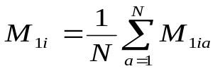  where:  i: pollutant  a: test cycle
3.1.3. | Condition B
3.1.3.1. | Conditioning of vehicle.  The vehicle shall be conditioned by driving the applicable type I driving cycle as set out in Annex B.5.15.
3.1.3.2. | The electrical energy/power storage device of the vehicle shall be discharged while driving (on the test track, on a chassis dynamometer, etc.):  (a) at a steady vehicle speed of 50 km/h until the fuel-consuming engine starts up, or  (b) if a vehicle cannot reach a steady vehicle speed of 50 km/h without the fuel-consuming engine starting up, the vehicle speed shall be reduced until it can run a at lower steady vehicle speed at which the engine does not start up for a defined time or distance (to be determined by the technical service and the manufacturer), or  (c) in accordance with the manufacturers’ recommendation.  The fuel-consuming engine shall be stopped within ten seconds of being automatically started.
3.1.3.3. | After this preconditioning and before testing, the vehicle shall be kept in a room in which the temperature remains relatively constant between 293.0 K and 303.0 K (20.0 °C and 30.0 °C). This conditioning shall be carried out for at least six hours and continue until the temperature of the engine oil and coolant, if any, are within ± 2.0 K (0.0 °C ) of the temperature of the room.
3.1.3.4. | Test procedure
3.1.3.4.1. | The vehicle shall be started up by the means provided to the driver for normal use. The first cycle starts on the initiation of the vehicle start-up procedure.
3.1.3.4.2. | Sampling shall begin (BS) before or at the initiation of the vehicle start-up procedure and end on conclusion of the final idling period of the applicable type I test cycle (end of sampling (ES)).
3.1.3.4.3. | The vehicle shall be driven according to the provisions of Annex B.5.15.
3.1.3.4.4. | The exhaust gases shall be analysed in accordance with point 3 of section B.2.
3.1.3.5. | The test results shall be compared with the limits in point 3 of section B.2. and the average emission of each pollutant for Condition B shall be calculated (M_{2i}). The test results M_{2i}, multiplied by the appropriate deterioration and K_{i} factors, shall be less than the limits prescribed in point 9 of section B.1.
3.1.4. | Test results
3.1.4.1. | Testing in accordance with point 3.1.2.5.2.1.  For reporting, the weighted values shall be calculated as follows:  Equation B.2.1.-2  M_{i} = (D_{e} · M_{1i} + D_{av} ·. M_{2i} )/(D_{e} + D_{av})  where:  M_{i} = mass emission of the pollutant i in mg/km;  M_{1i} = average mass emission of the pollutant i in mg/km with a fully charged electrical energy/power storage device, calculated in accordance with point 3.1.2.5.5.;  M_{2i} = average mass emission of the pollutant i in mg/km with an electrical energy/power storage device in minimum state of charge (maximum discharge of capacity), calculated in accordance with point 3.1.3.5.;  D_{e} = electric range of the vehicle determined according to the procedure set out in Annex B.4.6., where the manufacturer shall provide the means for taking the measurement with the vehicle running in pure electric mode;  D_{av} = average distance between two battery recharges, as follows:  - 4 km for a vehicle with an engine capacity < 150 cm³;  - 6 km for a vehicle with an engine capacity ≥ 150 cm³ and v_{max} < 130 km/h;  - 10 km for a vehicle with an engine capacity ≥ 150 cm³ and v_{max} ≥ 130 km/h.
3.1.4.2. | Testing in accordance with point 3.1.2.5.2.2.  For communication, the weighted values shall be calculated as follows:  Equation B.2.1.-3:  M_{i} = (D_{ovc} · M_{1i} + D_{av} · M_{2i} )/(D_{ovc} + D_{av})  where:  M_{i} = mass emission of the pollutant i in mg/km;  M_{1i} =average mass emission of the pollutant i in mg/km with a fully charged electrical energy/power storage device, calculated in accordance with point 3.1.2.5.5.;  M_{2i} = average mass emission of the pollutant i in mg/km with an electrical energy/power storage device in minimum state of charge (maximum discharge of capacity), calculated in accordance with point 3.1.3.5.;  D_{ovc} = OVC range established in accordance with the procedure in Annex B.4.6.;  D_{av} = average distance between two battery recharges, as follows:  - 4 km for a vehicle with an engine capacity < 150 cm³;  - 6 km for a vehicle with an engine capacity ≥ 150 cm³ and v_{max} < 130 km/h;  - 10 km for a vehicle with an engine capacity ≥ 150 cm³ and v_{max} ≥ 130 km/h.
3.2. | Externally chargeable vehicles (OVC HEVs) with an operating mode switch.
3.2.1. | Two tests shall be performed under the following conditions:
3.2.1.1. | Condition A: the test shall be carried out with a fully charged electrical energy/power storage device.
3.2.1.2. | Condition B: the test shall be carried out with an electrical energy/power storage device in minimum state of charge (maximum discharge of capacity).
3.2.1.3. | The operating mode switch shall be positioned in accordance with the Table B.2.1.-2.  Table B.2.1.-2: Look-up table to determine Condition A or B depending on different hybrid vehicle concepts and on the hybrid mode selection switch position.
   | Hybrid-modes -› | -Pure electric  - Hybrid | -Pure fuel-consuming  - Hybrid | -Pure electric  -Pure fuel-consuming  - Hybrid | -Hybrid mode n  -Hybrid mode mError: Reference source not found
  Battery state of charge |  | Switch in position | Switch in position | Switch in position | Switch in position
  Condition A  Fully charged |  | Hybrid | Hybrid | Hybrid | Most electric hybrid mode
  Condition B  Min. state of charge |  | Hybrid | Fuel-consuming | Fuel-consuming | Most fuel-consuming mode
3.2.2. | Condition A
3.2.2.1. | If the pure electric range of the vehicle is higher than one complete cycle, the type I test may at the manufacturer’s request be carried out in pure electric mode. In this case, the engine preconditioning prescribed in point 3.2.2.3 can be omitted.
3.2.2.2. | The procedure shall start with the discharge of the electrical energy/power storage device of the vehicle while driving with the switch in pure electric position (on the test track, on a chassis dynamometer, etc.) at a steady vehicle speed of 70 percent ± 5 percent of the maximum design vehicle speed of the vehicle.  Stopping the discharge occurs in any of the following conditions:  (a) when the vehicle is not able to run at 65 percent of the maximum thirty minutes vehicle speed;  (b) when the standard on-board instrumentation gives the driver an indication to stop the vehicle;  (c) after 100 km.  If the vehicle is not equipped with a pure electric mode, the electrical energy/power storage device shall be discharged by driving the vehicle (on the test track, on a chassis dynamometer, etc.) in any of the following conditions:  (a) at a steady vehicle speed of 50 km/h until the fuel-consuming engine of the HEV starts up;  (b) if a vehicle cannot reach a steady vehicle speed of 50 km/h without the fuel-consuming engine starting up, the vehicle speed shall be reduced until it can run at a lower steady vehicle speed at which the fuel-consuming engine does not start up for a defined time or distance (to be determined by the technical service and the manufacturer);  (c) in accordance with the manufacturers’ recommendation.  The fuel-consuming engine shall be stopped within ten seconds of being automatically started. By means of derogation if the manufacturer can prove to the technical service to the satisfaction of the [approval] / [certification] authority that the vehicle is physically not capable of achieving the thirty minutes vehicle speed the maximum fifteen minute vehicle speed may be used instead.
3.2.2.3. | Conditioning of vehicle  The vehicle shall be conditioned by driving the applicable type I driving cycle as set out in Annex B.5.15.
3.2.2.4. | After this preconditioning and before testing, the vehicle shall be kept in a room in which the temperature remains relatively constant between 293.0 K and 303.0 K (20.0 °C and 30.0 °C). This conditioning shall be carried out for at least six hours and continue until the temperature of the engine oil and coolant, if any, are within ±2.0 K (2.0 °C) of the temperature of the room, and the electrical energy/power storage device is fully charged as a result of the charging prescribed in point 3.2.2.5.
3.2.2.5. | During soak, the electrical energy/power storage device shall be charged with any of the following chargers:  (a) the on-board charger if fitted;  (b) an external charger recommended by the manufacturer, using the normal overnight charging procedure.  This procedure excludes all types of special charges that could be automatically or manually initiated, e.g. equalisation charges or servicing charges.  The manufacturer shall declare that a special charge procedure has not occurred during the test.  (c) End-of-charge criterion  The end-of-charge criterion corresponds to a charging time of 12 hours, except where the standard instrumentation gives the driver a clear indication that the electrical energy storage device is not yet fully charged.  In this case, the maximum time is = 3 · claimed battery capacity (Wh) / mains power supply (W).
3.2.2.6. | Test procedure
3.2.2.6.1. | The vehicle shall be started up by the means provided to the driver for normal use. The first cycle starts on the initiation of the vehicle start-up procedure.
3.2.2.6.1.1. | Sampling shall begin (BS) before or at the initiation of the vehicle start-up procedure and end on conclusion of the final idling period of the applicable type I test cycle (end of sampling (ES)).
3.2.2.6.1.2. | Sampling shall begin (BS) before or at the initiation of the vehicle start-up procedure and continue over a number of repeat test cycles. It shall end on conclusion of the final idling period of the applicable Type I test cycle during which the battery has reached the minimum state of charge in accordance with the following procedure (end of sampling (ES):
3.2.2.6.1.2.1. | The electricity balance Q (Ah) is measured over each combined cycle using the procedure in Annex B.4.5. and used to determine when the battery minimum state of charge has been reached;
3.2.2.6.1.2.2. | The battery minimum state of charge is considered to have been reached in combined cycle N if the electricity balance measured during combined cycle N+1 is not more than a 3 percent discharge, expressed as a percentage of the nominal capacity of the battery (in Ah) in its maximum state of charge, as declared by the manufacturer. At the manufacturer’s request, additional test cycles may be run and their results included in the calculations in points 3.2.2.7. and 3.2.3.4.2., provided that the electricity balance for each additional test cycle shows less discharge of the battery than over the previous cycle;
3.2.2.6.1.2.3. | After each cycle, a hot soak period of up to ten minutes is allowed. The powertrain shall be switched off during this period.
3.2.2.6.2. | The vehicle shall be driven according to the provisions of Annex B.5.15.
3.2.2.6.3. | The exhaust gases shall be analysed according to point 5 of section B.2.
3.2.2.7. | The test results shall be compared to the emission limits set out in point 9 of section B.1. and the average emission of each pollutant and CO₂ for Condition A shall be calculated (M_{1i}).  The test result of each combined cycle run M_{1ia}, multiplied by the appropriate deterioration and K_{i} factors, shall be less than the emission limits set out in point 9 of section B.1. For the purposes of the calculation in point 3.2.4., M_{1i} shall be calculated according to Equation B.2.1.-1.
3.2.3. | Condition B
3.2.3.1. | Conditioning of vehicle.  The vehicle shall be conditioned by driving the applicable Type I driving cycle set out in Annex B.5.15.
3.2.3.2. | The electrical energy/power storage device of the vehicle shall be discharged in accordance with point 3.2.2.2.
3.2.3.3. | After this preconditioning, and before testing, the vehicle shall be kept in a room in which the temperature remains relatively constant between 293.0 K and 303.0 K (20.0 °C and 30.0 °C). This conditioning shall be carried out for at least six hours and continue until the temperature of the engine oil and coolant, if any, are within ±2.0 K (0.0 °C) of the temperature of the room.
3.2.3.4. | Test procedure
3.2.3.4.1. | The vehicle shall be started up by the means provided to the driver for normal use. The first cycle starts on the initiation of the vehicle start-up procedure.
3.2.3.4.2. | Sampling shall begin (BS) before or at the initiation of the vehicle start-up procedure and end on conclusion of the final idling period of the applicable type I test cycle (end of sampling (ES)).
3.2.3.4.3. | The vehicle shall be driven in accordance with the provisions of Annex B.5.15.
3.2.3.4.4. | The exhaust gases shall be analysed in accordance with the provisions in point 5 of section B.2.
3.2.3.5. | The test results shall be compared with the pollutant limits in point 9 of section B.1. and the average emission of each pollutant for Condition B shall be calculated (M_{2i}). The test results M_{2i}, multiplied by the appropriate deterioration and K_{i} factors, shall be less than the limits in point 9 of section B.1.
3.2.4. | Test results
3.2.4.1. | Testing in accordance with point 3.2.2.6.1.2.1.  For communication, the weighted values shall be calculated as in Equation B.2.1.-2  where:  M_{i} = mass emission of the pollutant i in mg/km;  M_{1i} = average mass emission of the pollutant i in mg/km with a fully charged electrical energy/power storage device, calculated in accordance with point 3.2.2.7.;  M_{2i} = average mass emission of the pollutant i in mg/km with an electrical energy/power storage device in minimum state of charge (maximum discharge of capacity), calculated in accordance with point 3.2.3.5;  D_{e} = electric range of the vehicle with the switch in pure electric position, in accordance with Annex B.4.6. If there is not a pure electric position, the manufacturer shall provide the means for taking the measurement with the vehicle running in pure electric mode.  D_{av} = average distance between two battery recharges, as follows:  - 4 km for a vehicle with an engine capacity < 150 cm³;  - 6 km for a vehicle with an engine capacity ≥ 150 cm³ and v_{max} < 130 km/h;  - 10 km for a vehicle with an engine capacity ≥ 150 cm³ and v_{max} ≥ 130 km/h.
3.2.4.2. | Testing in accordance with point 3.2.2.6.1.2.2.  For communication, the weighted values shall be calculated as in Equation B.2.1.-3  where:  M_{i} = mass emission of the pollutant i in mg/km;  M_{1i} = average mass emission of the pollutant i in mg/km with a fully charged electrical energy/power storage device, calculated in accordance with point 3.2.2.7.;  M_{2i} = average mass emission of the pollutant i in mg/km with an electrical energy/power storage device in minimum state of charge (maximum discharge of capacity), calculated in accordance with point 3.2.3.5.;  D_{ovc} = OVC range according to the procedure in Annex B.4.6.;  D_{av} = average distance between two battery recharges, as follows:  - 4 km for a vehicle with an engine capacity < 150 cm³;  - 6 km for a vehicle with an engine capacity ≥ 150 cm³ and v_{max} < 130 km/h;  - 10 km for a vehicle with an engine capacity ≥ 150 cm³ and v_{max} ≥ 130 km/h.
3.3. | Not externally chargeable vehicles (not-OVC HEVs) without an operating mode switch
3.3.1. | These vehicles shall be tested according to the applicable test cycle set out in Annex B.5.15.
3.3.2. | For preconditioning, at least two consecutive complete driving cycles are carried out without soak.
3.3.3. | The vehicle shall be driven in accordance with to the provisions of Annex B.5.15.
3.4. | Not externally chargeable vehicles (not-OVC HEVs) with an operating mode switch
3.4.1. | These vehicles are preconditioned and tested in hybrid mode in accordance with section B.2. If several hybrid modes are available, the test shall be carried out in the mode that is automatically set after the ignition key is turned (normal mode). On the basis of information provided by the manufacturer, the technical service shall ensure that the limit values are complied with in all hybrid modes.
3.4.2. | For preconditioning, at least two consecutive complete applicable driving cycles shall be carried out without soak.
3.4.3. | The vehicle shall be driven in accordance with the provisions of section B.2.

B.2.2. | Annex: type I test procedure for vehicles fuelled with LPG, NG/biomethane, flex fuel H₂NG or hydrogen
1. | Introduction
1.1. | This annex describes the special requirements as regards the testing of LPG, NG/biomethane, H₂NG or hydrogen gas for the [approval] / [certification] of alternative fuel vehicles that run on those fuels or can run on petrol, LPG, NG/biomethane, H₂NG or hydrogen.
1.2. | The composition of these gaseous fuels, as sold on the market, can vary greatly and fuelling systems shall adapt their fuelling rates accordingly. To demonstrate this adaptability, the parent vehicle equipped with a representative LPG, NG/biomethane or H₂NG fuel system shall be tested in type I tests on two extreme reference fuels.
1.3. | The requirements of this annex as regards hydrogen shall apply only to vehicles using hydrogen as a combustion fuel and not to those equipped with a fuel cell operating on hydrogen.
2. | Granting of [approval] / [certification] for an vehicle equipped with a gaseous fuel system  [Approval] / [Certification] is granted subject to the following requirements:
2.1. | Exhaust emissions [approval] / [certification] of a vehicle equipped with a gaseous fuel system  It shall be demonstrated that the parent vehicle equipped with a representative LPG, NG/biomethane, H₂NG or hydrogen fuel system can adapt to any fuel composition that may appear on the market and comply with the following:
2.1.1. | In the case of LPG there are variations in C₃/C₄ composition (test fuel requirement A and B) and therefore the parent vehicle shall be tested on reference fuels A and B referred to in Annex B.5.2.;
2.1.2. | In the case of NG/biomethane there are generally two types of fuel, high calorific fuel (G20) and low calorific fuel (G25), but with a significant spread within both ranges; they differ significantly in Wobbe index. These variations are reflected in the reference fuels. The parent vehicle shall be tested on both reference fuels referred to in Annex B.5.2.;
2.1.3. | In the case of a flex fuel H₂NG vehicle, the composition range may vary from 0 % hydrogen (L-gas) to a maximum percentage of hydrogen within the mixture (H-gas), as specified by the manufacturer. It shall be demonstrated that the parent vehicle can adapt to any percentage within the range specified by the manufacturer and the vehicle shall be tested in the type I test on 100 % H-gas and 100 % L-gas. It shall also be demonstrated that it can adapt to any NG/biomethane composition that may appear on the market, regardless of the percentage of hydrogen in the mixture.
2.1.4. | For vehicles equipped with hydrogen fuel systems, compliance shall be tested on the single hydrogen reference fuel referred to in Annex B.5.2.
2.1.5. | If the transition from one fuel to another is in practice aided through the use of a switch, this switch shall not be used during [approval] / [certification]. In such cases, at the manufacturer’s request and with the agreement of the technical service, the pre-conditioning cycle referred in point 4.2.4 of section B.2. may be extended.
2.1.6. | The ratio of emission results ‘r’ shall be determined for each pollutant as shown in Table B.2.2. -1 for LPG, NG/biomethane and H₂NG vehicles.
2.1.6.1. | In the case of LPG and NG/biomethane vehicles, the ratios of emission results ‘r’ shall be determined for each pollutant as follows:  Table B.2.2.-1: Calculation ratio ‘r’ for LPG and NG/biomethane vehicles
  Type(s) of fuel | Reference fuels | Calculation of ‘r’
  LPG and petrol  ([Approval] / [Certification] B) | Fuel A | 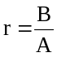
  or LPG only  ([Approval] / [Certification] D) | Fuel B
  NG/biomethane | fuel G20 | 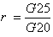
  NG/biomethane | fuel G25
2.1.6.2. | In the case of flex fuel H₂NG vehicles, two ratios of emission results ‘r₁’ and ‘r₂’ shall be determined for each pollutant as follows:  Table B.2.2.-2: look-up table ratio ‘r’ for NG/biomethane or H₂NG gaseous fuels
  Type(s) of fuel | Reference fuels | Calculation of ‘r’
  NG/biomethane | fuel G20 | 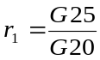
  NG/biomethane | fuel G25
  H₂NG | Mixture of hydrogen and G20 with the maximum percentage of hydrogen specified by the manufacturer | 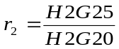
  H₂NG | Mixture of hydrogen and G25 with the maximum percentage of hydrogen specified by the manufacturer
2.2. | Exhaust emissions [approval] / [certification] of a member of the propulsion unit family  For the [approval] / [certification] of mono-fuel gas vehicles and bi-fuel vehicles operating in gas mode, fuelled by LPG, NG/biomethane, H₂NG or hydrogen, as a member of the propulsion unit family in Annex B.5.10., a type I test shall be performed with one gaseous reference fuel. For LPG, NG/biomethane and H₂NG vehicles, this reference fuel may be either of the reference fuels in Annex B.5.2. The gas-fuelled vehicle is considered to comply if the following requirements are met:
2.2.1. | The test vehicle shall comply with the definition of a propulsion unit family member in Annex B.5.10.
2.2.2. | If the test fuel requirement is reference fuel A for LPG or G20 for NG/biomethane, the emission result shall be multiplied by the relevant factor ‘r’ if r > 1; if r < 1, no correction is needed.
2.2.3. | If the test fuel requirement is reference fuel B for LPG or G25 for NG/biomethane, the emission result shall be divided by the relevant factor ‘r’ if r < 1; if r > 1, no correction is needed.
2.2.4. | At the manufacturer’s request, the type I test may be performed on both reference fuels, so that no correction is needed.
2.2.5. | The parent vehicle shall comply with the emission limits for the relevant category set out in point 9 of section B.1. and for both measured and calculated emissions.
2.2.6. | If repeated tests are conducted on the same engine, an average shall first be taken of the results on reference fuel G20, or A, and those on reference fuel G25, or B; the ‘r’ factor shall then be calculated from these averages.
2.2.7. | For the [approval] / [certification] of a flex fuel H₂NG vehicle as a member of a family, two type I tests shall be performed, the first test with 100 % of either G20 or G25, and the second test with the mixture of hydrogen and the same NG/biomethane fuel used during the first test, with the maximum hydrogen percentage specified by the manufacturer.
2.2.7.1. | If the NG/biomethane fuel is the reference fuel G20, the emission result for each pollutant shall be multiplied by the relevant factors (r₁ for the first test and r₂ for the second test) in point 2.1.6. if the relevant factor > 1; if the correspondent relevant factor < 1, no correction is needed.
2.2.7.2. | If the NG/biomethane fuel is the reference fuel G25, the emission result for each pollutant shall be divided by the corresponding relevant factor (r₁ for the first test and r₂ for the second test) calculated in accordance with point 2.1.6., if this is < 1; if the corresponding relevant factor > 1, no correction is needed.
2.2.7.3. | At the manufacturer’s request, the type I test shall be conducted with the four possible combinations of reference fuels, in accordance with point 2.1.6., so that no correction is needed.
2.2.7.4. | If repeated tests are carried out on the same engine, an average shall first be taken of the results on reference fuel G20, or H₂G20, and those on reference fuel G25, or H₂G25 with the maximum hydrogen percentage specified by the manufacturer; the ‘r₁’ and ‘r₂’ factors shall then be calculated from these averages.
2.2.8. | During the type I test, the vehicle shall use only petrol for a maximum of 60 consecutive seconds directly after engine crank and start when operating in gas-fuelling mode.

B.2.3. | Annex: type I test procedure for vehicles equipped with a periodically regenerating system
1. | Introduction  This Annex contains specific provisions regarding the [approval] / [certification] of vehicles equipped with a periodically regenerating system.
2. | Scope of the [approval] / [certification] for vehicles with a periodically regenerating system as regards type I tests.
2.1. | Vehicles that are equipped with periodically regenerating systems shall comply with the requirements laid down in this Annex.
2.2. | Instead of carrying out the test procedures in the following point, a fixed K_{i} value of 1.05 may be used if the technical service sees no reason why this value could be exceeded and after [approval] / [certification] of the [approval] / [certification] authority.
2.3. | During cycles where regeneration occurs, emission standards can be exceeded. If a regeneration of an anti-pollution device occurs at least once per Type I test and that has already regenerated at least once during the vehicle preparation cycle, it will be considered as a continuously regenerating system which does not require a special test procedure.
3. | Test procedure  The vehicle may be equipped with a switch capable of preventing or permitting the regeneration process provided that its operation has no effect on original engine calibration. This switch shall be used for the purpose of preventing regeneration only during loading of the regeneration system and during the pre-conditioning cycles. However, it shall not be used during the measurement of emissions in the regeneration phase; rather, the emission test shall be carried out with the unchanged original equipment manufacturer’s powertrain control unit / engine control unit / drive train control unit if applicable and powertrain software.
3.1. | Measurement of carbon dioxide emission and fuel consumption between two cycles where regenerative phases occur.
3.1.1. | The average of carbon dioxide emission and fuel consumption between regeneration phases and during loading of the regenerative device shall be determined from the arithmetic mean of several approximately equidistant (if more than two) type I operating cycles.  As an alternative, the manufacturer may provide data to show that carbon dioxide emissions and fuel consumption remain constant (+4 percent) between regeneration phases. In this case, the carbon dioxide emissions and fuel consumption measured during the regular type I test may be used. In any other case, emissions shall be measured for at least two type I operating cycles: one immediately after regeneration (before new loading) and one as immediately as possible before a regeneration phase. All emissions measurements and calculations shall be carried out in accordance with point 4 of section B.2. Average emissions for a single regenerative system shall be determined in accordance with point 3.3 and for multiple regeneration systems in accordance with point 3.4.
3.1.2. | The loading process and K_{i} determination shall be carried out on a chassis dynamometer during the type I operating cycles. These cycles may be run continuously (i.e. without the need to switch the engine off between cycles). After any number of completed cycles, the vehicle may be removed from the chassis dynamometer and the test continued at a later time.
3.1.3. | The number of cycles (D) between two cycles in which regeneration phases occur, the number of cycles over which emissions measurements are taken (n) and each emissions measurement (M’si_{j}) shall be reported according to the template of the test report referred to in Annex B.5.12.
3.2. | Measurement of carbon dioxide emissions and fuel consumption during regeneration
3.2.1. | If necessary, the vehicle may be prepared for the emissions test during a regeneration phase using the preparation cycles laid down in Annex B.5.15.
3.2.2. | The test and vehicle conditions for the type I test described in section B.2. apply before the first valid emission test is carried out.
3.2.3. | Regeneration shall not occur during the preparation of the vehicle. This may be ensured by one of the following methods:
3.2.3.1. | a ‘dummy’ regenerating system or partial system may be fitted for the pre-conditioning cycles;
3.2.3.2. | any other method agreed between the manufacturer and the [approval] / [certification] authority.
3.2.4. | A cold-start exhaust emission test including a regeneration process shall be carried out in accordance with the applicable type I operating cycle.
3.2.5. | If the regeneration process requires more than one operating cycle, subsequent test cycle(s) shall be driven immediately, without switching the engine off, until complete regeneration has been achieved (each cycle shall be completed). The time necessary to set up a new test shall be as short as possible (e.g. as required to change a particulate matter filter on the analysing equipment). The engine shall be switched off during this period.
3.2.6. | The emission values, including pollutant and carbon dioxide emission values, and fuel consumption during regeneration (M_{ri}) shall be calculated in accordance with section B.2. and point 3.3. The number of operating cycles (d) measured for complete regeneration shall be recorded.
3.3. | Calculation of the combined exhaust emissions of a single regenerative system:  Equation B.2.3.-1:  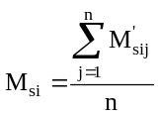 n ≥ 2  Equation B.2.3.-2:  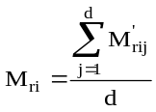  Equation B.2.3.-3:  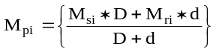  where for each pollutant (i) considered:  M’_{sij} = mass emissions of pollutant (i), mass emissions of CO₂ in g/km and fuel consumption in l/100 km over one type I operating cycle without regeneration;  M’_{rij} = mass emissions of pollutant (i), mass emissions of CO₂ in g/km and fuel consumption in l/100 km over one type I operating cycle during regeneration (when n > 1, the first type I test is run cold, and subsequent cycles are hot);  M_{si} = mean mass emissions of pollutant (i) in mg/km or mean mass emissions of CO₂ in g/km and fuel consumption in l/100 km over one part (i) of the operating cycle without regeneration;  M_{ri} = mean mass emissions of pollutant (i) in mg/km or mean mass emissions of CO₂ in g/km and fuel consumption in l/100 km over one part (i) of the operating cycle during regeneration;  M_{pi} = mean mass emissions of pollutant (i) in mg/km or mean mass emissions of CO₂ in g/km and fuel consumption in l/100 km;  n = number of test points at which emissions measurements (type I operating cycles) are taken between two cycles where regenerative phases occur, ≥ 2;  d = number of operating cycles required for regeneration;  D = number of operating cycles between two cycles in which regenerative phases occur.
 | 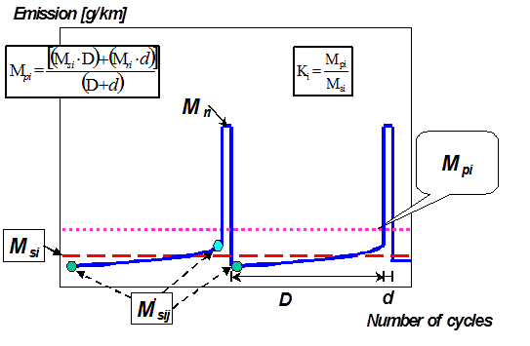Figure B.2.3.-1: Example of measurement parameters. Parameters measured during emissions or fuel consumption test during and between cycles in which regeneration occurs (schematic example – the emissions during ‘D’ may increase or decrease)
3.3.1. | Calculation of the regeneration factor K for each pollutant (i), carbon dioxide emission and fuel consumption (i) considered:  Equation B.2.3.-4:  K_{i} = M_{pi} / M_{si}  M_{si}, M_{pi} and K_{i} results shall be recorded in the test report delivered by the technical service.  K_{i} may be determined following the completion of a single sequence.
3.4. | Calculation of combined exhaust emissions, carbon dioxide emissions and fuel consumption of multiple periodic regenerating systems  Equation B.2.3.-5:  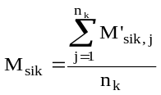 n_{k}≥ 2  Equation B.2.3.-6:  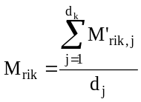  Equation B.2.3.-7:  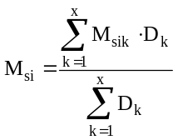  Equation B.2.3.-8:  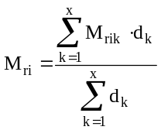  Equation B.2.3.-9:  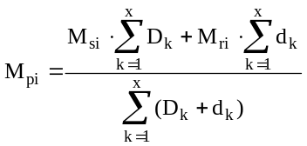  Equation B.2.3.-10:  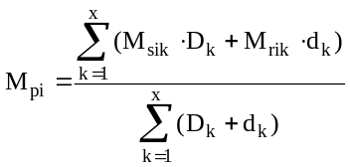  Equation B.2.3.-11:  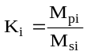  where for each pollutant (i) considered:  M’_{sik} = mass emissions of event k of pollutant (i) in mg/km, mass emissions of CO₂ in g/km and fuel consumption in l/100 km over one type I operating cycle without regeneration;  M_{rik} = mass emissions of event k of pollutant (i) in mg/km, mass emissions of CO₂ in g/km and fuel consumption in l/100 km over one type I operating cycle during regeneration (if d > 1, the first type I test is run cold, and subsequent cycles are hot);  M’_{sik,j} = mass emissions of event k of pollutant (i) in mg/km, mass emissions of CO₂ in g/km and fuel consumption in l/100 km over one type I operating cycle without regeneration measured at point j; 1 ≤ j ≤ n;  M’_{rik,j} = mass emissions of event k of pollutant (i) in mg/km, mass emissions of CO₂ in g/km and fuel consumption in l/100 km over one type I operating cycle during regeneration (when j > 1, the first type I test is run cold, and subsequent cycles are hot) measured at operating cycle j; 1 ≤ j ≤ d;  M_{si} = mass emission of all events k of pollutant (i) in mg/km, of CO₂ in g/km and fuel consumption in l/100 km without regeneration;  M_{ri} = mass emission of all events k of pollutant (i) in mg/km, of CO₂ in g/km and fuel consumption in l/100 km during regeneration;  M_{pi} = mass emission of all events k of pollutant (i) in mg/km, of CO₂ in g/km and fuel consumption in l/100 km;  n_{k} = number of test points of event k at which emissions measurements (type I operating cycles) are taken between two cycles in which regenerative phases occur;  d_{k} = number of operating cycles of event k required for regeneration;  D_{k} = number of operating cycles of event k between two cycles in which regenerative phases occur.
 | 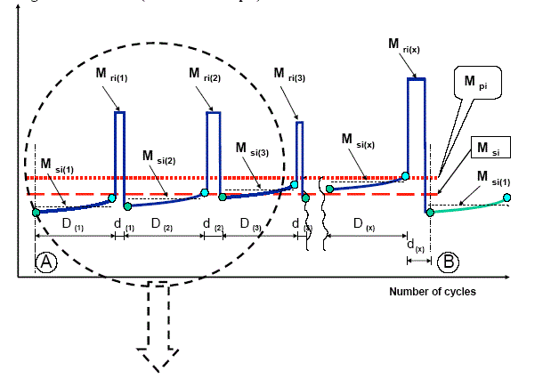Figure B.2.3.-2: Parameters measured during emissions test during and between cycles in which regeneration occurs (schematic example)
 | 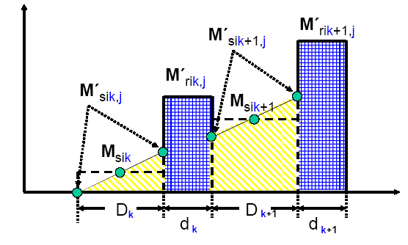Figure B.2.3.-3: Parameters measured during emissions test during and between cycles where regeneration occurs (schematic example)
For application of a simple and realistic case, the following description gives a detailed explanation of the schematic example shown in Figure Ap13-3:
1. ‘Particulate Filter’: regenerative, equidistant events, similar emissions (±15 percent) from event to event
Equation B.2.3.-12:
D_{k} = _{Dk+1} = D₁
Equation B.2.3.-13:
d_{k} = d_{k+1} = d₁
Equation B.2.3.-14:
M_{rik} — M_{sik} = M_{rik+1} — M_{sik}+1
where
n_{k} = n
2. ‘DeNO_{x}’: the desulphurisation (SO₂ removal) event is initiated before an influence of sulphur on emissions is detectable (±15 percent of measured emissions) and in this example, for exothermic reasons, together with the last DPF regeneration event.
Equation B.2.3.-15:
M’_{sik,j=1} = constant →M_{sik} = M_{sik+1} = M_{si2}
M_{rik} = M_{rik+1} = M_{ri2}
For SO₂ removal event: M_{ri2}, M_{si2}, d₂, D₂, n₂ = 1
3. Complete system (DPF + DeNO_{x}):
Equation B.2.3.-16:
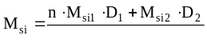
Equation B.2.3.-17:
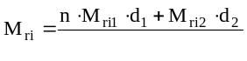
Equation B.2.3.-18:
The calculation of the factor (K_{i}) for multiple periodic regenerating systems is possible only after a certain number of regeneration phases for each system. After performing the complete procedure (A to B, see Figure Ap13-2), the original starting conditions A should be reached again.
3.4.1. | Extension of [approval] / [certification] for a multiple periodic regeneration system
3.4.1.1. | If the technical parameters or the regeneration strategy of a multiple regeneration system for all events within this combined system are changed, the complete procedure including all regenerative devices shall be performed by measurements to update the multiple K_{i} – factor.
3.4.1.2. | If a single device of the multiple regeneration system is changed only in strategy parameters (i.e. such as ‘D’ or ‘d’ for DPF) and the manufacturer can provide the technical service with plausible technical data and information demonstrating that:  (a) there is no detectable interaction with the other device(s) of the system; and  (b) the important parameters (i.e. construction, working principle, volume, location, etc.) are identical,  the necessary update procedure for k_{i} may be simplified.  In such cases, where agreed between the manufacturer and the technical service, only a single event of sampling/storage and regeneration shall be performed and the test results (‘M_{si}’, ‘M_{ri}’), in combination with the changed parameters (‘D’ or ‘d’), may be introduced into the relevant formula(e) to update the multiple K_{i} - factor in mathematically by substituting the existing basic K_{i} - factor formula(e).

B.3. | TEXT OF THE REGULATION, TEST TYPE II, TAILPIPE EMISSIONS AT (INCREASED) IDLE AND AT FREE ACCELERATION
1. | Introduction  This section describes the procedure for type II testing designed to ensure the requisite measurement of emissions during roadworthiness testing. The purpose of the requirements laid down in this section is to demonstrate that the [approved] / [certified] vehicle complies with the minimum requirements with regard to roadworthiness testing.
2. | Scope
2.1. | During the environmental performance [approval] / [certification] process, it shall be demonstrated to the technical service and [approval] / [certification] authority that the vehicles comply with the test type II requirements.
2.2. | Vehicles equipped with a propulsion unit type of which a positive ignition combustion engine forms part shall be subject only to a type II emission test as set out in points 3., 4., 5. and 6.
2.3. | Vehicles equipped with a propulsion unit type of which a compression ignition combustion engine forms part shall be subject only to a type II free acceleration emission test as set out in points 3., 7. and 8. In this case point 3.8. is not applicable.
3. | General conditions of type II emission testing
3.1. | A visual inspection of any emission-control equipment shall be conducted prior to start of the type II emission test in order to check that the vehicle is complete, in a satisfactory condition and that there are no leaks in the fuel, air supply or exhaust systems. The test vehicle shall be properly maintained and used.
3.2. | The fuel used to conduct the type II test shall be the reference fuel, specifications for which are given in Annex B.5.2. in accordance with the requirements set out in the scope with regard to the propulsion unit type.
3.3. | During the test, the environmental temperature shall be between 293.0 K and 303.0 K (20.0 °C and 30.0 °C).
3.4. | In the case of vehicles with manually-operated or semi-automatic-shift transmission, the test type II test shall be carried out with the gear lever in the ‘neutral’ position and the clutch engaged.
3.5. | In the case of vehicles with automatic-shift transmission, the idle type II test shall be carried out with the gear selector in either the ‘neutral’ or the ‘park’ position. Where an automatic clutch is also fitted, the driven axle shall be lifted up to a point at which the wheels can rotate freely.
3.6. | The type II emission test shall be conducted immediately after the type I emission test. In any event, the engine shall be warmed up until all coolant and lubricant temperatures and lubricant pressure have reached equilibrium at operational levels.
3.7. | The exhaust outlets shall be provided with an air-tight extension, so that the sample probe used to collect exhaust gases may be inserted at least 60 cm into the exhaust outlet without increasing the back pressure of more than 125 mm H₂O and without disturbing operation of the vehicle. This extension shall be so shaped as to avoid any appreciable dilution of exhaust gases in the air at the location of the sample probe. Where a vehicle is equipped with an exhaust system with multiple outlets, either these shall be joined to a common pipe or the carbon monoxide content shall be collected from each of them and an arithmetical average taken.
3.8. | The emission test equipment and analysers to perform the type II testing shall be regularly calibrated and maintained. A flame ionisation detection or nondispersive infrared (NDIR) analyser may be used for measuring hydrocarbons.
3.9. | The vehicles shall be tested with the fuel-consuming engine running.
3.10. | For hybrid vehicles, the manufacturer shall provide a type II test ‘service mode’ that makes it possible to inspect the vehicle for roadworthiness tests on a running fuel-consuming engine, in order to determine its performance in relation to the data collected. Where this inspection requires a special procedure, this shall be detailed in the service manual (or equivalent media). That special procedure shall not require the use of special equipment other than that provided with the vehicle.
4. | Test type II – description of test procedure to measure tailpipe emissions at (increased) idle and free acceleration
4.1 | Components for adjusting the idling engine speed
4.1.1. | Components for adjusting the idling engine speed for the purposes of conducting test type II refer to controls for changing the idling conditions of the engine which may be easily operated by a mechanic using only the tools referred to in point 4.1.2. In particular, devices for calibrating fuel and air flows are not considered as adjustment components if their setting requires the removal of the set-stops, an operation which can normally be performed only by a professional mechanic.
4.1.2. | The tools which may be used to adjust the idling engine speed are screwdrivers (ordinary or cross-headed), spanners (ring, open-end or adjustable), pliers, Allen keys and a generic scan tool.
4.2 | Determination of measurement points and type II idle test pass/fail criteria
4.2.1. | First, a measurement is taken at the setting in accordance with the conditions fixed by the manufacturer.
4.2.2. | For each adjustment component with a continuous variation, a sufficient number of characteristic positions shall be determined. The test shall be carried out with the engine at normal idling engine speed and at ‘high idle’ engine speed. High idle engine speed is defined by the manufacturer but it shall be higher than 2000 min⁻¹.
4.2.3. | The measurement of the carbon monoxide content of exhaust gases shall be carried out for all the possible positions of the adjustment components, but for components with a continuous variation only for the positions referred to in point 4.2.2.
4.2.4. | The type II idle test shall be considered passed if one or both of the following conditions is met:
4.2.4.1. | the values measured in accordance with point 4.2.3. shall be in compliance with the requirements set out in point 6.;
4.2.4.1.1. | if point 6.1. is selected by the manufacturer requesting whole vehicle approval in a country applying type-approval, the specific CO level given by the manufacturer shall be entered on the certificate of conformity;
4.2.4.2. | the maximum content obtained by continuously varying each of the adjustment components in turn while all other components are kept stable shall not exceed the limit value referred to in point 4.2.4.1.
4.2.4.3. | Alternatively, for vehicles equipped with suitable on-board diagnostic systems, the proper functioning of the pollutant emission abatement system can be checked by appropriate reading of the OBD device and checks on the proper functioning of the OBD system in place of emission measurements at engine idle in accordance with the manufacturer’s conditioning recommendations and other requirements.
4.2.5. | The possible positions of the adjustment components shall be limited by any of the following:
4.2.5.1. | the larger of the following two values: the lowest idling engine speed which the engine can reach; the engine speed recommended by the manufacturer, minus 100 revolutions per minute;
4.2.5.2. | the smallest of the following three values:  (a) the highest rotation speed which the crankshaft of the engine can attain by activation of the idling engine speed components;  (b) the rotation speed recommended by the manufacturer, plus 250 revolutions per minute;  (c) the cut-in rotation speed of automatic clutches.
4.2.6. | Settings incompatible with the correct running of the engine shall not be adopted as measurement settings. In particular, if the engine is equipped with several carburettors, all the carburettors shall have the same setting.
4.3. | The following parameters shall be measured and recorded at normal idling engine speed and at high idle engine speed:  (a) the carbon monoxide (CO) content by volume of the exhaust gases emitted (in vol%);  (b) the carbon dioxide (CO₂) content by volume of the exhaust gases emitted (in vol%);  (c) hydrocarbons (HC) in ppm;  (d) the oxygen (O₂) content by volume of the exhaust gases emitted (in vol%) or lambda, as chosen by the manufacturer;  (e) the engine speed during the test, including any tolerances;  (f) the engine oil temperature at the time of the test. Alternatively, for liquid cooled engines, the coolant temperature shall be acceptable. Alternatively for vehicles with air cooling the sparkplug seat/gasket temperature (T_{P}) shall be acceptable.
4.3.1. | With respect to the parameters under point 4.3. (d), the following shall apply:
4.3.1.1. | the measurement shall only be conducted at high idle engine speed;
4.3.1.2. | vehicles in the scope of this measurement are only those equipped with a closed loop fuel system;
4.3.1.3. | exemptions for vehicle with:
4.3.1.3.1. | engines equipped with a mechanically-controlled (spring, vacuum) secondary air system;
4.3.1.3.2. | two-stroke engines operated on a mix of fuel and lubrication oil.
5. | CO concentration calculation in the type II idle test
5.1. | The CO (C_{CO}) and CO₂ (C_{CO2}) concentration shall be determined from the measuring instrument readings or recordings, by use of appropriate calibration curves.
5.2. | The corrected concentration for carbon monoxide is:  Equation B.3.-1:  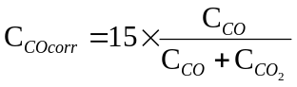
5.3. | The C_{CO} concentration (see point 5.1.) shall be measured in accordance with the formula in point 5.2. and does not need to be corrected if the total of the concentrations measured (C_{CO} + C_{CO2}) is at least:  (a) for petrol (E5): 15%;  (b) for LPG: 13.5%;  (c) for NG/biomethane: 11.5%;  (d) for ethanol (E85): x%;  (e) for H₂NG: y%;
6. | Fail criteria test type II for vehicles equipped with a PI combustion engine  The following alternative criteria shall be used to determine whether the vehicle has failed the type II test:
6.1. | gaseous emissions exceed the specific levels given by the vehicle manufacturer;
6.2. | if the information from the vehicle manufacturer is not made available and for vehicles without closed-loop fuel delivery control; CO emissions > 3.5%;
6.3. | if the information from the vehicle manufacturer is not available and for vehicles equipped with a closed-loop fuel delivery control system;  CO_{normal idle emissions} > 0.5%; or  CO_{high idle emissions} > 0.3%
6.4. | lambda outside the range 1 ± 0.03 or not in accordance with the manufacturer’s specification;
6.5. | OBD readout indicating significant emission relevant malfunction
7. | Test type II – free acceleration test procedure
7.1. | The exhaust gas opacity shall be measured during free acceleration (no load from idle up to cut-off engine speed) with gear lever in neutral and clutch engaged.
7.2. | Vehicle preconditioning:  Vehicles may be tested without preconditioning although for safety reasons checks should be made that the engine is warm and in a satisfactory mechanical condition. The following precondition requirements shall apply:
7.2.1. | The engine shall be fully warm, for instance the engine oil temperature measured by a probe in the oil level dipstick tube to be at least 353.0 K (80.0 °C), or normal operating temperature if lower, or the engine block temperature measured by the level of infrared radiation to be at least an equivalent temperature. If, owing to vehicle configuration, this measurement is impractical, the establishment of the engine’s normal operating temperature may be made by other means for example by the operation of the engine cooling fan;
7.2.2. | The exhaust system shall be purged by at least three free acceleration cycles or by an equivalent method;
7.2.3. | For vehicles equipped with continuously variable transmission (CVT) and automatic clutch, the driven wheels may be lifted from the ground;
7.2.4. | For engines with safety limits in the engine control (e.g. max. 1500 rpm without running wheels or without gear), this maximum engine speed shall be reached.
7.3. | Test procedure  The following test procedure shall be conducted:
7.3.1. | The combustion engine and any turbocharger or super-charger fitted shall be running at idle before the start of each free acceleration test cycle;
7.3.2. | To initiate each free acceleration cycle, the throttle shall be fully applied quickly and continuously (in less than one second) but not violently, so as to obtain maximum delivery from the injection pump;
7.3.3. | During each free acceleration cycle, the engine shall reach cut-off engine speed or, for vehicles with automatic transmissions, the engine speed specified by the manufacturer or if this data is not available then two thirds of the cut-off engine speed, before the throttle is released. This could be checked, for instance, by monitoring engine speed or by allowing a sufficient time to elapse between initial throttle depression and release, which should be at least two seconds elapsing between initial throttle depression and release.
7.3.4. | The average concentration level of the particulate matter (in m⁻¹) in the exhaust flow (opacity) shall be measured during five free acceleration tests.
7.3.5. | To avoid unnecessary testing, competent authority may fail vehicles which have measured values significantly in excess of the limit values after less than three free acceleration cycles or after the purging cycles. Equally to avoid unnecessary testing, competent authority may pass vehicles which have measured values significantly below the limits after less than three free acceleration cycles or after the purging cycles.
8. | Fail criteria test type II for vehicles equipped with a CI combustion engines
8.1. | The test shall only be regarded as failed if the arithmetic means of at least the last three free acceleration cycles are in excess of the limit value. This may be calculated by ignoring any measurement that departs significantly from the measured mean, or the result of any other statistical calculation that takes account of the scattering of the measurements.
8.2. | For countries applying type-approval, the measured type II opacity test value shall be entered on the certificate of conformity. Alternatively the vehicle manufacturer may specify the appropriate opacity level and enter this limit on the certificate of conformity.

B.4. | TEXT OF THE REGULATION, TEST TYPE VII, ENERGY EFFICIENCY
1. | Introduction
1.1. | This Annex sets out requirements with regard to energy efficiency of vehicles, in particular with respect to the measurements of CO₂ emissions, fuel or energy consumption as well as the electric range of a vehicle.
1.2. | The requirements laid down in this section apply to the following tests of vehicles equipped with associated powertrain configurations:  (a) the measurement of the emission of carbon dioxide (CO₂) and fuel consumption, the measurement of electric energy consumption and the electric range of vehicles powered by a combustion engine only or by a hybrid electric powertrain;  (b) the measurement of electric energy consumption and electric range of vehicles powered by an electric powertrain only.
1.3. | A standardised method for measuring vehicles’ energy efficiency (fuel or energy consumption, carbon dioxide emissions as well as electric range) is necessary to ensure that no technical barriers to trade arise between Contracting Parties and also to ensure that customers and users are supplied with objective and precise information.
2. | Specification and tests
2.1. | General  The components liable to affect CO₂ emissions and fuel consumption or the electric energy consumption shall be so designed, constructed and assembled as to enable the vehicle, in normal use, despite the vibrations to which it may be subjected, to comply with the provisions of this Annex. The test vehicles shall be properly maintained and used.
2.2. | Description of tests for vehicles powered by a combustion engine only
2.2.1. | The emissions of CO₂ and fuel consumption shall be measured according to the test procedure described in Annex B.4.1. Vehicles which do not attain the acceleration and maximum vehicle speed values required in the test cycle shall be operated with the accelerator control fully depressed until they reach the required operating curve again. Deviations from the test cycle shall be recorded in the test report. The test vehicle shall be properly maintained and used.
2.2.2. | For CO₂ emissions, the test results shall be expressed in grams per kilometre (g/km) rounded to the nearest whole number.
2.2.3. | Fuel consumption values shall be expressed in litres per 100 km in the case of petrol, LPG, ethanol (E85) and diesel or in kg and m³ per 100 km in the case of hydrogen, NG/biomethane and H₂NG. The values shall be calculated according to point 1.4.3. of Annex B.4.1. by the carbon balance method, using the measured emissions of CO₂ and the other carbon-related emissions (CO and HC). The results shall be rounded to one decimal.
2.2.4. | The appropriate reference fuels as set out in Annex B.5.2. shall be used for testing.  For LPG, NG/biomethane, H₂NG, the reference fuel used shall be that chosen by the manufacturer for the measurement of the propulsion unit performance. The fuel chosen shall be specified in the test report according to the template set out in Annex B.5.11.  For the purpose of the calculation referred in point 2.2.3., the fuel consumption shall be expressed in appropriate units and the following fuel characteristics shall be used:  (a) density: measured on the test fuel according to ISO 3675:1998 or an equivalent method. For petrol and diesel fuel, the density measured at 288.0 K (15.0 °C) and 101.3 kPa shall be used; for LPG, natural gas, H₂NG and hydrogen, a reference density shall be used, as follows:  0.538 kg/litre for LPG;  0.654 kg/m³for NG / biogas;  Equation B.4.-1  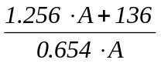 for H₂NG (with A being the quantity of NG/biomethane in the H₂NG mixture, expressed in percent by volume for H₂NG);  0.084 kg/m³ for hydrogen  (b) hydrogen-carbon ratio: fixed values will be used, as follows:  C₁:_{1.89}O_{0.016} for E5 petrol;  C₁:_{1.86}O_{0.005} for diesel;  C₁:₂ ₅₂₅ for LPG (liquefied petroleum gas);  C₁:₄ for NG (natural gas) and biomethane;  C₁:_{2.74}O_{0.385} for ethanol (E85).
2.3. | Description of tests for vehicles powered by an electric powertrain only
2.3.1. | The technical service in charge of the tests shall conduct the measurement of the electric energy consumption according to the method and test cycle described in Annex B.4.2.
2.3.2. | The technical service in charge of the tests shall measure the electric range of the vehicle according to the method described in Annex B.4.3.
2.3.2.1. | The electric range measured by this method shall be the only one referred to in promotional material.
2.3.2.2. | Vehicles designed to pedal shall be exempted from the electric range test.
2.3.3. | Electric energy consumption shall be expressed in Watt hours per kilometre (Wh/km) and the range in kilometres, both rounded to the nearest whole number.
2.4. | Description of tests for vehicles powered by a hybrid electric powertrain
2.4.1. | The technical service in charge of the tests shall measure the CO₂ emissions and the electric energy consumption according to the test procedure described in Annex B.4.3.
2.4.2. | The test results for CO₂ emissions shall be expressed in grams per kilometre (g/km) rounded to the nearest whole number.
2.4.3. | The fuel consumption, expressed in litres per 100 km (in the case of petrol, LPG, ethanol (E85) and diesel) or in kg and m³ per 100 km (in the case of NG/biomethane, H₂NG and hydrogen), shall be calculated according to point 1.4.3. of section B.2. by the carbon balance method using the CO₂ emissions measured and the other carbon-related emissions (CO and HC). The results shall be rounded to the first decimal place.
2.4.4. | For the purpose of the calculation referred to in point 2.4.3., the prescriptions and reference values of point 2.2.4. shall apply.
2.4.5. | If applicable, electric energy consumption shall be expressed in Watt hours per kilometre (Wh/km), rounded to the nearest whole number.
2.4.6. | The technical service in charge of the tests shall measure the electric range of the vehicle according to the method described in Annex B.4.3. The result shall be expressed in kilometre, rounded to the nearest whole number.  The electric range measured by this method shall be the only one referred to in promotional material and used for the calculations in Annex B.4.3.
2.5. | Interpretation of test results
2.5.1. | The CO₂ value or the value of electric energy consumption adopted as the [approval]/[certification] value shall be that declared by the manufacturer if this is not exceeded by more than 4 percent by the value measured by the technical service. The measured value may be lower without any limitations.  In the case of vehicles powered by a combustion engine only which are equipped with periodically regenerating systems as defined in point 4.45 in section B.1., the results are multiplied by the factor K_{i} obtained from Annex B.2.3. before being compared with the declared value.
2.5.2. | If the measured value of CO₂ emissions or electric energy consumption exceeds the manufacturer’s declared CO₂ emissions or electric energy consumption value by more than 4 percent, another test shall be run on the same vehicle.  Where the average of the two test results does not exceed the manufacturer’s declared value by more than 4 percent, the value declared by the manufacturer shall be taken as the [approval]/[certification] value.
2.5.3. | If, in the event of another test being run, the average still exceeds the declared value by more than 4 percent, a final test shall be run on the same vehicle. The average of the three test results shall be taken as the [approval]/[certification] value.
[3.] | [For Contracting Parties applying type-approval requirements with respect to modification and extension of approval of the approved type]
3.1. | For all approved types, the approval authority that approved the type shall be notified of any modification of it. The approval authority] may then either:
3.1.1. | consider that the modifications made are unlikely to have an appreciable adverse effect on the CO₂ emissions and fuel or electric energy consumption values and that the original environmental performance approval will be valid for the modified vehicle type with regard to the environmental performance, or
3.1.2. | require a further test report from the technical service responsible for conducting the tests in accordance with point 4.
3.2. | For Contracting Parties applying type-approval confirmation or extension of approval specifying the alterations, shall be communicated by the following procedure:
3.2.1. | If particulars recorded in the information package have changed, without requiring inspections or tests to be repeated, the amendment shall be designated a ‘revision’.  In such cases, the approval authority shall issue the revised pages of the information package as necessary, marking each revised page to show clearly the nature of the change and the
3.2.2. | The amendment shall be designated an ‘extension’ when particulars recorded in the information package have changed and any of the following occurs:  (a) further inspections or tests are required;  (b) any information on the approval certificate with the exception of its attachments, has changed;  (c) new requirements become applicable to the approved vehicle type or to the approved system, component or separate technical unit.  In the event of an extension, the approval authority shall issue an updated approval certificate denoted by an extension number, incremented in accordance with the number of successive extensions already granted. That approval certificate shall clearly show the reason for the extension and the date of re-issue.
3.3. | The approval authority that grants the extension of the approval shall assign a serial number for such an extension according to the procedure below:
3.3.1. | Whenever amended pages or a consolidated, updated version are issued, the index to the information package attached to the approval certificate shall be amended accordingly to show the date of the most recent extension or revision, or the date of the most recent consolidation of the updated version.
3.3.2. | No amendment to the approval of a vehicle shall be required if the new requirements referred to in point (c) of paragraph 3.2.2. are, from a technical point of view, irrelevant to that type of vehicle or concern categories of vehicle other than the category to which it belongs.
[4.] | [For Contracting Parties applying type-approval requirements with respect to conditions of extension of vehicle environmental performance approval]
4.1. | Vehicles powered by an internal combustion engine only, except those equipped with a periodically regenerating emission-control system  An approval may be extended to vehicles produced by the same manufacturer that are of the same type or of a type that differs with regard to the following characteristics in Annex B.4.1, provided the CO₂ emissions measured by the technical service do not exceed the approval value by more than 4 percent:
4.1.1. | reference mass;
4.1.2. | maximum authorised mass.;
4.1.3. | type of bodywork;
4.1.4. | overall gear ratios;
4.1.5. | engine equipment and accessories;
4.1.6. | engine revolutions per kilometre in highest gear with an accuracy of +/- 5 %.
4.2. | Vehicles powered by an internal combustion engine only and equipped with a periodically regenerating emission-control system.  The approval may be extended to vehicles produced by the same manufacturer that are of the same type or of a type that differs with regard to the characteristics in Annex B.4.1, as referred to in points 4.1.1. to 4.1.6., without exceeding the propulsion unit family characteristics of Annex B.5.9., provided the CO₂ emissions measured by the technical service do not exceed the [approval]/[certification] value by more than 4 percent, where the same K_{i} factor is applicable.  The approval may also be extended to vehicles of the same type, but with a different K_{i} factor, provided the corrected CO₂ value measured by the technical service does not exceed the approval value by more than 4 percent.
4.3. | Vehicles powered by an electric powertrain only  Extensions may be granted after agreement with the approval authority.
4.4. | Vehicles powered by a hybrid electric powertrain  The approval may be extended to vehicles of the same type or of a type that differs with regard to the following characteristics in Annex B.4.3. provided the CO₂ emissions and the electric energy consumption measured by the technical service do not exceed the approval value by more than 4 percent:
4.4.1. | reference mass;
4.4.2. | maximum authorised mass;
4.4.3. | type of bodywork;
4.4.4. | type and number of propulsion batteries. Where multiple batteries are fitted, e.g. to extend the range extrapolation of the measurement, the base configuration, taking into account the capacities and the way in which the batteries are connected (in parallel, not in series), shall be deemed sufficient.
4.5. | Where any other characteristic is changed, extensions may be granted after agreement with the approval authority.

Annexes to test type VII requirements
Annex Number | Annex title | Page #
B.4.1. | Annex: method of measuring carbon dioxide emissions and fuel consumption of vehicles powered by a combustion engine only | 114
B.4.2. | Annex: method of measuring the electric energy consumption of a vehicle powered by an electric powertrain only | 118
B.4.3. | Annex: method of measuring the carbon dioxide emissions, fuel consumption, electric energy consumption and driving range of vehicles powered by a hybrid electric powertrain | 122
B.4.4. | Annex: electrical energy/power storage device State Of Charge (SOC) profile for an externally chargeable Hybrid Electric Vehicle (OVC HEV) in a type VII test | 144
B.4.5. | Annex: method for measuring the electricity balance of the battery of OVC and NOVC HEV | 146
B.4.6. | Annex: method of measuring the electric range of vehicles powered by an electric powertrain only or by a hybrid electric powertrain and the OVC range of vehicles powered by a hybrid electric powertrain | 148

B.4.1. | Annex: method of measuring carbon dioxide emissions and fuel consumption of vehicles powered by a combustion engine only
1. | Specification of the test
1.1. | The carbon dioxide (CO₂) emissions and fuel consumption of vehicles powered by a combustion engine only shall be determined according to the procedure for the type I test in section B.2. in force at the time of the [approval]/[certification] of the vehicle.
1.2. | In addition to the CO₂ emission and fuel consumption results for the entire type I test, CO₂ emissions and fuel consumption shall also be determined separately for parts 1, 2 and 3, if applicable, by using the applicable type I test procedure.
1.3. | In addition to the conditions in section B.2. in force at the time of the [approval]/[certification] of the vehicle, the following conditions shall apply:
1.3.1. | Only the equipment necessary for the operation of the vehicle during the test shall be in use. If there is a manually controlled device for the engine intake air temperature, it shall be in the position prescribed by the manufacturer for the ambient temperature at which the test is performed. In general, the auxiliary devices required for the normal operation of the vehicle shall be in use.
1.3.2. | If the radiator fan is temperature-controlled, it shall be in normal operating condition. The passenger compartment heating system, if present, shall be switched off, as shall any air-conditioning system, but the compressor for such systems shall be functioning normally.
1.3.3. | If a super-charger is fitted, it shall be in normal operating condition for the test conditions.
1.3.4. | All lubricants shall be those recommended by the manufacturer of the vehicle and shall be specified in the test report.
1.3.5. | The widest tyre shall be chosen, except where there are more than three tyre sizes, in which case the second widest shall be chosen. The pressures shall be indicated in the test report.
1.4. | Calculation of CO₂ and fuel consumption values
1.4.1. | The mass emission of CO₂, expressed in g/km, shall be calculated from the measurements taken in accordance with the provisions of point 5 of section B.2.
1.4.1.1. | For this calculation, the density of CO₂ shall be assumed to be Q_{CO2} = 1.964•10³ g/m³.
1.4.2. | The fuel consumption values shall be calculated from the hydrocarbon, carbon monoxide and carbon dioxide emission measurements taken in accordance with the provisions of point 4 of section B.2. in force at the time of the [approval]/[certification] of the vehicle.
1.4.3. | Fuel consumption (FC), expressed in litres per 100 km (in the case of petrol, LPG, ethanol (E85) and diesel) or in kg per 100 km (in the case of an alternative fuel vehicle propelled with NG/biomethane, H₂NG or hydrogen) is calculated using the following formulae:
1.4.3.1. | for vehicles with a positive ignition engine fuelled with petrol (E5):  Equation B.4.1-1:  FC = (0.118/D) · ((0.848 · HC) + (0.429 · CO) + (0.273 ·CO₂));
1.4.3.2. | for vehicles with a positive ignition engine fuelled with LPG:  Equation B.4.1-2:  FC_{norm} = (0.1212 / 0.538) · ((0.825 · HC) + (0.429 · CO) + (0.273 · CO₂)).  If the composition of the fuel used for the test differs from that assumed for the calculation of normalised consumption, a correction factor (cf) may be applied at the manufacturer’s request, as follows:  Equation B.4.1-3:  FC_{norm} = (0.1212 / 0.538) · (cf) · ((0.825 · HC) + (0.429 · CO) + (0.273 · CO₂)).  The correction factor is determined as follows:  Equation B.4.1-4:  cf = 0.825 + 0.0693 · n_{actual};  where:  n_{actual} = the actual H/C ratio of the fuel used;
1.4.3.3. | for vehicles with a positive ignition engine fuelled with NG/biomethane:  Equation B.4.1-5:  FC_{norm} = (0.1336 / 0.654) · ((0.749 · HC) + (0.429 · CO) + (0.273 · CO₂))  in m³;
1.4.3.4. | for vehicles with a positive ignition engine fuelled by H₂NG:  Equation B.4.1-6:  in m³;
1.4.3.5. | for vehicles fuelled with gaseous hydrogen:  Equation B.4.1-7:  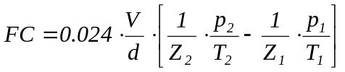  For vehicles fuelled with gaseous or liquid hydrogen, the manufacturer may alternatively, with the prior agreement of the [approval authority]/[certification authority], choose either the formula:  Equation B.4.1-8:  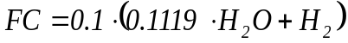  or a method in accordance with standard protocols such as SAE J2572.
1.4.3.6. | for vehicles with a compression ignition engine fuelled with diesel (B5):  Equation B.4.1-9:  FC = (0.116/D) · ((0.861 · HC) + (0.429 · CO) + (0.273 · CO₂));
1.4.3.7. | for vehicles with a positive ignition engine fuelled with ethanol (E85):  Equation B.4.1-10:  FC = (0.1742/D) · ((0.574 · HC) + (0.429 · CO) + (0.273 · CO₂)).
1.4.4. | In these formulae:  FC = the fuel consumption in litres per 100 km in the case of petrol, ethanol, LPG, diesel or biodiesel, in m³ per 100 km in the case of natural gas and H₂NG or in kg per 100 km in the case of hydrogen.  HC = the measured emission of hydrocarbons in g/km  CO = the measured emission of carbon monoxide in g/km  CO₂ = the measured emission of carbon dioxide in g/km  H₂O = the measured emission of water (H₂O) in g/km  H₂ = the measured emission of hydrogen (H₂₎ in g/km  A = the quantity of NG/biomethane in the H₂NG mixture, expressed in percent by volume  D = the density of the test fuel.  In the case of gaseous fuels, D is the density at 15 ºC and at 101.3 kPa ambient pressure:  d = theoretical distance covered by a vehicle tested under the type I test in km  p₁ = pressure in gaseous fuel tank before the operating cycle in Pa  p₂ = pressure in gaseous fuel tank after the operating cycle in Pa  T₁ = temperature in gaseous fuel tank before the operating cycle in K  T₂ = temperature in gaseous fuel tank after the operating cycle in K  Z₁ = compressibility factor of the gaseous fuel at p₁ and T₁  Z₂ = compressibility factor of the gaseous fuel at p₂ and T₂  V = inner volume of the gaseous fuel tank in m³  The compressibility factor shall be obtained from the following table:  Table B.4.1-1: Compressibility factor Z_{x} of the gaseous fuel
  T(k) \ p(bar) | 5 | 100 | 200 | 300 | 400 | 500 | 600 | 700 | 800 | 900
  33 | 0.8589 | 10.508 | 18.854 | 26.477 | 33.652 | 40.509 | 47.119 | 53.519 | 59.730 | 65.759
  53 | 0.9651 | 0.9221 | 14.158 | 18.906 | 23.384 | 27.646 | 31.739 | 35.697 | 39.541 | 43.287
  73 | 0.9888 | 0.9911 | 12.779 | 16.038 | 19.225 | 22.292 | 25.247 | 28.104 | 30.877 | 33.577
  93 | 0.9970 | 10.422 | 12.334 | 14.696 | 17.107 | 19.472 | 21.771 | 24.003 | 26.172 | 28.286
  113 | 10.004 | 10.659 | 12.131 | 13.951 | 15.860 | 17.764 | 19.633 | 21.458 | 23.239 | 24.978
  133 | 10.019 | 10.757 | 11.990 | 13.471 | 15.039 | 16.623 | 18.190 | 19.730 | 21.238 | 22.714
  153 | 10.026 | 10.788 | 11.868 | 13.123 | 14.453 | 15.804 | 17.150 | 18.479 | 19.785 | 21.067
  173 | 10.029 | 10.785 | 11.757 | 12.851 | 14.006 | 15.183 | 16.361 | 17.528 | 18.679 | 19.811
  193 | 10.030 | 10.765 | 11.653 | 12.628 | 13.651 | 14.693 | 15.739 | 16.779 | 17.807 | 18.820
  213 | 10.028 | 10.705 | 11.468 | 12.276 | 13.111 | 13.962 | 14.817 | 15.669 | 16.515 | 17.352
  233 | 10.035 | 10.712 | 11.475 | 12.282 | 13.118 | 13.968 | 14.823 | 15.675 | 16.521 | 17.358
  248 | 10.034 | 10.687 | 11.413 | 12.173 | 12.956 | 13.752 | 14.552 | 15.350 | 16.143 | 16.929
  263 | 10.033 | 10.663 | 11.355 | 12.073 | 12.811 | 13.559 | 14.311 | 15.062 | 15.808 | 16.548
  278 | 10.032 | 10.640 | 11.300 | 11.982 | 12.679 | 13.385 | 14.094 | 14.803 | 15.508 | 16.207
  293 | 10.031 | 10.617 | 11.249 | 11.897 | 12.558 | 13.227 | 13.899 | 14.570 | 15.237 | 15.900
  308 | 10.030 | 10.595 | 11.201 | 11.819 | 12.448 | 13.083 | 13.721 | 14.358 | 14.992 | 15.623
  323 | 10.029 | 10.574 | 11.156 | 11.747 | 12.347 | 12.952 | 13.559 | 14.165 | 14.769 | 15.370
  338 | 10.028 | 10.554 | 11.113 | 11.680 | 12.253 | 12.830 | 13.410 | 13.988 | 14.565 | 15.138
  353 | 10.027 | 10.535 | 11.073 | 11.617 | 12.166 | 12.718 | 13.272 | 13.826 | 14.377 | 14.926

B.4.2. | Annex: method of measuring the electric energy consumption of a vehicle powered by an electric powertrain only
1. | Test sequence
1.1. | Electric energy consumption of pure electric vehicles shall be determined according to the procedure for the type I test in section B.2. in force at the time of the [approval]/[certification] of the vehicle. For this purpose, a pure vehicle shall be classified according to its maximum attainable design vehicle speed.
 | If the vehicle has several driving modes which may be selected by the driver, the operator shall select that which best matches the target curve.
2. | Test method
2.1. | Principle  The following test method shall be used for measuring of the electric energy consumption, expressed in Wh/km:
2.2. | Table 5.2.-1: Parameters, units and accuracy of measurement
  Parameter | Units | Accuracy | Resolution
  Time | s | 0.1 s | 0.1 s
  Distance | m | ± 0.1 percent | 1 m
  Temperature | K | ± 1 K | 1 K
  Speed | km/h | ± 1 percent | 0.2 km/h
  Mass | kg | ± 0.5 percent | 1 kg
  Energy | Wh | ± 0.2 percent | Class 0.2 s  according to  IEC 687
2.3. | Test vehicle
2.3.1. | Condition of the vehicle
2.3.1.1. | The vehicle tyres shall be inflated to the pressure specified by the vehicle manufacturer when the tyres are at ambient temperature.
2.3.1.2. | The viscosity of the oils for the mechanical moving parts shall conform to the vehicle manufacturer’s specification.
2.3.1.3. | The lighting, signalling and auxiliary devices shall be off, except those required for the testing and usual day-time operation of the vehicle.
2.3.1.4. | All energy storage systems for other than traction purposes (electric, hydraulic, pneumatic, etc.) shall be charged to their maximum level as specified by the manufacturer.
2.3.1.5. | If the batteries are operated above the ambient temperature, the operator shall follow the procedure recommended by the vehicle manufacturer in order to keep the battery temperature in the normal operating range.  The manufacturer shall be in a position to attest that the thermal management system of the battery is neither disabled nor reduced.
2.3.1.6. | The vehicle shall have travelled at least 300 km in the seven days before the test with the batteries installed for the test.
2.3.2. | Classification of the pure electric test vehicle in the type I test cycle.  In order to measure its electric consumption in the type I test cycle, the test vehicle shall be classified according to the achievable maximum design vehicle speed thresholds only, set-out in point 2. of section B.1.2.
2.4. | Operation mode  All the tests are conducted at a temperature of between 293.0 K and 303.0 K (20.0 °C and 30.0 °C).  The test method includes the four following steps:  (a) initial charge of the battery;  (b) two runs of the applicable type I test cycle;  (c) charging the battery;  (d) calculation of the electric energy consumption.  If the vehicle moves between the steps, it shall be pushed to the next test area (without regenerative recharging).
2.4.1. | Initial charge of the battery  Charging the battery consists of the following procedures:
2.4.1.1. | Discharge of the battery  The battery is discharged while the vehicle is driven (on the test track, on a chassis dynamometer, etc.) at a steady vehicle speed of 70 percent ± 5 percent of the maximum design vehicle speed.  Discharging shall stop:  (a) when the vehicle is unable to run at 65 percent of the maximum thirty minutes vehicle speed, or  (b) when the standard on-board instrumentation indicates that the vehicle should be stopped, or  (c) after 100 km.  By means of derogation if the manufacturer can prove to the technical service to the satisfaction of the [approval authority]/[certification authority] that the vehicle is physically not capable of achieving the thirty minutes vehicle speed the maximum fifteen minute vehicle speed may be used instead.
2.4.1.2. | Application of a normal overnight charge  The battery shall be charged according to the following procedure:
2.4.1.2.1. | Normal overnight charge procedure  The charge shall be carried out:  (a) with the on-board charger if fitted;  (b) with an external charger recommended by the manufacturer, using the charging pattern prescribed for normal charging;  (c) in an ambient temperature of between 293.0 K and 303.0 K (20.0 °C and 30.0 °C).  This procedure excludes all types of special charges that could be automatically or manually initiated, e.g. equalisation or servicing charges.  The vehicle manufacturer shall declare that no special charge procedure has occurred during the test.
2.4.1.2.2. | End-of-charge criteria  The end-of-charge criteria shall correspond to a charging time of 12 hours except where the standard instrumentation indicates clearly that the battery is not yet fully charged, in which case:  Equation B.4.2.-1:
  Maximum time = | 3 claimed battery capacity (Wh)
  Maximum time = | mains power supply (W)
2.4.1.2.3. | Fully charged battery  Propulsion batteries shall be deemed as fully charged when they have been charged according to the overnight charge procedure until the end-of-charge criteria are fulfilled.
2.4.2. | Application of the type I test cycle and measurement of the distance  The end of charging time t₀ (plug off) shall be reported.  The chassis dynamometer shall be set according to the method in point 3.4.6. of section B.2.  Starting within four hours of t₀, the applicable type I test shall be run twice on a chassis dynamometer, following which the distance covered in km (D_{test}) is recorded. If the manufacturer can demonstrate to the [approval authority]/[certification authority] that twice the type I test distance can physically not be attained by the vehicle, the test cycle shall be conducted once and subsequently followed by a partial second test run. The second test run may stop if the minimum state of charge of the propulsion battery is reached as referred to in Annex B.4.4.
2.4.3. | Charge of the battery  The test vehicle shall be connected to the mains within 30 minutes of the second run of the applicable type I test cycle.  The vehicle shall be charged according to the normal overnight charge procedure in point 2.4.1.2.  The energy measurement equipment, placed between the mains socket and the vehicle charger, measures the energy charge E delivered from the mains and its duration.  Charging shall stop 24 hours after the end of the previous charging time (t₀).  Note:  In the event of a mains power cut, the 24 hour period may be extended in line with the duration of the cut. The validity of the charge shall be discussed between the technical services of the [approval]/[certification] laboratory and the vehicle manufacturer to the satisfaction of the [approval authority]/[certification authority].
2.4.4. | Electric energy consumption calculation  Energy E in Wh and charging time measurements are to be recorded in the test report.  The electric energy consumption c shall be determined using the formula:  Equation B.4.2.-2:  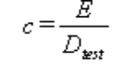(expressed in Wh/km and rounded to the nearest whole number)  where D_{test} is the distance covered during the test (in km).

B.4.3. | Annex: method of measuring the carbon dioxide emissions, fuel consumption, electric energy consumption and driving range of vehicles powered by a hybrid electric powertrain
1. | Introduction
1.1. | This annex lays down specific provisions on the [approval]/[certification] of hybrid electric vehicles (HEV) as regards measuring carbon dioxide emissions, fuel consumption, electric energy consumption and driving range.
1.2. | As a general principle for type VII tests, HEVs shall be tested according to the specified type I test cycles and requirements and in particular Annex B.5.15, except where modified by this Annex.
1.3. | OVC (externally chargeable) HEVs shall be tested under Conditions A and B.  The test results under Conditions A and B and the weighted average referred to in point 3 shall be given in the test report.
1.4. | Driving cycles and gear-shift points
1.4.1. | The driving cycle set out in Annex B.5.15. to this GTR applicable at the time of [approval]/[certification] of the vehicle shall be used, including the gear-shifting points in point 3.4.5. of section B.2.
1.4.2. | For vehicle conditioning, a combination of the driving cycles in Annex B.5.15. applicable at the time of [approval]/[certification] of the vehicle shall be used as laid down in this Annex.
2. | Categories of hybrid electric vehicles (HEV)  Table B.4.3.-1
  Vehicle charging | Off-Vehicle Charging  (OVC) |  | Not-off-vehicle Charging  (NOVC)
  Operating mode switch | Without | With | Without | With
3. | OVC (externally chargeable) HEV without an operating mode switch
3.1. | Two type I tests shall be performed under the following conditions:  a) condition A: the test shall be carried out with a fully charged electrical energy/power storage device;  b) condition B: the test shall be carried out with an electrical energy/power storage device in minimum state of charge (maximum discharge of capacity).  The profile of the state of charge (SOC) of the electrical energy/power storage device at different stages of the test is set out in Annex B.4.4.
3.2. | Condition A
3.2.1. | The procedure shall start with the discharge of the electrical energy/power storage device in accordance with point 3.2.1.1.:
3.2.1.1. | Discharge of the electrical energy/power storage device  The electrical energy/power storage device of the vehicle is discharged while driving (on the test track, on a chassis dynamometer, etc.) in any of the following conditions:  - at a steady vehicle speed of 50 km/h until the fuel-consuming engine starts up;  - if a vehicle cannot reach a steady vehicle speed of 50 km/h without the fuel-consuming engine starting up, the vehicle speed shall be reduced until it can run at a lower steady vehicle speed at which the fuel-consuming engine does not start up for a defined time or distance (to be determined by the technical service and the manufacturer to the satisfaction of the [approval authority]/[certification authority]);  - in accordance with the manufacturer’s recommendation.  The fuel-consuming engine shall be stopped within ten seconds of being automatically started.
3.2.2. | Conditioning of the vehicle
3.2.2.1. | The test vehicle shall be preconditioned by conducting the applicable type I test cycle in combination with the applicable gear-shifting in point 3.4.5.of section B.2.
3.2.2.2. | After this preconditioning and before testing, the vehicle shall be kept in a room in which the temperature remains relatively constant between 293.0 and 303.0 K (20.0 °C and 30.0 °C). This conditioning shall be carried out for at least six hours and continue until the temperatures of the engine oil and coolant, if any, are within ± 2.0 K (2.0 °C) of the temperature of the room, and the electrical energy/power storage device is fully charged as a result of the charging in point 3.2.2.4.
3.2.2.3. | During soak, the electrical energy/power storage device shall be charged in accordance with the normal overnight charging procedure described in point 3.2.2.4.
3.2.2.4. | Application of a normal overnight charge  The electrical energy/power storage device shall be charged according to the following procedure:
3.2.2.4.1. | Normal overnight charge procedure  The charging shall be carried out as follows:  (a) with the on-board charger, if fitted or  (b) with an external charger recommended by the manufacturer using the charging pattern prescribed for normal charging; and  (c) in an ambient temperature of between 20 ºC and 30 ºC. This procedure shall exclude all types of special charge that could be automatically or manually initiated, e.g. equalisation or servicing charges. The manufacturer shall declare that no special charge procedure has occurred during the test.
3.2.2.4.2. | End-of-charge criteria  The end-of-charge criteria shall correspond to a charging time of twelve hours, except where the standard instrumentation indicates clearly that the electrical energy/power storage device is not yet fully charged, in which case:  Equation B.4.3.-1:
  Maximum time is = | 3 claimed battery capacity (Wh)
  Maximum time is = | mains power supply (W)
3.2.3. | Test procedure
3.2.3.1. | The vehicle shall be started up by the means provided for normal use by the driver. The first cycle starts on the initiation of the vehicle start-up procedure.
3.2.3.2. | The test procedures defined in either point 3.2.3.2.1. or 3.2.3.2.2. may be used.
3.2.3.2.1. | Sampling shall begin (BS) before or at the initiation of the vehicle start-up procedure and end on conclusion of the final idling period in the applicable type I driving cycle (end of sampling (ES)).
3.2.3.2.2. | Sampling shall begin (BS) before or at the initiation of the vehicle start-up procedure and continue over a number of repeat test cycles. It shall end on conclusion of the applicable type I driving cycle during which the battery reached the minimum state of charge in accordance with the following procedure (end of sampling (ES)):
3.2.3.2.2.1. | The electricity balance Q (Ah) is measured over each combined cycle, using the procedure in Annex B.4.5., and used to determine when the battery’s minimum state of charge has been reached.
3.2.3.2.2.2. | The battery’s minimum state of charge is considered to have been reached in combined cycle N if the electricity balance Q measured during combined cycle N+1 is not more than a 3 percent discharge, expressed as a percentage of the nominal capacity of the battery (in Ah) in its maximum state of charge, as declared by the manufacturer. At the manufacturer’s request, additional test cycles may be run and their results included in the calculations in points 3.2.3.5. and 3.4., provided that the electricity balance for each additional test cycle shows less discharge of the battery than over the previous cycle.
3.2.3.2.2.3. | Between each pair of cycles, a hot soak period of up to ten minutes is allowed. The powertrain shall be switched off during this period.
3.2.3.3. | The vehicle shall be driven according to the applicable type I driving cycle and gear-shifting prescriptions in section B.2. and as explained in Annex B.5.16.
3.2.3.4. | The tailpipe emissions of the vehicle shall be analysed according to the provisions of section B.2. in force at the time of [approval]/[certification] of the vehicle.
3.2.3.5. | The CO₂ emission and fuel consumption results from the test cycle(s) for Condition A shall be recorded (respectively m₁ (g) and c₁ (l)). Parameters m₁ and c₁ shall be the sums of the results of the N combined cycles run.  Equation B.4.3.-2:  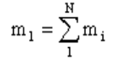  Equation B.4.3-3:  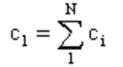
3.2.4. | Within the 30 minutes after the conclusion of the cycle, the electrical energy/power storage device shall be charged according to point 3.2.2.4. The energy measurement equipment, placed between the mains socket and the vehicle charger, measures the charge energy e₁ (Wh) delivered from the mains.
3.2.5. | The electric energy consumption for Condition A shall be e₁ (Wh).
3.3. | Condition B
3.3.1. | Conditioning of the vehicle
3.3.1.1. | The electrical energy/power storage device of the vehicle shall be discharged in accordance with point 3.2.1.1. At the manufacturer’s request, conditioning in accordance with point 3.2.2.1. may be carried out before electrical energy/power storage discharge.
3.3.1.2. | Before testing, the vehicle shall be kept in a room in which the temperature remains relatively constant between 293.0 K and 303.0 K (20.0 °C and 30.0 °C). This conditioning shall be carried out for at least six hours and continue until the temperatures of the engine oil and coolant, if any, are within ± 2.0 K (2.0 °C )of the temperature of the room.
3.3.2. | Test procedure
3.3.2.1. | The vehicle shall be started up by the means provided for normal use by the driver. The first cycle starts on the initiation of the vehicle start-up procedure.
3.3.2.2. | Sampling shall begin (BS) before or at the initiation of the vehicle start-up procedure and end on conclusion of the final idling period in the applicable type I driving cycle (end of sampling (ES)).
3.3.2.3. | The vehicle shall be driven using the applicable type I driving cycle and gear-shifting prescriptions set out in Annex B.5.15. and Annex B.5.16.
3.3.2.4. | The tailpipe emissions of the vehicle shall be analysed according to the provisions of section B.2.
3.3.2.5. | The test results for Condition B shall be recorded (m₂ (g) and c₂ (l) respectively).
3.3.3. | Within 30 minutes of the end of the cycle, the electrical energy/power storage device shall be charged in accordance with point 3.2.2.4.  The energy measurement equipment, placed between the mains socket and the vehicle charger, measures the energy charge e₂ (Wh) delivered from the mains.
3.3.4. | The electrical energy/power storage device of the vehicle shall be discharged in accordance with point 3.2.1.1.
3.3.5. | Within 30 minutes of the discharge, the electrical energy/power storage device shall be charged in accordance with point 3.2.2.4.  The energy measurement equipment, placed between the mains socket and the vehicle charger, measures the energy charge e₃ (Wh) delivered from the mains.
3.3.6. | The electric energy consumption e₄ (Wh) for Condition B is:  Equation B.4.3.-4:  e₄ = e₂ - e₃
3.4. | Test results
3.4.1. | The CO₂ values shall be:  Equation B.4.3.-5:  M₁ = m₁/D_{test1} and  Equation B.4.3.-6:  M₂ = m₂/D_{test2} (g/km)  where  D_{test1} and D_{test2} = the actual distances driven in the tests performed under Conditions A (point 3.2.) and B (point 3.3.) respectively, and  m₁ and m₂ = test results determined in points 3.2.3.5. and 3.3.2.5. respectively.
3.4.2. | For testing in accordance with point 3.2.3.2.1:  The weighted CO₂ values shall be calculated as follows:  Equation B.4.3.-7:  M = (D_{e} · M₁ + D_{av} ·.M₂ )/(D_{e} + D_{av})  where:  M= mass emission of CO₂ in grams per kilometre,  M₁ = mass emission of CO₂ in grams per kilometre with a fully charged electrical energy/power storage device,  M₂ = mass emission of CO₂ in grams per kilometre with an electrical energy/power storage device in minimum state of charge (maximum discharge of capacity),  D_{e} = electric range of the vehicle determined according to the procedure described in Annex 5.6., where the manufacturer shall provide the means for performing the measurement with the vehicle running in pure electric operating state,  D_{av} = average distance between two battery recharges, D_{av} =:  - 4 km for a vehicle with an engine capacity of < 150 cm³;  - 6 km for a vehicle with an engine capacity of ≥ 150 cm³ and v_{max} < 130 km/h;  - 10 km for a vehicle with an engine capacity of ≥ 150 cm³ and v_{max} ≥ 130 km/h.
3.4.2.1. | For testing in accordance with point 3.2.3.2.2.:  Equation B.4.3.-8:  M = (D_{ovc}·M₁ + D_{av}·M₂)/(D_{ovc} + D_{av})  where:  M = mass emission of CO₂ in grams per kilometre,  M₁ = mass emission of CO₂ in grams per kilometre with a fully charged electrical energy/power storage device,  M₂ = mass emission of CO₂ in grams per kilometre with an electrical energy/power storage device in minimum state of charge (maximum discharge of capacity),  D_{ovc} = OVC range according to the procedure described in Annex B.4.6.,  D_{av} = average distance between two battery recharges, D_{av} =:  - 4 km for a vehicle with an engine capacity of < 150 cm³;  - 6 km for a vehicle with an engine capacity of ≥ 150 cm³ and v_{max} < 130 km/h;  - 10 km for a vehicle with an engine capacity of ≥ 150 cm³ and v_{max} ≥ 130 km/h.
3.4.3. | The fuel consumption values shall be:  Equation B.4.3.-9:  C₁ = 100·c1/D_{test1}  Equation B.4.3.-10:  C₂ = 100·c₂/D_{test2} (l/100 km) for liquid fuels and (kg/100) km for gaseous fuel  where:  D_{test1} and D_{test2} = the actual distances driven in the tests performed under Conditions A (point 3.2.) and B (point 3.3.) respectively, and  c₁ and c₂ = test results determined in points 3.2.3.5. and 3.3.2.5. respectively.
3.4.4. | The weighted fuel consumption values shall be calculated as follows:
3.4.4.1. | For testing in accordance with point 3.2.3.2.1.:  Equation B.4.3.-11:  C = (D_{e}·C₁ + D_{av}·C₂)/(D_{e} + D_{av})  where:  C = fuel consumption in l/100 km,  C₁ = fuel consumption in l/100 km with a fully charged electrical energy/power storage device,  C₂ = fuel consumption in l/100 km with an electrical energy/power storage device in minimum state of charge (maximum discharge of capacity),  D_{e} = electric range of the vehicle determined according to the procedure described in Annex B.4.6., where the manufacturer shall provide the means for performing the measurement with the vehicle running in pure electric operating state,  D_{av} = average distance between two battery recharges, D_{av} =:  - 4 km for a vehicle with an engine capacity of < 150 cm³;  - 6 km for a vehicle with an engine capacity of ≥ 150 cm³ and v_{max} < 130 km/h;  - 10 km for a vehicle with an engine capacity of ≥ 150 cm³ and v_{max} ≥ 130 km/h.
3.4.4.2. | For testing in accordance with point 3.2.3.2.2.:  Equation B.4.3.-12:  C = (D_{ovc}·C₁ + D_{av}·C₂)/(D_{ovc} + D_{av})  where:  C = fuel consumption in l/100 km,  C₁ = fuel consumption in l/100 km with a fully charged electrical energy/power storage device,  C₂ = fuel consumption in l/100 km with an electrical energy/power storage device in minimum state of charge (maximum discharge of capacity),  D_{ovc} = OVC range according to the procedure described in annex B.4.6.  D_{av} = average distance between two battery recharges, D_{av} =:  - 4 km for a vehicle with an engine capacity of < 150 cm³;  - 6 km for a vehicle with an engine capacity of ≥ 150 cm³ and v_{max} < 130 km/h;  - 10 km for a vehicle with an engine capacity of ≥ 150 cm³ and v_{max} ≥ 130 km/h.
3.4.5. | The electric energy consumption values shall be:  Equation B.4.3.-13:  E₁ = e₁/D_{test1} and  Equation B.4.3.-14:  E₄ = e₄/D_{test2} (Wh/km)  with D_{test1} and D_{test2} the actual distances driven in the tests performed under Conditions A (point 3.2.) and B (point 3.3.) respectively, and e₁ and e₄ determined in points 3.2.5. and 3.3.6. respectively.
3.4.6. | The weighted electric energy consumption values shall be calculated as follows:
3.4.6.1. | For testing in accordance with point 3.2.3.2.1.:  Equation B.4.3.-15:  E = (D_{e}·E₁ + D_{av}·E₄) / (D_{e} + D_{av})  where:  E = electric consumption Wh/km,  E₁ = electric consumption Wh/km with a fully charged electrical energy/power storage device,  E₄ = electric consumption Wh/km with an electrical energy/power storage device in minimum state of charge (maximum discharge of capacity),  D_{e} = electric range of the vehicle determined according to the procedure described in Annex B.4.6., where the manufacturer shall provide the means for performing the measurement with the vehicle running in pure electric operating state,  D_{av} = average distance between two battery recharges, D_{av} =:  - 4 km for a vehicle with an engine capacity of < 150 cm³;  - 6 km for a vehicle with an engine capacity of ≥ 150 cm³ and v_{max} < 130 km/h;  - 10 km for a vehicle with an engine capacity of ≥ 150 cm³ and v_{max} ≥ 130 km/h.
3.4.6.2. | For testing in accordance with point 3.2.3.2.2.:  Equation B.4.3.-16:  E = (D_{ovc}·E₁ + D_{av}·E₄) / (D_{ovc} + D_{av})  where:  E = electric consumption Wh/km,  E₁ = electric consumption Wh/km with a fully charged electrical energy/power storage device,  E₄ = electric consumption Wh/km with an electrical energy/power storage device in minimum state of charge (maximum discharge of capacity),  D_{ovc} = OVC range according to the procedure described in annex B.4.6.  D_{av} = average distance between two battery recharges, D_{av} =:  - 4 km for a vehicle with an engine capacity of < 150 cm³;  - 6 km for a vehicle with an engine capacity of ≥ 150 cm³ and v_{max} < 130 km/h;  - 10 km for a vehicle with an engine capacity of ≥ 150 cm³ and v_{max} ≥ 130 km/h.
4. | Externally chargeable (OVC HEV) with an operating mode switch
4.1. | Two tests shall be performed under the following conditions:
4.1.1. | Condition A: test carried out with a fully charged electrical energy/power storage device.
4.1.2. | Condition B: test carried out with an electrical energy/power storage device in minimum state of charge (maximum discharge of capacity).
4.1.3. | The operating mode switch shall be positioned in accordance with Table B.2.2.1.1.-2, point 3.2.1.3. of Annex B.2.1.1.
4.2. | Condition A
4.2.1. | If the electric range of the vehicle, as measured in accordance with Annex B.4.6., is higher than one complete cycle, the type I test for electric energy measurement may be carried out in pure electric mode at the request of the manufacturer after agreement of the technical service and to the satisfaction of the [approval authority]/[certification authority]. In this case, the values of M₁ and C₁ in point 4.4. shall be taken as equal to 0.
4.2.2. | The procedure shall start with the discharge of the electrical energy/power storage device of the vehicle as described in point 4.2.2.1.
4.2.2.1. | The electrical energy/power storage device of the vehicle is discharged while driving with the switch in pure electric position (on the test track, on a chassis dynamometer, etc.) at a steady vehicle speed of 70 percent ± 5 percent of the maximum design vehicle speed in pure electric mode, determined in accordance with the test procedure to measure the maximum design vehicle speed.  Discharge shall stop in any of the following conditions:  - when the vehicle is unable to run at 65 percent of the maximum thirty minutes vehicle speed;  - when the standard on-board instrumentation indicates that the vehicle should be stopped;  - after 100 km.  If the vehicle is not equipped with a pure electric mode, the electrical energy/power storage device shall be discharged by driving the vehicle (on the test track, on a chassis dynamometer, etc.) at any of the following conditions:  - at a steady vehicle speed of 50 km/h until the fuel-consuming engine starts up;  - if a vehicle cannot reach a steady vehicle speed of 50 km/h without the fuel-consuming engine starting up, the vehicle speed shall be reduced until it can run at a lower steady vehicle speed at which the fuel-consuming engine does not start up for a defined time or distance (to be determined by the technical service and the manufacturer to the satisfaction of the [approval authority]/[certification authority]);  - in accordance with the manufacturer’s recommendation.  The fuel-consuming engine shall be stopped within ten seconds of being automatically started. By means of derogation if the manufacturer can prove to the technical service to the satisfaction of the [approval authority]/[certification authority] that the vehicle is physically not capable of achieving the thirty minutes vehicle speed the maximum fifteen minute vehicle speed may be used instead.
4.2.3. | Conditioning of the vehicle
4.2.3.1. | The test vehicle shall be preconditioned by conducting the applicable type I test cycle in combination with the applicable gear-shifting prescriptions in point 3.4.5. of section B.2.
4.2.3.2. | After this preconditioning and before testing, the vehicle shall be kept in a room in which the temperature remains relatively constant between 293.0 K and 303.0 K (20.0 °C and 30.0 °C). This conditioning shall be carried out for at least six hours and continue until the temperatures of the engine oil and coolant, if any, are within ± 2.0 K (2.0 °C) of the temperature of the room, and the electrical energy/power storage device is fully charged as a result of the charging prescribed in point 4.2.3.3.
4.2.3.3. | During soak, the electrical energy/power storage device shall be charged using the normal overnight charging procedure as defined in point 3.2.2.4.
4.2.4. | Test procedure
4.2.4.1. | The vehicle shall be started up by the means provided for normal use by the driver. The first cycle starts on the initiation of the vehicle start-up procedure.
4.2.4.2. | The test procedures defined in either point 4.2.4.2.1. or 4.2.4.2.2. may be used.
4.2.4.2.1. | Sampling shall begin (BS) before or at the initiation of the vehicle start-up procedure and end on conclusion of the final idling period in the applicable type I driving cycle (end of sampling (ES)).
4.2.4.2.2. | Sampling shall begin (BS) before or at the initiation of the vehicle start-up procedure and continue over a number of repeat test cycles. It shall end on conclusion of the applicable type I driving cycle during which the battery reached the minimum state of charge in accordance with the following procedure (end of sampling (ES)):
4.2.4.2.2.1. | the electricity balance Q (Ah) is measured over each combined cycle, using the procedure in Annex B.4.5., and used to determine when the battery’s minimum state of charge has been reached.
4.2.4.2.2.2. | the battery’s minimum state of charge is considered to have been reached in combined cycle N if the electricity balance measured during combined cycle N+1 is not more than a 3 percent discharge, expressed as a percentage of the nominal capacity of the battery (in Ah) in its maximum state of charge, as declared by the manufacturer. At the manufacturer’s request, additional test cycles may be run and their results included in the calculations in points 4.2.4.5. and 4.4., provided that the electricity balance for each additional test cycle shows less discharge of the battery than over the previous cycle.
4.2.4.2.2.3. | between each pair of cycles, a hot soak period of up to ten minutes is allowed. The powertrain shall be switched off during this period.
4.2.4.3. | The vehicle shall be driven using the applicable driving cycle and gear-shifting prescriptions as defined in section B.2. and Annex B.5.16.
4.2.4.4. | The exhaust gases shall be analysed according to section B.2. in force at the time of [approval]/[certification] of the vehicle.
4.2.4.5. | The CO₂ emission and fuel consumption results on the test cycle for Condition A shall be recorded (m₁ (g) and c₁ (l) respectively). In the case of testing in accordance with point 4.2.4.2.1., m₁ and c₁ are the results of the single combined cycle run. In the case of testing in accordance with point 4.2.4.2.2., m₁ and c₁ are the sums of the results of the N combined cycles run:  Equation B.4.3.-17:  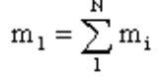  Equation B.4.3-18:  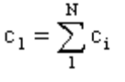
4.2.5. | Within 30 minutes of the end of the cycle, the electrical energy/power storage device shall be charged in accordance with point 3.2.2.4.  The energy measurement equipment, placed between the mains socket and the vehicle charger, shall measure the energy charge e₁ (Wh) delivered from the mains.
4.2.6. | The electric energy consumption for Condition A shall be e₁ (Wh).
4.3. | Condition B
4.3.1. | Conditioning of the vehicle
4.3.1.1. | The electrical energy/power storage device of the vehicle shall be discharged in accordance with point 4.2.2.1.  At the manufacturer’s request, conditioning in accordance with point 4.2.3.1. may be carried out before electrical energy/power storage discharge.
4.3.1.2. | Before testing, the vehicle shall be kept in a room in which the temperature shall remain relatively constant between 293.0K and 303.0 K (20.0 °C and 30.0 °C). This conditioning shall be carried out for at least six hours and continue until the temperatures of the engine oil and coolant, if any, are within ± 2.0 K (2.0 °C) of the temperature of the room.
4.3.2. | Test procedure
4.3.2.1. | The vehicle shall be started up by the means provided for normal use by the driver. The first cycle starts on the initiation of the vehicle start-up procedure.
4.3.2.2. | Sampling shall begin (BS) before or at the initiation of the vehicle start-up procedure and end on conclusion of the final idling period in the applicable type I driving cycle (end of sampling (ES)).
4.3.2.3. | The vehicle shall be driven using the applicable driving cycle and gear-shifting prescriptions as defined in section B.2.
4.3.2.4. | The exhaust gases shall be analysed in accordance with the provisions of section B.2. in force at the time of [approval]/[certification] of the vehicle.
4.3.2.5. | The CO₂ emission and fuel consumption results on the test cycle(s) for Condition B shall be recorded (m₂ (g) and c₂ (l) respectively).
4.3.3. | Within 30 minutes of the end of the cycle, the electrical energy/power storage device shall be charged in accordance with point 3.2.2.4.  The energy measurement equipment, placed between the mains socket and the vehicle charger, shall measure the energy charge e₂ (Wh) delivered from the mains.
4.3.4. | The electrical energy/power storage device of the vehicle shall be discharged in accordance with point 4.2.2.1.
4.3.5. | Within 30 minutes of the discharge, the electrical energy/power storage device shall be charged in accordance with point 3.2.2.4. The energy measurement equipment, placed between the mains socket and the vehicle charger, shall measure the energy charge e₃ (Wh) delivered from the mains.
4.3.6. | The electric energy consumption e₄ (Wh) for Condition B shall be:  Equation B.4.3.-19:  e₄ = e₂-e₃.
4.4. | Test results
4.4.1. | The CO₂ values shall be:  Equation B.4.3.-20:  M₁ = m₁/D_{test1} (g/km) and  Equation B.4.3.-21:  M₂ = m₂/D_{test2} (g/km)  where:  D_{test1} and D_{test2} = the actual distances driven in the tests performed under Conditions A (point 4.2.) and B (point 4.3.) respectively, and  m₁ and m₂ = test results determined in points 4.2.4.5. and 4.3.2.5. respectively.
4.4.2. | The weighted CO₂ values shall be calculated as follows:
4.4.2.1. | For testing in accordance with point 4.2.4.2.1.:  Equation B.4.3.-22:  M = (D_{e}·M₁ + D_{av}·M₂)/(D_{e} + D_{av})  where:  M = mass emission of CO₂ in grams per kilometre,  M₁ = mass emission of CO₂ in grams per kilometre with a fully charged electrical energy/power storage device,  M₂ = mass emission of CO₂ in grams per kilometre with an electrical energy/power storage device in minimum state of charge (maximum discharge of capacity),  D_{e} = electric range of the vehicle determined according to the procedure described in Annex B.4.6., where the manufacturer shall provide the means for performing the measurement with the vehicle running in pure electric operating state,  D_{av} = average distance between two battery recharges, D_{av} =:  - 4 km for a vehicle with an engine capacity of < 150 cm³;  - 6 km for a vehicle with an engine capacity of ≥ 150 cm³ and v_{max} < 130 km/h;  - 10 km for a vehicle with an engine capacity of ≥ 150 cm³ and v_{max} ≥ 130 km/h.
4.4.2.2. | For testing in accordance with point 4.2.4.2.2.:  Equation B.4.3.-23:  M = (Dovc·M1 + Dav·M2)/(Dovc + Dav)  where:  M = mass emission of CO₂ in grams per kilometre,  M₁ = mass emission of CO₂ in grams per kilometre with a fully charged electrical energy/power storage device,  M₂ = mass emission of CO₂ in grams per kilometre with an electrical energy/power storage device in minimum state of charge (maximum discharge of capacity),  D_{ovc} = OVC range according to the procedure described in annex B.4.6.  D_{av} = average distance between two battery recharges, D_{av} =:  - 4 km for a vehicle with an engine capacity of < 150 cm³;  - 6 km for a vehicle with an engine capacity of ≥ 150 cm³ and v_{max} < 130 km/h;  - 10 km for a vehicle with an engine capacity of ≥ 150 cm³ and v_{max} ≥ 130 km/h.
4.4.3. | The fuel consumption values shall be:  Equation B.4.3.-24:  C₁ = 100·c₁/D_{test1} and  Equation B.4.3.-25:  C₂ = 100·c₂/D_{test2} (l/100 km)  where:  D_{test1} and D_{test2} = the actual distances driven in the tests performed under Conditions A (point 4.2.) and B (point 4.3.) respectively.  c₁ and c₂ = test results determined in points 4.2.4.5. and 4.3.2.5. respectively.
4.4.4. | The weighted fuel consumption values shall be calculated as follows:
4.4.4.1. | For testing in accordance with point 4.2.4.2.1.:  Equation B.4.3.-26:  C = (D_{e}·C1 + D_{av}·C₂)/(D_{e} + D_{av})  where:  C = fuel consumption in l/100 km,  C₁ = fuel consumption in l/100 km with a fully charged electrical energy/power storage device,  C₂ = fuel consumption in l/100 km with an electrical energy/power storage device in minimum state of charge (maximum discharge of capacity),  D_{e} = electric range of the vehicle determined according to the procedure described in Annex B.4.6., where the manufacturer shall provide the means for performing the measurement with the vehicle running in pure electric operating state,  D_{av} = average distance between two battery recharges, D_{av} =:  - 4 km for a vehicle with an engine capacity of < 150 cm³;  - 6 km for a vehicle with an engine capacity of ≥ 150 cm³ and v_{max} < 130 km/h;  - 10 km for a vehicle with an engine capacity of ≥ 150 cm³ and v_{max} ≥ 130 km/h.
4.4.4.2. | For testing in accordance with point 4.2.4.2.2.:  Equation B.4.3.-27:  C = (Dovc·C1 + Dav·C2)/(Dovc + Dav)  where:  C = fuel consumption in l/100 km,  C₁ = fuel consumption in l/100 km with a fully charged electrical energy/power storage device,  C₂ = fuel consumption in l/100 km with an electrical energy/power storage device in minimum state of charge (maximum discharge of capacity),  D_{ovc} = OVC range according to the procedure described in annex B.4.6.,  D_{av} = average distance between two battery recharges, D_{av} =:  - 4 km for a vehicle with an engine capacity of < 150 cm³;  - 6 km for a vehicle with an engine capacity of ≥ 150 cm³ and v_{max} < 130 km/h;  - 10 km for a vehicle with an engine capacity of ≥ 150 cm³ and v_{max} ≥ 130 km/h.
4.4.5. | The electric energy consumption values shall be:  Equation B.4.3.-28:  E1 = e₁/D_{test1} and  Equation B.4.3.-29:  E₄ = e₄/D_{test2} (Wh/km)  where:  D_{test1} and D_{test2} = the actual distances driven in the tests performed under Conditions A (point 4.2.) and B (point 4.3.) respectively, and  e₁ and e₄ = test results determined in points 4.2.6. and 4.3.6. respectively.
4.4.6. | The weighted electric energy consumption values shall be calculated as follows:
4.4.6.1. | For testing in accordance with point 4.2.4.2.1.:  Equation B.4.3.-30:  E = (D_{e}·E₁ + D_{av}·E₄)/(D_{e} + D_{av})  where:  E = electric consumption Wh/km,  E₁ = electric consumption Wh/km with a fully charged electrical energy/power storage device,  E₄ = electric consumption Wh/km with an electrical energy/power storage device in minimum state of charge (maximum discharge of capacity),  D_{e} = electric range of the vehicle determined according to the procedure described in Annex B.4.6., where the manufacturer shall provide the means for performing the measurement with the vehicle running in pure electric operating state,  D_{av} = average distance between two battery recharges, D_{av} =:  - 4 km for a vehicle with an engine capacity of < 150 cm³ ;  - 6 km for a vehicle with an engine capacity of ≥ 150 cm³ and v_{max} < 130 km/h;  - 10 km for a vehicle with an engine capacity of ≥ 150 cm³ and v_{max} ≥ 130 km/h.
4.4.6.2. | For testing in accordance with point 4.2.4.2.2.:  Equation B.4.3.-31:  E = (D_{ovc}·E₁ + D_{av}·E₄) / (D_{ovc} + D_{av})  where:  E = electric consumption Wh/km,  E₁ = electric consumption Wh/km with a fully charged electrical energy/ power storage device,  E₄ = electric consumption Wh/km with an electrical energy/power storage device in minimum state of charge (maximum discharge of capacity),  Dovc = OVC range according to the procedure described in Annex B.4.6.,  D_{av} = average distance between two battery recharges, D_{av} =:  - 4 km for a vehicle with an engine capacity of < 150 cm³;  - 6 km for a vehicle with an engine capacity of ≥ 150 cm³ and v_{max} < 130 km/h;  - 10 km for a vehicle with an engine capacity of ≥ 150 cm³ and v_{max} ≥ 130 km/h.
5. | Not externally chargeable hybrid electric vehicle (NOVC HEV) without an operating mode switch
5.1. | The test vehicle shall be preconditioned by conducting the applicable type I test cycle in combination with the applicable gear-shifting prescriptions in point 3.4.5. of section B.2.
5.1.1. | Carbon dioxide (CO₂) emissions and fuel consumption shall be determined separately for parts 1, 2 and 3, if applicable, of the applicable driving cycle in Annex B.5.15.
5.2. | For preconditioning, at least two consecutive complete driving cycles shall be carried out without intermediate soak, using the applicable driving cycle and gear-shifting prescriptions set out in point 3.4.5. of section B.2.
5.3. | Test results
5.3.1. | The test results (fuel consumption C (l/100 km for liquid fuels or kg/100 km for gaseous fuels) and CO₂-emission M (g/km)) of this test shall be corrected in line with the energy balance ΔE_{batt} of the battery of the vehicle.  The corrected values C₀ (l/100 km or kg/100 km) and M₀ (g/km) shall correspond to a zero energy balance (ΔE_{batt} = 0) and shall be calculated using a correction coefficient determined by the manufacturer for storage systems other than electric batteries as follows: ΔE_{batt} shall represent ΔE_{storage}, the energy balance of the electric energy storage device.
5.3.1.1. | The electricity balance Q (Ah), measured using the procedure in Annex B.4.5. shall be used as a measure of the difference between the vehicle battery’s energy content at the end of the cycle and that at the beginning of the cycle. The electricity balance is to be determined separately for the individual parts 1, 2 and 3, if applicable, of the type I test cycle in section B.2.
5.3.2. | the uncorrected measured values C and M may be taken as the test results under the following conditions:  (a) the manufacturer can demonstrate to the satisfaction of the [approval authority]/[certification authority] that there is no relation between the energy balance and fuel consumption,  (b) ΔE_{batt} always corresponds to a battery charging,  (c) ΔE_{batt} always corresponds to a battery discharging and ΔEbatt is within 1 percent of the energy content of the consumed fuel (i.e. the total fuel consumption over one cycle).  The change in battery energy content ΔEbatt shall be calculated from the measured electricity balance Q as follows:  Equation B.4.3.-32:  ΔE_{batt} = ΔSOC(%) ·E_{TEbatt} 0.0036·|ΔAh|·V_{batt} = 0.0036·Q·V_{batt} (MJ)  where:  E_{TEbatt} = the total energy storage capacity of the battery (MJ) and  V_{batt} = the nominal battery voltage (V).
5.3.3. | Fuel consumption correction coefficient (K_{fuel}) defined by the manufacturer
5.3.3.1. | The fuel consumption correction coefficient (K_{fuel}) shall be determined from a set of n measurements, which shall contain at least one measurement with Qi < 0 and at least one with Qj > 0.  If this second measurement cannot be taken on the applicable test type I driving cycle used in this test, the technical service shall judge the statistical significance of the extrapolation necessary to determine the fuel consumption value at ΔEbatt = 0 to the satisfaction of the [approval authority]/[certification authority].
5.3.3.2. | The fuel consumption correction coefficient (K_{fuel}) shall be defined as:  Equation B.4.3.-33:  where:  C_{i} = fuel consumption measured during i^{th} manufacturer’s test (l/100 km or kg/100km),  Q_{i} = electricity balance measured during i^{th} manufacturer’s test (Ah),  n = number of data.  The fuel consumption correction coefficient shall be rounded to four significant figures (e.g. 0.xxxx or xx.xx). The technical service shall judge the statistical significance of the fuel consumption correction coefficient to the satisfaction of the [approval authority]/[certification authority].
5.3.3.3 | Separate fuel consumption correction coefficients shall be determined for the fuel consumption values measured over parts 1, 2 and 3, if applicable, of the type I test cycle in section B.2.
5.3.4. | Fuel consumption at zero battery energy balance (C₀)
5.3.4.1. | Fuel consumption C₀ at ΔEbatt = 0 is determined by the following equation:  Equation B.4.3.-34:  C₀ = C – K_{fuel}·Q (l/100 km or kg/100km)  where:  C = fuel consumption measured during test (l/100 km for liquid fuels and kg/100 km for gaseous fuels),  Q = electricity balance measured during test (Ah).
5.3.4.2. | Fuel consumption at zero battery energy balance shall be determined separately for the fuel consumption values measured over parts 1, 2 or 3, if applicable, of the type I test cycle in section B.2.
5.3.5. | CO₂-emission correction coefficient (K_{CO2}) defined by the manufacturer
5.3.5.1. | The CO₂-emission correction coefficient (K_{CO2}) shall be determined as follows from a set of n measurements, which shall contain at least one measurement with Q_{i} < 0 and at least one with Q_{j}> 0.  If this second measurement cannot be taken on the driving cycle used in this test, the technical service shall judge the statistical significance of the extrapolation necessary to determine the CO₂-emission value at ΔEbatt = 0 to the satisfaction of the [approval authority]/[certification authority].
5.3.5.2. | The CO₂-emission correction coefficient (K_{CO2}) is defined as:  Equation Ap3-35:  where:  M_{i} = CO₂-emission measured during i^{th} manufacturer’s test (g/km),  Q_{i} = electricity balance during i^{th} manufacturer’s test (Ah),  n = number of data.  The CO₂-emission correction coefficient shall be rounded to four significant figures (e.g. 0.xxxx or xx.xx). The technical service shall judge the statistical significance of the CO₂-emission correction coefficient to the satisfaction of the [approval authority]/[certification authority].
5.3.5.3. | Separate CO₂-emission correction coefficients shall be determined for the fuel consumption values measured over parts 1, 2 and 3, if applicable, of the type driving cycle in section B.2.
5.3.6. | CO₂-emission at zero battery energy balance (M₀)
5.3.6.1. | The CO₂-emission M₀ at ΔEbatt = 0 is determined by the following equation:  Equation B.4.3.-36:  M₀ = M — K_{CO2}·Q (g/km)  where:  C = fuel consumption measured during test (l/100 km for liquid fuels and kg/100 km for gaseous fuels),  Q = electricity balance measured during test (Ah).
5.3.6.2. | CO₂ emissions at zero battery energy balance shall be determined separately for the CO₂ emission values measured over part 1, 2 and 3, if applicable, of the type I test cycle set out in Annex B.5.15.
6. | Not Externally Chargeable (not OVC HEV) with an operating mode switch
6.1. | These vehicles shall be tested in hybrid mode in accordance with section B.2., using the applicable driving cycle and gear-shifting prescriptions in point 3.4.5. of section B.2. If several hybrid modes are available, the test shall be carried out in the mode that is automatically set after the ignition key is turned on (normal mode).
6.1.1. | Carbon dioxide (CO₂) emissions and fuel consumption shall be determined separately for parts 1, 2 and 3 of the type I test cycle in section B.2.
6.2. | For preconditioning, at least two consecutive complete driving cycles shall be carried out without intermediate soak, using the applicable type I test cycle and gear-shifting prescriptions in section B.2. and Annex B.5.16.
6.3. | Test results
6.3.1. | The fuel consumption C (l/100 km) and CO₂-emission M (g/km)) results of this test shall be corrected in line with the energy balance ΔE_{batt} of the battery of the vehicle.  The corrected values (C₀ (l/100 km for liquid fuels or kg/100 km for gaseous fuels) and M₀ (g/km)) shall correspond to a zero energy balance (ΔE_{batt} = 0), and are to be calculated using a correction coefficient determined by the manufacturer as defined in 6.3.3. and 6.3.5.  For storage systems other than electric batteries, ΔE_{batt} shall represent ΔE_{storage}, the energy balance of the electric energy storage device.
6.3.1.1. | The electricity balance Q (Ah), measured using the procedure in Annex B.4.5., shall be used as a measure of the difference between the vehicle battery’s energy content at the end of the cycle and that at the beginning of the cycle. The electricity balance is to be determined separately for parts 1, 2 and 3 of the applicable type I test cycle set out in section B.2.
6.3.2. | The uncorrected measured values C and M may be taken as the test results under the following conditions:  (a) the manufacturer can prove that there is no relation between the energy balance and fuel consumption,  (b) ΔE_{batt} always corresponds to a battery charging,  (c) ΔE_{batt} always corresponds to a battery discharging and ΔE_{batt} is within 1 percent of the energy content of the consumed fuel (i.e. the total fuel consumption over one cycle).  The change in battery energy content ΔE_{batt} can be calculated from the measured electricity balance Q as follows:  Equation B.4.3.-37:  ΔE_{batt} = ΔSOC(%)·E_{TEbatt} 0.0036·|ΔAh|·V_{batt} = 0.0036·Q·V_{batt} (MJ)  where:  E_{TEbatt} = the total energy storage capacity of the battery (MJ), and  V_{batt} the nominal battery voltage(V).
6.3.3. | Fuel consumption correction coefficient (K_{fuel}) defined by the manufacturer
6.3.3.1. | The fuel consumption correction coefficient (K_{fuel}) shall be determined from a set of n measurements, which shall contain at least one measurement with Q_{i} < 0 and at least one with Q_{j} > 0.  If this second measurement cannot be taken on the driving cycle used in this test, the technical service shall judge the statistical significance of the extrapolation necessary to determine the fuel consumption value at ΔE_{batt} = 0 to the satisfaction of the [approval authority]/[certification authority].
6.3.3.2. | The fuel consumption correction coefficient (K_{fuel}) shall be defined as:  Equation B.4.3.-38:  K_{fuel} = (n·ΣQ_{i}C_{i} — ΣQ_{i}·ΣC_{i}) / (n·ΣQ_{i}² — ΣQ_{i}²) in (l/100 km/Ah)  where:  C_{i} = fuel consumption measured during i^{th} manufacturer’s test (l/100 km for liquid fuels and kg/100 km for gaseous fuels)  Q_{i} = electricity balance measured during i^{th} manufacturer’s test (Ah)  n = number of data  The fuel consumption correction coefficient shall be rounded to four significant figures (e.g. 0.xxxx or xx.xx). The statistical significance of the fuel consumption correction coefficient shall be judged by the technical service to the satisfaction of the [approval authority]/[certification authority].
6.3.3.3. | Separate fuel consumption correction coefficients shall be determined for the fuel consumption values measured over parts 1, 2 and 3, if applicable, for the type I test cycle set out in section B.2.
6.3.4. | Fuel consumption at zero battery energy balance (C₀)
6.3.4.1. | The fuel consumption C₀ at ΔEbatt = 0 is determined by the following equation:  Equation B.4.3.-39:  C₀ = C – K_{fuel}·Q (in l/100 km for liquid fuels and kg/100 km for gaseous fuels)  where:  C = fuel consumption measured during test (in l/100 km or kg/100 km)  Q = electricity balance measured during test (Ah)
6.3.4.2. | Fuel consumption at zero battery energy balance shall be determined separately for the fuel consumption values measured over parts 1, 2 and 3, if applicable, for the type I test cycle set out in section B.2.
6.3.5. | CO₂-emission correction coefficient (K_{CO2}) defined by the manufacturer
6.3.5.1. | The CO₂-emission correction coefficient (K_{CO2}) shall be determined as follows from a set of n measurements. This set shall contain at least one measurement with Q_{i}< 0 and one with Q_{j}> 0.  If this second measurement cannot be taken on the type I test cycle used in this test, the technical service shall judge the statistical significance of the extrapolation necessary to determine the CO₂-emission value at ΔE_{batt} = 0 to the satisfaction of the [approval authority]/[certification authority].
6.3.5.2. | The CO₂-emission correction coefficient (K_{CO2}) shall be defined as:  Equation B.4.3.-40:  K_{CO2} = (n·ΣQ_{i}M_{i} — ΣQ_{i}·ΣM_{i}) / (n·ΣQ_{i}² — (ΣQ_{i})²) in (g/km/Ah)  where:  M_{i} = CO₂-emission measured during i^{th} manufacturer’s test (g/km)  Q_{i} = electricity balance during i^{th} manufacturer’s test (Ah)  N = number of data  The CO₂-emission correction coefficient shall be rounded to four significant figures (e.g. 0.xxxx or xx.xx). The statistical significance of the CO₂-emission correction coefficient shall be judged by the technical service to the satisfaction of the [approval authority]/[certification authority].
6.3.5.3. | Separate CO₂-emission correction coefficients shall be determined for the fuel consumption values measured over parts 1, 2 and 3 of the applicable type I test cycle.
6.3.6. | CO₂ emission at zero battery energy balance (M₀)
6.3.6.1. | The CO₂ emission M₀ at ΔEbatt = 0 is determined by the following equation:  Equation B.4.3.-41:  M₀ = M — K_{CO2}·Q in (g/km)  where:  C: fuel consumption measured during test (l/100 km)  Q: electricity balance measured during test (Ah)
6.3.6.2. | CO₂ emission at zero battery energy balance shall be determined separately for the CO₂-emission values measured over parts 1, 2 and 3, if applicable, for the type I test cycle set out in section B.2.

B.4.4. | Annex: electrical energy/power storage device State Of Charge (SOC) profile for an externally chargeable Hybrid Electric Vehicle (OVC HEV) in a type VII test
1. | State of charge (SOC) profile for OVC HEV type VII test  The SOC profiles for OVC-HEVs tested under Conditions A and B of the test type VII shall be:
1.1 | Condition A:  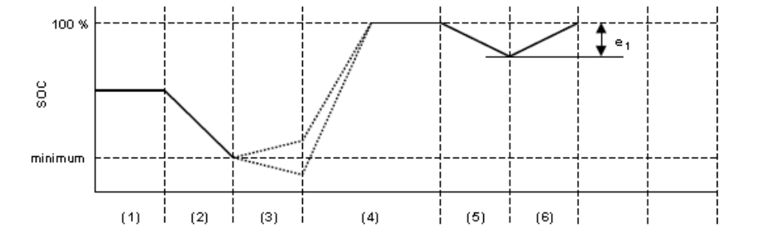  Figure B.4.4.-1: Condition A of the type VII test  (1) initial state of charge of the electrical energy/power storage device;  (2) discharge in accordance with point 3.2.1. or 4.2.2. of Annex B.4.3.;  (3) vehicle conditioning in accordance with point 3.2.2.or 4.2.3. of Annex B.4.3.;  (4) charge during soak in accordance with point 3.2.2.3. and 3.2.2.4. or 4.2.3.2. and 4.2.3.3. of Annex B.4.3.;  (5) test in accordance with point 3.2.3. or 4.2.4. of Annex B.4.3.;  (6) charging in accordance with point 3.2.4. or 4.2.5. of Annex B.4.3.
1.2. | Condition B:  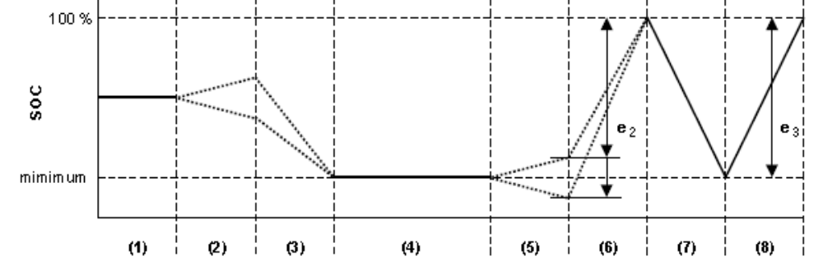  Figure B.4.4.-2: Condition B of the type VII test  (1) initial state of charge;  (2) vehicle conditioning in accordance with point 3.3.1.1. or 4.3.1.1. (optional) of Annex B.4.3.;  (3) discharge in accordance with point 3.3.1.1. or 4.3.1.1. of Annex B.4.3.;  (4) soak in accordance with point 3.3.1.2. or 4.3.1.2. of Annex B.4.3.;  (5) test in accordance with point 3.3.2. or 4.3.2. of Annex B.4.3.;  (6) charging in accordance with point 3.3.3. or 4.3.3. of Annex B.4.3.;  (7) discharging in accordance with point 3.3.4. or 4.3.4. of Annex B.4.3.;  (8) charging in accordance with point 3.3.5. or 4.3.5. of Annex B.4.3.;

B.4.5. | Annex: method for measuring the electricity balance of the battery of OVC and NOVC HEV
1. | Introduction
1.1. | This Annex sets out the method and required instrumentation for measuring the electricity balance of Off-vehicle Charging Hybrid Electric Vehicles (OVC HEV) and Not-Off-vehicle Charging Hybrid Electric Vehicles (NOVC HEV). Measurement of the electricity balance is necessary:  (a) to determine when the battery’s minimum state of charge has been reached during the test procedure in points 3.3. and 4.3. of Annex B.4.3., and  (b) to adjust the fuel consumption and CO₂-emissions measurements in line with the change in battery energy content during the test, using the method in points 5.3.1.1. and 6.3.1.1. of Annex B.4.3.
1.2. | The method described in this Annex shall be used by the manufacturer for taking the measurements to determine the correction factors K_{fuel} and K_{CO2}, as defined in points 5.3.3.2., 5.3.5.2., 6.3.3.2., and 6.3.5.2. of Annex B.4.3.  The technical service shall check whether these measurements have been taken in accordance with the procedure described in this Annex.
1.3. | The method described in this Annex shall be used by the technical service for measuring the electricity balance Q, as defined in the relevant points of annex B.4.5.
2. | Measurement equipment and instrumentation
2.1. | During the tests described in points 3 to 6 of Annex B.4.3., the battery current shall be measured using a current transducer of the clamp-on or the closed type. The current transducer (i.e. the current sensor without data acquisition equipment) shall have a minimum accuracy of 0.5 percent of the measured value or 0.1 percent of the maximum value of the scale.  Original equipment manufacturer diagnostic testers are not to be used for the purpose of this test.
2.1.1. | The current transducer shall be fitted on one of the wires directly connected to the battery. To make it easier to measure the battery current with external equipment, the manufacturer shall integrate appropriate, safe and accessible connection points in the vehicle. If that is not feasible, the manufacturer is obliged to support the technical service by providing the means to connect a current transducer to the wires connected to the battery as described in point 2.1.
2.1.2. | The output of the current transducer shall be sampled with a minimum sample frequency of 5 Hz. The measured current shall be integrated over time, yielding the measured value of Q, expressed in Ampere hours (Ah).
2.1.3. | The temperature at the location of the sensor shall be measured and sampled with the same sample frequency as the current, so that this value can be used for possible compensation of the drift of current transducers and, if applicable, the voltage transducer used to convert the output of the current transducer.
2.2. | The technical service shall be provided with a list of the instrumentation (manufacturer, model number, serial number) used by the manufacturer for determining the correction factors K_{fuel} and K_{CO2} set out in Annex B.4.3. and the last calibration dates of the instruments, where applicable.
3. | Measurement procedure
3.1. | Measurement of the battery current shall start at the beginning of the test and end immediately after the vehicle has driven the complete driving cycle.
3.2. | Separate values of Q shall be logged over the parts (cold/warm or phase 1 and, if applicable, phases 2 and 3) of the type I test cycle set out in section B.2.

B.4.6. | Annex: method of measuring the electric range of vehicles powered by an electric powertrain only or by a hybrid electric powertrain and the OVC range of vehicles powered by a hybrid electric powertrain
1. | Measurement of the electric range  The following test method set out in point 4 shall be used to measure the electric range, expressed in km, of vehicles powered by an electric power train only or the electric range and OVC range of vehicles powered by a hybrid electric powertrain with off-vehicle charging (OVC HEV) as defined in annex B.4.6.
2. | Parameters, units and accuracy of measurements  Parameters, units and accuracy of measurements shall be as follows:  Table B.4.6.-1: Parameters, units and accuracy of measurements
  Parameter | Unit | Accuracy | Resolution
  Time | s | ± 0.1 s | 0.1 s
  Distance | m | ± 0.1 percent | 1 m
  Temperature | K | ± 1 K | 1 K
  Speed | km/h | ± 1 percent | 0.2 km/h
  Mass | kg | ± 0.5 percent | 1 kg
  Electricity balance | Ah | ± 0.5 percent | 0.3 percent
3. | Test conditions
3.1. | Condition of the vehicle
3.1.1. | The vehicle tyres shall be inflated to the pressure specified by the vehicle manufacturer when the tyres are at the ambient temperature.
3.1.2. | The viscosity of the oils for the mechanical moving parts shall conform to the vehicle manufacturer’s specifications.
3.1.3. | The lighting and signalling and auxiliary devices shall be off, except those required for the testing and usual daytime operation of the vehicle.
3.1.4. | All energy storage systems for other than traction purposes (electric, hydraulic, pneumatic, etc.) shall be charged to their maximum level as specified by the manufacturer.
3.1.5. | If the batteries are operated above the ambient temperature, the operator shall follow the procedure recommended by the vehicle manufacturer in order to keep the battery temperature in the normal operating range. The manufacturer shall be in a position to attest that the thermal management system of the battery is neither disabled nor reduced.
3.1.6. | The vehicle shall have travelled at least 300 km in the seven days before the test with the batteries installed for the test.
3.2. | Climatic conditions  For testing performed outdoors, the ambient temperature shall be between 278.0 K and 305.0 K (5.0 °C and 32.0 °C).  The indoor testing shall be performed at a temperature of between 275.0 K and 303.0 K (2.0 °C and 30.0 °C).
4. | Operation modes  The test method includes the following steps:  (a) initial charge of the battery;  (b) application of the cycle and measurement of the electric range.  If the vehicle shall move between the steps, it shall be pushed to the next test area (without regenerative recharging).
4.1. | Initial charge of the battery  Charging the battery consists of the following procedure:
4.1.1. | The ‘initial charge’ of the battery means the first charge of the battery, on reception of the vehicle. Where several combined tests or measurements are carried out consecutively, the first charge shall be an ‘initial charge’ and the subsequent charges may follow the ‘normal overnight charge’ procedure set out in 3.2.2.4. of Annex B.4.3.
4.1.2. | Discharge of the battery
4.1.2.1. | For pure electric vehicles:
4.1.2.1.1. | The procedure starts with the discharge of the battery of the vehicle while driving (on the test track, on a chassis dynamometer, etc.) at a steady vehicle speed of 70 percent ± 5 percent of the maximum design vehicle speed.
4.1.2.1.2. | Discharging shall stop under any of the following conditions:  (a) when the vehicle is unable to run at 65 percent of the maximum thirty minutes vehicle speed;  (b) when the standard on-board instrumentation indicates that the vehicle should be stopped;  (c) after 100 km.  By means of derogation if the manufacturer can prove to the technical service to the satisfaction of the [approval authority]/[certification authority] that the vehicle is physically not capable of achieving the thirty minutes vehicle speed the maximum fifteen minute vehicle speed may be used instead.
4.1.2.2. | For externally chargeable hybrid electric vehicles (OVC HEV) without an operating mode switch as defined in annex B.4.6:
4.1.2.2.1. | The manufacturer shall provide the means for taking the measurement with the vehicle running in pure electric operating state.
4.1.2.2.2. | The procedure shall start with the discharge of the electrical energy/power storage device of the vehicle while driving (on the test track, on a chassis dynamometer, etc.) in any of the following conditions:  - at a steady vehicle speed of 50 km/h until the fuel-consuming engine of the HEV starts up;  -if a vehicle cannot reach a steady vehicle speed of 50 km/h without the fuel-consuming engine starting up, the vehicle speed shall be reduced until it can run at a lower steady vehicle speed at which the fuel-consuming engine does not start up for a defined time or distance (to be determined by the technical service and the manufacturer to the satisfaction of the [approval authority]/[certification authority]);  - in accordance with the manufacturer’s recommendation.  The fuel-consuming engine shall be stopped within ten seconds of being automatically started.
4.1.2.3. | For externally chargeable hybrid electric vehicles (OVC HEV) with an operating mode switch as defined in Annex B.4.3.:
4.1.2.3.1. | If the mode switch does not have a pure electric position, the manufacturer shall provide the means for taking the measurement with the vehicle running in pure electric operating state.
4.1.2.3.2. | The procedure shall start with the discharge of the electrical energy/power storage device of the vehicle while driving with the switch in pure electric position (on the test track, on a chassis dynamometer, etc.) at a steady vehicle speed of 70 percent ± 5 percent of the maximum design vehicle speed of the vehicle in pure electric mode.
4.1.2.3.3. | Discharging shall stop in any of the following conditions:  - when the vehicle is unable to run at 65 percent of the maximum thirty minutes vehicle speed;  - when the standard on-board instrumentation indicates that the vehicle should be stopped;  - after 100 km.  By means of derogation if the manufacturer can prove to the technical service to the satisfaction of the [approval authority]/[certification authority] that the vehicle is physically not capable of achieving the thirty minutes vehicle speed the maximum fifteen minute vehicle speed may be used instead.
4.1.2.3.4. | If the vehicle is not equipped with a pure electric operating state, the electrical energy/power storage device shall be discharged by driving the vehicle (on the test track, on a chassis dynamometer, etc.):  - at a steady vehicle speed of 50 km/h until the fuel-consuming engine of the HEV starts up; or  - if a vehicle cannot reach a steady vehicle speed of 50 km/h without the fuel-consuming engine starting up, the vehicle speed shall be reduced until it can run at a lower steady vehicle speed at which the fuel-consuming engine does not start up for a defined time or distance (to be determined by the technical service and the manufacturer to the satisfaction of the [approval authority]/[certification authority]); or  - in accordance with the manufacturer’s recommendation.  The fuel-consuming engine shall be stopped within ten seconds of being automatically started.
4.1.3. | Normal overnight charge  For a pure electric vehicle, the battery shall be charged according to the normal overnight charge procedure, as defined in point 2.4.1.2. of Annex B.4.2., for a period not exceeding twelve hours.  For an OVC HEV, the battery shall be charged according to the normal overnight charge procedure as described in point 3.2.2.4. of Annex 5.3.
4.2. | Application of the cycle and measurement of the range
4.2.1. | For pure electric vehicles:
4.2.1.1. | The test sequence set out in the Annexes shall be carried out on a chassis dynamometer adjusted as described in section B.2., until the test criteria are met.
4.2.1.2. | The test criteria shall be deemed as having been met when the vehicle is unable to meet the target curve up to 50 km/h, or when the standard on-board instrumentation indicates that the vehicle should be stopped.  The vehicle shall then be slowed to 5 km/h without braking by releasing the accelerator pedal, and then stopped by braking.
4.2.1.3. | At vehicle speeds of over 50 km/h, when the vehicle does not reach the acceleration or vehicle speed required for the test cycle, the accelerator pedal shall remain fully depressed, or the accelerator handle shall be turned fully, until the reference curve has been reached again.
4.2.1.4. | Up to three interruptions, of no more than 15 minutes in total, are permitted between test sequences.
4.2.1.5. | The distance covered in km (D_{e}) is the electric range of the electric vehicle. It shall be rounded to the nearest whole number.
4.2.2. | For hybrid electric vehicles:
4.2.2.1.1. | The applicable type I test cycle and accompanying gearshift arrangements, as set out in point 3.4.5. of section B.2. shall be carried out on a chassis dynamometer adjusted as described in section B.2., until the test criteria are met.
4.2.2.1.2. | To measure the electric range, the test criteria shall be deemed as having been met when the vehicle is unable to meet the target curve up to 50 km/h, or when the standard on-board instrumentation indicates that the vehicle should be stopped, or when the battery has reached its minimum state of charge. The vehicle shall then be slowed to 5 km/h without braking by releasing the accelerator pedal, and then stopped by braking.
4.2.2.1.3. | At vehicle speeds of over 50 km/h, when the vehicle does not reach the acceleration or vehicle speed required for the test cycle, the accelerator pedal shall remain fully depressed until the reference curve has been reached again.
4.2.2.1.4. | Up to three interruptions, of no more than 15 minutes in total, are permitted between test sequences.
4.2.2.1.5. | The distance covered in km using the electrical motor only (D_{e}) is the electric range of the hybrid electric vehicle. It shall be rounded to the nearest whole number. Where the vehicle operates both in electric and in hybrid mode during the test, the periods of electric-only operation will be determined by measuring current to the injectors or ignition.
4.2.2.2. | Determining the OVC range of a hybrid electric vehicle
4.2.2.2.1. | The applicable type I test cycle and accompanying gearshift arrangements, as set out in point 3.4.5. of section B.2., shall be carried out on a chassis dynamometer adjusted as described in section B.2., until the test criteria are met.
4.2.2.2.2. | To measure the OVC range D_{OVC}, the test criteria shall be deemed as having been met when the battery has reached its minimum state of charge according to the criteria in points 3.2.3.2.2.2. or 4.2.4.2.2.2. of Annex B.4.3. Driving shall be continued until the final idling period in the type I test cycle has been completed.
4.2.2.2.3. | Up to three interruptions, of no more than fifteen minutes in total, are permitted between test sequences.
4.2.2.2.4. | The total distance driven in km, rounded to the nearest whole number, shall be the OVC range of the hybrid electric vehicle.
4.2.2.3. | At vehicle speeds of over 50 km/h, when the vehicle does not reach the acceleration or vehicle speed required for the test cycle, the accelerator pedal shall remain fully depressed, or the accelerator handle shall be turned fully, until the reference curve has been reached again.
4.2.2.4. | Up to three interruptions, of no more than 15 minutes in total, are permitted between test sequences.
4.2.2.5. | The distance covered in km (D_{OVC}) is the electric range of the hybrid electric vehicle. It shall be rounded to the nearest whole number.

B.5. |  | TEXT OF THE REGULATION, COMMON ANNEXES
Annexes to test type I, II and VII
Annex Number | Annex title |  | Page #
B.5.1. | Annex: symbols |  | 154
B.5.2. | Annex: reference fuels |  | 158
B.5.3. | Annex: test vehicle requirements Test types I, II and VII |  | 164
B.5.4. | Annex: classification of equivalent inertia mass and running resistance, applicable for two- and three-wheeled vehicles (table method) |  | 166
B.5.5. | Annex: road tests of two- and three-wheeled vehicles equipped with one wheel on the driven axle for the determination of test bench settings |  | 169
B.5.6. | Annex: road tests of two- and three-wheeled vehicles equipped with two or more wheels on the powered axles for the determination of test bench settings |  | 175
B.5.7. | Annex: chassis dynamometer system |  | 182
B.5.8. | Annex: exhaust dilution system |  | 188
B.5.9. | Annex: [approval] / [certification] tests of a replacement pollution-control device type as separate technical unit |  | 201
B.5.10. | Annex: vehicle propulsion unit family with regard to environmental performance demonstration tests |  | 204
B.5.11. | Annex: information document containing the essential characteristics of the propulsion units and the pollutant control systems |  | 208
B.5.12. | Annex: test result reporting requirements and information concerning the conduct of tests |  | 228
B.5.13. | Annex: template form to record coast down times |  | 237
B.5.14. | Annex: template form to record chassis dynamometer settings |  | 238
B.5.15. | Annex: driving cycles for the type I test |  | 239
B.5.16. | Annex: explanatory note on the gearshift procedure |  | 277

B.5.1. |  | Annex: symbols
 | Symbol |  | Definition | Unit
 | a |  | Coefficient of polygonal function | -
 | a_{T} |  | Rolling resistance force of front wheel | N
 | A |  | NG / biomethane quantity within the H₂NG mixture | percent vol.
 | b |  | Coefficient of polygonal function | -
 | b_{T} |  | Coefficient of aerodynamic function | N/(km/h)2
 | c |  | Coefficient of polygonal function | -
 | C_{CO} |  | Concentration of carbon monoxide | ppm
 | C_{CO2} |  | Concentration of CO2 in the diluted exhaust gas contained in the sampling bag | percent vol.
 | C_{COcorr} |  | Corrected concentration of carbon monoxide | percent vol.
 | CO_{2c} |  | Carbon dioxide concentration of diluted gas, corrected to take account of diluent air | percent
 | CO_{2d} |  | Carbon dioxide concentration in the sample of diluent air collected in bag B | percent
 | CO_{2e} |  | Carbon dioxide concentration in the sample of diluent air collected in bag A | percent
 | CO_{2m} |  | Mass of carbon dioxide emitted during the test part | mg/km
 | CO_{c} |  | Carbon monoxide concentration of diluted gas, corrected to take account of diluent air | ppm
 | CO_{d} |  | Carbon monoxide concentration in the sample of diluent air, collected in bag B | ppm
 | CO_{e} |  | Carbon monoxide concentration in the sample of diluent air, collected in bag A | ppm
 | CO_{m} |  | Mass of carbon monoxide emitted during the test part | mg/km
 | C_{H2} |  | Concentration of hydrogen in the diluted exhaust gas contained in sampling bag | ppm
 | C_{H2O} |  | Concentration of H2O in the diluted exhaust gas contained in the sampling bag | percent vol.
 | C_{H2O-DA} |  | Concentration of H2O in the air used for dilution | percent vol.
 | C_{HC} |  | Concentration of HC in the diluted exhaust gas contained in the sampling bag | ppm (carbon equivalent)
 | d₀ |  | Standard ambient relative air density | -
 | d_{CO} |  | Density of carbon monoxide | mg/cm3
 | d_{CO2} |  | Density of carbon dioxide | g/dm3
 | d_{HC} |  | Density of hydrocarbon | mg/cm3
 | D_{av} |  | Average distance between two battery recharges | km
 | D_{e} |  | Electric range of the vehicle | km
 | DiF |  | Dilution factor | -
 | D_{OVC} |  | Distance from externally chargeable vehicle | km
 | S / d |  | Distance driven in a cycle part | km
 | d_{NOx} |  | Density of nitrogen oxide | mg/m3
 | d_{T} |  | Relative air density under test condition | -
 | Δt |  | Coast-down time | s
 | Δta_{i} |  | Coast-down time measured in the first road test | s
 | Δtb_{i} |  | Coast-down time measured in the second road test | s
 | ΔT_{E} |  | Coast-down time corrected for the inertia mass | s
 | Δt_{E} |  | Mean coast-down time on the chassis dynamometer at the reference vehicle speed | s
 | ΔT_{i} |  | Average coast-down time at specified vehicle speed | s
 | Δt_{i} |  | Coast-down time at corresponding s vehicle peed | s
 | ΔT_{j} |  | Average coast-down time at specified vehicle speed | s
 | ΔT_{road} |  | Target coast-down time | s
 | t |  | Mean coast-down time on the chassis dynamometer without absorption | s
 | Δv |  | Coast-down vehicle speed interval (2Δv = v1 – v2) | km/h
 | ε |  | Chassis dynamometer setting error | percent
 | F |  | Running resistance force | N
 | F* |  | Target running resistance force | N
 | F*_{(v0)} |  | Target running resistance force at reference vehicle speed on chassis dynamometer | N
 | F*_{(vi)} |  | Target running resistance force at specified vehicle speed on chassis dynamometer | N
 | f*₀ |  | Corrected rolling resistance in the standard ambient condition | N
 | f*₂ |  | Corrected coefficient of aerodynamic drag in the standard ambient condition | N/(km/h)²
 | F*_{j} |  | Target running resistance force at specified vehicle speed | N
 | f₀ |  | Rolling resistance | N
 | f₂ |  | Coefficient of aerodynamic drag | N/(km/h)2
 | F_{E} |  | Set running resistance force on the chassis dynamometer | N
 | F_{E(v0)} |  | Set running resistance force at the reference s vehicle peed on the chassis dynamometer | N
 | F_{E(v2)} |  | Set running resistance force at the specified vehicle speed on the chassis dynamometer | N
 | F_{f} |  | Total friction loss | N
 | F_{f(v0)} |  | Total friction loss at the reference vehicle speed | N
 | F_{j} |  | Running resistance force | N
 | F_{j(v0)} |  | Running resistance force at the reference vehicle speed | N
 | F_{pau} |  | Braking force of the power absorbing unit | N
 | F_{pau(v0)} |  | Braking force of the power absorbing unit at the reference vehicle speed | N
 | F_{pau(vj)} |  | Braking force of the power absorbing unit at the specified vehicle speed | N
 | F_{T} |  | Running resistance force obtained from the running resistance table | N
 | H |  | Absolute humidity | g of water / kg of dry air
 | HC_{c} |  | Concentration of diluted gases expressed in the carbon equivalent, corrected to take account of diluent air | ppm
 | HC_{d} |  | Concentration of hydrocarbons expressed in the carbon equivalent, in the sample of diluent air collected in bag B | ppm
 | HC_{e} |  | Concentration of hydrocarbons expressed in the carbon equivalent, in the sample of diluent air collected in bag A | ppm
 | HC_{m} |  | Mass of hydrocarbon emitted during the test part | mg/km
 | i |  | gear number | -
 | K₀ |  | Temperature correction factor for rolling resistance | -
 | K_{h} |  | Humidity correction factor | -
 | L |  | Approval limit values of gaseous pollutant emission | mg/km
 | m |  | Test vehicle mass | kg
 | ma |  | Actual mass of the test vehicle | kg
 | m_{corr} |  | PM mass corrected for buoyancy | mg
 | m_{f} i |  | Flywheel equivalent inertia mass | kg
 | mi |  | Equivalent inertia mass | kg
 | m_{mix} |  | molar mass of air in balance environment (28.836 gmol⁻¹) | gmol⁻¹
 | mr |  | Equivalent inertia mass of all the wheels | kg
 | mri |  | Equivalent inertia mass of all the rear wheel and vehicle parts rotating with wheel | kg
 | m_{k} or m_{ref} |  | Reference mass of the vehicle | kg
 | mrf |  | Rotating mass of the front wheel | kg
 | mrid |  | Rider mass | kg
 | m_{uncorr} |  | PM mass uncorrected for buoyancy | mg
 | M_{i} |  | Mass emission of the pollutant i in mg/km | mg
 | M_{2i} |  | Average mass emission of the pollutant i with an electrical energy/power storage device in minimum state of charge (maximum discharge of capacity) | mg/km
 | M_{1i} |  | Average mass emission of the pollutant i with a fully charged electrical energy/power storage device | mg/km
 | Mp |  | Particulate mass emission | mg/km
 | n |  | Engine speed | min-1
 | n |  | Number of data regarding the emission or the test | -
 | N |  | Number of revolution made by pump P | -
 | nd_{vi} |  | Ratio between engine speed in min⁻¹ and vehicle speed in km/h in gear ‘i’ | -
 | ng |  | Number of forward gears | -
 | n_{idle} |  | Idling engine speed | min-1
 | n_max_acc₍₁₎ |  | Upshift engine speed from gear 1 to gear 2 during acceleration phases | min-1
 | n_max_acc_{(i)} |  | Up shift engine speed from gear i to gear i+1 during acceleration phases, i>1 | min-1
 | n_min_acc_{(i)} |  | Minimum engine speed for cruising or deceleration in gear 1 | min-1
 | NO_{xc} |  | Nitrogen oxide concentration of diluted gases, corrected to take account of diluent air | ppm
 | NO_{xd} |  | Nitrogen oxide concentration in the sample of diluent air collected in bag B | ppm
 | NO_{xe} |  | Nitrogen oxide concentration in the sample of diluent air collected in bag A | ppm
 | NO_{xm} |  | Mass of nitrogen oxides emitted during the test part | mg/km
 | p₀ |  | Standard ambient pressure | kPa
 | p_{a} |  | Ambient/atmospheric pressure | kPa
 | p_{abs} |  | absolute pressure in balance environment
 | p_{d} |  | Saturated pressure of water at the test temperature | kPa
 | p_{i} |  | Average under-pressure during the test part in the section of pump P | kPa
 | p_{T} |  | Mean ambient pressure during the test | kPa
 | Pn |  | Rated power | kW
 | Q |  | Electric energy balance | Ah
 | ρ₀ |  | Standard relative ambient air volumetric mass | mg/cm³
 | ρ_{air} |  | density of air in balance environment | mg/cm³
 | ρ_{weight} |  | density of calibration weight used to span balance | mg/cm³
 | ρ_{media} |  | density of PM sample medium (filter) with filter medium Teflon coated glass fibre (e.g. TX40): ρ_{media} = 2.300 kg/m3 | mg/cm³
 | r |  | Ratios of emission results for each pollutant from LPG and NG/biomethane vehicles | -
 | r(i) |  | Gear ratio in gear i | -
 | R |  | molar gas constant (8.314 Jmol⁻¹K⁻¹) | Jmol⁻¹K⁻¹
 | R_{f} |  | Response factor to calibrate HC analyser | -
 | R_{F} |  | Final test result of pollutant emissions, carbon dioxide emission or fuel consumption | mg/km,  g/km, 1/100km
 | R₁ |  | Test results of pollutant emissions, carbon dioxide emission or fuel consumption for cycle part 1 with cold start | mg/km,  g/km, 1/100km
 | R₂ |  | Test results of pollutant emissions, carbon dioxide emission or fuel consumption for cycle part 2 with warm condition | mg/km,  g/km, 1/100km
 | R₃ |  | Test results of pollutant emissions, carbon dioxide emission or fuel consumption for cycle part 1 with warm condition | mg/km,  g/km, 1/100km
 | Ri₁ |  | First type I test results of pollutant emissions | mg/km
 | Ri₂ |  | Second type I test results of pollutant emissions | mg/km
 | Ri₃ |  | Third type I test results of pollutant emissions | mg/km
 | s |  | Rated engine speed | min-1
 | S |  | Accumulated distance in test cycle ( point 5.1.1.3 of Annex B.2) | km
 | T_{amb} |  | absolute ambient temperature of balance environment | K
 | T_{C} |  | Temperature of the coolant | K
 | T_{O} |  | Temperature of the engine oil | K
 | T_{P} |  | Temperature of the spark-plug seat/gasket | K
 | T₀ |  | Standard ambient temperature | K
 | T_{p} |  | Temperature of the diluted gases during the test part, measured in the intake section of pump P | K
 | T_{T} |  | Mean ambient temperature during the test | K
 | U |  | Relative humidity | percent
 | v |  | Specified vehicle speed | km/h
 | V |  | Total volume of diluted gas | m3
 | v_{max} |  | Maximum design vehicle speed of test vehicle | km/h
 | v₀ |  | Reference vehicle speed | km/h
 | V₀ |  | Volume of gas displaced by pump P during one revolution | m³/rev.
 | v₁ |  | Vehicle speed at which the measurement of the coast-down time begins | km/h
 | v₂ |  | Vehicle speed at which the measurement of the coast-down time ends | km/h
 | vi |  | Specified vehicle speed selected for the coast-down time measurement | km/h
 | w₁ |  | Weighting factor of cycle part 1 with cold start | -
 | w_{1warm} |  | Weighting factor of cycle part 1 with warm condition | -
 | w₂ |  | Weighting factor of cycle part 2 with warm condition | -
 | w₃ |  | Weighting factor of cycle part 3 with warm condition | -
 | Table B.5.1-1: symbols used

B.5.2. | Annex: reference fuels
1. | Specifications of reference fuels for testing vehicles in environmental tests, in particular for tailpipe and evaporative emissions testing
1.1. | The following tables list the technical data on liquid reference fuels that Contracting Parties may require to be used for environmental performance testing of two- and three-wheeled vehicles. These reference fuels were used to define the principle emission limits set out in point 9. of section B.1.
Type: Petrol (E5)
Parameter |  | Unit | Limits¹ |  | Test method
 |  | Unit | Minimum | Maximum | Test method
Research octane number, RON |  |  | 95.0 | - | EN 25164 / prEN ISO 5164
Motor octane number, MON |  |  | 85.0 | - | EN 25163 / prEN ISO 5163
Density at 15 °C |  | kg/m³ | 743 | 756 | EN ISO 3675 / EN ISO 12185
Vapour pressure |  | kPa | 56.0 | 60.0 | EN ISO 13016-1 (DVPE)
Water content |  | % v/v |  | 0.015 | ASTM E 1064
Distillation:
– Evaporated at 70 °C |  | % v/v | 24.0 | 44.0 | EN ISO 3405
– Evaporated at 100 °C |  | % v/v | 48.0 | 60.0 | EN ISO 3405
– Evaporated at 150 °C |  | % v/v | 82.0 | 90.0 | EN ISO 3405
– Final boiling point |  | °C | 190 | 210 | EN ISO 3405
Residue |  | % v/v | — | 2.0 | EN ISO 3405
Hydrocarbon analysis:
– Olefins |  | % v/v | 3.0 | 13.0 | ASTM D 1319
– Aromatics |  | % v/v | 29.0 | 35.0 | ASTM D 1319
– Benzene |  | % v/v | - | 1.0 | EN 12177
– Saturates |  | % v/v | Report |  | ASTM 1319
Carbon/hydrogen ratio |  |  | Report
Carbon/oxygen ratio |  |  | Report
Induction period² |  | minutes | 480 | - | EN ISO 7536
Oxygen content⁴ |  | % m/m | Report |  | EN 1601
Existent gum |  | mg/ml | - | 0.04 | EN ISO 6246
Sulphur content³ |  | mg/kg | - | 10 | EN ISO 20846 / EN ISO 20884
Copper corrosion |  |  | - | Class 1 | EN ISO 2160
Lead content |  | mg/l | - | 5 | EN 237
Phosphorus content |  | mg/l | - | 1.3 | ASTM D 3231
Ethanol⁵ |  | % v/v | 4.7 | 5.3 | EN 1601 / EN 13132
¹ The values quoted in the specifications are ‘true values’. For establishing the limit values, the terms of ISO 4259:2006 (Petroleum products — Determination and application of precision data in relation to methods of test) have been applied and for fixing a minimum value, a minimum difference of 2R above zero has been taken into account; for fixing a maximum and minimum value, the minimum difference is 4R (R = reproducibility).
Notwithstanding this measure, which is necessary for technical reasons, the fuel manufacturer shall nevertheless aim at a zero value where the stipulated maximum value is 2R and at the mean value when quoting maximum and minimum limits. Should it be necessary to clarify whether a fuel meets the requirements of the specifications, the terms of ISO 4259:2006 shall be applied.
² The fuel may contain oxidation inhibitors and metal deactivators normally used to stabilise refinery petrol streams, but detergent/dispersive additives and solvent oils shall not be added.
³ The actual sulphur content of the fuel used for the type I test shall be reported.
⁴ Ethanol meeting the specification of prEN 15376 is the only oxygenate that shall be intentionally added to the reference fuel.
⁵ There shall be no intentional addition to this reference fuel of compounds containing phosphorus, iron, manganese or lead.

Type: Ethanol (E85)
Parameter | Unit | Limits¹ |  | Test method²
Parameter | Unit | Minimum | Maximum | Test method²
Research octane number, RON |  | 95.0 | - | EN ISO 5164
Motor octane number, MON |  | 85.0 | - | EN ISO 5163
Density at 15°C | kg/m³ | Report |  | ISO 3675
Vapour pressure | kPa | 40.0 | 60.0 | EN ISO 13016-1 (DVPE)
Sulphur content^{3.4} | mg/kg | - | 10 | EN ISO 20846  EN ISO 20884
Oxidation stability | minutes | 360 |  | EN ISO 7536
Existent gum content (solvent washed) | mg/(100 ml) | - | 5 | EN ISO 6246
Appearance  This shall be determined at ambient temperature or 15 °C, whichever is higher. |  | Clear and bright, visibly free of suspended or precipitated contaminants |  | Visual inspection
Ethanol and higher alcohols⁷ | % V/V | 83 | 85 | EN 1601  EN 13132  EN 14517
Higher alcohols (C3-C8) | % V/V | - | 2.0
Methanol | % V/V |  | 0.5
Petrol⁵ | % V/V | Balance |  | EN 228
Phosphorus | mg/l | 0.3⁶ |  | ASTM D 3231
Water content | % V/V |  | 0.3 | ASTM E 1064
Inorganic chloride content | mg/l |  | 1 | ISO 6227
pHe |  | 6.5 | 9.0 | ASTM D 6423
Copper strip corrosion  (3h at 50 °C) | Rating | Class 1 |  | EN ISO 2160
Acidity (as acetic acid CH₃COOH) | % m/m  (mg/l) | - | 0.005  (40) | ASTM D 1613
Carbon/hydrogen ratio |  | report
Carbon/oxygen ration |  | report
¹ The values quoted in the specifications are ‘true values’. For establishing the limit values, the terms of ISO 4259:2006 (Petroleum products — Determination and application of precision data in relation to methods of test) have been applied and for fixing a minimum value, a minimum difference of 2R above zero has been taken into account; for fixing a maximum and minimum value, the minimum difference is 4R (R = reproducibility).
Notwithstanding this measure, which is necessary for technical reasons, the fuel manufacturer shall nevertheless aim at a zero value where the stipulated maximum value is 2R and at the mean value when quoting maximum and minimum limits. Should it be necessary to clarify whether a fuel meets the requirements of the specifications, the terms of ISO 4259:2006 shall be applied.
² In cases of dispute, the procedures for resolving the dispute and interpreting the results based on test method precision, as described in EN ISO 4259:2006, shall be used.
³ In cases of national dispute concerning sulphur content, either EN ISO 20846:2011 or EN ISO 20884:2011 shall be referred to in the same way as in the national annex of EN 228.
⁴ The actual sulphur content of the fuel used for the type I test shall be reported.
⁵ The unleaded petrol content can be determined as 100 minus the sum of the percentage content of water and alcohols.
⁶ There shall be no intentional addition to this reference fuel of compounds containing phosphorus, iron, manganese or lead.
⁷ Ethanol meeting the specification of EN 15376 is the only oxygenate that shall be intentionally added to this reference fuel.

Type: Diesel fuel (B5)
Parameter | Unit | Limits¹ |  | Test method
Parameter | Unit | Minimum | Maximum | Test method
Cetane number² |  | 52.0 | 54.0 | EN ISO 5165
Density at 15 °C | kg/m³ | 833 | 837 | EN ISO 3675
Distillation:
- 50 % point | °C | 245 | - | EN ISO 3405
- 95 % point | °C | 345 | 350 | EN ISO 3405
- Final boiling point | °C | - | 370 | EN ISO 3405
Flash point | °C | 55 | - | EN 22719
CFPP | °C | - | - 5 | EN 116
Viscosity at 40 °C | mm²/s | 2.3 | 3.3 | EN ISO 3104
Polycyclic aromatic hydrocarbons | % m/m | 2.0 | 6.0 | EN 12916
Sulphur content³ | mg/kg | - | 10 | EN ISO 20846 / EN ISO 20884
Copper corrosion |  | - | Class 1 | EN ISO 2160
Conradson carbon residue (10 % DR) | % m/m | - | 0.2 | EN ISO 10370
Ash content | % m/m | - | 0.01 | EN ISO 6245
Water content | % m/m | - | 0.02 | EN ISO 12937
Neutralisation (strong acid) number | mg KOH/g | - | 0.02 | ASTM D 974
Oxidation stability⁴ | mg/ml | - | 0.025 | EN ISO 12205
Lubricity (HFRR wear scan diameter at 60 °C) | μm | - | 400 | EN ISO 12156
Oxidation stability at 110 °C^{4.6} | h | 20.0 |  | EN 14112
FAME⁵ | % v/v | 4.5 | 5.5 | EN 14078
¹ The values quoted in the specifications are ‘true values’. For establishing the limit values, the terms of ISO 4259:2006 (Petroleum products — Determination and application of precision data in relation to methods of test) have been applied and for fixing a minimum value, a minimum difference of 2R above zero has been taken into account; for fixing a maximum and minimum value, the minimum difference is 4R (R = reproducibility).
Notwithstanding this measure, which is necessary for technical reasons, the fuel manufacturer shall nevertheless aim at a zero value where the stipulated maximum value is 2R and at the mean value when quoting maximum and minimum limits. Should it be necessary to clarify whether a fuel meets the requirements of the specifications, the terms of ISO 4259:2006 shall be applied.
² The range for Cetane number is not in accordance with the requirements of a minimum range of 4R. However, the terms of ISO 4259:2006 may be used to resolve disputes between fuel supplier and fuel user, provided replicate measurements, of sufficient number to archive the necessary precision, are taken in preference to single determinations.
³ The actual sulphur content of the fuel used for the type I test shall be reported.
⁴ Even though oxidation stability is controlled, it is likely that shelf life will be limited. Advice shall be sought from the supplier as to storage conditions and shelf life.
⁵ FAME content to meet the specification of EN 14214.
⁶ Oxidation stability can be demonstrated by EN ISO 12205:1995 or EN 14112:1996. This requirement shall be reviewed based on CEN/TC19 evaluations of oxidative stability performance and test limits.

Type: Liquefied petroleum gas (LPG)
Parameter | Unit | Fuel A | Fuel B | Test method
Composition: |  |  |  | ISO 7941
C₃-content | percent vol | 30 ± 2 | 85 ± 2
C₄-content | percent vol | Balance¹ | Balance¹
< C₃ , >C₄ | percent vol | max. 2 | max. 2
Olefins | percent vol | max. 12 | max. 15
Evaporation residue | mg/kg | max. 50 | max. 50 | ISO 13757 or EN 15470
Water at 0°C |  | free | free | EN 15469
Total sulphur content | mg/kg | max. 50 | max. 50 | EN 24260 or  ASTM 6667
Hydrogen sulphide |  | none | none | ISO 8819
Copper strip corrosion | rating | Class 1 | class 1 | ISO 6251²
Odour |  | characteristic | characteristic
Motor octane number |  | min. 89 | min. 89 | EN 589 Annex B
¹ Balance has to be read as follows: balance = 100 – C3 ≤ C3 ≥ C4.
² This method may not accurately determine the presence of corrosive materials if the sample contains corrosion inhibitors or other chemicals which diminish the corrosivity of the sample to the copper strip. Therefore, the addition of such compounds for the sole purpose of biasing the test method is prohibited.

Type: Natural gas (NG)/biomethane¹
Parameter | Unit | Basis | Limits³ |  | Test method
Parameter | Unit | Basis | Minimum | Maximum | Test method
Reference fuel G₂₀
Methane | percent mole | 100 | 99 | 100 | ISO 6974
Balance² | percent mole | - | - | 1 | ISO 6974
N₂ | percent mole |  |  |  | ISO 6974
Sulphur content² | mg/m³ | - | - | 10 | ISO 6326-5
Wobbe Index⁴ (net) | MJ/m³ | 48.2 | 47.2 | 49.2
Reference fuel G₂₅
Methane | percent mole | 86 | 84 | 88 | ISO 6974
Balance² | percent mole | - | - | 1 | ISO 6974
N₂ | percent mole | 14 | 12 | 16 | ISO 6974
Sulphur content³ | mg/m³ | - | - | 10 | ISO 6326-5
Wobbe Index (net)⁴ | MJ/m³ | 39.4 | 38.2 | 40.6
¹ Biofuel’ means liquid or gaseous fuel for transport, produced from biomass.
² Inerts (different from N₂) + C₂ +C₂₊.
³ Value to be determined at 293.0 K (20.0 °C) and 101.3 kPa.
⁴ Value to be determined at 273.0 K (0.0 °C) and 101.3 kPa.

Type: Hydrogen for internal combustion engines
Parameter | Unit | Limits |  | Test method
Parameter | Unit | Minimum | Maximum | Test method
Hydrogen purity | % mole | 98 | 100 | ISO 14687
Total hydrocarbon | µmol/mol | 0 | 100 | ISO 14687
Water¹ | µmol/mol | 0 | ⁽²⁾ | ISO 14687
Oxygen | µmol/mol | 0 | ⁽²⁾ | ISO 14687
Argon | µmol/mol | 0 | ⁽²⁾ | ISO 14687
Nitrogen | µmol/mol | 0 | ⁽²⁾ | ISO 14687
CO | µmol/mol | 0 | 1 | ISO 14687
Sulphur | µmol/mol | 0 | 2 | ISO 14687
Permanent particulates³ |  |  |  | ISO 14687
1 Not to be condensed.
2 Combined water, oxygen, nitrogen and argon: 1.900 µmol/mol.
3 The hydrogen shall not contain dust, sand, dirt, gums, oils or other substances in an amount sufficient to damage the fuelling station equipment of the vehicle (engine) being fuelled.

Type: Hydrogen for hydrogen fuel cell vehicles
Parameter | Unit | Limits |  | Test method
Parameter | Unit | Minimum | Maximum | Test method
Hydrogen fuel¹ | % mole | 99.99 | 100 | ISO 14687-2
Total gases³ | µmol/mol | 0 | 100
Total hydrocarbon | µmol/mol | 0 | 2 | ISO 14687-2
Water | µmol/mol | 0 | 5 | ISO 14687-2
Oxygen | µmol/mol | 0 | 5 | ISO 14687-2
Helium (He), Nitrogen (N₂), Argon (Ar) | µmol/mol | 0 | 100 | ISO 14687-2
CO₂ | µmol/mol | 0 | 2 | ISO 14687-2
CO | µmol/mol | 0 | 0.2 | ISO 14687-2
Total sulphur compounds | µmol/mol | 0 | 0.004 | ISO 14687-2
Formaldehyde (HCHO) | µmol/mol | 0 | 0.01 | ISO 14687-2
Formic acid (HCOOH) | µmol/mol | 0 | 0.2 | ISO 14687-2
Ammonia (NH₃) | µmol/mol | 0 | 0.1 | ISO 14687-2
Total halogenated compounds | µmol/mol | 0 | 0.05 | ISO 14687-2
Particulates size | µm | 0 | 10 | ISO 14687-2
Particulates concentration | µg/l | 0 | 1 | ISO 14687-2
1 The hydrogen fuel index is determined by subtracting the total content of non-hydrogen gaseous constituents listed in the table (total gases), expressed in mole percent, from 100 mole percent. It is less than the sum of the maximum allowable limits of all non-hydrogen constituents shown in the table.
2 The value of total gases is the sum of the values of the non-hydrogen constituents listed in the table, except the particulates.

B.5.3. | Annex: test vehicle requirements Test types I, II and VII
1. | General
1.1. | All components of the test vehicle shall conform to those of the production series or, if the test vehicle is different from the production series, a full description shall be given in the test report. In selecting the test vehicle, the vehicle manufacturer and the technical service shall agree to the satisfaction of the [approval authority] / [certification authority] which tested parent vehicle is representative of the related vehicle propulsion unit family as laid down in Annex B.5.10.
1.2. | Unless specified differently elsewhere within the GTR, the vehicle shall be used, adjusted, specified, maintained, fuelled and lubricated as it would be in the production series and as recommended to the user. Parts and consumables shall be used which are or will be commercially available and are permitted for use on the intended roads and for the atmospheric and road conditions experienced while under test.
1.3. | The lighting and signalling and auxiliary devices, except those required for the testing and usual daytime operation of the vehicle, shall be switched off.
1.4. | If the batteries are operated above the ambient temperature, the operator shall follow the procedure recommended by the vehicle manufacturer in order to keep the battery temperature in the normal operating range. The vehicle manufacturer shall be in a position to attest that the thermal management system of the battery is neither disabled nor reduced.
2. | Run-in  The vehicle shall be presented in good mechanical condition, properly maintained and used. It shall have been run in and driven at least 1,000 km before the test. The engine, pollutant emission abatement equipment, drive train, and vehicle shall be properly run in, in accordance with the vehicle manufacturer’s requirements.
3. | Adjustments  The test vehicle shall be adjusted in accordance with the vehicle manufacturer’s requirements, e.g. as regards the viscosity of the oils, or, if it differs from the production series, a full description shall be given in the test report. In case of a four by four drive, the axle to which the lowest torque is delivered may be deactivated in order to allow testing on a standard chassis dynamometer.
4. | Test mass and load distribution  The test mass, including the masses of the rider and the instruments, shall be measured before the beginning of the tests. The load shall be distributed across the wheels in conformity with the vehicle manufacturer’s instructions.
5. | Tyres  The tyres shall be of a type specified as original equipment by the vehicle manufacturer. The tyre pressures shall be adjusted to the specifications of the vehicle manufacturer or to those where the speed of the vehicle during the road test and the vehicle speed obtained on the chassis dynamometer are equalised. The tyre pressure shall be indicated in the test report.

B.5.4. |  |  | Annex: classification of equivalent inertia mass and running resistance, applicable for two- and three-wheeled vehicles (table method)
1. |  | The chassis dynamometer can be set using the running resistance table instead of the running resistance force obtained by the coast-down methods set out in sections B.5.5. or B.5.6. In this table method, the chassis dynamometer shall be set by the reference mass regardless of particular light motor vehicle characteristics.
2. |  | The flywheel equivalent inertia mass m_{ref} shall be the equivalent inertia mass m_{i} specified in point 3.4.6.1.2 of section B.2. The chassis dynamometer shall be set by the rolling resistance of front wheel ‘a’ and the aerodynamic drag coefficient ‘b’ specified in the following table.
 | Reference mass mref  (kg) |  |  | Equivalent inertia mass mi  (kg) | Rolling resistance of front wheel a  (N) | Aero drag coefficient b  (N/(km/h)²)
 | 0 < mref ≤ 25 |  |  | 20 | 1.8 | 0.0203
 | 25 < mref ≤ 35 |  |  | 30 | 2.6 | 0.0205
 | 35 < mref ≤ 45 |  |  | 40 | 3.5 | 0.0206
 | 45 < mref ≤ 55 |  |  | 50 | 4.4 | 0.0208
 | 55 < mref ≤ 65 |  |  | 60 | 5.3 | 0.0209
 | 65 < mref ≤ 75 |  |  | 70 | 6.8 | 0.0211
 | 75 < mref ≤ 85 |  |  | 80 | 7.0 | 0.0212
 | 85 < mref ≤ 95 |  |  | 90 | 7.9 | 0.0214
 | 95 < mref ≤ 105 |  |  | 100 | 8.8 | 0.0215
 | 105 < mref ≤ 115 |  |  | 110 | 9.7 | 0.0217
 | 115 < mref ≤ 125 |  |  | 120 | 10.6 | 0.0218
 | 125 < mref ≤ 135 |  |  | 130 | 11.4 | 0.0220
 | 135 < mref ≤ 145 |  |  | 140 | 12.3 | 0.0221
 | 145 < mref ≤ 155 |  |  | 150 | 13.2 | 0.0223
 | 155 < mref ≤ 165 |  |  | 160 | 14.1 | 0.0224
 | 165 < mref ≤ 175 |  |  | 170 | 15.0 | 0.0226
 | 175 < mref ≤ 185 |  |  | 180 | 15.8 | 0.0227
 | 185 < mref ≤ 195 |  |  | 190 | 16.7 | 0.0229
 | 195 < mref ≤ 205 |  |  | 200 | 17.6 | 0.0230
 | 205 < mref ≤ 215 |  |  | 210 | 18.5 | 0.0232
 | 215 < mref ≤ 225 |  |  | 220 | 19.4 | 0.0233
 | 225 < mref ≤ 235 |  |  | 230 | 20.2 | 0.0235
 | 235 < mref ≤ 245 |  |  | 240 | 21.1 | 0.0236
 | 245 < mref ≤ 255 |  |  | 250 | 22.0 | 0.0238
 | 255 < mref ≤ 265 |  |  | 260 | 22.9 | 0.0239
 | 265 < mref ≤ 275 |  |  | 270 | 23.8 | 0.0241
 | 275 < mref ≤ 285 |  |  | 280 | 24.6 | 0.0242
 | 285 < mref ≤ 295 |  |  | 290 | 25.5 | 0.0244
 | 295 < mref ≤ 305 |  |  | 300 | 26.4 | 0.0245
 | 305 < mref ≤ 315 |  |  | 310 | 27.3 | 0.0247
 | 315 < mref ≤ 325 |  |  | 320 | 28.2 | 0.0248
 | 325 < mref ≤ 335 |  |  | 330 | 29.0 | 0.0250
 | 335 < mref ≤ 345 |  |  | 340 | 29.9 | 0.0251
 | 345 < mref ≤ 355 |  |  | 350 | 30.8 | 0.0253
 | 355 < mref ≤ 365 |  |  | 360 | 31.7 | 0.0254
 | 365 < mref ≤ 375 |  |  | 370 | 32.6 | 0.0256
 | 375 < mref ≤ 385 |  |  | 380 | 33.4 | 0.0257
 | 385 < mref ≤ 395 |  |  | 390 | 34.3 | 0.0259
 | 395 < mref ≤ 405 |  |  | 400 | 35.2 | 0.0260
 | 405 < mref ≤ 415 |  |  | 410 | 36.1 | 0.0262
 | 415 < mref ≤ 425 |  |  | 420 | 37.0 | 0.0263
 | 425 < mref ≤ 435 |  |  | 430 | 37.8 | 0.0265
 | 435 < mref ≤ 445 |  |  | 440 | 38.7 | 0.0266
 | 445 < mref ≤ 455 |  |  | 450 | 39.6 | 0.0268
 | 455 < mref ≤ 465 |  |  | 460 | 40.5 | 0.0269
 | 465 < mref ≤ 475 |  |  | 470 | 41.4 | 0.0271
 | 475 < mref ≤ 485 |  |  | 480 | 42.2 | 0.0272
 | 485 < mref ≤ 495 |  |  | 490 | 43.1 | 0.0274
 | 495 < mref ≤ 505 |  |  | 500 | 44.0 | 0.0275
 | At every 10 kg |  |  | At every 10 kg | a = 0.088 × mi*/ | b = 0.000015 × mi+ 0.02 **/
*/The value shall be rounded to one decimal place.
**/The value shall be rounded to four decimal places.
 | Table B.5.4.-1: Classification of equivalent inertia mass and running resistance used for two- and three wheeled vehicles.

B.5.5. |  | Annex: road tests of two- and three-wheeled vehicles equipped with one wheel on the driven axle for the determination of test bench settings
1. | Requirements for the rider
1.1. | The rider shall wear a well-fitting (one-piece) suit or similar clothing and a protective helmet, eye protection, boots and gloves.
1.2. | The rider, dressed and equipped as described in point 1.1., shall have a mass of 75 kg ± 5 kg and be 1.75 m ± 0.05 m tall.
1.3. | The rider shall be seated on the seat provided, with his feet on the footrests and his arms extended normally. This position shall allow the rider to have proper control of the vehicle at all times during the tests.
2. | Requirement for the road and ambient conditions
2.1. | The test road shall be flat, level, straight and smoothly paved. The road surface shall be dry and free of obstacles or wind barriers that might impede the measurement of the running resistance. The slope of the surface shall not exceed 0.5% between any two points at least 2 m apart.
2.2. | During data collecting periods, the wind shall be steady. The wind speed and the direction of the wind shall be measured continuously or with adequate frequency at a location where the wind force during coast-down is representative.
2.3. | The ambient conditions shall be within the following limits:  - maximum wind speed: 3 m/s  - maximum wind speed for gusts: 5 m/s  - average wind speed, parallel: 3 m/s  - average wind speed, perpendicular: 2 m/s  - maximum relative humidity: 95%  - air temperature: 278.0 K to 308.0 K (5.0 °C to 35.0 °C)
2.4. | Standard ambient conditions shall be as follows:  - pressure, P₀: 101.3 kPa  - temperature, T₀: 293.0 K (20.0 °C)  - relative air density, d₀: 0.9197  - air volumetric mass, ρ₀: 1.189 kg/m³
2.5. | The relative air density when the vehicle is tested, calculated in accordance with the equation B.5.5.-1, shall not differ by more than 7.5% from the air density under the standard conditions.
2.6. | The relative air density, d_{T}, shall be calculated using the following formula:  Equation B.5.5.-1  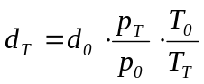  where:  d₀ is the reference relative air density at reference conditions (0.9197)  p_{T} is the mean ambient pressure during the test, in kPa;  p₀ is the reference ambient pressure (101.3 kPa);  T_{T} is the mean ambient temperature during test, in K;  T₀ is the reference ambient temperature (293.0 K) ( 20.0 °C).
3. | Condition of the test vehicle
3.1. | The test vehicle shall comply with the conditions described in point 1.1. of annex B.5.6.
3.2. | When installing the measuring instruments on the test vehicle, care shall be taken to minimise their effects on the distribution of the load across the wheels. When installing the vehicle speed sensor outside the vehicle, care shall be taken to minimise the additional aerodynamic loss.
3.3. | Checks  The following checks shall be made in accordance with the manufacturer’s specifications for the use considered: wheels, wheel rims, tyres (make, type and pressure), front axle geometry, brake adjustment (elimination of parasitic drag), lubrication of front and rear axles, adjustment of the suspension and vehicle ground clearance, etc. Check that during freewheeling, there is no electrical braking.
4. | Specified coast-down vehicle speeds
4.1. | The coast-down times shall be measured between v₁ and v₂ as specified in Table B.5.5.-1, depending on the vehicle class as defined in point 3. of section B.1.
4.2 | Table B.5.5.-1: Coast-down time measurement beginning vehicle speed and ending vehicle speed.
  Maximum design vehicle speed (km/h) | Specified target vehicle speed  v_{j} in (km/h) | v₁ in (km/h) | v₂ in (km/h)
  ≤ 25 km/h
   | 20 | 25 | 15
   | 15 | 20 | 10
   | 10 | 15 | 5
  ≤ 45 km/h
   | 40 | 45 | 35
   | 30 | 35 | 25
   | 20 | 25 | 15
  45 km/h < maximum design vehicle speed ≤ 130 km/h and > 130 km/h
   | 120 | 130*/ | 110
   | 100 | 110*/ | 90
   | 80 | 90*/ | 70
   | 60 | 70 | 50
   | 40 | 45 | 35
   | 20 | 25 | 15
4.3. | When the running resistance is verified in accordance with point 4.2.2.3.2. of section B.2., the test can be executed at v_{j} ± 5 km/h, provided that the coast-down time accuracy referred to in point 3.4.7. of section B.2. is ensured.
5. | Measurement of coast-down time
5.1. | After a warm-up period, the vehicle shall be accelerated to the coast-down starting vehicle speed, at which point the coast-down measurement procedure shall be started.
5.2. | Since shifting the transmission to neutral can be dangerous and complicated by the construction of the vehicle, the coasting may be performed solely with the clutch disengaged. Vehicles that have no means of cutting the transmitted engine power off prior to coasting may be towed until they reach the coast-down starting vehicle speed. When the coast-down test is reproduced on the chassis dynamometer, the drive train and clutch shall be in the same condition as during the road test.
5.3. | The vehicle steering shall be altered as little as possible and the brakes shall not be operated until the end of the coast-down measurement period.
5.4. | The first coast-down time Δt_{ai} corresponding to the specified vehicle speed vj shall be measured as the time taken for the vehicle to decelerate from vj + Δv to vj - Δv.
5.5. | The procedure described in points 5.1. to 5.4. shall be repeated in the opposite direction to measure the second coast-down time Δtbi.
5.6. | The average Δti of the two coast-down times Δt_{ai} and Δt_{bi} shall be calculated using the following equation:  Equation B.5.5.-2:  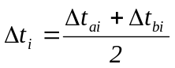
5.7. | At least four tests shall be performed and the average coast-down time ΔTj calculated using the following equation:  Equation B.5.5.-3  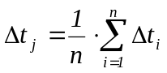
5.8. | Tests shall be performed until the statistical accuracy P is equal to or less than 3% (P ≤ 3%).  The statistical accuracy P (as a percentage) is calculated using the following equation:  Equation B.5.5.-4  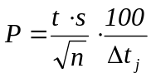  where:  t is the coefficient given in Table B.5.5.-2;  s is the standard deviation given by the following formula:  Equation B.5.5.-5  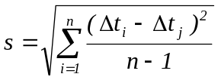  where:  n is the number of tests.  Table B.5.5.-2: Coefficients for statistical accuracy
  n | t | 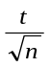
  4 | 3.2 | 1.60
  5 | 2.8 | 1.25
  6 | 2.6 | 1.06
  7 | 2.5 | 0.94
  8 | 2.4 | 0.85
  9 | 2.3 | 0.77
  10 | 2.3 | 0.73
  11 | 2.2 | 0.66
  12 | 2.2 | 0.64
  13 | 2.2 | 0.61
  14 | 2.2 | 0.59
  15 | 2.2 | 0.57
5.9. | In repeating the test, care shall be taken to start the coast-down after observing the same warm-up procedure and at the same coast-down starting vehicle speed.
5.10. | The coast-down times for multiple specified vehicle speeds may be measured in a continuous coast-down. In this case, the coast-down shall be repeated after observing the same warm-up procedure and at the same coast-down starting vehicle speed.
5.11. | The coast-down time shall be recorded. A specimen record form is given in the Regulation for administrative requirements.
6. | Data processing
6.1. | Calculation of running resistance force
6.1.1. | The running resistance force Fj, in Newton, at the specified vehicle speed vj shall be calculated using the following equation:  Equation B.5.5.-6  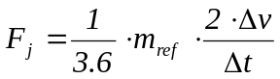  where:  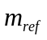= reference mass (kg);  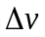 = vehicle speed deviation (km/h);  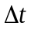 = calculated coast down time difference (s);
6.1.2. | The running resistance force Fj shall be corrected in accordance with point 6.2.
6.2. | Running resistance curve fitting  The running resistance force F shall be calculated as follows:
6.2.1. | The following equation shall be fitted to the data set of Fj and vj obtained in points 6.1. and 4. respectively by linear regression to determine the coefficients f0 and f2,  Equation B.5.5.-7  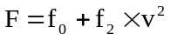
6.2.2. | The coefficients f0 and f2 thus determined shall be corrected to the standard ambient conditions using the following equations:  Equation B.5.5.-8  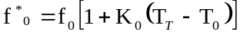  Equation B.5.5.-9  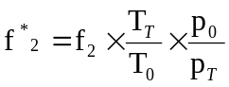  where:  K₀ shall be determined on the basis of the empirical data for the particular vehicle and tyre tests or shall be assumed as follows, if the information is not available: K₀ = 6·10-3 K-1.
6.3. | Target running resistance force F* for chassis dynamometer setting  The target running resistance force F*(v₀) on the chassis dynamometer at the reference vehicle speed v_{0,} in Newton, is determined using the following equation:  Equation B.5.5.-10  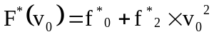

B.5.6. | Annex: road tests of two- and three-wheeled vehicles equipped with two or more wheels on the powered axles for the determination of test bench settings
1 | Preparation of the vehicle
1.1. | Running-in  The test vehicle shall be in normal running order and adjustment after having been run in for at least 300 km. The tyres shall be run in at the same time as the vehicle or shall have a tread depth within 90% and 50% of the initial tread depth.
1.2. | Checks  The following checks shall be made in accordance with the manufacturer’s specifications for the use considered: wheels, wheel rims, tyres (make, type and pressure), front axle geometry, brake adjustment (elimination of parasitic drag), lubrication of front and rear axles, adjustment of the suspension and vehicle ground clearance, etc. Check that during freewheeling, there is no electrical braking.
1.3. | Preparation for the test
1.3.1. | The test vehicle shall be loaded to its test mass including driver and measurement equipment, spread in a uniform way in the loading areas.
1.3.2. | The windows of the vehicle shall be closed. Any covers for air conditioning systems, headlamps, etc. shall be closed.
1.3.3. | The test vehicle shall be clean, properly maintained and used.
1.3.4. | Immediately before the test, the vehicle shall be brought to the normal running temperature in an appropriate manner.
1.3.5. | When installing the measuring instruments on the test vehicle, care shall be taken to minimise their effects on the distribution of the load across the wheels. When installing the vehicle speed sensor outside the test vehicle, care shall be taken to minimise the additional aerodynamic loss.
2. | Specified vehicle speed v  The specified vehicle speed is required for determining the running resistance at the reference vehicle speed from the running resistance curve. To determine the running resistance as a function of vehicle speed in the vicinity of the reference vehicle speed v0, running resistances shall be measured at the specified vehicle speed v. At least four to five points indicating the specified vehicle speeds, along with the reference vehicle speeds, shall be measured. The calibration of the load indicator referred to in point 2.2. of annex B.5.6. shall be performed at the applicable reference vehicle speed (v_{j}) referred to in Table B.5.6.-1.  Table B.5.6.-1: Specified vehicle speeds to perform the coast-down time test as well as the designated reference vehicle speed v_{j} depending on the maximum design vehicle speed (vmax) of the vehicle.
  Category  v_{max} | Vehicle speed (km/h)
  >130 | 120** | 100 | 80* | 60 | 40 | 20
  130 - 100 | 90 | 80* | 60 | 40 | 20 | -
  100 - 70 | 60 | 50* | 40 | 30 | 20 | -
  70-45 | 50** | 40* | 30 | 20 | - | -
  45-25 |  | 40 | 30* | 20
  ≤ 25 km/h |  |  |  | 20 | 15* | 10
  * Applicable reference vehicle speed v_{j}
  ** if the vehicle speed can be attained by the vehicle.
3. | Energy variation during coast-down procedure
3.1. | Total road load power determination
3.1.1. | Measurement equipment and accuracy  The margin of measurement error shall be less than 0.1 second for time and less than ± 0.5 km/h for vehicle speed. Bring the vehicle and the chassis dynamometer to the stabilised operating temperature, in order to approximate the road conditions.
3.1.2. | Test procedure
3.1.2.1. | Accelerate the vehicle to a vehicle speed of 5 km/h greater than the vehicle speed at which test measurement begins.
3.1.2.2. | Put the transmission to neutral or disconnect the power supply.
3.1.2.3. | Measure the time t1 taken by the vehicle to decelerate from:  v2 = v + Δ v (km/h) to v1 = v - Δ v (km/h)  where:  Δ v < 5 km/h for nominal vehicle speed < 50 km/h;  Δ v < 10 km/h for nominal vehicle speed > 50 km/h.
3.1.2.4. | Carry out the same test in the opposite direction, measuring time t2.
3.1.2.5. | Take the average ti of the two times t1 and t2.
3.1.2.6. | Repeat these tests until the statistical accuracy (p) of the average ≤ 4 percent:  Equation B.5.6.-1:  The statistical accuracy (p) is defined by:  Equation B.5.6.-2:  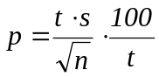  where:  t is the coefficient in Table B.5.6.-2;  s is the standard deviation.  Equation B.5.6.-3:  n is the number of tests  Table B.5.6.-2: Factors t and t/√n depending on the number of coast-down tests performed
  n | 4 | 5 | 6 | 7 | 8 | 9 | 10
  t | 3.2 | 2.8 | 2.6 | 2.5 | 2.4 | 2.3 | 2.3
  t/√n | 1.6 | 1.25 | 1.06 | 0.94 | 0.85 | 0.77 | 0.73
3.1.2.7. | Calculation of the running resistance force  The running resistance force F at the specified vehicle speeds v is calculated as follows:  Equation B.5.6.-4:  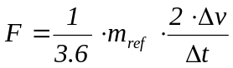  where:  = reference mass (kg);  = vehicle speed deviation (km/h);  = calculated coast down time difference (s);
3.1.2.8. | The running resistance determined on the track shall be corrected to the reference ambient conditions as follows:  Equation B.5.6.-5:  Fcorrected = k · Fmeasured  Equation B.5.6.-6:  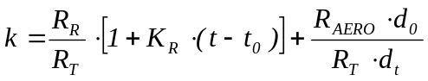  where:  RR is the rolling resistance at vehicle speed v (N);  RAERO is the aerodynamic drag at vehicle speed v (N);  RT is the total road load = RR+RAERO (N);  KR is the temperature correction factor of rolling resistance, taken to be equal to: 3.6 · 10-3/K;  t is the road test ambient temperature in K;  t0 is the reference ambient temperature (293.0 K)(20.0 °C);  dt is the air density at the test conditions (kg/m3);  d0 is the air density at the reference conditions (293.2 K (20.0 °C), 101.3 kPa) = 1.189 kg/m3.  The ratios RR/RT and RAERO/RT shall be specified by the vehicle manufacturer on the basis of the data normally available to the company and to the satisfaction of the technical service. If these values are not available or if the technical service or [approval authority] / [certification authority] do not accept these values, the following figures for the rolling/total resistance ratio given by the following formula may be used:  Equation B.5.6.-7:  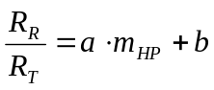  where:  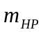 is the test mass and for each vehicle speed the coefficients a and b are as shown in the following table:  Table B.5.6.-3: Coefficients a and b to calculate rolling resistance ratio
  v (km/h) | a | b
  20 | 7.24 · 10⁻⁵ | 0.82
  40 | 1.59 · 10⁻⁴ | 0.54
  60 | 1.96 ·10⁻⁴ | 0.33
  80 | 1.85 · 10⁻⁴ | 0.23
  100 | 1.63 · 10⁻⁴ | 0.18
  120 | 1.57 · 10⁻⁴ | 0.14
3.2. | Setting of the chassis dynamometer  The purpose of this procedure is to simulate on the dynamometer the total road load power at a given vehicle speed.
3.2.1. | Measurement equipment and accuracy  The measuring equipment shall be similar to that used on the test track and shall comply with point 3.4.7. of section B.2. and point 1.3.5 of this section B.5.6.
3.2.2. | Test procedure
3.2.2.1 | Install the vehicle on the chassis dynamometer.
3.2.2.2. | Adjust the tyre pressure (cold) of the driving wheels as required for the chassis dynamometer.
3.2.2.3. | Adjust the equivalent inertia mass of the chassis dynamometer, in accordance with Table B.5.6.-4.
3.2.2.3.1. | Table B.5.6.-4: Determination of equivalent inertia mass for a vehicle equipped with two or more wheels on the powered axles.
  Reference mass (m_{ref})  (kg) | Equivalent inertia mass (m_{i})  (kg)
  m_{ref} ≤105 | 100
  105< m_{ref} ≤115 | 110
  115< m_{ref} ≤125 | 120
  125< m_{ref} ≤135 | 130
  135< m_{ref} ≤150 | 140
  150< m_{ref} ≤165 | 150
  165< m_{ref} ≤185 | 170
  185< m_{ref} ≤205 | 190
  205< m_{ref} ≤225 | 210
  225< m_{ref} ≤245 | 230
  245< m_{ref} ≤270 | 260
  270< m_{ref} ≤300 | 280
  300< m_{ref} ≤330 | 310
  330< m_{ref} ≤360 | 340
  360< m_{ref} ≤395 | 380
  395< m_{ref} ≤435 | 410
  435< m_{ref} ≤480 | 450
  480< m_{ref} ≤540 | 510
  540< m_{ref} ≤600 | 570
  600< m_{ref} ≤650 | 620
  650< m_{ref} ≤710 | 680
  710< m_{ref} ≤770 | 740
  770< m_{ref} ≤820 | 800
  820< m_{ref} ≤880 | 850
  880< m_{ref} ≤940 | 910
  940< m_{ref} ≤990 | 960
  990< m_{ref} ≤1050 | 1020
  1050< m_{ref} ≤1110 | 1080
  1110< m_{ref} ≤1160 | 1130
  1160< m_{ref} ≤1220 | 1190
  1220< m_{ref} ≤1280 | 1250
  1280< m_{ref} ≤1330 | 1300
  1330< m_{ref} ≤1390 | 1360
  1390< m_{ref} ≤1450 | 1420
  1450< m_{ref} ≤1500 | 1470
  1500< m_{ref} ≤1560 | 1530
  1560< m_{ref} ≤1620 | 1590
  1620< m_{ref} ≤1670 | 1640
  1670< m_{ref} ≤1730 | 1700
  1730< m_{ref} ≤1790 | 1760
  1790< m_{ref} ≤1870 | 1810
  1870< m_{ref} ≤1980 | 1930
  1980< m_{ref} ≤2100 | 2040
  2100< m_{ref} ≤2210 | 2150
  2210< m_{ref} ≤2320 | 2270
  2320< m_{ref} ≤2440 | 2380
  2440< RM | 2490
3.2.2.4. | Bring the vehicle and the chassis dynamometer to the stabilised operating temperature, in order to approximate the road conditions.
3.2.2.5. | Carry out the operations specified in point 3.1.2., with the exception of those in points 3.1.2.4. and 3.1.2.5.
3.2.2.6. | Adjust the brake to reproduce the corrected running resistance (see point 3.1.2.8.) and to take into account the reference mass. This may be done by calculating the mean corrected road coast-down time from v1 to v2 and reproducing the same time on the dynamometer as follows:  Equation B.5.6.-8:  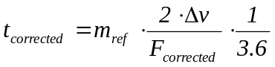
3.2.2.7. | The power Pa to be absorbed by the bench shall be determined in order to enable the same total road load power to be reproduced for the same vehicle on different days or on different chassis dynamometers of the same type.

B.5.7. | Annex: chassis dynamometer system
1. | Specification
1.1. | General requirements
1.1.1. | The dynamometer shall be capable of simulating road load within one of the following classifications:  (a) dynamometer with fixed load curve, i.e. a dynamometer whose physical characteristics provide a fixed load curve shape;  (b) dynamometer with adjustable load curve, i.e. a dynamometer with at least two road load parameters that can be adjusted to shape the load curve.
1.1.2. | Dynamometers with electric inertia simulation shall be demonstrated to be equivalent to mechanical inertia systems. The means by which equivalence is established are described in point 4.
1.1.3. | Where the total resistance to progress on the road cannot be reproduced on the chassis dynamometer between vehicle speeds of 10 km/h and 120 km/h, it is recommended that a chassis dynamometer with the characteristics defined in point 1.2. should be used.
1.1.3.1. | The load absorbed by the brake and the chassis dynamometer (internal frictional effects) between the vehicle speeds of 0 and 120 km/h is as follows:  Equation B.5.7.-1:  F = (a + b·v²) ±0.1·F₈₀ (without being negative)  where:  F = total load absorbed by the chassis dynamometer (N);  a = value equivalent to rolling resistance (N);  b = value equivalent to coefficient of air resistance (N/(km/h)²);  v = vehicle speed (km/h);  F₈₀ = load at 80 km/h (N). Alternatively for vehicles that cannot attain 80 km/h the load at the reference vehicle speeds v_{j} in table B.5.6.-1 in Annex B.5.5. or B.5.6. as applicable shall be determined.
1.2. | Specific requirements
1.2.1. | The setting of the dynamometer shall not be affected by the lapse of time. It shall not produce any vibrations perceptible to the vehicle and likely to impair the vehicle’s normal operations.
1.2.2. | The chassis dynamometer may have one roller or two rollers in the cases of three-wheel vehicles with two front wheels and quadricycles. In such cases, the front roller shall drive, directly or indirectly, the inertial masses and the power-absorption device.
1.2.3. | It shall be possible to measure and read the indicated load to an accuracy of ±5 percent.
1.2.4. | In the case of a dynamometer with a fixed load curve, the accuracy of the load setting at 80 km/h or of the load setting at the reference vehicle speeds (30 km/h, respectively 15 km/h) referred to in point 1.1.3.1. for vehicles that cannot attain 80 km/h, shall be ±5 percent. In the case of a dynamometer with adjustable load curve, the accuracy of matching dynamometer load to road load shall be ±5 percent for vehicle speeds > 20 km/h and ± 10 percent for vehicle speeds ≤ 20 km/h. Below this vehicle speed, dynamometer absorption shall be positive.
1.2.5. | The total inertia of the rotating parts (including the simulated inertia where applicable) shall be known and shall be within ± 10 kg of the inertia class for the test.
1.2.6. | The speed of the vehicle shall be measured by the speed of rotation of the roller (the front roller in the case of a two-roller dynamometer from which the actual speed of the vehicle is calculated). It shall be measured with an accuracy of ±1 km/h at vehicle speeds over 10 km/h. The distance actually driven by the vehicle shall be measured by the movement of rotation of the roller (the front roller in the case of a two-roller dynamometer).
2. | Dynamometer calibration procedure
2.1. | Introduction  This section describes the method to be used to determine the load absorbed by a dynamometer brake. The load absorbed comprises the load absorbed by frictional effects and the load absorbed by the power-absorption device. The dynamometer is brought into operation beyond the range of test vehicle speeds. The device used for starting up the dynamometer is then disconnected; the rotational speed of the driven roller decreases. The kinetic energy of the rollers is dissipated by the power-absorption unit and by the frictional effects. This method disregards variations in the roller’s internal frictional effects caused by rollers with or without the vehicle. The frictional effects of the rear roller shall be disregarded when the roller is free.
2.2. | Calibration of the load indicator at 80 km/h or of the load indicator referred to in point 1.1.3.1. for vehicles that cannot attain 80 km/h.  The following procedure shall be used for calibration of the load indicator to 80 km/h or the applicable load indicator referred to in point 1.1.3.1. for vehicles that cannot attain 80 km/h, as a function of the load absorbed (see also Figure B.5.7.-1):
2.2.1. | Measure the rotational speed of the roller if this has not already been done. A fifth wheel, a revolution counter or some other method may be used.
2.2.2. | Place the vehicle on the dynamometer or devise some other method for starting up the dynamometer.
2.2.3. | Use the flywheel or any other system of inertia simulation for the particular inertia class to be used.  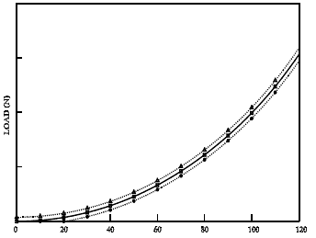  Figure B.5.7.-1: power absorbed by the chassis dynamometer  Legend:  ⁪F = a + b · v² ● = (a + b · v²) — 0.1 · F₈₀ Δ = (a + b · v²) + 0.1 · F₈₀
2.2.4. | Bring the dynamometer to a vehicle speed of 80 km/h or to the reference vehicle speed referred to in point 1.1.3.1. for vehicles that cannot attain 80 km/h.
2.2.5. | Note the load indicated F_{i} (N).
2.2.6. | Bring the dynamometer to a vehicle speed of 90 km/h or to the respective reference vehicle speed referred to in point 1.1.3.1. plus 5 km/h for vehicles that cannot attain 80 km/h
2.2.7. | Disconnect the device used to start up the dynamometer.
2.2.8. | Note the time taken by the dynamometer to pass from a vehicle speed of 85 to 75 km/h, or for vehicles that cannot attain 80 km/h referred to in Table B.5.5.-1: of annex B.5.5., note the time between v_{j} + 5 km/h to v_{j}- 5 km/h.
2.2.9. | Set the power-absorption device at a different level.
2.2.10. | The requirements of points 2.2.4. to 2.2.9. shall be repeated sufficiently often to cover the range of loads used.
2.2.11. | Calculate the load absorbed using the formula:  Equation B.5.7.-2:  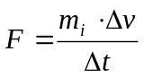  where:  F = load absorbed (N);  m_{i} = equivalent inertia in kg (excluding the inertial effects of the free rear roller);  Δ v = vehicle speed deviation in m/s (10 km/h = 2.775 m/s);  Δ t = time taken by the roller to pass from 85 km/h to 75 km/h, or for vehicles that cannot attain 80 km/h from 35 – 25 km/h, respectively from 20 – 10 km/h, referred to in Table B.5.5. of Annex B.5.5.
2.2.12. | Figure B.5.7.-2 shows the load indicated at 80 km/h in terms of load absorbed at 80 km/h.  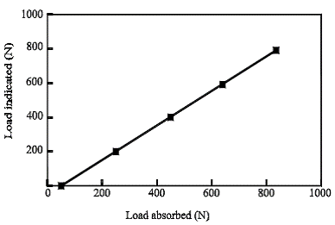  Figure B.5.7.-2: Load indicated at 80 km/h in terms of load absorbed at 80 km/h
2.2.13. | The requirements laid down in points 2.2.3. to 2.2.12. shall be repeated for all inertia classes to be used.
2.3. | Calibration of the load indicator at other vehicle speeds  The procedures described in point 2.2. shall be repeated as often as necessary for the chosen vehicle speeds.
2.4. | Calibration of force or torque  The same procedure shall be used for force or torque calibration.
3. | Verification of the load curve
3.1. | Procedure  The load-absorption curve of the dynamometer from a reference setting at a vehicle speed of 80 km/h or for vehicles that cannot attain 80 km/h at the respective reference vehicle speeds referred to in point 1.1.3.1., shall be verified as follows:
3.1.1. | Place the vehicle on the dynamometer or devise some other method for starting up the dynamometer.
3.1.2. | Adjust the dynamometer to the absorbed load (F₈₀) at 80 km/h, or for vehicles that cannot attain 80 km/h to the absorbed load F_{vj} at the respective target vehicle speed v_{j} referred to in point 1.1.3.1.
3.1.3. | Note the load absorbed at 120, 100, 80, 60, 40 and 20 km/h or for vehicles that cannot attain 80 km/h absorbed at the target vehicles speeds v_{j} referred to in point 1.1.3.1.
3.1.4. | Draw the curve F(v) and verify that it corresponds to the requirements of point 1.1.3.1.
3.1.5. | Repeat the procedure set out in points 3.1.1. to 3.1.4. for other values of F₈₀ and for other values of inertia.
4 | Verification of simulated inertia
4.1. | Object  The method described in this Annex makes it possible to check that the simulated total inertia of the dynamometer is carried out satisfactorily in the running phase of the operating cycle. The manufacturer of the chassis dynamometer shall specify a method for verifying the specifications according to point 4.3.
4.2. | Principle
4.2.1. | Drawing-up working equations  Since the dynamometer is subjected to variations in the rotating speed of the roller(s), the force at the surface of the roller(s) can be expressed by:  Equation B.5.7.-3:  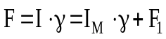  where:  F is the force at the surface of the roller(s) in N;  I is the total inertia of the dynamometer (equivalent inertia of the vehicle);  I_{M} is the inertia of the mechanical masses of the dynamometer;  γ is the tangential acceleration at roller surface;  F₁ is the inertia force.  Note: An explanation of this formula with reference to dynamometers with mechanically simulated inertia is appended.  Thus, total inertia is expressed as follows:  Equation B.5.7.-4:  I = I_{m}+ F₁ / γ  where:  I_{m} can be calculated or measured by traditional methods;  F₁ can be measured on the dynamometer;  γ can be calculated from the peripheral rotation speed of the rollers.  The total inertia (I) will be determined during an acceleration or deceleration test with values no lower than those obtained on an operating cycle.
4.2.2. | Specification for the calculation of total inertia  The test and calculation methods shall make it possible to determine the total inertia I with a relative error (ΔI/I) of less than ±2 percent.
4.3. | Specification
4.3.1. | The mass of the simulated total inertia I shall remain the same as the theoretical value of the equivalent inertia (see Annex B.5.4.) within the following limits:
4.3.1.1. | ±5 percent of the theoretical value for each instantaneous value;
4.3.1.2. | ±2 percent of the theoretical value for the average value calculated for each sequence of the cycle.  The limit specified in point 4.3.1.1. is brought to ±50 percent for one second when starting and, for vehicles with manual transmission, for two seconds during gear changes.
4.4. | Verification procedure
4.4.1. | Verification is carried out during each test throughout the test cycles defined in Annex B.5.16.
4.4.2. | However, if the requirements laid down in point 4.3. are met, with instantaneous accelerations which are at least three times greater or smaller than the values obtained in the sequences of the theoretical cycle, the verification described in point 4.4.1. will not be necessary.

B.5.8. | Annex: exhaust dilution system
1. | System specification
1.1. | System overview  A full-flow exhaust dilution system shall be used. This requires that the vehicle exhaust be continuously diluted with ambient air under controlled conditions. The total volume of the mixture of exhaust and dilution air shall be measured and a continuously proportional sample of the volume shall be collected for analysis. The quantities of pollutants are determined from the sample concentrations, corrected for the pollutant content of the ambient air and the totalised flow over the test period. The exhaust dilution system shall consist of a transfer tube, a mixing chamber and dilution tunnel, a dilution air conditioning, a suction device and a flow measurement device. Sampling probes shall be fitted in the dilution tunnel as specified in B.2.3.4.3.12. The mixing chamber described in this point shall be a vessel, such as those illustrated in Figures B.5.8.-1 and B.5.8.-2, in which vehicle exhaust gases and the dilution air are combined so as to produce a homogeneous mixture at the chamber outlet.
1.2. | General requirements
1.2.1. | The vehicle exhaust gases shall be diluted with a sufficient amount of ambient air to prevent any water condensation in the sampling and measuring system under any conditions which may occur during a test.
1.2.2. | The mixture of air and exhaust gases shall be homogeneous at the point where the sampling probe is located (see point 1.3.3. ). The sampling probe shall extract a representative sample of the diluted exhaust gas.
1.2.3. | The system shall enable the total volume of the diluted exhaust gases to be measured.
1.2.4. | The sampling system shall be gas-tight. The design of the variable dilution sampling system and the materials that go to make it up shall be such that they do not affect the pollutant concentration in the diluted exhaust gases. Should any component in the system (heat exchanger, cyclone separator, blower, etc.) change the concentration of any of the pollutants in the diluted exhaust gases and the fault cannot be corrected, sampling for that pollutant shall be carried out upstream from that component.
1.2.5. | All parts of the dilution system that are in contact with raw and diluted exhaust gas shall be designed to minimise deposition or alteration of the particulates or particles. All parts shall be made of electrically conductive materials that do not react with exhaust gas components and shall be electrically grounded to prevent electrostatic effects.
1.2.6. | If the vehicle being tested is equipped with an exhaust pipe comprising several branches, the connecting tubes shall be connected as near as possible to the vehicle without adversely affecting its operation.
1.2.7. | The variable-dilution system shall be designed so as to enable the exhaust gases to be sampled without appreciably changing the back-pressure at the exhaust pipe outlet.
1.2.8. | The connecting tube between the vehicle and dilution system shall be so designed as to minimise heat loss.
1.3. | Specific requirements
1.3.1. | Connection to vehicle exhaust  The connecting tube between the vehicle exhaust outlets and the dilution system shall be as short as possible and satisfy the following requirements:  (a) the tube shall be less than 3.6 m long, or less than 6.1 m long if heat insulated. Its internal diameter may not exceed 105 mm;  (b) it shall not cause the static pressure at the exhaust outlets on the test vehicle to differ by more than ±0.kPa at 50 km/h, or more than ±1.25 kPa for the whole duration of the test, from the static pressures recorded when nothing is connected to the vehicle exhaust outlets. The pressure shall be measured in the exhaust outlet or in an extension having the same diameter, as near as possible to the end of the pipe. Sampling systems capable of maintaining the static pressure to within ±0.25 kPa may be used if a written request from a manufacturer to the technical service substantiates the need for the closer tolerance;  (c) it shall not change the nature of the exhaust gas;  (d) any elastomeric connectors employed shall be as thermally stable as possible and have minimum exposure to the exhaust gases.
1.3.2. | Dilution air conditioning  The dilution air used for the primary dilution of the exhaust in the CVS tunnel shall be passed through a medium capable of reducing particles in the most penetrating particle size of the filter material by ≥ 99.95 percent, or through a filter of at least class H13 of EN 1822:1998. This represents the specification of High Efficiency Particulate Air (HEPA) filters. The dilution air may be charcoal scrubbed before being passed to the HEPA filter. It is recommended that an additional coarse particle filter is situated before the HEPA filter and after the charcoal scrubber, if used. At the vehicle manufacturer’s request, the dilution air may be sampled according to good engineering practice to determine the tunnel contribution to background particulate mass levels, which can then be subtracted from the values measured in the diluted exhaust.
1.3.3. | Dilution tunnel  Provision shall be made for the vehicle exhaust gases and the dilution air to be mixed. A mixing orifice may be used. In order to minimise the effects on the conditions at the exhaust outlet and to limit the drop in pressure inside the dilution-air conditioning device, if any, the pressure at the mixing point shall not differ by more than ±0.25 kPa from atmospheric pressure. The homogeneity of the mixture in any cross-section at the location of the sampling probe shall not vary by more than ±2 percent from the average of the values obtained for at least five points located at equal intervals on the diameter of the gas stream. For particulate and particle emissions sampling, a dilution tunnel shall be used which:  (a) shall consist of a straight tube of electrically-conductive material, which shall be earthed;  (b) shall be small enough in diameter to cause turbulent flow (Reynolds number ≥ 4000) and of sufficient length to cause complete mixing of the exhaust and dilution air;  (c) shall be at least 200 mm in diameter;  (d) may be insulated.
1.3.4. | Suction device  This device may have a range of fixed rotation speeds to ensure sufficient flow to prevent any water condensation. This result is generally obtained if the flow is either:  (a) twice the maximum flow of exhaust gas produced by accelerations of the driving cycle; or  (b) sufficient to ensure that the CO₂ concentration in the dilute exhaust sample bag is less than 3 percent by volume for petrol and diesel, less than 2.2 percent by volume for LPG and less than 1.5 percent by volume for NG/biomethane.
1.3.5. | Volume measurement in the primary dilution system  The method for measuring total dilute exhaust volume incorporated in the constant volume sampler shall be such that measurement is accurate to ± 2 percent under all operating conditions. If the device cannot compensate for variations in the temperature of the mixture of exhaust gases and dilution air at the measuring point, a heat exchanger shall be used to maintain the temperature to within ±6.0 K (6.0 °C) of the specified operating temperature. If necessary, some form of protection for the volume measuring device may be used, e.g. a cyclone separator, bulk stream filter, etc. A temperature sensor shall be installed immediately before the volume measuring device. This sensor shall have an accuracy and a precision of ±1.0 K (1.0 °C) and a response time of 0.1 s at 62 percent of a given temperature variation (value measured in silicone oil). The difference from atmospheric pressure shall be measured upstream and, if necessary, downstream from the volume measuring device. The pressure measurements shall have a precision and an accuracy of ±0.4 kPa during the test.
1.4. | Recommended system descriptions  Figure B.5.8.-1 and Figure B.5.8.-2 are schematic drawings of two types of recommended exhaust dilution systems that meet the requirements of this Annex. Since various configurations can produce accurate results, exact conformity with these figures is not essential. Additional components such as instruments, valves, solenoids and switches may be used to provide additional information and coordinate the functions of the component system.
1.4.1. | Full-flow dilution system with positive displacement pump  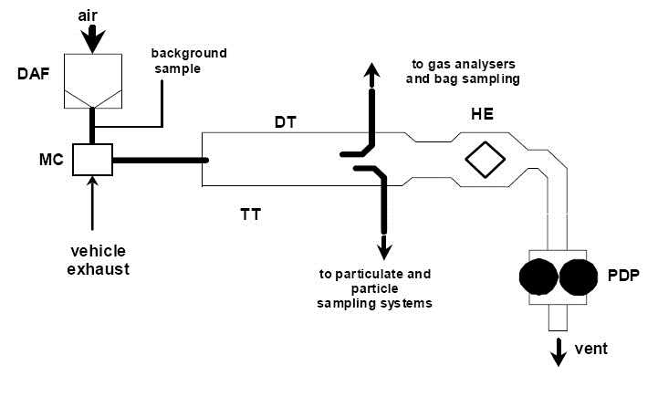  Figure B.5.8.-1: Positive displacement pump dilution system  The positive displacement pump (PDP) full-flow dilution system satisfies the requirements of this Annex by metering the flow of gas through the pump at constant temperature and pressure. The total volume is measured by counting the revolutions of the calibrated positive displacement pump. The proportional sample is achieved by sampling with pump, flow meter and flow control valve at a constant flow rate. The collecting equipment consists of:
1.4.1.1. | A filter (refer to DAF in Figure B.5.8.-1) for the dilution air shall be installed, which can be preheated if necessary. This filter shall consist of the following filters in sequence: an optional activated charcoal filter (inlet side) and a high efficiency particulate air (HEPA) filter (outlet side). It is recommended that an additional coarse particle filter is situated before the HEPA filter and after the charcoal filter, if used. The purpose of the charcoal filter is to reduce and stabilise the hydrocarbon concentrations of ambient emissions in the dilution air;
1.4.1.2. | A transfer tube (TT) by which vehicle exhaust is admitted into a dilution tunnel (DT) in which the exhaust gas and dilution air are mixed homogeneously;
1.4.1.3. | The positive displacement pump (PDP), producing a constant-volume flow of the air/exhaust-gas mixture. The PDP revolutions, together with associated temperature and pressure measurement, are used to determine the flow rate;
1.4.1.4. | A heat exchanger (HE) of a capacity sufficient to ensure that throughout the test the temperature of the air/exhaust-gas mixture measured at a point immediately upstream of the positive displacement pump is within 6.0 K (6.0 °C ) of the average operating temperature during the test. This device shall not affect the pollutant concentrations of diluted gases taken off afterwards for analysis.
1.4.1.5. | A mixing chamber (MC) in which exhaust gas and air are mixed homogeneously and which may be located close to the vehicle so that the length of the transfer tube (TT) is minimised.
1.4.2. | Full-flow dilution system with critical-flow venturi  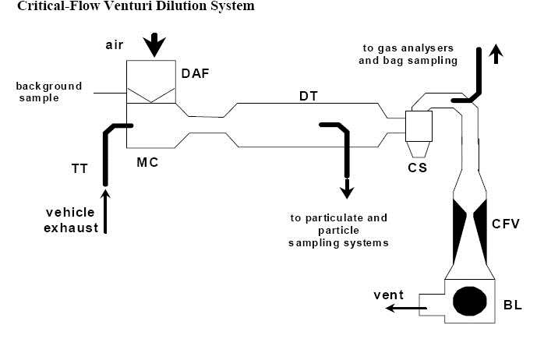  Figure B.5.8.-2: Critical-flow venturi dilution system  The use of a critical-flow venturi (CFV) for the full-flow dilution system is based on the principles of flow mechanics for critical flow. The variable mixture flow rate of dilution and exhaust gas is maintained at sonic velocity which is directly proportional to the square root of the gas temperature. Flow is continually monitored, computed and integrated throughout the test. The use of an additional critical-flow sampling venturi ensures the proportionality of the gas samples taken from the dilution tunnel. As pressure and temperature are both equal at the two venturi inlets, the volume of the gas flow diverted for sampling is proportional to the total volume of diluted exhaust-gas mixture produced, and thus the requirements of this Annex are met. The collecting equipment consists of:
1.4.2.1. | A filter (DAF) for the dilution air which can be preheated if necessary. This filter shall consist of the following filters in sequence: an optional activated charcoal filter (inlet side) and a high efficiency particulate air (HEPA) filter (outlet side). It is recommended that an additional coarse particle filter is situated before the HEPA filter and after the charcoal filter, if used. The purpose of the charcoal filter is to reduce and stabilise the hydrocarbon concentrations of ambient emissions in the dilution air;
1.4.2.2. | A mixing chamber (MC) in which exhaust gas and air are mixed homogeneously and which may be located close to the vehicle so that the length of the transfer tube (TT) is minimised;
1.4.2.3. | A dilution tunnel (DT) from which particulates and particles are sampled;
1.4.2.4. | Some form of protection for the measurement system may be used, e.g. a cyclone separator, bulk stream filter, etc.;
1.4.2.5. | A measuring critical-flow venturi tube (CFV) to measure the flow volume of the diluted exhaust gas;
1.4.2.6. | A blower (BL) of sufficient capacity to handle the total volume of diluted exhaust gas.
2. | CVS calibration procedure
2.1. | General requirements  The CVS system shall be calibrated by using an accurate flow-meter and a restricting device. The flow through the system shall be measured at various pressure readings and the control parameters of the system measured and related to the flows. The flow-meter shall be dynamic and suitable for the high flow-rate encountered in CVS testing. The device shall be of certified accuracy traceable to an approved national or international standard.
2.1.1. | Various types of flow-meter may be used, e.g. calibrated venturi, laminar flow-meter, calibrated turbine-meter, provided that they are dynamic measurement systems and can meet the requirements of point 1.3.5. of this Annex.
2.1.2. | The following points give details of methods of calibrating PDP and CFV units, using a laminar flow-meter which gives the required accuracy, together with a statistical check on the calibration validity.
2.2. | Calibration of the positive displacement pump (PDP)
2.2.1. | The following calibration procedure outlines the equipment, the test configuration and the various parameters that are measured to establish the flow-rate of the CVS pump. All the parameters relating to the pump are simultaneously measured with the parameters relating to the flow-meter which is connected in series with the pump. The calculated flow rate (given in m³/min at pump inlet, absolute pressure and temperature) can then be plotted against a correlation function that is the value of a specific combination of pump parameters. The linear equation that relates the pump flow and the correlation function is then determined. If a CVS has a multiple rotation speed drive, a calibration shall be performed for each range used.
2.2.2. | This calibration procedure is based on the measurement of the absolute values of the pump and flow-meter parameters that relate to the flow rate at each point. Three conditions shall be maintained to ensure the accuracy and integrity of the calibration curve:
2.2.2.1. | The pump pressures shall be measured at tappings on the pump rather than at the external piping on the pump inlet and outlet. Pressure taps that are mounted at the top centre and bottom centre of the pump drive head plate are exposed to the actual pump cavity pressures and therefore reflect the absolute pressure differentials;
2.2.2.2. | Temperature stability shall be maintained during the calibration. The laminar flow-meter is sensitive to inlet temperature oscillations which cause the data points to be scattered. Gradual changes of ±1.0 K (1.0 °C )in temperature are acceptable as long as they occur over a period of several minutes;
2.2.2.3. | All connections between the flow-meter and the CVS pump shall be free of any leakage.
2.2.3. | During an exhaust emission test, the measurement of these same pump parameters enables the user to calculate the flow rate from the calibration equation.
2.2.4. | Figure B.5.8.-3 of this Annex shows one possible test set-up. Variations are permissible, provided that the technical service approves them as being of comparable accuracy. If the set-up shown in Figure B.5.8.-3 is used, the following data shall be found within the limits of precision given:  Barometric pressure (corrected) (P_{b}) ±0.03 kPa  Ambient temperature (T) ±0.2 K (0.2 °C)  Air temperature at LFE (ETI) ±0.15 K (0.15 °C)  Pressure depression upstream of LFE (EPI) ±0.01 kPa  Pressure drop across the LFE matrix (EDP) ±0.0015 kPa  Air temperature at CVS pump inlet (PTI) ±0.2 K (0.2 °C)  Air temperature at CVS pump outlet (PTO) ±0.2 K (0.2 °C)  Pressure depression at CVS pump inlet (PPI) ±0.22 kPa  Pressure head at CVS pump outlet (PPO) ±0.22 kPa  Pump revolutions during test period (n) ±1 min⁻¹  Elapsed time for period (minimum 250 s) (t) ±0.1 s  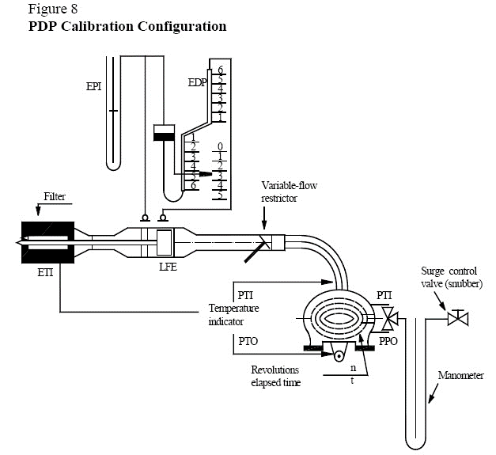  Figure B.5.8.-3 PDP calibration configuration
2.2.5. | After the system has been connected as shown in Figure B.5.8.-3, set the variable restrictor in the wide-open position and run the CVS pump for 20 minutes before starting the calibration.
2.2.6. | Reset the restrictor valve to a more restricted condition in an increment of pump inlet depression (about 1 kPa) that will yield a minimum of six data points for the total calibration. Allow the system to stabilise for three minutes and repeat the data acquisition.
2.2.7. | The air flow rate (Qs) at each test point is calculated in standard m³/min from the flow-meter data using the manufacturer’s prescribed method.
2.2.8. | The air flow-rate is then converted to pump flow (V0) in m³/rev at absolute pump inlet temperature and pressure.  Equation B.5.8.-1:  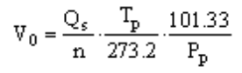  where:  V₀ = pump flow rate at T_{p} and P_{p} (m³/rev);  Qs = air flow at 101.33 kPa and 273.0 K (0.0 °C) in (m³/min);  T_{p} = pump inlet temperature (K);  P_{p} = absolute pump inlet pressure (kPa);  n = pump rotation speed (min-1).
2.2.9. | To compensate for the interaction of pump rotation speed pressure variations at the pump and the pump slip rate, the correlation function (x₀) between the pump rotation speed (n), the pressure differential from pump inlet to pump outlet, and the absolute pump outlet pressure is calculated as follows:  Equation B.5.8.-2:  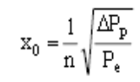  where:  x₀ = correlation function;  ΔP_{p} = pressure differential from pump inlet to pump outlet (kPa);  P_{e} = absolute outlet pressure (PPO + P_{b}) (kPa).
2.2.9.1. | A linear least-square fit is performed to generate the calibration equations which have the formula:  Equation B.5.8.-3:  V₀ = D₀ — M (x₀)  n = A — B (ΔP_{p})  D₀, M, A and B are the slope-intercept constants describing the lines.
2.2.10. | A CVS system that has multiple pump rotation speeds shall be calibrated on each rotation speed used. The calibration curves generated for the ranges shall be approximately parallel and the intercept values (D0) shall increase as the pump flow range decreases.
2.2.11 | If the calibration has been performed carefully, the calculated values from the equation will be within 0.5 percent of the measured value of V0.Values of M will vary from one pump to another. Calibration is performed at pump start-up and after major maintenance.
2.3. | Calibration of the critical-flow venturi (CFV)
2.3.1. | Calibration of the CFV is based on the flow equation for a critical-flow venturi:  Equation B.5.8.-4  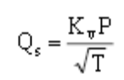  where:  Q_{s} = flow;  K_{v} = calibration coefficient;  P = absolute pressure (kPa);  T = absolute temperature (K).  Gas flow is a function of inlet pressure and temperature. The calibration procedure described in points 2.3.2. to 2.3.7. shall establish the value of the calibration coefficient at measured values of pressure, temperature and air flow.
2.3.2. | The manufacturer’s recommended procedure shall be followed for calibrating electronic portions of the CFV.
2.3.3. | Measurements for flow calibration of the critical-flow venturi are required and the following data shall be found within the limits of precision given:  Barometric pressure (corrected) (Pb) ±0.03 kPa  LFE air temperature, flow-meter (ETI) ±0.15 K (0.15 °C)  Pressure depression upstream of LFE (EPI) ±0.01 kPa  Pressure drop across (EDP) LFE matrix ±0.0015 kPa  Air flow (Qs) ±0.5 percent  CFV inlet depression (PPI) ±0.02 kPa  Temperature at venturi inlet (Tv) ±0.2 K (0.2 °C).
2.3.4. | The equipment shall be set up as shown in Figure B.5.8.-4 and checked for leaks. Any leaks between the flow-measuring device and the critical-flow venturi will seriously affect the accuracy of the calibration.  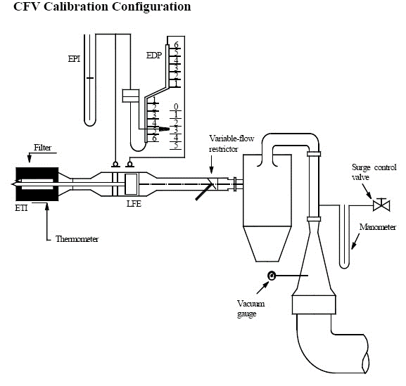  Figure B.5.8.-4 CFV calibration configuration
2.3.5. | The variable-flow restrictor shall be set to the open position, the blower shall be started and the system stabilised. Data from all instruments shall be recorded.
2.3.6. | The flow restrictor shall be varied and at least eight readings shall be taken across the critical flow range of the venturi.
2.3.7. | The data recorded during the calibration shall be used in the following calculations. The air flow-rate (Qs) at each test point is calculated from the flow-meter data using the manufacturer’s prescribed method. Calculate values of the calibration coefficient (K_{v)} for each test point:  Equation B.5.8.-5:  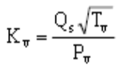  where:  Q_{s} = flow-rate in m³/min at 273.0 K (0.0 °C) and 101.3 kPa;  T_{v} = temperature at the venturi inlet (K);  P_{v} = absolute pressure at the venturi inlet (kPa).  Plot K_{v} as a function of venturi inlet pressure. For sonic flow, K_{v} will have a relatively constant value. As pressure decreases (vacuum increases), the venturi becomes unchoked and K_{v} decreases. The resultant K_{v} changes are not permissible. For a minimum of eight points in the critical region, calculate an average K_{v} and the standard deviation. If the standard deviation exceeds 0.3 percent of the average K_{v}, take corrective action.
3. | System verification procedure
3.1. | General requirements  The total accuracy of the CVS sampling system and analytical system shall be determined by introducing a known mass of a pollutant gas into the system while it is being operated as if during a normal test and then analysing and calculating the pollutant mass according to the formula in point 4, except that the density of propane shall be taken as 1.967 grams per litre at standard conditions. The two techniques described in points 3.2. and 3.3. are known to give sufficient accuracy. The maximum permissible deviation between the quantity of gas introduced and the quantity of gas measured is 5 percent.
3.2. | CFO method
3.2.1. | Metering a constant flow of pure gas (CO or C₃H₈) using a critical-flow orifice device
3.2.2. | A known quantity of pure gas (CO or C₃H₈) is fed into the CVS system through the calibrated critical orifice. If the inlet pressure is high enough, the flow-rate (q), which is adjusted by means of the critical-flow orifice, is independent of orifice outlet pressure (critical flow). If deviations exceeding 5 percent occur, the cause of the malfunction shall be determined and corrected. The CVS system is operated as in an exhaust emission test for about five to ten minutes. The gas collected in the sampling bag is analysed by the usual equipment and the results compared to the concentration of the gas samples which was known beforehand.
3.3. | Gravimetric method
3.3.1. | Metering a limited quantity of pure gas (CO or C₃H₈) by means of a gravimetric technique
3.3.2. | The following gravimetric procedure may be used to verify the CVS system. The weight of a small cylinder filled with either carbon monoxide or propane is determined with a precision of ±0.01 g. For about five to ten minutes, the CVS system is operated as in a normal exhaust emission test, while CO or propane is injected into the system. The quantity of pure gas involved is determined by means of differential weighing. The gas accumulated in the bag is analysed using the equipment normally used for exhaust-gas analysis. The results are then compared to the concentration figures computed previously.

B.5.9. | Annex: [approval] / [certification] tests of a replacement pollution-control device type as separate technical unit
1. | Scope of the annex  This Annex applies to the [approval] / [certification] of pollution-control devices as separate technical units to be fitted as replacement parts on one or more types of vehicle.
2. | Application for environmental performance [approval] / [certification]
2.1. | Applications for [approval] / [certification] of a type of replacement pollution-control device as a separate technical unit shall be submitted by the manufacturer of the system or by his authorised representative.
2.2. | A model for the information document is referred to in Annex B.5.11.
2.3. | For each type of replacement pollution-control device for which [approval] / [certification] is requested, the [approval] / [certification] application shall be accompanied by the following documents in triplicate, and by the following particulars:
2.3.1. | A description of the types of vehicles for which the device is intended, in terms of its characteristics;
2.3.2. | The numbers or symbols specific to the propulsion unit and vehicle type;
2.3.3. | Description of the replacement catalytic converter type stating the relative position of each of its components, together with the fitting instructions;
2.3.4. | Drawings of each component to facilitate location and identification, and statement of materials used. These drawings shall also indicate the intended location of the mandatory [approval] / [certification] mark.
2.4. | The following shall be submitted to the technical service responsible for the [approval] / [certification] test:
2.4.1. | Vehicle(s) of a type [approved] / [certified] in accordance with this annex equipped with a new original equipment pollution-control device type. This (these) vehicles shall be selected by the applicant with the agreement of the technical service to the satisfaction of the [approval authority] / [certification authority]. It (they) shall comply with the requirements of the type I test set out in section B.2.
2.4.2 | The test vehicles shall be without emission-control system defects and be properly maintained and used; any excessively worn out or malfunctioning emission-related original part shall be repaired or replaced. The test vehicles shall be tuned properly and set to the manufacturer’s specification prior to emission testing.
2.4.3. | One sample of the type of the replacement pollution-control device type. This sample shall be clearly and indelibly marked with the applicant’s trade name or mark and its commercial designation.
3. | Requirements
3.1. | General requirements  The design, construction and mounting of the replacement pollution-control device type shall be such that:
3.1.1. | the vehicle complies with the requirements of this GTR under normal conditions of use, and in particular regardless of any vibrations to which it may be subjected;
3.1.2. | the replacement pollution-control device displays reasonable resistance to the corrosion phenomena to which it is exposed, with due regard to the normal conditions of use of the vehicle;
3.1.3. | the ground clearance available with the original equipment pollution-control device type and the angle at which the vehicle can lean over are not reduced;
3.1.4. | the surface of the device does not reach unduly high temperatures;
3.1.5. | the outline of the device has no projections or sharp edges;
3.1.6. | shock absorbers and suspension have adequate clearance;
3.1.7. | adequate safety clearance is provided for pipes;
3.1.8. | the replacement pollution-control device is impact-resistant in a way that is compatible with clearly-defined maintenance and installation requirements;
3.1.9. | if the original equipment pollution-control includes thermal protection, the replacement pollution-control device shall include equivalent protection;
3.1.10. | if (an) oxygen probe(s) and other sensors or actuators are originally installed on the exhaust line, the replacement pollution-control device type shall be installed at exactly the same position as the original equipment pollution-control device and the position on the exhaust line of the oxygen probe(s) and other sensors or actuators shall not be modified.
3.2. | Requirements regarding emissions
3.2.1. | The vehicle referred to in point 2.4.1, equipped with a replacement pollution-control device of the type for which [approval] / [certification] is requested, shall undergo the tests laid down in sections B.2., B.3, B.4. and B.4. (depending on the [approval] / [certification] of the vehicle).
3.2.1.1. | Evaluation of pollutant emissions from vehicles equipped with replacement pollution-control devices  Requirements regarding tailpipe or evaporative emissions are deemed to be complied with if the test vehicle equipped with the replacement pollutant-control device complies with the limit values in point 9. of section B.1. (according to the [approval] / [certification] of the vehicle)Error: Reference source not found.
3.2.1.2. | Where the [approval] / [certification] application is for different types of vehicles from the same manufacturer, the type I test may be limited to as few as two vehicles selected after agreement with the technical service to the satisfaction of the [approval authority] / [certification authority], provided that the different types of vehicle are fitted with the same type of original equipment pollution-control device.
3.2.2. | Requirements regarding permissible sound level  The vehicles referred to in point 2.4.1, equipped with a replacement pollution-control device type that could allow worse noise emissions than the type for which [approval] / [certification] is requested, shall satisfy the applicable requirements of UN Regulations No 9, 41, 63 or 92. The test result for the vehicle in motion and for the stationary test shall be mentioned in the test report.
3.3. | Testing of the propulsion unit performance of the vehicle
3.3.1. | The replacement pollution-control device type shall be such as to ensure that the propulsion unit performance of the vehicle is comparable with that achieved with the original equipment pollution-control device type.
3.3.2. | The propulsion unit performance of the vehicle equipped with the replacement pollution-control device shall be compared with that of an original equipment pollution-control device, also in new condition, fitted in turn to the vehicle referred to in point 2.4.1.
3.3.3. | The maximum net power and maximum net torque as well as the maximum design vehicle speed, if applicable, measured with the replacement pollution-control device, shall not deviate by more than + 5% from those measured under the same conditions with the [approved] / [certified] original equipment pollution-control device type.

B.5.10. | Annex: vehicle propulsion unit family with regard to environmental performance demonstration tests
1. | Introduction
1.1. | In order to alleviate the test burden on manufacturers when demonstrating the environmental performance of vehicles these may be grouped as a vehicle propulsion unit family. One or more parent vehicles shall be selected from this group of vehicles by the manufacturer to the satisfaction of the [approval authority] / [certification authority] that shall be used to demonstrate environmental performance test types I, II and VII.
1.2. | A light motor vehicle may continue to be regarded as belonging to the same vehicle propulsion unit family provided that the vehicle variant, version, propulsion unit, pollution-control system listed in table B.5.10.-1 are identical or remain within the prescribed and declared tolerances.
1.3. | Vehicle and propulsion unit family attribution with regard to environmental tests  For the environmental test types I, II and VII a representative parent vehicle shall be selected within the boundaries set by the classification criteria laid down in point 2.
2. | Classification criteria

(‘X’ in the following table means ‘applicable’)
# | Classification criteria description |  | Test type I | Test type II | Test type VII
1. |  | Vehicle
1.1. |  | category; | X | X | X
1.2. |  | sub-category; | X | X | X
1.3. |  | the inertia of a vehicle variant(s) or version(s) within two inertia categories above or below the nominal inertia category; | X |  | X
1.4. |  | overall gear ratios (+/- 8%); | X |  | X
2. |  | Propulsion family characteristics
2.1. |  | number of engines or electric motors; | X | X | X
2.2. |  | hybrid operation mode(s) (parallel / sequential / other); | X | X | X
2.3. |  | number of cylinders of the combustion engine; | X | X | X
2.4. |  | engine capacity (+/- 2 %)⁽¹⁾ of the combustion engine; | X | X | X
2.5. |  | number and control (variable cam phasing or lift) of combustion engine valves; | X | X | X
2.6. |  | monofuel / bifuel / flex fuel H₂NG / multifuel; | X | X | X
2.7. |  | fuel system (carburettor / scavenging port / port fuel injection / direct fuel injection / common rail / pump-injector / other); | X | X | X
2.8. |  | fuel storage⁽²⁾;
2.9. |  | type of cooling system of combustion engine; | X | X | X
2.10. |  | combustion cycle (PI / CI / two-stroke / four-stroke / other); | X | X | X
2.11. |  | intake air system (naturally aspirated / charged (turbocharger / super-charger) / intercooler / boost control) and air induction control (mechanical throttle / electronic throttle control / no throttle); | X | X | X
3. |  | Pollution control system characteristics
3.1. |  | propulsion unit exhaust (not) equipped with catalytic converter(s); | X | X | X
3.1. |  | catalytic converter(s) type; | X | X | X
3.1.1. |  | number and elements of catalytic converters; | X | X | X
3.1.2. |  | size of catalytic converters (volume of monolith(s) +/- 15 %); | X | X | X
3.1.3. |  | operation principle of catalytic activity (oxidising, three-way, heated, SCR, other.); | X | X | X
3.1.4. |  | precious metal load (identical or higher); | X | X | X
3.1. |  | precious metal ratio (+/- 15 %); | X | X | X
3.1.5. |  | substrate (structure and material); | X | X | X
3.1.6. |  | cell density; | X | X | X
3.1.7. |  | type of casing for the catalytic converter(s); | X | X | X
3.2. |  | propulsion unit exhaust (not) equipped with particulate filter (PF); | X | X | X
3.2.1. |  | PF types; | X | X | X
3.2.2. |  | number and elements of PF; | X | X | X
3.2.3. |  | size of PF (volume of filter element +/- 10 %); | X | X | X
3.2.4. |  | operation principle of PF (partial / wall-flow / other); | X | X | X
3.2.5. |  | active surface of PF; | X | X | X
3.3. |  | Propulsion unit (not) equipped with periodically regenerating system; | X | X | X
3.3.1. |  | periodically regenerating system type; | X | X | X
3.3.2. |  | operation principle of periodically regenerating system; | X | X | X
3.4. |  | propulsion (not) equipped with selective catalytic converter reduction (SCR) system; | X | X | X
3.4.1. |  | SCR system type; | X | X | X
3.4.2. |  | operation principle of periodically regenerating system; | X | X | X
3.5. |  | Propulsion unit (not) equipped with lean NOx trap /absorber; | X | X | X
3.5.1. |  | lean NOx trap / absorber type; | X | X | X
3.5.2. |  | operation principle of lean NOx trap / absorber; | X | X | X
3.6. |  | Propulsion unit (not) equipped with a cold-start device or starting aid device(s); | X | X | X
3.6.1. |  | cold-start or starting aid device type; | X | X | X
3.6.2. |  | operation principle of cold start or starting aid device(s); | X | X | X
3.6.3. |  | Activation time of cold-start or starting aid device(s) and /or duty cycle (only limited time activated after cold start / continuous operation); | X | X | X
3.7. |  | propulsion unit (not) equipped with O₂ sensor for fuel control; | X | X | X
3.7.1. |  | O₂ sensor types; | X | X | X
3.7.2. |  | operation principle of O₂ sensor (binary / wide range / other); | X | X | X
3.7.3. |  | O₂ sensor interaction with closed-loop fuelling system (stoichiometry / lean or rich operation); | X | X | X
3.8. |  | propulsion unit (not) equipped with exhaust gas recirculation (EGR) system; | X | X | X
3.8.1. |  | EGR system types; | X | X | X
3.8.2. |  | operation principle of EGR system (internal / external); | X | X | X
3.8.3. |  | maximum EGR rate (+/- 5 %); | X | X | X

Explanatory notes:
(1) maximum 30% acceptable for test type VIII
(2) Only for vehicles equipped with storage for gaseous fuel
Table B.5.10.-1: Classification criteria propulsion unit family with regard to test types I, II and VII

B.5.11. |  |  |  |  | Annex: information document containing the essential characteristics of the propulsion units and the pollutant control systems
1. |  |  |  |  | The manufacturer shall complete the applicable item numbers of the list below, and submit it as part of the information folder.
Item No. | (Sub) categories |  |  |  |  |  | Detailed information
0. |  |  |  |  |  |  | GENERAL INFORMATION
A. |  |  |  |  |  |  | General information concerning vehicles
0.1. | L1e — L7e |  |  |  |  |  | Make (trade name of manufacturer):
0.2. | L1e — L7e |  |  |  |  |  | Type:
0.2.1 | L1e — L7e |  |  |  |  |  | Variant(s):
0.2.2 | L1e — L7e |  |  |  |  |  | Version(s):
0.2.3. | L1e — L7e |  |  |  |  |  | Commercial name(s) (if available):
0.3. | L1e — L7e |  |  |  |  |  | Category, subcategory and sub-subcategory of vehicle:
0.4. | L1e — L7e |  |  |  |  |  | Company name and address of manufacturer:
0.4.1. | L1e — L7e |  |  |  |  |  | Name(s) and address(es) of assembly plants:………………………………………………….
0.4.2. | L1e — L7e |  |  |  |  |  | Name and address of manufacturer’s authorised representative, if any:……………………..
0.5. |  |  | L1e — L7e |  |  |  |  |  |  | Manufacturer’s statutory plate(s): :
0.5.1. |  |  | L1e — L7e |  |  |  |  |  |  | Location of the manufacturer's statutory plate:
0.5.2. |  |  | L1e — L7e |  |  |  |  |  |  | Method of attachment:
0.5.3. | L1e — L7e |  |  |  |  |  | Photographs and/or drawings of the statutory plate (completed example with dimensions):
0.6. | L1e — L7e |  |  |  |  |  | Location of the vehicle identification number:
0.6.1. | L1e — L7e |  |  |  |  |  | Photographs and/or drawings of the locations of the vehicle identification number (completed example with dimensions):
0.6.1.1. |  |  | L1e — L7e |  |  |  |  | The serial number of the type begins with:
B. |  |  |  |  |  |  |  |  |  | General information concerning systems, components or separate technical units
0.7. |  |  | L1e — L7e |  |  |  |  |  |  | Make(s) (trade name(s) of manufacturer):
0.8. |  |  | L1e — L7e |  |  |  |  |  |  | Type:
0.8.1. |  |  | L1e — L7e |  |  |  |  |  |  | Commercial name(s) (if available):
0.8.2. |  |  | L1e — L7e |  |  |  |  |  |  | Type-approval number(s) (if available):
0.8.3. |  |  | L1e — L7e |  |  |  |  |  |  | Type-approval(s) issued on (date, if available):
0.9. | L1e — L7e |  |  |  |  |  | Company name and address of manufacturer:
0.9.1. | L1e — L7e |  |  |  |  |  | Name(s) and address(es) of assembly plants:………………………………………………
0.9.2. | L1e — L7e |  |  |  |  |  | Name and address of manufacturer’s authorised representative, if any:……………………..
0.10. |  |  |  |  |  |  |  |  |  | Vehicle(s) for which the system/separate technical unit is intended for⁽²¹⁾:
0.10.1. |  |  | L1e — L7e |  |  |  |  |  |  | Type:
0.10.2. |  |  | L1e — L7e |  |  |  |  |  |  | Variant:
0.10.3. |  |  | L1e — L7e |  |  |  |  |  |  | Version:
0.10.4. |  |  | L1e — L7e |  |  |  |  |  |  | Commercial name(s) (if available):
0.10.5. |  |  | L1e — L7e |  |  |  |  |  |  | Category, subcategory and sub-subcategory of vehicle:
0.11. |  |  | L1e — L7e |  |  |  |  |  |  | Type-approval marks for components and separate technical units:
0.11.1. |  |  | L1e — L7e |  |  |  |  |  |  | Method of attachment:
0.11.2. |  |  | L1e — L7e |  |  |  |  |  |  | Photographs and/or drawings of the location of the type-approval mark (completed example with dimensions):
C. |  |  |  |  |  |  |  |  |  | General information regarding conformity of production
0.12. |  |  |  |  |  |  | Conformity of production
0.12.1. | L1e — L7e |  |  |  |  |  | Description of overall quality-assurance management systems.
1. |  |  |  |  |  |  |  |  | GENERAL CONSTRUCTION CHARACTERISTICS
1.1. |  | L1e — L7e |  |  |  |  |  |  | Photographs and/or drawings of a representative vehicle:
1.2. |  | L1e — L7e |  |  |  |  |  |  | Scale drawing of the whole vehicle:
1.3. |  | L1e — L7e |  |  |  |  |  |  | Number of axles and wheels:
1.3.1. |  | L1e — L7e |  |  |  |  |  |  | Axles with twinned wheels:
1.3.2. |  | L1e — L7e |  |  |  |  |  |  | Powered axles:
1.4. |  | L1e — L7e |  |  |  |  |  |  | Chassis (if any) (overall drawing):
1.5. |  | L2e,  L5e-B, L6e-B, L7e-A2, L7e-B2, L7e-C |  |  |  |  |  |  | Material used for the bodywork:
1.6. |  | L1e — L7e |  |  |  |  |  |  | Position and arrangement of the propulsion unit(s):
1.7. |  | L4e,  L5e-B, L6e-B, L7e-A2, L7e-B2, L7e-C |  |  |  |  |  |  | Hand of drive: left/right/centre⁽⁴⁾:
1.7.1. |  | L1e — L7e |  |  |  |  |  |  | Vehicle is equipped to be driven in right/left-hand traffic and in countries that use metric/metric and imperial units.⁽⁴⁾: .
1.8. |  |  |  |  |  |  |  |  | Propulsion unit performance
1.8.1. |  | L3e, L4e, L5e, L7e-A, L7e-B2 |  |  |  |  |  |  | Declared maximum vehicle speed: km/h
1.8.2. |  | L1e, L2e, L6e, L7e-B1, L7e-C |  |  |  |  |  |  | Maximum design vehicle speed ⁽²²⁾: ….. km/h and gear in which it is reached:…….
1.8.3. |  | L1e — L7e |  |  |  |  |  |  | Maximum net power combustion engine: ...... kW at ...... min⁻¹ at A/F ratio:......
1.8.4. |  | L1e — L7e |  |  |  |  |  |  | Maximum net torque combustion engine: ......Nm at ......min⁻¹ at A/F ratio:......
1.8.5. |  | L1e — L7e |  |  |  |  |  |  | Maximum continuous-rated power electric motor (15/30 minutes power): ...... kW at ...... min⁻¹
1.8.6. |  | L1e — L7e |  |  |  |  |  |  | Maximum continuous-rated torque electric motor: ...... Nm at ...... min⁻¹
1.8.7. |  | L1e — L7e |  |  |  |  |  |  | Maximum continuous total power for propulsion unit(s):...... kW at ...... min⁻¹ at A/F ratio:......
1.8.8. |  | L1e — L7e |  |  |  |  |  |  | Maximum continuous total torque for propulsion unit(s): ...... Nm at ...... min⁻¹at A/F ratio:......
1.8.9. |  | L1e — L7e |  |  |  |  |  |  | Maximum peak power for propulsion unit(s): ...... kW at ...... min⁻¹at A/F ratio:......
2. |  |  |  |  |  |  |  |  |  |  | MASSES AND DIMENSIONS  (in kg and mm.) refer to drawings where applicable
2.1 |  |  |  |  |  |  |  |  |  |  | Range of vehicle mass (overall)
2.1.1. |  |  |  |  |  | L1e — L7e |  |  |  |  | Mass in running order: ...... kg
2.1.1.1. |  |  |  |  |  | L1e — L7e |  |  |  |  | Distribution of mass in running order between the axles: ...... kg
2.1.2. |  |  |  |  |  | L1e — L7e |  |  |  |  | Actual mass: ...... kg
2.1.8. |  |  |  |  |  | L1e — L7e |  |  |  |  | Mass of the optional equipment:...... kg
2.1.9. |  |  |  |  |  | L1e — L7e |  |  |  |  | Mass of the superstructure:...... kg
2.1.10. |  |  |  |  |  | L1e — L7e |  |  |  |  | Mass of the propulsion battery:..... kg
2.1.11. |  |  |  |  |  | L2e, L4e, L5e, L6e, L7e |  |  |  |  | Mass of the doors:..... kg
2.1.12. |  |  |  |  |  | L2e-U, L5e-B, L6e-BU, L7e-CU |  |  |  |  | Mass of the machines or equipment installed on the load platform area:..... kg
2.1.13. |  |  |  |  |  | L1e — L7e |  |  |  |  | Mass of the gaseous fuel system as well as storage tanks for gaseous fuel:..... kg
2.1.14. |  |  |  |  |  | L1e — L7e |  |  |  |  | Mass of the storage tanks to store compressed air:..... kg
2.1.15. |  |  |  |  |  | L1e — L7e |  |  |  |  | Reference mass:..... kg
2.2. |  |  |  |  |  |  |  |  |  |  | Range of vehicle dimensions (overall)
2.2.1. |  |  |  |  |  | L1e — L7e |  |  |  |  | Length:...... mm
2.2.2. |  |  |  |  |  | L1e — L7e |  |  |  |  | Width:...... mm
2.2.3. |  |  |  |  |  | L1e — L7e |  |  |  |  | Height:...... mm
2.2.4. |  |  |  |  |  | L1e — L7e |  |  |  |  | Wheelbase:...... mm
2.2.4.1. |  |  |  |  |  | L4e |  |  |  |  | Wheelbase sidecar: ……. mm
2.2.5. |  |  |  |  |  |  |  |  |  |  | Track width
2.2.5.1. |  |  |  |  |  | L1e — L7e if equipped with twinned wheels  L2e, L4e, L5e, L6e, L7e |  |  |  |  | Track width front: ...... mm.
2.2.5.2. |  |  |  |  |  | L1e — L7e if equipped with twinned wheels |  |  |  |  | Track width rear: ...... mm.
2.2.5.3. |  |  |  |  |  | L2e, L4e, L5e, L6e, L7e |  |  |  |  | Track width sidecar: ...... mm.
2.2.6. |  |  |  |  |  | L7e-B |  |  |  |  | Front overhang: ...... mm.
2.2.7. |  |  |  |  |  | L7e-B |  |  |  |  | Rear overhang: ...... mm.
2.2.8. |  |  |  |  |  |  |  |  |  |  | Load platform dimensions
2.2.8.1. |  |  |  |  |  | L2e-U, L5e-B, L6e-BU, L7e-B2, L7e-CU |  |  |  |  | Length of the load platform:...... mm
2.2.8.2. |  |  |  |  |  | L2e-U, L5e-B, L6e-BU, L7e-B2, L7e-CU |  |  |  |  | Width of load platform:...... mm
2.2.8.3. |  |  |  |  |  | L2e-U, L5e-B, L6e-BU, L7e-B2, L7e-CU |  |  |  |  | Height of load platform:...... mm
2.2.9.9. |  |  |  |  |  | L3e-AxE, L3e-AxT |  |  |  |  | Seat height: ……. mm
2.2.9.10. |  |  |  |  |  | L3e-AxE, L3e-AxT |  |  |  |  | Ground clearance: ……. mm
3. |  |  |  |  |  |  |  |  |  |  | GENERAL POWERTRAIN CHARACTERISTICS
3.1 |  |  |  |  |  |  |  |  |  |  | Manufacturer of the propulsion unit
3.1.1. |  |  |  |  |  |  |  |  |  |  | Combustion engine
3.1.1.1. |  |  |  |  |  | L1e — L7e |  |  |  |  | Manufacturer:
3.1.1.2. |  |  |  |  |  | L1e — L7e |  |  |  |  | Engine code (as marked on the engine or other means of identification):
3.1.1.3. |  |  |  |  |  | L1e — L7e |  |  |  |  | Fuel identification marking (if available):
3.1.2. |  |  |  |  |  |  |  |  |  |  | Electric motor
3.1.2.1. |  |  |  |  |  | L1e — L7e |  |  |  |  | Manufacturer:
3.1.2.2. |  |  |  |  |  | L1e — L7e |  |  |  |  | Electric motor code (as marked on the engine or other means of identification):
3.1.3. |  |  |  |  |  |  |  |  |  |  | Hybrid application
3.1.3.1. |  |  |  |  |  | L1e — L7e |  |  |  |  | Manufacturer:
3.1.3.2. |  |  |  |  |  | L1e — L7e |  |  |  |  | Application code (as marked on the engine or other means of identification):
3.1.3.3. |  |  |  |  |  | L1e — L7e |  |  |  |  | Fuel identification marking (if available):
3.1.3.4. |  |  |  |  |  | L1e — L7e |  |  |  |  |  | Photographs and/or drawings of the location of the code(s) and/or type-approval numbers (completed example with dimensions)⁽²⁰⁾:
3.2. |  |  |  |  |  |  |  |  |  |  | Combustion engine
3.2.1. |  |  |  |  |  |  |  |  |  |  | Specific engine information
3.2.1.1. |  |  |  |  |  | L1e — L7e |  |  |  |  | Number of combustion engines:
3.2.1.2. |  |  |  |  |  | L1e — L7e |  |  |  |  | Working principle: internal combustion engine (ICE)/positive ignition/compression ignition /external combustion engine (ECE)/turbine/compressed air⁽⁴⁾:
3.2.1.3. |  |  |  |  |  | L1e — L7e |  |  |  |  | Cycle: four-stroke/two-stroke/rotary/other:
3.2.1.4. |  |  |  |  |  | L1e — L7e |  |  |  |  | Cylinders
3.2.1.4.1. |  |  |  |  |  | L1e — L7e |  |  |  |  | Number: …..
3.2.1.4.2. |  |  |  |  |  | L1e — L7e |  |  |  |  | Arrangement: ….
3.2.1.4.3. |  |  |  |  |  | L1e — L7e |  |  |  |  | Bore: ...... mm
3.2.1.4.4. |  |  |  |  |  | L1e — L7e |  |  |  |  | Stroke:...... mm
3.2.1.4.5. |  |  |  |  |  | L1e — L7e |  |  |  |  | Number and configuration of stators in the case of rotary-piston engine:
3.2.1.4.6. |  |  |  |  |  | L1e — L7e |  |  |  |  | Volume of combustion chambers in the case of rotary-piston engine: ………..cm³
3.2.1.4.7. |  |  |  |  |  | L1e — L7e |  |  |  |  | Firing order:
3.2.1.5. |  |  |  |  |  | L1e — L7e |  |  |  |  | Engine capacity: ......cm³
3.2.1.6. |  |  |  |  |  | L1e — L7e |  |  |  |  | Volumetric compression ratio:
3.2.1.7. |  |  |  |  |  | L1e — L7e |  |  |  |  | Number of inlet and exhaust valves
* 3.2.1.7.1. |  |  |  |  |  | L1e — L7e |  |  |  |  | Number and minimum cross-sectional areas of inlet and outlet ports:
* 3.2.1.7.2. |  |  |  |  |  | L1e — L7e |  |  |  |  | Valve timing or equivalent data:
* 3.2.1.7.3. |  |  |  |  |  | L1e — L7e |  |  |  |  | Maximum lift of valves, angles of opening and closing, or timing details of alternative distribution systems, in relation to dead centres. For variable timing system, minimum and maximum timing:
* 3.2.1.7.4. |  |  |  |  |  | L1e — L7e |  |  |  |  | Reference and/or setting ranges:
3.2.1.8. |  |  |  |  |  | L1e — L7e |  |  |  |  | Drawings of combustion chamber, cylinder head, piston, piston rings:
3.2.1.9. |  |  |  |  |  | L1e — L7e |  |  |  |  | Normal warm engine idling speed: ...... min⁻¹
3.2.1.10. |  |  |  |  |  | L1e — L7e |  |  |  |  | Stop-start system: yes/no
*3.2.2. |  |  |  |  |  |  |  |  |  |  | Powertrain/propulsion unit/drive-train management system
3.2.2.1. |  |  |  |  |  | L1e — L7e |  |  |  |  | PCUs/ECUs software identification number(s):………… and calibration verification number(s) :……….
3.2.3. |  |  |  |  |  |  |  |  |  |  | Fuel
3.2.3.1. |  |  |  |  |  | L1e — L7e |  |  |  |  | Fuel type:
3.2.3.2.. |  |  |  |  |  | L1e — L7e |  |  |  |  | Vehicle fuel configuration: mono-fuel/bi- fuel/flex fuel
3.2.3.2.1. |  |  |  |  |  | L1e — L7e |  |  |  |  | Maximum amount of bio-fuel acceptable in fuel: ……..% by volume
3.2.4. |  |  |  |  |  |  |  |  |  |  | Fuel pressure delivery and control
3.2.4.1. |  |  |  |  |  | L1e — L7e |  |  |  |  | Brief description and schematic drawing of low-and/or high-pressure fuelling wet system(s):
3.2.4.2. |  |  |  |  |  | L1e — L7e |  |  |  |  | Low- and/or high-pressure fuel pump(s): yes/no
3.2.4.2.1. |  |  |  |  |  | L1e — L7e |  |  |  |  | Fuel pump control: mechanical/on/off electric/continuous operation/electronically controlled variable operation:
3.2.4.2.2. |  |  |  |  |  | L1e — L7e |  |  |  |  | For CI combustion engines and dual fuel engines only maximum fuel delivery: ...... g/s or mm³/stroke or cycle at an engine speed of:…min⁻¹ or, alternatively, a characteristic diagram:  (When boost control is supplied, state the characteristic fuel delivery and boost pressure versus engine speed)
3.2.4.3. |  |  |  |  |  | L1e — L7e |  |  |  |  | Common rail: yes/no
3.2.4.4. |  |  |  |  |  | L1e — L7e |  |  |  |  | Fuel distributor/rail/hoses: yes/no
3.2.4.5. |  |  |  |  |  | L1e — L7e |  |  |  |  | Fuel pressure and/or fuel flow regulator(s): yes/no
3.2.5. |  |  |  |  |  |  |  |  |  |  | Fuel mass metering and control
3.2.5.1. |  |  |  |  |  | L1e — L7e |  |  |  |  | By carburettor(s): yes/no
* 3.2.5.1.1. |  |  |  |  |  | L1e — L7e |  |  |  |  | Operating principle and construction:
* 3.2.5.1.2. |  |  |  |  |  | L1e — L7e |  |  |  |  | Maximum fuel-flow rate: ...... g/s at maximum power and torque:
3.2.5.1.3. |  |  |  |  |  | L1e — L7e |  |  |  |  | Carburettor(s) settings:
* 3.2.5.1.4. |  |  |  |  |  | L1e — L7e |  |  |  |  | Carburettor diffusers:
* 3.2.5.1.5. |  |  |  |  |  | L1e — L7e |  |  |  |  | Carburettor fuel-level in float chamber:
* 3.2.5.1.5.1. |  |  |  |  |  | L1e — L7e |  |  |  |  | Carburettor mass of float:
3.2.5.1.6. |  |  |  |  |  | L1e — L7e |  |  |  |  | Carburettor cold-starting system: manual/automatic: yes/no
3.2.5.1.6.1. |  |  |  |  |  | L1e — L7e |  |  |  |  | Carburettor cold-starting system operating principle(s):
3.2.5.1.7. |  |  |  |  |  | L1e — L7e |  |  |  |  | Mixture scavenging port: yes/no
3.2.5.1.7.1. |  |  |  |  |  | L1e — L7e |  |  |  |  | Mixture scavenging port dimensions:
3.2.5.2. |  |  |  |  |  | L1e — L7e |  |  |  |  | By mechanically/hydraulically controlled fuel injection: yes/no
3.2.5.2.1. |  |  |  |  |  | L1e — L7e |  |  |  |  | Operation principle:
3.2.5.2.2. |  |  |  |  |  | L1e — L7e |  |  |  |  | Mechanical/electronic adjustment of maximum fuel mass delivery: yes/no
3.2.5.3. |  |  |  |  |  | L1e — L7e |  |  |  |  | By electronically controlled fuel injection system: yes/no
3.2.5.3.1. |  |  |  |  |  | L1e — L7e |  |  |  |  | Operation principle: port injection/direct injection/pre-chamber/swirl chamber:
3.2.5.3.2. |  |  |  |  |  | L1e — L7e |  |  |  |  | Fuel injector(s): single-/multi-point/direct injection/other (specify):
3.2.5.3.3. |  |  |  |  |  | L1e — L7e |  |  |  |  | Total and per cylinder amount of fuel injectors:
3.2.5.4. |  |  |  |  |  | L1e — L7e |  |  |  |  | Air-assisted fuel injector: yes/no:
3.2.5.4.1. |  |  |  |  |  | L1e — L7e |  |  |  |  | Description and operating pressure of air-assist:
3.2.5.5. |  |  |  |  |  | L1e — L7e |  |  |  |  | Cold start system: yes/no
3.2.5.5.1. |  |  |  |  |  | L1e — L7e |  |  |  |  | Description of cold start system:
3.2.5.6. |  |  |  |  |  | L1e — L7e |  |  |  |  | Auxiliary starting aid: yes/no
3.2.5.7. |  |  |  |  |  | L1e — L7e |  |  |  |  | CI injection specific: yes/no
3.2.5.7.1. |  |  |  |  |  | L1e — L7e |  |  |  |  | Static injection timing:
3.2.5.7.2. |  |  |  |  |  | L1e — L7e |  |  |  |  | Injection advance curve:
3.2.6. |  |  |  |  |  |  |  |  |  |  | Gaseous fuelling system and control
3.2.6.1. |  |  |  |  |  | L1e — L7e |  |  |  |  | Brief description and schematic drawing of gaseous fuelling system(s):
3.2.6.2. |  |  |  |  |  | L1e — L7e |  |  |  |  | Liquefied petroleum gas (LPG) fuelling system: yes/no
3.2.6.2.1. |  |  |  |  |  | L1e — L7e |  |  |  |  | Type-approval number according to UN Regulation No 67 :
3.2.6.2.2. |  |  |  |  |  | L1e — L7e |  |  |  |  | Electronic engine management control unit for LPG fuelling: yes/no
3.2.6.2.2.1. |  |  |  |  |  | L1e — L7e |  |  |  |  | Emission-related adjustment possibilities:
3.2.6.2.3. |  |  |  |  |  | L1e — L7e |  |  |  |  | Further documentation:
* 3.2.6.2.3.1. |  |  |  |  |  | L1e — L7e |  |  |  |  | Description of the safeguarding of the catalyst at switch-over from petrol to LPG or back:
3.2.6.2.3.2. |  |  |  |  |  | L1e — L7e |  |  |  |  | System layout (electrical connections, vacuum connections, compensation hoses, etc.):
3.2.6.2.4. |  |  |  |  |  | L1e — L7e |  |  |  |  | Drawing of the symbol:
3.2.6.3. |  |  |  |  |  | L1e — L7e |  |  |  |  | Natural gas (NG) fuelling system: yes/no
3.2.6.3.1. |  |  |  |  |  | L1e — L7e |  |  |  |  | Type-approval number according to UN Regulation No 110:
3.2.6.3.2. |  |  |  |  |  | L1e — L7e |  |  |  |  | Electronic engine management-control unit for NG fuelling: yes/no
3.2.6.3.2.1. |  |  |  |  |  | L1e — L7e |  |  |  |  | Emission-related adjustment possibilities:
3.2.6.3.3.. |  |  |  |  |  | L1e — L7e |  |  |  |  | Further documentation:
* 3.2.6.3.3.1. |  |  |  |  |  | L1e — L7e |  |  |  |  | Description of the safeguarding of the catalyst at switch-over from petrol to NG or back:
3.2.6.3.3.2. |  |  |  |  |  | L1e — L7e |  |  |  |  | System layout (electrical connections, vacuum connections compensation hoses, etc.):
3.2.6.3.4. |  |  |  |  |  | L1e — L7e |  |  |  |  | Drawing of the symbol:
3.2.6.4. |  |  |  |  |  | L1e — L7e |  |  |  |  | Gaseous fuel: LPG/NG-H/NG-L/NG-HL: yes/no
3.2.6.4.1. |  |  |  |  |  | L1e — L7e |  |  |  |  | Pressure regulator(s) or vaporiser/pressure regulator(s)
* 3.2.6.4.1.1. |  |  |  |  |  | L1e — L7e |  |  |  |  | Number of pressure reduction stages:
3.2.6.4.1.2. |  |  |  |  |  | L1e — L7e |  |  |  |  | Pressure in final stage, minimum: …..kPa — maximum: ….kPa
3.2.6.4.1.3. |  |  |  |  |  | L1e — L7e |  |  |  |  | Number of main adjustment points:
3.2.6.4.1.4. |  |  |  |  |  | L1e — L7e |  |  |  |  | Number of idle adjustment points:
3.2.6.4.1.5. |  |  |  |  |  | L1e — L7e |  |  |  |  | Type-approval number:
3.2.6.4.2. |  |  |  |  |  | L1e — L7e |  |  |  |  | Fuelling system: mixing unit/gas injection/liquid injection/direct injection
* 3.2.6.4.2.1. |  |  |  |  |  | L1e — L7e |  |  |  |  | Mixture strength regulation:
3.2.6.4.2.2. |  |  |  |  |  | L1e — L7e |  |  |  |  | System description and/or diagram and drawings:
3.2.6.4.2.3. |  |  |  |  |  | L1e — L7e |  |  |  |  | Type-approval number:
3.2.6.4.3. |  |  |  |  |  | L1e — L7e |  |  |  |  | Mixing unit: yes/no
3.2.6.4.3.1. |  |  |  |  |  | L1e — L7e |  |  |  |  | Number:
3.2.6.4.3.2. |  |  |  |  |  | L1e — L7e |  |  |  |  | Location:
3.2.6.4.3.3. |  |  |  |  |  | L1e — L7e |  |  |  |  | Adjustment possibilities:
3.2.6.4.3.4. |  |  |  |  |  | L1e — L7e |  |  |  |  | Type-approval number:
3.2.6.4.4. |  |  |  |  |  | L1e — L7e |  |  |  |  | Inlet manifold injection: yes/no
3.2.6.4.4.1. |  |  |  |  |  | L1e — L7e |  |  |  |  | Injection: single-point/multi-point
3.2.6.4.4.2. |  |  |  |  |  | L1e — L7e |  |  |  |  | Injection: continuous/simultaneously timed/sequentially timed
3.2.6.4.5. |  |  |  |  |  | L1e — L7e |  |  |  |  | Injection equipment: yes/no
3.2.6.4.5.1. |  |  |  |  |  | L1e — L7e |  |  |  |  | Adjustment possibilities:
3.2.6.4.5.2. |  |  |  |  |  | L1e — L7e |  |  |  |  | Type-approval number:
3.2.6.4.6. |  |  |  |  |  | L1e — L7e |  |  |  |  | Supply pump: yes/no
3.2.6.4.6.1. |  |  |  |  |  | L1e — L7e |  |  |  |  | Type-approval number:
3.2.6.4.7. |  |  |  |  |  | L1e — L7e |  |  |  |  | Injector(s):
3.2.6.4.7.1. |  |  |  |  |  | L1e — L7e |  |  |  |  | Type-approval number:
3.2.6.4.8. |  |  |  |  |  | L1e — L7e |  |  |  |  | Direct/port injection: yes/no
3.2.6.4.9. |  |  |  |  |  | L1e — L7e |  |  |  |  | Injection pump/pressure regulator: yes/no⁾
3.2.6.4.9.1. |  |  |  |  |  | L1e — L7e |  |  |  |  | Type-approval number:
3.2.6.4.10. |  |  |  |  |  | L1e — L7e |  |  |  |  | Separate electronic control unit (ECU) for gaseous fuelling system: yes/no
3.2.6.4.10.1. |  |  |  |  |  | L1e — L7e |  |  |  |  | Adjustment possibilities:
3.2.6.4.10.2. |  |  |  |  |  | L1e — L7e |  |  |  |  | Software identification number(s):
3.2.6.4.10.3. |  |  |  |  |  | L1e — L7e |  |  |  |  | Calibration verification number(s):
3.2.6.5. |  |  |  |  |  | L1e — L7e |  |  |  |  | NG fuel-specific equipment:
3.2.6.5.1. |  |  |  |  |  | L1e — L7e |  |  |  |  | Variant 1 (only in the case of approvals of engines for several specific fuel compositions):
3.2.6.5.2. |  |  |  |  |  | L1e — L7e |  |  |  |  | Fuel composition:
Overview
methane (CH4): | basis: …....%mole | min. ….%mole | max. …..%mole
ethane (C₂H₆): | basis: …....%mole | min. ….%mole | max. …..%mole
propane (C₃H₈): | basis: …....%mole | min. ….%mole | max. …..%mole
butane (C₄H₁₀): | basis: …....%mole | min. ….%mole | max. …..%mole
C₅/C₅+: | basis: …....%mole | min. ….%mole | max. …..%mole
oxygen (O₂): | basis: …....%mole | min. ….%mole | max. …..%mole
inert (N₂, He, etc.): | basis: …....%mole | min. ….%mole | max. …..%mole

3.2.6.5.3. |  |  |  |  |  | L1e — L7e |  |  |  |  | Gaseous fuel injector(s):
3.2.6.5.4. |  |  |  |  |  | L1e — L7e |  |  |  |  | Variant 2 (only in the case of approvals for several specific fuel compositions):
3.2.6.6. |  |  |  |  |  | L1e — L7e |  |  |  |  | Hydrogen fuel-specific equipment: yes/no
3.2.6.6.1. |  |  |  |  |  | L1e — L7e |  |  |  |  | EC type-approval number according to Regulation (EC) No 79/2009 of the European Parliament and of the Council : 3
* 3.2.6.6.2. |  |  |  |  |  | L1e — L7e |  |  |  |  | Further documentation
3.2.6.6.3. |  |  |  |  |  | L1e — L7e⁾ |  |  |  |  | System layout (electrical connections, vacuum connections, compensation hoses, etc.):
* 3.2.6.6.4. |  |  |  |  |  | L1e — L7e |  |  |  |  | Description of the safeguarding of the catalyst at switch-over from petrol to hydrogen/H₂NG⁽⁴⁾ or back:
3.2.6.6.5. |  |  |  |  |  | L1e — L7e |  |  |  |  | Drawing of the symbol:
3.2.6.7. |  |  |  |  |  | L1e — L7e |  |  |  |  | H₂NG fuelling system: yes/no
3.2.6.7.1. |  |  |  |  |  | L1e — L7e |  |  |  |  | Percentage of hydrogen in the fuel (the maximum specified by the manufacturer):
3.2.7. |  |  |  |  |  |  |  |  |  |  | Air-induction system
3.2.7.1. |  |  |  |  |  | L1e — L7e |  |  |  |  | Brief description and schematic drawing of gaseous intake air-flow and induction system:
3.2.7.2. |  |  |  |  |  | L1e — L7e |  |  |  |  | Intake manifold description and working principle (e.g. fixed length/variable length/swirl valves)⁽⁴⁾ (include detailed drawings and/or photos):
* 3.2.7.2.1. |  |  |  |  |  | L1e — L7e |  |  |  |  | Description and drawings of inlet pipes and their accessories (plenum chamber, heating device with control strategy, additional air intakes, etc.):
3.2.7.3. |  |  |  |  |  | L1e — L7e |  |  |  |  | Intake air pressure charger: yes/no
3.2.7.3.1. |  |  |  |  |  | L1e — L7e |  |  |  |  | Brief description and schematic drawing of the intake air-pressure charger system:
3.2.7.3.2. |  |  |  |  |  | L1e — L7e |  |  |  |  | Working and control principles:
3.2.7.3.3. |  |  |  |  |  | L1e — L7e |  |  |  |  | Type(s) (turbo or supercharger, other):
3.2.7.3.4. |  |  |  |  |  | L1e — L7e |  |  |  |  | Maximum intake air-charge pressure and flow-rate at maximum torque and power:......kPa and g/s or charge pressure and flow-rate map:......kPa and g/s
3.2.7.4. |  |  |  |  |  | L1e — L7e |  |  |  |  | Waste gate: yes/no
3.2.7.5. |  |  |  |  |  | L1e — L7e |  |  |  |  | Intercooler: yes/no
3.2.7.5.1. |  |  |  |  |  | L1e — L7e |  |  |  |  | Type: air-air/air-water/other
* 3.2.7.5.2. |  |  |  |  |  | L1e — L7e |  |  |  |  | Intake depression at rated engine speed and at 100 % load (compression ignition engines only):.......... kPa
3.2.7.6. |  |  |  |  |  | L1e — L7e |  |  |  |  | Air filter, (drawings, photographs):
3.2.7.7. |  |  |  |  |  | L1e — L7e |  |  |  |  | Intake air-silencer description (drawings, photographs):
*3.2.7.7.1. |  |  |  |  |  | L1e — L7e |  |  |  |  | Working principle:
3.2.8. |  |  |  |  |  |  |  |  |  |  | Air-mass metering and control
3.2.8.1. |  |  |  |  |  | L1e — L7e |  |  |  |  | Brief description and schematic drawing of air-mass metering and control system:
3.2.8.2. |  |  |  |  |  | L1e — L7e |  |  |  |  | Mechanical throttle body: yes/no
3.2.8.3. |  |  |  |  |  | L1e — L7e |  |  |  |  | Electronic throttle control (ETC): yes/no
3.2.8.3.1. |  |  |  |  |  | L1e — L7e |  |  |  |  | Schematic drawing of electronic throttle control:
* 3.2.8.3.1.2. |  |  |  |  |  | L1e — L7e |  |  |  |  | Description of ETC hardware redundancies regarding sensors/actuators/electric power/ground/control electronics:
3.2.9. |  |  |  |  |  |  |  |  |  |  | Spark delivery system and control
3.2.9.1. |  |  |  |  |  | L1e — L7e |  |  |  |  | Brief description and schematic drawing of spark delivery and control system:
3.2.9.1.1. |  |  |  |  |  | L1e — L7e |  |  |  |  | Working principle:
* 3.2.9.1.2. |  |  |  |  |  | L1e — L7e |  |  |  |  | Ignition advance curve or map at wide open throttle: ………………………….
3.2.9.1.3. |  |  |  |  |  | L1e — L7e |  |  |  |  | Static ignition timing: ...... degrees before TDC at maximum torque and power
3.2.9.2. |  |  |  |  |  | L1e — L7e |  |  |  |  | Ion sense capability: yes/no
3.2.9.3. |  |  |  |  |  | L1e — L7e |  |  |  |  | Spark plugs:
3.2.9.3.1. |  |  |  |  |  | L1e — L7e |  |  |  |  | Gap setting: ……mm
3.2.9.4. |  |  |  |  |  | L1e — L7e |  |  |  |  | Ignition coil(s):
* 3.2.9.4.1. |  |  |  |  |  | L1e — L7e |  |  |  |  | Working principle:
* 3.2.9.4.2. |  |  |  |  |  | L1e — L7e |  |  |  |  | Dwell angle and timing at wide open throttle:
3.2.10. |  |  |  |  |  |  |  |  |  |  | Powertrain cooling system and control
3.2.10.1. |  |  |  |  |  | L1e — L7e |  |  |  |  | Brief description and schematic drawing of powertrain cooling and control system:
3.2.10.2. |  |  |  |  |  | L1e — L7e |  |  |  |  | Cooling system: liquid: yes/no
3.2.10.2.1. |  |  |  |  |  | L1e — L7e |  |  |  |  | Maximum temperature at outlet: ……K
3.2.10.2.2. |  |  |  |  |  | L1e — L7e |  |  |  |  | Nominal setting of the engine temperature control mechanism:
3.2.10.2.3. |  |  |  |  |  | L1e — L7e |  |  |  |  | Nature of liquid:
3.2.10.2.4. |  |  |  |  |  | L1e — L7e |  |  |  |  | Circulating pump(s): yes/no
3.2.10.2.4.1. |  |  |  |  |  | L1e — L7e |  |  |  |  | Characteristics:
3.2.10.2.5. |  |  |  |  |  | L1e — L7e |  |  |  |  | Drive ratio(s):
3.2.10.2.6. |  |  |  |  |  | L1e — L7e |  |  |  |  | Description of the fan and its drive mechanism:
3.2.10.3. |  |  |  |  |  | L1e — L7e |  |  |  |  | Air cooling: yes/no
3.2.10.3.1. |  |  |  |  |  | L1e — L7e |  |  |  |  | Reference point:
3.2.10.3.2. |  |  |  |  |  | L1e — L7e |  |  |  |  | Maximum temperature at reference point: ……K
3.2.10.3.3. |  |  |  |  |  | L1e — L7e⁾ |  |  |  |  | Fan: yes/no
3.2.10.3.3.1. |  |  |  |  |  | L1e — L7e |  |  |  |  | Characteristics:
3.2.10.3.3.2. |  |  |  |  |  | L1e — L7e |  |  |  |  | Drive ratio(s):
3.2.11. |  |  |  |  |  |  |  |  |  |  | Powertrain lubrication system and control
3.2.11.1. |  |  |  |  |  | L1e — L7e |  |  |  |  | Brief description and schematic drawing of powertrain lubrication and control system:
3.2.11.2. |  |  |  |  |  | L1e — L7e |  |  |  |  | Lubrication system configuration(s) (wet sump, dry sump, other, pump/injection into induction system/mixed with the fuel, etc.):
3.2.11.3. |  |  |  |  |  | L1e — L7e |  |  |  |  | Location of oil reservoir (if any):
3.2.11.4. |  |  |  |  |  | L1e — L7e |  |  |  |  | Feed system (pump/injection into induction system/mixed with the fuel, etc.):
3.2.11.5. |  |  |  |  |  | L1e — L7e |  |  |  |  | Lubricating pump: yes/no
3.2.11.6. |  |  |  |  |  | L1e — L7e |  |  |  |  | Oil cooler: yes/no
3.2.11.6.1. |  |  |  |  |  | L1e — L7e |  |  |  |  | Drawing
3.2.11.7. |  |  |  |  |  | L1e — L7e |  |  |  |  | Lubricant(s) characteristics:
3.2.11.8. |  |  |  |  |  | L1e — L7e |  |  |  |  | Lubricant mixed with the fuel: yes/no:
3.2.11.8.1. |  |  |  |  |  | L1e — L7e |  |  |  |  | Percentage range of lubricant mixed with the fuel:
3.2.12. |  |  |  |  |  |  |  |  |  |  | Exhaust system and control
3.2.12.1. |  |  |  |  |  | L1e — L7e |  |  |  |  | Brief description and schematic drawing of exhaust devices for noise and tailpipe emission control:
3.2.12.2. |  |  |  |  |  | L1e — L7e |  |  |  |  | Description and drawing of the exhaust manifold:
3.2.12.3. |  |  |  |  |  | L1e — L7e |  |  |  |  | Description and detailed drawing of the exhaust device:
3.2.12.4. |  |  |  |  |  | L1e — L7e |  |  |  |  | Maximum permissible exhaust back-pressure at rated engine speed and at 100 % load: ...... kPa
3.2.12.5. |  |  |  |  |  | L1e — L7e |  |  |  |  | Type, marking of exhaust noise-abatement device(s):
* 3.2.12.6. |  |  |  |  |  | L1e — L7e |  |  |  |  | Noise-reducing measures in the engine compartment and on the engine where relevant for external noise:
3.2.12.7. |  |  |  |  |  | L1e — L7e |  |  |  |  | Location of the exhaust outlet:
3.2.12.8. |  |  |  |  |  | L1e — L7e |  |  |  |  | Exhaust noise-abatement device containing fibrous materials: yes/no:
3.2.13. |  |  |  |  |  |  |  |  |  |  | Other electrical systems and control than those intended for the electrical propulsion unit
3.2.13.1. |  |  |  |  |  | L1e — L7e |  |  |  |  | Rated voltage: ...... V, positive/negative ground
3.2.13.2. |  |  |  |  |  | L1e — L7e |  |  |  |  | Generator: yes/no:
3.2.13.2.1. |  |  |  |  |  | L1e — L7e |  |  |  |  | Nominal output: ...... VA
3.2.13.3. |  |  |  |  |  | L1e — L7e |  |  |  |  | Battery(ies) : yes/no
3.2.13.3.1. |  |  |  |  |  | L1e — L7e |  |  |  |  | Capacity and other characteristics (mass,…):
3.2.13.4. |  |  |  |  |  | L1e — L7e |  |  |  |  | Electric heating systems for the passenger compartment: yes/no
3.3. |  |  |  |  |  |  |  |  |  |  | Pure electric and hybrid electric propulsion unit and control
3.3.1. |  |  |  |  |  | L1e — L7e |  |  |  |  | Electric vehicle configuration: pure electric/hybrid electric/manpower — electric:
3.3.2. |  |  |  |  |  | L1e — L7e |  |  |  |  | Brief description and schematic drawing of pure and hybrid electric propulsion unit(s) and its control system(s):
3.3.3. |  |  |  |  |  |  |  |  |  |  | Electric propulsion unit (e-motor)
3.3.3.1. |  |  |  |  |  | L1e — L7e |  |  |  |  | Number of electric motors for propulsion:
3.3.3.2. |  |  |  |  |  | L1e — L7e |  |  |  |  | Type (winding, excitation):
3.3.3.3. |  |  |  |  |  | L1e — L7e |  |  |  |  | Operating voltage: ...... V
3.3.4. |  |  |  |  |  |  |  |  |  |  | Propulsion batteries
3.3.4.1. |  |  |  |  |  | L1e — L7e |  |  |  |  | Primary propulsion battery
3.3.4.1.1. |  |  |  |  |  | L1e — L7e |  |  |  |  | Number of cells:
3.3.4.1.2. |  |  |  |  |  | L1e — L7e |  |  |  |  | Mass: ...... kg
3.3.4.1.3. |  |  |  |  |  | L1e — L7e |  |  |  |  | Capacity: ...... Ah (Amp-hours) / ...... V
3.3.4.1.4. |  |  |  |  |  | L1e — L7e |  |  |  |  | Voltage:...... V
3.3.4.1.5. |  |  |  |  |  | L1e — L7e |  |  |  |  | Position in the vehicle:
3.3.4.2. |  |  |  |  |  | L1e — L7e |  |  |  |  | Secondary propulsion battery
3.3.4.2.1. |  |  |  |  |  | L1e — L7e |  |  |  |  | Number of cells:
3.3.4.2.2. |  |  |  |  |  | L1e — L7e |  |  |  |  | Mass: ...... kg
3.3.4.2.3. |  |  |  |  |  | L1e — L7e |  |  |  |  | Capacity: ...... Ah (Amp-hours) / ...... V
3.3.4.2.4. |  |  |  |  |  | L1e — L7e |  |  |  |  | Voltage:...... V
3.3.4.2.5. |  |  |  |  |  | L1e — L7e |  |  |  |  | Position in the vehicle:
3.3.5. |  |  |  |  |  |  |  |  |  |  | Hybrid electric vehicle
3.3.5.1. |  |  |  |  |  | L1e — L7e |  |  |  |  | Engine or motor combination (number of electric motor(s) and/or combustion engine(s)/other)⁽⁴⁾:
3.3.5.2. |  |  |  |  |  | L1e — L7e |  |  |  |  | Category of hybrid electric vehicle: off-vehicle charging/not off-vehicle charging:
3.3.5.3. |  |  |  |  |  | L1e — L7e |  |  |  |  | Operating mode switch: with/without
3.3.5.4. |  |  |  |  |  | L1e — L7e |  |  |  |  | Selectable modes: yes/no
3.3.5.5. |  |  |  |  |  | L1e — L7e |  |  |  |  | Pure fuel consuming: yes/no
3.3.5.6. |  |  |  |  |  | L1e — L7e |  |  |  |  | Vehicle propelled with fuel cell: yes/no
3.3.5.7. |  |  |  |  |  | L1e — L7e |  |  |  |  | Hybrid operation modes: yes/no (if yes, short description):
3.3.6. |  |  |  |  |  |  |  |  |  |  | Energy storage device
3.3.6.1. |  |  |  |  |  | L1e — L7e |  |  |  |  | Description: (battery, capacitor, flywheel/generator)
3.3.6.2. |  |  |  |  |  | L1e — L7e |  |  |  |  | Identification number:
* 3.3.6.3. |  |  |  |  |  | L1e — L7e |  |  |  |  | Kind of electrochemical couple:
3.3.6.4. |  |  |  |  |  | L1e — L7e |  |  |  |  | Energy (for battery: voltage and capacity Ah in 2h, for capacitor: J,…, for flywheel/generator: J,…,) :
3.3.6.5. |  |  |  |  |  | L1e — L7e |  |  |  |  | Charger: on-board/external/without
3.3.7. |  |  |  |  |  |  |  |  |  |  | Electric motor (describe each type of electric motor separately)
3.3.7.1. |  |  |  |  |  | L1e — L7e |  |  |  |  | Primary use: propulsion motor/generator
3.3.7.2. |  |  |  |  |  | L1e — L7e |  |  |  |  | When used as propulsion motor: single-/multi-motors (number):
3.3.7.3. |  |  |  |  |  | L1e — L7e |  |  |  |  | Working principle:
3.3.7.4. |  |  |  |  |  | L1e — L7e |  |  |  |  | Direct current/alternating current/number of phases:
3.3.7.5. |  |  |  |  |  | L1e — L7e |  |  |  |  | Separate excitation/series/compound:
3.3.7.6. |  |  |  |  |  | L1e — L7e |  |  |  |  | Synchronous/asynchronous:
3.3.8. |  |  |  |  |  |  |  |  |  |  | Electric motor control unit
3.3.8.1. |  |  |  |  |  | L1e — L7e |  |  |  |  | Identification number:
3.3.9. |  |  |  |  |  |  |  |  |  |  | Power controller
3.3.9.1. |  |  |  |  |  | L1e — L7e |  |  |  |  | Identification number:
3.4. |  |  |  |  |  |  |  |  |  |  | Other engines, electric motors or combinations (specific information concerning the parts of these motors)
3.4.1. |  |  |  |  |  |  |  |  |  |  | Cooling system (temperatures permitted by the manufacturer)
3.4.1.1. |  |  |  |  |  | L1e — L7e |  |  |  |  | Liquid cooling:
3.4.1.1.1. |  |  |  |  |  | L1e — L7e |  |  |  |  | Maximum temperature at outlet: .... K
3.4.1.2. |  |  |  |  |  | L1e — L7e |  |  |  |  | Air cooling:
3.4.1.2.1. |  |  |  |  |  | L1e — L7e |  |  |  |  | Reference point:
3.4.1.2.2. |  |  |  |  |  | L1e — L7e |  |  |  |  | Maximum temperature at reference point: ......K
3.4.2. |  |  |  |  |  |  |  |  |  |  | Lubrication system
3.4.2.1. |  |  |  |  |  | L1e — L7e |  |  |  |  | Description of lubrication system:
3.4.2.2. |  |  |  |  |  | L1e — L7e |  |  |  |  | Location of oil reservoir (if any) :
3.4.2.3. |  |  |  |  |  | L1e — L7e |  |  |  |  | Feed system (pump/injection into induction system/mixed with the fuel, etc.):
3.4.2.4. |  |  |  |  |  | L1e — L7e |  |  |  |  | Lubricant mixed with the fuel:
3.4.2.4.1. |  |  |  |  |  | L1e — L7e |  |  |  |  | Percentage:
3.4.2.5. |  |  |  |  |  | L1e — L7e |  |  |  |  | Oil cooler: yes/no:
*3.4.2.5.1. |  |  |  |  |  | L1e — L7e |  |  |  |  | Drawing(s) :
3.5. |  |  |  |  |  |  |  |  |  |  | Drive-train and control⁾
3.5.1. |  |  |  |  |  | L1e — L7e |  |  |  |  | Brief description and schematic drawing of the vehicle drive-train and its control system (gear shift control, clutch control or any other element of drive-train):
3.5.2. |  |  |  |  |  |  |  |  |  |  | Clutch
3.5.2.1. |  |  |  |  |  | L1e — L7e |  |  |  |  | Brief description and schematic drawing of the clutch and its control system:
3.5.3. |  |  |  |  |  |  |  |  |  |  | Transmission
3.5.3.1. |  |  |  |  |  | L1e — L7e |  |  |  |  | Brief description and schematic drawing of gear shift system(s) and its control:
3.5.3.2. |  |  |  |  |  | L1e — L7e |  |  |  |  | Drawing of the transmission:
3.5.3.3. |  |  |  |  |  | L1e — L7e |  |  |  |  | Type (mechanical, hydraulic, electric, manual/manual automated/automatic/CVT/ other (indicate).):
3.5.3.4. |  |  |  |  |  | L1e — L7e |  |  |  |  | A brief description of the electrical/electronic components (if any):
3.5.3.5. |  |  |  |  |  | L1e — L7e |  |  |  |  | Location relative to the engine:
3.5.3.6. |  |  |  |  |  | L1e — L7e |  |  |  |  | Method of control:
3.5.4. |  |  |  |  |  |  |  |  |  |  | Gear ratios
 |  |  |  |  |  | L1e — L7e |  |  |  |  | Overview gear ratios
  Gear | Internal transmission ratios (ratios of engine to transmission output shaft revolutions) | Final drive ratio(s) (ratio of transmission output shaft to driven wheel revolutions) | Total gear ratios | Ratio (engine speed/vehicle speed) for manual transmission only
  Maximum for CVT (⁺)
  1
  2
  3
  ...
  Minimum for CVT(⁺)
  Reverse
  (⁺) Continuously variable transmission
3.5.4.1. |  |  |  |  |  | L3e-AxE,  L3e-AxT |  |  |  |  | Final drive ratio: …….
3.5.4.2. |  |  |  |  |  | L3e-AxE,  L3e-AxT |  |  |  |  | Overall gear ratio in highest gear:…..
3.6. |  |  |  |  |  |  |  |  |  |  | Cycles designed to pedal
3.6.1. |  |  |  |  |  | L1e |  |  | Ratio manpower/electric power: ……
3.6.2. |  |  |  | L1e |  |  |  |  | Maximum assistance factor::
3.6.3. |  |  |  | L1e |  |  |  |  | Maximum vehicle speed for which the electric motor gives assistance:…….km/h
3.6.4. |  |  |  | L1e |  |  |  |  | Switch-off distance:……..km
4. |  |  |  |  |  |  |  |  | GENERAL INFORMATION ON ENVIRONMENTAL AND PROPULSION PERFORMANCE
4.0 |  |  |  |  |  |  |  |  | General information on environmental and propulsion unit performance
4.0.1. |  |  |  | L1e — L7e |  |  |  |  | Environmental step: Euro ………………… (3/4/5)⁾
4.1. |  |  |  |  |  |  |  |  | Tailpipe emission-control system
4.1.1. |  |  |  | L1e — L7e |  |  |  |  | Brief description and schematic drawing of the tailpipe emission-control system and its control:
4.1.2. |  |  |  |  |  |  |  |  | Catalytic converter
4.1.2.1. |  |  |  | L1e — L7e |  |  |  |  | Configuration, number of catalytic converters and elements (information to be provided for each separate unit):
4.1.2.2. |  |  |  | L1e — L7e |  |  |  |  | Drawing with dimensions, shape and volume of the catalytic converter(s):
4.1.2.3. |  |  |  | L1e — L7e |  |  |  |  | Catalytic reaction:
* 4.1.2.4. |  |  |  | L1e — L7e |  |  |  |  | Total charge of precious metals:
* 4.1.2.5. |  |  |  | L1e — L7e |  |  |  |  | Relative concentration:
* 4.1.2.6. |  |  |  | L1e — L7e |  |  |  |  | Substrate (structure and material):
* 4.1.2.7. |  |  |  | L1e — L7e |  |  |  |  | Cell density:
* 4.1.2.8. |  |  |  | L1e — L7e |  |  |  |  | Casing for the catalytic converter(s):
4.1.2.9. |  |  |  | L1e — L7e |  |  |  |  | Location of the catalytic converter(s) (place and reference distance in the exhaust line):
4.1.2.10. |  |  |  | L1e — L7e |  |  |  |  | Catalyst heat-shield: yes/no
4.1.2.11. |  |  |  | L1e — L7e |  |  |  |  | Brief description and schematic drawing of the regeneration system/method of exhaust after-treatment systems and its control system:
*4.1.2.11.1. |  |  |  | L1e — L7e |  |  |  |  | Normal operating temperature range: ………K
4.1.2.11.2. |  |  |  | L1e — L7e |  |  |  |  | Consumable reagents: yes/no
4.1.2.11.3. |  |  |  | L1e — L7e |  |  |  |  | Brief description and schematic drawing of the reagent flow (wet) system and its control system:
4.1.2.11.4. |  |  |  | L1e — L7e |  |  |  |  | Type and concentration of reagent needed for catalytic action:
*4.1.2.11.5. |  |  |  | L1e — L7e |  |  |  |  | Normal operational temperature range of reagent: ………K
4.1.2.11.6. |  |  |  | L1e — L7e |  |  |  |  | Frequency of reagent refill: continuous/maintenance
4.1.2.12. |  |  |  | L1e — L7e |  |  |  |  | Identifying part number:
4.1.3. |  |  |  |  |  |  |  |  | Oxygen sensor(s)
4.1.3.1. |  |  |  | L1e — L7e |  |  |  |  | Oxygen sensor component(s) drawing(s):
4.1.3.2. |  |  |  | L1e — L7e |  |  |  |  | Drawing of exhaust device with oxygen sensor location(s) (dimensions relative to exhaust valves):
4.1.3.3. |  |  |  | L1e — L7e |  |  |  |  | Control range(s):
4.1.3.4. |  |  |  | L1e — L7e |  |  |  |  | Identifying part number(s):
4.1.3.5. |  |  |  | L1e — L7e |  |  |  |  | Description of oxygen sensor heating system and heating strategy:
4.1.3.6. |  |  |  | L1e — L7e |  |  |  |  | Oxygen sensor heat shield(s): yes/no
4.1.4. |  |  |  |  |  |  |  |  | Secondary air-injection (air-inject in exhaust)
4.1.4.1. |  |  |  | L1e — L7e |  |  |  |  | Brief description and schematic drawing of the secondary air-injection system and its control system:
4.1.4.2. |  |  |  | L1e — L7e |  |  |  |  | Configuration (mechanical, pulse air, air pump etc.):
4.1.4.3. |  |  |  | L1e — L7e |  |  |  |  | Working principle:
4.1.5. |  |  |  |  |  |  |  |  | External exhaust gas recirculation (EGR)
4.1.5.1. |  |  |  | L1e — L7e |  |  |  |  | Brief description and schematic drawing of the EGR system (exhaust flow) and its control system:
4.1.5.2. |  |  |  | L1e — L7e |  |  |  |  | Characteristics:
4.1.5.3. |  |  |  | L1e — L7e |  |  |  |  | Water-cooled EGR system: yes/no
4.1.5.4. |  |  |  | L1e — L7e |  |  |  |  | Air-cooled EGR system: yes/no
4.1.6. |  |  |  |  |  |  |  |  | Particulate filter
4.1.6.1. |  |  |  | L1e — L7e |  |  |  |  | PT component drawing with dimensions, shape and capacity of the particulate filter:
4.1.6.2. |  |  |  | L1e — L7e |  |  |  |  | Design of the particulate filter:
4.1.6.3. |  |  |  | L1e — L7e |  |  |  |  | Brief description and schematic drawing of the particulate filter and its control system:
4.1.6.4. |  |  |  | L1e — L7e |  |  |  |  | Location (reference distance in the exhaust line):
4.1.6.5. |  |  |  | L1e — L7e |  |  |  |  | Method or system of regeneration, description and drawing::
4.1.6.6. |  |  |  | L1e — L7e |  |  |  |  | Identifying part number:
4.1.7. |  |  |  |  |  |  |  |  | Lean NOx trap
4.1.7.1. |  |  |  | L1e — L7e |  |  |  |  | Operation principle of lean NOx trap:
4.1.8. |  |  |  |  |  |  |  |  | Additional tailpipe emission-control devices (if any not covered under another heading)
4.1.8.1. |  |  |  | L1e — L7e |  |  |  |  | Working principle:
5. |  |  |  |  |  |  |  |  | VEHICLE PROPULSION FAMILY
5.1. |  |  |  | L1e — L7e |  |  |  |  | To define the vehicle propulsion unit family, the manufacturer shall submit the information required for classification criteria set out in point 2 of point B.5.10., if not already provided in the information document.

B.5.12. | Annex: test result reporting requirements and information concerning the conduct of tests
1. | General requirements for the format of test reports
1.1. | The test reports shall comply with the provisions of Standard EN ISO/IEC 17025:2005. In particular it shall include the information mentioned in point 5.10.2, including footnote (1) of that standard.
1.2. | The template of the test reports shall be drawn up by the [approval authority] / [certification authority] in accordance with its rules of good practice.
1.3. | The test report shall be drafted in one of the official languages of the country where [approval] / [certification] is sought.
1.3.1. | Where a test has been carried out in a country other than the one handling the [approval] / [certification] application, the [approval authority] / [certification authority] may require the applicant to provide a certified translation of the test report.
1.4. | Only authenticated copies of a test report shall be submitted.
1.5. | The test reports shall include a description of the vehicle tested including its unambiguous identification. The parts having significant influence role in determining the test results shall be described and their identification number indicated.  Examples of parts include the silencers for noise measurement and the engine management system (ECU) for measuring tailpipe emissions.  Moreover it shall include at least the following information:
1.5.1. | A detailed description of the characteristics of the vehicle, system, component or separate technical unit characteristics in connection with the regulatory act;
1.5.2. | Category of vehicle tested;
1.5.3. | The information shall indicate the variant and/or version to which it applies. One version shall not have more than one test result. However, a combination of several test results per version, indicating the worst case, is permissible. In this case, a note shall state that for items marked (*) only worst-case results are given.
1.5.4. | When the tests are conducted on a vehicle, system, component or technical unit which combines a number of least favourable features concerning the required performance level (the worst-case), the test report shall include a reference stating how the selection was made by the manufacturer in agreement with the technical service.
1.5.5. | Condition of the vehicle influencing the test, such as fitted accessories; actual masses; test voltage; tyre sizes; tyre pressures; etc.;
1.5.6. | Identification of the system, component or separate technical unit tested;
1.5.7. | Ambient conditions influencing the test: steam pressure (kPa); relative humidity (%); ambient temperature (K); wind speed and direction on test track (km/h), etc.;
1.5.8. | The measurement results specified in the relevant regulatory acts and, where required, the limits or thresholds to be met;
1.5.9. | With regard to each measurement mentioned in point 1.5.5., the relevant decision: passed or failed;
1.5.10. | A detailed statement of compliance with the various provisions to be met, i.e. provisions for which measurements were not required.
1.5.11. | When test methods other than those prescribed in the regulatory acts are permitted, the report shall describe the test method used. The same applies when alternative provisions to those in the regulatory acts may be applied;
1.5.12. | The number of photographs to be taken during testing shall be decided by the [approval authority] / [certification authority]. In the case of virtual testing, screen prints or other suitable evidence may replace photographs;
1.5.13. | Technical service and persons responsible for carrying out the test and their position in the organisation;
1.5.14. | Conclusions drawn up;
1.5.15. | When opinions, assumptions and interpretations have been made, they shall be documented properly and marked as such in the test report.
2. | Minimum information to be included in the test reports
2.1. | In addition to the general requirements set out in point 1., the test reports shall contain as a minimum the information set out in point 2.2. This information can be grouped in an executive summary of the test report(s) applicable to the vehicle, system, component and separate technical unit, or be included in the test report(s) itself/themselves.
2.2. | Minimum information of the test reports by subject as follows:
2.2.1. | Generic information on environmental performance  The test report shall contain the following generic test data (only needed once per test type):
2.2.1.1. | Description of propulsion unit, propulsion unit family and drive-train of test vehicle(s) Error: Reference source not found:
2.2.1.2. | Emission level of test vehicle: Euro 3, Euro 4, Euro 5Error: Reference source not found Error: Reference source not found
2.2.1.3. | Description of emission test bench(es), specifications and settingsError: Reference source not found:
2.2.1.4. | Chassis/engine dynamometer(s) specificationsError: Reference source not found:
2.2.1.5. | Inertia (reference) mass and running resistance settings for single/dualError: Reference source not found roll chassis dynamometerError: Reference source not found:
2.2.1.6. | Comprehensive report of road test results for the determination of test bench settings, including coast down times for single/dualError: Reference source not found roll chassis dynamometerError: Reference source not found:
2.2.1.7. | Applicable test type I driving schedule (ECE R40 (with/without EUDC), ECE R47, WMTC stage 1, WMTC stage 2, revised WMTC) Error: Reference source not found Error: Reference source not found:
2.2.1.8. | Description gearshift prescriptions for environmental testingError: Reference source not found:
2.2.2. | Test type I: requirements: tailpipe emissions after cold start  The following items specific to test type I shall be providedError: Reference source not found:
2.2.2.1. | Description of tested vehicle(s) (prototype(s) or series production, hardware and software levels, VIN) Error: Reference source not found:
2.2.2.2. | Any deviations by test vehicle(s) from data provided in information document, section B.5.11.: yes/noError: Reference source not found Error: Reference source not found. If yes, please provide list with deviations.
2.2.2.3. | [Approval] / [Certification] number if not parent vehicleError: Reference source not found:
2.2.2.4. | Mileage(s) of test vehicle(s) Error: Reference source not found:
2.2.2.5. | Test fuel(s) usedError: Reference source not found:
2.2.2.6. | Description of test type I measurement methods for hybrid vehicles referred to in section B.2.1. Error: Reference source not found
2.2.2.7. | Description of test type I measurement methods for gas-fuelled vehicles referred to in section B.2.2. Error: Reference source not found
2.2.2.8. | Description of test type I measurement methods for vehicles equipped with a periodically regenerating system referred to in section B.2.3. Error: Reference source not found:
2.2.2.9. | Information on regeneration strategyError: Reference source not found:  D (number of operating cycles between 2 cycles when regenerative phases occur) Error: Reference source not found:  d (number of operating cycles required for regeneration) Error: Reference source not found:
2.2.2.10. | Description of weighting of type I test results as referred to in point 5.1.1.5. of section B.2. including equation number and weighting factorsError: Reference source not found:
2.2.2.11. | Number of type I operating cycles between two cycles where regenerative phases occur under the conditions equivalent to type I test (Distance ‘D’ in Figure B.2.3.-1 in section B.2.3.) Error: Reference source not found:
2.2.2.12. | Description of method employed to determine the number of cycles between two cycles where regenerative phases occurError: Reference source not found:
2.2.2.13. | Parameters to determine the level of loading required before regeneration occurs (i.e. temperature, pressure etc.) Error: Reference source not found:
2.2.2.14. | Description of method used to load system in the test procedure described in point 3.1. of section B.2.3. Error: Reference source not found:
2.2.2.15. | Test records according to point 6. of section B.2. Error: Reference source not found:
2.2.2.16. | Type I test resultsError: Reference source not found:  Table B.5.11.-1: Test type I results
  Test Type I Test Results (TR_{TTIx}) | Test No | CO | THC | NMHC | NOx | THC + NOx ^{(ix)} | PM
  TR_{TTI Measured x}^{(i) (iv)}  (mg/km) | 1
  TR_{TTI Measured x}^{(i) (iv)}  (mg/km) | 2
  TR_{TTI Measured x}^{(i) (iv)}  (mg/km) | 3
  TR_{TTI Measured x Mean}^{(i) (iv)}
  (mg/km)
  K_{i}^{(i) (v) (vii)}  ( no unit ) |  |  |  |  |  | ^{(ii)}
  TR_{TTIx} ^{(i) (vi)} =  K_{i} · TR_{TTI Measured x Mean}  (mg/km) &  (% of L_{x}) |  |  |  |  |  | ^{(iii)}
  Limit value L_{x}^{(viii)}
  (mg/km)
  (i) Where applicable.
  (ii) Not applicable.
  (iii) Mean value calculated by adding mean values (M · K_{i}) calculated for THC and NOx.
  (iv) Round to 2 decimal places.
  (v) Round to 4 decimal places.
  (vi) Round to 0 decimal places
  (vii) Set K_{i} = 1 in case:
  (a) the vehicle is not equipped with a periodically regenerating emission abatement system or;
  (b)the vehicle is not a hybrid electric vehicle.
  (viii) Test limit x set out in point 9. of section B.1. x = 1 to 4 and refers to the numbering of the pollutant constituents in point 9. of section B.1., e.g. the Euro 4 limit for CO is referred to as L₁, the limit for THC is referred to as L₂, the limit for NO_{x} as L₃ and the limit for PM as L₄.
  (ix) The individual THC and NOx measurement values shall also be filled out in this list.
2.2.3. | Test type II requirements: Tailpipe emissions at (increased idle)/free acceleration
2.2.3.1. | Details of test vehicle(s) if different from vehicle used for type I testingError: Reference source not found: (items 2.2.2.1. to 2.2.2.4. where different):
2.2.3.2. | Description of propulsion unit idling activation method in case of stop-start systemError: Reference source not found:
2.2.3.3. | Type II test resultsError: Reference source not found:  Table B.5.11.-2: Test type II results
  Test | CO  (% vol.) | Lambda | Engine speed (min-) | Engine oil temperature (K) | Measured & corrected value of absorption coefficient  (m⁻¹)
  PI: Low idle test |  |  |  |  | -
  PI: High idle test |  |  |  |  | -
  CI — Free acceleration test / Smoke opacity test results | - | - | - | -
2.2.4. | Test type V requirements: Durability of pollution-control devices
2.2.4.1. | Details of test vehicle(s), its powertrain and pollution-control devices explicitly documented and listed, emission test laboratory equipment and settings, if different from data reported under items 2.2.2.1. to 2.2.2.10. Error: Reference source not found:
2.2.4.2. | Test type V carried out on: test track, on the road, on a chassis dynamometerError: Reference source not found
2.2.4.3. | The test type V data outcome and the correspondent test report shall vary in relation with the chosen durability procedure set out in point 2.1. of Section B.4., established as followsError: Reference source not found:
2.2.4.3.1. | Test type V conducted according to point 2.1.1. of Section B.4. Error: Reference source not found
2.2.4.3.1.1. | Test cycle used (US EPA AMA cycle, SRC-LeCV) Error: Reference source not found Error: Reference source not found:
2.2.4.3.1.2. | In the case of SRC-LeCV, applicable durability test cycle vehicle group, refer to section B.4.1. (SRC-LeCV group No 1, 2, 3 or 4) Error: Reference source not found Error: Reference source not found:
2.2.4.3.1.3. | In the case of SRC-LeCV, amount of test type V soak procedures:
2.2.4.3.1.4. | In the case of US EPA AMA cycle, classification according to Annex B.4.2.(class I, II or III) Error: Reference source not found Error: Reference source not found.
2.2.4.3.1.5. | Mileage test vehicle(s) Error: Reference source not found:
2.2.4.3.1.6. | List of maintenance and adjustments over distance accumulationError: Reference source not found:
2.2.4.3.1.7. | The collection of test type I results (1 to n), (see point 2.2.2.12.), the calculated slopes and offsets, and the calculated test type V results shall be entered in the table belowError: Reference source not found.
2.2.4.3.1.8. | Table B.5.11.-3: Test type V results in case of compliance with point 2.1.1. of Section B.4.
  Test Type V Test Results (TR_{TTVx}) | Test No | Accumulated distance (km) | CO | THC | NMHC | NOx | THC + NOx ^{(ii)} | PM
  TR_{TTVx}^{(i)} (mg/km) & (% of L_{x}) | 1 | 100 km
  TR_{TTVx} ^{(i)}  (mg/km) & (% of L_{x}) | 2 | …
  TR_{TTVx} ^{(i)}  (mg/km) & (% of L_{x}) | 3 | …
  TR_{TTVx} ^{(i) (iv)}  (mg/km) & (% of L_{x}) | N | ^{(iii)}
  Limit value L_{x}^{(v)}
  (i) Where applicable.
  (ii) The individual THC and NOx measurement values shall also be entered in this list.
  (iii) Final distance set out in point 5 of section B.4.
  (iv) Round to 0 decimal places
  (v) Test limit x set out in point 9. of section B.1.. x = 1 to 4 and refers to the numbering of the pollutant constituents in point 9. of section B.1.); e.g. the Euro 4 limit for CO is referred to as L₁, the limit for THC is referred to as L₂, the limit for NO_{x} as L₃ and the limit for PM as L₄.
2.2.4.3.2. | Test type V conducted according to point 2.1.2. of Section B.4.: Partial distance accumulationError: Reference source not found.
2.2.4.3.2.1. | Test cycle used (SRC-LeCV): yes/noError: Reference source not found Error: Reference source not found:
2.2.4.3.2.2. | Applicable SRC-LeCV durability test cycle vehicle group: refer to section B.4.1. (SRC-LeCV group No 1, 2, 3 or 4) Error: Reference source not found Error: Reference source not found:
2.2.4.3.2.3. | Amount of SRC-LeCV soak proceduresError: Reference source not found:
2.2.4.3.2.4. | Mileage test vehicle(s) Error: Reference source not found:
2.2.4.3.2.5. | Applied stop criteria: yes/noError: Reference source not found Error: Reference source not found, which:
2.2.4.3.2.6. | List of ‘golden components’ complete with series, part and marking numberError: Reference source not found.
2.2.4.3.2.7. | List of ‘new components’ complete with series, part and marking numberError: Reference source not found.
2.2.4.3.2.8. | List of maintenance and adjustments over distance accumulationError: Reference source not found.
2.2.4.3.2.9. | The collection of test type I results (1 to n), (see point 2.2.2.12.), the calculated slopes and offsets, and the calculated test type V results shall be entered in the table belowError: Reference source not found.
2.2.4.3.2.10. | Table B.5.11.-4: Test type V results in case of compliance with point 2.1.2. of Section B.4.
  Test Type V Test Results (TR_{TTV}) | Test No | Accumulated distance (km) | CO | THC | NMHC | NOx | THC + NOx | PM
  TR_{TTV1x}^{(i)}  (mg/km) & (% of L_{x}) | 1 | 100 km
  Slope a^{(ii)}
  ( no unit)
  Offset b^{(ii)}
  ( no unit)
  Final calculated TR_{TTVFin}(iv)=  a · TR_{TTVnx}  + b  (mg/km) & (% of L_{x}) | N
  Limit value L_{x} ^{(v)} (mg/km)
  (i) Where applicable.
  (ii) Round to two decimal places.
  (iii) > 50 % of final distance set out in point 4 of section B.4.
  (iv) Round to 0 decimal places
  (v) Test limit x set out in point 9. of section B.1. x = 1 to 4 and refers to the numbering of the pollutant constituents in point 9. of section B.1.; e.g. the Euro 4 limit for CO is referred to as L₁, the limit for THC is referred to as L₂, the limit for NO_{x} as L₃ and the limit for PM as L₄.
2.2.4.4. | Test type V conducted according to point 2.1.3. of Section B.4.: Mathematical durability procedure
2.2.4.4.1. | The test type I results of the test vehicle and the applicable deterioration factors set out in point 6.3. of section B.4. shall be entered in the table below along with the calculated test type V results.
2.2.4.4.2. | Table B.5.11.-5: Test type V results in case of compliance with point 2.1.3. of Section B.4.
  Test type V test results (TR_{TTVx}) | Accumulated distance (km) | CO | THC | NMHC (mg/km) | NO_{x} (mg/km) | THC + NO_{x} (mg/km) | PM (mg/km)
  TR_{TTVx}^{(i) (ii)} | 100 km
  Deterioration Factor DF_{x}^{(iii)} (no unit)
  Final calculated
  (mg/km) & (% of L_{x})
  Limit value Lx^{(iv)} (mg/km)
  (i) Where applicable.
  (ii) Round to 0 decimal places.
  (iii) Fixed deterioration factors set out in point 2.1.3. of Section B.4. CO is referred to as L₁, the limit for THC is referred to as L₂, the limit for NO_{x} as L₃ and the limit for PM as L₄.
  (iv) Test limit according to point 9. of section B.1.
2.2.5. | Test type VII requirements: Measurement of CO₂ emissions, fuel consumption, electric energy consumption and electric range determination
2.2.5.1. | Details of test vehicle(s), its powertrain and pollution-control devices explicitly documented and listed, emission test laboratory equipment and settings if different from data reported under items 2.2.2.1. to 2.2.2.10. Error: Reference source not found.
2.2.5.2. | Documentation added according to UN Regulation No 101 (OJ L 138, 26.5.2012, p. 1): yes/noError: Reference source not found Error: Reference source not found
2.2.5.3. | The vehicle manufacturer has ensured that the CO₂ emissions, fuel consumption, electric energy consumption and electric range data are provided to the buyer of the vehicle at the time of purchase of a new vehicle: yes/noError: Reference source not found Error: Reference source not found
2.2.5.4. | A completed specimen of the test type VII result format used to inform the buyer of the new vehicle is added to the information document: yes/noError: Reference source not found Error: Reference source not found
2.2.5.5. | Type VII test results, where applicable and for each reference fuel testedError: Reference source not found:
2.2.5.6. | CO₂ emissions and fuel consumptionError: Reference source not found  Table B.5.11.-6: Test Type VII result table for propulsion unit(s) equipped with a combustion engine only or equipped with not-externally-chargeable (NOVC) hybrid electric propulsion unit(s)
  Test Type VII Test Results (TR_{TTVII}) | Test No | CO₂  (g/km) | Fuel consumption  (l/100km) or (kg/100 km)
  TR_{TTI Measured x}^{(i)(ii)} | 1
  TR_{TTI Measured x}^{(i)(ii)} | 2
  TR_{TTI Measured x}^{(i)(ii)} | 3
  TR_{TTI Measured Mean}^{(i) (ii)}
  K_{i}^{(i) (iii) (v)}
  ( no unit )
  TR_{TTVIIx} ^{(i) (iv)} =
  K_{i} · TR_{TTI Measured x Mean}
  (i) Where applicable.
  (ii) Round to 2 decimal places.
  (iii) Round to 4 decimal places.
  (iv) Round to 0 decimal places
  (v) Set K_{i} = 1 in case:
  (a) the vehicle is not equipped with a periodically regenerating emission abatement system or;
  (b)the vehicle is not a hybrid electric vehicle.
2.2.5.7. | CO₂ emissions/fuel consumption (manufacturer’s declared values) Error: Reference source not found
2.2.5.7.1. | Electric energy consumption and electric rangeError: Reference source not found:  Table B.5.11.-7: Test Type VII result table for pure electric propulsion unit(s)or not-externally-chargeable (NOVC) propulsion unit(s) equipped with an e-motor for traction
   | Measured electric energy consumption  (Wh/km) | Measured electric range  (km)
  Pure electric powertrain
  NOVC hybrid electric powertrain
2.2.5.7.2. | Electric energy consumption and electric rangeError: Reference source not found:  Table B.5.11.-8: Test Type VII result table for not-externally-chargeable (NOVC) propulsion unit equipped with an e-motor for traction
  Not-externally- chargeable (NOVC) hybrid electric or hybrid powertrain | CO₂  (g/km) | Measured electric energy consumption  (Wh/km) | Measured electric range  (km)
  Condition A, combined
  Condition B, combined
  Weighted, combined
  Pure electric range | - | -
2.2.5.7.3. | For light motor vehicles equipped with a passenger compartment, the maximum electrical consumption owing to auxiliary heating such as heating systems for the passenger compartment/seats/otherError: Reference source not found Error: Reference source not found: ...... kW

B.5.13. | Annex: template form to record coast down times
Trade name: Production number (Body):

Date: / / Place of the test: Name of recorder

Climate: Atmospheric pressure: kPa Atmospheric temperature: :K

Wind speed (parallel/perpendicular): / m/s

Rider height: m
Test Vehicle speed  km/h | Coast down time(s)  in s |  |  |  | Statistical accuracy in percent | Average coast down time in s | Running resistance in N | Target running resistance in N | Note
 | First
 | Second
 | First
 | Second
 | First
 | Second
 | First
 | Second
 | First
 | Second
 | First
 | Second
Curve fitting: F*= + v2

B.5.14. | Annex: template form to record chassis dynamometer settings
Trade name: Production number (Body):

Date: / / Place of the test: Name of recorder

Test Vehicle speed  in km/h | Coast down time(s)  in s |  |  |  | Running resistance  in N |  | Setting  error,  in percent | Note
 | Test 1 | Test 2 | Test 3 | Average | Setting value | Target value
Curve fitting: F*= + v2

B.5.15. | Annex: driving cycles for the type I test
1. | World Harmonised Motorcycle Test Cycle (WMTC), description of the test cycle
The WMTC to be used on the chassis dynamometer shall be as depicted in the following graph and as specified in the following points:
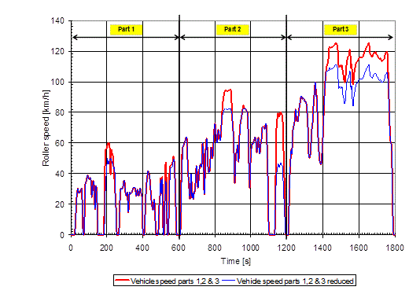
Figure B.5.15.-1: WMTC drive cycle
1.1. | The WMTC lasts 1800 seconds and consists of three parts to be carried out without interruption. The characteristic driving conditions (idling, acceleration, steady vehicle speed, deceleration, etc.). are set out in the following points and tables.

1.2. | WMTC, cycle part 1  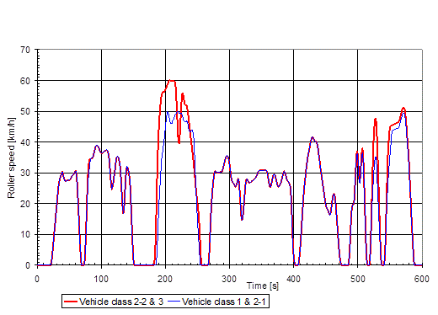  Figure B.5.15.-2: WMTC, part 1
1.2.1 | The characteristic desired vehicle speed versus test time of WMTC, cycle part 1 is set out in the following tables.

1.2.2.1. | 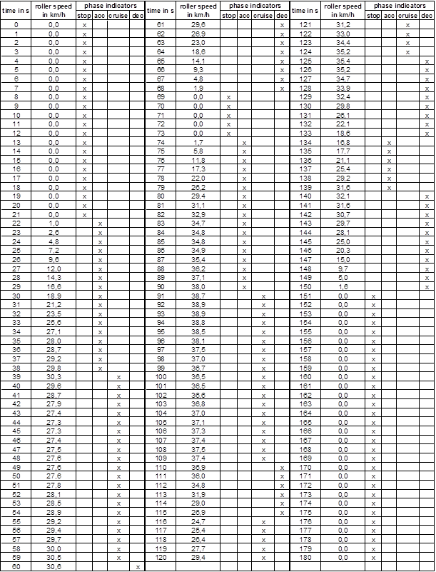
 | Table B.5.15.-1: WMTC, cycle part 1, reduced vehicle speed for vehicle classes 1 and 2-1, 0 to 180 s.

1.2.2.2. | 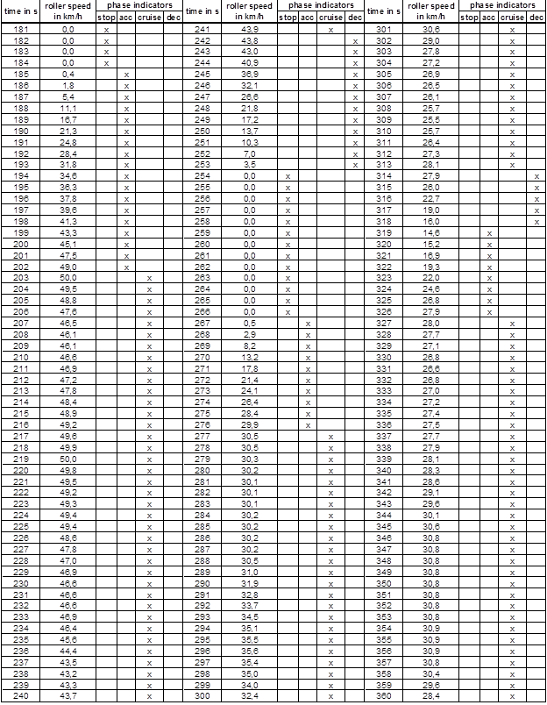
 | Table B.5.15.-2: WMTC, cycle part 1, reduced vehicle speed for vehicle classes 1 and 2-1, 181 to 360 s

1.2.2.3. | 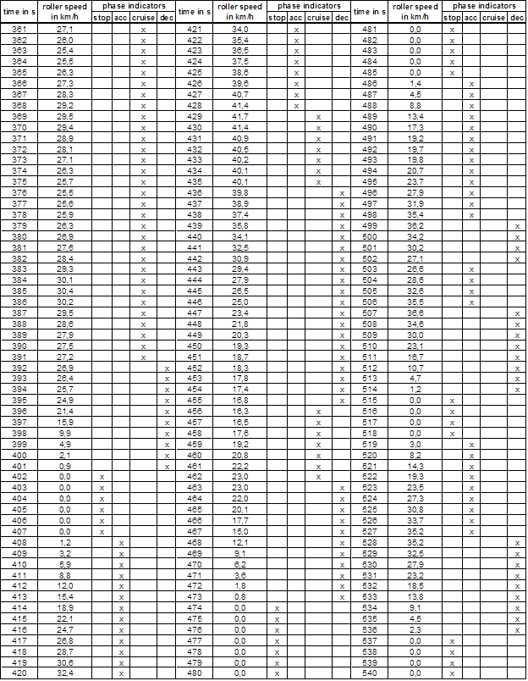
 | Table B.5.15.-3: WMTC, cycle part 1, reduced vehicle speed for vehicle classes 1 and 2-1, 361 to 540 s

1.2.2.4. | 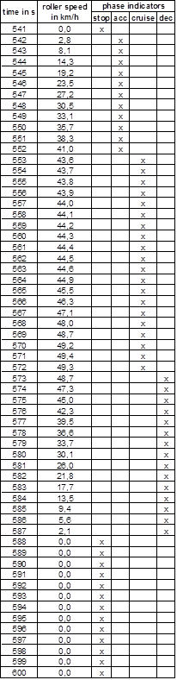
 | Table B.5.15.-4: WMTC, cycle part 1, reduced vehicle speed for vehicle classes 1 and 2-1, 541 to 600 s

1.2.2.5. | 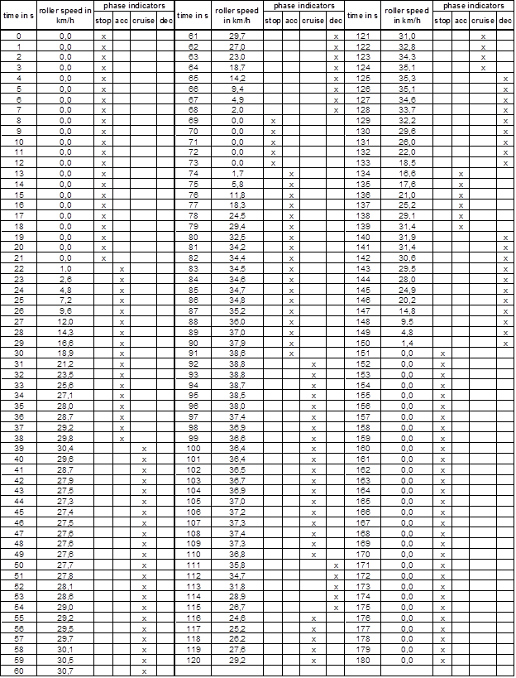
 | Table B.5.15.-5: WMTC, cycle part 1 for vehicle classes 2-2 and 3, 0 to 180 s

1.2.2.6. | 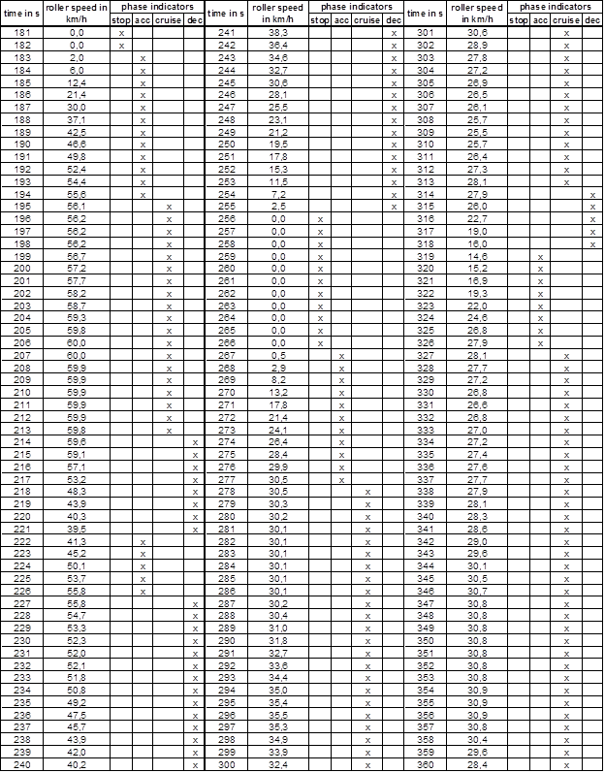
 | Table B.5.15.-6: WMTC, cycle part 1 for vehicle classes 2-2 and 3, 181 to 360 s

1.2.2.7. | 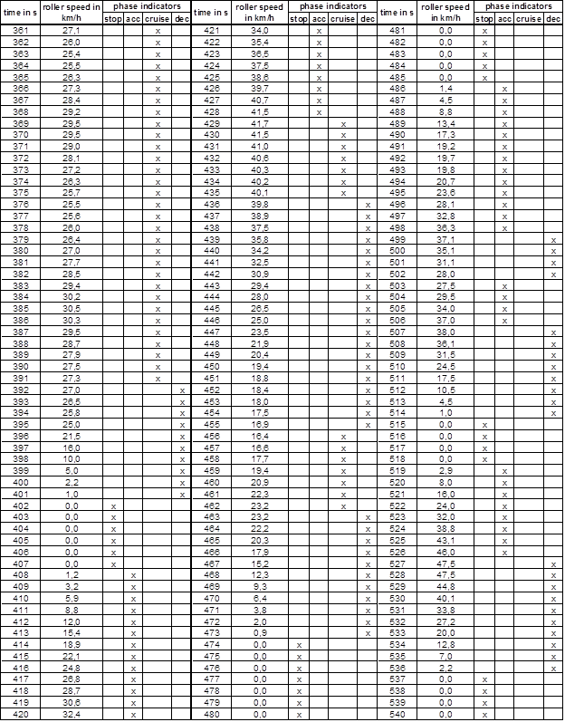
 | Table B.5.15.-7: WMTC, cycle part 1 for vehicle classes 2-2 and 3, 361 to 540 s

1.2.2.8. | 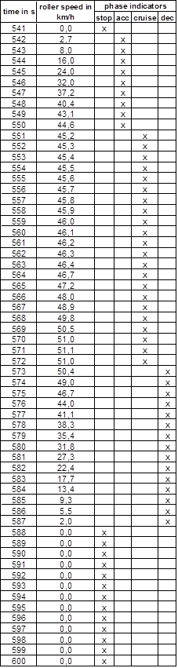
 | Table B.5.15.-8: WMTC, cycle part 1 for vehicle classes 2-2 and 3, 541 to 600 s

1.3. | WMTC, part 2  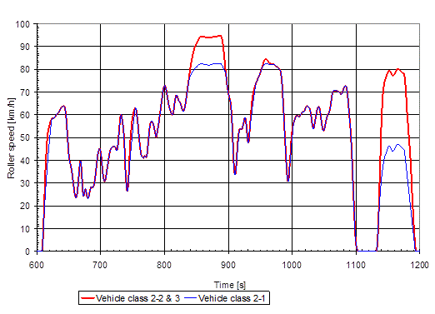  Figure B.5.15.-3: WMTC, part 2
3.1. | The characteristic desired vehicle speed versus test time of WMTC, part 2 is set out in the following tables.

1.3.1.1. | 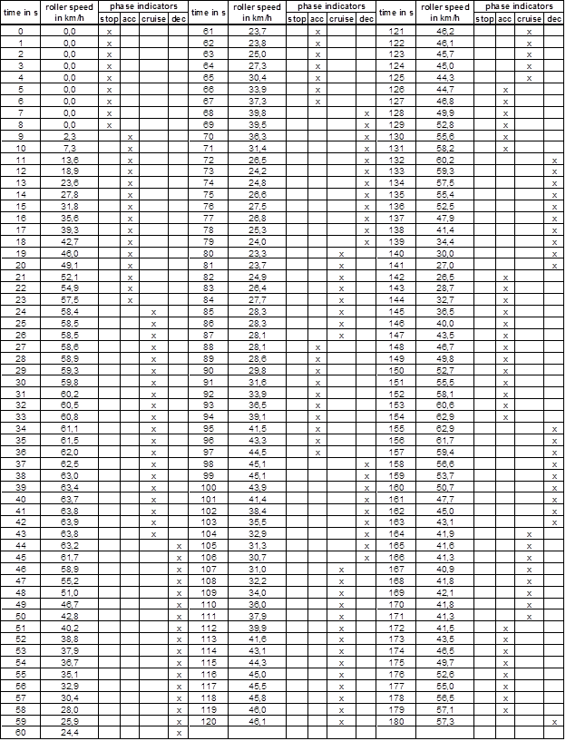
 | Table B.5.15.-9: WMTC, cycle part 2, reduced vehicle speed for vehicle class 2-1, 0 to 180 s

1.3.1.2. | 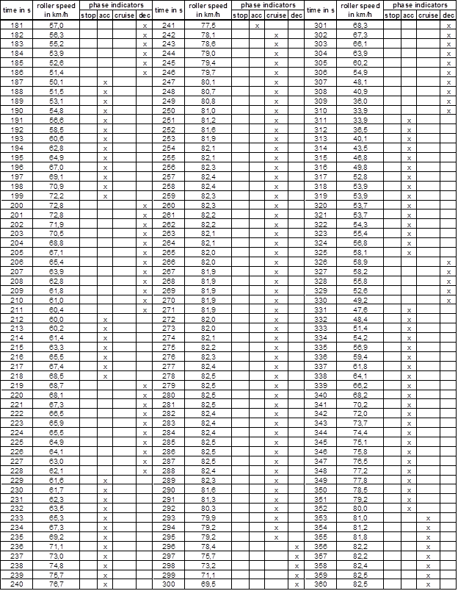
 | Table B.5.15.-10: WMTC, cycle part 2, reduced vehicle speed for vehicle class 2-1, 181 to 360 s

1.3.1.3. | 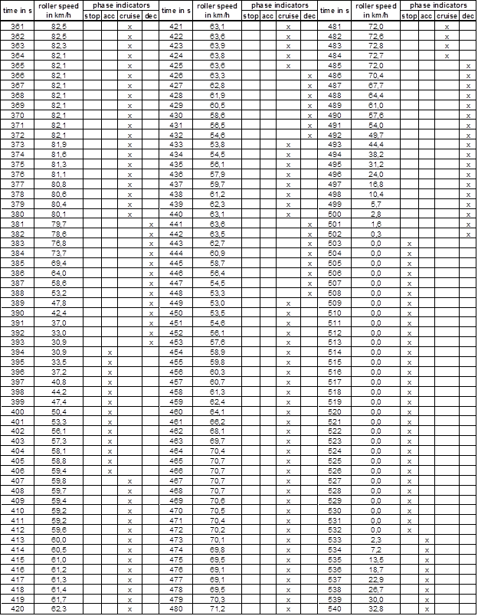
 | Table B.5.15.-11: WMTC, cycle part 2, reduced vehicle speed for vehicle class 2-1, 361 to 540 s

1.3.1.4. | 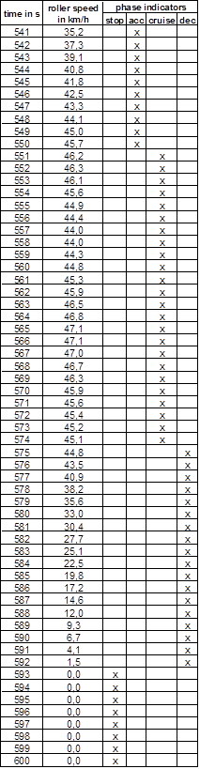
 | Table B.5.15.-12: WMTC, cycle part 2, reduced vehicle speed for vehicle class 2-1, 541 to 600 s

1.3.1.5. | 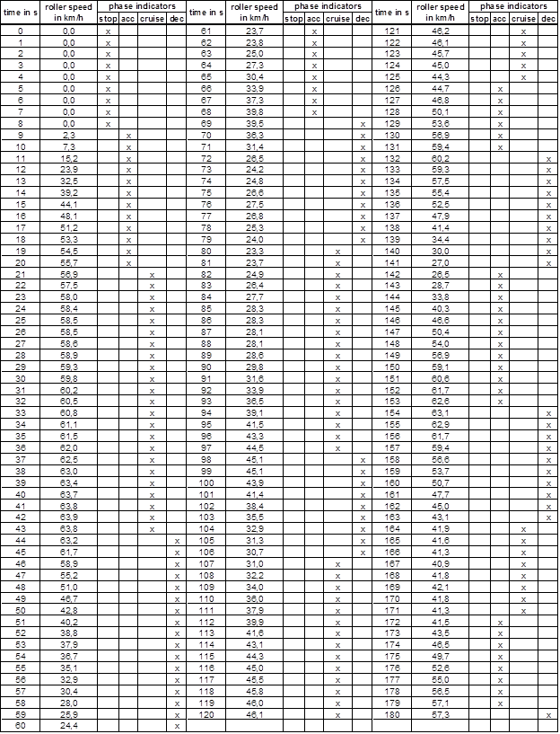
 | Table B.5.15.-13: WMTC, cycle part 2 for vehicle classes 2-2 and 3, 0 to 180 s

1.3.1.6. | 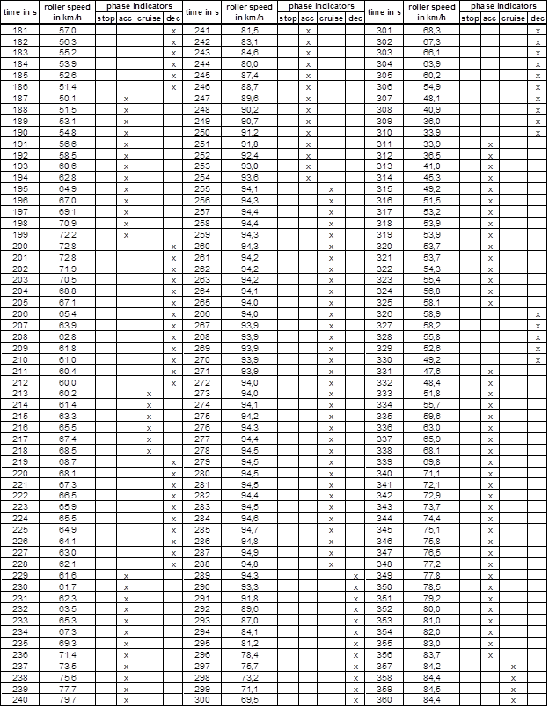
 | Table B.5.15.-14: WMTC, cycle part 2 for vehicle classes 2-2 and 3, 181 to 360 s

1.3.1.7. | 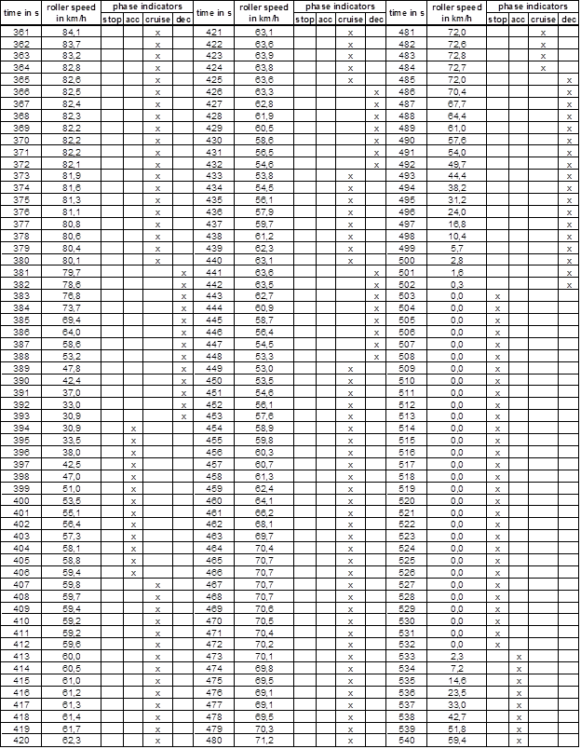
 | Table B.5.15.-15: WMTC, cycle part 2 for vehicle classes 2-2 and 3, 361 to 540 s

1.3.1.8. | 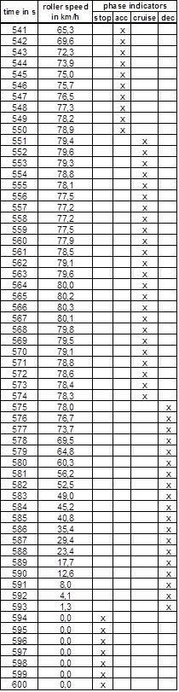
 | Table B.5.15.-16: WMTC, cycle part 2 for vehicle classes 2-2 and 3, 541 to 600 s

1.4. | WMTC, part 3  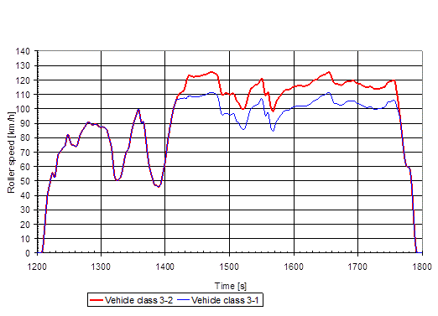Figure B.5.15.-4: WMTC, part 3.
1.4.1 | The characteristic desired vehicle speed versus test time of WMTC, part 3 is set out in the following tables.

1.4.1.1. | 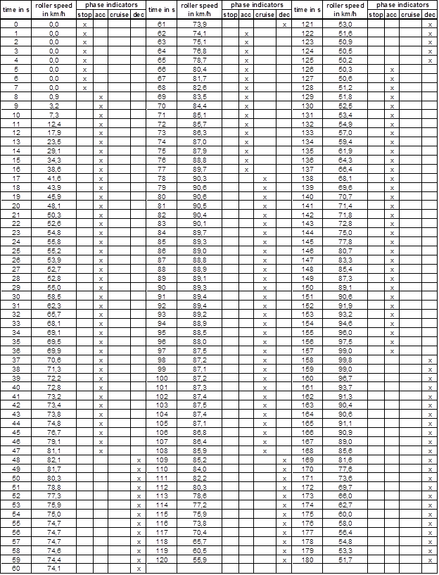
 | Table B.5.15.-17: WMTC, cycle part 3, reduced vehicle speed for vehicle class 3-1, 1 to 180 s

1.4.1.2. | 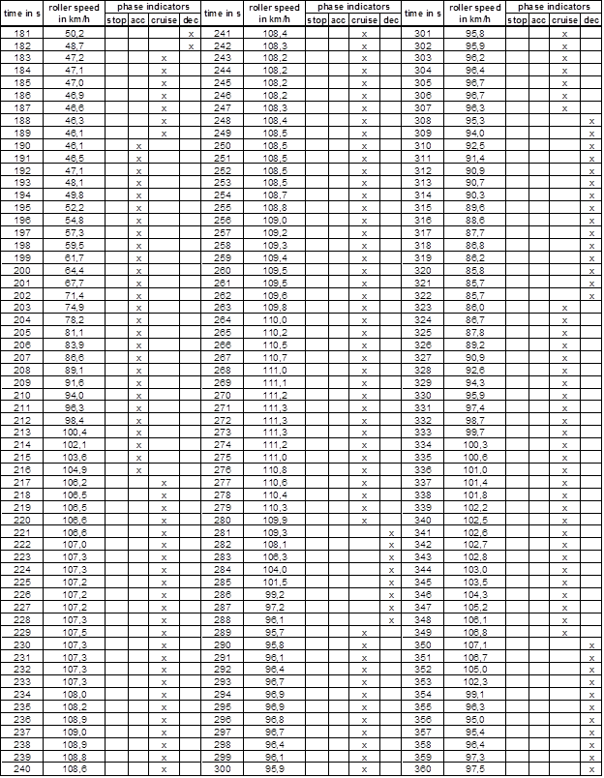
 | Table B.5.15.-18: WMTC, cycle part 3, reduced vehicle speed for vehicle class 3-1, 181 to 360 s

1.4.1.3. | 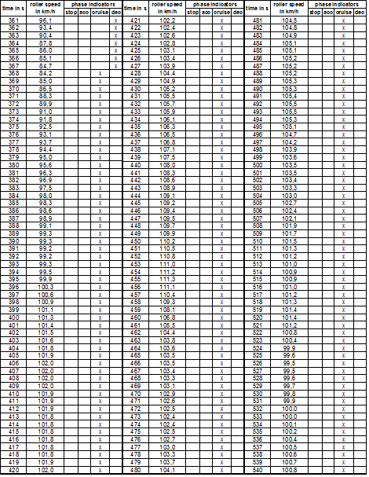
 | Table B.5.15.-19: WMTC, cycle part 3, reduced vehicle speed for vehicle class 3-1, 361 to 540 s
1.4.1.4. |  | 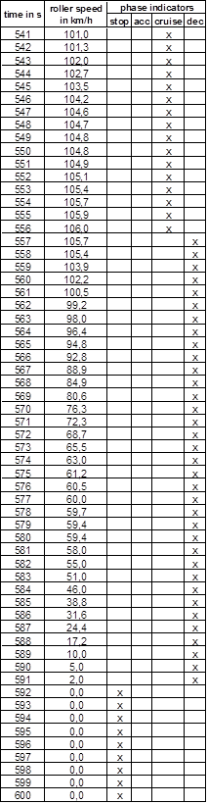
 |  | Table B.5.15.-20: WMTC, cycle part 3, reduced vehicle speed for vehicle class 3-1, 541 to 600 s

1.4.1.5.
Table B.5.15.-21: WMTC, cycle part 3 for vehicle class 3-2, 0 to 180 s

1.4.1.6. | 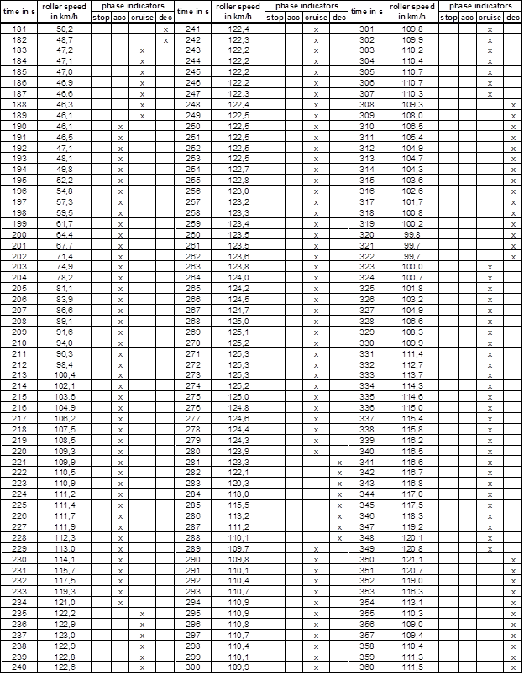
 | Table B.5.15.-22: WMTC, cycle part 3 for vehicle class 3-2, 181 to 360 s

1.4.1.7. | 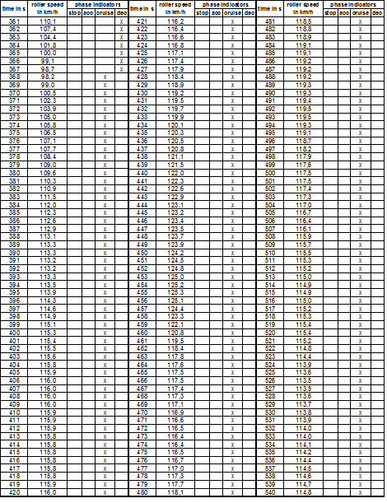
 | Table B.5.15.-23: WMTC, cycle part 3 for vehicle class 3-2, 361 to 540 s
1.4.1.8. | 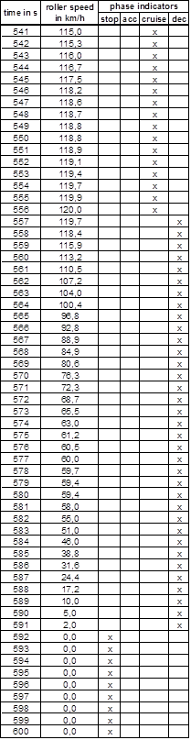
 | Table B.5.15.-24: WMTC, cycle part 3 for vehicle class 3-2, 541 to 600 s

2. | World Harmonised Motorcycle Test Cycle (WMTC) for two- or three-wheeled vehicles with an engine displacement < 50 cm³ and with a maximum design vehicle speed of 25 km/h, respectively 45 km/h.
2.1. | The WMTC to be used on the chassis dynamometer is depicted in the following graph for vehicles equipped with an engine displacement < 50 cm³ or with a maximum net power or maximum continues rated power ≤ 4 kW and with a low maximum design vehicle speed (25 km/h, 45 km/h, respectively 50 km/h), which consists of one cold phase 1 of the WMTC and one warm phase 1 of the WMTC.  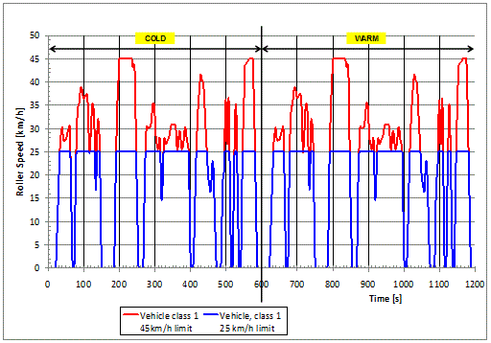  Figure B.5.15.-5: WMTC for vehicles with a low maximum design vehicle speed and low engine displacement or maximum net or continuous rated power. The truncated desired vehicle speed trace limited to 25 km/h is applicable for vehicles with a limited maximum design vehicle speed of 25 km/h.
2.2 | The cold and warm vehicle speed phases are identical.

2.3. | Description of the WMTC for vehicles with a low maximum design vehicle speed (25 km/h, 45 km/h, respectively 50 km/h) and a low engine displacement (< 50 cm³) or maximum net or continuous rated power (≤ 4 kW)  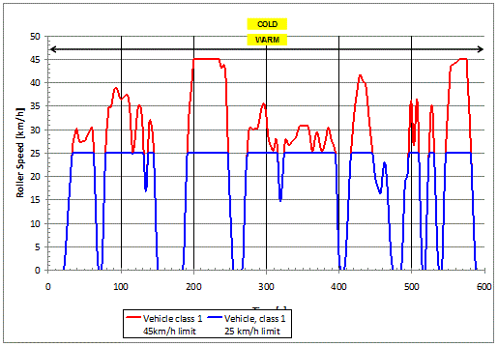  Figure B.5.15.-6: WMTC for vehicles with a low maximum design vehicle speed and low engine displacement or maximum net or continuous rated power. The truncated desired vehicle speed trace limited to 25 km/h is applicable for vehicles with a limited maximum design vehicle speed of 25 km/h.
2.3.1. | The desired vehicle speed trace WMTC shown in Figure Ap 6-10 is applicable for vehicles with a low maximum design vehicle speed (if applicable at 25 km/h, at 45 km/h or or50 km/h) and a low engine displacement (< 50 cm³) or a low maximum net or continuous rated power (≤ 4 kW) and consists of the desired vehicle speed trace WMTC stage 1, part 1 for class 1 vehicles, driven once cold followed by the same desired vehicle speed trace driven with a warm propulsion unit. The WMTC for vehicles with a low maximum design vehicle speed and low engine displacement or maximum net or continuous rated power lasts 1200 seconds and consists of two equivalent parts to be carried out without interruption.
2.3.2. | The characteristic driving conditions (idling, acceleration, steady vehicle speed, deceleration, etc.) of the WMTC for vehicles with a low maximum design vehicle speed (if applicable at 25 km/h, at 45 km/h, or at 50 km/h) and low engine displacement (< 50 cm³) or maximum net or continuous rated power (≤ 4 kW) are set out in the following points and tables.

2.3.2.1. | 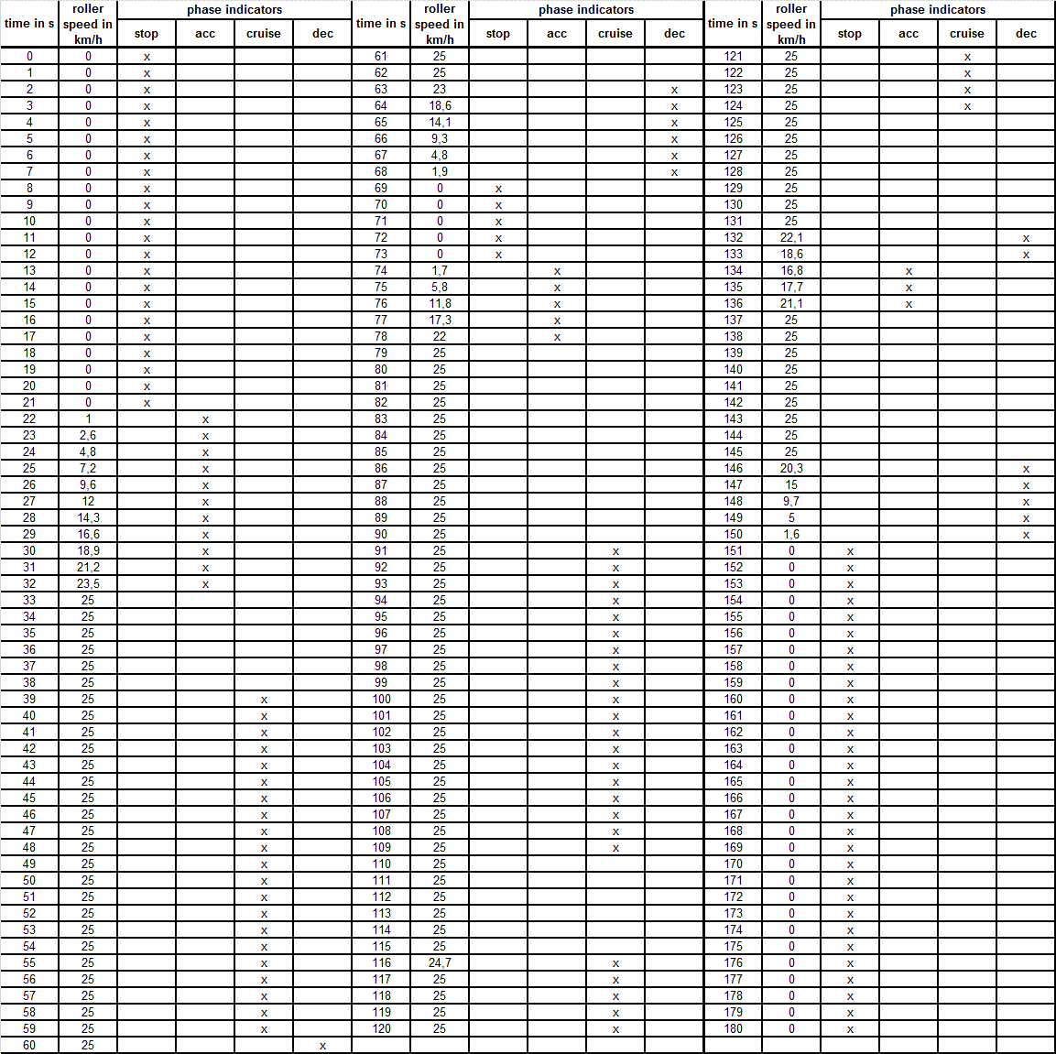
 | Table B.5.15.-25: WMTC, part 1, class 1, applicable for vehicles with a low maximum design vehicle speed (25 km/h) and a low engine displacement (< 50 cm³) or maximum net or continuous rated power (≤ 4 kW), cold or warm, 0 to 180 s

2.3.2.2. | 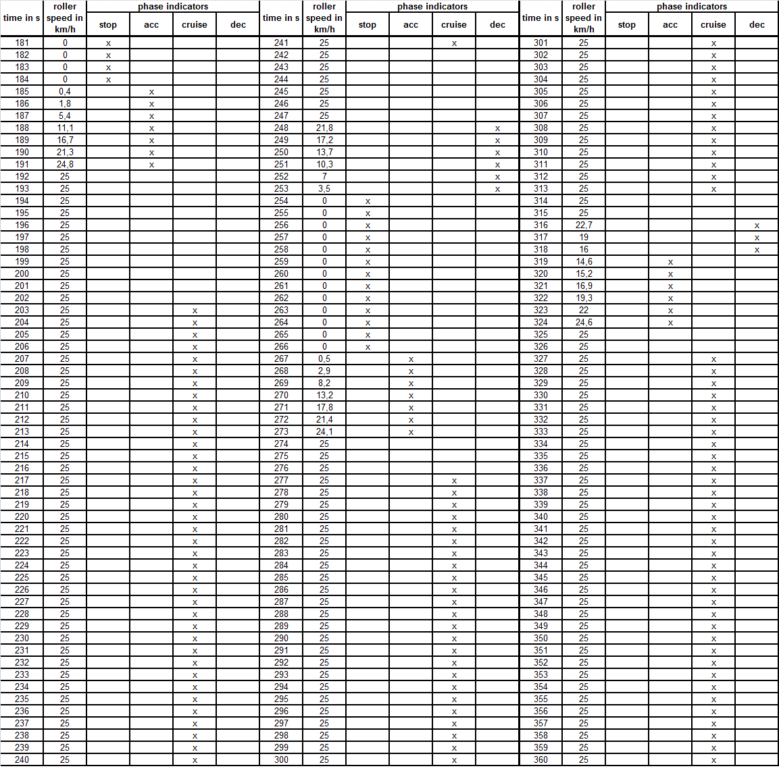
 | Table B.5.15.-26: WMTC, part 1, class 1, applicable for vehicles with a low maximum design vehicle speed (25 km/h) and a low engine displacement (< 50 cm3) or maximum net or continuous rated power (≤ 4 kW), cold or warm, 181 to 360 s

2.3.2.3. | 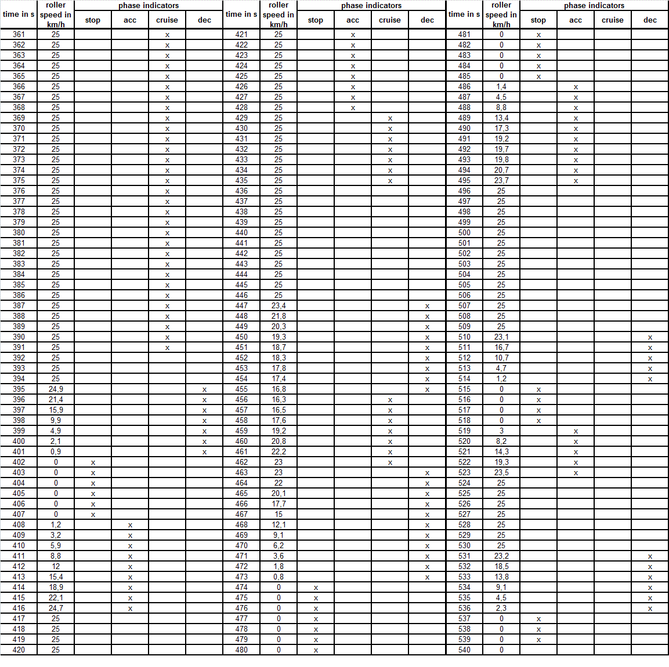
 | Table B.5.15.-27: WMTC, part 1, class 1, applicable for vehicles with a low maximum design vehicle speed (25 km/h) and a low engine displacement (< 50 cm³) or maximum net or continuous rated power (≤ 4 kW), cold or warm, 361 to 540 s

2.3.2.4. | 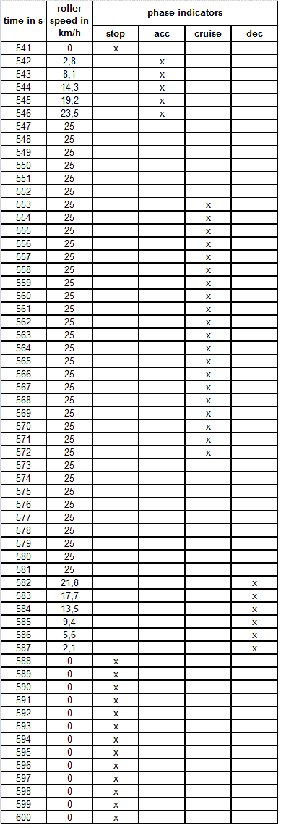
 | Table B.5.15.-28: WMTC, part 1, class 1, applicable for vehicles with a low maximum design vehicle speed (25 km/h) and a low engine displacement (< 50 cm³) or maximum net or continuous rated power (≤ 4 kW), cold or warm, 541 to 600 s

2.3.2.5. | 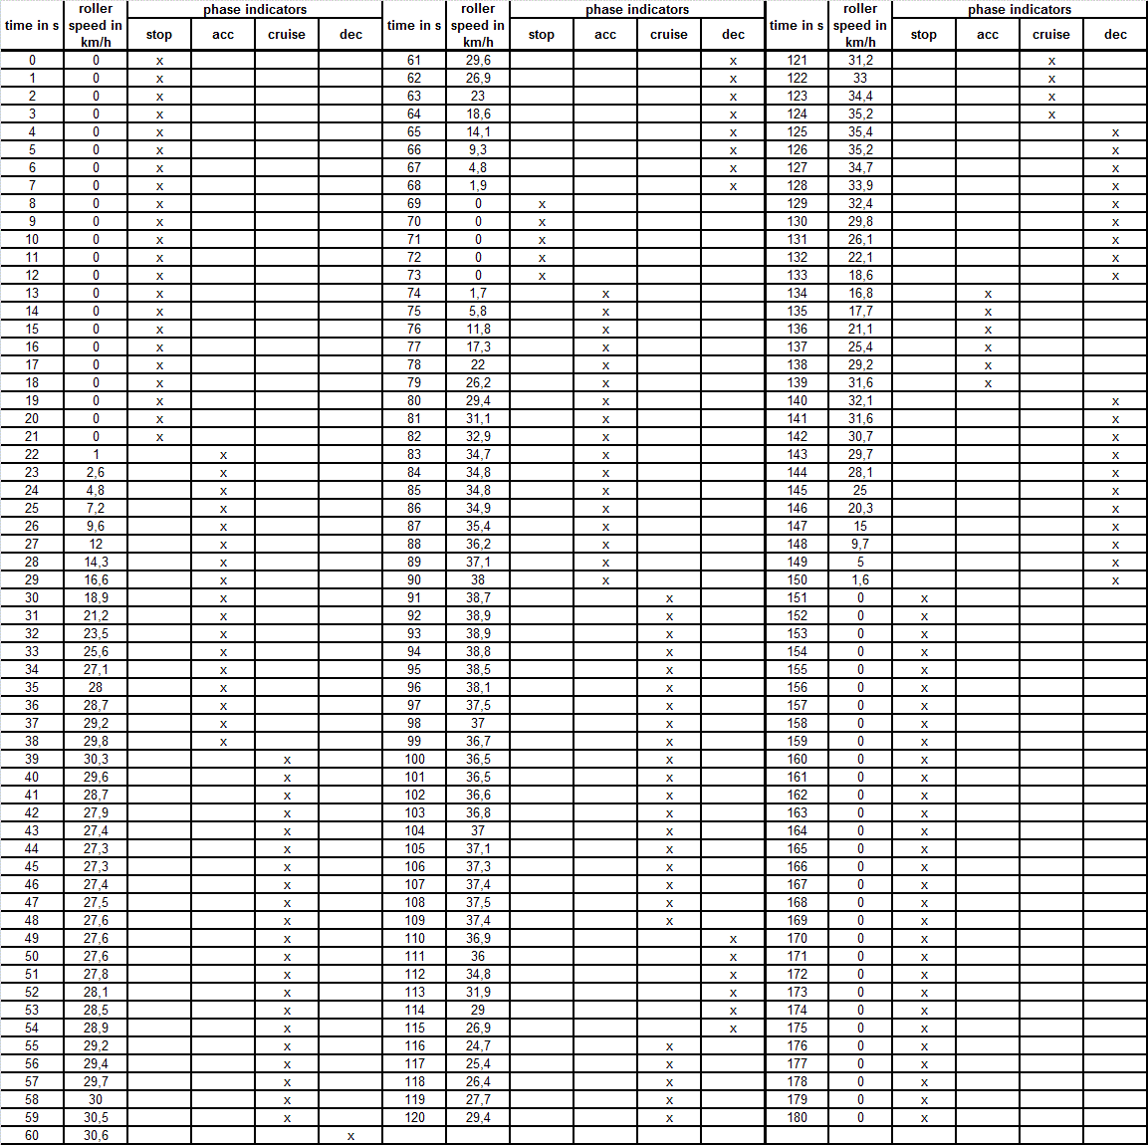
 | Table B.5.15.-29: WMTC, part 1, class 1, applicable for vehicles with a low maximum design vehicle speed (where applicable truncated at 45 km/h, respectively at 50 km/h) and a low engine displacement (< 50 cm³) or maximum net or continuous rated power (≤ 4 kW), cold or warm, 0 to 180 s

2.3.2.6. | 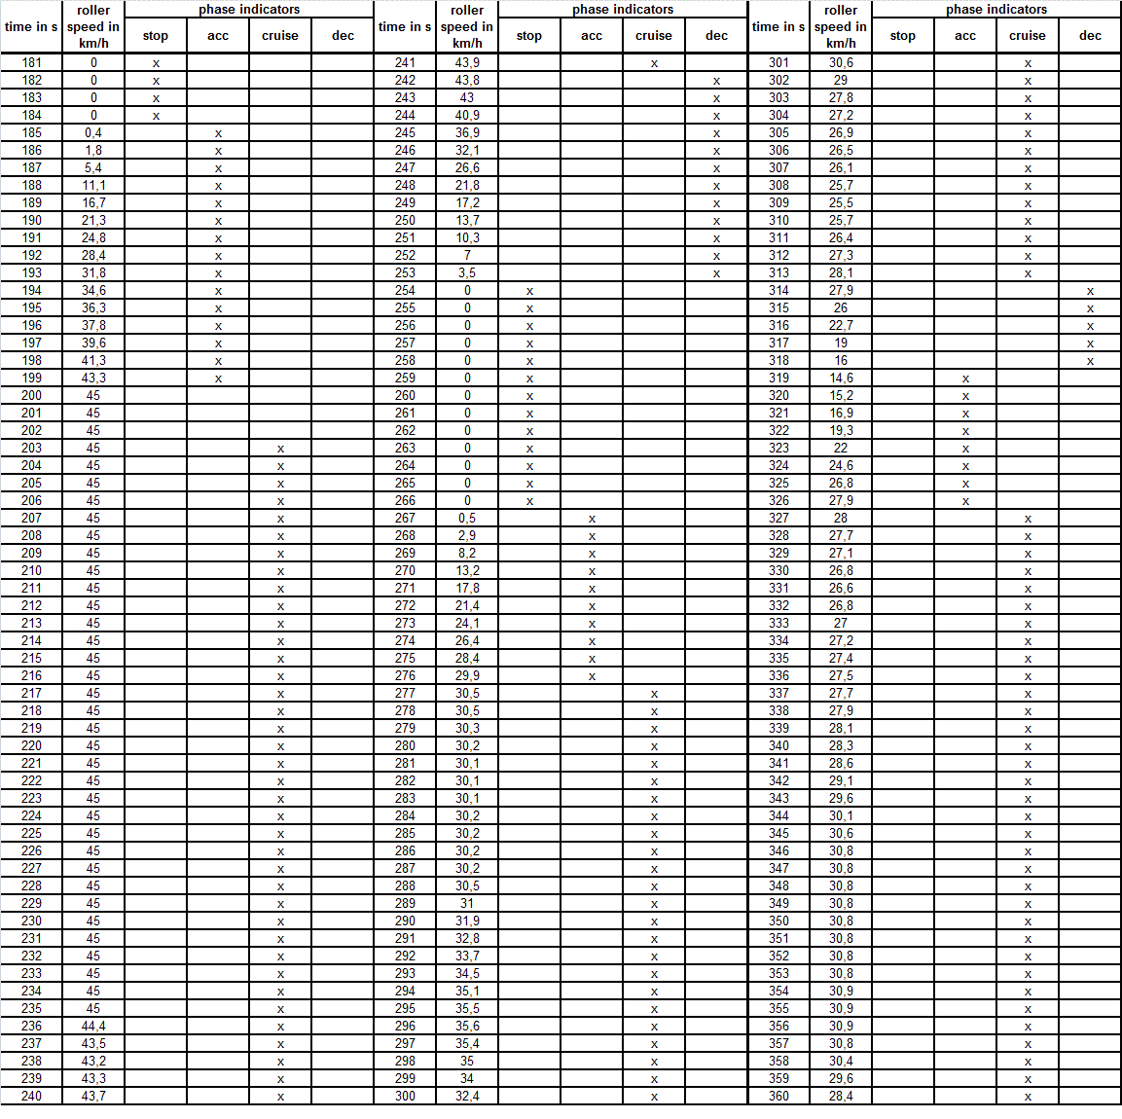
 | Table B.5.15.-30: WMTC, part 1, class 1, applicable for vehicles with a low maximum design vehicle speed (where applicable truncated at 45 km/h, respectively at 50 km/h) and a low engine displacement (< 50 cm³) or maximum net or continuous rated power (≤ 4 kW), cold or warm, 181 to 360 s

2.3.2.7. | 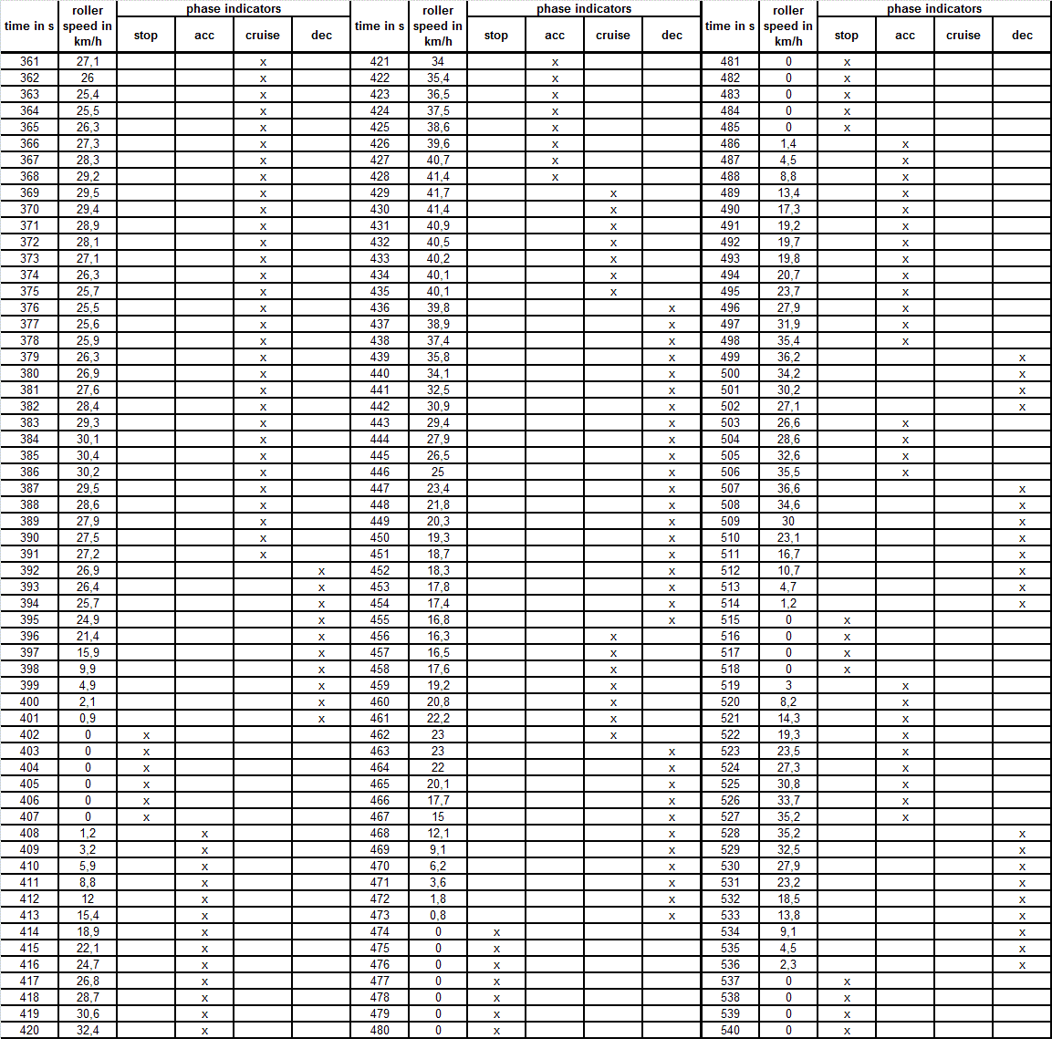
 | Table B.5.15.-31: WMTC, part 1, class 1, applicable for vehicles with a low maximum design vehicle speed (where applicable truncated at 45 km/h, respectively at 50 km/h) and a low engine displacement (< 50 cm³) or maximum net or continuous rated power (≤ 4 kW), cold or warm, 361 to 540 s

2.3.2.8. | 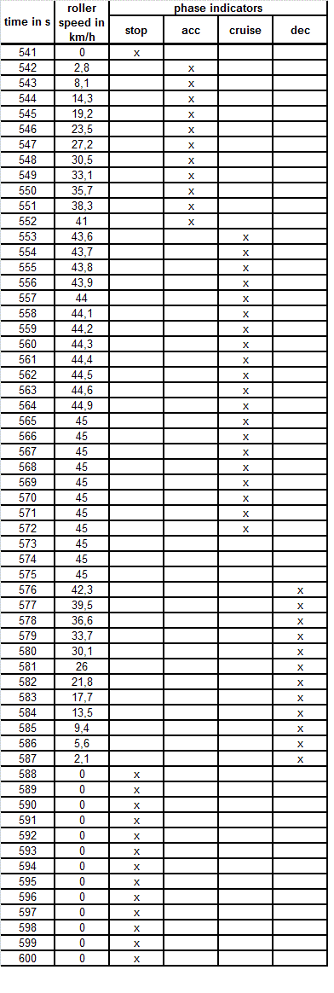
 | Table B.5.15.-32: WMTC, part 1, class 1, applicable for vehicles with a low maximum design vehicle speed (where applicable truncated at 45 km/h, respectively at 50 km/h) and a low engine displacement (< 50 cm³) or maximum net or continuous rated power (≤ 4 kW), cold or warm, 541 to 600 s

B.5.16. | Annex: explanatory note on the gearshift procedure
1. | Introduction  This explanatory note explains matters specified or described in this Regulation, including its Annexes or Appendices, and matters related thereto with regard to the gearshift procedure.
2. | Approach
2.1. | The development of the gearshift procedure was based on an analysis of the gearshift points in the in-use data. In order to establish generalised correlations between technical specifications of the vehicles and desired vehicle speeds to shift gears, the engine speeds were normalised to the utilisable band between rated engine speed and idling engine speed.
2.2. | In a second step, the end speeds (vehicle speed as well as normalised engine speed) for upshifts and downshifts were determined and recorded in a separate table. The averages of these speeds for each gear and vehicle were calculated and correlated with the vehicles’ technical specifications.
2.3. | The results of these analyses and calculations can be summarised as follows:  (a) the gearshift behaviour is engine-speed-related rather than vehicle-speed-related;  (b) the best correlation between gearshift desired vehicle speeds and technical data was found for normalised engine speeds and the power-to-mass ratio (maximum continuous rated power/(reference mass));  (c) the residual variations cannot be explained by other technical data or by different drive train ratios. They are most probably due to differences in traffic conditions and individual driver behaviour;  (d) the best approximation between gearshift desired vehicle speeds and power-to-mass ratio was found for exponential functions;  (e) the gearshift mathematical function for the first gear is significantly lower than for all other gears;  (f) the gearshift desired vehicle speeds for all other gears can be approximated by one common mathematical function;  (g) no differences were found between five-gear and six-gear transmissions;  (h) gearshift behaviour in Japan is significantly different from the equal-type gearshift behaviour in the European Union (EU) and in the United States of America (USA).
2.4. | In order to find a balanced compromise between the three regions, a new approximation function for normalised upshift engine speeds versus power-to-mass ratio was calculated as a weighted average of the EU/USA curve (with 2/3 weighting) and the Japanese curve (with 1/3 weighting), resulting in the following equations for normalised upshift engine speeds:  Equation B.5.16.-1: Normalised upshift engine speed in 1st gear (gear 1)  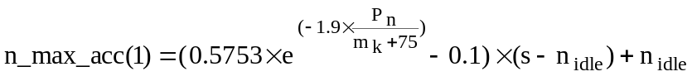  Equation B.5.16.-2: Normalised upshift engine speed in gears > 1  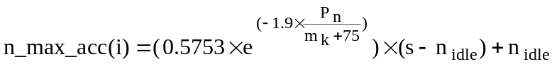
3. | Calculation example
3.1 | Figure B.5.16.-1 shows an example of gearshift use for a small vehicle:  (a) the lines in bold show the gear use for acceleration phases;  (b) the dotted lines show the downshift points for deceleration phases;  (c) in the cruising phases, the whole engine speed range between downshift engine speed and upshift engine speed may be used.  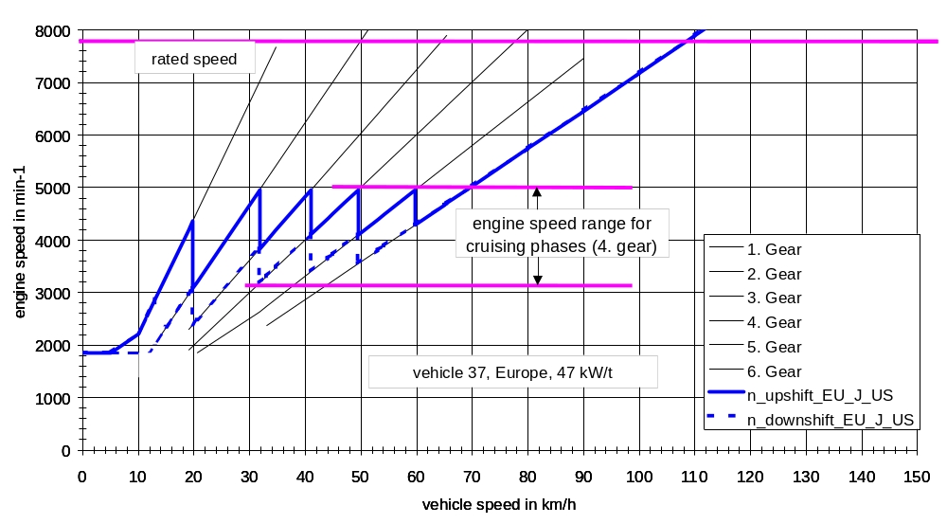  Figure B.5.16.-1: Example of a gearshift sketch for a small vehicle
3.2 | Where vehicle speed increases gradually during cruise phases, upshift engine speeds (v1→2, v2→3and vi→i+1) in km/h may be calculated using the following equations:  Equation B.5.16.-3:  Equation B.5.16.-4:  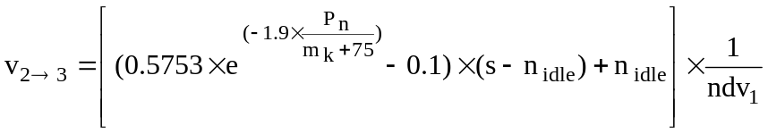  Equation B.5.16.-5:  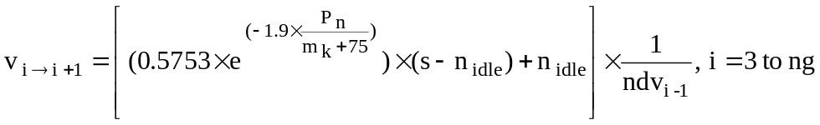  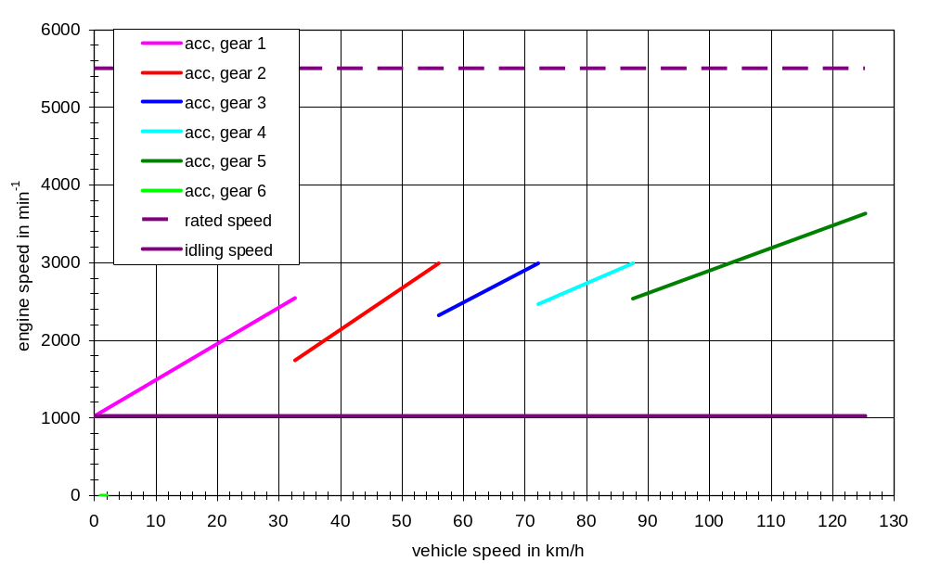  Figure B.5.16.-2: gear use during acceleration phases  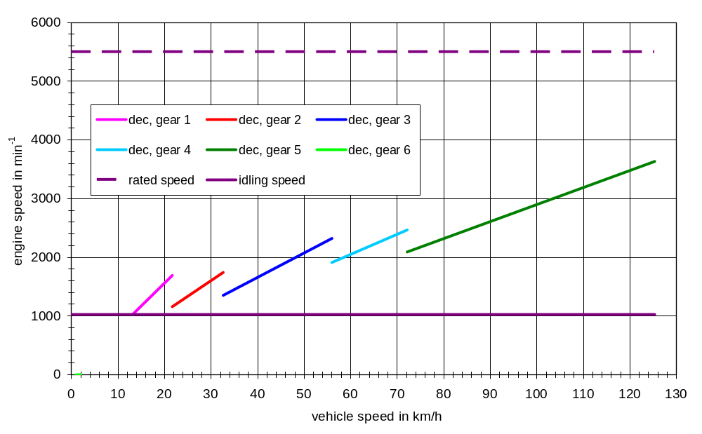  Figure B.5.16.-3: Example of a gearshift sketch — Gear use during deceleration and cruise phases  In order to allow the technical service more flexibility and to ensure driveability, the gearshift regression functions should be considered as lower limits. Higher engine speeds are permitted in any cycle phase.
4. | Phase indicators
4.1 | In order to avoid different interpretations in the application of the gearshift equations and thus to improve the comparability of the test, fixed-phase indicators are assigned to the vehicle speed pattern of the cycles. The specification of the phase indicators is based on the definition from the Japan Automobile Research Institute (JARI) of the four driving modes as shown in the following table:
4 modes | Definition
Idle mode | vehicle speed < 5 km/h and  -0.5 km/h/s (-0.139 m/s²) < acceleration < 0.5 km/h/s (0.139 m/s²)
Acceleration mode | acceleration > 0.5 km/h/s (0.139 m/s²)
Deceleration mode | acceleration < - 0.5 km/h/s (- 0.139 m/s²)
Cruise mode | vehicle speed ≥ 5 km/h and  -0.5 km/h/s (-0.139 m/s²) < acceleration < 0.5 km/h/s (0.139 m/s²)
Table B.5.16.-1: Definition of driving modes
4.2 | The indicators were then modified in order to avoid frequent changes during relatively homogeneous cycle parts and thus improve driveability. Figure Ap9-2 shows an example from cycle part 1.  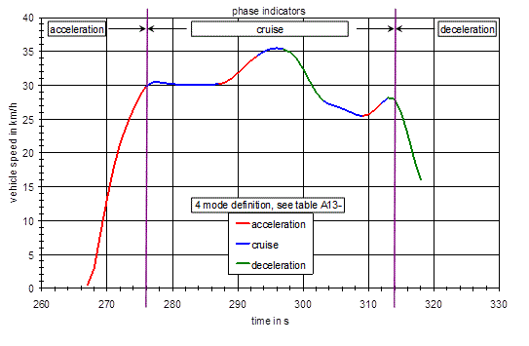  Figure B.5.16.4: Example for modified phase indicators
5. | Calculation example
5.1. | An example of input data necessary for the calculation of shift engine speeds is shown in Table B.5.16.-2. The upshift engine speeds for acceleration phases for first gear and higher gears are calculated using Equations B.5.16.-1 and B.5.16.-2. The denormalisation of engine speeds can be performed using the equation n = n_norm x (s — n_{idle}) + n_{idle}.
5.2. | The downshift engine speeds for deceleration phases can be calculated using Equations B.5.16.-3 and B.5.16.-4. The ndv values in Table B.5.16.-2 can be used as gear ratios. These values can also be used to calculate the corresponding vehicle speeds (vehicle shift speed in gear i = engine shift speed in gear i / ndvi). The results are shown in Tables B.5.16.-3 and B.5.16.-4.
5.3. | Additional analyses and calculations were conducted to investigate whether these gearshift algorithms could be simplified and, in particular, whether engine shift speeds could be replaced by vehicle shift speeds. The analysis showed that vehicle speeds could not be brought in line with the gearshift behaviour of the in-use data.
5.3.1. | Table B.5.16.-2: Input data for the calculation of engine and vehicle shift speeds
  Item | Input data
  Engine capacity in cm³ | 600
  Pn in kW | 72
  mk in kg | 199
  s in min⁻¹ | 11800
  nidle in min⁻¹ | 1150
  ndv1 */ | 133.66
  ndv2 | 94.91
  ndv3 | 76.16
  ndv4 | 65.69
  ndv5 | 58.85
  ndv6 | 54.04
  pmr **/ in kW/t | 262.8
  */ndv means the ratio between engine speed in min⁻¹ and vehicle speed in km/h
  **/pmr means the power-to-mass ratio calculated by
  Pn / (mk) · 1000; Pn in kW, mk in kg
5.3.2. | Table B.5.16.-3: Shift engine speeds for acceleration phases for first gear and for higher gears (see Table B.5.16.-1)
   | EU/USA/Japan driving behaviour
   | EU/USA/Japan driving behaviour | n_acc_max (1) n_acc_max (i)
  n_norm */ in percent | 24.9 | 34.9
  n in min-1 | 3804 | 4869
5.3.3. | Table B.5.15.-4: Engine and desired vehicle shift speeds based on Table B.5.16.-2
  Gearshift |  | EU/USA/Japan driving behaviour
   |  | v in km/h | n_norm (i)  in percent | n in min⁻¹
  Upshift | 1→2 | 28.5 | 24.9 | 3804
  Upshift | 2→3 | 51.3 | 34.9 | 4869
  Upshift | 3→4 | 63.9 | 34.9 | 4869
  Upshift | 4→5 | 74.1 | 34.9 | 4869
  Upshift | 5→6 | 82.7 | 34.9 | 4869
  Downshift | 2→cl */ | 15.5 | 3.0 | 1470
  Downshift | 3→2 | 28.5 | 9.6 | 2167
  Downshift | 4→3 | 51.3 | 20.8 | 3370
  Downshift | 5→4 | 63.9 | 24.5 | 3762
  Downshift | 6→5 | 74.1 | 26.8 | 4005
  */‘cl’ means ‘Clutch-Off’ timing.

http://www.unece.org/fileadmin/DAM/trans/main/wp29/wp29wgs/wp29gen/wp29registry/ECE-TRANS-180a2app1e.pdf
Regulation (EU) No 168/2013 of the European Parliament and of the Council of 15 January 2013 on the approval and market surveillance of two- or three-wheel vehicles and quadricycles (OJ L60, 2.3.2013, p. 52)
Commission Delegated Regulation (EU) No 134/2014 of 16 December 2013 supplementing Regulation (EU) No 168/2013 of the European Parliament and of the Council with regard to environmental and propulsion unit performance requirements and amending Annex V thereof (OJ L53, 21.2.2014, p. 1)
Table 31 in chapter 9: http://www.unece.org/fileadmin/DAM/trans/main/wp29/wp29wgs/wp29gen/wp29registry/ECE-TRANS-180a2app1e.pdf refers to three 49 cm³ mopeds and one 50 cm³ moped of the total of 53 test vehicles have been used to validate the basic WMTC
Also known as ‘externally chargeable’.
Also known as ‘not externally chargeable’.
For instance: sport, economic, urban, extra-urban position, etc.
Most electric hybrid mode: the hybrid mode which can be proven to have the highest electricity consumption of all selectable hybrid modes when tested in accordance with condition A of point 4 of Annex 10 to UN Regulation No 101, to be established based on information provided by the manufacturer and in agreement with the technical service.
Most fuel-consuming mode: the hybrid mode which can be proven to have the highest fuel consumption of all selectable hybrid modes when tested in accordance with condition B of point 4 of Annex 10 to UN Regulation No 101, to be established based on information provided by the manufacturer and in agreement with the technical service.
Mean value of G20 and G25 reference fuels at 288.0 K (15.0 °C).
International Electro technical Commission.
also known as ‘externally chargeable’.
also known as ‘not externally chargeable’.
As provided for in this GTR in the version applicable to the type-approval of that vehicle.
Regulation (EC) 2009/79/EC of the European Parliament and of the Council of 14 January 2009 on type-approval of hydrogen-powered motor vehicles, and amending Directive 2007/46/EC (OJ L 35, 4.2.2009, p. 32).

