DUAL FUNCTION SYSTEM: OICA proposal for IG CMS II-08
I. Text modifications
1) Introduce a new definition:
2.1.13: “Mirror and CMS dual function system” means a CMS in which a monitor complying with this regulation is placed behind a half transparent mirror complying with this regulation. Monitor becomes visible to the driver when CMS mode is in operation.
2) # 6.2.2.3.3.2. amend to read:
6.2.2.3.3.2. Luminance and contrast rendering
For luminance and contrast rendering the following requirements apply:
The minimum luminance contrast at the monitor (including any screen protector) reproducing a high contrast pattern shall be:
- for direct sunlight condition: 2:1
- for day condition with diffuse ambient light:
3:1 in general case
2:1 in case of Mirror and CMS dual function system
- for sunset condition: 2:1
- for night condition:
10:1 in general case
5:1 in case of Mirror and CMS dual function system

- Night condition for the cameras field of view is replicated in a dark environment such that the maximum illuminance on the objects to be measured shall not exceed 2.0 lx,
- The background luminance of the monitor shall be limited under night condition. Depending on the installation of the monitor inside the vehicle this will reduce annoying reflections on the windscreen or other window panes as well. The maximum background luminance under night condition shall be less than 2.0 cd/m²,
- The instructions for use shall contain a note that sunlight or light from other intense light sources upon the monitor reduces the luminance contrast which may require the driver to be especially alert and attentive.

6.2.2.3.3.2.1 Day condition with diffuse sky-light exposure test
For the day condition with diffuse sky-light exposure, the test method given in ISO 16505:2015 subclause 7.8.2 Test 2 shall be applied, but the value of 1,500 cd/m² for luminance diffuse illuminator shall be replaced by 4,200 cd/m2.

At the request of the manufacturer, the value for luminance diffuse illuminator may be determined by using the diagram of figure below.
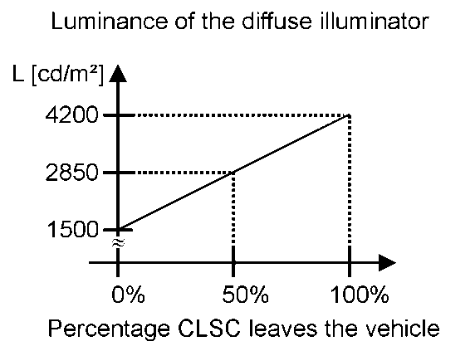
Ratio of the projected area leaving the vehicle

Ratio of projected area vs. luminance of the diffuse illuminator

Procedure for determining the ratio of the projected area leaving the vehicle:
A –In case the monitor is not adjustable
Determine the projected area in the vehicle that represents the mirror reflected direction from the monitor extended isotropy range.
Evaluation shall be made in the center of the monitor defined size, under consideration of the monitor design viewing direction (see figure below).
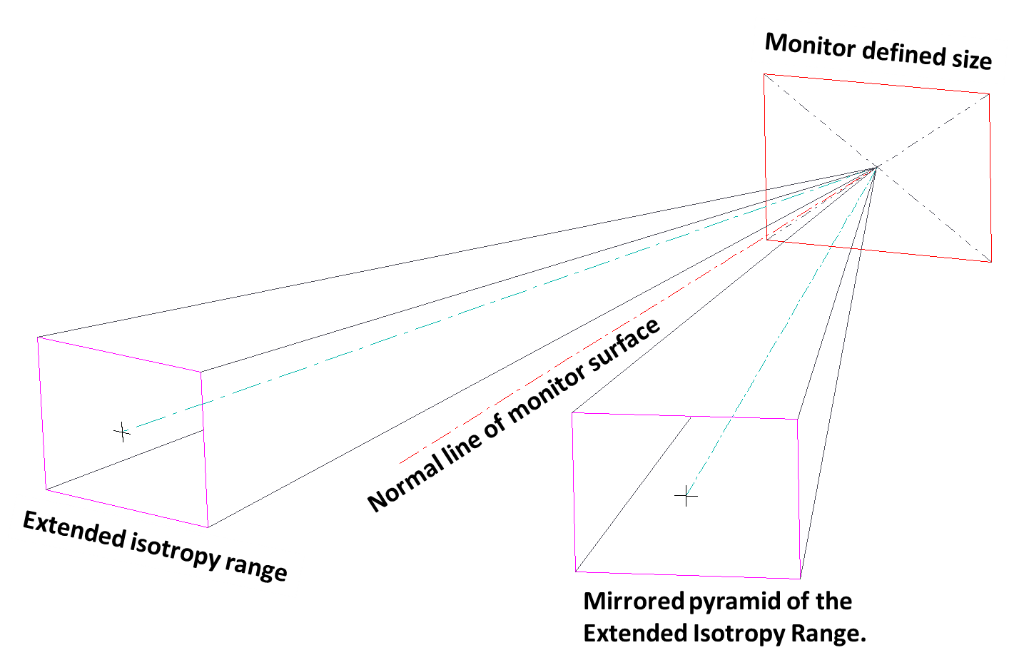

This projected area represents the 100% of the surface to be considered.
Based on virtual testing, evaluate the ratio of the projected area that leaves the vehicle trough openings (e.g. through a side door window, rear window or sunroof. But for example a sunroof having an opaque shutter shall not be considered as an opening).
Determine the luminance value that may be used by using the diagram shown in figure above in the paragraph.
B – In case the monitor is adjustable
Based on virtual testing, if the applicant demonstrates that the CMS adjustment range permits a driver to avoid any incident specular light from the vehicle opening while a driver’s eye is within any fixed position of the standard isotropy range, then the value for luminance diffuse illuminator shall be the one of ISO 16505:2015 subclause 7.8.2 Test 2: 1,200cd/m².
This provision applies also to Mirror and CMS dual function system of class I.
II. Justification:
-The expected head position range of a driver is defined as the “standard isotropy range” in the ISO16505. Therefore, if the monitor is adjustable enough to avoid any specular light from the vehicle outside opening when driver eye is positioned within the standard isotropy range, then the driver can adjust and avoid any discomfort or disturbing glare, which otherwise could decrease the luminance contrast ratio.
-Mirror and CMS Dual function system [of class I] offers the possibility to choose between a CMS mode and a conventional mirror mode, according to driver’s comfort. There is always the possibility to switch back from CMS mode to mirror mode. Both CMS and mirror modes comply with the appropriate requirements. Thus, including a mirror function, the Mirror and CMS Dual function system is adjustable (requirement of 2.1.1.1) and shall benefit from this particular provision.
-ISO 16505 group identified requirements and test procedures so that an ISO 16505 complying CMS offers a safe image in most use cases a driver meets. IG CMS II decided to go further for some requirements to extend to extreme use cases.
For extreme ambient luminance use cases a static monitor would meet, the minimum luminance contrast has been set to 3:1 ilo 2:1, and the value for luminance diffuse illuminator increased from 1,200 to 4,500cd/m². This was justified by the fact that if only a CMS is provided to a driver, and no mirror, its safety performance shall be maximized. The unique possibility that the Mirror and CMS Dual Function system offers in very difficult cases is to go back to a very standard mirror, and its usual performance. In this case the original reason to diverge from ISO 16505 performance level disappears.
Night condition contrast of 5:1 was the original requirement of the ISO16505 with the recommendation of 10:1 in consideration of the needs of older drivers. But, it was changed to 10:1 in the IG-CMS as a requirement to ensure the needs of older drivers were considered.
However, the dual function system [of class I] allows all drivers to use the mirror instead of the CMS at night if desired. Therefore the requirement of 10:1 places undue design restriction on the dual function system [of class I].

