 | United Nations | ECE/TRANS/WP.29/GRSP/2015/9
 | Economic and Social Council |  | Distr.: General  2 March 2015  Original: English
Economic Commission for Europe
Inland Transport Committee
World Forum for Harmonization of Vehicle Regulations
Working Party on Passive Safety
Fifty-seventh session
Geneva, 18-22 May 2015
Item 14 of the provisional agenda
Regulation No. 129 (Enhanced Child Restraint Systems)
Proposal for Proposal for the 01 series of amendments to Regulation No. 129 (Enhanced Child Restraint Systems)
Submitted by the expert from France*
The text reproduced below was prepared by the expert from France. It introduces the amendments to UN Regulation No. 129 (Enhanced Child Restraint System (ECRS)) that were agreed upon by the experts of the Informal Working Group on Child Restraint Systems (IWG CRS) in Phase 2 of the UN Regulation and extends the scope of the Regulation to Non-Integral child restraint systems ("Universal Booster" or "Specific to vehicle Booster"). It supersedes ECE/TRANS/WP.29/GRSP/2015/28 and it is based on an informal document GRSP-56-08 distributed at the fifty-sixth session of GRSP. The modifications to the existing text of the UN Regulation are marked in bold for new or strikethrough for deleted characters.

I. Proposal
In all the text, except in paragraph 5.2. when refers to Regulation No. 44, replaces respectively, "a Child Restraint Systems", "Child Restraint Systems", "CRS" and "a CRS" by:
"an Enhanced Child Restraint Systems", "Enhanced Child Restraint Systems", "ECRS" and "an ECRS"
Table Content, insert new Annexes 23 and 24:
"23. Standard safety-belt
24. Procedure and Measuring device to evaluate a Universal Booster Cushion "
Paragraph 1., amend to read:
"1. Scope
This Regulation applies (in its Phases 1 and 2) to Integral Universal ISOFIX Enhanced Child Restraint Systems (i-Size) and, to Integral Specific vehicle ISOFIX Enhanced Child Restraint Systems and to non-integral Enhanced Child Restraint Systems Universal Booster or Specific to vehicle Booster, for child occupants of power driven vehicles."
Paragraphs 2.3. to 2.4.2., amend to read:
"2.3. "Integral Universal" and "Non-Integral Universal"
2.3.1. "i-Size" (Integral Universal ISOFIX Enhanced Child Restraint Systems) is a category of Enhanced Child Restraint System primarily designed for use in all i-Size seating position of a vehicle, as defined and approved according to Regulations Nos. 14 and 16.
2.3.2. The "Universal Booster" (Non-Integral Universal Enhanced Child Restraint System) is a category of Enhanced Child Restraint Systems, primarily designed for use in all "Universal Booster Seating Positions" of a vehicle suitable for Enhanced Child Restraints System of the "universal booster" category, as defined and approved according to Regulation No. 16.
Universal Booster comprises two subcategories:
(a) "Universal Booster Seat" with an integrated backrest;
(b) "Universal Booster Cushion" without a backrest.
2.4. "Integral" and "Non-Integral"
2.4.1. "Integral" is a class of Enhanced Child Restraint System, meaning that the child is restrained only by components which comprise the Enhanced Child Restraint System (e.g. strap harness, impact shield, etc.), and not by means connected directly to the vehicle (e.g. adult seat belt).
2.4.2. "Non-Integral" is a class of Enhanced Child Restraint System, meaning that the retention of the child within the Enhanced Child Restraint System is achieved by means connected directly to the vehicle (e.g. adult seat belt)."

Paragraphs 2.7. to 2.7.2., amend to read:
"2.7. "Specific vehicle ECRS"
2.7.1. "Specific vehicle ISOFIX" is a category of Integral Enhanced Child Restraint System connecting to specific vehicle types. All vehicle anchorages are to be approved according to Regulation No. 14. It is also an indication for Enhanced Child Restraint Systems including dashboard as a vehicle contact zone.
2.7.2. "Specific Vehicle Booster" is a category of Non-Integral Enhanced Child Restraint System for use in specific vehicle types. All vehicle anchorages are to be approved according to Regulation No. 14. This category includes vehicles "Built-in Boosters". This category comprises two subcategories:
(a) "Specific Vehicle Booster Seat" with an integrated backrest;
(b) "Specific Vehicle Booster Cushion" without a backrest."
Paragraph 2.8. to 2.8.2., amend to read:
"2.8. "Size" indicates the stature of the Child.
2.8.1. "Size range" is a range for which the Enhanced Child Restraint System has been designed and approved.
2.8.2. Enhanced Child Restraint Systems may cover any size range provided that all requirements of this Regulation are fulfilled."
Paragraphs 2.17., 2.17.1. and 2.17.2., amend to read:
"2.17. "Vehicle Seat Fixture (VSF)"
2.17.1. "ISOFIX Vehicle seat fixture" means a fixture, according to ISOFIX size classes whose dimensions are given in Figures 1 to 7 of Appendix 2 to Annex 17 to Regulation No. 16, used by an Enhanced Child Restraint System manufacturer to determine the appropriate dimensions of an ISOFIX Enhanced Child Restraint System and the location of its ISOFIX attachments.

2.17.2. "Universal booster seat fixture" means a fixture, of the dimensions given in figure 1 of Annex 17, Appendix 5 of Regulation No. 16 and used by an Enhanced Child Restraint System manufacturer to determine the appropriate dimensions of a "Universal Booster" and its compatibility with most vehicle seating positions and, in particular, those which have been assessed without ISOFIX attachments, according to Regulation No. 16 as being compatible with such a category of an Enhanced Child Restraint System."
Paragraph 2.21., amend to read:
"2.21. "ECRS Belt" means an Enhanced Child Restraint System comprising a combination of straps with a securing buckle, adjusting devices and attachments."
Paragraph 2.22., amend to read:
"2.22. "Harness belt" means an ECRS belt assembly comprising a lap belt strap, shoulder restraints and a crotch strap."
Paragraph 2.23., amend to read:
"2.23. "Y-shaped belt" means an ECRS belt where the combination of straps is formed by a strap to be guided between the child's legs and a strap for each shoulder."
Paragraph 2.30., amend to read:
"2.30. "Lap strap" means a strap which, either in the form of a complete ECRS belt or in the form of a component of such an ECRS belt passes across the front of, and restrains, directly or not, the child's pelvis."
Paragraph 2.31., amend to read:
"2.31. "Shoulder strap" means that part of an ECRS belt which restrains the child's upper torso."
Paragraph 2.32., amend to read:
"2.32. "Crotch strap" means a … it is designed to prevent the child sliding under the lap belt strap in normal use and prevent the lap belt strap moving up off the pelvis in an impact."
Paragraph 2.33., amend to read:
"2.33. "Child-restraining strap" means a strap which is a constituent part of the ECRS belt (harness) and restrains only the body of the child."
Paragraph 2.37., amend to read:
"2.37. "Adjusting device" means a device enabling the ECRS belt or its attachments to be adjusted to the physique of the wearer. The adjusting device may either be part of the buckle or be a retractor or any other part of the ECRS belt."
Paragraph 2.44., amend to read:
"2.44. "Vehicle seat" means a structure, which may or may not be integral with the vehicle structure, complete with trim and intended to seat one adult person. In this respect:
2.44.1. "Group of vehicle seats" means either a bench seat or a plurality of seats which are separate but side by side (i.e. so fixed that the front anchorages of one seat are in line with the front or rear anchorages of another seat or on a line passing between those anchorages), each seat accommodating one or more seated adult persons.
2.44.2. "Vehicle bench seat" means a structure complete with trim and intended to seat more than one adult person.
2.44.3. "Vehicle front seats" means the group of seats situated foremost in the passenger compartment, i.e. having no other seat directly in front of them.
2.44.4. "Vehicle rear seats" are fixed, forward-facing seats situated behind another group of vehicle seats."
Insert a new paragraph 2.51., to read:
"2.51. "ECRS position"

Paragraph 2.51., amend to read:
"2.51.1. "ISOFIX position" means a location which allows for the installation of either:
(a) Universal ISOFIX Child Restraint System as defined in Regulation No. 44; or
(b) A "specific vehicle ISOFIX" Child Restraint System as defined in Regulation No. 44 or a "specific vehicle ISOFIX" Enhanced Child Restraint System as defined in this Regulation; or
(c) An i-Size Enhanced Child Restraint System suitable for use in specific ISOFIX seating positions as defined by the vehicle manufacturer according to Regulation No. 16."
Paragraph 2.51.2., amend to read:
"2.51.2. "Universal booster seating position" means a location which allows for the installation, at least without ISOFIX connections, of a "Universal Booster" Enhanced Child Restraint System as defined in this Regulation."
Paragraph 2.55., amend to read:
"2.55. "Shoulder strap positioner" means a device intended to maintain, during normal transit conditions, the appropriate shoulder strap position on the child’s torso, during normal transit conditions by connecting the shoulder straps to one another."
Insert new paragraphs 2.56. to 2.57., to read:
"2.56. "Lock-off device" locks and prevents movement of one section of the webbing of an adult safety-belt relative to another section of the webbing of the same belt. Such devices may act upon either the diagonal or the lap sections or secure together both lap and diagonal sections of the adult belt. The term covers the following classes:
2.56.1. "Class A device" prevents the child from pulling the webbing of the retractor through to the lap part of the belt, when the adult belt is used to restrain the child directly.
2.56.2. "Class B device" (to be used in phase III) allows the retention of an applied tension in the lap part of an adult safety-belt, when the adult belt is used to restrain the Enhanced Child Restraint System. The device intends to prevent the webbing from slipping from the retractor through the device, which would release the tension and place the restraint in a non-optimal position.
2.57. "Module", is a part of an ECRS that is separate from the ISOFIX connectors and is in direct contact with the child. A module can be used as stand-alone to restrain a child in a car. A base is allowed to accept more than one module (Module A, Module B, etc.)."
Paragraph 3.2.2., amend to read:
"3.2.2. The applicant shall indicate the kind of application:
(a) Application for an i-Size Enhanced Child Restraint Systems; or
(b) Application for a Specific vehicle ISOFIX; or
(c) Application for a Universal Booster Enhanced Child Restraint System; or
(d) Application for a Specific to vehicle Booster Enhanced Child Restraint System."
Paragraph 3.2.3., amend to read:
"3.2.3. For Enhanced Child Restraint Systems … combination of the Enhanced Child Restraint System and the car or the ISOFIX seating position and the relevant car environment for which the manufacturer has requested a Specific vehicle ISOFIX approval. This documentation needs to indicate:
(a) The available area around the Enhanced Child Restraint System when installed on the vehicle seating position. In particular it shall include parts which might interfere with the Enhanced Child Restraint System during an impact;
(b) All relevant vehicle parts which might influence the (rotational) movement of the Enhanced Child Restraint System during an impact, due to their strength or stiffness."
Paragraph 3.2.7., amend to read:
"3.2.7. In case of a "Specific vehicle ISOFIX" application when tests are performed in a vehicle body shell, a body of the vehicle, including adult seats and the relevant parts of the car environment shall be available."
Paragraph 4.3., amend to read:
"4.3. The orientation of the Enhanced Child Restraint System relative to the vehicle. The size range(s) of the Enhanced Child Restraint System in centimetres and the maximum occupant mass allowed for the Integral Enhanced Child Restraint System in kilograms shall be clearly indicated on the product.
If the Enhanced Child Restraint System is to be used in combination with an adult safety belt, the correct webbing path shall be clearly indicated by means of a drawing permanently attached to the Enhanced Child Restraint System. If the restraint is held in place by the adult safety-belt, the webbing paths shall be clearly marked on the product by colour coding. The colours used for the path of the safety-belt when the device is installed in the forward-facing position shall be red and when installed in the rearward-facing shall be blue. The same colours shall also be used on the labels on the device that illustrate the methods of use.
There shall be a clear differentiation between the intended paths for the lap section and the diagonal section of the safety belt. Indication such as colour coding, words, shapes, etc. shall distinguish between sections of the safety belt.
The marking defined in this paragraph shall be visible with the Enhanced Child Restraint System in the vehicle, with the child in the Enhanced Child Restraint System."
Paragraph 4.5., amend to read:
"4.5. In the case of Integral Enhanced Child Restraint Systems that can be used forward facing, it shall have the following label permanently attached and visible to the person installing an Enhanced Child Restraint System in the vehicle:
The manufacturer ..."
Paragraphs 4.6. to 4.7.2., amend to read:
"4.6. Marking for integral ECRS including ISOFIX connections i-Size marking
The marking shall be located on the part of the ECRS which includes the ISOFIX connectors.
One of the following information labels shall be permanently visible to someone installing the Enhanced Child Restraint System in a vehicle:
4.6.1. The i-Size ECRS:
i-Size logo. The symbol … or by adequate relief if it is molded or embossed;
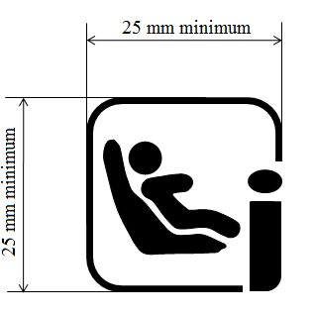
4.6.2. The size range of the Child Restraint System in centimeters;
4.6.3. The maximum occupant mass allowed for the Child Restraint System in kilograms.
4.6.2. Specific Vehicle ISOFIX ECRS:
If the product includes …
… colours or by adequate relief if it is molded or embossed.
B, C and F
The Specific vehicle ISOFIX Enhanced Child Restraint System shall have a permanently attached label visible to the person installing the Enhanced Child Restraint System in the car, containing the following information:
Specific Vehicle ISOFIX 
4.7. Booster marking
4.7.1. Universal booster Enhanced Child Restraint Systems shall have a permanently attached label with the following information visible to the person installing the Enhanced Child Restraint System in the car:
Universal booster
4.7.2. The Specific Vehicle Booster Enhanced Child Restraint System (except built-in) shall have a permanently attached label with the following information visible to the person installing the Enhanced Child Restraint System in the car:
Specific vehicle booster "
Paragraph 5.4.1.1., the reference to footnote ¹ and footnote ¹, renumber as footnote ²
Paragraphs 5.4.2. to 5.4.2.3., amend to read:
"5.4.2. The following additional symbols:
5.4.2.1. The words "i-Size universal ISOFIX", or "universal booster", or "specific vehicle ISOFIX" or "specific vehicle booster" depending on the category of Enhanced Child Restraint System;
5.4.2.2. The size range for which the Enhanced Child Restraint System has been designed;
ECRS which can be converted into another configuration for taller children shall accommodate an uninterrupted range of child statures.
Note: For example, a booster shall not accommodate children of 100 cm to 130 cm and then children of 140 cm to 150 cm with an "interruption"."
5.4.2.3. The symbol "S" in the case of a "Special Needs Restraint"."
Paragraph 6.1.1., amend to read:
"6.1.1. Enhanced Child Restraint Systems in the i-Size category are for use in i-Size seating positions, when the Enhanced Child Restraint Systems are fitted in conformity with the vehicle manufacturer's instructions.
Enhanced Child Restraint Systems in the Specific Universal Booster category are primarily designed for use in all Universal Booster seating positions.
Enhanced Child Restraint Systems in the specific vehicle ISOFIX category are for use in all ISOFIX positions and also in the luggage area, if the restraints are fitted in conformity with the vehicle manufacturer's instructions.
Enhanced Child Restraint Systems in the specific vehicle booster category are to be used according to manufacturer's instructions."
Paragraph 6.1.2., amend to read:
"6.1.2. According to the category in which it belongs to, see Table 1, the integral Enhanced Child Restraint System shall be secured to the vehicle structure or to the vehicle seat structure:"
Paragraph 6.1.2.2., the title of Table 1, amend to read:
"Table 1
Possible configurations for type approval for Integral Enhanced Child Restraint Systems."
Paragraph 6.1.3., renumber as paragraph 6.1.2.3.

Insert new paragraphs 6.1.3. to 6.1.3.5., to read:
"6.1.3. According to the category as defined by Table 2, the Non-Integral Enhanced Child Restraint System and the child shall be secured in a vehicle seating position:
6.1.3.1. For the Universal Booster category, by means of the adult safety seat belt and possibly with optional ISOFIX attachments, if these are stowable (see Regulation No 16, Annex 17, Appendix 5, Figure 1, Detail B).
6.1.3.2. For the Specific Vehicle Booster category, by means of the adult safety seat belt and possibly with attachments designed by the manufacturer of the Enhanced Child Restraint System, secured to anchorages as designed by the vehicle manufacturer.
Table 2
Possible configurations of Non-Integral Enhanced Child Restraint Systems for type approval
 | Orientation | Subcategory | Category
Non-Integral | Forward Facing |  | Universal Booster | Specific Vehicle Booster (Built-in included)
Non-Integral | Forward Facing | Booster Seat | A | A
Non-Integral | Forward Facing | Booster Cushion | A | A
Non-Integral | Rearward Facing | Booster Seat & Booster Cushion | NA | NA
A: Applicable
NA: Non-Applicable
6.1.3.3. Non-integral Enhanced Child Restraint Systems shall not accommodate a stature below 100 cm.
Booster seats shall insure lateral protection of the child as described in paragraph 7.1.3.1.3. up to a stature of 135 cm.
Above a stature of 125 cm, booster cushions shall position the child’s head according to the requirements of paragraph 6.3.2.2.2.
6.1.3.4. Enhanced Child Restraint Systems of the Universal Booster category shall have a main load-bearing contact point, between the Enhanced Child Restraint System and the adult safety belt. This point shall not be less than 150 mm from the Cr axis when measured with the Enhanced Child Restraint System on the dynamic test bench installed in accordance with paragraph 7.1.3.5.2.2. of this Regulation, without a dummy. This shall apply to all adjustment configurations and variable belt paths.
6.1.3.5. The adult seat belt required to secure a Universal Booster on the dynamic test bench is defined in Annex 23 to this Regulation. The Enhanced Child Restraint System shall be secured onto the test bench using the appropriate standard seat belt described in Annex 23 using a preload tension of 50N +/- 5N. The dummy shall not be installed unless the design of the restraint is such that the installation of a dummy would increase the amount of belt used. With the Enhanced Child Restraint System in the installed position, there shall be no additional tension in the belt, apart from that exerted by the standard retractor (4 ± 3 N), where fitted. Where the retractor belt is used, this condition shall be met with at least 150 mm of belt remaining on the spool.
A clamping mechanism used according to paragraph 7.1.3.5.2.2. shall not have any influence on the belt path."
Paragraph 6.2.1.2., amend to read:
"6.2.1.2. The Enhanced Child Restraint System shall be such that the child may be easily and readily restrained or removed. In the case of an Enhanced Child Restraint System in which the child is restrained by means of a harness belt or a Y-shaped belt without a retractor each shoulder restraint and lap strap shall be capable of movement relative to each other during the procedure prescribed in paragraph 6.7.1.4. below; in these cases the belt assembly of Enhanced Child Restraint System belt assembly may be designed with two or more connecting parts.
For Special Needs Restraints it is recognized that the additional restraining devices will restrict the speed by which a child can be restrained and removed. However, the additional devices shall be designed to release quickly so far as possible;"
Paragraph 6.2.1.4., amend to read:
"6.2.1.4. To prevent submarining, either by impact or through restlessness, a crotch strap shall be required on all integral forward-facing restraints incorporating an integral harness belt system."
Paragraph 6.2.1.5., amend to read:
"6.2.1.5. All restraint devices utilizing a "lap strap" shall positively guide the "lap strap" to ensure that the loads transmitted by the "lap strap" are transmitted through the pelvis. The assembly shall not subject weak parts of the child’s body (abdomen, crotch, etc.) to excessive stresses.
Moreover, the design shall be such that compression loads shall not be imposed on the crown of the child’s head in the event of a collision;"
Insert new paragraph 6.2.1.6., to read:
"6.2.1.6. For universal or specific vehicle boosters, the lap portion of the adult seat belt shall be positively guided to ensure that the loads transmitted by the adult lap belt are transmitted through the pelvis. The shoulder portion of the adult safety belt shall be positively guided to ensure that the child torso and neck do not escape."
Paragraphs 6.2.1.6.(former), renumber as paragraphs 6.2.1.7. and amend to read:
"6.2.1.7. All straps of the restraint shall be so placed that they cannot cause discomfort to the wearer in normal use or assume a dangerous configuration. Y-shaped belts may only be used in rearward facing and lateral facing Enhanced Child Restraint Systems (carrycots). The distance between the shoulder-straps in the vicinity of the neck should be at least the width of the neck of the appropriate dummy."

Paragraph 6.2.1.7.(former), renumber as paragraph 6.2.1.8. and amend to read:
"6.2.1.8. With the crotch strap attached and in its longest position if adjustable, it shall not be possible to adjust the lap strap to lie above the pelvis of both the smallest and largest dummy within the mass groups "size range" covered by the approval. For all forward-facing restraints, it shall not be possible to adjust the lap strap to lie above the pelvis of both the smallest and largest dummy within the masse groups "size range" covered by the approval."
Paragraph 6.2.1.8.(former), renumber as paragraph 6.2.1.9.
Insert new paragraph 6.2.1.10., to read:
"6.2.1.10. At least the worst case configuration of dynamic test for the Enhanced Child Restraint System shall be performed after conditioning according to paragraph 7.2.6."
Paragraph 6.2.5., amend to read:
"6.2.5. An Enhanced Child Restraint System may be designed for use in any range of size range specified by the manufacturer provided that it satisfies the requirements laid down in this Regulation."
Paragraph 6.3.2.1., amend to read:
"6.3.2.1. Internal geometric characteristics
The Technical Service conducting the approval tests shall verify that the internal dimensions of the Enhanced Child Restraint System conform to the requirements of Annex 18. For any size within the size range declared by the manufacturer the minimum dimensions for minimum shoulder breadth, minimum hip breadth and minimum sitting height shall be fulfilled together with as well as the dimensions for minimum and maximum shoulder height."
Paragraphs 6.3.2.2., amend to read:
"6.3.2.2. External dimensions
The Universal Integral Class Enhanced Child Restraint Systems shall be adjusted to the largest size of its declared stature range (height, depth and width dimensions as defined in Annex 18). Universal Booster Seats shall be adjusted to accommodate children of 135 cm stature (height, depth and width dimensions as defined in Annex 18) or to the largest size of its declared stature range in case the upper limit is below 135 cm. In this case, it must fit within each of its declared Vehicle Seat Fixtures in at least one adjustable position. The Enhanced Child Restraint System may be adjusted to other inclined positions (less or more reclined) that are outside the Vehicle Seat Fixture’s height; in this case, the child restraint manufacturer’s user manual shall clearly indicate that when used in one of these configurations, the Enhanced Child Restraint System may not fit in all vehicles approved for a Universal fixture."
6.3.2.2.1. Integral Class Enhanced Child Restraint Systems
The maximum dimensions for width, height and depth of the Enhanced Child Restraint System and the locations of the ISOFIX anchorages system with which its attachments shall engage, shall be defined by the ISOFIX Vehicle Seat Fixture (VSF1) as defined in paragraph 2.17.1. of this Regulation.
(a) i-Size Forward facing Enhanced Child Restraint Systems shall fit within the ISO/F2x size envelope for a reduced-height forward-facing toddler CRS ISOFIX SIZE CLASS B1;
(b) i-Size Rearward facing Enhanced Child Restraint Systems shall fit within the ISO/R2 size envelope for a reduced-size rearward-facing toddler CRS ISOFIX SIZE CLASS D;
(c) Specific vehicle ISOFIX Enhanced Child Restraint Systems shall fit in vehicle(s) specified or shall may fit within any at least in one of ISO (R1, R2, R3, F2, F2X, F3, L1, L2) size envelope."
Insert a new paragraph 6.3.2.2.2., to read:
"6.3.2.2.2. Non-Integral Class Enhanced Child Restraint Systems
The maximum external dimensions for the width, height and depth of the Enhanced Child Restraint System and the locations of the ISOFIX anchorages system if any, with which its attachments shall engage, shall be defined by the Universal booster seat fixture as defined in paragraph 2.17.2. of this Regulation.
(a) Universal Booster Enhanced Child Restraint Systems shall fit within the ISO/F4 size envelope;
(b) Specific Vehicle Booster Enhanced Child Restraint Systems shall fit in vehicle(s) specified by the child seat manufacturer;
(c) A Universal booster cushion shall position the child’s head in the zone where the adult’s head would be positioned. A measuring device described in annex 24 shall be used to check that the size range declared satisfies the following requirements:
The dimensions measured Z5 and Z95 shall be between 770 mm and [910] mm;
770 mm represents the highest point of the head relative to the Cr point in the Z direction of the HIII 5th female dummy when seated on the Regulation No. 129 bench;
[910] mm represents the highest point of the head relative to the Cr point in the Z direction of the HIII 95th male dummy when seated on the Regulation No. 129 bench."
Paragraph 6.3.5., the reference to footnote ² and footnote ², renumber as footnote ³
Paragraph 6.3.5.1., amend to read:
"6.3.5.1. Support-leg and support-leg foot geometrical requirements
…
(c) In height by a plane parallel to the X'-Y' plane, positioned at a distance of 70 mm above the origin and measured perpendicular to the X'-Y' plane. Rigid, … volume."
Paragraph 6.3.5.4. amend the text to read:
"6.3.5.4. Support-leg foot jig
A jig shall be used to check that the support-leg foot meets the requirements defined in paragraph 6.3.5.2. above (see Figure 0(e)). As an alternative a computer simulation shall also be considered satisfactory.
The jig is defined as the ISOFIX CRF corresponding to the size class of the Enhanced Child Restraint System. The jig is expanded with two 6 mm diameter ISOFIX low anchorages. The striped box positioned in front of the jig is positioned and sized according paragraph 6.3.5.2. above. The ECRS shall have its attachments latched when conducting the assessment."
Paragraph 6.6.3.1., amend to read:
"6.6.3.1. Except for the booster cushion, the Child Restraint System shall be tested as prescribed in paragraph 7.1.2. of this Regulation; at no point during the whole test shall the manikin be fully ejected from the device. In addition when the test bench is in the upside down position, the dummy’s head shall not move more than 300 mm from its original position in a vertical direction relative to the test bench; this measurement shall be performed after the load has been removed."
Paragraphs 6.6.4.1. to 6.6.4.1.4., amend to read:
"6.6.4.1. General: The dynamic test shall be performed on Enhanced Child Restraint Systems which have not previously been under load and the Enhanced Child Restraint System shall be subjected to dynamic tests, in accordance with Table 4, in conformity with paragraph 7.1.3. below:

Table 4

Application of different criteria depending on test set up
Frontal impact |  |  |  | Rear impact |  | Lateral impact
Test on trolley+  standard seat |  | Test in car body |  | Test on trolley+  standard seat | Test in car body | Test on trolley+  standard seat
Forward facing | Rearward and lateral facing | Forward facing | Rearward and lateral facing | Rearward and lateral facing | Rearward and lateral facing | Forward facing | Rearward and lateral facing

Note 1: Standard seat means a test seat or test bench as defined in Annex 6.

Note 2: For lateral facing Enhanced Child Restraint Systems in lateral impact, if two positions are possible, then the dummy’s head shall be situated near the side door.

6.6.4.1.1. i-Size category Enhanced Child Restraint Systems shall be tested on the test trolley by means of the test seat bench prescribed in Annex 6, and in conformity with paragraph 7.1.3.1. below.
6.6.4.1.2. Enhanced Child Restraint Systems of the Specific vehicle categories shall be tested with each vehicle model for which the Enhanced Child Restraint System is intended. The Technical Service responsible for conducting the test may reduce the number of vehicle models tested if they do not differ greatly in the aspects listed in paragraph 6.6.4.1.2.3. of this Regulation. The Enhanced Child Restraint System may be tested in one of the following ways:
6.6.4.1.2.1. Enhanced Child Restraint Systems according to paragraph 2.7. and in conformity with paragraph 6.3. of this Regulation and which fit in an envelope defined in Regulation No. 16, Annex 17, Appendix 2, on the test trolley by means of the test bench prescribed in Annex 6 and in conformity with paragraph 7.1.3.1. of this Regulation or in a vehicle body shell in conformity with paragraph 7.1.3.2. of this Regulation.
6.6.4.1.2.2. For Enhanced Child Restraint Systems which are in conformity with paragraph 6.3. of this Regulation (for example ECRS using no anti-rotation device or using additional anchorages) or do not fit in any envelope defined in Regulation No. 16, Annex 17, Appendix 2 on the test trolley in a vehicle body shell in conformity with paragraph 7.1.3.2. or in a complete vehicle in conformity with paragraph 7.1.3.3. of this Regulation.
6.6.4.1.2.3. Using sufficient parts of the vehicle body shell to be representative of the vehicle structure and impact surfaces. If the Enhanced Child Restraint System is intended for use in the rear seat, these shall include the back of the front seat, the rear seat, the floor pan, the B and C pillars and the roof. If the Enhanced Child Restraint System is intended for use in the front seat, the parts shall include the dashboard, the A pillars, the windscreen, any levers or knobs installed in the floor or on a console, the front seat, the floor pan and the roof. The Technical Service responsible for conducting the test may permit items to be excluded if they are found to be superfluous. Testing shall be as prescribed in paragraph 7.1.3.2. of this Regulation, except for lateral impact.
6.6.4.1.3. The dynamic test shall be performed on Child Restraint Systems which have not previously been under load. The Enhanced Child Restraint System of the Universal booster category shall be tested on the test bench described in Annex 6, and in conformity with paragraph 7.1.3.1. below.
6.6.4.1.4. If an "Specific vehicle ISOFIX" Enhanced Child Restraint System is installed in the area behind the rearmost forward facing adult seat positions (for example, the luggage area), one test with the largest dummy/dummies, as allowed by the Enhanced Child Restraint System, on a complete vehicle as prescribed in paragraph 7.1.3.3. of this Regulation shall be performed. The other tests, including the conformity of production, may be done as prescribed in paragraph 7.1.3.2. of this Regulation, at the request of the manufacturer."
Paragraphs 6.6.4.1.6. to 6.6.4.1.6.2., amend to read:
"6.6.4.1.6. In the case of an Enhanced Child Restraint System making use of an anti-rotation device and / or a shoulder strap guide, the dynamic test shall be carried out as follows:
6.6.4.1.6.1. With the anti-rotation device and with the shoulder strap guide in use, and
6.6.4.1.6.2. without the anti-rotation device and without the shoulder strap guide in use, unless a mechanism is provided to prevent incorrect use of the anti-rotation device and / or the shoulder strap guide."
Paragraph 6.6.4.3.1., amend to read:
"6.6.4.3.1. Injury assessment criteria for frontal and rear impact as in Table 5.
Table 5
Criterion | Abbreviation | Unit | Q0 | Q1 | Q1,5 | Q3 | Q6 | Q10
Head performance criterion (only in case of contact during in-vehicle testing) | HPC* (15) |  | 600 | 600 | 600 | 800 | 800 | [800]
Head acceleration 3 ms | A head 3 ms | g | 75 | 75 | 75 | 80 | 80 | [80]
Upper neck tension Force | Fz | N | For monitoring purpose only**
[Upper neck flexion moment] | My | Nm | For monitoring purpose only***  17 53 61 79 118 |  |  |  |  | 157
[Chest acceleration 3 ms] | A chest 3 ms | g | 55 | 55 | 55 | 55 | 55 | 55
[Chest deflection] | TBC | mm | NA | 40 | 40 | 40 | 56 | 56
[Abdominal pressure] | [P] | Bar | NA | NA | 1.2 | 1.2 | 1.2 | 1.2
- * HPC: see Annex 17.
- ** To be reviewed within 3 years following entry into force of this Regulation.
- ** To be reviewed within 3 years following entry into force of this Regulation."
Paragraph 6.6.4.4.1., amend to read:
"6.6.4.4.1. Enhanced Child Restraint Systems of i-Size universal categories:"
Paragraph 6.6.4.4.1.1., amend to read:
"6.6.4.4.1.1. Forward facing Enhanced Child Restraint Systems
Head excursion: No part of the head of the dummy shall pass beyond the planes BA, DA and DE as defined in Figure 1 below except for booster seats and booster cushions when using the largest dummy Q10 where the value in relation to the DA plane is 840 mm and the value in relation to the BA plane is 550 mm. This shall be judged up to 300 ms or the moment that the dummy has come to a definitive standstill whatever occurs first."
Paragraph 6.6.4.4.2., amend to read:
"6.6.4.4.2. When Enhanced Child Restraint Systems of the "Specific vehicle ISOFIX" categories are tested in a complete vehicle or a vehicle body shell, the head performance criterion (HPC) and the Head Acceleration 3 ms shall be used as assessment criteria. Where there is no head contact, these criteria shall be satisfied without measurement, and recorded only as "No Head Contact". After a test, using a complete vehicle, it shall be possible to remove the fully assembled dummy from the Enhanced Child Restraint System without the use of mechanical leverage, or the use of tools on the Enhanced Child Restraint System or vehicle structure."
Paragraph 6.6.4.5.1., amend to read:
"6.6.4.5.1. Main injury assessment criterion — Head containment
…
(b) Head shall not exceed … Appendix 3, Figure 1. This criteria is for monitoring purpose only for tests with Q10 dummy."
Paragraph 6.6.4.5.2., amend to read:
"6.6.4.5.2. Additional Injury assessment criteria for lateral impact
Criterion | Abbreviation | Unit | Q0 | Q1 | Q1,5 | Q3 | Q6 | Q10
Head performance criterion | HPC (15) |  | 600 | 600 | 600 | 800 | 800 | For monitoring purpose only
Head acceleration  3 ms | A head 3 ms | g | 75 | 75 | 75 | 80 | 80 | For monitoring purpose only
Upper neck tension force | Fz | N | For monitoring purpose only*
Upper neck flexion moment | Mx | Nm | For monitoring purpose only*
* To be reviewed within 3 years following entry into force of this Regulation. "
Paragraph 6.7.1.4. amend to read:
"6.7.1.4. It shall be possible to release the child from the restraint by a single operation on a single buckle after release of the shoulder strap positioner, if any. It is allowed to remove the child together with devices such as infant carrier/carry-cot/carry-cot restraints if the Enhanced Child Restraint System can be released by operation of a maximum of two release buttons."
Paragraph 6.7.3.1.2., amend to read:
"6.7.3.1.2. If the retractor is part of a lap strap, the retracting force … are effected."
Paragraph 6.7.3.2.5., amend to read:
"6.7.3.2.5. If the retractor is part of a lap strap, … are effected.
Paragraph 6.7.5., amend to read:
"6.7.5. ISOFIX attachment specifications
"ISOFIX attachments" and latching …conditions of use."
Paragraph 7.1.2.4., amend to read:
"7.1.2.4. Remove the load at a rate not exceeding 400 mm/min and measure residual displacement."
Paragraph 7.1.3., amend to read:
"7.1.3. Dynamic testing for frontal, rear and lateral impact:
(a) Frontal impact test shall be performed on i-Size (Integral Universal ISOFIX Enhanced Child Restraint Systems)and, Specific vehicle ISOFIX Enhanced Child Restraint Systems and to non-integral Enhanced Child Restraint Systems Universal Boosters and specific to vehicle Boosters;
(b) Rear impact test shall be performed on i-Size and Specific Vehicle ISOFIX Rearward facing Enhanced Child Restraint Systems;
(c) Lateral impact test are performed only on the test bench for i-Size Integral Universal ISOFIX Enhanced Child Restraint Systems, Specific vehicle ISOFIX and for non-integral Enhanced Child Restraint Systems Universal Boosters seat and specific to vehicle Booster seats;
(d) The ECRS shall be tested in its most upright used position. If this upright position falls outside the Seat Fixture, this position shall still to be chosen. However with width positions outside the Seat Fixture, for the lateral test the width position of lateral shock absorbers that still fit in the Vehicle Seat Fixture shall be chosen;
(e) The lateral dynamic test(s) will be performed in this(ese) configuration(s);
(f) For frontal and rear impacts, the tests shall be performed with the ECRS adjusted to the size of the dummy (ies) selected to cover the entire size range, in the child seating position representing the worst case for this dummy and impact orientation;
(g) An anti rebound device acting on the vehicle seatback shall stay inside the seat fixture in one position, but may protrude beyond the seat fixture in its adjusted position according to the user manual."
Paragraph 7.1.3.1.1., amend to read:
"7.1.3.1.1. Frontal and rear impact tests."
Paragraph 7.1.3.1.3.5., shall be deleted
Paragraph 7.1.3.1.3.6., renumber as paragraph 7.1.3.1.3.5.
Paragraph 7.1.3.4., amend to read:
"7.1.3.4. The conditions for dynamic test are summarized in Table 6:
Table 6
…"
Paragraphs 7.1.3.5.2. and 7.1.3.5.2.1., amend to read:
"7.1.3.5.2. Installation for frontal, rear and lateral impacts.
7.1.3.5.2.1. Installation of a Integral Universal ISOFIX Enhanced Child Restraint Systems (i-Size), or Integral Specific vehicle ISOFIX Enhanced Child Restraint Systems on the test bench.
The unoccupied ISOFIX Enhanced Child Restraint System shall be attached to the ISOFIX anchorage system.
Securing the ISOFIX attachments to the ISOFIX lower anchorages shall be permitted to draw the unoccupied Enhanced Child Restraint System towards those anchorages.
An additional force of 135 +/- 15N shall be applied in a plane parallel to the surface of the test seat cushion. The force shall be applied along the centre line of the Enhanced Child Restraint System and at a height no more than 100 mm above the cushion.
If present, the top tether shall be adjusted to achieve a tension load of
50 +/- 5N. Alternatively, and if present, the support-leg shall be adjusted according to the Enhanced Child Restraint System manufacturer's instructions.
The Enhanced Child Restraint System centre line shall be aligned with the centre line of the test bench.
The dummy shall be placed in the Enhanced Child Restraint System separate from the seat-back of the chair by a flexible spacer. The spacer shall be 2.5 cm thick and 6 cm wide. It shall have length equal to the shoulder height less the thigh height, both in the sitting position and relevant to the dummy size being tested. The resulting height of the spacer is listed in the table below for the different dummy sizes. The board should follow as closely as possible the curvature of the chair and its lower end should be at the height of the dummy's hip joint.
 | Q0 | Q1 | Q1.5 | Q3 | Q6 | Q10  (design targets)
 | Dimensions in mm
Height of spacer device for positioning of dummy | 173 ± 2 | 229 ± 2 | 237 ± 2 | 250 ± 2 | 270 ± 2 | 359 ± 2
Adjust the ECRS belt in accordance with the manufacturer's instructions, but to a tension of 250 ± 25 N above the adjuster force, with a deflection angle of the strap at the adjuster of 45 ± 5°, or alternatively, the angle prescribed by the manufacturer.
The spacer shall then be removed and the dummy pushed towards to the seat back. Distribute the slack evenly throughout the harness.
The longitudinal plane passing through the centre line of the dummy shall be set midway between the two lower ECRS belt anchorages, however note shall also be taken of paragraph 7.1.3.2.1.3. above.
7.1.3.5.2.2. Installation of a non-integral Enhanced Child Restraint Systems Universal Booster or Specific to vehicle Booster on the test bench.
The unoccupied Booster shall be placed on the test bench.
If present and tested, securing the ISOFIX attachments to the ISOFIX lower anchorages shall be permitted to draw the unoccupied Enhanced Child Restraint System towards these anchorages. An additional force of 135 +/-15N shall be applied in a plane parallel to the surface of the test seat cushion. The force shall be applied along the centre line of the Enhanced Child Restraint System and at a height of no more than 100 mm above the cushion.
The dummy shall be placed in the Enhanced Child Restraint System.

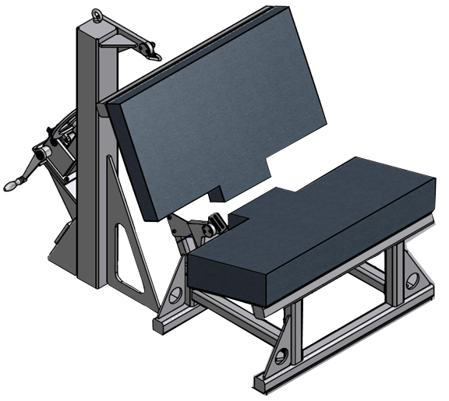
Pillar Loop
Test cushion
Load cell 1
Load cell 2
Lock-off position,
if fitted
« B » Post
Standard Retractor

Fit load cell 1 to the outboard position as shown above. Install the Enhanced Child Restraint System in the correct position. If a lock-off device is fitted to the Enhanced Child Restraint System and acts upon the diagonal belt, place load cell 2 at a convenient position behind the Enhanced Child Restraint System between the lock-off device and the buckle as shown above. If no lock-off device is fitted or if the lock-off device is fitted at the buckle, position the load cell at a convenient position between the pillar loop and the Enhanced Child Restraint System.
Adjust the lap portion of the reference belt to achieve a tension load of 50N ± 5N at load cell 1. Make a chalk mark on the webbing where it passes through the simulated buckle. While maintaining the belt at this position, adjust the diagonal to achieve a tension of 50N ± 5N at load cell 2 by either locking the webbing at the Enhanced Child Restraint System webbing locker or by pulling the belt between the belt clamping mechanism and the standard retractor. If the tension in load cell 2 is achieved by pulling the belt between the clamping mechanism and the retractor, the clamping mechanism shall now be locked.
Extract all webbing from the retractor spool and rewind the excess webbing keeping a tension of 4 ± 3 N in the belt between the retractor and the pillar loop. The spool shall be locked before the dynamic test. Conduct the dynamic crash test.
7.1.3.5.2.3. After installation
After installation, the dummy position shall be adjusted so that:
The dummy centre line and the Enhanced Child Restraint System centre line shall be aligned exactly with the centre line of the test bench.
The arms of the dummy shall be positioned symmetrically. Elbows shall be positioned in such a way that the upper arms are closely aligned with the sternum.
Hands shall be positioned on the thighs.
Legs shall be positioned parallel to one another or at least symmetrically.
For lateral impact, positive measures shall be taken to ensure the stability of the dummy is maintained until t0 and this shall be confirmed using video analysis. Any means used to stabilise the dummy before t0 shall not influence the dummy kinematics after t0.
Because the foam of the test bench seat cushion will compress after installation of the Enhanced Child Restraint System, the dynamic test shall be conducted no more than 10 minutes after installation.
To allow the test bench seat cushion to recover, the minimum period between two tests using the same test bench seat cushion shall be 20 minutes.
Example for arm alignment:
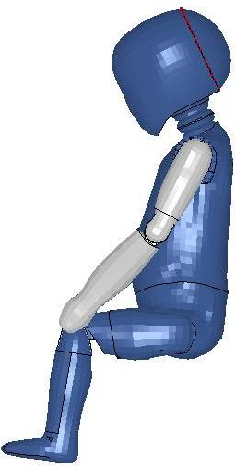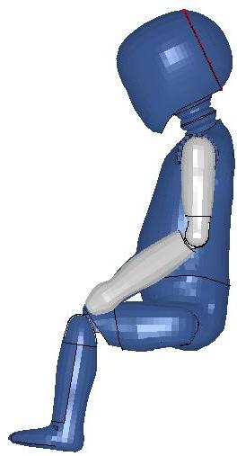
Arms are aligned with sternum | Arms are not aligned with sternum | "
Paragraph 7.1.3.6., amend to read:
"7.1.3.6. i- Size indication
The dynamic tests shall be conducted with the largest dummy and the smallest dummy as defined in the following tables according to the size range indicated by the manufacturer for the Enhanced Child Restraint System.
Table 7
Selection criteria for the dummy according to the range
Size range indication (in cm) | ≤ 60 | 60 < x ≤ 75 | 75 < x ≤ 87 | 87 < x ≤ 105 | 105 < x ≤ 125 | >125
Dummy | Q0 | Q1 | Q1.5 | Q3 | Q6 | Q10¹
¹ No lateral impact test is required for size range over 125 cm until Q10 dummy injury criteria for the lateral impact test are established.
Where the Enhanced Child Restraint System requires … defined above."
Paragraph 7.1.3.6.3., amend to read:
"7.1.3.6.3. If the i-Size Enhanced Child Restraint System uses a support-leg, as an anti-rotation device the hereafter mentioned dynamic tests shall be carried out as follows:
(a) The tests … in Annex 6, Appendix 2, Figure 2;
…"
Paragraph 7.2.1.1.2., amend to read:
"7.2.1.1.2. The Enhanced Child Restraint System shall be removed from the test trolley bench or the vehicle without opening the buckle. … dynamic test."
Paragraph 7.2.1.2.1., amend to read:
"7.2.1.2.1. A buckle assembly which has not previously been subjected to a load shall be mounted and positioned under a "no load" condition."
Paragraph 7.2.4.1.1. amend to read:
"7.2.4.1.1. The retracting forces shall be measured with the safety ECRS belt assembly, fitted to a dummy as for the dynamic test prescribed in paragraph 7.1.3. above. … of 0.6 m/min."
Paragraph 7.5., amend to read:
"7.5. The measuring procedures shall correspond to those defined in the latest version of ISO 6487. The channel frequency class shall be:

Table 9
Type of measurement | CFC(F_{H}) | Cut-off frequency (F_{N})
Trolley acceleration | 60 | see ISO 6487Annex A
Belt loads | 60 | see ISO 6487Annex A
Chest acceleration | 180 | see ISO 6487Annex A
Head acceleration | 1 000 | 1 650 Hz
Upper neck force | 1 000
Upper neck moment | 600
Chest deflection | 600
Abdominal pressure | 180
The sampling rate … per second per channel)."
Paragraph 8.1., amend to read:
"8.1. The test report shall record the results of all tests and measurements including the following test data:
…
(h) The following dummy criteria: HIC, Head Acceleration 3 ms, Upper Neck Tension Force, Upper Neck Moment, Thorax Chest Deflection; Abdominal Pressure (in frontal impact) and
(i) The lap belt force.Adult Seat belt bench installation forces."
Paragraph 9.2., amend to read:
"9.2. Qualifying the production of Enhanced Child Restraint Systems
The production of each new approved type of Enhanced Child Restraint System of categories i-Size and specific to vehicle shall be subjected to production qualification tests. Additional qualifications of production may be prescribed following paragraph 11.4.
For this purpose, a random sample of 5 Enhanced Child Restraint Systems will be taken from the first production batch. The first production batch is considered to be the production of the first block containing a minimum of 50 Enhanced Child Restraint Systems and a maximum of 5,000 Enhanced Child Restraint Systems."
Paragraph 9.2.1.2., amend to read:
"9.2.1.2. For each test described in paragraph 9.2.1.1. above, the injury criteria described in paragraph 6.6.4.3.1. above; and
For forward facing the head excursion described in paragraph 6.6.4.4.1.1. above;
For rearward facing and carrycots the head excursion described in paragraph 6.6.4.4.1.2.1. above and head excursion described in 6.6.4.4.1.2.2. above;
Shall be measured."
Paragraph 9.2.2., amend to read:
"9.2.2. Dynamic tests for lateral impact
The monitoring of head acceleration on production samples will define acceptance criteria in lateral impact for production qualification as defined in paragraph 9. (to be review before finalising phase 3)"
Paragraph 14.2.1., amend to read:
"14.2.1. For "i-Size" category Enhanced Child Restraint Systems the following label shall be clearly visible on the exterior of the packing:
Notice
This is an "i-Size" Enhanced Child Restraint System. It is approved according to Regulation No.129, for use in, "i-Size compatible" vehicle seating positions as indicated by vehicle manufacturers in the vehicle users’ manual.
If in doubt, consult either the Enhanced Child Restraint System manufacturer or the retailer. | "
Insert new paragraph 14.2.2., to read:
"14.2.2. For universal booster category Enhanced Child Restraint Systems the following label shall be clearly visible on the exterior of the packing:
Notice
This is a universal booster Enhanced Child Restraint System. It is approved according to Regulation No. 129, for use in "Universal booster seating positions" as indicated by vehicle manufacturers in the vehicle user’s manual.
If in doubt, consult either the Enhanced Child Restraint System manufacturer or the retailer. | "
Paragraphs 14.2.2.(former), renumber as paragraph 14.2.3. and amend to read:
"14.2.3. For "Specific vehicle ISOFIX" category Enhanced Child Restraint Systems information on the applicable vehicle shall be clearly visible at the point of sale without removing the Enhanced Child Restraint System from its packing; 14.2.3. For "Specific vehicle ISOFIX" category Enhanced Child Restraint Systems information on the applicable vehicle shall be clearly visible at the point of sale without removing the Enhanced Child Restraint System from its packing;"
Paragraphs 14.2.3. to 14.2.7., renumber as paragraphs 14.2.3. to 14.2.8.
Paragraph 14.2.8.(former), renumber as paragraph 14.2.9. and amend to read:
"14.2.9. For " i-Size Special Needs Restraints" Enhanced Child Restraint Systems the following information shall be clearly visible at the point of sale without removing the Enhanced Child Restraint System from its packing:
This " i-Size Special Needs Restraint" is designed to give extra support to children who have difficulty in sitting correctly in conventional seats. Always consult your doctor to make sure that this restraint system is suitable for your child. | "
Paragraph 14.3.1., amend to read:
"14.3.1. The "Size range" and for integral Enhanced Child Restraint System the maximum occupant mass for which the device is intended:"
Insert new paragraphs 16. to 16.4., to read:
"[16. Transitional provisions
16.1. As from the official date of entry into force of the 01 series of amendments, no Contracting Party applying this Regulation shall refuse to grant ECE approval under this Regulation as amended by the 01 series of amendments.
16.2. As from 12-months after the date of entry into force of the 01 series of amendments, Contracting Parties applying this Regulation shall grant approvals only if the Enhanced Child Restraint System type to be approved meets the requirements of this Regulation as amended by the 01 series of amendments.
16.3. During the 12-month period which follows the date of entry into force of the 01 series of amendments, Contracting Parties applying this Regulation can continue to grant type approvals to Enhanced Child Restraint Systems which comply with the requirements of this Regulation as in its original version.
16.4. During the 36-month period which follows the date of entry into force of the 01 series of amendments, Contracting Parties applying this Regulation shall not refuse to grant extensions of approval to the original version of this Regulation.] "

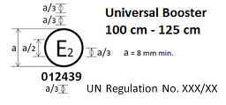
Annex 2, insert at the end two new approval marks, to read:
"

The Enhanced Child Restraint System bearing the above approval mark can be fitted in any Universal Booster seating position and used for the 100 cm - 125 cm size range; it is approved in France (E 2) under the number 012439. The approval number indicates that the approval was granted in accordance with the requirements of the Regulation concerning the approval of Enhanced Child Restraint Systems used on-board of motor vehicles as amended by the 01 series of amendments. In addition, the name of the regulation is to be identified on the approval mark followed by the series of amendment according to which the approval has been granted.

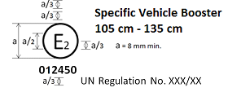
The Enhanced Child Restraint System bearing the above approval mark is a device not capable of being fitted in every vehicle but capable of being used for the 105 cm - 135 cm size range; it is approved in France (E 2) under the number 012450. The approval number indicates that the approval was granted in accordance with the requirements of the Regulation concerning the approval of Specific Vehicle Booster Enhanced Child Restraint Systems used onboard of motor vehicles as amended by the 01 series of amendments. In addition the name of the regulation has to be identified on the approval mark followed by the series of amendment according to which the approval has been granted."
Annex 6, paragraph 3.1.2., amend to read:
"3.1.2. Rigid seating, made from a rigid metal sheet, dimensions of which are given in Appendix 1 to this annex. The rear part of the seating is made from a rigid sheet metal,. The front part of the seating is also made of a 20 mm diameter tube;"
Annex 6, paragraph 3.1.5., Table 1, amend to read:
" Table 1
…
Indentation Load Deflection (ILD) | EN ISO 2439B (40 % compression) | 480 (+/15%) | N
…
"
Annex 6, Appendix 1, shall be deleted
Annex 6, insert new Appendix 1, to read:
- "Annex 6 - Appendix 1
Figure 1
Dimensions in mm of the seat and the seat cushions
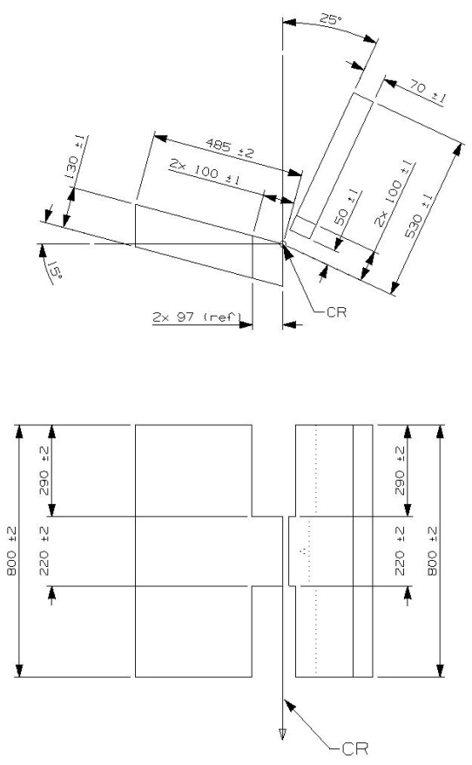
Figure 2
Dimensions of the aluminium bottom-plate and dimensions of the aluminium backrest plate
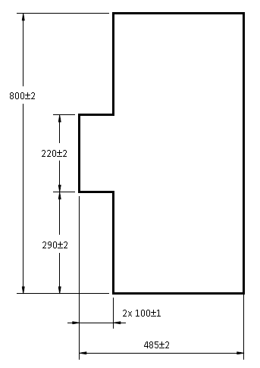
Figure 3
Dimensions of the cover material (dimensions in mm)

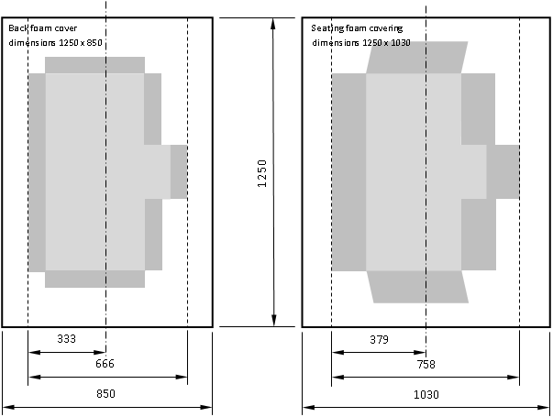

- Annex 6, Appendix 2, amend to read:
"Annex 6 - Appendix 2
Arrangement and use of anchorages on the test trolley
1. The anchorages shall be positioned as shown in the figure below.
2. Enhanced Child Restraint Systems in the i-Size "universal", "specific" and "restricted" categories shall use the following anchorage points: H₁ and H₂.
3. For testing of Enhanced Child Restraint Systems with top tether, the anchorage G₁ or G₂ shall be used.
4. In the case of Enhanced Child Restraint Systems utilising a support-leg, the Technical Service shall select the anchorages to be used according to paragraph 3. above and with the support-leg adjusted as specified in paragraph 7.1.3.6.3. of this Regulation.
5. The structure carrying the anchorages shall be rigid. The upper anchorages shall not be displaced by more than 0.2 mm in the longitudinal direction when a load of 980 N is applied to them in that direction. The trolley shall be so constructed that no permanent deformation shall occur in the parts bearing the anchorages during the test.
Figure 1
Top View – Bench with Isofix anchorages (Tolerance general: ±2 mm)
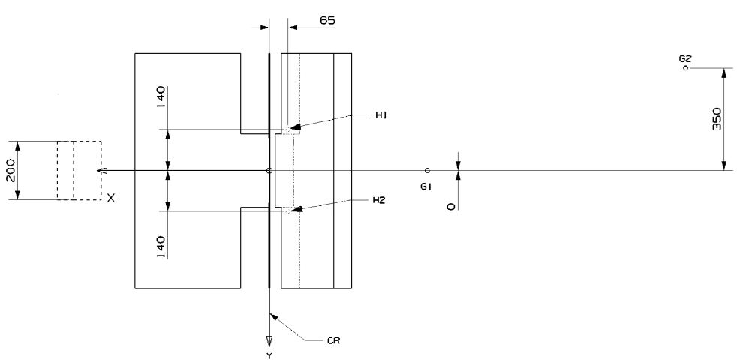
Figure 2
Side View – Bench with anchorages (Tolerance general: ±2 mm)
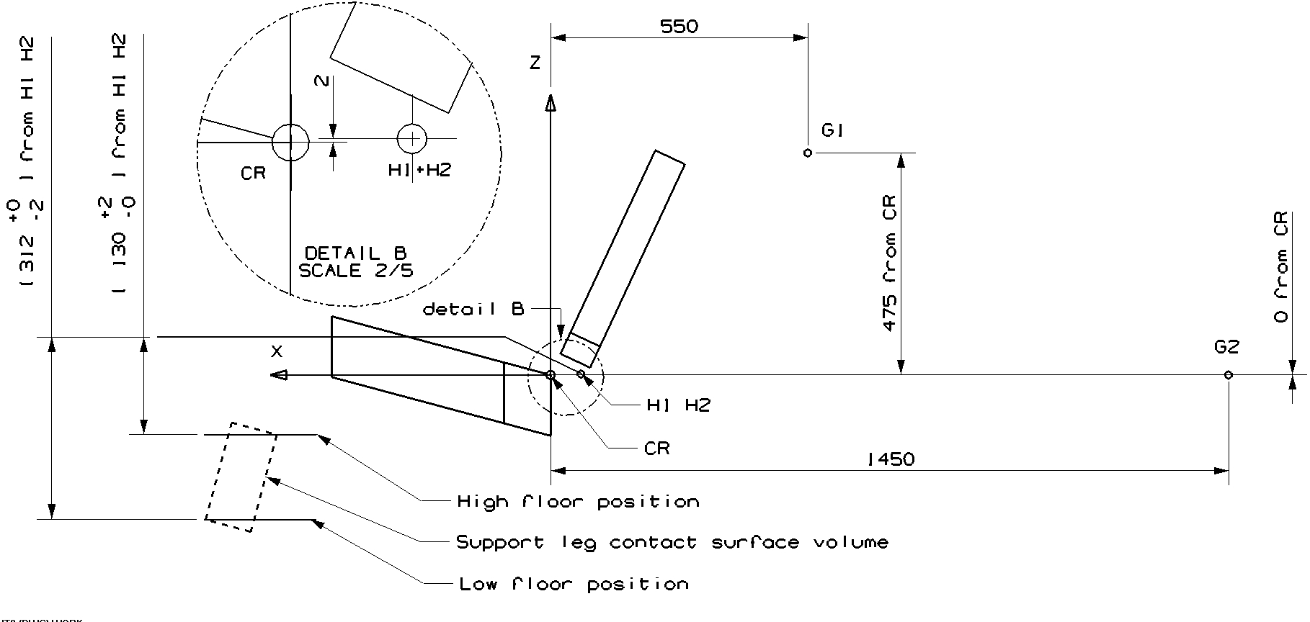
- Definition of belt anchorages
- The following table gives the belt anchorages points.
Table 1
 | Upper Anchorage (P) |  |  | Buckle (A2) |  |  | Lower outer (A1)
Direction | X | Y | Z | X | Y | Z | X | Y | Z
Distance  (mm) | -240 | -220 | -630 | -29 | 200 | 59 | 10 | -200 | 14.5

Figure 3
Top View – Bench with belt anchorages (Tolerance general: ±2 mm)
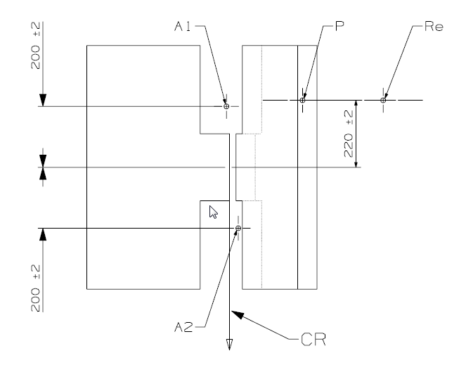
"Re" is located on the centre line of the retractor spool
Figure 4
Side View – Bench with belt anchorages (Tolerance general: ±2 mm)
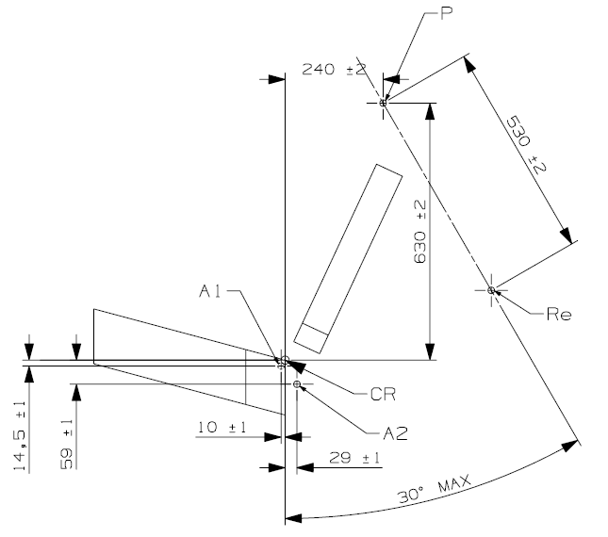
"Re" is located on the centre line of the retractor spool"
Annex 6, Appendix 3, amend to read:
  - "Annex 6 - Appendix 3
  - Definition of side impact door
1. Door panel definition
The dimension and initial position of the impact door relative to the bench are described in the following figures.
The stiffness and strength of the door panel shall be sufficient to avoid excessive oscillation or significant deformation during lateral dynamic test.
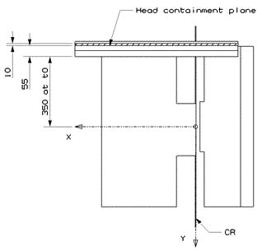
Figure 1
Door panel geometry and position at T0 – Top view

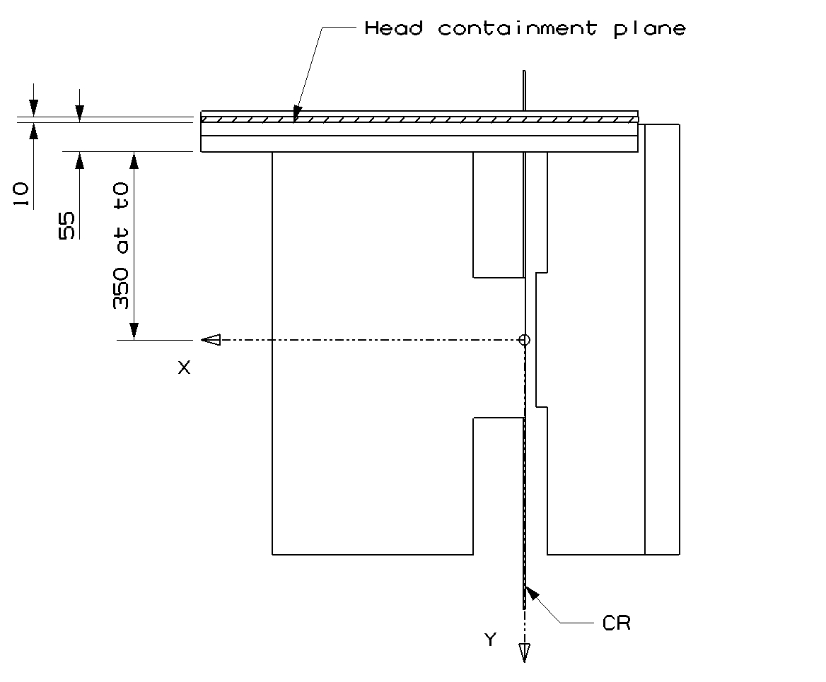
Figure 2
Door panel geometry – Side view (Tolerance general: ±2 mm and ±1 degree)
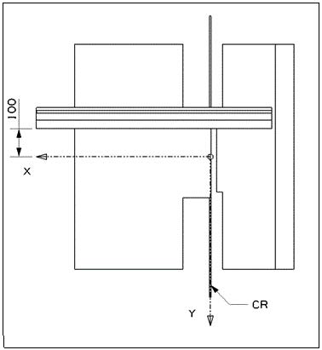
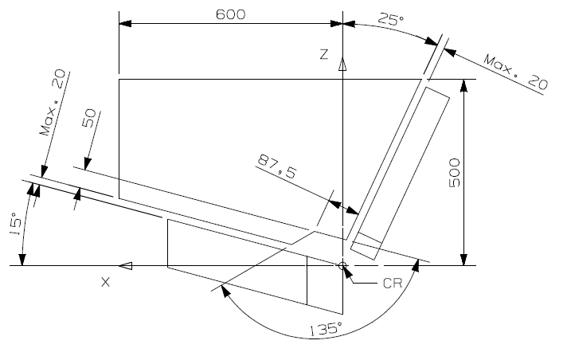
Figure 3
Door panel approximate maximum intrusion – Side view (For information)
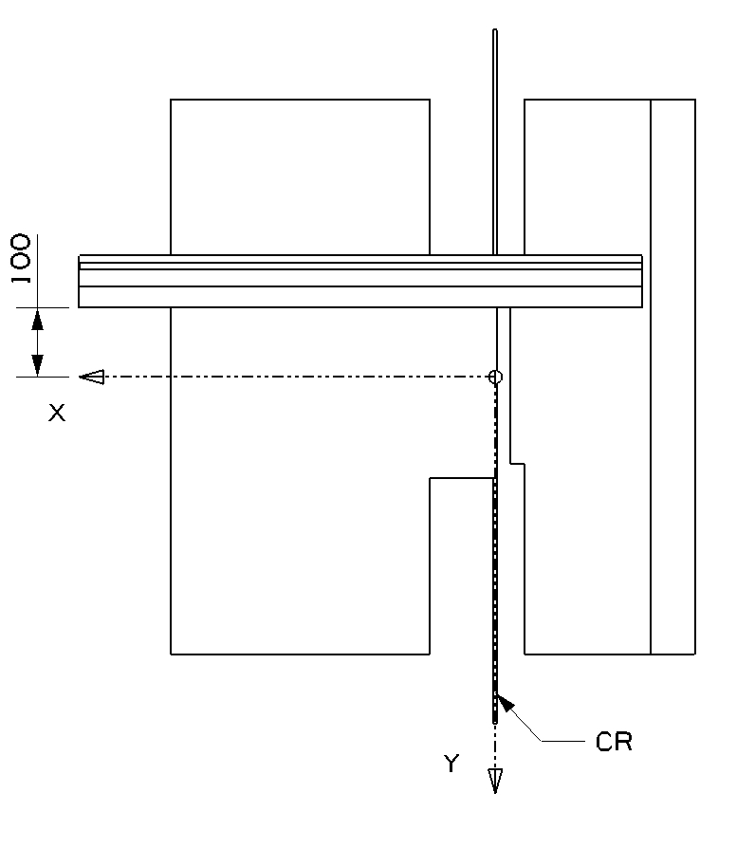
2. Panel padding specification
2.1. General
The impact surface of the door panel shall be entirely covered with a padding material of 55 mm in thickness (see Figure 1 above). The material shall comply with the performance criteria specified in paragraph 2.3. (figure 4 below) of this appendix when tested in accordance with paragraph 2.2. of this appendix.
A material combination meeting these requirements is described in paragraph 2.4. of this appendix. The door panel is padded with 55 mm padding material (Annex 6, Appendix 3, Figure 1), which has to comply with the performance criteria as described in Appendix 3 to this Regulation, paragraph 2.3. realised in a test set up as described in Appendix 3 to this Regulation, paragraph 2.2.
2.2. Test procedure for the assessment of panel padding material
The test set up consists of a simple drop test using a spherical head form. The spherical head form has a diameter of 150 mm and a mass of 6 kg (±0.1 kg). The impact speed is 4 m/s (±0.1 m/s). The instrumentation should allow the assessment of the time of first contact between the impactor and the sample as well as the head form acceleration at least in direction of impact
(Z-direction).
The material sample should have the dimensions of 400 x 400 mm. The sample should be impacted in its centre.
2.3. Performance criteria for the padding material
The time of first contact between sample material and head form (t0) is 0 ms.
The impactor acceleration shall not exceed 58 g.
Figure 4
Corridor for the padding material
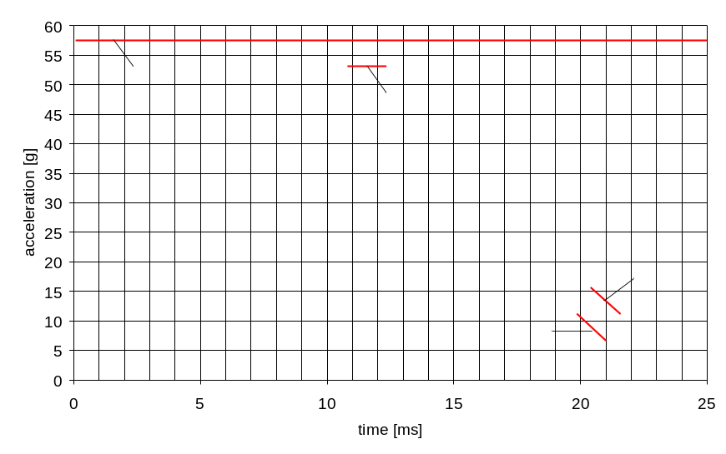
Key
1 - Upper limit of 58 g
2 - Lower limit for the maximum peak at 53 g (11 to 12 ms)
3 - Upper limit for the decline of acceleration (15 g at 20,5 ms to 10 g at 21,5 ms)
4 - Lower limit for the decline of acceleration (10 g at 20 ms to 7 g at 21 ms)
2.4. Example of material meeting the test requirements:
Rubber cell foam Polychloropren CR4271 measuring 35 mm in thickness attached to the door panel structure to which shall then be attached a subsequent layer of Styrodur C2500 20 mm in thickness. The Styrodur needs to be replaced after each test."
Annex 6, insert new Appendix 4, to read:
- "Annex 6 - Appendix 4
- Stopping device
Frontal impact dimensions (in mm)

Figure 1
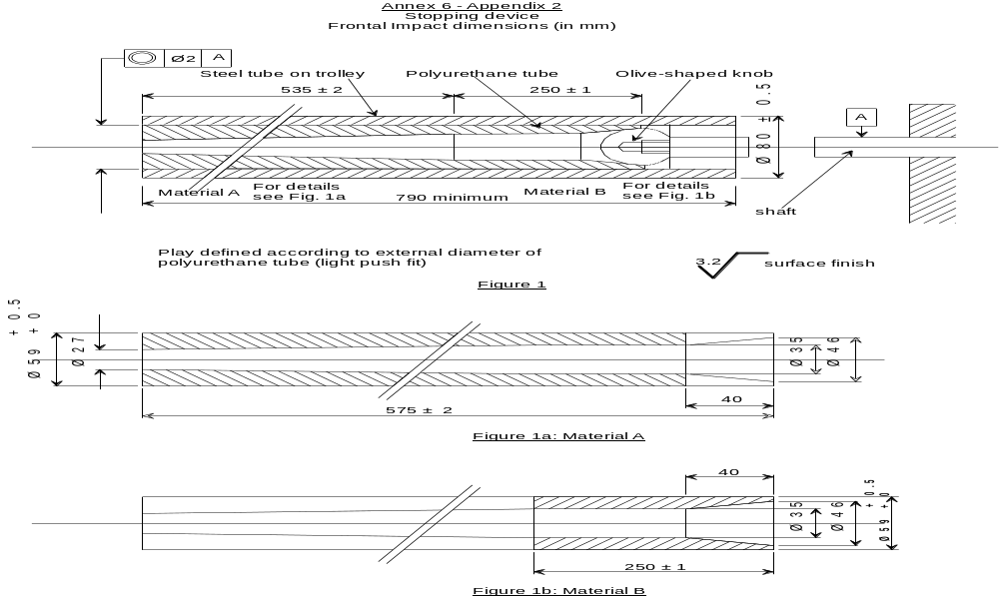

Figure 1a

Material A

Figure 1b

Material B

Figure 2

Stopping device olive-shaped knob

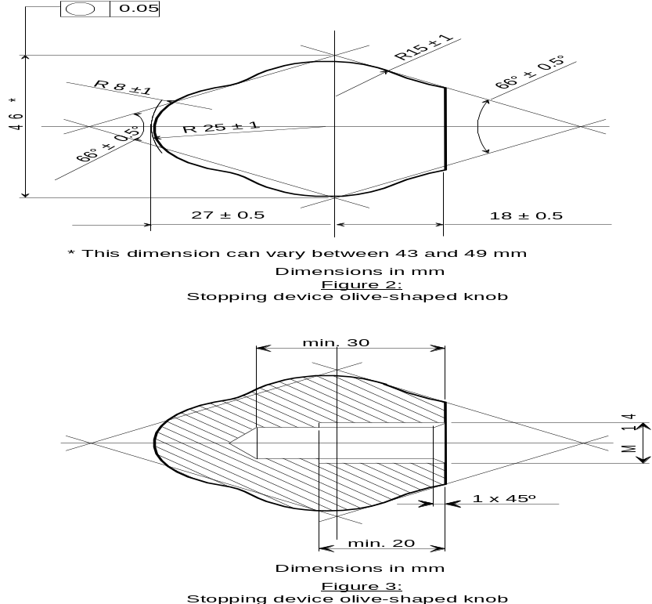

Figure 3

Stopping device olive-shaped knob
Figure 4
Stopping Device (assembled)
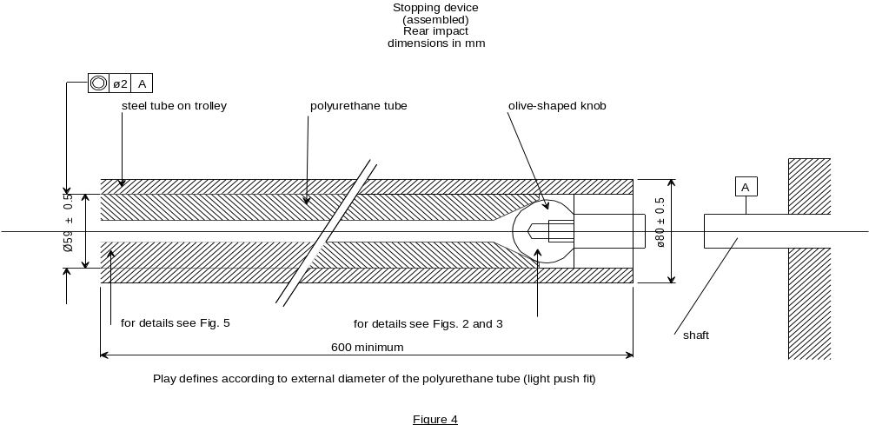

Figure 5
Stopping Device – polyurethane tube
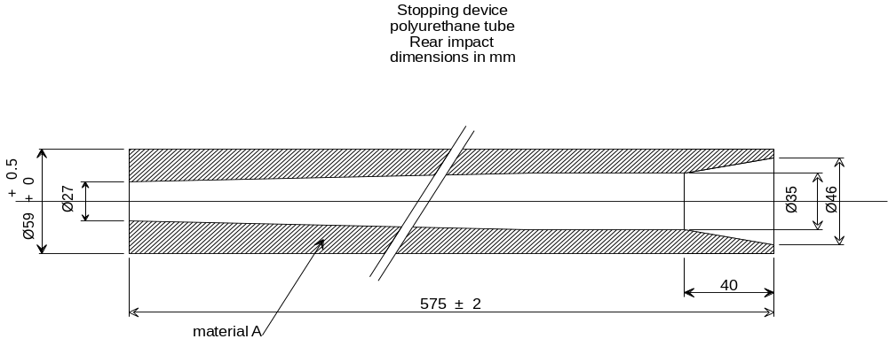
"
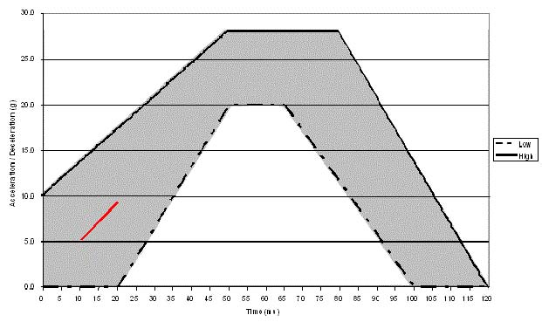
Annex 7, Appendix 1, the figure, amend to read:
"

”
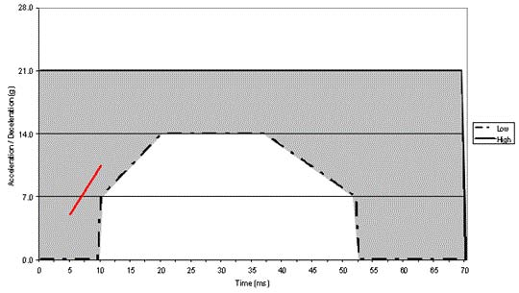
Annex 7, Appendix 2, the figure, amend to read:
"

"
Annex 7, Appendix 4, shall be deleted
Annex 8, paragraph 1, amend to read:
"1. GENERAL
1.1. The dummies prescribed in this Regulation are described in this annex, in technical drawings [held by Humanetics Innovative Solutions Inc. and in the user manuals delivered with the dummies. The abdominal pressure sensors prescribed in this Regulation are described in this annex, in technical drawings held by the French institute of science and technology for transport, spatial planning, development and networks (IFSSTAR) and in the user manuals delivered with the instrumentation.]
1.2. Alternative dummies and abdominal instrumentation may be used provided that:
1.2.1. Their equivalence can be demonstrated to the satisfaction of the Type Approval Authority, and
1.2.2. Their use is recorded in the test report, and in the communication form described in Annex 1 to this Regulation."
Annex 8, Table 2 and the notes, amend to read:

"Table 2
Q-dummy dimensions
No. |  | Q0 | Q1 | Q1.5 | Q3 | Q6 | Q10  (design targets)
 |  | Dimensions in mm
17 | Seating height  (head tilted forward) | 355 ± 9 | 479 ± 9 | 499 ± 9 | 544 ± 9 | 601 ± 9 | < 748 ± 9
18 | Shoulder height  (sitting) | 225 ± 7 | 298 ± 7 | 309 ± 7 | 329 ± 7 | 362 ± 7 | 473 ± 7
 | Stature  (head tilted forward) | - | 740 ± 9 | 800 ± 9 | 985 ± 9 | 1143 ± 9 | < 1443 ± 9
5 | Chest depth | - | 114 ± 5 | 113 ± 5 | 146 ± 5 | 141 ± 5 | 171 ± 5
15 | Shoulder width | 230 ± 7 | 227 ± 7 | 227 ± 7 | 259 ± 7 | 305 ± 7 | 338 ± 7
13 | Neck diameter | 44 | 61.9¹ | 61.9¹ | 61.9¹ | 61.9  58.0  76.0 | 65.0¹  85.9⁴
12 | Hip width | - | 191 ± 7 | 194 ± 7 | 200 ± 7 | 223 ± 7 | 270 ± 7
1 | Back of buttocks to front of knees | 130 ± 5 | 211 ± 5 | 235 ± 5 | 305 ± 5 | 366 ± 5 | 488 ± 5
2 | Back of buttocks to popliteus | - | 161 ± 5 | 185 ± 5 | 253 ± 5 | 299 ± 5 | 418 ± 5
21 | Thigh height, sitting |  | 69 | 72 | 79 | 92 | 114
 | Height of spacer device for positioning of dummy | 173 ±2 | 229 ± 2 | 237 ± 2 | 250 ± 2 | 270 ± 2 | 359 ± 2
¹ See section 7.1.3.5.2.1: Height of spacer device (hinged board or similar flexible device) equals shoulder height sitting minus thigh height sitting.
Notes:
1. Adjustments of joints
Joints should preferably be adjusted according to procedures included in the
Q- dummy manuals.
2. Instrumentation
Instrumentation in the Q family of dummies shall preferably be installed and calibrated according to procedures contained in the Q-dummy manuals.²"

Annex 8, paragraph 3.5., amend to read:
"3.5. Abdomen
The abdomen is foam covered with skin. Biomechanical data from children has been usedto determine the required stiffness. The Q0 abdomen has a simplified layout with an integral foam part for the complete torso. For frontal impact, the abdomen of the Q1.5, Q3, Q6 and Q10 are instrumented using Abdominal Pressure Twin Sensors (APTS)."

Annex 8, paragraph 4.1., amend to read:
"4.1. Mass
Table 1
Q-dummy mass distributions
 | Q0 | Q1 | Q1.5 | Q3 | Q6 | Q10 Design targets
Mass in [kg]
Head + Neck (incl. acc. mount) | 1.10 ± 0.10 | 2.41 ± 0.10 | 2.80 ± 0.10 | 3.17 ± 0.10 | 3.94 ± 0.10 | 4.19
Torso (incl. acc. mount and chest deflection sensor, not including APTS) | 1.50 ± 0.15 | 4.21 ± 0.25 | 4.74 ± 0.25 | 6.00 ± 0.30 | 9.07 ± 0.40 | 14.85  (incl. suit)
Legs (together) | 0.58 ± 0.06 | 1.82 ± 0.20 | 2.06 ± 0.20 | 3.54 ± 0.10 | 6.90 ± 0.10 | 12.50
Arms (together) | 0.28 ± 0.03 | 0.89 ± 0.20 | 1.20 ± 0.20 | 1.48 ± 0.10 | 2.49 ± 0.10 | 4.00
Suit | 0.27 ± 0.05 | 0.27 ± 0.05 | 0.30 ± 0.05 | 0.40 ± 0.10 | 0.55 ± 0.10 | (see torso)
Total | 3.73 ± 0.39 | 9.6 ± 0.80 | 11.10 ± 0.80 | 14.59 ± 0.70 | 22.95 ± 0.80 | 35.54
The installation of Abdominal Pressure Twin Sensors (APTS) in frontal impact may add up 0.2 kg to the Q1.5 and 0.5kg to the Q3, Q6 and Q10 dummies.

Annex 8, paragraph 4.2., Note 2, amend to read:

"2. Instrumentation
Instrumentation in the Q family of dummies shall be installed and calibrated according to procedures contained in the Q-dummy manuals 1 and the APTS manual."

Annex 12, paragraph 2.3., amend to read:
"2.3. For "Specific vehicle ECRS ISOFIX" devices according to paragraph 2.1.2.4.1. above, the Enhanced Child Restraint System manufacturer may choose Conformity of Production procedures according to either paragraph 2.2. above, on a test bench, or paragraphs 2.3.1. and 2.3.2. below , in a vehicle body shell."
Annex 12, paragraph 2.3.1., amend to read:
"2.3.1. For "Specific vehicle ISOFIX ECRS" devices, the following test frequencies shall apply once every eight weeks:
…"
Annex 14, paragraph 1, amend to read:
"1. Place the device … Annex 13. This area shall include the backrest and side wings, including the inner edges (zone of radius) of the side wings. In the case of carrycot devices where a symmetrical installation of the dummy is not possible according to the device and manufacturer instructions, the area complying with Annex 13 shall be all internal surfaces above a point "A", …"
Annex 18, amend to read:
"Annex 18
Geometrical dimensions of i-Size Enhanced Child Restraint Systems

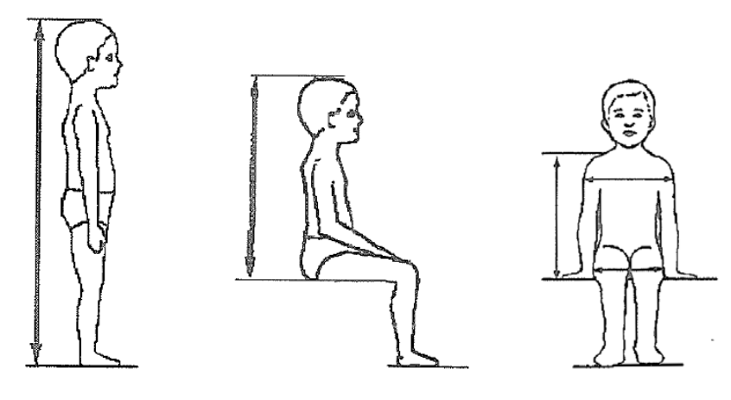
Figure 1

A
B
C
E
D

Stature cm | Minimum  Sitting height cm | Minimum  Shoulder breadth cm | Minimum  Hip breadth cm | Minimum  Shoulder height cm | Maximum  Shoulder height cm
A | B | C | D | E1 | E2
 | 95%ile | 95%ile | 95%ile | 5%ile | 95%ile
40 | NA | NA | NA | NA | NA
45 | 39.0 | 12.1 | 14.2 | 27.4 | 29.0
50 | 40.5 | 14.1 | 14.8 | 27.6 | 29.2
55 | 42.0 | 16.1 | 15.4 | 27.8 | 29.4
60 | 43.5 | 18.1 | 16.0 | 28.0 | 29.6
65 | 45.0 | 20.1 | 17.2 | 28.2 | 29.8
70 | 47.1 | 22.1 | 18.4 | 28.3 | 30.0
75 | 49.2 | 24.1 | 19.6 | 28.4 | 31.3
80 | 51.3 | 26.1 | 20.8 | 29.2 | 32.6
85 | 53.4 | 26.9 | 22.0 | 30.0 | 33.9
90 | 55.5 | 27.7 | 22.5 | 30.8 | 35.2
95 | 57.6 | 28.5 | 23.0 | 31.6 | 36.5
100 | 59.7 | 29.3 | 23.5 | 32.4 | 37.8
105 | 61.8 | 30.1 | 24.9 | 33.2 | 39.1
110 | 63.9 | 30.9 | 26.3 | 34.0 | 40.4
115 | 66.0 | 32.1 | 27.7 | 35.5 | 41.7
120 | 68.1 | 33.3 | 29.1 | 37.0 | 43.0
125 | 70.2 | 34.5 | 30.5 | 38.5 | 44.3
130 | 72.3 | 35.7 | 31.9 | 40.0 | 46.1
135 | 74.4 | 36.9 | 33.3 | 41.5 | 47.9
140 | 76.5 | 38.1 | 34.7 | 43.0 | 49.7
145 | 78.6 | 39.3 | 36.3 | 44.5 | 51.5
150 | 81.1 | 41.5 | 37.9 | 46.3 | 53.3
When All lateral dimensions are measured under a contact force of 50 N with the device described in Figure 2 of this annex and the following tolerances will be applied to the dimensions:
Minimum Sitting height:
- From 40 up to 87 cm B - 5 per cent
- From stature from 87 cm and up to 150 cm B - 10 per cent,
Minimum shoulder breadth: C -0+2 cm
Minimum hip breadth: D -0+2 cm
Minimum shoulder height (5 percentile): E1 ₋₂⁺⁰ cm
Maximum shoulder height (95 percentile): E2 ₋₀⁺² cm
The mass of the device described in Figure 2 of this annex shall be 10 kg +/- 1 kg"
Annex 22, insert new paragraph 2.5., to read:
"2.5. For Infant carrier module the following label shall be clearly visible on the exterior of the packing:
Notice | "
This is an Enhanced Infant Carrier Module to be used in combination with i-size product approved according to Regulation No. 129, for use in, "i-Size compatible" vehicle seating positions as indicated by vehicle manufacturers in the vehicle user’s manual. This module could also be used as a stand-alone infant carrier according to the instructions of the Enhanced Child Restraint System manufacturer. | "
If in doubt, consult either the manufacturer or the retailer of the Enhanced Child Restraint System. | "

Insert new Annex 23, to read:
"Annex 23
Standard safety-belt
1. The safety-belt for the dynamic test and for the maximum length requirements shall be made according to one of the two configurations shown in Figure 1. These are a three-point retracting belt system.
2. The three-point retracting belt has the following rigid parts: a retractor (R), a pillar loop (P), two anchorage points (A1 and A2) (see Figure 1), and a central part (N, in detail in Figure 3). The retractor shall comply with the requirements of Regulation No. 16 (paragraph 6.2.5.2.2.) for retraction force. The retractor spool diameter is 33 ± 0.5 mm [(example is given in Mutual Resolution No. 1 (M.R.1))].
3. The retracting belt shall be fitted to the anchorages on the test bench, described in Annex 6, Appendix 2 as follows:
(a) Belt anchorage A1 shall be fitted to trolley anchorages B0 (outboard);
(b) Belt anchorage A2 shall be fitted to trolley anchorage A (inboard);
(c) Belt pillar loop P shall be fitted to trolley anchorage C;
(d) Belt retractor R shall be fitted to trolley anchorage such that the spool centre line is positioned on Re.
The value of X in Figure 1 below is 200 ± 5 mm. The effective strap length between A1 and the centre line of the retractor spool Re (when the webbing is fully extracted including the minimum length of 150 mm for testing of Enhanced Child Restraint System shall be [2820] ± 5 mm when measured in a straight line without load and on a horizontal surface. This length may be increased for the testing of restricted categories; for all categories with the Enhanced Child Restraint System installed, there shall be a minimum of 150 mm of strap length on the retractor spool.
4. The strap requirements for the belt as follows:
(a) Material: polyester spinnblack;
(b) Width: 48 +/- 2 mm at 10,000 N;
(c) Thickness: 1.0 +/- 0.2 mm;
(d) Elongation: 8 +/- 2 per cent at 10,000 N.
Figure 1
Standard seat belt configurations
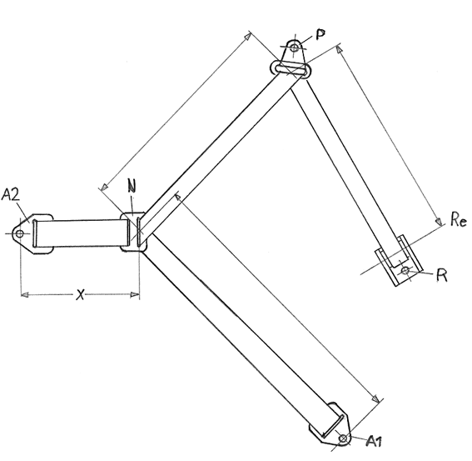

Figure 2
Typical standard anchorage plate

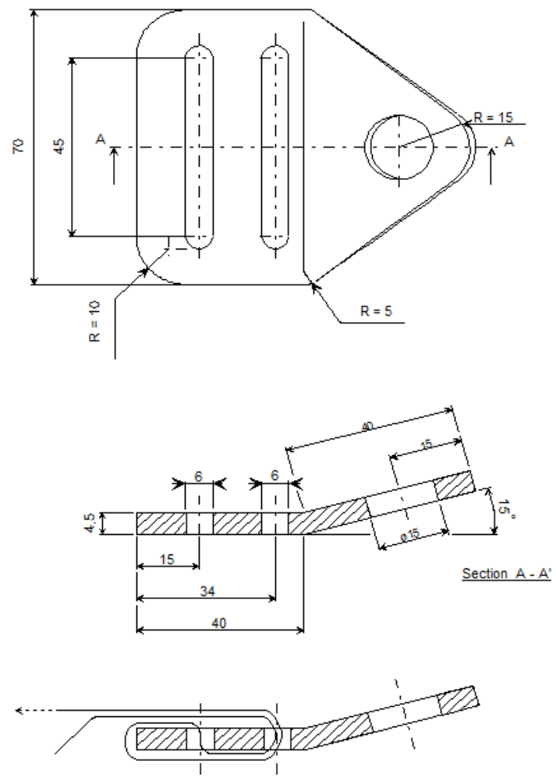
Figure 3
Central part of the standard belt configuration
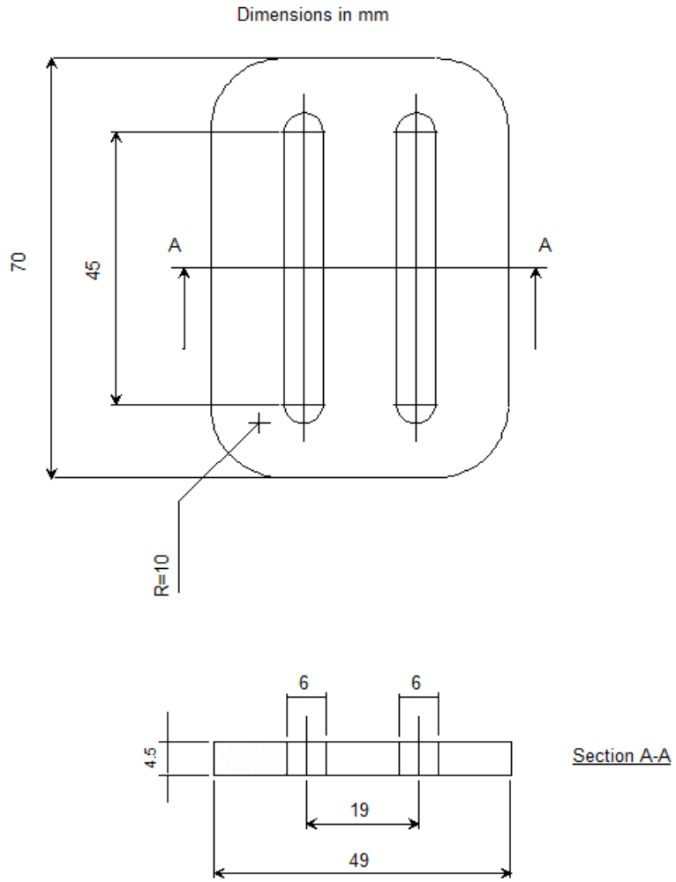
Figure 4
Pillar loop
Finish: Chromium plated
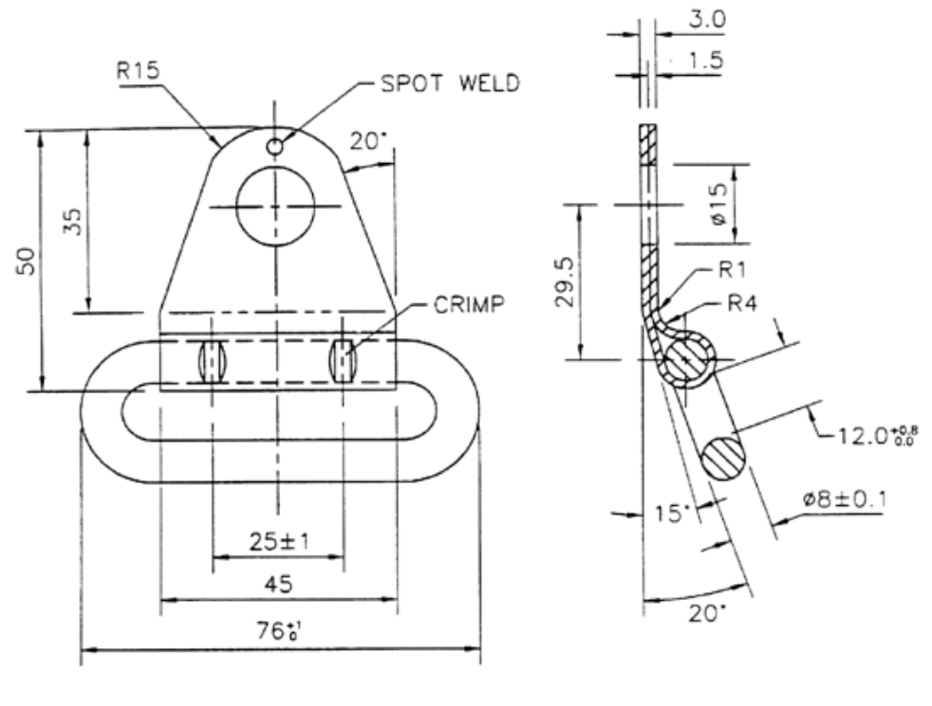"
Insert new Annex 24, to read:
"Annex 24
Procedure and Measuring device to evaluate a Universal Booster Cushion
1. Definition of the measuring device to assess a universal Booster Cushion
The measuring device to assess a universal Booster Cushion is described in Figure 1. This measuring device shall have a mass of 10±1 kg.
Figure 1
Measuring Device for a Universal Booster Cushion

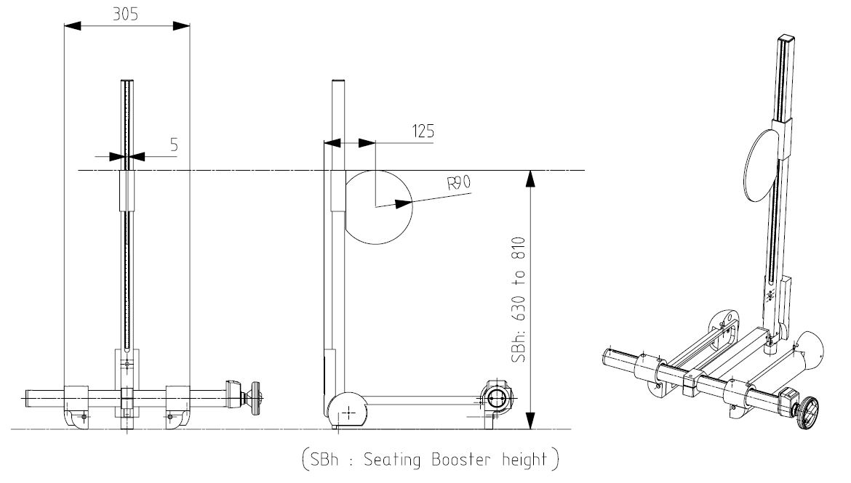

2. Procedure to evaluate a Universal Booster Cushion
2.1. Using Table 1 below, adjust the Seating Booster height (SBh) to the 5th percentile seating height of the lower stature defined for the Booster Cushion.
2.2. Position the Booster Cushion on the Regulation No. 129 test bench.
2.3. Position the Booster Measuring Device on the Booster Cushion as defined in Figure 2.
2.4. Measure the upper position of the cylinder relative to the Cr point in the Z direction: Z5.
2.5. Using Table 1 below, adjust the Seating Booster height (SBh) to the 95th percentile seating height of the taller stature defined for the Booster Cushion.
2.6. Position the Booster Measuring Device on the Booster Cushion.
2.7. Measure the upper position of the cylinder relative to the Cr point in the Z direction: Z95.

Table 1
 | Child Sitting height in cm
Stature in cm | 5th | 50th | 95th
125 | 63 | 66 | 70
130 | 65 | 68 | 72
135 | 67 | 70 | 74
140 | 68 | 72 | 77
145 | 70 | 74 | 79
150 | 71 | 76 | 81

Figure 2
Installation of the Measuring Device to measure Z5 and Z95

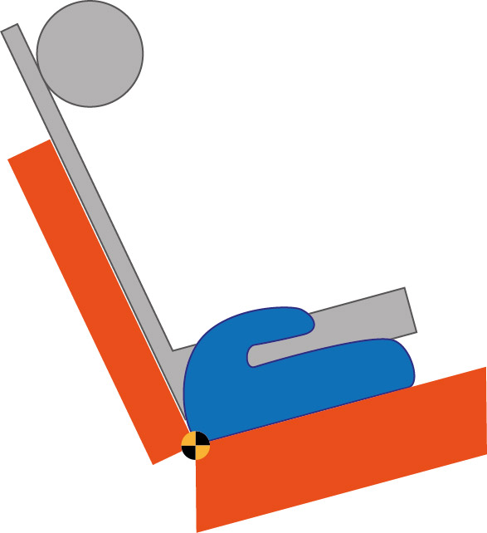
910

Z5 or Z95
770
R 129 Bench
Booster Cushion
Measuring Device
Cr Point

"
II. Justification
1. The proposed amendment aims to include Enhanced Child Restraint Systems from the booster category (booster seat with backrest and booster cushion without backrest) into the scope of UN Regulation No. 129. This represents Phase 2 of the UN Regulation.
2. The proposal also introduces some corrections to the original version of the Regulation as part of Phase 1 of this UN Regulation.
3. The text includes all modifications proposed by GRSP up to and including its fifty-fifth session (Geneva, 19–23 May 2014) as well as those of the IWG CRS up to and including its forty-sixth session (Vienna, 3 September 2014).
4. A full, consolidated version of the UN Regulation, including the draft 01 series of amendments, is available on the World Forum for Harmonization of Vehicle Regulations website on the webpage of the IWG CRS (CRS-46-07, GRSP-55-08-Rev3.doc).
5. The reference document is the original UN Regulation No. 129, Corrigendum 1 and Supplements 1, 2 and 3.
6. This proposal includes all corrections until the last meeting of the IWG CRS (24-11-2014).

* * In accordance with the programme of work of the Inland Transport Committee for 2012–2016 (ECE/TRANS/224, para. 94 and ECE/TRANS/2012/12, programme activity 02.4), the World Forum will develop, harmonize and update Regulations in order to enhance the performance of vehicles. The present document is submitted in conformity with that mandate.
? Detail B describes the standard dimensions without ISOFIX attachments. Figure 1 gives the dimensions for optional stowable ISOFIX attachments.
1 The neck diameter is taken as the diameter of the top and bottom plate of the Q dummy necks. Middle disks are 56.9 mm 2 Q6 neck disk at top
3 Q6 neck disk at bottom
4 Neck shield diameter
? See paragraph 7.1.3.5.2.1.: Height of spacer device (hinged board or similar flexible device) equals shoulder height sitting minus thigh height sitting.
? The technical specifications and detailed drawings of Q-dummy, and the for their adjustment for the tests of this Regulation are deposited in a transitory way on the website of the informal working group on Enhanced Child Restraint Systems (www2.unece.org/wiki/display/trans/Q-dummy+drawings) of the UNECE, Palais de Nations, Geneva, Switzerland. At the time of the adoption of this Regulation by the World Forum for Harmonization of Vehicle Regulations (WP.29), the text restricting the use of the drawings and technical specifications will be removed from the individual pages and they will be reloaded on the above-mentioned website. After a time period needed by the Informal Working Group to finalize the examination of the technical specifications and drawings of dummies to cover the phase 2 of the Regulation, the final and agreed drawings will be relocated in the Mutual Resolution of the 1958 and 1998 Agreements, hosted in the website of the World Forum WP.29.”
1 1 The technical specifications and detailed drawings of Q-dummy and APTS, and the technical specifications for their adjustment for the tests of this Regulation are deposited in a transitory way on the website of the informal working group on Child Restraint Systems (https://www2.unece.org/wiki/display/trans/Q-dummy+drawings) of the UNECE, Palais de Nations, Geneva, Switzerland. At the time of the adoption of this Regulation by the World Forum for Harmonization of Vehicle Regulations (WP.29), the text restricting the use of the drawings and technical specifications will be removed from the individual pages and they will be reloaded on the above-mentioned website. After a time period needed by the Informal Working Group to finalize the examination of the technical specifications and drawings of dummies to cover the phase 2 of the Regulation, the final and agreed drawings will be relocated in the Mutual Resolution of the 1958 and 1998 Agreements, hosted in the website of the World Forum WP.29.

