Proposal for the 05 Series of Amendments to UN Regulation No. 100 (Electric Power Trained Vehicles)

Submitted by the Special Interest Group on Thermal Propagation ∗
The text reproduced below was prepared by the experts from [Australia], France, Germany, Italy, Japan, [Republic of Korea], the Netherlands, Spain, the United Kingdom of Great Britian and Northern Ireland, and the European Commission. It aims to introduce the improved requirements on thermal propagation and the approval of electric powered vehicles. In addition, the provisions concerning the treatment of intellectual properties of manufacturers have been introduced into the UN Regulation. The document is to replace ECE/TRANS/WP.29/GRSP/18. The modifications to the current text of the UN Regulation (including ECE/TRANS/WP.29/2024/41) are marked in bold for new or strikethrough for deleted characters while the modification from ECE/TRANS/WP.29/GRSP/18 are indicated in red coloured texts.

I. Proposal
Table of contents, amend to read:
"Regulation
1. Scope
2. Definitions
3. Application for approval
4. Approval
5. Part I: Requirements of a vehicle with regard to specific requirements for the electric power train
6. Part II: Requirements of a Rechargeable Electrical Energy Storage System (REESS) with regard
to its safety
7. Part III: Requirements for the installation of an approved Rechargeable Electrical Energy Storage System (REESS) for the purpose of a vehicle approval
87. Modifications and extension of the type approval
98. Conformity of production
109. Penalties for non-conformity of production
1110. Production definitively discontinued
1211. Names and addresses of Technical Services responsible for conducting approval tests and
of Type Approval Authorities
1312. Transitional provisions
Annexes
1 Part 1 - Communication concerning the approval or extension or refusal or withdrawal of approval
or production definitively discontinued of a vehicle type with regard to its electrical safety pursuant
to Regulation No. 100
1 Part 2 - Communication concerning the approval or extension or refusal or withdrawal of approval
or production definitively discontinued of a REESS type as component/separate technical unit
pursuant to Regulation No. 100
1 Appendix 1
1 Appendix 2
2 Arrangements of the approval marks
3 Protection against direct contacts of parts under voltage
4 Verification of potential equalization
5A Isolation resistance measurement method for vehicle based tests
5B Isolation resistance measurement method for component based tests of a REESS
6 Confirmation method for function of on-board isolation resistance monitoring system
7A Verification method for testing authorities confirming document based isolation resistance
compliance of electrical design of the vehicle after water exposure
7B Vehicle-based test procedure for protection against water effects
8 Determination of hydrogen emissions during the charge procedures of the REESS
Appendix 1 - Calibration of equipment for hydrogen emission testing
Appendix 2 - Essential characteristics of the vehicle family
9 REESS test procedures
Appendix 1 - Procedure for conducting a standard cycle
Appendix 2 – Procedure for SOC adjustment
9A Vibration test
9B Thermal shock and cycling test
9C Mechanical shock
9D Mechanical integrity
9E Fire resistance
Appendix 1 - Dimension and technical data of firebricks
9F External short circuit protection
9G Overcharge protection
9H Over-discharge protection
9I Over-temperature protection
9J Over-current protection
9K Thermal propagation test
Appendix 1 - Thermal runaway trigger method with localized fast external heater
Appendix 2 - Thermal runaway trigger method with internal heater
Appendix 3 - Thermal runaway trigger method with nail penetration
Appendix 4 - Thermal runaway trigger method with laser-based trigger
10 Provisions for a label for vehicles of categories M2/N2 and M3/N3
equipped with an electric power train "

Insert new paragraph 1.3., to read:
"1.3. Part III: Requirements with respect to Approval of a vehicle with regard to the installation of an approved Rechargeable Electrical Energy Storage System (REESS) to the road vehicles of categories M, N and O equipped with electric power train, excluding vehicles permanently connected to the grid."
Paragraph 2.51., amend to read:
"2.51. "Vehicle type" means vehicles which do not differ in such essential aspects as:
(a) Installation of the electric power train and the galvanically connected high voltage bus as well as the position of the REESS in the vehicle in so far as it has an adverse effect on the requirements of paragraph 5.2.2.;
(b) Nature and type of electric power train and the galvanically connected high voltage components;"
Insert new paragraph 2.56., to read:
"2.56. "Common space" means an area on which two or more information functions (e.g. symbol) may be displayed but not simultaneously."
Insert new paragraph 2.57., to read:
"2.57. "Alkali metal anodes" means negative electrodes of the battery cells which are based on lithium, sodium, or potassium, e.g. alkali metal foils (stand alone or supported on a current collector) and alkali metals encapsulated in host structure(s)."
Insert new paragraphs 3.4. to 3.5., to read:
"3.4. In cases where information is shown to be covered by intellectual property rights or to constitute specific know-how of the manufacturer or of their suppliers, the manufacturer or their suppliers shall make available sufficient information to enable the correct verifications referred to in this Regulation. Such information shall be treated on a confidential basis.
3.5. Documentation shall be made available in two parts:
(a) The formal documentation package for the approval, containing the material specified in Annex 1, Appendix 1 or Appendix 2 which shall be supplied to the Approval Authority or its Technical Service at the time of submission of the type approval application. This documentation package shall be used by the Approval Authority or its Technical Service as the basic reference for the approval process. The Approval Authority or its Technical Service shall ensure that this documentation package remains available for at least 10 years from the time when production of the vehicle/REESS type is definitively discontinued.
(b) Additional material relevant to the requirements of this Regulation may be retained by the manufacturer, and available for inspection at the time of type approval. The manufacturer shall ensure that any material available for inspection at the time of type approval remains available for at least a period of 10 years from the time when production of the vehicle and/or REESS type is definitively discontinued."
Paragraphs 4.2., amend to read:
"4.2. Notice of approval or of refusal or of extension or withdrawal of approval or production definitively discontinued of a vehicle type pursuant to this Regulation shall be communicated to the Parties to the Agreement applying this Regulation, by means of a form conforming to the model in Annex 1, Part 1 (for approval of type of vehicle according to Part I or Part III of this Regulation) or Part 2 (for approval of type of REESS according to Part II of this Regulation) as appropriate to this Regulation."
Paragraphs 5.2.1. and 5.2.1.1., shall be deleted
Paragraph 5.2.1.2.(former), renumber as new paragraph 5.2.1.
Insert new paragraphs 5.2.2. and 5.2.2.2.5.2.2.1., to read:
"5.2.2. Requirements for the installation of a REESS
5.2.2.1. Structural compatibility
The type of REESS shall be fully compatible with the design of the type(s) of vehicle(s), inter alia it shall be adequately protected against contact with possible obstacles on the ground.
5.2.2.2. Smoke caused by thermal propagation shall not be released into the passenger compartment. This requirement shall be verified by the design review of the intended venting strategy of the REESS and its installation."
Paragraph 5.2.2. (former), renumber as paragraph 5.2.2.3.5.2.2.2.
Paragraph 6.4.2.3., amend to read:
"6.4.2.3. Acceptance criteria
During the test there shall be no evidence of:
(a) Fire;
(b) Explosion;
(c1) Electrolyte leakage if tested according to paragraph 6.4.2.1.1.6.4.1.1.:
(i) In case of …
(c2) Electrolyte leakage if tested according to paragraph 6.4.2.1.2. or paragraph 6.4.2.2.
For a high voltage REESS, the …"
Paragraph 6.12.3., amend to read:
"6.12.3. For REESS other than open-type traction battery, the requirement of paragraph 6.12.1. is deemed to be satisfied, if all applicable requirements of the following tests are met: paragraph 6.2. (vibration), paragraph 6.3. (thermal shock and cycling), paragraph 6.6. (external short circuit protection), paragraph 6.7. (overcharge protection), paragraph 6.8. (over-discharge protection), paragraph 6.9. (over-temperature protection), and paragraph 6.10. (overcurrent protection) and paragraph 6.15. (thermal propagation)."
Paragraphs 6.15. to 6.15.2.4.3., amend to read and remove footnote:
"6.15. Thermal propagation.
For a REESS containing flammable electrolyte or alkali metal anodes, the vehicle occupants shall not be exposed to any hazardous environment caused by thermal propagation which is triggered by an internal short circuit leading to a single cell thermal runaway. To ensure this, the requirements of paragraphs 6.15.1. and 6.15.2. shall be satisfied in accordance with the verification procedure described in paragraph 6.15.3.4
The requirements of this paragraph do not apply to REESS that are solely installed on vehicles of category O nor to batteries on vehicles of category O used for recuperation only.
6.15.1. The REESS or vehicle system shall provide a signal to activate the advance warning specified in paragraph 5.2.3. in the event of a thermal propagation which is triggered by an internal short circuit leading to a single cell thermal runaway in order indication in the vehicle to allow egress. This requirement is deemed to be met if one of the below conditions is satisfied:
(a) the presence of a hazardous situation as defined by pass/fail criteria in paragraph 6.15.3.4. does not occur within 5 minutes following the warning signal; or
(b) the single cell thermal runaway does not lead to thermal propagation in the REESS during 2 hours after its triggering; or
(c) the single cell thermal runaway cannot be triggered and this is confirmed by repeating the same test procedure (i.e. the same trigger method and the same test level) or by conducting a cell level test.
In case of the conditions (b) or (c), the warning indication specified in paragraph 6.15.1. is not mandatory. or 5 minutes prior to the presence of a hazardous situation inside the passenger compartment caused by thermal propagation which is triggered by an internal short circuit leading to a single cell thermal runaway such as fire, explosion or smoke. This requirement is deemed to be satisfied if the thermal propagation does not lead to a hazardous situation to the vehicle occupants. REESS or vehicle manufacturer shall make available, at the request of Technical Service with its necessity, the following documentation explaining safety performance of the system level or sub-system level of the vehicle:
6.15.1.1. The REESS or vehicle manufacturer shall make available the following documentation:
6.15.1.1. (a) The parameters (for example, temperature, voltage or electrical current) which trigger the warning indication.
6.15.1.2. (b) Description of the warning system.
6.15.2. The REESS or vehicle system shall have functions or characteristics in the cell, REESS or vehicle or REESS intended to protect vehicle occupants (as described in paragraph 6.15.) in conditions caused by thermal propagation which is triggered by an internal short circuit leading to a single cell thermal runaway. REESS or vehicle manufacturer shall make available, at the requested of Technical Service with its necessity, the following documentation explaining safety performance of the system level or sub-system level of the vehicle:
6.15.2.1. A risk reduction analysis using appropriate industry standard methodology (for example, IEC 61508, MIL-STD 882E, ISO 26262, AIAG DFMEA, fault analysis as in SAE J2929, or similar), which documents the risk to vehicle occupants caused by thermal propagation which is triggered by an internal short circuit leading to a single cell thermal runaway and documents the reduction of risk resulting from implementation of the identified risk mitigation functions or characteristics.
6.15.2.2. A system diagram of all relevant physical systems and components. Relevant systems and components are those which contribute to protection of vehicle occupants from hazardous effects caused by thermal propagation triggered by a single cell thermal runaway.
6.15.2.3. A diagram showing the functional operation of the relevant systems and components, identifying all risk mitigation functions or characteristics.
6.15.2.4. For each identified risk mitigation function or characteristic:
6.15.2.4.1. A description of its operation strategy;
6.15.2.4.2. Identification of the physical system or component which implements the function;
6.15.2.4.3. One or more of the following engineering documents relevant to the manufacturers design which demonstrates the effectiveness of the risk mitigation function:
(a) Tests performed including procedure used and conditions and resulting data;
(b) Analysis or validated simulation methodology and resulting data. "
Insert new paragraphs 6.15.3. to 6.15.4.4., to read:
"6.15.3. The verification process of thermal propagation safety compliance
Recognizing that there are different REESS and vehicle designs on the market, and to ensure the technical neutrality of this requirement, the verification of thermal propagation safety compliance follows a multistep approach described in paragraphs 6.15.3.1. to 6.15.3.4.
Conformance with thermal propagation safety is either demonstrated by physical testing (as described in Annex 9K) or when it is deemed that physical testing is not possible without compromising the REESS safety design, e.g. because REESS design precludes disassembly, by a systematic risk management analysis method (paragraph 6.15.4.). The Type Approval Authority and the Technical Service shall determine, with the help of documentation provided by the manufacturer, whether the physical testing is possible without compromising the safety functionality and design of the vehicle and/or REESS.
If the REESS is designed to be charged only by an energy source on the vehicle and its capacity in Ah multiplied by its nominal voltage does not exceed 2 kWh, only the risk management analysis according to paragraph 6.15.4. needs to be performed.
[If the REESS is not installed adjacent to the passenger compartment and if it features a dedicated venting system with exit away from the passenger compartment, only the component level test needs to be conducted. In consultation with the Technical Service, the smoke ingress test may be waived.]

[Figure 3
Decision Flow of Verification Process (Informative)]
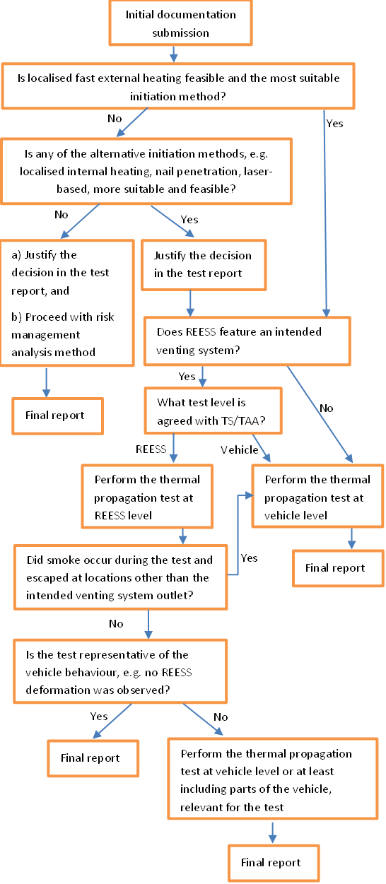

6.15.3.1. Step 1: Initial documentation submission
The manufacturer shall provide technical documentation containing:
(a) A system diagram of all relevant physical systems and components;
(b) A diagram showing the functional operation of the relevant systems and components, identifying all risk mitigation functions or characteristics;
(c) For each identified risk mitigation function of characteristic implemented, the physical system or component which implements the function shall be identified and the operating strategy described;
(d) the maximum operating temperature;
(e) The recommendations on the feasibility for conducting the physical testing;
(f) If applicable, the recommendations on a more suitable and feasible trigger method including appropriate parameters for the details of the trigger method, the preparation and instrumentation of the Tested-Device; and
(g) If applicable, the recommendation on pre-instrumentation of the triggering and measuring devices including sufficient details of such pre-instrumentation.
Relevant systems and components are those which contribute to protection of vehicle occupants from any hazardous situation caused by thermal propagation triggered by a single cell thermal runaway.
6.15.3.2. Step 2: Selection of trigger method
Technical Service shall start the selection process for the trigger method for physical testing of thermal propagation safety performance by considering the localized fast external heating first. Alternative methods, e.g. localized internal heater, nail penetration or laser-based trigger, may be used if one of those methods is recommended by the manufacturer and recognized as more suitable for the REESS design by the Technical Service to cause the single cell thermal runaway satisfying the criteria given in Annex 9K, paragraph 5. The decision of the Technical Service shall be duly documented and justified in the test report.
Test method descriptions for the respective trigger methods are found in Annex 9K – Appendices 1 to 4.
6.15.3.3. Step 3: Selection of test level
Either the vehicle-based test or the component-based test shall be performed.
If the component-based test is performed, the thermal propagation test shall be complemented by:
(a) If, during the component-based test, smoke resulting from thermal propagation is emitted from the intended venting system of the REESS, an additional test is required to demonstrate the protection of vehicle occupants against smoke as described in Annex 9K, paragraph 7. The position(s) of the REESS vent(s) in the event of visible smoke shall be documented by the REESS manufacturer in order to perform the smoke ingress test as describe in Annex 9K paragraph 7. If the REESS casing lacks an intended venting system and smoke occurs during the test, or if smoke due to thermal propagation is released from locations other than the intended venting system, the vehicle-based test shall be carried out.;
(b) Demonstrate In addition, it shall be demonstrated that the component-based test is representative of a vehicle-level behaviour. Phenomena such as deformation of the REESS casing during the thermal propagation test shall be considered as evidence demonstrating that component-based test may not be representative of vehicle-level behaviour. In this case, the thermal propagation test shall be performed at the vehicle level or shall at least include the parts of the vehicle relevant for the test.
6.15.3.4. Pass and fail criteria for the physical thermal propagation test
For 5 minutes following the signal to activate the warning indication, none of the following hazardous situations caused by thermal propagation shall occur:
(a) Fire;
(b) Explosion;
(c) Smoke release into inside the passenger compartment.
The warning indicator may occur either when the triggered cell enters thermal runaway or when the REESS has reliably identified a thermal propagation event, provided that the safety objectives listed above are met.
For the vehicle-based test, evidence of a hazardous condition, i.e. fire, explosion and smoke release into inside the passenger compartment, shall be verified by visual inspection without disassembling any part of the Tested-Device or vehicle.
For the component-based test, evidence of a hazardous condition, i.e. fire, and explosion and smoke from thermal propagation not escaping the REESS through the intended venting system, shall be verified by visual inspection without disassembling any part of the Tested-Device.
6.15.3.4.1. If no thermal propagation is observed during the 2 hours after the thermal runaway was triggered in the initiation cell, the requirements of paragraph 6.15.3.4. are deemed to be satisfied.
6.15.3.4.2. If thermal runaway is not triggered during the test with the chosen trigger method, and confirmed by repetition of the same test procedure (i.e. the same trigger method and the same test level) or by conducting a cell level test with the same trigger method, the requirements of paragraph 6.15.3.4. are deemed to be satisfied.
6.15.4. Risk management analysis method (if applicable/required following paragraph 6.15.3.)
The manufacturer shall perform and document a risk assessment and risk reduction analysis to consider occupant protection in normal operating conditions as defined in paragraph 2.31. The risk analysis shall be holistic and follow a systematic procedure including hardware and software aspects, (see for example ISO 6469-1:2019/AMD 2022 and ISO 26262 or equivalent standards for additional guidance). The work product shall explain the safety performance of the vehicle systems in conditions caused by thermal propagation which is triggered by an internal short circuit leading to a single cell thermal runaway.
The manufacturer shall make available a high-level report including essential data and a summary of important information on occupant protection in the case of a single cell thermal runaway and thermal propagation from the risk assessment and the risk reduction activities to the Type Approval Authority and Technical Service. The report shall comprise four parts that relate to paragraphs 6.15.4.1., 6.15.4.2., 6.15.4.3. and 6.15.4.4. below.
6.15.4.1. System analysis
The system analysis shall include:
(a) A system diagram of all relevant physical systems and components;
(b) Description of systems and components relevant to single-cell thermal runaway and thermal propagation due to internal short circuit and their interoperability. Relevant systems and components are those which contribute to protection of vehicle occupants from hazardous effects caused by thermal propagation triggered by a single cell thermal runaway include, but are not limited to REESS, sensors, thermal management system, battery management systems;
(c) A description of warning indication and of operating logic; and
(d) Functional analyses identifying the conditions leading to single cell thermal runaway, i.e. internal short circuit of the cell, and allocating them to the corresponding components or functional units or subsystems;
6.15.4.2. Risk identification and mitigation
A risk identification and mitigation analysis using appropriate industry standard methodology (for guidance, see for example, IEC 61508, MIL-STD 882E, ISO 26262, AIAG & VDA FMEA Handbook, fault analysis as in SAE J2929, or similar) documents: the hazards to vehicle occupants caused by thermal propagation triggered by an internal short circuit leading to a single cell thermal runaway, and the reduction of risk resulting from implementation of the identified risk mitigation functions or characteristics. The severity of the thermal event and the risk of propagation to adjacent cells in the battery pack shall be determined.
The risk identification and mitigation analysis shall include, as appropriate:
(a) Risk mitigation by design;
(b) Risk mitigation by manufacturing control; and
(c) Risk mitigation by other means.
The risk analysis shall also include information and justifications about any assumptions on system performance characteristics and properties, model behaviour or relative relevance and the likelihood of specified risk scenarios.
The risk assessment is limited to occupant protection for the relevant operational design domain of REESS and the vehicle.
6.15.4.3. Risk mitigation effectiveness – validation and verification
The effectiveness of each of the risk reduction measures shall be analysed and evaluated. Effectiveness may be analysed by testing, analysis, simulation, models, reference to scientific papers, field data and/or other appropriate methods, either singly or in combination. Effectiveness assessments shall fulfil the requirements of paragraphs 6.15.4.3.1. and 6.15.4.3.2., as appropriate.
6.15.4.3.1. Test and verification methods
Test and verification methods used for unit testing, implementation testing and validation shall be documented, clearly identifying which safety functionalities are addressed with the respective methods. Recognized industry standard tests, for example ISO, IEC, SAE or equivalent, should be used when available and appropriate for the testing purposes. In the absence of appropriate industry standard methods and tests, the manufacturer shall design test methods and verification techniques that are feasible to verify component and/or system performance as required to verify and validate the effectiveness of the risk mitigation strategy. Any such methods used shall be explicitly documented, including an explanation of what property, capability or attribute that is tested and the suitability of the method to generate the data required, as well as the rationale for why the method is appropriate.
6.15.4.3.2. Data sources and quality requirements
The data set shall evaluate performance of the components and functional units that have been identified in the allocation process. The relevance and appropriateness of the data shall be described and justified. Major uncertainty factors shall be identified and quantified as far as possible.
Data may include technical specifications and verifying test reports from suppliers and/or manufacturers, mathematical simulations from theoretical or empirical system models, scientific reports and publications, as well as field data.
All relevant results available shall be gathered to create a full consistent reports. The sources of externally derived data shall be identified.
A completeness check shall be conducted so as to ensure that all relevant information and data needed for the interpretation are available and complete.
A sensitivity check shall be conducted to evaluate the reliability of the final results and the conclusions by determining how they are affected by uncertainties in the data, allocation methods or assumptions made about the REESS.
6.15.4.4. Conclusions
(a) The concluding part of the report shall comprise a brief summary of the major results of the risk management analysis and a statement that the requirements in paragraphs 6.15.1. and 6.15.2. are satisfied, including: the methods used are scientifically and technically valid for the scope of the risk management analysis;
(b) The data used are appropriate and reasonable in relation to the intention of the risk management analysis;
(c) The interpretations are relevant and reflect the assumptions made and the limitations identified for the study.
This part may be in the form of an internal or external critical review report, if the manufacturer has such a process in place."
Insert new paragraph 6.16., to read:
"6.16. Communication between vehicle and REESS.
REESS and vehicle shall be compatible with regard to their communication."
Insert new paragraphs 7. to 7.2., to read:
"7. Part III: Requirements for the installation of an approved Rechargeable Electrical Energy Storage System (REESS) for the purpose of a vehicle approval
7.1. For an REESS which has been type approved in accordance with Part II of this Regulation, installation shall be in accordance with the instructions provided by the manufacturer of the REESS, and in conformity with the description provided in Annex 1, Part 2 to this Regulation. If the component-based test is performed for the verification of thermal propagation and thermal propagation occurred during the test, the additional test specified in paragraph 6.15.3.3.(a) shall be performed on the vehicle in accordance with Annex 9K, paragraph.7.
7.2. The requirements stated in paragraphs 5.1. to 5.1.4.4. and paragraphs 5.2.2. to 5.5.3. above shall be met."
Paragraphs 7. to 11. (former), renumber as paragraphs 8. to 12.
Insert new paragraphs 13. to 13.2., to read:

"13. Transitional Provisions
13.1. General
13.1.1. Contracting Parties applying this Regulation may grant type approvals according to any of the preceding series of amendments to this Regulation.
13.1.2. Contracting Parties applying this Regulation shall continue to grant extensions of existing approvals to any of the preceding series of amendments to this Regulation.
13.2. Transitional provisions applicable to the 03 series of amendments."
Paragraphs 12.1. to 12.4. (former), renumber as paragraphs 13.2.1. to 13.2.4.
Insert new paragraph 13.3., to read:
"13.3. Transitional provisions applicable to the 04 series of amendments. "
Paragraph 12.5. (former), renumber as paragraph 13.3.1.
Paragraphs 12.6. to 12.9. (former), renumber as paragraphs 13.3.2. to 13.3.5. and amend to read.:
"12.6.13.3.2. As from 1 September 2026, Contracting Parties applying this UN Regulation shall not be obliged to accept UN type approvals to any of the preceding series of amendments that were first issued on or after 1 September 2026.
12.7.13.3.3. Until 1 September 2027, Contracting Parties applying this UN Regulation shall accept UN type approvals to the 03 preceding series of amendments that were first issued before 1 September 2026.
12.8.13.3.4. As from 1 September 2027, Contracting Parties applying this Regulation shall not be obliged to accept type approvals issued to any of the preceding series of amendments to this Regulation.
12.9.13.3.5. Notwithstanding paragraph 12.8.13.3.4., Contracting Parties applying this Regulation shall continue to accept type approvals issued according to the 03 series of amendments of this Regulation, for the vehicles and vehicle systems which are not affected by the changes introduced by the 04 series of amendments. "
Paragraph 12.10. (former), shall be deleted
Paragraph 12.11. (former), renumber as paragraph 13.3.6. and amend to read:
"12.11.13.3.6. Notwithstanding the transitional provisions above, Contracting Parties who start to apply this Regulation after the date of entry into force of the 04 most recent series of amendments are not obliged to accept type approvals which were granted in accordance with any of the preceding series of amendments to this Regulation. "
Insert new paragraphs 13.4. to 13.4.7., to read:
"13.4. Transitional provisions applicable to the 05 series of amendments.
13.4.1. As from the official date of entry into force of the 05 series of amendments, no Contracting Party applying this Regulation shall refuse to grant or refuse to accept type approvals under this Regulation as amended by the 05 series of amendments.
13.4.2. As from 1 September 2027, Contracting Parties applying this Regulation shall not be obliged to accept type approvals to any of the preceding series of amendments, first issued after 1 September 2027.
13.4.3. Until 1 September 2028, Contracting Parties applying this Regulation shall accept type approvals to the 04 series of amendments, first issued before 1 September 2027.
13.4.4. As from 1 September 2028, Contracting Parties applying this Regulation shall not be obliged to accept type approvals issued to any of the preceding series of amendments to this Regulation.
13.4.5. Notwithstanding paragraph 13.4.4. however, until 1 September 2034, Contracting Parties applying this Regulation shall continue to accept type approvals issued according to the 03 (subject to paragraph 13.3.5.) or 04 series of amendments to this Regulation, applying the provisions in paragraph 6.15.1. (a) of the 03 or 04 series of amendments to this Regulation, first issued before 1 September 2027.
13.4.56. Notwithstanding paragraph 13.4.4., Contracting Parties applying this Regulation shall continue to accept type approvals issued according to the 03 (subject to paragraph 13.3.5.) or 04 series of amendments to this Regulation, for the vehicles/vehicle systems which are not affected by the changes introduced by the 05 series of amendments.
13.4.67. Notwithstanding the transitional provisions above, Contracting Parties who start to apply this Regulation after the date of entry into force of the 05 series of amendments are not obliged to accept type approvals which were granted in accordance with any of the preceding series of amendments to this Regulation / are only obliged to accept type approval granted in accordance with the 05 series of amendments."
Annex 1 – Part 1, amend to read:

"Communication
…
18. Remarks: "
Annex 1 – Part 2, amend to read:

"Communication
…
6. Installation restrictions applicable to the REESS as described in paragraphs 6.4., and 6.5., 6.10., 6.15. and 6.16.:
6.1. Intended category of vehicles for installing the REESS
…
18. Remarks: "
Annex 2, amend to read:

"Annex 2

Arrangements of the Approval Marks

Model A

(See paragraph 4.4. of this Regulation)

Figure 1
a = 8 mm min.
100 R - 05042492

The approval mark in Figure 1 affixed to a vehicle shows that the road vehicle type concerned has been approved in the Netherlands (E 4), pursuant to Regulation No. 100, and under the approval number 04052492. The first two digits of the approval number indicate that the approval was granted in accordance with the requirements of Regulation No. 100 as amended by 0405 series of amendments.

Figure 2
100 RES - 05042492
a = 8 mm min.
The approval mark in Figure 2 affixed to a REESS shows that the REESS type ("ES") concerned has been approved in the Netherlands (E 4), pursuant to Regulation No. 100, and under the approval number 04052492. The first two digits of the approval number indicate that the approval was granted in accordance with the requirements of Regulation No. 100 as amended by 0405 series of amendments.

Model B
(See paragraph 4.5. of this Regulation)
100 | 0504 2492
42 | 00 1628

a = 8 mm min.
The above approval mark affixed to a vehicle shows that the road vehicle concerned has been approved in the Netherlands (E4) pursuant to Regulations Nos. 100 and 42. The approval number indicates that, at the dates when the respective approvals were granted, Regulation No. 100 was amended by the 0405 series of amendments and Regulation No. 42 was still in its original form. "

Insert new Annex 9K and Annex 9K Appendices 1 to 4, to read:

"Annex 9K

Thermal Propagation Test
1. Purpose
The purpose of the thermal propagation test is to ensure occupant safety in a vehicle when a forced thermal runaway of a cell in the REESS is triggered/initiated. The phenomena of forced thermal runaway simulate a severe thermal event caused by an internal short circuit.
2. Installations
This test shall be conducted either with a complete vehicle or using the complete REESS or REESS subsystem(s) at the discretion of the manufacturer in agreement with the Technical Service. If the manufacturer chooses to test with REESS subsystem(s), the manufacturer shall demonstrate that the test result can reasonably represent the performance of the complete REESS with respect to its safety performance under the same conditions.
For a test using REESS or REESS subsystem, the parts of the vehicle relevant for the test shall be installed to the Tested-Device, in case phenomena rendering the test non-representative of REESS installed in a vehicle are expected.
3. General test conditions
The following conditions shall apply to the test.
3.1. Environmental conditions
(a) The test shall be conducted either indoors or outdoors. In case of outdoor testing there shall be no direct exposure of the vehicle/Tested-Device to precipitation for the duration of the test.
(b) Immediately before the test, the wind speed shall be measured at a location which is no more than 5 m from the Tested-Device and the average wind speed over 10 min shall be less than 7.8 m/s. It shall be ensured that the results are not affected by gusts of wind. Gusts shall not exceed 10 m/s when measured over a period of 20 s. The test set-up shall consider the impact of features such as shielding screens or walls which may create excessive funnelling effects during the test.
3.2. Tested-Device
(a) Required modifications shall be kept to a minimum compared to the original unmodified Tested-Device. Any modifications of REESS components, such as mechanical and thermal barriers, cooling plates/channels, electrical connections, and cell-to-cell spacing shall be documented and justification provided as to why such changes will not result in a significant change in performance. Confirm that the original sealing capability of the REESS is not compromised by instrumentation and that any venting shall be through pre-existing seals. All components and features that are required for the functioning of the Tested-Device and safety related features e.g. cell connecting busbars, tab welding, connection and functionality of the relevant management system, isolation resistance, etc., shall be maintained and not compromised;
(b) For the vehicle-level test, all windows, roof and doors are closed;
(c) At the beginning of the test, the State of Charge (SoC) shall be adjusted according to the procedure described in Annex 9 - Appendix 1 of this Regulation;
(d) At the beginning of the test, and for as long as possible during the test, all necessary functions of the Tested-Device shall be operational. The Tested-Device shall be representative of the REESS when installed in a vehicle that is stationary and in active-driving possible mode. The defined thermal management/safety strategy and the battery management system used in the REESS shall be fully operational. The coolant flow may be zero or active depending on the management system of the Tested-Device. The native thermal management strategy (if installed), and other relevant management systems of the Tested-Device, which are necessary for the test, shall be operational for as long as possible during the test.
(e) Immediately before turning on the initiation device, the temperature of the cells in the Tested-Device, shall be maintained between 18 °C and maximum operating temperature defined by the manufacturer.
3.3. Initiation cell
In the field, a single cell thermal runaway may occur in any REESS cell location. For the test, the selection of the initiation cell shall consider the number of adjacent cells, cell packaging, and the distance between cells in proximity to the potential initiation cell, as well as the practicality of initiation.
The intent is to allow for the selection of any cell in the pack. However, it is understood that there are differing limitations in the ability to access certain cells in any given Tested-Device and that certain cells may pose a higher risk of propagation stemming from a single cell failure. The criteria below will ensure that Tested-Device functionality and safety systems are not compromised by installation of test equipment. It also provides the basis for selecting a cell that is potentially at a higher risk of causing propagation.
Paragraph 3.3.1. below is essential to ensure that the whole system is tested and any that safety systems installed in the Tested-Device are not compromised.
Paragraph 3.3.2. below is subjective to the specific product as well as to the test level and the initiation method selected in accordance with paragraph 6.15.3. A representative case shall be determined by the Technical Service, in consultation with the manufacturer, on the basis of documentation provided by the manufacturer.
3.3.1. The installation of test equipment shall not compromise the functionality of the REESS relevant to the safety performance. The installation shall minimize modification to thermal insulators and structure and shall not:
(a) Disable or affect the functionality of the battery management systems;
(b) Change pack gas flow direction and permeability, both internal and exit paths.
3.3.2. The selected cell shall represent severe conditions for the generation of potentially hazardous conditions in the event of a thermal runaway, i.e.:
(a) A high level of heat transfer to at least one adjacent cell (e.g. thinnest spacers/gaps/barriers or vent direction towards an adjacent cell);
(b) Subject to heat sink(s) and non-productive thermal pathway(s) (e.g. edge cell with few adjacent cells and/or with large adjacent air space(s)); or
(c) Any other criteria of condition or location known by the manufacturer which could potentially to lead to a hazardous condition.
4. Recorded data and measurements
4.1. The following information shall be recorded during the test and during the observation period. All data measurement systems shall be referenced to the same starting time.
(a) Identification of the test method, including the trigger method, and a description of the test set-up;
(b) Test conditions (e.g. environmental conditions, SoC, and other pre-conditioning parameters);
(c) Temperature of the initiation cell, ensuring that the trigger device or test instrumentation does not influence the measurement;
(d) Voltage of the initiation cell during the thermal runaway triggering procedure;
(e) Temperature of one adjacent cell;
(f) Video and audio recording, including indication of a time stamp of observable events during the test (e.g. initiation cell thermal runaway and venting, thermal propagation to adjacent cell(s), smoke, fire or flame, explosion, etc.);
(g) Condition of the Tested-Device at the end of the test, supported by video or photographs (before and after test);
(h) If the test is performed on vehicle level, the time stamp of warning indications or alarms to occupants. If the test is performed on REESS or REESS subsystem, the time stamp of the signal to trigger the warning indications;
(i) The Technical Services may perform additional optional measurements and record the data, e.g. infrared temperature video, if deemed necessary.
5 Detection criteria of thermal runaway
Thermal runaway can be detected by the following conditions:
(i) The measured voltage of the initiation cell drops, and the drop value exceeds 25 per cent of the initial voltage for at least 1 second;
(ii) The measured temperature of the initiation cell exceeds the maximum operating temperature defined by the manufacturer;
(iii) dT/dt ≥ 1 °C/s of the measured temperature of the initiation cell for at least 3 consecutive seconds.
(a) Both (i) and (iii) are detected; or
(b) Both (ii) and (iii) are detected.
6. Trigger methods to initiate thermal runaway
The trigger method shall not affect the adjacent cell(s), e.g. if localized rapid external heating, localized internal heating or laser-based trigger methods are used, the temperature of the adjacent cell(s) shall not exceed maximum operating temperature, defined by the manufacturer before the thermal runaway of the initiation cell is detected. Appropriate methods may be used to isolate the adjacent cell(s), provided that original functionality of REESS is not impeded.
7. Additional smoke ingress test on vehicle
7.1. Environmental conditions:
(a) The test may be conducted either indoors or outdoors. In an outdoor test, there shall not be precipitation for the duration of the test.
(b) Immediately before the test, the wind speed shall be measured at a location which is no more than 5 m from the Tested-Device and the average wind speed over 10 min shall be less than 7.8 m/s. It shall be ensured that the results are not affected by gusts of wind. Gusts shall not exceed 10 m/s when measured over a period of 20 s. The test set-up shall consider the impact of features such as shielding screens or walls which may create excessive funnelling effects during the test.
(c) The temperature shall be within the range of the operational temperatures of the smoke machine specifications.
7.2. Smoke machine
The smoke machine shall be able to generate visible smoke at a flow rate representative of the exhaust of the battery venting exit for the duration of the test.
7.3. Vehicle configuration
7.3.1. The vehicle shall represent the series production without previous modifications or repairs that may affect the test results.
7.3.2. All windows, roof, doors and air ventilation are closed. Air inlets that can be automatically closed upon detection of any thermal event are closed.
[7.3.3. The passenger compartment shall be maintained at an under-pressure of at least 2 mbar for the duration of the test.]
7.4. Smoke ingress verification procedure
The smoke ingress inside the passenger compartment is checked using a sufficient number of different video camera locations.
The smoke machine exhaust exit shall be positioned at the proxy of battery venting exit pointing toward the exhaust from the battery venting.
7.5. Test steps:
(a) The start time begins when smoke production by the smoke machine starts.
If the smoke machine requires a to warm up period, the first visible smoke from the machine shall be taken as the starting time.
(b) The smoke machine shall function at least 5 minutes.
(c) Report the time of the first smoke entrance visible on camera if it is the case.
7.6. Pass or fail criteria for the smoke ingress test:
During the first 5 minutes of the test, a visual check in accordance with paragraph 7.5, shall confirm a lack of smoke inside the passenger compartment, without disassembling any part of the Tested-Device or vehicle.

Annex 9K – Appendix 1

Thermal Runaway Trigger Initiation Method with a Localized Rapid External Heater
1. Preparation of the Tested-Device
1.1. The feed-through installation of the selected heating element and measuring sensors should only modify the REESS by allowing the necessary electrical and thermocouple connections. These connections must provide greater sealing integrity than the other REESS connectors.
1.2. The selected heating element shall not be in direct contact with any surface of the components in the Tested-Device other than the initiation cell. Close thermal contact between the heating element and the surface of the initiation cell is important for the success of this method. Thermal contact between the heating element and initiation cell may be improved through various methods (e.g. avoid air gaps, add a heat transfer paste and apply pressure, which should be maintained throughout the test).
1.3. Examples of potential heater application methods are shown in Figure 1: the method used depends on the design of the REESS or REESS subsystem. Maintain a contact pressure for the heating element on the initiation cell during the test to ensure contact and optimal heat transfer, see Figure 1.
Figure 1
Methods of Applying Pressure on the Heating Element to Maintain Heating Element Contact with the Initiation Cell Throughout the Test for Different Cell Types
(a) REESS with large spaces between the cells
Key
Heating element
Heat transfer paste
Ceramic paper/foam
Wire or high-temperature tape
Initiation cell
(b) Centre cell fixed spacing (e.g. prismatic cells)
Initiation cell
Key
Heating element
Heat transfer paste
Ceramic paper/foam
Adjacent cell

(c) Centre cell compressed modules (e.g. pouch cells)
External applied pressure
Initiation cell
Key
Heating element
Heat transfer paste
Ceramic paper/foam
Adjacent cell

1.5. For vehicle-based tests, the vehicle response shall not be influenced by this trigger method in the REESS.
1.6. A temperature sensor shall be placed on the surface of the heating element and affixed with high-temperature resistant and electrically insulating tape for power regulation of the heater.
Figure 2
Example of Placement of the Temperature Sensor on the Heater Element

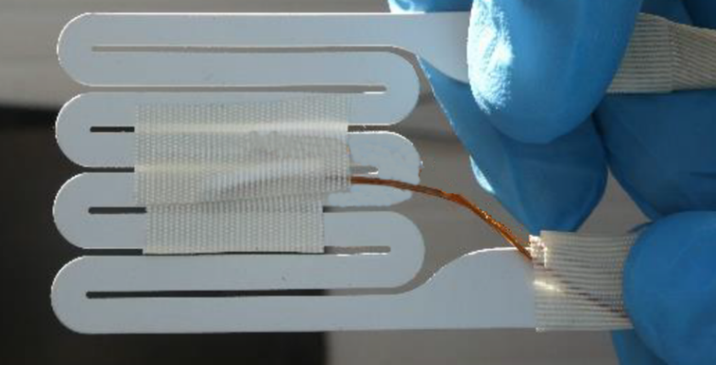
2. Selection Guide for the Heater Element
2.1. The trigger method applies a high-powered heat pulse, locally, to the external surface of the initiation cell. The successful implementation of the method requires the application of sufficient power to the chosen heating element but it shall also not apply so much power that there is a premature heating element failure nor a side wall failure of the initiation cell prior to thermal runaway.
2.2. The heating device shall be a resistive heating element, or other suitable heating device/technology capable of delivering the target parameters. See Table 1 for the target parameters for the heating element.

Table 1
Heater Device Selection Guide: Target Parameters
Parameter | Value | Rationale
Heater device material | A suitable resistive heating material, e.g. nickel-chrome, with an isolating barrier | Achieve high temperatures and prevent element failures.  Isolating materials may include alumina, ceramic, or fiberglass.
Thickness | <5 mm | Minimize effect of heater on REESS. Some REESS designs may require a thinner heating element.
Area | As small as possible, but no larger than 20 per cent of the surface area of the targeted face of the initiation cell | Concentrate heat on the smallest feasible area of the cell surface.  Largest cell surface should be used, if possible
Heating rate | ≥15 °C/s | Similar to heating rates observed within thermal runaway conditions.ª
Maximum temperature | At least 100 °C larger than the maximum operating temperature | Heater shall maintain integrity and take into account temperature deviations from heater element to thermocouple.^{b}
Control method | Thermostatic closed loop | Avoids undesirable test results, such as heating element burnout, elevated heating element temperature, battery cell sidewall ruptures due to high element temperatures.^{c}
ª The heating rate is measured directly by an external thermocouple placed on top of the heating element installed in the pack (Figure 2).
^{b} This temperature may be adjusted for other chemistries and potentially other cell types to avoid cell sidewall ruptures.
^{c} Use of a low voltage power source for the heating element will require higher currents (thicker wires), while a higher voltage source will require more resistant isolating material and higher levels of user safety during the test.

3. Test procedure for vehicle-based test
The general conditions in Annex 9K, paragraph 3 shall be satisfied when the method is implemented with the vehicle.
(a) Instrument the REESS and the vehicle as outlined above and place the vehicle in the active-driving possible mode. Make sure that the cooling and communication system operate as intended.
(b) Start recording the data that are needed to determine if thermal runaway and/or thermal propagation occur. Verify that fault codes or failures relevant for the outcome of the test are not in the system.
(c) Begin sending power to the heating element.
(d) Switch off the heater after a total energy input to the heater reaches 20 per cent of initiation cell energy.
(e) If (d) is satisfied, but thermal runaway has not occurred in the initiation cell during the observation period of 1 hour after the opening of the heater relay, the REESS type is considered to comply with this requirement.
(f) The test ends when one of the conditions specified below is met:
(i) The initiation is stopped in accordance with subparagraph (d) above followed by an observation period of 1 hour; or
(ii) At least 5 minutes elapse after the signal to activate activation of the warning indication, if thermal propagation is observed; or
(iii) If thermal runaway has occurred in the initiation cell, but no thermal propagation ensued, the observation period of 2 hours after the confirmation of thermal runaway is applied to Tested-Device.
4. Test procedure for component-based test
The general conditions in Annex 9K, paragraph 3. shall be satisfied when the method is implemented on the REESS or REESS subsystem.
(a) Instrument the REESS or REESS subsystem as outlined above and prepare the REESS or REESS subsystem such that it represents the situation when it is installed in the vehicle, with the system in the active-driving possible mode. Make sure that the thermal management and communication system operate as intended.
(b) Start recording the necessary data to determine if thermal runaway and/or thermal propagation occur. Verify that fault codes or failures relevant for the outcome of the test are not in the system.
(c) Begin sending power to the heating element.
(d) Switch off the heater immediately when thermal runaway is confirmed or after total energy input to the heater reaches 20 per cent of initiation cell electric energy.
(e) If (d) is satisfied, but thermal runaway has not occurred in the initiation cell during the observation period of 1 hour after the opening of the heater relay, the REESS type is considered to comply with this requirement.
(fe) The test ends when one of the conditions specified below is met:
(i) The initiation is stopped in accordance with the subparagraph (d) above followed by an observation period of 1 hour; or
(ii) at least 5 minutes elapse after the signal to activate activation of the warning indication, if thermal propagation is observed; or
(iii) If thermal runaway has occurred in the initiation cell, but no thermal propagation ensued, the observation period of 2 hours after the confirmation of thermal runaway is applied to Tested-Device.

[Annex 9K – Appendix 2

Thermal Runaway Trigger Initiation Method with an Internal Heater
This test method is similar to the localised fast external heating method except that it relies on an internal, localized short circuit inside the cell created by a local heater. The concept of this trigger method is to create an internal short circuit by creating a hole in the separator of the initiation cell. The hole comes from the local melting of the separator induced by the local heater.

The trigger method applies a high-powered heat pulse, locally, to the jellyroll surface of one initiation cell within the REESS via an internal heater with minimal increase in temperature of the adjacent battery cell(s) prior to thermal runaway inwithin the initiation cell. The temperature of adjacent cell(s), prior to thermal runaway in the initiation cell, shall remain below the maximum operating temperature, defined by the manufacturer.

1. Description of the Trigger Method
The heating device should shall be a resistive heating element, or other suitable heating device/technology capable of delivering the target parameters. See Table 1 for the target Target parameters for the heating element are listed in Table 1.
The resistance, power and duration shall be adjusted according to the electrochemistry and the size of the cell.
Parameters to use with this test methodology for typical lithium-ion battery cells for electric vehicles are shown in Table 2 as a guideline. The power of the heater is dependent on cell chemistry, energy density and volume of the initiation cell. The maximum time allowed for the first thermal runaway event shall be agreed between the manufacturer and the Technical Service (see soak time in Table 2).
Figure 1
Example of an internal heater flat spiral Internal Heater Flat Spiral of Tungsten
(Dimensions in millimetres)
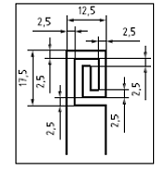
Note: The wire diameter is usually from 0.1 mm to 0.3 mm.
Table 1
Heating Element Selection Guide: Target Parameters
Parameter | Value | Reasoning
Heating element material | A suitable resistive heating material with an insulating barrier, e.g. copper or tungsten | Achieve high temperatures and prevent element failures. Isolating material may include polyimide or other heat-resisting material.
Thickness [mm] (mm) | ≤0.5 | As the heater needs to be placed inside of a cell, thickness of heater should be minimized.Due to the heater need to be placed inside of cell, thickness of heater should be controlled in a reasonable value.
Area[mm2] (mm²) | 225 - 500 50*50~15*15 | Concentrate heat to the smallest feasible area on the cell jellyroll surface.
Power of heater[W] (W) | 150~700 | Provide enough heat to enable initiation of cell thermal runaway.
Table 2
Typical Heater Parameters for Implementing of the Internal Heater Methodology
Parameter Category | VED<450Wh/L  (e.g. LFP Cell) | VED≥450Wh/L  (e.g. NCM Cell) | Remarks
Power of heater[W] | 400~700 | 150~700 | These values are based on: cell chemistry/energy density/ volume of the initiation cell.
Soak time phase and power-off condition | Heating until thermal runaway is achieved or until heater is burnout |  | Heating until thermal runaway is achieved within 5 minutes.

Heater Characteristic (for example):
The dimension of heater is 30mm x 30mm, and heating power is 250W. When the internal heater is used to trigger the initiation cell to thermal runaway, the temperature of heater surface will rapidly increase beyond 300 °C with a rate of ~80 °C/s, and the maximum temperature will reach ~700 °C (as shown in Figure 2). For normal design, the separator will rapidly melt down at the temperatures filed, and lead to cell thermal runaway by an internal short circuit.
Figure 2
Thermal Behaviour of an Internal Heater
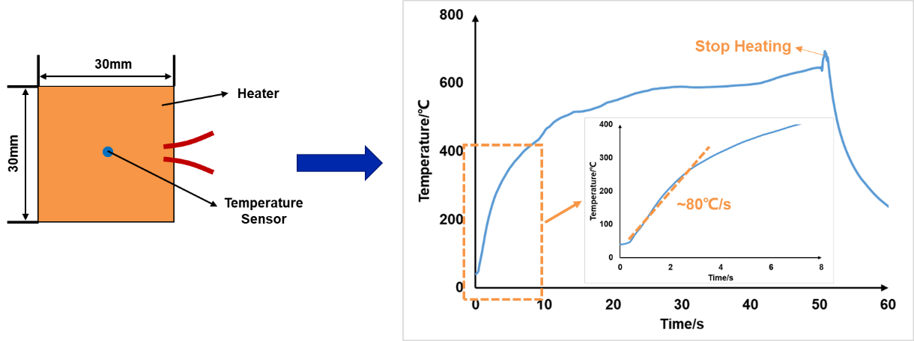

2. Test Application and Necessary Modifications – Subsystem Level Testing
The use of this test method relies on quickly and effectively heating a single cell into thermal runaway within a REESS or REESS subsystem. To ensure that the test is conducted efficiently, a preliminary test on a single cell or a small number of cells should be performed using a modified cooling strategy (if desired). This subsystem level test permits the refinement of test parameters (heating rate, target temperature, soak time) for the specific cell used in the chosen REESS design, which vary (from those shown in Table 1 and Table 2) upon change of cell chemistry and cell size/construction. Modifications required for subsystem level testing should mimic those found in the REESS to obtain an accurate test result relative to that obtained at a REESS test level.
23. Initiation Cell/Cell Block Preparation
The heater shall be inserted in the connected electrode stack or jellyroll before cell sealing. The applied method is dependent on the REESS or REESS subsystem design and manufacturing process. Here is an example of the manufacturing process for this special cell.
The internal heater is assembled in the cell during the production of cell. Here is the example of manufacturing process for this special cell.
23.1. Step 1:
One or two hole(s) are drilled into the cover to allow the electrical feedthrough of the heater from inside the cell to the outside (Figure 2).
Figure 2
Example of specific holes in cover for heater connection
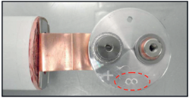
Locate the heater on the surface of the jellyroll. For one-jellyroll-cell, the heater is suggested to be located on the surface of jellyroll. For n-jellyrolls-cell (n≥2), the heater is suggested to be located on the surface of jellyroll and is surround by two jellyrolls, as shown in Figure 3.
Figure 3
Example of the Location of an Internal Heater in a Cell with More Than One Jellyroll

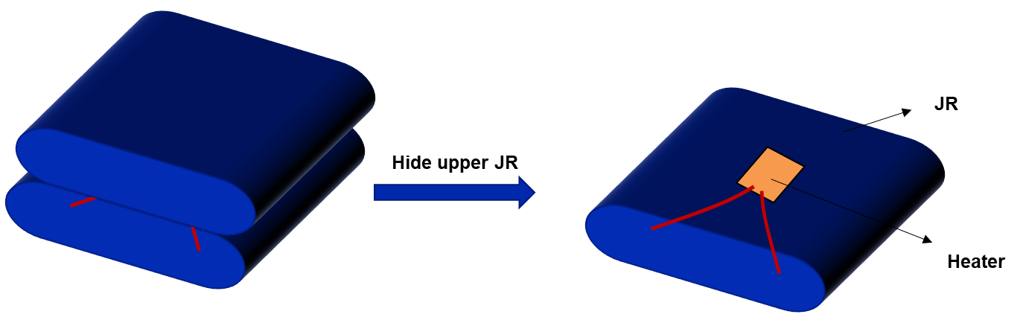
23.2. Step 2:
Unroll the separators and the electrodes to insert the heater.A hole is drilled into the top cover of the cell to allow the electrical feedthrough of the heater from the inside to the outside of the cell.
23.3. Step 3:
Locate the heater on the last wrap of electrode. The heater is placed between the outermost negative and positive electrodes for the cell (see Figures 3, 4 and 5).
Avoid unrolling a larger part of the jelly roll, since this can lead to damage of the jelly roll. Use an outer stack in case of stacked layers.
Figure 3
Example of heater location inside the cylindrical cell
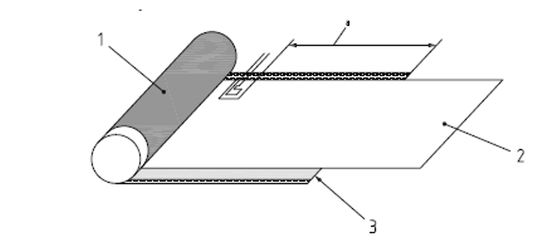
Key
1 positive electrode
2 separator
3 negative electrode
a 180 mm from end of positive electrode and 15mm from end of negative electrode, tolerance ±5 mm

Figure 4
Example of heater location inside the prismatic cell
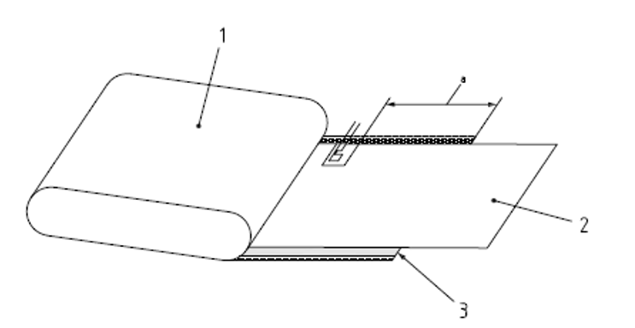
Key
1 positive electrode
2 separator
3 negative electrode
a 180 mm from end of positive electrode and 15mm from end of negative electrode, tolerance ±5 mm

Figure 5
Example of located on the last lap of negative electrode
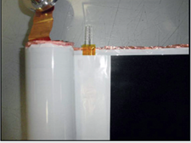
All wires used in the REESS or REESS subsystem shall be electrically isolated. Furthermore, it should be ensured that electrolyte or gases cannot leak out through the space between the wire strand and the wire insulator.
The selection of sealing resin is critical as the strength of seal shall be greater than any installed vent of the cell.
Next, assemble the cell according to the standard manufacturing process (Figure 4). After it is completely dry, carry out a helium test to check the sealing before filling the cell with electrolyte.
When the helium test is successful, the cell is ready to be filled and formed. After the helium test, verification of the characteristic parameters (voltage, ACR, dimension, etc.) should be performed and the tolerance range should be provided.
According to requirement of experiment, the prepared cell can be assembled inside the battery module, or REESS or REESS subsystem. The CCS component needs to be drilled a hole to make sure the electrical feedthrough of the heater can come out of cell block (Figure 5).
Figure 4
Example of a Cell Assembly
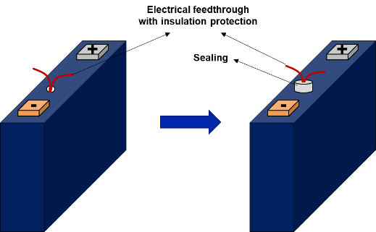

Figure 5
Example of a Module Assembly
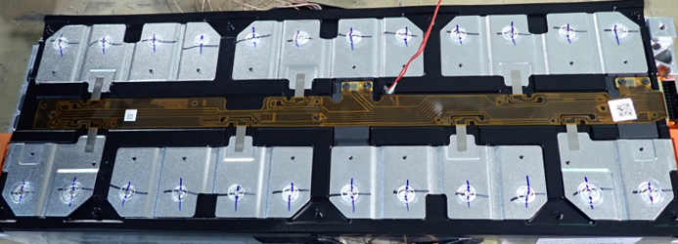
23.4. Step 4:
Wind the jelly roll with the heater (see Figure 6).Connect wires of the heater to the outside of the REESS or REESS subsystem though the sealing pad between pack top cover and pack casing and seal the position with sealant. The wires can also come out of the pack though a hole in the REESS casing, which is then sealed with heat-resistant resin.
Figure 6
Example of jelly roll equipped with heater
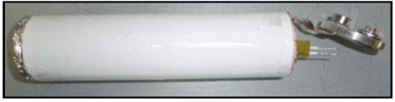
2.5. Step 5:
All wires used in the REESS or REESS subsystem shall be electrically isolated.
The cell shall be assembled according to standard manufacturing processes (e.g. electrolyte filling, cover welding), ensuring no electrolyte or gases can leak out through the space between the wire strand and the wire insulator.
Selection of resin is critical as the strength of seal shall be greater than any installed vent of the cell.
After the resin is completely dry, carry out a helium test to check the sealing before filling the cell with electrolyte.
Figure 7
Example of finished cell with heater
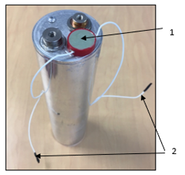
Key
1 resin for sealing the heater supply
2 supply wires of the heater

Figure 8
Example of cell before filling with electrolyte
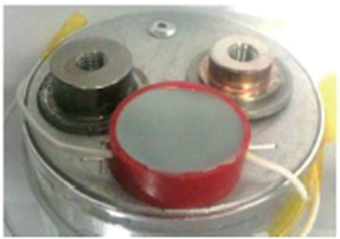

2.6. Step 6:
The initiation cell shall be assembled inside the REESS or REESS subsystem, which could be modified to make sure the electrical feedthrough of the heater can come out of cell block.
The feedthrough installation of the heating element and measuring sensors should only modify the REESS (or REESS subsystem) by permitting necessary electrical and thermocouple connections. These connections shall provide greater seal integrity than the other connectors in the REESS (or REESS subsystem).
For a vehicle level test, mount the REESS on the vehicle, according to manufacturer’s specifications.
34. Test Procedure for the Vehicle-Based Test
The general conditions in Annex 9K, paragraph 3. shall be satisfied when the method is implemented with the vehicle.
(a) Instrument the REESS and the vehicle as outlined above and place the vehicle in the active-driving possible mode. Make sure that the cooling and communication system operate as intended.
(b) Start recording the data that are needed to determine if thermal runaway and/or thermal propagation occur. Verify that fault codes or failures relevant for the outcome of the test are not in the system.
(c) Begin sending power to the heating element.
(d) Switch off the heater immediately when thermal runaway is confirmed or after a total energy input to the heater reaches 20 % of initiation cell electric energy.
(e) If (d) is satisfied, but no thermal runaway has occurred in the initiation cell during the observation period of 1 hour after the opening of the heater relay, the REESS type is considered to comply with this requirement.
(fd) The test ends when one of the conditions specified below is met:
(i) The initiation is stopped in accordance with the subparagraph (db) above followed by an observation period of 1 hour; or
(ii) At least 5 minutes elapse after the signal to activate activation of the warning indication, if thermal propagation is observed; or
(iii) If thermal runaway has occurred in the initiation cell, but no thermal propagation ensued, the observation period of 2 hours after the confirmation of thermal runaway is applied to Tested-Device.
45. Test procedure for the component-based test
The general conditions in Annex 9K, paragraph 3. shall be satisfied when the method is implemented on the REESS or REESS subsystem.
(a) Instrument the REESS or REESS subsystem as outlined above and prepare the REESS or REESS subsystem such that it represents the situation when it is installed in the vehicle, with the system in the active-driving possible mode. Make sure that the thermal management and communication system operate as intended.
(b) Start recording the data that are needed to determine if thermal runaway and/or thermal propagation occur. Verify that fault codes or failures relevant for the outcome of the test are not in the system.
(c) Begin sending power to the heating element.
(d) Switch off the heater immediately when thermal runaway is confirmed or after a total energy input to the heater reaches 20 % of initiation cell electric energy.
(e) If (d) is satisfied, but no thermal runaway has occurred in the initiation cell during the observation period of 1 hour after the opening of the heater relay, the REESS type is considered to comply with this requirement.
(fd) The test ends when one of the conditions specified below is met:
(i) The initiation is stopped in accordance with the subparagraph (db) above followed by an observation period of 1 hour; or
(ii) At least 5 minutes elapse after the signal to activate activation of the warning indication, if thermal propagation is observed; or
(iii) If thermal runaway has occurred in the initiation cell, but no thermal propagation ensued, the observation period of 2 hours after the confirmation of thermal runaway is applied to Tested-Device.]

Annex 9K – Appendix 3

Thermal Runaway Trigger Initiation Method with Nail Penetration
1. Preparation of the Tested-Device
If the REESS is enclosed in a housing, a penetrating hole on the housing may be needed to enable the nail to be inserted into a target position of an initiation cell. The device such as gas tight sleeve for the nail that prevents venting gas from leaking out from the nail hole should be applied, if necessary.
The nail penetrating position and direction are selected from the position and direction of the nail where causing a thermal runaway in an initiation cell is possible (e.g. in perpendicular direction to electrode layer).
Not limited to the above, the manufacturer may conduct other necessary test preparations with the agreement of Technical Service. (e.g. modification to the case of an initiation cell)
2. Nail Selection Guide
The nail type can be chosen from the parameters given in Table 1, or other appropriate international standard and so on. (e.g. for the shape of the nail tip).
The details of trigger method including appropriate parameters recommended by the manufacturer in accordance with paragraph 6.15.3.1.(f) shall be respected subject to the agreement of the Technical Service..
Table 1
Nail Selection Guide: Target Parameters
Parameter | Value | Rationale
(i) Material | Steel | To be electrically conductive and sufficiently hard to penetrate a cell outer case.
(ii) Diameter (mm) | [3 to 8] | To be smaller to simulate the internal short circuit.  If the thickness of cell casing is thick, the nail may break and it may not be possible to cause thermal runaway. In such a case, a nail with larger diameter up to 8 mm may be used. However, the diameter shall be thinner than the cell width of the penetrating surface to minimize gas leakage from the nail holes.
(iii) Angle of tip (°) | [20 to 60] | To be smaller to minimize effect on the cell casing.  To select angle to occur cause thermal runaway.
(ⅳ) Penetrating speed (mm/s) | 0.1 to 1 | If the speed is low, the nail travelling is easily controlled, especially to stop.

3. Test Procedure for the Vehicle-Based Test
The general conditions in Annex 9K, paragraph 3. shall be satisfied when the method is implemented with the vehicle.
(a) Instrument the REESS as outlined above and connect all thermal management and high voltage lines, and reinstall REESS into vehicle.
(b) Start recording the data that are needed to determine if thermal runaway and/or thermal propagation occur. Verify that fault codes or failures relevant for the outcome of the test are not in the system.
(c) Select the nail shape and diameter and set the appropriate penetrating speed according to the guidance in paragraph 2.(iv).
(d) Tune on the power to the nail operating device.
(e) Stop the nail and let it remain inside the initiation cell when the thermal runaway is confirmed or the nail has penetrated both the front and back side of the cell.
(f) The test ends when one of the conditions specified below is met:
(i) The initiation is stopped in accordance with the subparagraph (e) above followed by an observation period of 1 hour; or
(ii) At least 5 minutes elapse after the signal to activateactivation of the warning indication, if thermal propagation is observed; or
(iii) If thermal runaway has occurred in the initiation cell, but no thermal propagation ensued, the observation period of 2 hours after the confirmation of thermal runaway is applied to Tested-Device.
4. Test Procedure for the Component-Based Test
The general conditions in Annex 9K, paragraph 3. shall be satisfied when the method is implemented on the REESS or REESS subsystem.
(a) Instrument the REESS or REESS subsystem as outlined above and prepare the REESS or REESS subsystem such that it represents the situation when it is installed in the vehicle, with the system in the active-driving possible mode. Make sure that the thermal management and communication system operate as intended.
(b) Start recording the data that are needed to determine if thermal runaway and/or thermal propagation occurare taking place. Verify that there fault codes or failures relevant for the outcome of the test are not in the system.
(c) Select the nail shape and diameter and set the appropriate penetrating speed according to the guidance in paragraph 2.(iv).
(d) Tune on the power to the nail operating device.
(e) Stop the nail and let it remain inside the initiation cell when thermal runaway is confirmed or the nail has penetrated both the front and back side of the cell.
(f) The test ends when one of the conditions specified below is met:
(i) The initiation is stopped in accordance with the subparagraph (e) above followed by an observation period of 1 hour; or
(ii) At least 5 minutes elapse after the signal to activate activation of the warning indication, if thermal propagation is observed; or
(iii) If thermal runaway has occurred in the initiation cell, but no thermal propagation ensued, the observation period of 2 hours after the confirmation of thermal runaway is applied to Tested-Device.

Annex 9K – Appendix 4

Thermal Runaway Trigger Initiation Method with a Laser-Based Trigger
1. Preparation of the Tested-Device
Before conducting the test, the laser beam path shall be secured so that the laser beam reaches a predetermined position on the initiation cell surface. Figure 1 shows examples of laser irradiation to on-board battery modules consisting of different types of battery cells.
Figure 1
Examples of Laser Irradiation to On-Board Battery Modules Consisting of Different Types of Battery Cells
(a) Cylindrical cell module | (b) Square cell module | (c) Pouch cell module
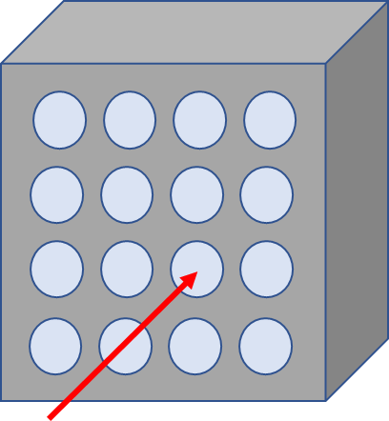 | 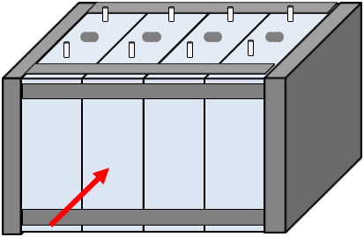 | 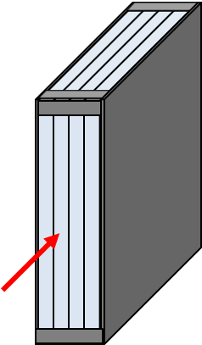

2. Laser Selection Guide
The laser type can be chosen from material process lasers such as used for cutting, welding or hardening, e.g. CO2 laser, YAG laser, semiconductor laser, disk laser, fiber laser, and so on.
An example of a laser irradiation system is shown in Figure 2.
Figure 2
Example of a Laser Irradiation System
Laser processing head
Laser fiber
Laser beam

3. Test procedure for a vehicle-based test
The general conditions in Annex 9K, paragraph 3. shall be satisfied when the method is implemented with the vehicle.
(a) Instrument the REESS as outlined above and connect all thermal management and high voltage lines, and reinstall REESS into vehicle.
(b) Start recording the data that are needed to determine if thermal runaway and/or thermal propagation occur. Verify that fault codes or failures relevant for the outcome of the test are not in the system.
(c) Before starting the test, secure the laser beam path so that the laser beam reaches the initiation cell surface of the Tested-Device.
(d) Set and confirm the laser irradiation program.
(e) Irradiate the initiation cell with the laser at the determined point.
(f) Stop the laser irradiation program when thermal runaway is confirmed or after a total energy input from the laser reaches 20 per cent of the initiation cell energy.
(g) If (f) is satisfied, but no thermal runaway has occurred in the initiation cell during the observation period of 1 hour after the laser switch off, the REESS type is considered to comply with this requirement.
(h) The test ends when one of the conditions specified below is met:
(i) The initiation is stopped in accordance with the subparagraph (f) above followed by an observation period of 1 hour; or
(ii) 5 minutes after the signal to activate activation of the warning indication, if thermal propagation is observed; or
(iii) If thermal runaway has occurred in the initiation cell, but no thermal propagation ensued, the observation period of 2 hours after the confirmation of thermal runaway is applied to Tested-Device.
4. Test procedure for a component-based test
The general conditions in Annex 9K, paragraph 3. shall be satisfied when the method is implemented on the REESS or REESS subsystem.
(a) Instrument the REESS or REESS subsystem as outlined above and prepare the REESS or REESS subsystem such that it represents the situation when it is installed in the vehicle, with the system in the active-driving possible mode. Make sure that the thermal management and communication system operate as intended.
(b) Start recording the data that are needed to determine if thermal runaway and/or thermal propagation occur. Verify that fault codes or failures relevant for the outcome of the test are not in the system.
(c) Before starting the test, secure the laser beam path so that the laser beam reaches the initiation cell surface of the Tested-Device.
(d) Set and confirm the laser irradiation program.
(e) Irradiate the initiation cell with the laser at the determined point.
(f) Stop the laser irradiation program when thermal runaway is confirmed or after a total energy input from the laser reaches 20 per cent of the initiation cell energy.
(g) If (f) is satisfied, but thermal runaway has not occurred in the initiation cell during the observation period of 1 hour after the laser switch off, the REESS type is considered to comply with this requirement.
(h) The test ends when one of the conditions specified below is met:
(i) The initiation is stopped in accordance with the subparagraph (f) above followed by an observation period of 1 hour; or
(ii) 5 minutes after the signal to activate activation of the warning indication, if thermal propagation is observed; or
(iii) If thermal runaway has occurred in the initiation cell, but thermal propagation did not ensue, the observation period of 2 hours after the confirmation of thermal runaway is applied to Tested-Device."

II. Justification
1. Thermal runaway is a known failure mode of the lithium-ion battery, but also of other contemporary traction battery cells, which are currently used in many REESS for electric vehicles. Thermal runaway reactions occur when the thermal stability limit of the cell chemistry is exceeded, and the cell releases its energy exothermically at an uncontrolled rate. The thermal runaway is typically accompanied by venting, fire and, in extreme cases, possibly even explosion. The vented gas and smoke contain flammable, toxic and corrosive substances, can become very hot and can ignite. Fire is very common during thermal runaway, given the emission of hot gases and smoke. Usually when a cell undergoes thermal runaway, it will transfer heat to adjacent cells via conductive, convective, and radiative heat transfer modes. By heat transfer, the thermal runaway in a single cell may propagate to the surrounding cells, causing thermal propagation that can involve the entire REESS. The smoke, fire and explosion threaten the safety of occupants of electric vehicles. The hazard caused by thermal propagation must be restricted.
2. The internal short circuit in contemporary traction batteries has already been reported in field failures. Requirements are needed to ensure that an internal short failure occurring in an electric vehicle does not lead to significant risks for vehicle occupants.
3. The thermal propagation test procedure has not been adopted as a requirement. Instead, the requirement exists whereby the manufacturer is required to submit engineering documentation to demonstrate the vehicle's ability to minimize the risk associated with single cell thermal runaway. This implies that the conformity assessment is based solely on the implementation and validation of the countermeasures by the manufacturer to minimize or prevent single cell thermal runaway and its propagation in REESS.
4. Given a considerable divergence in the application of the existing documentation requirement by different Technical Services under the type approval system, the impracticality of such a requirement, particularly in the context of the verification of compliance, and with a view to improve regulatory certainty for economic operators, a test procedure needs to be provided to demonstrate that potential risks to vehicle occupants associated with thermal propagation are appropriately minimized.
5. The purpose of the thermal propagation test is to ensure occupant safety in a vehicle if thermal runaway occurs in the battery system.
6. Four different test methods were selected to initiate the thermal runaway of a single cell in terms of practicability and repeatability. Localized fast external heating is the trigger method for physical testing of thermal propagation safety performance, which is considered first by the Technical Service. Alternative methods, e.g. localized internal heater, or nail penetration, or laser-based trigger, may be used if one of those methods is recommended by a manufacturer and recognized as the most suitable for the REESS design by the Type Approval Authority and Technical Services to cause the single cell thermal runaway.
7. This test shall be conducted either with the vehicle or the complete REESS or with REESS subsystem(s). [In case the component-based test is performed at the REESS level, and in order to approve it for the installation in a vehicle, the thermal propagation test shall be complemented by additional tests.] If the manufacturer chooses to test with related subsystem(s), the manufacturer shall demonstrate that the test result can represent the performance of the complete REESS with respect to its safety performance under the same conditions.
8. While the current requirements concerning thermal propagation apply to REESS containing flammable electrolyte, the proposed requirements also apply to REESS containing alkali metal anodes taking into account relevant field data. The contracting parties agreed to discuss extending the scope of the thermal propagation requirements to any technology that is subject to thermal runaway. This discussion should take place in the informal working group on safety of electric vehicles, and depending on the outcome of such a discussion, a further amendment of UN Regulation No. 100 may be envisaged in the near future.
9. In order to allow the industry to adapt to new requirements and to facilitate the deployment of new electric vehicle technologies, [two specific derogations have been introduced in the transitional provisions applicable to thermal propagation requirements, i.e. for vehicles complying with the egress requirements and for REESS technologies other than those containing flammable electrolyte and/or alkali metal anodes.]

∗ In accordance with the programme of work of the Inland Transport Committee for 2024 as outlined in proposed programme budget for 2024 (A/78/6 (Sect. 20), table 20.5), the World Forum will develop, harmonize and update UN Regulations in order to enhance the performance of vehicles. The present document is submitted in conformity with that mandate.
4 The manufacturer will be accountable for the verity and integrity of documentation submitted, and assume full responsibility for the safety of occupants against adverse effects arising from thermal propagation caused by internal short circuit.
The latter number is given only as an example.

