DRAFT REPORT
Details for Rev1 see end of the document

3rd meeting of GRRF Informal Working Group on
Automatically Commanded Steering Function

Venue: AUDI Training Center – Airport Munich, Germany.
Chairman: Mr. Christian Theis (D) and Mr. Hidenobu Kubota (J)
Secretariat: Mr. Jochen Schaefer (CLEPA)
Dates: 02.-03. September 2015
Website: https://www2.unece.org/wiki/display/trans/ACSF+3rd+session

- Participants:
see special attachment

- Welcome and Introduction
- Approval of the report of the 2nd Session
The report of the 2nd Session was approved by the delegates
ACSF-02-14-Rev2 - Report 2nd session
- Approval of the agenda
The agenda was adopted and confirmed by the delegates without amendments.
ACSF-03-01-Rev1 - Agenda for the 3rd meeting
- List of Documents:
Documents:
ACSF-03-03 (D), Draft proposal
ACSF-03-03-Rev1 (D) New Revision of Document ACSF-03-03
ACSF-03-03-Rev1.1 (D) ACSF-03-03-Rev1 document - without strike through, markings and comments
ACSF-03-04 (NL) Comments to ACSF-03-03
ACSF-03-05 (CLEPA) Tool to calculate physical values of distances
ACSF-03-06 (J) Japanese proposal for ACSF 03-03
ACSF-03-07 (J) Japanese opinion on ACSF 03-03
ACSF-03-08 (J) Difference for "Automatically commanded steering function" , "Corrective steering function" and " Autonomous Steering System "
ACSF-03-09 (D) Presentation of the content of ACSF-03-03-Rev1
ACSF-03-10 - (OICA/CLEPA) Comment on ACSF 02-03 (D) Emergency Test 1 (EM1)
ACSF-03-11 - (OICA/CLEPA) Revised proposal Transition Test 2 (TR2) – ACSF 02-03
ACSF-03-12 - (OICA/CLEPA) Proposals for ACSF status definition and HMI
ACSF-03-13 - (OICA/CLEPA) Industry Homework for 3rd meeting of ACSF IWG
ACSF-03-14 - (OICA-CLEPA) Proposal for a new FU2 Test

ACSF-03-15 - (OICA/CLEPA) Proposal about “Minimal risk manoeuvre”
ACSF-02-09-Rev1 - (OICA) Evaluation of ACSF during periodic technical inspection – Rev1

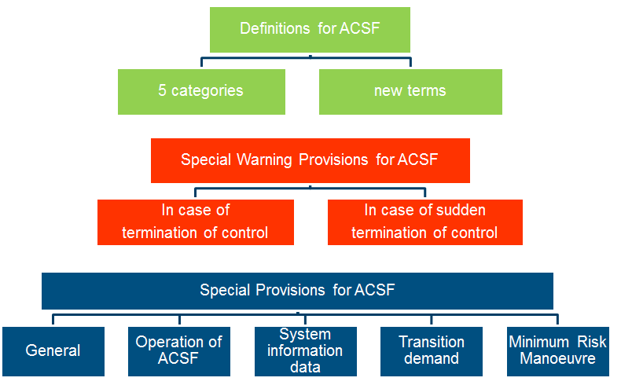
- Discussion for draft proposal to GRRF
  - General issues
ACSF-03-09 (D) Presentation of the content of ACSF-03-03-Rev1
(D) present their proposal ACSF-03-03-Rev1 based on a PowerPoint presentation. The document shows the structure of the document.
Based on this explanation, D proposed to take the German proposal ACSF-03-03-Rev1 and to delete all old comments and strike through wordings, to start the discussion based on a “clean version”. This was confirmed by the delegates.
ACSF-03-03-Rev1 => ACSF-03-03-Rev1.1
The new document ACSF-03-03-Rev1.1 was the basis for the following discussion and was amended within the meeting.
The final document of the meeting is now: ACSF-03-16
  - Discussion:
Before starting the discussion, the item “Security” was brought up by NL
NL: The security of the system (not only for external signals) is very important and should be reflected in the requirements.
UK: Shares the concerns with NL. Should be included in the regulation.
D: Raised the question, if security is rather an issue of all complex electronic systems and if therefore this should be handled in a separate “horizontal” regulation for all complex electronic systems?
Homework: All delegates to think about this item and bring in their
opinions/proposals in the next session
    - Definitions:
      - Categories:
[Category A ACSF means, a function that operates at a speed no greater than 10 km/h to assist the driver, on demand, in low speed manoeuvring or parking operations.
Category B ACSF means a function which is initiated/activated by the driver and which keeps the vehicle within its lane by influencing the lateral movement of the vehicle.
Category C ACSF means, a function which can perform a single manoeuver (e.g. lane change) when commanded by the driver.
Category D ACSF means, a function which can indicate the possibility of a single manoeuvre (e.g. lane change) but performs that function only following a confirmation by the driver.
Category E ACSF means, a function which is [initiated/activated] by the driver and which can continuously determine the possibility of a manoeuvre (e.g. lane change) and complete these manoeuvers for extended periods without further driver command/confirmation.]
The categories have been renamed from 1…5 to A…E, because the numbers have been sometimes mixed with the “levels” of automation.
Maximum speed was removed from the definitions of the ACSF categories and should be included in the requirements (D: if necessary)
The delegates showed their surprise, that in the document ACSF-03-13 from OICA/CLEPA it was proposed to change the definitions.
F: ACSF is only steering
D: A CAT E system should also include CAT B – otherwise CAT E makes no sense.
J: CAT E should include: Lane change, lane “guidance” and longitudinal control
Discussion, ends without final result.
Conclusion: Categories are defined as mentioned above, final definition has to be reviewed when requirements are finalized.
      - Definition Motorway:
[2.4.8.1 “Motorway” means, a road section, dedicated exclusively to motor vehicles, having [a speed limit of more than 100 km/h and] at least two traffic lanes for each direction of travel and having a physical separation of traffic moving in opposite directions. ]
Lengthy discussion with regard to the definition:
B: use definition of the Vienna Convention
SE: problem with speed limit and current definition of Motorway in VC, and condition No3 (signposted as a motorway).
UK: Target is, that esp. CAT E should work only on motorways. When 2 lanes merge to one lane with oncoming traffic the system shall not overtake.
J: Motorway should only be applied on CAT E systems
D: In Germany there are a lot of Highway sections, which are limited to a speed limit 80 km/h, where ACSF should be allowed to use. The speed limit of 100 km/h in the current definition will lead to problems.
B: Should we remove “traffic” in “traffic lane”?
We had a long discussion on replacing “traffic lane” with “travel lane”
SE comment was that this is not the same thing, these are not defined perhaps carriageways is better.
Conclusion: Keep definitions as it is, review later, when requirements are fixed
      - Conditions for safe operation
[2.4.8.10 "Conditions for safe operation" mean all circumstances like traffic situation, road category, quality of lane markings, vehicle speed, curvature of the road, lighting, sensor capabilities etc. specified by the vehicle manufacturer that have to be fulfilled when an ACSF shall be able to be activated by a driver.]
OICA: Proposal in ACSF-03-13 to amend this paragraph.
UK: Proposal would change the meaning of the paragraph and should not been applied.
UK: In principle all definitions have to be reviewed until the requirements are defined.
Conclusion: all definitions remain in […]
    - Requirements
General: Definition of a speed limit is postponed
All paragraphs not mentioned below have not been modified.

      - Activation of the system
5.6.1.1.2. (old) The system shall only be able to be activated by deliberate action of the driver and if the conditions for safe operation of the system are fulfilled [all associated functions – e.g. brakes, accelerator, steering, camera/radar/lidar etc. are working proper).
NL: had a problem with word “activated”
SE: can the proposed text be interpreted so that systems are allowed to run in background so that emergency function can operate even if not all conditions are met?
CHAIR: this is our interpretation but we can have further discussions later..
OICA: showed ACSF-03-12
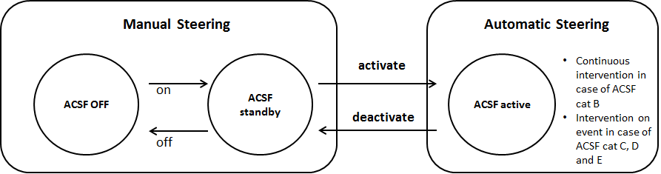
Conclusion:
5.6.1.1.2. (new) The vehicle shall be equipped with a means for the driver to activate and deactivate the system. The deactivation shall be possible at any time.
      - Deactivation with manual steering
5.6.1.1.3. (old) The system shall be able to detect if the driver controls the steering function manually. If the system detects, that the driver is steering manually , ACSF shall be deactivated automatically.
J: is it necessary to define a steering torque, when the deactivation should occur?
CHAIR: asked SE about opinions discussed in LKAS drafting group.
SE: Torque has been discussed in the group two separate issues maximum torque by system and required torque from driver to abort system.
Conclusion:
5.6.1.1.3. (new) If the driver is steering manually , ACSF shall be deactivated automatically.
      - Maximum lateral torque
5.6.1.1.4. The system shall not induce in normal driving situations a lateral acceleration of more than 3 m/s².
Brackets around “3” have been removed.
Condition “in normal driving situations” was added.
D: reasons for “3 m/s²”: according research, this is the value, which can be handled by a normal driver.

      - “Attention recognition system”
5.6.1.1.5. The system shall comprise an driver recognition system that is active whenever the system is active.
OICA: Document ACSF-03-13 explains, that a technology to detect the “attention” of a driver is not available. Proposal to focus on activity, presence or availability.
Conclusion: Definition from industry is temporarily accepted. Further performance requirements may be necessary.
      - Signalization about the system status
5.6.1.1.7. The system shall at any time give a noticeable and distinctive signalization to the driver about the system status. This signalization shall be at least a visual signal. Any change in system status shall be indicated by an optical and [, if not initiated by the driver,] either an acoustic or haptic signal.
Homework: OICA to make a new proposal
      - “lane change manoeuvre shall be initiated only if:”
5.6.1.2.1. Any lane change manoeuvre shall be initiated only if:
- the vehicle is travelling on a motorway as defined in paragraph 2.4.8. and
- any traffic that can affect the safe manoeuvre shall be identified by equipment
installed on the vehicle and
- the vehicle equipment can analyze speed and distance of the identified traffic to ensure
a safe manoeuvre (e.g. does not cause a deviation to the flow or direction of other traffic).
Homework: OICA to review, taking into consideration comments from J
and NL
      - Direction indicators
5.6.1.2.2. If a lane change manoeuvre is carried out, the correspondent direction indicator lamps shall be automatically activated minimum [3s] prior to the steering operation.
Homework: OICA to propose the time to activate the direction indicator
prior steering

      - Completion of a lane change manoeuvre
5.6.1.2.3. The lane change manoeuvre shall be completed, except the system detects an imminent critical situation [or the system is overridden by the driver].
J: ACSF-03-06: Proposal with regard to the requirement, not to have an “abrupt change of vehicle behavior” even in failure conditions
UK: we should differentiate between normal operation and failure condition
Homework: J + OICA to make a proposal
      - Safe lateral distance
5.6.1.2.4. The activated system shall at any time ensure a safe lateral distance to other road users. The vehicle manufacturer shall provide documentation about how such a safe distance is achieved to the technical service.
NL: is it necessary to define a “lateral-distance-test”?
Chair asked OICA if they could draft a proposal centering the vehicle in the middle of the lane.
SE: We would prefer to avoid centering the vehicle due to excessive wear of road or to allow it only when the road is narrow.
Homework: D + OICA to review
      - Driver monitoring
5.6.1.2.6 [If the attention recognition system detects that the driver is inattentive, it shall give a warning to restore attentiveness again. The manufacturer shall provide information to the technical service how the attention recognition systems detects inattentiveness of the driver. ]
NL: is it necessary to define the duration of the driver monitoring?
D: Wouldn’t the warning section being the right place for this ?
Homework: NL + D + OICA to review
      - System Information Data
Discussion about the necessity to fix the SW-Nr. In the technical report.
Conclusion: Item is not new and in use for other safety systems.
=> Is covered by CEL-Annex (Annex 6)

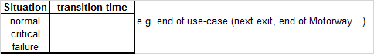
      - Transition time
5.6.1.3.1.4. The specific values for time intervals acc. to 5.6.1.5.2 which are foreseen for safe transition to manual steering under different circumstances.
NL: Proposal for 10s (ACSF-0304)
OICA: value seems to be too high
J: differentiate between “Normal” and “critical” operation
D: proposes table below, which was supported by UK
Homework: all, to think about the content of the table
      - Lateral acceleration
5.6.1.4.4. If the vehicle reaches a lateral acceleration of more than 3 m/s² a transition demand shall be given. (normal driving conditions to be included)
UK: has no feeling, what 3m/s² is for normal driving
D: BASt will provide examples at the next meeting
Homework: NL + OICA to provide a new wording
Homework: D (BASt) to provide examples for 3m/s²
      - Minimum risk manoeuvre
5.6.1.5.1. If the system detects that after a transition demand the driver does not take over manual control of the steering again the vehicle shall carry out a minimum risk manoeuvre.
NL: proposes to have test
OICA: different situations will have different scenarios – see ACSF-03-15
UK: stopping on the carriage way is too dangerous. Maybe this item should be handled in a side group.
Homework: D + CLEPA to check the situation and make a new proposal

      - Annex 7
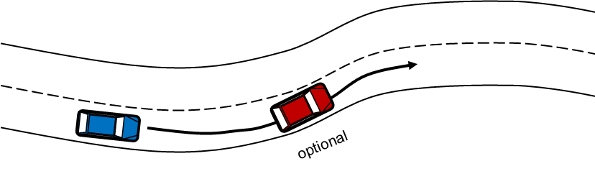
      - FU1 (lane keeping test)
UK: system should also work without lead vehicle
D: main reason was to cover also Traffic Jam Assist (TJA) which may need a lead vehicle
EC: maybe different systems need different tests
UK: propose to concentrate first on CAT E
D: for CAT E no lead vehicle should be necessary
OICA: There may be CAT E systems only up to 40 km/h for traffic jam
D: In a traffic jam with max. 40 km/h a lane change makes no sense
Debate, whether the blue vehicle shall accelerate or change the lane, without result
Homework: OICA to define a new proposal for FU1-Test (CAT E)
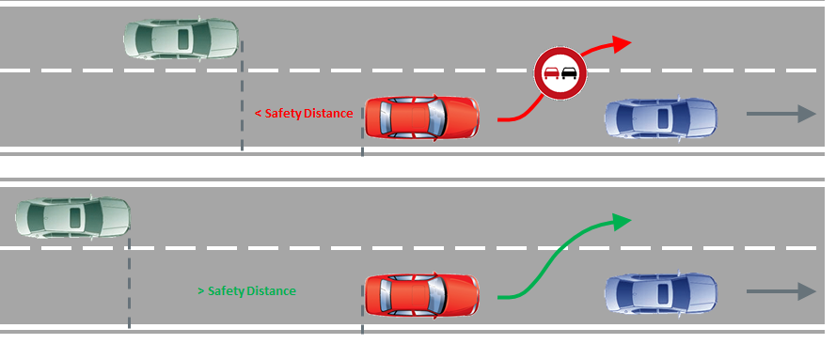
      - FU 2 (new Lane change test)
The current FU2-Test (ACSF-03-09)is very difficult to verify on a test track
CLEPA: proposes new Lane change test (ACSF-03-14)
CPs confirm, that the test is in principle ok
Missing: - pass/fail criteria
- define safety distance requirements
Homework: CLEPA to complete the missing points
      - FU 2 (Lane change test with obscured vehicle)
UK: a test, maybe by simulation, would be necessary to test the system, if a fast vehicle is coming from behind
CLEPA: explained document ACSF-03-05 where the physical parameters/values can be calculated. Even the sensor position, vehicle width etc. could be modified if sheet is unprotected by the password (“test”)
UK: the test should ensure that the vehicle can detect a narrow target approaching from behind before commencing a lane change manoeuvre
Homework: OICA/CLEPA to propose a test
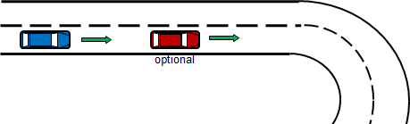
      - TR 1 (tight curve: ay beyond system boundaries)
CLEPA: as a CAT E system should only work on motorways, it might be difficult for the technical Service to find an appropriate test track
OICA: sees no problem to run the test also on a “normal” test track
Homework: D + OICA + CLEPA to rework the test for CAT E only

      - TR 2 new (missing lane marking)
NL: propose that the driver will get the transition demand 5s prior the lane marking ends
OICA: with the current technic this is not possible
CPs confirm, that the test is in principle ok
Homework: D to rework the test
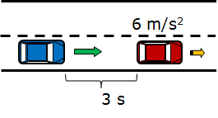
      - EM 1 (Braking behind lead vehicle)
D: Picture in the presentation ACSF-03-09 is not relevant, as the shown target cannot perform the test speed.
CPs confirm, that the test is in principle ok
Homework: D to rework the test
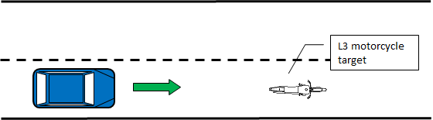
      - EM 2 (Braking behind motorcycle)
D: The test should show the performance of the system if the lane is blocked
NL: we should consider pedestrians
UK at least we need a “small” target. A motorcycle is a valid target
OICA: lane change of the blue car could also be a solution to defuse the situation
D: During the EM 2 test, the 2nd lane is always free, but what about the reality, if there are other vehicles on the 2nd so that a lane change is not possible. We want to test, if the vehicle is able to brake.
Homework: D + OICA to rework the test

      - Additional Tests proposed by NL (ACSF-03-04)
NL-Test-1: reaction system in case a failure
OICA: should be considered by CEL (Annex 6). Remaining functions depend
on the failure.
Homework: NL to rework the test
NL-Test-2: System activation is only on dedicated roads possible
OICA: not for every requirement a test is necessary.
Homework: NL to rework the test
NL-Test-3, -4, -5, -6, -7:
Delayed until the requirements are finalized
- Confirmation of TOR (Preparation of formal document for next GRRF) and status report for next GRRF
Confirmation GRRF-80-03 - (Germany/Japan) Proposal for revised ToR for the IWG on ACSF
Informal document for the 80th session of GRRF was confirmed by the delegates
- OBD/EDR
not discussed – delayed to the next meeting
- Other business
No issues

- List of action items:
Think about (cyber) security requirements for the system | all
5.6.1.1.7 (The system shall at any time give a noticeable and distinctive signalization) rework | OICA
5.6.1.2.1 (Any lane change manoeuvre shall be initiated only if: ) rework with NL, J comments | OICA
5.6.1.2.2 (direction indicator lamps shall be automatically activated minimum [3s] ) make proposal | OICA
5.6.1.2.3 (The lane change manoeuvre shall be completed, except ) think about | J+OICA
5.6.1.2.4 (activated system shall at any time ensure a safe lateral distance ) review | D+OICA
5.6.1.2.6 (If the attention recognition system detects) new definition incl. requirements | D, NL, OICA
5.6.1.3.1.4 (specific values for time intervals… for safe transition) think about content of “table” | all
5.6.1.5.4 (If the vehicle reaches a lateral acceleration of more than 3 m/s2) new wording | NL+OICA
provide examples with 3m/s² | D
5.6.1.5 (minimal risk manoeuvre) Check and make a new proposal | D+CLEPA
FU1-Test – make a new proposal (for CAT E) | OICA
FU2-Test – to be completed with pass fail | CLEPA
- obscured vehicle: Test/simulation? to be defined | OICA/CLEPA
TR1-Test – to define new TR1 for CAT E only | D+OICA/CLEPA
TR2-Test – rework | D
EM1-Test – rework | D
EM2-Test – rework | D+OICA
Definition of „Motorway“ | tbd.
NL-Test-1: - rework | NL
NL-Test-2: - rework | NL

- Schedule for further meetings.
80th session of GRRF : 15.-18. September 2015 in Geneva (CH)
4th session IWG ACSF: End of November 2015 in Japan
Details will follow soon

Rev. | Date | Content
1 | 18.11.2015 | Amendments referred to SE advice  Adjustments made in the list of action items (10.)

