Task Force on the Regulatory Fitness for Automated Driving Systems (FADS)
Twenty-eighth Meeting
_____________________________________________
Date & Time | 20 October 2025 (2 p.m. – 5 p.m. CEST)  21 October 2025 (9.30 a.m. – 12:30 p.m. and 2 p.m. – 5 p.m. CEST)  22 October 2025 (9.30 a.m. – 12:30 p.m. and 2 p.m. – 5 p.m. CEST)  23 October 2025 (9.30 a.m. – 12:30 p.m.)
Venue | Paris, France (Grande Arche, La Défense)  Remote connection details below

Meeting notes by agenda item
- Approval of the agenda and minutes of the previous meeting
The agenda (FADS-28-01r2) was adopted.

The minutes of the 27th meeting (FADS-27-10) were approved.
- Amendment to UN Regulations and GTRs regarding their fitness for automated vehicles

  - Amendment of UN Regulation No. 89, 90, 130, 131, 139, 140 and 152 for driverless vehicles
Documents: GRVA-23-17 - Proposal for amendments to UN Regulations prepared by the Task Force on FADS
FADS-28-05r1 (FADS) Modifications to GRVA-23-17r1 - highlighting the changes to GRVA-23-17
FADS-28-08r2 (FADS) Draft submission to GRVA to amend UNRs 13 89 90 130 131 139 140 152 157 171 178

R89
- Para. 5.1.11. Discussion on whether "limitation speed" or "set speed" is the right term to be used to describe the maximum design speed of an ADS on a vehicle of category X or Y. Consensus that "set speed" is the right term.
- OICA/CLEPA: Section 5 is dedicated to the function while section 12 is for the device. Para. 5.1.11. is mixing both and must revised to only refer to SLF.
- Para. 21.2.7.5. - Discussion on whether an ASLF may be reactivated automatically while the ADS is deactivated as suggested by industry. UK argued there are some safety risks, e.g. if ASLF is initially set to 30 km/h, when the ADS mode is switched off while the vehicle is on highway, it may create confusion for the driver and unexpected situations as the vehicle will be blocked at 30 km/h.
Text has been deleted and industry was invited to demonstrate that any automatic reactivation is safe.

R90
- No comments or objections were raised regarding the proposed amendment.

R130
- Para. 5.6.2. - Term “reinstated” is the correct wording instead of "reactivated" or other words.
- EC: LDWS is not a continuous assistance system and is on by default when there is a human driver, therefore it shall be reactivated when ADS is deactivated to keep the spirit of the regulation.
- OICA/CLEPA has the same understanding as EC.

R131
- Same reactivation requirements as in R130.

R139
- No comments or objections were raised regarding the proposed amendment.

R140
- Addition of para. 1.2.3. about the scope exclusion.

R152
- No comments or objections were raised regarding the proposed amendment.

Conclusion: All changes were captured in FADS-28-08r2, which has since been transmitted to GRVA as document GRVA/2026/6.

ESC alternative

Document: FADS-28-03r1 (OICA-CLEPA) ESC alternative v3

- OICA/CLEPA proposed on a text to be included in R13, R140 and R[ADS] that would allow certain ADS vehicles to be excluded from the scope of these regulations, provided that the ADS can always maintain vehicle stability by individually controlling each wheel or axle of the vehicle. The proposal now makes a clear link between the braking and steering regulations and the ADS regulation by requiring equivalent performance.
- UK supported the addition of these provisions between square brackets but emphasized the need for clear ADS regulation requirements to define equivalent performance.
- JP raised concerns about the term "equivalent" being potentially misleading without clear criteria and methodology for assessment.
- FR stressed the need for explicit evaluation criteria in the ADS regulation because equivalent performances is not assessable.
- OICA requested that contracting parties provide specific feedback on what additional requirements beyond "equivalent performance" would be needed to make the proposal acceptable, proposing a follow-up meeting for the next week.
- Conclusion: Agreement was reached to include the scope exclusion paragraphs between square brackets in the FADS documents for R13 and 140, with the understanding that these would be removed if adequate ADS regulation provisions are developed.

Input from OICA/CLEPA on R79

Document: FADS-28-10 (OICA-CLEPA) Amendments to R79 v1

- OICA/CLEPA presented a proposal to exempt CSF controlled by an ESC to be deactivated while ADS is active by amending para. 5.8.5. Industry explained that CSF serves multiple functions beyond lane-keeping, including vehicle stability improvement as e.g. in split friction conditions.
- It was confirmed that CSF definition includes 3 types of actions, the second one being specifically designed to improve vehicle stability through compensation for side wind and differing road adhesion conditions.
- UK raised concerns about CSF definition under ADAS section 2.3.4. in R79 since ADAS is defined as assisting drivers while ADS operates without driver involvement.
- Conclusion: Agreement was reached that ESC interventions should be permitted during ADS operation, with CSF interventions specifically allowed when controlled by ESC systems to maintain vehicle stability.

Discussion expanded to vehicles of O categories
- Questions raised about equipping trailers with sensors and ensuring compatibility between trailers and ADS tractors.
- UK identified specific regulatory provisions that would be incompatible with trailers on ADS vehicles, such as mechanical warning devices that require driver visibility, and referenced existing annexes in R79 for trailer sensors supporting ADAS functions.
- OICA clarified that the sensor requirements in R79 annex were specifically for lane change assist systems and are handled by the towing vehicle, not requiring trailer-specific requirements for ADS applications.
- Conclusion: FADS agreed to add trailer compatibility issues to the next meeting agenda, requesting UK and France to conduct a preliminary regulatory review.

  - Amendment of UN Regulations No. 157, 171, 175 and 178
Document: FADS-28-02 (UK) Proposal for amendments to UN Regulation No 157 (ALKS)

- Proposal to exclude vehicles with ALKS approved as ADS features from requiring separate R157 approval, preventing dual regulatory requirements for the same functionality.
- Conclusion: Agreed to submit it to GRVA January session.

Other regulations

R171 (DCAS)
Document: FADS-28-06r1 (EC) Amendments to R171_in session

- JP reminded that the transition from ADS to DCAS (para. 5.2.3.2.) is still under discussion in IWG ADS. If accepted, this paragraph will have be modified.
- FR suggested that deliberate action should be clarified and that perhaps some limits/boundaries should be added.
- UK stressed R79 for ACSF leaves this human factor/interaction of activation to the ADS. He suggested to not touch this again.
- Conclusion: Wording was revised to make it neutral and independent of further discussion on user interaction in IWG ADS.

R175 (ACPE)
- As para. 5.2.3.1.3.1. clearly indicates that ACPE may be suspended while an ADS is active.
- Conclusion: Agreed to keep the text unchanged.

R178 (ELKS)
Document: FADS-28-07r1 (EC) Amendments to R178_in session
  - Amendment of GTR No. 8 for driverless vehicles
Document: FADS-28-04 (China) GTR8 fitness revision

- This revision is mainly based on the modifications made in the corresponding UN regulation. China checked if there were any new modification points but given the similarity between the technical texts of UNR and GTR, they did not find any additional ones. The revision is not based on the latest version of the UNR revision, a further update will be provided later.
- Conclusion: Agreement that GTR 8 should reflect the latest changes made for R140. This document in its current version will not be submitted to next GRVA.

  - Amendment of UN Regulation No. 78 for driverless vehicles
R78
- Consensus that the focus of FADS should be on L6/L7.
- UK suggested that the group could consider the relative merits of amending R78 to be fit for ADS, versus adding categories L6/L7 optionally into the scope of R13-H (which has already been adapted by FADS). The expert noted that adapting R78 will be a challenge as it doesn’t include any complex braking or electronic system requirements and only has provisions for basic braking systems, making it difficult to account for ADS.
- FR expressed interest in using basic technical requirements of R78 for small delivery robots while benefiting from ETBS capabilities, raising questions about whether to modernize R78.
- Conclusion: EC will internally review the comparative analysis of performance requirements between R78 and R13-H, though no timeline was promised for completion.

- Coordination and harmonisation between GRs and IWG ADS

  - Review of amendment proposals from GRs other than GRVA

- EC shared a brief update and informed that GRSG only adopted 15 out of 30+ proposals from TF AVRS. The remaining proposals will be discussed at the April session and will be sent to WP.29 November session. GRPE also decided to postpone the submission of all proposals to November too. GRE, GRSP and GRVA are supposed to meet the June deadline.
- The co-Chair suggested to raise that issue at the joint meeting next week and eventually raise the issue at WP.29 directly if FADS deems it is important to keep the June deadline.
- OICA/CLEPA expressed disappointment and concern about the late decision change, noting it compromises the whole timing strategy.
FADS made a peer review of the draft proposals that are scheduled for the GR sessions of October, November and December 2025.

The 93rd session of GRPE, where amendments to UN Regulation No. 83, UN Regulation No. 24, UN Regulation No. 68 and UN Regulation No. 115 were adopted.

UN Regulation No. 83
- EC explained that driver selectable mode was changed to user selectable mode as a driving mode can be change based on a human input.
- No comments from FADS.

UN Regulation No. 24, UN Regulation No. 68 and UN Regulation No. 115
- EC explained that the regulations received minor amendments including footnote updates for X and Y vehicle categories and engine speed demand terminology for diesel smoke testing.
- No comments from FADS.

The 93rd session of GRE, where amendments to UN Regulation No. 48 and UN Regulation No. 45 will be discussed

UN Regulation No. 48
- The co-Chair introduced the discussion taking place at GRE by using the status report of TF AVSR to GRE.
- EC reminded some background discussion. In manual mode, automatic lighting functions will behave and tested as today. When ADS is active, the ADS is in charge of the control of the lights and will be tested in the ADS regulation.
- UK agreed that the automatic control should be deactivated when the ADS is active as the ADS is controlling the lights. The idea is to put a paragraph similar to the one inserted for ADAS regulations.
- JP noted that the functionality should be checked under R48 and not in ADS regulation.
- FR tended to agree with JP as the requirements are in R48. GRE should revise R48 to give the flexibility to an ADS to operate an automatic high beam.
- EC stressed that all ADS vehicles will be compliant with R48 as there is no exemption foreseen while the switching in/off should be done in the ADS regulation only to avoid double testing.
- FR suggested that AVRS or FADS should ask IWG ADS to add this verification in the confirmatory test section.
- UK confirmed that the control of the lighting should be part of the ADS testing.
- The group wondered whether an AFS is compatible with an ADS.
- UK stressed the need to draw a line between an AFS and an automatic turn on/off function as an assisted function will be overridden by an automated function.
- Conclusion: FADS comments on R48 were captured in ECE-TRANS-WP.29-GRE-2025-23e (FADS comments on R48)

UN Regulation No. 45
- Automatic terminology creates confusion in ADS context.
- Agreed that any manual control of cleaning devices should be operable from driver seat except in categories X and Y.
- Additional paragraph needed to specify that while ADS features are active, ADS may control cleaning devices.
- Conclusion: FADS comments on R45 were captured in ECE-TRANS-WP.29-GRE-2025-22e (FADS comments on R45)

The 78th session of GRSP, where amendments to the following UN Regulations will be discussed:

- UN Regulation No. 11 (Door latches and hinges)

Document: FADS-28-09 (FADS) Comments on ECE-TRANS-WP29-GRSP-2025-11e (Amendments to UN Regulation No. 11)

- Understanding of para. 6.3.2.1. in the context of ADS was summarized by UK in the table below. FADS agreed to share it with GRSP TF AVRS.
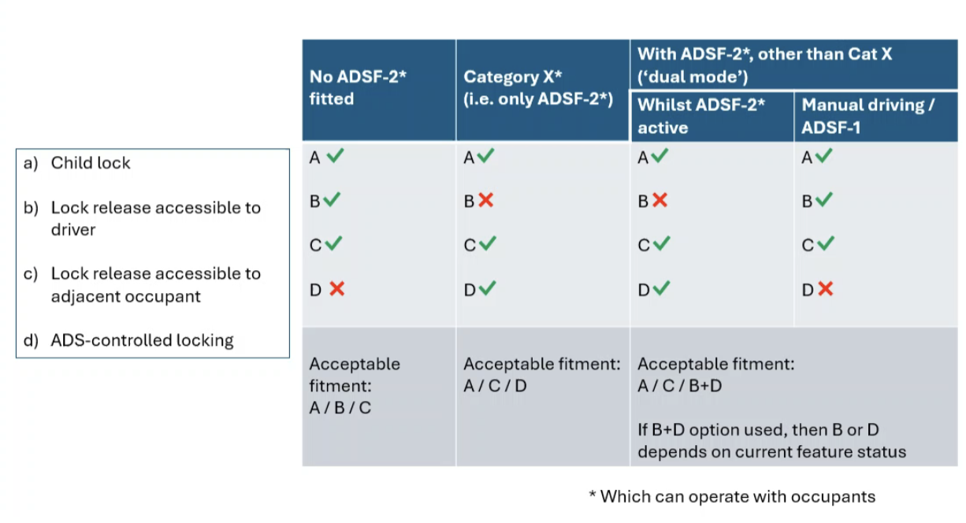
- Vehicles without ADSF2 features can use standard B or C locking options, while vehicles with ADSF2 that operate with occupants cannot use B options since driver-accessible locks don't make sense without a driver present.
- Dual-mode vehicles require either A or C options that work in all cases, or a combination of B and D where B works in manual mode and D works in ADS mode.
- Para. 6.3.2.2. is not correct and needs to be revised to reflect the table above.

Following regulations were not considered by FADS during this session.

  - UN Regulation No. 12 (Steering mechanism) (INFORMAL UPDATE)
  - UN Regulation No. 14 (Safety-belt anchorages)
  - UN Regulation No. 16 (Safety-belts) (INFORMAL UPDATE)
  - UN Regulation No. 17 (Strength of seats, their anchorages and head restraints)
  - UN Regulation No. 21 (Interior fittings)
  - UN Regulation No. 29 (Cabs of commercial vehicles) (INFORMAL UPDATE)
  - UN Regulation No. 94 (Frontal collision protection) (INFORMAL UPDATE)
  - UN Regulation No. 95 (Lateral collision protection)
  - UN Regulation No. 100 (Electric power trained vehicles)
  - UN Regulation No. 114 (Airbag module for a replacement airbag system) UN Regulation No. 127 (Pedestrian safety performance)
  - UN Regulation No. 134 (Hydrogen and fuel cell vehicles)
  - UN Regulation No. 135 (Pole side impact)
  - UN Regulation No. 137 (Frontal impact with focus on restraint systems)
  - UN Regulation No. 145 (ISOFIX anchorage systems, ISOFIX top tether anchorages and i-Size seating positions)
  - UN Regulation No. 153 (Fuel system integrity and electric power train safety at rear-end collision)
  - UN Regulation No. 28-08 (Installation of occupant restraint systems)
  - UN Regulation No. 174 (Safety-belt reminders) (INFORMAL UPDATE)

- FADS may also wish to review the upcoming working documents proposing amendments to the GRPE UN Regulations Nos. 49, 154 and 168.

No discussion under this agenda item.

- FADS may also wish to review the upcoming working documents proposing amendments to the GRBP UN Regulations Nos. 64 and 142.

- EC informed that both regulations covering spare tires and tire installation now require ADS to receive information about speed restrictions when fitted with temporary use tires or severe snow condition tires rather than visual warnings.
- Most of the issues concerned the adaptation of the testing procedures.
- Discussion about the need to keep “logic or logical signal”. FADS will recommend keeping “signal” only.
  - Other coordination activities
    - As discussed during the 6th joint meeting of the WP.29 expert groups on regulatory fitness for ADS, FADS may wish to discuss the potential organisation of a workshop that would allow experts to physically check their amendment proposals against various designs of automated vehicles.
No discussion under this agenda item
    - Comments from the industry regarding UN Regulation No. 48, paragraph 5.41.

These comments were taken into account by FADS in its proposals sent to GRE TF AVSR.

    - GRSG TF AVRS comments on FADS amendments to UN Regulation No. 79

- The co-Chair reminded that GRSG TF AVRS initially agreed that vehicles of category X could be exempt from the scope of several regulations and would later work on the crashworthiness regulation. However, GRSG then decided that exempting all kinds of manual modes of categories X and Y was not acceptable.
- EC identified 3 key misunderstandings with the GRSG TF, including expectations about provisions in the ADS safety concept, general wording in R79, and misconceptions about manual driving mode being regular rather than emergency use.
- OICA/CLEPA expressed their disagreement with the concerns of GRSG regarding potential misuse of manual driving modes up to 6 km/h, arguing that driving indefinitely at such low speeds represents an unrealistic use case.
- FADS identified six potential options to take into account the concerns of GRSG, including a dedicated regulation for the general safety of category X vehicles, a new annex in the UN regulation on ADS, and improved requirements in R79 and R13, including measures to limit manual mode usage.
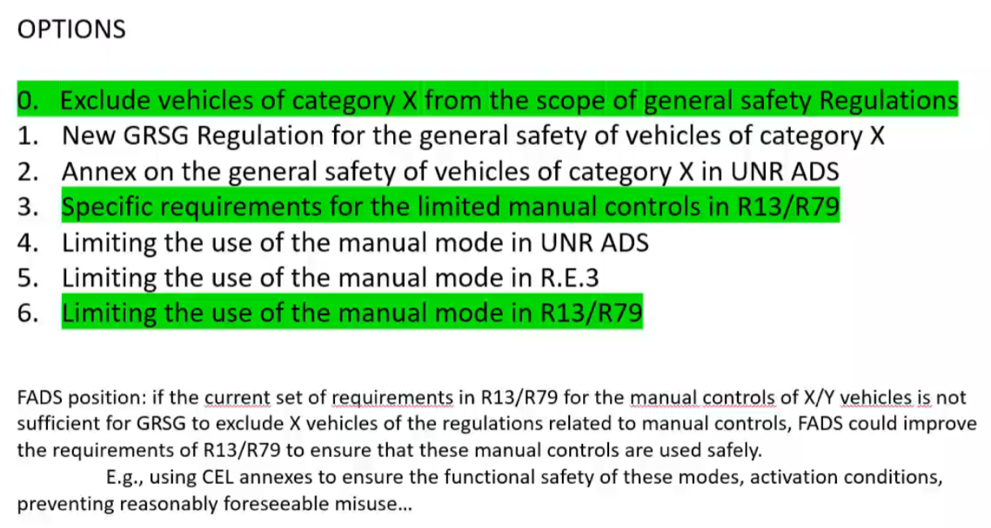

- UK recommended combining options 3 and 6 as the most practical approach, involving more detailed requirements and constraints on manual mode usage.
- Conclusion: FADS could offer to work on R13 and R79 provisions for manual controls, suggesting they provide preliminary wording to GRSG to assess and limit the use of the manual mode in order to satisfy their concerns.

Non-DDT tasks

Document: FADS-J5-01 (EC) Non-DDT tasks High-level requirements draft 3.0

- FADS reviewed the status of non-DDT safety-related tasks that has been prepared previously by EC and shared with IWG ADS. The document proposes changes to ADS regulation to address non-DDT safety-related tasks and define expected ADS behaviours.
- EC explained that the intended use of the document was for inclusion in an interpretation document.
- The provisions included in current regulations were considered satisfactory by both IWG ADS and screening TFs.
- UK clarified that at this stage there will no requirements in the ADS regulation on how to handle those tasks but guidance on expected behaviours might be included in a next amendment or in an interpretation document.
- Conclusion: It is too early at this stage to further discuss this topic.

    - Following the discussions at the 130th session of GRSG, General requirements for ADS vehicles and appropriate location for these requirements.

See above
- Any other business
Next online meetings:
- 29th meeting on 14 November from 9:30 to 12:30 CET.
- 30th meeting on 15 December from 9:30 to 12:30 CET.

__________________

