 | United Nations | ECE/TRANS/WP.29/GRE/2025/xx
 | Economic and Social Council |  | Distr.: General  Xx July 2025  Original: English  TFSR-24-02
Economic Commission for Europe
Inland Transport Committee
World Forum for Harmonization of Vehicle Regulations
Working Party on Lighting and Light-Signalling
Ninety-third session
Geneva, 21-23 October 2025
Item x of the provisional agenda
UN Regulations Nos. 37 (Filament lamps), 99 (Gas discharge light sources), 128 (Light emitting diodes light sources) and the Consolidated Resolution on the common specification of light source categories
Proposal for amendment [xx] to the Consolidated Resolution on the common specification of light source categories (R.E.5)
Submitted by the Task Force on Substitutes and Retrofits*
The text reproduced below was prepared by the Task Force on Substitutes and Retrofits (TF SR), with the aim to introduce new light emitting diode (LED) replacement light source categories H8, H16 and HB4. Whereof the H8 proposal is based on GRE-92-08, presented at the ninety-second session of the Working Party on Lighting and Light-Signalling (GRE).
The dedicated specifications were derived from the enforced H11_LEDr category sheet and – based on the established equivalence criteria as detailed in document GRE-83-15 – adapted to the specifications of the corresponding filament light source categories. The proposal for the three categories uses the established bi-directional equivalence concept.
The modifications to the existing text of the Resolution are marked in bold for new or strikethrough for deleted characters.

I. Proposal
The Status table, insert a new row at the bottom to read:
Amend. [xx] to the Original Version | [xx.xx.2026] | [….] | [ECE/TRANS/WP.29/2026/xx] | Introduction of a new LED replacement light source category H8, H16, HB4
”
Paragraph 3.3., insert in the table for Group 5 a new line after the entry C5W, to read:
“
Group 5
LED replacement light source categories^{3, 4} only for use in lamps approved with filament light source(s) with the same category designation
Category | Sheet number(s)
C5W | C5W_LEDr/1 to 4
H8 | H8_LEDr/1 to 7
H11 | H11_LEDr/1 to 7
H16 | H16_LEDr/1 to 7
HB4 | HB4_LEDr/1 to 7
”
Annex 3, insert in the listing new sheet numbers to read:
“List of sheets for LED light sources and their sequence in this annex:
Sheet number(s)
…
C5W_LEDr/1 to 4
H8_LEDr/1 to 7
H11/LED/1 to 7
H11_LEDr/1 to 7
H16_LEDr/1 to 7
HB4_LEDr/1 to 7
..
”
After sheet C5W_LEDr/4, insert new sheets H8_LEDr/1 to 7, and
after sheet H11_LEDr/7, insert new sheets H16_LEDr/1 to 7 and HB4_LEDr/1 to 7, to read:
(see following pages; one page per sheet)

II. Justification

1. The GRE Task Force LED Substitutes / Retrofits (TF S/R) has prepared proposals for additional LED replacement light categories in accordance with the intended way forward as detailed in documents GRE-91-14 and GRE-92-08.
2. This proposal introduces 3 new LED replacement light source categories for front fog applications, categories H8_LEDr, H16_LEDr and HB4_LEDr.
3. These proposals for the category sheets H8_LEDr, H16_LEDr and HB4_LEDr were developed taking into account the equivalence criteria (as detailed in document GRE-83-15):
- Photometric performance
- dedicated near-field photometry including homogeneity and contrast.
- dedicated far-field photometry including distortion free zones and block-top region.
- using the established bi-directional equivalence concept, as used for the enforced H11_LEDr.
- Thermal performance
- Photometric performance at elevated ambient temperature.
- Maximum cap temperature specification to avoid too high temperatures at the holder.
- Electrical performance
- Photometric performance in the range of input voltages from 12 V to 14 V direct current (DC).
- Minimum power consumption to ensure compatibility with failure-detection systems and an option for a “high efficiency” type.
4. The drawing convention for Figure 1 in the HB4_LEDr proposal deviates from that of Figure 1 in the HB4 filament category sheet. It was decided, for consistency among the LED replacement light source specifications, to align the Figure 1 of the HB4_LEDr category sheet with the drawing convention of the H11_LEDr, which is also consistent with the one used in the H8_LEDr and H16_LEDr proposals.
5. The HB4 filament light source has a bowtie-shaped “butterfly coil box” and the corresponding criteria for the bowtie shaped HB4_LEDr Light-Emitting-Area (LEA) have been developed based on the formalism given in GRE-83-15 for a trapezoidal coil box.

Category H8 Sheet H8_LEDr/1
The drawings are intended only to illustrate the essential dimensions (in mm) of the LED light source.
Figure 1
Main drawings

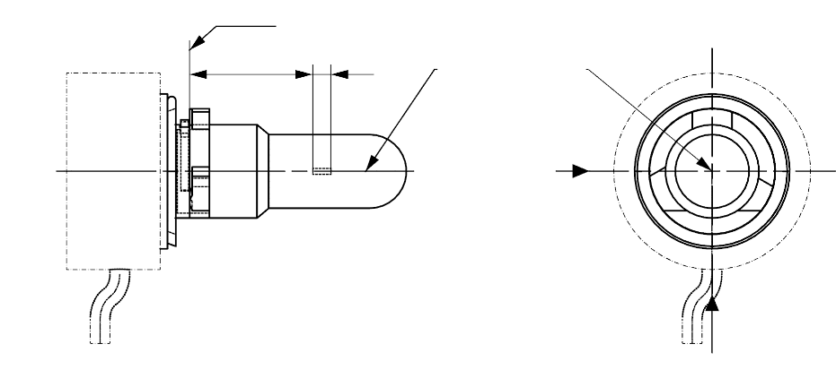
T_{cap} ^{5/}
View C
View A
Reference plane ^{1/}
Reference axis ^{2/}
A
B
e
f
^{4/}

Figure 2
Maximum LED light source outline ^{3/}
35
∅15.0
25.0
4
44.0
∅19.0
∅25.0
∅ 50
50°
Reference plane
Reference axis

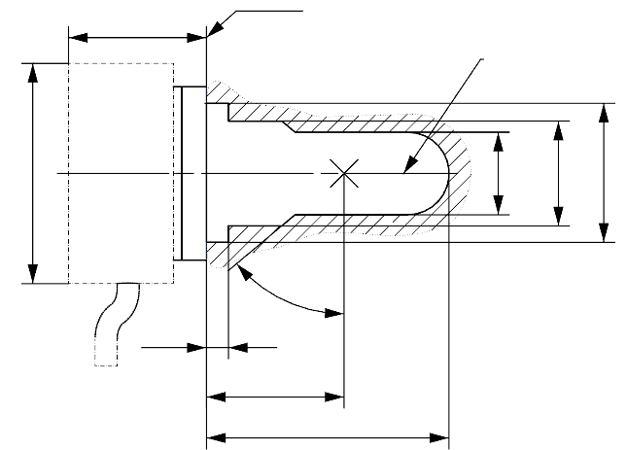

^{1/} The reference plane is the plane formed by the underside of the bevelled lead-in flange of the cap.
^{2/} The reference axis is perpendicular to the reference plane and passing through the centre of the 19 mm cap diameter.
^{3/} The LED light source shall not exceed the envelope as indicated in Figure 2.
^{4/} The light source shall function in either voltage polarity.
^{5/} Measurement point for cap temperature T_{cap}

Category H8 Sheet H8_LEDr/2
Table 1
Essential electrical and photometrical characteristics of the LED light source

Dimensions in mm |  |  | LED light sources of normal production
e ^{2/} |  |  | 25.0 nom.
f ^{2/} |  |  | 3.7 nom.
Contrast ^{4/} |  |  | 100 min.
Elevated ambient air temperature ^{3/} |  |  | 60°C
Cap H8 PGJ19-1 ^{6/} in accordance with IEC Publication 60061 (sheet 7004-110-3)
Electrical and photometric characteristics ^{9/}
Rated values |  | Volts | 12
 |  | Watts | 18 ^{8/}
Test voltage (DC) |  | Volts | 13.2
Objective values | Power | Watts | 18 min. ^{7/}  43 max. ^{8/}
Objective values | Cap temperature T_{cap} | °C | 100 max. ^{7/}
Objective values | Electrical current | mA | 1300 min. ^{7/}  (at 12-14 V DC)
Objective values | Luminous flux ^{1/ 3/} | lm | 800 ± 15%
Objective values | Luminous flux deviation ^{5/}  (voltage range limits) | lm | ±10% (at 12V)  ±10% (at 14V)

^{1/} The light emitted shall be white or selective yellow without a correlated colour temperature restriction.
^{2/} To be checked by means of a "box system", sheet H8 LEDr/3
^{3/} The luminous flux measured at the elevated ambient air temperature shall be at least 75% of the objective luminous flux (both measured at test voltage)
^{4/} The contrast is the proportion of luminous flux originating from two different areas, see details in sheet H8_LEDr/3
^{5/} The maximum luminous flux deviation at the tolerance limits is calculated by using the measured flux at test voltage as reference. The luminous flux behaviour shall be substantially uniform within the specified voltage range.
^{6/} The maximum specifications of parameters G and K are excluded, but the maximum outline dimensions in Figure 2 apply
^{7/} Not applicable for high-efficiency type
^{8/} For high-efficiency type 12W rated value and 18W max. objective value applies
^{9/} In case of LED light source failure (no light emitted) the max. electrical current draw, when operated between 12V and 14V, shall be less than 100 mA (open circuit condition)

Category H8 Sheet H8_LEDr/3
Screen projection requirements
The following test is intended to define the requirements for the apparent light emitting area of the LED light source and to determine whether the light emitting area is correctly positioned relative to the reference axis and reference plane in order to check compliance with the requirements.
The position of the light emitting area is checked by a box system defined in Figure 3 when operated at test voltage, which shows the projections when viewing from A and –A (see sheet H8_LEDr/1, Figure 1), i.e. along the C-planes C₉₀ and C₂₇₀ (as defined in Figure 5). The distance z between the surfaces of the opposite light emitting areas shall not exceed 2.9 mm.
The proportion of the total luminous flux emitted into these viewing directions from the area(s) as defined in Figure 3:
- Total box area: (A+B+C) / E shall be not less than 90%
- Area A: A / (A+B+C) shall be not more than 14%
- Areas B₁, B₂ and B₃: B₁/B, B₂/B, B₃/B shall each be not less than 15%
- Area B: B / (A+B+C) shall be not less than 65 %
- Area C: C / (A+B+C) shall be not more than 27%
Figure 3
Box definition of the light emitting area (dimensions given in Table 2)
c1
x1
x2
c2
b1
b2
y1
y1
e
a1/2
a2
E
B1
B2
B3
C
B
A
Reference axis
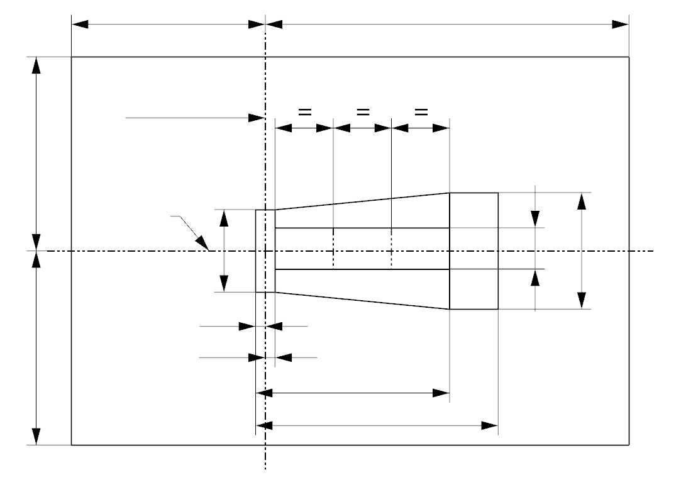
a1
The contrast is checked by a box system defined in Figure 4 when operated at test voltage, which shows the projections when viewing from A and –A (see sheet H8_LEDr/1, Figure 1), i.e. along the C-planes C₉₀ and C₂₇₀ (as defined in Figure 5).

Category H8 Sheet H8_LEDr/4
The contrast is the proportion of the total luminous flux values emitted into these viewing directions from the corresponding areas (A+B+C) and D. The value of the contrast (A+B+C) / D shall be within the limits given in Table 1 (see Figure 4 for the definition of the area D).
Figure 4
Box definition of the area D (dimensions given in Table 2)

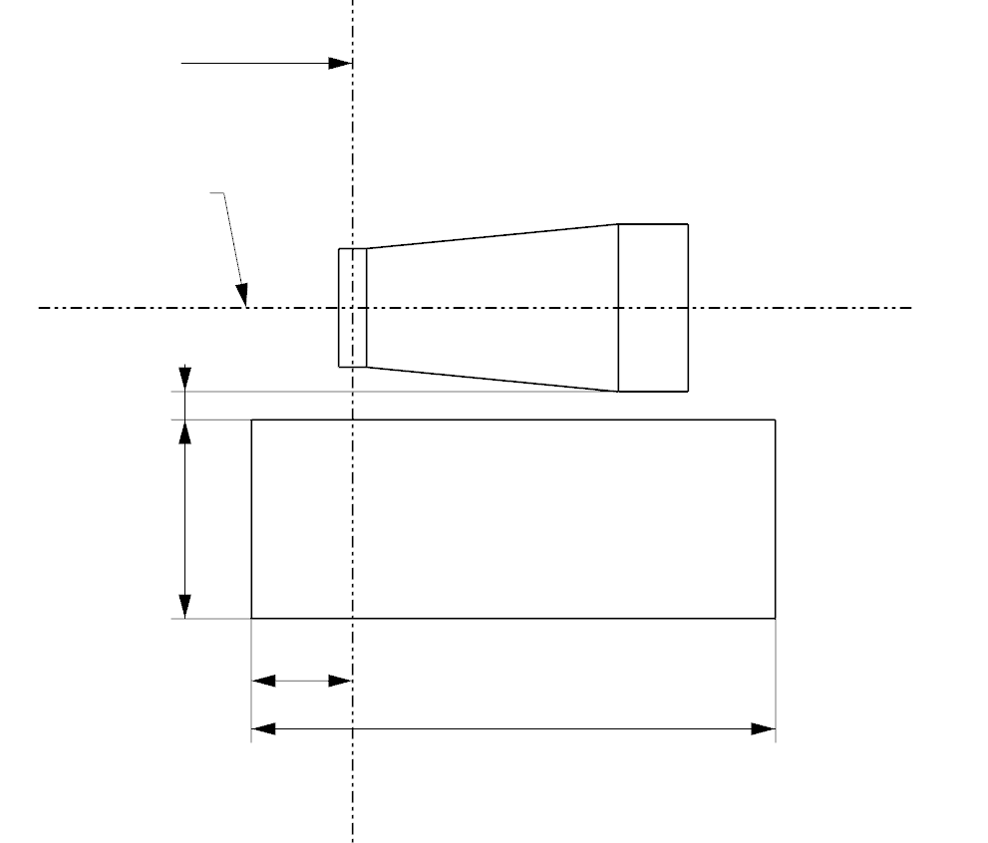
g2
g3
d
g1
A
D
C
B
e
Reference axis

Table 2
Dimensions of the box definitions in Figure 3 and Figure 4
All views  (as specified above) | Dimensions in mm | All views  (as specified above) | Dimensions in mm
a1 | 1.7 | x1 | 25
a2 | 1.9 | x2 | 19
b1 | 0.25 | y1 | 12.5
b2 | 0.25 | g1 | 2.85
c1 | 4.6 | g2 | 6.9
c2 | 3.5 | g3 | 1.4
d | 0.4

Category H8 Sheet H8_LEDr/5
Normalized luminous intensity distribution
The following test is intended to determine the normalized luminous intensity distribution of the light source in the C-planes as described in Figure 5 when operated at test voltage. The intersection of the reference axis and the plane parallel to the reference plane at distance e = 25.0 mm is used as the coordinate system origin.
The light source is mounted on a flat plate with the corresponding holder features. The plate is fixed to the goniometer table by a bracket, so that the reference axis of the light source lines up with one of the rotating axis of the goniometer. The corresponding measurement set-up is described in Figure 5.
Luminous intensity data is recorded with a standard photo-goniometer. The measurement distance should be chosen appropriately in order to make sure that the detector is located in the far field of the light distribution.
The measurements shall be performed in C-planes for which the line of intersection coincides with the reference axis of the light source. The test points for each plane and polar angles γ are specified in Table 3.
The measured luminous intensity values, normalised to the measured luminous flux of the individual light source under test, shall be converted to normalised luminous intensity values of a 1000 lm light source. These data shall comply with the limits as defined in Table 3.
Figure 5
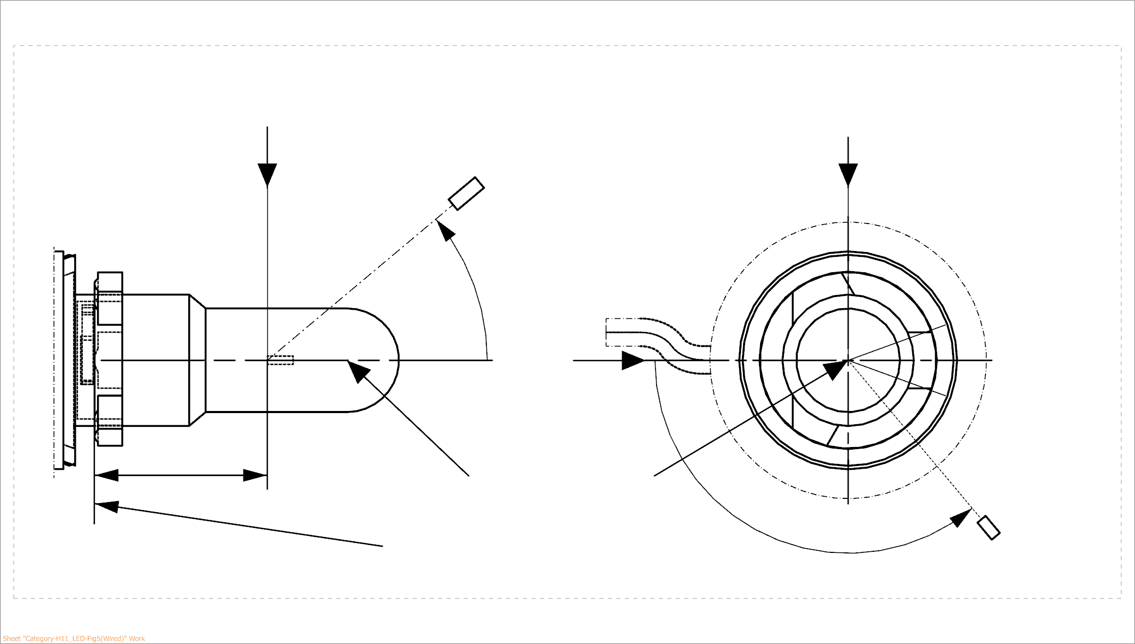
Setup to measure the luminous intensity distribution and the definition of C-Planes and angle γ
25,0
View from B
View from C
Reference plane
Reference axis
B
A
C = 270°
C = 90°
C = 180°
C
C = 0°
γ
A
Photo-Detector of Goniometer

C-planes: see CIE publication 70-1987, "The measurement of absolute intensity distributions".

Category H8 Sheet H8_LEDr/6

Table 3 – Part 1

Test point values of normalized intensity [(“Black top area”)]

LED light source of normal production
 | Minimum intensity (cd/klm) | Maximum intensity (cd/klm)
γ | C₀, C₉₀, C₁₈₀, C₂₇₀ | C₀, C₉₀, C₁₈₀, C₂₇₀
0° | n/a | 10
10° | n/a | 10
20° | n/a | 10
30° | n/a | 10
The light pattern as described in Table 3 – part 1 shall be substantially uniform, i.e. in between two adjacent grid points the relative luminous intensity requirement is calculated by linear interpolation using the two adjacent grid points. In case of doubt this may be checked in addition to verification of the grid points given in Table 3 – part 1.

Table 3 – Part 2

Test point values of normalized intensity [(“Distortion free area”)]

 | LED light source of normal production
 | Minimum intensity (cd/klm) | Maximum intensity (cd/klm)
γ | C₉₀, C₂₇₀ | C₉₀, C₂₇₀
50° | 100 | 160
60° | 115 | 175
70° | 125 | 185
80° | 130 | 190
90° | 130 | 195
100° | 130 | 190
110° | 125 | 185
120° | 115 | 175
130° | 100 | 160
140° | 80 | 145

The light pattern as described in Table 3 – part 2 (excluding the sections between C₉₀ and C₂₇₀ and between C₂₇₀ and C₉₀) shall be substantially uniform, i.e. in between two adjacent grid points the relative luminous intensity requirement is calculated by linear interpolation using the two adjacent grid points. In case of doubt this may be checked in addition to verification of the grid points given in Table 3 – part 2.

Category H8 Sheet H8_LEDr/7

Table 3 – Part 3

Test point values of normalized intensity [(“Shading area” of the lead-in wire of the counterpart filament light source)]

 | LED light source of normal production
 | Minimum intensity (cd/klm) | Maximum intensity (cd/klm)
C-plane | γ = 90° | γ = 90°
C₀ | n.a. | n.a.
C₃₀ | 50 | 130
C₆₀ | 110 | 175
C₉₀ | 130 | 195
C₁₂₀ | 110 | 175
C₁₅₀ | 50 | 130
C₁₈₀ | n.a. | n.a.
C₂₁₀ | 50 | 130
C₂₄₀ | 110 | 175
C₂₇₀ | 130 | 195
C₃₀₀ | 110 | 175
C₃₃₀ | 50 | 130
C₃₆₀ (= C₀₎ | n.a. | n.a.

The light pattern as described in Table 3 – part 3 (excluding the sections between C₁₅₀ and C₂₁₀ and between C₃₃₀ and C₃₀) shall be substantially uniform, i.e. in between two adjacent grid points the relative luminous intensity requirement is calculated by linear interpolation using the two adjacent grid points. In case of doubt this may be checked in addition to verification of the grid points given in Table 3 – part 3.

* In accordance with the programme of work of the Inland Transport Committee for 2020 as outlined in proposed programme budget for 2020 (A/74/6 (part V sect. 20) para 20.37), the World Forum will develop, harmonize and update UN Regulations in order to enhance the performance of vehicles. The present document is submitted in conformity with that mandate.

