TFSR-24-04
Category HB4 Sheet HB4_LEDr/1
The drawings are intended only to illustrate the essential dimensions (in mm) of the LED light source.
Figure 1
Main drawings
Reference diameter
Reference plane ^{1/}
Reference axis ^{2/}
T_{cap} ^{6/}
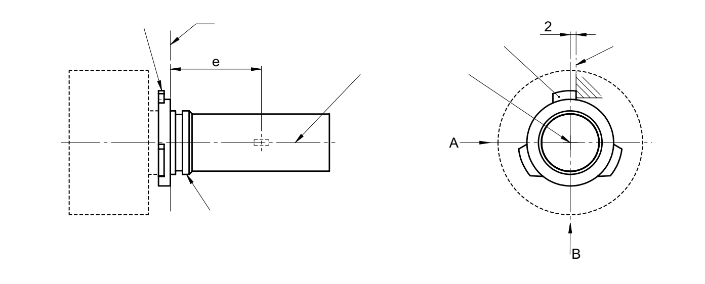
^{5/}
View A
View C
Reference lug

Figure 2
Maximum LED light source outline ^{3/}
Reference plane ^{1/}
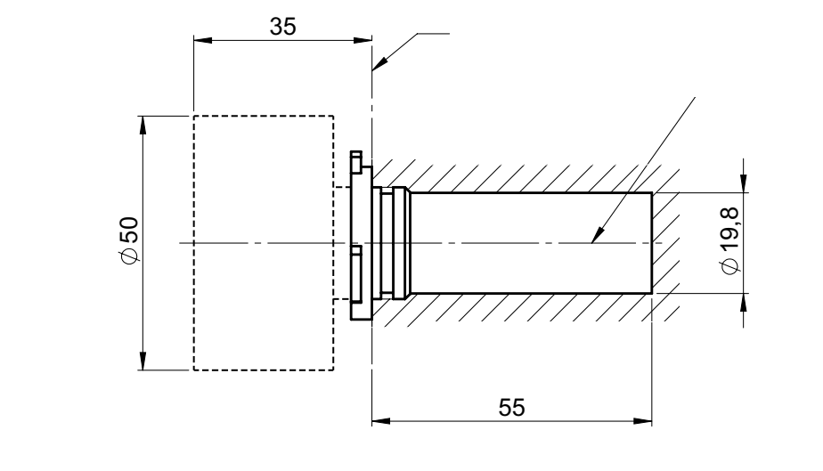
Reference axis ^{2/}

^{1/} The reference plane is the plane defined by the meeting points of cap-holder fit.
^{2/} The reference axis is perpendicular to the reference plane and concentric with the reference diameter of the cap.
^{3/} The LED light source shall not exceed the envelope as indicated in Figure 2.
^{4/} The light source shall function in either voltage polarity.
_{5/} The LED light source shall be rotated in the measuring holder until the reference lug contacts the plane of the holder
^{6/} Measurement point for cap temperature T_{cap}

Category HB4 Sheet HB4_LEDr/2
Table 1
Essential electrical and photometrical characteristics of the LED light source

Dimensions in mm ^{9/} |  |  | LED light sources of normal production
e ^{2/} |  |  | 31.5 nom.
f ^{2/} |  |  | 5.1 nom.
Contrast ^{4/} |  |  | 100 min.
Elevated ambient air temperature ^{3/} |  |  | 60°C
Cap HB4 P22d ^{6/} in accordance with IEC Publication 60061 (sheet 7004-32-2)
Electrical and photometric characteristics ^{10/}
Rated values |  | Volts | 12
 |  | Watts | 25 ^{8/}
Test voltage (DC) |  | Volts | 13.2
Objective values | Power | Watts | 25 min. ^{7/}  62 max. ^{8/}
Objective values | Cap temperature T_{cap} | °C | 100 max. ^{7/}
Objective values | Electrical current | mA | 1900 min. ^{7/}  (at 12-14 V DC)
Objective values | Luminous flux ^{1/ 3/} | lm | 1095 ± 15%
Objective values | Luminous flux deviation ^{5/}  (voltage range limits) | lm | ±10% (at 12V)  ±10% (at 14V)

^{1/} The light emitted shall be white or selective yellow without a correlated colour temperature restriction.
^{2/} To be checked by means of a "box system", sheet HB4_LEDr/3
^{3/} The luminous flux measured at the elevated ambient air temperature shall be at least 75% of the objective luminous flux (both measured at test voltage)
^{4/} The contrast is the proportion of luminous flux originating from two different areas, see details in sheet HB4_LEDr/3
^{5/} The maximum luminous flux deviation at the tolerance limits is calculated by using the measured flux at test voltage as reference. The luminous flux behaviour shall be substantially uniform within the specified voltage range.
^{6/} The maximum specifications of parameter AC, AE and AO are excluded, but the maximum outline dimensions in Figure 2 apply
^{7/} Not applicable for high-efficiency type
^{8/} For high-efficiency type 16W rated value and 25W max. objective value applies
^{9/} Dimensions shall be checked with O-ring removed
^{10/} In case of LED light source failure (no light emitted) the max. electrical current draw, when operated between 12V and 14V, shall be less than 100 mA (open circuit condition)

Category HB4 Sheet HB4_LEDr/3
Screen projection requirements
The following test is intended to define the requirements for the apparent light emitting area of the LED light source and to determine whether the light emitting area is correctly positioned relative to the reference axis and reference plane in order to check compliance with the requirements.
The position of the light emitting area is checked by a box system defined in Figure 3 when operated at test voltage, which shows the projections when viewing from A and –A (see sheet HB4_LEDr/1, Figure 1), i.e. along the C-planes C₉₀ and C₂₇₀ (as defined in Figure 5). The distance z between the surfaces of the opposite light emitting areas shall not exceed 2.9 mm.
The proportion of the total luminous flux emitted into these viewing directions from the area(s) as defined in Figure 3:
- Total box area: (A+B+C) / E shall be not less than 90%
- Area B: B / (A+B+C) shall be not less than 73%
- Areas B₁, B₂ and B₃: B₁/B, B₂/B, B₃/B shall each be not less than 15%
- Area A: A / (A+B+C) shall be not more than 14 %
- Area C: C / (A+B+C) shall be not more than 17%
Figure 3
Box definition of the light emitting area (dimensions given in Table 2)
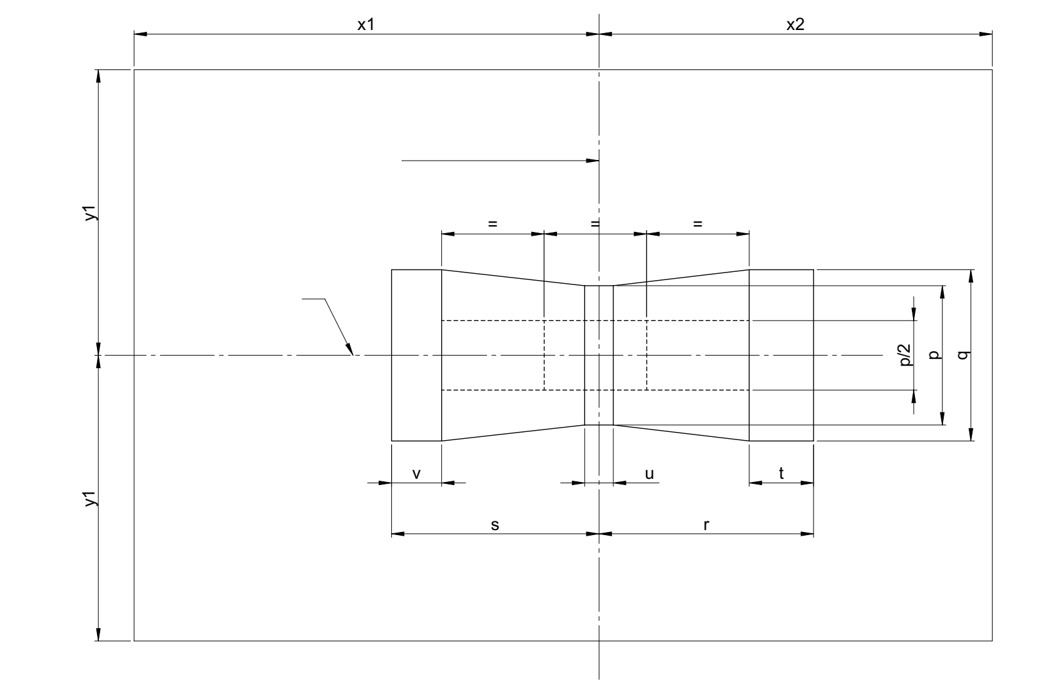
B
E
Reference axis
B3
B2
B1
C
A
e

The contrast is checked by a box system defined in Figure 4 when operated at test voltage, which shows the projections when viewing from A and –A (see sheet HB4_LEDr/1, Figure 1), i.e. along the C-planes C₉₀ and C₂₇₀ (as defined in Figure 5).

Category HB4 Sheet HB4_LEDr/4
The contrast is the proportion of the total luminous flux values emitted into these viewing directions from the corresponding areas (A+B+C) and D. The value of the contrast (A+B+C) / D shall be within the limits given in Table 1 (see Figure 4 for the definition of the area D).
Figure 4
Box definition of the area D (dimensions given in Table 2)

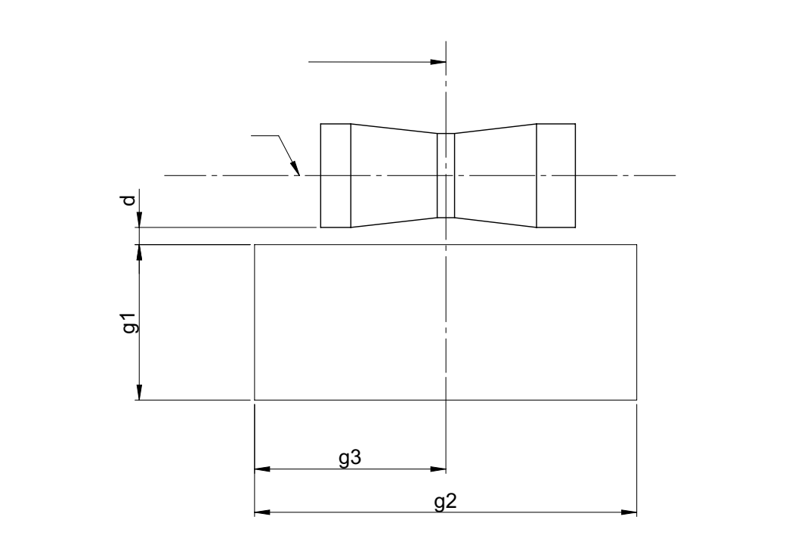
Reference axis
e
C
A
B
D

Table 2
Dimensions of the box definitions in Figure 3 and Figure 4
All views  (as specified above) | Dimensions in mm | All views  (as specified above) | Dimensions in mm
p | 1.95 | x1 | 31.5
q | 2.4 | x2 | 23.5
u | 0.4 | y1 | 9.9
v | 0.7 | g1 | 3.6
t | 0.9 | g2 | 8.85
r | 3.0 | g3 | 4.43
s | 2.9 | d | 0.4

Category HB4 Sheet HB4_LEDr/5
Normalized luminous intensity distribution
The following test is intended to determine the normalized luminous intensity distribution of the light source in the C-planes as described in Figure 5 when operated at test voltage. The intersection of the reference axis and the plane parallel to the reference plane at distance e = 31.5 mm is used as the coordinate system origin.
The light source is mounted on a flat plate with the corresponding holder features. The plate is fixed to the goniometer table by a bracket, so that the reference axis of the light source lines up with one of the rotating axis of the goniometer. The corresponding measurement set-up is described in Figure 5.
Luminous intensity data is recorded with a standard photo-goniometer. The measurement distance should be chosen appropriately in order to make sure that the detector is located in the far field of the light distribution.
The measurements shall be performed in C-planes for which the line of intersection coincides with the reference axis of the light source. The test points for each plane and polar angles γ are specified in Table 3.
The measured luminous intensity values, normalised to the measured luminous flux of the individual light source under test, shall be converted to normalised luminous intensity values of a 1000 lm light source. These data shall comply with the limits as defined in Table 3.
Figure 5
Setup to measure the luminous intensity distribution and the definition of C-Planes and angle γ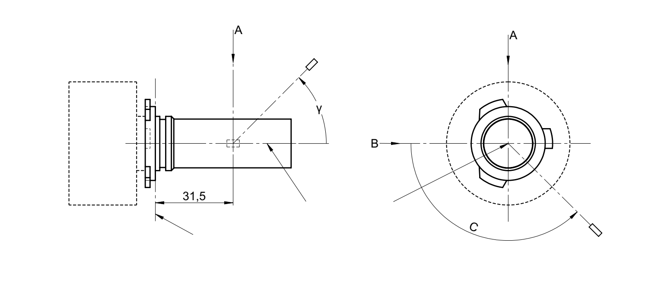
View B
View C
Photo-Detector of Goniometer
Reference plane
Reference axis
C = 0°
C = 180°
C = 270°
C = 90°

C-planes: see CIE publication 70-1987, "The measurement of absolute intensity distributions".

Category HB4 Sheet HB4_LEDr/6

Table 3 – Part 1

Test point values of normalized intensity [(Black top area)]

LED light source of normal production
 | Minimum intensity (cd/klm) | Maximum intensity (cd/klm)
γ | C₀, C₉₀, C₁₈₀, C₂₇₀ | C₀, C₉₀, C₁₈₀, C₂₇₀
0° | n/a | 10
10° | n/a | 10
20° | n/a | 10
30° | n/a | 10
The light pattern as described in Table 3 – part 1 shall be substantially uniform, i.e. in between two adjacent grid points the relative luminous intensity requirement is calculated by linear interpolation using the two adjacent grid points. In case of doubt this may be checked in addition to verification of the grid points given in Table 3 – part 1.

Table 3 – Part 2

Test point values of normalized intensity [(Distortion free area)]

 | LED light source of normal production
 | Minimum intensity (cd/klm) | Maximum intensity (cd/klm)
γ | C₉₀, C₂₇₀ | C₉₀, C₂₇₀
50° | 100 | 160
60° | 115 | 175
70° | 125 | 185
80° | 130 | 190
90° | 130 | 195
100° | 130 | 190
110° | 125 | 185
120° | 115 | 175
130° | 100 | 160
140° | 80 | 145

The light pattern as described in Table 3 – part 2 (excluding the sections between C₉₀ and C₂₇₀ and between C₂₇₀ and C₉₀) shall be substantially uniform, i.e. in between two adjacent grid points the relative luminous intensity requirement is calculated by linear interpolation using the two adjacent grid points. In case of doubt this may be checked in addition to verification of the grid points given in Table 3 – part 2.

Category HB4 Sheet HB4_LEDr/7

Table 3 – Part 3

Test point values of normalized intensity [(Shading area of the lead-in wire of the counterpart filament light source)]

 | LED light source of normal production
 | Minimum intensity (cd/klm) | Maximum intensity (cd/klm)
C-plane | γ = 90° | γ = 90°
C₀ | n.a. | n.a.
C₃₀ | 50 | 130
C₆₀ | 110 | 175
C₉₀ | 130 | 195
C₁₂₀ | 110 | 175
C₁₅₀ | 50 | 130
C₁₈₀ | n.a. | n.a.
C₂₁₀ | 50 | 130
C₂₄₀ | 110 | 175
C₂₇₀ | 130 | 195
C₃₀₀ | 110 | 175
C₃₃₀ | 50 | 130
C₃₆₀ (= C₀₎ | n.a. | n.a.

The light pattern as described in Table 3 – part 3 (excluding the sections between C₁₅₀ and C₂₁₀ and between C₃₃₀ and C₃₀) shall be substantially uniform, i.e. in between two adjacent grid points the relative luminous intensity requirement is calculated by linear interpolation using the two adjacent grid points. In case of doubt this may be checked in addition to verification of the grid points given in Table 3 – part 3.

