Minutes

Committee / topic | GRSP TF on hydrogen regulations (TFH2) – Kick-off meeting
Location | RDW Brussels, Froissart Straat 95 / MS Teams
Dates | Tuesday, 01 July 2025 | 10:00 AM | to | 5:30 PM | CET
Dates | Wednesday, 02 July 2025 | 9:00 AM | to | 5:00 PM | CET
Chairs | Hans Lammers (NL) / Antoine Azzopardi (F)
Secretariat | Amy Ryan (OICA) / Annett Schuessling (OICA)

Item | Description | Responsible
1 | Welcome | Hans Lammers / Antoine Azzopardi
1.1 | Roll call
1.2 | Approval of agenda
2 | Recap of the 77th GRSP, May 2025 | Chair(s) / secretariat
Terms of reference:
- Recommendation for IWG GTR 13 Phase 3
- Chairs and Secretariat to contact JRC and EU Com on further development on testing facilities for hydrogen material compatibility

3 | Regulation on Liquefied Hydrogen | All
3.1 | - New Regulation vs. Inclusion in UN-R 134
- Japan has presented their opinion voting for option 1 – a separate UN regulation.
- The TF agreed that this is the best way forward until more experience has been made with LH2.
General information:
- ISO 13985 will handle the container requirements for LH2
- For all the components a separate ISO standard will be developed under work item ISO/NP26018
3.2 | Requirements
- Some terminology needs to be reviewed because it is focussed on CH₂.
- Some revision is required for measurement of leakage and post-crash requirements
- Post-crash criteria has been moved to the dedicated crash regulations
- Scope: should it be limited to HDV?
  - Including light vehicles in the scope requires an update of crash requirements for these vehicle categories!
- How to deal with cryo-compressed storage systems? Are they excluded or included? Do we have to specifically indicate this in the regulation?
- Tolerances for RGB code in Annex 6
- Requirements for PTI similar to R 110?
- Incorporate paragraph 8 in paragraph 7
- Information document to be updated, (unnecessary info for CHSS)
- No transitional provisions needed
- How does the new UN regulation work with the (EU) 2021/535 Annex XIV?
- Are installation restrictions (400mm from the front, 200 mm from the sides for the primary closure devices) required in combination with sled test?
- Can we limit the material to metal as a first step? Is there any development towards composite material for the inner or outer shell?
- Type definition of storage system and vehicle
- Define cryo-compressed hydrogen and add a footnote to exclude it from the scope?
- Do we need a drop test or impact test?
4. | Supply lines for additional TPRDs | All
 | - ISO 19887-1:2024, chapter 19
- Myrna presents the initial thought of the industry TF on supply lines
- Japan presents their initial feedback on the supply line requirements
- Chapter 22 (Fittings) needs to be referred as well
- Raw component? = actual tube with fittings
- ISO also requires material compatibility and seems to be inconsistent with UNR 134
5. | Periodic technical inspection | All
 | - Alignment with UN-R 110?
- different pressures (CNG v CH₂) need to be considered
- Manufacturers shall provide instructions on how to service / inspect the vehicle
- In EU there is a directive on PTI but it is implemented by each MS in different ways
- ISO 19881:2025 container standard – every periodic requalification shall be …
- Is R 134 the right place for this?
- Hexagon: Do we want to include other methods for inspection, e.g. x-ray or ultrasonic?
- Forvia is opposed to that suggestion, these methods are not yet accepted in ADR
- Thinks this discussion is too early for requalification
- Linamar in favour to use these technologies for PTI
- Can be useful to detect flaws during service life.
- ISO standards that contain options for inspection:
  - https://www.iso.org/obp/ui/fr/#iso:std:iso:19016:dis:ed-1:v3:en
  - https://www.iso.org/obp/ui/en/#iso:std:iso:11623:ed-3:v1:en
- Requalification provisions can be included in the manufacturer recommendations – should not be mandatory if not required by the manufacturer
- Re-use of systems within their service life is not covered by this regulation
- PTI requirements should also be included in LHSS proposal
6. | Receptacle geometry | All
 | - ISO 17268-1:2025
- The ISO is out for ballot until July 18th 2025 and is expected to be published shortly after.
- Updated working documents will be submitted to WP.29 before the deadline for submission (August 18th 2025).
7. | Any other topics
8. | Next steps:
 | - Provide comments on the drafts for the  - Prio 1: LHSS proposal (new regulation), incorporating PTI requirements  - Prio 2: supply line proposal (supplement to 03 series of UN-R 134),  - Prio 2: PTI proposal (new series 04 to UN-R 134)  - Inform about publication of ISO 17268-1:2025 | All
9. | Next meeting(s) | All
- August 26th: 9-11 pm PDT
- August 27th: 6-8 am CET; 1-3pm JST

Deadline for submission of working doc: September 8th 2025

- September 23rd: 9-11 pm PDT
- September 24th: 6-8 am CET; 1-3pm JST
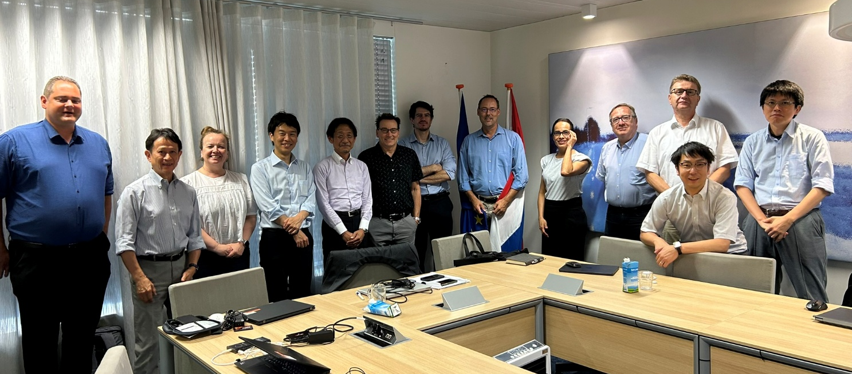
Participants:
Antoine Azzopardi (France)
Breuer, Patrick (Hexagon Purus)
Bruyninx, Johan (Idiada)
Cashatt, Myrna (Linamar)
Castenhag Blomström Ylva (Scania)
Daval, Romary (Luxfer)
Dijkhof, Paul (KIWA)
Frame, Daniel (Arrowhead)
Fujimoto, Yoshio (NTSEL)
Gambone, Livio (Toyota)
Gissibl, Gerhard (BMW)
Ikehata, Hirokazu (MLIT_JAPAN)
Imagawa, Hidekazu (Mitsubishi Fuso Trucks)
Iwasaki, Masaaki (Jama)
Jouvenot, Gilles (opmobility)
Kanai, Satoru (MLIT, Japan)
Karunakaran, Alagurajan (Cummins)
Kataoka, Chiaki (Toyota)
Kondo, Masaaki (Toyota)
Lammers, Hans (NL)
Larocque-Legros, Marc-André (Canada)
Mattelaer, Vincent (Toyota)
Mori, Masato (METI)
Morinaga, Yasuyuki (KHK, Japan)
Otremba, Frank (NPROXX)
Ramsey-Idem, Karen M (Cummins)
Rubio, Sandra (Luxfer)
Schüßling, Annett (VDA)
Sekiya, Yuto (KHK, Japan)
Shimane, Yoshichika (Toyota)
Smutny, Tanja (Powertech)
TAMURA, Hiroaki (Jari)
Tanaka, Yoshinori (NTSEL)
TROTT, Richard (Forvia)
Tsunoda, Miyu (METI, Japan)
YAHI, Sofia (opmobility)

