DRAFT REPORT

7th meeting of GRRF Informal Working Group on
Automatically Commanded Steering Function

Venue: Conference Centre of the Department for Business, Innovations and Skills (BIS),
1 Victoria Street, London, SW1H 0ET (UK)
Chairman: Mr. Christian Theis (D) and Mr. Hidenobu Kubota (J)
Secretariat: Mr. Jochen Schaefer (CLEPA)
Dates: 28.-30. June 2016
Website: https://www2.unece.org/wiki/display/trans/ACSF+7th+session

- Participants:
see special attachment

- Welcome and Introduction
- Approval of the report of the 6th Session
The report of the 6th Session was approved by the delegates
ACSF-06-29-Rev1 - (Secretary) Report of 6th session - approved by the delegates

- Approval of the agenda
The agenda was adopted and confirmed by the delegates without amendments.
ACSF-07-03-Rev1 (Secretary) Agenda 7th session

- List of Documents:

ACSF-07-01 - (UK) Info to the 7th meeting which take place in London on 28-30 June 2016
ACSF-07-02 - (CPs) New text proposal to include CAT B1 in Regulation 79
ACSF-07-03 - Draft Agenda for the 7th session of the informal group
ACSF-07-04 - (D) FU0_Test for ACSF Testing
ACSF-07-05 - (D) Calculation of ranges for monitoring the driving environment
ACSF-07-06 - (TRL-EC) Support for amendments to UN R79 to allow approval of ACSF, in particular LKA and LCA
ACSF-07-07 - (D) Text-Proposal for Cat. A (RCP - Remote Controlled Parking)
ACSF-07-08 - (D) ACSF Type Approval Number (ACSFTAN)
ACSF-07-09 - (ROK) Timing to be activated the hazard lights
ACSF-07-10 - (J) Requirements per ACSF category in R79
ACSF-07-11 - (J) Requirements per ACSF category in R79
ACSF-07-12 - (OICA-CLEPA) Proposed amendments of FU0_Test (ACSF-07-04)
ACSF-07-13 - (OICA-CLEPA) Amendments toText proposal to include CAT B1 in Regulation 79 (ACSF-07-02)
ACSF-07-14 - (OICA-CLEPA) System Status and HMI
ACSF-07-15 - (CPs) New text proposal to define Corrective Steering Function (CSF)
ACSF-07-16 - (J) Borderline between CSF and ACSF
ACSF-07-17 - (OICA) - CSF definitions and requirements
ACSF-07-18 - (OICA) - prevent excessive intervention
ACSF-07-19 - (OICA) - Boundaries CSF - ACSF

- Report from WP.29
(UK): Bernie Frost, the representative of UK and Chairman of the GRRF made an oral report about the ACSF activities in the WP.29.
The ITS/AD reflects the situation of Driver in the Loop (DIL) and Driver out of the loop (DOL) which is also important for this group.It was decided, that on 19. September 2016, one day before GRRF82, a special session will be arranged in Geneva. The group will report on Tuesday to GRRF about ther results of their meeting.
Because of the regulation issues of the last months (Diesel) WP.29 asked ervery Working Party of WP.29 to have a close look on every system where software is included. We have to be alerted, whether the software is used correctly in the system. These arealso new challenges for GRRF.

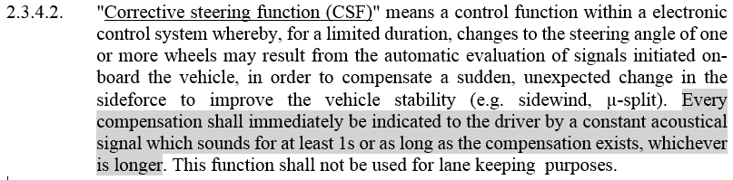
  - Corrective Steering Function (CSF) (ACSF-07-15)
(Chair-D, in the following C-D): A clear definition of CSF is necessary, otherwise CSF should be deleted. We have to avoid, that CSF is missused as an ACSF-function.
(OICA): not every intervention of CSF should have a warning.
(C-D): ESC has currently an optical warning, this will not been changed. If the intervention is done by steering, this warning should occur.
(OICA): if only short interventions are necessary, are there the warnings really necessary?
(D): if there is an intervention while an emergency situation, a warning is necessary.
(OICA): Sidewind may occur quite often. We should not warn all the times.
(EC): is this sidewind compensation (SWC) a part of CAT B1?
(OICA): SWC is definitely to keep the vehicle in the lane.
(D): are there other systems on the market, which would use the CSF intervention?
(ALL): Discussion with regard to steering interventions by systems/functions on the market. Some CPs have doubts, whether these systems/functions are visible for the Technical Service.
(ALL): Discussion, whether the word “complex” is necessary “… within a complex electronic control system…” with the result, to remove the word “complex”, as these systems are all regarded to be “complex” according Annex 6 of Regulation 79.
(ALL): Discussion, where the threshhold between CSF and CAT B1 should be.
Proposals:
1. CSF is a lane keeping function, which reacts outside of the “lane
center line” - (e.g.) +/- 0,5m
2. CSF is a lane keeping function, which reacts outside of the lane
markings
Result: use proposal 2. (A, B, C, D not finally concluded)
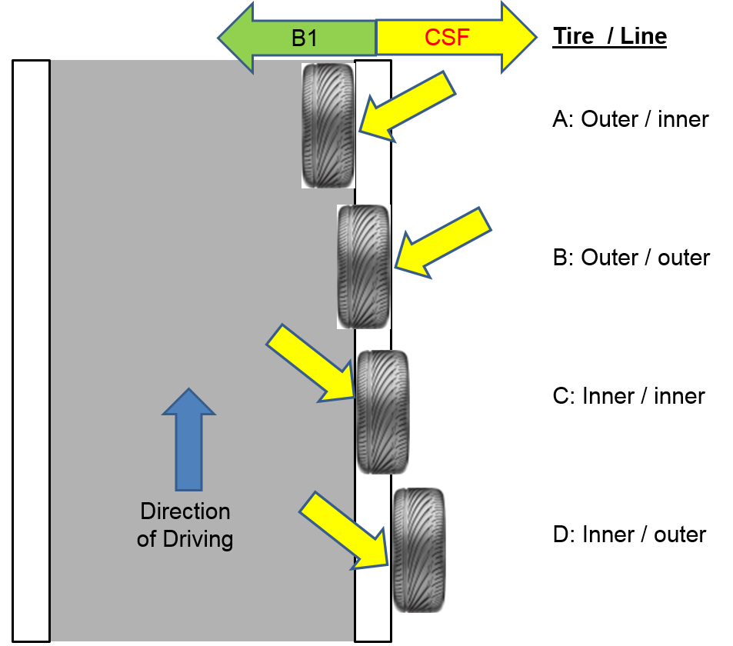
Conclusion (confirmed by the delegates):
2.3.4.2. "Corrective steering function (CSF)" means a control function within an electronic control system whereby, for a limited duration [and independent of the drivers demand] changes to the steering angle of one or more wheels may result from the automatic evaluation of signals initiated on-board the vehicle, in order to assist the avoidance of a collision, or to compensate a sudden, unexpected change in the sideforce to improve the vehicle stability (e.g. sidewind, µ-split) or to correct lane departure after crossing the lane marking.

  - Warning signals for CSF
    - Signals for Dynamic interventions by CSF
It was concluded, that dynamic interventions, where actuation of the steering system by automatic means, in which the lane keeping is secondary to vehicle behaviour modification, is clearly a CSF function, whenever it occurs. This intervention shall be signalled to the driver by an optical signal. Discussion, whether for this purpose the ESC signal may be used, was not finalized.
    - Signals for Lane Departure by CSF
It was concluded, that a CSF-intervention to correct/avoid lane departure shall have to the optical signal an aoustical an addition, if the intervention time is too long, or occurs too often.
Conclusion (confirmed by the delegates):
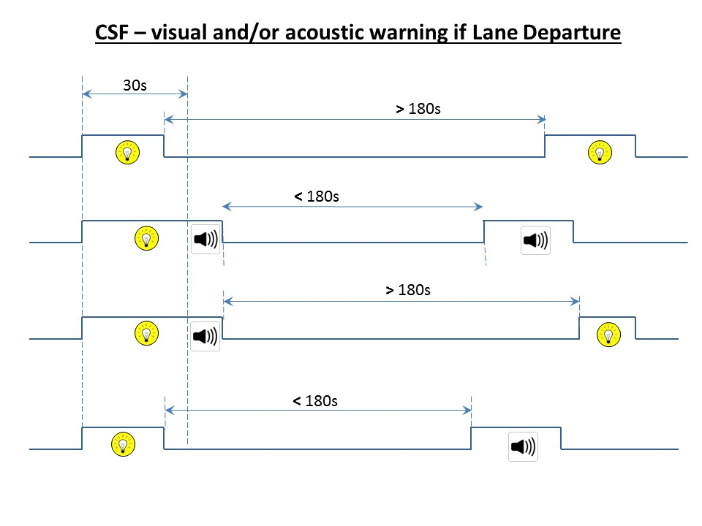
5.xxxx Every intervention to correct a lane departure shall immediately be indicated to the driver by an optical signal which is displayed for at least 1s or as long as the compensation exists, which ever is longer.
In the case of a lane departure intervention longer than [30s], an acoustic warning shall be provided until the end of the intervention.
In the case of 2 or more consecutive lane departure interventions within a rolling interval of 180s and in the absence of a steering input by the driver during the intervention, an acoustic warning shall be provided by the system during the second and any further intervention.
  - Document ACSF-07-02 vs. ACSF-07-13
5.6.5.2.1 The activated system shall at any time ensure that the vehicle does not cross
any lane marking. (ACSF-07-02)
vs.
The activated system assists the driver in keeping the vehicle within the chosen
lane, by intervention starting before crossing the lane marking. (ACSF-07-13)
(OICA): Lane keeping under all conditions is not possible for a CAT B1 system, as it is only an assistance system.
(C-D): but it is mentioned in the proposal, that the requirements have only to be met within the system boundaries. He expects, that the system works correctly within the boundaries, defined by the vehicle manufacturer.
Discussion whether a CAT B1 system may or may not cross the lane markings…
(C-D): surprised, that it is not going forward. He sees the jeopardy that a working document will not be finalized until September GRRF82.
(D): if we find no conclusion on the values for CSF, no further approvals on CSF will be granted.
(C-D): we should avoid the proposal of D.
(UK): has two hats on: (UK) + (Chair of GRRF) and he supports C-D that this should to be avoided. What would the politicians say, if they here, that the system works as the manufacturer explains? We have to change the regulation that at least some requirements are in. Test conditions have to be inline with the real test tracks.
Conclusion (confirmed by the delegates):
Activation and Deactivation – 5.6.5.1.2
(OICA): would like to delete, that the deactivation shall be possible at any time.
Conclusion (confirmed by the delegates):
Intervention of the System – 5.6.5.1.3 (incl. ACSF-07-18)
Discussions about the requirements to prevent excessive interventions.
Operation of ACSF
Conclusion (confirmed by the delegates):
5.6.5. Special Provisions for ACSF of Category B1
Any system of Category B1 ACSF shall fulfill the following requirements within the specified boundary conditions
5.6.5.1. General
5.6.5.1.1 The activated system shall at any time ensure that the vehicle does not cross a lane marking under any condition defined by the specified boundary conditions.

5.6.5.1.2 The vehicle shall be equipped with a means for the driver to activate and deactivate the system. The deactivation shall be possible at any time.
Homework:
D to improve wording
5.6.5.1.3 The system shall be designed so that excessive, intervention of steering control (e.g. an excessive steering torque) is suppressed to ensure the steering operability by the driver and to avoid unexpected vehicle behaviour, during its operation.
5.6.5.2. Operation of ACSF
5.6.5.2.1 If the system is active an optical signal shall be provided to the driver.
5.6.5.2.2 When the system is temporarily not available, for example due to inclement weather conditions, the system shall clearly inform the driver about the system status by an optical signal, except if the system is in the OFF mode, e.g. switched off.
5.6.5.2.3 A system failure shall be signaled to the driver. The optical signal mentioned in 5.6.5.2.2 may be used for this purpose. However, when the system is manually deactivated by the driver, the indication of failure mode may be suppressed.

  - Warning - 5.6.5.2.4 (incl. ACSF-07-13)
(OICA): proposes to increase the warning time for hands-off detection for low vehicle speeds.
Proposal is, to calculate the time with the formula:
t = 30 x 130 / V (V= vehicle speed in km/h).
This would mean, that at low speeds the time, when the driver is warned because of hands-off, would be extended up to 180s.
(ALL): this was refused by most of the CPs
(F): if the maximum time would be limited to 45s, he could agree to the calculation.
(ROK): proposes to replace 130 with mid-range speed, 60, in formula, with survey result that hand-off warning time of vehicles fitted with LKAS in korean market is from 4s to 15s
(EC): sees only the need for a monitoring, if the vehicle is driven with ACC-“ON”
Conclusion (green area: confirmed by the delegates):
Further activities:
- ROK to provide survey result
- OICA to provide information about the different detection
means for a Hands-OFF detection
Homework:
ROK
and
OICA
5.6.5.2.4 When the system is active (i.e. ready to intervene or intervening), it shall provide a means of detecting that the driver is holding the steering control.
If the driver is not holding the steering control for a time span not exceeding [30s], a warning shall be immediately provided until this is no longer the case or until the system is deactivated, either manually or automatically.
This warning shall be provided by at least two means out of optical, acoustic and haptic given simultaneously or in a cascade.
If this warning continues for more than 30s the system shall be automatically deactivated. In this case the system shall clearly inform the driver about the system status by an emergency signal for at least 5s which is different from the warning signal.

  - FU0-Test (ACSF-07-04)
(ALL): discussion whether the test should combine the performance and the warning test. This would make the test quite complicated. Also the availibility of the necessary test track is unclear.
(UK): we should define the test how it should be and do the wording of the test afterwards.
Homework:
D and OICA to define CAT B1 incl. test
3.1.0. Functionality Test 0 (FU0): Test for lane keeping and holding the steering control
3.1.0.1 Drive the vehicle with activated ACSF with v_{smin} + 10 km/h or 50 km/h whatever is higher on a curved track with road markings at each side of the lane. Release the steering control and continue to drive until the ACSF is deactivated by the system. The track shall be selected such that the lateral accelerations remain in the range from [± 0.5 m/s² ]and allow driving with activated ACSF for at least 60 s without any driver intervention.
3.1.0.2 The requirements of the test are fulfilled if
- the vehicle does not cross any lane marking and
- the distinctive warning was given at the latest [30s] after the steering control has been released and the warning signal remains until ACSF is deactivated and
- the ACSF is deactivated at least 60 s after the steering control has been released with an emergency signal of at least 5 s which is different from the warning signal.

  - Software
Some CPs informed the delegates, that they see a need to verify, that always the correct SW is in the vehicle. This could lead in a SW-Check at the PTI (Periodical Technical Inspection).
Discussion about the need and benefit of such an activity. Not all CPs support this SW-check.
(C-D): maybe this is a general issue which should be solved in general.
The discussion was postponed to the next meeting.
  - Others
(D): As D has expected, that the group will have more results to provide a working document to GRRF, what is not the case, they will create a Working Document for GRRF82 (ECE/TRANS/WP.29/GRRF/2016/45) to decide about the following options/proposals:
1. Delete CSF in Regulation 79
2. Define transitional provisions, when CSF will de deleted
3. Define the CSF-amendments, as concluded in 7. Session (without CAT B1)
4. Define the CSF-amendments incl. a CAT B1
For 3. and 4.: the proposed wording for CSF and B1 shall be available as an Informal Document in GRRF82.
For GRRF an Informal Document to extend the work of this Informal Group is necessary.
- Schedule for further meetings.
8th session IWG ACSF: 6. – 8. September in Sweden
(Details will follow)
GRRF82: 20. – 23. September 2016 in Geneva (CH)
9th session IWG ACSF 22. – 24. November 2016 in Japan
(Details will follow)
Please provide the documents for the next meeting at least one week prior to the meeting start

