(EVSTF-08-01e)
Proposal on draft GTR (EVS-10-05e) by TF-7
(4th April 2016)

I. STATEMENT OF TECHNICAL RATIONALE AND JUSTIFICATION
4. TECHNICAL RATIONALE AND JUSTIFICATION
4.5. Rationale for REESS requirements

XX. Fire resistance: paragraph 6.2.6.3.2.2.1.:
  - Propane Bunsen burner is used to meet the test condition of the 6.2.6.3.2.2.1. Propane burner fire has an advantage of repeatability and consistency of flame temperature, and it is easy to control the test condition.

  - In order to verify the equivalency between 6.2.6.3.2.2.1 and 6.2.6.3.2.2.2, temperature and heat flux of flame are measured in a same condition without Tested-Device. The temperature is measured under Tested-Device’s setting position at 5 horizontal points which can represent the whole bottom area of the Tested-Device. The heat flux is measured at a certain separation distance from the flame and central area of the Tested-Device’s setting position.

  - The flame temperature and heat flux of propane burner fire are shown in Figure X₁. Those are measured every 1 minute by increasing the mass flow rate of propane. Temperature and heat flux of gasoline pool fire for phase A, B and C measured in accordance with 6.2.6.3.2.2.2. are shown in Figure X₂.

Heat flux of propane burner fire shows constant 30-40 kW/m² value at each mass flow rate. As mass flow rate increases, heat flux increases almost proportionally. And the heat flux of gasoline pool fire is around 25-50 kW/m².

Figure X₁
Flame temperature and heat flux on propane burner fire by increasing mass flow rate of propane
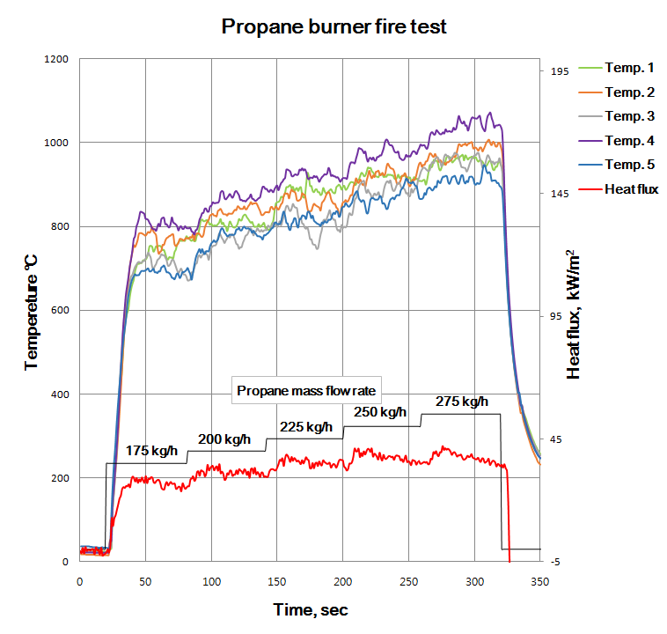

Figure X₂
Flame temperature and heat flux on gasoline pool fire
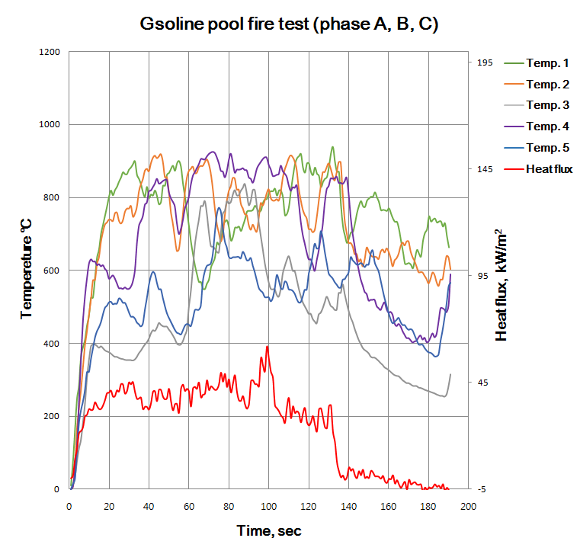
Table X shows integral heat flux at each test condition. In 6.2.6.3.2.2.1. Option 1, there are integral heat flux of propane burner fire during direct exposure to flame(800℃ reaching time and 2 minutes) at each mass flow rate of propane and in 6.2.6.3.2.2.2. Option 2, there are integral heat flux of gasoline pool fire during 130 seconds(phase B, C)
Table X
6.2.6.3.2.2.1. Option 1 |  | 6.2.6.3.2.2.2. Option 2
Fuel (Mass flow rate) | Integral Heat flux | Fuel | Integral Heat flux
Propane (175kg/h) | 4,181 | Gasoline | 4,460
Propane (200kg/h) | 4,450
Propane (225kg/h) | 4,945

II. TEXT OF REGULATION
6. Test procedures
6.2.6. Fire resistance test
6.2.6.1. Purpose
The purpose of this test is to verify the resistance of the REESS, against exposure to fire from outside of the vehicle due to e.g. a fuel spill from a vehicle (either the vehicle itself or a nearby vehicle). This situation should leave the driver and passengers with enough time to evacuate.
6.2.6.2. Installations
6.2.6.2.1 This test shall be conducted either with the complete REESS or with related REESS subsystem(s) including the cells and their electrical connections. If the manufacturer chooses to test with related subsystem(s), the manufacturer shall demonstrate that the test result can reasonably represent the performance of the complete REESS with respect to its safety performance under the same conditions. If the electronic management unit for the REESS is not integrated in the casing enclosing the cells, then the electronic management unit may be omitted from installation on the Tested-Device if so requested by the manufacturer. Where the relevant REESS subsystems are distributed throughout the vehicle, the test may be conducted on each relevant REESS subsystem.
6.2.6.3. Procedures
6.2.6.3.1. General test conditions
The following requirements and conditions shall apply to the test:
(a) the test shall be conducted at a temperature of at least 0°C.
(b) at the beginning of the test, the SOC shall be adjusted according to paragraph 6.2.1.2.
(c) at the beginning of the test, all protection devices which effect the function of the Tested-Device and are relevant for the outcome of the test shall be operational.
6.2.6.3.2. Test procedure
A vehicle based test or a component based test shall be performed at the discretion of the manufacturer.
In case of component based test, the manufacturer may choose either 6.2.6.3.2.2.1. Option 1 or 6.2.6.3.2.2.2. Option 2
6.2.6.3.2.1. Vehicle based test
The Tested-Device shall be mounted in a testing fixture simulating actual mounting conditions as far as possible; no combustible material should be used for this with the exception of material that is part of the REESS. The method whereby the Tested-Device is fixed in the fixture shall correspond to the relevant specifications for its installation in a vehicle. In the case of a REESS designed for a specific vehicle use, vehicle parts which affect the course of the fire in any way shall be taken into consideration.
6.2.6.3.2.2. Component based test
6.2.6.3.2.2.1. Option 1:
(a) The Tested-Device shall be placed on a test equipment, in the position that the manufacturer’s design intends.
(b) The temperature sensors shall be installed at 5 or more points which can represent the whole area of Tested-Device downward 25 mm ± 10 mm from the bottom of the Tested-Device's external surface. The flame temperature should be measured continuously at all temperature sensors during the whole fire exposure.
(c) The Tested-Device shall be exposed to the flame directly by fuel combustion.
(d) The Tested-Device shall be exposed to flame for 2 minutes after the temperature reach to 800°C within 30 seconds. The temperature shall not exceed 1,100°C. After direct exposure to flame the Tested-Device shall be observed until such time as the surface temperature of the Tested-Device has decreased to ambient temperature or has been decreasing for a minimum of 3 hours.
6.2.6.3.2.2.2. Option 2:
The Tested-Device shall be placed on a grating table positioned above the pan, in an orientation according to the manufacturer’s design intent.
The grating table shall be constructed by steel rods, diameter 6-10 mm, with 4-6 cm in between. If needed the steel rods could be supported by flat steel parts.
(a) The flame to which the Tested-Device is exposed shall be obtained by burning commercial fuel for positive-ignition engines (hereafter called "fuel") in a pan. The quantity of fuel shall be sufficient to permit the flame, under free-burning conditions, to burn for the whole test procedure.
The fire shall cover the whole area of the pan during whole fire exposure. The pan dimensions shall be chosen so as to ensure that the sides of the Tested-Device are exposed to the flame. The pan shall therefore exceed the horizontal projection of the Tested-Device by at least 20 cm, but not more than 50 cm. The sidewalls of the pan shall not project more than 8 cm above the level of the fuel at the start of the test.
(b) The pan filled with fuel shall be placed under the Tested-Device in such a way that the distance between the level of the fuel in the pan and the bottom of the Tested-Device corresponds to the design height of the Tested-Device above the road surface at the unladed mass if paragraph 6.2.6.3.2.1. is applied or approximately 50 cm if paragraph 6.2.6.3.2.2.2. is applied. Either the pan, or the testing fixture, or both, shall be freely movable.
(c) During phase C of the test, the pan shall be covered by a screen. The screen shall be placed 3 cm +/- 1 cm above the fuel level measured prior to the ignition of the fuel. The screen shall be made of a refractory material, as prescribed in Figure 12. There shall be no gap between the bricks and they shall be supported over the fuel pan in such a manner that the holes in the bricks are not obstructed. The length and width of the frame shall be 2 cm to 4 cm smaller than the interior dimensions of the pan so that a gap of 1 cm to 2 cm exists between the frame and the wall of the pan to allow ventilation. Before the test the screen shall be at least at the ambient temperature. The firebricks may be wetted in order to guarantee repeatable test conditions.
(d) If the tests are carried out in the open air, sufficient wind protection shall be provided and the wind velocity at pan level shall not exceed 2.5 km/h.
(e) The test shall comprise of three phases B-D, if the fuel is at temperature of at least 20 °C. Otherwise the test shall comprise four phases A-D.
Phase A: Pre-heating (Figure 11-A)
The fuel in the pan shall be ignited at a distance of at least 3 m from the Tested-Device. After 60 seconds pre-heating, the pan shall be placed under the Tested-Device. If the size of the pan is too large to be moved without risking liquid spills etc. then the Tested-Device and test rig can be moved over the pan instead. 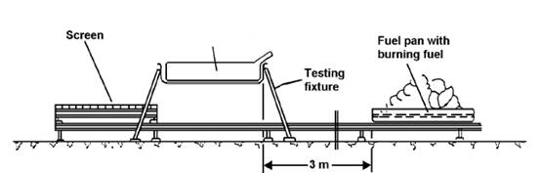
Figure 11-A Phase A: Pre-heating

Phase B: Direct exposure to flame (Figure 11-B)
The Tested-Device shall be exposed to the flame from the freely burning fuel for 70 seconds. 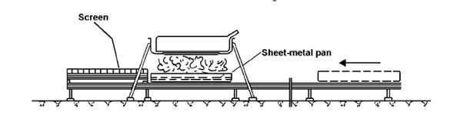
Figure 11-B Phase B: Direct exposure to flame

Phase C: Indirect exposure to flame (Figure 11-C)
As soon as phase B has been completed, the screen shall be placed between the burning pan and the Tested-Device. The Tested-Device shall be exposed to this reduced flame for a further 60 seconds.
As a compliance alternative to conducting Phase C of the test, Phase B may, at the choice of the manufacturer, be continued for an additional 60 seconds.
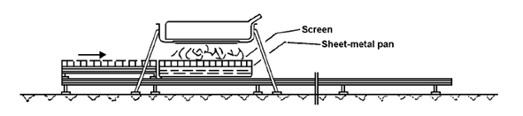Figure 11-C Phase C: Indirect exposure to flame

Phase D: End of test (Figure 11-D)
The burning pan covered with the screen shall be moved back to the position described in phase A. No extinguishing of the Tested-Device shall be done. After removal of the pan the Tested-Device shall be observed until such time as the surface temperature of the Tested-Device has decreased to ambient temperature or has been decreasing for a minimum of 3 hours.
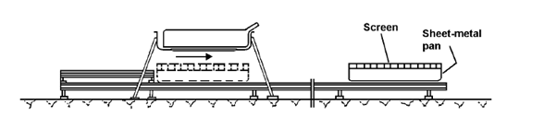
Figure 11-D Phase D: End of test

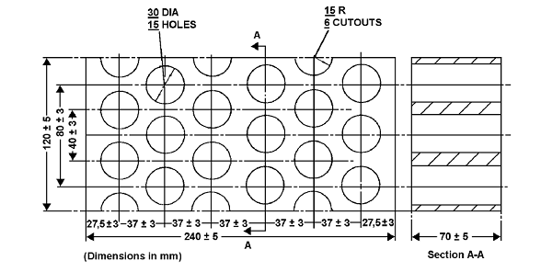
Figure 12 Dimension of Firebricks

Fire resistance (Seger-Kegel) SK 30
Al₂O₃ content 30 - 33 per cent
Open porosity (Po) 20 - 22 per cent vol.
Density 1,900 - 2,000 kg/m³
Effective holed area 44.18 per cent

