IWG PTI – Draft Action Plan
Reference document: ECE/TRANS/WP.29/2024/159
The aim of this document is to trigger the discussions within the group in order to define its next activities.

Whole-life compliance (Nov 2024 – Nov 2027)
The discussions will take into account the document ECE/TRANS/WP.29/2023/89 and, where appropriate, consider its evolution.

Measures to detect tampering: methods and supervision (June 2025 – Dec 2026)
General overview on tapering. Group members will be invited to submit their proposals, including a commitment to a time line.
Tampering on emissions systems: PN gasoline and NOx. In coordination with the Anti-tampering Task Force.
Odometer tampering: in coordination with the Task Force R39

Advanced Driver Assistance Systems (ADAS) and Automated Driving Systems (ADS) (April 2025 – April 2027)
Proposal from Japan, necessary provisions for each UNR related the application of ePTI.
Analysis of possible options. Group members will be invited to submit their proposals, including a commitment to a time line.

Consistency between the provisions of the 1968 Vienna Convention and the technical provisions for vehicles against the rules in the framework of the 1997 Vienna Agreement
Identification of subjects: Group members will be invited to submit their proposals, including a commitment to a time line.

Guidance for PTI (Sept 2025 – April 2026)
Ongoing activity. To take into account the update of the EU’s Roadworthiness Package.
Development of a proposal to check the software version and integrity information. Group members will be invited to submit their proposals, including a commitment to a time line.

Guidance for Roadside technical inspection and enforcement (Jan 2026 – Dec 2026)
To take into account the update of the EU’s Roadworthiness Package. Group members will be invited to submit their proposals, including a commitment to a time line.

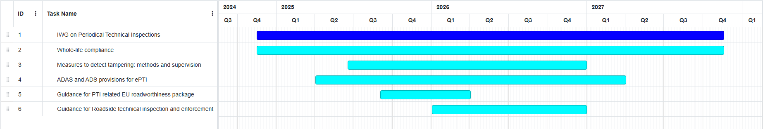
Gantt view:

Working items | Task Lead | 2025 |  | 2026 |  | 2027
Working items | Task Lead | 1H | 2H | 1H | 2H | 1H | 2H
Whole-life compliance | Russian Federation |  | Vision/Structure/Concept | UN Regulations draft amendments | Approval WP29/GRs | Approval WP29/GRs | AC.1
Provisions for testing ADAS/ADS at Periodic Technical Inspection | Russian Federation  +  FSD |  | Vision/Structure/Concept | Draft regulatory text | Approval WP29/GRs | Approval WP29/GRs
Specific information needed for testing electronic controlled safety and environmental relevant vehicle systems. | FSD |  |  | Vision/Structure/Concept | Draft regulatory text | Approval WP29/GRs
ePTI Provisions | JAPAN  +  FSD  +  KOTSA | Request to the WP.29 | Vision/Structure/Concept | UN Regulations draft amendments | Approval WP29/GRs | Approval WP29/GRs | AC.1
The strategic vision of Periodical Technical Inspections of driverless vehicles. | CITA  +  Russian Federation |  | Vision/Structure/Concept |  | Draft regulatory text | Approval WP29/GRs | Approval WP29/GRs
Measures to detect tampering - PN measurement for gasoline vehicles | UN Taskforce Anti-tampering |  |  | Draft regulatory text | Approval WP29/GRs | Approval WP29/GRs | AC.4
Draft amendment Rule 1 | CITA |  | Draft regulatory text | Approval WP29/GRs | Approval WP29/GRs |  | AC.4
Draft amendment Rule 4 | CITA |  |  | Draft regulatory text | Approval WP29/GRs | Approval WP29/GRs | AC.4
Draft amendment RE6 | CITA |  | Draft regulatory text | Approval WP29/GRs | Approval WP29/GRs

