Meeting Minutes
(12th June, 11:00 AM cet. ~ 12:20 PM cet.)

Agenda Item 1: Welcome and introduction
The leader started the A-LCA IWG SG3 members meeting at 11:00 (cet.) and welcomed the participants.

Agenda Item 2: Adoption of the agenda
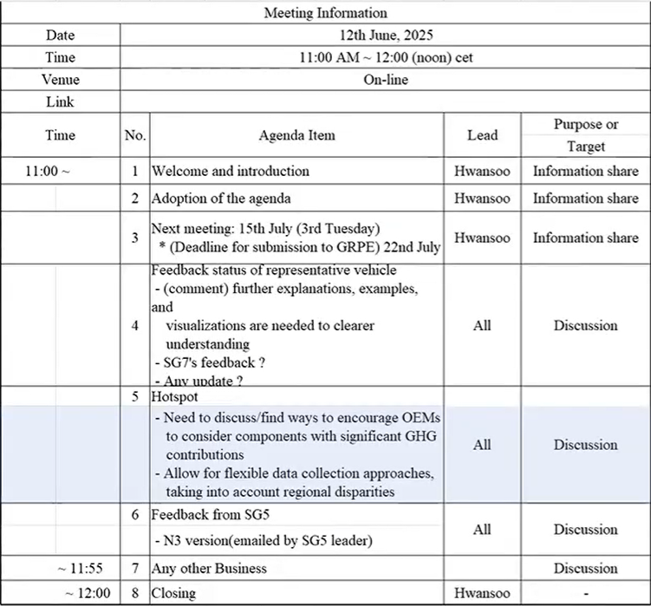

Agenda Item 3: Next July Meeting: 8th July 11:00cet.
- Reschedule the time of the next meeting
  - Next meeting will be fixed on 8th July, 11 AM Central European time.
  - The meeting date may be changed to 15th July following the Chicago meeting.
  - As the IWG activity period has been extended until the end of 2025, meetings have been scheduled for September, October, and November.

Agenda Item 4: Feedback Status of Representative Vehicle
- Status
- There are currently no comments or questions.
- Discussions are underway to address issues related to the definition of ‘powertrain family’ with the Japanese side.
- Suggestion
- It is suggested that the presentation explaining the representative vehicles be utilized as a guidance document.

Agenda Item 5: Hotspot
- Discussion on Comments from the Previous Meeting
- There is a need to explore ways to encourage OEMs to consider components with significant greenhouse gas contributions.
  - The core of LCA is to focus on parts with high GHG contributions or significant reduction potential. Therefore, it is believed that OEMs will collect primary data mainly for such components. Transparency can be ensured by clearly disclosing which parts were assessed with primary data.
- Level 3 should allow for flexible data collection approaches, taking into account regional disparities.
  - It is considered that the level 3 definition of N4 already sufficiently reflects regional disparities.
- Primary Data & PDS (Primary Data Share)
- The definition of primary data is inconsistent.
  - The definition of primary data is aligned with the ISO standard.
  - Previously, SG3 stated that government data is not regarded as primary data. Later, the U.S. proposed to treat government data as primary data (not acceptable).
- Discussion on whether to replace the term "default" with "prospective" in the definition of secondary data, or to use both terms together.
- Discussion on whether data should be regarded as primary data if either activity data or emission factor is primary.
  - Proposal: If both are primary data, it should be classified as 100% primary data; if only one is primary, it should be classified as 50% primary data.

Agenda Item 6: Feedback from SG5
- SG5 feedback has been incorporated into N4.

Agenda Item 7: Any other Business
- The document will be shared after reflecting OICA’s comments on N4.

Agenda Item 10: Closing
The meeting was closed at 12:20PM.

