Meeting Minutes
(8th July, 11:00 AM cet. ~ 12:00 PM cet.)

Meeting

Agenda Item 1: Welcome and introduction
The leader started the A-LCA IWG SG3 members meeting at 11:00 (cet.) and welcomed the participants.

Agenda Item 2: Adoption of the agenda
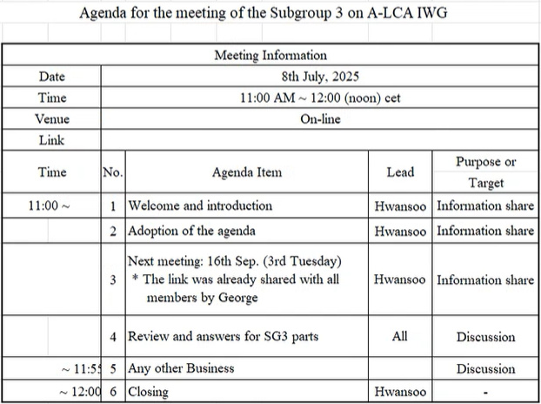

Agenda Item 3: Next meeting
The next meeting will be after summer break, on Tuesday, September 16th (the third Tuesday of the month).

Agenda Item 4: Review and answers for SG3 parts
- Discussion on the Definition and Representation of the ‘Representative Vehicle’
  - Comments from Japan
    - The comment or the idea from Japan is regarding the title of the representative vehicle and to make it different which is much more appropriate to the content itself.
      - [George] Proposal: Change the phrase to "comparison of LCA studies" to make it more neutral and comprehensive.
    - The Japanese side proposed deleting OEM-to-OEM comparison.
    - Japan’s proposal to change 'region of production' to 'energy mix at production location' is not agreed upon by OICA, as the representative vehicle section is intended only to describe how to build the LCA group and select representative vehicles, while detailed calculations and production data are defined in each subgroup’s dedicated sections, and noted that draft structure and section numbering should be adjusted by SG7 since environmental impact categories and indicators are separate topics.
  - Confirmed that the traction battery is currently excluded from calculations and will be added later after separate calculations.
i. It was proposed to include the definition of the traction battery in the definitions section and noted that SG7 needs to review it from the perspective of the entire draft.
  - Comments
    - Comment #6 is not related to the representative vehicle, and SG7 will verify the section numbering and any unresolved changes.
    - CLEPA suggested that carbon footprint reporting should include not only the final value but also specific contributions such as fossil, biogenic, and aircraft emissions, and recommended adding reporting guidance similar to ISO 14067.
    - The chapter title and numbering remain under review by SG7, and the inclusion of the illustrative graph is also to be discussed.
    - And, the data collection chapter was inconsistent and messy, prompting full revision, and it was agreed that the revised chapter, addressing all previous issues, should be shared with all SG3 members and reviewed in its clean version rather than through individual comments or original slides.

- Primary Data and Data Quality
  - Primary data are data specific to a company’s processes and may include measured data or data calculated from measurements.
  - Primary data should be used preferentially; however, secondary data may be used if primary data are not available.
  - Data quality criteria include temporal, geographical, and technological representativeness, completeness, consistency, and traceability.

- Primary Data Sharing (PDS)
  - When primary and secondary data are mixed, they are considered 50% primary data.
  - PDS is essential for detailed modeling within the supply chain, particularly in the material production stage.
  - Discussion on Level 3 and Level 4 studies: Level 4 requires PDS, whereas Level 3 is optional or limited to critical areas (hotspots).

- Data Cut-off Rules
  - A 3% cut-off threshold is discussed for each reporting level. Correct application of cut-off at each stage ensures that the total cut-off for the final product remains within 3%.

- Allocation Hierarchy
  - Physical allocation is prioritized, and economic allocation is used only as a last resort.
  - The distinction between co-products and by-products is determined based on product value ratio (currently set at 50%, with additional testing planned).
    - [Tina]: defines this as a practical matter of distinguishing between co-products and by-products. She agrees that the current method of considering something a by-product if there is a large value difference is acceptable.
    - [Ansgar]: mentions that this exception was also discussed when they adopted the definition from ISO 14067, and he proposes a threshold of a '5-times value ratio.' He admits there is no scientific basis for this number but says its appropriateness can be verified through testing.

- Chain of Custody
  - The discussion considers whether to maintain the chain of custody model in the main text (Chapter 3) rather than as an appendix.
  - The requirements for using the chain of custody model remain as previously described.

- Transport Emissions
  - Transport emissions must be aligned with the system boundary and infrastructure emissions.
  - Responsibility for ensuring consistency lies with SG1, while methodological inputs may be handled by SG3.

- Selection of Representative Vehicles
  - The LCA group defines representative vehicles based on vehicle structure, powertrain, and production region.
  - The representative vehicle selection is conducted in two steps:
    - Option A: Based on sales volume. The best-selling powertrain in a specific region is chosen.
    - Option B Based on average value. The powertrain closest to the average of all available powertrains is selected.
      - Preferences for Options A and B and Future Plans
        - OEMs: Prefer Option A. They believe it's more representative and realistic because it's based on sales volume.
        - [Tina]: From a scientific perspective, she supported Option A, stating it's closer to reality and reduces errors when extending the calculation to other vehicles within the same family.
        - [Hwansoo]: Agreed with George's methodology (selecting a powertrain, then applying the maximum weight) and stated that South Korea would share its preference for either Option A or B after internal discussions.
        - [George]: agreed to this approach, concluding that if there were no objections from SG3, Option A would be included in the text, and a report on the need for further discussion would be made at the next meeting.

Agenda Item 5: Any other Business
- The draft will be shared with SG7, and a comparison discussion of Options A and B is planned.
- Further adjustments will be made based on SG2 input and the results of the SG7 workshop.
- An optional meeting is scheduled for next week, and final inputs are to be submitted by July 16.
- SG3 has already reviewed and confirmed the glossary. Additional comments from other groups can be discussed via email if necessary.

Agenda Item 6: Closing
The meeting was closed at 12:00PM.

