- Proposal

Table of contents, amend to read:
"Contents
Page
I. Statement of technical rationale and justification....................
I-1. Phase 1
A. Introduction
B. Procedural background
C. Technical background
D. Principle for developing the global technical regulation.
E. Technical rationale and justification
F. Recommendations
G. Existing regulations, directives, and international voluntary standards
H. Benefits and costs
I-2. Phase 2 #
J. Background
K. Technical rationale and justification
L. Recommendations
M. Existing regulations, directives, and industry standards
II. Text of regulation
…
6.2.12. Thermal propagation test
…
8.2.11. Thermal propagation test
…
Annexes
1 Determination of hydrogen emissions during the charge procedures of the REESS
Appendix 1: Calibration of equipment for hydrogen emission testing
2 Verification method for testing authorities confirming document based isolation resistance
compliance of electrical design of the vehicle after water exposure
3 Thermal Propagation – Initiation methods
Appendix 1: Thermal Runaway Initiation Method with a Localized External Rapid Heater
Appendix 2: Thermal Runaway Initiation Method with an Internal Heater (Method 1)
Appendix 3: Thermal Runaway Initiation Method with an Internal Heater (Method 2)
Appendix 4: Thermal Runaway Initiation Method with Nail Penetration
Appendix 5: Thermal Runaway Initiation Method with Laser-Based Initiation "

Insert new title of sub-clause I-1., to read:
" I. Statement of technical rationale and justification
I-1. Phase 1
A. Introduction
…"
Insert new sub-clause I-2. At the end of existing Part I, to read:
" I-2. Phase 2
J. Background
249. In November 2017, the Executive Committee of the 1998 Agreement (AC.3) endorsed the Authorization to develop Phase 2 of the UN GTR (ECE/TRANS/WP.29/AC.3/50) submitted by the representatives of China, Japan, the United States of America and the European Union, in advance to the formal establishment of UN GTR No.20 (Phase 1). The mandate has been extended several times, namely in November 2021, November 2022, March 2024 and March 2025.
250. The following topics were listed as the scope of work in Phase 2:
(a) Water immersion test;
(b) Long-term fire resistance test;
(c) Rechargeable Electrical Energy Storage System (REESS) rotation test;
(d) REESS vibration profile;
(e) Flammability, toxicity and corrosiveness of vented gas (i.e. quantification of venting for tests addressing safety of REESS post-crash, potential risk of "toxic gases" from non-aqueous electrolyte);
(f) Thermal propagation and methods of initiation in the battery system;
(g) Post-crash REESS safety assessment and stabilization procedures;
(h) Light electric vehicles (e.g. categories L₆ and L₇, low speed vehicles);
(i) Protection during Alternating Current and Direct Current charging and feeding process;
(j) Overcurrent requirements plus tests (component based).
251. As a result of extensive discussion made on these topics, the informal working group agreed to maintain existing contents of the regulatory text of the UN GTR No.20, except for thermal propagation.
252. The following sections provide the conclusions made for each topic in phase 2 other than thermal propagation. Should conditions change, these conclusions may be reconsidered for future IWG activities
1. Water immersion test
253. In the GTR No.20 Phase 2 discussion, the informal working group discussed the necessity of REESS water immersion requirement. China, South Korea and Russia noted that there are frequent number of natural disasters causing water immersion of motor vehicles. China and South Korea provided the materials (EVS27-E4WI-0200) of REESS water immersion test and pointed out that severe phenomena such as fire or explosion may happen in such a test if appropriate design measures were not properly implemented. However, the United States, Canada, Japan and OICA noted that such extreme conditions due to catastrophic natural disasters should not be addressed in this GTR and the risk from water immersion would not be unique to electric vehicles. The United States also questioned whether the proposed test procedure would reasonably represent the realistic situation and contribute to the improvement of vehicle safety. Finally, the informal working group decided to suspend this topic until new field data indicating an actual need for such a test becomes available.
2. Long-term fire resistance test
254. In GTR No.20 Phase 1, it was concluded (EVS19-E7FR-0100) that additional discussions were required on some critical issues, where research and testing of methods were still in progress or needed to be verified by Contracting Parties. One of these topics was a potential long-term fire-resistance test.
255. However, no field evidence has come up that would justify such a test. The reported number of electric vehicle fires in the field remains rather scarce despite the strongly growing presence of vehicles with electric drivetrains in the different markets worldwide. But the reported accidents either in production or in transport or in normal vehicle use would not have been mitigated or prevented by a long-term fire resistance test. Moreover, a presentation shown by OICA in the GTR No.20 Phase 2 discussions has shown that a long-term fire-resistance test does not provide additional safety benefits. This position was supported by Canada (EVS20-A07[Approved]EVS19 Meeting minutes). Based on several sources referenced in the presentation, no added vehicle fire hazard caused by a burning battery has been shown. This is in line with several scientific studies in this subject. Thus, a mandatory long-term fire-resistance test would be a regulatory burden for electric vehicles without bringing any safety benefit for the customers.
3. Rechargeable Electrical Energy Storage System (REESS) rotation tests
256. In F(C)MVSS305, there is static rollover test of the vehicle after conducting crash test．When this standard was developed, open-type batteries (e.g. lead-acid batteries) were the most popular type of batteries and electrolyte spillage from such batteries are considered as potential risk for the vehicle occupants and surrounding people being exposed to the spilled electrolyte with strong acidity. This procedure is developed for post-crash vehicle assessment and not applied for component level tests.

257. Chinese national standard GB/T 31467.3-2015 on the safety of lithium-ion battery pack and systems includes a rotation test at a battery pack level. A survey presented by China in the GTR No.20 Phase 2 discussions has shown that all investigated batteries comply with the requirements of a test used by Chinese authorities. This can be explained by the fact that the cells of lithium-ion batteries are sealed-type and will not cause any electrolyte leakage unless the cells are seriously damaged. A mandatory REESS rotation test would be a regulatory burden for electric vehicles without bringing any safety benefit for the costumers. (Related information: EVS19-E8RT-0100)
4. REESS vibration profile
258. The vibration requirement in GTR No.20 is based on the test procedure described in the UN Regulation No. 100-02, which entered into force as of 15 July 2013. The test procedure for UN-R100-02 was developed by the group of interested experts on Rechargeable Energy Storage System (REESS IWG) led by Germany joined by the experts from Europe and Japan, from 2010 to 2012. Around that period, relatively limited experiences on the high energy traction batteries of EV were available within the automotive industry and the industry standards with respect to the safety of the automotive traction battery system were being developed at ISO or SAE in parallel. However, the safety regulation for REESS had to be prepared in order to wipe away the anxiety in the market and to support the growth of the electric vehicle market.
259. For the development of the vibration test procedure, the REESS IWG recognized the difficulty in determining a common vibration profile applicable to various types of vehicles and REESS. It was therefore decided to use the profile of “UN Manual of Tests and Criteria”, paragraph 38.3.4.3. (Test T3: Vibration) as the basis. This vibration profile is not intended to simulate and reproduce the vibration of an actual vehicle, but to apply reasonable levels of mechanical stress in order to eliminate the poorly designed batteries from the market. For GTR No. 20 Phase 1, it was agreed to maintain the test procedure of UN-R100-02 and to resume the discussion in Phase 2.
260. In the GTR No.20 Phase 2, China, with the aim to have a vibration profile closer to real-life conditions, provided the results of their research for the development of the vibration profile for Chinese national standard, GB38031-2020. In their research (EVS1419-401), numbers of vehicles in different sizes and categories were driven on a test track consisting of various road surfaces and the measured accelerations were normalized to determine the power spectral density (PSD) of the random vibration profile adopted in GB38031-2020. The vibration profile proposed by China was considered as significantly more severe than the test conditions specified in GTR No.20 Phase 1 (EVS18-E2VP-0300). On the other hand, there have been no notable field incidents due to vibration. Although China provided some examples of failures observed after vibration tests or field usage such as coolant leakage, seal damage, and mechanical connection damage (EVS22-E3VP-0100), none of these failures would result in immediate safety critical events. The IWG concluded that there is no evidence that would justify the need of enhancing the strength of the vibration test.
261. The US, Canada and OICA provided a report (EVS21-E3VP-0101) explaining that the maintenance of vibration requirements will not significantly increase the safety of production electric vehicles and thus should be removed from future versions of GTR No.20. That report contains an FMEA analysis for the potential failures caused by vibration on the traction batteries concluding that the potential safety implications from vibration induced failure modes are sufficiently mitigated by other safety system performance requirements already specified in the GTR. However, certain Contracting Parties who already implemented vibration requirements considered that the existing requirement has certain effect and there is a lack of confidence to remove current regulatory requirement.
262. Finally, because there is no agreement on removing nor modifying the requirements of vibration test, the IWG decided to retain current vibration test requirements in Phase 2 without any amendments. (Related information: EVS27-E3VP-0300)
5. Flammability, toxicity and corrosiveness of vented gas
263. At the 22nd meeting of the Informal Working Group in October 2021, the Task Force on toxic gases (TP-TG), chaired by the EC, was established aiming at revisiting the adequacy of the visual inspection as a verification method for the occurrence of electrolyte leakage and venting. Experts from Australia, Canada, China, EU, India, Japan, Korea, USA and OICA have contributed to the work of the Task Force. Also, external independent specialists were invited to the TF-TG meetings and shared their research findings with the Task Force members. Thorough consideration has been given to various topics, including vented gas composition, toxic gas exposure thresholds, methods and techniques to detect and quantify venting and electrolyte leakage. Periodic progress reports on the work of TF-TG have been provided to the Informal Working Group (Related information: EVS24-E2TG-0101, EVS25-E2TG-0100, EVS27-E2TG-0100).
264. Given the fact that no sufficiently specific, accurate and robust method could be identified for the detection of venting and electrolyte leakage, the IWG recognised that more research is necessary to be able to conclude this topic (reflected in the 27th IWG meeting minutes, EVS27-A07). Hence, the decision was to retain the visual inspection as a verification method for the occurrence of electrolyte leakage and venting also in Phase 2 and to revisit the topic when more research data becomes available.
265. The IWG recognised that more research is necessary to be able to conclude this topic (reflected in the meeting minutes, EVS27-A07). Hence, the IWG decision is to retain the toxic gas provisions from Phase 1 also in Phase 2 and to revisit the topic when more research data becomes available. ]
6. Post-crash REESS safety assessment and stabilization procedure
266. In GTR No.20 Phase 2, the Contracting Parties and the experts in this field provided information on the practises currently applied. However, it was apparent that no single specific procedure for safety assessment and stabilization can be identified. Different strategies are needed to cater to the large variety of system designs and battery chemistries used in the field. Further, there is still continuous technology development of electric vehicle batteries systems and system integration, and the methods of safety assessment and stabilization procedures must be continuously reviewed and updated in line with these developments. Hence, no concrete proposal was made for the technical requirements addressing this issue and no amendment to the regulatory text of UN GTR No.20 is proposed.
7. Light electric vehicles (e.g. categories L6 and L7, low speed vehicles)
267. It was recognized that different stakeholders should participate into the development of GTR for such categories of vehicles and therefore another informal working group should be established if any Contracting Party would sponsor that.
8. Protection during Alternating Current and Direct Current charging and feeding process
268. In principle, the AC and DC charging and feeding process requires the coordination and collaboration of different industries, e.g. automobile, electrical equipment, etc., through a wide range of different technical standards by international or national standardization organizations like ISO, SAE, IEC, SAC(China) etc. Accordingly, the compliance with the relevant technical standards in each region is essential to ensure safety as well as reliability, durability, inter-operability, co-existence and so on. These standards are under constant revisions to take account for the rapid development of technology and new challenges that might arise therefrom. Significant market penetration of electric vehicles has shown that these standardization activities are able to set an acceptable level of safety worldwide and there is no evidence that this is in danger since standardization activities typically are undertaken by a large consortium including vehicle manufacturers, battery manufacturers, charging equipment manufacturers, infrastructure providers and others.
269. Thus, a mandatory requirement only for vehicles for protection during AC and DC charging and feeding would be a regulatory burden for electric vehicles without bringing any safety benefit for the costumers. Furthermore, it could be detrimental for future technologies because it could freeze the protective measures to a certain state of the art. (Related information EVS19-E6AC-0100)
9. Overcurrent requirements plus tests (component based)
270. The overcurrent test developed for light-duty vehicles during GTR No.20 Phase 1 is a vehicle level test. OICA provided data showing that, for heavy-duty vehicles, a vehicle level test would not be practicable. First, the number of vehicle variants is significantly higher for heavy-duty vehicles, leading to an unreasonable test burden for the manufacturers. Second, the overall vehicle energy is typically 3-5 times higher compared to light-duty vehicles. This places severe constraints on the test set-up, where the power supply must be at least 750 kW/h or even higher (EVS21-E5OC-0100). There are currently no test lab facilities capable of performing vehicle level overcurrent tests on heavy-duty vehicles (EVS22-E5OC-0100).
271. REESS for heavy-duty vehicles will typically comprise of multiple battery packs, e.g. 3-8 packs. During charging, the charging current enters a control unit which distributes the current between the different battery packs, thus further reducing the likelihood of an overcurrent condition arising in any of the batteries in the REESS. OICA demonstrated that the hazard condition assessed by the overcurrent test overlaps with other tests in GTR No.20: namely the overtemperature test, overcharge test and external short circuit test, and questioned the effectiveness of this test, especially for heavy-duty vehicles (EVS21-E5OC-0100, EVS22-E5OC-0100).
272. As a compromise, OICA offered wording on a component level test (EVS23-E5OC-0100, EVS23-E5OC-0110). The participants were requested to review the proposal and provide comments to the next meeting (EVS24-A07). However, the topic was not addressed at the subsequent IWG meetings, and no decision to include the overcurrent test for heavy-duty vehicles in GTR No.20 was made by the IWG.
K. Technical rationale and justification
1. Thermal propagation
273. Phase 2 efforts and discussions focused on thermal propagation which is triggered by an internal short circuit leading to a single cell thermal runaway. Formation of internal short-circuits in a single cell may have different causes as described in ISO-6469-1 Amendment 1 (2022). For example, potential causes of internal short-circuits may include manufacturing defects involving foreign debris or misalignment of electrode active material and the separator, separator shrinkage, pinholes or creasing, etc.
274. Since 2018, the informal working group has continued discussions on thermal propagation-related topics. Canada, China, the European Union, Japan, Korea, the United States and OICA shared progress in thermal propagation research and field data. Updates on the progress of ISO/TC22/SC37/WG3 (Working Group on Rechargeable Energy Storage Systems) were also presented. In October 2021, the informal working group established the thermal propagation task force (TP-TF), led by China, Japan, and Canada) and a thermal propagation documentation sub-group (led by the US). The TP-TF reached consensus on some aspects such as target cell selection and thermal runaway detection criteria. Between 2023 and 2024, the work of the Ad-hoc Special Interest Group on model regulation regarding the safety of electric vehicles with a focus on a thermal propagation test method, also laid an important foundation for the development of Phase 2 of the regulation.
275. Two compliance paths were further developed by the IWG over the course of Phase 2. The first safety path was a physical test of vehicles or REESS and the second safety path was the risk management approach. After much discussion and consideration, Contracting Parties agreed that any Contracting Party may select one or both of those safety paths in their domestic jurisdictions.
276. For the Contracting Parties electing to incorporate the test approach in their respective jurisdictions, there are 5 initiation methods (see Annex 3). A Contracting Party may adopt one or more of the available initiation methods in Annex 3 in their national/regional regulation. It should be noted that these initiation methods have been widely applied to lithium-ion batteries containing flammable electrolyte. The GTR does not prescribe which or how many of the initiation methods in Annex 3 are to be used. The final determination of the initiation method(s) to be used resides with the Contracting Party. For the implementation of the approach, a manufacturer may be consulted regarding recommendations specific to their design and be invited for information exchanges. A Contracting Party may allow additional methods as proposed by the manufacturer and approved by the Contracting Party.
277. For the Contracting Parties electing to pursue a risk management approach (RMA), the intent is to (1) document the known risk to vehicle occupants caused by thermal propagation which is triggered by an internal short-circuit leading to single cell thermal runaway, and (2) document the reduction of risk resulting from implementation of the identified risk mitigation functions or characteristics at the cell, REESS, or vehicle level. Through the RMA, known risks are systematically identified, evaluated, mitigated, managed, and/or prevented in all normal vehicle operation modes (i.e., parking, external charging, and active driving modes). The documentation provided by the manufacturer shall align with the structure developed by the IWG during Phase 2, inspired by ISO26262 and ISO6469-1 Amendment 1. For implementation of the RMA requirement, the following regulation or standard may provide practical guidance, (a) The United States of America – 49 CFR Part 561 – Documentation for Electric Powered Vehicles, (b) The 05 series of amendments to UN Regulation No. 100 – Uniform provisions concerning the approval of vehicles with regard to specific requirements for the electric power train, or (c) ISO 6469-1:2019/Amd 1: 2022 Electrically propelled road vehicles - Safety specifications - Part 1: Rechargeable energy storage system (RESS)/ Amendment 1: Safety management of thermal propagation.
278. At the time this amendment was developed, the following regulations were published: FMVSS No. 305a and Part 561, the 05 series of amendments to UN R100, and GB38031-2025. As the Amendment 1 to GTR No. 20 was prepared after Contracting Party-specific regulatory updates had been published or concluded, the IWG agreed to capture the minimum common safety elements in the various international standards to ensure the Phase 2 regulatory text was aligned with the recently published Contracting Party-specific standards. Thus, the IWG agreed to formulate Phase 2 regulatory text at a high-level, to capture the minimum common elements between Contracting Party positions and approaches, and in a manner that did not require any changes to the recently published regulatory documents.
L. Recommendations
279. With the adoption of the proposed amendments to GTR No.20, a comprehensive framework for electric vehicle safety has been created. Multiple Contracting Parties have already adopted national regulations consistent with the content of the amended GTR No.20 but the full implementation for many of these regulations will still be in the future. Therefore, it is not yet possible to know the effectiveness of the amended GTR No.20 contents in addressing actual field safety incidents.
280. Further, the electric vehicle technologies continue to evolve including new lithium-ion chemistries, new chemistry families, new or enhanced battery diagnostic capabilities, higher power, energy and/or voltage system designs and so on. These technology advancements may impact what is an effective and appropriate safety regulation while it is not foreseeable as to which technologies will be adopted for commercial products. The IWG efforts toward additional regulatory requirements would be severely hindered and likely result in premature and inappropriate regulation.
281. Therefore, it is recommended that the IWG work on GTR No.20 be suspended, pending subsequent identification of emerging field safety needs. All Contracting Parties should monitor technology developments and the field safety of electric vehicles within their jurisdictions and report any emerging or potential issues to WP.29 or GRSP for consideration of re-initiating the IWG. Clear and specific terms of reference to define the scope and duration of the IWG work should be determined based on the actual field data and the assessment of the effectiveness of existing requirements in GTR No.20.
M. Existing regulations, directives, and industry standards
282. International, national regulations, recommendation and directives:
• The United States of America -- FMVSS 305 – Electric-Powered Vehicles: Electrolyte Spillage and Electrical Shock Protection
• The United States of America -- FMVSS 305a – Electric-Powered Vehicles: Electric Powertrain Integrity
• The United States of America – 49 CFR Part 561 – Documentation for Electric Powered Vehicles
• UN Regulation No. 12 – Uniform provisions concerning the approval of vehicles with regard to the protection of the driver against the steering mechanism in the event of impact
• UN Regulation No. 94 – Uniform provisions concerning the approval of vehicles with regard to the protection of the occupants in the event of a frontal collision
• UN Regulation No. 95 – Uniform provisions concerning the approval of vehicles with regard to the protection of the occupants in the event of a lateral collision
• UN Regulation No. 100 – Uniform provisions concerning the approval of vehicles with regard to specific requirements for the electric power train
• UN Regulation No. 135 – Uniform provisions concerning the approval of vehicles with regard to their Pole Side Impact performance (PSI)
• UN Regulation No. 137 – Uniform provisions concerning the approval of passenger cars in the event of a frontal collision with focus on the restraint system
• UN Regulation No. 153 – Uniform provisions concerning the approval of vehicles with regard to fuel system integrity and safety of electric power train in the event of a rear-end collision
• Japan – Attachment 111 – Technical Standard for Protection of Occupants against High Voltage after Collision in Electric Vehicles and Hybrid Electric Vehicles
China – GB 18384-2020 - Electric vehicles safety requirements
• China – GB 38031-2025 - Electric vehicles traction battery safety requirements
• China – GB 38032-2020 - Electric buses safety requirements
• China – GB/T 31498-2021 – Post crash safety requirement for electric vehicle
• Canada – CMVSS 305 – Electric Powered Vehicles: Electrolyte Spillage And Electrical Shock Protection
• Republic of Korea – Motor Vehicle Safety Standard, Article 18-2 – High Voltage System, Test Procedure Table 1 – Part 47. Safety Test for High Voltage System
• Republic of Korea – Motor Vehicle Safety Standard, Article 18-3 – Rechargeable Energy Storage System (REESS), Test Procedure Table 1 – Part 48. Safety Test for REESS
• Republic of Korea – Motor Vehicle Safety Standard, Article 91-4 – High Voltage System in Crash test, Test Procedure Table 1 – Part 47. Safety Test for High Voltage System
• India – AIS 038 (Rev.2) – Amendment 4 – Specific Requirements for Electric Power Train of Vehicles
• Recommendations on the Transport of Dangerous Goods, Manual of Tests and Criteria, paragraph 38.3 (LITHIUM METAL AND LITHIUM ION BATTERIES)
283. List of relevant standards for electric vehicle safety:
• ISO 6469-1:2019/Amd 1: 2022 Electrically propelled road vehicles - Safety specifications - Part 1: Rechargeable energy storage system (RESS)/ Amendment 1: Safety management of thermal propagation
• ISO 6469-2:2022 Electrically propelled road vehicles - Safety specifications - Part 2: Vehicle operational safety
• ISO 6469-3:2021 Electrically propelled road vehicles - Safety specifications - Part 3: Electrical safety
• ISO 6469-4:2015 Electrically propelled road vehicles - Safety specifications - Part 4: Post crash electrical safety
• ISO 5474-1:2024 Electrically propelled road vehicles - Functional and safety requirements for power transfer between vehicle and external electric circuit - Part 1: General requirements for conductive power transfer
• ISO 5474-2:2024 Electrically propelled road vehicles - Functional and safety requirements for power transfer between vehicle and external electric circuit - Part 2: AC power transfer
• ISO 5474-3:2024 Electrically propelled road vehicles - Functional and safety requirements for power transfer between vehicle and external electric circuit - Part 3: DC power transfer
• ISO 5474-4:2025 Electrically propelled road vehicles - Functional and safety requirements for power transfer between vehicle and external electric circuit - Part 4: Magnetic field wireless power transfer
• ISO 26262-2:2018 Road vehicles - Functional safety - Part 2: Management of functional safety• ISO26262-3:2018 Road vehicles - Functional safety - Part 3: Concept phase
• ISO26262-4:2018 Road vehicles - Functional safety - Part 4: Product development at the system level
• ISO26262-5:2018 Road vehicles - Functional safety - Part 5: Product development at the hardware level
• ISO26262-6:2018 Road vehicles - Functional safety - Part 6: Product development at the software level
• ISO26262-7:2018 Road vehicles - Functional safety - Part 7: Production, operation, service and decommissioning
• ISO26262-8:2018 Road vehicles - Functional safety - Part 8: Supporting processes
• ISO26262-9:2018 Road vehicles - Functional safety - Part 9: Automotive safety integrity level (ASIL)-oriented and safety-oriented analyses
• IEC 62196-1:2022 Plugs, socket-outlets, vehicle connectors and vehicle inlets - Conductive charging of electric vehicles - Part 1: General requirements
• IEC 62196-2:2022 Plugs, socket-outlets, vehicle connectors and vehicle inlets - Conductive charging of electric vehicles - Part 2: Dimensional compatibility requirements for AC pin and contact-tube accessories
• IEC 62196-3:2022 Plugs, socket-outlets, and vehicle couplers - conductive charging of electric vehicles - Part 3: Dimensional compatibility requirements for DC and AC/DC pin and contact-tube vehicle couplers
• IEC 62660-2:2018 Secondary lithium-ion cells for the propulsion of electric road vehicles – Part 2: Reliability and abuse testing
• IEC 62660-3:2022 Secondary lithium-ion cells for the propulsion of electric road vehicles – Part 3: Safety requirements
• SAE J1766_201401 Recommended Practice for Electric and Hybrid Electric Vehicle Battery Systems Crash Integrity Testing
• SAE J1772_202401 SAE Electric Vehicle and Plug in Hybrid Electric Vehicle Conductive Charge Coupler
• SAE J3400_202504 Connectors and Inlets for the North American Charging System (NACS) for Electric Vehicles
• SAE J2929_201302 Safety Standard for Electric and Hybrid Vehicle Propulsion Battery Systems Utilizing Lithium-based Rechargeable Cells
• SAE J2464_202108 Electric and Hybrid Electric Vehicle Rechargeable Energy Storage System (RESS) Safety and Abuse Testing
• SAE J2344_202010 Guidelines for Electric Vehicle Safety
• UL 2580:2022 Batteries for Use In Electric Vehicles"
Paragraph 3.42., amend to read:
"3.42. "Specific voltage condition" means the condition that the maximum voltage of a galvanically connected electrical circuit between a DC live part and any other live part (DC or AC) is ≤ 30 V AC (rms) and ≤ 60 V DC.
Note 1: When a DC live part of such an electrical circuit is connected to chassis and the specific voltage condition applies, the maximum voltage between any live part and the electrical chassis is ≤ 30 V AC (rms) and ≤ 60 V DC.
Note 2: For pulsating DC voltages (alternating voltages without change of polarity) the DC threshold shall be applied. "
Paragraphs 5.4.12. to 5.4.12.1., amend to read:
"5.4.12. Thermal propagation.
For the vehicles equipped with a REESS containing flammable electrolyte or alkali metal anode, the vehicle occupants shall not be exposed to any hazardous environment caused by thermal propagation which is triggered by an internal short circuit leading to a single cell thermal runaway. To ensure this, the requirements of paragraphs 5.4.12.1. and 5.4.12.2. shall be satisfied. Contracting Parties may select one or both of the approaches in paragraph 5.4.12.3 to demonstrate compliance with paragraphs 5.4.12.1 and 5.4.12.2 in their domestic jurisdictions.
5.4.12.1. The vehicle shall provide an advance warning indication 5 minutes prior to the presence of a hazardous situation inside the passenger compartment caused by thermal propagation which is triggered by an internal short circuit leading to a single cell thermal runaway such as fire, explosion or smoke. This warning shall have characteristics in accordance with paragraph 5.3.3.2.
Delete paragraphs 5.4.12.1.1. to 5.4.12.1.2.
Paragraph 5.4.12.2., amend to read:
"5.4.12.2. The vehicle shall have functions or characteristics in the cell, REESS or vehicle intended to protect vehicle occupants (as described in paragraph 5.4.12.) in conditions caused by thermal propagation which is triggered by an internal short circuit leading to a single cell thermal runaway. Vehicle manufacturers shall make available, at the request of the regulatory or testing entity as applicable with its necessity, the following documentation explaining safety performance of the system level or sub-system level of the vehicle (see also paragraph 196 in Part 1, section E): "
Delete paragraphs 5.4.12.2.1. to 5.4.12.2.4.3.
Insert new paragraphs 5.4.12.3. to 5.4.12.3.2.4., to read:
5.4.12.3. Thermal propagation compliance options
5.4.12.3.1. Test approach in accordance with paragraph 6.2.12.
5.4.12.3.1.1. The manufacturer shall have available test setup documentation in accordance with paragraph 6.2.12.2.1.
5.4.12.3.1.2. The initiation method is to be one of those listed in Annex 3. The method or methods available for use are determined by the Contracting Party. A Contracting Party may allow additional methods as proposed by the manufacturer and approved by the Contracting Party.
5.4.12.3.1.3. Each Contracting Party shall select if the test shall be performed at either vehicle level, REESS level, or REESS sub-system level, subject to the provisions of paragraph 6.2.12.2.3.
5.4.12.3.1.4. The test results shall be evaluated in accordance with the acceptance criteria specified in paragraph 6.2.12.2.4.
5.4.12.3.2 Risk management approach – Each Contracting Party may apply this option to all vehicle modes (parking, external charging, and active driving possible modes) under normal operating conditions (as defined in paragraph 3.31.).
5.4.12.3.2.1. Part I – System analysis
(a) Identify all risks and conditions known to the manufacturer related to single-cell thermal runaway and propagation due to an internal short-circuit (e.g., functional analyses);
(b) System diagram and operational descriptions of relevant parts and systems;
(c) Description of the warning and operating logic.
5.4.12.3.2.2 Part II – Risk identification & mitigation
Discuss whether and how each identified risk is managed, mitigated, and/or prevented (e.g., Failure Modes and Effects Analysis);
5.4.12.3.2.3 Part III – Risk mitigation strategy – verification & validation
Description of how each risk mitigation strategy was verified and validated and what were the results.
Insert new paragraphs 6.2.12. to 6.2.12.6., to read:
"6.2.12. Thermal propagation test
6.2.12.1. Purpose
The purpose of the thermal propagation test is to ensure occupant safety in a vehicle when a forced thermal runaway of a cell in the REESS is initiated. The phenomenon of a forced thermal runaway simulates a severe thermal event caused by an internal short circuit.
6.2.12.2. Test approach – overview of steps
6.2.12.2.1. Step 1 – Initial documentation specific to the test approach.
The manufacturer shall have available the following technical documentation containing:
(a) A system diagram of all relevant physical systems and components;
(b) A diagram showing the function operation of the relevant systems and components, identifying all risk mitigation functions or characteristics;
(c) For each identified risk mitigation function of characteristic implemented, the physical system or component which implements the function shall be identified and the operating strategy described;
(d) The maximum operating temperature;
(e) If applicable, the recommendation on pre-instrumentation of the triggering and measuring devices including sufficient details of such pre-instrumentation;
(f) If applicable, the recommendations on a more suitable and feasible trigger method including appropriate parameters for the details of the trigger method, the preparation and instrumentation of the Tested-Device.
Relevant systems and components are those which contribute to protection of vehicle occupants from any hazardous situation caused by thermal propagation initiated by a single-cell thermal runaway.
6.2.12.2.2. Step 2 – Selection of initiation method according to paragraph 5.4.12.3.1.2.
6.2.12.2.3. Step 3 – Selection of the test level.
For a test using REESS or REESS subsystem, the parts of the vehicle relevant for the test shall be installed to the Tested-Device, in case phenomena rendering the test non-representative of REESS installed in a vehicle are expected. If the REESS casing lacks an intended venting system and smoke due to thermal propagation occurs during the test, or if this smoke is released from locations other than the intended venting system, the vehicle-based test shall be carried out.
In addition, it shall be demonstrated that the component-based test is representative of a vehicle-level behaviour. In case vehicle parts may affect the outcome of the test, e.g. due to phenomena like essential deformation etc., these shall be included in the test set-up. In case of doubt, the thermal propagation test shall be performed at the vehicle level or shall at least include the parts of the vehicle relevant for the test.
6.2.12.2.4. Step 4 –Acceptance criteria of the thermal propagation test results.
For 5 minutes following the signal to activate the warning indication, none of the following hazardous situations caused by thermal propagation shall occur:
(a) Fire;
(b) Explosion;
(c) Smoke release into the passenger compartment.
The warning indication may occur either when the initiated cell enters thermal runaway or when the REESS has reliably identified a thermal propagation event, provided that the safety objectives listed above are met.
For the vehicle based-test, evidence of a hazardous condition, i.e., fire, explosion, and smoke release into the passenger compartment, shall be verified by visual inspection without disassembling any part of the vehicle.
For the component-based test, evidence of a hazardous condition, i.e., fire, explosion and smoke from thermal propagation not escaping the REESS through the intended venting system, shall be verified by visual inspection without disassembling any part of the Tested-Device.
If no thermal propagation is observed during the 2 hours after the thermal runaway was triggered in the initiation cell, the requirements are deemed to be satisfied.
If thermal runaway is not triggered during the test with the chosen initiation method, and confirmed by repetition of the same test procedure (i.e., the same initiation method and the same test level) or by conducting a cell level test with the same initiation method, the requirements are deemed to be satisfied.
6.2.12.3. General test conditions
The following conditions shall apply to the test:
6.2.12.3.1. Environmental conditions
(a) The test shall be conducted either indoors or outdoors. In case of outdoor testing there shall be no direct exposure of the vehicle/Tested-Device to precipitation for the duration of the test.
(b) Immediately before the test, the wind speed shall be measured at a location which is no more than 5 m from the Tested-Device and the average wind speed over 10 min shall be less than 7.8 m/s. It shall be ensured that the results are not affected by gusts of wind. Gusts shall not exceed 10 m/s when measured over a period of 20 s. The test set-up shall consider the impact of features such as shielding screens or walls which may create excessive funnelling effects during the test.
6.2.12.3.2. Tested-Device
(a) Required modifications shall be kept to a minimum compared to the original unmodified Tested-Device. Any modifications of REESS components, such as mechanical and thermal barriers, cooling plates/channels, electrical connections, and cell-to-cell spacing shall be documented and justification provided as to why such changes will not result in a significant change in performance. Confirm that the original sealing capability of the REESS is not compromised by instrumentation and that any venting shall be through pre-existing seals. All components and features that are required for the functioning of the Tested-Device and safety related features e.g. cell connecting busbars, tab welding, connection and functionality of the relevant management system, isolation resistance, etc., shall be maintained and not compromised;
(b) For the vehicle-level test, all windows, roof and doors are closed;
(c) At the beginning of the test, the State of Charge (SoC) shall be adjusted according to the procedure described in paragraph 6.2.1.2.;
(d) At the beginning of the test, and for as long as possible during the test, all necessary functions of the Tested-Device shall be operational. The Tested-Device shall be representative of the REESS when installed in a vehicle that is stationary and in active-driving possible mode. The defined thermal management/safety strategy and the battery management system used in the REESS shall be fully operational. The coolant flow may be zero or active depending on the management system of the Tested-Device. The native thermal management strategy (if installed), and other relevant management systems of the Tested-Device, which are necessary for the test, shall be operational for as long as possible during the test.
(e) Immediately before turning on the initiation device, the temperature of the cells in the Tested-Device, shall be maintained between 18 °C and maximum operating temperature defined by the manufacturer.
6.2.12.3.3. Initiation cell
In the field, a single cell thermal runaway may occur in any REESS cell location. For the test, the selection of the initiation cell shall consider the number of adjacent cells, cell packaging, and the distance between cells in proximity to the potential initiation cell, as well as the practicality of initiation.
The intent is to allow for the selection of any cell in the pack. However, it is understood that there are differing limitations in the ability to access certain cells in any given Tested-Device and that certain cells may pose a higher risk of propagation stemming from a single cell failure. The criteria below will ensure that Tested-Device functionality and safety systems are not compromised by installation of test equipment. It also provides the basis for selecting a cell that is potentially at a higher risk of causing propagation.
Paragraph 6.2.12.3.3.1. below is essential to ensure that the whole system is tested and any that safety systems installed in the Tested-Device are not compromised.
Paragraph 6.2.12.3.3.2. below is subjective to the specific product as well as to the test level and the initiation method selected in accordance with paragraph 6.2.12.2.
6.2.12.3.3.1. The installation of test equipment shall not compromise the functionality of the REESS relevant to the safety performance. The installation shall minimize modification to thermal insulators and structure and shall not:
(a) Disable or affect the functionality of the battery management systems;
(b) Change pack gas flow direction and permeability, both internal and exit paths.
6.2.12.3.3.2. The selected cell shall represent severe conditions for the generation of potentially hazardous conditions in the event of a thermal runaway, i.e.:
(a) A high level of heat transfer to at least one adjacent cell (e.g. thinnest spacers/gaps/barriers or vent direction towards an adjacent cell);
(b) Subject to heat sink(s) and non-productive thermal pathway(s) (e.g. edge cell with few adjacent cells and/or with large adjacent air space(s)); or
(c) Any other criteria of condition or location which could potentially to lead to a hazardous condition.
6.2.12.4. Recorded data and measurements
6.2.12.4.1. The following information shall be recorded during the test and during the observation period. All data measurement systems shall be referenced to the same starting time.
(a) Identification of the test method, including the initiation method, and a description of the test set-up;
(b) Test conditions (e.g. environmental conditions, SoC, and other pre-conditioning parameters);
(c) Temperature of the initiation cell, ensuring that the initiation device or test instrumentation does not influence the measurement;
(d) Voltage of the initiation cell during the thermal runaway initiation procedure;
(e) Temperature of one adjacent cell;
(f) Video and audio recording, including indication of a time stamp of observable events during the test (e.g. initiation cell thermal runaway and venting, thermal propagation to adjacent cell(s), smoke, fire or flame, explosion, etc.);
(g) Condition of the Tested-Device at the end of the test, supported by video or photographs (before and after test);
(h) If the test is performed on vehicle level, the time stamp of warning indications or alarms to occupants. If the test is performed on REESS or REESS subsystem, the time stamp of the signal to trigger the warning indications;
6.2.12.5. Detection criteria of thermal runaway
Thermal runaway can be detected by the following conditions:
(i) The measured voltage of the initiation cell drops, and the drop value exceeds 25 per cent of the initial voltage for at least 1 second;
(ii) The measured temperature of the initiation cell exceeds the maximum operating temperature defined by the manufacturer;
(iii) dT/dt ≥ 1 °C/s of the measured temperature of the initiation cell for at least 3 consecutive seconds.
(a) Both (i) and (iii) are detected; or
(b) Both (ii) and (iii) are detected.
6.2.12.6. Initiation methods to trigger thermal runaway
The initiation method shall not affect the adjacent cell(s), e.g. if localized rapid external heating, localized internal heating or laser-based initiation methods are used, the temperature of the adjacent cell(s) shall not exceed maximum operating temperature, defined by the manufacturer before the thermal runaway of the initiation cell is detected. Appropriate methods may be used to isolate the adjacent cell(s), provided that original functionality of REESS is not impeded. "
Paragraphs 7.3.12. to7.3.12.1., amend to read:
"7.3.12. Thermal propagation.
For the vehicles equipped with a REESS containing flammable electrolyte or alkali metal anode, the vehicle occupants shall not be exposed to any hazardous environment caused by thermal propagation which is triggered by an internal short circuit leading to a single cell thermal runaway. To ensure this, the requirements of paragraphs 7.3.12.1. and 7.3.12.2. shall be satisfied. Contracting Parties may select one or both of the approaches in paragraph 7.3.12.3 to demonstrate compliance with paragraphs 7.3.12.1 and 7.3.12.2 in their domestic jurisdictions.
7.3.12.1. The vehicle shall provide an advance warning indication 5 minutes prior to the presence of a hazardous situation inside the passenger compartment caused by thermal propagation which is triggered by an internal short circuit leading to a single cell thermal runaway such as fire, explosion or smoke. This warning shall have characteristics in accordance with paragraph 7.2.3.2.
Delete paragraphs 7.3.12.1.1. to 7.3.12.1.2.
Paragraph 7.3.12.2., amend to read:
"7.3.12.2. The vehicle shall have functions or characteristics in the cell, REESS or vehicle intended to protect vehicle occupants (as described in paragraph 7.3.12.) in conditions caused by thermal propagation which is triggered by an internal short circuit leading to a single cell thermal runaway. Vehicle manufacturers shall make available, at the request of the regulatory or testing entity as applicable with its necessity, the following documentation explaining safety performance of the system level or sub-system level of the vehicle (see also paragraph 196 in Part 1, section E):"
Delete paragraphs 7.3.12.2.1. to 7.3.12.2.4.3.
Insert new paragraphs 7.3.12.3. to 7.3.12.3.2.4., to read:
"7.3.12.3. Thermal propagation compliance options
7.3.12.3.1. Test approach in accordance with paragraph 8.2.11.
7.3.12.3.1.1. The manufacturer shall have available test setup documentation in accordance with paragraph 8.2.11.2.1.
7.3.12.3.1.2. The initiation method is to be one of those listed in Annex 3. The method or methods available for use are determined by the Contracting Party. A Contracting Party may allow additional methods as proposed by the manufacturer and approved by the Contracting Party.
7.3.12.3.1.3. Each Contracting Party shall select if the test shall be performed at either vehicle level, REESS level, or REESS sub-system level, subject to the provisions of paragraph 8.2.11.2.3.
7.3.12.3.1.4. The test results shall be evaluated in accordance with the acceptance criteria specified in paragraph 8.2.11.2.4.
7.3.12.3.2 Risk management approach – Each Contracting Party may apply this option to all vehicle modes (parking, external charging, and active driving possible modes) under normal operating conditions (as defined in paragraph 3.31.).
7.3.12.3.2.1. Part I – System analysis
(a) Identify all risks and conditions known to the manufacturer related to single-cell thermal runaway and propagation due to an internal short-circuit (e.g., functional analyses);
(b) System diagram and operational descriptions of relevant parts and systems;
(c) Description of the warning and operating logic.
7.3.12.3.2.2 Part II – Risk identification & mitigation
Discuss whether and how each identified risk is managed, mitigated, and/or prevented (e.g., Failure Modes and Effects Analysis);
7.3.12.3.2.3 Part III – Risk mitigation strategy – verification & validation
Description of how each risk mitigation strategy was verified and validated and what were the results.
Insert new paragraphs 8.2.11. to 8.2.11.6., to read:
"8.2.11. Thermal propagation test
8.2.11.1. Purpose
The purpose of the thermal propagation test is to ensure occupant safety in a vehicle when a forced thermal runaway of a cell in the REESS is initiated. The phenomenon of a forced thermal runaway simulates a severe thermal event caused by an internal short circuit.
8.2.11.2. Test approach – overview of steps
8.2.11.2.1. Step 1 – Initial documentation specific to the test approach.
The manufacturer shall have available the following technical documentation containing:
(a) A system diagram of all relevant physical systems and components;
(b) A diagram showing the function operation of the relevant systems and components, identifying all risk mitigation functions or characteristics;
(c) For each identified risk mitigation function of characteristic implemented, the physical system or component which implements the function shall be identified and the operating strategy described;
(d) The maximum operating temperature;
(e) If applicable, the recommendation on pre-instrumentation of the triggering and measuring devices including sufficient details of such pre-instrumentation;
(f) If applicable, the recommendations on a more suitable and feasible trigger method including appropriate parameters for the details of the trigger method, the preparation and instrumentation of the Tested-Device.
Relevant systems and components are those which contribute to protection of vehicle occupants from any hazardous situation caused by thermal propagation initiated by a single-cell thermal runaway.
8.2.11.2. Step 2 – Selection of initiation method according to paragraph 7.3.12.3.1.2.
8.2.11.2.3. Step 3 – Selection of the test level.
For a test using REESS or REESS subsystem, the parts of the vehicle relevant for the test shall be installed to the Tested-Device, in case phenomena rendering the test non-representative of REESS installed in a vehicle are expected. If the REESS casing lacks an intended venting system and smoke due to thermal propagation occurs during the test, or if this smoke is released from locations other than the intended venting system, the vehicle-based test shall be carried out.
In addition, it shall be demonstrated that the component-based test is representative of a vehicle-level behaviour. In case vehicle parts may affect the outcome of the test, e.g. due to phenomena like essential deformation etc., these shall be included in the test set-up. In case of doubt, the thermal propagation test shall be performed at the vehicle level or shall at least include the parts of the vehicle relevant for the test.
8.2.11.2.4. Step 4 –Acceptance criteria of the thermal propagation test results.
For 5 minutes following the signal to activate the warning indication, none of the following hazardous situations caused by thermal propagation shall occur:
(a) Fire;
(b) Explosion;
(c) Smoke release into the passenger compartment.
The warning indication may occur either when the initiated cell enters thermal runaway or when the REESS has reliably identified a thermal propagation event, provided that the safety objectives listed above are met.
For the vehicle based-test, evidence of a hazardous condition, i.e., fire, explosion, and smoke release into the passenger compartment, shall be verified by visual inspection without disassembling any part of the vehicle.
For the component-based test, evidence of a hazardous condition, i.e., fire, explosion and smoke from thermal propagation not escaping the REESS through the intended venting system, shall be verified by visual inspection without disassembling any part of the Tested-Device.
If no thermal propagation is observed during the 2 hours after the thermal runaway was triggered in the initiation cell, the requirements are deemed to be satisfied.
If thermal runaway is not triggered during the test with the chosen initiation method, and confirmed by repetition of the same test procedure (i.e., the same initiation method and the same test level) or by conducting a cell level test with the same initiation method, the requirements are deemed to be satisfied.
8.2.11.3. General test conditions
The following conditions shall apply to the test:
8.2.11.3.1. Environmental conditions
(a) The test shall be conducted either indoors or outdoors. In case of outdoor testing there shall be no direct exposure of the vehicle/Tested-Device to precipitation for the duration of the test.
(b) Immediately before the test, the wind speed shall be measured at a location which is no more than 5 m from the Tested-Device and the average wind speed over 10 min shall be less than 7.8 m/s. It shall be ensured that the results are not affected by gusts of wind. Gusts shall not exceed 10 m/s when measured over a period of 20 s. The test set-up shall consider the impact of features such as shielding screens or walls which may create excessive funnelling effects during the test.
8.2.11.3.2. Tested-Device
(a) Required modifications shall be kept to a minimum compared to the original unmodified Tested-Device. Any modifications of REESS components, such as mechanical and thermal barriers, cooling plates/channels, electrical connections, and cell-to-cell spacing shall be documented and justification provided as to why such changes will not result in a significant change in performance. Confirm that the original sealing capability of the REESS is not compromised by instrumentation and that any venting shall be through pre-existing seals. All components and features that are required for the functioning of the Tested-Device and safety related features e.g. cell connecting busbars, tab welding, connection and functionality of the relevant management system, isolation resistance, etc., shall be maintained and not compromised;
(b) For the vehicle-level test, all windows, roof and doors are closed;
(c) At the beginning of the test, the State of Charge (SoC) shall be adjusted according to the procedure described in paragraph 8.2.1.2.;
(d) At the beginning of the test, and for as long as possible during the test, all necessary functions of the Tested-Device shall be operational. The Tested-Device shall be representative of the REESS when installed in a vehicle that is stationary and in active-driving possible mode. The defined thermal management/safety strategy and the battery management system used in the REESS shall be fully operational. The coolant flow may be zero or active depending on the management system of the Tested-Device. The native thermal management strategy (if installed), and other relevant management systems of the Tested-Device, which are necessary for the test, shall be operational for as long as possible during the test.
(e) Immediately before turning on the initiation device, the temperature of the cells in the Tested-Device, shall be maintained between 18 °C and maximum operating temperature defined by the manufacturer.
8.2.11.3.3. Initiation cell
In the field, a single cell thermal runaway may occur in any REESS cell location. For the test, the selection of the initiation cell shall consider the number of adjacent cells, cell packaging, and the distance between cells in proximity to the potential initiation cell, as well as the practicality of initiation.
The intent is to allow for the selection of any cell in the pack. However, it is understood that there are differing limitations in the ability to access certain cells in any given Tested-Device and that certain cells may pose a higher risk of propagation stemming from a single cell failure. The criteria below will ensure that Tested-Device functionality and safety systems are not compromised by installation of test equipment. It also provides the basis for selecting a cell that is potentially at a higher risk of causing propagation.
Paragraph 8.2.11.3.3.1. below is essential to ensure that the whole system is tested and any that safety systems installed in the Tested-Device are not compromised.
Paragraph 8.2.11.3.3.2. below is subjective to the specific product as well as to the test level and the initiation method selected in accordance with paragraph 8.2.11.2.
8.2.11.3.3.1. The installation of test equipment shall not compromise the functionality of the REESS relevant to the safety performance. The installation shall minimize modification to thermal insulators and structure and shall not:
(a) Disable or affect the functionality of the battery management systems;
(b) Change pack gas flow direction and permeability, both internal and exit paths.
8.2.11.3.3.2. The selected cell shall represent severe conditions for the generation of potentially hazardous conditions in the event of a thermal runaway, i.e.:
(a) A high level of heat transfer to at least one adjacent cell (e.g. thinnest spacers/gaps/barriers or vent direction towards an adjacent cell);
(b) Subject to heat sink(s) and non-productive thermal pathway(s) (e.g. edge cell with few adjacent cells and/or with large adjacent air space(s)); or
(c) Any other criteria of condition or location which could potentially to lead to a hazardous condition.
8.2.11.4. Recorded data and measurements
8.2.11.4.1. The following information shall be recorded during the test and during the observation period. All data measurement systems shall be referenced to the same starting time.
(a) Identification of the test method, including the initiation method, and a description of the test set-up;
(b) Test conditions (e.g. environmental conditions, SoC, and other pre-conditioning parameters);
(c) Temperature of the initiation cell, ensuring that the initiation device or test instrumentation does not influence the measurement;
(d) Voltage of the initiation cell during the thermal runaway initiation procedure;
(e) Temperature of one adjacent cell;
(f) Video and audio recording, including indication of a time stamp of observable events during the test (e.g. initiation cell thermal runaway and venting, thermal propagation to adjacent cell(s), smoke, fire or flame, explosion, etc.);
(g) Condition of the Tested-Device at the end of the test, supported by video or photographs (before and after test);
(h) If the test is performed on vehicle level, the time stamp of warning indications or alarms to occupants. If the test is performed on REESS or REESS subsystem, the time stamp of the signal to trigger the warning indications;
8.2.11.5. Detection criteria of thermal runaway
Thermal runaway can be detected by the following conditions:
(i) The measured voltage of the initiation cell drops, and the drop value exceeds 25 per cent of the initial voltage for at least 1 second;
(ii) The measured temperature of the initiation cell exceeds the maximum operating temperature defined by the manufacturer;
(iii) dT/dt ≥ 1 °C/s of the measured temperature of the initiation cell for at least 3 consecutive seconds.
(a) Both (i) and (iii) are detected; or
(b) Both (ii) and (iii) are detected.
8.2.11.6. Initiation methods to trigger thermal runaway
The initiation method shall not affect the adjacent cell(s), e.g. if localized rapid external heating, localized internal heating or laser-based initiation methods are used, the temperature of the adjacent cell(s) shall not exceed maximum operating temperature, defined by the manufacturer before the thermal runaway of the initiation cell is detected. Appropriate methods may be used to isolate the adjacent cell(s), provided that original functionality of REESS is not impeded."
Insert new Annex 3 and its Appendices 1 to 5, to read:

"Annex 3
Thermal propagation– Initiation methods
The details of the initiation methods are specified in Appendices 1 to 5.

Annex 3 – Appendix 1
Thermal runaway initiation method with a localized external rapid heater
This test is performed by applying heat to the external surface of one target lithium-ion battery cell within the REESS via an external heater until thermal runaway is achieved with minimal increase in temperature of the adjacent lithium-ion battery cell(s) prior to thermal runaway within the target cell.
1. Preparation of the Tested-Device
1.1. The feed-through installation of the selected heating element and measuring sensors should only modify the REESS by allowing the necessary electrical and thermocouple connections. These connections must provide greater sealing integrity than the other REESS connectors.
1.2. The selected heating element shall not be in direct contact with any surface of the components in the Tested-Device other than the initiation cell. Close thermal contact between the heating element and the surface of the initiation cell is important for the success of this method. Thermal contact between the heating element and initiation cell may be improved through various methods (e.g. avoid air gaps, add a heat transfer paste and apply pressure, which should be maintained throughout the test).
1.3. Examples of potential heater application methods are shown in Figure 1: the method used depends on the design of the REESS or REESS subsystem. Maintain a contact pressure for the heating element on the initiation cell during the test to ensure contact and optimal heat transfer, see Figure 1.
Figure 1
Methods of applying pressure on the eating element to maintain heating element contact with the initiation cell throughout the test for different cell types
(a) REESS with large spaces between the cells
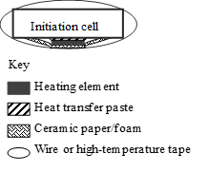
(b) Centre cell fixed spacing (e.g. prismatic cells)
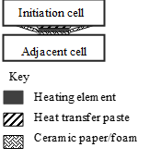
(c) Centre cell compressed modules (e.g. pouch cells)
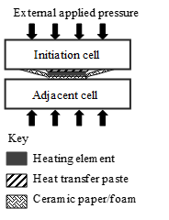
1.5. For vehicle-based tests, the vehicle response shall not be influenced by this initiation method in the REESS.
1.6. A temperature sensor shall be placed on the surface of the heating element and affixed with high-temperature resistant and electrically insulating tape for power regulation of the heater.
Figure 2
Example of placement of the temperature sensor on the heater element

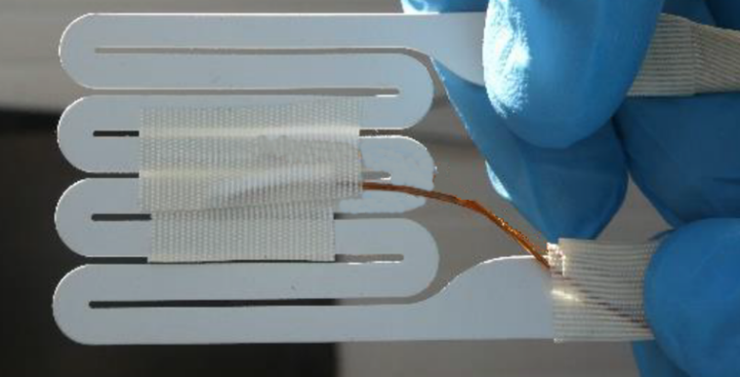
2. Selection guide for the heater element
2.1. The initiation method applies a high-powered heat pulse, locally, to the external surface of the initiation cell. The successful implementation of the method requires the application of sufficient power to the chosen heating element but it shall also not apply so much power that there is a premature heating element failure nor a side wall failure of the initiation cell prior to thermal runaway.
2.2. The heating device shall be a resistive heating element, or other suitable heating device/technology capable of delivering the target parameters. See Table 1 for the target parameters for the heating element.

Table 1
Heater device selection guide: Target parameters
Parameter | Value | Rationale
Heater device material | A suitable resistive heating material, e.g. nickel-chrome, with an isolating barrier | Achieve high temperatures and prevent element failures.  Isolating materials may include alumina, ceramic, or fibreglass.
Thickness | < 5 mm | Minimize effect of heater on REESS. Some REESS designs may require a thinner heating element.
Area | As small as possible, but no larger than 20 per cent of the surface area of the targeted face of the initiation cell | Concentrate heat on the smallest feasible area of the cell surface.  Largest cell surface should be used, if possible
Heating rate | ≥ 15 °C/s | Similar to heating rates observed within thermal runaway conditions.ª
Maximum temperature | At least 100 °C larger than the maximum operating temperature | Heater shall maintain integrity and take into account temperature deviations from heater element to thermocouple.^{b}
Control method | Thermostatic closed loop | Avoids undesirable test results, such as heating element burnout, elevated heating element temperature, battery cell sidewall ruptures due to high element temperatures.^{c}
ª The heating rate is measured directly by an external thermocouple placed on top of the heating element installed in the pack (Figure 2).
^{b} This temperature may be adjusted for other chemistries and potentially other cell types to avoid cell sidewall ruptures.
^{c} Use of a low voltage power source for the heating element will require higher currents (thicker wires), while a higher voltage source will require more resistant isolating material and higher levels of user safety during the test.

3. Test procedure for vehicle-based test
The general conditions in paragraphs 6.2.12.3. and 8.2.11.3. shall be satisfied when the method is implemented with the vehicle.
(a) Instrument the REESS and the vehicle as outlined above and place the vehicle in the active-driving possible mode. Make sure that the cooling and communication system operate as intended.
(b) Start recording the data that are needed to determine if thermal runaway and/or thermal propagation occur. Verify that fault codes or failures relevant for the outcome of the test are not in the system.
(c) Begin sending power to the heating element.
(d) Switch off the heater after a total energy input to the heater reaches 20 per cent of initiation cell energy.
(e) If (d) is satisfied, but thermal runaway has not occurred in the initiation cell during the observation period of 1 hour after the opening of the heater relay, the REESS type is considered to comply with this requirement.
(f) The test ends when one of the conditions specified below is met:
(i) The initiation is stopped in accordance with subparagraph (d) above followed by an observation period of 1 hour; or
(ii) At least 5 minutes elapse after the activation of the warning indication, if thermal propagation is observed; or
(iii) If thermal runaway has occurred in the initiation cell, but no thermal propagation ensued, the observation period of 2 hours after the confirmation of thermal runaway is applied to Tested-Device.
4. Test procedure for component-based test
The general conditions in paragraphs 6.2.12.3. and 8.2.11.3. shall be satisfied when the method is implemented on the REESS or REESS subsystem.
(a) Instrument the REESS or REESS subsystem as outlined above and prepare the REESS or REESS subsystem such that it represents the situation when it is installed in the vehicle, with the system in the active-driving possible mode. Make sure that the thermal management and communication system operate as intended.
(b) Start recording the necessary data to determine if thermal runaway and/or thermal propagation occur. Verify that fault codes or failures relevant for the outcome of the test are not in the system.
(c) Begin sending power to the heating element.
(d) Switch off the heater immediately when thermal runaway is confirmed or after total energy input to the heater reaches 20 per cent of initiation cell electric energy.
(e) If (d) is satisfied, but thermal runaway has not occurred in the initiation cell during the observation period of 1 hour after the opening of the heater relay, the REESS type is considered to comply with this requirement.
(f) The test ends when one of the conditions specified below is met:
(i) The initiation is stopped in accordance with the subparagraph (d) above followed by an observation period of 1 hour; or
(ii) at least 5 minutes elapse after the signal to activate the warning indication, if thermal propagation is observed; or
(iii) If thermal runaway has occurred in the initiation cell, but no thermal propagation ensued, the observation period of 2 hours after the confirmation of thermal runaway is applied to Tested-Device.

Annex 3 – Appendix 2
Thermal runaway initiation method with an internal heater (Method 1)
The concept of this trigger method is to create an internal short circuit by creating a hole in the separator of the initiation cell. The hole comes from the local melting of the separator induced by the local heater.
The initiation method applies a high-power heat pulse, locally, to the jellyroll surface of one initiation cell within the REESS via an internal heater with minimal increase in temperature of the adjacent battery cell(s) prior to thermal runaway in the initiation cell. The temperature of adjacent cell(s), prior to thermal runaway in the initiation cell, shall remain below the maximum operating temperature.
1. Description of the initiation method
The heating device shall be a resistive heating element, or other suitable heating device/technology capable of delivering the target parameters. Target parameters for the heating element are listed in Table 1.
The resistance, power and duration shall be adjusted according to the electrochemistry and the size of the cell.

Figure 1
Example of an internal heater flat spiral
(Dimensions in millimetres)
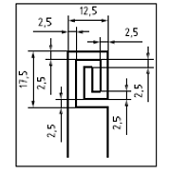

Table 1
Heating element selection guide: Target parameters
Parameter | Value | Reasoning
Heating element material | A suitable resistive heating material with an insulating barrier, e.g. copper or tungsten | Achieve high temperatures and prevent element failures. Isolating material may include polyimide or other heat-resisting material.
Thickness (mm) | ≤ 0.5 | As the heater needs to be placed inside of a cell, thickness of heater should be minimized.
Area (mm²) | 225 - 500 | Concentrate heat to the smallest feasible area on the jellyroll surface.
Power of heater (W) | 150~700 | Provide enough heat to enable initiation of cell thermal runaway.

2. Initiation cell/cell block preparation
The heater shall be inserted in the connected electrode stack or jellyroll before cell sealing. The applied method is dependent on the REESS or REESS subsystem design and manufacturing process. Here is an example of the manufacturing process for this special cell.
2.1. Step 1:
One or two hole(s) are drilled into the cover to allow the electrical feedthrough of the heater from inside the cell to the outside (Figure 2).
Figure 2
Example of specific holes in cover for heater connection
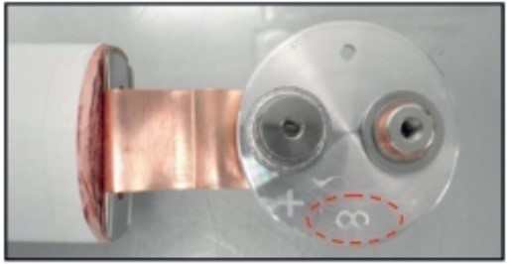
2.2. Step 2:
Unroll the separators and the electrodes to insert the heater.
2.3. Step 3:
Locate the heater on the last wrap of electrode. The heater is placed between the outermost negative and positive electrodes for the cell (see Figures 3a, 4a and 5).
Avoid unrolling a larger part of the jelly roll, since this can lead to damage of the jelly roll. Use an outer stack in case of stacked layers.

Figure 3
Example of heater location inside the cylindrical cell
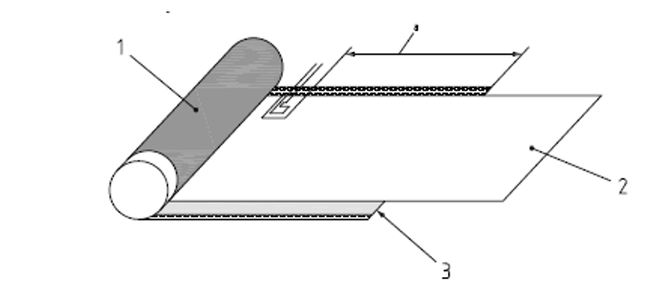
Key
1 positive electrode
2 separator
3 negative electrode
a 180 mm from end of positive electrode and 15 mm from end of negative electrode, tolerance ±5 mm

Figure 4
Example of heater location inside the prismatic cell
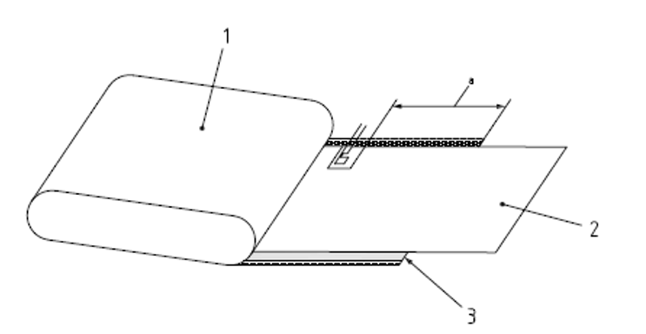 Key
1 positive electrode
2 separator
3 negative electrode
a 180 mm from end of positive electrode and 15 mm from end of negative electrode, tolerance ±5 mm

Figure 5
Example of located on the last lap of negative electrode
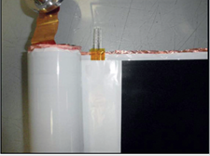
2.4. Step 4:
Wind the jelly roll with the heater (see Figure 6).
Figure 6
Example of jelly roll equipped with heater
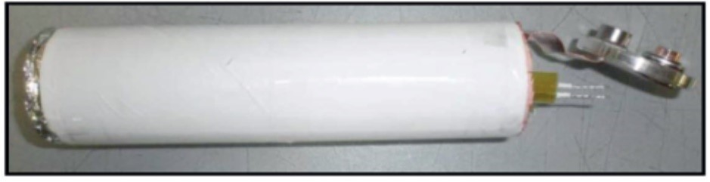
2.5. Step 5:
All wires used in the REESS or REESS subsystem shall be electrically isolated.
The cell shall be assembled according to standard manufacturing processes (e.g. electrolyte filling, cover welding), ensuring no electrolyte or gases can leak out through the space between the wire strand and the wire insulator.
Selection of resin is critical as the strength of seal shall be greater than any installed vent of the cell.
After the resin is completely dry, carry out a helium test to check the sealing before filling the cell with electrolyte.
Figure 7
Example of finished cell with heater
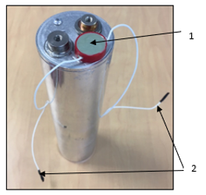
Key
1 resin for sealing the heater supply
2 supply wires of the heater

Figure 8
Example of cell before filling with electrolyte
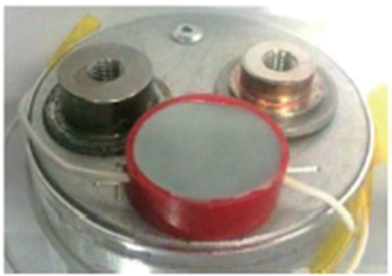

2.6. Step 6:
The initiation cell shall be assembled inside the REESS or REESS subsystem, which could be modified to make sure the electrical feedthrough of the heater can come out of cell block.
The feedthrough installation of the heating element and measuring sensors should only modify the REESS (or REESS subsystem) by permitting necessary electrical and thermocouple connections. These connections shall provide greater seal integrity than the other connectors in the REESS (or REESS subsystem).
For a vehicle level test, mount the REESS on the vehicle, according to manufacturer’s specifications.
3. Test procedure for the vehicle-based test
The general conditions in paragraphs 6.2.12.3. and 8.2.11.3. shall be satisfied when the method is implemented with the vehicle.
(a) Instrument the REESS and the vehicle as outlined above and place the vehicle in the active-driving possible mode. Make sure that the cooling and communication system operate as intended.
(b) Start recording the data that are needed to determine if thermal runaway and/or thermal propagation occur. Verify that fault codes or failures relevant for the outcome of the test are not in the system.
(c) Begin sending power to the heating element.
(d) Switch off the heater immediately when thermal runaway is confirmed or after a total energy input to the heater reaches 20 % of initiation cell electric energy.
(e) If (d) is satisfied, but no thermal runaway has occurred in the initiation cell during the observation period of 1 hour after the opening of the heater relay, the REESS type is considered to comply with this requirement.
(f) The test ends when one of the conditions specified below is met:
(i) The initiation is stopped in accordance with the subparagraph (d) above followed by an observation period of 1 hour; or
(ii) At least 5 minutes elapse after the activation of the warning indication, if thermal propagation is observed; or
(iii) If thermal runaway has occurred in the initiation cell, but no thermal propagation ensued, the observation period of 2 hours after the confirmation of thermal runaway is applied to Tested-Device.
4. Test procedure for the component-based test
The general conditions in paragraphs 6.2.12.3. and 8.2.11.3. shall be satisfied when the method is implemented on the REESS or REESS subsystem.
(a) Instrument the REESS or REESS subsystem as outlined above and prepare the REESS or REESS subsystem such that it represents the situation when it is installed in the vehicle, with the system in the active-driving possible mode. Make sure that the thermal management and communication system operate as intended.
(b) Start recording the data that are needed to determine if thermal runaway and/or thermal propagation occur. Verify that fault codes or failures relevant for the outcome of the test are not in the system.
(c) Begin sending power to the heating element.
(d) Switch off the heater immediately when thermal runaway is confirmed or after a total energy input to the heater reaches 20 % of initiation cell electric energy.
(e) If (d) is satisfied, but no thermal runaway has occurred in the initiation cell during the observation period of 1 hour after the opening of the heater relay, the REESS type is considered to comply with this requirement.
(f) The test ends when one of the conditions specified below is met:
(i) The initiation is stopped in accordance with the subparagraph (d) above followed by an observation period of 1 hour; or
(ii) At least 5 minutes elapse after the signal to activate the warning indication, if thermal propagation is observed; or
(iii) If thermal runaway has occurred in the initiation cell, but no thermal propagation ensued, the observation period of 2 hours after the confirmation of thermal runaway is applied to Tested-Device.

Annex 3 – Appendix 3
Thermal runaway initiation method with an internal heater (Method 2)
The test involves the application of heat to the electrodes inside a target cell within the REESS via an internal heater until thermal runaway. This test method relies on internal failure or thermal runaway caused by single cell failure created by a heater. This initiation method is performed by applying heat to the center of outer surface of the jelly roll or stacked layers of the initiated battery cells within the RESS, with minimal increase in temperature of the adjacent battery cell(s) prior to thermal runaway in the initiated cell.
1. Initiation method description
The heating unit shall be a resistive heating element or other suitable heating technology capable of delivering heat. A resistive heating element shall consist of a resistive heating section and an insulating material. Examples of the heater pattern are demonstrated in Figure 1.
Figure 1
Typical structure of a resistive heating element
Dimensions in millimetres
(a) Spiral wire coated in an insulating film | (b) S-curved wire coated in an insulating film
Key
L₁ | Length of the insulating material
L₂ | width of the insulating material
L₃ | Length of the resistive heating section
L₄ | width of the resistive heating section
NOTE 1 L3*L4 is defined as the effective heating area. The majority of heat is generated by the wires within this area, with minimal production of heat by the wire leads.
NOTE 2 It is vital that the distance of (L1-L3) and (L2-L4) is no less than 3 mm on each side, on account of the potential shrinkage of the isolating material when subjected to heat.
Table 1 lists the specification of an eligible resistive heater as well as the instruction on preparing and triggering of the battery that contains a built-in heater.
Table 1

Guidance for selection and use of a resistive heating element
Parameter |  | Input
Specification of the heater | Material | Resistive heating section: use copper or other metal wire with a high melting point.  Insulating section: use polyimide or another appropriate electric insulator.
Specification of the heater | Effective heating area  [mm²] | 15*15~60*60
Specification of the heater | Thickness  [mm] | ≤0.5
Specification of the heater | Power  [W] | Initiation cell with an energy of less than 500 Wh: 150 W~700 W  Initiation cell with an energy of no less than 500 Wh: 200 W~700 W
Instruction for operation | Placement of the heater | Exterior centre of the jelly roll or stacked layers
Instruction for operation | Seal of the lead wire | Resin (e.g. epoxy glue), or other appropriate sealing structure

2. Preparation
Preparation of the initiation cell with a built-in heater
Flow chart of a representative cell production process is shown in Figure 2.
The heater is attached on the electrode stack or jelly roll before cell sealing. Steps are described in detail as follows.

Figure 2
Production process of normal and heater cells

NOTE Processes highlighted are optional and belong to heater cell making.

2.1.1. Step 1: Punch one or more suitable holes on cell case to feed heater leads from inside the cell to the outside, as represented in Figure 3.
Figure 3
Example of the outlet for heater feedthrough
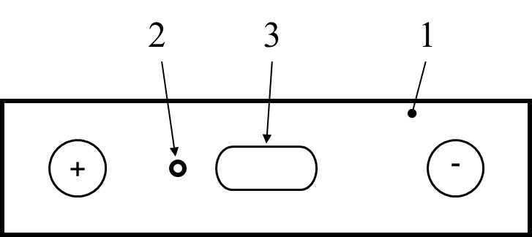 | 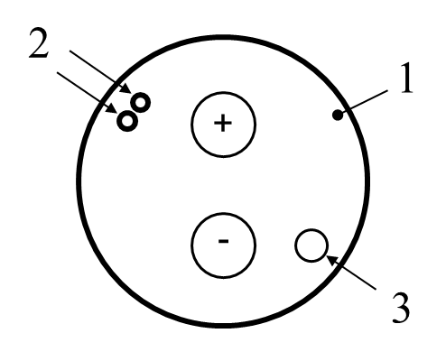 | 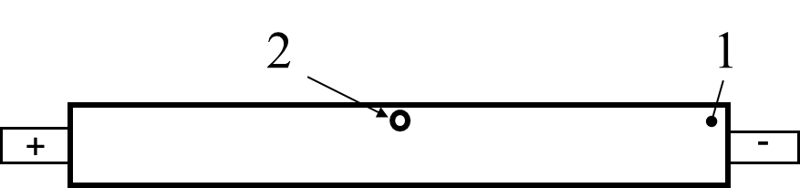
(a) For prismatic cell | (b) For cylindrical cell | (c) For pouch cell
Key
1 | The cell top
2 | The drilled hole
3 | The vent
NOTE Figure 3 shows the top view perspective.
2.1.2. Step 2: Locate the internal heater on the centre of the outer surface of the jelly roll or stacked layers (Figure 4).
Figure 4
Installation of the heater on the jelly roll/stack

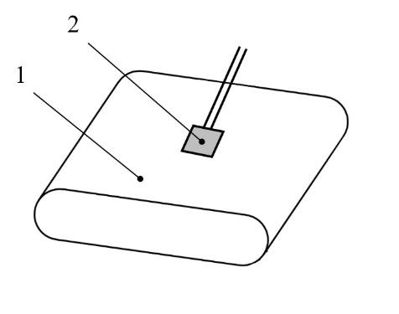 | 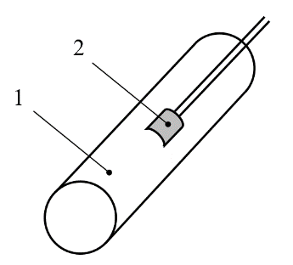
(a) For prismatic/pouch cell | (b) For cylindrical cell
Key
1 | The jelly roll/stack
2 | The heater

2.1.3. Step 3: Pass the leading wires of the heater through the specific holes on cell shell and all heater cords are required to be insulated from the rest of the cell. Continue to assemble the cell according to subsequent standard manufacturing processes.
2.1.4. Step 4: After cell cover welding, seal the leads of the heater from the openings, as illustrated in Figure 5. Determination of the sealing structure is critical as:
(a) No electrolyte or gases shall be allowed to escape from the space between the cords and the hole.
(b) The sealing strength shall be greater than that of any installed vent of the cell.
It is crucial to ensure the tightness of the sealed interface. The chosen methods for tightness confirmation and detection criteria shall be reported.

Figure 5
Description of sealing for heater feedthrough

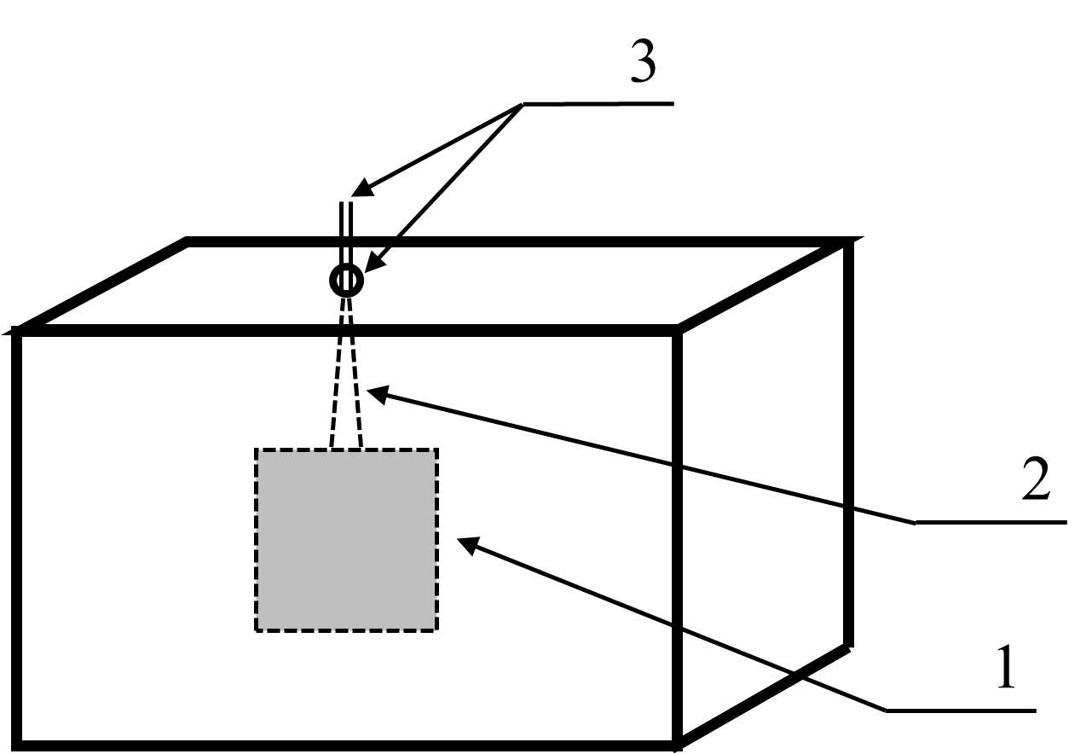 | 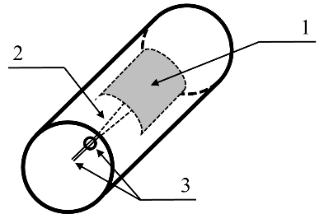
(a) For prismatic/pouch cell | (b) For cylindrical cell
Key
1 | The heater
2  3 | The leads  The seal location: the case opening (permanent) and the cord end (temporary for transfer/storage)
2.2 Preparation of the REESS or REESS subsystem with an initiation cell
In accordance with the procedures below to install the initiation cell in the REESS or REESS subsystem.
2.2.1 Step 1: Assemble the prepared cell into a module or pack based on the standard configuration.
Non-functional modifications may be necessary under certain circumstances. Sometimes cables can only be routed through punched holes at the non-structural areas (e. g. plastic connecter) as indicated below in Figure 6 a).
Figure 6
Example of the REESS or REESS subsystem with an initiation cell

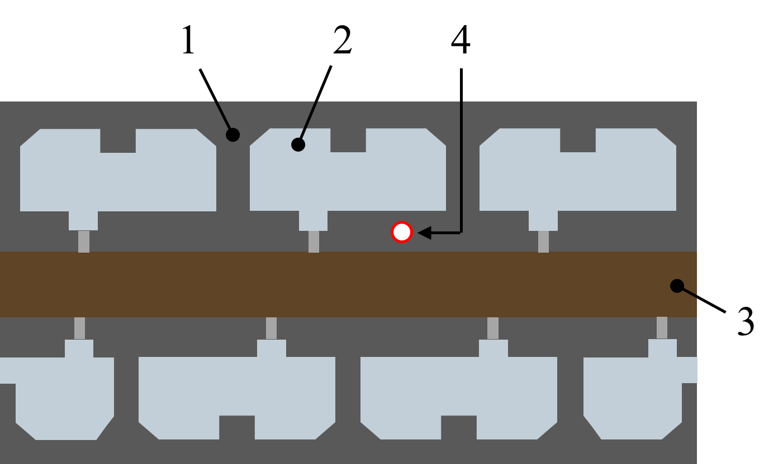 | 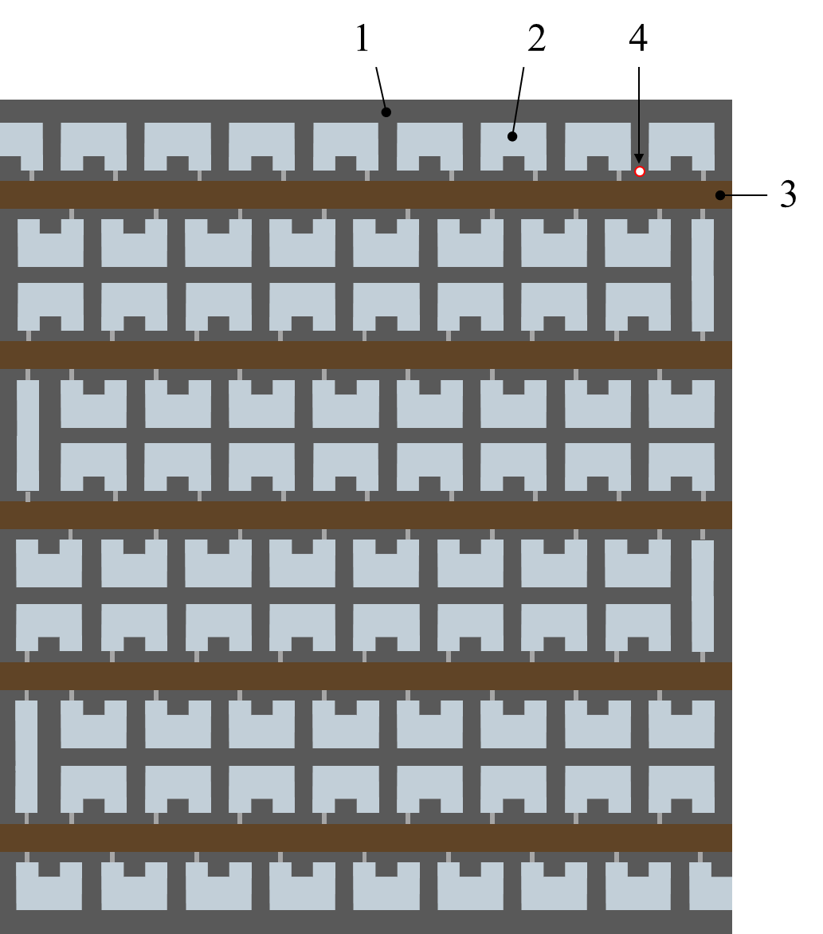
(a) A module assembly | (b) A pack assembly
Key
1 | Non-structural areas (e. g. plastic connecter)
2  3  4 | Busbars  Printed circuit board (PCB)  Lead exit location

2.2.2 Step 2: Route all cables from the heater, thermocouples, and voltage sensors to the outside of the REESS or REESS subsystem.
One way to do this is to cut one or more holes in the REESS or REESS subsystem housing of sufficient diameter to allow one or more clusters of cables to pass through, and then plug them with a sealing structure such as a heat-resistant resin (see Figure 7 (a)). This shall not affect the deformation of the battery housing. Alternatively, if possible, connect all cables externally through a channel between the cover and the case, while applying a heat-resistant resin to ensure a tight seal (see Figure 7 (b)).
It is required that no oxygen or flame escapes from the sealed interface during the test.
All connections (power supply, temperature sensors and voltage sensors) used in the REESS or REESS subsystem shall be electrically isolated.
Figure 7
Example of the REESS or REESS subsystem with a target cell

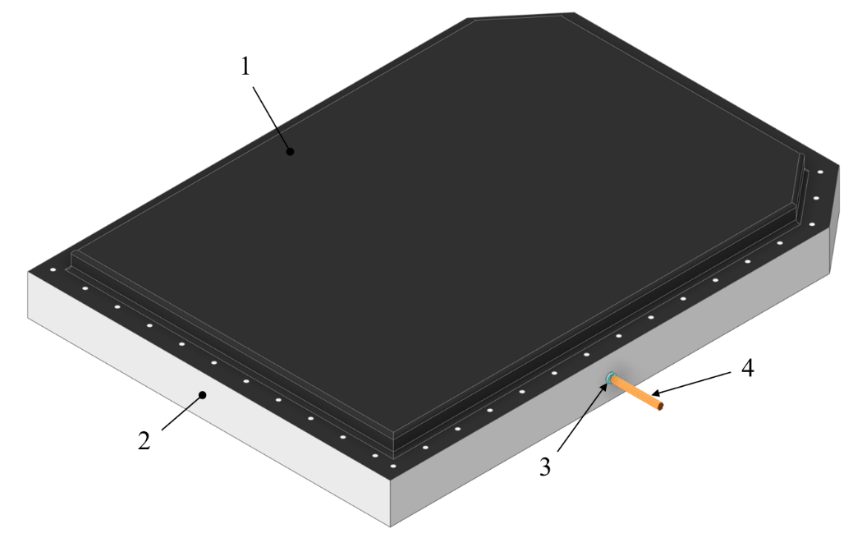
- Hole sealing technology
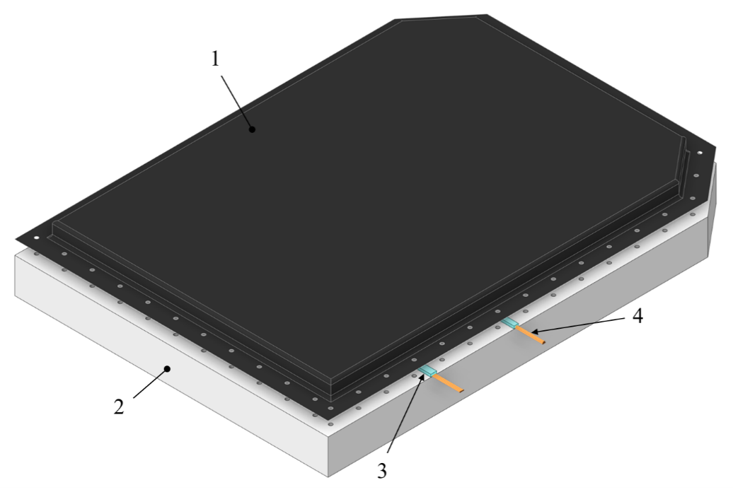
(b) Glue sealing technology
Key
1 | Battery cover
2  3  4 | Battery case  Sealing structure such as a heat-resistant resin  Cables

3. Test procedure for the vehicle-based test
The general conditions in paragraphs 6.2.12.3. and 8.2.11.3. shall be satisfied when the method is implemented with the vehicle.
(a) Instrument the REESS and the vehicle as outlined above and place the vehicle in the active-driving possible mode. Make sure that the cooling and communication system operate as intended.
(b) Start recording the data that are needed to determine if thermal runaway and/or thermal propagation occur. Verify that fault codes or failures relevant for the outcome of the test are not in the system.
(c) Begin sending power to the heating element.
(d) Switch off the heater immediately when thermal runaway is confirmed or after a total energy input to the heater reaches 20 % of initiation cell electric energy.
(e) If (d) is satisfied, but no thermal runaway has occurred in the initiation cell during the observation period of 1 hour after the opening of the heater relay, the REESS type is considered to comply with this requirement.
(f) The test ends when one of the conditions specified below is met:
(i) The initiation is stopped in accordance with the subparagraph (d) above followed by an observation period of 1 hour; or
(ii) At least 5 minutes elapse after the activation of the warning indication, if thermal propagation is observed; or
(iii) If thermal runaway has occurred in the initiation cell, but no thermal propagation ensued, the observation period of 2 hours after the confirmation of thermal runaway is applied to Tested-Device.
4. Test procedure for the component-based test
The general conditions in paragraphs 6.2.12.3. and 8.2.11.3. shall be satisfied when the method is implemented on the REESS or REESS subsystem.
(a) Instrument the REESS or REESS subsystem as outlined above and prepare the REESS or REESS subsystem such that it represents the situation when it is installed in the vehicle, with the system in the active-driving possible mode. Make sure that the thermal management and communication system operate as intended.
(b) Start recording the data that are needed to determine if thermal runaway and/or thermal propagation occur. Verify that fault codes or failures relevant for the outcome of the test are not in the system.
(c) Begin sending power to the heating element.
(d) Switch off the heater immediately when thermal runaway is confirmed or after a total energy input to the heater reaches 20 % of initiation cell electric energy.
(e) If (d) is satisfied, but no thermal runaway has occurred in the initiation cell during the observation period of 1 hour after the opening of the heater relay, the REESS type is considered to comply with this requirement.
(f) The test ends when one of the conditions specified below is met:
(i) The initiation is stopped in accordance with the subparagraph (d) above followed by an observation period of 1 hour; or
(ii) At least 5 minutes elapse after the signal to activate the warning indication, if thermal propagation is observed; or
(iii) If thermal runaway has occurred in the initiation cell, but no thermal propagation ensued, the observation period of 2 hours after the confirmation of thermal runaway is applied to Tested-Device.

Annex 3 – Appendix 4
Thermal runaway initiation method with nail penetration
This test describes the penetration of a target cell by a nail to create a short circuit that brings the target cell into a thermal runaway to release its electrical and chemical energy.
1. Preparation of the Tested-Device
If the REESS is enclosed in a housing, a penetrating hole on the housing may be needed to enable the nail to be inserted into a target position of an initiation cell. The device such as gas tight sleeve for the nail that prevents venting gas from leaking out from the nail hole should be applied, if necessary.
The nail penetrating position and direction are selected from the position and direction of the nail where causing a thermal runaway in an initiation cell is possible (e.g. in perpendicular direction to electrode layer).
2. Nail selection guide
The nail type can be chosen from the parameters given in Table 1, or other appropriate international standards. (e.g. for the shape of the nail tip).

Table 1
Nail selection guide: Target parameters
Parameter | Value | Rationale
(i) Material | Steel | To be electrically conductive and sufficiently hard to penetrate a cell outer case.
(ii) Diameter (mm) | 3 to 8 | To be smaller to simulate the internal short circuit.
(iii) Angle of tip (°) | 20 to 60 | To be smaller to minimize effect on the cell casing.  To select angle to cause thermal runaway.
(ⅳ) Penetrating speed (mm/s) | 0.1 to 1 | If the speed is low, the nail travelling is easily controlled, especially to stop.

3. Test procedure for the vehicle-based test
The general conditions in paragraphs 6.2.12.3. and 8.2.11.3. shall be satisfied when the method is implemented with the vehicle.
(a) Instrument the REESS as outlined above and connect all thermal management and high voltage lines, and reinstall REESS into vehicle.
(b) Start recording the data that are needed to determine if thermal runaway and/or thermal propagation occur. Verify that fault codes or failures relevant for the outcome of the test are not in the system.
(c) Select the nail shape and diameter and set the appropriate penetrating speed according to the guidance in paragraph 2.(iv).
(d) Tune on the power to the nail operating device.
(e) Stop the nail and let it remain inside the initiation cell when the thermal runaway is confirmed or the nail has penetrated both the front and back side of the cell.
(f) The test ends when one of the conditions specified below is met:
(i) The initiation is stopped in accordance with the subparagraph (e) above followed by an observation period of 1 hour; or
(ii) At least 5 minutes elapse after the activation of the warning indication, if thermal propagation is observed; or
(iii) If thermal runaway has occurred in the initiation cell, but no thermal propagation ensued, the observation period of 2 hours after the confirmation of thermal runaway is applied to Tested-Device.
4. Test procedure for the component-based test
The general conditions in paragraphs 6.2.12.3. and 8.2.11.3. shall be satisfied when the method is implemented on the REESS or REESS subsystem.
(a) Instrument the REESS or REESS subsystem as outlined above and prepare the REESS or REESS subsystem such that it represents the situation when it is installed in the vehicle, with the system in the active-driving possible mode. Make sure that the thermal management and communication system operate as intended.
(b) Start recording the data that are needed to determine if thermal runaway and/or thermal propagation occur. Verify that there fault codes or failures relevant for the outcome of the test are not in the system.
(c) Select the nail shape and diameter and set the appropriate penetrating speed according to the guidance in paragraph 2.(iv).
(d) Tune on the power to the nail operating device.
(e) Stop the nail and let it remain inside the initiation cell when thermal runaway is confirmed or the nail has penetrated both the front and back side of the cell.
(f) The test ends when one of the conditions specified below is met:
(i) The initiation is stopped in accordance with the subparagraph (e) above followed by an observation period of 1 hour; or
(ii) At least 5 minutes elapse after the signal to activate the warning indication, if thermal propagation is observed; or
(iii) If thermal runaway has occurred in the initiation cell, but no thermal propagation ensued, the observation period of 2 hours after the confirmation of thermal runaway is applied to Tested-Device.

Annex 3 – Appendix 5
Thermal runaway initiation method with laser-based initiation
This test is performed by applying heat to the external surface of one target lithium-ion battery cell within the REESS via laser until thermal runaway is achieved with minimal increase in temperature of the adjacent lithium-ion battery cell(s) prior to thermal runaway within the target cell.
1. Preparation of the Tested-Device
Before conducting the test, the laser beam path shall be secured so that the laser beam reaches a predetermined position on the initiation cell surface. Figure 1 shows examples of laser irradiation to on-board battery modules consisting of different types of battery cells.
Figure 1
Examples of laser irradiation to on-board battery modules consisting of different types of battery cells
(a) Cylindrical cell module | (b) Square cell module | (c) Pouch cell module
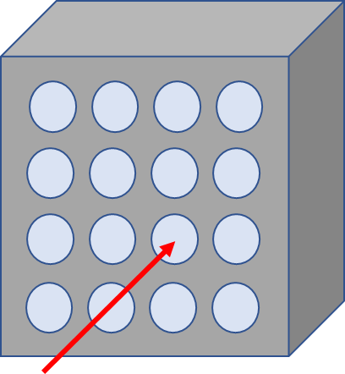 | 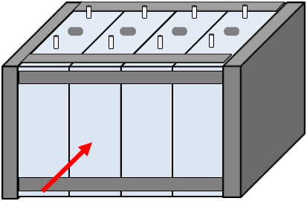 | 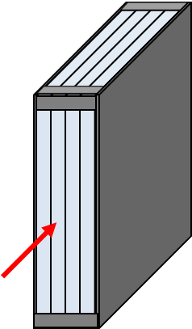

2. Laser selection guide
The laser type can be chosen from material process lasers such as used for cutting, welding or hardening, e.g. CO₂ laser, YAG laser, semiconductor laser, disk laser, fibre laser, and so on.
An example of a laser irradiation system is shown in Figure 2.

Figure 2
Example of a laser irradiation system

3. Test procedure for a vehicle-based test
The general conditions in paragraphs 6.2.12.3. and 8.2.11.3. shall be satisfied when the method is implemented with the vehicle.
(a) Instrument the REESS as outlined above and connect all thermal management and high voltage lines, and reinstall REESS into vehicle.
(b) Start recording the data that are needed to determine if thermal runaway and/or thermal propagation occur. Verify that fault codes or failures relevant for the outcome of the test are not in the system.
(c) Before starting the test, secure the laser beam path so that the laser beam reaches the initiation cell surface of the Tested-Device.
(d) Set and confirm the laser irradiation program.
(e) Irradiate the initiation cell with the laser at the determined point.
(f) Stop the laser irradiation program when thermal runaway is confirmed or after a total energy input from the laser reaches 20 per cent of the initiation cell energy.
(g) If (f) is satisfied, but no thermal runaway has occurred in the initiation cell during the observation period of 1 hour after the laser switch off, the REESS type is considered to comply with this requirement.
(h) The test ends when one of the conditions specified below is met:
(i) The initiation is stopped in accordance with the subparagraph (f) above followed by an observation period of 1 hour; or
(ii) 5 minutes after the activation of the warning indication, if thermal propagation is observed; or
(iii) If thermal runaway has occurred in the initiation cell, but no thermal propagation ensued, the observation period of 2 hours after the confirmation of thermal runaway is applied to Tested-Device.
4. Test procedure for a component-based test
The general conditions in paragraphs 6.2.12.3. and 8.2.11.3. shall be satisfied when the method is implemented on the REESS or REESS subsystem.
(a) Instrument the REESS or REESS subsystem as outlined above and prepare the REESS or REESS subsystem such that it represents the situation when it is installed in the vehicle, with the system in the active-driving possible mode. Make sure that the thermal management and communication system operate as intended.
(b) Start recording the data that are needed to determine if thermal runaway and/or thermal propagation occur. Verify that fault codes or failures relevant for the outcome of the test are not in the system.
(c) Before starting the test, secure the laser beam path so that the laser beam reaches the initiation cell surface of the Tested-Device.
(d) Set and confirm the laser irradiation program.
(e) Irradiate the initiation cell with the laser at the determined point.
(f) Stop the laser irradiation program when thermal runaway is confirmed or after a total energy input from the laser reaches 20 per cent of the initiation cell energy.
(g) If (f) is satisfied, but thermal runaway has not occurred in the initiation cell during the observation period of 1 hour after the laser switch off, the REESS type is considered to comply with this requirement.
(h) The test ends when one of the conditions specified below is met:
(i) The initiation is stopped in accordance with the subparagraph (f) above followed by an observation period of 1 hour; or
(ii) 5 minutes after the signal to activate the warning indication, if thermal propagation is observed; or
(iii) If thermal runaway has occurred in the initiation cell, but thermal propagation did not ensue, the observation period of 2 hours after the confirmation of thermal runaway is applied to Tested-Device."

https://wiki.unece.org/pages/viewpage.action?pageId=235372775&src=contextnavpagetreemode

