Annex 3 – Appendix 2 – Thermal Runaway Initiation Method with an Internal Heater (Method 1)
This test method is similar to the localised fast external heating method except it relies on an internal, localized short circuit inside the cell created by a heater. The concept of this trigger method is to create an internal short circuit by creating a hole in the separator of the initiation cell. The hole comes from the local melting of the separator induced by the local heater.
The initiation method applies a high-power heat pulse, locally, to the jellyroll surface of one initiation cell within the REESS via an internal heater with minimal increase in temperature of the adjacent battery cell(s) prior to thermal runaway in the initiation cell. The temperature of adjacent cell(s), prior to thermal runaway in the initiation cell, shall remain below the maximum operating temperature.
1. Description of the Initiation Method
The heating device shall be a resistive heating element, or other suitable heating device/technology capable of delivering the target parameters. Target parameters for the heating element are listed in Table 1.
The resistance, power and duration shall be adjusted according to the electrochemistry and the size of the cell.

Figure 1
Example of an internal heater flat spiral
(Dimensions in millimetres)
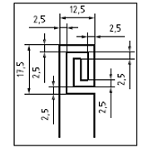

Table 1
Heating Element Selection Guide: Target Parameters
Parameter | Value | Reasoning
Heating element material | A suitable resistive heating material with an insulating barrier, e.g. copper or tungsten | Achieve high temperatures and prevent element failures. Isolating material may include polyimide or other heat-resisting material.
Thickness (mm) | ≤ 0.5 | As the heater needs to be placed inside of a cell, thickness of heater should be minimized.
Area (mm²) | 225 - 500 | Concentrate heat to the smallest feasible area on the jellyroll surface.
Power of heater (W) | 150~700 | Provide enough heat to enable initiation of cell thermal runaway.

2. Initiation Cell/Cell Block Preparation
The heater shall be inserted in the connected electrode stack or jellyroll before cell sealing. The applied method is dependent on the REESS or REESS subsystem design and manufacturing process. Here is an example of the manufacturing process for this special cell.
2.1. Step 1:
One or two hole(s) are drilled into the cover to allow the electrical feedthrough of the heater from inside the cell to the outside (Figure 2).
Figure 2
Example of specific holes in cover for heater connection
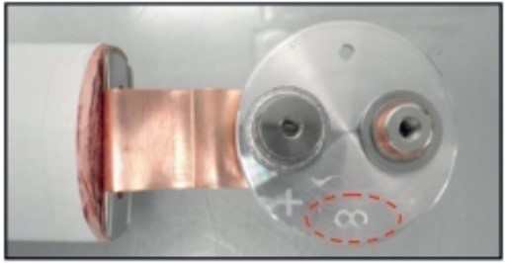
2.2. Step 2:
Unroll the separators and the electrodes to insert the heater.
2.3. Step 3:
Locate the heater on the last wrap of electrode. The heater is placed between the outermost negative and positive electrodes for the cell (see Figures 3a, 4a and 5).
Avoid unrolling a larger part of the jelly roll, since this can lead to damage of the jelly roll. Use an outer stack in case of stacked layers.

Figure 3
Example of heater location inside the cylindrical cell
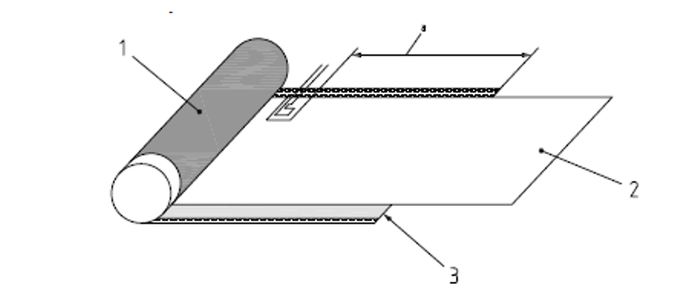

Key
1 positive electrode
2 separator
3 negative electrode
a 180 mm from end of positive electrode and 15 mm from end of negative electrode, tolerance ±5 mm

Figure 4
Example of heater location inside the prismatic cell
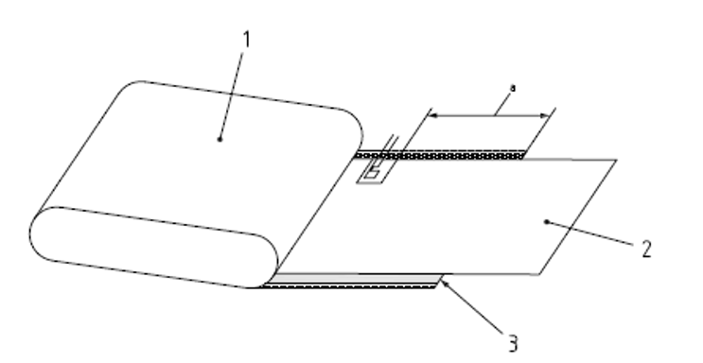

Key
1 positive electrode
2 separator
3 negative electrode
a 180 mm from end of positive electrode and 15 mm from end of negative electrode, tolerance ±5 mm

Figure 5
Example of located on the last lap of negative electrode
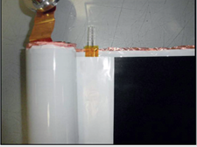
2.4. Step 4:
Wind the jelly roll with the heater (see Figure 6).
Figure 6
Example of jelly roll equipped with heater
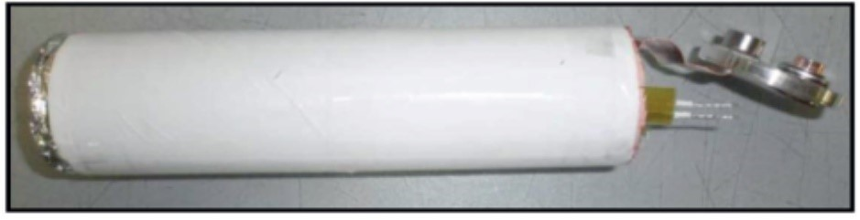
2.5. Step 5:
All wires used in the REESS or REESS subsystem shall be electrically isolated.
The cell shall be assembled according to standard manufacturing processes (e.g. electrolyte filling, cover welding), ensuring no electrolyte or gases can leak out through the space between the wire strand and the wire insulator.
Selection of resin is critical as the strength of seal shall be greater than any installed vent of the cell.
After the resin is completely dry, carry out a helium test to check the sealing before filling the cell with electrolyte.
Figure 7
Example of finished cell with heater
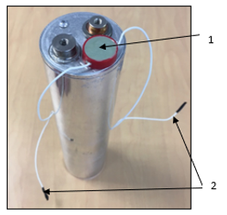
Key
1 resin for sealing the heater supply
2 supply wires of the heater

Figure 8
Example of cell before filling with electrolyte
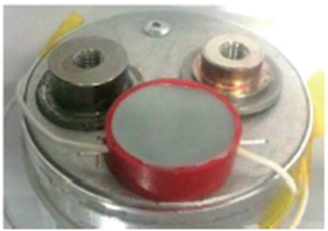

2.6. Step 6:
The initiation cell shall be assembled inside the REESS or REESS subsystem, which could be modified to make sure the electrical feedthrough of the heater can come out of cell block.
The feedthrough installation of the heating element and measuring sensors should only modify the REESS (or REESS subsystem) by permitting necessary electrical and thermocouple connections. These connections shall provide greater seal integrity than the other connectors in the REESS (or REESS subsystem).
For a vehicle level test, mount the REESS on the vehicle, according to manufacturer’s specifications.
3. Test Procedure for the Vehicle-Based Test
The general conditions in Annex 3, paragraph 3. shall be satisfied when the method is implemented with the vehicle.
(a) Instrument the REESS and the vehicle as outlined above and place the vehicle in the active-driving possible mode. Make sure that the cooling and communication system operate as intended.
(b) Start recording the data that are needed to determine if thermal runaway and/or thermal propagation occur. Verify that fault codes or failures relevant for the outcome of the test are not in the system.
(c) Begin sending power to the heating element.
(d) Switch off the heater immediately when thermal runaway is confirmed or after a total energy input to the heater reaches 20 % of initiation cell electric energy.
(e) If (d) is satisfied, but no thermal runaway has occurred in the initiation cell during the observation period of 1 hour after the opening of the heater relay, the REESS type is considered to comply with this requirement.
(f) The test ends when one of the conditions specified below is met:
(i) The initiation is stopped in accordance with the subparagraph (d) above followed by an observation period of 1 hour; or
(ii) At least 5 minutes elapse after the activation of the warning indication, if thermal propagation is observed; or
(iii) If thermal runaway has occurred in the initiation cell, but no thermal propagation ensued, the observation period of 2 hours after the confirmation of thermal runaway is applied to Tested-Device.
4. Test procedure for the component-based test
The general conditions in Annex 3, paragraph 3. shall be satisfied when the method is implemented on the REESS or REESS subsystem.
(a) Instrument the REESS or REESS subsystem as outlined above and prepare the REESS or REESS subsystem such that it represents the situation when it is installed in the vehicle, with the system in the active-driving possible mode. Make sure that the thermal management and communication system operate as intended.
(b) Start recording the data that are needed to determine if thermal runaway and/or thermal propagation occur. Verify that fault codes or failures relevant for the outcome of the test are not in the system.
(c) Begin sending power to the heating element.
(d) Switch off the heater immediately when thermal runaway is confirmed or after a total energy input to the heater reaches 20 % of initiation cell electric energy.
(e) If (d) is satisfied, but no thermal runaway has occurred in the initiation cell during the observation period of 1 hour after the opening of the heater relay, the REESS type is considered to comply with this requirement.
(f) The test ends when one of the conditions specified below is met:
(i) The initiation is stopped in accordance with the subparagraph (d) above followed by an observation period of 1 hour; or
(ii) At least 5 minutes elapse after the signal to activate the warning indication, if thermal propagation is observed; or
(iii) If thermal runaway has occurred in the initiation cell, but no thermal propagation ensued, the observation period of 2 hours after the confirmation of thermal runaway is applied to Tested-Device.

