ADS IWG Working Document
Change Proposal Form
One major comment per form
(Shaded blocks for use by the IWG Secretariat)
Document Reference | ADS-14-04/Rev.1 | Date | 14 October 2025
Agenda item
Proposed by (affiliation only—no personal information)
China
Summary of Change (25 words or less)
Minor revision of the description of Confirmatory testing scenario in 6.3.3.1.1
Reason for Change (Justification)
Traffic disturbance scenarios, including but not limited to behaviours in the presence of surrounding motor vehicles, vulnerable road users, and non-motorized vehicle, which includes "Situations with a large number of other road users", and specially indicate the trigger conditions for ADS safety concerns. More information, please find the interpretation document in the appendix.
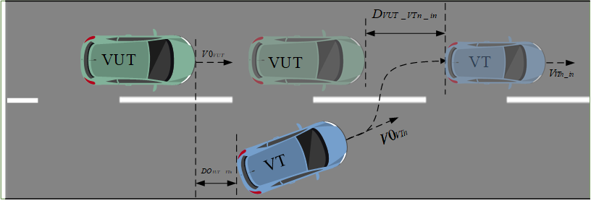
Figure 1 Traffic disturbance example 1：Other vehicles cutting in
Figure 2 Traffic disturbance example 2: Meeting an accident car
Figure 3 Traffic disturbance example 3: Pedestrian crossing through an occlusion zone
Figure 4 Traffic disturbance example 4: Motorcycle cutting in through an occlusion zone
Location | ADS-13-03-GTR 6.3.3.1.1&UNR 8.3.3.1.1
Original text
(c) Situations with a large number of other road users, unlikely road infrastructure, or abnormal geographic/environmental conditions,
Revised text
c) Situation with traffic disturbance, unlikely road infrastructure or abnormal geographic/environmental conditions,
c) Situations with a large number of other road users with traffic disturbance, unlikely road infrastructure, or abnormal geographic/environmental conditions,

