ADS IWG Working Document
Change Proposal Form
One major comment per form
(Shaded blocks for use by the IWG Secretariat)
Document Reference | ADS-17-06/Rev.3 | Date | 10 December 2025
Agenda item | 6.1. | Outcome | Adopted
Proposed by (affiliation only—no personal information)
OICA
Summary of Change (25 words or less)
Proposal to clarify introduction section of the GTR and also align it with UNR
Reason for Change (Justification)
- Para 45. of the GTR currently reads that it provides minimum requirements both to the ADS and the vehicles, but GTR only provides minimum requirements for the safety of an ADS
- Alignment also with UNR
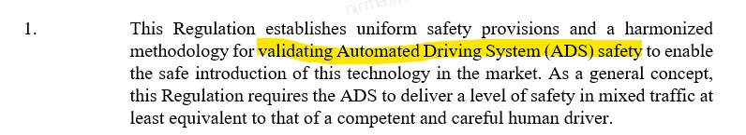
Location | ADS-15-04r3 - GTR Paragraph 45

Original text
45. There are several GRVA subgroups active in the field of vehicle automation (EDR/DSSAD, TF AVC, TF FADS, CS/OTA). This first GTR is based on the information currently available from these subgroups. It provides worldwide harmonised procedures to set and verify compliance with minimum requirements for the safety of ADS and vehicles equipped with ADS with the notion that future improvements of the GTR are expected as ADS technologies continue to evolve. It takes into consideration existing and new data, research, and standards proposed by the contracting parties and industry.
Revised text
GTR |  | UNR
45. There are several GRVA subgroups active in the field of vehicle automation (EDR/DSSAD, TF AVC, TF FADS, CS/OTA). This first GTR is based on the information currently available from these subgroups. It provides worldwide harmonised procedures to set and verify compliance with minimum requirements for the safety of vehicles with regard to their an ADS, and vehicles equipped with an ADS with the notion that future improvements of the GTR are expected as ADS technologies continue to evolve. It takes into consideration existing and new data, research, and standards proposed by the contracting parties and industry. |  | 1. This Regulation establishes uniform safety provisions and a harmonised methodology for validating the safety of vehicles with regard to their Automated Driving System (ADS) safety to enable the safe introduction of this technology in the market. As a general concept, this Regulation requires the ADS to deliver a level of safety in mixed traffic at least equivalent to that of a competent and careful human driver.

