Inhalt
2 Preamble 2
3 Purpose 2
4 Scope 2
5 (Normative references – should be moved to the preamble) 2
5.1 Netherlands 2
5.2 OICA 2
6 Terms and definitions 3
6.1 Definition of fast charging 3
6.2 Definition of family criteria 4
6.2.1 Test family criteria from Netherlands 4
6.2.2 Test family criteria from OICA 4
6.2.3 Test family criteria from JRC 4
6.2.4 Parent family criteria from Netherlands 5
6.2.5 Parent family criteria from OICA 5
6.2.6 Other possible approaches on parent family 5
7 Abbrevations 5
8 Test cases 5
8.1 Overview of test cases from the Netherlands 5
8.2 Overview of test cases from OICA 5
8.3 Overview of test cases JRC 5
9 General requirements 6
9.1 Vehicle manufacturer specifications 6
9.1.1 OICA 6
9.1.2 Netherlands 6
9.2 Specifications and tests – test system requirements 6
9.2.1 Netherlands 7
9.2.2 OICA 7
9.2.3 JRC comments 8
10 Determination of … 9
10.1 Parameters proposed by OICA 9
10.2 JRC 9
11 KPI‘s 10
11.1 Netherlands 10
11.2 OICA 10

JRC: Discussion points
F&SC-04-03e document: Uniform provisions concerning the optimal charging power curve of light-duty electrified chargeable vehicles using direct current – Fastest Recharge Power Curve (FRPC)

Preamble

Purpose
From the 1st drafting meeting: The Fast and Smart Charging (F&SC) cluster aims at developing a provision concerning the charging power curve of light-duty vehicle electrified chargeable vehicles using direct current. The procedure to determine the power charging curve shall be both reproducible and repeatable, and representing real-world charging. This will provide consumers with reliable information on the FRPC and related KPIs.
OICA:
This Resolution provides a worldwide harmonized method to set and verify minimum performance requirements on DC fast charging of Pure Electric Vehicles (PEVs) and Off-vehicle Charging Hybrid Electric Vehicles (OVC-HEVs).

Scope
OICA: This resolution applies to vehicles of categories 1-2 and 2, that have a technically permissible maximum laden mass not exceeding 3,855 kg, and to vehicles of category 1-1, that are PEV and OVC-HEV vehicles.
At the option of the Contracting Party, the scope may be limited to 3,500 kg for the relevant categories.

(Normative references – should be moved to the preamble)

Netherlands
- GTR 15 (WLTP)/ UNR 154
- GTR 22 (Battery durability LDV)
- ISO 12906 (FRPC specific and complimentary source of requirements)
- HDV Battery durability GRPE proposal, if applicable

OICA
- UNR 154 series 2 and 3 (WLTP)
- GTR 22 (Battery durability LDV
- ISO 12906

Terms and definitions

Definition of fast charging
- Focus on DC-charging
- Minimum power “fast charging” from a charging station point (s. Fig. 1 and 2)
- Focus on what is possible in the vehicle:
"Fully charged, 100% state of charge (SOC), corresponds to the highest SOC which is achievable with normal operation of the vehicle", however, fast charging is typically terminated at 80% SoC due to battery durability aspects.
- Norming factor: UBE on the vehicle (defined by WLTP and GTR22)
- Scope: BEV and PHEV tbd?

- https://www.charin.global/media/pages/technology/knowledge-base/63d38591d7-1639130326/charin_dc_ccs_power_classes.pdf
- 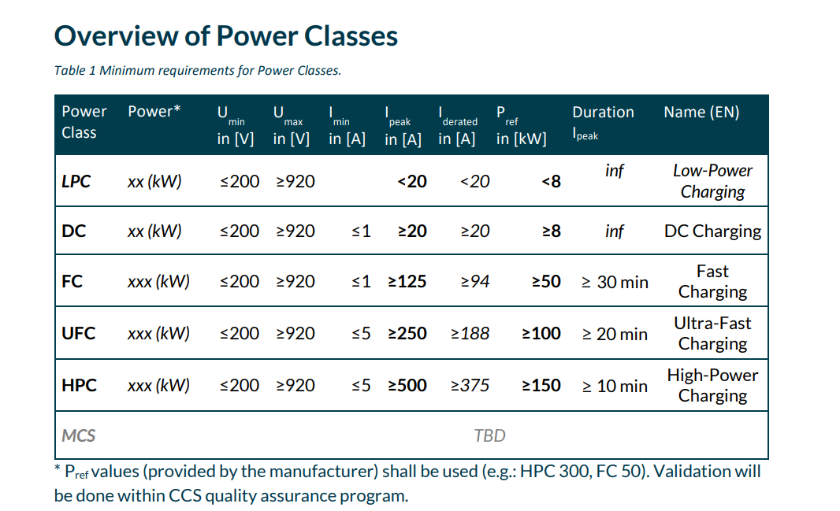
Figure 1: From CharIn

- Recharging systems | European Alternative Fuels Observatory

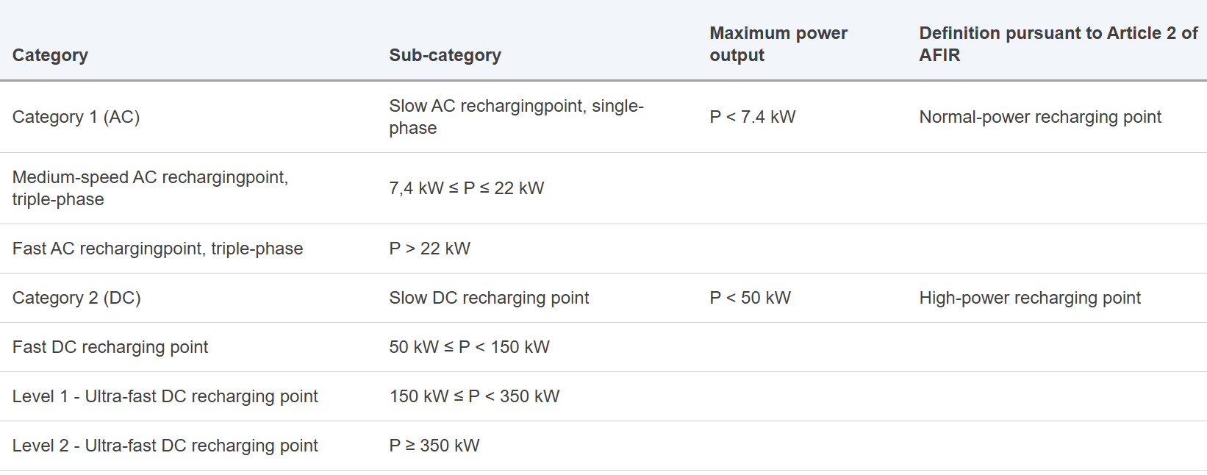
Figure 2: From EU-Com

Definition of family criteria

Test family criteria from Netherlands
Definition of vehicle family GTR 22, part B family as a basis

Test family criteria from OICA
GTR22 Part B criteria for battery durability were used and adjusted for fast charging:
- Battery and charging system design including thermal management and any other characteristics having a non-negligible influence on fast charging
- (Declared maximum charging power (Value from OEM))
- Type of battery (e.g., type of cell, including format, capacity (Ampere-hour), nominal voltage, nominal power tbd by the drafting group) with focus on fast charging
- Battery management system (BMS) with regards to fast charging monitoring and estimations
- Operation strategy of all components influencing the fast charging

Test family criteria from JRC
GTR No. 22 Part B family adjusted to consider the parameters related to the DC fast charging,
-any other characteristics having a non-negligible influence on fast charging
-BMS related to DC fast charging,
-thermal management of the battery, battery conditioning function? Vehicle with/without battery conditioning function in the same family?
In ISO/SAE 12906 optimizing features are in 6.2.1. General requirement, 6.3.2.2. Relocations (optimizing features not allowed), 6.3.2.3 Soaking phase (not allowed), 6.3.2.4 Preparation phase (optional)
(b) Type of battery (dimensions, type of cell, including format and chemistry, capacity (Ampere-hour), nominal voltage, nominal power.

Parent family criteria from Netherlands
Worst-case principle: test family member with expected worst performance

Parent family criteria from OICA
In general worst-case principle
Definition of worst case may be related to second order characteristics like thermal management, HV-system (length of HV cables)

Remark: Could be very difficult to prove what is “worst case”

Other possible approaches on parent family
GTR22: maximum energy consumption (witness testing, part of WLTP measurement cycle)

Abbrevations

Test cases

Overview of test cases from the Netherlands
Charge power curve to cover the entire UBE spectrum from zero charge (0% SoC) to full charge (100% SoC)- FRPC to cover the full charging window from close to 0% to close to 100%
Consumer metric might focus on given charging window, eg. 10% to 80% or else

Overview of test cases from OICA
Discuss charge power curve (handling, parameter, measurement, tolerances …) separately with more time - not part of the resolution, focus on 10-80% SoC relevant for fast charging
Start Point and End Point for the fast charging procedure have to be defined

Overview of test cases JRC
To agree on the test case requirements and customer metric post-processing and KPI.
Not all the DC HP charging stations will allow to reach automatically the full charged status of the battery due to battery protection systems, and unplugging and plugging again the vehicle is needed to complete the charge at lower power with the same station.
In the draft HDV GTR a provision has been added to take into account this and give instruction on how to charge at full.
To consider in case to prescribe the reporting on how the full charge was reached (i.e. with/without interruption, ...).

General requirements

Vehicle manufacturer specifications

OICA
Required charging values (current, voltage, power and their duration) to be provided by OEM’s see also ISO/SAE 6.2.1 Vehicle manufacturer specifications
Measurement set up, tolerances and accuracies see ISO/SAE 6.2.3 Measurement tolerances and accuracies

Netherlands
Condition for charging
- Break-off criterion: same as UBE from GTR 15 / ISO
- When reached, the battery is nearly empty (close to 0% SoC)
- End-of-charge criterion: same as for UBE from GTR 15 / ISO
- When reached, the battery is nearly full (close to 100% SoC)
Pre-conditioning, soaking, preparation
- Align with GTR 15 / GTR22 as much as possible
- Where GTR15 / GTR22 are not comprehensive enough, follow ISO 12906
- Allow for active/passive battery preconditioning (flag to be recorded)

- Need for vehicle dyno for preparation phase?
  - Is it possible to do without a dyno if UN GTR 15 / GTR22/ISO is used as a basis?
  - Validation test to confirm if vehicle dyno is required
  - Implication of dyno usage:
    - Higher resources needed
    - Restrict potential application of FRPC resolution to OEMs / certification bodies /technical services

Specifications and tests – test system requirements
1st Drafting meeting E-laad also posed the question whether a real market available charging station should be used during the testing or a more sophisticated but more controlled EVSE emulator should be used.
To specify this in the test system requirements can be an option

Netherlands

EVSE specifications and requirements:
- Voltage: as recommended by vehicle manufacturer
- Current: [10%] more than max current from OEMs specs

Test system requirements:
- GTR15 where relevant (Annex 6, para 2.2.)
- Test location requirement from ISO 12906, para 6.3.2.5.
Sampling rate:
- [1]Hz / [20]Hz for energy (as ISO12906)

OICA
Refer in general to ISO/SAE 6.3.2 Test procedure for test case Fast Charge
Start/stop conditions in ISO12906 chapter 6.3.2.5 for 10-80% SoC evaluation
Pre-cond/soaking/prep, focus on ISO12906 only
Conditioning on a dyno for charging possible, could be set as optional
EVSE requirements:
- Remove +10% current not feasible for high charging current demand
Test system requirements:
- Add ISO 6.3.2.3 soaking phase requirements
For test location requirements refer to ISO12906
Sampling rate:
- 1Hz

JRC comments
- Pre-conditioning, soaking, preparation:
- ISO preparation phase: optional
25-30km/h for a maximum 30 minutes or alternatively EV may be soaked for maximum 30 min at temp 0 -30 C
- Green NCAP: conditioning drive on dyno or on road for approx. 15 minutes
- UN GTR No 15: pre-cond WLTC

- Allow for active/passive battery preconditioning (flag to be recorded)
- In ISO/SAE 12906
optimizing features 6.2.1. General requirement,
6.3.2.2. Relocations (optimizing features not allowed),
6.3.2.3 Soaking phase (not allowed),
6.3.2.4 Preparation phase (optional)
- To consider to prescribe the reporting on active/passive battery preconditioning and flag

- Need for vehicle dyno for preparation phase?
- Preparation phase prescribes different drive cycle in ISO/SAE, Green NCAP, GTR 15/22 etc…Dyno can also not be needed for preparation.
But:
- ISO/SAE 12906
It requires dyno for determining the DBE (discharged battery energy) versus SOC curve
This curve DBE vs SOC is needed to determine:
- the recharged usable battery energy within a reference time t_ref
- and the recharged electric range
For the recharged electric range calculation the EC_DC,WLTC is also needed as parameter. This is derived from the WLTP.
To discuss in the group based on KPI

Bidirectional power supply system may be used to deplete the battery during the preparation and to derive the curve DBE vs SOC. But the influence on the battery and systems during preparation is different. Moreover, for the curve DBE vs SOC an error is introduced.
- EVSE specifications and requirements:
- to consider to add provision on modular charging station, for charging efficiency related aspects
-Test system requirements:
- GTR 15 0.1 Hz Pressure, humidity, 0.033Hz temperature
- ISO 1 Hz SOC, Power, Energy depleting 20 Hz,
- Green NCAP , 1 Hz
- GTR 22, GTR 21
- Voltage, Current, 20 Hz during depleting, 0.033Hz during charging
- Room temperature 0.033Hz
- Time, ± 10 ms
- CAN bus data from vehicle?
- SOC monitor vehicle?
- Voltage, current, SOC, from charging station if possible?
- Voltage, current, SOC, man-in-the-middle or EVSE emulator?
- Moving average power window for the calculation of the maximum power?
- ISO the maximum charging power is the highest averaged power within a 30 s interval during the charging duration
- Ambient temperature,
- ISO 23C +/- 3 C on a 5 minutes running arithmetic average during soak with no systematic deviation from the set point,
- ISO 0-30C, 23C+/- 3 C recommended; during charging phase, to resemble real-world conditions

Determination of …
Parameters proposed by Netherlands
- Power at the station (MP2 point of ISO 12906)
- Energy: Station and vehicle/battery
- SoC calculated: from energy at the battery and UBE
- SoC declared: value on dashboard/ from on-board system
(SoC calculated from energy recharged and on-board SoC also collected)
- Charging efficiency derived from total energy at the station vs. UBE (like ISO)
- [Battery/cell] temperature
- Activation flag for Battery pre-conditioning (heating/cooling active)
- Others ?

Parameters proposed by OICA
- Time
- Indicated SoC (declared SoC)
- Electrical power

JRC

KPI‘s

Netherlands
Consumer metric might focus on given charging window, eg. 10% to 80% or else
Consumer info metrics to be proposed later
Energy recharged to be compared to declared UBE as part of GTR 15/ISO

OICA
@ temperature = 23±3°C (tolerance from ISO12906)
Charging time from 10-80% SoC
Maximum charging power
Discuss charge power curve (handling, parameter, measurement, tolerances …) separately with more time - not part of the resolution, focus on 10-80% SoC relevant for fast charging

