Minutes of GRPE F&SC TF Drafting meeting #01 (kick-off)

Date and time : Monday, July 7, 2025, 11:30–13:30 (CET)
Location : Online (Teams)
Attendees : See attendee list

Agenda (see document FRPC-01-01e):
1. Welcome
2. Introduction – Tour de table
3. Presentation on proposed approach
4. Discussion
5. Inventory of issues for outline document
6. Wrap-up with agreements and actions
7. Any other business
8. Meeting schedule
9. Closing

Notes:
1. Welcome
The drafting coordinator Iddo Riemersma (TNO on behalf of the Dutch Ministry of Infrastructure and Waterways) introduced himself, welcomed the meeting participants and introduced his role of drafting coordinator.
A dedicated working folder for the work of the group has been created by the UNECE secretariat at this link: https://wiki.unece.org/display/WP5/Drafting+Team .
The JRC will be in charge of taking the minutes of the meetings.
2. Introduction – Tour de table
A rapid tour de table of all the participants followed:
- One representative from China (CATARC)
- Two representatives from JRC
- Five representatives from OICA
- One representative from Elaad
- One representative from the Netherlands (drafting coordinator)
- One representative from France (UTAC)
- Two representatives from CARB - not present during the meeting
3. Presentation on proposed approach
The drafting team is composed of 13 people from industry, technical services and representatives from contracting parties, with the occasional invitation of external experts in case of need. Also the F&SC chair Pieter Looijestijn and the UNECE secretariat François Cuenot could attend the future meetings as observers.
The drafting coordinator explained the mandate from the F&SC task force to the drafting team, which consists of drafting the text of the procedure reflecting the decisions taken in the larger group. Due to the short time frame, the drafting team will have to work in parallel to the discussion, starting with a general concept of the draft text procedure. Therefore, it was agreed that the drafting team should work on an outline document, which would serve as guidance and highlight the most important open points to the F&SC main group to reach consensus.
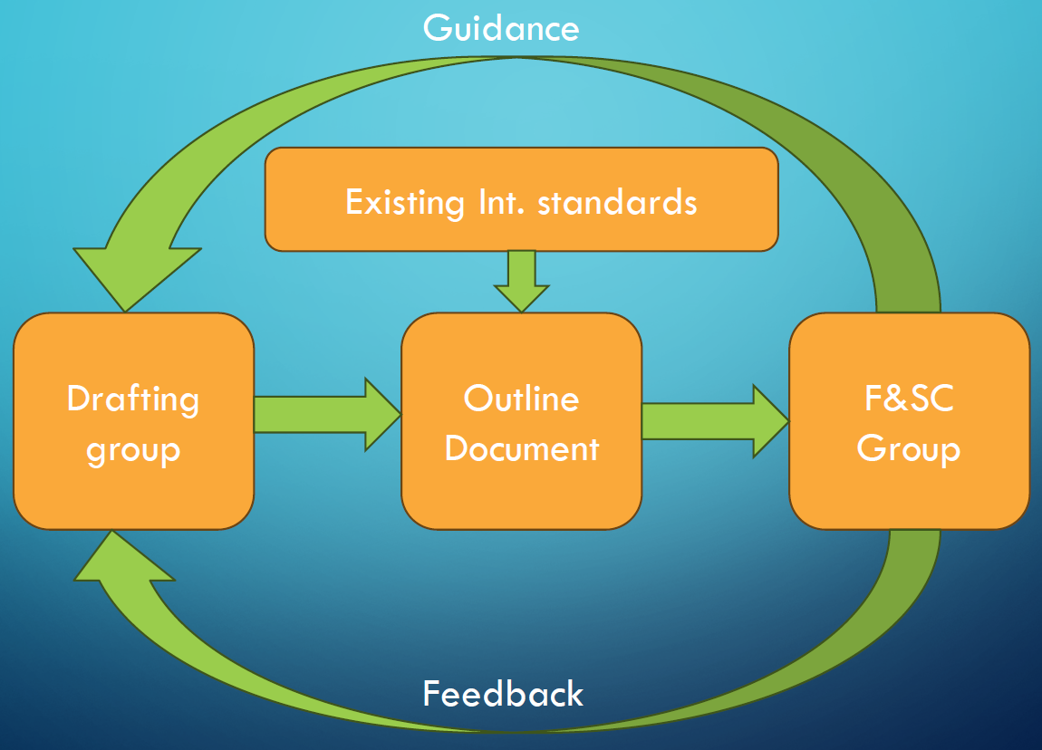
The iterative process is highlighted in the scheme here reported, prepared by the drafting coordinator. The proposed approach was shown in a presentation, see document FRPC-01-02e.
4. Discussion
A draft structure of the mutual resolution has been already prepared by the F&SC secretariat and shared within the group members in the 4th meeting (F&SC-04-03e) and will be the starting point for the drafting group. The first draft version of the FRPC will be a skeleton for all sections that need to be covered, merging the F&SC-04-03e document with the other inputs presented during the F&SC meetings, e.g. family criteria, pre-conditioning, test conditions, etc. (F&SC-05-02).
The chair of the drafting team emphasised that the F&SC cluster aims to arrive at a procedure that is both reproducible and repeatable, and within that context represents real-world charging. This should provide consumers with reliable information on the FRPC and related KPIs.
Another topic briefly discussed and to be clarified within the F&SC group and the UNECE secretariat is how and to what extent to refer to or cite international standards, in particular ISO/SAE 12906, in the document.
5. Inventory of issues for outline document
The drafting coordinator then analysed in more detail the open points to be addressed by the drafting team, referring to the list in slide 8 of document FRPC-01-02e, which the drafting coordinator was also presented to the main F&SC group during the last meeting, assessing the work that would be in charge to the drafting team.
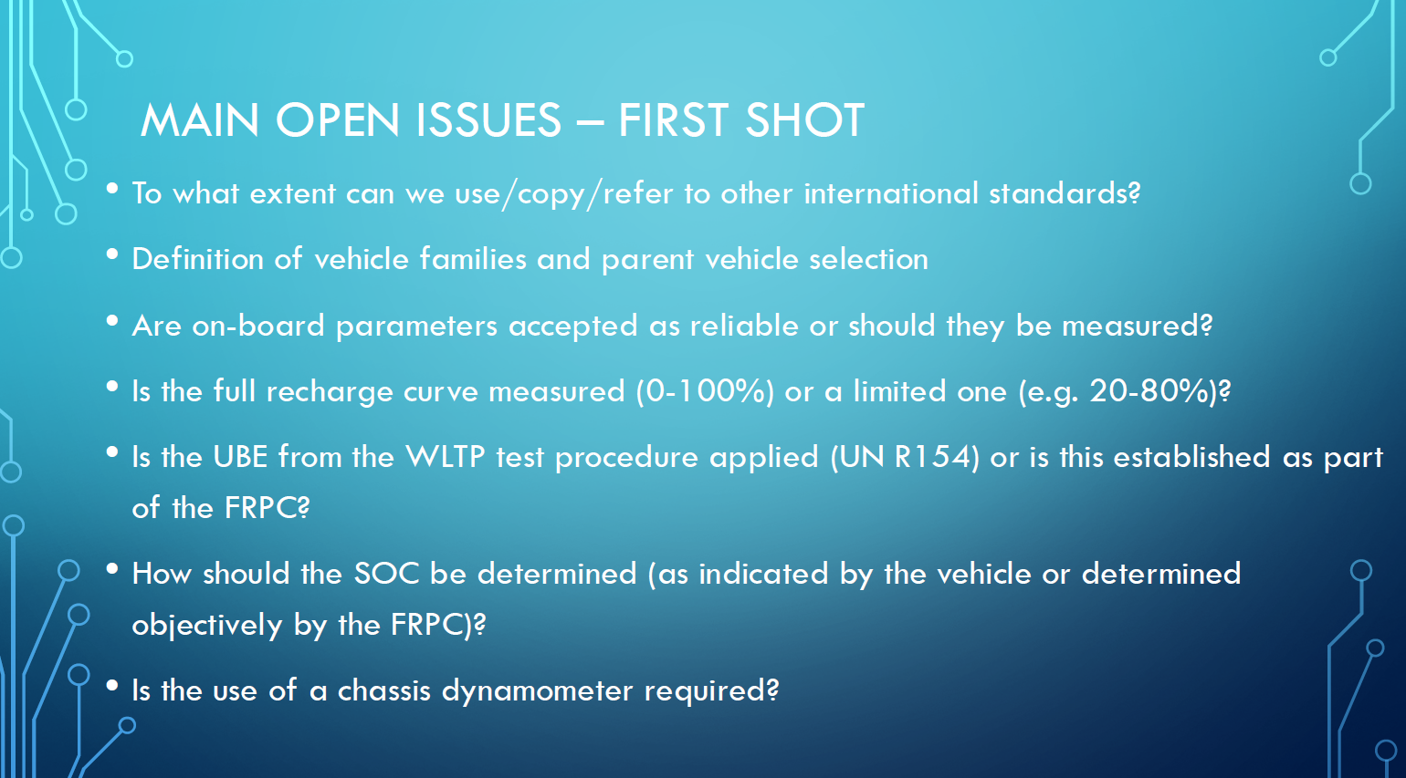
The drafting coordinator requested the collaboration of all parties of the drafting team to study existing standards and to think about what additional open points should be defined in the F&SC mutual resolution.
Afterwards, a brief discussion on the timeline to develop a final document and the current state of progress was addressed. The timeline has the challenging target of having a mutual resolution ready by December 2025.
An OICA representative posed the question of what the resolution should look like. It has to be verified if an official template for a resolution exists. The drafting coordinator stated there are two types of test procedures: a scientific one that provides general guidance on how to perform a test (it seems that ISO 12906 is of this type), and a type-approval procedure where abuse to bias the results is avoided. Since the FRPC KPI’s will be commercially sensitive information, the procedure we develop need to be of the second type. This means we should focus on it to be robust, ensuring optimal consumer information.
The Elaad representative suggested that in addition to the vehicle, a source of information during the charging test could be the charging station itself or the communication between the vehicle and the charging station (e.g. voltage, current and SoC).
An OICA representative also outlined that, for some of the open topics highlighted, OICA had already provided a position at the last F&SC meeting (F&SC-07-09e). The drafting coordinator elaborated that the different stances of all parties should arrive at a common agreement for the F&SC methodology, and asked OICA to pre-arrange a file to note the positions of the different parties together, to be appended to the outline document and added in the several section of the official draft document. This document will probably be published and kept up-to-date on the wiki page. The possibility of creating an editable, shared file is to be verified, but this will probably be difficult.
An OICA representative suggested also to add the list of the relevant KPIs to the list of open items for discussion in the outline document.
Elaad also posed the question whether a real market available charging station should be used during the testing or a more sophisticated but more controlled EVSE emulator should be used.
The JRC outlined that there are specific sections in the document F&SC-04-03e, i.e., 5.1, 5.2 … that refer to the EVSE specifications and requirements and to the test system requirements. They could be added as important sections to define the equipment to be used covering the suggestions from Elaad.
Additional open topics identified were the vehicle preparation and preconditioning before the tests, the frequency of the data acquisition and accuracy of the measurements, the necessity to prescribe in the mutual resolution COP and ISC requirements.
The drafting coordinator concluded by inviting again all parties to review the procedure and to identify possible additional discussion points.
6. Wrap-up with agreements and actions
During the wrap-up, the discussion developed on to whether the entire discharge and charge window of SoC should be explored or only a part of it, acknowledging there are different positions in the group. OICA emphasised that for fast charging performances the window between 20 and 80 per cent of the SoC is the relevant one, where the charging power is not limited. However, it was also analysed that according to ISO/SAE 12906 the measurement of the full UBE during depleting vs. SoC is required during the test to derive the recharged energy in a reference time or SoC window. The definition of UBE is another point to agree upon, if referring to the UBE defined in the WLTP GTR 15 or introducing a new definition for the purpose, and also considering introducing an UBE recharge concept as in the HDV Battery Durability GTR.
Action items:
Action nr. |  | Responsible | Description
01-01 |  | OICA | Prepare a first draft with the open issues, integrating the different position where possible, as presented so far in F&SC meetings, and include issues mentioned during this meeting (see point 5)
01-02 |  | Drafting coordinator | Check with UN secretariat if a template exists for a resolution and if CoP/ISC need to be included
01-03 |  | Drafting coordinator | Check and decide if we will use a sharepoint version for the outline and draft documents
01-04 |  | Drafting coordinator | Provide a link to the procedure developed by Green NCAP
01-05 |  | JRC | Indicate in the minutes the topics/paragraphs missing in the slides, 5.1, 5.2

7. Any other business
The drafting coordinator mentioned that Green NCAP is also developing a test procedure concerning fast charging performance, interesting to be analysed; the document is available at the following link:
https://www.greenncap.com/wp-content/uploads/GNT_DC_Charging_Test_Procedure_v1.0.0.pdf
8. Meeting schedule
It was decided to have two drafting sessions between each F&SC meeting. The proposed draft calendar is as follows, with recurring meetings on Mondays from 11.30 to 13.30 CET. Participants of the drafting team are requested to reserve these in their calendars.
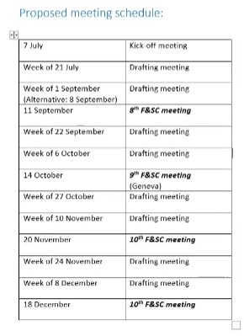
9. Closing
As practical information the drafting coordinator stated that all the official emails from his side will come from his TNO email account (iddo.riemersma@tno.nl), while for receiving a faster response the daily working email to be used is its private company one (iddo@sidekickprojects.nl), so please copy that address in the cc box.

