 | United Nations | ECE/TRANS/WP.29/GRPE/2025/17
 | Economic and Social Council |  | Distr.: General  5 August 2025  Original: English
Economic Commission for Europe
Inland Transport Committee
World Forum for Harmonization of Vehicle Regulations
Working Party on Pollution and Energy
Ninety-third session
Geneva, 14-17 October 2025
Item 14 of the provisional agenda
Automotive Life Cycle Assessment (A-LCA)
Proposal for a new [Mutual] Resolution [No. 5 (M.R.5)] concerning Automotive Life Cycle Assessment (A-LCA)
Submitted by the Informal Working Group on Automotive Life Cycle Assessment *
The text reproduced below was prepared by the Informal Working Group on Automotive - Life Cycle Assessment (A-LCA). It is a proposal for a new [Mutual] Resolution [No. 5 (M.R.5)] concerning Automotive Life Cycle Assessment (A-LCA). It is submitted to the Working Party on Pollution and Energy consideration at its 93rd session.

  - Chain of custody
In the automobiles supply chain, the multiple inputs (resources), outputs (products), and processes exist, and the LCA of automotive products is generally conducted within a complex system. As a method for the appropriate allocation and management of environmental attributes within such a system, Chain of Custody may be applied. ISO 22095:2020 specifies five models of Chain of Custody (Table 4, Figure 13).

Table 4
Chain of Custody Models
Input/Output Relation | Identity preserved | Segregated | Controlled blending | Mass balance | Book and claim
All input characteristics translate unchanged to output characteristics | ✓ | ー | ー | ー | ー
Mixing of inputs from different sources | ー | ー | ✓ | ✓ | ✓
Output characteristics reflect the average of input flow characteristics | ✓ | ー | ✓ | ー | ー
Physical connection | ✓ | ✓ | ✓ | ✓ | ー

Figure 13
Overview of chain of custody models
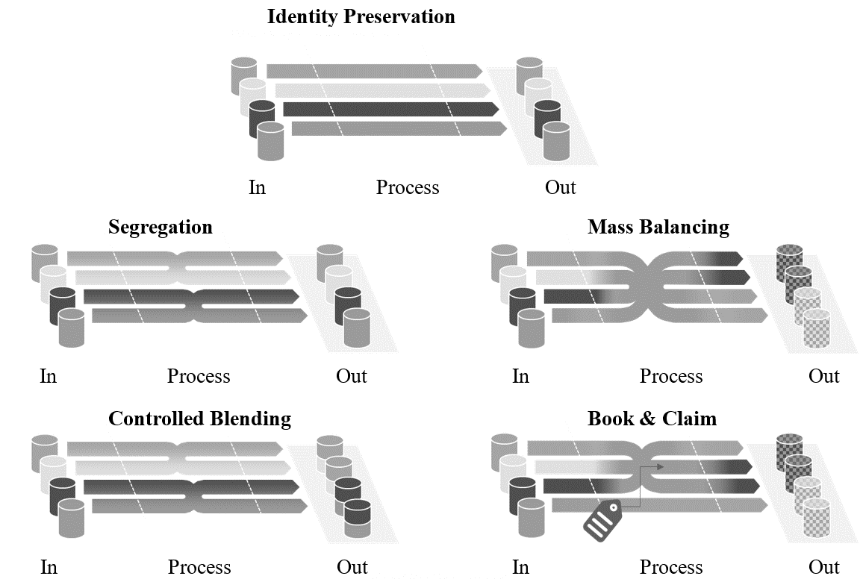

In this resolution, Book and Claim may only be applied to energy carriers such as electricity, fuels, and biomethane. Certification systems for all energy carriers must meet comparable requirements that also apply to electricity and are defined in Chapter 3.2.15.

The Mass Balance model may enable a flexible allocation of environmental attributes; however, in order to ensure transparency and credibility, its application requires prudent consideration. More detailed provisions on Mass Balance are currently under discussion in ISO 13662, while ISO 14077 is addressing its application to LCA.
Accordingly, in automotive LCA, minimum requirements shall be established to prevent diverse interpretations and misuse of Mass Balance. These requirements shall be continuously reviewed and revised, taking into account the developments of global standards such as ISO and the GHG Protocol.

Requirements for Mass Balance
This model shall correspond to “Mass Balance” as defined in ISO 22095:2020.
- This model shall only be applied when it is possible to establish a physical connection exists between input and output. The physical connection does not need to be established if that required additional GHG emissions.
- This model shall be operated under the management of the same company, corporate group, or joint venture.
- This model shall be operated under accounting controls that the claimed output exactly matches the actual input also taking into account material yields and scrap, to avoid any double counting.
- The reliability of this model shall primarily be ensured through verification, and at a minimum, an equivalent independent and transparent scheme shall be required.
- When the environmental attributes of products using this model are claimed, clear and transparent information shall be provided to stakeholders.
- Technical feasibility: When the model is applied it shall be technically possible according to standard industry practice to produce a mass-balanced product from mass balanced materials” (e.g. Blast furnace vs. Electric arc furnace route for steel). It shall not be allowed to allocate more alternative material to a product than technically admissible for that product.
- Technical equivalence: When the model is applied the product must possess the same technical properties as the equivalent product without applied measures.
- When the model is applied, only additional measures relative to the PCF of the residual product shall be considered. The residual product is the product without reduction measures used in mass balance within the respective reporting year.

* In accordance with the programme of work of the Inland Transport Committee for 2025 as outlined in proposed programme budget for 2025 (A/79/6 (Sect. 20), table 20.6), the World Forum will develop, harmonize and update UN Regulations in order to enhance the performance of vehicles. The present document is submitted in conformity with that mandate.

